Abstract
This report details the investigation into a control system with a PID controller and a transfer function.
Instrumentation and control
ACDA5011

Table of Contents
Table of figures 2
Introduction 3
Method 4
Tuning 5
Transfer function 8
Stability 11
Comparison 12
Simulation one 12
Nyquist diagram 13
Simulation two 16
Conclusion 19
References 20

Table of figures
Figure 1: Control system in Simulink 4
Figure 2: Simulation graph before tuning 5
Figure 3: Tuned vs block output prior to tuning 6
Figure 4: Tuned vs block output post tuning 7
Figure 5: Simulation graph after tuning 8
Figure 6: Block diagram for the controller and process 10
Figure 7: Block diagram for the complete system 11
Figure 8: Simulation graph with modified P, I, D and N figures 12
Figure 9: Simulation graph after tuning 13
Figure 10: Nyquist diagram 14
Figure 11: Nyquist diagram with circle 15
Figure 12: Controller parameters 15
Figure 13: Modified control system 16
Figure 14: Simulation graph with consolidated transfer function 17
Figure 15: Simulation graph after tuning 18

Introduction
In this report I will detail the investigation into the control systems of an industrial process, containing a PID controller and has the following transfer function G(s) and values:
$$G\left(s\right)=\frac{1}{as^{2}+bs+c}$$
$$a=3$$
$$b=5$$
$$c=2$$
The control system is designed to bring the process under control within two seconds with overshoot of less than 5%. The report also contains the closed loop transfer function of the complete system.
A PID controller allows a controller to be produced which has no steady state error and reduces the likelihood of oscillations. One of the main areas where this type of controller is used is within temperature controllers within a house. The controller is key to maintaining a stable temperature within the room. A PID controller can be tuned to
The controller can be set to use proportional control, proportional plus derivative, proportional plus integral or proportional plus integral and derivative, and values need to be set for the K_{p}, K_{i} or K_{d}. These change how the system reacts to a change in the set value and how long it takes to settle after the change. Proportional control gives a fast response to oscillations allowing them to die away, however this leaves a steady state error. Proportional plus integral control is likely to oscillate before settling and doesn’t have a steady state error. Proportional plus integral and derivative also doesn’t give a steady state error and oscillates, however does less than the proportional plus integral. [1, p. 112]

Method
A control system was drawn up in Simulink within MATLAB which was designed to meet the requirements of the task. MATLAB is a desktop environment which allows analysis and design processes to be conducted. [2] Simulink is a program which exists within Matlab. It is a block diagram environment which allows systems to be designed, simulated and tested. [3]
The control system has the following features: a step, an error calculator block (add), a PID controller, a transfer function and a scope. The scope was set up with four inputs. The inputs are connected to the step input, error signal, controller output and the plant output. The layout and setup of the control system is shown in Figure 1.
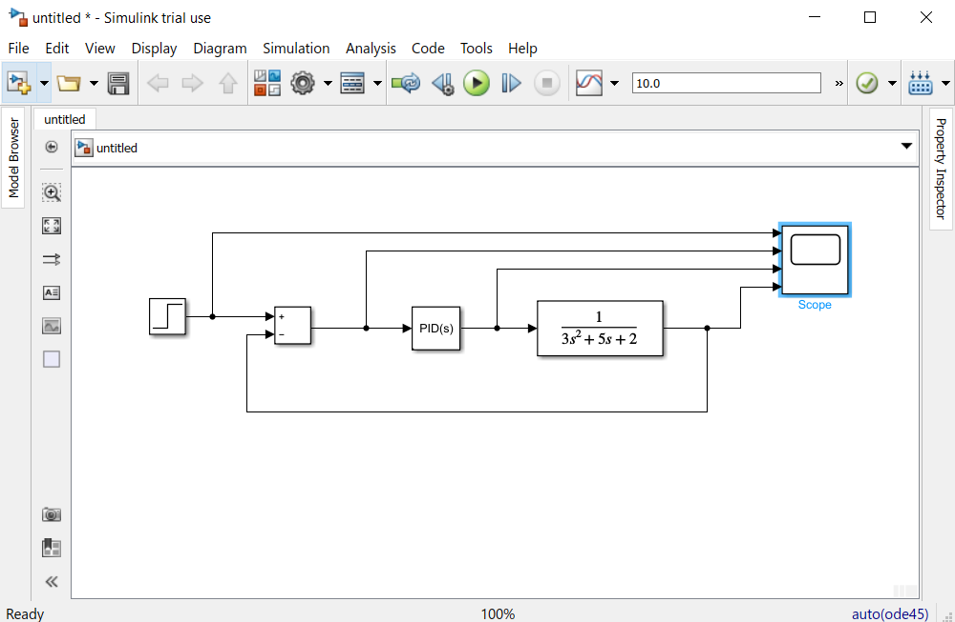
Figure 1: Control system in Simulink
The transfer function box had the numerator coefficient set to “1” and the denominator coefficient was set to “3 5 2” as specified in the requirement. The transfer function is expressed below.
$$G\left(s\right)=\frac{1}{3s^{2}+5s+2}$$

The control system simulation was run for a period of 10 seconds. A graph was created from the scope to show all four inputs. The inputs are from top to bottom; the step input, the error signal, the controller output and the plant output Figure 2. The graph shows a gradual decrease from the error signal and a gradual increase from the plant output.
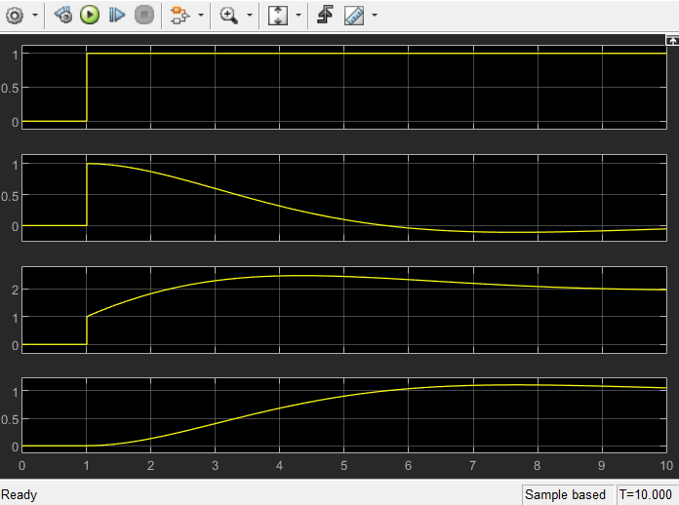
Figure 2: Simulation graph before tuning
The PID controller settings as a parallel form PID controller were set as follows before tuning:
- Proportional (P): 1
- Integral (I): 1
- Derivative (D): 0
- Filter coefficient (N): 1
The PID controller formula is as follows:
$$P+1\frac{1}{s}+D\frac{N}{1+N\frac{1}{s}}$$

Tuning
In order to allow the PID controller to behave as required it requires tuning. Tuning is the method to select the best settings to obtain the desired performance. [1, p. 112] Figure 3 Shows the tuned response and the block response prior to manual tuning. The block response shown follows the same upward trend as the plant output shown in Figure 2.
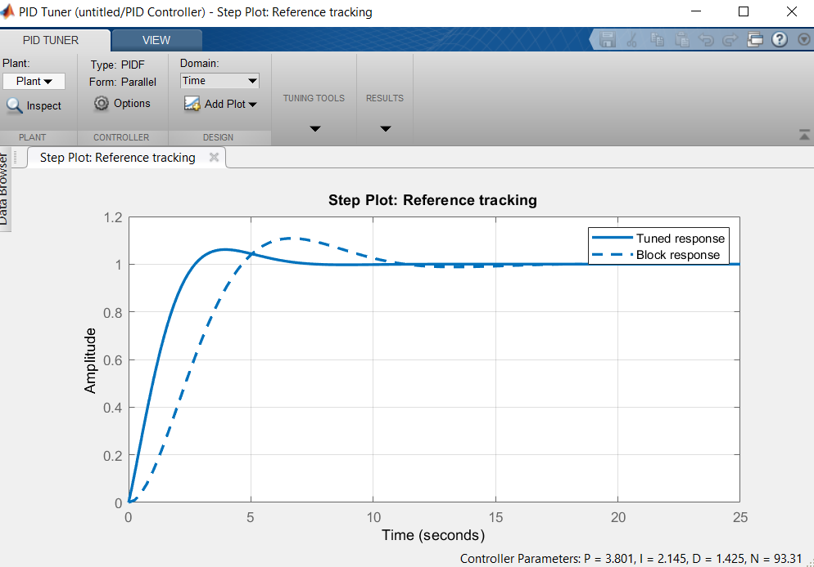
Figure 3: Tuned vs block output prior to tuning
The response time and transient behaviour of the PID controller can be modified. The transient behaviour can be made more robust or more aggressive. Making it more robust decreases the rise time and making it more aggressive increases the rise time. Making it more aggressive, however, also makes the PID controller less stable and more prone to oscillation. A quicker rise time is preferred however a balance between this, and a more stable PID controller is required.
The requirement for tuning are that it settles within two seconds and that the overshoot is within 5%.
The settle time is the time taken for the oscillations to die away. For the response to be within the percentage of the steady state value stated. [1, p. 228]
Overshoot is the maximum amount the response overshoots the steady-state value so is the amplitude of the initial peak. [1, p. 227]
The response time and the transient behaviour were manipulated until it was within the requirement. The settings which brought about the required settling time and overshoot are as follows:
- Response time: 0.4711
- Transient behaviour: 0.79
The Proportional (P), Integral (I), Derivative (D) and filter coefficient (N) after tuning were noted along with the settling time and the overshoot.
- Settling time: 2 seconds
- Overshoot: 4.43%
- P: 26.5291
- I: 14.0372
- D: 12.4007
- N: 485.2161
After tuning the response time and the transient behaviour the tuned output shown in Figure 4 has a quicker rise time. The same trend can be seen on the scope for the error signal and the plant output when the simulation is rerun Figure 5.
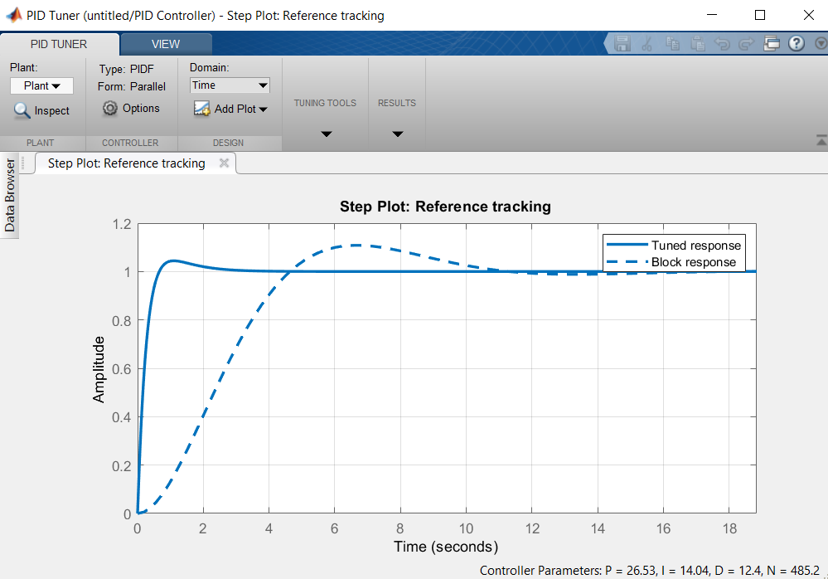
Figure 4: Tuned vs block output post tuning
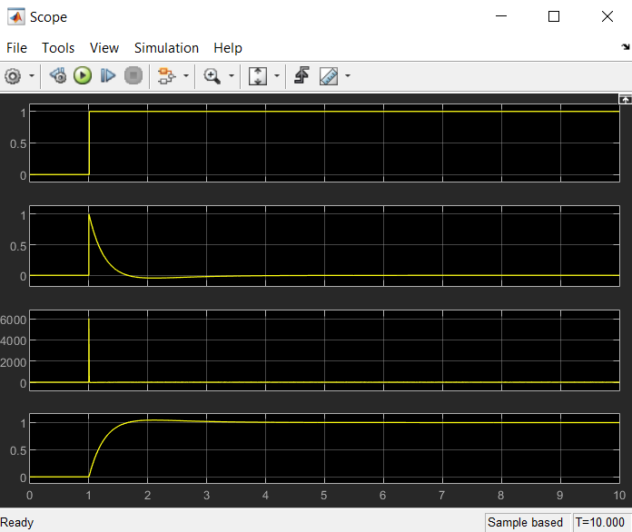
Figure 5: Simulation graph after tuning

Transfer function
The transfer function of the PID controller will be:
$$K_{p}+K_{i}\frac{1}{s}+K_{d}\frac{s}{\frac{1}{N}s+1}$$

K_{d}: 12.4007
K_{p}: 26.5291
K_{i}: 14.0372
N: 485.2161
$$26.5291+\frac{14.0372}{s}+12.4007\frac{s}{\frac{1}{485.2161}s+1}$$
In order to calculate the forward path transfer function of the complete system it is necessary to multiply this equation, the transfer function of the controller, by the transfer function of the process. [1, p. 200] The transfer function of the process is represented by the following equation with the figures for a, b and c as given in the assignment brief.
$$G\left(s\right)=\frac{1}{as^{2}+bs+c}$$
$$a=3$$
$$b=5$$
$$c=2$$
$$K_{p}+K_{i}\frac{1}{s}+K_{d}\frac{s}{\frac{1}{N}s+1} × \frac{1}{as^{2}+bs+c}$$

$$\left(26.5291+\frac{14.0372}{s}+12.4007\frac{s}{\frac{1}{485.2161}s+1}\right) ×\left(\frac{1}{3s^{2}+5s+2}\right)$$

$$\left(26.5291+\frac{14.0372}{s}+12.4007\frac{s}{\frac{s+485.2161}{485.2161}}\right)×\left(\frac{1}{3s^{2}+5s+2}\right)$$

$$\left(26.5291+\frac{14.0372}{s}+12.4007\left(s÷\frac{s+485.2161}{485.2161}\right)\right)×\left(\frac{1}{3s^{2}+5s+2}\right)$$

$$\left(26.5291+\frac{14.0372}{s}+12.4007\left(s\left(\frac{485.2161}{s+485.2161}\right)\right)\right)×\left(\frac{1}{3s^{2}+5s+2}\right)$$

$$\left(26.5291+\frac{14.0372}{s}+12.4007\left(\left(\frac{485.2161s}{s+485.2161}\right)\right)\right)×\left(\frac{1}{3s^{2}+5s+2}\right)$$

$$\left(26.5291+\frac{14.0372}{s}+\left(\frac{2017.0193s}{s+485.2161}\right)\right)×\left(\frac{1}{3s^{2}+5s+2}\right)$$

$$\left(\frac{\left((s\left(s+485.2161\right))×26.5291\right)+\left(s+485.2161\right)14.0372+s\left(2017.0193s\right)}{s\left(s+485.2161\right)}\right)×\left(\frac{1}{3s^{2}+5s+2}\right)$$

$$\left(\frac{26.5291s^{2}+12872.3464s+14.0372s+6811.0754+2017.0193s^{2}}{s^{2}+485.2161s}\right)×\left(\frac{1}{3s^{2}+5s+2}\right)$$

$$\left(\frac{2043.5484s^{2}+12886.3836s+6811.0754}{s^{2}+485.2161s}\right)×\left(\frac{1}{3s^{2}+5s+2}\right)$$

$$\frac{2043.5484s^{2}+12886.3836s+6811.0754}{\left(s^{2}+485.2161s\right)\left(3s^{2}+5s+2\right)}$$

$$\frac{2043.5484s^{2}+12886.3836s+6811.0754}{3s^{4}+5s^{3}+2s^{2}+1455.6483s^{3}+2426.0805s^{2}+970.4322s}$$

This equation can be rewritten as follows:
$$\frac{2043.5484s^{2}+12886.3836s+6811.0754}{3s^{4}+1460.6483s^{3}+2428.0805s^{2}+970.4322s}$$

This means that the block diagram can be rewritten as shown in Figure 6:
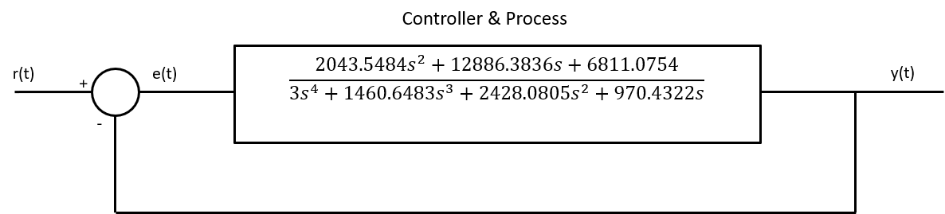
Figure 6: Block diagram for the controller and process
As this is a closed loop system in order to calculate the transfer function of the whole of the system we use the following equation: [1, p. 201]
$$Transfer function= \frac{G(s)}{1+G\left(s\right)H(s)}$$
G: is the forward path transfer function
H: is the transfer function of the feedback loop. [1, p. 271] In this system H = 1.
TF: is the transfer function of the whole system.
$$\frac{2043.5484s^{2}+12886.3836s+6811.0754}{3s^{4}+1460.6483s^{3}+2428.0805s^{2}+970.4322s}$$

$$TF=\frac{\frac{2043.5484s^{2}+12886.3836s+6811.0754}{3s^{4}+1460{.6483s}^{3}+2428.0805s^{2}+970.4322s}}{1+\left(\frac{2043.5484s^{2}+12886.3836s+6811.0754}{3s^{4}+1460{.6483s}^{3}+2428.0805s^{2}+970.4322s}\right)×1}$$
$$TF= \frac{\frac{2043.5484s^{2}+12886.3836s+6811.0754}{3s^{4}+1460{.6483s}^{3}+2428.0805s^{2}+970.4322s}}{\frac{3s^{4}+1460{.6483s}^{3}+2428.0805s^{2}+970.4322s}{3s^{4}+1460{.6483s}^{3}+2428.0805s^{2}+970.4322s}+\frac{2043.5484s^{2}+12886.3836s+6811.0754}{3s^{4}+1460{.6483s}^{3}+2428.0805s^{2}+970.4322s}}$$

$$TF=\frac{\frac{2043.5484s^{2}+12886.3836s+6811.0754}{3s^{4}+1460{.6483s}^{3}+2428.0805s^{2}+970.4322s}}{\frac{3s^{4}+1460{.6483s}^{3}+2428.0805s^{2}+970.4322s+2043.5484s^{2}+12886.3836s+6811.0754}{3s^{4}+1460{.6483s}^{3}+2428.0805s^{2}+970.4322s}}$$

$$TF=\frac{\frac{2043.5484s^{2}+12886.3836s+6811.0754}{3s^{4}+1460{.6483s}^{3}+2428.0805s^{2}+970.4322s}}{\frac{3s^{4}+1460.6483s^{3}+4471.6289s^{2}+13856.8158s+6811.0754}{3s^{4}+1460{.6483s}^{3}+2428.0805s^{2}+970.4322s}}$$

$$TF=\frac{2043.5484s^{2}+12886.3836s+6811.0754}{3s^{4}+1460{.6483s}^{3}+2428.0805s^{2}+970.4322s}×\frac{3s^{4}+1460{.6483s}^{3}+2428.0805s^{2}+970.4322s}{3s^{4}+1460.6483s^{3}+4471.6289s^{2}+13856.8158s+6811.0754}$$

$$TF=\frac{\left(2043.5484s^{2}+12886.3836s+6811.0754\right)\left(3s^{4}+1460{.6483s}^{3}+2428.0805s^{2}+970.4322s\right)}{\left(3s^{4}+1460{.6483s}^{3}+2428.0805s^{2}+970.4322s\right)\left(3s^{4}+1460.6483s^{3}+4471.6289s^{2}+13856.8158s+6811.0754\right)}$$

$$TF=\frac{6130.6452s^{6}+ 3023564.647s^{5}+23804807.55s^{4}+43220887.6s^{3}+29043200.95s^{2}+6609686.885s}{9s^{8}+8763.8898s^{7}+2154192.584s^{6}+10122530.55s^{5}+32535302.75s^{4}+47933462.61s^{3}+29984939.6s^{2}+6609686.885s}$$

The block diagram for the system can again be redrawn as a single block as shown in Figure 7.
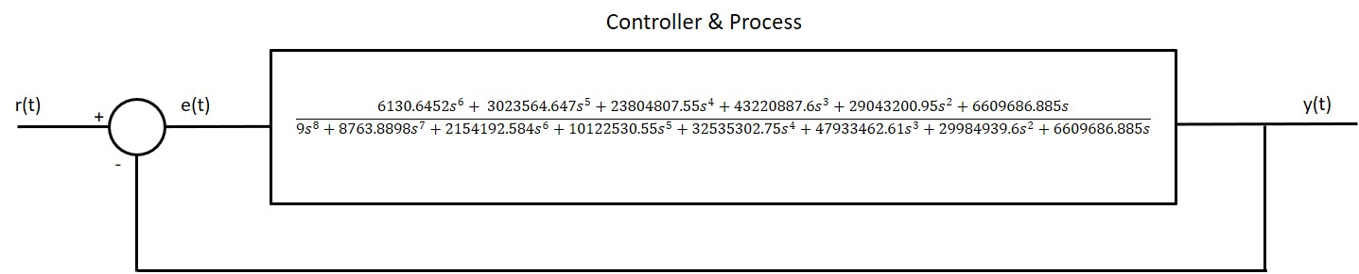
Figure 7: Block diagram for the complete system

Stability
The open loop transfer function is expressed by the term G(s)H(s). The open loop transfer function is the transfer function of the system with the feedback path removed. The open loop transfer function is significant in determining how stable the system will be. [1, p. 271] If the output signal from G(s) is fed back through the feedback loop, H(s), with an amplitude equal to that of the input signal but 180° out of phase then the error signal within the system will create a self-sustaining oscillation and is marginally stable. If the signal being fed back has a smaller amplitude than the initial signal, then the signal will die away over a period of time and the system is stable. If the fed back signal has a larger amplitude than the initial signal then the amplitude of the oscillation will increase, and continue to increase, so will be unstable. A system will be unstable if the gain is greater than 1 and is 180° out of phase. [1, p. 260]

Comparison
Two comparison simulations were run.

Simulation one
The P, I, D and N figures obtained from the above were inputted into the PID controller in the simulation and it was run for 10 seconds. The graph with these figures (Figure 8) was compared to the graph from the tuned simulation (Figure 9). There are no discernible differences between the two graphs.
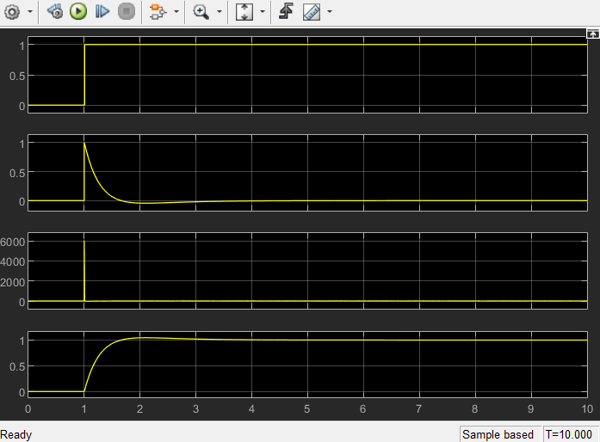
Figure 8: Simulation graph with modified P, I, D and N figures
Figure 9: Simulation graph after tuning

Nyquist diagram
A Nyqusit diagram is a method of describing the frequency response of systems and their stability. In these diagrams the gain and the phase of the open-loop transfer function are plotted for various frequencies as polar graphs. [1, p. 271]
A Nyquist diagram was produced in Matlab (Figure 10). A circle was placed over the Nyquist diagram (Figure 11). The distance from where it intersects with the line in both the imaginary axis and the positive real axis to the origin gives the gain of the system. The angle between the origin and the intersection is the phase shift between the input and the output of the system. [1, pp. 275-277] This angle is visibly equal to the phase margin angle for the block, 83.5° (Figure 12). This diagram shows that the system is stable.

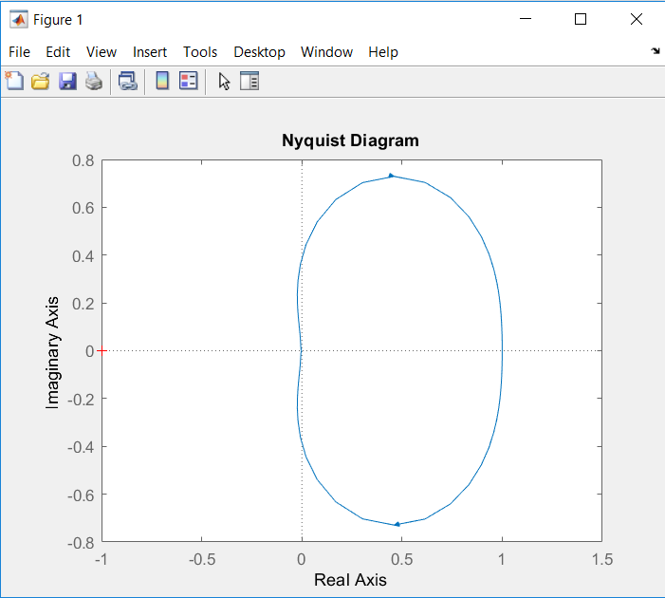
Figure 10: Nyquist diagram
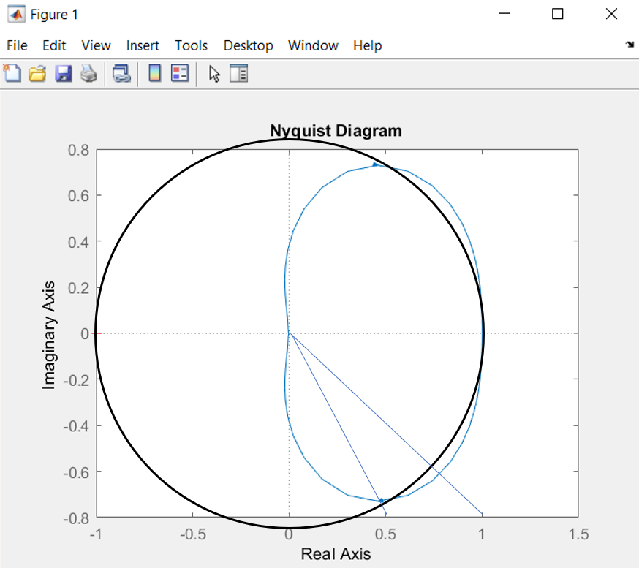
Figure 11: Nyquist diagram with circle
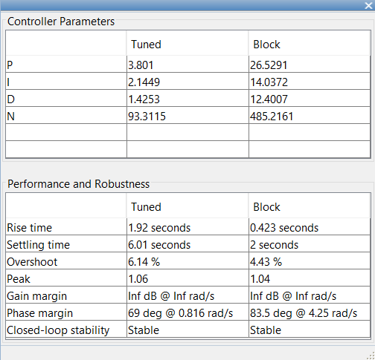
Figure 12: Controller parameters

Simulation two
In order to check the figures obtained in the simulation another simulation was run. This simulation looks at the system as a whole as opposed to the PID controller and transfer function as separate entities. The control system was redrawn in Simulink containing only a step, the transfer function and a scope Figure 13. The equation derived above, which represents the transfer function of the complete system, was inputted into the transfer function of the system. The numerator coefficient was set to [6130.6452 3023564.647 23804807.55 43220887.6 29043200.95 6609686.885 0] which represents:
$6130.6452s^{6}+ 3023564.647s^{5}+23804807.55s^{4}+43220887.6s^{3}+29043200.95s^{2}+6609686.885s$.
The denominator coefficient was set as [19 8763.8898 2154192.584 10122530.55 32535302.75 47933462.61 29984939.6 6609686.885 0] which represents:
$19s^{8}+8763.8898s^{7}+2154192.584s^{6}+10122530.55s^{5}+32535302.75s^{4}+47933462.61s^{3}+29984939.6s^{2}+6609686.885s$
This gives the equation for the transfer function of the system as follows:
$$\frac{6130.6452s^{6}+ 3023564.647s^{5}+23804807.55s^{4}+43220887.6s^{3}+29043200.95s^{2}+6609686.885s}{9s^{8}+8763.8898s^{7}+2154192.584s^{6}+10122530.55s^{5}+32535302.75s^{4}+47933462.61s^{3}+29984939.6s^{2}+6609686.885s}$$
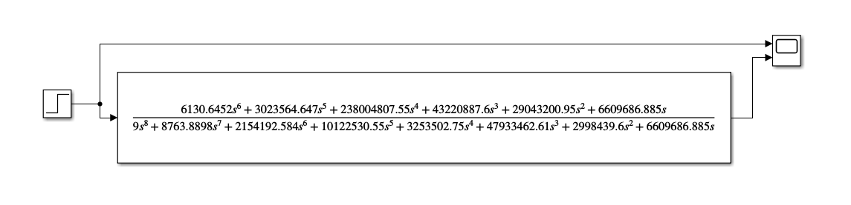
Figure 13: Modified control system
The control system simulation was run for a period of 10 seconds. A graph was created from the scope to show the input and the output of the system. These are, from top to bottom, the step input, plant output. The graph (Figure 14) shows oscillation which increases by 50% as it oscillates. This indicates that the amplitude of the fed back signal is larger than the initial signal, causing the oscillation to increase, and continue to increase. The system is unstable. [1, p. 260]
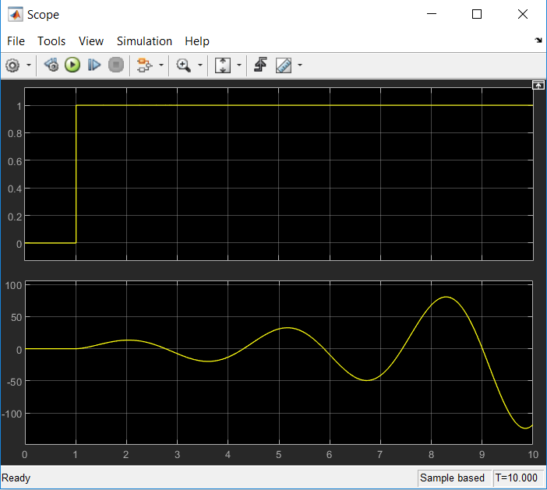
Figure 14: Simulation graph with consolidated transfer function
When compared to the tuned PID controller (Figure 15) the oscillation in the output signal differs considerably. The tuned PID controller rises to 1 within half a second. There is oscillation which peaks at approximately 1.1 at one second and appears to settle within 3.5 seconds. For the consolidated transfer function the oscillation rises to an amplitude of approximately 12 and approximately doubling every cycle. Exact figures are not possible to be determined due to the graduations on the graphs.

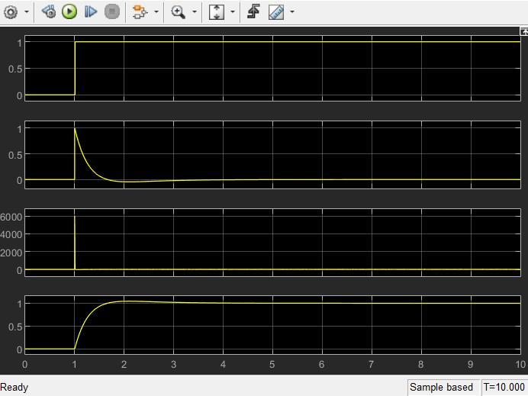
Figure 15: Simulation graph after tuning

Conclusion
The tuning of the PID controller brought the process control within two seconds as per the requirement. It did, however, create more oscillation in the signal. When compared to the initial, untuned system there is oscillation, however the rise time for the system was significantly shorter.
When the graphs of the output of the tuned PID controller is compared to the graph of the output of the consolidated PID controller and transfer function there are a number of differences between the two. The simulation with the P, I, D and N figures inputted is stable with the oscillations in the signal diminishing as per the requirements. The simulation for the consolidated PID controller and transfer function, however, has oscillations which increase in amplitude and as such is unstable.

References

[1] | W. Bolton, Instrumentation and Control Systems, Oxford: Newnes Publishing, 2015.
[2] | Matlab, [Online]. Available: https://uk.mathworks.com/products/matlab.html. [Accessed 15 06 2020].
[3] | Matlab, [Online]. Available: https://uk.mathworks.com/help/simulink/index.html?s_tid=srchtitle. [Accessed 15 06 2020].
[4] | P. I. Wells, “MATLAB Introducfgtion: Lecture 1,” [Online]. Available: https://moodle.uwtsd.ac.uk/course/view.php?id=2258. [Accessed 15 06 2020].
[5] | P. I. Wells, “MATLAB Introduction: Lecture 2,” [Online]. Available: https://moodle.uwtsd.ac.uk/course/view.php?id=2258. [Accessed 15 06 2020].
[6] | P. I. Wells, “Introduction to Simulink,” [Online]. Available: https://moodle.uwtsd.ac.uk/course/view.php?id=2258. [Accessed 15 06 2020].

