

Understanding and engaging stakeholders
Stakeholder engagement plan
INDITEX
Module Code: LCLM5001
Student Name: Anna Chausheva
Student Number: 2335868
Lecture Name: Dr Kazeem Oseni

Session: October 2025 Term

Table of Contents

Introduction to the Organisation 3
Situational Analysis of the Organisation 3
PESTLE Analysis 4
SWOT Analysis 5
SMART Objectives of the Project 7
Stakeholder Identification 8
Stakeholder Benefits and Challenges 9
Stakeholder Analysis Using Tools 10
Roles of the Project Manager in Stakeholder Engagement 13
Communication Plan 14
Levels of Stakeholder Engagement 16
RACI Matrix 17
Significance of Stakeholder Engagement 18
Recommendations 19
Conclusion 21
References 23

Introduction to the Organisation
Owen Mumford is an established manufacturer of medical devices within the UK, which is known for producing inventive solutions that facilitate the delivery of safe, effective, and sustainable healthcare. The company, which is based in Oxfordshire, was founded in 1952, and it designs and manufactures injection systems, drug-delivery devices, and point-of-care medical technologies used in the clinical and home care markets of the world (Owen Mumford, 2025). It has established itself as a reliable partner to pharmaceutical companies and health care providers across the globe due to its dedication to innovation driven by research, its compliance with various regulations, and its ability to produce high-quality products. Sustainability, patient safety, and usability are central priorities for the organisation, ensuring that its products meet evolving healthcare requirements and professional standards. Regarding the suggested wearable health-monitoring device, the technical experience and long record of innovation of products with Owen Mumford will be a good foundation to create a product that is reliable, user-friendly, and commercially viable. The project is based on the company’s achievements in digital health integration and patient-centred product design, and will support its strategic goal of extending to connected medical devices and facilitating more proactive, data-oriented health care models.

Situational Analysis of the Organisation
Situational analysis provides a necessary basis for assessing the organisation’s preparedness of Owen Mumford to create and implement the proposed wearable health-monitoring device. This section evaluates the macro-environmental and micro-environmental tools by analysing external market factors and the organisation’s internal capability to respond (Clarke, et. al., 2022).

PESTLE Analysis
Factor | Key Influence on the Project
Political | Stable UK regulatory climate for medical devices supports R&D investment; government incentives for digital health innovation enhance project feasibility (Calvert, et. al., 2021).
Economic | Rising healthcare costs and pressures on health systems create demand for preventative and remote-monitoring devices; however, inflation may increase production costs.
Social | Ageing populations and growing public interest in self-management of chronic conditions drive widespread acceptance of wearables.
Technological | Advancements in sensors, connectivity, and data analytics offer strong opportunities for innovation; cybersecurity requirements remain a critical consideration.
Legal | Strict compliance with MDR, GDPR, and data-protection laws is essential for market approval and consumer trust.
Environmental | Growing expectations for sustainable materials and low-waste manufacturing align with the firm’s existing environmental commitments.
The PESTLE findings indicate favourable conditions for digital health solutions, although stringent regulatory and data-security demands require careful project planning (Buye, 2021).
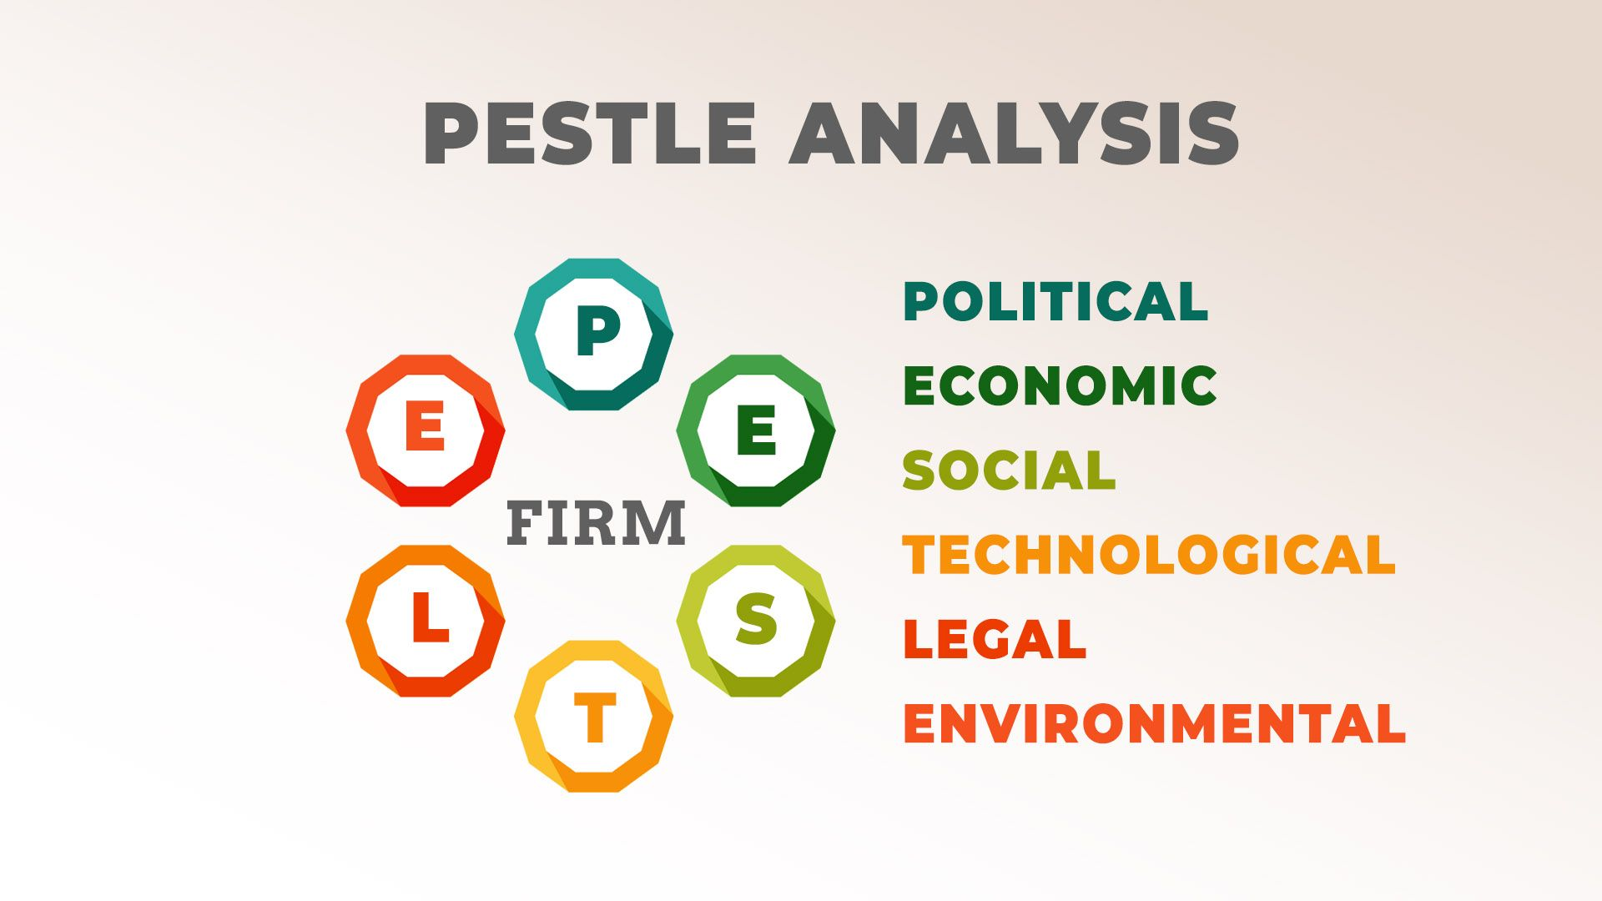
Figure: PESTLE Analysis
Source: (Buye, 2021)

SWOT Analysis
Strengths | Weaknesses
Established expertise in medical device design and manufacturing. | Limited existing product portfolio in digital or wearable technologies.
Strong global reputation and partnerships with pharmaceutical firms. | High R&D costs are associated with entering a new market segment.
Commitment to sustainability and patient-centred design. | Dependence on external software capabilities for connectivity functions (Benzaghta, et. al., 2021).

Opportunities | Threats
Growing demand for remote patient monitoring and digital health platforms. | Intense competition from established technology companies and emerging health-tech start-ups (Micalo, 2022).
Potential for long-term partnerships with healthcare providers and insurers. | Rapid technological change may shorten product life cycles.

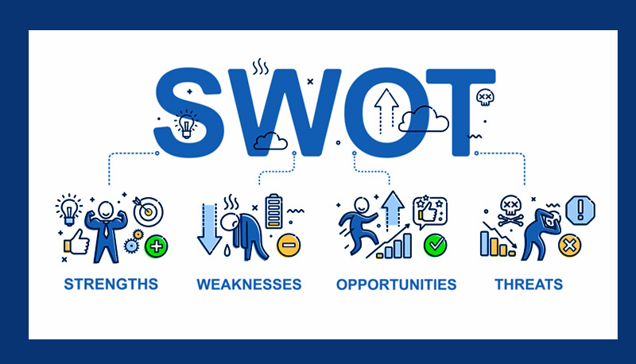
Figure: SWOT Analysis
Source: (Benzaghta, et. al., 2021)
Altogether, the PESTLE and SWOT analyses discussed jointly demonstrate that Owen Mumford is in a good place to pursue this project. The organisation enjoys robust production strengths and a good reputation, whereas the external environment gives it tremendous growth opportunities in related health markets. However, to guarantee successful access to the wearable-device industry, the company should be able to effectively deal with the capability gaps in digital technology and overcome the competition pressures by proposing innovations and by engaging the stakeholders properly.

SMART Objectives of the Project
The SMART model offers a systematic model for forecasting the objectives of the proposed project of a wearable health-monitoring device that Owen Mumford is planning to start. The organisation can align its innovation engagements to its internal strengths and external market environments outlined in the situational analysis by making sure that the objectives are specific, measurable, achievable, realistic, and time-bound (Westbrook, et. al., 2024).
Specific:
The main aim of the project will be to design and develop a clinically valid wearable health-monitoring system that measures essential physiological parameters in the form of heart rate, temperature, and blood oxygen concentrations. The device will assist people in controlling chronic conditions and allow medical workers to retrieve the correct, real-time information. There is a direct response to the demographic and lifestyle trends in the PESTLE analysis through preventative care.
Measurable:
Success will be measured using well-established metrics, including regulatory approval under the UK Medical Device Regulations, conducting all development milestones in terms of budgets, and attaining at least three strategic collaborations with medical providers before entering the market. Other strategies involve accuracy levels of performance and the level of user satisfaction in clinical trials.
Achievable:
The goal is attainable since Owen Mumford possesses strong competencies in medical device engineering, established quality-control systems, and long-term collaborations with healthcare organisations. Although digital technology is a more recent field for the firm, the identified gaps in capability can be closed through external partnerships and intentional investment into software expertise (Umoren, 2022).
Realistic:
The project is realistic, considering the increased demand for remote patient-monitoring solutions and the innovation history of the organisation in patient-centred products. Despite the SWOT analysis demonstrating that the company will likely face competition based on technology companies, the emphasis on clinical reliability, compliance and sustainability by Owen Mumford gives the company a viable ground in the market (Mumuni, et. al., 2024).
Time-bound:
The project is planned to be finished in a period of twenty-four months, and then six months of regulatory and pilot-testing period will commence. The market launch is therefore planned within three years. This can be combined with vigorous R&D, regulatory filing and stakeholder engagement.
All these SMART objectives would create a very strong strategic base on which to launch an excellent, compliant, and commercially viable wearable health-monitoring gadget.

Stakeholder Identification
The implementation of the wearable health-monitoring device designed by Owen Mumford is successful only when a great number of internal and external actors are involved. Such groups can add various types of expertise, resources, and influence, and it is necessary to identify them in order to plan and engage.
Stakeholder Group | Type | Role in the Project
Senior Management | Internal | Provides strategic direction, approves budgets, and monitors project progress (Kerzner, 2023).
R&D Department | Internal | Leads device design, engineering, prototype development, and product testing.
Quality Assurance (QA) | Internal | Ensures product safety, compliance, and adherence to manufacturing standards.
Regulatory Affairs Team | Internal | Manages submissions under MDR and UK medical device regulations.
Marketing and Sales Teams | Internal | Develops positioning strategies, market insights, and launch plans.
IT and Software Developers | Internal | Designs digital interfaces, data-processing systems, and device connectivity features.
Supply Chain and Procurement | Internal | Secures components, manages suppliers, and coordinates production timelines.
Manufacturing Teams | Internal | Oversees large-scale production and maintains quality control during assembly.
Clinicians and Healthcare Partners | External | Provide clinical validation, user insights, and trial participation (Dagenais, et. al., 2022).
Suppliers and Component Manufacturers | External | Deliver sensors, materials, and electronic parts needed for device construction.
Regulatory Bodies (e.g., MHRA) | External | Grant approvals required for legal product launch and market entry.
End-Users (Patients and Carers) | External | Offer usability feedback, influence adoption, and shape final design features.
Healthcare Providers and Insurers | External | Support integration into care pathways and influence purchasing decisions.

Stakeholder Benefits and Challenges
All stakeholders involved in the wearable device project bring valuable experience that will help make the project successful, but they also have to deal with some challenges that should be addressed with caution. Strategic leadership and financial resources offered by the senior management allow long-term investment in innovation, but they might be subject to pressure to keep the costs within control and the technological ambition high. The R&D team will have technical expertise that would help in designing the device, but they might experience difficulties in integrating the new digital features and working within the tight development schedule (Liu and Cao, 2025).
The specialist knowledge of the QA and Regulatory Affairs teams ensures that the device complies with regulations, which is beneficial in enhancing credibility in the market. Their difficulty is that they have to manage complicated and changing legal requirements, and this aspect may slow them down. IT and software teams allow connecting and processing data in real time, although they must mitigate cybersecurity threats and ensure interoperability with healthcare systems. Marketing and sales teams ' involvement involves the analysis of the requirements of the market and the determination of the commercial strategy of the product, but they might experience challenges in terms of product differentiation within a competitive digital-health market.
Clinically, clinical validation and user insights have to be provided by external sources of clinicians and healthcare partners, yet they might be time-constrained in trials. Suppliers will be providing the vital ingredients, but could be affected by instability in the supply of materials. The end-users give feedback that is mostly viable and brings about usability of their products, although their worries about data privacy and accuracy of the device may serve as a hindrance to its adoption (Burgess, et. al., 2023).
All these advantages and issues lead to the conclusion that the stakeholder involvement during the project must be strong.

Stakeholder Analysis Using Tools
With the help of stakeholder analysis, Owen Mumford can comprehend the degree of power, interest, and influence possessed by people and groups that participated in the wearable health-monitoring device project. The use of the Power-Interest Matrix by Mendelow is an organised way of classifying the stakeholders and the type of engagement strategy that should be implemented (Newsome and Lloyd, 2023).
The most influential team in the high power-high interest quadrant is the senior management, the R&D department, and the Regulatory Affairs team. They play a critical role in decision-making, including project funding, technical orientation, and adherence to regulatory requirements. These stakeholders should be under close management with constant communication, review of progress and their participation in major decisions. They have a strong interest that would provide continued engagement, but the lack of alignment between the expectations of costs and the innovation goals may lead to conflict in case it is not managed in advance.
Regulatory bodies like the MHRA and large suppliers fall under the high power-low interest group. They might not be in the day-to-day operations, but their decisions would have significant consequences for the approval processes and the availability of key elements. These stakeholders should be kept satisfied through timely communication, submitting documentation on time, and making the procurements trustworthy. Any inability to deliver to the regulatory expectation or stability in the supply chain will significantly slow down the project (Burke and Saxena, 2021).
Low power-high interest stakeholders are clinicians, healthcare partners, and end-users. They have useful information on usability, clinical relevance and patient experience. They cannot make a grandiose change to final decisions, although it is necessary to have them involved in ensuring that the device addresses the requirements of the market and is accepted in the healthcare environment. Consultations, prototype testing and feedback should be used to keep these groups informed. Their fears about the accuracy or the privacy of data can point out critical design problems at an early stage of development.
The low-power, low-interest group consists of broader community members and ordinary consumers who might not yet have been directly impacted by the project. They need the least monitoring; however, when the product is close to launch, and the process of communication starts broadly, they become more pertinent (Nahar, et. al., 2022).
The stakeholder map underlines the need to focus on prioritisation. The project core is comprised of high-influence internal teams, whereas the external stakeholders affect long-term adoption and regulatory success. More importantly, the review demonstrates that there may be some contradictions between technological aspiration and regulatory restrictions, commercial goals, and clinical demands. These implications explain why there should be specific engagement approaches that would be modelled to the level of influence and interest that the group has (Rouse, et. al., 2025).
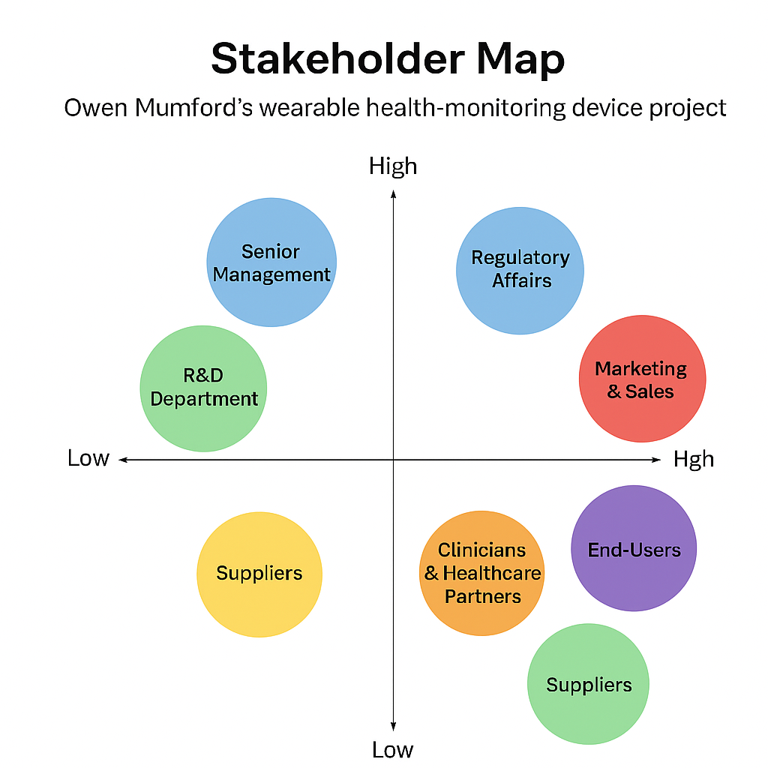
Figure: Stakeholder Map
Source: Author

Roles of the Project Manager in Stakeholder Engagement
The project manager is one of the key players in the process of organising the stakeholder involvement in the creation of the wearable health-monitoring device. Their role begins with establishing clear communication mechanisms that deliver timely and accurate information to all stakeholders. Proper communication can help to ensure that there are no contradictions in expectations and minimise the likelihood of miscommunications that can destroy the progress. One of the key tasks in this regard is to match messages with various stakeholder groups, as senior executives need strategic reports, whereas technical teams need operational information connected with development milestones (Munoru, 2024).
The other significant role would be to foster cross-departmental coordination, and this is necessary in the projects where engineering, digital technology and clinical input are combined. The manager should make sure that internal teams work well together and prevent siloed working practices, which can slow development. This involves the implementation of systematic communication resources, including a progress board and regular multidisciplinary conferences, which facilitate transparency and responsibility of all the involved parties. Another aspect that the manager should evaluate is the interdependencies between tasks, since improper management of the workflow relationship may result in bottlenecks that limit the efficiency of the project.
Conflict management is an important element of stakeholder management, especially when incompatible priorities arise or there is a limited supply available. The project manager should be able to spot the areas of tension at the earliest, foster free discussion and come to an agreement that would accommodate both technical demands, as well as regulatory and commercial realities. It requires emotional intelligence and objective decision-making to carry out this role, particularly in negotiating between the top-level decision-makers and the working teams. A reflective approach is necessary since unresolved conflict may hasten schedules, quality of products, and trust of stakeholders (Bálint, et. al., 2025).
Strategic alignment is another important task of the manager, who should be able to keep the objectives of the project aligned with the broader organisational ones. This involves keeping track of stakeholder expectations and changing engagement approaches where priorities change. The manager should also create encouraging relationships by being dependable, responsive and engaging the stakeholders in making significant decisions. Good relations facilitate collaboration and minimise the opposition to change, especially when new technologies threaten the customary ways of doing things (Haniff and Galloway, 2022).
In general, the role of the project manager is complex and highly significant to the maintenance of the purposeful, coordinated, and adaptive stakeholder engagement.

Communication Plan
The communication plan must be structured to address the stakeholder expectations and coordinate the whole development process of the wearable health-monitoring device by Owen Mumford. The plan also describes the way of sharing information, who will be involved in every communication activity and the tools to facilitate the communication effectively. A consistent approach is useful in ensuring transparency, minimising uncertainty, and facilitating cooperation between internal and external stakeholders (Siukonen, 2023).
The communication plan is grounded in transparency, frequency, and applicability. Top management needs level 2 reports, which are devoted to the budgetary level, risks in the project, and strategic decisions. Technical teams require side-by-side information on operations in order to assist with design, testing, and regulatory compliance. Clinicians, regulators, and suppliers are external stakeholders who need their own specific communication with the reflection of their contributions and constraints.
Communication Plan Table
Stakeholder Group | Communication Channel | Frequency | Message Type | Responsible Person | Tools Used
Senior Management | Progress meetings | Monthly | Strategic updates, risks, budgets | Project Manager | Slide decks, dashboards
R&D, IT, QA Teams | Internal team meetings | Weekly | Technical progress, issues, task updates | Project Manager / Team Leads | MS Teams, Jira, shared drives
Regulatory Affairs | Compliance reviews | Bi-monthly | Documentation updates, regulatory requirements | Regulatory Lead | Document management systems
Clinicians & Healthcare Partners | Prototype testing sessions | Quarterly | Usability feedback, clinical observations | Clinical Liaison Officer | Email, video calls, trial reports
Suppliers | Procurement reviews | Monthly | Component availability, lead times | Procurement Manager | Emails, procurement software
Marketing & Sales | Market-readiness meetings | Monthly | User insights, launch planning | Marketing Lead | Shared reports, CRM tools
End-Users (Pilot Participants) | Feedback surveys | During trial cycles | Usability, comfort, satisfaction | UX Researcher | Online surveys, mobile apps

Levels of Stakeholder Engagement
The project of Owens Mumford on wearable health-monitoring devices includes the stakeholders of different degrees of influence and interest, which means that a range of different engagement strategies should be used. With the engagement continuum, the stakeholders can be categorised based on their level of participation, which is needed (Davis, et. al., 2022).
- Inform: This category belongs to bigger communities and general consumers. Public communications, newsletters, or press releases are also the main methods of their exposure to project updates, thus making them aware without necessarily having to provide feedback.
- Consult: External stakeholders (clinicians and healthcare partners) are consulted in the process of prototype testing and clinical trials. Their feedback helps in product usability and safety, and the final decision is made by internal teams.
- Involve: Regulatory bodies and suppliers are actively engaged in the key processes, such as the compliance reviews and the procurement planning. Frequent contacts ensure approvals and availability of components in time and reduce project delays (Vaghani, 2024).
- Collaborate: Multidisciplinary meetings and shared project platforms are part of the collaboration between internal teams such as R&D, QA, IT and Marketing. This integration determines the technical integration, operational efficiency and alignment with strategic objectives.
- Empower: The topmost involvement is the senior management. They possess the decision-making powers regarding the budgets, timelines, and the strategic direction, which allow quick resolution of the issues which have a high impact on the project.
Individualising the level of engagement will bring the resources optimally, reinforce the commitment of stakeholders, and address possible conflicts.
4C | Application in the Owen Mumford Project | Purpose / Outcome
Connectedness | Link internal teams (R&D, IT, QA, Marketing) and external stakeholders (clinicians, regulators, suppliers, end-users) | Ensures aligned goals and coordinated actions
Communication | Tailored updates for each stakeholder group (strategic, operational, regulatory, usability) | Prevents miscommunication and builds trust
Collaboration | Multidisciplinary workshops, shared dashboards, joint problem-solving | Accelerates decision-making and improves technical integration
Commitment | Actively integrate feedback and demonstrate stakeholder impact | Enhances trust, engagement, and adoption of the device

RACI Matrix
The RACI framework defines the wearable health-monitoring device project and provides accountability and minimises the presence of task ambiguity (Wijaya, et. al., 2025).
Task | Responsible (R) | Accountable (A) | Consulted (C) | Informed (I)
Project Planning & Scheduling | Project Manager | Senior Management | Team Leads | All Stakeholders
Device Design & Prototype | R&D Department | Project Manager | QA, IT | Senior Management
Digital Integration & Software Development | IT & Software Developers | Project Manager | R&D, Clinicians | Senior Management
Regulatory Compliance Submission | Regulatory Affairs | Project Manager | QA, Clinicians | Senior Management
Procurement of Components | Supply Chain & Procurement | Project Manager | Suppliers | Senior Management
Manufacturing & Assembly | Manufacturing Teams | Project Manager | QA | Senior Management
Clinical Trials & Usability Testing | Clinicians & Healthcare Partners | Project Manager | R&D, QA | Senior Management, End-Users
Marketing Strategy & Launch Planning | Marketing & Sales | Project Manager | R&D, Clinicians | Senior Management
Stakeholder Engagement & Communication | Project Manager | Senior Management | All Teams | All Stakeholders

Significance of Stakeholder Engagement
Justification of Engagement
The success of the project connected with the wearable health-monitoring device by Owen Mumford is dependent on effective stakeholder engagement. Stakeholder involvement makes sure that the objectives of the project and the organisational strategy are in line with each other, especially in cases that deal with complicated regulatory, technical and commercial landscapes (Prebanić and Vukomanović, 2023). Active interest helps reduce risks, as probable conflicts or hold-ups will be spotted in time and prevented. Indicatively, practical feedback given by clinicians and end-users will lead to usability being improved to ensure adoption, and regulatory bodies will steer compliance, avoiding the chances of approval delays. Equally, the participation of suppliers guarantees a stable supply of components, which avoids congestion during production. The involvement also leads to commitment, trust and transparency, which enhances cooperation and minimises resistance to change.
Influence on Organisational Performance
Sustainable stakeholder engagement has a positive impact on organisational performance through encouraging efficiency, innovation, and strategic alignment. Interested stakeholders provide knowledge, skills, and resources that increase their capabilities in decision-making and problem-solving (van Lieshout, et. al., 2021). As an example, the R&D and IT teams that work in close collaboration with clinical partners enhance product accuracy and usability, which has a direct practise on the success of the products in the market. There is also improved financial and operational performance since the aligned stakeholders minimise project overruns and wastage of resources. In addition, an efficient engagement process will support the reputation of the organisation as a reliable, compliant, and patient-centred innovative partner, which will reinforce its collaboration with healthcare providers and insurers. The long-term engagement fosters a culture of continual improvement, sharing of knowledge, and innovation in order to help the organisation fulfil its strategic aspiration to move into related medical devices. Through the active engagement of all stakeholders at all levels, Owen Mumford is improving the project results and general resilience of organisations operating in the dynamic healthcare and technology context (Ahsan, 2025).

Recommendations
The wearable health-monitoring device project initiated by Owen Mumford should be successful only with good stakeholder engagement. According to the stakeholder analysis, the recommendations below would be used to improve communication, collaboration, and conflict management during the project lifecycle.
- Structured engagement planning will ensure that stakeholders are engaged at the appropriate time and in an appropriate way. By working out an elaborate engagement timeline, based on the influence and interest of each stakeholder, the project team can prioritise the interactions and predict the challenges as well as efficiently allocate resources. By doing so, the possibility of missing the stakeholder needs will be minimised, and the important stakeholders will not be lost (Hollmann, et. al., 2022).
- Personalised Communication must also be introduced so that the stakeholders can be furnished with pertinent information according to their position and interest. Senior management would need a strategic report on budgets, risks, and progress, and technical teams would need operations details. Customised messages with the clear definition of expectations, responsibilities, and deadlines are beneficial to external stakeholders (clinicians, regulators, suppliers, etc.). Customisation of communication enhances comprehension, creates trust and minimises misunderstanding.
- Collaboration can be strengthened through regular multidisciplinary meetings and progress reviews, and shared project dashboards. Regular evaluations allow identifying the bottlenecks early, prioritising tasks, and being proactive in solving the issues. This also enhances accountability and transparency, which keeps the stakeholders updated and active in the project (Urton and Murray, 2021).
- Product usability, clinical relevance, and compliance are not possible without feedback Integration. The gathering and analysis of end-user, healthcare partners and supplier input is done in a systematic manner to ensure that design changes are based on the needs of the stakeholders. Responsiveness through acting on the feedback shows that the stakeholders are satisfied, and the device is accepted in the market (Negash and Sarmiento, 2023).
Taken together, these suggestions can offer a strategic guideline in achieving better engagement, communication, and collaborative relationships and eventually help in the successful realisation of a safe and viable, effective, and commercially viable wearable health-monitoring device.

Conclusion
The evaluation of the wearable health-monitoring device project created by Owen Mumford proves that stakeholder involvement is the key to successful product development. Successful identification, mapping and categorisation of stakeholders using tools such as Mendelow’s Matrix helps in channelling resources to high-power, high-interest groups without assuming that the less influential stakeholders should not be properly involved. The functions of the project manager are very important, and they include communication, coordination, conflict management and alignment with organisational goals. Systemic interaction facilitates solutions integration among internal departments, encompassing R&D, IT, QA, and marketing, and at the same time, integrates external input of clinicians, regulators, suppliers, and end-users. Sustained interaction enhances decision-making, reduces risks, builds trust and delivers practical returns on both project results and organisational performance. Responsibilities are formalised, transparency is improved, and collaboration becomes simpler with the use of tools like RACI matrices, engagement continuums, and communication plans. With the strategy of engagement differentiated to the needs and influence level of stakeholders, Owen Mumford will be able to reduce the risk of regulatory obstacles, improve product usability, and become commercially viable. Overall, integrating stakeholder engagement as an ongoing and flexible process helps in the areas of innovation, efficiency, and market preparedness. Established partnerships with clinical partners, regulatory agencies, and healthcare providers over the long term provide a platform for the future connected health programmes. Moreover, sustainable practices and digital expertise can be integrated to make organisations resilient to the changing healthcare environment. The strategic planning, management, and participation of the stakeholders will ensure that the project of the wearable device will not only fulfil the technical and regulatory criteria but also add to the image of Owen Mumford as a reliable, patient-centred, and innovative manufacturer of medical devices.

References
Ahsan, M.J., (2025). Cultivating a culture of learning: the role of leadership in fostering lifelong development. The learning organization, 32(2), pp.282-306.
Bálint, M., Vilas-Boas da Silva, J.M. and Möhring, M.M., (2025). Green innovations in third-party logistics: managerial reasons, external stakeholder influences and contingencies in the natural-business environment. Cogent Business & Management, 12(1), p.2460613.
Benzaghta, M.A., Elwalda, A., Mousa, M.M., Erkan, I. and Rahman, M., (2021). SWOT analysis applications: An integrative literature review. Journal of Global Business Insights, 6(1), pp.54-72.
Burgess, E.R., Jankovic, I., Austin, M., Cai, N., Kapuścińska, A., Currie, S., Overhage, J.M., Poole, E.S. and Kaye, J., (2023, April). Healthcare AI treatment decision support: Design principles to enhance clinician adoption and trust. In Proceedings of the 2023 CHI Conference on Human Factors in Computing Systems (pp. 1-19).
Burke, G. and Saxena, N., (2021). Cyber risks prediction and analysis in medical emergency equipment for situational awareness. Sensors, 21(16), p.5325.
Buye, R., (2021). Critical examination of the PESTEL Analysis Model. Project: Action Research for Development, pp.1-12.
Calvert, M.J., Marston, E., Samuels, M., Rivera, S.C., Torlinska, B., Oliver, K., Denniston, A.K. and Hoare, S., (2021). Advancing UK regulatory science and innovation in healthcare. Journal of the Royal Society of Medicine, 114(1), pp.5-11.
Clarke, A.E., Washburn, R. and Friese, C., (2022). Introducing situational analysis. In Situational analysis in practice (pp. 5-36). Routledge.
Dagenais, S., Russo, L., Madsen, A., Webster, J. and Becnel, L., (2022). Use of real‐world evidence to drive drug development strategy and inform clinical trial design. Clinical Pharmacology & Therapeutics, 111(1), pp.77-89.
Davis, M., Kirwan, M., Maclay, W. and Pappas, H. eds., (2022). Closing the care gap with wearable devices: Innovating healthcare with wearable patient monitoring. CRC Press.
Haniff, A.P. and Galloway, L., (2022). Modeling strategic alignment in project networks. International Journal of Project Management, 40(5), pp.517-530.
Hollmann, S., Regierer, B., Bechis, J., Tobin, L. and D’Elia, D., (2022). Ten simple rules on how to develop a stakeholder engagement plan. PLoS Computational Biology, 18(10), p.e1010520.
Kerzner, H., (2023). Project management metrics, KPIs, and dashboards: a guide to measuring and monitoring project performance. John wiley & sons.
Liu, T. and Cao, X., (2025). Going green: How executive environmental awareness and green innovation drive corporate sustainable development. Journal of the Knowledge Economy, 16(2), pp.6577-6604.
Micalo, S., (2022). Healthtech innovation: How entrepreneurs can define and build the value of their new products. CRC Press.
Mumuni, A.N., Hasford, F., Udeme, N.I., Dada, M.O. and Awojoyogbe, B.O., (2024). A SWOT analysis of artificial intelligence in diagnostic imaging in the developing world: making a case for a paradigm shift. Physical Sciences Reviews, 9(1), pp.443-476.
Munoru, E., (2024). Stakeholder involvement in the implementation of digital health technologies.
Nahar, N., Zhou, S., Lewis, G. and Kästner, C., (2022, May). Collaboration challenges in building ml-enabled systems: Communication, documentation, engineering, and process. In Proceedings of the 44th international conference on software engineering (pp. 413-425).
Negash, Y.T. and Sarmiento, L.S.C., (2023). Smart product-service systems in the healthcare industry: Intelligent connected products and stakeholder communication drive digital health service adoption. Heliyon, 9(2).
Newsome, I. and Lloyd, D., (2023). The challenge of inclusivity, capability and change in complex, multi‐stakeholder problem situations—Practical insight from the application of participative systems methods, models and facilitation within an organisational setting. Systems Research and Behavioral Science, 40(4), pp.639-653.
Owen Mumford, (2025). Medical Device Manufacturer | Owen Mumford. [online] Owen Mumford. Available at: https://www.owenmumford.com/ [Accessed 10 Dec. 2025].
Prebanić, K.R. and Vukomanović, M., (2023). Exploring stakeholder engagement process as the success factor for infrastructure projects. Buildings, 13(7), p.1785.
Rouse, P., Sherkat, O. and O'Grady, W., (2025). Dynamic Stakeholder Analysis Through Process Mapping. Financial Accountability & Management, 41(2), pp.398-418.
Siukonen, P., (2023). Increasing strategic communication value through improved stakeholder expectation management.
Umoren, R. ed., (2022). Simulation and Game-Based Learning for the Health Professions. IGI Global.
Urton, D. and Murray, D., (2021). Project manager's perspectives on enhancing collaboration in multidisciplinary environmental management projects. Project leadership and society, 2, p.100008.
Vaghani, B.M., (2024). Integrating Quality at Source into Supplier Management: a Pathway to Cost Efficiency and Regulatory Compliance. Journal of Current Science and Research ReviewVolume, 2(2), pp.56-68.
van Lieshout, J.W., Nijhof, A.H., Naarding, G.J. and Blomme, R.J., (2021). Connecting strategic orientation, innovation strategy, and corporate sustainability: A model for sustainable development through stakeholder engagement. Business Strategy and the Environment, 30(8), pp.4068-4080.
Westbrook, J.I., Seaman, K., Wabe, N., Raban, M.Z., Urwin, R., Badgery-Parker, T., Mecardo, C., Mumford, V., Nguyen, A.D., Root, J. and Balmer, S., (2024). Designing an informatics infrastructure for a national aged care medication roundtable. In 19th World Congress on Medical and Health Informatics, MedInfo 2023 (pp. 404-408). IOS Press.
Wijaya, I.S., Bora, M.A., Permatasari, R.D. and Zulkarnaian, M.A.F., (2025). Application of RACI Framework for Optimization of Key Performance Indicators (KPI) in Manufacturing Companies. Dinasti International Journal of Education Management and Social Science, 6(4).

