

Student Name: Fenil Bharatbhai Sutariya

Student ID: 2433115

Module Name: International Marketing: Principles and Practices

Module Code: LCMB7026

Lecturer’s Name: Tushara Balendran (London)

Term 2

Table of Content
INTRODUCTION 10
1.COMPANY BACKGROUND - Overview of the chosen brand and its operation in the chosen countries 10
1.1 Company Overview 10
1.2 Netflix in the United Kingdom (Country A) 11
1.3 Netflix in India (Country B) 14
2. The Macroenvironment (PESTLE) Analysis 18
2.1 Political 20
2.1.1 United Kingdom 20
2.1.2 India 21
2.2 Economic 22
2.2.1 United Kingdom 22
2.2.2 India 24
2.3 Sociocultural 26
2.3.1 United Kingdom 26
2.3.2 India 27
2.3.2 Social Factors: Changing Trends 29
2.3.2.1 United Kingdom 29
2.3.2.2 India 30
2.3.3 Cultural Factors 31
2.3.3.1 Hofstede Model 31
2.3.3.2 Advantages and Disadvantages of the Hosted Model 32
2.3.3.4 Hofstede Analysis 33
2.3.3.5 United Kingdom Cultural Factors 34
2.3.3.7 Similarities and Differences of Cultural Factors between the UK and India 36
2.4 Technological 37
2.4.1 United Kingdom 37
2.4.2 India 38
2.5 Legal 39
2.5.1 United Kingdom 39
2.5.2 India 40
2.6 Environmental 40
2.6.1 United Kingdom 40
2.6.2 India 41
2.7 Similarities and Differences between the UK and India Across the PESTLE Dimensions 41
3. Comparison of Netflix’s STP Strategies in the United Kingdom and India 44
3.1 Segmentation Strategies 44
3.1.1 United Kingdom 44
3.1.2 India 45
3.1.3 VALS-2 Personality Types 45
3.1.4 Segmentation Strategies for Netflix in the UK and India 46
3.2 Targeting Strategies 48
3.2.1 United Kingdom 49
3.2.2 India 49
3.3 Positioning Strategies 50
3.3.1 United Kingdom 51
3.3.2 India 51
3.4 Comparison of Netflix’s STP Strategies - United Kingdom vs India 52
4. Comparison of Netflix’s Marketing Mix Strategies in the UK and India 53
4.1 Product 53
4.1.1 United Kingdom 54
4.1.2 India 55
4.1.3 Product Variety, Depth & Width 56
4.1.3.1 United Kingdom 56
4.1.3.2 India 57
4.1.3.3 Main Differences Between the UK and India 58
4.1.4 Product Design 59
4.1.4.1 United Kingdom 59
4.1.4.2 India 60
4.1.5 Branding Strategies 60
4.1.5.1 Branding Strategies in the UK and India 60
4.1.5.2 Branding Strategy in the United Kingdom 61
4.1.5.3. Branding Strategy in India 61
4.2 Price 62
4.2.1. United Kingdom 62
4.2.2. India 62
4.3 Place (Distribution) 63
4.3.1. United Kingdom 63
4.3.2. India 65
4.3.3. Market Entry Methods 67
4.3.3.1. Why Netflix Uses This Method 67
4.3.3.2. Advantages and Disadvantages (India as the example country) 67
4.4 Promotion 69
4.4.1. United Kingdom 69
4.4.2. India 69
4.4.3. Promotion Strategy Comparison – Netflix (UK vs India) 70
4.5 People 74
4.5.1. United Kingdom 75
4.5.2. India 75
4.6 Process 76
4.6.1. United Kingdom 76
4.6.2. Complement/ Customer complaint process-United Kingdom. 76
4.6.3. India 77
4.6.4. Customer Complaint Process - India 78
4.7 Physical Evidence 79
4.7.1. United Kingdom 79
4.7.2. India 79
4.8. Evaluation of Marketing Strategies 80
4.8.1. United Kingdom 80
4.8.2. India 80
4.8.3. Profit and Sales 81
4.8.3.1. United Kingdom 81
4.8.3.2. India 81
4.8.4. Social Media Engagement 81
4.8.4.1. United Kingdom 81
4.8.4.2. India 82
4.8.5. Customer Reviews 82
4.8.5.1. United Kingdom 82
4.8.5.2. India 82
4.8.6. Similarities & Dissimilarities of Netflix UK vs India Across Key Marketing Elements 83
4.9. Similarities & Dissimilarities Marketing Mix 84
5. Ethics of the United Kingdom 87
6. Recommendations 89
Recommendations – United Kingdom 89
Recommendations – India 90
7. Conclusion 91
References 93

List of Figures
Figure 1: Netflix Logo 11
Figure 2: Netflix launch in the UK 12
Figure 3: Netflix UK Originals Portfolio 13
Figure 4: Netflix UK Viewing Trends 14
Figure 5: Asia-Pacific Subscriber Growth 15
Figure 6: Netflix India Creative Partnerships 16
Figure 7: India Streaming Market Share 17
Figure 8: Definition of Macroenvironment (PESTLE) Analysis 18
Figure 9: PESTLE Diagram 18
Figure 10: PESTLE For Netflix 19
Figure 11: Political factors 20
Figure 12: UK Streaming Regulation Scrutiny 21
Figure 13: India Streaming Market Share 22
Figure 14: Economic Factors 22
Figure 15: UK Production Cost Pressures 23
Figure 16: Mobile-First Price Sensitivity 24
Figure 17: India’s Growth in Global Context 25
Figure 18: Sociocultural Factors 26
Figure 19: UK Netflix Originals Showcase 27
Figure 20: Netflix India Local Originals 28
Figure 21: Sociocultural (Social) Factors 29
Figure 22: Netflix British storytelling 30
Figure 23: Netflix India User Engagement 31
Figure 24: Hofstede’s cultural model definition 31
Figure 25: Hofstede Model 32
Figure 26: Hofstede Model 33
Figure 27: Netflix UK Cultural Identity 35
Figure 28: Netflix India Originals 36
Figure 29: Technological Factors 37
Figure 30: UK Streaming Technology Landscape 38
Figure 31: India OTT Market Fragmentation 38
Figure 32: Legal Factors 39
Figure 33: UK Data Protection Law 40
Figure 34: Environmental Factors 40
Figure 35: STP Strategies 44
Figure 36: VALS-2 Personality Types 46
Figure 37: Differentiated and Undifferentiated Targeting Strategies – Netflix 49
Figure 38: Definition of Perceptual map 50
Figure 39: Perceptual map for Netflix 50
Figure 40: Marketing mix 7ps 53
Figure 41: Product Definition 53
Figure 42: UK Global Award-Winning Content 54
Figure 43: Netflix India Regional Focus 55
Figure 44: Product Variety, Depth & Width Definition 56
Figure 45: UK multi-season series 57
Figure 46: Netflix Multilingual Expansion India 58
Figure 47: Product Design Definition 59
Figure 48: Netflix Recommendation Algorithm 60
Figure 49: Mobile-First Pricing Strategy 60
Figure 50: Price Definition 62
Figure 51: Place (Distribution) Definition 63
Figure 52: Netflix Distribution UK 64
Figure 53: Netflix Distribution India 65
Figure 54: Promotion Definition 69
Figure 55: People Definition 74
Figure 56: Process Definition 76
Figure 57: Customer Complaint Process - United Kingdom 77
Figure 58: Customer Complaint Process - India 78
Figure 59: Physical Evidence Definition 79
Figure 60: Definitions of Ethical and Unethical Marketing 87

List of Tables
Table 2: Advantages and Disadvantages of the Hosted Model 32
Table 3: Similarities and Differences between the UK and India 37
Table 4: Similarities and Differences between the UK and India Across the PESTLE Dimensions 43
Table 5: Segmentation Strategies for Netflix in the UK and India 48
Table 6: Comparison of Netflix’s STP Strategies - United Kingdom vs India 52
Table 7: Direct vs Indirect Channels and Intensive Distribution – Netflix UK and India 67
Table 8: Promotion Strategy Comparison 74
Table 9: Similarities & Dissimilarities of Netflix UK vs India Across Key Marketing Elements 83
Table 10: Similarities & Dissimilarities Marketing Mix 86
Table 11: Ethical vs Unethical Marketing Examples (UK Context – Netflix) 89
Table 12: New Target Markets for Netflix (STP / 7Ps Perspective) 91

INTRODUCTION
This report focuses on the analysis of Netflix's international marketing strategies in the context of the United Kingdom (Country A) and India (Country B), two unique markets that constitute opposite levels of digital maturity and cultural diversity. As a worldwide streaming leader, Netflix adjusts its brand position, content strategies, pricing approaches and technological innovations to local preferences, while maintaining a consistent global identity. This study examines Netflix's response to influences in the macro environment, cultural factors and sociocultural trends in both the countries. Furthermore, evaluates the company's segmentation, targeting, and positioning (STP) and marketing mix strategies to understand the performance of the company's competitive performance in all these markets.

1.COMPANY BACKGROUND - Overview of the chosen brand and its operation in the chosen countries

1.1 Company Overview
Netflix, Inc. is a subscription-based entertainment company that distributes films, TV shows, and documentaries through online streaming sources (Hosch and Ashburn, 2025). The company was founded in 1997 and has its base in Los Gatos, California, and has shifted its business model to be a global digital streaming giant, now serving almost 200 countries.
The current report examines the operational processes of Netflix in two different markets the United Kingdom (Country A) and the Indian market (Country B). The aim is to analyse the adjustment of the brand strategies in both developed and new markets. This will analyze the brand positioning and the marketing strategies as well as the digital transformation efforts by the firm in the two regions. The areas of great interest comprise strategic operations, cultural adaptation, market penetration, and digital technologies implementation to increase customer engagement.

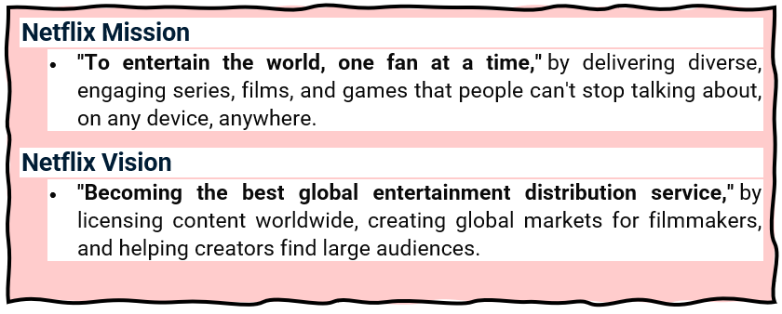

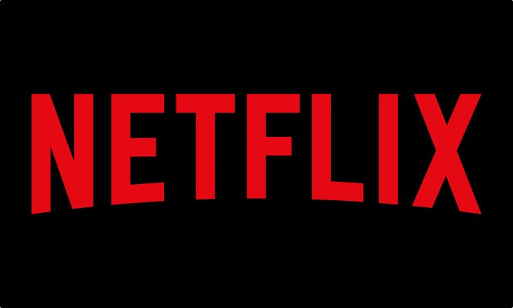
Figure 1: Netflix Logo
(Source: Netflix, 2025)

1.2 Netflix in the United Kingdom (Country A)
Netflix launched in United Kingdom in January 2012, which was a first big move outside the United States as the company opens the UK as a gateway market because of high penetration of broadband internet, UK has one of the matured digital markets (Netflix, Inc., 2019). The entry strategy included content localization, massive marketing, and partnerships with internet service providers in the U.K. to enable quick accessibility and visibility of the brand (Brown, 2024).
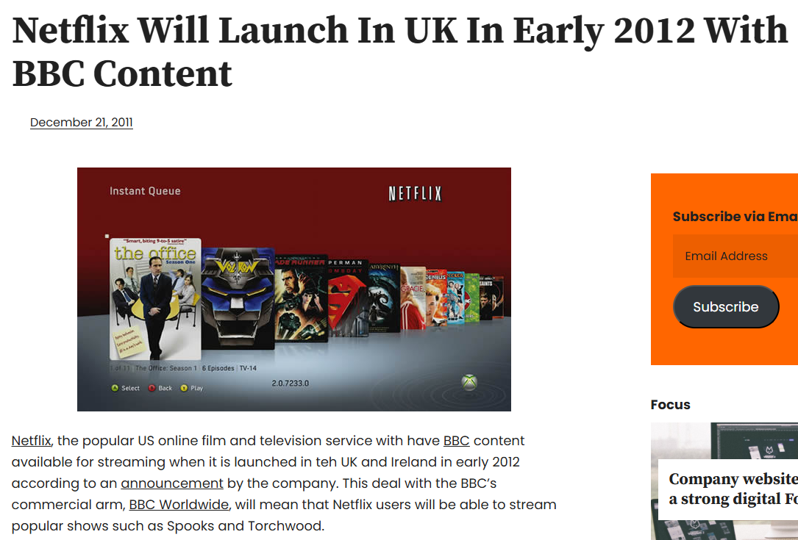
Figure 2: Netflix launch in the UK
(Source: Tim, 2011)
Due to an intention to establish its presence on the domestic creative sphere, Netflix was opening a production facility in Shepperton Studios in the United Kingdom in 2019, thus indicating its long-term interest in the sphere of producing narratives in the United Kingdom and training the local talents (Netflix, Inc., 2019). The company has significantly boosted its brand credibility with such projects as The Crown and Sex Education, at the same time, enhancing the creative economy of the United Kingdom and expanding its reach into the cultural sector of the global economy (Antunes, 2025).

Figure 3: Netflix UK Originals Portfolio
(Source: Miller et al., 2025)
Culturally, Netflix has harmonised its brand globally with the tastes of the British audience, with a focus on authentic drama and documentary-centric programming (Brown, 2024). By combining global production standards with native narratives Netflix has both established itself as a dominant market leader and a cooperative collaborator within the digital entertainment ecosystem in the United Kingdom (Nelsa et al., 2025).
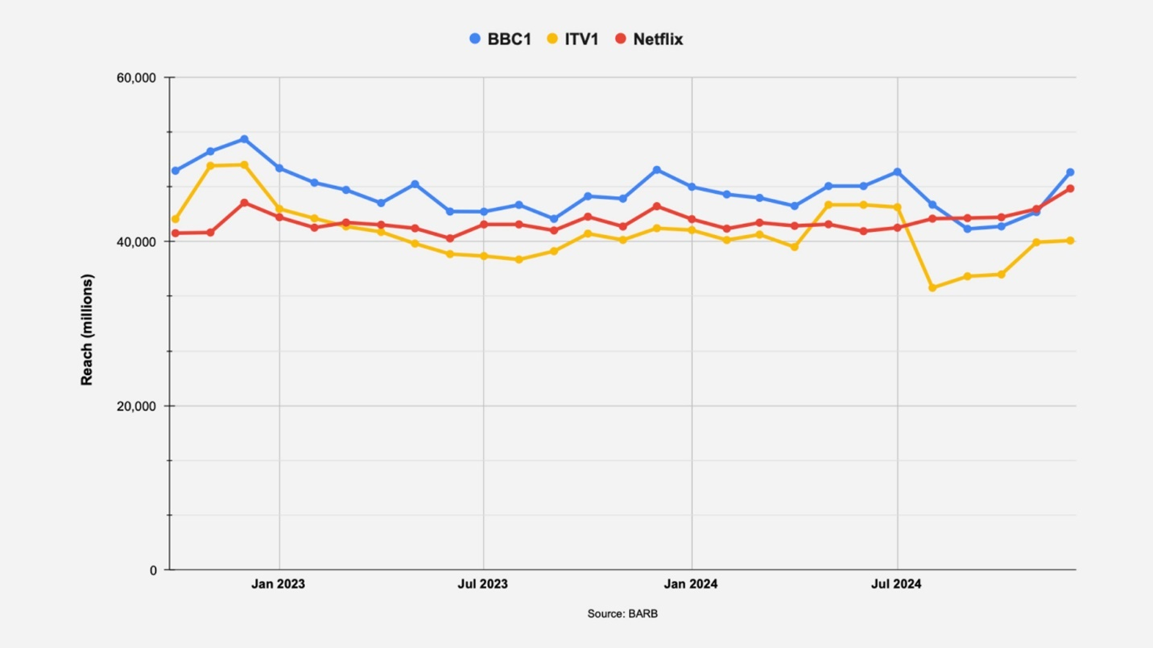
Figure 4: Netflix UK Viewing Trends
(Source: Brit Asia TV, 2025)

1.3 Netflix in India (Country B)
Netflix-moved into the Indian market in January 2016 as part of their overall expansion into Asia-Pacific, due to their motivation by Reed Hastings to capture the rapidly growing digital consumer base of India (Barraza, 2025). The firm came in independently and one of its claims to fame was being perceived as a premium OTT platform in a space that saw a lot of competition from Hotstar, Amazon Prime Video and even from localization of some of our local services such as Zee5, with a focus on cultural and linguistic localization (Elanjimattom, 2023).
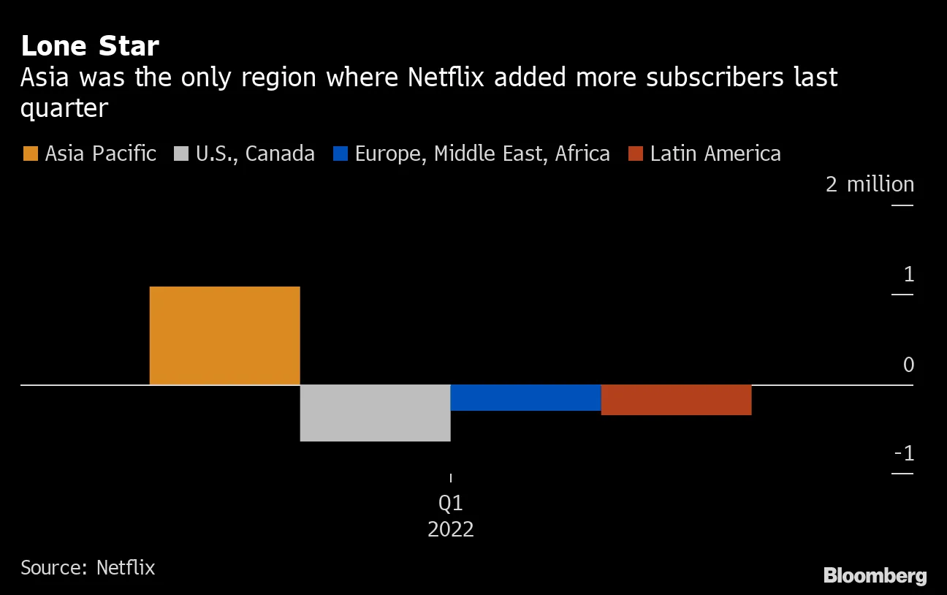
Figure 5: Asia-Pacific Subscriber Growth
(Source: Netflix, 2025)
To become more culturally relevant, Netflix has partnered with Indian producers and movie production companies to create its content in various languages, including Hindi, Tamil, and Telugu (Jain, 2025). The commercial success of the show in Sacred Games (2018) was an indication of the platform ability to portray Indian stories in the real life way; later shows, such as Delhi Crime and Lust Stories, would further establish the credibility of Netflix with the local creative industry (Barraza, 2025).
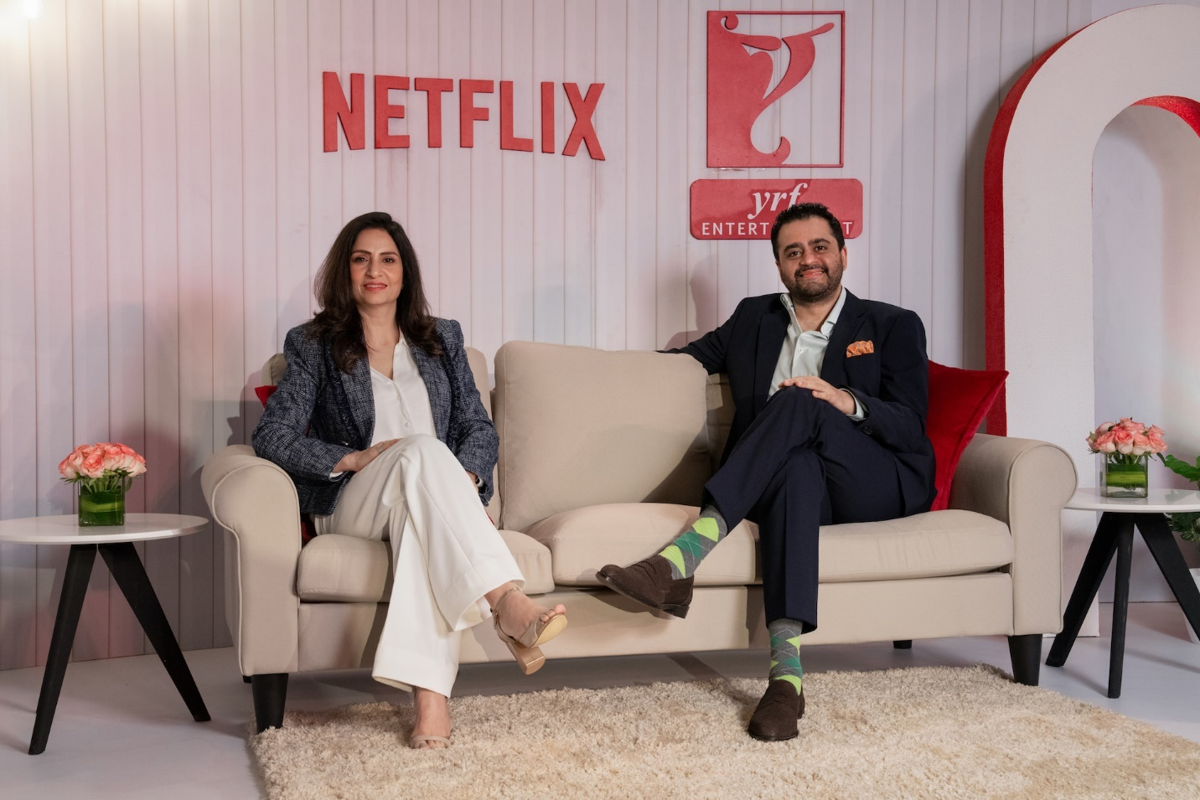
Figure 6: Netflix India Creative Partnerships
(Source: Netflix, 2025)
From a market adaption point of view, Netflix launched mobile-only and cheaper plans to target India's price sensitive and smartphone-oriented consumer base (Shekhar, 2025). This affordability driven strategy which, when coupled with strong local storytelling, allowed Netflix to align its global brand positioning with the cultural assimilation and accessibility of the Indian digital entertainment market (Elanjimattom, 2023, Jain 2025).
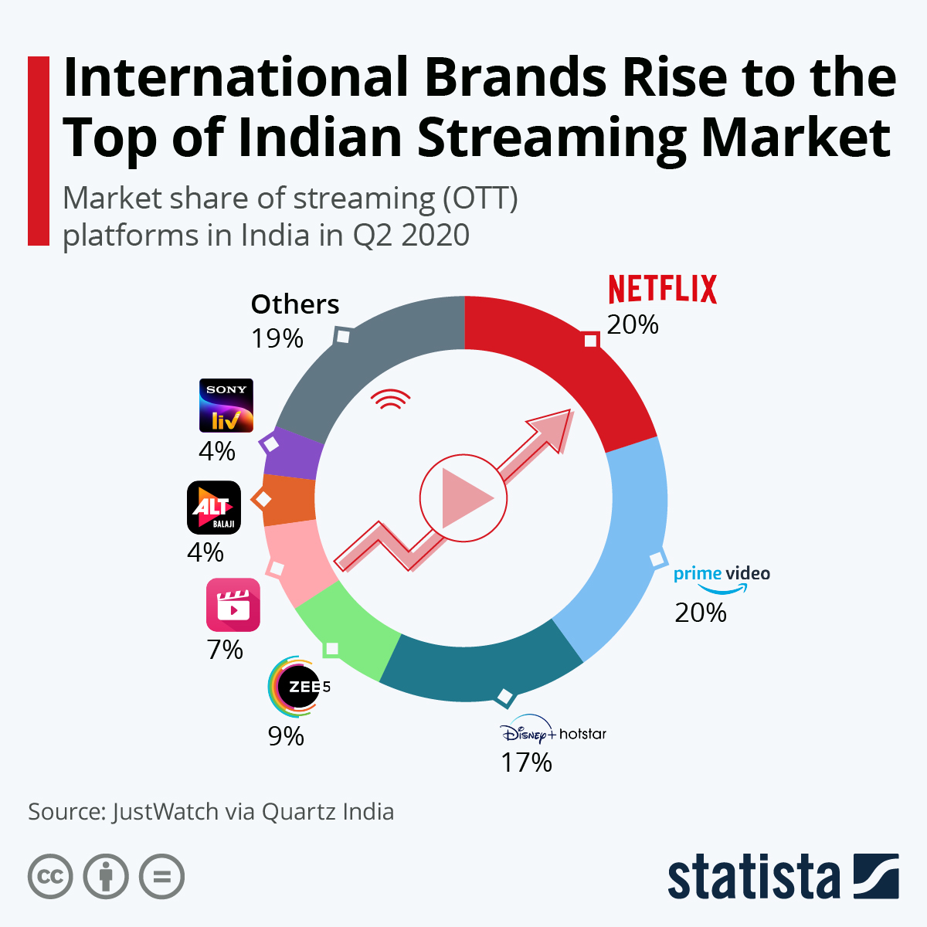
Figure 7: India Streaming Market Share
(Source: Buchholz, K., 2020)

2. The Macroenvironment (PESTLE) Analysis
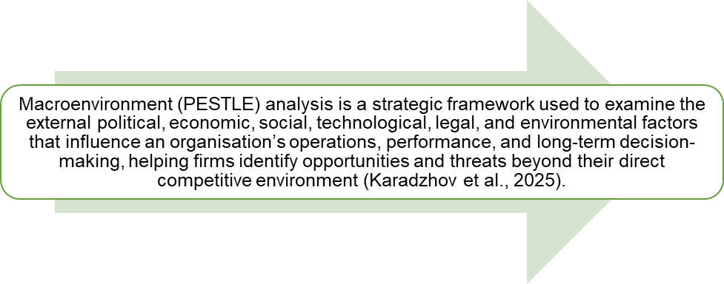
Figure 8: Definition of Macroenvironment (PESTLE) Analysis
(Created by learner)
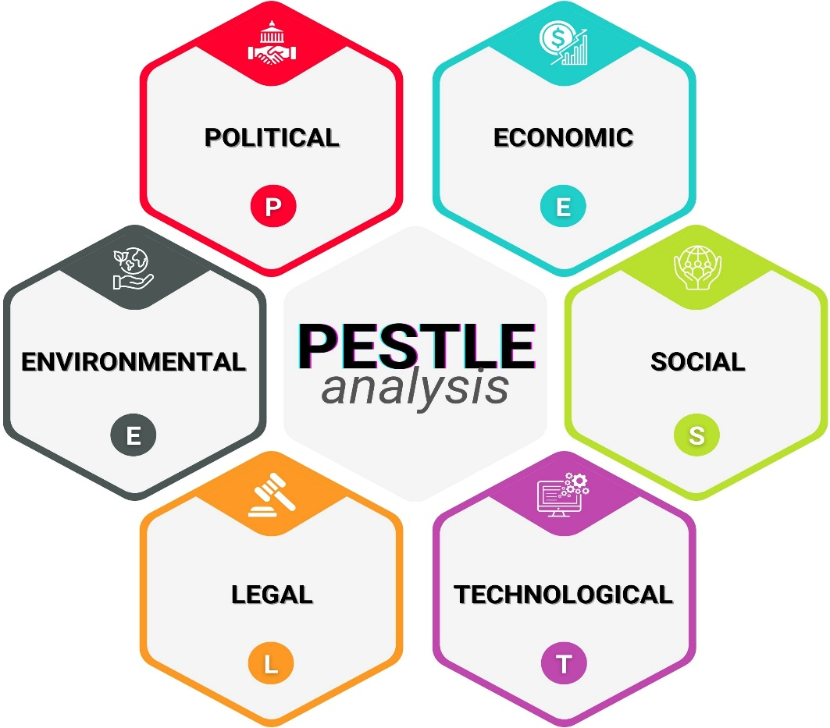
Figure 9: PESTLE Diagram
(Created by learner)
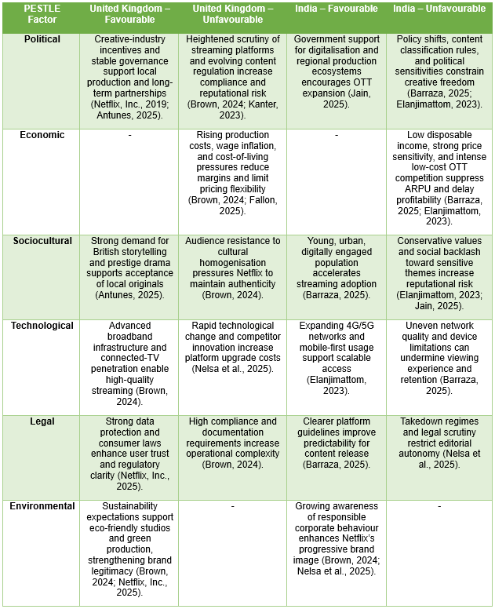
Figure 10: PESTLE For Netflix
(created by learner)

2.1 Political
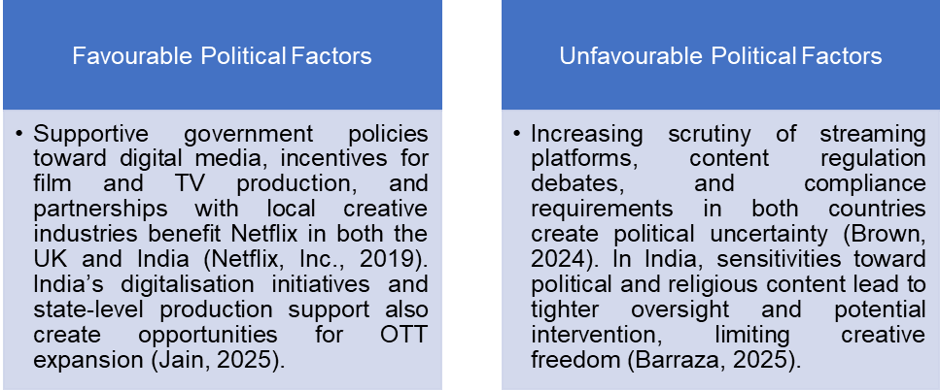
Figure 11: Political factors
(Created by learner)

2.1.1 United Kingdom
Creative-industry policy and film/TV incentives serve as the basis for local production and compete with Netflix's UK production hub and British-collaborating with local creators that are positive for pipeline reliability and cultural resonance (Netflix, Inc., 2019; Antunes, 2025).
At the same time, the development of broadcasting and the guidelines for online content, the public debate about the power of the platforms, and periodic audits of large technology companies can lead to an increased compliance and reputational cost that is unfavourable counterweight (Brown, 2024: Kanter, J., 2023).
Company stability at global scale, repeatable commissioning processes and matured public affairs capacity help in absorbing political variability (Netflix, Inc., 2025).
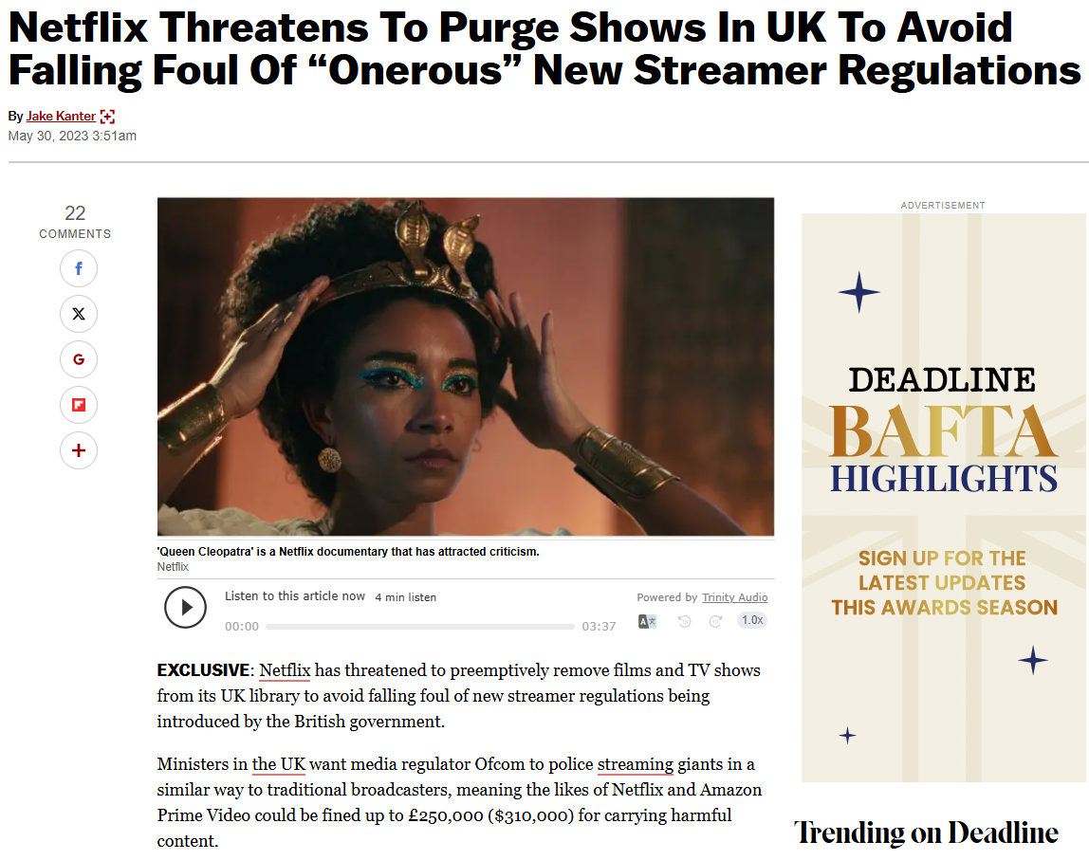
Figure 12: UK Streaming Regulation Scrutiny
(Source: Kanter, J., 2023)

2.1.2 India
The streamline services and the presence of streamlining as supported by the government and manufacture ecosystems at the state level provides an opportunity of growth and development into the streaming service industry and grants the prospects of the local content co-production (Jain, 2025). On the other hand, the changes in policy related to digital content, classification criteria, and sensitivities associated with social and political issues could limit narrative space, thus creating negative tension on original productions (Barraza, 2025; Elanjimattom, 2023). The operational history of Netflix in terms of format, language, editorial review allows stabilising execution where cases of increased scrutiny take place (Nelsa et al., 2025).
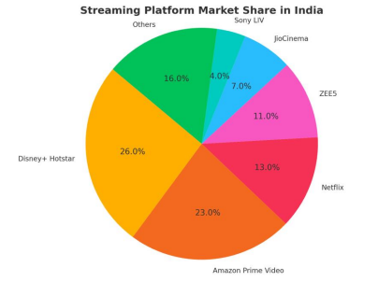
Figure 13: India Streaming Market Share
(Source: Barraza, C., 2025)

2.2 Economic
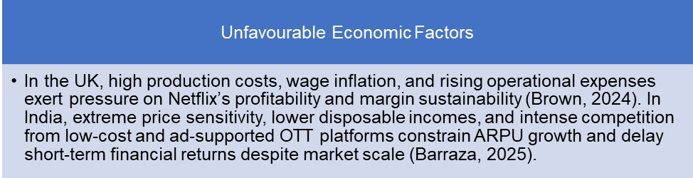
Figure 14: Economic Factors
(Created by learner)

2.2.1 United Kingdom
In the United Kingdom, Netflix addresses constantly rising costs of production, wage inflation and rising costs on energy and studio facilities, which take up on the operating costs and make the profit margins smaller. Widespread inflationary surroundings as well as broader pressures on costs of living further restrict the price demeanour bolster flexibility despite the comparatively robust incomes (Brown, 2024 Fallon, 2025).
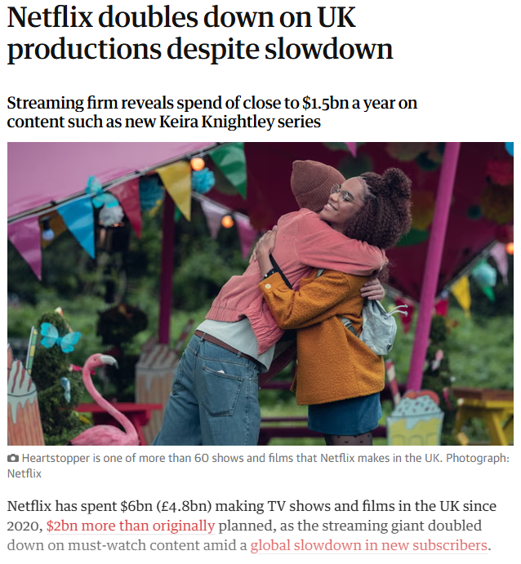
Figure 15: UK Production Cost Pressures
(Source: Sweney, M., 2023)

2.2.2 India
In India, the disadvantaged disposable incomes and significantly high levels of price sensitivity limit the ability of Netflix to earn high average revenue per user (ARPU) despite the anticipated economic growth. Pricing power is also further undermined by the presence of intense competition by low-cost and advertising-supported over-the-top (OTT) platforms. Furthermore, the high expenses of localization and content investment postpone short-term profitability and financial gains (Barraza, 2025; Elanjimattom, 2023).
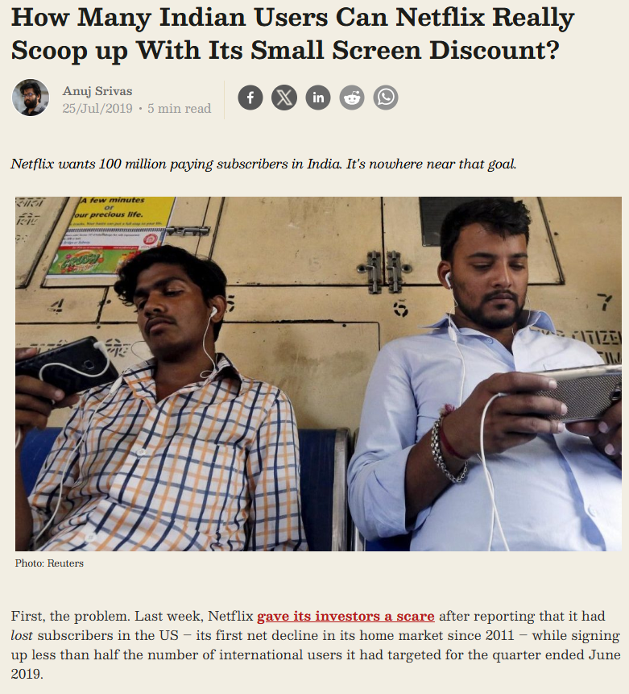
Figure 16: Mobile-First Price Sensitivity
(Source: Srivas, A., 2019)
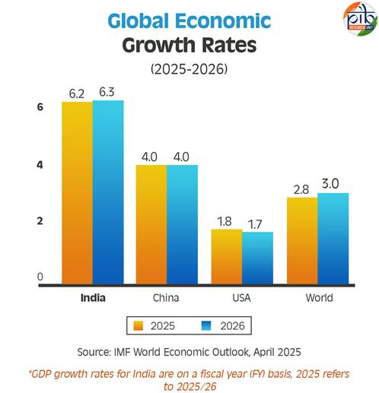
Figure 17: India’s Growth in Global Context
(Source: ABS News Service, 2025)
The chart shows India to be the fastest growing large economy with growth in gross domestic product at 6.2⁻ 6.3 per cent in 2025 and 2026, which is well above the world average of 2.8 to 3.0 per cent. Since the United Kingdom does not present in the data set, one cannot deduce a growth rate of this country and rather has to turn to other economic reports to do so.

2.3 Sociocultural
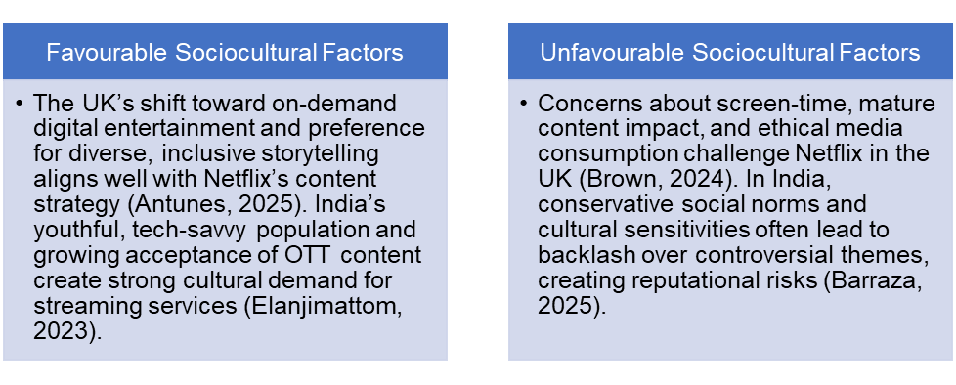
Figure 18: Sociocultural Factors
(Created by learner)

2.3.1 United Kingdom
Strong interest in British stories and prestige drama orient the viewers towards the production of series with the references to the local production that become valued internationally (Antunes, 2025). But national inclinations also demand authenticity and representation; therefore, the content which did not correspond to these expectations can be met with opposition and even an unfavourable risk profile (Brown, 2024). The fact that Netflix invests into the UK talent and culture-specific stories makes the platform fit the expectations of the audience, thus stabilising the market fit (Antunes, 2025).

Figure 19: UK Netflix Originals Showcase
(Source: Goldbart, M., 2024)

2.3.2 India
The situation of high language and geographical heterogeneity is more prone to rules out a multilingual slate and offer diversity in genres but simultaneously creates more complications when it comes to curation and promotional efforts, including positive dynamics, which include reach, and negative dynamics, which include fragmentation (Barraza, 2025). In addition, an example of programs whose production and promotion occurs locally, like Sacred Games and Delhi Crime, depict how culturally specific layers and regional interfaces can ease the process of maintaining interest among heterogeneous groups (Jain, 2025; Elanjimattom, 2023; Thomas et al., 2021).
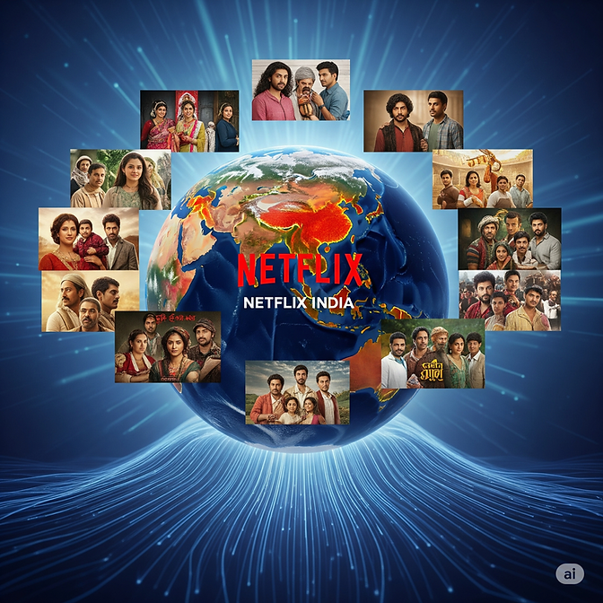
Figure 20: Netflix India Local Originals
(Source: Srivas, A., 2019)

2.3.2 Social Factors: Changing Trends
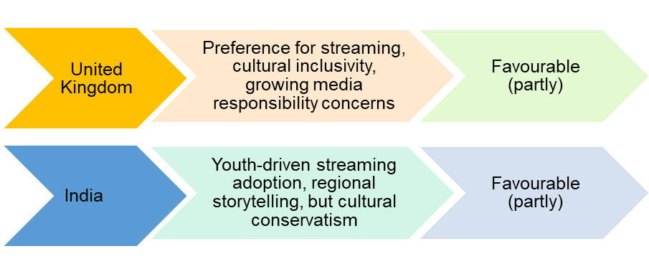
Figure 21: Sociocultural (Social) Factors
(Created by learner)

2.3.2.1 United Kingdom
Within the United Kingdom, the sociocultural trends are more in favour of Netflix as consumer trends lean more toward streaming, binge-watching, and on-demand consumption to replace conventional broadcast media (Brown, 2024). The need to tell good, non-implied British stories has helped the success of homegrown productions, adding to the trust in corporate brands. However, the concerns about screen time, content ethics and youthful exposure create a moderate level of social responsibility pressures (Antunes, 2025; Brown, 2024).
The overall social trend in the United Kingdom is a good one, albeit with some moderate risks in terms of social responsibility.

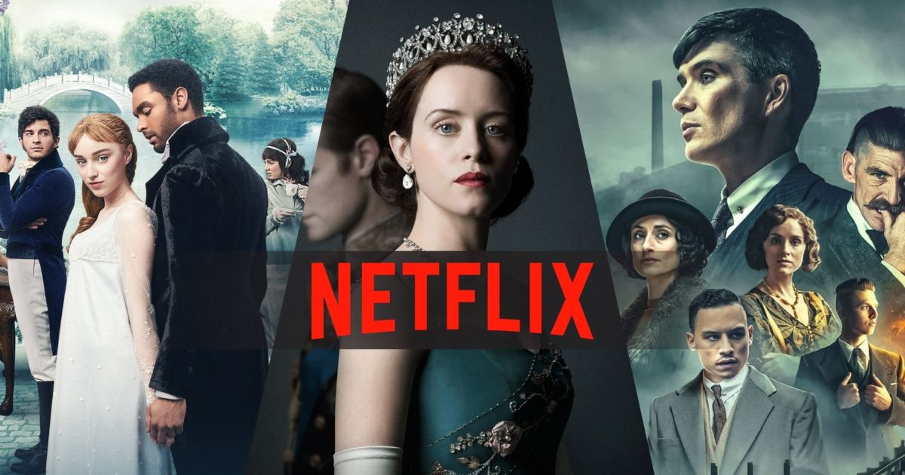
Figure 22: Netflix British storytelling
(Source: Greenwood, J., 2023)

2.3.2.2 India
The growing shopping population in India due to its youth, urbanisation and high levels of digitalisation has boosted the adoption rate of streaming platforms, thus creating an overwhelmingly favourable social environment that Netflix is most likely to thrive (Barraza, 2025). This growth is supported by the strong demand of culturally and linguistically localised content but sometimes it leads to the backlash and examination hence requiring careful cultural adaptation (Elanjimattom, 2023; Jain, 2025).
The general tendency in Indian society is positive; nevertheless, attentiveness to the cultural peculiarities is a problematic question.
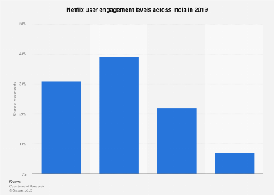
Figure 23: Netflix India User Engagement
(Source: Statista Research Department, 2019)

2.3.3 Cultural Factors

2.3.3.1 Hofstede Model
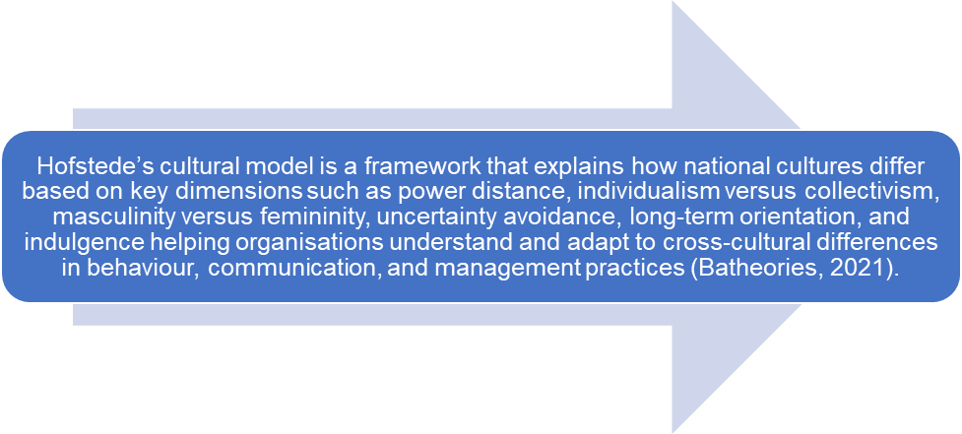
Figure 24: Hofstede’s cultural model definition
(Created by learner)
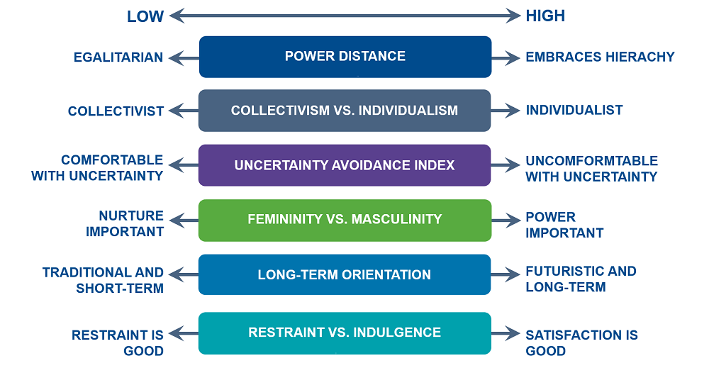
Figure 25: Hofstede Model
(Source: Batheories, 2021)

2.3.3.2 Advantages and Disadvantages of the Hosted Model
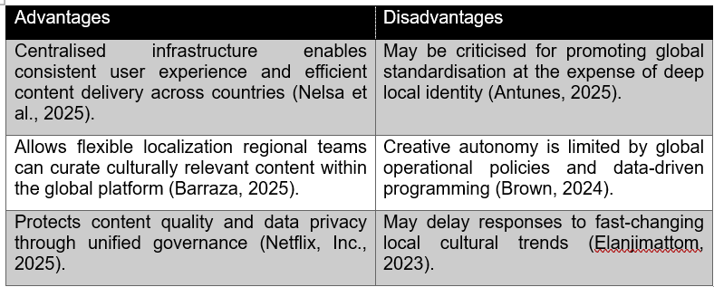
Table 2: Advantages and Disadvantages of the Hosted Model
(Created by learner)

2.3.3.4 Hofstede Analysis
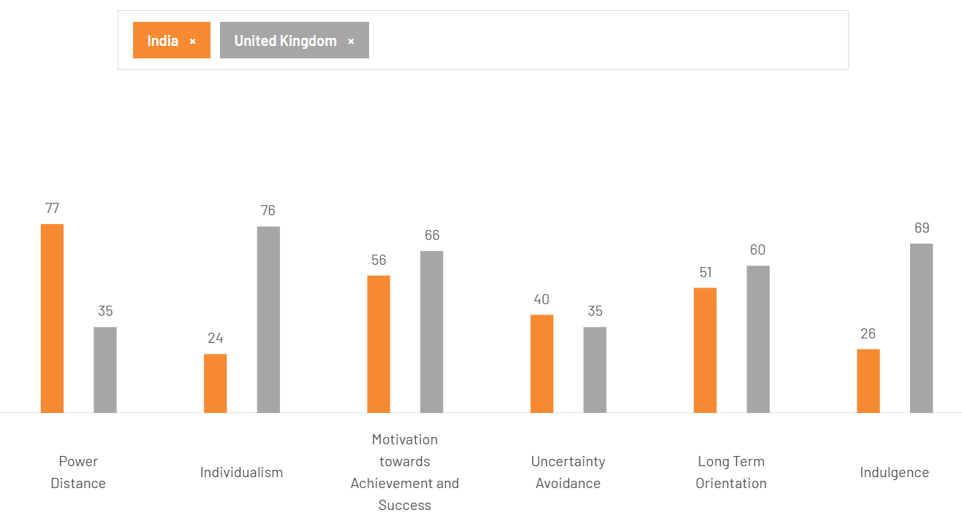
Figure 26: Hofstede Model
(Created by learner)
Hofstede's cross-cultural measures are used to show strong cultural differences that affect the consumer behaviour in India and the United Kingdom. The power distance index 77 for India is high compared to 35 for the United Kingdom, which denotes a societal acceptance of a hierarchy rather than equality and more individual autonomy (Hofstede Insights, 2025).
The extreme individualism in the United Kingdom with a score of 76 is contrasted by the collectivism of India with a score of 24. Consequently, Netflix has sought to tailor their content strategies so that they foreground personalisation of autonomous viewing journeys in the UK, whilst focussing on family or community orientated narratives for their Indian audience (Antunes, 2025).
India's relative low indulgence score of 26 is indicative of restrained consumption patterns, while that for the United Kingdom at 69 is indicative of a preference for entertainment driven behaviour. These varying levels of indulgences have an impact on the types of media offerings that are popular within each market.
Further shades of differences in dimensions of uncertainty avoidance and long-term orientation serve to strengthen different content preferences and communication styles, informing the ways of developing media messaging and how it is understood in the two contexts (Barraza, 2025).

2.3.3.5 United Kingdom Cultural Factors
The British culture appreciates authentic storytelling, social realism and local experience-based humour hence providing a favourable environment to the Netflix originals in the UK that embodies the national identity and diversity (Antunes, 2025). However, viewers are still sceptical of cultural homogenisation, which compares Netflix to public television negatively, as this kind of pressure puts it under strain to deliver credibility at the local level. In general, the cultural environment is mostly positive, and the perceived cultural dilution has moderate risks (Brown, 2024; Nelsa et al., 2025).
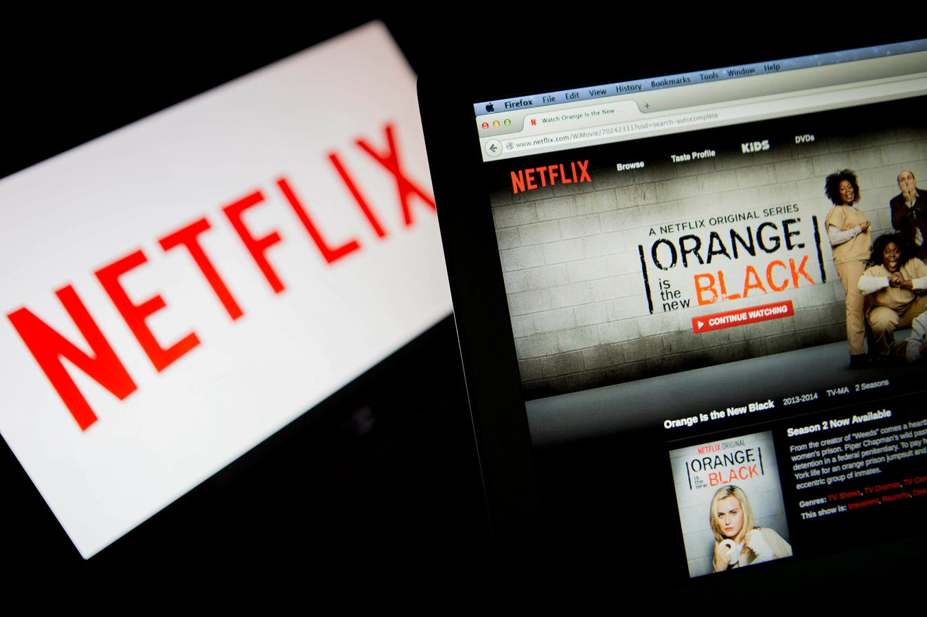
Overall cultural impact in the UK: largely favourable, with moderate risk of cultural dilution.
Figure 27: Netflix UK Cultural Identity
(Source: Goldbart, M., 2024)

2.3.3.6 India Cultural Factors
The culturally diverse and multilingual society of India offers Netflix with enormous opportunities to create regionally relevant content that will tend to appeal to the local and global audiences like the example of Sacred games and Delhi Crime (Jain, 2025; Barraza, 2025). However, the dominance of conservative social values and an intensified number of sensitivities in relation to religion, sexuality, and politics inhibit creativity and increase reputational risk, which requires a careful cultural adjustment. To this end, the cultural environment, in general, is quite accommodating, but highly sensitive to the old-fashioned standards (Elanjimattom, 2023; Brown, 2024).
All-cultural influence in India: positive but delicate towards the traditional norms.
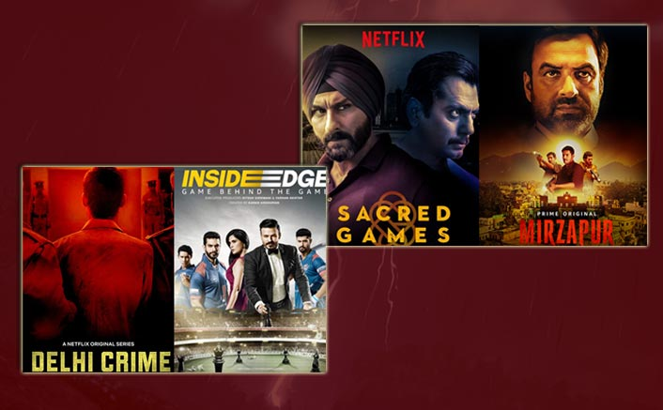
Figure 28: Netflix India Originals
(Source: Punwani, U., 2020)

2.3.3.7 Similarities and Differences of Cultural Factors between the UK and India
Aspect | Similarity | Difference | Favourable Status
Cultural Emphasis | Both markets value storytelling authenticity and local representation (Antunes, 2025; Barraza, 2025). | UK prioritises realism and satire; India focuses on emotional and moral narratives. | Favourable
Content Adaptation | Local originals enhance brand acceptance in both countries. | India requires multi-language production; UK emphasises social inclusivity. | Favourable
Cultural Constraints | Growing debates on cultural influence of global media. | India faces stronger moral and political censorship pressures than the UK. | UK – favourable; India – partly favourable
Audience Response | Appreciation for global-quality local stories. | British audiences prefer subtle cultural expression; Indian audiences favour bold, emotive plots. | Favourable
Table 3: Similarities and Differences between the UK and India
(Created by learner)

2.4 Technological
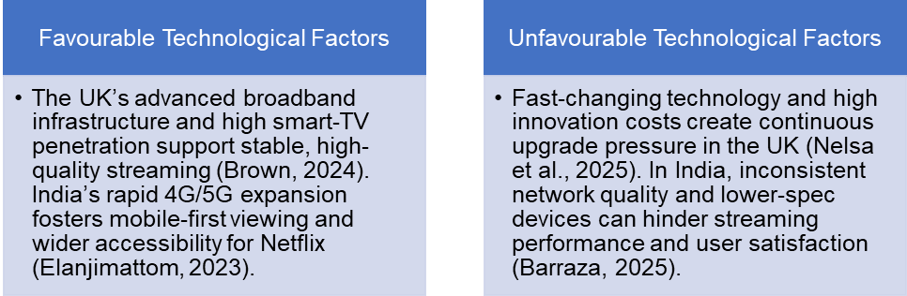
Figure 29: Technological Factors
(Created by learner)

2.4.1 United Kingdom
The unlimited broadband power, the widespread use of connected TV, and the introduction of good post-production facilities all facilitate the credibly high-quality streaming and high-quality production (Brown, 2024). Nevertheless, the high in rate of the development of devices and operating systems, along with innovation by the competitors, will require continuous upgrades of the platforms, and this can be counterproductive in terms of price and complexity (Nelsa et al., 2025). Platform engineering and content-supplies orchestration ensures stability by using the tooling and data-driven operations in Netflix (Thompson, 2024; Nelsa et al., 2025).
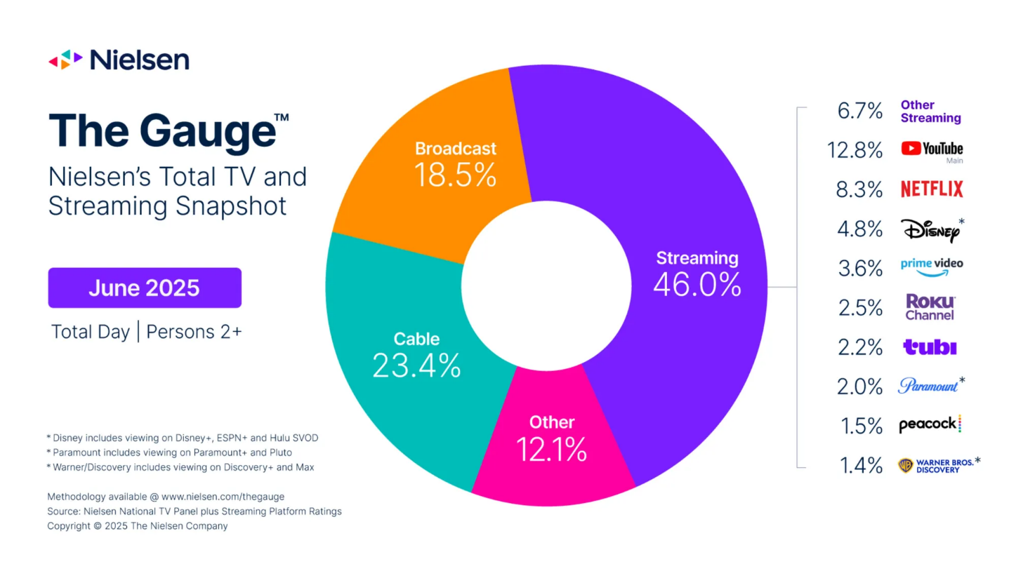
Figure 30: UK Streaming Technology Landscape
(Source: Nielsen, 2025)

2.4.2 India
The growth of 4G and 5G network coupled with a culture of mobile-first viewers and application drive the adoption of on-the-go viewing and the implementation of short onboarding funnels (Elanjimattom, 2023). Nevertheless, quality of network and device level can affect the quality of experience (QoE) in a way that affects the user's retention in a negative manner (Barraza, 2025). Techniques such as adaptive streaming, offline download capabilities and mobile-optimised subscription plans act to stabilise user engagement even in the face of infrastructural variability (Nelsa et al., 2025).
Figure 31: India OTT Market Fragmentation
(Source: Jaze Networks, 2024)

2.5 Legal
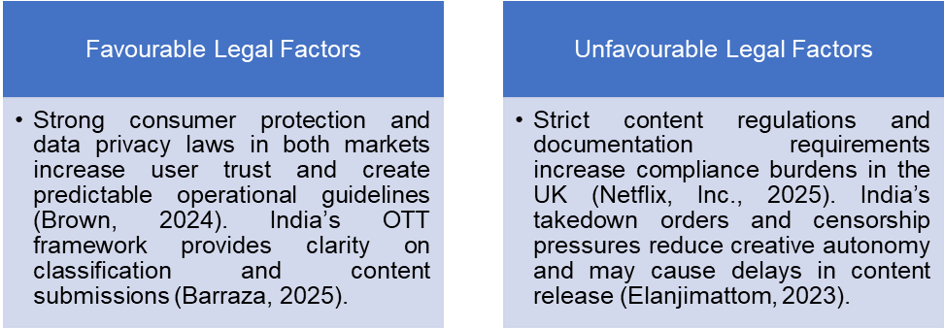
Figure 32: Legal Factors
(Created by learner)

2.5.1 United Kingdom
Related to the advancement of trust and encouraging of predictable regulatory frameworks, but equally adding compliance burdens and documentation requirements, the data protection, consumer law and content standards have both positive and negative outcomes (Brown, 2024). The legal stability of Netflix is based on its governance, disclosure practices, which have been developed during its international operations (Netflix, Inc., 2025).

Figure 33: UK Data Protection Law
(Source: Ardent Privacy, 2024)

2.5.2 India
Guidelines of the platform, the certification and takedown regimes lead to a greater clarity of purpose but limits the creative freedom in favour of predictability at the cost of editorial risk (Barraza, 2025). The internal cheque-up procedures and collaboration with local lawyers also lead to better stabilisation of the commissioning deadlines (Nelsa et al., 2025).

2.6 Environmental
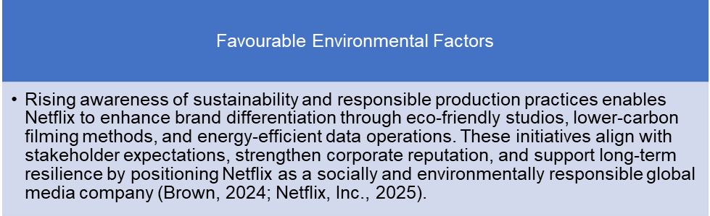
Figure 34: Environmental Factors
(Created by learner)

2.6.1 United Kingdom
In the United Kingdom, the growing focus on sustainable media production supports Netflix's efforts to develop eco-friendly studios and environmental filming practices and therefore maintain brand reputation and stakeholder confidence. Ranging in accordance with national models of sustainability and being environmentally accountable adds legitimacy to Netflix and contributes to long-term operational resilience within a mature, regulation-aware marketplace (Brown, 2024; Netflix, Inc., 2025).

2.6.2 India
In India, a growing awareness of sustainability and responsible corporate actions provides Netflix with the chance to build its image as a forward-thinking global brand, which it can do through things like having energy-efficient digital operations and environmentally conscious production processes. These measures strengthen positive perceptions from stakeholders and are aligned with current expectations of responsible growth combined with the growth of India's digital economy in the parallel fashion (Brown, 2024; Nelsa et al., 2025).

2.7 Similarities and Differences between the UK and India Across the PESTLE Dimensions
PESTLE Aspect | Similarities | Differences (UK vs India) | Favourable / Unfavourable Outcome
Political | Both countries offer government support for digital media and local production partnerships. Both experience increasing scrutiny of OTT platforms. | UK has stable regulatory frameworks but rising scrutiny around big tech; India has stronger political/religious sensitivities and stricter oversight on content. | UK – mostly favourable with compliance risks; India – mixed due to political sensitivities and censorship pressures.
Economic | Both markets provide opportunities for growth through digital entertainment and expanding streaming adoption. | UK: high income, high ARPU, but high production costs. India: large audience, fast growth, but strong price sensitivity and lower ARPU. | UK – favourable but costly; India – favourable growth but constrained returns.
Sociocultural | Both audiences value culturally authentic content and appreciate local storytelling. Growing concerns over media influence exist in both markets. | UK prefers realistic, socially inclusive narratives; India favours emotive, multi-language, culturally rooted storytelling but faces stronger conservative backlash risks. | UK – favourable with social responsibility concerns; India – favourable with cultural sensitivity challenges.
Cultural (Hofstede) | Both countries require culturally adapted content for audience resonance. Local originals succeed in both markets. | UK: individualistic, low PDI, high indulgence → supports creative freedom. India: collectivist, high PDI, low indulgence → requires culturally cautious storytelling. | UK – highly favourable; India – favourable but with creative constraints.
Technological | Both countries benefit from expanding broadband/telecom infrastructures and increased device adoption. | UK: strong fibre network and high smart-TV penetration. India: mobile-first market with variable network quality and lower-spec devices. | UK – favourable; India – favourable but constrained by QoE variability.
Legal | Strong consumer protection and data governance frameworks enhance trust in both markets. | UK: strict documentation and content standards. India: takedown orders, classification norms, and censorship pressures. | UK – favourable but administratively heavy; India – mixed with higher creative risk.
Environmental | Sustainability expectations rising in both countries; both markets reward eco-friendly production. | Environmental compliance more predictable in UK; India’s varied locations may pose logistical sustainability challenges. | Both – favourable long term but with higher short-term operational costs.
Table 4: Similarities and Differences between the UK and India Across the PESTLE Dimensions
(Created by learner)

3. Comparison of Netflix’s STP Strategies in the United Kingdom and India
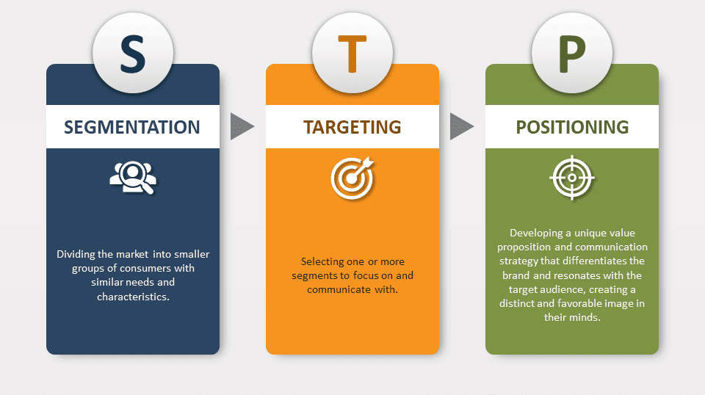
Figure 35: STP Strategies
(Source: PresentationGo, 2025)

3.1 Segmentation Strategies

3.1.1 United Kingdom
Netflix's segmentation strategy in the United Kingdom mainly draws from demographic factors and psychographic factors, emphasizing the millennial consumers who are technologically savvy, Generation Z consumers, and households that are currently equipped with multiple gadgets, all of which favour convenience and originality (Thomas & George, 2021).
The predilections of British audiences for high-quality storytelling, authentic portrayals, and the underrepresentation of minority groups inform Netflix's content development choices and result in the production of local dramas, comedies, and documentaries with national sensibilities (Antunes, 2025).
Segmentation is further educated by watching habits: urban viewers are inclined to want drama and satire and audience that were a family unit and older age groups are more attracted to documentary and period pieces (Brown, 2024).
Such diversification of segmentation is helpful in maintaining the engagement of different generational and lifestyle cohorts.

3.1.2 India
In India, Netflix will operate according to a geo-demographic and cultural segmentation model, which reflects the geographical diversity and multi of the country (Barraza, 2025). The platform profiles its audience based on language, the geographic area, and income level, where the focus on young urban professionals and users who are mobile based dominates (Elanjimattom, 2023). Netflix is psychographically focused on inspirational consumers that want to receive entertainment with global standards and, also, appreciate culturally oriented stories. Such a complex segmentation helps the company create regionally specific content plans, such as the implementation of Hindi, Tamil, and Telugu originals aimed at satisfying various preferences of the different viewer groups (Jain, 2025).

3.1.3 VALS-2 Personality Types
Psychographic segmentation can be used more specifically using the VALS-2 framework (Values and Lifestyles), which categorises consumers into different segments depending on their resources and general motivations (e.g. Innovators, Thinkers, Achievers, Experiencers, Strivers, Makers, and Survivors) (Thomas and George 2021). Concerning Netflix in the United Kingdom, the Innovators and Experiencers are key segments: Innovators are high - resource, sophisticated viewers who are drawn to prestige originals and cutting-edge formats, while Experiencers are younger, entertainment-seeking patrons who participate in trend-driven series and social-media conversations (Thomas and George, 2021). Achievers are also a significant group of people, seeing Netflix as a convenient way to relax while fitting everyday professional lives (Brown, 2024).
Analysing the Indian context, VALS-2 segments like Strivers and Makers are especially relevant for price sensitive, aspirational audiences who subscribe to Netflix's mobile-only or lower-tier plans and get attracted to hardcore emotionally rich, culturally resonant local content (Barraza, 2025). Experiencers and Innovators in metropolitan areas are drawn to global hits and wild originals, and this brings Netflix close to a modern and cosmopolitan identity (Jain, 2025). By matching the content themes, pricing levels and promotional messages to these VALS-2 personality types, Netflix optimises its STP strategy beyond general demographic categories and targets more accurately in both the United Kingdom and Indian markets (Thomas and George, 2021; Xiao, 2023).
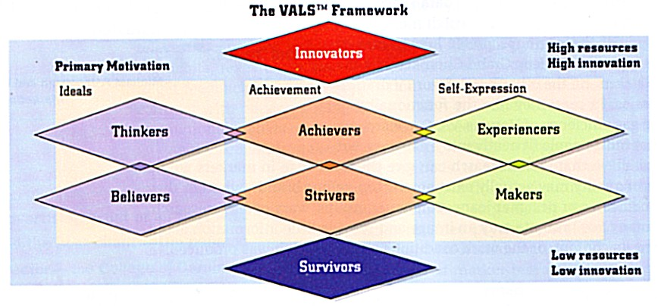
Figure 36: VALS-2 Personality Types
(Source: Sharma, S., 2024)

3.1.4 Segmentation Strategies for Netflix in the UK and India
Segmentation Variable | United Kingdom (Country A) | India (Country B)
Demographic Segmentation | • Targets millennials, Gen Z, and middle- to high-income households.  • Appeals to urban professionals, families, and multicultural audiences.  • Strong focus on 18–45 age groups with high digital adoption. | • Targets young urban professionals, students, and mobile-first users.  • Appeals to middle-income and aspirational consumers across regional markets.  • Multiple linguistic groups (Hindi, Tamil, Telugu, Malayalam, Bengali).
Geographic Segmentation | • Focus on metropolitan areas (London, Manchester, Birmingham).  • High broadband penetration enables access through smart TVs and multi-device households.  • Regional storytelling for England, Scotland, Wales, and Northern Ireland. | • Strong focus on Tier 1 and Tier 2 cities (Mumbai, Delhi, Bangalore).  • Mobile-first approach for semi-urban regions.  • Local-language content designed for specific states (Maharashtra, Tamil Nadu, Kerala, Punjab).
Psychographic Segmentation | • Targets audiences seeking premium content, diversity, realism, and artistic storytelling.  • Appeal to socially conscious viewers interested in inclusivity and global narratives.  • Attracts binge-watchers and innovation-oriented digital users. | • Appeals to value-conscious, entertainment-driven, and culturally rooted audiences.  • Targets aspirational consumers seeking modern, global-quality content with local relevance.  • Strong appeal among emotional, family-oriented, and tradition-influenced segments.
Behavioural Segmentation | • Heavy users who prefer binge-watching and multi-episode series.  • Loyalty driven by personalised recommendations and high-quality originals.  • Favour genres like drama, documentary, thriller, and comedy. | • Frequent mobile viewers consuming short-form and long-form content.  • Subscription decisions driven by affordability and content relevance.  • Favour genres like crime, romance, family drama, mythology, and regional cinema.
Cultural Segmentation | • Focus on British storytelling, diversity, and social realism.  • Content reflects inclusivity, humour, and relatable local narratives. | • Multi-cultural segmentation reflecting India’s linguistic, religious, and regional diversity.  • Deep localisation with multilingual content and culturally sensitive themes.
Table 5: Segmentation Strategies for Netflix in the UK and India
(Created by learner)

3.2 Targeting Strategies
Figure 37: Differentiated and Undifferentiated Targeting Strategies – Netflix
(Created by learner)

3.2.1 United Kingdom
Netflix uses mass targeting in the United Kingdom with a broad approach, based on algorithmic personalisation. The brand is appealing to audiences valuing digital convenience and content variety as well as having appreciable resonance in the younger age group of 18–45-year-olds (Brown, 2024).
Positive partnerships with UK production companies and talent also contribute in strengthening brand loyalty by merging local authenticity with worldwide storytelling (Antunes, 2025).
Through the combination of personalization algorithms and localized recommendation systems, Netflix helps ensure that users get the content that is congruent with their content viewing behaviour and thus benefits loyalty and retention (Nelsa etäuft, 2025).

3.2.2 India
Netflix has been employing a selective niche-targeting approach in the Indian environment that focuses on elevated and culturally involved consumer segments found in urban places of residence and Tier 1 cities (Barraza, 2025). The company has faced a price-sensitive market and needed to attract younger consumers to boost its subscriber base by launching mobile-only and low-cost subscriptions targeting the younger demographic and (mostly) digital natives (Shekhar, 2025). Cooperation with local filmmakers and studios is a way Netflix focuses on the local audiences by providing stories that can be related to, are regionally attractive, and are emotionally targeted. This kind of targeted discussion has helped Netflix to stand out in the Indian competitive over-the-top (OTT) content market that is mostly dominated by Hotstar and Amazon Prime (Elanjimattom, 2023).

3.3 Positioning Strategies
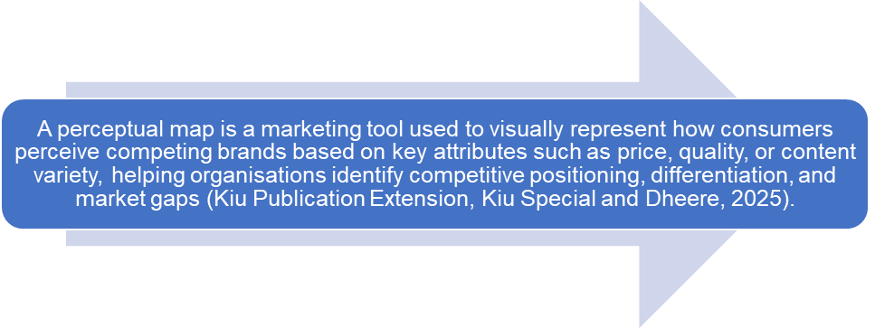
Figure 38: Definition of Perceptual map
(Created by learner)
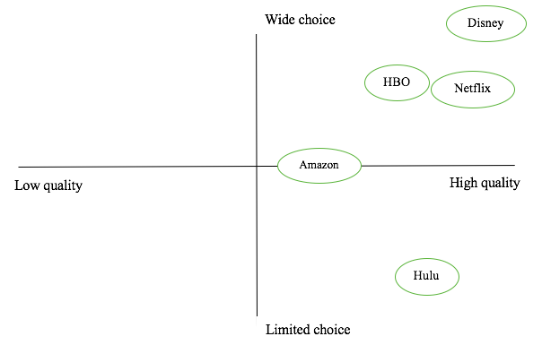
Figure 39: Perceptual map for Netflix
(Created by learner)
The positioning map shows that Netflix, Disney and HBO are in the high quality, wide choice quadrant, and this therefore represents a strong diversity of content and high-quality production values. Amazon is in the middle of the quality/range of choice category, which is a relatively mixed content depth. Hulu is located at the high end in terms of quality but low in terms of choice, meaning a considerable investment in original content but a comparatively lower content pool when compared to the main rivals.

3.3.1 United Kingdom
Netflix uniquely markets itself in the United Kingdom as a luxury entertainment centre with innovative, diverse and award-winning content that is attributable to world excellence and creativity (British) (Antunes, 2025). The UK positioning of Made in the UK, Watched Worldwide campaigns are enforcing the idea that it is a local content provider as well as a global trendsetter. Inclusivity and creative collaboration make the brand image of the facilitator of British talent and cultural expression better (Brown, 2024). Therefore, Netflix positioning in the UK reflects a sense of pretence, availability, and social content amongst a well-established digital ecosystem.

3.3.2 India
The positioning of Netflix in India combines both global and domestic relevance and follows a policy of local appeal to the cultural authenticity and appeal to emotions (Barraza, 2025). Netflix seems to position itself as an entity capable of embracing regional diversity and maintaining standards of global storytelling by making Indian originals like Sacred, or Delhi, Crime (Jain, 2025). Its positioning message, which is based on the aspirational consumption and the freedom of creativity, targets the audiences who identify with Netflix as an embodiment of modernity and the sophistication (Elanjimattom, 2023). However, the way to harmonise cultural sensitivity and bold content subjects is still a pressing issue to positioning sustainability.

3.4 Comparison of Netflix’s STP Strategies - United Kingdom vs India
Table 6: Comparison of Netflix’s STP Strategies - United Kingdom vs India
(Created by learner)

4. Comparison of Netflix’s Marketing Mix Strategies in the UK and India
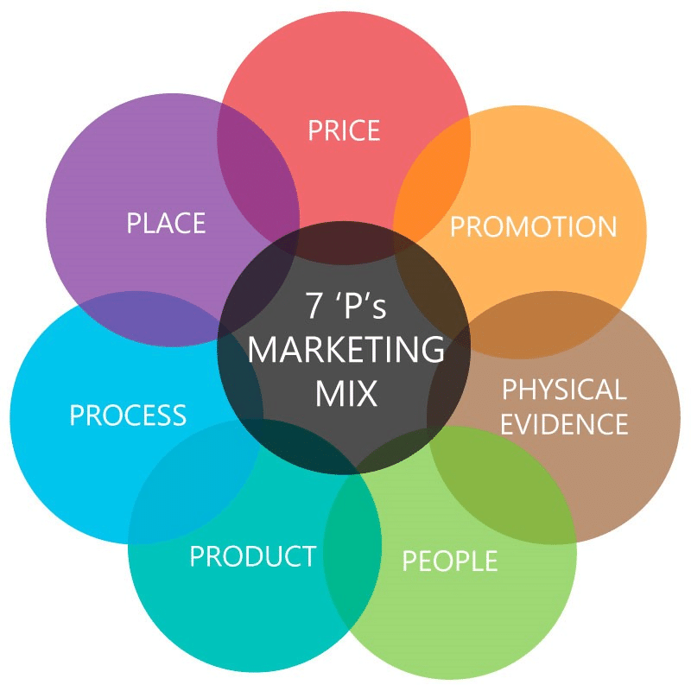
Figure 40: Marketing mix 7ps
(Source: Nguyen, H., 2018)

4.1 Product
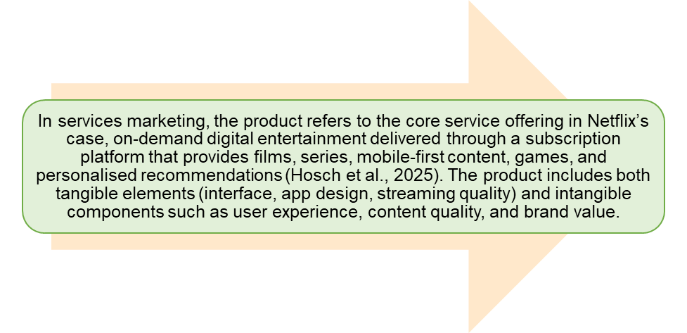
Figure 41: Product Definition
(Created by learner)

4.1.1 United Kingdom
In the United Kingdom, Netflix's product is concerned with high-quality culturally resonant storytelling, production values and a catalogue that incorporates British follows, while also including global franchises. Localised content such as The Crown and Sex Education falls in line with the UK audience's fondness for realism, social depth and diversity (Antunes, 2025). The UK product strategy also benefits from the good broadband infrastructure and smart TV penetration of the country; thus, improving the quality of delivery and supporting the premium expectations (Brown, 2024). As a result the characteristics of the UK product include cinematic production standards, local commissioning and seamless viewing experiences.
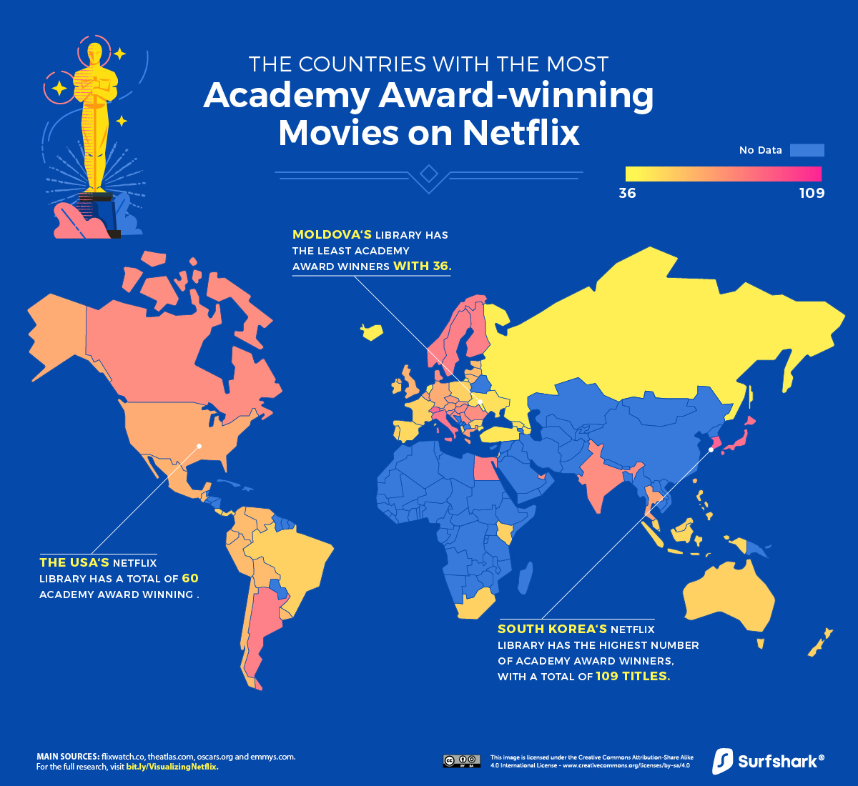
Figure 42: UK Global Award-Winning Content
(Source: Surfshark, 2025)

4.1.2 India
Netflix adapts the platform in the Indian context to a mobile-first, multilingual platform. The service is focusing on diversity in the area by including content in Hindi, Tamil, Telugu, Malayalam, and Bengali, but at the same time incorporates global franchises (Jain, 2025). Indian films, including such titles as *Delhi Crime and Sacred Games are examples of how thematic content, the selection of cast, or the plot is shaped to fit into the existing culture (Barraza, 2025). Besides, the system is designed to serve heterogeneous bandwidth conditions using adaptive streaming, offline downloads, and mobile-only levels of subscriptions, thus making the services accessible to a wide range of devices and network structures (Nelsa et al., 2025).
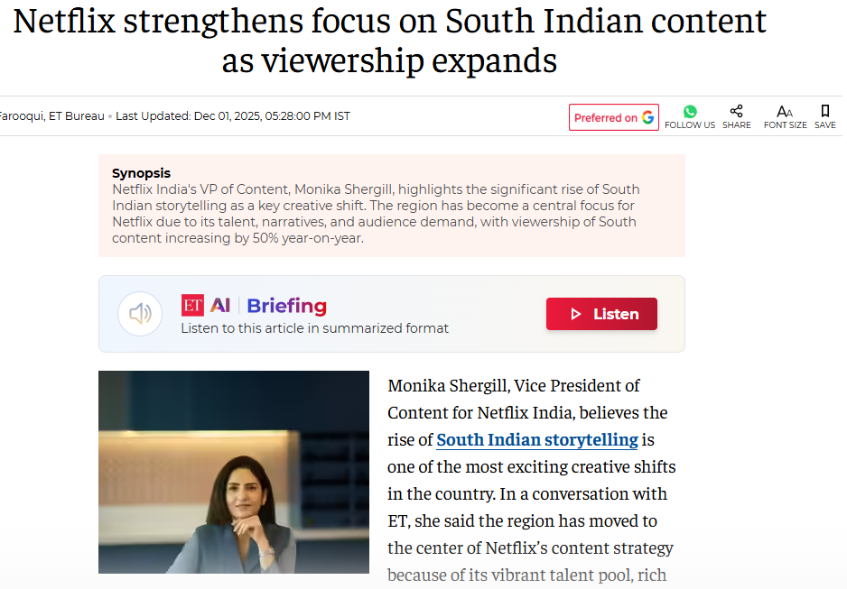
Figure 43: Netflix India Regional Focus
(Source: Farooqui, J., 2025)

4.1.3 Product Variety, Depth & Width
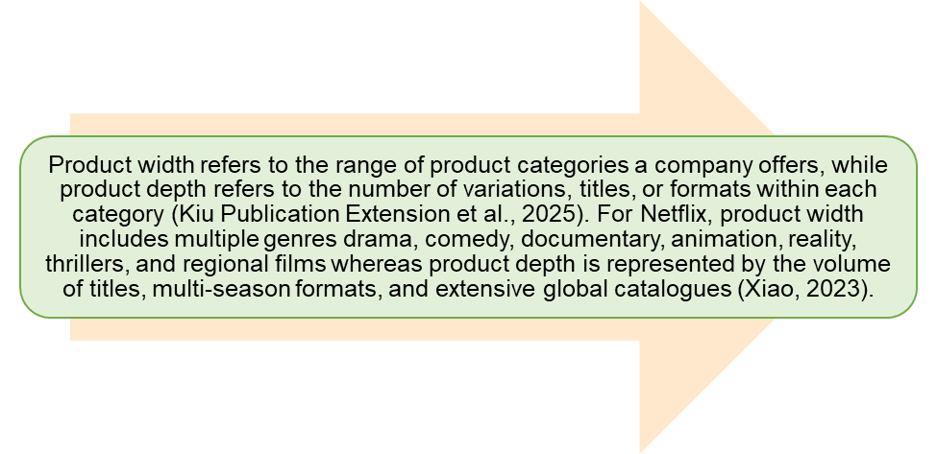
Figure 44: Product Variety, Depth & Width Definition
(Created by learner)

4.1.3.1 United Kingdom
Netflix in the United Kingdom has a product scope mainly focusing on the British dramas, comedies, true-crime documentaries and socially conscious stories (Antunes, 2025). It has a depth that is quite deep with multi-season shows, multiple cycles of commissioning and a mix of both domestic and international content. Domestic productions with high budget also enhance depth through offering various narrative lines, through character growth and through genre-hybrid content.

Figure 45: UK multi-season series
(Source: Thompson et al., 2025)

4.1.3.2 India
India has a broader product variety because of multilingual demands, where there are Hindi, Tamil, Telugu and Malayalam and Kannada and Bengali content lines (Jain, 2025).
Depth increases along each linguistic segment in the multiple titles, anthologies, regional originals and dubbed versions of global franchises and thus produces a deeper and more complex product mix, as compared to the United Kingdom, created by the cultural and linguistic fragmentation of India (Barraza, 2025).
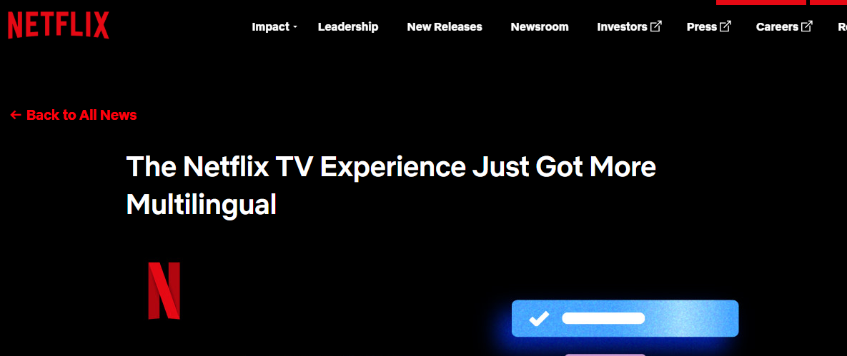
Figure 46: Netflix Multilingual Expansion India
(Source: Netflix, 2025)

4.1.3.3 Main Differences Between the UK and India
The United Kingdom has a priority on genre-based breadth (with a special emphasis on drama, comedy, and documentary content), while India has a priority on language-based breadth because of its regional linguistic diversity (Jain, 2025). Depth in the UK is also embodied in the form of long-running seasons and prestige series, in India, depth is built up through the production of a good number of titles in multiple linguistic markets. For this, one may perceive the United Kingdom's product mix as having depth of genre but narrowness of language, whereas India is perceived to have broadness of language and a layered culture.

4.1.4 Product Design
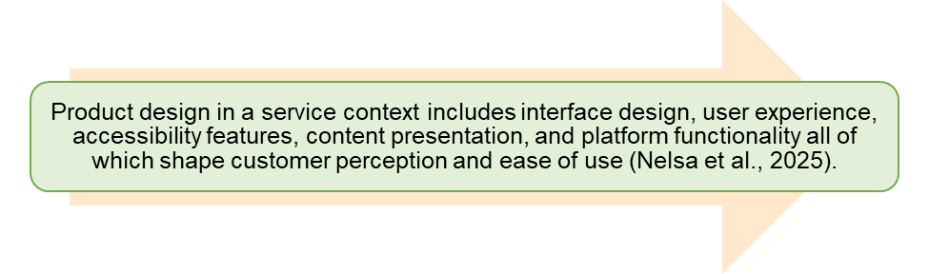
Figure 47: Product Design Definition
(Created by learner)

4.1.4.1 United Kingdom
In the United Kingdom, product design focuses on high-resolution streaming, smart TV compatibility, simple navigation, and personalization of the recommendation algorithm. The platform prominently displays the British originals in order to be in line with national taste profiles (Antunes, 2025). Mature infrastructure helps Netflix assign the right format for cinemas, HDR support, and immersive audio technologies (Brown, 2024). A clean, easy-to-use interface and reliable playback provide further support for Netflix's high-end positioning.
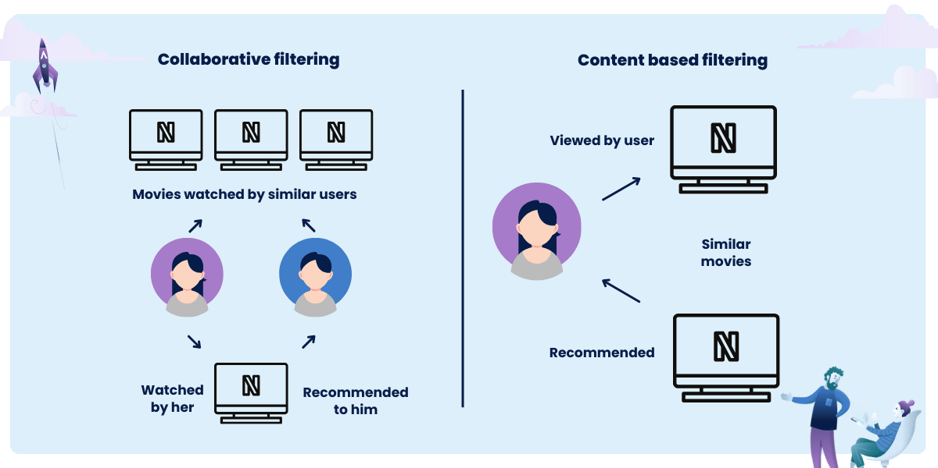
Figure 48: Netflix Recommendation Algorithm
(Source: Krysik, A., 2024)

4.1.4.2 India
Within India, design is geared towards mobile-first behaviour. Netflix focuses on data saving modes, mobile only subscription plans, offline downloads, region-specific language interfaces and adaptive bitrate streaming (Elanjimattom, 2023). Interface localization allows users to browse and get recommendations in their own language, therefore improving accessibility in a culturally diverse market (Jain, 2025). Accordingly, the design is very heavily tailored to device limitations, sensitivity toward price and regional favourites.
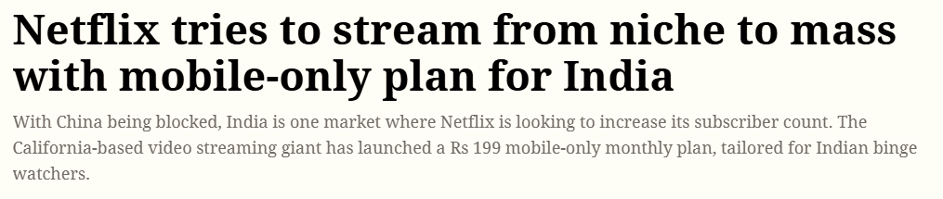
Figure 49: Mobile-First Pricing Strategy
(Source: Bhatia, A., 2019)

4.1.5 Branding Strategies

4.1.5.1 Branding Strategies in the UK and India
Netflix adopts a globally coherent branding framework that is based on consistency, reliability and innovation, while at the same time allowing local adaptation through culturally pertinent original content (Xiao, 2023). The brand identity is backed by emotive storytelling, high production values and a reputation of pushing the boundaries of creativity (Antunes, 2025). Nonetheless, the implementation of this strategy differs significantly between the United Kingdom and India due to differences in cultural expectations and media consumption habits.

4.1.5.2 Branding Strategy in the United Kingdom
Within the United Kingdom, Netflix portrays itself as the premium storyteller. Marketing initiatives centre British made prestige titles that point towards national identity and cultural realism (Antunes, 2025). Partnerships with well-known British creators, actors and studios help to reinforce credibility. The brand emphasises diversity, authenticity and cultural sophistication, in keeping with the UK audience's penchant for socially attuned stories (Brown, 2024). Strong local collaborations - such as Netflix's hub in Shepperton Studios is boosting branding through a demonstrable commitment to the UK's creative economy (Netflix, Inc., 2019).

4.1.5.3. Branding Strategy in India
In India, Netflix uses the localisation-intensive brand that focuses on linguistic diversity and culturally specific marketing and engagement (Jain, 2025). Campaigns highlight regional narratives, local celebrities and culturally rooted narratives thereby positioning Netflix as a producer of high-quality Indian natives (Barraza, 2025). The brand also emphasizes the aspect of creative audacity and cinematic quality in differentiation with the low-cost competitors. However, branding should be a balancing act between innovation and cultural sensitivity because controversial topics can generate political or public backlash (Elanjimattom, 2023). Netflix's adaptive, global strategy ensures that the brand will remain relevant and reputation risks reduced.

4.2 Price
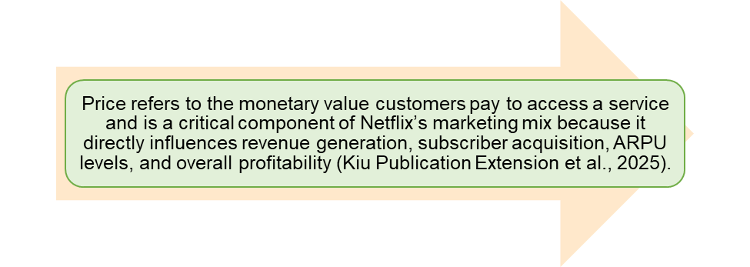
Figure 50: Price Definition
(Created by learner)

4.2.1. United Kingdom
Netflix has been using a premium pricing strategy in the United Kingdom that fits high-income consumers and strong demand of digital entertainment. There is a high rate of subscription in the market, which can allow the service to maintain high price levels without losing a high rate of churn (Fallon, 2025). Incomes have been high and UK revenues are above 1.8-2.4 billion pounds but returns on the investments have slowed due to the increase in production costs, local talent competition and the growing investment in British originals (Fallon, 2025; Ramachandran, 2025). Regardless of these limitations the UK consumers continue to embrace premium pricing as provided by Netflix since it offers high quality content, high local relevancy, and stable performance on the platform. In line with this, this price positioning supports the Netflix brand image as a premium streaming platform in addition to sustaining its ARPU average levels.

4.2.2. India
Netflix, in India, is adopting a market-penetration and price-affordability pricing strategy to fit in a price-sensitive market and escalating competition posed by cheaper OTT service providers. We have seen subscription levels such as low-cost mobile-only subscriptions that have greatly boosted subscriber numbers, especially young mobile first viewers (Barraza, 2025). Though the city of low-cost prices decreases the short-run margins and ARPU remains relatively low, Netflix considers India to be a long-term growth market. The economic impact of investing in the platform is projected to have created US$2(billion) between 2021 and 2024, and this indicates the potential within the entire Indian entertainment ecosystem (Shekhar, 2025). Regional pricing, combine and sell packages, and tiered flexibility are price policies to focus on the affordability of the products and sustainable growth of revenue.

4.3 Place (Distribution)
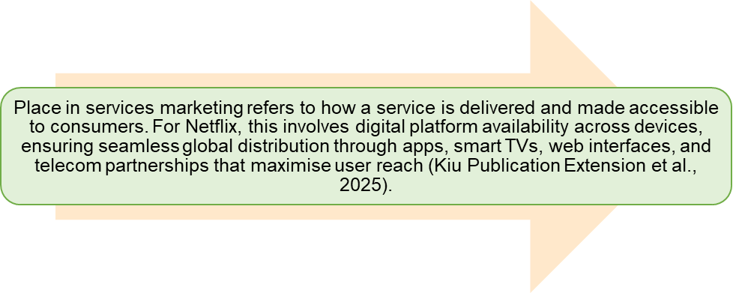
Figure 51: Place (Distribution) Definition
(Created by learner)

4.3.1. United Kingdom
Netflix has been using a premium pricing strategy in the United Kingdom that fits high-income consumers and strong demand of digital entertainment. There is a high rate of subscription in the market, which can allow the service to maintain high price levels without losing a high rate of churn (Fallon, 2025). Incomes have been high and UK revenues are above 1.8-2.4 billion pounds but returns on the investments have slowed due to the increase in production costs, local talent competition and the growing investment in British originals (Fallon, 2025; Ramachandran, 2025). Regardless of these limitations the UK consumers continue to embrace premium pricing as provided by Netflix since it offers high quality content, high local relevancy, and stable performance on the platform. In line with this, this price positioning supports the Netflix brand image as a premium streaming platform in addition to sustaining its ARPU average levels.
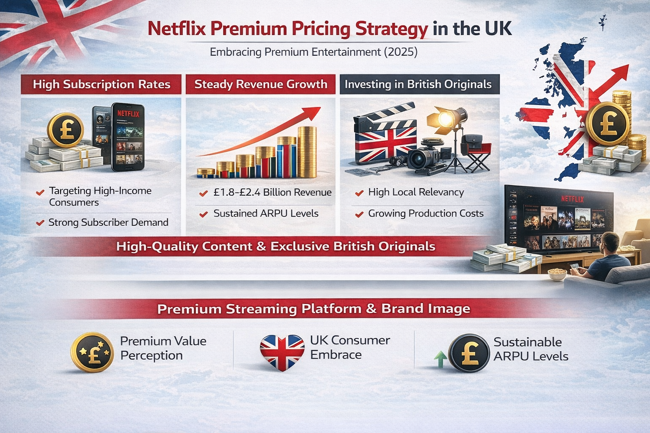
Figure 52: Netflix Distribution UK
(Created by learner)

4.3.2. India
Netflix, in India, is adopting a market-penetration and price-affordability pricing strategy to fit in a price-sensitive market and escalating competition posed by cheaper OTT service providers. We have seen subscription levels such as low-cost mobile-only subscriptions that have greatly boosted subscriber numbers, especially young mobile first viewers (Barraza, 2025). Though the city of low-cost prices decreases the short-run margins and ARPU remains relatively low, Netflix considers India to be a long-term growth market. The economic impact of investing in the platform is projected to have created US$2(billion) between 2021 and 2024, and this indicates the potential within the entire Indian entertainment ecosystem (Shekhar, 2025). Regional pricing, combine and sell packages, and tiered flexibility are price policies to focus on the affordability of the products and sustainable growth of revenue.
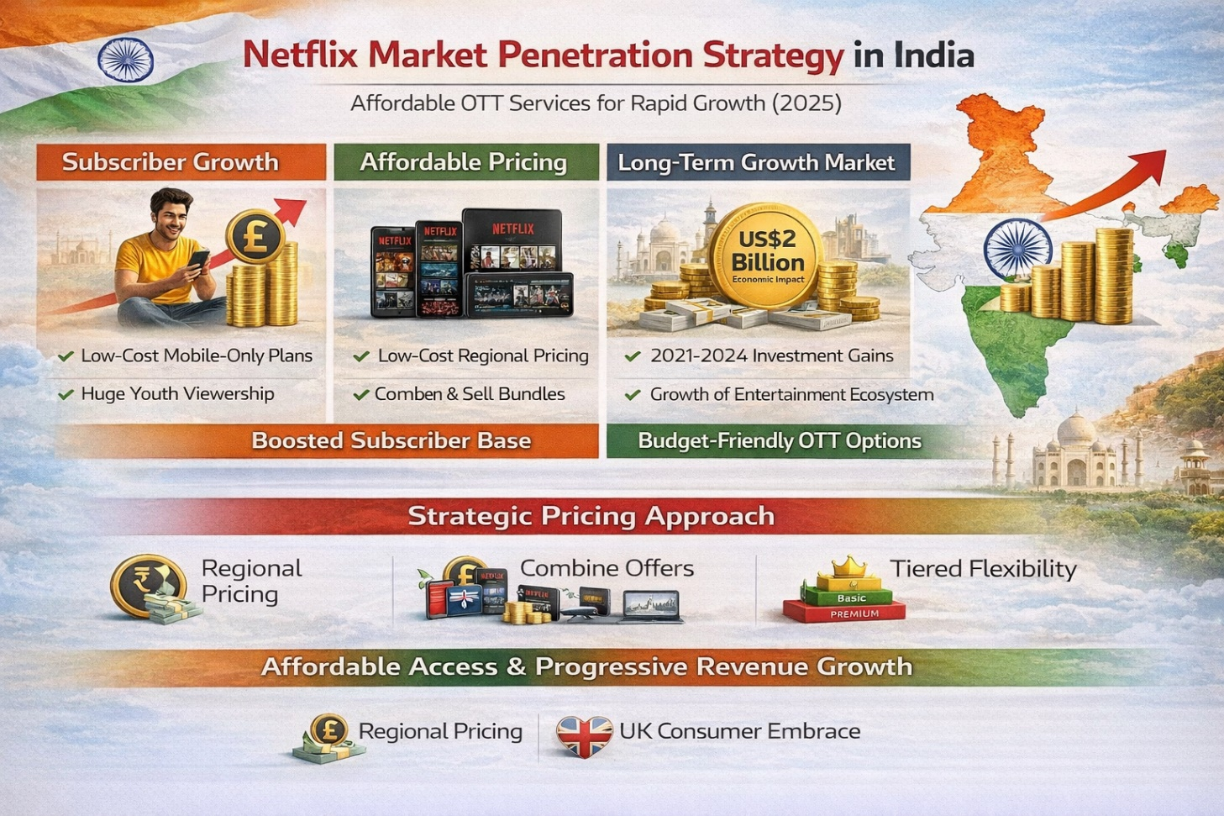
Figure 53: Netflix Distribution India
(Created by learner)
Aspect | United Kingdom | India
Direct Channels | Netflix primarily uses direct digital channels, including its website, smart-TV apps, and mobile applications. Direct access is strengthened through seamless integration with home entertainment systems and high broadband penetration, ensuring users stream content without intermediaries (Brown, 2024; Netflix, Inc., 2025). | Netflix relies heavily on direct digital delivery through mobile and smart-device apps, optimised for a mobile-first market. Features such as downloads and adaptive streaming support direct access even in low-bandwidth areas, enabling nationwide reach (Elanjimattom, 2023; Barraza, 2025).
Indirect Channels | Indirect distribution occurs through partnerships with ISPs and device manufacturers such as Sky, BT, Virgin Media, and smart-TV brands where Netflix is pre-installed or offered within bundled subscriptions (Brown, 2024). These alliances expand accessibility without altering digital ownership. | Indirect channels include telecom bundles with Jio, Airtel, and Vi, where Netflix subscriptions are integrated into data plans or postpaid packages. Device partnerships and promotional bundles help penetrate price-sensitive and regional markets (Jain, 2025; Barraza, 2025).
Intensive Distribution Strategy | Netflix adopts an intensive distribution strategy by ensuring the platform is available across virtually all connected devices, including smart TVs, consoles, laptops, tablets, and phones. The presence of Netflix buttons on UK remote controls exemplifies intensified access (Brown, 2024). | Netflix uses intensive digital distribution by ensuring availability on all major smartphones, smart TVs, low-cost Android devices, and telecom-linked platforms. Mobile-first optimisation and regional-language interfaces reinforce broad market saturation across diverse user groups (Elanjimattom, 2023; Netflix, Inc., 2025).
Table 7: Direct vs Indirect Channels and Intensive Distribution – Netflix UK and India
(Created by learner)

4.3.3. Market Entry Methods
- Market Entry Method Used: Digital Direct Exporting / Wholly Owned Online Operations
Netflix makes its entry in both the UK and Indian markets by direct digital market entry, i.e., the company owns and controls all the content distribution, platform operations, and customer interactions using its globally hosted digital infrastructure (Nelsa et al., 2025).

4.3.3.1. Why Netflix Uses This Method
Netflix uses this approach as their service is purely digital and as the middle men are removed their operational complexity is lower, brand consistency is maintained across the globe, and it has the power of data driven personalisation at scale (Xiao, 2023). The hosted model also guarantees content governance, data privacy control and efficient scalability into new markets (Netflix, Inc,2025).

4.3.3.2. Advantages and Disadvantages (India as the example country)
Advantages of the Market Entry Method in India
1. Complete operations and content control: Instant direct digital access will allow Netflix to provide full control over data privacy, recommendation engines, and platform standards, which will reduce reliance on local distributors (Barraza, 2025).
2. Scalability in a short period of time across geographical locations: A hosted digital infrastructure enables faster penetration into the linguistic heterogeneous Indian markets without need to build physical infrastructure (Nelsa et al., 2025).
3. Effective content delivery and localization: A centralized operation of the company allows Netflix to quickly implement multilingual interface, dubbing, and subtitles in response to the regional preferences (Jain, 2025).
4. Lower entry barriers: Lack of physical store front or franchise networks significantly reduces entry barriers and market penetration becomes economically sustainable in the vast geographical landscape of India (Elanjimattom, 2023).

Disadvantages of the Market Entry Method in India
1. The risks of cultural backlash include the fact that the operations are centrally controlled, and the content might become a point of criticism of the conservative groups since the local gatekeeping can be limited, and it might fail to adequately respond to the local sensibilities (Barraza, 2025).
2. The issue of regulatory vulnerability includes the use of a global streaming model, which makes Netflix prone to sudden shifts in Indian regulations of the digital content and the threat of takedown orders (Elanjimattom, 2023).
3. Weaker reaction to rapid shifts in local tastes is also explained by centralised decision-making that can delay the reaction to changing regional trends compared with competitors that have more local autonomy (Nelsa et al., 2025).
4. Netflix bears high-cost burden of localisation because the company has to pay for dubbing, subtitles, and other multilingual promotion on its own since external distributors do not have to incur the same cost (Jain, 2025).

4.4 Promotion
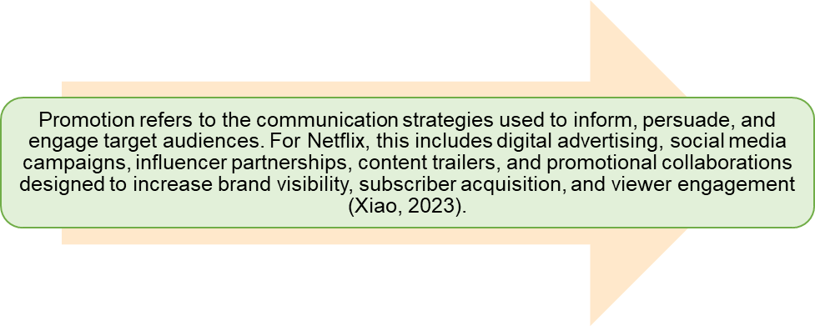
Figure 54: Promotion Definition
(Created by learner)

4.4.1. United Kingdom
In the United Kingdom, Netflix promotion strategy brings premium content to the forefront through social media marketing, targeted online advertising efforts and high-profile billboards highlighting British originals such as The Crown and Sex Education (Antunes, 2025). Collaborations with UK creators and media content reinforce a resonance of culture, whilst algorithm driven personalised recommendations drive subscriber retention. Promotional partnerships with Sky and Virgin Media boost the reach of the platform and therefore strengthen Netflix's brand identity as a major provider of prestige entertainment (Brown, 2024).

4.4.2. India
According to Jain (2025), in India, Netflix follows a highly localised approach to promotional activities, which includes multilingual promotional activities, celebrity endorsements in specific regions, and social media campaigns that are tailored to local cultures.In India for example Netflix also employ a very localised approach to their promotional strategy, which includes multilingual promotional activities, celebrity endorsements in specific regions, and social media campaigns that are tailored to local cultures. Trailers, influencer partnerships and ones that are available at festival seasons also give an underlining to Indian originals like *Delhi Crime* and *Lust Stories*, in turn closing the case on the importance of cultural relevance (Barraza, 2025). Partnerships with telecom companies like Jio, Airtel make bundled promotional offers possible, which helps in extending affordability and reach in a highly competitive over-the-top market (Elanjimattom, 2023).

4.4.3. Promotion Strategy Comparison – Netflix (UK vs India)
Promotion Element | United Kingdom (Country A) | India (Country B) | Similarities | Differences | Evaluation of Promotion Strategies
Brand Messaging | Emphasises British storytelling, creativity, and award-winning originals (The Crown, Sex Education) to position Netflix as a premium cultural brand (Antunes, 2025). | Highlights regional narratives and emotional storytelling using titles like Sacred Games and Delhi Crime to build cultural resonance (Jain, 2025). | Both highlight culturally relevant content to strengthen emotional connection (Xiao, 2023). | UK focuses on prestige and artistry; India focuses on regional identity and cultural depth. | Effective because messaging is adapted to local cultural expectations, enhancing brand relevance in both markets (Nelsa et al., 2025).
Advertising Platforms | Heavy use of digital ads, UK billboards, trailers on social media, and partnerships with UK broadcasters (Brown, 2024). | Uses YouTube ads, regional OTT promos, telecom bundle ads, and high-volume Instagram promotions (Elanjimattom, 2023). | Both rely heavily on digital-first advertising due to high online consumption (Xiao, 2023). | India uses more frequency-based regional ads; UK uses brand-led prestige campaigns. | Both strategies effectively match media habits: UK consumers respond to brand storytelling; Indian consumers respond to volume-driven digital ads (Barraza, 2025).
Celebrity Endorsements | Limited but strategic use of local actors and directors during premieres and interviews (Antunes, 2025). | Heavy use of Bollywood and regional film stars to attract mass audiences (Jain, 2025). | Both markets feature local celebrities to promote content. | India uses celebrity endorsements more aggressively due to star-driven culture. | This approach increases reach, but celebrity-heavy promotion is more impactful in India’s star-oriented entertainment market (Barraza, 2025).
Social Media Marketing | Engages UK audiences with humour, memes, behind-the-scenes clips, and culturally themed posts (Xiao, 2023). | High-frequency posts in multiple languages on Instagram, YouTube, and X/Twitter featuring regional dialects and festivals (Jain, 2025). | Both rely on social media as a primary promotional tool. | India’s social media is more regional and language-diverse. | Highly effective because interactive posts increase engagement and encourage binge-watching behaviour (Nelsa et al., 2025).
Influencer Campaigns | Collaborations with UK influencers focusing on reviews, reaction videos, and cultural commentary (Brown, 2024). | Collaborations with digital creators, comedians, and regional influencers with strong youth followings (Elanjimattom, 2023). | Both use influencers to appeal to younger audiences. | India uses micro-influencers; UK uses content critics and digital culture creators. | Influencer partnerships increase organic reach and create credible recommendations that drive subscriptions (Xiao, 2023).
Customer Engagement Activities | Launch events, red-carpet premieres, live Q&A sessions with British actors, and local pop-up experiences (Antunes, 2025). | Netflix India hosts fan meetups, promotional tours, and festival-based marketing tied to local holidays (Jain, 2025). | Both involve experiential marketing and fan engagement. | India leverages cultural events; UK focuses on cinematic premieres. | Engaging experiences strengthen emotional bonds and improve brand loyalty across markets (Brown, 2024).
Promotional Discounts / Bundles | Occasional free trials, student offers, and bundled access with broadband providers (Brown, 2024). | Mobile-only plans, telecom partnership bundles (Jio, Airtel), and introductory regional offers (Shekhar, 2025). | Both implement price-related promotions. | India uses more aggressive discounts to attract price-sensitive consumers. | Promotional offers support subscriber growth but must be balanced with profitability goals (Fallon, 2025).
Customer Reviews & Word-of-Mouth | Reviews influence UK viewership decisions; positive buzz around UK originals drives binge-watching (Antunes, 2025). | User reviews and viral social-media reactions significantly shape regional popularity (Barraza, 2025). | Strong reliance on user-generated buzz for content success. | India’s viral reactions often spread through multilingual channels. | Reviews enhance algorithm recommendations and directly influence future content direction (Nelsa et al., 2025).
Table 8: Promotion Strategy Comparison
(Created by learner)

4.5 People
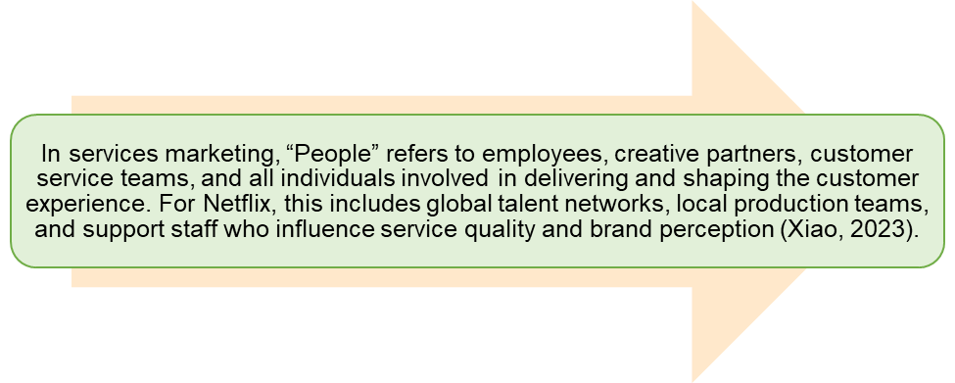
Figure 55: People Definition
(Created by learner)

4.5.1. United Kingdom
In the United Kingdom, Netflix has about 1,500-2,000 employees including corporate, production and creative teams that are backed by their production hub in the UK and large-scale acquisition of local talent (Netflix, Inc., 2025; Hosch and Ashburn, 2025). In this respect, Netflix depends on the high level of creative individuals, production teams, scriptwriters, and actors who participate in creating high-quality British originals, including the series The Crown and Sex Education (Antunes, 2025). The local commissioning teams work in conjunction with UK studios and cultural consultants in order to achieve authenticity and representation. The customer support units also improve service experiences with responsive and data-driven service. This one coherent human-resource approach make Netflix one of the best creative employers and enhances its compatibility with the expectations of the UK viewers (Brown, 2024).

4.5.2. India
The type of core workforce in India is concentrated around the content, marketing and partnership functions and comprise 400-600 workers but highly dependent on outsourced production crews and local studios to produce original content (Barraza, 2025; Netflix, Inc., 2025). The platform uses a wide range of regional creators, directors, writers and actors to create locally based originals in different languages to guarantee high levels of audience relevance (Jain, 2025). Local editorial and cultural review teams are useful to overcome sensitivities and ensure adherence in the highly structured social environment in India (Barraza, 2025). Also, the multilingual customer support improves customer satisfaction in diversified areas. The approach to people will help Netflix to handle cultural diversity without causing doubts and mistrust in the growing OTT ecosystem in India (Elanjimattom, 2023).

4.6 Process
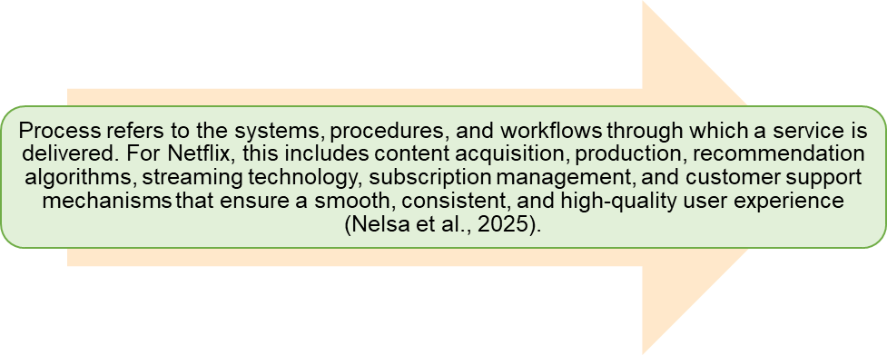
Figure 56: Process Definition
(Created by learner)

4.6.1. United Kingdom
The operational structure of Netflix in the United Kingdom focuses on the efficient bereavement of contents, the upholding of high-quality production cycles, and fluent connection of workflow and post-production with British studios and film editing units (Antunes, 2025). Complex prediction systems customize the viewing experience, and there is a powerful broadband to support continuous streaming functionality (Brown, 2024). The onboarding of subscriptions, billing and customer service are all completely digitalized, with automated processes to reduce friction. All these steps support a high-quality and trustworthy service, which corresponds to the demands of UK viewers and technological development in the country (Netflix, Inc., 2025).

4.6.2. Complement/ Customer complaint process-United Kingdom.
The customer complaint process in the United Kingdom is structured in a way where Netflix has rapid digital services that are availed via chat, email, and in-app customer support. Complaints are recorded through the automatic systems that focus on fast diagnostics and offer tailored solutions to complaints based on account information and history of viewing (Brown, 2024). The UK consumers expect transparency and prompt service; therefore, Netflix puts the emphasis on effective communication, follow-ups, and service recovery. Good governance and developed operations systems guarantee regular management of the technical and account related problems (Netflix, Inc., 2025).
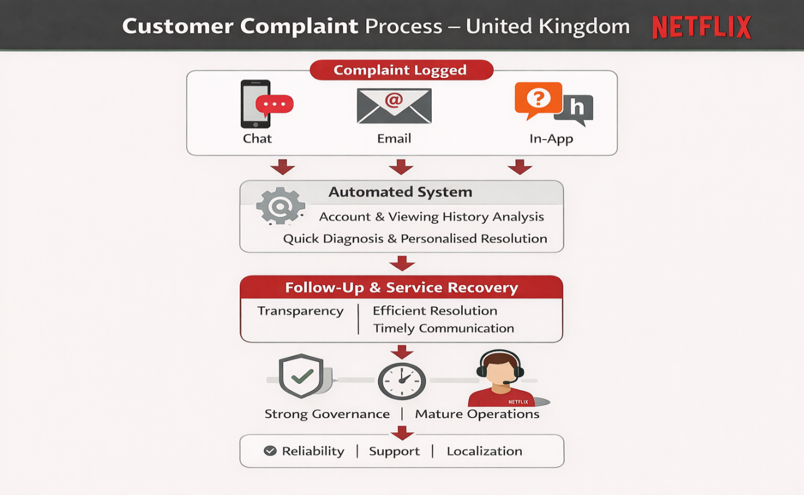
Figure 57: Customer Complaint Process - United Kingdom
(Created by learner)

4.6.3. India
In India, Netflix's framework of operations aims at localisation and mobile-first optimisation and comprises multilingual interfaces, adaptive streaming protocols and regional content pipelines to suit the heterogeneous demands of consumers (Jain, 2025). The editorial and culture review processes of the platform ensure content sensitivity and compliance with the laws (Barraza, 2025). Subscription workflows abide by telecom bundling tactics, therefore streamlining the onboarding process in the upcoming markets Moreover, the offline download feature and data-saving features give resale for users facing intermittent connectivity making Netflix's delivery process very adaptable for India's varied digital landscape (Elanjimattom, 2023).

4.6.4. Customer Complaint Process - India
Within the Indian market, Netflix handles consumer issues using multilingual channels for customer service that caters to the country's multilingual user base. Issues are largely resolved through in-app help, chatbot interfaces and telecom-partner support frameworks thus ensuring accessibility across disparate markets (Jain, 2025). Complaints are most often directed at the terms of payment or the performance of a mobile application or the availability of content. Given the increased cultural and regulatory strictness, communication strategies should be well-tuned in particular regarding content-related concerns (Barraza, 2025). To combat such challenges, Netflix takes localised review teams and data driven diagnostic procedures to provide exponential resolutions in the context of the heterogeneous digital sector in India (Elanjimattom, 2023).
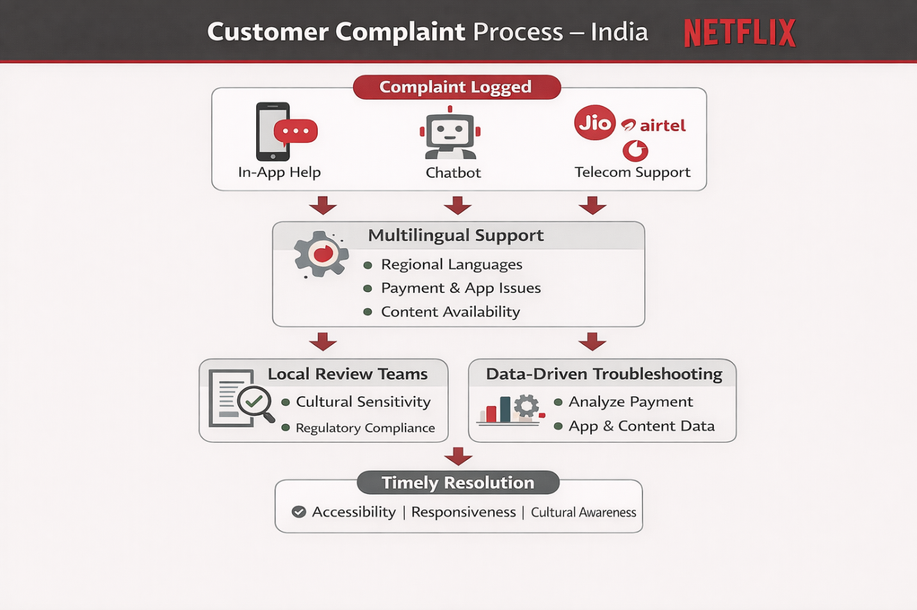
Figure 58: Customer Complaint Process - India
(Created by learner)

4.7 Physical Evidence
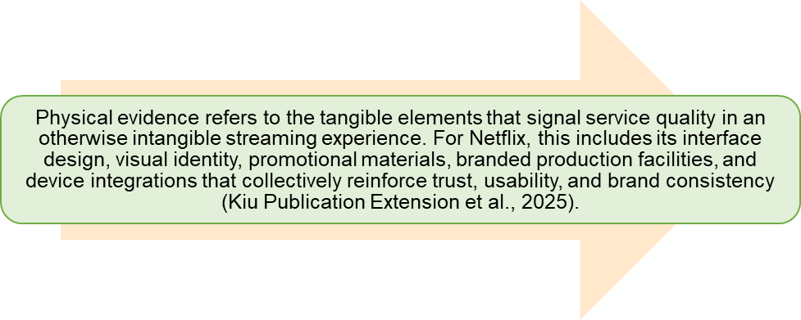
Figure 59: Physical Evidence Definition
(Created by learner)

4.7.1. United Kingdom
Physical evidence in the case of the United Kingdom takes the form of the Netflix application on the smart televisions, tablets, and smartphones and the gaming consoles, which are supported with the help of an interface that provides the message of high-quality. The Shepperton Studios production centre is a symbolic signifier of Netflix investment on the production of British narratives (Netflix, Inc., 2019). Also, branded billboards, outdoor advertising, and displays of retail partners contribute to strengthening brand awareness, and promotional imagery related to British originals triggers a greater brand cultural resonance and enhances observed authenticity of the service (Antunes, 2025).

4.7.2. India
Physical evidence can manifest itself in the Indian context in terms of multilingual application interfaces, geographically oriented artwork, promotion designs adapted to the culture to serve heterogeneous users of the product (Jain, 2025). Online marketing, joint promotions with telecommunication companies, and integrations in cinemas include outdoor advertising, brand awareness in the urban and semi-urban segments. In addition, the existence of an agreement on preloading device and graphic visualizations of packages plans support the physical presence of Netflix. Taken together, these visible indicators strengthen brand recognition and help the local population to create visual associations with an inherently online streaming platform (Xiao, 2023).

4.8. Evaluation of Marketing Strategies

4.8.1. United Kingdom
The future marketing strategy of Netflix in the United Kingdom predicts premium position, local culture, and collaboration. The brand relevance is supported through high-impact outdoor advertising, strategic social media campaigns, and strong planning of making British originals popular in the UK including The Crowns and Sex Education because UK customers prefer realisms and accurate representations (Antunes, 2025). Alliances with Sky, BT and Virgin Media provide greater market penetration, and more advanced data-driven targeting will increase individual connexion. This, in combination, fits the UK standards of quality storytelling and digital convenience, which solidifies the position of Netflix on the market (Brown, 2024).

4.8.2. India
Netflix utilises heavy localisation approach in India based on monolingual marketing, endorsements of local celebrities and promoting through festivals (Jain, 2025). Indian originals promoted include things like *Delhi Crime* or Lust Storeys, which appeal to culturally diverse viewers (Barraza, 2025). Cooperation with Jio, Airtel, and Vi will guarantee affordability, and the mostly mobile-first promotion strategy will capture the trends of national consumption (Elanjimattom, 2023). The personal approach will help Netflix overcome its cultural sensitivities and develop a deep connexion with the linguistic and regional customer groups.

4.8.3. Profit and Sales

4.8.3.1. United Kingdom
Netflix's revenue for the United Kingdom has continued to grow strongly with earnings increasing beyond the range of 1.8-2.4 bn., whereas the profit margin has shrunk in response to inflationary pressures, increased tear production costs, and increased competition for British talent (Fallon, 2025; Ramachandran, 2025). High rates of subscription penetration are combined with a premium pricing strategy which sustain high levels of ARPU, thus supporting steady sales growth. Investment in local content strengthens brand loyalty, but also fosters long-term commitments in cost. Despite these challenges, the United Kingdom remains one of the most profitable international markets for Netflix (Netflix, Disk Assignment to education.2025).

4.8.3.2. India
In India, the growth in sales is primarily driven by the high growth in the number of subscribers made possible by the low pricing of mobile plans. Whilst ARPU is still a huge amount lower than those seen in the United Kingdom, the sheer size of the market provides a huge potential for sales in the long term (Barraza, 2025). Netflix's investment in India has been estimated to have an economic impact of about $2 billion in the economic period 2021-2024, which represents value derived from production, employment and regional content development (Shekhar, 2025). Although profitability in this market is still marginal, it is extremely important in the strategy of attaining the market dominance in the future.

4.8.4. Social Media Engagement

4.8.4.1. United Kingdom
The involvement of Netflix on social media in the UK can be defined by the use of humour, behind-the-scenes content, and narrative that appeals to cultural norms associated with the UK audience (Antunes, 2025). Instagram, X, Tik Tok, and other platforms release brief videos, quippy maxims of characters, and creators in interviews, building a connexion with the audience on an emotional level. Peaks of engagement go along with releases of British-originated material and award-season promotions. Usually, the communication style is humorously and socially conscious and in accordance with the current cultural discussion in the country, thus keeping the positioning statement of Netflix as an asset of the current entertainment media (Brown, 2024).

4.8.4.2. India
The social-media strategy employed by Netflix in India can be best described as vibrant, multilingual, and very emotional. The content approach includes allusions to Bollywood, local humour, meme culture and festival tie-ins which optimally handles the heterogeneous demographic situation (Jain, 2025). Specific regional pages are offered with the content in Tamil, Telugu, Hindi, and Malayalam, which increases relevance and interest. Advertising of Indian original productions is a trend, which often to the whole country, due to the influence of celebrities and the themes that the local people empathise with (Barraza, 2025). This is an intensive, geographically focused on-line presence significantly enhancing brand presence.

4.8.5. Customer Reviews

4.8.5.1. United Kingdom
UK customer reviews make it known the appreciation for British originals, high streaming quality, and personalised recommendations (Antunes, 2025). Some of the criticisms are that subscription prices have increased, and sometimes content gets cut. Users appreciate Netflix's reliability and ease of navigation but are concerned about competition that causes reduced unique content availability. Overall sentiment is still at the positive end, due to good quality original programming and performance.

4.8.5.2. India
Indian reviews frequently praise Netflix for its high-quality regional originals, variety of genres and ad-free stream (Jain, 2025). Complaints are mainly cantered around pricing perceived as higher than competitor platforms, and cultural sensitivity in some of the titles (Barraza, 2025). Mobile users love offline download and data saving features. Overall reception is favourable among the premium audience and urban audiences with growing acceptance among the regional audience.

4.8.6. Similarities & Dissimilarities of Netflix UK vs India Across Key Marketing Elements
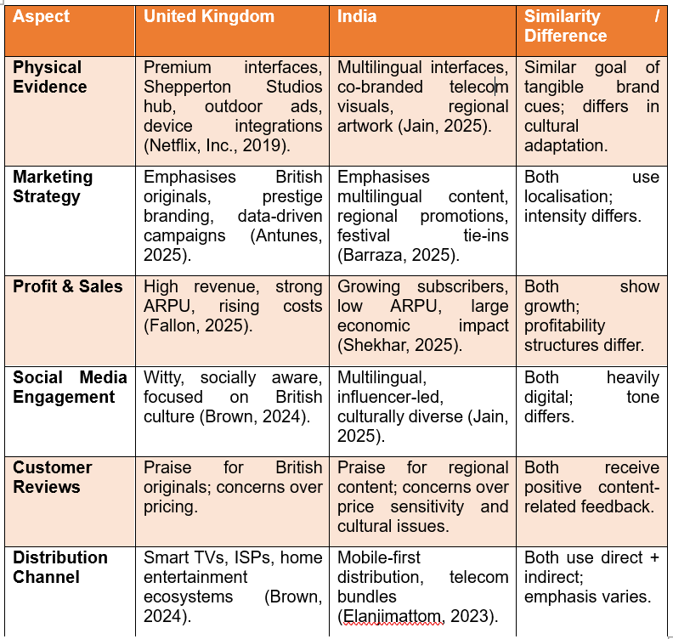
Table 9: Similarities & Dissimilarities of Netflix UK vs India Across Key Marketing Elements
(Created by learner)

4.9. Similarities & Dissimilarities Marketing Mix
The marketing mix policies deployed by Netflix in the United Kingdom and in India reflect the ability of the company to balance the global consistency with the local adaptability. Netflix in the United Kingdom uses a premium positioning strategy where it delivers high-quality original content like the king show, sex education that reflect the creativity and social inclusivity of the British (Antunes, 2025). The pricing scheme of the platform will address middle- and high-income computer households that use these devices, with the distribution mix supported by an effective broadband network and collaboration with smart TV companies to ensure easy access (Brown, 2024).Diversity, creativity, and British storytelling are amplified through promotion campaigns, which will attract culturally aware and sophisticated audience (Nelsa et al., 2025).
On the other hand, in India, the marketing mix of Netflix focuses on the affordability and the localisation aspects. The brand launched mobile-only subscriptions to meet the price-sensitive mobile-first personalities and created regional-language originals, including *Delhi Crime* and *Sacred Games* to engage the heterogeneous audiences emotionally (Barraza, 2025; Jain, 2025). The promotional programmes utilise the endorsements in celebrity promotions and the use of social media to increase reach (Elanjimattom, 2023). Therefore, whereas the Netflix approach to the UK predicts exclusivity and cultural status, the strategy in India is oriented on accessibility and the ability to connect with the culture of the national market, a twofold approach that allows the platform to gain strength in separate groups of consumers (Brown, 2024).
7Ps Element | United Kingdom (UK) | India | Similarities | Differences
Product | Premium original content such as The Crown and Sex Education; strong focus on British storytelling, diversity, and high production value. | Localised products such as Sacred Games and Delhi Crime in multiple languages; strong emphasis on regional narratives. | Both offer originals, global hits, and culturally relevant content. | UK focuses on prestige and social realism; India prioritises multi-language and culturally rooted stories.
Price | Tiered pricing with Standard and Premium plans for high-income households. | Low-cost, mobile-only plans to target price-sensitive, mobile-first consumers. | Both use subscription-based pricing and promotional discounts. | UK pricing is premium; India focuses on affordability and accessibility.
Place (Distribution) | High broadband penetration; strong smart TV usage; partnerships with UK ISPs. | Smartphone-first distribution; accessible via telecom bundles in semi-urban and urban areas. | Available on all major devices and apps in both countries. | UK relies on broadband and smart TVs; India depends heavily on mobile devices.
Promotion | Digital marketing, influencer campaigns, and UK-centric promotions on diversity and British culture. | Celebrity endorsements, social media promotions, and regional-language campaigns across states. | Both use strong online and social media marketing. | UK campaigns focus on inclusivity and creativity; India’s are region-specific and celebrity-driven.
People | Local British actors, directors, and creative teams enhance UK cultural alignment. | Indian producers, regional film industries, and multi-language creative teams. | Both invest in local talent and partnerships. | UK talent supports high-budget British originals; India features diverse regional creators.
Process | AI-driven personalised recommendations, smooth onboarding, and multi-device streaming. | Mobile-first interface, regional language navigation, simplified purchase process. | Both rely on automated, algorithm-driven user interfaces. | UK emphasises multi-device experience; India emphasises mobile optimisation.
Physical Evidence | High production quality, global branding, UK production hub at Shepperton Studios. | Regional event promotions, multilingual interface, culturally localised visuals. | Both demonstrate strong brand presence and quality assurance. | UK physical evidence highlights prestige and scale; India focuses on cultural familiarity.
Table 10: Similarities & Dissimilarities Marketing Mix
(Created by learner)

5. Ethics of the United Kingdom
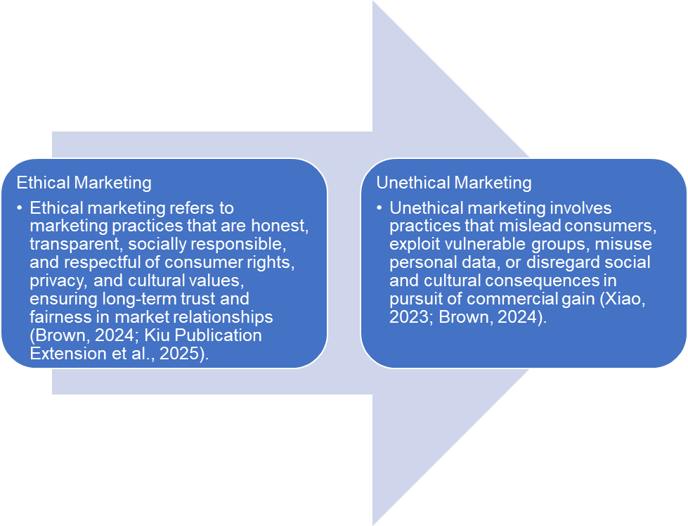
Figure 60: Definitions of Ethical and Unethical Marketing
(Created by learner)
Ethics in the United Kingdom is a critical factor to the operation environment of Netflix, especially in terms of content responsibility, data privacy, disclosure, and a business and corporate behaviour. The strong legal system of the United Kingdom, which incorporates the Data Protection Act and the General Data Protection Regulation, stipulates that online platforms must use their system in the strictest possible manner to provide privacy, to guarantee data safety, and to communicate responsibly to their customers (Brown, 2024). The ethical imperatives fulfilled through the Netflix being transparent in its privacy disclosures, consent mechanisms, and data management options by the user help in upholding ethical standards worldwide, and hence reinforcing consumer confidence (Netflix, Inc., 2025).
Another salient dimension in the United Kingdom is the ethical content responsibility. The British value proper depiction, inclusion, and non-use of negative stereotypes in media (Antunes, 2025). The presence of UK-based productions commissioned by Netflix, like the series of shows like The Crown and Sex Education, is indicative of Netflix being determined to pursue culturally authentic storytelling, socially conscious, and diverse. However, some controversies may occur regarding depicting delicate historical moments or adult content and thus Netflix should find a balance between artistic freedom and the preferences of a society in regard to responsible media consumption (Brown, 2024).
Furthermore, Netflix faces ethical assessment as to the pricing fairness and increase in costs. While premium pricing may reflect higher production standards, consumer advocacy groups believe that constant price changes are a burden on lower income households. Transparent communication-which includes some marketing of announcements and explanations of price changes, is designed to diminish the risks of reputational costs and is consistent with ethical marketing practices (Fallon, 2025).
Framework | Ethical Marketing Example | Unethical Marketing Example
STP – Segmentation & Targeting | Netflix ethically targets UK audiences using age-appropriate segmentation and personalised recommendations while complying with GDPR and consent-based data use, protecting user privacy and autonomy (Brown, 2024; Netflix, Inc., 2025). | Using behavioural data to aggressively target vulnerable users (e.g. minors or compulsive binge-watchers) without adequate safeguards would be considered unethical due to exploitation and lack of informed consent (Brown, 2024).
STP – Positioning | Netflix positions itself as an inclusive and culturally responsible platform by commissioning British originals that promote diversity and authentic representation, enhancing social value alongside entertainment (Antunes, 2025). | Positioning content in a way that sensationalises historical events or reinforces stereotypes purely to drive viewership could be viewed as unethical cultural misrepresentation in the UK context (Brown, 2024).
7Ps – Product & Promotion | Ethical promotion is demonstrated through transparent content descriptions, clear age ratings, and responsible marketing communications aligned with UK media standards (Antunes, 2025). | Misleading trailers, exaggerated promotional claims, or inadequate content warnings for mature themes would constitute unethical promotion by distorting consumer expectations (Brown, 2024).
7Ps – Price | Netflix’s ethical pricing approach includes advance communication of subscription price changes and justification linked to content investment, supporting fairness and transparency (Fallon, 2025). | Sudden price increases without clear explanation or targeting locked-in subscribers unfairly could be considered unethical pricing behaviour (Brown, 2024).
Table 11: Ethical vs Unethical Marketing Examples (UK Context – Netflix)
(Created by learner)

6. Recommendations

Recommendations – United Kingdom
• Continue to thrive on the idea of premium localisation by continuing to invest in high-quality UK originals that reflect on the cultural realism, diversity and social topics of Britain, hence the local credibility and audience trust (Antunes, 2025).
• Improve the level of transparency in terms of ethical elements in pricing and data utilisation by further developing clearer communication on subscription modifications and personalised recommendation rationale, to address demanding expectations of consumer protection (Brown, 2024; Netflix, Inc., 2025).
• Become more sustainable and environmentally responsible: increase the use of eco-friendly production and disclose energy efficiency in stream production in accordance with the changing demands of the UK consumers regarding the ethical conduct in businesses (Antunes, 2025).
• Build on its existing strong collaboration with media owners, production companies, and intelligent-TV software to enhance dominance in distribution and maintain long-term user retention in a saturated market (Brown, 2024).

Recommendations – India
• Increase the focus on localisation into the region by acquiring more partnerships with regional content creators and dedicating investments to the multilingual interface, dubbing, and subtitling, thus, expanding cultural resonance and reducing risks of product sensitivity in particular regions (Barraza, 2025; Jain, 2025).
• Implement price flexibility strategies that include ad-based packages, family packages, and more mobile-focused plans, which will allow it to respond to increased sensitivity to prices and to gradually boost the average revenue per user (ARPU) (Elanjimattom, 2023; Shekhar, 2025).
• Extend the relationship with the telecoms and smartphone companies to make it more affordable, easier to bill, and make it penetrate deeper in the mobile-first and in the semi-urban areas (Elanjimattom, 2023).
• Have powerful cultural review systems supported by local advisory boards to proportion the creative freedom and societal and regulatory pressures to protect brand image (Barraza, 2025).
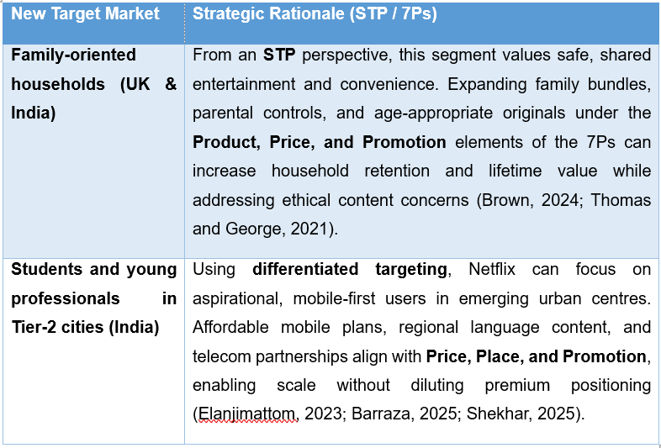
Table 12: New Target Markets for Netflix (STP / 7Ps Perspective)
(Created by Larner)

7. Conclusion
The current study evaluates critically the marketing strategies of Netflix in the United Kingdom and India using a suite of analytical frameworks in conformance to the structural guidelines set forth in the brief. Based on the business vision of the company, as expressed in its official website (Netflix, 2024), analysis is conducted in the strategic context further analysed by PESTLE; Foster and Marshall's classification can be seen as simple in the diagram, which in fact shows how the environmental forces can be favourable and unfavourable depending on the national conditions. Complementary models, such as Hofstede's cultural dimension (Hofstede, 2001), segmentation by value of lifestyles (VALS2) and segmentation on demographic and behavioural basis, enhance the understanding of the market segmentation by bringing out salient characteristics of the culture and consumers. Comparative assessments of the product's width and depth, branding activities, channels of distribution, market entry strategies, promotional activities, process elements (including the treatment of complaints), and physical evidence difference and commonalities between the two markets can be seen. Tables created by the researcher support such comparisons. A further investigation of ethical considerations, metrics of profitability, engagement with social media and customer reviews give further depth of context.

References
ABS News Service (2025) IMF Projects India’s Economy to Grow at 6.2% in 2025 and 6.3% in 2026. Available at: https://worldtradescanner.com/IMF%20Projects%20India%20Economy%20to%20Grow%20at%206.2pc%20in%202025%20and%206.3pc%20in%202026.htm
Antunes, F. (2025) ‘Building the Netflix Brand: Franchise Logic, Authorship, and Distinction in the Promotion of Stranger Things’, Television & New Media, 26(6). Available at: https://doi.org/10.1177/15274764251315704
Barraza, C. (2025) Global Brand, Local Market: A Strategic Analysis of Netflix’s Adaptation Challenges in India. Honors Program: Theses. University of Nebraska–Lincoln, May. Available at: https://digitalcommons.unl.edu/honorstheses/830
Batheories (2021) Hofstede’s Cultural Dimensions Theory. Available at: https://www.batheories.com/hofstede-cultural-dimensions-theory/
Brown, L. (2024) ‘Netflix PESTEL/PESTLE Analysis & Recommendations’, Panmore Institute, 19 November. Available at: https://panmore.com/netflix-pestle-analysis/?srsltid=AfmBOopXZ1dIpjaSLjQxkl9OXfMAt7OZsupuZNphbebda3_XR6yb_8Rz
Brown, L. (2024) ‘Netflix’s Operations Management, 10 Critical Decisions, Productivity’, Panmore Institute, updated 21 November. Available at: https://panmore.com/netflix-operations-management-10-critical-decisions-productivity-case-study
Elanjimattom, N.J. (2023) ‘OTTraction: Netflix business model in India and the attraction to OTT platforms in Kerala’, in Over the Top in India. Kerala: Media Village Publications, February.
Fallon, H. (2025) ‘Netflix UK revenues hit £1.8bn but profit growth slows’, ScreenDaily, 8 August. Available at: https://www.screendaily.com/news/netflix-uk-revenues-hit-18bn-but-profit-growth-slows/5207702.article
Hosch, W.L. and Ashburn, N. (2025) Netflix, Inc. Encyclopaedia Britannica. Available at: https://www.britannica.com/money/Netflix-Inc
Jain, R. (2025) ‘Netflix India celebrates a blockbuster year of global acclaim and local love’, Netflix Newsroom, available at: https://about.netflix.com/en/news/netflix-india-celebrates-a-blockbuster-year-of-global-acclaim-and-local-love
Kiu Publication Extension, Kiu Special and Dheere, F. S. (2025) ‘7 Ps of Marketing: Overview of Marketing’, Proceedings of the 7 Ps of Marketing: Overview of Marketing Conference, February. https://doi.org/10.1098/gdshajsd
Nelsa, P., Paradita, A. X., Hermawan, F. F. and Ghifari, M. Y. (2025) ‘Netflix's Digital Transformation Strategy: A Systematic Review of Challenges and Risk Mitigation Approaches’, JIPI (Jurnal Ilmiah Penelitian dan Pembelajaran Informatika), 10(2). Available at: https://doi.org/10.29100/jipi.v10i2.5927
Nelsa, P., Paradita, A. X., Hermawan, F. F., Ghifari, M. Y. and Lubis, M. (2025) ‘Netflix’s Digital Transformation Strategy: A Systematic Review of Challenges’, JIPI (Jurnal Ilmiah Penelitian dan Pembelajaran Informatika), 10(2), pp. 1133–1148. Available at: https://doi.org/10.29100/jipi.v10i2.5927
Pereira, D. (2025) ‘Pestle Analysis Examples: Netflix PESTLE Analysis’, Business Model Analyst Blog, 7 April. Available at: https://businessmodelanalyst.com/netflix-pestle-analysis/?srsltid=AfmBOopXZ1dIpjaSLjQxkl9OXfMAt7OZsupuZNphbebda3_XR6yb_8Rz
Nelsa, P., Paradita, A.X., Hermawan, F.F. and Ghifari, M.Y. (2025) ‘Netflix's digital transformation strategy: A systematic review of challenges and risk mitigation approaches’, JIPI (Jurnal Ilmiah Penelitian dan Pembelajaran Informatika), 10(2), March.
Netflix, Inc. (2019) ‘Netflix creates UK production hub at Shepperton Studios’, Business, 03 July. Available at: https://about.netflix.com/en/news/netflix-creates-uk-production-hub-at-shepperton-studios
Netflix, Inc. (2025) Form 10-K – Annual Report for the fiscal year ended December 31, 2024. Available at: https://s22.q4cdn.com/959853165/files/doc_financials/2024/ar/Netflix-10-K-01272025.pdf
Nguyen, H. (2018) Marketing Indochina Luxury and Tailored Tour to Finnish Consumers: Case Eviva Tour Vietnam. Degree Programme in Tourism. Amcham Finland. https://doi.org/10.13140/RG.2.2.22070.14406
PresentationGo (2025) STP Marketing Model for PowerPoint and Google Slides. Available at: https://presentationgo.com/presentation/stp-marketing-model-powerpoint-google-slides/2025
Ramachandran, N. (2025) ‘Netflix U.K. revenue surges to $2.4 billion, profits grow’, Variety, 8 August. Available at: https://variety.com/2025/tv/news/netflix-uk-revenue-surges-2-billion-profits-grow-1236482444/
Sharma, S. (2024) VALS Framework: The VALS (Values and Lifestyles)... LinkedIn post, 8 months ago. Available at: https://www.linkedin.com/posts/simran-sharma-47b2b7346_vals-framework-the-vals-values-and-lifestyles-activity-7312722068544868354-AMY2/
Shekhar, R. (2025) ‘Netflix’s India investment created $2 bn in economic impact from 2021–24’, Business Standard, 3 May. Available at: https://www.business-standard.com
Thomas, M. R. and George, G. (2021) ‘Segmenting, targeting, and positioning (STP) of generational cohorts Y, Z and Alpha’, IIMS Journal of Management Science, 12(2), pp. 115–129. https://doi.org/10.5958/0976-173X.2021.00008.7
Thompson, A. (2024) ‘Netflix’s Inventory Management’, Panmore Institute, updated 21 November. Available at: https://panmore.com/netflix-inventory-management
Xiao, H. (2023) ‘Research on the Brand Marketing Strategy of Netflix in the New Media Environment’, Advances in Economics, Management and Political Sciences, 56(1), pp. 195–202. Available at: https://doi.org/10.54254/2754-1169/56/20231087
Tim (2011) ‘Netflix will launch in UK in early 2012 with BBC content’, TechFruit, 21 December. DOI: https://techfruit.com/2011/12/21/netflix-will-launch-in-uk-in-early-2012-with-bbc-content/
Miller, J.A. and Corbett, E. (2025) ‘18 British shows to take you straight across the pond’, Tudum by Netflix, 29 August. DOI: https://www.netflix.com/tudum/articles/british-shows
Brit Asia TV (2025) Netflix takes over BBC One in British TV ratings: A streaming revolution, BritAsia TV, 15 January. DOI: https://britasia.tv/netflix-surpasses-bbc-one-in-british-tv-ratings-a-streaming-revolution/
Buchholz, K. (2020) ‘International brands rise to the top of Indian streaming market’, Statista, 23 September. DOI: https://www.statista.com/chart/23009/market-share-streaming--ott--platforms-in-india/
Greenwood, J. (2023) ‘The 15 all-time best British shows you can watch on Netflix’, MovieWeb, 15 July. DOI: https://movieweb.com/british-shows-on-netflix/
Statista Research Department (2019) ‘Netflix user engagement levels across India’, Statista. DOI: https://www.statista.com/statistics/1018871/india-netflix-engagement-levels/
Kanter, J. (2023) ‘Netflix threatens to purge shows in UK to avoid falling foul of “onerous” new streamer regulations’, Deadline, 30 May. DOI: https://deadline.com/2023/05/netflix-threatens-delete-uk-shows-media-bill-1235382495/
Barraza, C. (2025) Global brand, local market: A strategic analysis of Netflix’s adaptation challenges in India. Honors thesis, University of Nebraska–Lincoln. DigitalCommons@University of Nebraska–Lincoln. DOI: https://digitalcommons.unl.edu/honorstheses/830/
Sweney, M. (2023) ‘Netflix doubles down on UK productions despite slowdown’, The Guardian, 26 April. DOI: https://www.theguardian.com/media/2023/apr/26/netflix-uk-productions-spend
Srivas, A. (2019) ‘How many Indian users can Netflix really scoop up with its small screen discount?’, The Wire, 25 July. DOI: https://thewire.in/business/netflix-india-small-screen-subscription
Goldbart, M. (2024) ‘The “Suits” effect: Why older British network shows are doing the business for Netflix UK’, Deadline, 28 November. DOI: https://deadline.com/2024/11/netflix-uk-licensing-suits-brassic-deadwater-fell-capital-1236186658/
Punwani, U. (2020) ‘Mirzapur vs Sacred Games, Inside Edge vs Delhi Crime & more – Who wins amongst Netflix & Amazon Prime (India)?’, Koimoi, 31 March. DOI: https://www.koimoi.com/television/mirzapur-vs-sacred-games-inside-edge-vs-delhi-crime-more-who-wins-amongst-netflix-amazon-prime-india/
Jaze Networks (2024) ‘Who leads the race in India’s booming OTT sector?’, Jaze Networks, 27 December. DOI: https://www.jazenetworks.com/tech-news/who-leads-the-race-in-indias-booming-ott-sector/
Ardent Privacy (2024) ‘Data Protection Act (DPA) – UK’, Ardent Privacy. DOI: https://www.ardentprivacy.ai/data-protection-act/
Kalra, A. (2023) ‘India proposes new law with self-certification for broadcasters, streaming giants’, Reuters, 10 November. DOI: https://www.reuters.com/world/india/india-proposes-new-law-with-self-certification-broadcasters-streaming-giants-2023-11-10/
Farooqui, J. (2025) ‘Netflix strengthens focus on South Indian content as viewership expands’, The Economic Times, 1 December. DOI: https://economictimes.indiatimes.com/industry/media/entertainment/netflix-strengthens-focus-on-south-indian-content-as-viewership-expands/articleshow/125694178.cms
Thompson, K. and Burack, E. (2022) ‘The best British shows on Netflix’, Town & Country, 7 April. DOI: https://www.townandcountrymag.com/leisure/arts-and-culture/g20952672/british-shows-on-netflix/
Krysik, A. (2024) ‘How Netflix recommendation system works’, Stratoflow, 28 August (updated 26 May 2025). DOI: https://stratoflow.com/how-netflix-recommendation-system-works/
Bhatia, A. (2019) ‘Netflix tries to stream from niche to mass with mobile-only plan for India’, The Indian Express, 25 July. DOI: https://indianexpress.com/article/technology/tech-news-technology/netflix-tries-to-stream-from-niche-to-mass-with-mobile-only-plan-for-india-5850090/

