Reason’s (1990) “Swiss cheese model” in an exploration of the 1999 Saxeten Canyon disaster



Index

- Video
- Conceptual model
- References

Video link: https://sho.co/1J14G

Conceptual Model

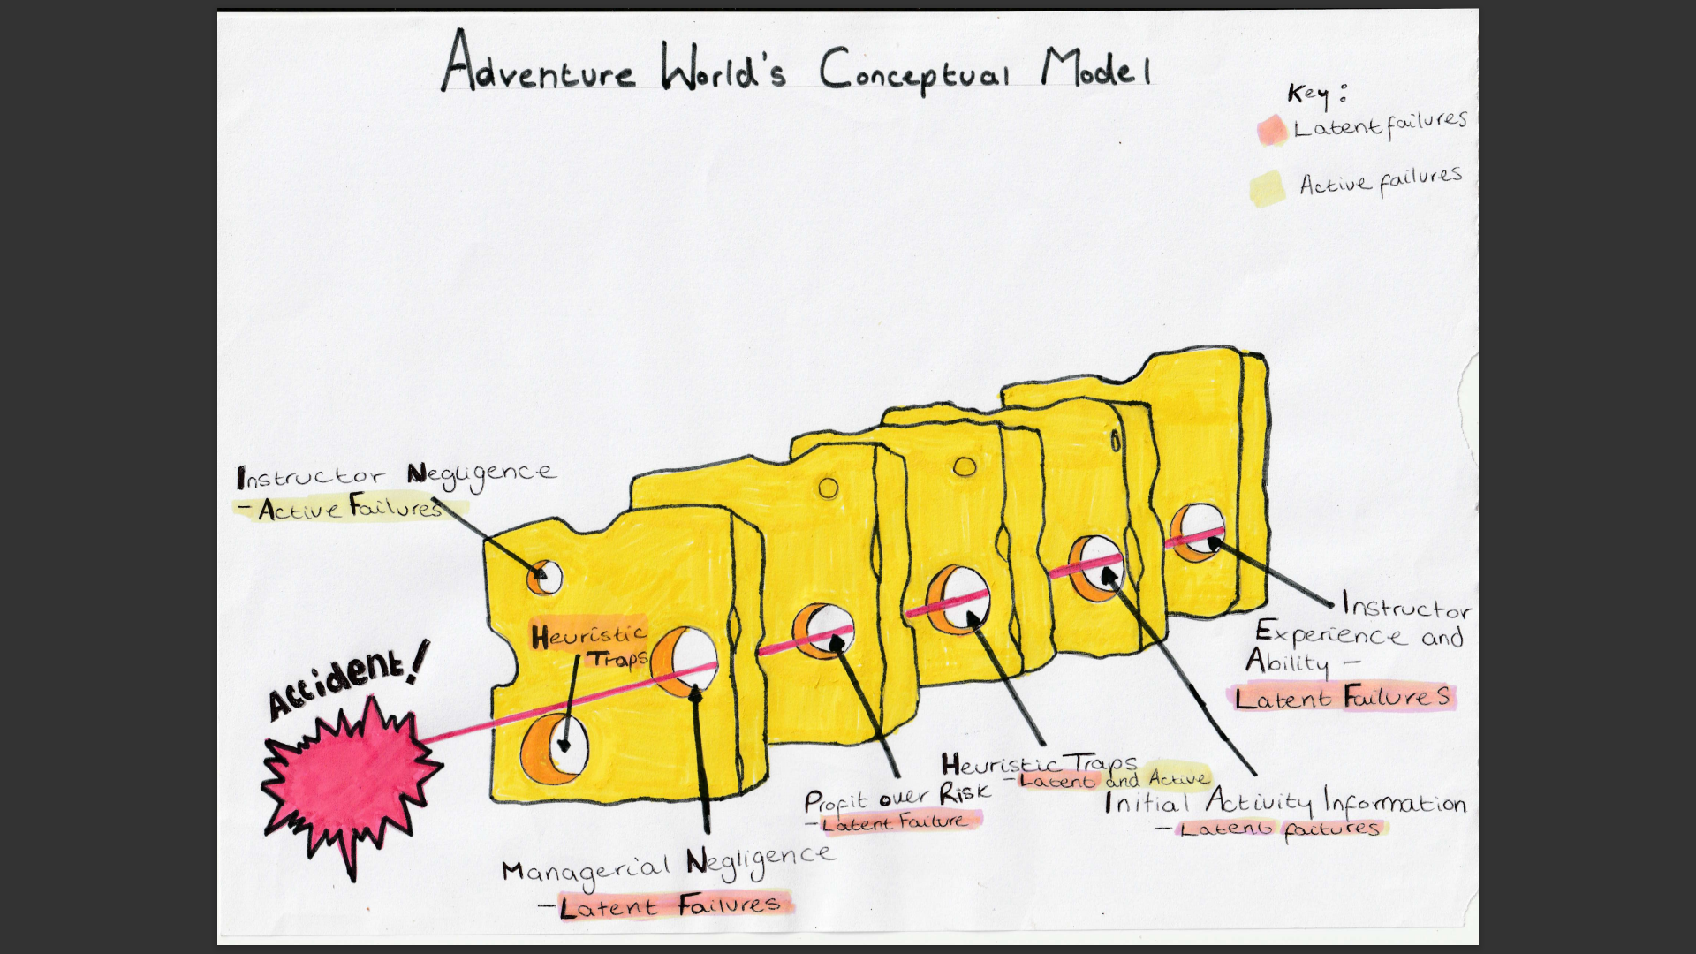

References

Barton, B. (2007) Safety, risk and adventure in outdoor activities. London: Sage.
Bell, S. and Bale, J. (1999) ‘Probe on canyon horror’, Inderpendent.ie, July 29. Available at: https://www.independent.ie/world-news/probe-on-canyon-horror-26145675.html (Accessed: 24 January 2023).
Froelicher, C. and Wienand, A. (2019) ‘'I just surrendered': How an Aussie survived disaster and found closure 20 years on’ SBS German, 14th October. Available at: https://www.sbs.com.au/language/german/en/article/i-just-surrendered-how-an-aussie-survived-disaster-and-found-closure-20-years-on/z6eajt2ai (Accessed: 24 Janaury 2023).
Giroud, T. (2017) ‘Safety still a question 20 years after Interlaken canyoning accident’, Alpine Environment. Available at: https://www.swissinfo.ch/eng/risk-sports_safety-still-a-question-20-years-after-interlaken-canyoning-accident/45105312 (Accessed: 24 Janaury 2023).
Hickman, M. and Stokes, P. (2016) ‘Beyond learning by doing: an exploration of critical incidents in outdoor leadership education’, Journal of Adventure Education and Outdoor Learning, 16(1), pp. 63–77.
Head, M. (1999) ‘Profit drive blamed for Swiss canyon tragedy’, World Solcialst Website, 6th August. Available at: https://www.wsws.org/en/articles/1999/08/swss-a06.html (Accessed: 24 January 2023).
Heath and safety executive (2021) Risk at Work - Personal protective equipment (PPE). Available at: https://www.hse.gov.uk/toolbox/ppe.htm (Accessed: 24 Janaury 2023).
Hulme, A. and Finch, C.F. (2015) ‘From monocausality to systems thinking: a complementary and alternative conceptual approach for better understanding the development and prevention of sports injury’, Injury Epidemiology. 2, 31.
Jenkins, M. (1999) ‘Storm in the distance’, Outside, 1st November. Available at: https://www.outsideonline.com/outdoor-adventure/exploration-survival/storm-distance/ (Accessed: 24 January 2023).
Johnson, J., et al. (2020) ‘Rethinking the heuristic traps paradigm in avalanche education: Past, present and future’, Cogent Social Sciences, 6(1), pp. 1807111.
Lashmar, P. and Karacs, I. (1999) ‘Swiss river disaster: Black wall of water swept down the gorge, crushing everyone in its path’, The Independent, 28 July. Available at: https://www.independent.co.uk/news/swiss-river-disaster-black-wall-of-water-swept-down-the-gorge-crushing-everyone-in-its-path-1109256.html (Accessed: 24 January 2023).
Leland, J. (1999) ‘A Wall of Black Water’, Newsweek, 8th August. Available at: https://www.newsweek.com/wall-black-water-165758 (Accessed: 24 January 2023).
Levine, T. (1999) ‘Swept away’, People, 16th August. Available at: https://people.com/archive/swept-away-vol-52-no-6/ (Accessed: 24 January 2023).
Manghani, K. (2011) ‘Quality assurance: Importance of systems and standard operating procedures’, Perspectives in clinical research, 2(1), pp. 34–37.
McCammon, I., (2002) Evidence of heuristic traps in recreational avalanche accidents. In Proceedings of the International Snow Science Workshop (Vol. 30).
Mitten, D. (2007) ‘An Analysis of Outdoor Leaders’ Ethics Guiding Decisions’, The Journal of experiential education, 29(3), pp. 373–377.
Outdoor Education Advisers’ Panel (2020) ‘4.1b Emergencies and Critical Incidents – Overview’ .Available at: https://oeapng.info/downloads/download-info/4-1b-emergencies-and-critical-incidents-overview/ (Accessed: 24 Janaury 2023).
Padilla-Meléndez, A., Fernández-Gámez, M.A. and Molina-Gómez, J. (2014) ‘Feeling the risks: effects of the development of emotional competences with outdoor training on the entrepreneurial intent of university students’, International entrepreneurship and management journal, 10(4), pp. 861–884.
Perneger, T. V. (2005). The Swiss cheese model of safety incidents: are there holes in the metaphor?. BMC health services research, 5(1), pp. 71.
Reason J. (1990) Human Error. Cambridge: Cambridge University Press.
Reason, J. (2016). Managing the risks of organizational accidents. London: Routledge.
Robinson, A (2015) Einstein: A Hundred Years of Relativity. Princeton: Princeton University Press.
Shooter, W., Sibthorp, J. and Paisley, K. (2009) ‘Outdoor Leadership Skills: A Program Perspective’, The Journal of experiential education, 32(1), pp. 1–13.
The Sydney Morning Herald (2002) Convicted Swiss drop their appeals over canyon deaths, The Sydney Morning Herald, 8th September. Available at: https://www.smh.com.au/world/convicted-swiss-drop-their-appeals-over-canyon-deaths-20020908-gdfm5v.html (Accessd: 24 January 2023).
Underwood, P. and Waterson, P. (2014) ‘Systems thinking, the Swiss Cheese Model and accident analysis: a comparative systemic analysis of the Grayrigg train derailment using the ATSB, AcciMap and STAMP models’, Accident Analysis & Prevention, 68, pp.75-94.
University of East Anglia (2018). Human failure. Available at: https://www.youtube.com/watch?v=XINCYII2K0c (Accessed: 24 January 2023).
University of East Anglia (2019). Identifying error Swiss cheese model at: https://www.youtube.com/watch?v=JRCMxfBULB4 (Accessed: 24 January 2023).
Zajchowski, C. A., Brownlee, M. T., and Furman, N. N. (2016) ‘The dialectical utility of heuristic processing in outdoor adventure education’, Journal of Outdoor Recreation, Education, and Leadership, 8(2), pp. 119-135.

