Academic and Employability Skills (BMSW 4001)
Reflective Writing
By
SCOTT UWAFIOKUN EWEKA 2122699
UNIVERSITY OF WALE TRINITY SAINT DAVID
Academic and Employability Skills (BMSW4001_BIRM)
Certificate of Higher Education Health and Social Care, Level 4
Lecturer Mr. Isiah Oino

CONTENT
INTRODUCTION:………………………………………….2 .. AIM………………………………………………………………3
Week One……………………………………………………..4
Week Two………………………………………………………….5
Week Three…………………………………………………………6
Week Four…………………………………………………………….7
Week Five……………………………………………………………….8
Week Six…………………………………………………………………9
WeekSeven………………………………………………………………10
he job vacancy title………………………………………………………..11
Week Eight…………………………………………………………………….12
Personal Development Form ………………………………………………13
Conclusion………………………………………………………………………14

.

INTRODUCTION

Higher education institutions are increasingly recognizing the importance of students' reflective skills for improving their lifelong learning and professional practice (Rogers , 2001). The value of reflective practice is widely accepted in educational circles, but the issue is that reflective practice is an 'advanced, sophisticated, intellectual, and emotional task which takes time to do well' (Rodgers, 2002). Therefore, reflective writing is writing about one thought, feeling, or action that is in the past. That is looking back, checking what was done, and identifying both the wrong and the right to learn to improve the future. By reflecting on the past, we can be able to improve on tomorrow.” Reflection is a promising teaching strategy for assessing students' understanding of the challenging concepts taught in interprofessional education. Reflective writing has been extensively reviewed in the various health profession” (Miraglia & Asselin, 2015). While (Sandars, 2009 ) put it this way “Reflection is a metacognitive process that creates a greater understanding of both the self and the situation so that future actions can be informed by this understanding.”.

AIM
This article aims to make us focus on learning from experience to improve practice. Critical reflective practice pays attention to our emotional responses and challenges our assumptions and the things we take for granted in our daily work of study. (Bassot, 2018).
It is important to reflect as a professional because of the following reasons
1, Provide us with a space for deep thinking. 2, Evaluate and develop practice 3, Prevent stagnation
4, help us to Strive for excellence 5, Make practice creative 6, Self-awareness
7, Being slow to make assumptions 8, Providing aid for supervision
9, Providing a means for constructing professional knowledge. This article aims to make us focus on learning from experience to improve practice. Critical reflective practice pays attention to our emotional responses and challenges our assumptions and the things we take for granted in our daily work of study. (Bassot, 2018). The reaction is regarded by many educationists and writing practitioners as a defining characteristic of student portfolios. (Fink, 2005), (Zubizarreta, 2009), (Jones & Shelton, 2011) Writing portfolios without reactions, according to them, are merely collections of written work that do not contribute to 'real' learning.” The act of reactive writing compels ‘the writer to examine, clarify, and crystallize thoughts and ideas that might otherwise be outing around the mind in disconnected fragments” (Jones & Shelton, 2011). It has become increasingly popular over the last few decades to use reflective practice in various fields of professional practice and education.
There are some professions where it has become one of the defining features of competence, even if, on occasion, it has been incorrectly and unreflectively used to rationalize existing practice.
This tendency to 'reflection bandwagon' is because it 'rings true' (Loughran, 2000).

Week One
On that first day at the University of Wales Trinity Saint David, I was very excited because, after 35 years of education, I was back again in class and in an English-speaking country. The lecturer Mr. Isaiah the lecturer, welcome us and introduce us to the module. The module name was Academic and employability skills and the module code was BMSW4001-BIRM. We were thought that day about notetaking and the skill. We were made to understand that notetaking is very important in our study as it enables us to remember the key point discussed in the lecture, we were also taught that day about time management. We were taught that skill is the ability to do something well and that academic skill is an Aspect of behavior learned by students while studying that is required to operate successfully at the level of higher education (Academic Skills Specialists, 2013). We were also taught the factor that determines a good taking which includes the density or complexity of the information and how fast the information is presented. We also talked about working memory (WM) how some people can hold up to 10 pieces of information at a time, while others 3 information, that the average is 6 information, and that our working memory governs our ability to understand what we read or hear

Week Two
In week two, we were introduced to an assignment, on how to evaluate sources of pieces of information
Where we can begin research which is
The UWTSD online library ( www.used.ac.UK/library ), Google Scholar a useful tool for finding academic sources of information (https://scholar.google.co.uk/ ), Some UK government websites. ( www.gov.uk ) The NHS website. (www.NHS.uk ) etc. We were taught that Some sources are not reliable, like Wikipedia, YouTube, and blogging websites
can be edited by anyone and are not peer-reviewed and verified. And that to test the reliability of any information, The CRAAP Test was developed by Blakeslee (2004). It is a list of questions to help you evaluate the information you find. (Blakeslee, 2004)
the CRAAP test which stands for
Currency: The timeliness of the information
Relevance: The importance of the information for your needs.
Authority: The source of the information.
Accuracy: The reliability, truthfulness, and correctness of the content.
Purpose: The reason the information exists.

Week Three:
Understanding Referencing & Plagiarism
We learned the meaning of Referencing. regarding the who, what, when, where, why, and how.
We were also taught that we should always reference our work and that when we reference our work correctly, it shows that we have read widely and that we acknowledge the owner of the piece of work or article we are using in our writing. We were also taught about in-text citation and the reference list we were also shown a video about Harvard Referencing and reflection. The lecturer Mr. Isaiah also lecture us about Plagiarism, its meaning, and how to avoid it.it was also established that Plagiarism is an academic offense a lecture was made on how to paraphrase our work to reduce similarity. And never eliminate referencing our work even when it has been paraphrased.
In that lecture, I understand referencing and citation in the context of my writing and understand the serious nature of committing an academic offense. And practice constructing references for books, websites, and journals.

Week Four
Academic Writing: In this week, we were taught How sentences work “A sentence must have a verb, a doing word (McMillan & Weyers, 2014). There are three types of sentences. A simple sentence, compound sentence, and complex sentence. Simple sentences are sentences that have a verb and a phrase. Compound sentences are sentences that are joined together by either “and” or” but” while complex sentences are sentences with the main clause and a subordinate we were also taught about the use of Data in our writing. how to build data in or around our sentences we learned about Plan Timeline which involves the gathering of information, processing of information, final check-up, and submissions. In this week’s lecture, I have learned the Composition of sentences
Composition of paragraphs
Using data and planning my assignments

Week Five
Presentation Skills Workshop and Academic Report Workshop.
Professional looking at the presentation skill report, we disused what makes a good presentation, while in the academic skills report we revised what we have learned in the previous week. We looked at note-taking methods and time-management strategies. We spoke about how to find information. We looked at Harvard referencing and talked about academic writing.
We also learned how to create professional-looking presentations, slides, and designs. A video about what makes an excellent assignment was also shown to us.
An excellent assignment concentrates on the subject, topic, or task at hand. has a well-defined framework that is simple to follow. is evidence-based and well-researched The word limit, page numbering, margins, line spacing, font type, and spelling are all appropriately referenced and effectively presented.

Week Six
Introduction to Employability skills
In week six,
we studied the meaning of employability skills as the ability to obtain and maintain decent employment. We also look at A series of accomplishments, understandings, and personal characteristics that make people more likely to find work and succeed in their chosen fields. We also looked at the different carrier paths set up by the government of the UK for people to learn different careers. We were able to look at some jobs titles and their duties example business and finance under ( Bank Banking) customer service adviser job include Banking customer service advisers providing face-to-face service in banks and building societies.
We looked at what it meant to have employability skills, which we defined as the capacity to find and keep good jobs. We also look at several achievements. we were shown a video of an Amazon company in Germany with the Managers, their work, and their responsibilities example Dennis the Pack Area Manager in Graben, in MUC3, south Germany near Munich, Johannes the Area Manager for customer returns and vendors in Amazon's distribution canter located in the south of Germany. Some of the jobs of the Manager include performance, productivity, quality, and safety of the various department.
We also look at Some Skills Employers look for in an interview including
Verbal Communication: The ability to express ideas clearly and confidently in speech
Teamwork: Able to work with a group
Commercial Awareness: understand the commercial reality affecting a company
Self-motivation initiative, Drive and Analysing and investigating. We were later giving some class Activity, which is to look for a job in a family support film
And identify a job role, the key skills required for success in the job, and the skills we already have. And
The skills we need to develop

Week Seven
Navigating Job ads & Group work.
In week seven, we were given a group task. We were asked to work together in choosing a specific job role. Design a job advertisement for the job role. Include all the key information required. Present your job ad as either a poster, presentation, or video. Share your finished job ad with your peers and receive feedback we created a job postal Thrill Ville Company name was:​SASLT Domestic Abuse Support 10 Brindley Place, Birmingham, B12JB our logo was” Reaching out to the hard to Reach”
The job vacancy title Domestic Violence Support Worker
Description of the task: was to carry out initial assessment, and risk assessment in cases of domestic abuse and to liaise with supporting agencies.
To be able to support victims with housing and welfare benefit application
To be able to direct the victims to counselling services
advert was. Do you have what it takes to help people overcome domestic abuse?
Our team is looking to recruit several domestic abuse support workers to support victims of domestic abuse in refugees, support accommodation, and outreach services.
SASLT provide safe accommodation and ensure their safety and make sure the victims have access to all the options and services and they understand their rights.
Our “Essential Requirements Experience supporting Victims of DV
Strong Safeguarding and risk assessment skills
DBS issued within the last 12 months
Work hours 9-5 Monday-Friday
(On-call in case of emergencies).
What we offer!
Excellent rates of pay
Paid 28 days (about 4 weeks) of annual leave including Bank Holidays
Optional overtime on weekends with flexible hours
Potential of long-term placement
Comprehensive career development
Employee assistance
1 to 1 training
Bonus payment of £300 payable to new staff who join us with a level 4 health and social care at workplace qualification
Job Role
Support victims of DV and their children in refugees supported accommodation and outreach
Support clients with practical and emotional needs including safety, housing benefits, financial, social inclusion, schooling, mental health, and sexual abuse.
Annual Salary £19000 a year With a possible rise to £25000 with enough experience
Application Deadline
28th of March 2022
Contact Us
SASLT Domestic Abuse Support
10 Brindley place Birmingham B12 Jb
TelF:01217894432
SASLTdvsupport@outlook.com
Visit us on the Web:
HTTP:/SASLTSsupport.co.uk

Week 8
Group Task Presentation Week
Group Task Presentation Week
This was the week of presentation. Each completed their presentation finished work.
we then presented and explained their completed Job Ad Each group will evaluate the work of their fellow groups
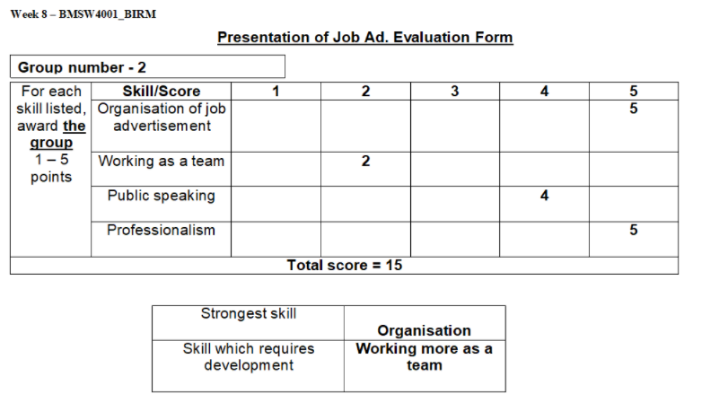

This was the graft of the evaluation form where we identify four main skills namely
Organisation of job advertisement skill
Working as a team skill
Public speaking skill
Professionalism
In this graft, the strongest skill was the Organisation of job advertisement
While the skill we have to work on was working more as a team

MY PERSONAL DEVELOPMENT FORM(PDP)
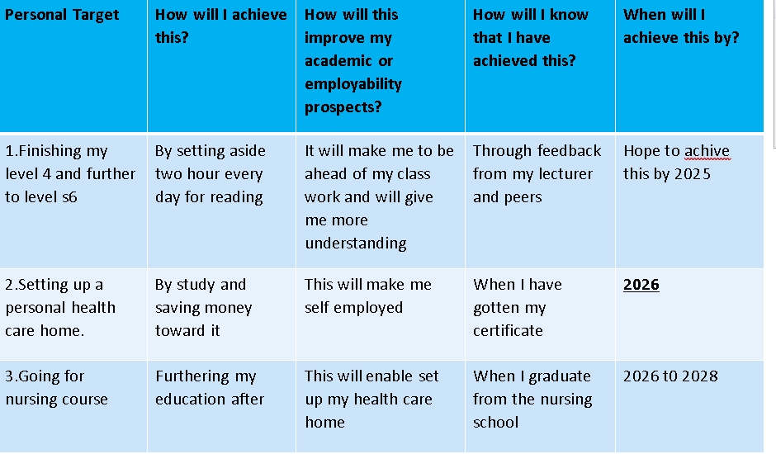

.

Conclusion
Looking back at the start of the course and checking were i am now in terms of education, i can see my dream coming through i now Understanding Assignments & Finding information,case study ,how to successfull do a report.

