RAPORT-EFFECTIVE TEAM-WORKING AND COMMUNICATION
Student ID: 2127563
Student Name:Dragos Axente
Course Name: BMSW 4002

Executive summary
The report entitles the conceptualisation of effective teamwork and communication standard as a success factor of the organisation. In the absence of a proper communication channel, standard, and process, the teamwork concept cannot be evaluated in the modern business world. As the teamwork concept is dependent on communication factors, the absence of an effective conversational flow resists making a team dynamic situation. Through the implication of an open-ended and transparent communication process and Tuckman or Belbin-based teamwork concept, the organisational market sustainability level can be up-scaled. The report is also entitled how different communication models such as Shannon-Weaver, Schram, and Berlo are used in the selected case example for making an effective communication environment.

Table of Contents
Introduction 4
Task 1 4
Application of teamwork theories in teamwork amendments in the case study-based organisation 4
Task 2 7
Detailed demonstration of the particular barriers experienced within the case study enterprise 7
Illustration of each of the communication models 8
Recommendations for each key issue in case scenario 10
Conclusion 11
References 12

Introduction
Concrete communication is playing a significant role in maintaining transparency and an open-ended understanding scenario among employees in business enterprises. The prime benefit of using an effective communication process in the contemporary business world is to streamline the conversational flow in a team and improve the organisational aggregate productivity and profitability structure. The effective team-working concept in the modern business landscape promotes group thinking and group-based problem-solving approaches for betterment in business operational excellence.

Task 1

Application of teamwork theories in teamwork amendments in the case study-based organisation
Tuckman leadership theory
The prime purpose of using this leadership theory in the business world is to explain the team’s level of capability, maturity, and relationship-building styles. The model illustrates directing styles at the beginning, then proceeding toward coaching, and next, participating with a delegation.
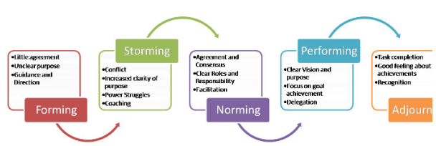
Figure 1: Tuckman concept in leadership
(Source: Plush, 2018)
Stage 1: Forming
According to Kiweewa et al., (2018, p. 280), teamwork is recognised as a significant capability to work in a group with full potential for achieving specific goals and agendas. This is the initiation phase where the new members join a team and are completely unsure about their exact responsibilities and role-play. Uncertainty and stress are present among the teammates as they are meeting with each other for the very first time. In contrast, there is also a level of excitement about the new members and the teammates are highly dependent on the leader’s direction and guidance. Considering the example of a case scenario organisation, the leaders should be sufficiently prepared to answer all the questions thrown by their new members for doubt clearing. In this phase, Andrea Jones could be also available to distribute the tasks among the teammates equally and transparently share the team’s objectives at the earliest stage.
Stage 2: Storming
In this phase, the teammates may face both agreement and disagreement while working in a group. During this phase, the clarity of the team’s motto is increased but there can be a wider chance of persisting uncertainties (Nawi et al., 2022, p. 936). For example, Andrea Jones could promote group-based decision-making and collaborative work culture maintenance among her teams for the timely achievement of predefined goals.
Stage 3: Norming
This is the third phase where consensus and agreement are formed among the teams to evaluate an effective team productivity rate. By considering this phase, Andrea Jones could clearly define the specific roles of each teammate and make them assure to become involved in developing stress-free teamwork. The selected leader could allow the team to make a small decision separately while the big decisions could be formulated with participative decision-making styles.
Stage 4: Performing
It is the final stage where the team’s strategic awareness level is upgraded and is also fully clear about the significance of teamwork (Patsute, 2020). Considering the case example, Andrea Jones could provide a high degree of performance autonomy to hit the predefined goals. The teammates can independently perform their assigned tasks and make a knowledge-sharing and idea-exchanging culture for betterment in their performance rate.
Step 5: Adjourning
In this phase, the leaders and teammates are involved in a discussion about what worked perfectly and what did not. For example, in this phase, Andrea Jones could celebrate the success milestones of their social services by clicking pictures and capturing video-based reviews from the benefitted social community.
Belbin leadership theory
The prime benefit of using this kind of leadership theory in business enterprises is to select appropriate labour for developing a high-performing team. Through the implication of this leadership theory, the strategic leaders in the business can be able to perfectly develop high-performing virtual teamwork.
Team roles | Conceptualisation | Application
Resource investigator | Showcases their inquisitive trait to identify ideology for bringing back to the learning mode | Acquiring this type of teammate in a team, Andrea Jones could be able to gather more innovative ideations and expand opportunities in developing unique social services for the community.
Teamworker | This type of member in a team integrates their versatility for developing a diplomatic and cooperative approach to achieving the team's goals (Türkben and Hammadi, 2022, p. 1126) | By possessing this kind of teammate, the huge level of work-based transparency between 96 members or 8 teams could be maintained by Andrea Jones
Coordinator | Focusing on the team's objectives and delegating the works | This type of teammate could help Andrea Jones to maturely and confidently handle their responsibilities and improve the overall team performance level
Plant | They are good at problem-solving and possess a high degree of innovative mindset | Possessing these kind of teammates, the creative thinking skills and solving difficulties could be visualised which could help Andrea Jones to promptly resolve the team conflict and focus on minimising the operational complexities
Monitor evaluator | Possessing a logical eye and having impartial judgemental skills (Jones et al., 2020, p. 330) | Possessing this type of teammate, Andrea Jones could maintain a high-performing team culture where the team could judge both minor and major issues logically and make more strategic decisions for overcoming them
Specialist | Having the characteristic of self-motivated, single-mindedness, and dedicated | These teammates could provide specialist professional knowledge only such as offering financial advice for the selected case study firm. Therefore, the sharpen prevention of budgetary shortage issues while involved in a particular project in social services.
Shaper | Possesses a dynamic and challenging nature under pressure | These teammates could have positive reinforcement in making a high emotional resilience while the teammates of the selected case study enterprise have to perform their work under severe work pressure.
Implementer | Acquiring the traits of efficiency, practical-oriented, and reliability | Selecting these types of teammates in Andrea Jones’ teams, the ideas are transformed into actions and more realistic social service policies and protocols are constituted.
Complete finisher | Possessing the characteristics of searching out errors, being conscientious, and anxious | Andrea Jones could be able to deliver more polished and error-free social services as the team members are involved in scrutinising the errors for quality control in the offered services.

Task 2

Detailed demonstration of the particular barriers experienced within the case study enterprise
The case scenario reveals that Andrea Jones is appointed as a new Head of Social Services in the Local Council and handles 96 Social Workers or 8 teams at a time. During the pandemic session, the firm has experienced “a being separated” kind of issues in a Work-From-Home era and eventually far away from the track of office-based work culture. Another crucial complexity, that was ongoing in the firm, was the presence of a “high degree of employee turnover” and “increased staff absenteeism concept. This scenario created an “enlarged staff shortage” ambience in the workplace, resulting in the performance degradation of the enterprise.
On the other hand, the “team’s underperformance” is recognised as one of the key barriers as the teams are consistently involved in a forming stage and henceforth, the absence level among the social workers was visualised. In this context, the firm is facing a “poor mental well-being status of staff” as the employee shortage scenario created a huge work pressure. Therefore, the rest of the staff had to forcefully take on extra responsibilities and were unable to maintain a great balance between their personal and professional lifestyles (Salas et al., 2018, p. 593). Eventually, “staff stress” is also recognised as a great issue in this firm as this reported the appearance of decision-making divergence. For instance, one social worker makes suggestive ideation for rescuing the child from the risky atmosphere while another social worker completely declines the ideology.
Another vital hurdle was that the firm experienced a “permanent manager shortage for some teams”. As a result, some teams were not getting proper guidance and were unable to make more concrete decisions regarding the offering of exclusive social services. The firm is also facing the issues such as a “poor relationship standard between social workers” and as a result, an effective teamwork concept was completely broken. During the unlocking phase, the employees returned to their work-from-office culture and were unable to spend more time with their family mates, resulting in the presence of demotivating attitude among the workers.
Besides, the employees interacted with a lot of new faces and then they just put their heads down, finished their assigned tasks, and backed home, resulting in the consideration of poorly written cases and reports. Another barrier is the “presence of verbal and informal directions” from the leader’s end and henceforth, a misunderstanding, increased level of mistakes, and diluted message type of ambience was created. Absence of the “meeting conduction concept”, the team’s performance level was not tracked and the overall performance of the firm was degraded. The available managers were too busy firefighting to address such kinds of issues and make decisions for employee training. Another crucial issue is that the last Head of Service was handed off and he preferred to connect with the staff via email and the majority of the time he was in a delay to respond. He only arranged an occasional meet-up with the managers in a one-way proforma, resulting in the presence of a communication gap and zero scopes of teamwork.

Illustration of each of the communication models
Berlo communication model
According to Muyanga and Phiri, (2020, p. 452), this communication model is associated with four factors such as “sender”, “message”, “receiver”, and “channel”. Through the implication of this model, an effective communication scenario can be articulated if both the “receiver” and “sender” are in a similar dimension (Dimbleby and Burton, 2020).
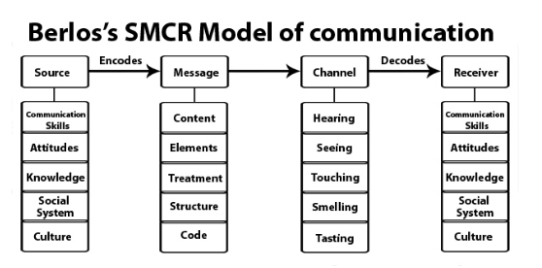
Figure 2: Berlo’s communication framework
(Source: Communication Models, 2019)
By using this kind of communication process in the considerable case study firm, Andrea Jones could share upgraded information regarding business performance and maintain a huge level of transparency with her 8 teams.
Shannon-Weaver communication model
As opined by Gillespie and Schiffman, (2018, p. 220), Shannon-Weaver’s linear communication model is popular as it demonstrates how important content and messages are sent to the receivers by the senders through a proper transmitter and channel.
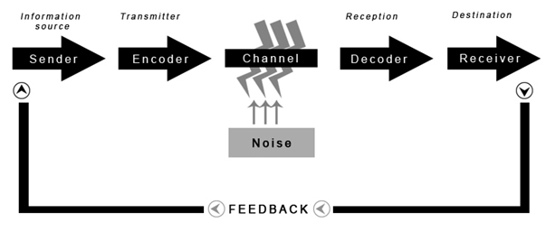
Figure 3: Shannon-Weaver communication
(Source: Communication Models, 2014)
Through the implication of this communication model in the selected case firm, Andrea Jones could gather feedback-based information from her teammate’s end to make a communication benchmarking. By getting feedback from the receiver’s end, she could make changes in resources (budget, service facility offering style, organisational structure and culture-based innovation, and employee training) for upgrading the firm’s goodwill.
Schram communication model
As stated by Muksin et al., (2021, p. 142), Schram’s circular communication model is recognised as reciprocal and equal while three communicating steps such as “encoding”, “decoding”, and “interpreting” are integrated.
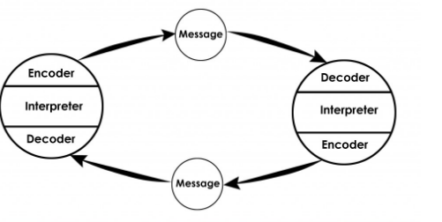
Figure 4: Shannon-Weaver communication
(Source: Communication Models, 2014)
For example, through the application of this type of communication model in the selected case scenario, both ends can play the role of receiver and sender to make a two-way and more open-ended communication platform. During the communication between Andrea Jones and the last Head of Social Service, both make a circular communication flow to foster more innovative ideation for the betterment of service facilities and the firm’s fame level.

Recommendations for each key issue in the case scenario
Considering the above-mentioned issues for the selected case firm, the suggestive ideas are revealed,
R1: Investment in employee training sessions for team performance boosting
This recommended action would reduce the employee absenteeism rate and boost the staff motivation level. By sharpening the existing interpersonal, technical, and professional knowledge, the social workers of this firm would be able to make connections with each other and minimise the staff turnover scenario.
R2: Implication of adequate meet-up sessions for minimising staff turnover and absenteeism
Through the consideration of this suggestive ideation, the strategic leader, Andrea Jones and other heads of service facilitators of the selected firm would connect with their teammates and track the gap between the team conflict rate and group performance score. It would help to share formal and written directions with the teams to achieve the goals on time.
R3: Talent hiring for staff shortage issue mitigation
This strategy would reduce the staff shortage scenario if the management of the selected firm focuses on the “regional talent-hiring” concept with zero discrimination against age, culture, and gender.
R4: Revolution of staff mental happiness sessions for work pressure addressing
This recommended approach would provide tips to the social workers on how to hold self-patience in a most challenging and excessive workload situation and make a valid decision in a stressful situation.
R5: Consideration of “clan” culture for staff connectivity development
This strategic suggestion would promote coordinated team culture and group-based innovation approach with a transparent, knowledge-sharable, ideology-exchanging, and mutual understanding-based connectivity among the teammates for embracing the firm’s performance.

Conclusion
Good teamwork in the business enterprise embraces the staff efficiency rate and overall productivity level of the organisation. The prime impact of using a teamwork concept in the business territory is to foster better ideation for minimising business obstacles. The teamwork concept upgrades the staff motivation and employee morale rate, reflecting the improvement of the staff involvement rate and overall team performance scale. The basic advantage of applying leadership theories in the business enterprise is to measure the group dynamics rate and the procedure of building an effective teamwork culture.

References
Books
Dimbleby, R. and Burton, G., 2020. More than words: An introduction to communication. Routledge. https://www.academia.edu/download/33621338/More_than_words_an_introduction_to_communication.pdf
Patsute, R.D., 2020. The Spirit of Leadership: A Complete Book on Understanding Leadership. Notion Press. https://books.google.com/books?hl=en&lr=&id=2q7_DwAAQBAJ&oi=fnd&pg=PT6&dq=leadership+model+book&ots=pRMw_yCOCm&sig=N9L6u_iBc8JAzppt0xJyykkONw0
Journals
Gillespie, D.J. and Schiffman, R., 2018. A critique of the Shannon-Weaver theory of communication and its implications for nursing. Research and Theory for Nursing Practice, 32(2), pp.216-225. https://connect.springerpub.com/content/sgrrtnp/32/2/216.abstract
Jones, G., Chace, B.C. and Wright, J., 2020. Cultural diversity drives innovation: empowering teams for success. International Journal of Innovation Science. Vol. 12 No. 3, 2020 pp. 323-343 Emerald Publishing Limited 1757-2223 DOI 10.1108/IJIS-04-2020-0042
Kiweewa, J.M., Gilbride, D., Luke, M. and Clingerman, T., 2018. Tracking growth factors in experiential training groups through Tuckman’s conceptual model. The Journal for Specialists in Group Work, 43(3), pp.274-296. https://www.tandfonline.com/doi/abs/10.1080/01933922.2018.1484539
Muksin, N.N., Shabana, A. and Tohari, M.A., 2021, June. Online Based Communication Model For Indonesian Migrant Workers In Hong Kong On Financial Management. In Journal Universitas Muhammadiyah Gresik Engineering, Social Science, and Health International Conference (UMGESHIC) (Vol. 1, No. 1, pp. 138-146). http://journal.umg.ac.id/index.php/umgeshic/article/download/2746/1679
Muyanga, C.C. and Phiri, J., 2020. Assessment of Effective Communication in International Schools in Developing Countries Based on the Berlo’s SMCR Model. Open Journal of Business and Management, 9(1), pp.448-459. https://www.scirp.org/journal/paperinformation.aspx?paperid=106967
Nawi, M., binti Nordin, N.A., binti Zabidin, N. and Sain, N., 2022. Group Online Engagement: An Analysis From Tuckman Model. Journal of Academic Research in Business and Social Sciences, 12(9), pp.931-949. https://knowledgewords.com/images/group-online-engagement-an-analysis-from-tuckman-model.pdf1663837680.pdf
Salas, E., Reyes, D.L. and McDaniel, S.H., 2018. The science of teamwork: Progress, reflections, and the road ahead. American Psychologist, 73(4), p.593. http://tarjomefa.com/wp-content/uploads/2018/02/263-English-TarjomeFa.pdf
Türkben, A.K. and Hammadi, Z.R., 2022. Developing A Student Team Formation Using Belbin Team Role With Fuzzy Technique. Computer Integrated Manufacturing Systems, 28(11), pp.1124-1136. http://cims-journal.com/index.php/CN/article/view/316
Websites
Communication Models, I.C. (2014) Osgood- Schramm Model of Communication, Communication Theory. Available at: https://www.communicationtheory.org/osgood-schramm-model-of-communication/ (Accessed: December 16, 2022).
Communication Models, I.C. (2014) Shannon and Weaver Model of Communication, Communication Theory. Available at: https://www.communicationtheory.org/shannon-and-weaver-model-of-communication/ (Accessed: December 16, 2022).
Communication Models, I.C. (2019) Berlo's SMCR model of communication, Communication Theory. Available at: https://www.communicationtheory.org/berlos-smcr-model-of-communication/ (Accessed: December 16, 2022).
Plush, S. (2018) Tuckman's Model of Group Development, LinkedIn. Available at: https://www.linkedin.com/pulse/tuckmans-model-group-development-sonal-solanki (Accessed: December 16, 2022).

