

Name: Olakitan Adeusi
Student ID: 2412888
Module: Changemakers: Building My Personal Brand for Sustainable Employment
Module code: BMHP5015
Lecturer: Olufemi Oluranti
Topic: Portfolio Component 1
Date: 05/07/2026
Word count:2917

Task 1 – Personal Brand
Write about your own person brand and how you could develop this to enable you to reach your employment goals (250 words- Minimum of 2 referenced sources)
My personal brand is centred on compassion, self-reflection, and a strong commitment to upholding dignity, wellbeing, and individual rights, which closely aligns with my aspiration to pursue a career in social care. I strive to be an active listener, communicate with empathy, and respond to challenges in a professional and patient manner. These qualities enable me to build positive relationships and prove the core value expected of health and social care professionals. Personal branding involves communicating one’s strengths, values, and professional identity to potential employers, and I aim to present myself as dependable, ethical, and dedicated to making a meaningful contribution to the lives of others (Peters, 1997).

To achieve my career goals, I recognize the importance of continually developing my skills and professional profile. A key area for improvement is enhancing my digital presence, particularly through professional networking platforms such as LinkedIn, to highlight my qualifications, experience, and commitment to ongoing professional development. Evidence suggests that supporting a strong professional online identity can improve employability and increase visibility within competitive job markets. In addition, I intend to strengthen my understanding of safeguarding practices, develop confidence in multi-agency collaboration, and gain further practical experience through supervised learning opportunities. Through reflective practice, constructive feedback, and continuous learning, I can further develop a personal brand that reflects my values and values and preparedness for a career in social work.
In summary, cultivating a strong personal brand will enhance my professional profile and support my progression towards becoming a qualified social worker (Khedher,2015).

Task 2 - Network Map and RationaleCreate a map of your own network considering career, support, social and community dimensions. Additionally, you should provide a supporting rationale explaining and critically assessing this (250 words-Minimum of 2 referenced sources).
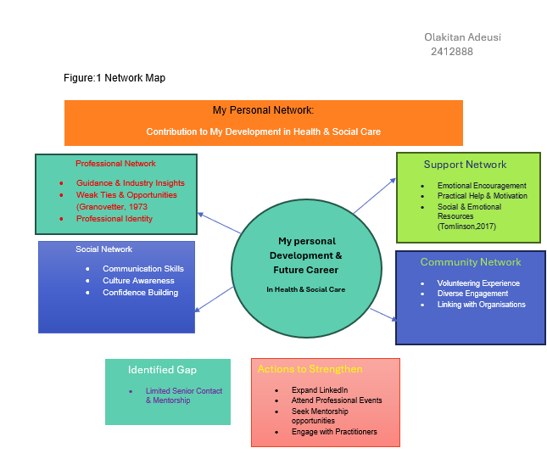
My personal network comprises for keys areas: professional, support, social and community networks, which contribute to my personal development and future career in health and social care. Professionally, I am connected to lecturers, tutors, placement supervisors, and LinkedIn contacts who provide guidance and industry insights. Many of these relationships are weak ties that offer access to valuable information and career opportunities (Granovetter, 1973).

My support network includes family, friends, and fellow students who provide emotional and practical support during academic and placement challenges. This reflects the importance of social and emotional resources in employability. Additionally, friendships, faith groups, and online communities help develop my communication skills, confidence, and cultural awareness, which are essential for effective, person-centred health and social care practice (Tomlinson, 2017).

My community network includes local organisations, voluntary groups, and faith communities that provide opportunities for volunteering, practical experience, and with engagement with diverse groups. These experiences enhance my understanding of different perspectives. While my network offers strong personal support, I plan to expand my professional connection through LinkedIn, professional events, and motoring opportunities to enhance my employability and support my goal of becoming a qualified social worker.
Task 3- Blog
Write a blog exploring a current topic or issue of your choice within the health and social care sector in the UK. The purpose of this is to inform a specific target audience of your choosing (400 words).
Figure:2 Prevanlence of anxiety and group in the UK.

Public Health England (2023) NHS Digital (2022).
The chart illustrates that individuals in lower-income groups experience higher levels of common mental health problems compared with those in lower-income groups.
Public Health England (2023) NHS Digital (2022).
Mental Health and Health Inequalities in the Uk
Introduction
Mental health inequalities continue to be a major public health concern in the United Kingdom. Research consistently proves that people from lower income background experience higher rates of mental health conditions, including anxiety and depression, and are more likely to have unmet mental health needs. For Health and Social Care students, understanding the impact of social and economic disadvantages on mental health outcomes is essential for promoting fair, person-centred care. The chart illustrates a clear relationship between income level and mental health outcomes, showing the in the lowest income group experience more than twice the prevalence of anxiety and depression compared with those in the highest income group (Mental Health Foundation, 2024).
Main Discussion
Mental health inequalities are strongly influenced by the wider social determinants of health, such as housing conditions, employment opportunities, education attainment, and access to community resources. Individuals living in deprived areas are often exposed to long-term stressors, including financial hardship, insecure employment, overcrowded housing, and limited access to recreational and green spaces. These factors can negatively affect mental wellbeing and reduce opportunities for recovery and resilience (Department of Health and Social, Care2018, Mental Health Foundation, 2024).
Young people from disadvantaged backgrounds are particularly vulnerable to poor mental health outcomes. They may face more challenges, including educational pressures, digital exclusion, and restricted access to early intervention and mental health services. Furthermore, the COVID-19 pandemic worsened existing inequalities, as many low-income communities experienced increased social isolation, disruptions to education, and heightened family and financial pressures (Guardian, 2025).
Inequalities are also clear in access to mental health services. Although digital mental health interventions and online support services have expanded significantly, not all individuals can benefit equally. Limited internet access, lack of digital skills, and financial barriers may prevent some groups from engaging with online therapies and support platforms, thereby widening existing disparities in mental health care (Mental Health Foundation 2024).
Conclusion
Reducing mental health inequalities requires a collaborative approach involving health, social care, education, and community organisations. Healthcare professionals should adopt culturally sensitive and trauma-informed practices while supporting policies that address poverty, improve living conditions, and enhance access to mental health services. For future Health and Social
Care practitioners, recognizing the influence of social and economic factors on mental health is crucial to deliver compassionate, effective, and fair care.
Task 4- NHS Equality, Diversity and Inclusion Quiz (250 words equivalent)
1 What is the primary goal of the NHS Equality, Diversity, and Inclusion Improvement Plan?
The plan is to improve equality, diversity, and inclusion across the NHS workforce and ensure all staff feel valued, respected, and able to thrive in the workplace (NHS England, 2023).
2.How does the NHS EDI Improvement Plan propose to tackle the gender pay gap?
The NHS EDI Improvement plan aims to reduce the pay inequalities through pay-gap analysis, targeted actions, flexible working career progression, and ongoing monitoring (NHS England,2023).
3.What is meant by the term ‘intersectionality’ as used in the NHS EDI Improvement Plan?
understanding that individuals may experience multiple and overlapping forms of discrimination or disadvantage based on their various identities and characteristics, requiring a more holistic approach to equality and inclusion (NHS England,2023).
4.Why is it important for the NHS to create a psychologically safe work environment?
Psychological safety supports open communication, teamwork, and patient safety by enabling NHS staff to raise concerns without fear of blame (NHS England, 2023).
5.How does the NHS EDI Improvement Plan suggest improving the experience of internationally recruited staff?
The NHS Equality, Diversity, and Inclusion (EDI) Improvement plan support internationally recruited staff through inclusive workplaces, wellbeing support, effective induction, and equitable career development opportunities (NHS England, 2023; 2024).
6.What role does leadership play in advancing EDI objectives according to the NHS Improvement Plan?
The Leadership is fundamental to promoting EDI within the NHS by demonstrating inclusive practice, establishing clear expectations, and fostering an environment where staff feel respected and confident to voice their concerns (NHS England, 2023).
7. Identify one way the NHS EDI Improvement Plan aims to reduce health inequalities within the workforce.
The NHS EDI Improvement plan promotes fair career development and progression, helping staff from diverse backgrounds advance equitably within the workforce (NHS England,2023).
8. Why does the NHS EDI Improvement Plan emphasise the importance of collecting and analysing data on protected characteristics?
The NHS EDI plan uses data on protected characteristics to identify inequalities, monitor progress, reduce disparities, and support inclusive workforce decisions (NHS England, 2023).
9. Explain how flexible working policies can contribute to equality and inclusion in the NHS workforce.
Flexible working arrangements promote equality, diversity, and inclusion by supporting work-life balance, improving wellbeing, and increasing accessibility for staff with caring responsibilities, disabilities or long-term health conditions (NHS England,2023).
10 What is one strategy mentioned in the NHS EDI Improvement Plan to combat bullying and harassment in the workplace?
The NHS EDI Improvement plan strengthens reporting and accountability to address bullying and harassment, encouraging safe reporting and promoting an inclusive workplace culture (NHS England, 2023).
Task 5- A Letter to Yourself
Think of a time in the past when you may have been experiencing issues or difficulties, and after considering what you have learned in this module about emotional intelligence and resilience write a letter to your younger self explaining how these attributes were important at that time and perhaps how developing these areas could have been useful (300 words)
Dear Younger Me
I am writing to you from a place of greater understanding gained through studying emotional intelligence and resilience, two concepts that would have been highly valuable during one of the most difficult periods of your life. I clearly remember the challenges you faced when trying to secure accommodation while preparing for your GCSE examinations, alongside coping with the loss of parents within an abbreviated period. The combined impact of grief, academic pressure, and Instability placed significant strain on your emotional wellbeing, leaving you overwhelmed and uncertain about how to cope effectively. At that time, your understanding of intelligence was limited. You often suppressed your emotions, believing that strength meant remaining silent and not expressing how you felt. However, emotional intelligence involves recognizing, understading, and managing emotions in a healthy and constructive way. It would have helped you show feelings such as fear, sadness, and exhaustion, while encouraging you to seek support and communicate your needs appropriately. This reflects the importance of emotional awareness and self-regulation in supporting wellbeing (Goleman,1996).
Similarly, resilience was understood as simply enduring difficulties without showing vulnerability. In contrast, resilience is now recognized as a dynamic process involving adaptation, reflection, and help-seeking. With his understanding, you have felt more confident reaching out to teachers, friends, or trusted adults instead of facing challenges alone during a highly stressful period (Southwick et al., 2024).
Despite these experiences, you proved early resistance by continuing your education, adapting to difficult circumstances, and persisting through adversity. These challenges contributed to your personal growth, strengthening your empathy, adult determination, and commitment to development.
It is important for you to understand that your struggles were not a sign of weakness but the result of circumstances beyond your control. Emotional intelligence and resilience would have helped you recognize that seeking support is a strength and that healing takes time.
With compassion,
Your future Self.

Task 6- GANTT Chart (200 words equivalent)
Compile a Gantt chart which illustrates the tasks you must complete to achieve your future.
employment goals.

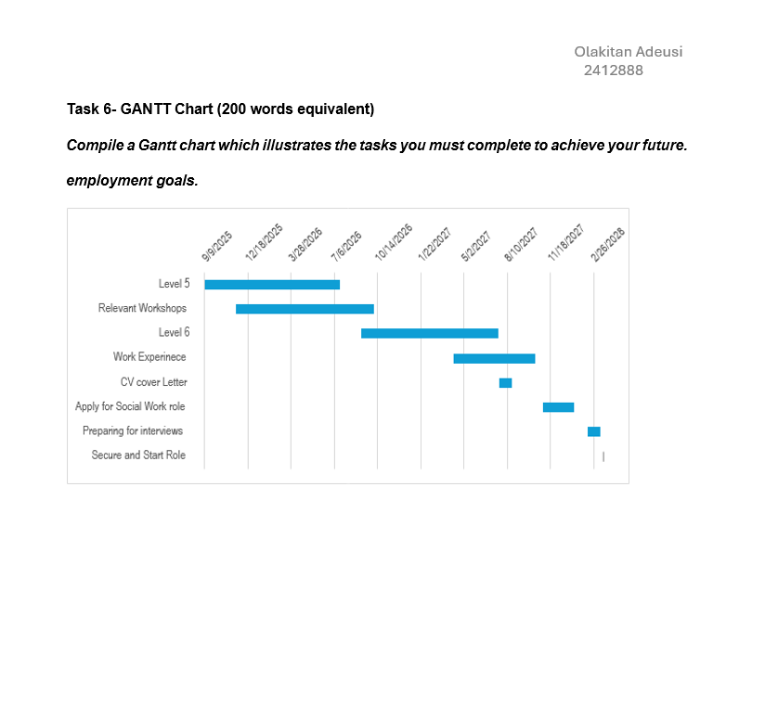

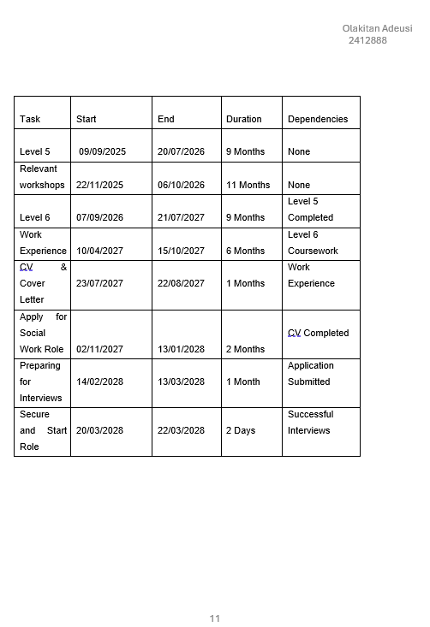
Explanation Gantt chart
This Gantt charts a structure and achievable pathway towards my long-tern goal to becoming a qualified Social Worker. It proves how academic study, professional development, and career preparation are planned over a two-year period to support my progression into the profession.
The timeline begins with the completion of level 4 coursework, which provides the academic foundation needed for further study and professional growth. Alongside my studies, I will attend workshops and training sessions to enhance my knowledge of safeguarding, communication, and reflective practice. These skills are essential for effective social work and contribute to my ongoing professional development (University
of Trinity Saint David, 2025).
During 2025, the focus shifted to completing Level 5&6 coursework while gaining practical experience within social care settings. This experience enables me to apply theoretical knowledge in practice, strengthen my resilience, and further develop my emotional intelligence. These qualities are recognized as important attributes for effective professional practice and employability (Goleman, 1996; Tomlinson, 2017).
Following the completion of my academic studies and practical experience, the final stage will focus on employment preparation. This will include updating my CV and cover letter, applying for social work positions, and preparing for interviews. The final milestone is to secure and begin a social work role by March 2028. Achieving this goal will prove the successful integration of academic achievement, professional skills, and career readiness, supporting my transition into the social work profession.

Task 7- Making Changes- Report
You are the manager of a care home and want to make changes your workplace. Identify one specific change that you want to implement and write a brief report on how this is going to be achieved considering the necessary skills needed and addressing possible barriers to success. Relevant change models can be highlighted (350 words Minimum of - 3 referenced sources).

Lewin’s Change Model

UNFREEZE
- Explain need for change
- Consult staff
- Address concerns
- Update policies
- Plain Implementation

CHANGE
- Install digital system
- Staff training
- IT support
- Pilot Implementation
- Monitor progress

REFREEZE
- New system becomes routine
- Regular audits
- Refresher training
- Continuous monitoring
- Improved patient safety

Introducing a Digital Medication Management System in a Care Home
Introduction
As the manager of a residential care home, I plan to implement a digital medication management system to replace paper-based (MAR) sheets. This aims to improve medication accuracy, reduce administration errors, and enhance safety and support the delivery of high-quality person centred care (NICE, 2023).
Planning the change
The proposed change involves replacing manual MAR records with a secure digital system that enables real-time recording, monitoring, and updating of medication administration. Successful implementation will require staff training, policy updates, and compliance with relevant regulations. Lewin’s Change Management Model will be used to guide the process through its three stages: unfreezing, changing, refreezing. During unfreezing stage, staff will be informed of limitations of the current paper-based system and the benefits of digital technology. The change stage will focus on training and support, while refreezing stage will embed new practices through monitoring, evaluation, and regular audits to ensure sustainability (Lewin, 1951).
Skills Required
Effective implementation will require strong leadership, communication, and project management skills. Digital competence will support staff in using the new system, while emotional intelligence will help address concerns and resistance to change. Critical thinking will be essential for overcoming challenges and ensuring a smooth transition (Goleman, 1996).
Barriers and Solution
Potential barriers include staff resistance to innovative technology, particularly among individuals with limited digital confidence. This can be addressed through training, reassurance, and staff involvement in the implementation process. Time constraint may reduce opportunities for training; therefore, protected learning tome should be provided. Financial challenges associated with software and equipment cost can be managed through phased implementation and external funding. Technical difficulties may also occur; so, ongoing IT support and clear troubleshooting procedures should be proved to minimize disruption and keep staff confidence throughout the transition (NHS England, 2023).
Conclusion
The introduction of digital medication management system has the potential to improve safety, efficiency, and accuracy within the care home. Through effective leadership and a structured approach to change management the initiative can be successfully implemented and sustained over time.

Reference List
BASW (2021) Professional capabilities framework. Birmingham: British Association of Social Workers.
Birmingham Children’s Trust (2024) Early help family support worker. Available at: https://www.birminghamchildrenstrust.co.uk (Accessed: 20 June 2026).
Goleman, D. (1996) Emotional intelligence: why it can matter more than IQ. London: Bloomsbury.
Granovetter, M.S. (1973) ‘The strength of weak ties’, American Journal of Sociology, 78(6), pp. 1360–1380.
Grant, L. and Kinman, G. (2014) ‘Developing resilience for social work practice’, Social Work Education, 33(5), pp. 1–16.
HM Government (2023) Working together to safeguard children: a guide to inter-agency working to safeguard and promote the welfare of children. London: Department for Education.
Khedher, M. (2015) ‘A brand for everyone: Guidelines for personal brand managing’, Journal of Global Business Advancement, 8(1), pp. 19–27. doi:10.1504/JGBA.2015.071272.
Lewin, K. (1951) Field theory in social science. New York: Harper & Row.
Mosley, T.J., Zajdel, R.A., Alderete, E., Clayton, J.A., Heidari, S., Pérez-Stable, E.J., Salt, K. and Bernard, M.A. (2025) ‘Intersectionality and diversity, equity, and inclusion in the healthcare and scientific workforces’, The Lancet Regional Health – Americas, 41, p. 100973. doi:10.1016/j.lana.2024.100973.
Munro, E. (2011) The Munro review of child protection: final report, a child-centred system. London: Department for Education.
NHS England (2023a) Digital transformation in health and social care. Available at: https://www.england.nhs.uk (Accessed: 20 June 2026).
NHS England (2023b) Improving patient safety culture: a practical guide. Available at: https://www.england.nhs.uk (Accessed: 20 June 2026).
NHS England (2023c) NHS equality, diversity and inclusion (EDI) improvement plan. Available at: https://www.england.nhs.uk/publication/nhs-edi-improvement-plan/ (Accessed: 14 June 2026).
NHS England (2024) International recruitment toolkit. Available at: https://www.england.nhs.uk/long-read/international-recruitment-toolkit/ (Accessed: 17 June 2026).
NICE (2023) Managing medicines in care homes (SC1). Available at: https://www.nice.org.uk/guidance/sc1 (Accessed: 20 June 2026).
Peters, T. (1997) ‘The brand called you’, Fast Company, 10, pp. 83–90.
Southwick, S.M., Bonanno, G.A., Masten, A.S., Panter-Brick, C. and Yehuda, R. (2014) ‘Resilience definitions, theory, and challenges: interdisciplinary perspectives’, European Journal of Psychotraumatology, 5(1), pp. 1–14. doi:10.3402/ejpt.v5.25338.
Tomlinson, M. (2017) ‘Forms of graduate capital and their relationship to graduate employability’, Education + Training, 59(4), pp. 338–352. doi:10.1108/ET-05-2016-0090.
Trevithick, P. (2012) Social work skills and knowledge: a practice handbook. 3rd edn. Maidenhead: Open University Press.
University of Wales Trinity Saint David (2025) Graduate Attributes Framework. Available at: https://www.uwtsd.ac.uk/graduate-attributes-framework (Accessed: 19 June 2026).

