Name: Lucian Daniel Oprea

Student number: 2107118

Module code: BMSW 5106

Lecturer’s Name: Dr Sujeewa Herath
Dr Sampath Liyanage

KNOWLEDGE AND INFORMATION MANAGEMENT SKILLS FOR THE WORKPLACE

TASK 2

Executive Summary

The report is based on the information management system and knowledge based on an organisational context. Here, the chosen business organisation is a reputed USA-based tourism broker, Airbnb. The Introduction section has provided a brief overview of the chosen company and its current revenue. The MIS system applied in the company has been described here along with its strengths and weaknesses. Challenges encountered during the deployment of the application have also been presented here. The report has further analysed that the daily operational choices that are made at the lowest level of management are required of Airbnb. An ERP system like SAP can be challenging to adopt, and this can also have an impact on system upkeep. The recruitment and selection processes may be hampered by ERP system sessions, which may present challenges for Airbnb's HR administration. Since the ERP system makes all Airbnb employees more visible and transparent, it may be leveraged to improve sales and marketing efforts. The sales and marketing divisions may be better able to work together when the data is centralized. The sales and marketing departments' ability to provide insights for promoting Airbnb's goods and services to clients is made possible by the ERP system. The increasing training costs for the MIS system at Airbnb could be a major issue for the business. The setup of the software comes at a high expense in terms of training and development, and management may find it challenging to administer the software. The system demands expertise, which is a crucial component that is challenging for the teams.

Table of Contents
Introduction 3
Knowledge requirements 3
MIS system- Purpose and Importance 3
Strengths and Weaknesses of MIS System 3
Challenges in deploying the Information systems 3
Recommendations 4
Conclusion 4
Reference list 5

Introduction
A knowledge and Information management system is generally referred to as an integrated system which combines a lot of settings and operations for controlling, modifying and generating informative data in any organisational context. Airbnb is a reputed United States-based online marketplace provider. The company deals with certain short-term homestays and related bookings for the travel experience. In such context, the chosen company, Airbnb acts as a broker of the travel agencies performing the tourism business in the United States of America. As per the latest financial report published by the American Stock Exchange, the company’s revenue stands at 8.40 billion USD (Airbnb.co.in, 2023). This report is aimed at providing key knowledge on the knowledge required to manage information within an organisational context such as Airbnb. An elaborate description of the MIS system with its strength and weaknesses will be provided here along with the challenges experienced while applying the system.

Knowledge requirements
The most basic form of knowledge is considered Explicit knowledge as it is easy to pass along. Explicit knowledge is accessible and written down, it is the result of data when it is organized, processed, interpreted and structured. The explicit knowledge is recorded, articulated and communicated and then it is stored. On the other hand, Tactic knowledge can be considered as tangible information that can be difficult to articulate. Knowledge refers to the information, facts, understanding and awareness gained by the individual through education, experience or learning. Knowledge refers to tacit and explicit knowledge (Asbari et al. 2019). Explicit knowledge can be considered as the structured set of information that can be categorized as stored, recognized and shared. Tactic knowledge can be referred to as the hidden, unrecorded and unstated depository of knowledge, which is hidden. Airbnb utilises explicit knowledge to share valuable information with its customers or co-workers. Transferring information within the organization is a useful way for decision-making. The most important benefit function of explicit knowledge is decision-making (Pérez-Luño et al. 2019). With the help of explicit information, the documentation can be established such as the data of the customer. This enables the rental company to solve the problems of the employees and make decisions related to the work. The management at Airbnb can utilise the tactic and explicit knowledge requirement for streamlining the operations so that they can share information such as customer feedback which is an important aspect of the organization. It helps in creating a source of collective knowledge, the explicit information can be used for creating a source of collective knowledge in an organization that can help in creating a source of the collective information. Airbnb creates a source for collective knowledge with which documenting the explicit knowledge can e easier as it creates a source for the collective information. This information is shared among the team members in the company. Moreover, for assisting the employees in the company, the knowledge requirement can be used, when the employee begins a new role in the organization, they can refer to the explicit knowledge for the process of documentation (Wang et al. 2022). The knowledge requirement can be facilitated in making three types of decisions such as operational, tactical and strategic. Strategic decisions are major choices of influence and actions.
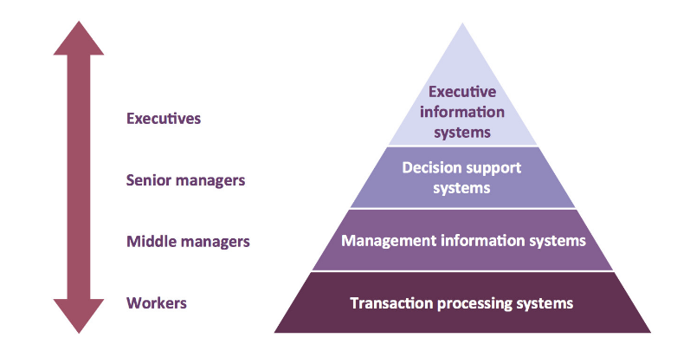
Figure: Explicit and Tactic knowledge
(Source: Faud, 2020)
These are the major part of the Airbnb where the contribution is directly achieved with the common goal of the enterprise. The long-term implications of the busies enterprise involve major departures. This might further affect the procedures and practice of the strategic decisions which can be followed earlier. The decisions in Airbnb are developed with the partial knowledge that is present in the environment (Ganguly et al. 2019). These factors can be considered dynamic and uncertain factors. These decisions are the higher-level decisions taken at the higher level of management.
Moreover, tactical decisions are related to the implementation of strategic decisions. The decisions are directed toward the development of the structural workflows, divisional plan and also establishment with the institution. The decisions are generally based on environmental and partial knowledge factors which are uncertain and dynamic. The decisions are based on the higher level of management. Tactical decisions are the decisions which are related to the implementation of strategic decisions (Bashir and Farooq, 2019). The tactical decisions are directed towards developing the division plans and establishing more distribution channels for the organisation. The acquisition of resources is also based on tactical plans such as materials, men and money. These decisions are taken for the implementation of the middle level of management. The operational decisions are also helping the rental company Airbnb in the decision-making as these decisions are related to the day-to-day operations. The operational decision is taken daily and these decisions are taken repetitively. The operational decisions are made concerning the facts that are regarding the events. These events do not require much attention and business judgment. Airbnb has to take operational decisions daily which are taken at the lower level of management. The required information is based on well-informed, rational decisions. These are the decisions which needed to be focussed on in the process of decision-making on a managerial basis.

MIS system- Purpose and Importance
The study of management, people and the relationship between time is referred to as the Management Information system. The selected MIS systems are Customer Relationship Management systems and Enterprise Resource planning systems.
Customer Relationship Management Systems
Customer relationship management is the combination of strategies, practices, and technologies that companies are using for analysing and managing the data and customer interactions throughout the lifecycle of the customers (Nelson et al. 2020). The CRM tool has many benefits which include having customer information such as interactions and past purchase history so that they can easily access it. This will help the customer support representative to provide faster and better customer service. Customer relationship management tools also help in collecting customer data to help businesses to identify insights and trends about their customers through the process of visualization and reporting.
Purpose and Importance
The purpose of customer relationship management in Airbnb is to improve the interactions and relationships with potential customers and customers. Airbnb is a platform in which the guests are charged a fee between 5% and 15 % of the reservation. The rental company makes their profits from the booking that they get from their websites. CRM gives solutions for businesses such as Airbnb with no inventory and physical stores a medium to manage the stay connected with their customers. CRM is an important tool as it has enabled Airbnb to improve its profitability and streamline its processes. According to the report of new. Airbnb (2022), the company has generated a revenue of $ 8.4 billion in the financial year of 2022. The net income for the company was 1.9 billion, making a profitable year. The purpose of the company is to focus on the goal of the organization including the service users, customers and the supplier (Chatterjee et al. 2019). Customer relationship management is the fastest-growing enterprise application as it is expected to reach by the end of 2027 at USD 114.4 billion.
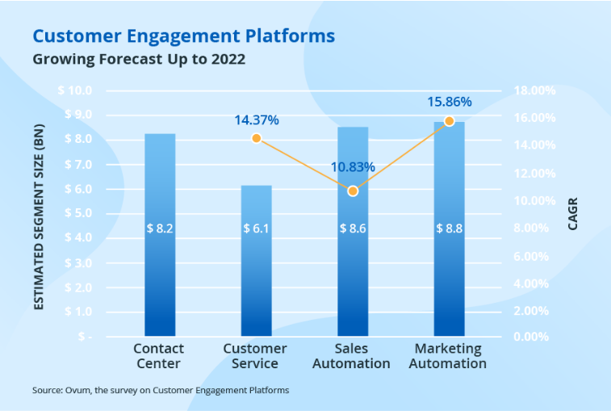
Figure: Market of CRM
(Source: Science Soft, 2022)
Airbnb can utilize CRM software for streamlining their business using a strategy that can enable reaching the targets, profitability and business objectives (Chagas et al. 2018). The marketing team at Airbnb can utilize the software to see everything in one place, status orders, issues related to customer service and much more. It gives a much more evaluative solution to optimize and manage the lead journeys and campaigns with a data-driven approach. A CRM system can help in finding new customers for the rental company and also keep them organized and informed (Shukla and Pattnaik, 2019). The new generation CRM software such as Hubspot, Salesforce, Zoho and EnagaeBay.CRM software can be used to automatically generate better insights for the company. Airbnb uses its own CRM software which helps them to keep track of its customers. They use CRM software to predict the customers in a better way. It has been sued for boosting the customer experience in the company. There are majorly three types of CRM that Airbnb can use, to streamline its business which include analytical, collaborative and operational (Guerola-Navarro et al. 2021). These tools help in creating a conversational customer experience for the customers and also help them book with the company more easily.
Enterprise Resource Planning Systems
Enterprise resource planning (ERP) is a system that provides integration, automation and intelligence to the organisation that is essential to perform the day-to-day busies operations. ERP is an important system in the organization which can deliver the right services and products for logistics on time. The management is required to collect important information for the business and the visibility that is achieved from ERP helps the company perform better and achieve better (Anguelov, 2021). There are numerous benefits of ERP which include higher productivity, as streamlining the business in Airbnb can be easier while implementing the ERP software.
Purpose and Importance
It helps the business in achieving more with limited resources. It also gives deeper insights by eliminating the information, to get quick answers for mission-critical questions to the business. With Accelerate reporting the ERP system can help in achieving better financial reporting and fast-track business. an easy way of sharing results is also a consequence of ERP by improving the performance of the company in real-time (AboAbdo et al. 2019). The focus of Airbnb is to automate its operations and get faster reporting so that it can improve its business functions. With a lower risk of failure, the ERP model can help the rental company maximize business control and visibility. It will also ensure the regulatory and compliance requirements by predicting the risk and preventing it. Airbnb can utilize the ERP system with engineering, accounting, legal and IT services.
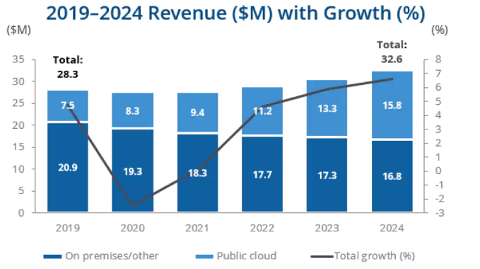Figure: Growth in Revenue after using ERP
(Source:Netsuite ,2022)
The company can get real-time powerful mobile ERP technology which can support them in financial health and servicing the commitment. This requires the key professionals to get successfully balance the financial health service delivery commitments. Moreover, Airbnb can get professional services with the availability to manage the project (Ferrari et al. 2021). This can ensure the profitability of the projects by utilizing the ERP systems. Airbnb can integrate the ERP system for providing solutions to an enormous range of the functionality of the business. However, they need to combine with the different systems. This can help synchronies data sources such as HCM and CRM software, industry-specific solutions, and e-commerce platforms. With proper ERP integration, the company can get support and they can even improve the customer experience and facilitate collaboration across the business partners and teams.

Strengths and Weaknesses of MIS System
The strategic approach of Customer relationship management can help the organisation to manage the relationship with the potential customer. With the growth of the business, there are different data streams which include customer support, sales and social media. CRM can help in growing the business in every term by enabling the business by offering better profitability, goals and sales for the business. The CRM also empowers the real-time information that is important for the business.
Strengths and weakness of Customer Relationship Management Systems
The customer relationship management application can help enable the data by building customer experiences. CRM can be used in human resource management to manage relationships with potential candidates. The recruiters can take effective decisions regarding the recruiting process. They can also automate the communication process which can improve the candidate experience and engagement (Guerola-Navarro et al. 2020). CRM allows human resource management to manage the business in a better way by building positive customer relationships and driving more success for the company. It allows the business to track the leads which are generated from the inbound process and provides platforms for marketing and sales to understand the impact of the business (Chengwu, 2020). The human resource management at Airbnb recruits potential candidates with the help of a customized CRM system. However, the CRM system is expensive and the human resource system needs extensive training when it comes to using the tool.
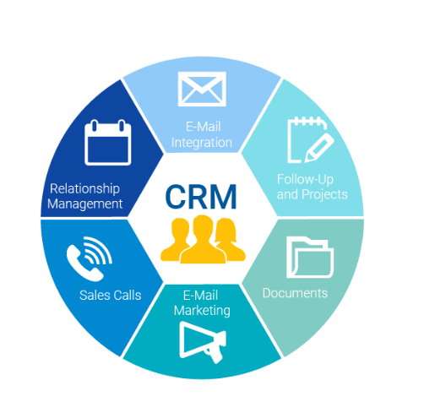
Figure: CRM tool
(Source: Perfectview, 2022)
Customer relationship management can also help the Sales and marketing teams in taking decisions as they by organizing and identify the leads, to take an informed decision which is the result of understanding the information in a better way. Airbnb can also utilise the CRM tool in accessing the data and anticipating customer needs (Chatterjee et al. 2020). The sales and marketing teams at Airbnb can access the information, from the company's website and track the information of the potential customer. However, The time taken to implement the CRM system is long , it might take weeks to set up the system for the sales and marketing team to manage the leads and set up the proper system. Whenever the customer login into the Airbnb website to get the information of the consumer.CRM can manage the financial functions of the company concerning decision-making, as it helps in making better decisions for the company. The CRM can improve cashflows and profitability, by maximizing the ability to repay debts and loans. This can be done by eliminating the low vale task and upgrading the optimization of finance functions.
Strengths and weakness of Enterprise Resource Planning Systems
ERP is a system which can help Airbnb to grow with enhanced business reporting.ERP is software that helps all the different functions in the organisation to integrate such as accounting, finance, HR, sales, marketing, etc. The HR department at Airbnb can utilise the ERP to track the performance of the employees, they can get more support on training and development and it also supports the recruitment functions of the organization.
The implementation of an ERP system such as SAP is difficult and it might affect the maintenance of the system as well. The HR management at Airbnb can face difficulty as the sessions of the ERP system can hamper the recruitment and selection process. The system of ERP can be used for upgrading the efforts of sales and marketing as it increases the visibility and transparency for all the employees of Airbnb. When the data is centralized, it can allow the sales and marketing departments to collaborate effectively. The ERP system can help sales and marketing to produce insights for promoting the products and services of Airbnb to the customers.
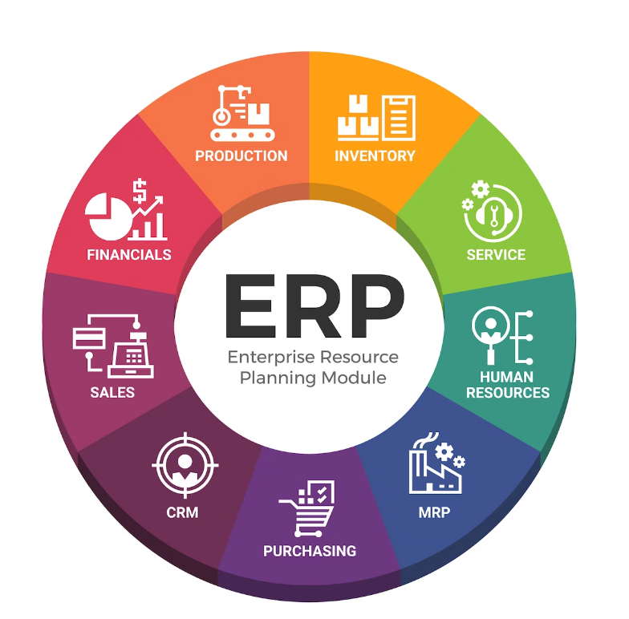
Figure: Erp tool
(Source: SDC, 2022)
It also boosts the efforts of personalized marketing by improving the customer preferences of potential customers. Personalization is an important aspect of the business, as the customers of Airbnb browse the website to get personalized results.ERP system can help in offering the specific consumer group by increasing the sales of the business.
However, the ERP system has complex data which is difficult to convert. It is also difficult to develop a data conversion strategy for customers of Airbnb. This will require examining, defining and analysing the data sources. Therefore, an ERP system can make it difficult for sales and marketing to convert data. Bad data can make the process difficult and will cause delays and increased delays.

Challenges in deploying the Information systems
There are certain challenges faced by the organisation while implementing the ERP and CRM systems. These challenges can create issues in the company as they can create certain obstacles that can lead to the failure of the systems. These challenges have been described below.

Creating a suitable information architecture: Creating a suitable information system based on the required data in an organisational context can be encountered with initiation challenges. The loopholes in a system are directly responsible for the potential data-leakage threat. Such loopholes generally occur when the employees or the system operator tries to make a complex ERD diagram for connecting the information flow and controls in a comparatively short time (Avgerou, 2019). This problem can be mitigated by the application of an expert viewpoint for making a simple but robust information-sharing network and also utilising the system to restrict the information flow to external sources.
Lack of communication and deployment type
Lack of communication can lead give rise to mental barriers and insecurities in the mind of the employees. Relying on the CRM system can give rise to the communication gap as the CRM is responsible for providing proper support and details to the clients on their behalf. At Airbnb, the management team use CRM software to get insights and track the customer. However, the built-in function of the communication might fail and it will take the sales and marketing team extra efforts to get the details. Without having an understanding of the type of CRM that is suited for the organization can lead to difficulty in handling daily tasks (Cricelli et al. 2020). Handling the task on a dedicated CRM is an important task and the busies might face challenges in understanding the business preferences.
Data integration and cost
The process of data integration is tiresome and it can be challenging as well. The team should be able to implement the ERP from the older files to the new ERP databases (Chofreh et al. 2020). The integration requires tedious work and it gets difficult for the team at Airbnb to do so. Issues such as duplicate data, and inaccurate data might occur which can affect the transfer of data.CRM and ERP systems are expensive and hiring an experienced consultant for setting up the system is costly (Menon, 2019). The system needs proper customization according to the needs of the business. At Airbnb, the training cost for the MIS system is higher and hence this can be a big problem for the company. The training and development cost of setting up the software is high as well and the management can have a difficult time managing the software. The system requires expertise which is an important aspect that is difficult for the teams.
Lack of management
One of the challenges of using the ERP and CRM structure could be a lack of clearly defined objectives and mismanagement. It is important for the organization to clearly define the plan and the structure that is required for the company to grow the information on transactional issues in the company. Moreover, implementing the system can be a difficult task as a lack of understanding of the technological changes may create issues in the team. It is important for the organization to implement the changes that are required for the functioning. However, lack of conversation and management can make situation difficult for the team at Airbnb to implement such changes. This can create challenging situations for the organization.

Recommendations
Preparing the workforce for any significant change: The workforce of the company, Airbnb should be made aware of any system-related change in database management before considering the application of the change in the real-time organisational process. This will probably benefit the company to provide ample time to the employees working in the system to get a glimpse of the new proposed algorithm and management setting (Pham et al. 2019). This will further allow the host server to detect its primary faults also.
Improving employee engagement: Employee engagement should be improved because improved employee engagement also conveys a good communication network among them through which they can effectively share certain system-related information to their peers for solving any adjustment issue. The most interconnected section of the workforce is capable of handling MIS network issues.
Better articulation of ROI: For limiting any damage that can be experienced during the initial deployment of MIS operations at the initial state, the articulation of ROI plays perhaps the most pivotal role (Alawamleh et al. 2021). A better-equipped ROI is said to be effective enough to send system prompts to detect any initial operational error and if the detection gets straightforward, the mitigation procedure can be very useful in making the necessary changes for the next operation.
Additional security: The application of certain security measures such as system security monitoring and pivot report amalgamation can be very useful in providing required security to the scenario of making safer MIS operations. The root of the security measure is thus based on the choice of antivirus and hack-proof shields for securing the core database of the company, Airbnb.

Conclusion
It can be concluded that Explicit knowledge is thought to be the most fundamental type of knowledge since it is simple to transmit. Explicit knowledge is readily available, is recorded in writing, and is produced when data is arranged, processed, evaluated, and structured. Airbnb makes use of explicit knowledge to impart useful information to its clients or employees. Decision-making can benefit from the transfer of information inside the company. Making decisions is the most significant advantage function of explicit knowledge. Customer relationship management (CRM) is the collection of strategies, methods, and technology used by businesses to analyse and manage customer interactions and data over the course of a customer's lifecycle. CRM provides a way for companies without physical stores or inventories, like Airbnb, to maintain their customer relationships. Enterprise resource planning (ERP) is a system that gives the organisation the intelligence, automation, and integration needed to carry out daily business activities. CRM helps human resource management run the firm more effectively by fostering strong client relationships and boosting business success. The workforce at Airbnb has to put in a lot of boring effort, which becomes challenging. The transfer of data may be impacted by problems like duplicate data and erroneous data. The cost of CRM and ERP systems is high, as is the cost of employing an expert consultant to set them up.

Reference list
AboAbdo, S., Aldhoiena, A. and Al-Amrib, H., 2019. Implementing Enterprise Resource Planning ERP system in a large construction company in KSA. Procedia Computer Science, 164, pp.463-470.
Airbnb.co.in “Host an Experience” Available at: www.airbnb.co.in [Accessed on: 18 Mar 2023]
Alawamleh, H.A., ALShibly, M.H.A.A., Tommalieh, A.F.A., Al-Qaryouti, M.Q.H. and Ali, B.J., 2021. The challenges, barriers and advantages of management information system development: Comprehensive review. Academy of Strategic Management Journal, 20(5), pp.1-8.
Anguelov, K., 2021, May. Indicators for the Effectiveness and Efficiency of the Implementation of an Enterprise Resource Planning System. In 2021 12th National Conference with International Participation (ELECTRONICA) (pp. 1-4). IEEE.
Asbari, M., Wijayanti, L.M., Hyun, C.C., Purwanto, A. and Santoso, P.B., 2019. Effect of tacit and explicit knowledge sharing on teacher innovation capability. Dinamika Pendidikan, 14(2), pp.227-243.
Avgerou, C., 2019. Contextual explanation: Alternative approaches and persistent challenges. MIS Quarterly, 43(3), pp.977-1006.
Avgerou, C., 2019. Contextual explanation: Alternative approaches and persistent challenges. MIS Quarterly, 43(3), pp.977-1006.
Bashir, M. and Farooq, R., 2019. The synergetic effect of knowledge management and business model innovation on firm competence: A systematic review. International Journal of Innovation Science, 11(3), pp.362-387.
Chagas, B.N.R., Viana, J.A.N., Reinhold, O., Lobato, F., Jacob, A.F. and Alt, R., 2018, December. Current applications of machine learning techniques in CRM: a literature review and practical implications. In 2018 IEEE/WIC/ACM International Conference on Web Intelligence (WI) (pp. 452-458). IEEE.
Chatterjee, S., Ghosh, S. and Chaudhuri, R., 2020. Adoption of ubiquitous customer relationship management (uCRM) in enterprise: leadership support and technological competence as moderators. Journal of Relationship Marketing, 19(2), pp.75-92.
Chatterjee, S., Ghosh, S.K., Chaudhuri, R. and Nguyen, B., 2019. Are CRM systems ready for AI integration? A conceptual framework of organizational readiness for effective AI-CRM integration. The Bottom Line, 32(2), pp.144-157.
Chengwu, S.U.N., 2020. The research and evaluation of customer relationship management and social responsibility on competitive advantage. Revista de Cercetare şi Intervenţie Socială, (69), pp.131-142.
Chofreh, A.G., Goni, F.A., Klemeš, J.J., Malik, M.N. and Khan, H.H., 2020. Development of guidelines for the implementation of sustainable enterprise resource planning systems. Journal of Cleaner Production, 244, p.118655.
Cricelli, L., Famulari, F.M., Greco, M. and Grimaldi, M., 2020. Searching for the one: Customer relationship management software selection. Journal of Multi‐Criteria Decision Analysis, 27(3-4), pp.173-188.
Cruz-Torres, W., Alvarez-Risco, A. and Del-Aguila-Arcentales, S., 2021. Impact of Enterprise Resource Planning (ERP) implementation on performance of an education enterprise: a Structural Equation Modeling (SEM). Studies in Business and Economics, 16(2), pp.37-52.
Ferrari, A.M., Volpi, L., Settembre-Blundo, D. and García-Muiña, F.E., 2021. Dynamic life cycle assessment (LCA) integrating life cycle inventory (LCI) and Enterprise resource planning (ERP) in an industry 4.0 environment. Journal of Cleaner Production, 286, p.125314.
Ganguly, A., Talukdar, A. and Chatterjee, D., 2019. Evaluating the role of social capital, tacit knowledge sharing, knowledge quality and reciprocity in determining innovation capability of an organization. Journal of knowledge management.
Guerola-Navarro, V., Oltra-Badenes, R., Gil-Gomez, H. and Gil-Gomez, J.A., 2021. A research model for measuring the impact of customer relationship management (CRM) on performance indicators. Economic research-ekonomska istraživanja, 34(1), pp.2669-2691.
Guerola-Navarro, V., Oltra-Badenes, R., Gil-Gomez, H. and Gil-Gomez, J.A., 2020. Customer relationship management (CRM): a bibliometric analysis. International Journal of Services Operations and Informatics, 10(3), pp.242-268.
https://news.airbnb.com/airbnb-q4-2022-and-full-year-financial-results/
Linkedin.com, 2020 Available at: https://www.linkedin.com/pulse/information-system-hierarchy-fuad-habibullah
Menon, S., 2019. Critical challenges in enterprise resource planning (ERP) implementation. International Journal of Business and Management, 14(7).
Nelson, C.A., Walsh, M.F. and Cui, A.P., 2020. The role of analytical CRM on salesperson use of competitive intelligence. Journal of Business & Industrial Marketing, 35(12), pp.2127-2137.
Netsuite.com, 2022 Available at: https://www.netsuite.com/portal/resource/articles/erp/what-is-erp.shtml
Pérez-Luño, A., Alegre, J. and Valle-Cabrera, R., 2019. The role of tacit knowledge in connecting knowledge exchange and combination with innovation. Technology Analysis & Strategic Management, 31(2), pp.186-198.
Pham, H.C., Brennan, L. and Furnell, S., 2019. Information security burnout: Identification of sources and mitigating factors from security demands and resources. Journal of Information Security and Applications, 46, pp.96-107.
Scnsoft.com, 2022 Available at: https://www.scnsoft.com/blog/crm-market-statistics
Sdcexec.com,2022 Available at: https://www.sdcexec.com/sourcing-procurement/erp/article/22512067/senecaglobal-what-to-do-about-disparate-erp-systems
Shukla, M.K. and Pattnaik, P.N., 2019. Managing customer relations in a modern business environment: towards an ecosystem-based sustainable CRM model. Journal of Relationship Marketing, 18(1), pp.17-33.
Situmorang, P.P., 2020. The effect of system quality and information quality on the satisfaction of user enterprise resource planning-system application and product in data processing (ERPSAP) with perceived usefulness as a variable moderating in PTPN III (persero) unit of labuhan. International Journal of Public Budgeting, Accounting and Finance, 2(4), pp.1-11.
Wang, N., Yin, J., Ma, Z. and Liao, M., 2022. The influence mechanism of rewards onknowledge-sharingg behaviors in virtual communities. Journal of Knowledge Management, 26(3), pp.485-505.

