L7 Engineering Design & Analysis

M7X01379

Engineering Design Exercise

External Pipe Climbing Device

1. Introduction
This exercise is to design a device to climb up the outside of a piece of 15 mm copper pipe lifting an increasing load in the form of a chain. At the top the device will reverse and return to its original starting point. The ‘device’ can be of any construction but it must be electrically powered and meets the size and cost specification detailed below. The relative performance will be determined on the quickest time taken for the device to pull the load to the top of the tube and return to the starting point at the bottom.
The test rig will comprise of the pipes located into 17mm diameter holes. These will allow the pipe to be lifted upwards if required so that the device can be fitted onto the pipe. The pipe will then be replaced before the commencement of a run. An illustration is below with the chain removed for clarity. Figure 1 dimensions the external pipe climber test rig

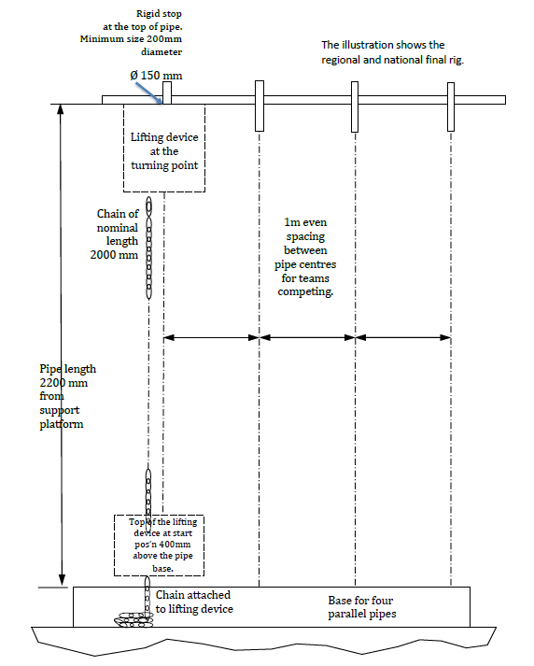

2. Rules
2.1. The ‘device’ can be of any type, but it must be self-contained and at all times within a cylindrical envelope of 200 mm radius and 300 mm height, as shown in Figure 2 below.

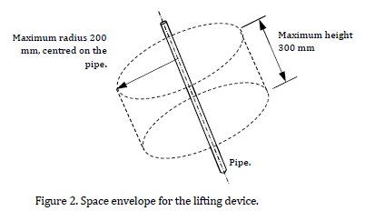
2.2. The test area will consist of up to four identical pipes to allow for parallel runs. The “Device Controller” is allowed to hold their device in position up to or below the datum line (0.4m above bottom of the pipe) before starting. Teams will be required to start their devices simultaneously. Once started there can be no outside interference. Having started their device the Device Controller must then step away from the tube.
2.3. The devices must have a method of attachment/detachment to a length of chain.
2.4. Once a heat has started the device may not be touched until it is over. The device may not be caught and if required, impact protection should be designed as part of the device.
2.5. No adhesive or lubricant is to be used between the device and the tube. Devices must not cause any damage or leave any debris on the external surfaces of the tube.
2.6. Heats will consist of up to four devices running in parallel. The time will be recorded for each successful attempt. The time is measured from the “Starters Order” until the top of the device passes the datum in the downward direction. The device must make contact with the top after the upward travel and before the downward travel.
2.7. It is permissible to replenish the device’s energy source between testing.

2.8. The total cost of the device must be under £25. The cost of any batteries must be included as part of the design even if they are under 20p.
2.9. Details of the pipe and chain suppliers including part references can found at the following links:-

https://www.screwfix.com/p/wednesbury-copper-pipe-15mm-x-3m/98683
http://www.diy.com/departments/side-welded-steel-chain-3mm-x-2m/1267464_BQ.prd?icamp=recs&rrec=true

