Networks

and

Cyber Security Essentials

Module Name: Networks and Cyber Security Essentials
Module Code: ACCA4024
Student Name: Hebun AY
Student ID: 2529281
Group: 2
Lecturer’s Name: Amit Naik

Abstract

SteelForm Manufacturing Ltd (SFM) has started using connected technologies such as IoT sensors, automated machinery and a cloud-based production system. These systems can support faster and more efficient production, but they also increase the number of possible cybersecurity risks. SFM has already experienced problems including malware, phishing emails and attempts to access its production network without permission. This report examines the main internal and external threats that may affect the company and suggests security policies that could reduce these risks. It also considers practical controls for protecting company data and production systems, together with methods for monitoring suspicious activity and responding to security incidents. Staff awareness and training are also included because employee behaviour can have a direct effect on security. The purpose of the report is to provide SFM with a realistic cybersecurity approach that protects important information, supports reliable production and reduces the impact of future cyber incidents.

Introduction
Technology is now a major part of modern manufacturing. Many companies use connected machines, IoT devices and cloud-based systems to manage production more efficiently. These technologies can make work faster and easier to control, but they can also create new security weaknesses. When more systems are connected to each other, there are more possible ways for attackers to enter a network or interfere with important business operations.
SteelForm Manufacturing Ltd (SFM) is a medium-sized manufacturer that produces specially engineered components for the automotive and aerospace sectors. The company has recently introduced smart manufacturing technologies, including automated machinery, IoT-enabled sensors and a cloud-based production management system. At the same time, SFM has already faced several cybersecurity problems, such as malware infections, phishing emails aimed at procurement employees and attempts to access the production network without permission.
Because SFM works with valuable engineering information and depends heavily on its production systems, a successful cyberattack could affect more than just computers. It could expose sensitive customer information, change important production data or stop manufacturing activity. For this reason, the company needs to protect confidentiality, integrity and availability. These three areas are commonly explained through the CIA Triad. In SFM’s case, confidentiality relates to keeping business and customer information private, integrity means making sure information remains correct, and availability means keeping systems and production services working when they are needed.
This report focuses on the main internal and external cyber threats that could affect SFM. It also looks at suitable security policies, practical measures to reduce risk, methods for monitoring suspicious activity and procedures for responding to incidents. Staff training is also considered because employees can either strengthen or weaken the company’s overall security depending on how they use systems and handle information.

- IDENTIFICATION OF THREATS
  - External Threats
SFM is exposed to a number of external cyber threats, and phishing is one of the most realistic risks for the company. This is especially important because procurement staff regularly deal with suppliers, invoices and payment information. An attacker could send an email that looks like it has come from a genuine supplier and try to convince an employee to open a harmful attachment, enter login details on a fake website or approve a false payment request.
Another major threat is ransomware. If ransomware enters the company network, it could lock important files or make business systems unavailable. In a manufacturing company, this could have a direct effect on production because staff may lose access to schedules, customer orders or production management systems. Ransomware could enter through phishing emails, weak passwords, unpatched software or insecure remote-access services.
Connected devices also create additional risk. SFM uses IoT sensors and automated equipment, which means that some production systems are connected to wider networks. If these devices have outdated software, weak passwords or poor security settings, attackers may try to use them as an entry point. A compromise in one part of the network could potentially allow an attacker to move towards more sensitive production systems.
Industrial espionage is another relevant concern for SFM. The company works in the automotive and aerospace sectors, where engineering information can be commercially valuable. Technical drawings, product specifications, manufacturing methods and customer details could be targeted by criminals or other organisations seeking to gain a competitive advantage.
Supply-chain attacks should also be considered. SFM is likely to exchange information with suppliers and may rely on external companies for software, equipment or maintenance. If one of these trusted third parties is compromised, an attacker could use that relationship to gain access to SFM systems or data.
  - Internal Threats
  - Not all cybersecurity risks come from outside the company. SFM also needs to consider threats that may come from employees, contractors or other people who already have some level of access to company systems. These threats can be deliberate, but they can also happen by mistake.
One example is an employee who has access to sensitive engineering files and intentionally copies them for personal use or shares them with another organisation. This type of insider threat could be particularly serious for SFM because the company handles technical information related to automotive and aerospace manufacturing.
Accidental mistakes can also create security problems. An employee may click on a suspicious link, open an infected attachment, send confidential information to the wrong person or use the same password across different services. A member of staff may also connect an unknown USB device to a work computer, which could introduce malware into the network.
Another risk is giving users more access than they actually need. If an employee account has unnecessary administrator privileges, a compromised account could give an attacker greater control over company systems. For this reason, access rights should be limited according to job responsibilities.
SFM should also make sure that accounts are removed or disabled when employees leave the company. If an old account remains active, it could still be used to access company information. Regular access reviews would help SFM identify unnecessary or outdated permissions before they become a security problem.

Threat
  Likelihood
  Impact
  Risk Level
Phishing | High | High | Critical
Ransomware |  |  | Critical
  High
  Very High
IoT/OT attack | Medium |  | Critical
  Very High
Insider threat |  | High
  Medium
  High
Supply-chain attack | Medium
  High
  High
Data leakage | Medium
  High
  High
Table 1: Main cybersecurity risks identified for SFM

SECURITY POLICIES
- Proposed Security Policies
  - Access Control Policy
SFM should implement an access control policy based on the principle of least privilege. Employees should only have access to the systems and information required for their job responsibilities. Administrator accounts should not be used for normal daily activities. Multi-factor authentication (MFA) should be required for cloud services, remote access and administrator accounts.
User access should also be reviewed regularly. When an employee leaves the organisation, their accounts should be disabled immediately. Access rights should also be reviewed when an employee changes job role.

3.2 Network Security Policy
The corporate IT network and the production or operational technology network should be separated. Network segmentation can reduce the possibility of malware spreading from an employee computer to production machinery. Firewalls should control communication between network areas and only necessary connections should be permitted.
IoT devices should also be placed within controlled network segments. Default passwords must be changed, unnecessary services should be disabled and firmware should be updated where possible.

3.3 Password and Authentication Policy
SFM should require strong passwords and prevent employees from sharing login credentials. Multi-factor authentication should provide an additional layer of security because a stolen password alone would not automatically provide access to an account. Privileged administrator accounts require particularly strong authentication controls.

3.4 Data Governance Policy
Information should be classified according to its sensitivity. SFM could use four classifications: Public, Internal, Confidential and Restricted. Engineering designs, aerospace customer information, employee records, credentials and security configurations should be classified as Confidential or Restricted.
Sensitive information should be encrypted when stored and when transferred across networks. Access should be logged and information should only be retained for as long as there is a legitimate business or legal requirement. Personal information must also be managed in accordance with UK data protection requirements.

3.5 Backup Policy
Important systems and data should be backed up regularly. At least one protected backup should be separated from normal network access so that ransomware cannot easily encrypt the backup at the same time as production data. SFM should also test backups by restoring information periodically because an untested backup may fail during a real incident.
MITIGATION MEASURES
- Mitigation Measures and Implementation
SFM should introduce the recommended controls in stages so that security improvements do not unnecessarily interrupt production.
The first step should be to create an accurate inventory of company assets. This should include computers, servers, cloud systems, network devices, IoT sensors, production equipment and remote connections. It is difficult to protect systems that the organisation does not know exist.
During the first stage, SFM should enable MFA, remove unused accounts and check administrator permissions. Endpoint protection should be installed and centrally managed on supported computers. Email security controls should also be improved because phishing is already a known problem for the company.
Procurement and finance employees should introduce an additional verification procedure when suppliers request changes to bank details. Instead of responding directly to an email, employees should contact the supplier using previously verified contact information.
Network segmentation should then be introduced. Business computers, servers, guest devices, IoT equipment and production systems should operate within separate network zones. Firewall rules should allow only authorised communication between these areas.
SFM should also introduce a patch-management process. Normal IT systems should receive security updates regularly. Production equipment requires greater care because an update could affect machine operation. Therefore, OT updates should be tested and coordinated with engineering staff before installation.
These measures follow a defence-in-depth approach. No single control can completely prevent cyberattacks. However, several security layers make it more difficult for an attacker to successfully compromise critical systems.
MONITORING AND INCIDENT RESPONSE
- Network Monitoring and Incident Response
SFM should continuously monitor important systems so that suspicious activity can be identified at an early stage. Security logs should be collected from firewalls, cloud accounts, servers, endpoint protection systems, VPN connections and important production systems.
Security alerts should include repeated failed login attempts, unexpected administrator accounts, unusual large data transfers, disabled antivirus software and unusual communication between the corporate and production networks.
When an incident occurs, employees should know exactly who must be contacted. The IT Security Manager should coordinate the technical response while senior management and relevant production staff should become involved when an incident could affect manufacturing operations.

Security Alert Detected
↓
Validate the Incident
↓
Assess Severity and Impact
↓
Contain the Threat
↓
Investigate and Remove the Cause
↓
Recover Systems and Data
↓
Monitor for Further Activity
↓
Lessons Learned and Improve Controls
Figure 1: Proposed incident response process for SteelForm Manufacturing Ltd

Containment decisions must consider the manufacturing environment. For example, immediately disconnecting an important production system could create additional operational or safety problems. IT security staff should therefore coordinate with production engineers when critical OT systems are involved.
Evidence such as system logs should be preserved during an investigation. After the threat has been removed, affected systems should be restored using trusted backups. Finally, SFM should conduct a lessons-learned review to identify why the incident occurred and what controls should be improved.
TRAINING AND AWARENESS
Staff Training and Security Awareness Programme
Employees are an important part of SFM’s cybersecurity programme. Security awareness training should therefore be mandatory for all staff. New employees should receive basic cybersecurity training during their induction and existing employees should receive regular refresher training.
The programme should explain phishing, password security, MFA, safe internet use, confidential information, removable media and how to report a suspected security incident. Training should use practical examples that employees may encounter during their normal work.
Different departments should receive additional training according to their risks. Procurement and finance staff should receive training about fake invoices, supplier impersonation and fraudulent requests to change bank details. Engineering and maintenance staff should learn about USB security, IoT devices and remote vendor access. IT administrators should receive more advanced training covering privileged accounts, backups, security logs and incident response.
Short awareness activities should take place throughout the year rather than relying on one annual training session. Controlled phishing simulations may also be used to measure employee awareness. However, the purpose should be education rather than punishment.
SFM should measure the effectiveness of the programme. Useful indicators include training completion rates, the number of suspicious emails reported by staff, phishing simulation results and the time taken by employees to report security incidents. This allows the organisation to identify weaknesses and improve future training.
CONCLUSION
SteelForm Manufacturing Ltd is becoming increasingly dependent on connected manufacturing technologies. While IoT devices, automation and cloud systems provide important business benefits, they also increase cybersecurity risks. The company’s recent malware, phishing and unauthorised access incidents demonstrate that stronger controls are required.
This report identified phishing, ransomware, attacks against IoT and operational technology, industrial espionage, insider threats and supply-chain compromise as important risks. A combination of security policies and technical controls has been recommended, including multi-factor authentication, least-privilege access, network segmentation, patch management, encryption, protected backups and continuous monitoring.
Cybersecurity should not be treated as a one-time technical project. SFM should regularly review risks, monitor systems, test its incident response procedures and provide ongoing staff training. Using a layered approach will improve confidentiality, integrity and availability while reducing the possibility that a cyberattack causes serious data loss or production downtime.
REFERENCES
[1] C. Pascoe, S. Quinn and K. Scarfone, “The NIST Cybersecurity Framework (CSF) 2.0,” NIST CSWP 29, National Institute of Standards and Technology, Feb. 2024. doi: 10.6028/NIST.CSWP.29.
[2] T. Kalsoom et al., “Impact of IoT on Manufacturing Industry 4.0: A New Triangular Systematic Review,” Sustainability, vol. 13, no. 22, p. 12506, 2021. doi: 10.3390/su132212506.
[3] National Cyber Security Centre, “Phishing attacks: defending your organisation,” NCSC, Feb. 2024. [Online]. Available: https://www.ncsc.gov.uk/guidance/phishing
[4] National Cyber Security Centre, “Mitigating malware and ransomware attacks,” NCSC. [Online]. Available: https://www.ncsc.gov.uk/guidance/mitigating-malware-and-ransomware-attacks
[5] National Cyber Security Centre, “10 Steps to Cyber Security,” NCSC, May 2021. [Online]. Available: https://www.ncsc.gov.uk/collection/10-steps
[6] National Cyber Security Centre, “Network security fundamentals,” NCSC, Feb. 2025. [Online]. Available: https://www.ncsc.gov.uk/guidance/network-security-fundamentals
[7] Information Commissioner’s Office, “Principle (f): Integrity and confidentiality (security),” ICO. [Online]. Available: https://ico.org.uk/for-organisations/uk-gdpr-guidance-and-resources/data-protection-principles/a-guide-to-the-data-protection-principles/integrity-and-confidentiality-security/
[8] National Cyber Security Centre, “Data security,” 10 Steps to Cyber Security, NCSC, May 2021. [Online]. Available: https://www.ncsc.gov.uk/collection/10-steps/data-security
[9] National Cyber Security Centre, “Logging and monitoring,” 10 Steps to Cyber Security, NCSC, May 2021. [Online]. Available: https://www.ncsc.gov.uk/collection/10-steps/logging-and-monitoring
[10] A. Nelson et al., “Incident Response Recommendations and Considerations for Cybersecurity Risk Management: A CSF 2.0 Community Profile,” NIST SP 800-61 Rev. 3, National Institute of Standards and Technology, Apr. 2025. doi: 10.6028/NIST.SP.800-61r3.
[11] J. Prümmer, T. van Steen and B. van den Berg, “A systematic review of current cybersecurity training methods,” Computers & Security, vol. 136, p. 103585, 2024. doi: 10.1016/j.cose.2023.103585.

Appendix A – Board Presentation
1
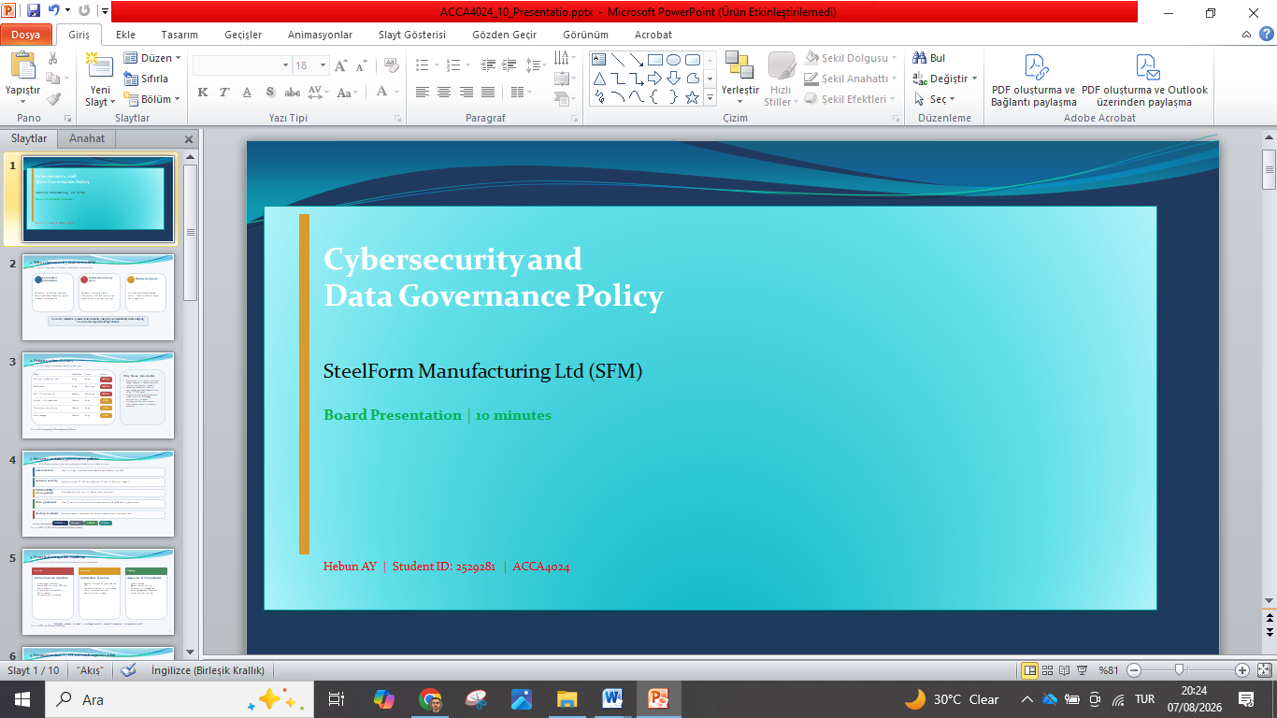
2
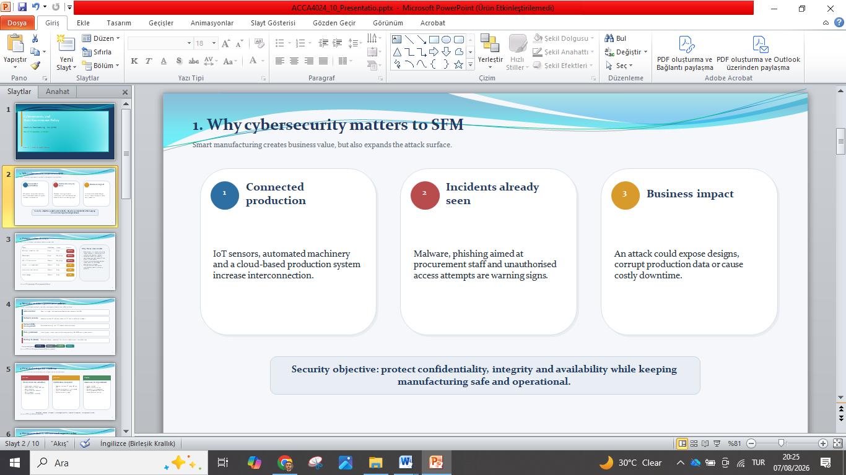
3
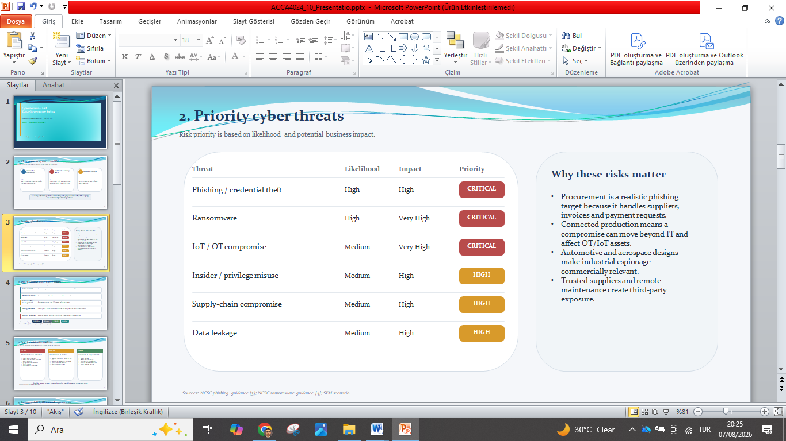
4
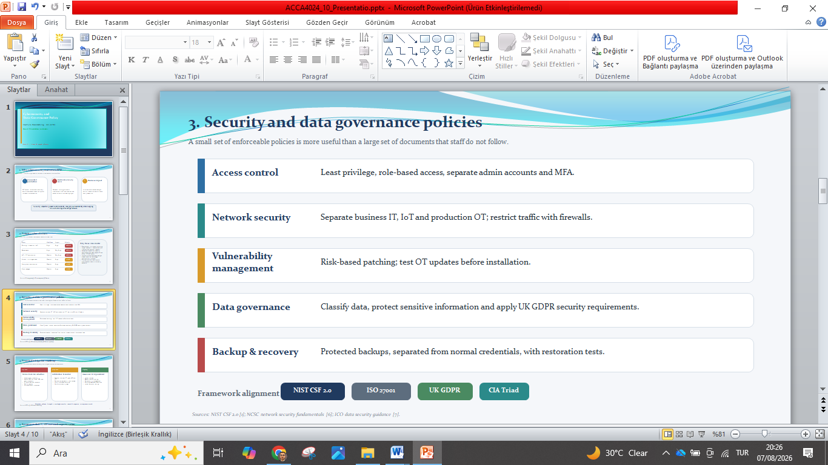
5
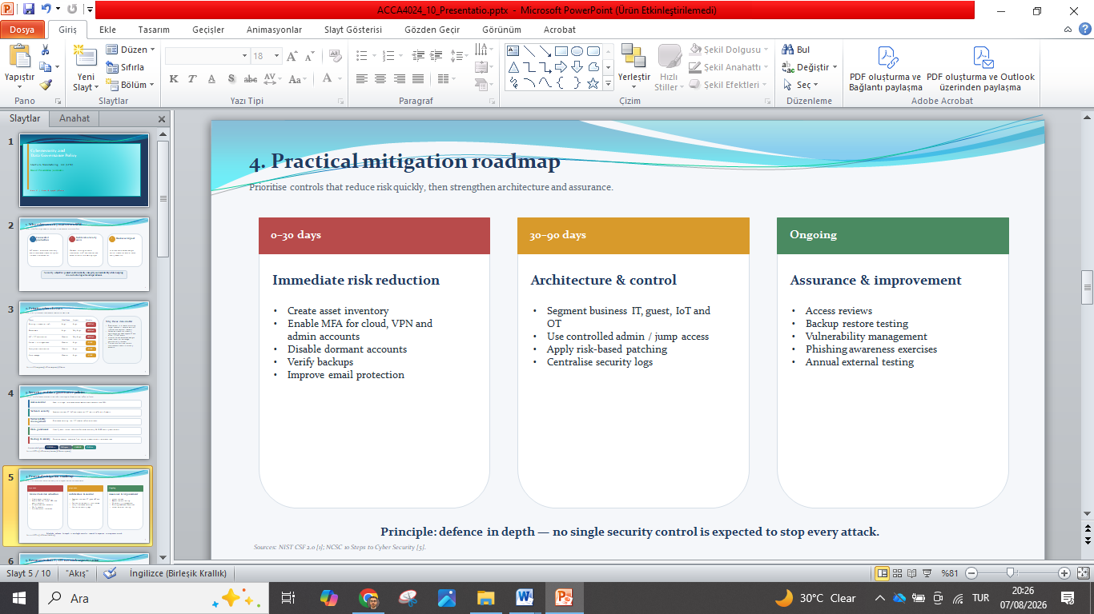
6
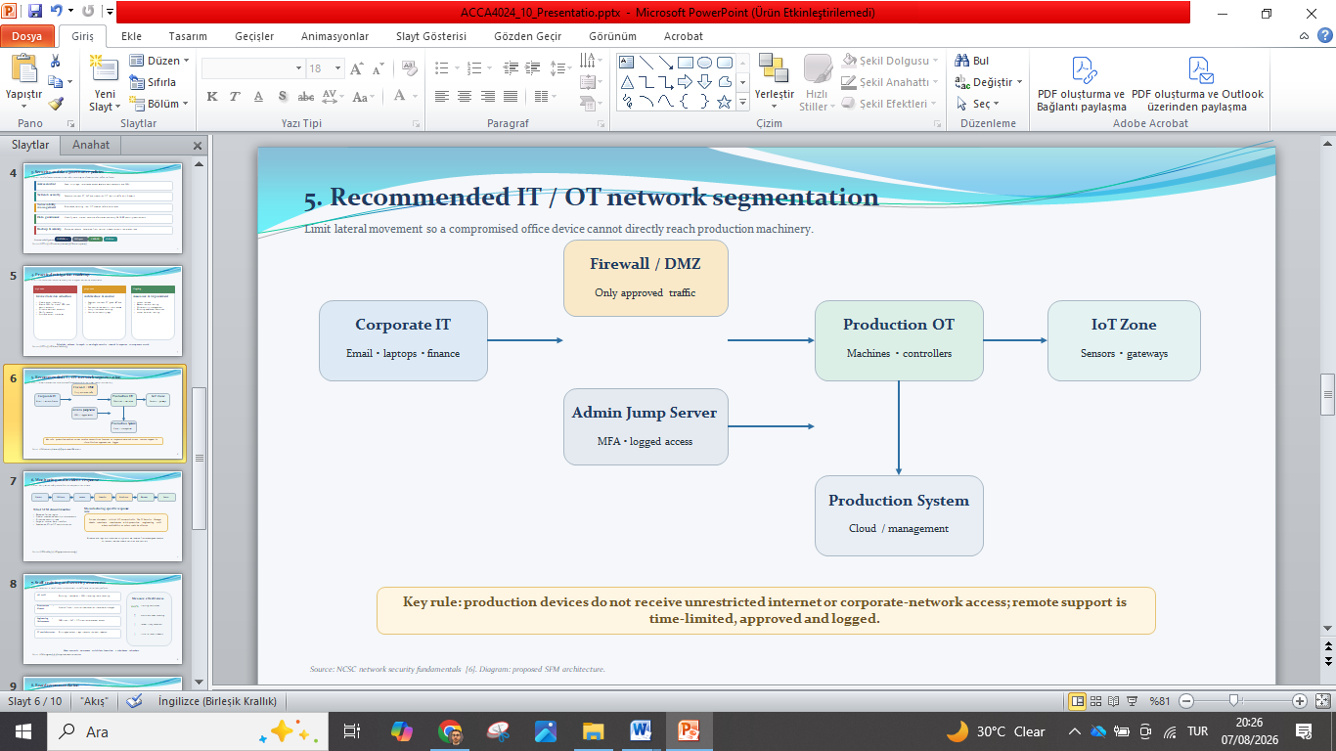
7
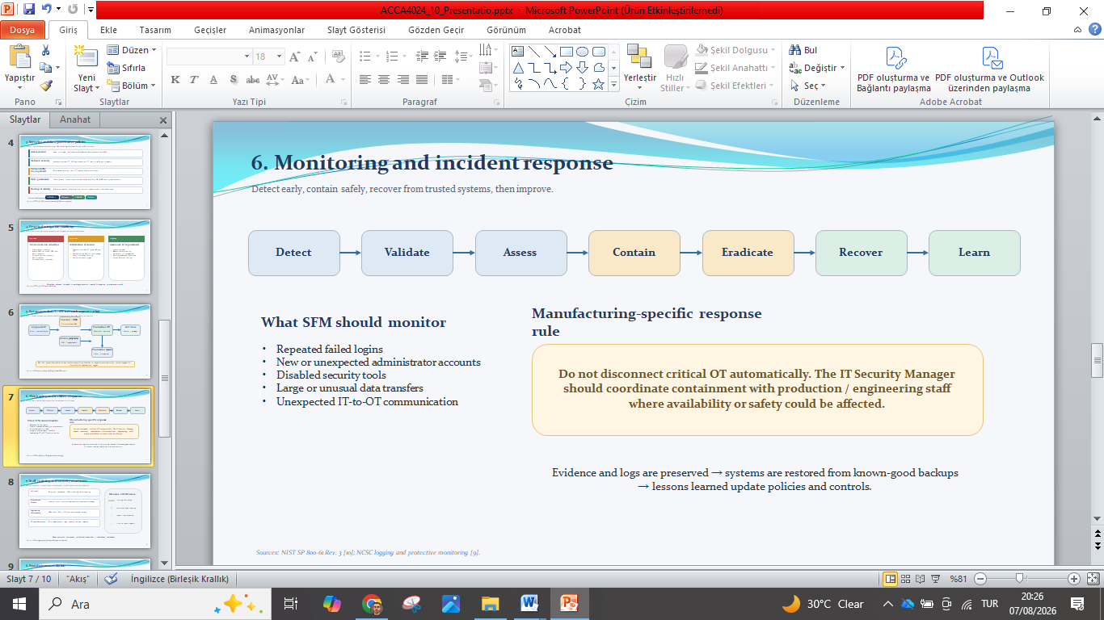
8
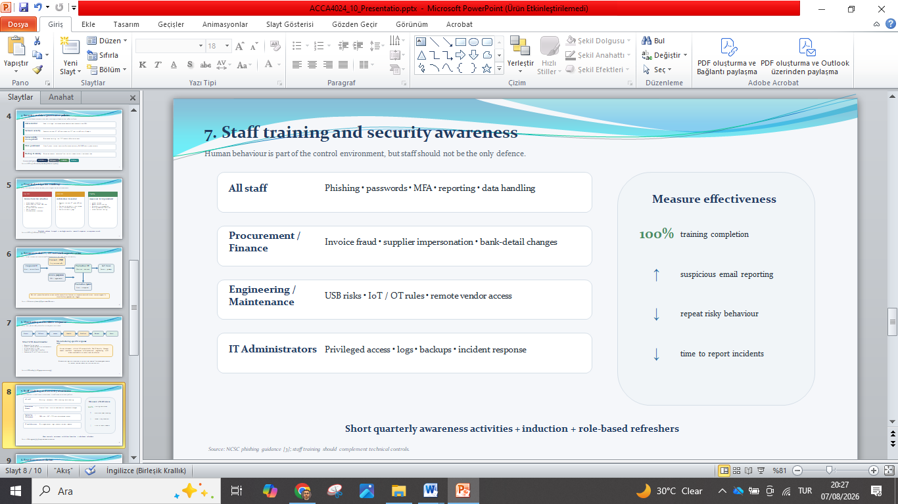
9
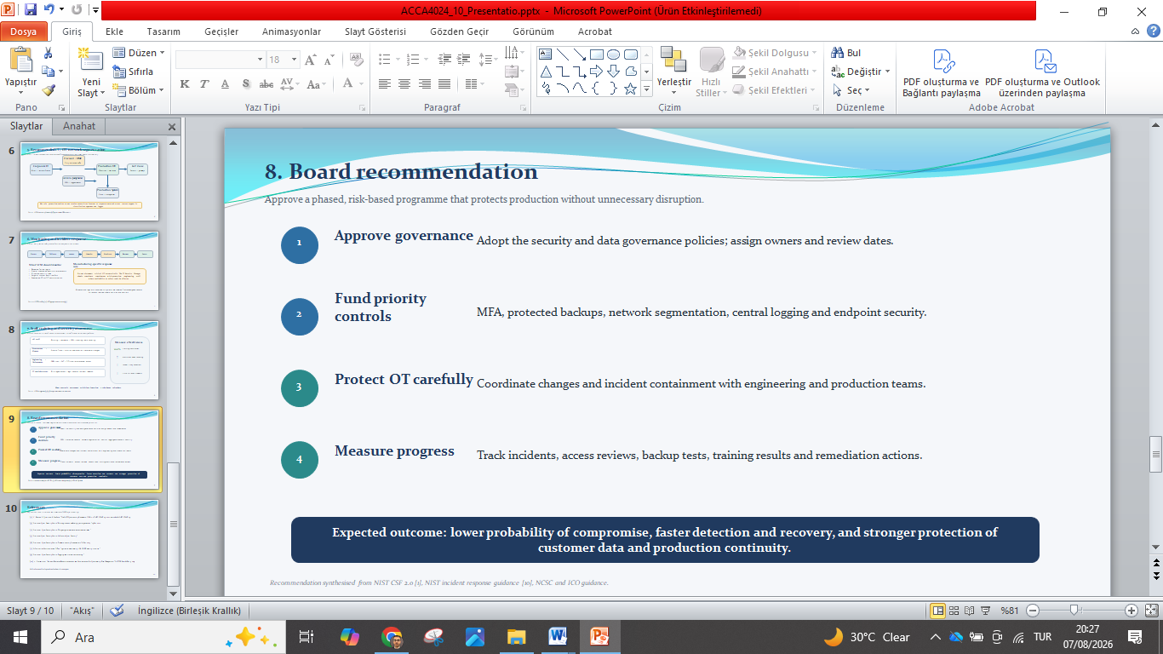
10


