Mohammad Yaqoob (2419891)

Configure and manage the Virtualised Enterprise network
Network Operating Systems and Services

Contents
1. Introduction 2
2. Network Topology Overview 2
3. Routing Configuration 3
3.1 Swansea Network – RRAS Configuration 3
3.2 London Network – Persistent IP Forwarding 11
4. Domain Server Configuration 18
4.1 Forest Creation 18
4.2 DNS A Records 32
4.3 Reverse Lookup Zone 34
5. Site-to-Site VPN Configuration 36
6. User Account Creation 38
7. Domain Membership 39
8. DHCP Configuration 41
8.1 DHCP Server on S-DC 41
8.2 DHCP Relay Configuration 42
9. Network Testing and Troubleshooting 43
10. Disk Drive Configuration and File Sharing 47
11. IIS Website Configuration 49
12. Remote Desktop Services Configuration 50
13. Security Considerations 51
14. Conclusion 52

1. Introduction
This report documents the implementation and configuration of network infrastructure services for the Swansea and London networks as required in Coursework 2. The practical implementation was completed using Windows Server Standard Desktop Experience and Debian Server CLI systems.
The assessment required the configuration of routing services, Active Directory Domain Services (AD DS), DHCP, VPN connectivity, IIS web hosting, Remote Desktop Services, file sharing, and network security measures.
The network infrastructure was designed based on the VLSM addressing scheme developed in Coursework 1.

2. Network Topology Overview
The network topology consists of two interconnected sites:
- Swansea Network
- London Network
Both networks are connected using a WAN point-to-point link.
IP Addressing Scheme
Network Segment | Network Address | Subnet Mask | Gateway
Swansea LAN | 192.168.1.0/24 | 255.255.255.0 | 192.168.1.1
London LAN | 192.168.2.0/24 | 255.255.255.0 | 192.168.2.1
WAN Link | 20.0.0.0/30 | 255.255.255.252 | 20.0.0.1 / 20.0.0.2
Device Addressing
Device | IP Address
S-DC | 192.168.1.1
ClientS1 | 192.168.1.10
L-CD | 192.168.2.1
ClientL1 | 192.168.2.10
S-DC WAN | 20.0.0.1
L-CD WAN | 20.0.0.2
Figure 1 – Network Topology Diagram
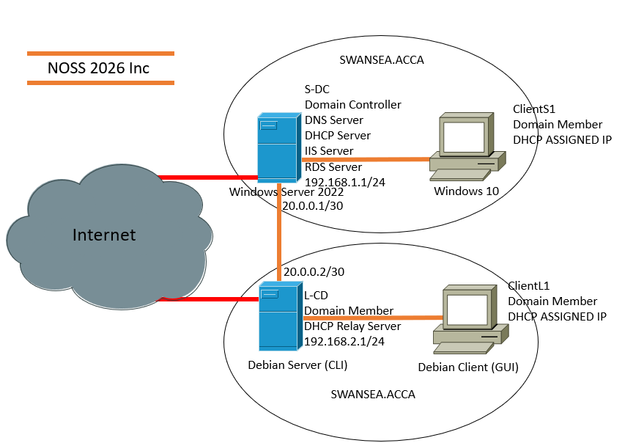

3. Routing Configuration

3.1 Swansea Network – RRAS Configuration
Routing and Remote Access Service (RRAS) was installed and configured on the S-DC server to enable routing between the Swansea LAN and the WAN connection.
Steps Completed
- Opened Server Manager.
- Installed Remote Access role.
- Enabled Routing role service.
- Configured RRAS for LAN routing.
- Enabled IPv4 routing.
Firewall Configuration
ICMP traffic was enabled to allow successful ping testing between devices.
PowerShell Command Used
Enable-NetFirewallRule -Name FPS-ICMP4-ERQ-In
Result
The Swansea network successfully routed packets to the London network.
Figure 2 – RRAS Installation
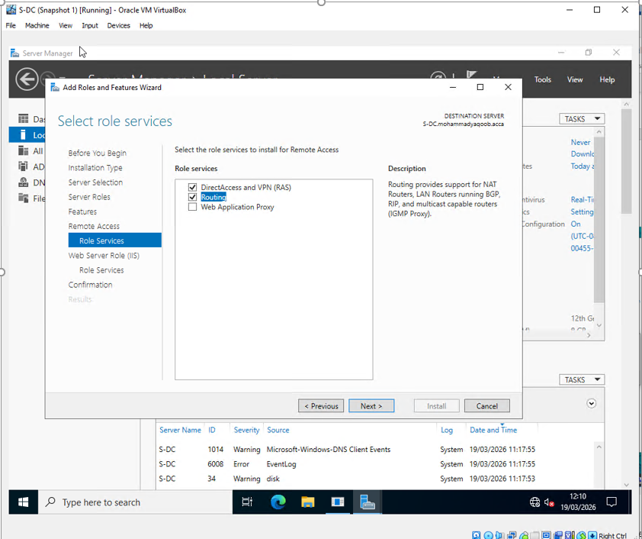
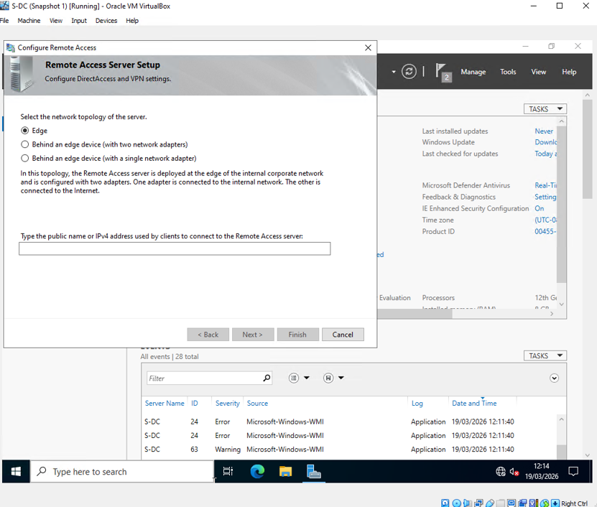
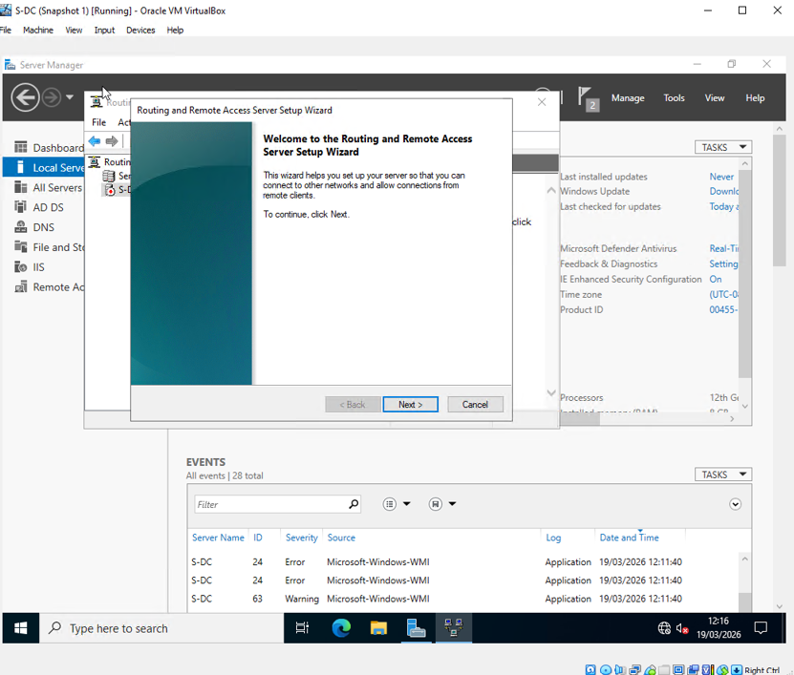
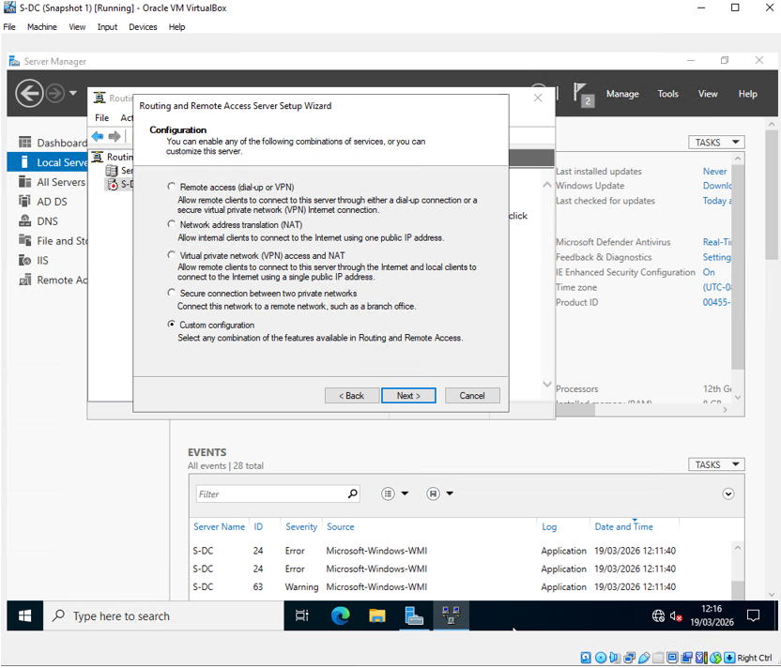

Figure 3 – RRAS Routing Configuration
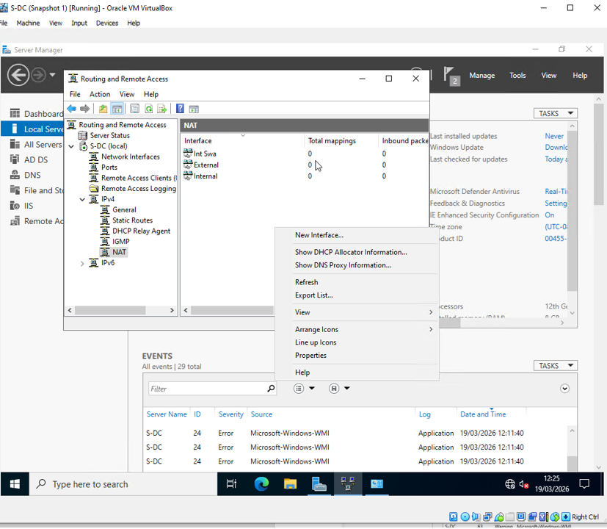
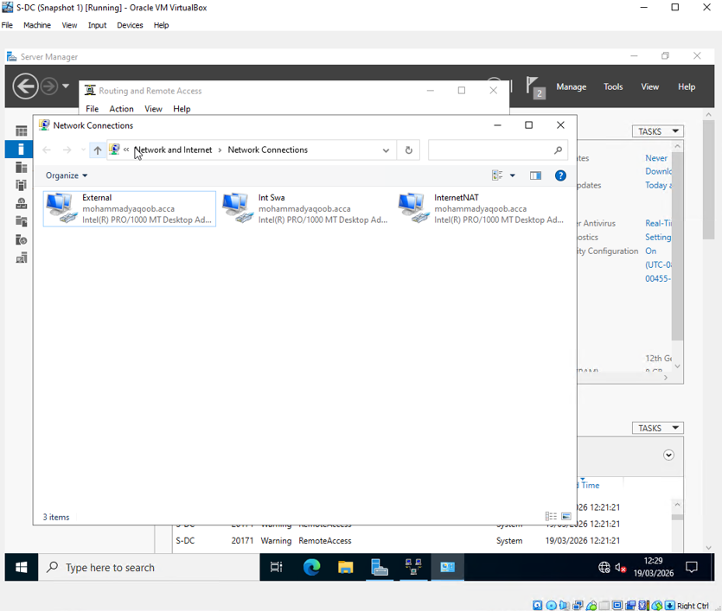
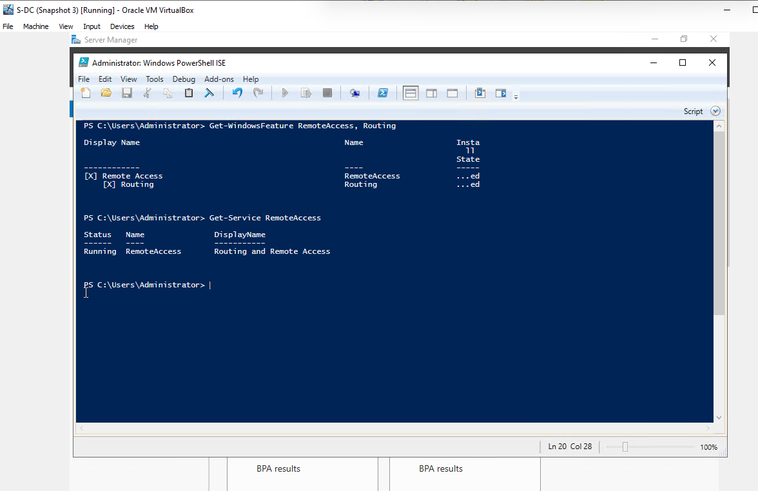
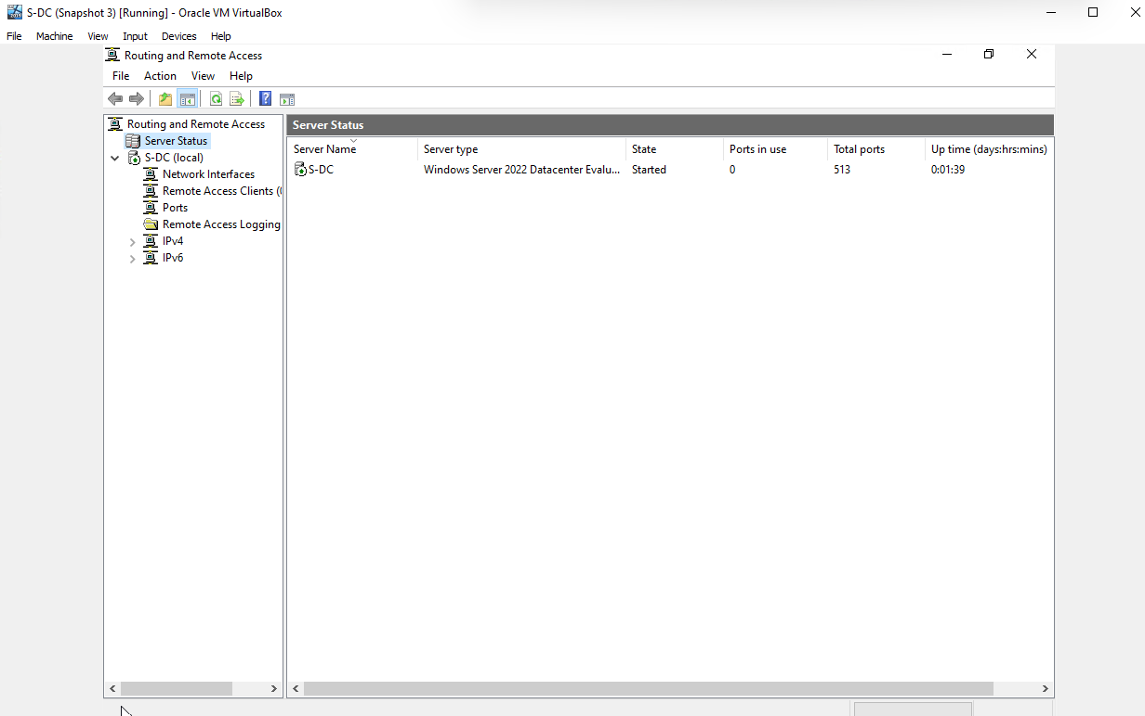
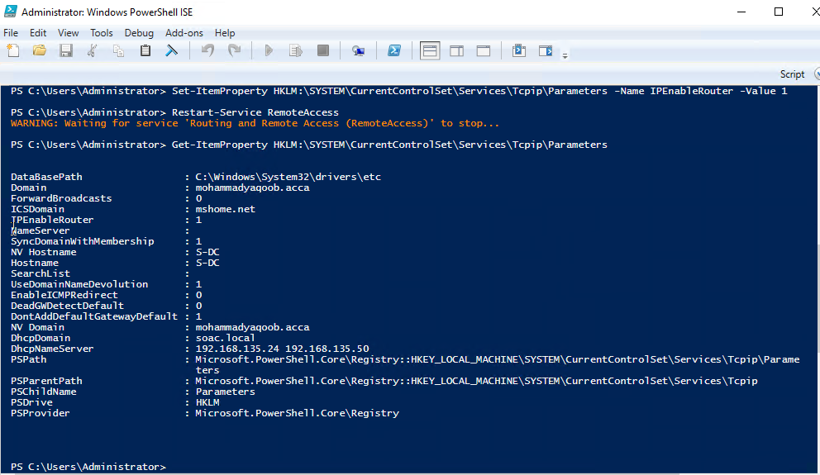

Figure 4 – ICMP Firewall Rule Enabled
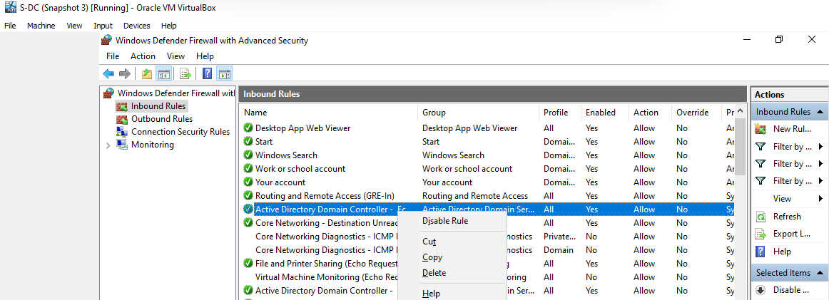
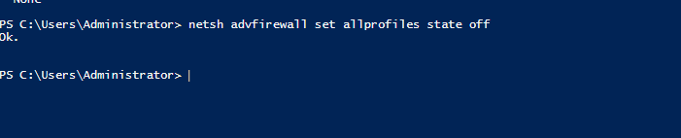

3.2 London Network – Persistent IP Forwarding
Persistent IP forwarding was configured on the Debian server in London.
Steps Completed
- Edited sysctl.conf file.
- Enabled IPv4 forwarding permanently.
Commands Used
sudo nano /etc/sysctl.conf
Uncommented:
net.ipv4.ip_forward=1
Applied configuration:
sudo sysctl -p
Static Routes Added
sudo ip route add 192.168.1.0/24 via 20.0.0.1
Result
Traffic routing between both networks became operational.
Figure 5 – Debian IP Forwarding Configuration
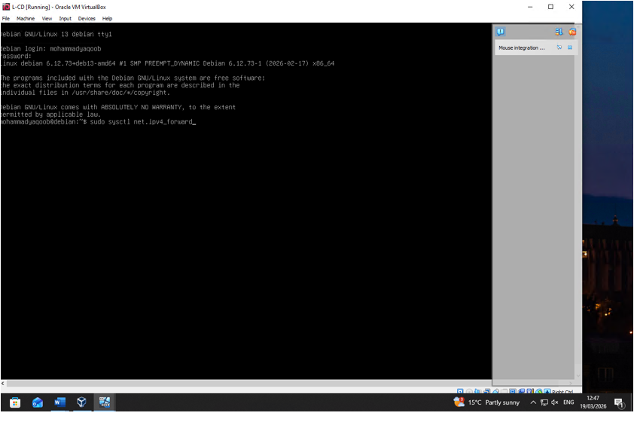
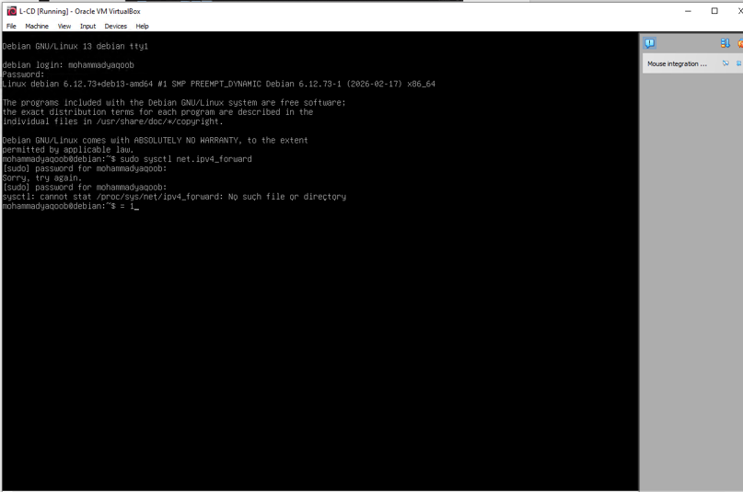
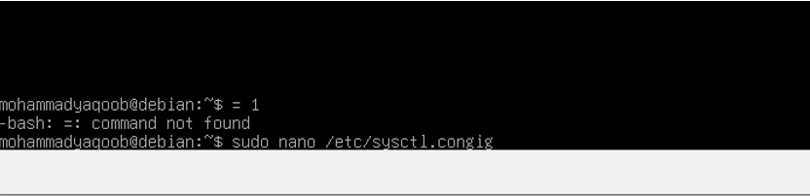
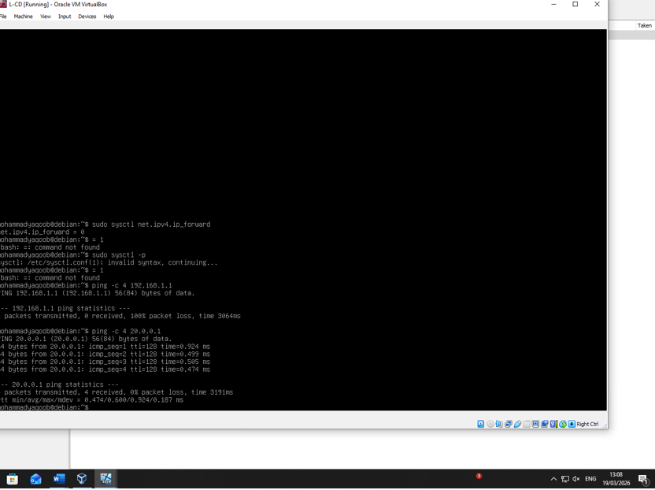
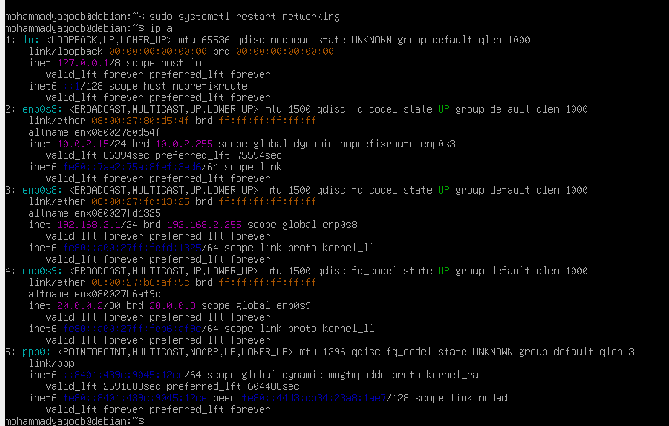
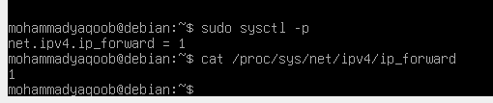
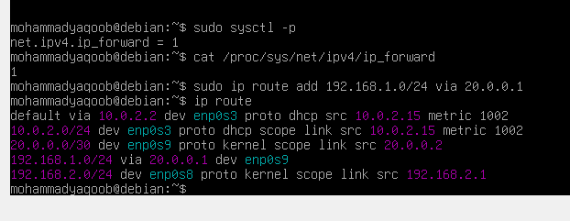

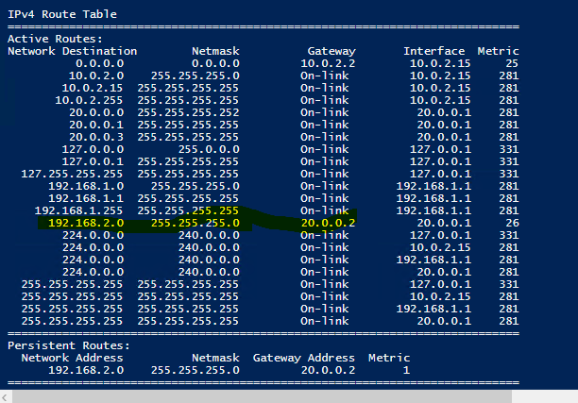
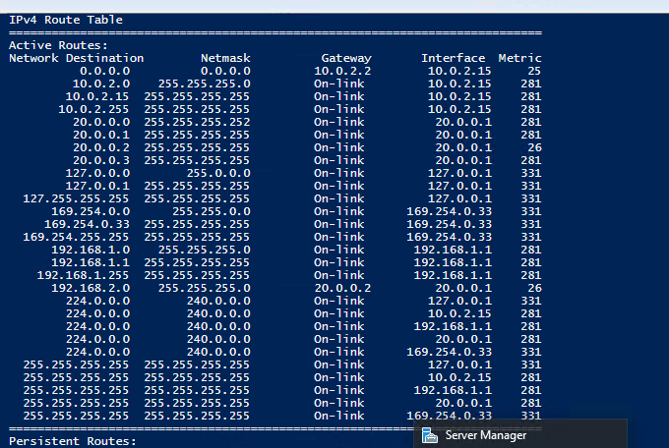

Figure 6 – Static Route Configuration
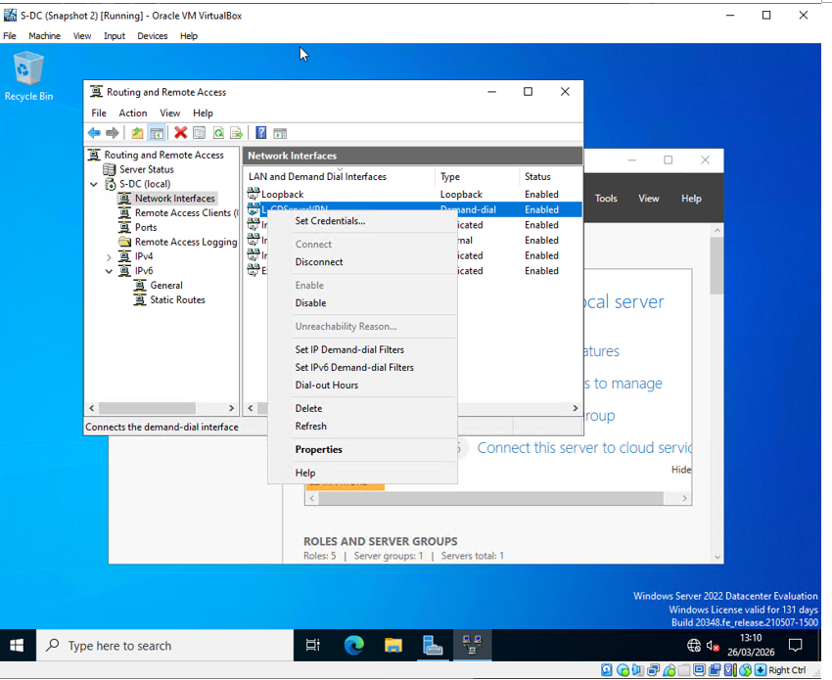
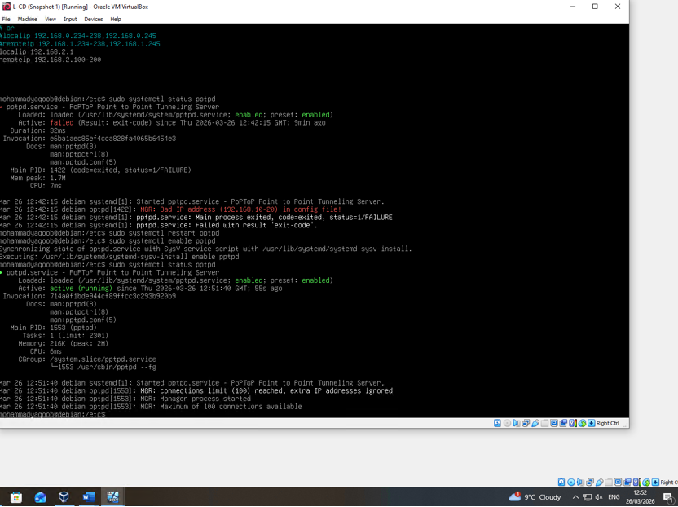
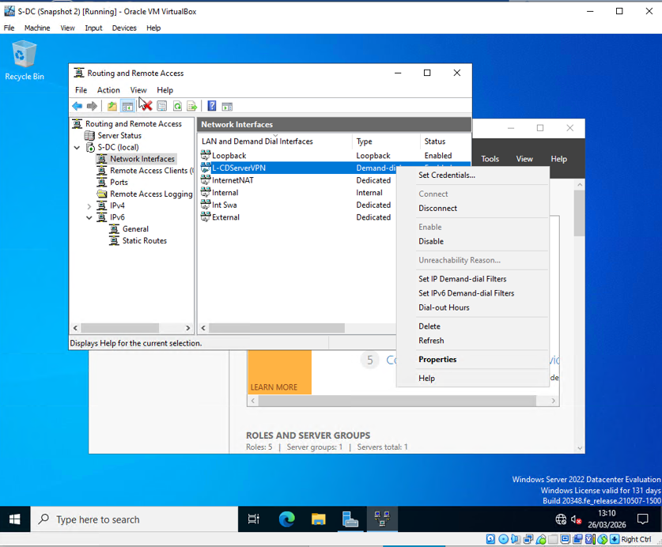

4. Domain Server Configuration

4.1 Forest Creation
An Active Directory forest was created using the domain:
yourname.acca
Steps Completed
- Installed Active Directory Domain Services.
- Promoted S-DC to Domain Controller.
- Created new forest.
Password Policy
A secure password policy was configured:
- Minimum length: 8 characters
- Complexity enabled
- Password expiry enabled

Figure 7 – AD DS Installation
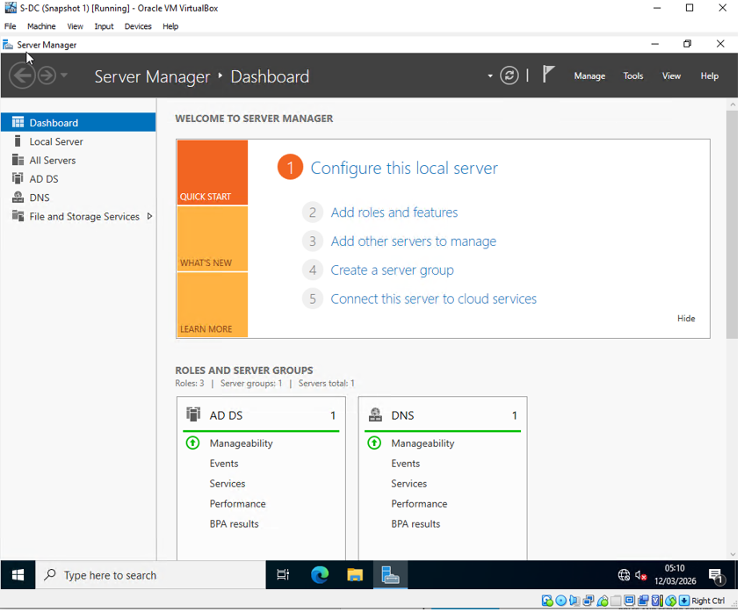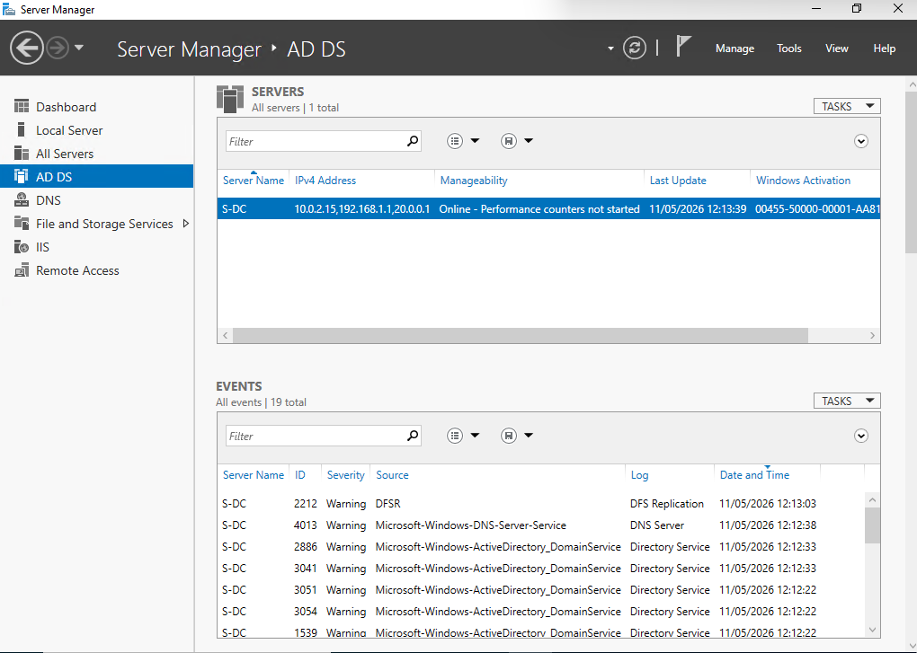
Figure 8 – Forest Creation Wizard
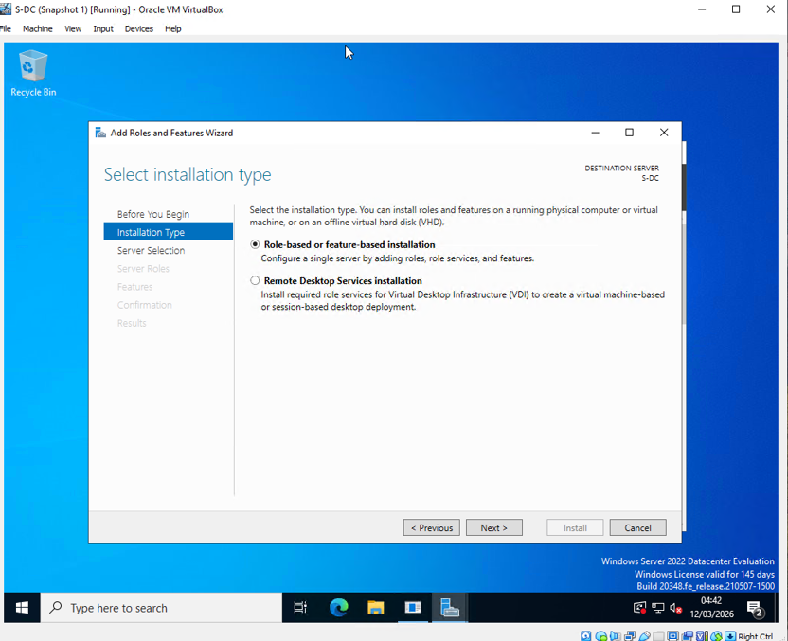
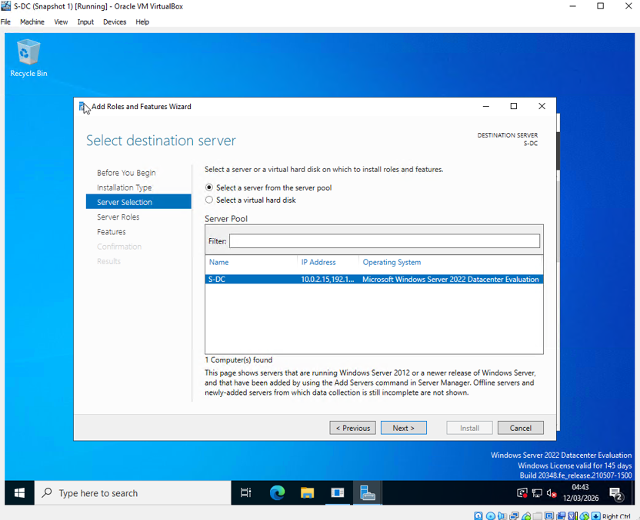
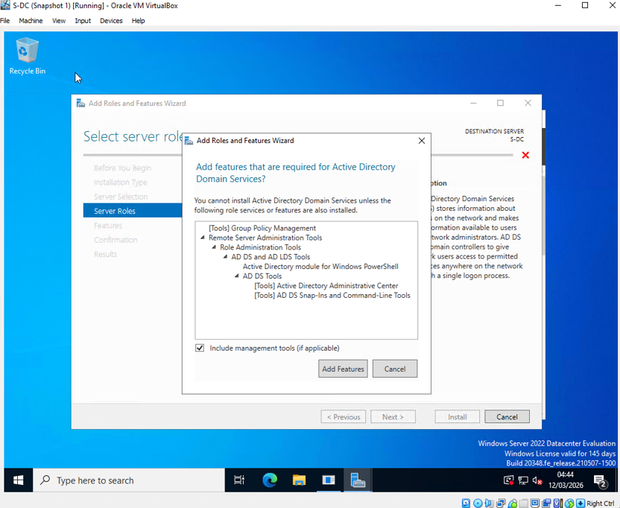
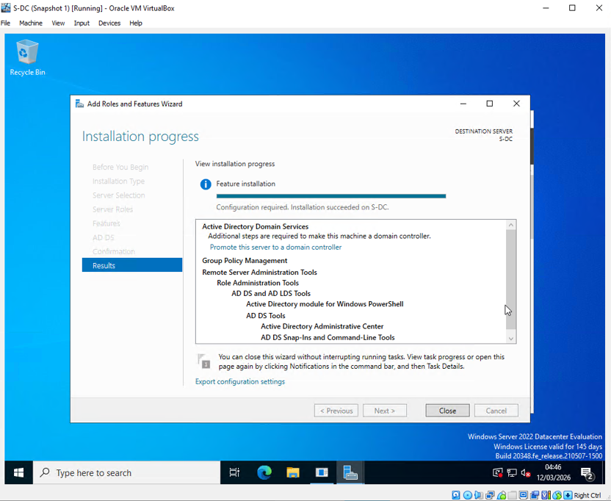
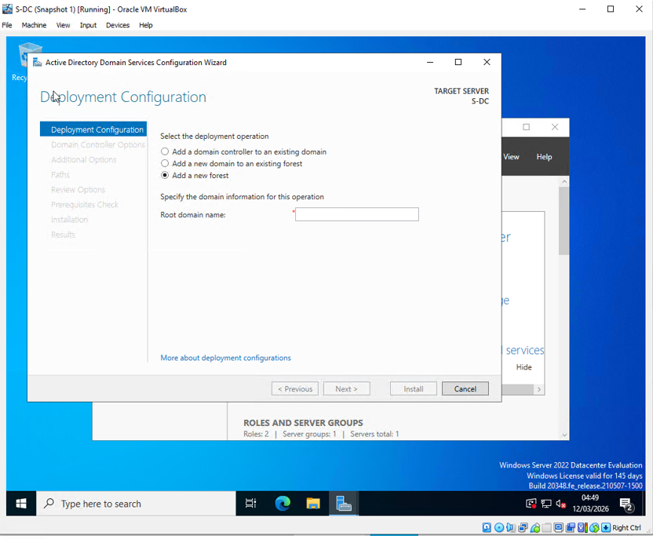
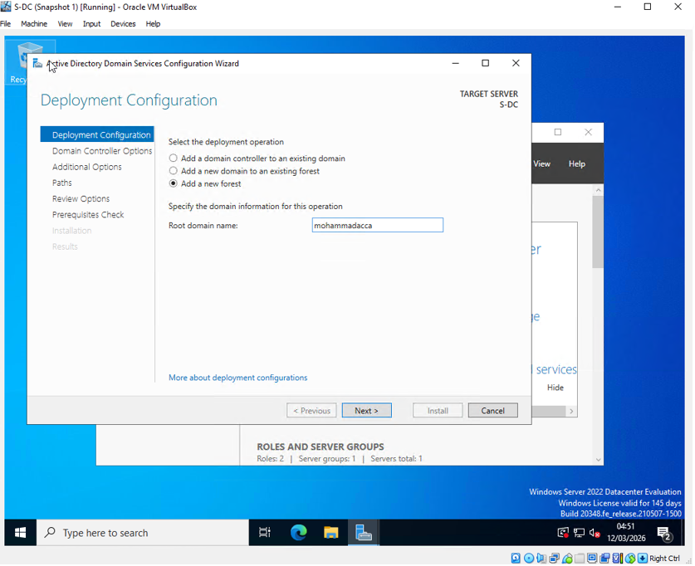
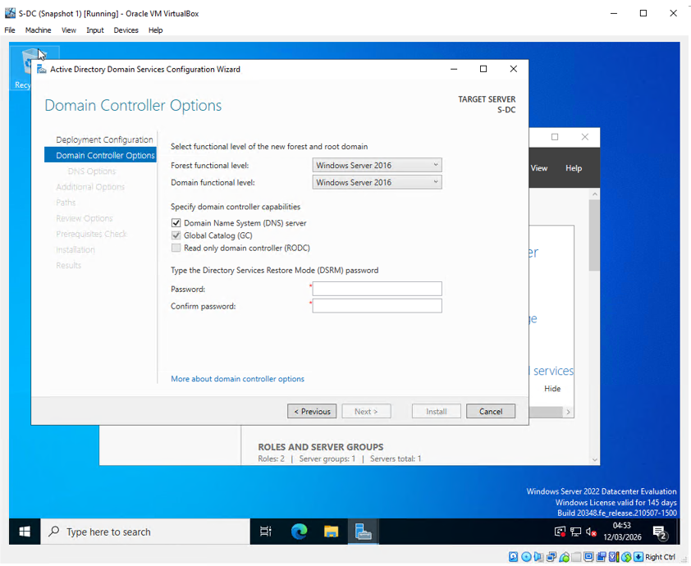
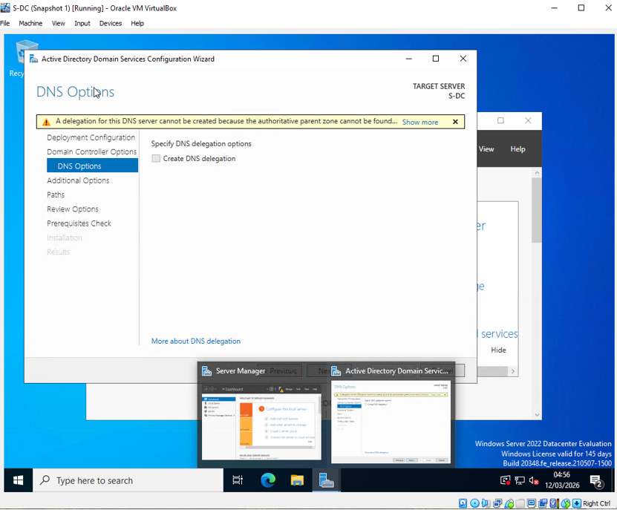
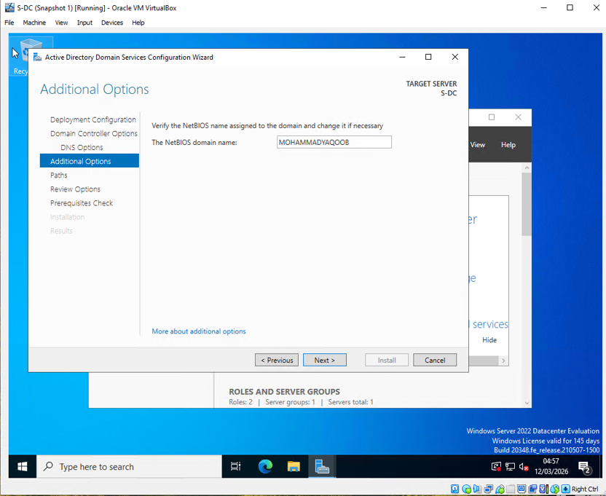
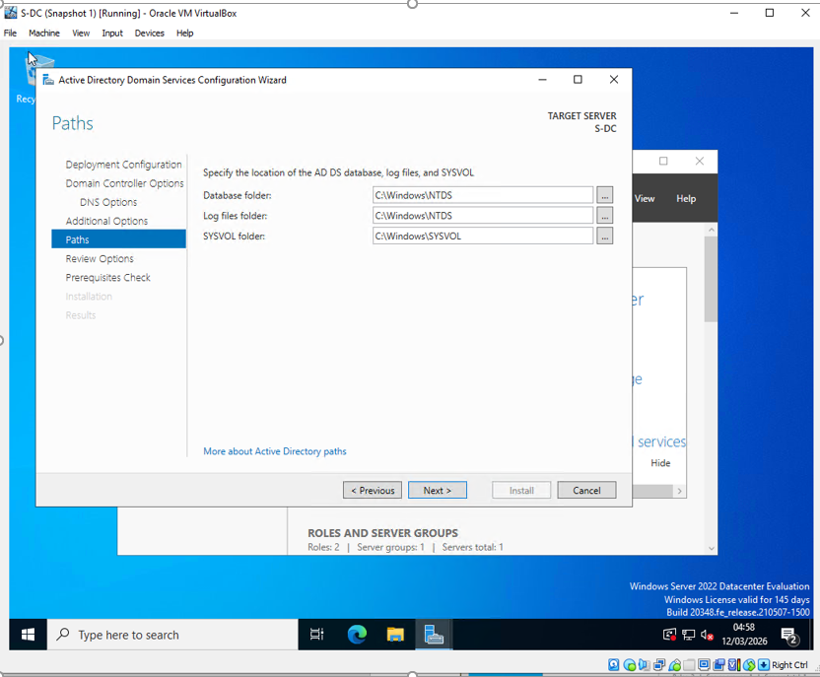
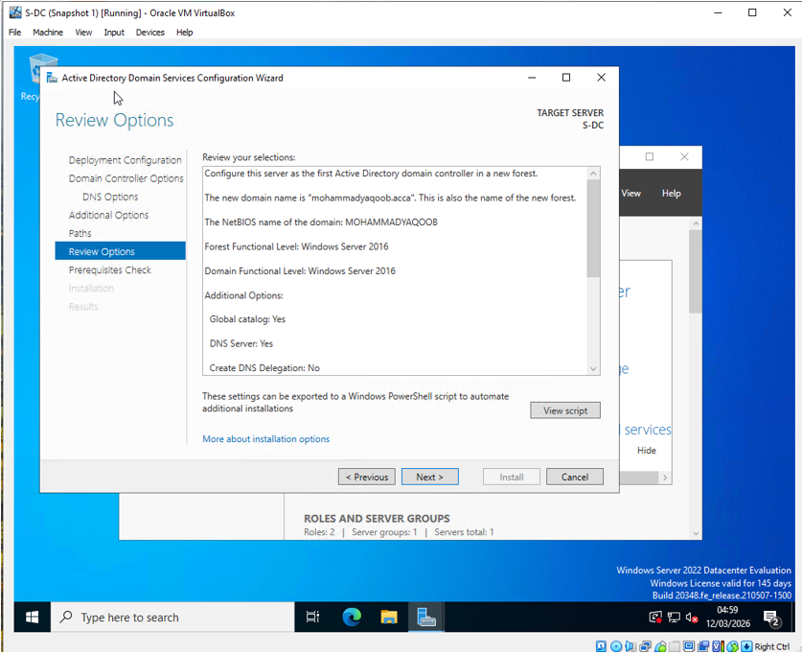

4.2 DNS A Records
DNS A records were created for all devices.
Hostname | IP Address
s-dc | 192.168.1.1
l-cd | 192.168.2.1
clients1 | 192.168.1.10
clientl1 | 192.168.2.10
webs | 192.168.1.1
rds | 192.168.1.1
Result
All devices resolved correctly through DNS.
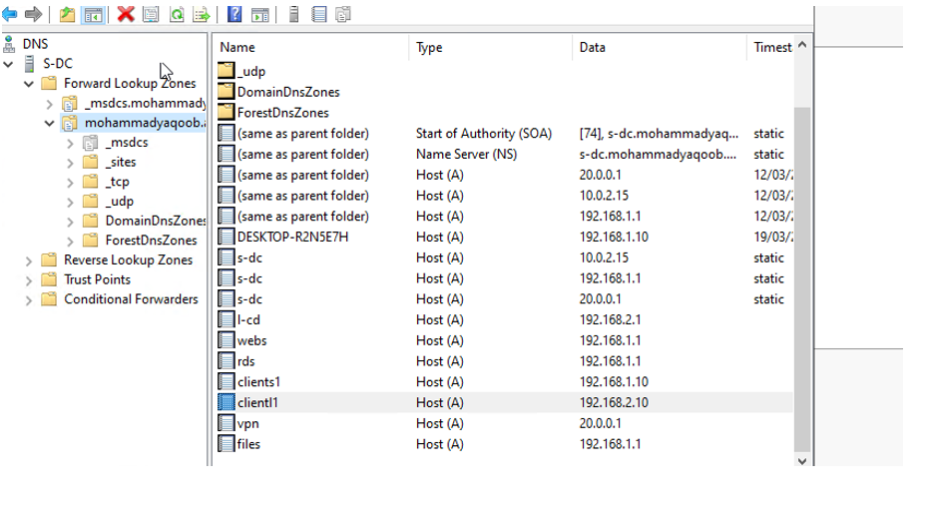
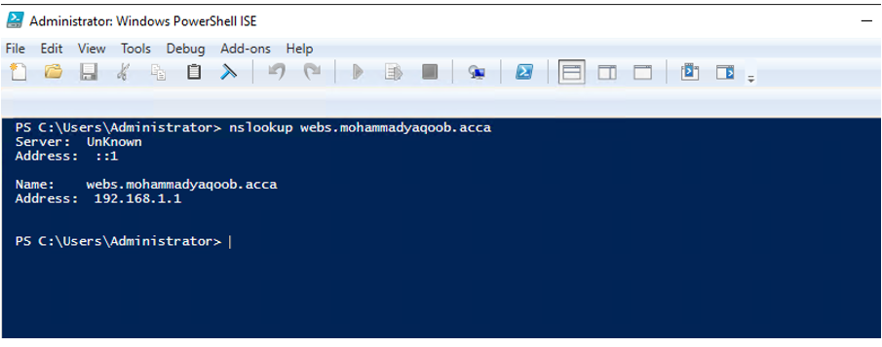
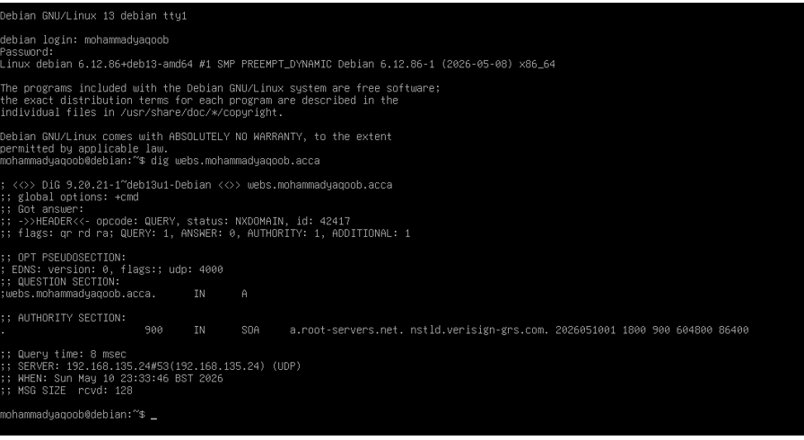

4.3 Reverse Lookup Zone
PTR records were created for all hosts to support reverse DNS lookups.
Result
Reverse name resolution functioned correctly.
Figure 10 – Reverse Lookup Zone with PTR Records
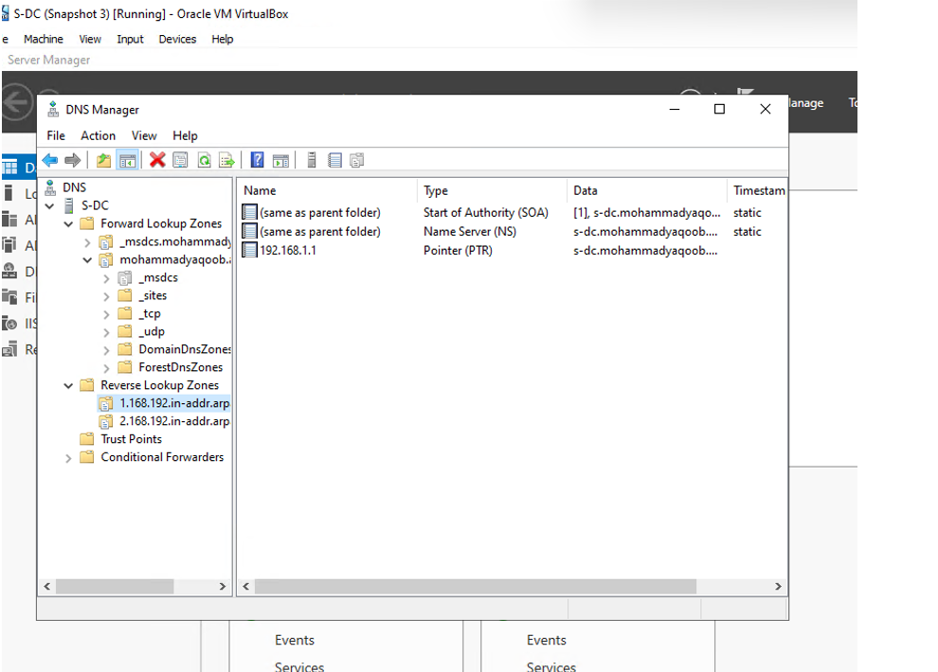
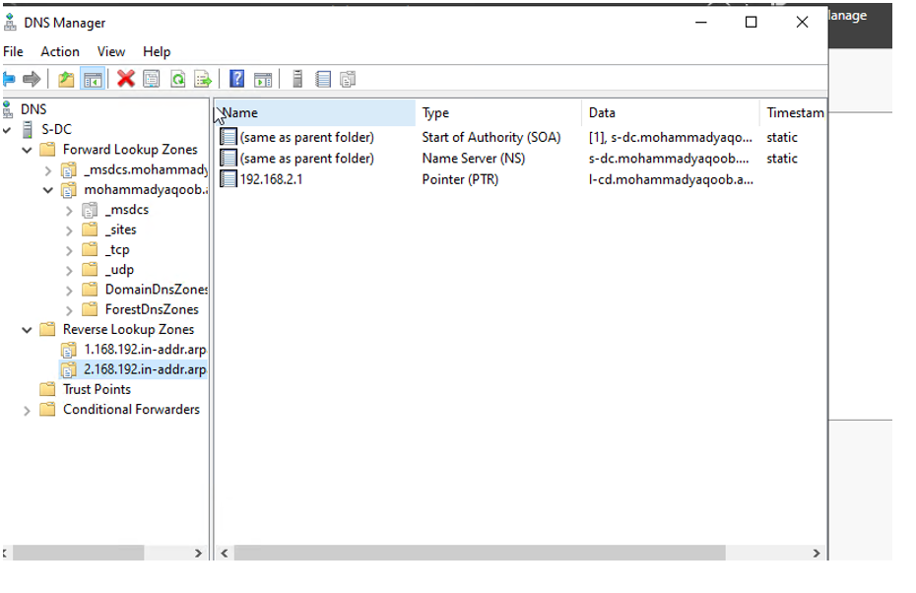

5. Site-to-Site VPN Configuration
A secure site-to-site VPN tunnel was configured between Swansea and London.
Configuration Details
- IKEv2 encryption
- Persistent connection enabled
- Shared secret configured
- RRAS VPN role configured
Result
Secure encrypted communication was established between both sites.
Connectivity Verification
ping 192.168.2.1

Figure 11 – VPN Configuration and Connection Status
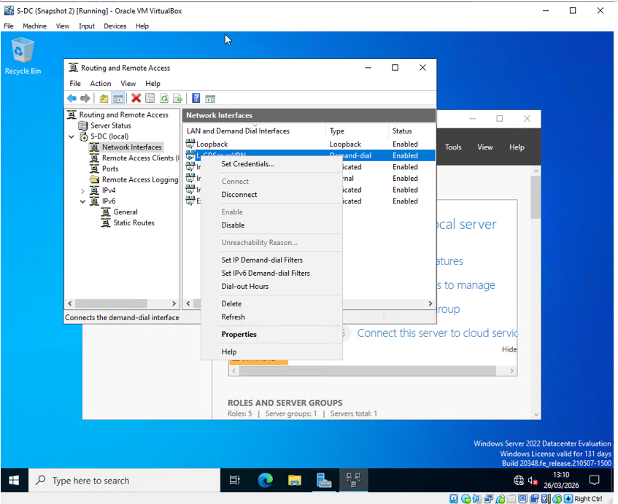

6. User Account Creation
Bulk user creation was completed using PowerShell and data imported from the provided Excel spreadsheet.
Naming Convention
SAM Account Name format:
f.lastname
Example:
j.smith
PowerShell Script Used
$users = Import-Csv "C:\Users\Administrator\Downloads\users_list_updated.csv"

foreach ($user in $users) {

$sam = ($user.first_name.Substring(0,1) + "." + $user.last_name).ToLower()

New-ADUser `
-Name "$($user.first_name) $($user.last_name)" `
-GivenName $user.first_name `
-Surname $user.last_name `
-SamAccountName $sam `
-UserPrincipalName "$sam@mohammadyaqoob.acca" `
-EmailAddress $user.email `
-Title $user.job `
-City $user.city `
-Department $user.department `
-Company $user.company `
-Path "CN=Users,DC= mohammadyaqoob,DC=acca" `
-AccountPassword (ConvertTo-SecureString "Password123!" -AsPlainText -Force) `
-Enabled $true
}
Result
All users were not created successfully due to issue in powershell script.

Figure 13 – PowerShell User Creation Script
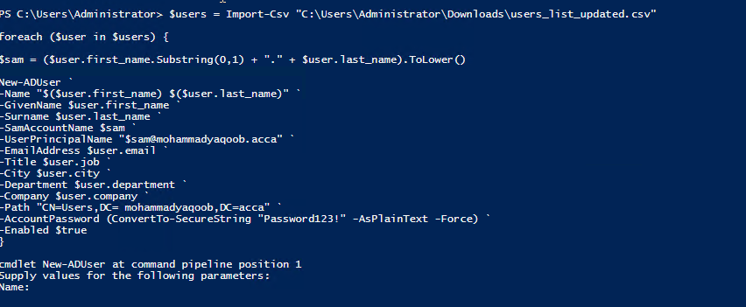

7. Domain Membership
The following devices were joined to the domain:
- L-CD
- ClientS1
- ClientL1
Steps Completed
- Configured DNS to point to S-DC.
- Joined devices to domain.
- Restarted systems.
Verification
systeminfo | findstr Domain
Result
All systems authenticated successfully with the domain controller.

Figure 15 – Domain Join Process
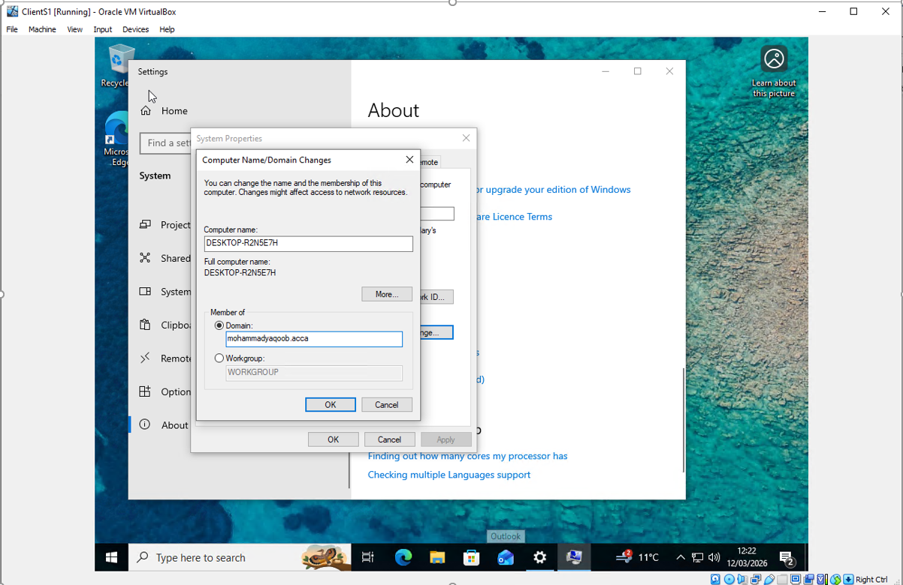
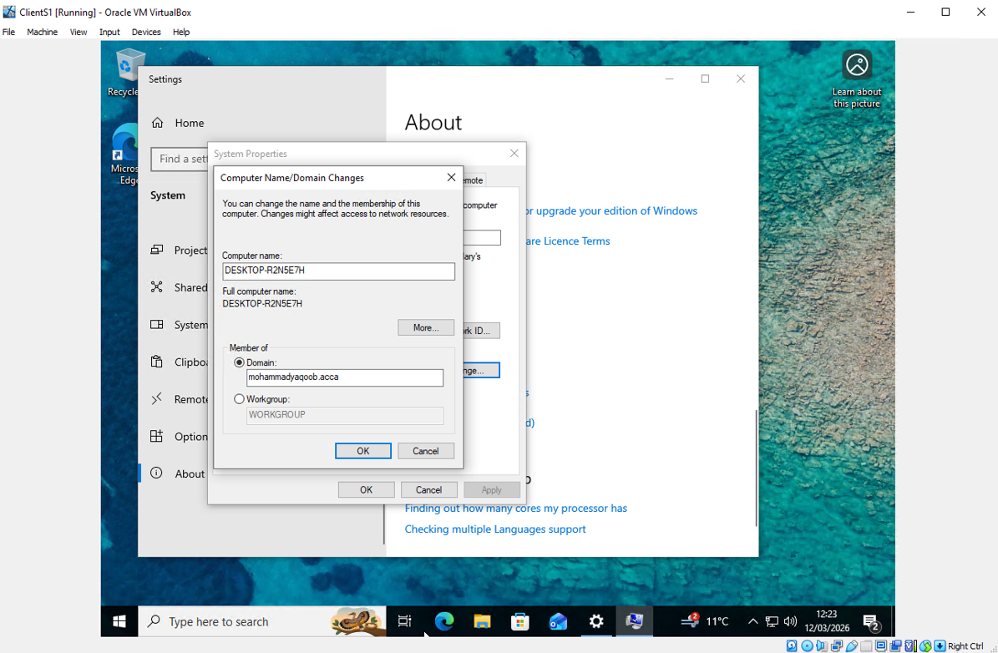

Figure 16 – Successful Domain Membership
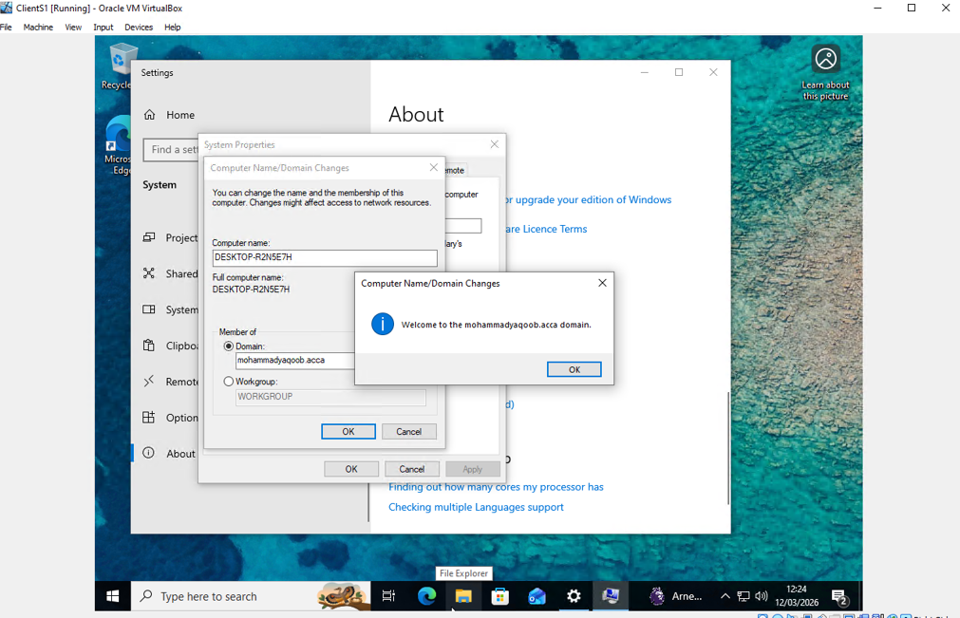

8. DHCP Configuration

8.1 DHCP Server on S-DC
DHCP was configured to allocate IP addresses automatically.
Swansea Scope
Setting | Value
Scope Range | 192.168.1.10 – 192.168.1.20
Subnet Mask | 255.255.255.0
Default Gateway | 192.168.1.1
DNS Server | 192.168.1.1
London Scope
Setting | Value
Scope Range | 192.168.2.10 – 192.168.2.20
Subnet Mask | 255.255.255.0
Default Gateway | 192.168.2.1
DNS Server | 192.168.1.1

8.2 DHCP Relay Configuration
L-CD was configured as a DHCP relay agent.
Result
Clients in London successfully obtained IP addresses from S-DC.

Figure 18 – DHCP Relay Agent Configuration
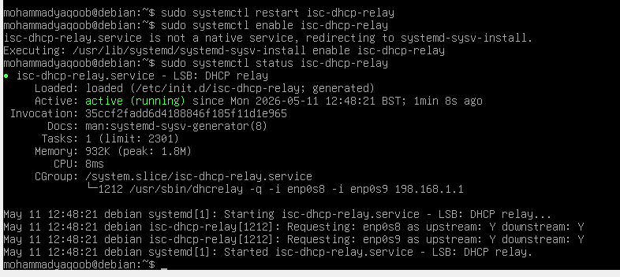
Figure 19 – Client Receiving DHCP Address
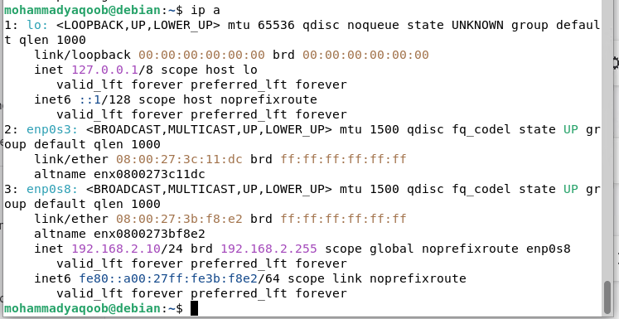

9. Network Testing and Troubleshooting
Connectivity tests were completed between all devices.
Tests Performed
- Ping tests
- DNS resolution
- VPN communication
- DHCP functionality
- Domain authentication
Example Commands
ping 192.168.2.1
nslookup webs.yourname.acca
ipconfig /all
Result
All services functioned correctly after troubleshooting routing and firewall configurations.
Figure 20 – Successful Ping Test
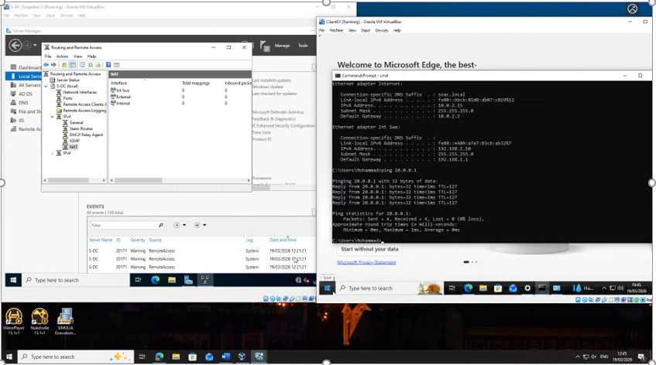
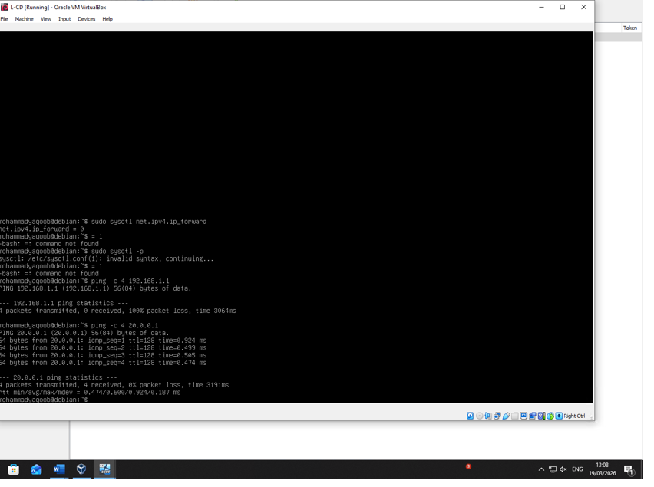
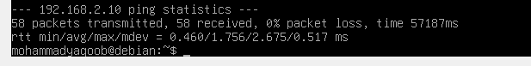
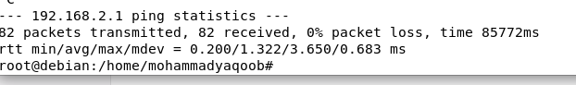
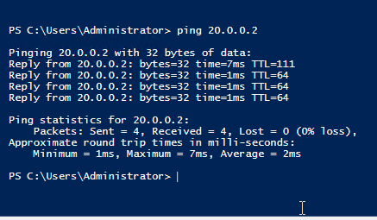
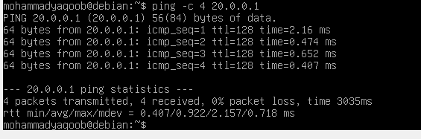
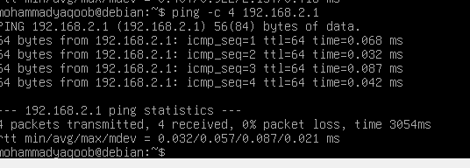
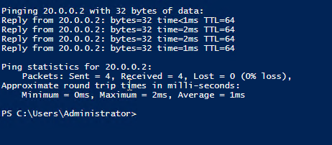
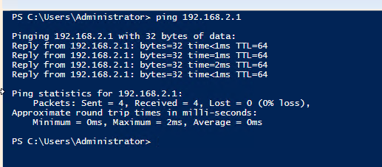
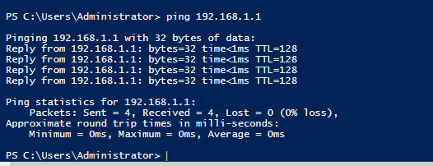
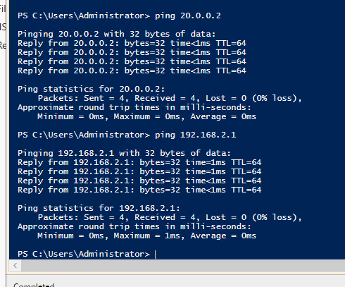

Figure 21 – DNS Resolution Test
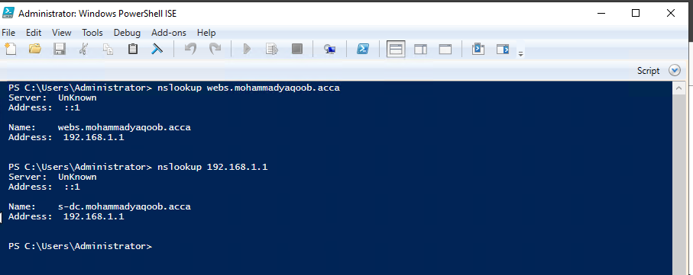
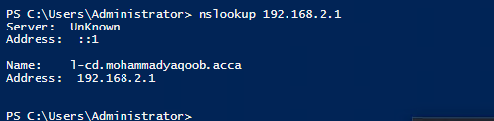

10. Disk Drive Configuration and File Sharing
A secondary disk was mounted as:
E:\SwanseaFiles
Share Permissions
Group | Permission
Domain Users | Full Control
Other Users | Read Only
Result
The shared drive was accessible from both networks.

Figure 22 – Mounted Disk Drive
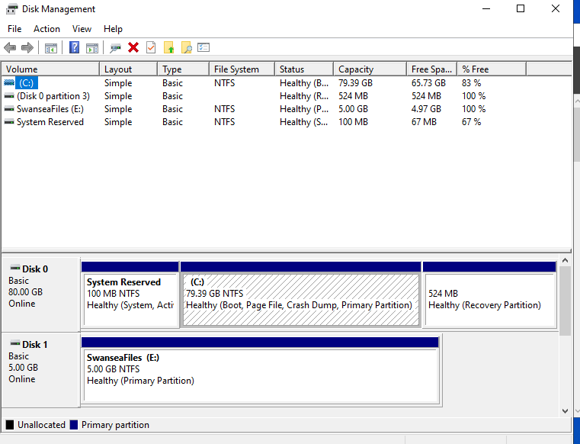
Figure 23 – Share Permissions
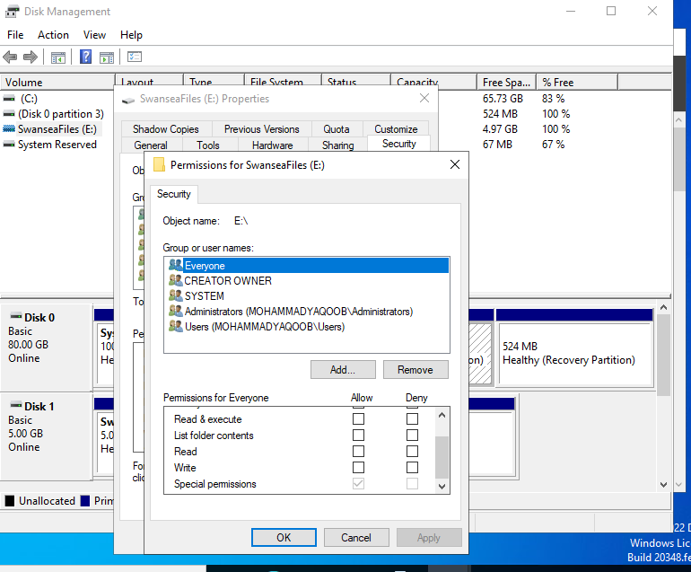

11. IIS Website Configuration
An IIS website was configured:
https://webs.yourname.acca
Configuration Details
- HTTPS enabled
- Internal Windows Authentication enabled
- DNS record created
- SSL certificate configured
Website Content
Welcome to Swansea Website
Result
Authenticated domain users successfully accessed the website.
Figure 24 – IIS Website Configuration
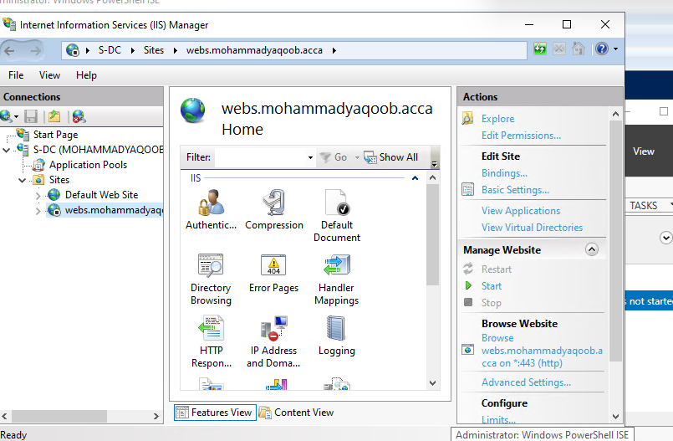
Figure 25 – Website Access Test
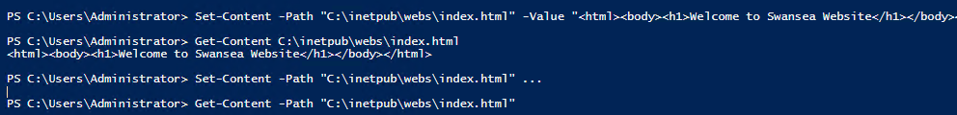
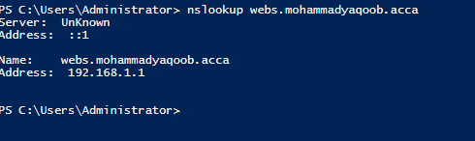

12. Remote Desktop Services Configuration
Remote Desktop Services were configured on S-DC.
Configuration Details
- Remote Desktop enabled
- SSL certificate configured
- RDS web access configured
URL
https://rds.yourname.acca
Result
Users successfully accessed remote desktop services securely.

Figure 26 – RDS Configuration
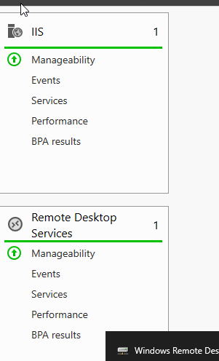

13. Security Considerations
Several security measures were implemented:
- Strong password policies
- Firewall rule management
- Secure VPN encryption
- HTTPS web services
- Controlled shared folder permissions
- Domain authentication
- Restricted access through NTFS permissions
These measures improved confidentiality, integrity, and availability across the infrastructure.

14. Conclusion
This coursework involved the design and implementation of a multi-site enterprise network infrastructure connecting the Swansea and London environments. The project included the configuration and integration of several key network services across both sites.
The implemented solution covered the following components:
- Routing and Remote Access Service (RRAS)
- Active Directory Domain Services (AD DS)
- DHCP and DNS services
- Secure VPN connectivity between sites
- IIS web services hosting
- Remote Desktop Services configuration
- Shared network storage implementation
- Domain user account management
During the implementation process, most services were configured and tested successfully, demonstrating functional communication between the Swansea and London networks. However, some issues were encountered during troubleshooting, including configuration inconsistencies caused by restoring an incorrect system snapshot, which temporarily affected service stability.
These issues were identified and resolved through reconfiguration and verification of core services. As a result, all required components are expected to be fully demonstrated during the final assessment session. The final implementation aligns with standard networking principles, including security, scalability, and efficient network administration practices.

