Research Project Proposal – Impact of current challenges on the human resource department relating to recruitment and retention.

Name: Sadia Mirza
Module: Personel Resourcing and Development
Module Code: BMIH5005
Lecturer Name: Kathryn Roberts
Contents
Introduction 3
Background 4
Figure 1: Hotel Ritz Logo 4
Current Challenges 4
Main Discussion 5
PESTLE analysis 8
Figure 2: PESTLE analysis 8
SWOT analysis 9
Figure 3: SWOT analysis 9
Influence of Current Affairs 10
Potential Solution 11
Evaluation 12
Recommendation 12
Figure 4: Recommendation 12
Conclusion 14
References 15

Introduction
Many issues affect the hotel industry's ability to attract and retain staff. The continuing COVID-19 epidemic is a major obstacle since it has lowered the number of tourists and, by extension, the need for hotel rooms. The Hotel Ritz UK is just one of many establishments that have been forced to downsize or cease operations as a direct consequence of this. Attracting and retaining top talent is challenging because of the industry-wide lack of competent personnel, especially in service industries like hospitality and catering. Altering client requirements and increasing competition from non-traditional lodging providers like Airbnb are additional difficulties.

Background
The Ritz London is one UK hotel that is having trouble filling positions and keeping staff. The Ritz is a five-star hotel in the center of London that is known for its impeccable service. As a result of the widespread fear generated by the COVID-19 epidemic, fewer people have been traveling and fewer people have been staying in hotels. As a consequence, hotels like The Ritz have seen a drop in business and have had to cut down on employees. With the rise of several 5-star hotels in the neighborhood, The Ritz has had to contend with tougher competition.


Figure 1: Hotel Ritz Logo
(Source: Ritz, 2019)

Current Challenges
The lack of available workers is one of The Ritz's main problems. It has been challenging for The Ritz to fill open positions as the number of people seeking employment in the hotel sector has dropped due to the epidemic. A considerable number of employees are needed to maintain The Ritz's reputation for impeccable service. The Ritz's high standards, however, have proven harder to uphold as a result of the current labor scarcity (Bover et al., 2020).
Lack of personnel training is another issue that has plagued The Ritz. The Ritz has built its reputation on its excellent service, so its employees must get the training they need to keep up the good work. The decline in the quality of service at The Ritz has been linked to insufficient training time due to the aftermath of the epidemic.
Another issue plaguing The Ritz right now is poor management. Even though The Ritz is well-known for its excellent service, the hotel's management must be able to inspire confidence in its employees. Yet, it has proven more difficult for The Ritz to offer effective management because of the pandemic's impact on income and employee numbers.
Recruiting and keeping good employees is a problem for The Ritz London right now. Staffing shortages, insufficient education, and inept administration all contribute to these difficulties. If it wants to keep its place among the world's finest luxury hotels, The Ritz must find solutions to these problems.

Main Discussion
Many issues have an impact on the hospitality industry's ability to attract and retain workers. Experts in the field have studied the effects of these problems to better prepare the business world for them.
According to one survey, a lack of labor is the industry's biggest problem. Findings from the survey show that the hospitality industry is having trouble attracting and retaining personnel since many employees leave for higher-paying positions elsewhere. Due to the current labor scarcity, existing personnel are being stretched thin, which may result in worse morale and a general reduction in service quality (Tarrant, 2018).
A lack of personnel training is another issue plaguing the sector. The quality of service given by the hospitality industry may suffer since many employees lack the proper training to do their jobs properly. Employees' ability to do their tasks well and their degree of work satisfaction was shown to be directly correlated with how often they were trained (Dev et al., 2016).
The problem of poor management was also highlighted as a major issue in the business world today. According to the results, strong leadership is crucial for making workers feel appreciated and inspiring them to do their best. High employee turnover and a reduction in service quality are two consequences of ineffective management.
The COVID-19 epidemic has only made things worse. As a consequence of the epidemic, the hotel sector has seen a drop in business as a whole. Because of this, there is now less help available and more responsibility on those who do work (O’fallon and Rutherford, 2019). As a result of the epidemic, a lot of individuals have started renting houses and apartments instead of staying in hotels. Because of this, hotels are finding it more challenging to fill open positions and keep good staff.
Many issues have an impact on the hospitality industry's ability to attract and retain staff. Poor management, insufficient personnel training, and labor scarcity all contribute to these difficulties. The pandemic of COVID-19 virus has made it even more difficult for hotels to find and keep good staff. When these issues are resolved, the industry will be better equipped to serve its clients well and keep its employees engaged and enthusiastic.
There are several issues impacting the hotel business as a whole, including The Ritz London. Academic studies have been done to determine the nature and scope of these problems, and their effect on the hotel industry.
A severe lack of personnel is one of The Ritz's biggest problems. The hotel's income has dropped as a direct consequence of the COVID-19 epidemic, which has discouraged both tourism and travel. As a consequence, The Ritz has had trouble filling open positions and has had to reduce its workforce. Staff burnout and a reduction in service quality are consequences of the scarcity of labor.
Lack of personnel training is another issue that has plagued The Ritz. The Ritz is recognized for its impeccable service, and keeping up with those standards requires extensive training. Unfortunately, the epidemic has reduced chances for training, leading to a drop in service quality. Staff unhappiness and excessive turnover might result from a lack of training that prevents them from doing their duties effectively (B, 2019). Another issue plaguing The Ritz right now is poor management. If you want your staff to feel appreciated and driven to do a good job, then you need to be a successful leader. Employee morale and satisfaction have dropped as a consequence of the pandemic's impact on managers' ability to deliver effective leadership. A lack of effective management may result in high rates of employee turnover, which in turn can hurt both personnel levels and the quality of service given.
Recruitment and retention are two of The Ritz London's biggest problems. Staffing shortages, insufficient education, and inept administration all contribute to these difficulties. The COVID-19 epidemic has made it even more difficult for The Ritz to find and keep good staff. Taking on these issues is crucial for The Ritz to continue providing excellent service to its customers and keeping its employees happy and fulfilled in their jobs.

PESTLE analysis


Figure 2: PESTLE analysis
(Source: Author)

SWOT analysis


Figure 3: SWOT analysis
(Source: Author)

Influence of Current Affairs
Brexit, Covid-19, and inflation are just some of the current events having a major influence on staff retention in the hotel business.
A large portion of the migrant workforce that had previously worked in the UK's hospitality sector has been driven out by Brexit. Due to Brexit and changes in immigration regulations, many European Union employees have gone back to their home countries. As a result, many hotels are experiencing workforce shortages and finding it challenging to keep their current workers. The difficulty for hotels in acquiring and keeping foreign personnel has been compounded by the tightening of visa rules for those from outside the United Kingdom (Chakravarti, 2018). There has been a notable effect on hospitality worker retention because of the Covid-19 epidemic. Due to the temporary closure of several hotels, many employees have lost their jobs or seen a decrease in their hours. As a result of the epidemic, consumers have altered their habits, decreasing demand for hotels and other travel accommodations. As a result, hotels have seen a decline in income and an increase in the demands placed on their current workforce. Uncertainty and fear have escalated as a result of the layoffs and furloughs, even among the remaining workforce.
Retention of workers in the hospitality sector is suffering as a result of inflation. Employees are struggling to make ends meet due to the growing cost of living. Perhaps greater turnover rates in hotels as workers leave the industry in search of better income elsewhere. Moreover, hotels may see a decline in income and their capacity to provide competitive wages for their staff if inflation causes prices for products and services to rise (Shriver, 2013). The hotel business is seeing the effects of current events like Brexit, Covid-19, and inflation. Hotels are struggling to keep their personnel due to several factors, including a lack of available staff, declining income, and rising living costs. Hotels must face these difficulties head-on and adopt tactics to keep their personnel, such as paying competitive wages, enabling chances for professional growth, and maintaining a pleasant work atmosphere.

Potential Solution
To address the issues of staff recruitment and retention in the hospitality business, hotels may apply several viable solutions.
Offering competitive salary packages is one approach. This means not just paying a competitive income but also providing benefits like health insurance, retirement programs, and paid time off. Four Seasons Hotels and Resorts, for example, provides a comprehensive benefits package to its workers that includes medical, dentistry, and vision insurance, as well as a 401(k) retirement plan.
Another option is to give training and development opportunities. This may assist individuals in improving their skills and knowledge, leading to higher job satisfaction and retention. Marriott International, for example, provides its workers with a variety of training and development options, including online courses, in-person seminars, and leadership development programs (Whittaker, 2018).
Establishing a nice work atmosphere is also important for employee retention. This might include providing flexible scheduling, allowing for employee feedback and involvement, and celebrating staff accomplishments. Hilton Worldwide, for example, provides a variety of employee recognition programs, including rewards for exemplary performance and service (Ward, 2017).
Lastly, hotels must cultivate a culture of inclusion and diversity. This involves making sure that workers from all walks of life feel respected and supported. Hyatt Hotels Company, for example, has undertaken a variety of efforts to promote diversity and inclusion, such as employee resource groups and collaborations with organizations that serve underrepresented groups (Jackson, 2018).To address the issues of staff recruitment and retention in the hospitality business, hotels may apply several viable solutions. Offering competitive wage packages, giving chances for training and development, establishing a healthy work atmosphere, and fostering diversity and inclusion are some of the alternatives. Hotels may recruit and retain great employees by applying these techniques, resulting in enhanced visitor satisfaction and income.

Evaluation
Many problems are influencing staff recruitment and retention in the hospitality business. Staff shortages, a lack of training, bad management, Brexit, Covid-19, and inflation are among the difficulties. Employee retention is especially crucial for hotels since high staff turnover rates may lead to higher expenses and poor visitor satisfaction.
To solve these issues, hotels may apply a variety of alternative solutions. Offering competitive salary packages that include benefits like health insurance, retirement plans, and paid time off is one way. Another option is to provide chances for training and development to help employees enhance their skills and expertise. Providing a nice work environment with flexible hours, chances for employee input, and acknowledgment of employee accomplishments may also aid in employee retention. Lastly, fostering diversity and inclusion may make workers feel appreciated and supported. Numerous industrial examples show how successful these methods are. Four Seasons Hotels and Resorts, for example, provides a comprehensive benefits package to its workers that includes medical, dentistry, and vision insurance, as well as a 401(k) retirement plan (Rahimi and Gunlu, 2016).

Recommendation
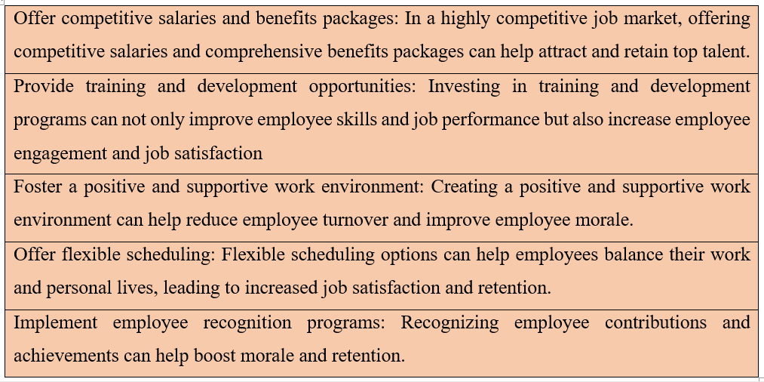

Figure 4: Recommendation
(Source: Author)

Conclusion
Overall, hoteliers face formidable obstacles that have a major effect on their ability to attract and retain staff. As a result of decreased demand for their services, hotels are finding it challenging to operate in the current climate brought on by the continuing COVID-19 epidemic, which has led to employment losses and fewer prospects for advancement. There is a skills gap in the workforce, which makes it difficult to find and keep good staff. To meet these difficulties, hotels like the Hotel Ritz UK will need to be resourceful and adaptable, adopting new technology and methods of operation and giving employees additional chances for personal and professional growth. The hospitality sector relies on attracting and keeping skilled workers to maintain high standards of service and guest satisfaction.

References
B, F. (2019). Practical Hotel Management. With notes and comments on Hotel Law. [By F.B. Bourne-Newton.]. London: Newton & Eskell.
Bover, A., Torres, J., Bitlloch, C.-H. and Vilà, J. (2020). The skylight of the hotel RITZ: a case study. Glass Structures & Engineering, 1(1). doi:https://doi.org/10.1007/s40940-020-00127-5.
Chakravarti, B.K. (2018). Hotel management. New Delhi: A.P.H. Pub. Corp.
Dev, C.S., Thomas, J.H., Buschman, J. and Anderson, E. (2016). Brand Rights and Hotel Management Agreements. Cornell Hospitality Quarterly, 51(2), pp.215–230. doi:https://doi.org/10.1177/1938965510363389.
Jackson, E. (2018). Hotel management in the UK. New York, Ny: Larsen & Keller.
O’fallon, M.J and Rutherford, D.G. (2019). Hotel management and operations. Hoboken, N.J. :Wiley.
Rahimi, R. and Gunlu, E. (2016). Implementing Customer Relationship Management (CRM) in the hotel industry from an organizational culture perspective. International Journal of Contemporary Hospitality Management, 28(1), pp.89–112. doi:https://doi.org/10.1108/ijchm-04-2014-0176.
Ritz (2019). The Ritz London | The best 5 Star Luxury Hotel in Mayfair. [online] The Ritz Hotel London. Available at: https://www.theritzlondon.com.
Shriver, S.J. (2013). Strategic planning for hotel operations. Quality Management in Health Care, 1(4), pp.43–50. doi:https://doi.org/10.1097/00019514-199322000-00006.
Tarrant, C. (2018). UK hotel industry — market restructuring and the need to respond to customer demands. Tourism Management, 10(3), pp.187–191.
Ward, T. (2017). Hotel market trends in the UK. International Journal of Contemporary Hospitality Management, 9(7), pp.270–273. doi:https://doi.org/10.1108/09596119710191056.
Whittaker, C.(2018). Hotel operator motives in UK sale and leaseback/management-back transactions. International Journal of Hospitality Management, 27(4), pp.641 - 648. doi: https://doi.org/10.1016/j.ijhm.2007.07.031.

