

Silent cry
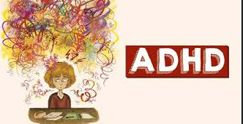

Naeed khan: 2228648

Integrated project

Lectures: Irena Neaga and Nathan Morgan

Contents

Abstract 2
Introduction 3
Chapter 1: Some signs of ADHD 4
Chapter 2: Dealing with ADHD 7
chapter 3: The addiction to screen time 8
Chapter 4: aim of the project. 9
Chapter 5: Conclusion and recommendation 12

Abstract

ADHD has become so common worldwide, it can be very difficult for many people to understand what ADHD is. Some people have very vague understanding of this condition and how to be able to understand the difference between ADHD and a misbehaving child. It does not mean that you are a teacher, parent, or any other role you can recognise the signs and pre warning.

People seem to forget that ADHD is a form of disability, not all disabilities are visual I have included reports and quotes and tried to give a clearer understanding of ADHD which is common in adults and children if treated early it can make a huge difference in a life.

The daily reality pf ADHD and how signs can be seen but ignored or how the student is so perfect how can he have ADHD. Had the signs be treated and supported early by support workers it would not lead to that child now an adult having ADHD.

Dealing with someone who as ADHD can not be easy, it can be extremely draining for them and their families. Many things will occur in the mind of someone with ADHD they can be more stressed, difficulty in communication as they are always using screen time.

Screen time can be a cause to many situations aa it becomes the thing in which the person with ADHD totally relies on, it can be very difficult for them to not use anything screen related.

Introduction

We are all born different, and our appearance may not be the same as our next-door Neighbors, today we are judged on what we see on the outside but when you search deep inside a person mind can u know what has gone on with them, can u know their health conditions.

can you see beyond their behavior? The answer is no, as we do not know the hidden truth inside. On the outside this child seems a normal healthy young person, a grade A student, hardworking individual they are so clever, they are so Intelligent, so what went wrong?

Was it behavior, was it influence with friends, was it all related to becoming grown children, all of these played a factor in a child life but inside they were fighting a silent battle with ADHD and may more conditions. Which can be called an excuse for your child misbehaving; this is not the case at all; this is a silent cry; this is the pain they carry with them.

Many adults have lived their lives without knowing what was wrong with them they suffered in silence and became labelled as the misbehaving child, util they reached adulthood and found out that there needed help, and it was ignored.

Chapter 1: Some signs of ADHD

Every day a struggle your life becomes torn between what you want to do and what you are doing. Ask yourself while you reading this project can you focus?
Can you read each word and mark the project? Or are you sitting there thinking what I am doing, are you fidgeting with your fingers or pen, are you jumping around a room and shouting loud and causing disruption. Are you doing everything else your mind says to do but what your actual task is? The information does not fully reach their brains like it does to many people.

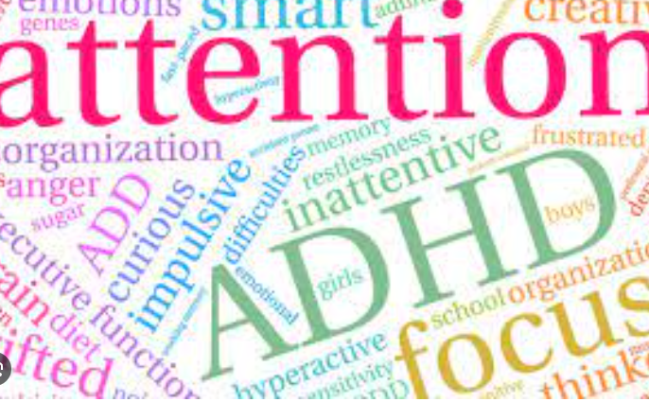 Figure 1

[1]Attention-deficit/hyperactivity disorder (ADHD) in children"Adult ADHD: 14 Signs and Symptoms - Healthline." 02 Jan. 2023, https://www.healthline.com/health/adhd/adult-adhd.

“Although ADHD can cause visible challenges in everyday life, the symptoms in children and adults vary and are sometimes difficult to recognize.” Medically reviewed by Bethany Juby, PsyD — By Eleesha Lockett, MS — Updated on March 14, 2022

Adult ADHD: 14 Signs and Symptoms - Healthline

“ADHD affects about 8.4% of children and 2.5% of adults, according to the American Psychiatric Association”.

The question is can you focus? Thae answer for many is yes, but the increase is on the rise for those to whom are not able.

Some common signs of this are what we may consider to be an everyday teenager growing up,

- Fidgeting
- Speaks loudly, disrupts the class and other students.
- He is seeking attention because he cannot sit still in his seat.
- He shouts out the answers.

That child sitting there in a classroom not able to do his work not able to concentrate, cannot sit still, he is nonstop shouting out and he spend the full year in dentitions every day over 100 detentions and still he alone, he is in this shell not understanding what he is doing why he is doing it. He has no idea how much effect this had on the people around him and himself, all because there was no support, and no one listened to him.

A view from a mother who has gone through this life-changing situation with her son.
A mother’s tears are real. The child's pain is heartbreaking as all you have been told is you have a naughty child, until one day she receives that call from that one member of staff who has concerns that this child may have ADHD.

After years and years, the mother battled but because this child was a high achieving student, he could not have it, finally new doors opened, and help became available. It is important to have an individual plan for each person with ADHD to give them the support they need.

This condition not only affects children but adults Aswell. Many adults have had this condition since childhood and have never received the support unit in their later years.
This would have made an enormous difference in childhood had signs been recognized earlier. Things such as sitting exams, guidance, support, discipline theses are key factors in ADHD. For a child/adult preparing for exams can be extremely stressful and exceedingly difficult for them.

Figure
https://www.additudemag.com/how-to-study-for-final-exams-adhd/

“For final exams is sometimes more difficult than the actual studying part. I work with students all day long helping them build their study skill set and it can be quite overwhelming.”

Many teachers and parents will have missed the sign of a child who is not able to deal with the pressure of an exam or simple assessment. The child could have increased anxiety and many other issues occurring in their minds. Ther many ways that they will hide these things like shouting, fidgeting, becoming loud it will seem as they are disruptive, but it can be signs of wanting help and they just won’t say.

Chapter 2: Dealing with ADHD

Millions of children and adults are diagnosed with ADHD world-wide; the common signs may seem like everyday teenagers Statics show that on

“An average 10% or 3- to 17-year-old have been diagnosed with ADHD sine 2019.” https://www.fda.gov/consumers/consumer-updates/treating-and-dealing-adhd

Understanding a child with ADHD and how their brain works differently from an average child, they cannot focus on task especially when it comes to reading or pen to paper, they are much better on task that are hands on such as cooking, engineering, woodwork.
They find pressure difficult, and struggle to understand task and may refuse to do these things which may come across as misbehaving child, they don’t understand how load they are becoming. Or how they are even acting.

“An ADHD brain exhibits distinct neural patterns compared to a neurotypical brain, including variations in brain structure and activity that influence attention, impulsivity, and executive functioning. These differences are key to understanding the challenges and strengths of individuals with ADHD.”
Reviewed by
Alice
The mini Adhd coach

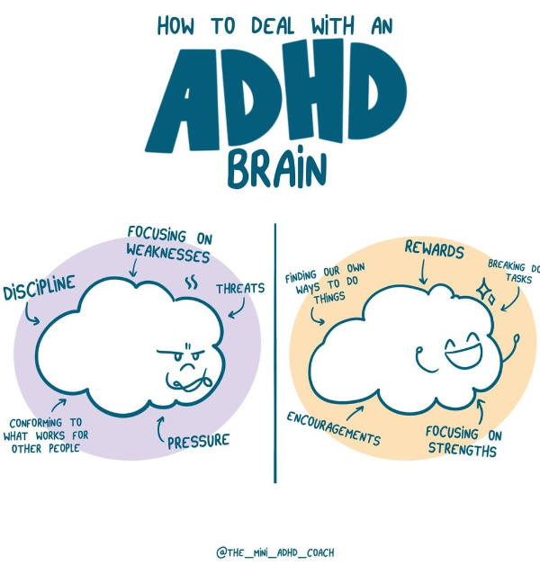

Figure 3 understanding ADHD to manage the struggles.
https://www.theminiadhdcoach.com/adhd-awareness/adhd-brain

chapter 3: The addiction to screen time

One of the problems with a child with ADHD is that they are addicted to screen time. It is the one thing that they can focus on totally give them pen and paper it will not last long, same with board games, and many other things. How can we an ADHD child/adult get support in reducing the screen time?

This is not an easy situation as you cannot expect them to just give up on screen time and if you take it away from them, they will be fine. Research shows that if you try different methods in how to manage screen time, this is also incredibly challenging time for the family and the child with ADHD.

- Breaking the screen time
- Give the child warnings 5 to 10 minutes prior.
- Use tool apps.
- Make rules in the house and stick to them no matter how exhausted you have become.
There are many effects that can cause more difficulties for a child using a lot of screentime.
- Obesity, as they no longer exercise and are just attached to console, computers, phones etc.…

- They have difficulty sleeping as their brain will not function, especially if they spend a lot of time on screen then they are going to bed.

- Depression and anxiety, they will no longer interact with people their focus in life will be talking on online games playing them and communicating this way.

Medically reviewed by Nathan Greene, PsyD — By Michael Hovde — Updated on July 27, 2022"ADHD and Screen Time: What's the Link? | Psych Central." 27 Jul. 2022, https://psychcentral.com/adhd/screen-time-and-children-with-adhd.
ADHD and Screen Time: What's the Link? | Psych Central

Chapter 4: aim of the project.

The aim of the project is to be based on research into ADHD and how it can affect a child and how worldwide over six million children have been evaluated and diagnosed with ADHD.
ADHD can vary in adult and child based on it specific goals we know every person will suffer in their own way with help and support at early age it can make an enormous difference in person life. We should make ADHD more aware amongst many people it is exceedingly difficult for people to recognize early signs from an everyday child and a child with ADHD as they are mistaken as being a naughty or misbehaving child. Thay are already given a label without any support of trying to even find out the root of this problem and how you can understand the signs of misbehaving and signs for ADHD.
"The Signs of ADHD in Children and Adults - Healthline." 19 Feb. 2020, https://www.healthline.com/health/adhd/signs.

Medically reviewed by Bethany Juby, PsyD — By Eleesha Lockett, MS — Updated on March 14, 2022

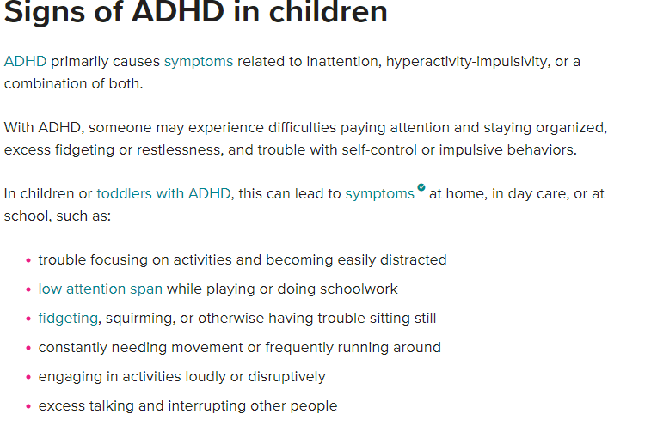

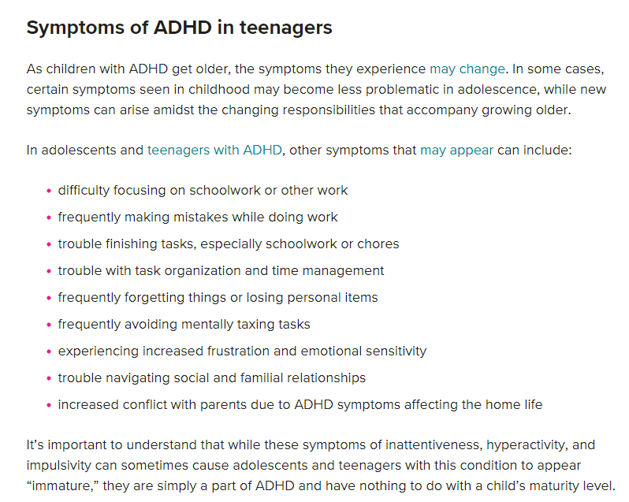

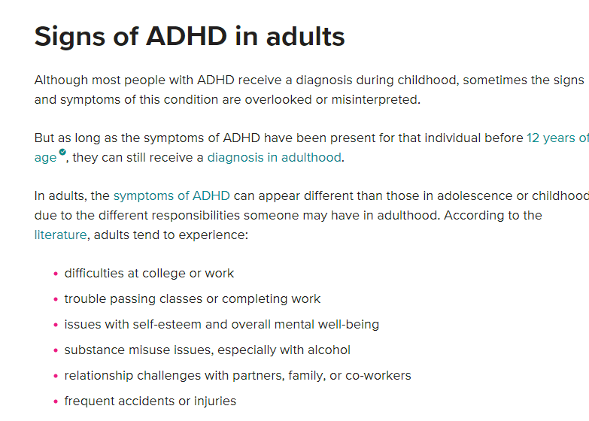

Chapter 5: Conclusion and recommendation

Overall, as project that I have done this has been the one closest to me and to be able to research so much into it has helped me myself to gain a better understanding of ADHD. To research into what a person is going through with ADHD compared to one without, to be able to understand their feelings and how they are going through so many emotions which can be compared to an everyday teenager.
Worldwide research sows a Vass population of children are diagnosed with ADHD to help these children they would need their own SENDCO worker and have a team leader that they can turn to Aswell as their own support work, this is a huge benefit for them. Their support worker is them to talk to them help them through difficult times guide them in a direction where they know help is there for them.
Before we even judge a child that looks as if they are misbehaving and that mother cannot control them, please STOP and THINK, not all children show their disability. that child could be looking normal but not all disabilities are visible, that mother may not be a useless mother who cannot control her child, but a mother struggling for support and help from anyone who can give it her. The parents are distressed along with their child and suffer with them and their child pain.
It not shameful to get help that why it is available it is more damaging and stressful on everyone to suffer in silence and go through struggles that van be overcome, and your situation can be improved.

References

[1] | U. o. P. H. T. H. P. H. N. Angela Ine Frank-Briggs a Department of Pediatrics and Child Health, Attention deficit hyperactivity disorder (ADHD).
[2] | B. P. H. Wender, Attention-Deficit Hyperactivity Disorder in Children, Adolescents.

"ADHD and Screen Time: What's the Link? | Psych Central." 27 Jul. 2022, https://psychcentral.com/adhd/screen-time-and-children-with-adhd.

"Internet Addiction and ADHD - CHADD." https://chadd.org/adhd-news/adhd-news-adults/internet-addiction-and-adhd/.

