
University of Wales Trinity St David
Managing a Hardware Project for Disaster Recovery
Name
Sam Logan Thomson
Student No
1701907
Email
1701907@student.uwtsd.ac.uk
Course
Computer Networks and Cybersecurity (BSc)
Module Name
Project Management
Module Code
ACDA5004
Lecturer
Sue Maw

The work of this report completed under the supervision of Sue Maw. I declare that this report is the product of my own work and is not being submitted for any other degree etc.
Sam Logan Thomson

Contents
Table of Figures 1
Introduction 1
1. Risk 1
1.1 Identifying Risks 1
1.2 Risk Evaluation Matrix 2
1.3 Risk Mitigation 2
2. Sustainability Issues 3
2.1 First Order Sustainability Issues 3
2.2 Second Order Sustainability Issues 4
2.3 Third Order Sustainability Issues 4
2.4 Code of Practice 5
3. Ethical and Legal Issues 5
3.1 Ethical Issues 5
3.2 Legal Issues 6
4. Quality Assurance 7
4.1 Measuring Network Quality 7
4.2 Network Quality Metrics 7
5. Evidence of Project 8
5.1 Demo 8
5.2 Project Plan 9
Conclusion 9
References 10

Table of Figures

Figure 1- EPA Greenhouse Gas Emissions 2016 [6] 4
Figure 2- Network Demo 8
Figure 3- Project Plan Screenshot 8

Introduction
The purpose of this report is to provide an overview of some areas that could affect the project planned by Sam Thomson to provide an emergency network in the situation of a disaster scenario.
This report will be considering identifying risks to the project and a suitable strategy to manage the risks. The first step in the risk management process will be to identify the risks that could face this project. Once the risks have been identified a strategy for mitigating the risks can be developed. This section will also contain a Risk Evaluation Matrix.
An overview of sustainability issues that could be faced by the project including first, second and third order sustainability issues.
Also, a look at the legal and ethical issues that could be faced by the project with a reference to the BCS code of conduct and mention of the BCS Digital Brexit Report, including any predictions of issues that could become a reality due to Brexit. This section will also contain a method for mitigating any issues identified.
Included in this report will be a way to monitor quality of the project. Including suitable Quality Assurance metrics and any issues faced during the quality assurance process.

Risk

Identifying Risks
One of the most important things to consider when dealing with a project is risk management. According to A.Rai, M.Keil and L.Wallace [1]
“As organizations continue to invest time and resources into strategically important software projects, managing the risk associated with such projects becomes a critical concern.”
During the initial stages of the project when drafting the Project Initiation Document, several risks to the project were identified, these risks are shown in the table below.
Table 1 - Project Risks
Number | Risk | Risk Description
R1 | Staff | The Senior Infrastructure Engineer will be able to handle the project workload while also maintaining current workload.
R2 | Management | The Project Manager will keep an open channel of communication with the Project Sponsor and Senior Infrastructure Engineer
R3 | Sponsor | The Project Sponsor will continue to provide support as and when required while also managing their current workload
R4 | Stakeholder | All stakeholders will be able to provide support as and where required without sacrificing day to day duties
R5 | Budget | The project will keep to budget and not require any additional funding
R6 | Illness | Illness could potentially bring a halt to the project due to this currently being a one-man team.
As can be seen from the above table there are numerous risks that could affect the project. Some new risks have been added since the first draft in the Project Initiation Document. If you see in the below section that contains the risk evaluation matrix.

Risk Evaluation Matrix
The next step of our risk management process is to include a risk evaluation matrix. According to N J, Dujim [2] A risk matrix is a common feature of risk management.
A risk matrix essentially shows the likelihood of each risk to occur, this mapping will allow for planning of how to mitigate the risks.
Table 2- Risk Evaluation Matrix
Risk | Impact | Likelihood | Rating
R1 | Medium | Medium | Medium
R2 | Medium | Low | Low
R3 | Low | Low | Low
R4 | Low | Low | Low
R5 | High | Medium | High
R6 | High | Medium | High

As can be seen from the matrix the highest risks to the project are the budget and illness of staff. The reasoning behind this being that if the project was to go over budget this would bring a halt to the project until additional funds are allocated making the impact of this risk high. The reason for illness being a high impact risk is this is project is currently a single person workforce. If this person were to fall ill the project would grind to a halt as there is no other resources allocated.

Risk Mitigation
Mitigating R6 and R5 would be essential to the project.
The first risk R5 relating to the budget could be mitigated with proper financial planning, possibly asking for a budget over what could be necessary, in this circumstance delivering the project either under budget or on budget would be considered a success.
Preventing R6 illness from affecting the project can be managed rather simply by bringing in additional staff resources to the project. If there are additional staff resources allocated to the project this means in the event of staff illness there is still someone to work on the project and this would mean the project does not grind to a halt.
Table 3- Risk Evaluation Matrix Updated
Risk | Impact | Likelihood | Rating
R1 | Low | Low | Low
R2 | Medium | Low | Low
R3 | Low | Low | Low
R4 | Low | Low | Low
R5 | Medium | Medium | Medium
R6 | Medium | Low | Low
As can be seen from the updated risk evaluation matrix this would also have a knock-on effect on some of the other risks as additional staff resources would make it unlikely that the Senior Infrastructure Engineer would be unable to manage their current workload as well. Therefore, reducing R1 to a low impact low likelihood risk.

Sustainability Issues

First Order Sustainability Issues
When considering sustainability for the project we should consider First Order sustainability issues with procurement for the equipment required. According to the HMRC policy on sustainable procurement [3] to procure goods in a way that achieves value for money over the life of the goods but also providing benefits for the organization and to society while minimizing environmental damage.
In the case of the current project this would be picking suitable routers that offer efficiency over power consumption. Possibly choosing an environmentally friendly router like one running JRS eco-Wi-Fi firmware[4], according to the article from JRS Eco this cuts down on unnecessary broadcast traffic saving power and also lowering the EM radiation levels that standard Wi-Fi equipment produces.
Another consideration could be the running of the trucks. As part of the project specifications the truck is due to run network equipment and connect back to a satellite. This will need to be powered. Does this run off the trucks engine and could the truck potentially use a sustainable fuel source like bio-diesel. Or could the truck be fitted with solar panels which could then be used to power the systems. The most likely choice would be a hybrid of the two as solar power is not always possible depending on the environment the trucks would be deployed to.
However, care would have to be taken with the procurement of the bio-diesel as according to the biofuel organisation on GHG emissions and global warming in relation to bio-diesel [5]
“This is the area in which the most care must be taken in how biofuels are produced. If biofuels are produced in the “correct” way, they can greatly reduce GHG emissions. If produced incorrectly they can increase emissions.”
Bio-fuel comes from plant crops and the growing of crops requires energy as well. If this is not done in a sustainable way then the GHG emissions can also be greater than regular fuels [5].

Second Order Sustainability Issues
When considering the Second Order sustainability issue of the project we need to look at travel and transportation for the system. Unfortunately, due to the size of the system this may be hard to mitigate.
As the system is due to run on a truck to be portable, regardless of where the truck is deployed this will require transport. Due to the size of the trucks this may require large transport for example a cargo boat or a large plane.
Unfortunately as can be seen from the Figure from the US EPA [6] transport accounts for 28% of green house gas emissions.
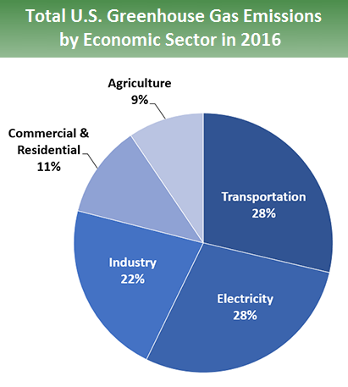
Figure 1- EPA Greenhouse Gas Emissions 2016 [6]

Unfortunately, due to the nature of the project and the way it is designed it requires transportation to affected areas. Perhaps a future consideration for the project could be a way to make it portable without the use of trucks. Allowing for easier transportation.

Third Order Sustainability Issues
When considering third order sustainability we need to consider what this means, third order sustainability relates to long-term social and economic changes. In this case will the project provide a positive benefit economically and socially.
The intent of the project is an emergency network that can be deployed in a disaster scenario and used by emergency services and aid workers. This provides much needed communication in a disaster zone and the system can be setup as such that it can be deployed to cover vast areas like a whole city.
It will prevent costly measures like putting in a temporary fibre network which could cost money and increase the carbon footprint of the disaster zone.

Code of Practice
Based on all the research done into sustainability issues the code of practice for the project is set out as follows.
- Where possible use energy efficient hardware to limit electricity requirements and lower greenhouse gas emissions.
- Try and cut down on transport fuel emissions during development by sourcing as much as possible from closer locations and cutting down on transportation greenhouse gasses.
- Consider sourcing solar panels for trucks to allow generation of own electricity for running network gear.
- Consider having trucks run using bio-fuel engines instead of standard petrol or diesel engines to lower environmental impact.
- If bio-fuel is used make sure this is sourced from a sustainable provider.

Ethical and Legal Issues

Ethical Issues
Some potential ethical issues that could come up during the course of this project would most likely be covered under the British Computer Society code of conduct specifically the Duty To Relevant Authority section [7] specifically
“Not disclose or authorise to be disclosed, or use for personal gain or to benefit a third party, confidential information except with the permission of your Relevant Authority, or as required by legislation.”
As this project will involve deploying an emergency network. The data that runs through this network needs to be kept secure and access granted only to people who require this data. This means the network will need to be securely locked down and proper security implementations considered.
Another ethical issue could relate to the Professional Competence and Integrity section of the BCS code of conduct [7]
“NOT claim any level of competence you do not possess.”
While at present this is a sole project being run by one person. This may involve at later stages of the project use of systems or setups that the Senior Infrastructure Engineer is unfamiliar with. If this is the case outside help may need to be brought in. In the form of either a colleague or possibly a consultant. If the Senior Infrastructure Engineer was to attempt to do something outside their level of knowledge of competence this would be a serious ethical breach.
Another possible ethical breach could be considered under the BCS code of Conduct Public Interest section [7]
“Have due regard for public health, privacy, security and wellbeing of others and the environment”
If corners are cut during the project design this could result in a faulty product for example a poorly designed insecure network with no regard for data privacy thus breaching this part of the code of conduct. Or possibly even a badly designed truck that is prone to catching fire which could cause problems with the health and wellbeing of the truck operators.

Legal Issues
The most important legal issue to be considered with regards to this project is data retention. Currently the law with regards to data protection and retention is based on an European Union Data Directive General Data Protection Regulations according to the BCS Brexit Report [8]
“Irrespective of EU membership any organisation that holds data on European citizens will need to comply with GDPR. In order to maintain and grow a data industry and support all businesses that interact with consumers, it is essential that UK law is officially recognized as compatible or equivalent to European Protections.”
This could potentially be an issue after Brexit. As although if this project was to operate in a country with EU citizens or be expected to follow GDPR if it held any data on EU citizens. There is nothing stopping the British Government from coming up with their own completely different policy on Data Protection and retention. With this being a UK based firm, this could be complex and require multiple different methods of data retention depending on where the project is due to be setup for operation.
Another potential legal issue could be intellectual property issues. While currently the network is planned only for emergency service workers and aid workers. A future consideration was an open Wi-Fi network that the public can access for whatever their needs are within the disaster zone.
However this potentially opens the door for copyright infringement, currently in the UK ISPs are required to block websites as required by a current High Court blocking sites that have copyrighted content on them allowing either illegal streaming or file sharing according to Virgin Media [9] some of the blocked websites include The Pirate Bay, H33t, Fenopy and EZTV.
These are currently blocked at a network level based on websites named by a court order. When someone tries to access one of the blocked websites the device trying to access it is directed to a holding page explaining why it is blocked. In the case of the emergency network there is no precedent currently set for this. Would this blocking fall under the responsibility of the ISP that the network uses for the backbone or the network itself to police access to websites. Also, if this were to be deployed outside of the UK, would it follow UK law or the laws of the country it is setup in.

Quality Assurance

Measuring Network Quality
So, when looking at quality testing for a network one of the first things to consider is how to measure this as a metric. Do we purely look at the download speeds for everything, do we consider how many transactions can go on at the same time, do we include latency and network utilisation?
According to Geoff Huston [10] when looking at something as vast as network performance speed is not always the most important factor, the capability to handle multiple requests at the same time, transmit large volumes of data are also worth considering for overall network performance.
We do not just want to consider how quickly the data can be downloaded. We want to take into account latency, packet loss and overall network utilisation. Perhaps considering a solution from an outside company such as SolarWinds RMM [11] or even PRTG Network Monitor from Paessler [12].
Both software solutions work by using SNMP. According to the IETF RFC on SNMP [13]
“SNMP entities executing command generator and notification receiver applications monitor and control managed elements. Managed elements are devices such as hosts, routers, terminal servicers, etc., which are monitored and controlled via access to their management information.”
A system using SNMP allows for the remote monitoring and control of connected devices. The software mentioned provides handy reporting tools like graphs of network utilisation, testing for packet loss and jitter.
This would be the best solution as all the information is collected centrally and then the ability to view provided by a central management console.

Network Quality Metrics
Unfortunately, at present moment it would be impossible to provide accurate quality metrics for the network design chosen for the project. As when looking at network performance a baseline needs to be taken. According to S.Subbaiyan [14] a network baseline is a set of ideal metrics for network performance that can be obtained by measuring the network over a period of time.
In order to obtain a set of quality metrics for a network a baseline needs to be taken when the network is under light, medium and heavy traffic loads. Allowing to identify what the network should look like while under different loads. This can then be used for troubleshooting as if you have light traffic but spiking of certain metrics this can then be used for troubleshooting.
In reference to the current project the baselines would be taken during a stress testing phase allowing for a set of quality metrics to be selected and a monitoring process implemented.

Evidence of Project

Demo
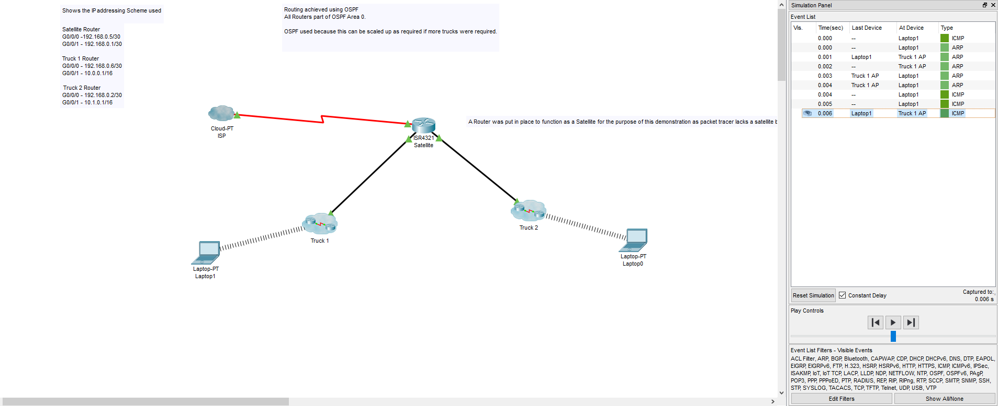
Figure 2- Network Demo

Project Plan
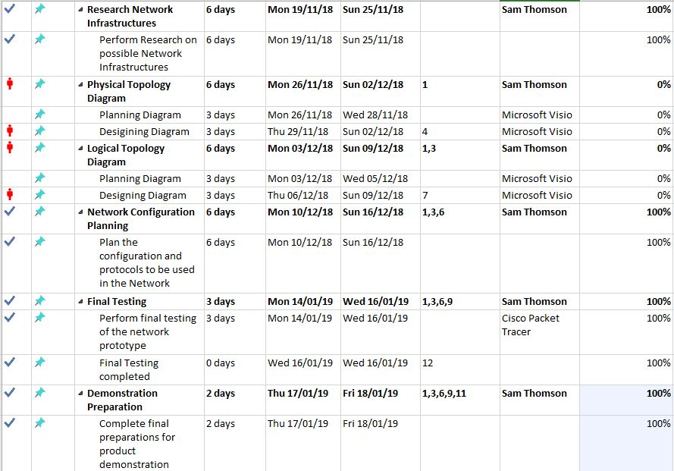
Figure 3- Project Plan Screenshot

Conclusion
A lot of factors need to be taken into consideration with any project. Risk being one of the most important factors having a way to plan out what risks can occur and how to mitigate them is essential to project success.
In the changing times of the modern world sustainability should play a major factor in any project. Limiting damage to the environment and taking responsibility for the consequences of any action should absolutely be at the front of any project managers mind.
Legal and Ethical issues should always be considered as important as well. No project should intend on breaking any laws or ethical boundaries. Also changing political situations such as Brexit should always be considered as these could well change the laws that companies currently operate under and could involve major change.
Lastly quality assurance of any project is important as there needs to be a way to measure whether any project is a success. In the case of this project the quality assurance tests would be done in a different way to a software project however nonetheless the steps still need to be taken to measure the quality of the project.

References

[1] L. Wallace, M. Keil, and A. Rai, “How Software Project Risk Affects Project Performance: An Investigation of the Dimensions of Risk and an Exploratory Model*,” Decis. Sci., vol. 35, no. 2, pp. 289–321, May 2004.
[2] N. Jan Duijm Duijm and N. Jan, “Recommendations on the use and design of risk matrices.”
[3] HMRC, “HMRC Sustainable Procurement Strategy.”
[4] JRS ECO, “Low radiation wifi routers JRS eco-wifi – JRS Eco Wireless.” [Online]. Available: https://www.jrseco.com/pcat/low-radiation-wifi-routers-jrs-eco-wifi/. [Accessed: 24-Jan-2019].
[5] Biofuel, “Biofuels - Advantages of Biofuels - Greenhouse Gas Emissions.” [Online]. Available: http://biofuel.org.uk/greenhouse-gas-emissions.html. [Accessed: 24-Jan-2019].
[6] O. US EPA, “Sources of Greenhouse Gas Emissions.”
[7] British Computer Society, “Code Of Conduct.” .
[8] British Computer Society, “Digital Brexit Planning for a successful digital future outside of the EU.”
[9] Virgin Media, “List of Court Orders.” [Online]. Available: https://help.virginmedia.com/system/templates/selfservice/vm/help/customer/locale/en-GB/portal/200300000001000/article/HELP-2374/List-of-Court-Orders. [Accessed: 24-Jan-2019].
[10] G. Huston, “Measuring IP Network Performance A Functional Definition of Network Performance.”
[11] SolarWinds, “SolarWinds RMM Trial | SolarWinds MSP.” [Online]. Available: https://www.solarwindsmsp.com/products/remote-management/trial?utm_campaign=rm-glbl-t-cpc-capterra-paidlisting-06_02_2017&utm_source=capterra-networkmonitor&utm_medium=cpc&utm_term=capterra. [Accessed: 25-Jan-2019].
[12] Paessler, “PRTG Network Monitor » All-In-One Network Monitoring Software.” [Online]. Available: https://www.paessler.com/prtg?utm_source=capterra&utm_medium=display&utm_campaign=capterra-2014-q2&utm_content=directory-placement-networkmonitoring&utm_term=prtg. [Accessed: 25-Jan-2019].
[13] D. Harrington, B. Wijnen, and R. Presuhn, “An Architecture for Describing Simple Network Management Protocol (SNMP) Management Frameworks.”
[14] S. Subbayin, “Geek Speak: Networking 101 – The Importance of ... | THWACK.” [Online]. Available: https://thwack.solarwinds.com/community/solarwinds-community/geek-speak/blog/2014/02/26/networking-101-the-importance-of-network-baselining. [Accessed: 25-Jan-2019].

