A literature review on the harbour porpoise in South Wales and beyond
Lucy Fairbrother

7 December 2020

Contents
1 Introduction 1
2 Population and distribution 2
3 Threats 4
3.1 Introduction 4
3.2 Fishing 5
3.3 Food reduction 5
3.4 Climate change 6
3.5 Noise and disturbance 6
3.6 Pollution 7
3.7 Bottlenose dolphin attack 7
4 Management 8
4.1 Protected status 8
4.2 Management solutions 9
4.2.1 Acoustic deterrents 9
4.2.2 Fishing restrictions 9
4.2.3 Reduction of pollutants 9
4.2.4 Vessel traffic management 9
4.3 Challenges to conservation 9
5 Conclusion 11
6 References 12

Tables and figures
Figure 2.1: Strandings and encounters by month 3
Table 3.1: Cause of death of stranded harbour porpoises 4
Figure 3.1: Annual reported strandings in Swansea and Gower 5
Figure 4.1: Bristol Channel Approaches SAC boundary (shown in blue) 8

Introduction
While their diminutive size and wary nature (Roberts, et al., 2019; Learmonth, et al., 2014) make them relatively hard to spot, harbour porpoises are the most common cetacean found in UK waters (Hammond, et al., 2017). Globally, their conservation status is Least Concern (Braulik, et al., 2020), justified by a lack of evidence that the pressures they are subjected to have led to a global decline in numbers, and that the species maintains a wide range and relative abundance (Braulik, et al., 2020). However, it has been suggested that a global picture may mask pressures evident on a more local scale (Oakley, et al., 2016).
Sightings data in the Swansea and Gower area suggest that there is a resident population of harbour porpoise that rely on specific areas for breeding (Jenkins, et al., 2009). Consequently, human activities around this partly-urbanised coastline are likely to have a significant impact (JNCC, 2019a). While there is insufficient data to make definitive conclusions about the current size and trend of the local population, meta-analysis of surveys has concluded that numbers are declining in UK waters (NAMMCO, 2019). The key pressures include fishing bycatch, attack by bottlenose dolphin, disturbance by vessel and construction activity and pollution (Northridge, et al., 2017; Wisneiwska, et al., 2018; Roberts, et al., 2019).
By analysing the threats to the harbour porpoise in Swansea, conclusions may be drawn about whether a decline in population elsewhere might also be reflected here, and whether management solutions on a more local scale may help to conserve this species. This paper looks at sightings and strandings data collected in Swansea Bay and Gower, and compares them to literature to inform analysis of how management efforts may help to conserve the harbour porpoise.

Population and distribution
The population of harbour porpoise in UK waters was estimated to be 197,579 animals (95% confidence interval [163,294-239,063]) in 2016 (Hammond, et al., 2017; JNCC, 2019a). This represented a large decrease from 2013, which numbers were derived using the same data collection methods; however, the decrease was not statistically sufficient to conclude an overall decline (JNCC, 2019a). The overall decrease was driven primarily by a consistent decline in the numbers of porpoises found in the Celtic and Irish Sea, which is projected to continue into the future (NAMMCO, 2019).
The surveys took place over the course of 6 weeks, around July (Hammond, et al., 2017). This is useful for annual comparison, but may not give an accurate estimate of a local population, given seasonal variances. Hammond, et al. (2017) did not conclude whether the decline resulted from a change in distribution or an overall decrease in population.
Oakley, et al. (2016) collated data from land-based and vessel surveys conducted around the Swansea Bay and Gower areas over 10 years. There were a range of methodologies and wide differences in the results; collating the data from all vessel surveys led to a conclusion that there was a high density of harbour porpoises in the area, of around 0.58 hp km⁻². There was also a continuous presence for 12 months of the year.
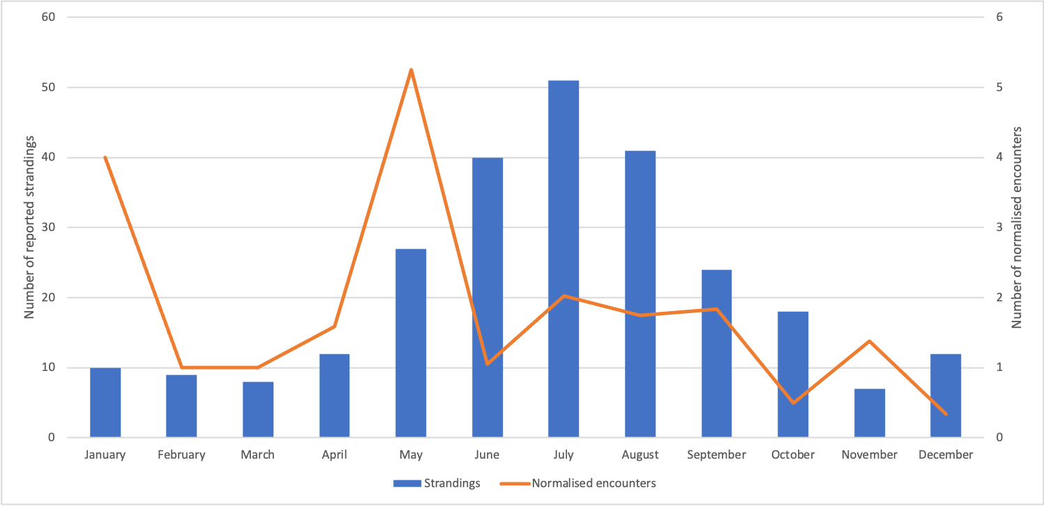
This confirms studies recognising the Bristol Channel as an area of high density all year round (Heinänen & Skov, 2015), although the calculations of porpoise density in Oakley, et al. (2016) were higher than the estimation by Hammond, et al. (2017) for the Bristol Channel of 0.118 hp km⁻². The difference may reflect the particularly high density of porpoise in Swansea Bay and Gower compared to the rest of the wider area (the surveys in Hammond, et al. (2017) did not extend past the Gower); or because of different survey methods and/or modelling. The datasets collated by Oakley, et al. (2016) were based on different methods of data collection, so it was not possible to carry out meaningful comparisons of the data in order to conclude year on year trends in population or distribution.

Figure 2.1: Strandings and encounters by month
Both sightings data (Jenkins, 2007) and strandings data (Penrose, 2003:2018) indicate a year-round presence, as shown in Figure 2.1. The encounters from sightings peak in May, with the lowest numbers occurring in winter. The number of strandings increase steadily from May, peaking in July and remaining high throughout the summer and early Autumn. Assuming there is some time-lag between the death of a porpoise and its appearance on land, the increase in strandings from May onwards concurs with the peak in encounters. The encounters in May correlate with their usual breeding time and evidences their use of the area for breeding (Learmonth, et al., 2014).
Later surveys, summarised in Oakley, et al. (2016), contradict these findings, showing that the highest number of normalised sightings occurred in November and December, and between February and April. The discrepancy between the two studies may demonstrate the variable use of the area as a habitat by a highly mobile species, where the population fluctuates according to the conditions. The small sample size may also cause a variability in results.

Threats

Introduction
In the UK, the main threats to the harbour porpoise include bycatch and other harm incidental to fishing activities (Omeyer, et al., 2020), pollution (Murphy, et al., 2015), and competition with or attack by other species (JNCC, 2019a). Further threats include noise and interference from vessels and commercial activities (Wisneiwska, et al., 2018; Roberts, et al., 2019) and reduction in food availability, both as a result of fishing and climate change (JNCC, 2019a). These broadly reflect global threats (Braulik, et al., 2020).
There are challenges with using strandings data to make direct inferences about mortality rates (Calderan & Leaper, 2019) but they are useful to see how the picture locally compares with the UK as a whole. Table 3.1 sets out the reported causes of death of harbour porpoises stranded on the coastline of Carmarthenshire, Swansea and Neath Port Talbot (together “Swansea and Gower”) and the UK coastline respectively, together with the proportion that each cause of death represents, as a percentage of all animals where a post mortem was carried out (Penrose, 2003:2018; CSIP, 2002:2015).
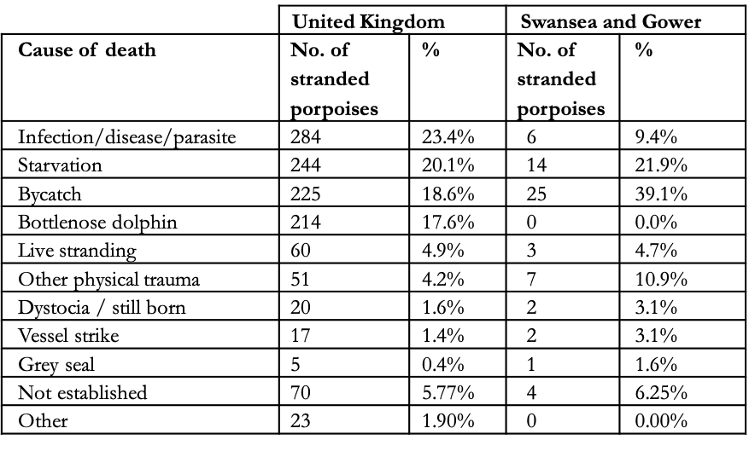
Table 3.1: Cause of death of stranded harbour porpoises
Figure 3.1 shows how the number of reported strandings varies annually and the proportion of stranded neonates (Penrose, 2003: 2018).
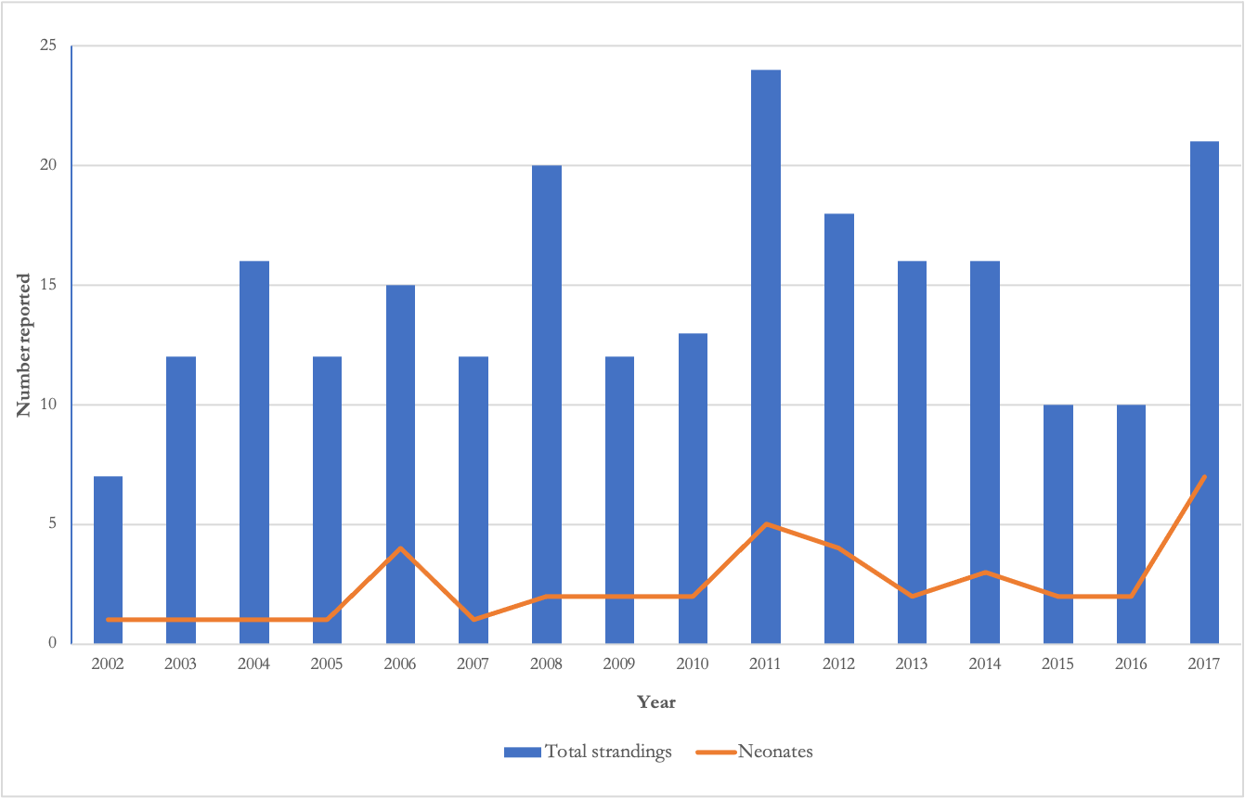
Figure 3.1: Annual reported strandings in Swansea and Gower

Fishing
Bycatch, primarily relating to gillnet fishing, is recognised as the most significant threat to the species throughout its range (Braulik, et al., 2020). Bycatch rates in the Celtic and Irish Seas in 2018 reached between 1.1-2.4% of the population (Calderan & Leaper, 2019). This has a significant impact on population due to their late maturity and low reproductive rates (Omeyer, et al., 2020).
As shown in Table 3.1, bycatch accounted for the deaths of 18.6% of porpoises given a post-mortem examination in UK waters. In contrast, bycatch accounted for the deaths of 39.0% in Swansea and Gower. Calderan & Leaper (2019) suggests that this is partly due to the prevailing winds off the southwest coast. However, Northridge, et al. (2017) supports the conclusion that there are relatively high bycatch rates off the southwest coast. The study found that Bristol Channel had the second highest estimated total of bycaught porpoises, likely as a result of a combination of the high population densities and heavy use of gillnets (Calderan & Leaper, 2019).

Food reduction
Porpoises’ small size means that they are at particular risk of starvation and hypothermia if they are underfeeding and they rely on frequent foraging on a wide range of prey species (Roberts, et al., 2019).
The proportion of animals whose deaths were attributed to starvation was similar as between Swansea and Gower (21.9%) and UK-wide (20.1%). However, a much greater proportion (14.0%) were neonates in Swansea and Gower, and this proportion has increased since 2002. The difference is further indication of the use of the area for breeding.
The fishing industry may also be having an indirect impact by the reduction of food availability. Although prey depletion has been identified as a potential pressure (JNCC, 2019a) there have not been any studies found that established a causal link between fishing and harbour porpoise starvation.

Climate change
The Joint Nature Conservation Committee (JNCC) identified climate change as a likely threat to food availability, as it may result in the decline or extinction of prey species, although the impact may be mitigated by the porpoise’s wide range of food sources (JNCC, 2019a). MacLeod, et al. (2007) suggested that warmer seas are likely to have an impact on sandeels in springtime, when porpoises are particularly reliant on this high-energy prey. The study was based on small sample sizes taken over 8 years (although the results were statistically significant) and has not been repeated since.
On the other hand, solutions to reducing the demand for fossil fuels may themselves constitute a threat, as the construction of offshore renewable energy structures has been found to disturb the behaviour of porpoises (Graham, et al., 2019). Despite the identification of sites along the Welsh Coast as being attractive locations for offshore wind generation (The Carbon Trust, 2018), according to the JNCC, there are “no plans for development of a commercial offshore windfarm” in or close to the Bristol Channel SAC (JNCC, 2019b, p.13).

Noise and disturbance
Much of the UK’s marine environment is busy with traffic. Vessel strikes were confirmed as the probable cause of death in only 3.1% of porpoises (Table 3.1) in Swansea and Gower. However, disturbance from vessel traffic may have an impact on the porpoises’ ability to forage. Harbour porpoise rely on sound for feeding, navigation and communication and noise pollution can therefore be disruptive; they have been observed to react to high level of exposure to noise from vessels by changing their behaviour (Wisneiwska, et al., 2018). Wisneiwska, et al. (2018) found that porpoises in Danish waters exhibited fluking behaviour and ceased foraging activities and vocalisations when disturbed by passing vessels. These results have been confirmed in research from other areas; for example Roberts, et al. (2019) found a negative impact between vessel traffic and porpoise behaviour in studies off the Devon coast, and suggested that this could interrupt their feeding, leaving them at greater risk of starvation and hypothermia.
Harbour porpoises favour particular habitats for specific uses, making them vulnerable to displacement (Oakley, et al., 2016). Compounding this problem, vessel traffic is often busiest in May or June, which coincides with breeding time (Oakley, et al., 2017; Roberts, et al., 2019). Results from studies measuring vessel interaction have varied as between the reactions to different vessels and movements (Oakley, et al., 2017; Roberts, et al., 2019); however, the consensus is that porpoises generally have a negative reaction to vessels and this is likely to affect their feeding opportunities.

Pollution
Harbour porpoises appear to prefer coastal depths of around 20m (Jenkins, 2007). This near-shore presence places them close to sources of pollution. Studies concerning the impact of pollution on harbour porpoises have focussed on polychlorinated biphenyls (PCBs). This is significant in Swansea, as the industrial heritage in Swansea Bay has left a legacy of contamination, including PCBs (Waters, et al., 2005).
PCBs have been linked to reproductive problems in females (Murphy, et al., 2015). However, the study was based on strandings data alone, so may not be a true reflection of the population as a whole. The evidence of the impact of PCBs poses particular challenges: the pollutants can be passed on maternally, so may cause harm from one generation to the next, and it is difficult to establish causal relationships between a source of pollution and harm caused (Murphy, et al., 2015).

Bottlenose dolphin attack
While attack by bottlenose dolphins accounted for the death of 17.6% of the stranded harbour porpoises UK-wide, Swansea and Gower do not have a resident population of bottlenose dolphins, so there were no recorded incidences of attack (CSIP, 2002:2015).

Management

Protected status
The harbour porpoise enjoys protected status in the UK under both national and international law. The Habitats Directive (European Commission, 1992), as implemented by UK law, requires the UK to anticipate future threats to the population and habitat and take steps to avoid them, including establishing special areas of conservation (SACs). There are currently six SACs designated specifically for the protection of harbour porpoise (JNCC, 2020a). It is too early to provide a firm assessment of their effectiveness (Omeyer, et al., 2020). However, the UK Government considers the overall future prospects for the harbour porpoise to be favourable and, in particular, the status of its habitats to be “very positive” on the basis of their introduction (JNCC, 2019a, p.10).
The Bristol Channel Approaches SAC is shown in Figure 4.1 (JNCC, 2020b). The JNCC has set out conservation objectives and management advice for the SAC, including the use of habitat regulations assessments. Oakley, et al. (2016) argued that the SAC should also extend into Swansea Bay and remaining parts of the Gower, given the density and year-round presence of harbour porpoise in that area, as well as the use of those areas for breeding.
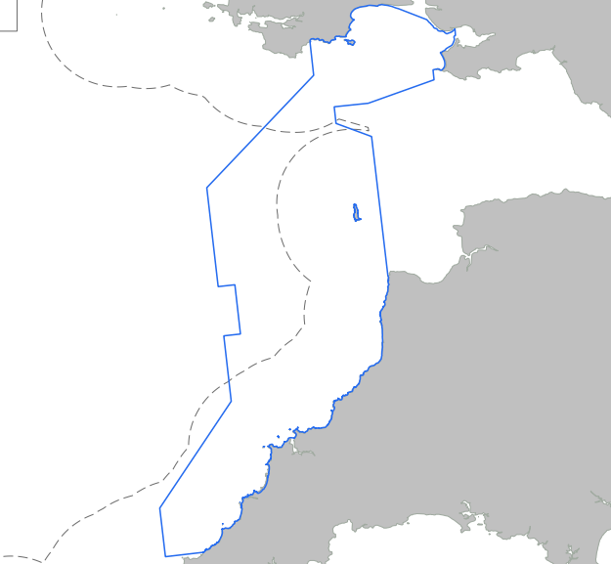

Figure 4.1: Bristol Channel Approaches SAC boundary (shown in blue)
While it is important to ensure that critical habitats within SACs are protected, conservation efforts must also look outside SACs not least because the majority of gillnet activities are outside these areas (Calderan & Leaper, 2019).

Management solutions

Acoustic deterrents
Acoustic alarms (known as pingers) are commonly used to mitigate bycatch (Omeyer, et al., 2020). In the Bristol Channel pingers are required all year round on vessels 12m or over using gillnets or entangling nets (Marine Management Organisation, 2017).
Northridge, et al. (2017) estimates that pingers could reduce the mortality rate from bycatch in the Bristol Channel by around 6.5%. There have been concerns that pingers could have long-term behavioural effects on harbour porpoise, but the results of a recent study suggest that the effect of pingers was localised and did not result in habitat displacement (Omeyer, et al., 2020).

Fishing restrictions
There is pressure to look beyond pingers and address fishing practices, such as introducing temporary exclusions and gillnet alternatives such as longlines (Calderan & Leaper, 2019).
The sightings data in Jenkins (2007) demonstrated seasonal variations in harbour porpoise distribution. Seasonal closures/restrictions at a local level may therefore be an effective way of balancing strengthened protection with the needs of residents and businesses.

Reduction of pollutants
The use of PCBs was banned in the UK in 1981, and the concentration of PCBs found in stranded harbour porpoises on UK coastline decreased between 1990 and 1998 and between 1998 and 2012 remained at a similar level (Jepson, et al., 2016). JNCC advice recommends the use of habitat assessments where any project may involve the release of pollutants that might affect the Bristol Channel SAC or its environs, which is likely to include any activities in Swansea Bay (JNCC, 2019b).

Vessel traffic management
Oakley, et al. (2017) suggested measures to control behaviour by small and recreational vessels. Swansea council distributed a voluntary code of conduct for marine vessels in 2015 by leaflet, but there has been no follow-up campaign or materials produced since.

Challenges
One of the barriers to implementing further protection for harbour porpoises has been a lack of research data on their population and distribution (Oakley, et al., 2016). Their mobility also poses difficulties in terms of designating boundaries for protection areas (JNCC, 2017).
The apparent stability of their global population and range has decreased the urgency of political action (IAMMWG, et al., 2015). The UK Marine Strategy (DEFRA, 2019) groups harbour porpoise with all other cetaceans and the conclusion reached for cetaceans as a whole is that the population is not threatened significantly by human activities. Monitoring and mitigation measures already in place are continuing, but no new initiatives or solutions have been proposed.
It is unclear how the legal and policy framework for marine management will look after the Brexit transition period ends. The Fisheries Act 2020 contains overarching objectives but specific measures will be contained, if at all, in secondary legislation, so it is as yet unclear how bycatch will be monitored or mitigated after EU legislation no longer applies.

Conclusion
Insufficient data is frequently cited as a barrier to effective conservation efforts. Further monitoring efforts are required to establish a fuller picture of the status of harbour porpoise. Understanding of the pressures at a local scale is crucial to our ability to effectively protect the species. Bycatch is a key threat to harbour porpoises in this area so fishing activities should be a primary target for mitigation measures.

References
Braulik, G., Minton, G., Amano, M. & Bjørge, A., 2020. Phocoena phocoena. The IUCN Red List of Threatened Species. [Online] Available at: https://dx.doi.org/10.2305/IUCN.UK.2020- 2.RLTS.T17027A50369903.en [Accessed 20 November 2020].
Calderan, S. & Leaper, R., 2019. Review of harbour porpoise bycatch in UK waters and recommendations for management, Nairobi: United Nations Environment Programme.
Coram, A. & Northridge, S., 2018. Bycatch and Mitigation Approaches for Harbour Porpoise Special Areas of Conservation, s.l.: DEFRA.
CSIP, 2002:2015. UK Cetacean Strandings Investigation Programme. [Online] Available at: http://ukstrandings.org/csip-reports/ [Accessed November 2020].
DEFRA, 2019. Marine Strategy Part One: UK updated assessment and Good Environmental Status. [Online] Available at: https://assets.publishing.service.gov.uk/government/uploads/system/uploads/attachment_data/file/921262/marine-strategy-part1-october19.pdf
European Commission, 1992. Council Directive 92/43/EEC of 21 May 1992 on the Conservation of Natural Habitatsand of Wild Fauna and Flora. [Online] Available at: https://eur-lex.europa.eu/legal-content/EN/TXT/PDF/?uri=CELEX:31992L0043&from=EN [Accessed November 2020].
Graham, I.M., Merchant, Nathan D., Farcas, Adrian, Barton, Tim R., Cheney, Barbara, Bono, Saliza & Thompson, P.M, 2019. Harbour porpoise responses to pile-driving diminish over time. Royal Society Open Science, 6 (190335).
Hammond, P.S., Lacey, C, Gilles, A, Viquerat, S., Börjesson, P., Herr, H., Macleod, K., Ridoux, V., Santos, M.B., Scheidat, M, Teilmann, J., Vingada, J. & Øien, N., 2017. Estimates of cetacean abundance in European Atlantic waters in summer 2016 from the SCANS-III aerial and shipboard surveys, s.l.: Wageningen Marine Research.
Heinänen, S. & Skov, H., 2015. The identification of discrete and persistent areas of relatively high harbour porpoise density in the wider UK marine area, Peterborough: JNCC Report 544.
IAMMWG, Camphuysen, C. & Siemensma, M., 2015. A Conservation Literature Review for the Harbour Porpoise (Phocoena phocoena), Peterborough: JNCC Report No. 566.
Jenkins, R.E., 2007. Aspects of Harbour Porpoise Population Dynamics in the Bristol Channel and Strategies for Conservation Management, Ph.D. thesis, Swansea: Univeristy of Wales
Jenkins, R.E., Brown, R. & Phillips, M., 2009. Harbour porpoise (Phocoena phocoena) conservation management: A dimensional approach. Marine Policy, Volume 33, pp. 744-749.
Jepson, P.D., Deaville, R, Barber, J.L., Aguilar, À., Borrell, A., Murphy, S, Barry, J., Brownlow, A., Barnett, J., Berrow, S., Cunningham, A.A., Davison, N.J, Doeschate, M., Esteban, R, Ferreira, M., Foote, A.D., Genov, T. & Gimenez, J., 2016. PCB pollution continues to impact populations of orcas and other dolphins in European waters. Scientific Reports, Volume 6, pp. 1-17.
JNCC, 2017. SAC Selection Assessment: Bristol Channel Approaches / Dynesfeydd Môr Hafren, UK: Joint Nature Conservation Committee.
JNCC, 2019a. Fourth Report by the United Kingdom under Article 17, s.l.: European Community Directive on the Conservation of Natural Habitats and of Wild Fauna and Flora (92/43/EEC).
JNCC, 2019b. Harbour Porpoise (Phocoena phocoena) Special Area of Conservation: Bristol Channel Approaches / Dynesfeydd Môr Hafren. Conservation Objectives and Advice on Operations, s.l.: Department for Environment Farming and Rural Affairs.
JNCC, 2020a. 1351 Harbour porpoise Phocoena phocoena. [Online] Available at: https://sac.jncc.gov.uk/species/S1351/ [Accessed 25 November 2020].
JNCC, 2020b. Bristol Channel Approaches MPA. [Online] Available at: https://jncc.gov.uk/our-work/bristol-channel-approaches-mpa/
[Accessed November 2020].
Learmonth, J.A., Murphy, S., Luque, P.L., Reid, R.J., Patterson, A.P., Brownlow, A., Ross, H.M., Barley, J.P., Santos, M.B. & Pierce, G.J., 2014. Life history of harbor porpoises (Phocoena phocoena) in Scottish (UK) waters. Marine Mammal Science, 30(4), pp. 1427-1455.
MacLeod, C.D, Santos, M.B.; Reid, R.J., Scott, B.E. & Pierce, G.J., 2007 Linking sandeel consumption and the likelihood of starvation in harbour porpoises in the Scottish North Sea: could climate change mean more starving porpoises?. Biology Letters, Volume 3, pp. 185-188.
Marine Management Organisation, 2017. Areas where the use of acoustic deterrent devices is required under Council Regulation (EC) No 812/2004 and the vessels/gear and times of year when it applies. [Online] Available at: https://assets.publishing.service.gov.uk/government/uploads/system/uploads/attachment_data/file/314526/acoustic_deterrent_devices_map.pdf [Accessed 1 December 2020].
Murphy, S., Barber, J.L., Learmonth, J.A., Read, F.L., Deaville, R., Perkins, M.W., Brownlow, A., Davison, N., Penrose, R., Pierce, G.J, Law, R.J. & Jepson, P.D., 2015. Reproductive Failure in UK Harbour Porpoises Phocoena phocoena: Legacy of Pollutant Exposure?. PLoS ONE, 10(7), pp. 1-32.
NAMMCO, 2019. Report of Joint IMR/NAMMCO International Workshop on the Status of Harbour Porpoises in the North Atlantic. Tromsø, North Atlantic Marine Mammal Commission and the Norwegian Institute of Marine Research.
Northridge, S., Kingston, A. & Thomas, L., 2017. Annual report on the implementation of Council Regulation (EC) No 812/2004 during 2016, United Kingdom: University of St Andrews.
Oakley, J.A., Jenkins, R.E., Thomas, T, Williams, A.T. & Phillips, M.R., 2016. Assessing harbour porpoise populations in south-west Wales, data issues and implications for conservation and management. Ocean & Coastal Management, January, Volume 119, pp. 45-57.
Oakley, J.A., Williams, A.T. & Thomas, T., 2017. Reactions of harbour porpoise (Phocoena phocoena) to vessel traffic in the coastal waters of South West Wales, UK. Ocean & Coastal Management, Volume 138, pp. 158-169.
Omeyer, L.C.M., Doherty, P.D., Dolman, Sarah, Enever, Robert, Reese, Allan, Tregenza, Nicholas, Williams, Ruth & Godley, B.J., 2020. Assessing the Effects of Banana Pingers as a Bycatch Mitigation Device for Harbour Porpoises (Phocoena phocoena). frontiers in Marine Science, 7(285).
Penrose, R., 2003:2018. Marine Mammal & Marine Turtle Strandings (Welsh Coast). Marine Environmental Monitoring [Online] Available at: http://www.strandings.com/Wales.html [Accessed November 2020].
Penrose, R., 2020. Marine Mammal & Marine Turtle Strandings (Welsh Coast), Ceredigion: Marine Environmental Monitoring.
Roberts, L., Collier, S., Law, S. & Gaion, A., 2019. The impact of marine vessels on the presence and behaviour of harbour porpoise ( Phocoenaphocoena ) in the waters off Berry Head, Brixham (South West England). Ocean & Coastal Management, 1 September.Volume 179.
The Carbon Trust, 2018. Future Potential for Offshore Wind in Wales. [Online]
Available at: https://gov.wales/sites/default/files/publications/2019-07/future-potential-for-offshore-wind.pdf [Accessed 25 November 2020].
Waters, C.N., Price, S.J., Davies, J., Tye, A.M., Brown, S.E. & Schofield, D.I., 2005. Urban geology of Swansea: Neath : Port Talbot. In: M. G. Bassett, V. K. Deisler & D. Nicol, eds. Urban geology in Wales : 2.. Cardiff: National Museum of Wales, pp. 7-22.
Wisneiwska, D.M., Johnson, M., Teilmann, J., Siebert, U., Galatius, A., Dietz, R. & Madsen, P.T., 2018. High rates of vessel noise disrupt foraging in wild harbour porpoises (Phocoena phocoena). Proceedings of the Royal Society B, 285(20172314).

