
Master of Business Administration
LCMB7024 Marketing Management
Portfolio: Brand development
Lecturer Name: Taonga Kaonga Sobere-Snithers
Student Name: Latoya Green
Student ID: 2241202
Word Count: 2500
Submission Date: 30/07/2026

Table of Contents
Element 1: Sustainable Brand Extension Poster 3
Element 2: Segmentation, Targeting, Differentiation and Positioning Analysis 4
Introduction 4
Market Segmentation 4
Geographic Segmentation 4
Demographic Segmentation 4
Psychographic Segmentation 4
Behavioural Segmentation 4
Targeting Strategy 5
Differentiation Strategy 5
Positioning Strategy 6
Positioning Statement 6
Conclusion 6
Element 3: Marketing Mix (4Ps) 7
Introduction 7
Product 7
Price 8
Place 8
Promotion 9
Conclusion 9
Element 4: Reflection 10
References 12

Portfolio: Brand development

Element 1: Sustainable Brand Extension Poster
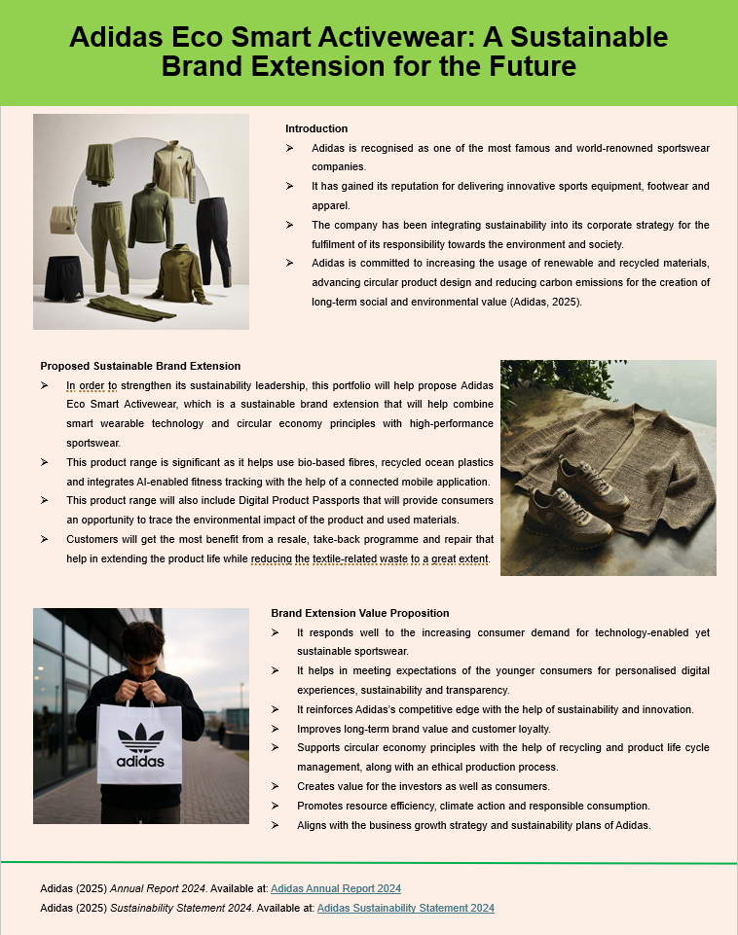

Element 2: Segmentation, Targeting, Differentiation and Positioning Analysis

Introduction
A successful sustainable brand extension needs a segmentation, targeting, differentiation and positioning (STDP) strategy. Using STDP, organisations can identify potential market opportunities, figure out what customers really need, and develop a product that provides the best value to customers compared to competitors (Kotler et al., 2024). In the case of Adidas EcoSmart Activewear, this approach can contribute to market expansion by reaching eco-minded customers who are looking for eco-friendly and innovative sportswear options.

Market Segmentation
Market segmentation is splitting the market into groups with similar characteristics for the organisation to market towards (Kotler et al., 2024). Adidas EcoSmart Activewear segments based on geographic, demographic, psychographic and behavioural segmentation.

Geographic Segmentation
Its key markets are in Europe and North America, where consumers are becoming more aware of sustainability issues and willing to pay more for top-quality sportswear. In these areas, consumers residing in urban areas are more inclined to buy sustainable products and digital fitness pads, such as the Adidas digital fitness pad (Adidas, 2025).

Demographic Segmentation
The brand extension is likely targeted at the 18- 40-year-old consumer market, especially those in Generation Z and Millennials, who are moderate to high spenders. Sports, fitness and outdoor activities are ways they are actively involved, and they're interested in innovation, quality and sustainable consumption.

Psychographic Segmentation
Its target audience will be people who are green-minded, interested in healthy living and ethical buying. They value transparent brands and appreciate sustainability and social responsibility, and they will pay a premium for environmentally friendly products.

Behavioural Segmentation
Behaviourally, the brand aims to market towards those who regularly buy high-quality sportswear, who look to fitness apps and are actively interested in buying sustainable products. Consumers are keen on using high-quality products, innovation, stewardship and durability, and are highly loyal to the brand and ready to engage in recycling and take-back initiatives that facilitate circular economy projects.

Targeting Strategy
An Adidas multi-targeting approach is needed that targets multiple segments of customers with similar sustainability attitudes but different purchase motives.
The main audience is Generation Z and the Millennial consumer who is environmentally conscious and who is at ease with technology and uses sports, fitness and wellness at least every other week. They are looking for brands to strike a balance between innovation and sustainability, and more are looking at sustainability in their buying considerations.
A secondary target is professional sportsmen, fitness and active fans who demand performance-enhancing, high-quality sportswear made from sustainable fabrics. Sustainable lifestyles are also a promising institutional market, comprising university and corporate wellness programmes. This can help Adidas to fully exploit market opportunities while keeping the brand focused on sustainability.

Differentiation Strategy
Differentiation helps companies gain a competitive edge by providing unique characteristics of their products that their competitors cannot easily duplicate (Kotler+ et al., 2024). One of the areas in which Adidas EcoSmart Activewear stands out is in the fusion of sustainability and smart technology together with circular economy principles.
The proposed range is comprised of recycled ocean plastics, recycled polyester and bio-based fibres, and wearable technology driven by AI that monitors fitness performance via a connected mobile app. Digital Product Passports contain information about the materials used, the manufacturing stages and the carbon footprint of a product and are a key step towards improving transparency and consumer trust (Adidas 2025).
Moreover, the repair, resale and take-back programme fosters a consumer movement to fulfil the programme's mission of repurposing and recycling used garments to help diminish the textile waste stream and product life. These are measure-taking steps which consolidate Adidas' competitiveness against rival companies Nike, Puma and Under Armour as well as strengthen its sustainability goals.

Positioning Strategy
Positioning helps create a unique positioning in the consumers' minds compared to the competitive brands (Kotler et al., 2024). Adidas EcoSmart Activewear will be a high-quality range developed to combine performance excellence, green credentials and innovative tech.

Positioning Statement
Adidas EcoSmart Activewear is a product line of high-performance sportswear that promotes an active lifestyle through smart technology, sustainable innovation and a circular design.
This positioning brings the best characteristics of the product to the forefront and highlights sustainability, innovation and transparency. RedShift aligns with the increasing demand from consumers for responsible products and digital experiences, enhancing brand equity and customer loyalty over time.

Conclusion
The proposed STDP strategy is known as "strategic target, door to door", and is a sound strategy on which Adidas EcoSmart Activewear can be based. Market segmentation highlights promising target groups, and differentiated targeting is about targeting environmentally conscious customers and tech-savvy users. Sustainable materials, Artificial Intelligence and circular economy projects provide an obvious competitive edge. Together with their high positioning strategy, all elements add to Adidas' reputation as an innovative and sustainability-minded sportswear brand with long-term potential for business growth (Kotler et al., 2024; Adidas, 2025).

Element 3: Marketing Mix (4Ps)

Introduction
The marketing mix is a strategic tool that can be used to create products that meet customers' needs and are designed for the benefit of the organisation. 4Ps - Product, Price, Place and Promotion- are the main parts of the marketing mix that help organisations to develop value for customers and gain competitive advantage (Kotler et al., 2024). In the brand extension due to be launched in 2017 for Adidas 'EcoSmart Activewear', every detail will be optimised for sustainability, bolstering brand value, and catering to the demand for sustainable and tech-heavy sportswear brands. The strategy is in line with the long-term ambitions of Adidas in terms of innovation, digital transformation and sustainability (Adidas, 2025).

Product
Product is the most important part of a product mix because it provides value and sets a brand's product apart from that of other brands (Kotler et al., 2024). In the new range, Adidas EcoSmart Activewear builds on the company's extensive array of sportswear offerings by adding high-performance sportswear that marries sustainable materials with smart wearables. This includes performance T-shirts, bio-based and recycled polyester and recycled ocean plastics clothing, bespoke jackets and training collections – as well as reducing the amount of virgin material used, it helps with environmental sustainability (Adidas, 2025).
One of the major aspects is the use of active sensors that measure activity, posture and fitness performance by activating an Adidas mobile application. A Digital Product Passport is also available for each garment through its QR code with data on how the material was sourced, how it is manufactured, carbon emissions, and recycling instructions. It deepens a consumer's confidence and aids in responsible buying (Kotler et al., 2024).
Repair, resale and take-back programmes for the collection of used garments encourage people to bring back their clothes for re-use and recycling and are also part of the product strategy and embody principles of the circular economy. Such efforts significantly cut down on textile waste, prolong product lifecycles, and solidify Adidas' sustainability efforts (Adidas, 2025). Thus, EcoSmart Activewear provides customers with functional and environmental benefits and reinforces customer loyalty.

Price
Customer perceptions of quality and value are affected by the price. Having a value-based premium pricing approach would be the right approach for Adidas as it allows them to incorporate premium materials and sustainable production methods whilst keeping wearability technology at an affordable cost. It captures the quality of the product and its innovation, and overcompensates for material and technology costs (Kotler et al., 2024).
Consumers are increasingly willing to consider higher prices for products that actually offer environmental added value, transparency and conviction. Smart technology and high-quality materials and circular services add value and significantly elevate the brands for premium pricing. Adidas can also promote repeat sales by offering some discounts and incentives for customers who return garments as part of the garment return programme and use it as part of membership of its new adiClub membership rewards programme to achieve sustainable consumption (Solomon, 2023). The approach will place EcoSmart Activewear on the level playing field with its higher-end counterparts as well as bolstering Adidas' image as a pioneer in innovation and sustainability.

Place
Place is about product distribution and availability to customers (Kotler et al., 2024). Adidas needs to move into an omnichannel marketing approach and bring together digital and offline sales. EcoSmart Activewear will be sold via the Adidas website, its App, the Adidas flagship stores and select authorised stores.
It is important because the customers who are the target market use digital platforms and often buy products online. Customers have access to tailor-made recommendations through the Adidas app, monitor data from wearables and participate in recycling programs (Adidas, 2025). Flagship shops benefit from digital channels with product demonstrations, information about sustainability and sustainability collection areas for returned outfits.
Recyclable packaging and logistics partners with the goal of even further reducing carbon emissions contribute to Adidas' environmental goals (Adidas, 2025). This comprehensive distribution approach enhances customer convenience, boosts interaction and helps the business achieve its circular economy goals.

Promotion
A marketing communication entity that communicates the value of the product to the customer and produces customer response is known as promotion. Promotion utilises integrated marketing communications to communicate the value of the product to the customers and attract them to the product (Kotler et al, 2024). Promotion for EcoSmart Activewear should prioritise sustainability, innovation, and digital interaction.
Product features and characteristics, sustainability programs and customer experiences can be featured on social media channels like Instagram, TikTok, YouTube and LinkedIn. Co-branding with athletes, fitness influencers and environmental activists will make authorisations more credible and help to promote user-generated content. Digital engagement helps to enhance customer relationships by engaging and personalising communications (Chaffey and Ellis-Chadwick, 2022).
Educational campaigns involving the story of transformed recycled elements as a finished product will help to prove authenticity. Videos about manufacturing processes and carbon reductions/recycling options can be made available on clothes with QR codes, to enhance transparency and consumer trust (Adidas, 2025). Other promotional items could facilitate the uptake of recycling programmes, such as sustainability events, fitness challenges and adiClub loyalty schemes, and promote long-term customer relationships.

Conclusion
Provided that the marketing mix is coherent, it proposes a strategy to launch Adidas EcoSmart Activewear. Sustainable goods with smart technology will provide value to customers, and value-based premium pricing will push the quality of and innovation into the product. An omnichannel distribution approach increases accessibility and contributes to the implementation of circular economy actions, while promotion, by focusing on the digital dimension, promotes transparency and communication about sustainability. The four elements complement Adidas' sustainability agenda, contribute to developing brand value and building a long-term competitive advantage on the global market for sportswear (Kotler et al., 2024; Adidas, 2025).

Element 4: Reflection
Creating the Adidas EcoSmart Activewear brand extension has helped me learn a lot about sustainable marketing and strategic brand extension. During this project, I had the opportunity to use important marketing principles such as Segmentation, Targeting, Differentiation, and Positioning (STDP) and Marketing Mix (7Ps) principles and develop a strong marketing strategy to meet the evolving demands of consumers and rising environmental awareness. By applying these theoretical concepts in my practical thinking, I gained insight into the aspects of creating novel products whilst keeping a solid competitive advantage. It also emphasised the synergy of Corporate Social Responsibility (CSR) and brand values for sustained value enhancement for customers and sustained business success (Kotler et al., 2024).
As one of the most crucial learning outcomes of this project, it was the realisation of how much sustainability has become a part of the marketing landscape these days. Customers are now more conscious of their environmental concerns, and demand proof of brands' commitment to responsible and sustainable business. For the brand extension Adidas EcoSmart Activewear, I examined the implementation of sustainable packaging in the design, pricing, distribution, and promotion of a product without compromising customer satisfaction or brand identity. This experience reinforced the skills I had to look at marketing in a business and environmental sense.
Poster presentation helped further enhance my communication, research, and creative thinking skills as I prepared it. It was a challenge to design and print an attention-catching and informative poster where I needed to express a lot of marketing ideas simply, concisely and enthusiastically. I learned to structure information and learn to prioritise main messages and utilise visual components effectively to sell ideas. Researching the availability of credible academic literature and industry reports also helped me build my capacity to analyse corporate strategies. As well, studying Adidas' sustainability programmes and positioning reinforced my capacity to evaluate information using credible academic resources and industry-based reports. It helped to strengthen my research skills and also reinforced the importance of using reliable sources to support strategic decisions for marketing within the marketing process (Adidas, 2025).
Moreover, I have been able to boost my analytical and problem-solving skills through identifying market opportunities, assessing consumer needs, and recommending suitable marketing strategies for a sustainable brand extension in the project. Addressing each project phase added to my confidence in harnessing marketing concepts to a business situation and showed the significance of strategic planning in attaining organisational aims.
Overall, this project was a great learning experience, and it helped me gain a deeper understanding of Sustainable Marketing, Strategic Brand Management and Communication. It boosted my confidence when it comes to creating strategies based on data and proficiency in analytical skills, conducting research and presenting it. For future projects, I hope to build upon my presentation delivery, design of visuals, data analysis skills and continue to investigate new trends and areas of sustainability, digital marketing and consumer behaviour. Improvements will enable me to become a more effective marketing professional, able to create business strategies which are offered innovatively, are focused on the customer and are eco-friendly.

References
Adidas (2025) Annual Report 2024. Herzogenaurach: Adidas AG. Available at: https://report.adidas-group.com/2024/en/ (Accessed: 4 July 2026).
Chaffey, D. and Ellis-Chadwick, F. (2022) Digital Marketing: Strategy, Implementation and Practice. 8th edn. Harlow: Pearson.
European Commission (2024) EU Strategy for Sustainable and Circular Textiles. Available at: https://environment.ec.europa.eu/strategy/textiles-strategy_en (Accessed: 4 July 2026).
International Data Corporation (IDC) (2024) Worldwide Wearables Market Forecast. Available at: https://www.idc.com/ (Accessed: 4 July 2026).
Journal of Cleaner Production (2023) ‘Circular economy practices and sustainable product innovation in the apparel industry’, Journal of Cleaner Production, 389, Article 136089.
Kotler, P., Keller, K.L. and Chernev, A. (2024) Marketing Management. 16th Global edn. Harlow: Pearson.
McKinsey & Company (2024) The State of Fashion 2024. Available at: https://www.mckinsey.com/industries/retail/our-insights/the-state-of-fashion-2024 (Accessed: 4 July 2026).
Organisation for Economic Co-operation and Development (OECD) (2024) OECD Digital Economy Outlook 2024. Paris: OECD Publishing. Available at: https://www.oecd.org/digital/ (Accessed: 4 July 2026).
Solomon, M.R. (2023) Consumer Behaviour: Buying, Having, and Being. 14th edn. Harlow: Pearson.
World Economic Forum (2024) The Future of Jobs Report 2025. Geneva: World Economic Forum. Available at: https://www.weforum.org/reports/the-future-of-jobs-report-2025/ (Accessed: 4 July 2026).

