

Assignment Title : Report - Reflection
Module Name : Professional Career Development
Module Code : BMSW4005
Name : Ramona Dorelia Stefan
Student ID : 2022359
Lecturer : Hossain Shokri
Level 4 : Certificate In Higher Education Health And Social Care 2021

Table of Contents
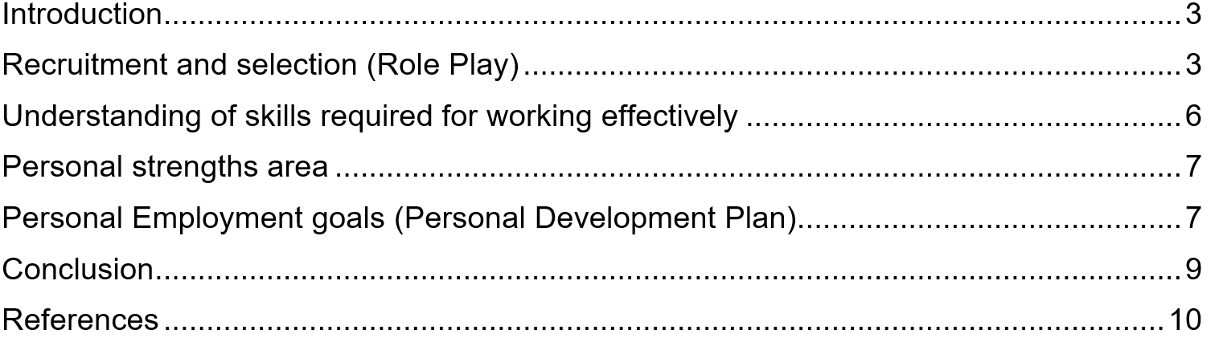

Introduction
The purpose of this reflection-based evaluation is to reflect on the job of nurse in a health and social care home. This assessment was also made based on the aspect of recruitment and selection, and my career development planning was reviewed utilizing theories (Wickramasinghe and Perera, 2010). The concept of Gibbs, which is mostly in his reflection theory, has been applied to efficiently complete this examination (Suleman, 2018). In addition, my strengths and weaknesses, as well as certain areas of potential, were explored during this evaluation in order to create a personal growth plan for my work aspirations in any organization. My career ambition is to work as a Nurse for a global corporation. The reflections of my experience from the role-playing and career development phases have been displayed based on that specific work strategy.

Recruitment and selection (Role Play)
In this assessment, I've reflected based on the role-playing discussion with my partner on the selection and recruiting processes using Gibbs' reflection model (Markkanen, et al. 2020). The role-play reflection has been provided, as well as my professional growth plan for the following step.
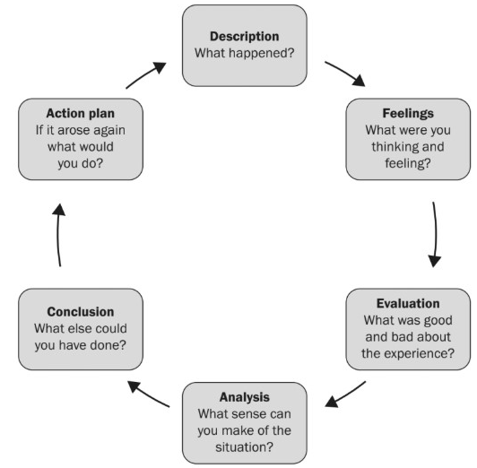
Figure: Gibbs model of Reflection
Source: (Rosenberg, et al. 2012)
Description
In this position, one of my partners and I worked as a Nurse for a well-reputed health and social care home. Regarding the issues of the activities undertaken by a Nurse in any major firm, we both served as interviewer and interviewee. We go through some of the Nurse's most important tasks and responsibilities, such as the recruiting and selection process (Lowden, et al. 2011). We also go through some of the tasks that a Nurse in a health and social care home performs, such as making people aware about diseases of different types, abuses, self-harm, social and financial anxiety, inequality, mental sickness and so on. We also learnt about the issues that Nurses confront in the workplace, as well as the numerous conflict management tactics that Nurses at a health care environment. Understanding and impression of the function of a Nurse has grown as a result of our conversation about various strategies and activities used by Nurses.
Feelings
I'm in the early phases of the conversation with my partner, and I'm terrified of this aspect. I was quite perplexed at the beginning since I wasn't prepared for the interview (Laguna-Sánchez, et al., 2020). Furthermore, I was humiliated in the early parts of the role-play session because I had not received any preparation on the topic of discussion with my partner. However, after I started conversing with my classmate, I found myself in a comfortable scenario since he was also quite encouraging. I was considering asking my classmate some tough questions, and he was doing a fantastic job answering them. After two or three answers were exchanged among us, I felt really at ease, which increased our confidence in asking each other numerous inquiries about the issue.
Evaluation
The term "evaluation" refers to determining what was excellent of what was unpleasant about a certain event (He, et al. 2018). To begin with, I can state that during this interview session, my speaking quality and interview abilities improved. In addition, I have gained fresh insights and knowledge on the tasks and responsibilities of Nurses in any global corporation. My comprehension of human people has also improved as a result of effectively identifying my partner's thinking. One positive aspect of the actual interview that I noticed was my mentor's assistance in closing the topic as a role-play (Chen, 2021). The worst part of the interview process for me was that we were unable to conclude the interview in the allotted 20 minutes. In addition, the electrical grid has been harmed as a result of the interview session not being completed on time. Another negative factor has been highlighted as mine and my partner's anxiousness during the first phases of the interview, which has squandered a significant amount of time.
Analysis
The analysis step entails determining what else a person can do with the circumstance (Adeani, et al. 2020). Here, I have effectively examined that I can make sense of the fact that I have successfully learnt about some of the most important and primary tasks of a Nurse in any global corporation. In addition, I believe that the recruitment and selection interview session has helped me grasp the right recruiting procedure utilized by global organizations (Laguna-Sánchez, et al., 2020). During this 25-minute interview evaluation, I also highlighted the skills and traits necessary by the health and social care home. Furthermore, I discovered that both of us have increased our confidence in taking the interview to each other and that we are quite familiar with each other. Furthermore, I have determined that the interview process has improved my oral abilities for interacting with others as well as my strong communication skills.
Conclusion
The final stage is a brief conversation regarding what else the person who has gotten the experience may have done (Markkanen, et al. 2020). Here, I have a problem with time management, so I could not have completed the interview in the allotted time. I could have used a wristwatch to keep track of the 20-minute time limit for finishing the interview procedure on time. In addition, I could have minimized my uneasiness during the initial stages of the interview, reducing overall time necessary to complete the interview. Also, I might well have utilized a piece of paper and a pen to jot down some of the most important relevant questions the candidate.

Action plan
The plan of action is a short conversation about what actions should be taken by the individual if the circumstance develops again (Rosenberg, et al. 2012). Here, I feel that if I were to participate in another interview session like this, you would want to utilize a pen and paper to jot down some key questions for the actual interview on the issue. I'll also work on managing time and overcoming my fear of communication with my anxiousness at first. If a circumstance like this comes again, I'll choose a more current topic related to the present business sector to broaden my understanding of current business operations and variables.

Understanding of skills required for working effectively
- Communication skills
Communication skills are the abilities that each employee must possess in order to engage with coworkers (Suleman, 2018). To communicate clearly with my target audience as well as my subordinates, I require good verbal and written communication abilities.
- IT skills
Every company action in today's technological era is dependent on several IT facts (Adeani, et al. 2020). As a result, technology skills are in great demand in the workplace. I need additional expertise and understanding of how to use various software and technology in the office, such as PowerPoint presentation slides, MS Documents, Google Sheets, and so forth. It will help me to keep the improvement of my patients recorded properly.
- Decision-making skills
Any employee in the office has to be able to make sound decisions based on a variety of criteria (Laguna-Sánchez, et al., 2020). In this case, the individual must have the bravery to make the correct decision at the appropriate moment in order to meet the company's projected aims and outcomes.

- Managerial skills
Every worker in any organization must manage numerous sorts of operations as well as individuals in the office (Rosenberg, et al. 2012). As a result, management talent is among the most prevalent and effective aspects necessary for effective operating. A person can have more influence over the work of the organization to attain some shared goals and objectives by employing management talents.
- Time management skills
Various sorts of tasks must be performed in the workplace by any individual in accordance with the instructions of their colleagues and upper executives (Wickramasinghe and Perera, 2010). As a result, having superior time management skills enables any individual to complete the allotted work and objectives within the time frame specified. Furthermore, in order to operate successfully and provide desired results, each worker must improve their time management abilities.

Personal strengths area
- I am well-versed in the use of numerous types of equipment and software to carry out various internal business functions.
- One of my greatest talents is my extensive understanding of leadership and leadership philosophies.
- Considering several factor analyses, I have improved my decision-making abilities.
- I have a good understanding of how most of the major names' internal data software works, which boosts my competitiveness in the career path.

Personal Employment goals (Personal Development Plan)
My own career objective in this field is to become a head of my department a global health and social care home. As previously said, I have addressed a few of the abilities that I currently possess, as well as a few of the skills that are essential for efficient professional performance (He, et al. 2018). Now, I've created a personal growth plan in which I've addressed my areas for improvement with the appropriate specifications.
Area of improvement | Actions to be taken | Implementation in future | Time Horizon
Public speaking | To develop my public speaking talents, I would enroll in a three-month online course to learn about many areas of public speaking. I will also buy at least two scholarly works on enhancing public speaking quality and practice with either of my mates on a regular basis to enhance my communication skills. | Inside the future, I hope in becoming a Nurse, which is why I need to improve my public speaking abilities in order to offer guidance to my subordinate. In addition, as a Nurse in the future, I will be able to use my public speaking abilities to engage with some of the possible applicants throughout the recruiting and selection process. | 3 months
Time management | I'm going to watch clips on YouTube on employee management strategies. In addition, I will participate in the tiffin online and offline segment from motivating speakers on time management and the necessity of time management in the professional domain. | As such a Nurse in the coming, I will just use my time management abilities to handle all duties within the time constraints. In addition, I will use my time management abilities to coordinate training sessions and various external interactions with corporate stakeholders. | 4 months

Conclusion
So, they are some of the aspects of my career that I need to improve in order to be more competitive in the employment market. Furthermore, my reflection on the role-play depth interview along my collaborator has been mentioned in this assessment. In addition, I have mentioned a few of the squares that are necessary for being a good employer, as well as my areas of strength as an employee. In order to make the report legitimate and helpful, many sorts of qualitative data and information were employed in this evaluation.

References
Adeani, I.S., Febriani, R.B. and Syafryadin, S., 2020. USING GIBBS’REFLECTIVE CYCLE IN MAKING REFLECTIONS OF LITERARY ANALYSIS. Indonesian EFL Journal, 6(2), pp.139-148.
Chen, J.H., 2021. Augmenting Student and Professional Training with Peer Learning Groups: Results from Focus Group Interviews (Doctoral dissertation, Rutgers The State University of New Jersey, Graduate School of Applied and Professional Psychology).
He, K.N., Parkinson, L. and Doyle, A.K., 2018. Gibbs’ Reflective Cycle.
Husebø, S.E., O'Regan, S. and Nestel, D., 2015. Reflective practice and its role in simulation. Clinical Simulation in Nursing, 11(8), pp.368-375.
Laguna-Sánchez, P., Abad, P., de la Fuente-Cabrero, C. and Calero, R., 2020. A university training programme for acquiring entrepreneurial and transversal employability skills, a students’ assessment. Sustainability, 12(3), p.796.
Lowden, K., Hall, S., Elliot, D. and Lewin, J., 2011. Employers’ perceptions of the employability skills of new graduates. London: Edge Foundation.
Markkanen, P., Välimäki, M., Anttila, M. and Kuuskorpi, M., 2020. A reflective cycle: Understanding challenging situations in a school setting. Educational Research, 62(1), pp.46-62.
Rosenberg, S., Heimler, R. and Morote, E.S., 2012. Basic employability skills: A triangular design approach. Education+ Training.
Suleman, F., 2018. The employability skills of higher education graduates: insights into conceptual frameworks and methodological options. Higher Education, 76(2), pp.263-278.
Wickramasinghe, V. and Perera, L., 2010. Graduates', university lecturers' and employers' perceptions towards employability skills. Education+ Training.

