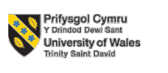

LCMB7023
Human Capital Management

Assessment component 1- Individual report – HR strategy

Integrated Human Capital Blueprint

Title: Human Capital Management through Aligning People and Performance at Aether Innovations

Submitted by-
Student Name-
ID-

Submission deadline: 20th March 2026 by 2PM
Table of Contents
Introduction 3
Part 1: Integrated Human Capital Blueprint 4
Option 2 – Building a Culture of Innovation & Future Work Practices 4
1.1 Examine the current practices in culture and work among the tech companies 4
1.2 Recommend cultural and structural initiatives that embed innovation (e.g. innovation sprints, intrapreneurship, cross-functional teams). 6
1.3 Propose a Future of Work model (hybrid/remote) that supports collaboration and creativity….. 8
1.4 How the new approach would motivate and enable staff to perform optimally. 10
Part 2: Write a reflection 12
2.1 Learning the learning journey achieved through Gibbs reflective cycle and how they offer a baseline to design appropriate Learning and Development approaches to cultivate a culture of innovation and growth mind-set 12
2.2 How I plan to stay relevant as AI is increasingly capable of handling many traditional jobs and positions. 15
Conclusion 16
References 17

Introduction
Aether Innovations is a fast-growing technology company which has serious problems that it is trying to solve, such as the lack of growth, high-employee turnover, and customer dissatisfaction. Aether Innovations has 300-staff. These integrated problems are warning signs of a fundamental misfit between people practises and the strategic aims of the organisation. This report is a full HR Blueprint and suggests an integrated HR strategy that would restore innovation capacity, reinforce employee engagement, and improve organisational performance. Part 1 reviews existing industry practises and offers cultural, structural, and future-of-work activities to entrench innovation. Part 2 is a personal reflective report on the learning experience during this module and how AI affects future career relevancy.

Figure: Aether Innovations (Amabile and Pratt, 2024).

Part 1: Integrated Human Capital Blueprint

Option 2 – Building a Culture of Innovation & Future Work Practices

1.1 Examine the current practices in culture and work among the tech companies
Innovation-driven organisational culture
Current technology market can be broadly typified by what cultures desire to be agile, flat, and innovation-driven, but most companies fail to turn the desire into reality. Open cultures that promote experimentation, psychological safety, and knowledge sharing have become popular in organisations like Google, Microsoft, and Spotify (Edmondson and Bransby, 2023). Nevertheless, it has been found that a large fraction of tech firms is culturally drifting as they grow, where early start-up momentum gives way to bureaucratic inertia and work-in-silos (Katzenbach et al., 2021).
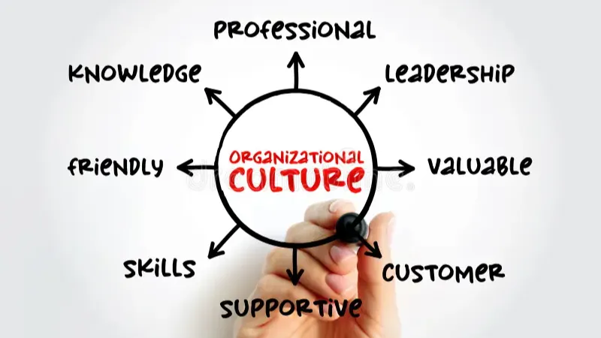
Figure: Organisational culture (Bailey et al., 2022).
Agile and flexible work structures
In the case of Aether Innovations, the flattened growth and high turnover rates indicate that the organisational culture has failed to keep up with the brewing expansion, introducing a mismatch between the supposed values and the actual directives of the employees. Moreover, numerous technology companies continue to use old-fashioned performance management strategies that are based on individual effort instead of group-based innovation, which may hinder knowledge-sharing behaviours that are essential to long-term competitive advantage (Collings et al., 2021).

Digital collaboration and technology tools
The post-pandemic shift of work to hybrid and remote patterns has transformed current practises in tech companies significantly. Research reveals that more than 70% of technology employees currently demand some level of flexibility at work as a normal job requirement (CIPD, 2023). Nevertheless, most organisations have adopted a hybrid model without properly redesigning workflows, communication protocols, or work collaboration areas, resulting in disjointed team processes and decreased innovation output (Gratton, 2022).
Remote and hybrid work practices
In Aether Innovations, poor customer satisfaction could also be partially explained by deteriorated cross-functional cooperation imposed by disorganised mechanisms of work. Furthermore, employee engagement surveys throughout the industry indicate repeatedly that workers seek meaningful autonomy and growth opportunities and a purpose, and these must be structural, not only left to a single manager (Bailey et al., 2022).
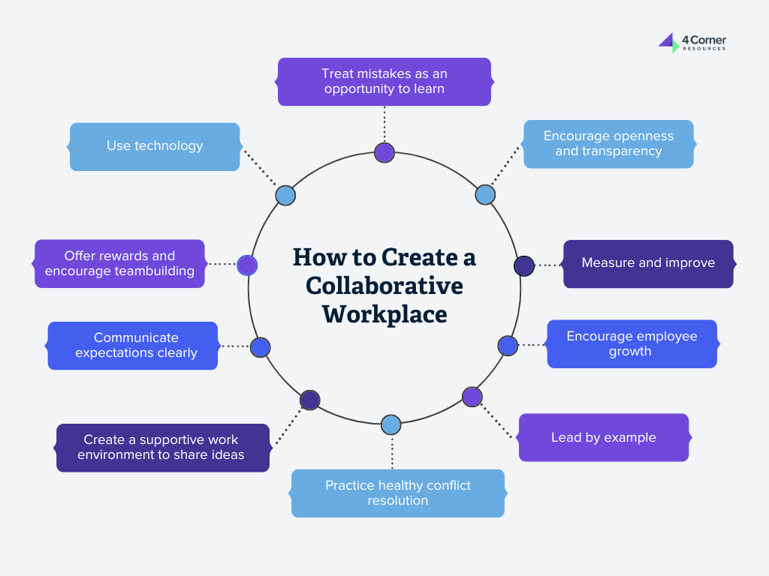
Figure: Collaboration strategies (CIPD, 2023).

1.2 Recommend cultural and structural initiatives that embed innovation (e.g. innovation sprints, intrapreneurship, cross-functional teams).
Innovation Sprints
Aether Innovations ought to implement organised innovation sprints, time-constrained sessions where cross-functional teams enter into a state of pure innovation generation, prototyping, and testing. Innovation sprints, based on the design sprint approach popularised by Google Ventures, adjust a area of committed creativity in solving problems beyond the constraints of regular running (Knapp et al., 2021).
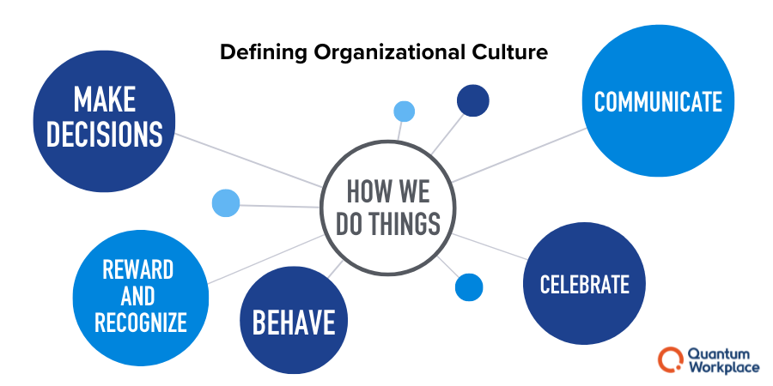
Figure: Organisational culture (Cascio and Montealegre, 2023).
Intrapreneurship Programmes
It is advisable that the firm has a formal intrapreneurship programme to enable employees to create entrepreneurial initiatives within the corporate structure. It has been demonstrated that intrapreneurship increases employee engagement, retention, and innovation performance through placing individuals in ownership roles of creative projects alongside corporate resources and support (Corbett and Hmieleski, 2020).

This might be the annual innovation fund at Aether Innovations, where staff would submit their ideas to a review panel, with winners getting assigned some time, funds, and guidance. Furthermore, emergent entrepreneurship will yield a pipeline of products and services developed internally that can contribute to diversifying revenues and overcoming the existing flat growth curve (Rao and Weintraub, 2023).
Cross-Functional Teams and Collaborative Structures
The redesign of work around permanent cross-functional teams instead of strict hierarchies based on departments is the key to innovation, in order to entrench it at Aether Innovations. Cross-functional teams eliminate duplication of efforts through concentrated expertise, thus allowing quicker identification of issues, as well as developing solutions more creatively (Hamel and Zanini, 2020). The company ought to work on adopting a squad-like approach, as in the case of Spotify, where autonomous small teams are set to particular outcomes (Sparrow and Cooper, 2024). The squad must have a representative of the engineering, design, marketing and customer experience functions to guarantee that thinking is integrated (Edmondson and Bransby, 2023).
Recognition and award Systems in alignment
Aether Innovations needs to redesign its recognition and reward systems so as to motivate innovative behaviour and not merely through completion of work or individual performance. Studies show that when organisations acknowledge collaborative innovation, smart risk-taking, and learning through failure they develop more robust innovation cultures in comparison to those that strive on past output measurements (Shields et al., 2020).

1.3 Propose a Future of Work model (hybrid/remote) that supports collaboration and creativity.
Hybrid work model (office + remote work)
Aether Innovations ought to establish a deliberate hybrid operational framework that is inclusive of both distance freedom and deliberate face-to-face cooperation. Instead of requiring dedicated office days, the model is supposed to be activity-based, where workers work remotely to perform specific individual tasks and meet in the office to develop innovations during sprints, brainstorms, and share perspectives with the team (Gratton, 2022).
Flexible working hours and outcome-based performance
This will accommodate employee tastes of flexibility without necessarily compromising the spontaneous interactions and relationship-building that are critical to innovation. The company must invest in the redesign of its physical workspace to incorporate collaboration areas, prototyping laboratories, and informal social spaces, which would ensure that in-person time is worthwhile (CIPD, 2023). The remote working component should be supported by clear digital collaboration protocols, such as asynchronous norms of communication skills and shared digital workspaces, to avoid information silos (Chiu et al., 2021).
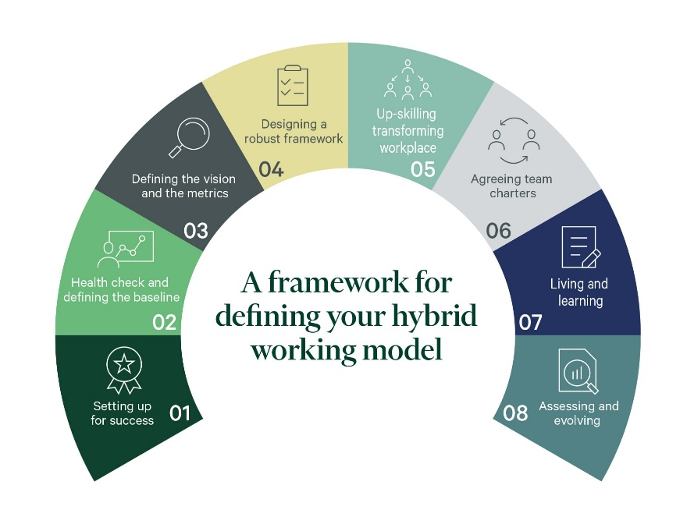
Figure: Hybrid Working model (Chiu et al., 2021).
Hybrid Collaboration Technology Infrastructure
The hybrid model needs a solid technology infrastructure to facilitate smooth cooperation despite the location (Amabile and Pratt, 2024). It is recommended that Aether Innovations implement both real-time communication and project management tools alongside knowledge-sharing tools like Microsoft Teams in combination with Miro or Notion to establish an integrated digital workspace (Kane et al., 2021). They should avail virtual white boarding and prototyping tools so that people at a distance can participate equally in creative sessions (Gagne et al., 2022).
Virtual innovation workshops and brainstorming sessions
The company also ought to offer employees proper home-working amenities as well as ergonomic concessions as a sign of true concern about employee health in all work situations. The need to invest in such technologies directly also aids the innovation agenda by lowering the friction in the collaborative processes and allowing the ideas to flow freely throughout the organisation (Cascio and Montealegre, 2023).

1.4 How the new approach would motivate and enable staff to perform optimally.
Increased employee autonomy and empowerment
Teenagers will develop their own learning process, which will become more interesting as they understand their personal purpose and gain autonomy. The proposed initiatives directly cover the three fundamental needs outlined in the Self- Determination Theory: autonomy, competence, and relatedness (Deci and Ryan, 2020).
Greater collaboration and knowledge exchange
The hybrid model offers employees relevant autonomy in terms of where and when to work, and intrapreneurship programme offer chances to learn and show competence in entrepreneurial situations. When the three needs are met, workers feel increased rates of intrinsic drive, which a body of literature has shown to correlate with the increased levels of creativity, perseverance, and job satisfaction (Gagne et al., 2022).
Developing Organisational Strength
Aether Innovations can considerably decrease the rate of turnover by establishing the innovative pathways, by investing in the infrastructure of collaboration, and rewarding the creative input. The employees who see a significant chance of progressing and contributing to something are significantly less inclined to take up external chances (Sparrow and Cooper, 2024). Taken together, these efforts form a vicious cycle: low turnover retains institutional knowledge, which enhances innovation capacity, which leads to higher customer satisfaction, which subsequently promotes the growth and additional investment in people (Ulrich and Dulebohn, 2024).
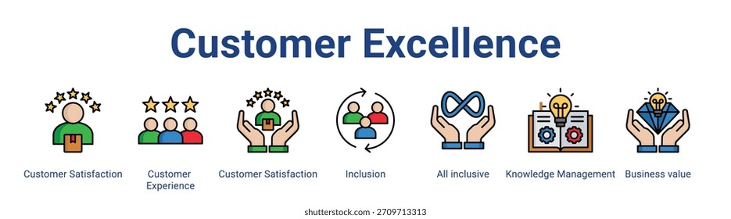
Figure: Customer excellence (Deci and Ryan, 2020).
Connecting Customer Excellence
The final success metric of these initiatives will be customer satisfaction. Studies have shown a consistent positive relationship between employee engagement and customer satisfaction, with engaged employees providing better quality service and responding more proactively to customer needs and becoming genuine brand ambassadors (Bailey et al., 2022). Here, at Aether Innovations, the suggested change in culture and structure develop the conditions.
Higher job satisfaction and engagement
Sprint-based customer pain point-driven innovation processes make sure that creative efforts are aimed at commercially significant outputs. Its customer-outcome alignment makes the squad model a model in which cross-functional teams remain undeterred in their relentless pursuit of delivering value to final users (Collings et al., 2021).

Part 2: Write a reflection

2.1 Learning the learning journey achieved through Gibbs reflective cycle and how they offer a baseline to design appropriate Learning and Development approaches to cultivate a culture of innovation and growth mind-set
Description
At the start of this module, I already had a basic idea of human resource management but had little intuitive insight into how holistic people strategies can improve multi-faceted organisational issues. During the module, I worked with theoretical frameworks such as the Harvard HRM model, Self-Determination Theory, and organisational culture and innovation models. I have taken part in case studies, group activities and hands-on assignments which involved me putting these frameworks into a realistic business situation, and now, I am presenting this consultancy report on behalf of Aether Innovations.
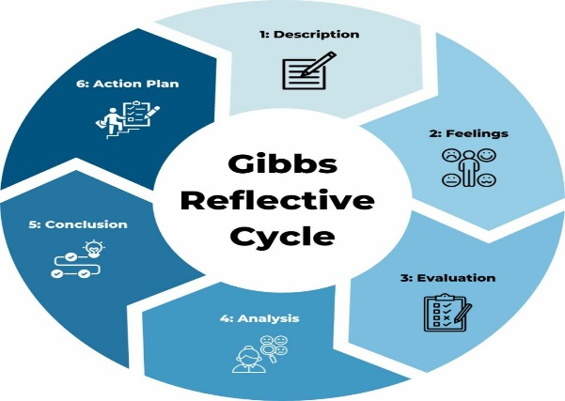
Figure: Gibbs Reflection cycle (Edmondson and Bransby, 2023).
Feelings
My first impression of the topic was the vastness of that matter and my doubts about my potential in synthesising different theories into a unified strategic proposal. However, my confidence improved, and I found myself starting to see bridges between what appeared to be rather distant topics. I found the discussion about innovation culture to be especially interesting because of my personal philosophy that organisations thrive when they truly invest in the people they employ. I also found the difficulty in designing hybrid working models challenging, as I realised that no easy answers exist to the conflict between flexibility and collaboration.
Evaluation
I feel that the module has been of great importance in shaping me as a future professional in the field of HR. The focus on holistic thinking, instead of considering HR functions as disconnected actions, has changed my outlook radically (Gagne et al., 2022). The group discussions were especially useful because listening to people with different points of view compelled me to reassess my assumptions and examine other possibilities. Nevertheless, I also acknowledge that I was at times unable to find a balance between theoretical rigour and practical applicability, sometimes over-applying academic frameworks without giving due consideration to the issues of theory implementation.
Analysis
I have come to realise that establishing a culture of innovation takes a systemic change in the various organisational dimensions such as structure, leadership, reward systems, and working practises. Psychological safety, a notion that is central to the wider body of innovation literature, has altered my thinking, in particular. I understand that my personal risk-aversion and desire to have certainty may hamper my performance as an innovative leader. Another thing that I have learnt to value is that learning and development is not a single intervention but a continuous process of inculcating a sense of curiosity, strength, and responsiveness. It now dawns on me that I will need to practise being able to embrace challenges and redefine failure as an opportunity to learn and cultivate a growth mind-set.
Conclusion
I find that this module has equipped me with a strong foundation of designing learning and development strategies that foster innovation and growth mentality. I have pinpointed particular areas of individual growth, such as my comfort working with ambiguity, my collaborative leadership abilities, and my systemic thinking when dealing with organisational problems. I understand that I will still have to find out activities that push my boundaries and open my eyes to a wide range of thoughts before I am able to be a good human capital consultant.

Action Plan
I intend to engage in continuing education by completing CIPD qualifications and certification in innovation management. To develop collaborative skills that I have listed as a development priority, I will pursue cross-functional project opportunities in my workplace. I will also develop a routine reflective practise, with the Gibbs cycle, and make sure that I keep on learning through experience, and correct my practise accordingly. I would also ensure I attend industry conferences and networking to keep abreast with current trends and best practises in human capital management.
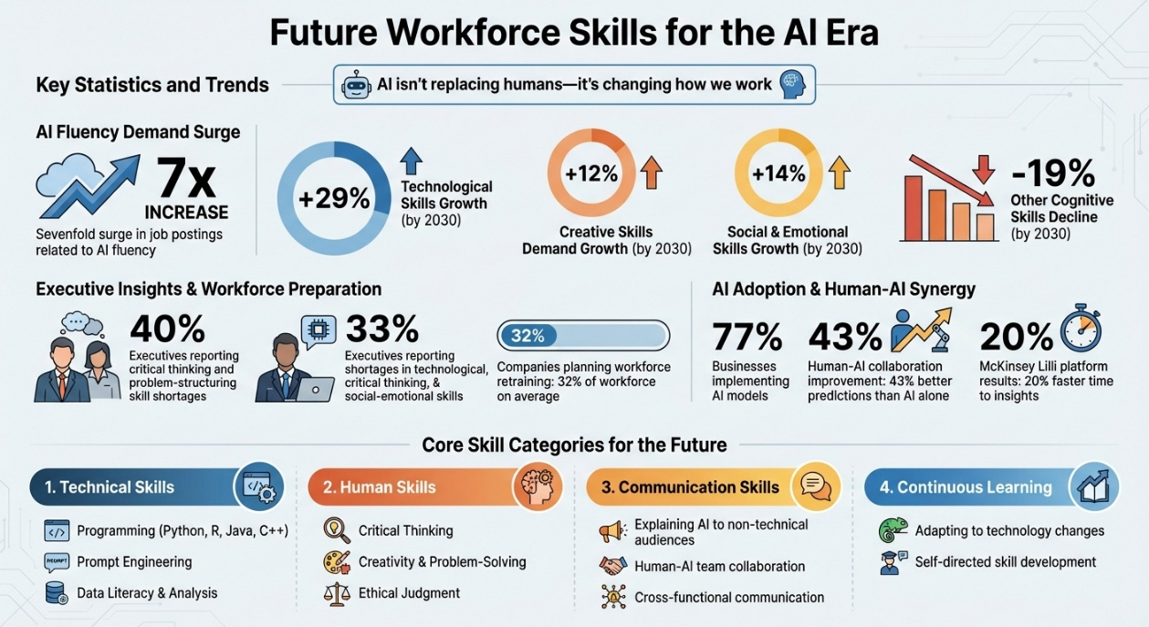
Figure: AI skills (Gagné et al., 2022).

2.2 How I plan to stay relevant as AI is increasingly capable of handling many traditional jobs and positions.
The AI Landscape and the AI Implication
I understand that artificial intelligence is quickly changing the landscape of work and is automating mundane chores and taking over jobs in increasing numbers that would have been thought safe by automation representatives. I will know that with the increased capabilities of AI, I will need to actively acquire skills and competencies that are complementary, not competing with machine capabilities. In my opinion, my professional worth will continuously be related to my capacity to exercise judgement, empathy, ethical thinking, and creativeness of thought which cannot be entirely AI-powered despite the rise of AI.
AI as an Acceptance, not a Substitution
I will also actively incorporate AI in practise to increase my productivity and decision-making. I will apply AI-based analytics to the planning of my workforce, talent mapping, and sentiment analysis of employees, hoping to apply these technologies to create insights that will guide my strategic advice. Nevertheless, I will make sure that AI does not replace my functions but rather enhances them. My critical thinking abilities will not fade, as I will always question what AI has produced, take into account contextual aspects that algorithms might miss, and use ethical theory in making decisions based on technologies. I feel that the human ability in relationship building, communication subtlety and cultural sensitivity will continue being requisite in human capital management, despite technology.
Making Lifelong Learning and Adaptability a commitment
Lifelong learning is my main approach towards ensuring that I remain relevant in my profession (Gagne et al., 2022). I will keep up with my digital literacy, being aware of new AI tools and their use in HR. I will also invest in my strategic and consultative capabilities by becoming a relied advisor who can help resolve the divide between technological potential and human-centred organisational design. Functionally, I believe that, through the combination of technological aptitude and profound understanding of people management, I will be able to forge a professional identity that is resistant to AI overthrow, yet qualitatively useful to the organisations that I will be working in.

Conclusion
As has been shown in this report, Aether Innovations can defeat the current challenges of its flat development, high turnover, and decreasing customer satisfaction through an integrated human capital approach focused on innovation culture, collaborative frameworks, and a meaningful hybrid model of work. All the suggested measures, such as innovation sprints, intrapreneurship programmes, cross-functional teams, and reengineered reward systems, all combine to provide the environment of employee performance and customer excellence. The personal reflection highlights the need to further acquire knowledge, pursue reflective practise, and use strategic thinking with artificial intelligence to develop a sustainable and future-proof career in human capital management.

References
Amabile, T.M. and Pratt, M.G. (2024) 'The dynamic componential model of creativity and innovation in organisations', Research in Organisational Behavior, 44, pp. 1–18.
Bailey, C., Madden, A., Alfes, K. and Shantz, A. (2022) The Meaning of Employee Engagement: Rethinking the Employee–Organisation Relationship. London: Routledge.
Cascio, W.F. and Montealegre, R. (2023) 'How technology is changing work and organisations', Annual Review of Organisational Psychology and Organisational Behavior, 10(1), pp. 349–372.
Chiu, C.Y., Owens, B.P. and Tesluk, P.E. (2021) 'Initiating and utilising shared leadership in teams', Journal of Applied Psychology, 106(3), pp. 401–414.
CIPD (2023) Flexible and Hybrid Working Practices in 2023. London: Chartered Institute of Personnel and Development.
Collings, D.G., McMackin, J., Nyberg, A.J. and Wright, P.M. (2021) 'Strategic human resource management and COVID-19: emerging challenges and research opportunities', Journal of Management Studies, 58(5), pp. 1378–1382.
Corbett, A.C. and Hmieleski, K.M. (2020) 'Entrepreneurial action within organisations', Journal of Business Venturing Insights, 14, pp. e00195.
Deci, E.L. and Ryan, R.M. (2020) 'Intrinsic motivation and self-determination in human behavior: an updated perspective', Perspectives on Psychological Science, 15(4), pp. 1–15.
Edmondson, A.C. and Bransby, D.P. (2023) 'Psychological safety comes of age: observed themes in an established literature', Annual Review of Organisational Psychology and Organisational Behavior, 10(1), pp. 55–78.
Gagné, M., Parker, S.K., Griffin, M.A., Dunlop, P.D. and Kanfer, R. (2022) 'Understanding and shaping the future of work with self-determination theory', Nature Reviews Psychology, 1(7), pp. 378–392.
Gratton, L. (2022) Redesigning Work: How to Transform Your Organisation and Make Hybrid Work for Everyone. London: Penguin Business.
Hamel, G. and Zanini, M. (2020) Humanocracy: Creating Organisations as Amazing as the People Inside Them. Boston: Harvard Business Review Press.
Kane, G.C., Phillips, A.N., Copulsky, J.R. and Andrus, G.R. (2021) The Technology Fallacy: How People Are the Real Key to Digital Transformation. Cambridge, MA: MIT Press.
Katzenbach, J., Oelschlegel, C. and Thomas, J. (2021) 'The critical few: energise your company's culture by choosing what really matters', Strategy+Business, Spring Issue, pp. 22–31.
Knapp, J., Zeratsky, J. and Kowitz, B. (2021) Sprint: How to Solve Big Problems and Test New Ideas in Just Five Days. 2nd edn. London: Transworld Publishers.
Rao, J. and Weintraub, J. (2023) 'How innovative is your company's culture?', MIT Sloan Management Review, 64(3), pp. 29–37.
Shields, J., Brown, M., Kaine, S., Dolle-Samuel, C., North-Samardzic, A., McLean, P., Johns, R., O'Leary, P., Plimmer, G. and Robinson, J. (2020) Managing Employee Performance and Reward: Systems, Practices and Prospects. 3rd edn. Cambridge: Cambridge University Press.
Sparrow, P. and Cooper, C. (2024) Human Resource Management: Strategic and International Perspectives. 4th edn. London: Sage Publications.
Ulrich, D. and Dulebohn, J.H. (2024) 'Are we there yet? What's next for HR?', Human Resource Management Review, 34(1), pp. 100–115.

