
APPENDIX GA36c

LEVEL 6 ASSESSMENT SPECIFICATION

Student name: | Connor Moriarty | Student ID number: | 264542
Programme: | Applied Computing
Module: | Usability Engineering
Module code: | ACCB6017 | Contribution to Overall Module Assessment (%): | 50%
Lecturer: | Pauline Greenaway | Internal Verifier: | Gaynor Thomas
Assignment Title: | Prototyping & Testing | Word count (or equivalent): | 3000
Submission deadline: | 24/3/23 | Return date of provisional marks & written feedback: | TBA
Submission method: | All written assessments, where practical and possible, must be submitted via Turnitin unless otherwise instructed by the Lecturer. (Please DO NOT put this assessment specification into Turnitin or it will match many similarities with other students’ submissions.)  Alternative submission method (if applicable):  Late submission of the assessment will result in a late penalty mark. Penalties for late submission: Up to one week late, maximum mark of 40%. Over one week late, 0%. Only the Extenuating Circumstances Panel may approve a change to submission dates.
Academic honesty / referencing: | Academic honesty is required. In the main body of your submission you must give credit to authors on whose research and ideas your work is based. Append to your submission a reference list that indicates the books, articles, etc. that you have used, cited or quoted in order to complete this assessment.
Module Learning Outcomes
(from module syllabus)
Upon the successful completion of this module, the student should be able to:
- Research and evaluate cognitive and social information processing
- Select, apply and analyse critically techniques of interface evaluation
- Synthesize a solution to a complex design problem from the concepts and principles of usability engineering and software development
- Critically analyse, individually and as part of a team exercise, input and output hardware appropriate for specialised applications, for example for use by disabled people, and for three-dimensional modelling applications

TASK DESCRIPTION

Task 1
Twitter (2006) and Mastodon (2016) are two short-form messaging applications. On both systems, users can publish short messages (which may include images) to their followers, who may in turn “like” them, forward them to their own followers, or message the original author. Due to the recent changes at Twitter many users have decided to delete their accounts and move to Mastodon instead.

After downloading and using these applications, write a short report that discusses the following issues:

- How do the applications use psychology, usability, and design to engage and maintain user interest in the conversation space?
- What user experience lessons has Mastodon learned from Twitter and how does it make itself appealing to its target audience?
- How do the differences between the applications provide different social experiences for their users?
The report should include appropriate illustrations and references to research literature (8-10 references are sufficient, and at least two thirds of these should be books/journal papers).

Your submission should be presented in the form of a report that includes the following sections:
- (15%) A (very!) brief description of the applications, including similarities and differences in their mechanics and interfaces.
- (15%) Consideration of the target user groups for the applications. Is there any overlap or potential to encourage users of one application to migrate to the other?
- (40%) What elements of psychology, usability, design and copyrighting are significant and how these interact to provide an emotionally satisfying user experience?
- (20%) Are there any elements that don’t work? If a user of one application decides to try the other application then what elements are likely to feel comfortable or uncomfortable? Are there any features that might be missed?

The final 10% will be awarded for document presentation and appropriate references to the research literature.

The report should be submitted through Turnitin. Do not submit the assignment brief document with this.

Task 2

The boardgame CLUEDO is familiar to many as one that requires players to move their pieces around a board that represents a country mansion, finding clues that will help them solve the murder of Dr Black.
You are to design a UWTSD version of this as a computer game.

“Oh no! The Vice-Chancellor has been murdered! Who did it?”

You may set the game on any or all of the university campuses, and may include up to 8 players who should represent different parts of the university. This task represents your initial user research and design ideas for the game interface. In the next assignment you will develop your ideas further into a full colour design.

You should submit a report containing the following:
- A set of four detailed personas with associated scenarios and an indication of the main user and experience requirements relating to each persona;
- An appropriate information architecture for your game with justification for its structure;
- An initial set of wireframe storyboards;
- A description of the process used to collect feedback on your storyboard prototypes and a summary of the positive and negative feedback elicited.
The report should include appropriate illustrations and references to research literature (at least two thirds of these should be books/journal papers).

Your submission should be presented in the form of a report that includes the following sections:
- (20%) Who are your test personas? What are their user and experience requirements? Remember that students are not all able-bodied 18-21 year olds living in the Swansea area.
- (20%) How did you gather information to support the design of your personas? Discuss the results of any focus groups you held to elicit this information. Lists of user and experience requirements, categorised using the MoSCoW criteria, should be provided in an appendix.
- (20%) What information is necessary for the game to be a success? How does this need to be structured to make it easy to use? What information is location-sensitive, and how does this fit into the app?
- (20%) Storyboards should be wireframe only, rather than full colour design. They should show all of the major functionality of the app at a size appropriate for a mobile phone, and should take all of the usual aspects of interaction design theory into account in the design. The complete set of storyboards should be presented in an appendix but significant elements such as the main screen designs should be discussed in the main body of the report. These can be created using any suitable software; Adobe XD is a good choice for this, but other packages are fine provided that you remember to show not only the screens but how the user moves between the screens.
- (10%) How did you collect feedback on your prototypes? How did you ensure that your test subjects covered the range of personas you defined earlier? What feedback did you get, both in terms of usability and of emotional response? Were these what you expected and, if not, why not?

The final 10% will be awarded for document presentation and appropriate references to the research literature.

The report should be submitted through Turnitin. Do not submit the assignment brief document with this.

GUIDANCE FOR Students IN THE COMPLETION OF TASKS

NOTE: The guidance offered below is linked to the five generic assessment criteria overleaf.

- Engagement with Literature Skills
Your work must be informed and supported by scholarly material that is relevant to and focused on the task(s) set; you should make use of scholarly reviews and primary sources, where appropriate (for example, refereed research articles and/or original materials appropriate to the discipline). You should provide evidence that you have accessed a wide range of sources, which may be academic, governmental and industrial; these sources may include academic journal articles, textbooks, current news articles, organisational documents, and websites. You should consider the credibility of your sources; academic journals are normally highly credible sources while websites require careful consideration/selection and should be used sparingly. Any sources you use should be current and up-to-date, mostly published within the last five years or so, though seminal/important works in the field may be older. You must provide evidence of your research/own reading throughout your work, using a suitable referencing system, including in-text citations in the main body of your work and a reference list at the end of your work.

Guidance specific to this assessment: Task 1: Remember that although you should present your opinions of the user interface, you should justify those opinions with reference to the relevant areas of the literature. Task 2: Remember to justify your choices for the design with reference to research literature.

- Knowledge and Understanding Skills
At level 6, you should be able to demonstrate coherent and detailed knowledge and a systematic understanding of the subject area, at least some of which is informed by the latest research and/or advanced scholarship within the discipline. You should be aware of the uncertainty, ambiguity and limits of knowledge. Your work must demonstrate the growing extent of your knowledge and systematic understanding of concepts and underlying principles associated with the subject area. Knowledge relates to the facts, information and skills you have acquired through your learning. You demonstrate your understanding by interpreting the meaning of the facts and information (knowledge). This means that you need to select and include in your work the concepts, techniques, models, theories, etc. appropriate to the task(s) set. You should be able to explain the theories, concepts, etc. meaningfully to show your understanding. Your mark/grade will also depend upon the extent to which you demonstrate your knowledge and understanding; ideally each should be complete and detailed, with comprehensive coverage.

Guidance specific to this assessment: Task 1: Consider the elements of the interfaces and of the gameplay – what works, what doesn’t work, and why? Task 2: Not applicable.

- Cognitive and Intellectual Skills
You should be able to: critically evaluate evidence, arguments, assumptions, abstract concepts and data some of which are at the forefront of a discipline (and that may be incomplete) to devise and sustain arguments, to make judgements and/or solve problems; describe and comment upon particular aspects of current research, or equivalent advanced scholarship, in the discipline Your work must contain evidence of logical, analytical thinking, evaluation and synthesis. For example, to examine and break information down into parts, make inferences, compile, compare and contrast information. This means not just describing what! But also justifying: Why? How? When? Who? Where? At what cost? At all times, you must provide justification for your arguments and judgements. Evidence that you have reflected upon the ideas of others within the subject area is crucial to you providing a reasoned and informed debate within your work. Furthermore, you should provide evidence that you are able to make sound judgements and convincing arguments using data and concepts. Sound, valid conclusions are necessary and must be derived from the content of your work. Where relevant, alternative solutions and recommendations may be proposed.

Guidance specific to this assessment: Task 1: How transferrable are skills learned between the two games? Task 2: You should produce appropriately detailed personas and use these to help guide your information architecture design.

- Practical Skills
At level 6, you should be able to apply the methods and techniques that you have learned to review, consolidate, extend and apply your knowledge and understanding, and to initiate and carry out projects. You will deploy accurately established techniques of analysis and enquiry relevant to the discipline, and apply them in complex and unpredictable contexts, to devise and sustain arguments and/or to solve problems. You should be able to frame appropriate questions to achieve a solution - or identify a range of solutions. You should be able to demonstrate how the subject-related concepts and ideas relate to real world situations and/or a particular context. How do they work in practice? You will deploy models, methods, techniques, and/or theories, in that context or circumstances, to assess current situations, perhaps to formulate plans or solutions to solve problems, or to create artefacts, some of which may be innovative and creative. This is likely to involve, for instance, the use of real world artefacts, examples and cases, the application of a model within an organisation and/or benchmarking one theory or organisation against others based on stated criteria. You should show awareness of the limitations of concepts and theories when applied in particular contexts.

Guidance specific to this assessment: Task 1: Not applicable. Task 2: You should produce a full interface for this prototype design, using an appropriate workplace tool. This should be tested with real users rather than simply relying upon designer tests. Remember that you can perform user tests via Zoom or Teams.

- Transferable Skills for Life and Professional Practice
Your work must provide evidence of the qualities and transferable skills necessary for graduate-level employment requiring the exercise of initiative and personal responsibility and decision-making in complex and unpredictable circumstances. This includes demonstrating: the learning ability for professional development to advance existing skills and acquire new competences of a professional nature that will enable you to assume significant responsibility within organisations; that you can initiate and complete tasks and procedures, whether individually and/or collaboratively; that you can use appropriate media to effectively communicate information, arguments and analysis in a variety of forms to specialist and non-specialist audiences; fluency of expression; clarity and effectiveness in presentation and organisation. Work should be coherent and well-structured in presentation and organisation.

Guidance specific to this assessment: Tasks 1 and 2: This is a report, not a paper, so no abstract is needed. Ensure that your report looks professional. You should show how you’re using common professional techniques like task analysis effectively. Remember to write the report in an academic manner with numerical referencing, correct captioning of illustrations, appropriate technical English.

Student FEEDBACK FORM

This section details the extent to which the assessment criteria are demonstrated by you, which in turn determines your mark. The marks available for each category of skill are shown. Lecturers will use the space provided to comment on the achievement of the task(s), including those areas in which you have performed well and areas that would benefit from development/improvement.

Generic Assessment Criteria | Marks available | Marks  awarded
1. Engagement with Literature Skills
.
Comparison between similarities and differences of Twitter and Mastadon provided, together with target user groups. This is supported by references but could have been more detailed in nature. Very little reference to cognitive psychology in relation to the platforms. No reference to perception theories. Some reference to interaction design theories in analysing and comparing the platforms although this could have included more reference to the specific design principles with supporting references included. Brief consideration of Shneiderman’s design rules in relation to wireframes. This is very limited and no supporting references provided. |  | 16
 | 30 | 16
2. Knowledge and Understanding Skills

 | 0
3. Cognitive and Intellectual Skills

 | 0
4. Practical Application Skills

4 test personas developed as a result of focus group findings although these could have been more comprehensive in nature. Reference could also have been made to psychographics, end user goals etc. No reference to MOSCOW in terms of user expectations. Key screens have been annotated in terms of functionality but there is no evidence of any navigation between screens. No additional screens included in the Appendix, suggesting a limited attempt at completing a suitable storyboard. Brief reference to feedback received from users but no evidence of usability testing provided. |  | 27
 | 50 | 27
5. Transferable Skills for Life and Professional Practice

Report format not applied. Content page included but no front sheet and no introductory/concluding paragraphs. Site map and flow chart produced to illustrate the logical stages and processes of the proposed app. HTA produced but this could have been far more detailed and include plans for each task. Decomposition of tasks should have been illustrated horizontally. Generally well-expressed throughout. |  | 12
 | 20 | 12

Assessment Mark (Assessment marks are subject to ratification at the Exam Board. These comments and marks are to give feedback on module work and are for guidance only until they are confirmed. ) | Late Submission Penalties (tick if appropriate) |  | 55%
 | Up to 1 week late (40% Max) |  | 55%
 | Over 1 week late (0%) |  | 55%

GENERIC ASSESSMENT CRITERIA

Level 6
In accordance with the Framework for Higher Education Qualifications, at the end of Level 6 students should have coherent and detailed knowledge and a systematic understanding of their subject area, at least some of which is informed by the latest research and/or advanced scholarship within the discipline. They will be able to accurately deploy established techniques of analysis and enquiry within a discipline, using their conceptual understanding to devise and sustain arguments and/or to solve problems. They should be aware of the uncertainty, ambiguity and limits of knowledge. They should be able to critically evaluate evidence, arguments, assumptions, abstract concepts and data (that may be incomplete), to make judgements, and to frame appropriate questions to achieve a solution - or identify a range of solutions. They will apply the methods and techniques that they have learned to review, consolidate, extend and apply their knowledge and understanding, and to initiate and carry out projects. They will have the ability to manage their own learning, and to make use of scholarly reviews and primary sources (for example, refereed research articles and/or original materials appropriate to the discipline). They will demonstrate the qualities and transferable skills necessary for employment requiring: the exercise of initiative and personal responsibility; decision-making in complex and unpredictable contexts; the learning ability needed to undertake appropriate further training of a professional or equivalent nature.

Level 6 | FAIL | MARGINAL FAIL | SATISFACTORY  (3rd / Pass) | GOOD  (2.2 / Pass) | VERY GOOD  (2.1 / Merit) | EXCELLENT  (1st / Distinction) | EXCEPTIONAL  (1st / Distinction)
Category | 0-29% | 30-39% | 40-49% | 50-59% | 60-69% | 70-84% | 85-100%
Engagement with literature (including reading, referencing,  academic conventions and  academic honesty) | Little or no evidence of reading and/or reliance on inappropriate sources.  Views and findings mostly unsupported and non-authoritative.  Referencing conventions used incoherently or largely absent. | Poor engagement with essential reading. No evidence of wider reading. Reliance on inappropriate sources, and/or indiscriminate use of sources. Heavily reliant on information gained through class contact. Inconsistent and weak use of referencing. | Engagement with a limited range of mostly relevant and credible sources. Some omissions and minor errors.  Referencing conventions evident though not always applied accurately or consistently. | Engagement with an appropriate range of research-informed literature, including sources retrieved independently. Some over-reliance on texts. Referencing may show minor inaccuracies or inconsistencies. | Engagement with a wide range of research-informed literature, including sources retrieved independently.  Selection of relevant and credible sources. Very good use of referencing, with no/very few inaccuracies or inconsistencies. | Engagement with an extensive range of relevant and credible literature, informed by the latest research. Consistently accurate application of referencing. | Exceptional engagement with an extensive range of relevant and credible literature, informed by the latest research. High-level referencing skills consistently and professionally applied.
Knowledge and understanding (Coherent and detailed knowledge and systematic understanding of the subject area, at least some of which is informed by the latest research and/or advanced scholarship within the discipline.) | Major gaps in knowledge and systematic understanding of the subject matter. Substantial inaccuracies. No awareness of knowledge of the latest research and/or advanced scholarship within the discipline. | Gaps in knowledge, with only superficial systematic understanding. Some significant inaccuracies and/or irrelevant material. No awareness of knowledge of the latest research and/or advanced scholarship within the discipline. | Limited knowledge and systematic understanding of the relevant concepts and principles within the subject area which to some limited extent, is informed by current research and scholarship. | Knowledge is reasonably detailed, accurate with a good systematic understanding of the field of study and to some extent, current research and scholarship. | Knowledge is reasonably extensive coherent and detailed. Exhibits very good understanding of the breadth and depth of established views, and the work is, at least in part, well-informed by current research and scholarship. | Excellent coherent and detailed knowledge and systematic understanding of the principles and theories of current research and scholarship. Clear awareness of challenges to established views and the limitations of the knowledge base. | Exceptionally coherent and detailed knowledge and systematic understanding of the principles and theories of the subject, well-informed by current research and scholarship. A critical, sophisticated and nuanced awareness of the ambiguities and limitations of knowledge.
Cognitive and intellectual skills  (Conceptual and critical thinking, analysis, synthesis and evaluation of research, assumptions, abstract concepts and data (that may be incomplete); logic, argument and judgement.) | Wholly or almost wholly descriptive work. Little or no analysis, synthesis or evaluation.  Failure to develop arguments, leading to illogical or invalid judgements. Unsubstantiated generalisations, made without use of any credible evidence. | Largely descriptive work, with superficial use of critical evaluation. Weak development of arguments and judgements. Information accepted uncritically, uses generalised statements made with scant evidence and unsubstantiated opinions. Ideas sometimes illogical and contradictory. | Limited attempt at critical thinking, analysis, synthesis and evaluation, tending towards description.  Some evidence to support emerging arguments and judgements but these may be underdeveloped or with a little inconsistency / mis-interpretation.  Asserts rather than argues a case. | Some critical thinking, analysis, synthesis and evaluation. Can analyse new and/or abstract concepts and data without guidance.  An emerging awareness of different stances and ability to use evidence (that may be incomplete) to support the argument.  Mostly valid arguments and logical judgements. Some tendency to assert/state opinion rather than argue on the basis of reason and evidence. | Sound critical thinking, analysis, synthesis and evaluation demonstrating critical thinking. Ability to devise and sustain persuasive arguments, and to review the reliability, validity and significance of evidence (that may be incomplete) to make mostly appropriate and valid judgements. | Excellent critical thinking, analysis, synthesis and evaluation. Ability to investigate contradictory or incomplete information and make strong, persuasive, arguments and sophisticated judgements. Some evidence of independent thought and ability to ‘see beyond the question’, suggesting a grasp of the broader field and wider concepts. | Exceptional critical thinking, analysis, synthesis and evaluation based on judiciously selected evidence.  Ability to investigate contradictory or incomplete information and make strong, persuasive, arguments and sophisticated, nuanced, judgements. Evidence of independent thought and ability to ‘see beyond the question’, suggesting an outstanding grasp of the broader field and wider concepts.
Practical skills  (Apply/deploy accurately established tools and techniques; initiate and carry out projects; formulate solutions to solve problems in complex and unpredictable contexts.) | Limited or no use of methods, materials, tools and/or techniques.  Little or no appreciation of the context of the application.  Limited understanding of the application of theory to practice or making appropriate links between the two.  Very weak problem-solving skills in complex and unpredictable contexts. | Rudimentary application of methods, materials, tools and/or techniques but without consideration and competence. Flawed appreciation of the context of the application.  Weak understanding of the application of theory to practice, with only occasional evidence of making appropriate links between the two. Weak problem-solving skills in complex and unpredictable contexts. | An adequate awareness and mostly appropriate application of well-established methods, materials, tools and/or techniques.  Basic appreciation of the context of the application. Theoretical knowledge and understanding applied in practice, but not always making logical links between the two.  Can identify problems and propose basic solutions in complex and unpredictable contexts without fully appreciating the complexity. | A good and appropriate application of standard methods, materials, tools and/or techniques.  Clear appreciation of the context of the application. Mainly consistent, accurate and logical application of theory to practice, making appropriate links between the two  Can identify problems and propose mostly appropriate solutions in complex and unpredictable contexts. | A very good application of a range of methods, materials, tools and/or techniques.  Very good consideration of the context of the application, with perceptive insights. Can identify problems and propose appropriate solutions in complex and unpredictable contexts.  Evidence of some innovation and creativity. | An advanced application of a range of methods, materials, tools and/or techniques.  The context of the application is well considered, and insightful.  Application and deployment extend beyond established conventions. Can identify complex problems and propose excellent solutions. Innovation and creativity evident. | Exceptional levels of application and deployment skills in unpredictable, practical contexts, drawing skilfully on the latest research within the discipline. Can identify complex problems and propose sophisticated solutions. Assimilation and development of cutting edge processes and techniques.
Transferable skills for life and professional practice  (Exercise of initiative and personal responsibility; professional development; initiate and complete tasks and procedures: individually and/or collaboratively; use appropriate media to communicate effectively; fluency of expression; clarity and effectiveness in presentation and organisation.) | Communication medium is inappropriate or misapplied.  Work is poorly structured, disorganised and/or confusingly expressed. Very weak use of language and/or very inappropriate style. Little or no evidence of autonomy (or collaboration, where relevant) in the completion of tasks. Little or no evidence of the skills required in graduate employment. | Communication medium is poorly designed and/or not suitable for the audience.  Work is poorly presented in a disjointed manner. It is loosely, and at times incoherently, structured, with information and ideas often poorly expressed. Weak use of language and/or inappropriate style. Weak independent initiative (or collaboration, if relevant). Limited evidence of the skills required in graduate employment. | Can communicate in a suitable medium but with some room for improvement.  Mostly ordered presentation and structure in which relevant ideas / concepts are reasonably expressed. Work may lack coherence in places. Can work as part of a team, but with limited involvement in group activities.  Demonstrates the basic skills required in graduate employment, with some areas of minor weakness. | Can communicate effectively in a suitable format, but may have minor errors.  Mostly coherent, organised work, in a suitable structure and is for the most part clearly expressed. Can work effectively independently and/or as part of a team, with clear contribution to group activities.  Demonstrates the skills required in graduate employment, with some areas of strength and some of minor weakness. | Can communicate well, confidently and consistently in a suitable format.  Work is coherent, fluent, well-structured and organised. Can work very well autonomously and/or as part of a team, with very good contribution to group activities.  Demonstrates very good graduate employment skills, with just occasional minor weakness. | Can communicate professionally confidently and consistently in a suitable format.  Work is coherent, very fluent and is presented professionally. Can work autonomously with initiative. Where relevant can work professionally within a team, showing leadership skills as appropriate, managing conflict and meeting obligations. Demonstrates excellent graduate employment skills and an appetite for further development. | Can communicate with an exceptionally high level of professionalism.  Work is exceptionally coherent, very fluent and is presented professionally. Can work exceptionally well and professionally within a team, showing advanced leadership skills. Demonstrates exceptional graduate employment skills and an appetite for further development.

THIS DOCUMENT IS ALSO AVAILABLE IN WELSH

Contents
Task 1 12
Similarities and Differences 12
Target User Groups 12
User Experience 12
Psychology 12
Usability 12
Design 13
Copyrighting 13
Task 2 14
User Personas 14
Game Architecture 15
Sitemap 15
Flow Chart 16
Task Analysis 17
Storyboard Wireframes 18
Start Page 18
Main Page 18
Map Page 19
Choose Card Page 19
Checklist Page 20
Suggest Page 20
Accuse Page 21
Feedback 21
References 22
Appendix A. Twitter Error Message 23
Appendix B. User Personas 24

Task 1

Similarities and Differences
Both Twitter and Mastodon are microblogging social media platforms which allow users to share posts will followers quickly and directly. They share many similar features due to being made for the same task and catering for the same audience. These features include creating accounts, allowing users to ‘tag’ other accounts in their posts or on others posts, ‘like’ posts, comments on others posts, share a multitude of media such as videos and images along with many other features. (1) Though Twitter and Mastodon share many similarities regarding the main aim of the application – sharing posts – that is where the similarities end, and the differences start to show.

The first difference between the two platforms is that Mastodon is decentralised whereas Twitter is not. This means that there is not a single entity that runs Mastodon, unlike Twitter. Mastodon is split into multiple servers that are run by the creators of the server, allowing them to enforce their own rules on their server. This then removes the risk of the platform owner to make huge changes across the whole app (2), much like what has happened to Twitter. (3)

Another difference between Twitter and Mastodon is that Twitter shows the user tweets by using an algorithm based on many factors which has been frowned upon by users as it is very likely for users to miss certain tweets. Mastodon, however, has opted using a chronological order to show tweets which many users are pleased about. (2)

Regarding both platforms’ interfaces, Mastodon has been deemed ‘harder to use’. This is a drawback of using a decentralised structure because there are far more options included within Mastodon in order to locate certain servers and individuals. This paired with Mastodon being a newer platform with less user feedback in order to create a more efficient platform, results in a harder to use platform when compared to a well-recognised platform such as Twitter. (1)

Target User Groups
Both Twitter and Mastodon have a very similar target audience with both platforms having roughly around 70% of male users and the age group that mostly uses both platforms is 25-34 years old. (4), (5) This makes these platforms direct competitors due to having very similar target audiences which forces each platform to stand out from one another. Mastodon however does have potential to encourage users from Twitter to move to their platform due to a recent major shift in ownership of Twitter. Recently, Elon Musk has taken ownership of the platform and has imposed drastic changes. One of these changes being firing a huge number of staff, dissolving the trust and safety council of twitter that addressed the hate speech, suicide, and other major problems within the platform. (6) This has caused a huge fall in Twitter users, and a huge increase in Mastodon users with the platform growing by eight times within a matter of weeks. (7) Mastodon is also targeting to a more niche audience which could encourage some users to move from Twitter over to the application. The application was made by tech savvy hackers and tech writers for that specific audience as a more controllable, open-source, decentralised version of its Twitter counterpart. (8)

User Experience
Ensuring the user has a satisfying experience with the application is very crucial and could be a deciding factor whether the user then carries on with using the said application. The elements that can affect a user’s satisfaction are psychology, usability, design, and copyrighting.

Psychology
The first element that is used to ensure the user has a satisfying experience is the use of cognitive psychology. Cognitive psychology is the study of the human mind in order to gather information on how we perceive certain things, how the mind remembers, how it thinks, along with how it solves problems. (9) This information can be very useful when used in conjunction with creating an application to ensure a user’s satisfaction whilst using said app. Twitter makes very good use of cognitive psychology with its user interface such as the navigation bar being located at the bottom of the screen which is similar to many other applications and the main interface being able to be scrolled down which is another very common feature.
Mastodon, however, has been criticised for being very difficult to use when compared with other applications such as Twitter. Mastodon does make use of some familiar elements that Twitter uses such as a bottom navigation system and a scrolling newsfeed however, the rest of the application is not intuitive and takes time to get used to as it is a more complex application that is targeted to more experienced technology users. (10)

Usability
The next element that must be looked at to ensure a satisfying experience is the usability of the application. Alan Dix set out three main principles that can be followed in order to support the usability of the application which will therefore present a more satisfying experience. These three main principles are learnability which focuses on how new users are able to effectively use the new system. Flexibility which focusses on the multiple ways the user can exchange information with the system. And robustness which focusses on the level of support that is offered to the user to carry out tasks. (11)
Twitter uses a very friendly interface that can be easily understood and used by a large demographic as seen by their huge number of daily users (259.4 million (13)). Mastodon, however, is seen as a very complicated application, even for more experienced users as it was originally created for hacking and programming enthusiasts therefore even for the average user, Mastodon is a complex application to pick up and start using. (10) In terms of flexibility, Twitter is a very rigid application. This is due to Twitter being centralised and Mastodon being decentralised. This gives the users of Mastodon far more freedom in what they are able to do with the application whereas Twitter is far stricter. Twitter in terms of robustness does a good job of mitigating the errors that users come across by bottlenecking how much the user can actually do within the application outside of the normal actions such as ‘Tweeting’. However, if the user does come across an error, the application provides them with no real explanation or way of resolving the error other than try again therefore Twitter is not very robust. (See Appendix A) Mastodon, however, allows the user to observe a lot of the internal state of the application as it is an open source, decentralised application. Mastodon also provides the user with straightforward error messages that clearly show the user what has happened and how to resolve the error, making the application far more robust than Twitter.

Design
The third element that must be implemented, ensuring a satisfying experience for the user is the use of design rules. Ben Schneiderman set out 8 golden rules that when followed, can create a more satisfying experience for the user. The 8 rules are consistency, using colours, icons, menu hierarchies, along with other methods, making the application seem more familiar. Shortcuts that enable the more frequent users of the application to carry out tasks faster and more efficiently. Informative feedback so that the user knows exactly what is going on throughout the experience. Dialogue to yield closure for the user to know what their actions using the application has done. Simple error handling so users are herded away from making errors or given the proper instructions on how to handle the error if faced with one. Easy action reversal. Control of the system to give the user a sense of jurisdiction. Finally, reducing the memory load that the user must take in on each page as humans are only able to maintain a small number of items within their memory in a short period of time before it is forgotten. (12)
The design of Twitter checks the boxes of many of the golden rules set out by Schneiderman as it is targeted to a large demographic therefore creating a satisfying experience for the user is a huge target. Twitter makes very good use of consistency, largely due to being a centralised application therefore carrying out this is very easy. Twitter has also been around for a large period of time therefore has evolved to be a more efficient application making use of short cuts and cutting out parts of the application that were unnecessary. Twitter also makes good use of information, informing the user what they have done and where they are throughout their use of the application however, Twitter falls in terms of simple error handling. The application steers users away from errors by limiting what the user can do with the application (limiting the application in the control element as well) however, when an error is found, the app usually does not give any advice how to fix it. Twitter does make very good use of reducing short-term memory load however by keeping the design of the application very clean and simple for the user to understand.
Mastodon, however, does not implement as many elements of the golden rules as Twitter does. The application is very inconsistent due to being decentralised so there is no way for each hashtag or server within the application can be kept consistent other than the main colour scheme of the application which is kept consistent. There is also no use of shortcuts and to navigate the menu, if the user is not very familiar with the application, the user will have to go through may different servers and hashtags to get to their desired location within the app. Mastodon is quite good in terms of simple error handling, offering the users resolutions when errors are met and the application also allows for easy reversal of actions such as deleting a post once it has been posted. As previously stated, Mastodon is a very complex application in comparison with Twitter therefore there is a range of ways the user can use the application in order to feel in control which hits the seventh golden rule. Another downfall, however, is the short-term memory load. Due to being not as developed as Twitter, the application isn’t as efficient as it could be therefore there is usually a large amount on the screen at once time which can put off users.

Copyrighting
Copyrighting rules can also be a deciding factor in if a user has a satisfying experience using the application. Mastodon being a decentralised, open-source application, has no copyrighting over the application therefore users are free to collaborate and improve upon it to increase the satisfaction of use. Twitter, however, has a full copyright over the application and can only make changes themselves, usually not taking user ideas into consideration.

Task 2

User Personas
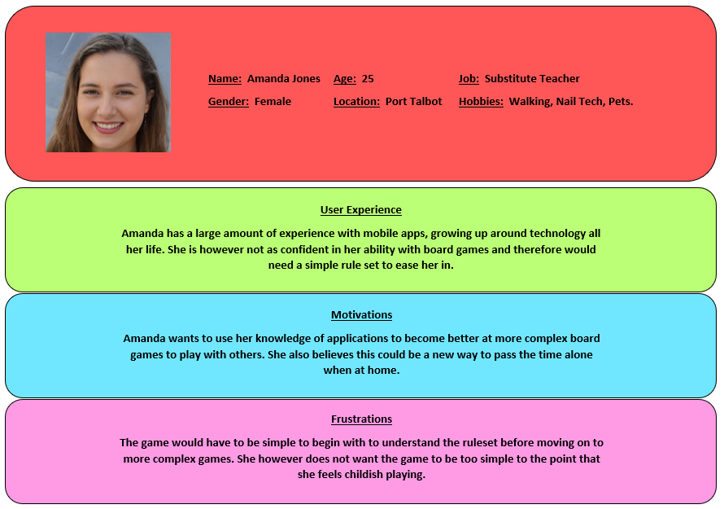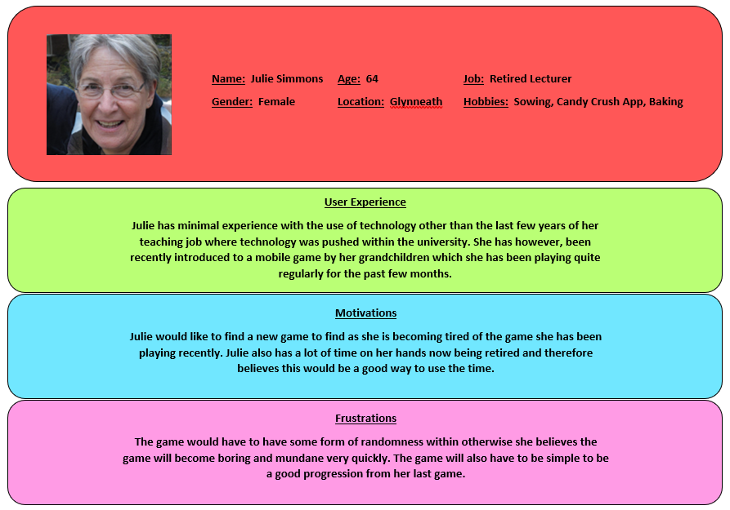
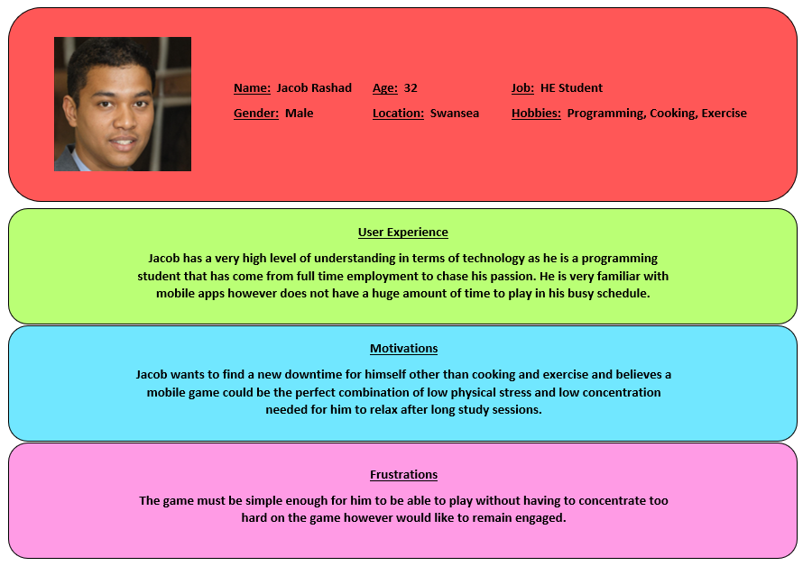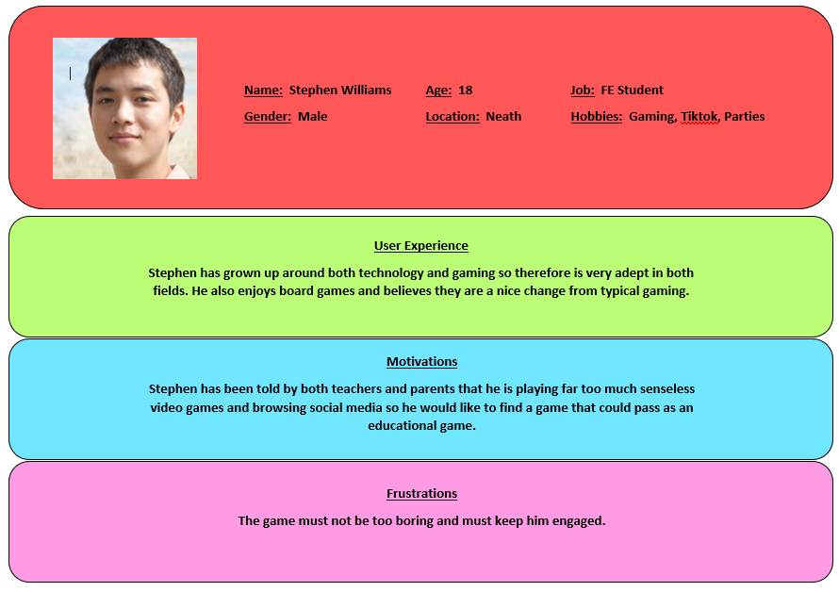
(See Appendix B)
In order to gather the information required for the personas, a focus group was carried out. During this focus group, the potential users were asked a series of questions in order to establish their previous experience with technology, games, and specifically the game ‘Cluedo’. Once their previous experience was established, their motivations and frustrations must then be found. The motivations consist of why they would like to play a new Cluedo application and what it would do for their personal life. Frustrations were then found which highlighted what the game must have or do for the user to enjoy.

Game Architecture
In order for the game to be a success, certain information is needed. This information is a sitemap in order to show each page of the application and how it links together. A flow chart which is necessary to visually show the process of the application. And finally, a hierarchical task analysis in order to show each step needed with their subgoals in order to achieve the overall goal.

Sitemap

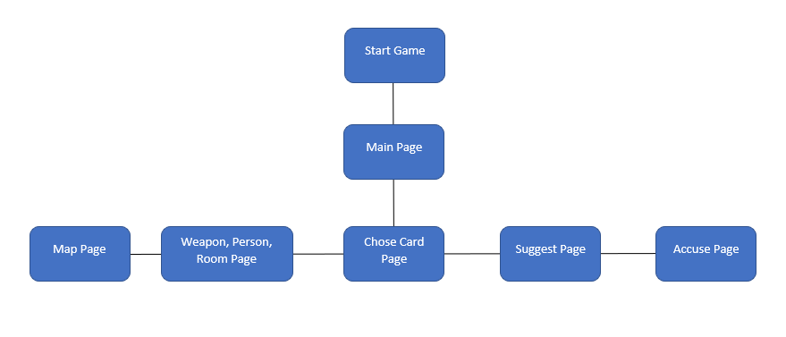

Flow Chart

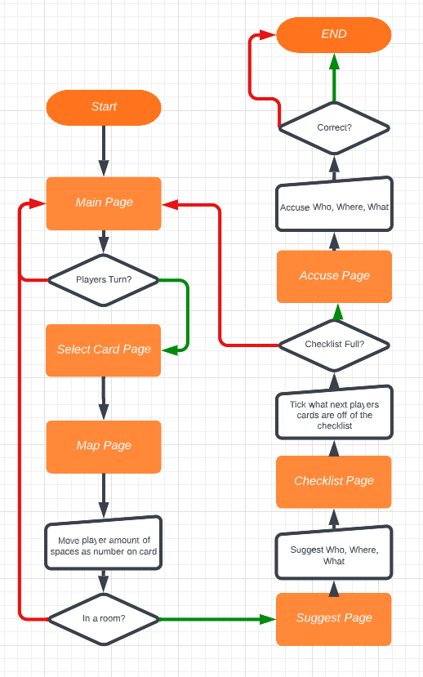

Task Analysis

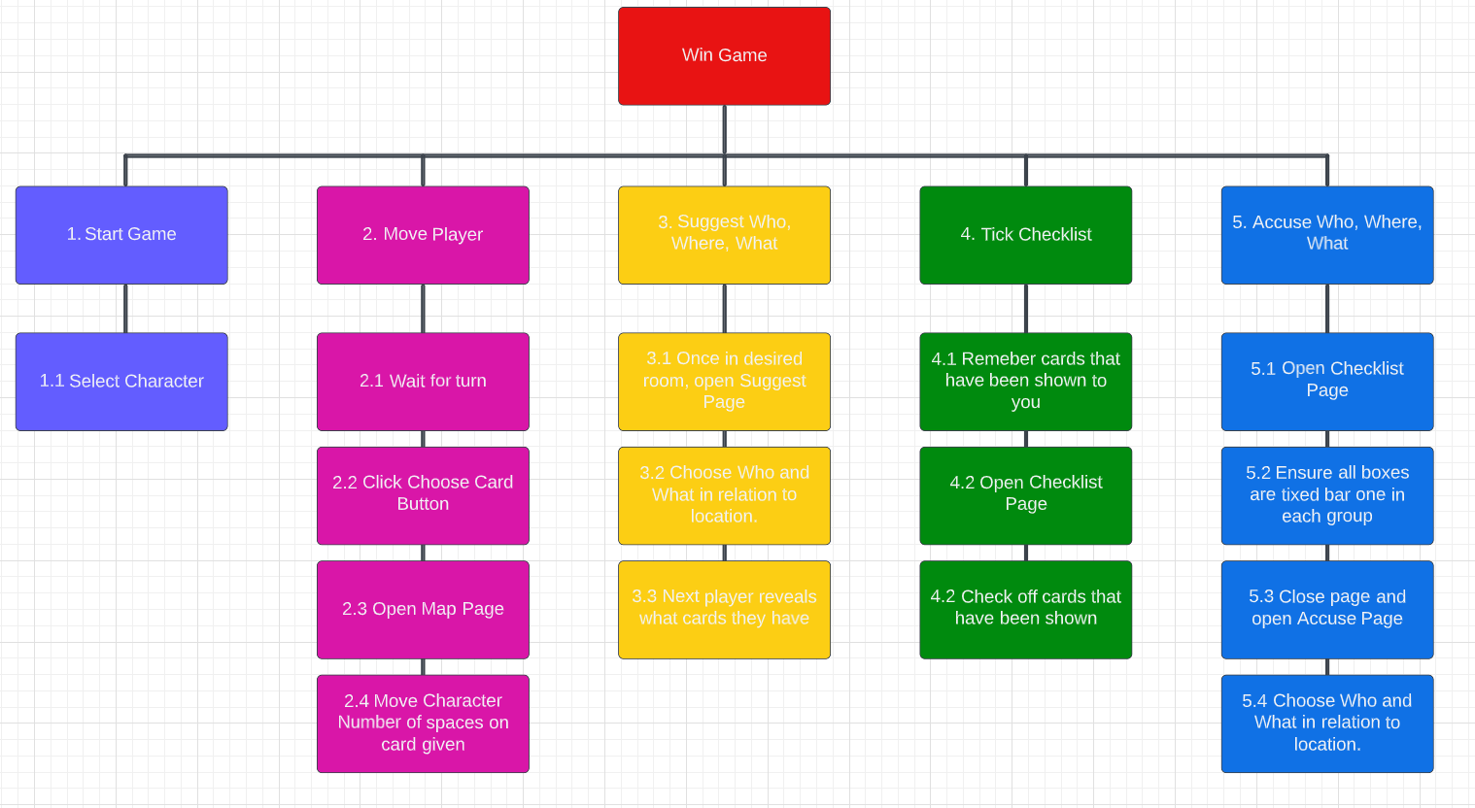

Storyboard Wireframes
Wireframes were created in order to give a prototype of the final game to ensure it meets the users wants and needs.

Start Page
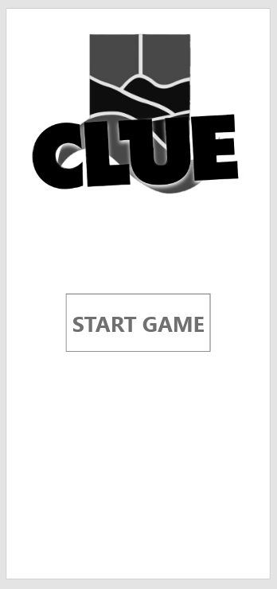
Button
Logo
The start page is the first page the user is greeted by and is a simple page to begin the game. Within it is the logo of the game along with the start button.

Main Page
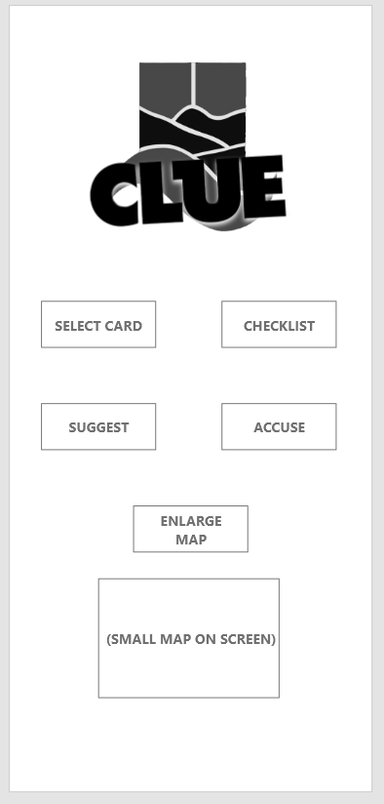
Small Map
Button(s)
Logo
Once the game has been commenced, the user will be met with the main page of the game. Within the page is the logo of the game along with five buttons and a small map to show the player where themselves and the other places are in the game. The first button will take you to the Choose Card Page. The second button takes the player to the Checklist Page. The third button takes the user to the Suggest Page. The fourth button takes the user to the Accuse Page. And the final fifth button takes the user to the Map Page.

Map Page
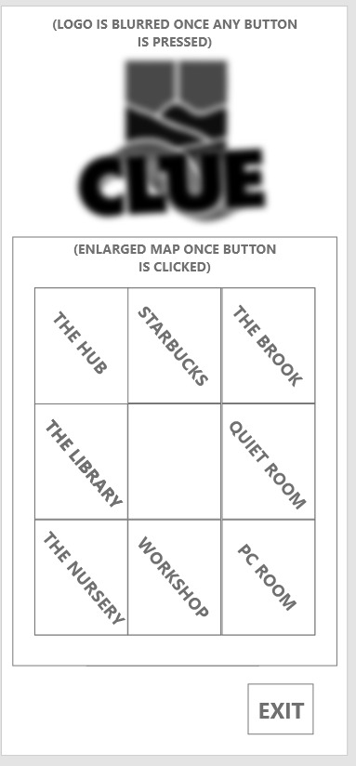
Exit Button
Enlarged Map
Logo (Blurred)
Once the map button is pressed, it will enlarge the map, blurring the background. The map has eight locations with a centre of the game where the players can move around as many times depending on what card they receive. The page also has an exit button to return to the main page.

Choose Card Page
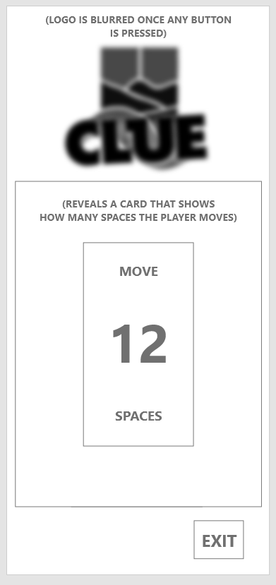
Card revealed to player.
Logo (Blurred)

Exit Button
One the select card button is pressed, a sub menu will appear blurring the background. The menu will reveal a card to the player which tells them how many spaces they are able to move their character. The menu also has an exit button to return to the main page.

Checklist Page
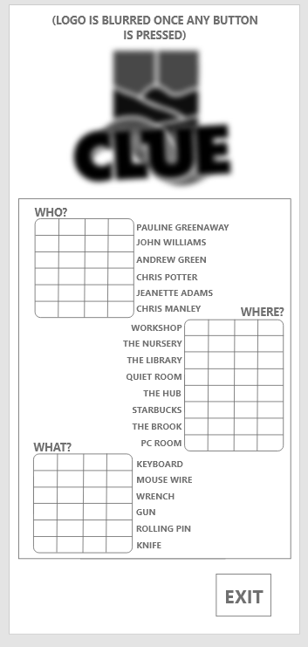
Checklist
Logo (Blurred)

Exit Button
Once the checklist button is selected, a sub menu will appear blurring the background. Within the submenu are three tables holding the players, locations, and murder weapons. The player can then check off the players, locations, and weapons that were not a part of the murder to then, by process of elimination, find out the killer. The page also has an exit button to return to the main page.

Suggest Page
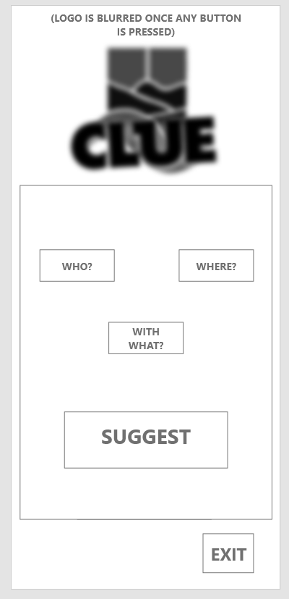
Button(s)
Logo (Blurred)

Exit Button
Once the suggest button is selected, a sub menu will appear blurring the background. Within the menu are four buttons, one to select the character you think it is, one to select where you think it was, and a button to select the murder weapon. The final button is to apply your suspicion. The next player will then reveal their cards if they are correct, and they can then be ticked from the checklist. The page also has an exit button to return to the main page.

Accuse Page
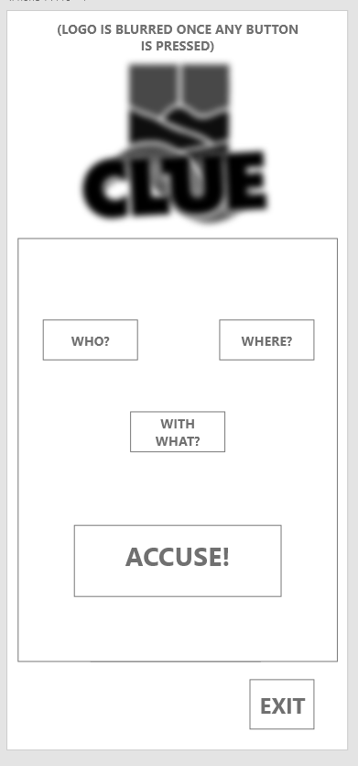
Button(s)
Logo (Blurred)

Exit Button
Once the accuse button is selected, a sub menu will appear blurring the background. Within the menu are four buttons, one to select the character you think it is, one to select where you think it was, and a button to select the murder weapon. The final button is to apply your accusation. This button should only be pressed when you are certain it is the right answer as getting the answer wrong will end the game. The page also has an exit button to return to the main page.

Following from Schneiderman’s 8 golden rules, the application was kept consistent along with ensuring it was easy to navigate with shortcuts to ensure the users satisfaction whilst using the application. The application is also very simple and clearly shows the users where they are within the application at all times, adhering to the design dialogue to yield closure rule. In addition to the simple nature of the application, this also benefits in terms of short term memory load as there are never more than five to six things on the screen at one time. The application also allows the user to reverse their actions with exit buttons or different selecting buttons.

Feedback
Feedback was then collected on the prototype in order to ensure the final iteration of the application will meet the users wants and needs. The method of testing was done through unmoderated walkthrough usability testing. This method allows the user to use the application in order to see if they are using it in the intended method, and to then gather the feedback from the participants. The feedback given through the testing was largely good with users saying they like the simple design of the application along with the easy and simple user interface. However, the feedback also indicated that the interface may be slightly too simple and therefore may become boring quickly. Although this is a prototype, the feedback from the users indicated that the current colour scheme (black and white) is too professional looking and gives the game a more boring feel. This was somewhat expected feedback as the goal was to create a game easy enough for anyone to play however this goal may have been overshot and taken too seriously, creating a game that is too simple.

References
- Eliacik E. Can decentralized mastodon replace Twitter as the common digital town square the world needs? [Internet]. Dataconomy. Dataconomy; 2022 [cited 2023Feb14]. Available from: https://dataconomy.com/2022/10/mastodon-social-media-twitter-alternative/
- Davies H. Twitter vs mastodon: Which social media site is better? [Internet]. Trusted Reviews. Trusted Reviews; 2022 [cited 2023Feb14]. Available from: https://www.trustedreviews.com/versus/twitter-vs-mastodon-4289276
- Griffin A. What is actually happening inside Elon Musk's twitter? [Internet]. The Independent. Independent Digital News and Media; 2022 [cited 2023Feb15]. Available from: https://www.independent.co.uk/tech/twitter-elon-musk-what-next-booed-b2244190.html
- Shepherd J. 22 essential twitter statistics you need to know in 2023 [Internet]. The Social Shepherd. The Social Shepherd; 2023 [cited 2023Feb15]. Available from: https://thesocialshepherd.com/blog/twitter-statistics#:~:text=18%2D24%20year%20olds%3A%2017.1,year%20olds%3A%2017.1%25%20of%20users
- Mastodon.social Traffic Analytics & Market Share | similarweb [Internet]. SimilarWeb. SimilarWeb; 2023 [cited 2023Feb20]. Available from: https://www.similarweb.com/website/mastodon.social/
- Sweney M. Twitter 'to lose 32M users in two years after Elon Musk takeover' [Internet]. The Guardian. Guardian News and Media; 2022 [cited 2023Feb20]. Available from: https://www.theguardian.com/technology/2022/dec/13/twitter-lose-users-elon-musk-takeover-hate-speech#:~:text=More%20than%2030%20million%20users,takeover%2C%20according%20to%20a%20forecast.
- Fung B. As twitter backlash grows, rival Mastodon reaches 2.5 million monthly users | CNN business [Internet]. CNN. Cable News Network; 2022 [cited 2023Feb20]. Available from: https://edition.cnn.com/2022/12/20/tech/mastodon-twitter-usage/index.html
- Syme P. I spent a week on Mastodon, the social media platform some are turning to as they abandon Elon Musk's Twitter. this is what it was like. [Internet]. Business Insider. Business Insider; 2022 [cited 2023Feb20]. Available from: https://www.businessinsider.com/what-it-is-like-to-use-mastodon-twitter-social-media-2022-11?r=US&IR=T#mastodon-was-designed-for-a-specific-audience-i-dont-think-it-works-for-me-8
- Mcleod S. Cognitive approach in psychology [Internet]. Simply Psychology. Simply Psychology; 2023 [cited 2023Feb25]. Available from: https://simplypsychology.org/cognitive.html
- George A. What is mastodon? this buzzy twitter alternative, explained [Internet]. Digital Trends. Digital Trends; 2022 [cited 2023Mar1]. Available from: https://www.digitaltrends.com/social-media/what-is-mastodon/#:~:text=While%20the%20user%20interface%20has,that%20all%20instances%20adhere%20to.
- Dix A, Lauesen S. Chapter 7. In: Human-Computer Interaction third edition. Third. Harlow, England: Prentice Hall; 2007. p. 260–73.
- Wong E. Shneiderman's eight golden rules will help you design better interfaces [Internet]. The Interaction Design Foundation. Interaction Design Foundation; 2021 [cited 2023Mar9]. Available from: https://www.interaction-design.org/literature/article/shneiderman-s-eight-golden-rules-will-help-you-design-better-interfaces
- Shepherd J. 22 essential twitter statistics you need to know in 2023 [Internet]. The Social Shepherd. The Social Shepherd; 2023 [cited 2023Mar9]. Available from: https://thesocialshepherd.com/blog/twitter-statistics

Appendix A. Twitter Error Message

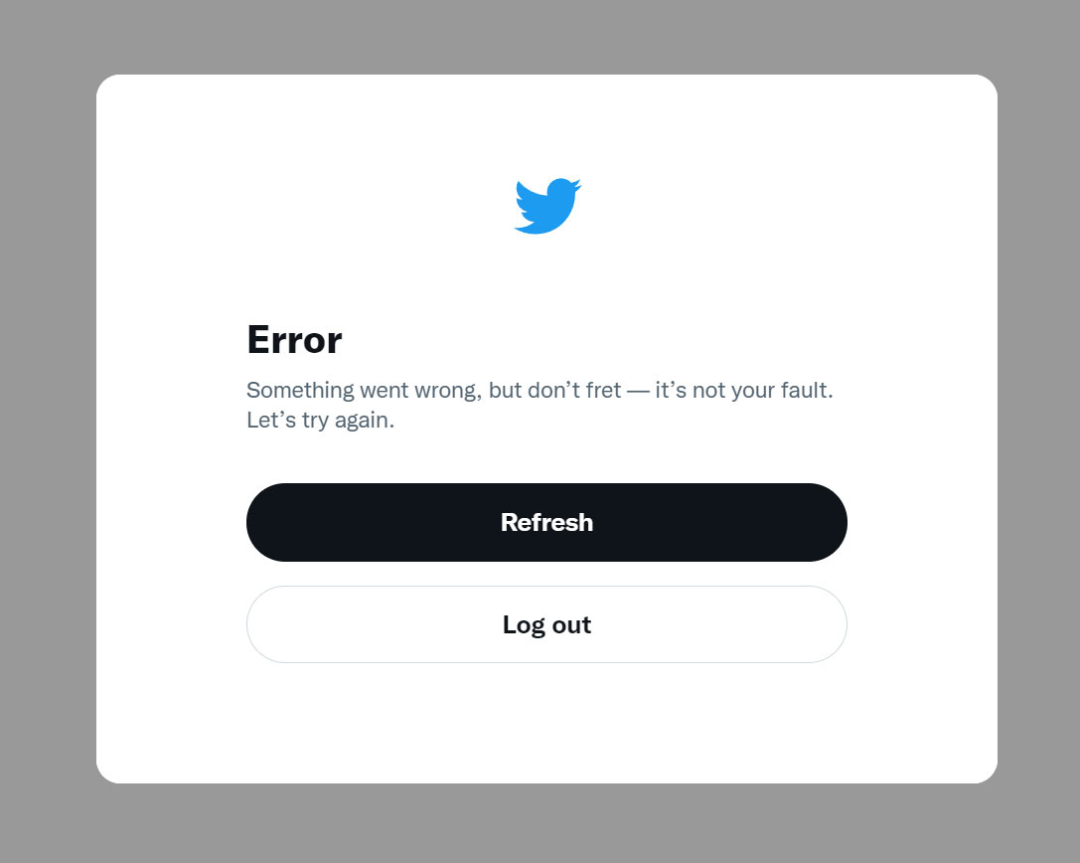

Appendix B. User Personas

