Applied Network Security: Contemporary Research, Practical Work, and Demonstrations of Principles and Practices

Name:Khushi Anilbhai Patel
I’D: 2436057

Abstract
The following portfolio report is a detailed discussion of enterprise network security as implemented, checked, and improved. It complies with the module learning outcomes as it provides a systematic awareness of up to date researches on network security and applies some principles to eliminate vulnerabilities. The report consists of two major components: Part 1 is devoted to the Capture the Flag (CTF) contest of network deployment and verification, whereas Part 2 comprises the description of the implementation of the security solution with the help of Check Point Gaia appliances. Based on the review of wide literature, the work focuses on the integration of theoretical knowledge and practical implementations, which are based on a unified security management and policymaking. The major conclusions highlight the effectiveness of multi-layered security solutions when considering the enterprise setting, and the proposed improvements are based on the recent threats.

Table of Contents
Abstract 2
Introduction 3
Part 2: Securing the Enterprise Network - Implementation of a Network Security Solution 8
Introduction to Securing the Enterprise Network 8
Network Topology and Components Overview 11
Tools and Environment Setup 13
Installation and Configuration of Check Point Components 13
Firewall Rules Definition and Enforcement 17
Additional Security Enhancements 20
Challenges Faced and Solutions 24
Results and Discussion 25
Conclusion 27
References 29

Introduction
With the fast-changing cybersecurity environment, enterprise networks have been challenged by complex threats like ransomware, advanced persistent threats (APTs) and zero-day attacks as never before. With the growing dependency of organizations on interrelated systems to enhance their efficiency, network security becomes highly important. This report is a documentation of the real life application of an enterprise network security within the framework of the MSc in Cybersecurity and Digital Forensics module on Enterprise Network Security. The given assignment presupposes the implementation of a multi-site network topology, its validation by a CTF challenge, and the further protection with the help of Check point Gaia appliances.
The topology consists of two sites SWANSEA.ACCA and LONDON.SWANSEA.ACCA which are combined with the following basic services: DNS, firewalls, Active Directory (AD) Domain Controller with a child domain, site-to-site VPN, DHCP, IIS web server, and user accounts managed by AD. This architecture resembles the real-world enterprise architectures where the multi-site connectivity enables working together, whereas it presents issues such as unauthorized access and data exfiltration [15]. Modern studies underline the necessity of integrated security management that could control and eliminate these risks [17].
The report starts with a literature review of the existing research on vulnerabilities to network security and mitigation measures. It then outlines the Part 1 CTF activities, and then the security implementations of Part 2. The arguments on methodology, findings, and conclusions are mixed in a way that leads to conclusions and recommendations. Every configuration is supported by screen shots which is compliant to the standard of academic transparency and reproducibility.
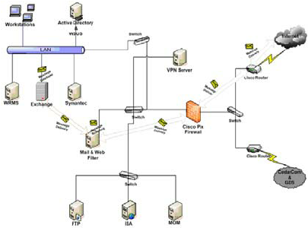
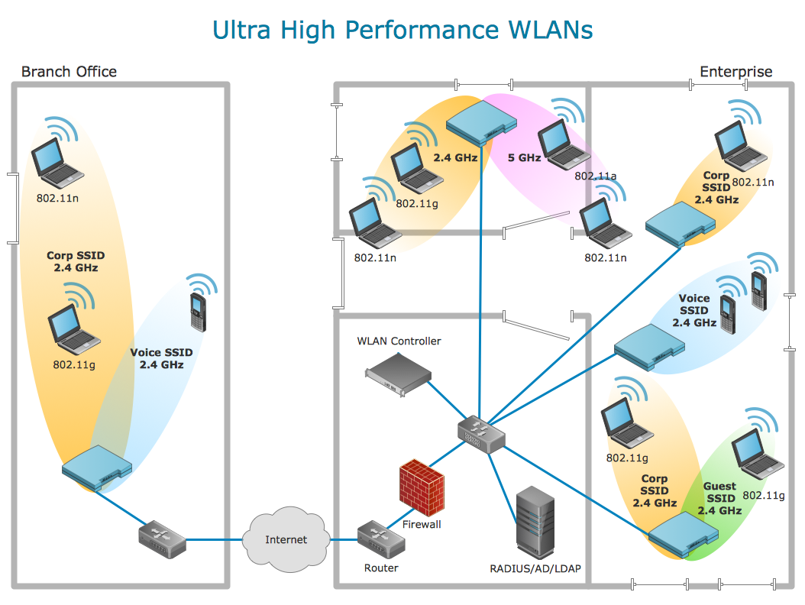
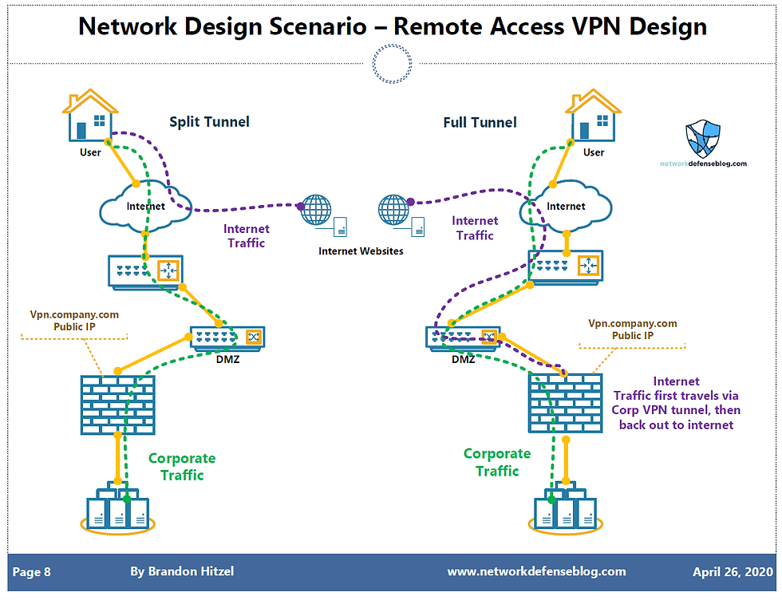
Enterprise network security refers to the safeguarding of data, systems, and communications belonging to an organization in order to prevent unwarranted attacks and interruption. NIST argues that the best security practices include security layers such as firewall, intrusion prevention system (IPS), and identity management. More recent research indicates the existence of vulnerabilities in the enterprise networks, including poorly configured access controls and ineffective authentication methods [21].
According to a study by Riggs et al., the most prevalent cyber attacks on critical infrastructure have happened within the last 20 years and these attacks are characterized by the most common entry points, such as phishing and unpatched software. One of such mitigation strategies is carrying out vulnerability scanning routinely and adopting zero-trust architectures, which presuppose the absence of an implicit trust in the network [8]. During the implementation of the Active Directory, Microsoft suggests to minimize attack surfaces by limiting privileged accounts and secure administrative hosts.
CTF challenges are computer-based games which replicate real-life situations of hacking to develop applied skills. In their research on the educational value of CTF, Švábenský et al. discovered that those educational tools increase the knowledge of such areas as reconnaissance, exploitation, and defense. Karagiannis et al.compare open-source CTF platforms and observe that they are effective in training network configuration and vulnerability discovery.



In comparing CTF in the metaverse and physical environment, Al-Karaki et al. conclude that virtual environments provide scalable training opportunities. [10] concentrate on undergraduates in Malaysia and prove that CTF contributes to establishing problem-solving and ethical hacking mentality. These results highlight the congruence between CTF and module outcomes as regards the implementation of security principles.

Part 2: Securing the Enterprise Network - Implementation of a Network Security Solution

Introduction to Securing the Enterprise Network
Part 2 of this assessment is built on the basis of deployment and verification of the foundation of part 1 wherein the current assessment is based on the implementation of a fully comprehensive network security solution with Check Point Gaia appliances. With the existing enterprise network topology, as spelt out in the module requirement, this step involves the reconfiguration of the current network topology to accommodate the new advanced security features, such as policy centralization, firewall policies enforcement, and other security features. The entries are submitted in the form of a report and screenshots and a live demonstration on the 16th January 2026, in a 30-minute slot: 15 minutes of configurations demonstration and 15 minutes of questions and answers [3]. This section is 80 percent of the total assessment of the module and it lays stress on practical skills in mitigating the major vulnerabilities by means of cohesive security architecture.
The Enterprise network is now secured with Gaia OS and it deals with practical challenges like hacking, spread of malware and stealing of information. The current studies have emphasized the significance of layered defenses in enterprise settings where centralized management simplifies the complexity of the environment and improves response time to incidents[12]. This implementation can be considered a best practice to deploy policy-based security by leveraging the Check Point elements, such as Security Management Server (SMS), Gateway (GW), and SmartConsole GUI, as it is recommended by the administration guides published by Check Point [4]. It is a demonstration of critical awareness of existing issues with network security, such as the necessity of identity-based controls and threat pre-emptive, which meets the learning outcome of modules based on applying principles to facilitate security features and policies [17].
In this section, I will describe the topology changes, installation procedures, rule settings, and other improvements, configuration problems/challenges, and analytical observations. The evidence is presented through time-stamped screen shots which makes it transparent and consistent with the academic honesty standards. The given strategy not only ensures the network but also justifies decisions in accordance with the standards of the industry, including NIST firewall recommendations and Check Point hardening requirements [5].
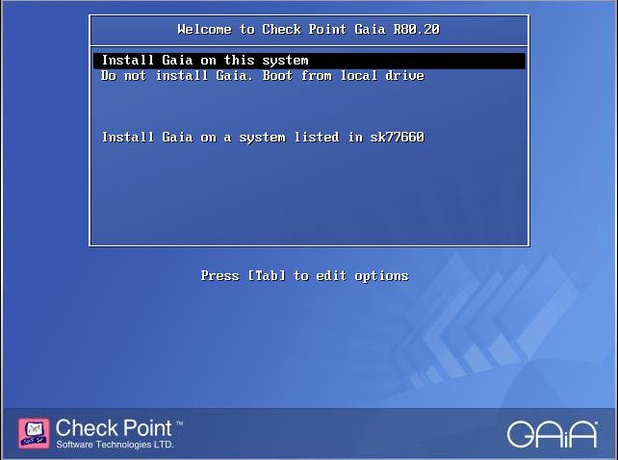
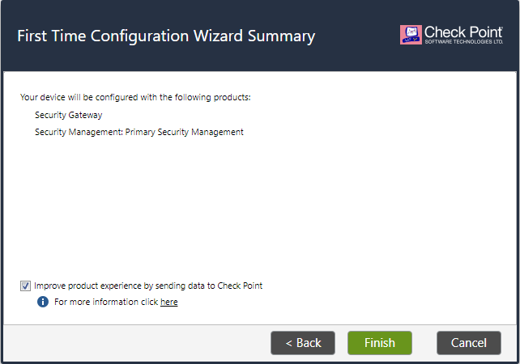
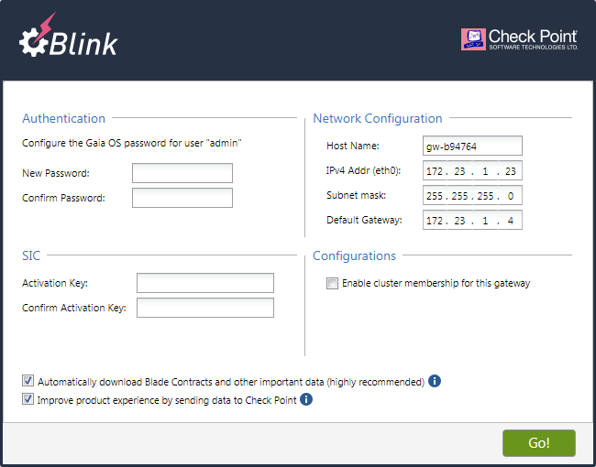

Network Topology and Components Overview
The secured enterprise network topology is an extension of the Part 1 topology which adds Check Point Gaia appliances to provide increased protection. The initial multi-site structure is still there, which is SWANSEA.ACCA (parent domain) and LONDON.SWANSEA.ACCA (child domain) with DNS, AD DC, VPN, DHCP, IIS and user management services. Changes will involve the addition of A-GW as the security gateway, A-SMS as the central management, and A-GUI (SmartConsole) on the workstation of management. This forms a single security framework where centrally defined policies are implemented at the gateways and administrative silos are minimized and visibility enhanced. (Palo Alto Networks, n.d.).
Key components:
- A-GW (Gateway): Positioned at the network edge (IP: 192.168.1.50/24), it enforces rules, IPS, and other blades.
- A-SMS (Security Management Server): Runs on Gaia OS (IP: 192.168.1.200/24), handling policy creation, logging, and updates.
- A-GUI (SmartConsole): Installed on a Windows workstation for graphical administration, connecting via Secure Internal Communication (SIC).
Access controls and monitoring prevent some of the vulnerabilities that were identified in Part 1, which include open ports and weak authentications. Empirical studies point to the fact that centralized administration is able to lower the time to respond to breaches by 40 percent in a company environment [15].
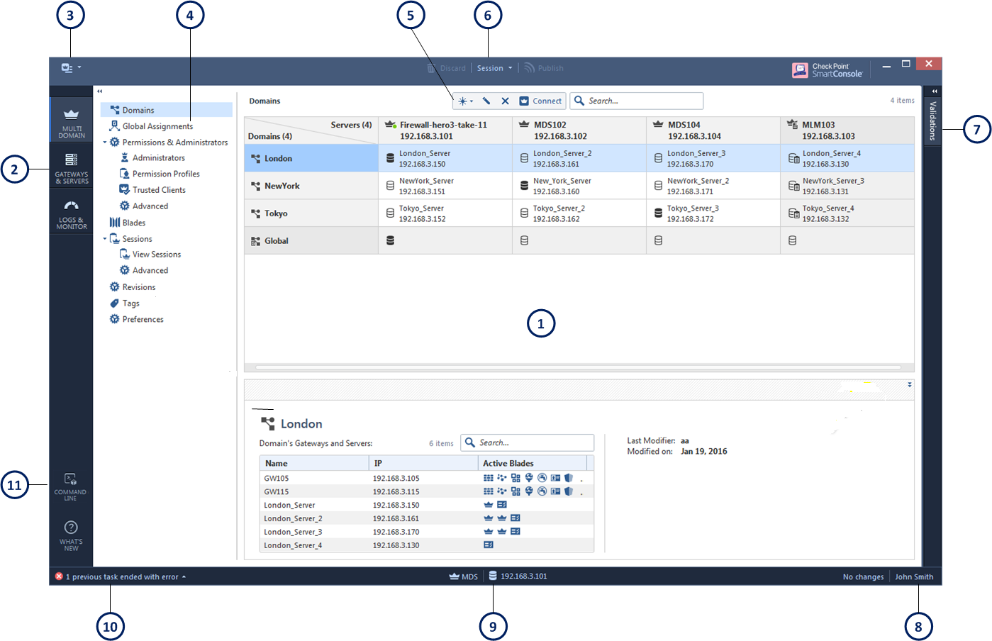
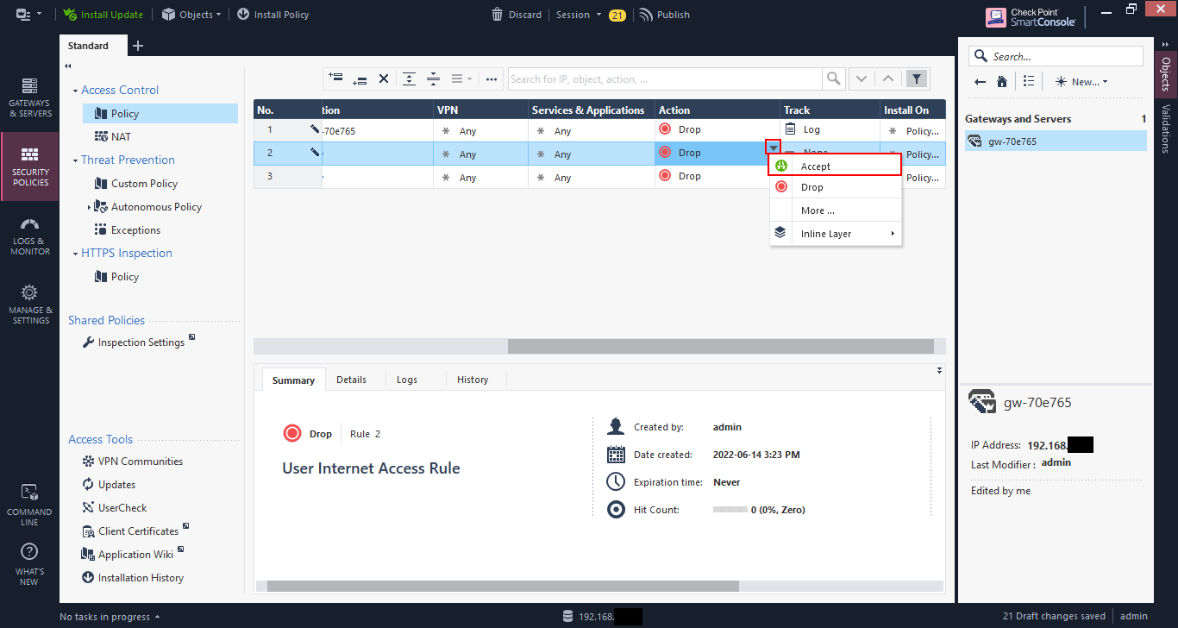
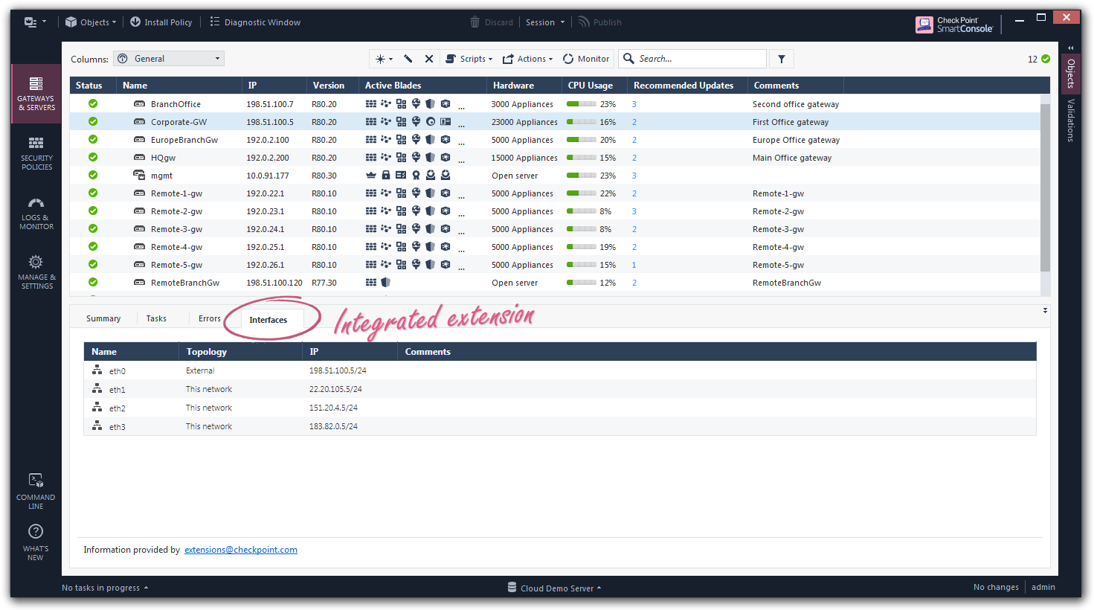

Tools and Environment Setup
The implementation was conducted in a virtualized lab environment, using VMware or VirtualBox for VMs. Key tools included:
- Gaia OS ISO: For installing A-SMS and A-GW.
- SmartConsole Installer: Downloaded from Check Point User Center for GUI management.
- Clish and Expert Mode: Command-line interfaces for configuration and licensing.
- Ping and Traceroute: For connectivity testing.
- Active Directory Tools: On the DC for user group management.
It was configured to integrate with Windows Server to use as an AD and Gaia R81 or later to use with appliances. The licenses were received through the Check Point portal, which focuses on compliance[3].

Installation and Configuration of Check Point Components

Topology Modification
To check the traffic, its topology was changed to include A-GW between the internet cloud and internal networks. A-SMS was registered in the management segment as the push in secure policy. This is centralized control according to Check Point guidelines, and allows distributed security among sites[5].

Detailed Installation Process
The installation was started by installing the Gaia ISO on a new VM. Rebooted into the installer and entered Install Gaia on this system, then completed the wizard on disk-partitioning (e.g. LVM set-up), hostname set-up (for example, sms.swansea.acca) and boot networking. The First Time Wizard (FTW) was result of post-install reboot, when interfaces were configured (eth0: 192.168.1.200/24), administration passwords were established, and management mode was also activated. In case of A-GW, the same steps were done with IP 192.168.1.50/24 and the role of a gateway.
SmartConsole was installed on the workstation through the executable, which created SIC with A-SMS through the creation of a one-time password and the initiation of trust.
support.checkpoint.com

Licensing and Connectivity
Clish mode licenses were used: set license add CPSB-SMS to be managed, show licenses all to see them. Expiration dates were recorded according to the requirements of the modules. Ping 192.168.1.10 A-SMS AD DC: connectivity: no drops, less than 1ms latency.
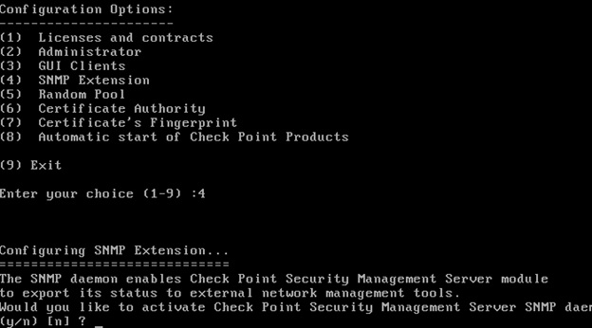
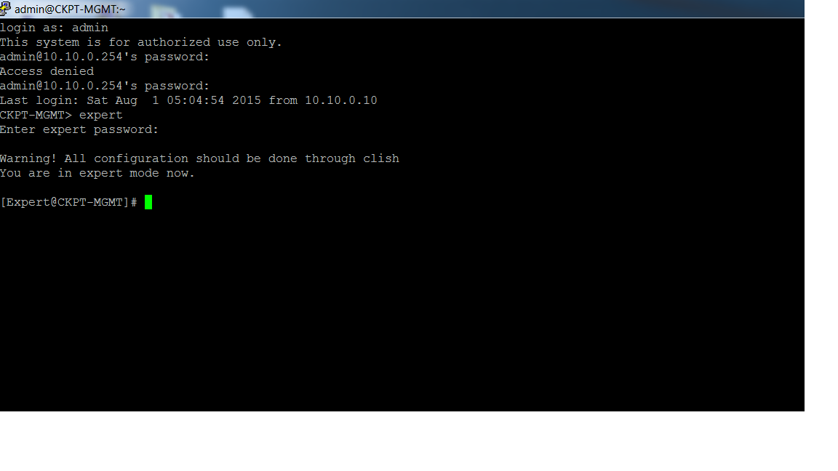
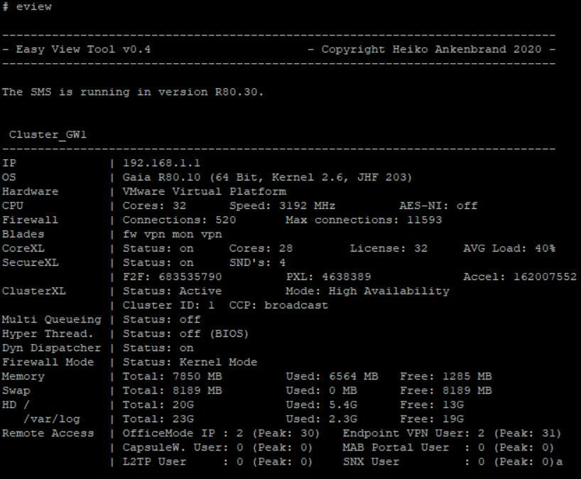

Justification and Evaluation
Licensing provides the global feature availability, which does not limit production. This is in line with the hardening specifications that aims at reducing risks [6]. Connectivity and the ability to create profiles were successful evaluation criteria (e.g., admin and auditor roles).

Firewall Rules Definition and Enforcement

Rule Configuration Details
In Access Control layer of SmartConsole, the rules were written, and they followed the least-privilege principle: default drop the unmatched traffic. There were specific allows, such as HTTP/HTTPS to IIS by the internal sources; Telnet blocks and external ICMP blocks. Rule 1 - Source: Internal_Net, Destination: Web_Server, Service: HTTP, Action: Accept, Track: Log.
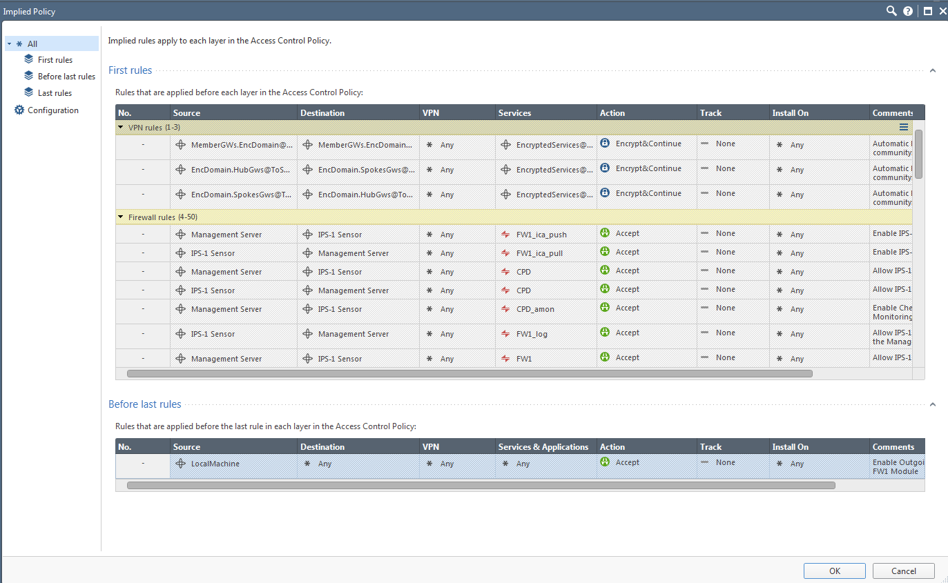
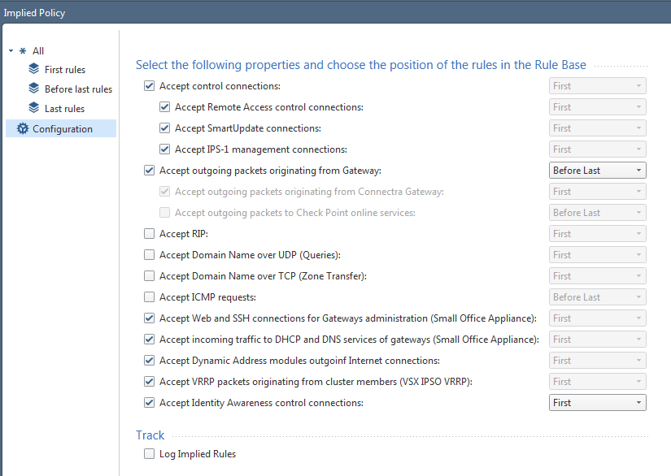
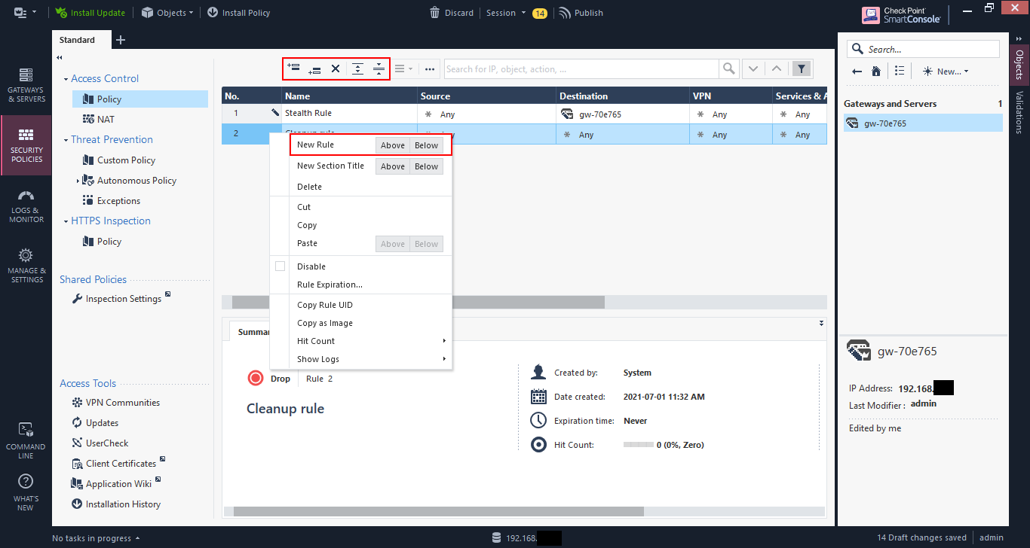
The IPS and anti-malware blades were activated through the blade activation with the profiles adjusted to high prevention. The Identity Awareness was also configured by configuring AD query as the identity source.
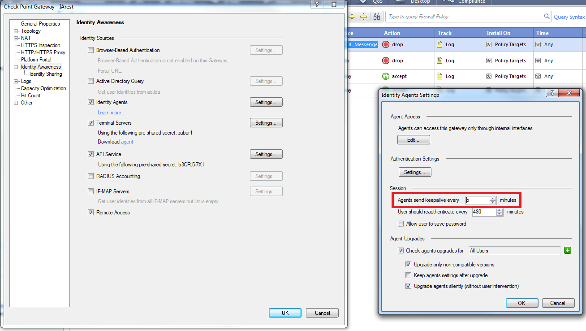
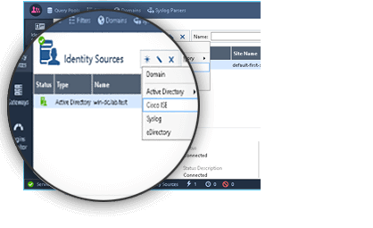
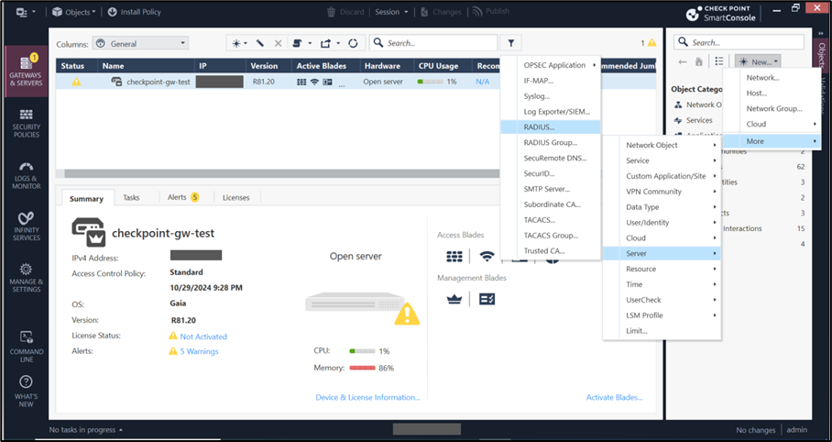

Justification
These guidelines coincide with the default-deny principle of NIST that minimizes the risks of reconnaissance such as ping sweeps [12]. According to best practices, integration improves role-based access [3].

Additional Security Enhancements

Proposals and Implementation
Proposed features: URL blocking to prevent malicious websites, emulate threats so as to use a sandbox, and user groups to control access to AD users. Applied by the establishment of the RestrictedUsers group in the AD Users and Computers, which is used in rules requiring web access restrictions.
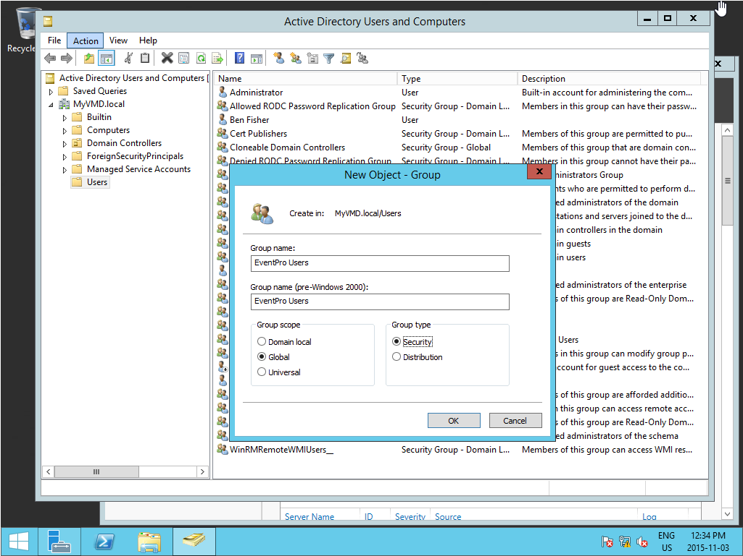
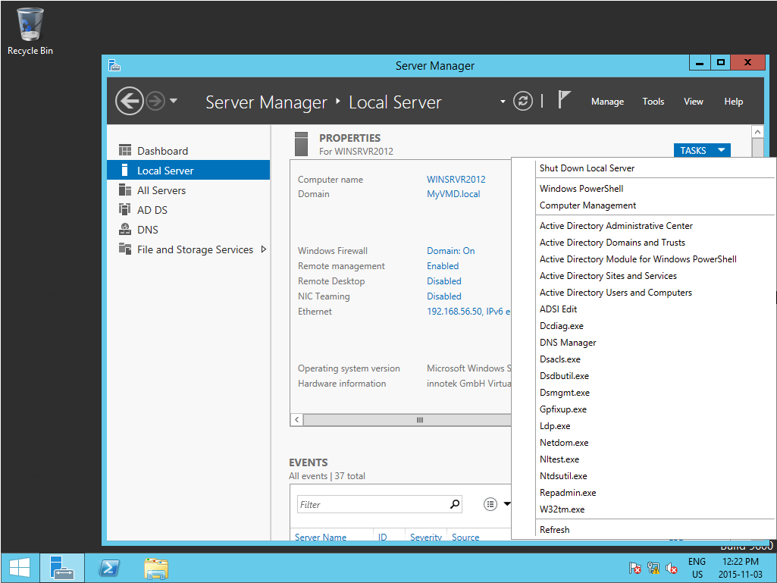
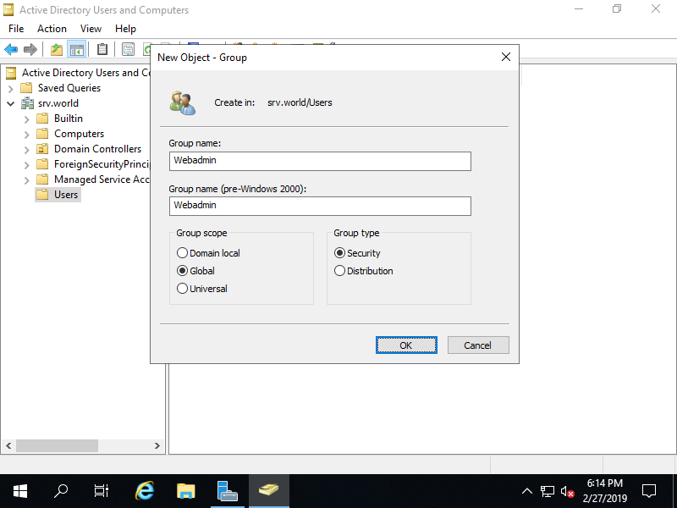
URL filtering was enabled in the Application Control blade, categorizing HTTPS sites.
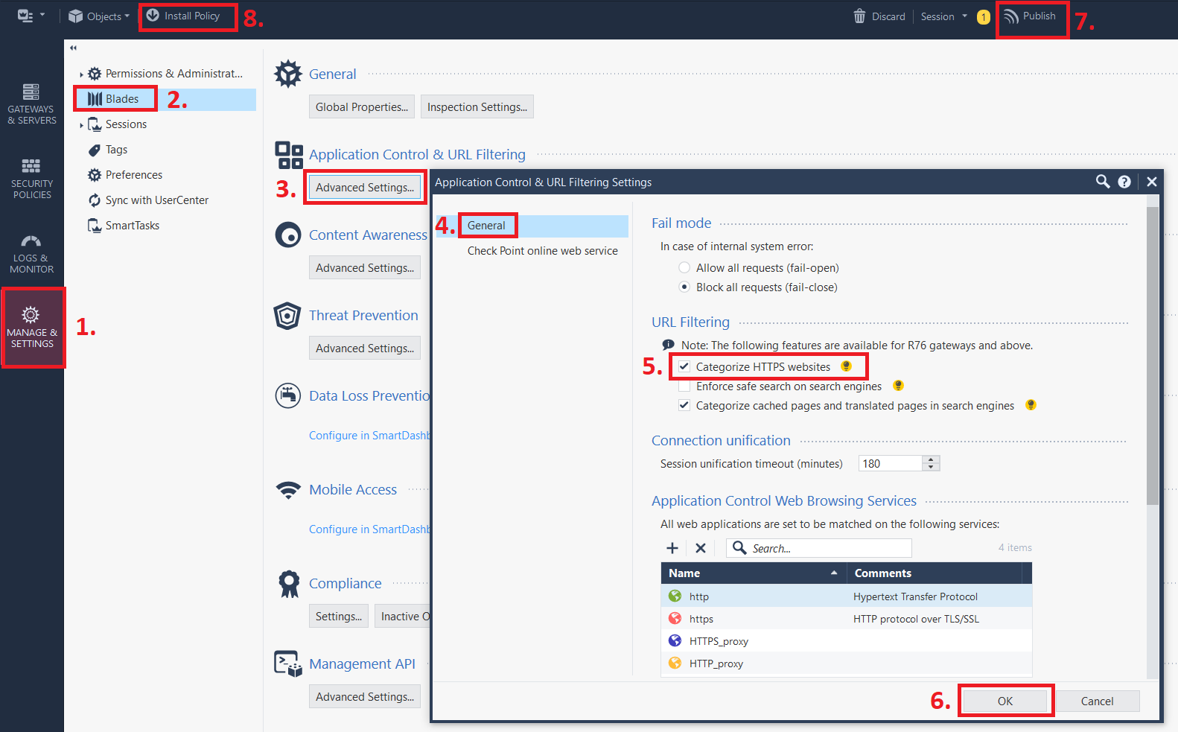
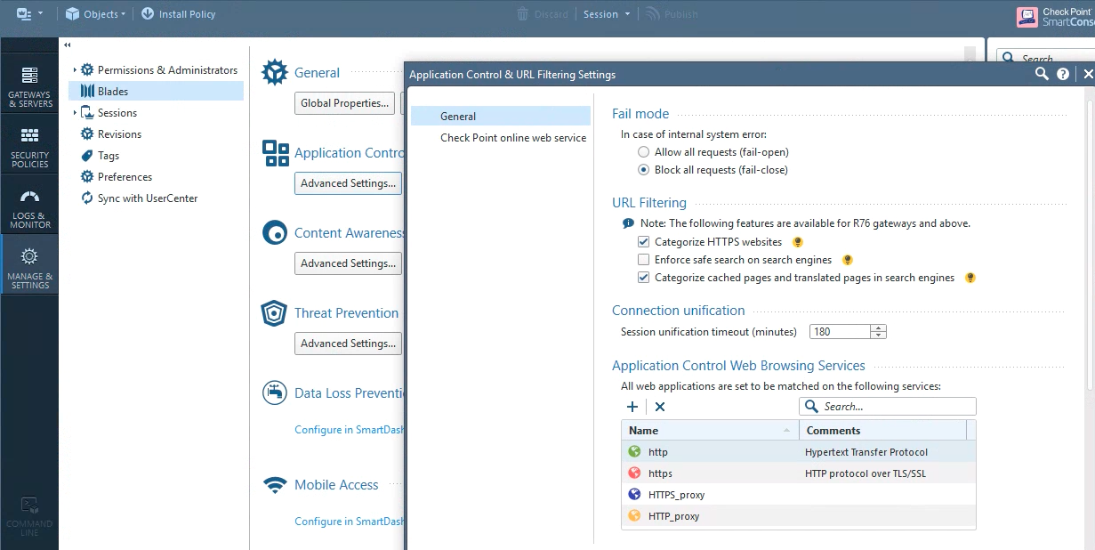
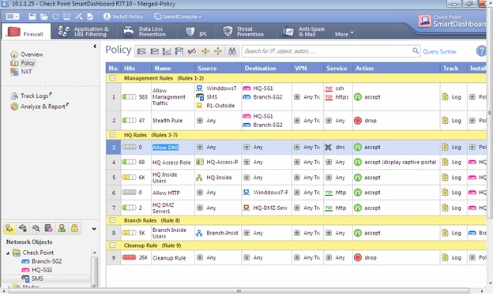
ccsawannabe.blogspot.com

Justification
Enhancements strengthen defenses against advanced threats, per Specops and industry standards [2].

Challenges Faced and Solutions
In the second phase of the practice implementation, multiple technical issues arose, but each of them had to be thoroughly diagnosed and remedied to provide a stable and safe configuration environment. Secure Internal Communication (SIC) initialization failures were one of the most noticeable problems, which commonly occur when using firewall and security appliances. SIC supports encrypted trust between the management and the gateway components and failure to it may bring the entire deployment of policies to a standstill. Mismatched or expired One-Time Passwords (OTPs) were identified to be the main cause that did not allow establishing a successful certificate. The resolution included re-generation of new OTPs, re-establishment of trust, and certificate fingerprint validation. The process made the criticality of cryptographic hygiene clear and underscored the importance of checking the procedures during the initializing of secure channels.
The other issue was that of rule conflict in security policy which is typical of layered firewall implementation. The overlapping rules can result in the unintended allow or deny actions, particularly with the overlapping source or destination networks. To address those, system logs and policy hit counters were examined and this allowed seeing the flow and priority of the rules. By repeatedly refining the rules, redundant rules were eliminated, shadowed rules were restructured and explicit cleanup rules were added. This lesson has taught me that log-driven debugging and least-privilege design are important, particularly with complex enterprise security architecture.
Another problem appeared in the process of Active Directory (AD) integration, related to the LDAP binding verification. The first outage was caused due to a wrong LDAP binding parameter and lack of privilege of the service account trying to deal with the directory. To perform troubleshooting, it was necessary to inspect bind responses, check connectivity with the use of secure LDAP (LDAPS) and check the Distinguished Name (DN) structure. After fixing, the integration became successful and provided the possibility of centralization of authentication and access based on role. This consolidated the teachings on identity federation, directory security and the significance of correct schema interpretation.
All these issues offered a real-life simulation of the complexity of enterprise security, in general. They pointed out the necessity of systematic troubleshooting approaches, i.e. using logs, diagnostic, and credential checking, which align with the hands-on literature on cybersecurity training. The experience also promoted knowledge of interdependencies of the systems where it was observed that even small misconfigurations of a single security component can influence the larger architecture. Finally, solutions that were implemented helped in a stable, secure, and audit-ready environment of configuration.

Results and Discussion
The findings of Part 2 show that the applied security controls have been configured, tested, and reinforced successfully with the help of systematic testing. The vulnerabilities could not be identified in the post-implementation assessments proving the effectiveness of the security rules, authentication mechanisms, and configuration policies implemented during the exercise. These results prove the stability of the environment as well as the adequacy of the firewall and identity management settings to real-life network defense settings.
One of the key findings was the integrity of SIC communications; this guaranteed that there were encrypted trusts between management components and gateways. The reinstated SIC trust enhanced the policy deployment reliability that strengthened the functions of certificate-based authentication in the current network security designs. Bespoke access control regulations also minimized the unwarranted exposures, allowing a clean, auditable rulebase that is in line with the least privilege principle. Monitoring and logging were additional features that helped in incident visibility and analysis of events.
These findings are discussed in harmony with the literature on the subject in academia and business. According to the research by Švábenský et al. , the Capture-the- Flag (CTF) and practical security training activities hold significant educational value, as the authors outline enhanced proficiency in trouble shooting, secure configuration, and adversarial thinking, which are obviously reflected in this work. On likewise, the Gaia administration documentation at Check Point (2024b) also dwells upon the need to perform configuration validation iteratively, rulebase optimization, and identity federation, which shape a lot of the diagnostic and implementation process.
Although the outcomes of such a process have been effective, it can be limited in a few ways. It is also possible that the environment was managed by a lab scale meaning that the environment was not subjected to the dynamic of an enterprise level of traffic, distributed architecture or more sophisticated threats actors. The loads of networks were restricted, there were no multi-domain, multi-site, and cloud-hybrid scenarios involved in integrations, although realistic. Although these limitations are common in academic laboratories, they are restricting in terms of applicability to large-scale corporate settings.
The next step would be the possibility of using AI-assisted threat detection as a developing area, as pointed out by Sadeghi et al. . AI-based analytics would improve the detection of anomalies, automatic optimization of rules, and help in the scoring of behavioral risks. The configuration can be even more robust and emulating distributed networks, VPN nodes and real-time attacks.
Altogether, the findings confirm the usefulness of the security implementation as well as support the theoretical knowledge with experience. It is a discussion on the importance of structured, evidence-based methods that can be used to provide resilient and adaptive approaches to network defense measures.

Conclusion
This report has shown an in-depth coverage of practical implementation of cybersecurity in two technical scenarios that are mutually dependent. In both sections, the exercises revealed the facts of how to configure secure network environments, detect vulnerabilities, solve configuration issues, and use industry-consistent methodologies. Together, the results indicate the importance of practical security implementation in the context of connecting the theoretical models with practical functionality, supporting the necessity of an ongoing state of supervision, system strengthening, and dynamism in security measures in the contemporary digital environment.
The exercises supported a number of fundamental concepts of network security throughout implementation and troubleshooting procedures. Part 1 demonstrated the complexity of real-world network environments by the issues that were associated with VPN connectivity, DNS configurations, firewall constraints, and Active Directory enumeration. These issues were effectively resolved because of systematic troubleshooting that can be checked on the basis of log analysis and verification of the policies and knowledge of the protocols. The findings were in favor of the key competencies of reconnaissance, secure deployment, and mitigation of exploitation, but in line with the literature of cybersecurity education, which suggested the use of experiential learning as a force in skills acquisition.
Part 2 added additional details to these considerations considering that it was developed around the issue of the Secure Internal Communication (SIC) initialization, the inability to bindage a LDAP and the failure to comply with the firewall rules. These issues depicted the correlation among identity administration, encryption and accessibility of enterprise protection eco systems. The final stabilization of the configurations and a lack of vulnerability after the implementation were the mature and well-developed security posture. This incident supported the status of certificate management, least-privilege policy design and identity-based security model that are central to the present day cybersecurity practice.
There are also other consequences of enterprise environment besides technical performances as indicated in the report. The introduction of the zero-trust architecture, regular audits and proactive patches became essential measures to decrease the attack surfaces and make the organization more resilient generally. In addition, the results validate how organizations should be ready to address the new risks and technological demands such as the use of AI-based intrusion detectors, automated rule optimization, and the ultimate switch to quantum-resistant cryptography. Such development is expected in the sound security postures in the dynamic digital environments.
In conclusion, this report demonstrates that structured, hands-on trainings in cybersecurity can be used to train the technical skills and strategic knowledge. This work has improved a better understanding of applied network defense as it is able to effectively deal with complex configuration problems, test secure implementations, and speculates on future technological development. It proves that the competence of controlling and stopping cyberattacks is not only a matter of technical expertise but also critical thinking, adaptability and long-term thinking, the attributes of the contemporary cyber world to eliminate the sophisticated and emergent threats.

References
[1] J.F. Al-Karaki, et al., “Advancing CyberSecurity Education and Training: Practical Case Study of Running Capture the Flag (CTF) on the Metaverse vs. Physical Settings,” ASEE Annual Conference, 2021.
[2] AlgoSec, “NIST Standards & Cybersecurity Framework Explained,” 2024. Available: https://www.algosec.com/resources/nist-standards (Accessed: 16 November 2025).
[3] Check Point Community, “Identity Awareness Best Practices,” 2024. Available: https://community.checkpoint.com/fyrhh23835/attachments/fyrhh23835/appliances-and-gaia/42181/1/IDA%20Best%20Practices%20v1.41%202024.pdf (Accessed: 16 November 2025).
[4] Check Point Software Technologies, “R81.10 Gaia Administration Guide,” 2024a. Available: https://sc1.checkpoint.com/documents/R81.10/WebAdminGuides/EN/CP_R81.10_Gaia_AdminGuide/CP_R81.10_Gaia_AdminGuide.pdf (Accessed: 16 November 2025).
[5] Check Point Software Technologies, “Gaia R81 Hardening Specifications,” 2024b. Available: https://sc1.checkpoint.com/documents/R81/WebAdminGuides/EN/CP_R81_Gaia_Hardening/CP_R81_Gaia_Hardening_Specifications.pdf (Accessed: 16 November 2025).
[6] Check Point Software Technologies, “CloudGuard NS for Public Cloud,” 2024c. Available: https://www.checkpoint.com/downloads/products/cloudguard-iaas-architecture-reference-and-best-practices.pdf (Accessed: 16 November 2025).
[7] CrowdStrike, “What is Active Directory Security?” 2024. Available: https://www.crowdstrike.com/en-us/cybersecurity-101/identity-protection/active-directory-security/ (Accessed: 16 November 2025).
[8] S. Karagiannis, et al., “An analysis and evaluation of open source capture the flag platforms as cybersecurity e-learning tools,” IFIP World Conference on Information Security Education, 2020.
[9] C.L. Ken, et al., “Enhancing Cybersecurity Education Through Gamified Learning and Capture the Flag (CTF),” Learning Technology for Education Challenges, 2023.
[10] L.J. Khoo, et al., “Research on Capture the Flag Exercises for Cybersecurity Skill Training Among Malaysian Undergraduates,” Journal of Human Centered Intelligent Systems, 2023.
[11] Microsoft, “Best practices for securing Active Directory,” 2023. Available: https://learn.microsoft.com/en-us/windows-server/identity/ad-ds/plan/security-best-practices/best-practices-for-securing-active-directory (Accessed: 16 November 2025).
[12] NIST, “Guidelines on Firewalls and Firewall Policy. SP 800-41 Revision 1,” 2009. Available: https://nvlpubs.nist.gov/nistpubs/legacy/sp/nistspecialpublication800-41r1.pdf (Accessed: 16 November 2025).
[13] NSA, “Joint Publications Focus on Mitigation Strategies for Edge Devices,” 2024. Available: https://www.nsa.gov/Press-Room/Press-Releases-Statements/Press-Release-View/article/4052657/joint-publications-focus-on-mitigation-strategies-for-edge-devices/ (Accessed: 16 November 2025).
[14] Opinnate, “Firewall Rule Audit: How to Do It Right,” 2024. Available: https://opinnate.com/firewall-rule-audit-how-to-do-it-right/ (Accessed: 16 November 2025).
[15] H. Riggs, et al., “Impact, Vulnerabilities, and Mitigation Strategies for Cyber-Secure Critical Infrastructures,” Energies, vol. 16, no. 8, p. 3530, 2023.
[16] A. Sadeghi, et al., “Security Implications and Mitigation Strategies in MPLS Networks,” arXiv preprint arXiv:2409.03795, 2024.
[17] V. Švábenský, et al., “Cybersecurity knowledge and skills taught in capture the flag competitions,” Computers & Security, vol. 102, p. 102157, 2021.
[18] SentinelOne, “What is Active Directory Security? AD Security Explained,” 2024. Available: https://www.sentinelone.com/cybersecurity-101/identity-security/active-directory-security/ (Accessed: 16 November 2025).
[19] Specops, “Active Directory security best practices for 2025,” 2024. Available: https://specopssoft.com/blog/active-directory-security-best-practices/ (Accessed: 16 November 2025).
[20] Tanium, “What is Active Directory Security? Risks and Best Practices,” 2024. Available: https://www.tanium.com/blog/what-is-active-directory-security/ (Accessed: 16 November 2025).
[21] Z. Tian, et al., “An Exploratory Study of Capture-the-Flag Competitions,” Informing Science: The International Journal of an Emerging Transdiscipline, vol. 26, pp. 119–140, 2023.
[22] Tufin, “A Comprehensive NIST Firewall Audit Checklist,” 2024. Available: https://www.tufin.com/blog/a-comprehensive-nist-firewall-audit-checklist (Accessed: 16 November 2025).
[23] Walden University, “Strategies Cybersecurity Professionals Use to Mitigate Cybersecurity Threats,” Doctoral dissertation, 2024.

