S U M M A R Y
Essential skills for study and work
I
n this century the technologies are an integral part of our lives. Digital literacy is essential for success in every area of life. The ability to use digital technologies and social media in an appropriate way is critical [5].



Now, digitality occupies a huge place in training and working. In this society - digital literacy is crucial for success. The essential skills that people need for study and work are time management and collaboration skills. Also, the skills of easy problem-solving and decision-making are important [1].

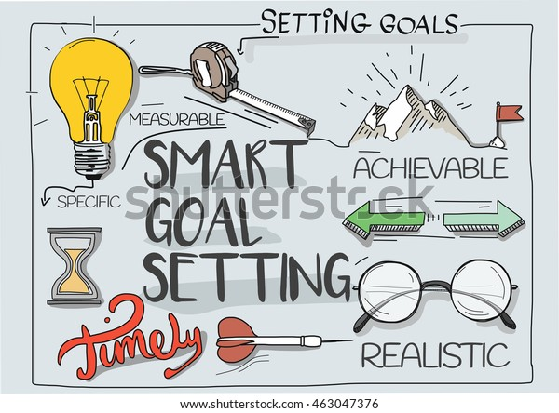
The way of communication with others is critical for easy and quick problem-solving. Decision-making is an essential factor in the career selection process and has a large role in professional development [4].

Organise the time with SMART technique is one of the main abilities which keep the focus and motivation and produce the best work or study results [2], [3].


Creativity or an open mind in a combination with critical thinking in different situations for solving – problems are important. The development of those skills helps to see the big picture. Creativity is a motivation to achieve unique outcomes.

These essential skills are part of the learning process. Gaining new skills and knowledge creates study and working habits, which is critical for a future career after graduation. Building these habits in the learning process helps to accumulate confidence and competence and create professionalism.

REFERENCES
[1] Dr. R. Strazdina, “Skills for the Digital Era,” CEE Multi-Country News Center, Aug. 26, 2020. https://news.microsoft.com/en-cee/2020/08/26/skills-for-the-digital-era/ (accessed Mar. 19, 2021).
[2] S. Drew and R. Bingham, The Guide to Learning and Study Skills: for Higher Education and at Work. Farnham: Gower, 2010.
[3] S. O’hara, Improving Your Study Skills: Study smart. Study less. Hoboken, Nj: Wiley, 2006.
[4] Paloma Díaz, Andri Ioannou, Kaushal Kumar Bhagat, and J Michael Spector, Learning in a Digital World: Perspective on Interactive Technologies for Formal and Informal Education. Singapore Springer Singapore Imprint, Springer, 2019.
[5] S. Cottrell, The Study Skills Handbook, 5th ed. London: Red Globe Press, 2019.

