Powertrain Design and Efficiency

Assignment Report.

M5X02200

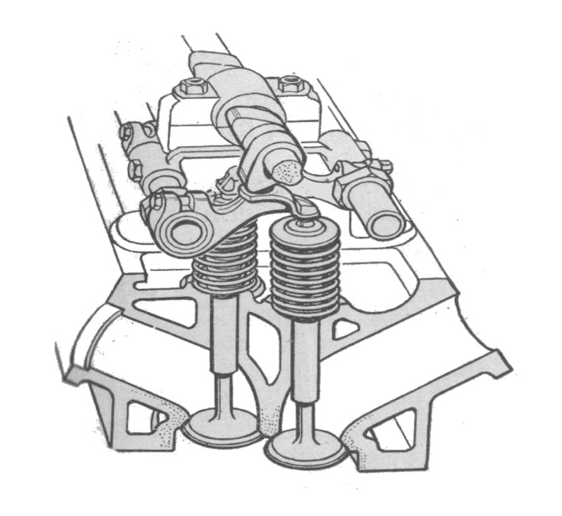

Image of inlet and Exhaust Valve. (2020). [image] [Accessed 2 Jan. 2020].

By: Daniel Davies.

Student Number: 1801345.
Date: 2nd January 2020.

Contents
  - Introduction.
  - Purpose of the assignment.
  - Acknowledgements.

Section 1. Data Collection.
1.1 Components weight values.
1.2 Compression ratio and bore/stroke of engine of the engine.
1.3 Camshaft profile (inlet cam) and graphs of valve lift against crank angle.
1.4 Health and Safety.
1.5 Flow Tests. Graphs of flow properties of cylinder head and ancillaries.

Section 2. Systems Inspection.
2.2 Can larger inlet and exhaust valves be fitted? Current ratio of inlet to exhaust diameter.
2.3 Scope of modifications which could be undertaken to improve the flow coefficient.
2.4 Graphs showing CFM per sq. inch against lift for inlet, with and without inlet manifold.
Section 3. Data Analysis
3.1. Graphs of flow coefficient (CF) against lift for all tests.
3.2 Graphs of inlet flow coefficient against crank angle.
3.3 Determined mean inlet flow coefficient for the bare head and for the head and inlet manifold.
3.4 Determined engine speed for maximum power on the road engine.
3.5 Graph showing required inlet valve lift profile (graph - lift v crank angle) needed to achieve the required mean flow coefficient to raise the RPM of max power by 50%.
Section 4. Conclusion.

Section 5. References.

Section 6. Appendices.

Abbreviations

- CF Flow Coefficient
- CFM Cubic Feet a Minute
- Per Sq inch Per square inch
- RPM Revolutions Per Minute
- CR Compression Ratio
- Cyl Cylinder
- Dia Diameter

- Introduction.

Efficient engine combustion requires certain ratios of air, fuel and heat and the design of the inlet and exhaust valves, the intake and exhaust ports and cylinder head directly dictate how an engine performs. These components are the conduits that directly allow an engine to ‘breathe’ and therefore need to undergo air flow efficiency checks, both for quality control purposes and to identify any potential increase in performance. A flow bench can be used to identify and determine methods and modifications that would improve the airflow which can often result in an increase in power and efficiency.

Flowperformance.com. (2007). [Accessed 3 Jan. 2020].

‘‘A flow bench measures the volume or mass of air that passes through a bounded path or conduit in relation to an applied pressure differential’’. By creating a pressure differential across the test object, this causes air to flow through not only the test object but through the entire flow bench. At some point in the flow bench the air flow velocity is measured. From the measured air velocity, the volume or mass of air that is flowing through the test object can be calculated.

Flowperformance.com. (2008). [Accessed 3 Jan. 2020].

The volume of air flow is usually measured in Cubic Feet per Minute or CFM.

- Purpose of this assignment.

This assignment aims to investigate and report on the factors which influence the design and operation of an intake manifold. Using a flow bench, the flow rate will be measured at various valve lift settings and the test data collected will be analysed to produce a critical evaluation of the flow characteristics of a cylinder head. The data recorded will be analysed and considered against manufacturer’s figures. Whilst promoting team-working during researching, collecting and the analysing of data the report will investigate and attempt to explain the practical operation of a Ford Sigma 1.6 engine intake and exhaust system.

- Acknowledgements.

To Mr Andrew Harrison for his guidance and advice during lectures.

Section 1. Data Collection.
  - Components weight values.
The components of the Ford Sigma engine that were weighed include one inlet and one exhaust valve and their shims, buckets, collets, inner and outer springs and retainers.
Table 1.
Masses (Standard)
Intake | Mass (Kg) | Quantity | Total (Kg)
Valve | 0.055 | 2 | 0.11
Shim | 0.002 | 2 | 0.004
Bucket | 0.041 | 2 | 0.082
Collet | 0.0005 | 4 | 0.002
Outer Spring | 0.049 | 1 | 0.049
Inner Spring | 0.017 | 1 | 0.017
Retainer | 0.0156 | 1 | 0.0156
 |  | Total Moving Mass (Intake) - M (Kg) | 0.2796
Exhaust | Mass (Kg) | Quantity | Total (Kg)
Valve | 0.051 | 2 | 0.102
Shim | 0.002 | 2 | 0.004
Bucket | 0.041 | 2 | 0.082
Collet | 0.0005 | 4 | 0.002
Outer Spring | 0.049 | 1 | 0.049
Inner Spring | 0.017 | 1 | 0.017
Retainer | 0.0156 | 1 | 0.0156
 |  | Total Moving Mass (Exhaust) - M (Kg) | 0.2716

Included angle between valves | 41.75

  - Compression ratio and bore/stroke of the engine.
The compression ratio (CR) of an engine is the ratio of the maximum volume of space when the piston is at bottom dead centre to the minimum volume of space when the piston is at top dead centre during a stroke. The CR is usually specified according to the output required, standard petrol fuelled engines normally operate with a CR between 10:1 and 14:1.
Mechanical Booster. (2017). [Accessed 3 Jan. 2020].

To calculate the compression ratio or CR, the bore and stroke of the engine block was measured. The process required taking precise measurements using accurate tools on clean engine surfaces, double-checking all measurements.
The bore of an engine is the internal diameter of the cylinder or combustion chamber. The stroke is the length of travel of the piston between top dead centre and bottom dead centre.

Engine | Sigma 1.6 2010 cyl head
Bore (dia) | 79 mm
Stroke (lngth) | 81.4 mm
Piston to top of cyl block | 5.5 mm
Cam lift | 8 mm
Headgasket thickness | 3.0 mm
Table 2

The compression ratio (or CR) of the Sigma Engine was calculated.

CR =

cyl vol + piston to deck vol + gasket vol
piston to deck vol + gasket vol

Table 3
Based on: Volume of a cyl = (π x r² x h) = π x radius of bore² x stroke
Cylinder volume = π x 3.88² cm x 8.14cm = 388.95 cm²
Piston to deck vol = π x 3.88² cm x 0.55cm = 26.28 cm²
Headgasket vol = π x 3.88² cm x 0.30cm = 13.1 cm²

CR = 388.95 + 26.28 + 1.31 = 428.33 = 10.84:
26.28 + 1.31 39.38

  - Camshaft profile (inlet cam) measurements and graphs of valve lift against crank angle.

Consisting of a shaft with numerous ‘hardened’ journals and egg-shaped lobes the camshaft or ‘cam’ manages and determines the timing of the opening and closing of the inlet and exhaust valves. It also allows the valve ‘overlap’ that occurs at top dead centre (tdc) during the exhaust stroke. These lobes rotate and create ‘lift’ against pushrods, cam followers, lifters or straight on to valve stems thus operating the valve gear to open and close. The amount of lift created depends on the shape, size and height of the cam lobes with the tapered section providing lift to open a valve while the rounded section allows the valve to close.
Image source
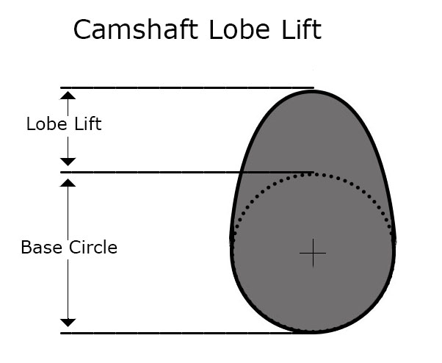
Dia 1. Cam Lobe profile

Camshaft Lobe Lift. (n.d.). [image] [Accessed 5 Jan. 2020].

It Still Runs. (2020) [Accessed 9 Jan. 2020].

Graph 1. shows values for valve lift v crank angle.

The inlet valve starts to open at 98 degrees, continuing until it is fully open at 192 degrees which equates to maximum lift. It then starts to close and becomes fully closed at 257 degrees.

1.4 Health and safety.
Care was taken when working on the SuperFlow bench towards health and safety during the flow tests. A relevant risk assessment was carried out to identify and address any probable hazards. Students were protected from harm through the effective control of any risks to health or injury arising from handling the cylinder head, electrocution from the 240V test equipment and eliminating trip hazards on the floor caused by loose equipment or cables.

  - Flow Tests.
A SuperFlow Flow bench was used to measure the air-flow resistance at various lifts. The Sigma cylinder head was mounted onto the flow bench using a cylinder adapter and the upper and lower flanges made airtight. A test gauge and dial indicator was attached to the cylinder head to measure and open the valves to the test positions. The intake flow was adjusted to read a test pressure of 25”. The valve was opened to record the flow at valve lift ranging from 1mm to the maximum valve lift test point of 8.5mm.
Three tests were carried out. Air was drawn through and the bare head was tested followed by the head with standard intake or manifold and finally with a ‘flared’ entry port.

Table 4. Test Readings

Flow properties of bare cylinder head.
Valve Lift | Reading | Modifier | Litres per Second | CFM
0.5 | 49 | 16.5 | 8.085 | 17.1
1 | 87 | 16.5 | 14.355 | 30.4
1.5 | 74 | 33.2 | 24.568 | 52.1
2 | 91 | 33.2 | 30.212 | 64
2.5 | 54 | 69.7 | 37.638 | 79.8
3 | 61 | 69.7 | 42.517 | 90.1
3.5 | 70 | 69.7 | 48.79 | 103
4 | 72 | 69.7 | 50.184 | 106
4.5 | 82 | 69.7 | 57.154 | 121
5 | 43 | 138.2 | 59.426 | 126
5.5 | 45 | 138.2 | 62.19 | 132
6 | 46 | 138.2 | 63.572 | 135
6.5 | 48 | 138.2 | 66.336 | 141
7 | 48 | 138.2 | 66.336 | 141
7.5 | 49 | 138.2 | 67.718 | 143
8 | 49 | 138.2 | 67.718 | 143
8.5 | 49 | 138.2 | 67.718 | 143

The CFM peaks at a value of 143 at a valve lift of 7.5mm
0.25D lift shows a CFM of 143

Table 5. Flow properties of cylinder head with standard intake.
Valve Lift | Reading | Modifier | Litres per Second | CFM
0.5 | 49 | 16.5 | 8.085 | 17.13114
1 | 86 | 16.5 | 14.19 | 30.06691
1.5 | 66 | 33.2 | 21.912 | 46.4289
2 | 79 | 33.2 | 26.228 | 55.57398
2.5 | 48 | 69.7 | 33.456 | 70.88925
3 | 51 | 69.7 | 35.547 | 75.31983
3.5 | 63 | 69.7 | 43.911 | 93.04214
4 | 70 | 69.7 | 48.79 | 103.3802
4.5 | 74 | 69.7 | 51.578 | 109.2876
5 | 79 | 69.7 | 55.063 | 116.6719
5.5 | 81 | 69.7 | 56.457 | 119.6256
6 | 83 | 69.7 | 57.851 | 122.5793
6.5 | 85 | 69.7 | 59.245 | 125.533
7 | 85 | 69.7 | 59.245 | 125.533
7.5 | 86 | 69.7 | 59.942 | 127.0099
8 | 87 | 69.7 | 60.639 | 128.4868
8.5 | 87 | 69.7 | 60.639 | 128.4868

The CFM peaks at a value of 128.48 at a valve lift of 8mm.
0.25D lift shows a CFM of 127

Table 6. Flow properties of cylinder head

with ‘flared’ entry port.
Valve Lift | Reading | Modifier | Litres per Second | CFM
0.5 | 47 | 16.5 | 7.755 | 16.43191
1 | 83 | 16.5 | 13.695 | 29.01806
1.5 | 64 | 33.2 | 21.248 | 45.02196
2 | 81 | 33.2 | 26.892 | 56.98092
2.5 | 47 | 69.7 | 32.759 | 69.41239
3 | 58 | 69.7 | 40.426 | 85.65784
3.5 | 66 | 69.7 | 46.002 | 97.47272
4 | 75 | 69.7 | 52.275 | 110.7645
4.5 | 81 | 69.7 | 56.457 | 119.6256
5 | 86 | 69.7 | 59.942 | 127.0099
5.5 | 90 | 69.7 | 62.73 | 132.9173
6 | 93 | 69.7 | 64.821 | 137.3479
6.5 | 47 | 138.2 | 64.954 | 137.6297
7 | 48 | 138.2 | 66.336 | 140.558
7.5 | 49 | 138.2 | 67.718 | 143.4863
8 | 49 | 138.2 | 67.718 | 143.4863
8.5 | 48 | 138.2 | 66.336 | 140.558

The CFM peaks at a value of 143.48 at a valve lift of 8mm
0.25D lift shows a CFM of 143.48

The overall test results show that the worst performing setup was the standard intake manifold. Up to a valve lift of 1mm all three set ups matched in performance. Above 1mm the bare head showed a higher air flow until reaching a lift of 3.5mm with a CFM of 103. The flared entry slightly lower at 97 and the standard intake at 93. However, above a valve lift of 4.5mm and beyond, both the bare head and the flared entry set ups maintained close values of within 3 CFMs of each other while the intake set up showed readings 17CFM lower.
The tests showed that the addition of the standard intake/manifold hindered the performance of the cylinder head when compared to the flared head at a valve lift of 0.25D by as much as 11%. The flared inlet improved the flow entering the inlet port. Therefore, the intake manifold records an 88% efficiency.
Test | Flow at valve lift = quarter of valve dia (0.25D)
Cylinder head with flared entry | 143.48 CFM
Bare cylinder head | 143 CFM
Cylinder head with standard intake/manifold | 127 CFM
Table 7. CFM with Valve Lift at 0.25D

At 0.25D the valve lift is equal to one quarter of the valve diameter and signifies the point where the ‘curtain area’ equals the valve head area.

Muscle Car DIY. (2015). Developing Highly Functional Cylinder Heads for Performance Applications - Part 10. [online] Available at: https://www.musclecardiy.com/cylinder-heads/developing-highly-functional-cylinder-heads-performance-applications-part-10/ [Accessed 6 Jan. 2020].

Section 2. Systems Inspection.

2.1 Can larger inlet and exhaust valves be fitted?

Table 8. Current ratio of inlet to exhaust diameter.
Sigma 1.6 2010 Head q4nra | Current inlet valve | Current exhaust valve
Valve Diameter | 1.18” (30.mm) | 0.98” (25.mm)
Valve Surface Area (πr²) | 1.09” sq. | 0.75” sq.
Valve Stem Diameter | 0.1955” (4.966mm) | 0.1951” (4.956mm)
Valve Stem Area | 0.03“sq. | 0.03” sq.
Net valve area | 1.06” sq. | 0.72” sq.
Current Ratio Inlet: Exhaust Dia | 30:25 = 1.2:1

DSPORT Magazine. (2020). [Accessed 3 Jan. 2020]
The installation of larger valves is one option of increasing the engine’s performance at higher rpm, if there is sufficient room to do so. Having inspected the cylinder head, it was considered that the valves could potentially be increased by 3mm in diameter.

Table 9. Ratio of inlet to exhaust diameter of larger valves.
 | Max available Inlet Valve |  | Max available Ex Valve
Valve Diameter | 1.29” (33.mm) |  | 1.10” (28mm)
Valve Surface Area (πr²) | 1.31” sq. |  | 0.95’’sq.
Valve Stem Diameter | 0.1955” (4.966mm) |  | 0.1951” (4.956mm)
Valve Stem Area | 0.03’’sq. |  | 0.03” sq.
Net valve area | 1.28” sq. |  | 0.92” sq.
Valve lift (d / 4) | 0.32” (8.25mm) |  | 0.27” (6.85mm)
Ratio Inlet: Exhaust Dia |  | 33:28 = 1.17: 1
This would continue to maintain a ‘safe working distance’ of 2 mm from the cylinder wall. But to achieve the full benefit of the larger valves the ports would also need to be opened. However, on smaller capacity engines such as the Sigma 1600 cc this could have a negative effect on the flow rate at low engine rpm resulting in ‘low end’ poor performance.
Howrah.org. (2016). [Accessed 9 Jan. 2020].

2.2 Scope of modifications which could be undertaken to improve the flow coefficient (CF).
“The power of an engine is directly proportional to the amount of air drawn into the cylinder and retained until ignition occurs” – quote - SuperFlow SF 300/600 Manual

Flow Coefficient CF = Measured CFM per sq inch
Perfect CFM per sq inch
The Ford Sigma 1.6 utilises a conventional poppet-valve style cylinder head and a long curved intake/manifold. The flow of air cannot follow a straight-line path into the combustion chamber as it must travel around the curve in the intake and the ‘bend’ in the port and the valve stem before making its way around the valve stem and eventually the head of the valve. The scope of any possible modifications would be based on maximising the flow around these restrictions or ‘corners’. * The fitting of individual throttle bodies to replace the lengthy standard intake would improve the flow coefficient.
Muscle Car DIY. (2015). Developing Highly Functional Cylinder Heads for Performance Applications - Part 10. [online] Available at: https://www.musclecardiy.com/cylinder-heads/developing-highly-functional-cylinder-heads-performance-applications-part-10/ [Accessed 6 Jan. 2020].

Improving the intake design to the cylinder head itself can be carried out by removing material using accurate cutting tools. Slight changes to increase the outside curve of the internal radius of the port will result in an improved air flow.

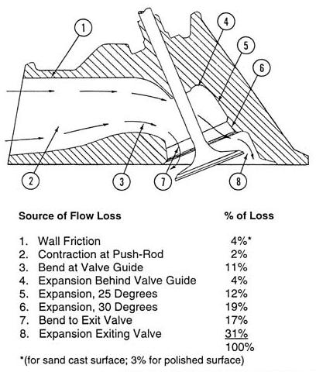 Dia 2. Subtle and minor modifications to the bend at the valve guide and the expansion areas before and after the valve can also result in a more direct line, less friction and an improvement in the CFM.
However, care should always be taken to avoid removing any excess metal and risk cutting through to the internal water cooling channels.
Image source
Inlet Port Profile. (n.d.). [image] [Accessed 10 Jan. 2020].

Changing the valve seat to an angle steeper than the standard 45 degrees setting can also provide an improvement in airflow although may sacrifice performance at low revs. Any changes should be measured before carrying out a further cycle of modifications and measurement.
Wood, R. (n.d.). [Accessed 4 Jan. 2020].

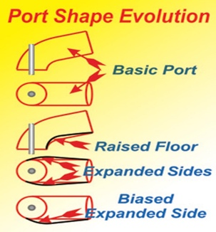
An inlet port can be made more effective through ‘port shape evolution’ Raising the inner curve or ‘floor’ allows an increase in the radius of the shorter side. To compensate for the reduced cross-sectional area the port then needs to be widened. The resulting shape of the port closely follows the direction that the indrawn air wants to travel and therefore provides an improvement in the Coefficient of flow.
Image source

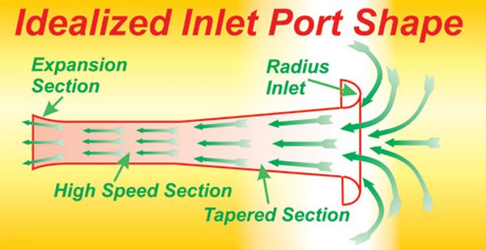
Port. (n.d.). [image] [Accessed 10 Jan. 2020].

A straightened intake port would significantly improve the flow coefficient as the long curve of the standard Sigma intake manifold influences the resulting airflow.
Image source

Muscle Car DIY. (2015) [Accessed 6 Jan. 2020].

2.3 Graphs showing CFM per inch² against lift for inlet, with and without inlet manifold.
Table 10. CFM per inch² against inlet. With and without manifold.

Valve Lift | CFM per inch²  With inlet manifold | CFM per inch²  (Without inlet manifold.)
  0.5
  1
  1.5
  2
  2.5
  3
  3.5
  4
  4.5
  5
  5.5
  6
  6.5
  7
  7.5
  8
  8.5
  7.91
  13.74
  21.21
  25.39
  32.39
  34.41
  42.51
  47.24
  49.94
  53.31
  54.66
  56.01
  57.36
  57.36
  58.03
  58.71
  58.71
  7.81
  13.89
  23.8
  29.24
  36.46
  41.17
  47.07
  48.44
  55.29
  57.58
  60.32
  61.69
  64.43
  64.43
  65.35
  65.35
  65.35

The test results showed that the least efficient setup was the standard intake manifold. Up to a valve lift of 2mm the cylinder head without manifold showed an increase of 4 CFM per inch² above the manifold set up. Above 2mm the gap widens by 3 to 4 CFM per inch² until they reach a valve lift of 4mm where the difference decreases to 1.2 CFM per inch² between both cylinder heads. Above a lift of 4mm the bare head without manifold continues to increasingly outperform the manifold set up which fails to get within 10 CFM per inch² of the bare head. The addition of the intake/manifold hindered the performance of the cylinder head when compared to the bare head at a valve lift o 0.25D by as much as 11%.

Section 3. Data Analysis

3.1. Graphs of flow coefficient (CF) against lift for all tests.

Flow Coefficient CF = Measured CFM per sq inch.
Perfect CFM per sq inch

Table 11. CF against lift for all tests
Valve Lift | CF  (Bare Head) | CF  (Manifold) | Loss in CF by  adding manifold (-) | CF  (Flared Entry) | Improvement  by adding  flared entry (+)
  0.5
  1
  1.5
  2
  2.5
  3
  3.5
  4
  4.5
  5
  5.5
  6
  6.5
  7
  7.5
  8
  8.5
  0.05
  0.09
  0.15
  0.18
  0.22
  0.25
  0.29
  0.3
  0.34
  0.35
  0.37
  0.38
  0.4
  0.4
  0.4
  0.4
  0.4
  0.05
  0.08
  0.12
  0.15
  0.19
  0.21
  0.26
  0.28
  0.3
  0.32
  0.33
  0.34
  0.35
  0.35
  0.35
  0.36
  0.36
  0.0
  0.01
  0.03
  0.03
  0.03
  0.04
  0.03
  0.02
  0.04
  0.03
  0.04
  0.04
  0.05
  0.05
  0.05
  0.04
  0.04
  0.05
  0.1
  0.15
  0.19
  0.23
  0.28
  0.32
  0.37
  0.4
  0.42
  0.44
  0.45
  0.46
  0.46
  0.47
  0.47
  0.46
  0.0
  0.02
  0.03
  0.04
  0.04
  0.07
  0.04
  0.09
  0.1
  0.1
  0.11
  0.11
  0.11
  0.11
  0.12
  0.11
  0.10

The flared entry was the more efficient set up which showed a continuing proportional improvement ranging from .02 CF at a lift of 1mm to 0.12 CF at a lift of 7.5mm. As there is no further increase in a reading of 0.47, this is the maximum practical flow coefficient for the Sigma cylinder head which also equates to 0.25D.
The addition of an intake manifold creates a loss in the flow coefficient of the bare head ranging from -0.01 at 1mm of lift through to -0.05 at a lift of 7.5mm. However, when a flared entry is added the flow coefficient increases by 0.02 at 1mm of lift followed by a proportional increase of 0.12 at 7.5mm of lift seen as a steady curve on Graph 11.

3.2 Graphs of inlet flow coefficient against crank angle.
Graphs of Inlet flow coefficient against Valve lift with a polynomial trend line

The polynomial graphs show the inlet flow coefficient against valve lift. The flared entry test proved to be the most efficient followed by the bare cylinder head with the standard manifold the least progressive.

3.3 Determined mean inlet flow coefficient for the bare head and for the head and inlet manifold.
Mean inlet flow coefficient for the bare head | (Total 4.97 ÷ 17) = 0.29
Mean inlet flow coefficient for the head and manifold | (Total 4.4 ÷ 17) = 0.25

3.4. Determined engine speed for maximum power on the road engine.
Given that the
Mean inlet flow coefficient for the head with inlet manifold = 0.25
Inlet valve diameter = 30mm /1.18”
Effective valve is = 6.83cm² / 1.06inch²
Displacement of 1 cyl = 400cc / 24.49 cu inch

Calculate engine speed for maximum power;
Ci (Mean CF) = Total 4.4 ÷ 17 points = 0.25
Mean effective area over duration of valve opening = 0.25 x 2 x πD (30)² = 3.53
4
Peak gas velocity at max power assumed as 330 m/s
Mean gas velocity = 2 x 330 = 210 m/s @ max power
π
Therefore, if at max power mean gas flow = 210m/s
and effective mean area (from above) = 3.53

The flow rate of air into engine = 3.53 x 210 = 741.3

The total amount of air drawn in per cycle @ max power can be calculated as follows;

Effective area x Mean CF x Duration the valve is open x Cyl displacement

Duration of time the valve is open is 250 x 60 = 0.69 x 60
360 RPM RPM

From this, the RPM at maximum flow can be calculated as

0.25 x 2 x πD² x 10⁻⁶ x 210 x 250 x 60 = 5944 RPM (@ max flow) rate
4 360 400x 10⁻⁶

3.5 Graph showing required inlet valve lift profile (graph - lift v crank angle) needed to achieve the required mean flow coefficient to raise the RPM of max power by 50%.

Using

Maximum inlet valve area = 1.06 in² / 8.25 cm²

Highest practical flow coefficient of head type = 0.36
Current RPM at max power = 5944 rpm
Effective
Mean effective area = 0.18 x 2 x π30² = 508.93
4

8800(RPM) = 508.93 x 210 x 60 x (valve profile)
400x10^{-6.} 360

Calculate required inlet valve lift profile (lift v crank angle) needed to achieve the required mean flow required to raise the RPM of Maximum power by 50% to 8800 RPM.

Section 4.
Conclusion

The Superflow tests determined that the standard intake manifold delivered the least CFM readings. Above 1mm of valve lift the bare head showed a higher air flow until reaching a lift of 3.5mm with a CFM of 103. The flared entry delivered a slightly lower 97 CFM and the standard intake at 93 CFM. However, when the valve lift reached 4.5mm and above, both the flared entry and the bare head set ups maintained values within 3 CFMs of each other. The standard intake set trailed behind with readings 17CFM below.
The flow tests discovered that attaching the standard intake/manifold negatively affected the performance of the flared cylinder head by as much as 11% at a valve lift of 7.5mm or 0.25D.
The tests demonstrated that the intake manifold and cylinder head are key components that determine the power an engine develops. When producing an engine such as the Sigma 1.6 manufacturers suffer from the constraints of casting cylinder heads and manifolds at a reasonable cost and high volume castings often lead to compromises in air flow.
Although some aspects of turbulent flow can be positive in achieving an efficient combustion, an increase in the flow properties of the cylinder head can be achieved by altering or ‘cleaning’ the internal diameters of the cylinder head ports. The loss in flow arises from any change in direction. Removing the ‘rough’ casting surfaces around the edges or valve posts keeps any changes down to a minimum. Uneven surfaces inside the cylinder ports can result in a turbulent flow and affect the flow coefficient. Removing material on outside corners or bends increases the radius and smooths the pathway. Re-working the factory finish ports by hand is carried out using power grinding /rotary tools. The most critical part of the cylinder head intake port is the area situated 12mm above and below the valve where the greatest loss in flow occurs, caused by the expansion of the air as it leaves the valve. (Superflow SF600 Operation Manual https://pdfslide.net/documents/sf600-operation-manual-2009.html).
Other factors which influence the design and operation of a cylinder head and intake manifold include the restriction on under-bonnet space available. It is interesting to note that when comparing the figures for the standard manifold and the flared inlet guide, when the manifold is attached, there occurs a reduction in efficiency of 11% in the total flow. Considering these results, the current curvature of the intake manifold may have even more room for improvement than the cylinder head. This curvature creates a restriction as it does not follow the direction that the indrawn air wants to travel and therefore affects flow. Replacing the standard intake with individual throttle bodies would improve air flow prior to the cylinder head. An intake track of the correct length and angle could also improve the flow.
Section 5. References.
Lumley, J. (1999). Engines. Cambridge, UK: Cambridge University Press.

DSPORT Magazine. (2020). Ford EcoBoost 1.6L Analysis | Turbo, Direct-Injection & CCVTC. [online] Available at: https://dsportmag.com/the-tech/ford-ecoboost-1-6l-analysis-turbocharged-direct-injection-ccvtc/ [Accessed 3 Jan. 2020].

Flowperformance.com. (2007). Flow Performance | Flow Performance Flow Bench | Flow Bench FAQ. [online] Available at: http://www.flowperformance.com/faq.html [Accessed 3 Jan. 2020].

Flowperformance.com. (2008). Flow Performance | Flow Performance Flow Bench | Flow Bench 101. [online] Available at: http://www.flowperformance.com/flowbench.html [Accessed 3 Jan. 2020].

Mechanical Booster. (2017). What is Compression Ratio - Petrol and Diesel Engine? - Mechanical Booster. [online] Available at: https://www.mechanicalbooster.com/2017/12/what-is-compression-ratio-petrol-diesel-engine.html [Accessed 3 Jan. 2020].

Wood, R. (n.d.). Gas Flow Engineering - Ric Wood. [online] Ric Wood. Available at: https://ricwood.com/facilities/ric-wood-gas-flow-engineering/ [Accessed 4 Jan. 2020].

Magda, M. (2014). Valve Seats: Will 50- or 55-degree Angles Work For Your Engine? [online] Dragzine. Available at: https://www.dragzine.com/features/valve-seats-will-50-55-degree-angles-work-engine/ [Accessed 5 Jan. 2020].

Baechtel, J. (2015). Techtips - Cylinder Head Math for Engine Performance. [online] Cartechbooks.com. Available at: https://www.cartechbooks.com/techtips/cylinder-head-math-for-engine-performance/ [Accessed 6 Jan. 2020].

Muscle Car DIY. (2015). Developing Highly Functional Cylinder Heads for Performance Applications - Part 10. [online] Available at: https://www.musclecardiy.com/cylinder-heads/developing-highly-functional-cylinder-heads-performance-applications-part-10/ [Accessed 6 Jan. 2020].

Burtonpower.com. (n.d.). Burton CNC machined cylinder head Stage 3 Ford Zetec E 1.8/2.0i -05/98. [online] Available at: https://www.burtonpower.com/burton-cnc-cylinder-head-stage-3-zetec-e-1-8-2-0i-05-98-pch113.html [Accessed 8 Jan. 2020].

Howrah.org. (2016). Valves: Increase the Power of Your Ride. [online] Available at: http://www.howrah.org/valves.html [Accessed 9 Jan. 2020].

BIN ABD KADIR, M. (2008). INTAKE PORT FLOW STUDY ON VARIOUS CYLINDER HEAD USING FLOWBENCH. [ebook] PAHANG: MOHD TAUFIK BIN ABD KADIR. Available at: https://core.ac.uk/download/pdf/159176836.pdf [Accessed 8 JAN. 2020].

Appendices.
List of Tables.
Table No. Title. Page.
- Component weight values. 2
- Sigma 1.6 cyl head bore/stroke. 4
- Combustion chamber volume data. 5
- Test readings. Flow properties, bare cyl head. 7
- Test readings. Flow properties, standard intake. 8
- Test readings. Flow properties, flared entry. 9
- CFM with Valve lift at 0.25D. 10
- Current ratio of inlet: exhaust diameter. 10
- Ratio of inlet: exhaust diameter of larger valves. 11
- CFM per inch² against inlet. With / without manifold 13
- CF against lift for bare head, with / without manifold 15
List of Graphs.
Graph No. Title. Page.
- Valve lift against crank angle. 6
- CFM of bare cylinder head. 7
- CFM with manifold. 8
- CFM with flared entry. 9
- CFM bare cyl head, std intake and flared entry. 9
- CFM per inch² with manifold. 14
- CFM per inch² without manifold. 14
- CFM per inch² with / without manifold. 14
- Valve lift against CF Bare head. 15
- Valve lift against CF with manifold. 15
- Valve lift against CF with flared entry. 15
- CF against crank angle (bare head) (polynominal) 17
- CF against crank angle (manifold) (polynominal) 17
- CF against crank angle (Flared) (polynominal) 17
- Valve lift against CF (flared)

Diagrams.
- Camshaft lobe lift 5
- Inlet port profile 11
- Inlet port shape evolution 13
- Ideal inlet port shape 13

