

A Study of the Enhancing Usability and User Experience in Healthcare Data Dashboard
by
Christopher Hampton

Supervisor: Prof. Nik Whitehead

Project submitted as part of the requirements for the award of
BSc (Hons) Computing (Data and Information Systems)

July 2025

Declaration

I, Christopher Hampton, declare that I am the sole author of this Project; that all references cited have been consulted; that I have conducted all work of which this is a record, and that the finished work lies within the prescribed word limits.

This work has not previously been accepted as part of any other degree submission.

Form of Consent

I, Christopher Hampton, hereby consent that my Project, submitted in candidature for the B.Sc. (Hons) Computing (Data and Information Systems) degree, if successful, may be made available for inter-library loan or photocopying (subject to the law of copyright), and that the title and abstract may be made available to outside organisations.

Abstract

Healthcare data dashboards play a pivotal role in supporting clinical and operational decision-making, yet they often struggle with information overload, poor navigation, inadequate feedback, and accessibility barriers. This study investigates how established usability and user-experience (UX) frameworks ranging from Nielsen’s heuristics and Shneiderman’s Eight Golden Rules to Norman’s design principles, Cognitive Load Theory, and Morville’s UX Honeycomb, can be integrated to enhance the design of a ‘Community Rehabilitation’ dashboard. A rapid double-diamond methodology guided discovery, definition, development, and delivery phases.
In the Discover phase, a mixed-methods pre-development survey (n≈20) and stakeholder interviews revealed four thematic user segments - data-focused analysts, strategic planners, frontline managers, and mobile-first clinicians. These insights informed wireframes and prototypes built in Power BI, underpinned by Feature-Driven Development and data models scripted in Azure Databricks. The Define and Develop phases produced interactive components KPI tiles, drill-through tabs, tooltips, and colour-coded alerts mapped to real-world NHS pathways.
During the Deliver phase, a post-implementation System Usability Scale (SUS) survey (mean = 79.6) exceeded the industry benchmark of 68, while think-aloud testing and an eye-tracking exercise identified minor refinements in interactive affordances and tooltip visibility. Colour-contrast and simulated colour-blindness checks confirmed WCAG compliance.
Findings demonstrate that a structured, user-centred approach yields highly usable dashboards that align with workflows, improve decision speed, and support equitable access. Future work should explore long-term adoption, real-time predictive analytics, and a standardised usability-UX toolkit for healthcare dashboards.

Table of Contents
Declaration 2
Form of Consent 2
Abstract 3
Chapter 1 – Introduction 9
Chapter 2 – Research and Review of Literature 10
2.1 Theoretical Frameworks for Usability and UX 10
2.1.2. User-centred Design (UCD) 10
2.1.3. Nielsen’s Usability Heuristics 11
2.1.3. Shneiderman’s Eight Golden Rules 13
2.1.4. Norman’s Design Principles 14
2.1.5. Cognitive Load Theory (CLT) 15
2.1.6. UX Honeycomb - Peter Morville 16
2.1.7 Health-Specific Evaluation Models 17
2.2. Healthcare Dashboards: An Overview 18
2.2.1. Usability Challenges in Healthcare Dashboards 22
2.3. Design Best Practices for Usability and UX 23
2.3.1 Intuitive Navigation 24
2.3.2 Visual Hierarchy 24
2.3.3 Accessibility and Inclusive Design 25
2.4. Impact of Usability and UX Design on Healthcare Outcomes 25
2.5. Case Studies and Examples 26
2.5.1 Johns Hopkins Hospital – Capacity Command Centre 26
5.2.2 Ochsner Health – Laboratory Analytics Dashboard for Quality Improvement 27
5.2.3 Rush University Medical Centre – Readmissions Reduction Dashboard 28
2.6. Emerging Technologies and Future Directions 29
2.6.1 Artificial Intelligence and Advanced Analytics 29
2.6.2 Internet of Things (IoT) and Real-Time Data 30
2.6.3 Real-Time Predictive Analysis 30
2.7. Research Gaps and Opportunities 30
Chapter 3 – Methodology 31
3.1 Project Methodology 31
3.1.1 Discover 31
3.1.2 Define 31
3.1.3 Develop 32
3.1.4 Deliver 32
3.2 Risks & Limitations 33
3.3 Ethical Issues 33
3.4 Validity, Reliability & Generalisability 33
3.4.1 Validity 33
3.4.2 Reliability 33
3.4.3 Generalisability 34
3.5 Data Evaluation Methods 34
3.6 Development Methodology 35
3.7 Resources 36
3.7.1 Hardware Resources 36
3.7.2 Software Resources 36
3.7.3 Information Resources 36
3.7.4 Human Resources 36
Chapter 4 - Design and Implementation 38
4.1 Discover - User Needs Analysis 38
4.1.2 Themes 38
4.2 Define - Translating Survey Findings into Wireframe Designs 41
4.3 Develop 43
4.3.1 Data Scripting and Technical Implementation 43
4.3.1 Dashboard Prototyping and Functional Refinement 44
Chapter 5 – Evaluation 50
5.1 Deliver 50
5.1.1 Post Development Evaluation Using SUS Survey 50
5.1.2 Think-Aloud Usability Testing with GazeRecorder 53
5.2 Accessibility Aspects 54
5.2.1 Colour Contrast 54
5.2.2 Colour Blindness 55
5.2.3 Layout 56
5.3 Post Delivery Sustainability 57
Chapter 6 – Conclusion and Future Work 58
6.1 Conclusion 58
6.2 Suggestions for Further Work 58
Chapter 7 – Reflection 60
Chapter 8 – References 61
Chapter 9 – Bibliography 69
Appendices 69
Appendix 1 – Predevelopment Survey 69
Appendix 2 – SUS Survey 69
Appendix 3 - Metrics and Measures 70
Appendix 4 - Pre-Development Text Analysis 71
Appendix 5 – Word Counts 73
Cluster 1 73
Cluster 2 73
Cluster 3 73
Cluster 4 74
Appendix 6 - Referrals SQL Script 74
Appendix 7 - Activity SQL Script 75
Appendix 8 - Dax Measures 77
Appendix 9 - Sus Response Answers 86
Appendix 10 – Sus Scoring Criteria 86
Appendix 11 - Sus Scoring Script 87
Appendix 12 - Sus Scoring visual Script 88
Appendix 13 – Eye Tracking Visuals 88
Appendix 14 - Think-Aloud Session Transcript 90

Table Of Figures
Figure 1 - UX Honeycomb [39] 16
Figure 2 - NHS England Dashboard – 1 [52] 18
Figure 3 - NHS England Dashboard - 2 [51] 19
Figure 4 - NHS Scotland Dashboard -1 [53] 19
Figure 5 - NHS Scotland Dashboard -2 [53] 20
Figure 6 - NHS Wales Dashboard – 1 [54] 20
Figure 7 – NHS Northern Ireland Dashboard – 1 [55] 21
Figure 8 – NHS Northern Ireland Dashboard –2 [55] 21
Figure 9 - John Hopkins Demand Dashboard [83] 27
Figure 10 - Ochsner Dashboard [84] 28
Figure 11 - Rush Readmissions [87] 29
Figure 12- Double Diamond [93] 31
Figure 13- Cluster 1 - Top 10 common words 38
Figure 14 - Cluster 1 word cloud 38
Figure 15 - Cluster 2 Top 10 words 39
Figure 16 - Cluster 2 Word Cloud 39
Figure 17 - Cluster 3 Top 10 common words 40
Figure 18 - Cluster 3 Word Cloud 40
Figure 19 - Cluster 4 word count 40
Figure 20 - Cluster 4 word cloud 41
Figure 21 - Wireframe 1 41
Figure 22 - Wireframe 2 42
Figure 23 - Referral Table Relationship Entity 43
Figure 24 - Activity Relationship Entity 44
Figure 25- Dashboard – Summary 45
Figure 26 - Title Hover 45
Figure 27 - Dashboard Referrals 46
Figure 28 - Dashboard Assessments 46
Figure 29 - Dashboard Interventions 47
Figure 30 - Dashboard Discharges 47
Figure 31 - Back and Home buttons 48
Figure 32 - Information and Help Icons 48
Figure 33- Updated Meta 48
Figure 34 - Tooltip 1 48
Figure 35 - ToolTip 2 49
Figure 36 - Pre-Development Flow Diagram 50
Figure 37 - SUS Scoring Distribution 51
Figure 38 - SUS Scoring Box Plot 52
Figure 39 - Sus Score Grades 52
Figure 40 - Eye Tracking 1 53
Figure 41- Colour Contrast 1 [109] 54
Figure 42 - Colour Contrast 2 [109] 54
Figure 43 - Colour Contrast 3 [109] 55
Figure 44 - Colour Contrast 4 [109] 55
Figure 45 - Colour Contrast 5 [109] 55
Figure 46 - Deuteranopia Simulation 56
Figure 47 - Tritanopia Simulation 56
Figure 48 - Achromatopsia Simulation 56
Figure 49 - Eye Tracking 2 88
Figure 50 - Eye Tracking 3 89
Figure 51 - Eye Tracking 4 89
Figure 52 - Eye Tracking 5 90

Chapter 1 – Introduction
Electronic Health Records (EHRs) began in the 1960s with the Mayo Clinic’s early digitisation efforts and Lawrence Weed’s problem-oriented medical record [1]. Since then, healthcare systems increasingly rely on digital platforms to optimise decision-making, healthcare dashboards have emerged as vital tools for operational and clinical efficiency.

Despite their widespread adoption, many dashboards suffer from usability shortcomings, ranging from overwhelming interfaces and poor navigation to lack of accessibility and feedback clarity. These issues not only hinder user engagement but also risk compromising data interpretation, delaying decisions, and inadvertently affecting patient care.

This project explores how usability and UX can be systematically improved in healthcare dashboards. This study seeks to integrate these theories into a practical Power BI dashboard.

The aim is to design and evaluate a healthcare data dashboard that enhances usability and user experience, ensuring effective decision-making and data visualisation for healthcare professionals.

The objectives to achieve this aim are:
- Investigate Usability Principles - Review existing literature on usability to guide dashboard design.

- Develop a User-Centred Dashboard - Implement best practices in UX to create an intuitive interface tailored to healthcare professionals.

- Assess User Experience - Conduct usability testing and feedback analysis to measure efficiency, satisfaction, and ease of use.

- Identify Challenges and Solutions - Explore common usability barriers and recommend improvements for optimal data accessibility.

- Evaluate Impact on Decision-Making - Assess how the dashboard facilitates informed decisions by enhancing data comprehension.

The Community Rehab Team require a dashboard that meets their reporting requirements, Appendices > Appendix 1 – Metrics and Measures, the research and project will aim to produce a dashboard that satisfies these requirements with a high focus on usability and UX.

The chapters ahead follow a structured path to address these goals. Chapter 2 presents a comprehensive review of UX and usability literature in healthcare contexts, laying the theoretical foundation. Chapter 3 details the methodological approach, including the use of Double Diamond and Feature-Driven Development frameworks. Chapter 4 describes the dashboard’s design and implementation process, from wireframes to prototype creation. Chapter 5 evaluates the dashboard’s usability through surveys and testing tools, while Chapter 6 draws conclusions and presents recommendations for future work. Finally, Chapter 7 reflects on the overall learning journey and Chapter 8 contains references to support academic rigour.

Chapter 2 – Research and Review of Literature
User-centred, accessible, and insight-driven dashboards have become vital as healthcare systems shift from paper records to complex, data-rich platforms. This chapter examines foundational theories and frameworks that will guide the design to evaluate and optimise the digital interfaces.

2.1 Theoretical Frameworks for Usability and UX
To understand user interactions with systems and services, there are several theoretical frameworks for usability and user experiences that provide a structured approach that helps designers evaluate and enhance the effectiveness, efficiency, and satisfaction of user experiences [2].

Before UX became a cornerstone for interface design, Don Norman [3] and Jakob Nielsen [4] collaborated to unveil the hidden mechanics of effective design. Norman, with his cognitive science background, highlighted how the mind perceives, remembers and makes sense of products. Nielsen distilled we interactions into a set of heuristics that would become the ‘gold-standard’ of interface evaluation. Together, creating the Nielsen Norman Group (NNg), they load a foundation for designers to think primarily about real people rather than abstract features.
From this foundation, Steve Krug [5] injected a simplicity approach, ‘Don’t Make Me Think’, advocating for regular user testing to ensure that design decisions represented genuine feedback rather than theoretical ideas. Similarly, Alan Cooper [6] was championing another viewpoint of personas. By coaxing designers to forge vivid character profiles, he helped teams move beyond generic archetypes to create experiences that resonate on a human level.
Theoretical underpinnings of interaction design continued to deepen by Ben Shneiderman [7] and Peter Morville [8]. Shneiderman’s ‘Eight Golden Rules’ offered heuristics for co-existence between people and technology, while Morville’s UX Honeycomb charted seven facets that every digital product should satisfy. Their work translated UX from best practices to nuances discipline that balances form, function, and emotion.
These influential figures have driven much of what is considered the core UX principles, others like Jared Spool, Jane Fulton Suri, and Jeff Raskin continue to expand the horizon, ensuring that design remains an ever-evolving subject.
Using a framework addresses pain points systematically, reducing guesswork and improving efficiency. It allows for benchmarking to evaluate qualities such as accessibility, credibility, and desirability. Some of the most influential and popular frameworks are:

2.1.2. User-centred Design (UCD)
UCD is an iterative design process that prioritises user needs, preferences, and experiences at every development stage. The goal is to create products that are intuitive, accessible and efficient for the intended audience. Interactive Design Foundation (IxDF) [9] describe the four pillars behind UCD:

- Understanding the users’ needs – Interviews, surveys, and testing provides insights into users' behaviours and challenges.

- Iterative Process - Design cycle refinements improve elements by testing and feedback.

- Usability Focus - Feedback simplifies tasks and makes actions intuitive.

- Collaborative Approach - Holistic design with experts like psychology, engineering, and design.

IxDF describes how UCD is widely used across industries, including healthcare, to enhance user engagement and satisfaction, aligning final products with user expectations.
Goel et. al. [10], expanded on the original concept of UCD by defining the UCD methodology as:

- Define – understanding the users and value of the product is key to a strong definition of the end goal.

- Research –interviews, surveys and analysis can guide decisions to improve efficiency during development.

- Ideate – validation, through research data, can identify solutions and generate ideas.

- Design – prototyping aligns the users needs. Focusing on the Information Architecture and User Interface.

- Test - feedback will inform the desingers on any adjustments.

By basing their research on these design principles, they noted a high user appreciation, and mentioned Artificial Intelligence can be used for further enhancements.

Similar concepts were discussed by Raj et. al. [11], suggesting that the UCD concept is sound and applicable. However, the paper only has a five-year scope which can lead to limited research to other relevant studies. The paper also suggests using tools, like Figma, for design creations, and assumes that adopting these tools will universally improve User Interface (UI)/User Experience (UX) outcomes which may not be the case.

2.1.3. Nielsen’s Usability Heuristics
The meaning of heuristic is defined as:

A heuristic method of learning involves discovery and problem-solving, using reasoning and past experience. [12]

Nielsen’s ten usability heuristics highlight decades of Human Computer Interaction (HCI) and cognitive-psychology research into a lightweight checklist that helps designers spot major interface issues early in a cost-effective way. First laid out in ‘Finding Usability Problems Through Heuristic Evaluation’ [13], Nielsen showed this rule-based review was far more cost-effective than unguided testing. Although they’ve seen only minor tweaks since, these heuristics still form the backbone of most web and app evaluations.

Concluding, that heuristic evaluation is an advantageous method in usability engineering. From this Nielsen set the foundation to create the ‘10 Usability Heuristics for User Interface Design’ [14] [15].

Heuristic | Description | Healthcare Dashboard Example
Visibility of System Status | Keep users informed of their actions through timely feedback. | When running a dashboard is updating a loading spinner is used to indicate the visual is loading.
Match Between System and the Real World | Use terminology and visuals familiar to users’ domain knowledge. | Dashboard tabs labelled “Emergency Admissions” and “Bed Occupancy” reflect real-world hospital units rather than acronyms.
User Control and Freedom | Allow users to navigate freely and undo actions easily. | After applying a filter, a “Clear Filters” button instantly resets the view without restarting the session.
Consistency and Standards | Maintain uniform design patterns so users learn once, apply everywhere. | All dashboards use the same “Refresh” icon in the top-right corner and consistent date-picker controls across modules.
Error Prevention | Design to prevent mistakes and confirm critical actions. | Before removing or changing data from the dashboard, a modal pops up: “Are you sure? This cannot be undone.”
Recognition Rather Than Recall | Minimize memory load by making options and data visible. | A “Recent Views” panel lists the last dashboards or visuals accessed, so the user doesn’t have to recall the location.
Flexibility and Efficiency of Use | Support both novice and power users with shortcuts and customization. | Power users can assign keyboard shortcuts to switch between pages in the dashboards instantly.
Aesthetic and Minimalist Design | Display only relevant information to avoid clutter. | The main dashboard highlights key metrics while detailed settings live supplementary pages.
Help Users Recognise, Diagnose, and Recover from Errors | Provide clear, constructive error messages and recovery options. | Having a back button or undo feature to allow the user to retrace their steps.
Help and Documentation | Offer easy-to-search, task-focused guidance. | A built-in “?” icon opens context-sensitive tooltips explaining each KPI and links to quick-start tutorials.

Ivanovs [16] explores the benefits of using these heuristics, but combining them with other methods, like usability testing, can provide a deeper understanding of how a real user interacts with a system. Explaining that other evaluation methods could offer a fresh perspective to enhance a product’s user experience.

Nielsen’s heuristics have drawn criticism for their one-size-fits-all application and narrow cultural viewpoint. Wilkinson [17] points out that NNg’s YouTube content largely features young, white, conventionally attractive voices, which can undermine inclusivity, and Costanza-Chock [18] similarly argues for community-led, justice-oriented design. To address these gaps, designers can complement Nielsen’s rules with:

- Government UX Guidelines: The US Digital.gov and UK Government Design Principles,
- The UX Cookbook: A beginner-friendly UX resource,
- Indigenous Participatory Design Toolkit: A toolkit designed for inclusive and participatory UX practices.

2.1.3. Shneiderman’s Eight Golden Rules
Shneiderman’s Eight Golden Rules establish a foundation for intuitive, efficient, and user-friendly interfaces. By making interactions predictable, accessible, and responsive, they reduce cognitive load and empower users [19].

Even cutting-edge technologies like AI and VR apply these same principles. For example, Aottiwerch et al. [20] implemented augmented reality in an educational setting strictly following Shneiderman’s rules. Results showed a user-centric AR experience that was both powerful and accessible for students.

The Eight Golden Rules:

Principle | Description | Healthcare Dashboard Example
Strive for Consistency | Consistent language and layout to reduce cognitive load [19] [21]. | All hospital dashboards use standardised colour codes for alerts (e.g., red for critical vitals, green for stable readings).
Enable Frequent Users to Use Shortcuts | Shortcuts to speed up frequent tasks for experienced users [19]. | Clinicians can assign keyboard shortcuts for switching views between “Radiology Results” and “Medication History” dashboards.
Offer Informative Feedback | Clearly show user actions to reduce uncertainty and improve trust [22]. | After submitting a risk assessment form, the system displays a confirmation message: “Assessment Saved Successfully.”
Design Dialogs to Yield Closure | Each task feels complete with a clear finish and confirmation [22]. | After generating a report for patient discharge metrics, the dashboard ends with a “Report Complete” screen and download link.
Offer Simple Error Handling | Plain-language error messages and recovery instructions [19] [22]. | If a data import fails due to a missing patient ID, the system displays: “Missing ID field: please review and re-upload file.”
Permit Easy Reversal of Actions | Undo features to reduce anxiety about accidental changes [21]. | If a user accidentally filters out certain data, a visible “Undo Filter” button restores the previous dashboard view instantly.
Support Internal Locus of Control | Predictable responses that put users in control [22]. | Adjusting the length-of-stay filter immediately refreshes visualizations, reinforcing the user’s sense of control.
Reduce Short-Term Memory Load | Display relevant information at the right time to reduce mental effort [19] [22]. | When selecting diagnosis, the dashboard suggests the most recent ICD-10 codes based on user’s past selections.

Mokhtar et al. [23] showed that selectively applying five of the eight rules can simplify interface design by focusing on the most critical usability needs. Yet user feedback, citing more shortcuts and clearer feedback, suggests that leveraging all eight rules yields a more robust, fully functional interface. Shneiderman’s principles remain foundational across both classic desktop systems and cutting-edge AI interfaces, reinforceing their lasting relevance.

2.1.4. Norman’s Design Principles
Don Norman’s ‘The Design of Everyday Things’ [24] first introduced his design principles to emphasise how to make products user-friendly and intuitive. The design attributes focused on making the UX effortless. Dam [25] expressed how not only does Norman’s principles apply to digital products and interfaces, but everyday physical objects like doors and appliances.

Norman’s Design Principles are broken down into seven aspects:

Principle | Description | Healthcare Dashboard Example
Visibility | Functions should be easily noticeable. As Dam [25] explained, "the more visible functions are, the more likely users will know what to do next." Norman [26] emphasizes using clear labels and ‘signifiers’ to guide users [27]. | The dashboard displays real-time alerts with coloured icons (e.g., red for critical vitals).
Feedback | Feedback must be prompt and clear, confirming actions taken [28][31]. It may be visual, auditory, or tactile. | When a patient record is updated, a message appears instantly: “Patient data saved.” Graphs refresh to reflect new values with a subtle animation.
Constraints | Constraints limit user actions and guide correct usage [25] [28]. Norman classifies them as physical, logical, and cultural. | Some dashboards disable the “Submit” button until all mandatory fields in a health form are completed.
Mapping | Controls should intuitively reflect their outcomes. Good mappings reduce confusion by aligning actions with expected results [29]. | Selecting a ward updates only the relevant bed occupancy data, minimizing irrelevant information.
Consistency | Consistent behaviours and layouts accelerate learning and reduce errors. Bayer [30] stresses balancing consistency with goals. | Each page on a dashboard will have a consistent view, regardless of subject whether Inpatients, Outpatients, or A&E attendances.
Affordance | Affordances suggest how an object should be used, like pull signs on doors [31]. Norman adapted this to digital interfaces [29]. | Icons like bins for “delete” and pencils for “edit” are used across modules, visually suggesting the expected action without relying on text.
Discoverability | Users should be able to identify available functions intuitively. Norman and Nielsen [32] argue poor discoverability increases cognitive strain. | A patient dashboard includes hover-to-reveal tooltips on all icons and uses breadcrumb navigation to signal available paths through data.

Norman’s design principles provide a foundation for creating interfaces that are both intuitive and user-friendly.

2.1.5. Cognitive Load Theory (CLT)
Cognitive Load Theory, developed by John Sweller in 1980, explains how human cognitive capacity affects learning. UX is based on creating engaging digital experiences, but a psychological principle underlines the role in shaping this experience. Cognitive load is the concept of how the users engage with an interface. Leahy et. al. [33] and Sithole [34] detail how CLT is based on learning and how a user stores information to interact with a system.

Lopez [35] describes how CLT is categorised into three types:

- Intrinsic: the inherent complexity of the content. E.g. introducing statistical concepts through visualisations rather that presenting the comprehensive dataset all at once.

- Extraneous: effort imposed by how information is presented. E.g. minimalist design that avoids too complex graphics.

- Germane: mental work devoted to learning and forming long-term memory. E.g. interactive elements that allow the user to manipulate variables and have immediate feedback.

These examples are reinforced by Mărcuță’s [36] and their strategies to reduce cognitive load.

For any interface is it important to balance these three loads. To minimise extraneous load and manage intrinsic load while maximising germane load, for effective design, it is important to reduce unnecessary distractions, adjust tasks to match the complexity, and promote deep understanding of the interface.

The balanced approach allows for a smoother learning curve of the interface that leads to an improved retention of the application or interface.

2.1.6. UX Honeycomb - Peter Morville
Morville introduced the UX Honeycomb that comprises of seven facets or principles that creates a framework to define a ‘good’ user experience. The notion that the UX Honeycomb is described as just ‘good’ since it is designed to cover essential qualities and not necessarily exceptional or transformative. The facets of this framework meets the user needs to avoid the common UX pitfalls, as described in articles produced by the Claritee Team [37] and UXPin Team [38]. Both describe how if a product satisfies all seven facets, it is likely to be ‘good enough’ to succeed.

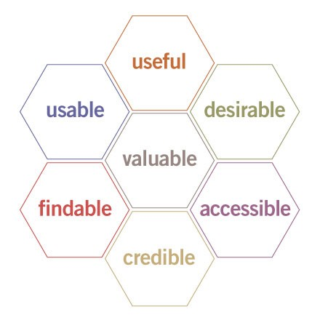
Figure 1 - UX Honeycomb [39]
The figure above shows the honeycomb as interconnected cells, representing that each facet is crucial and interrelated [37] [40].

Principle | Description | Healthcare Dashboard Example
Useful | Core functionality that directly addresses the top priorities [39] [41]. | A real-time early warning score panel that aggregates vital signs and flags patients at imminent risk of deterioration.
Usable | Intuitive, efficient interface that reduces interactions through clear layouts and guided workflows [39] [42]. | A filter sidebar with preset views letting users drill into relevant data with one click.
Desirable | Engages users emotionally through polished visuals, meaningful patient stories, or subtle animations that reinforce trust and satisfaction [39]. | A “Spotlight” carousel that highlights success stories alongside performance metrics, complete with smooth transition effects.
Findable | Organises data and functions so users can locate any metric instantly, with consistent labelling [39] [41] [42]. | A universal search bar that returns patient charts, protocol documents, and bed-occupancy graphs in a single list.
Accessible | Full operability for all users via screen-reader compatibility, shortcuts, high-contrast themes, and scalable text [39] [41] [42] [43]. | A high-contrast toggle and labelled controls on every chart, with possible keyboard navigation for clinicians with visual or motor impairments.
Credible | Builds trust by surfacing data provenance, timestamps, audit trails, and clinical guideline links within each dashboard widget [39] [41] [44] [45]. | Each metric shows its data source, last-refreshed time, and a link to the underlying guidelines.
Valuable | Demonstrates clear return on investment, time saved, improved outcomes, or cost reductions, so users immediately see its impact [42]. | The data and visuals allow users to quickly scan, and deep dive into the data saving time understanding the service resources.

2.1.7 Health-Specific Evaluation Models
Usability and UX frameworks offer a structured, user-centred roadmap that aligns design choices with real user needs. As Lewis et al. [46] explain, they distil best practices into clear guidelines, and Lesselroth et al. [47] highlight Health-ITUEM’s healthcare-specific criteria for error prevention, learnability, and performance, a model that can be paired with Health-ITUES and Post-Study System Usability Questionnaire (PSSUQ) for satisfaction benchmarking [48]. This reduces guesswork and these frameworks streamline development, enable consistent team collaboration, and provide measurable targets for accessibility, credibility, and desirability. A study conducted by Schnall et. al. [49] showed that a PSSUQ can be used to measure the user’s perceived satisfaction of digital services.
Frameworks like Shneiderman’s, Norman’s, and Nielsen’s offer solid guidance for healthcare dashboards, but O’Donoghue [50] argues they can be adapted when user research and testing show a workflow-driven change improves efficiency. Ooi’s study [51] finds all three emphasise consistency, error prevention, and feedback, crucial for patient data, while each brings its own advantages - Norman on cognitive fit, Nielsen on common usability pitfalls, and Shneiderman on developer-tested norms.

Overall, by comparing the frameworks, no framework can cover every eventuality. A multifaceted approach to the value of the frameworks can demonstrate how integration of these principles can drive practical improvements for many interfaces.

For examples how some aspects of the frameworks can be incorporated into real life examples, UK Healthcare organisations have adopted usability and UX principles in their endeavour to publish health data dashboards.

2.2. Healthcare Dashboards: An Overview
Every healthcare provider will want and need to understand their data. For organisations within the National Health Service (NHS), they produce public facing dashboards to show their performance metrics on a national scale.

Usability and UX is exasperated when producing dashboards for public viewing, since there is a greater audience, with a more diverse range of expertise, and more of an emphasis is placed on context.

The example below, from the Office for Health Improvement & Disparities, highlights some good UX design features. From an initial summary page, with navigation, to subsequent supplementary pages with easy-to-follow navigation icons.

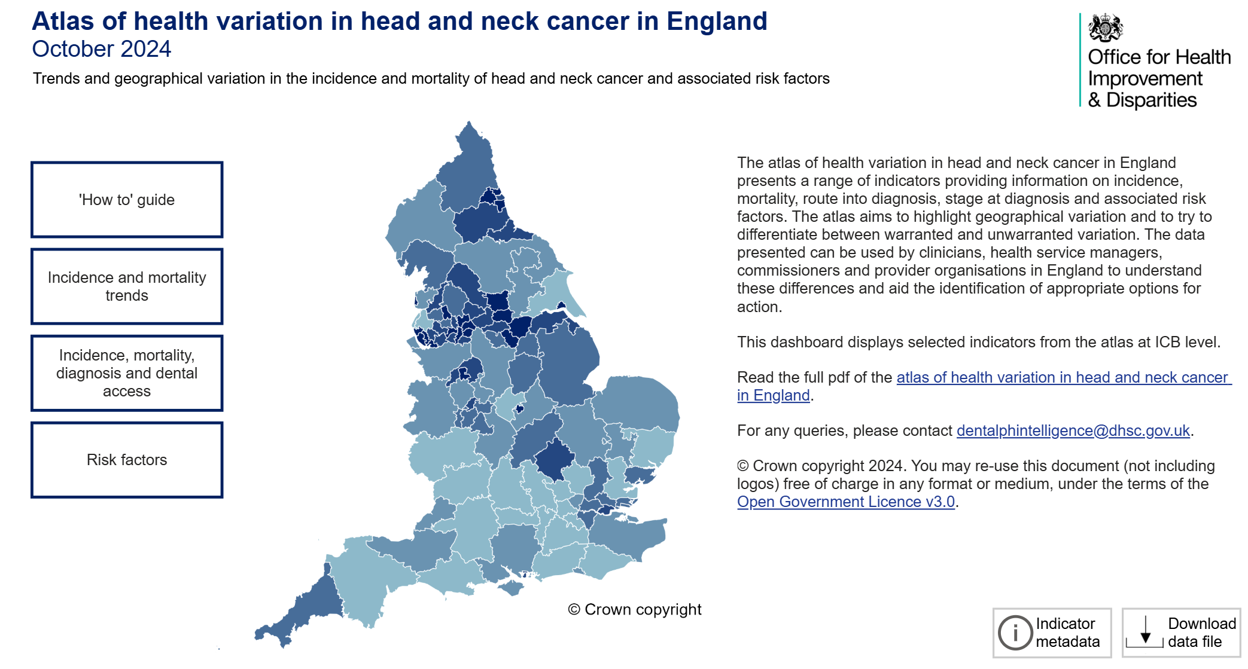
Figure 2 - NHS England Dashboard – 1 [52]
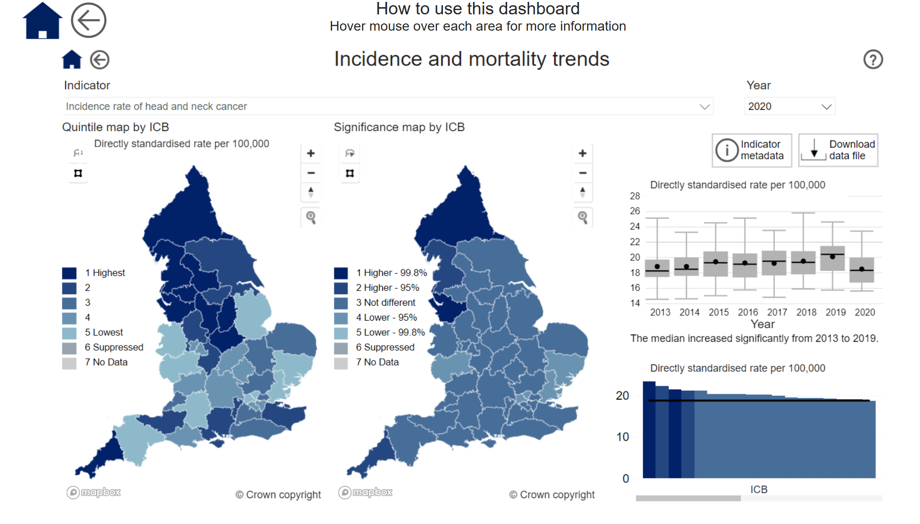
Figure 3 - NHS England Dashboard - 2 [51]
NHS Scotland has taken a different approach from NHS England, where they haven’t utilised any mapping visuals. This can be seen as an improvement as it removes the ability for the user to know here their location is.

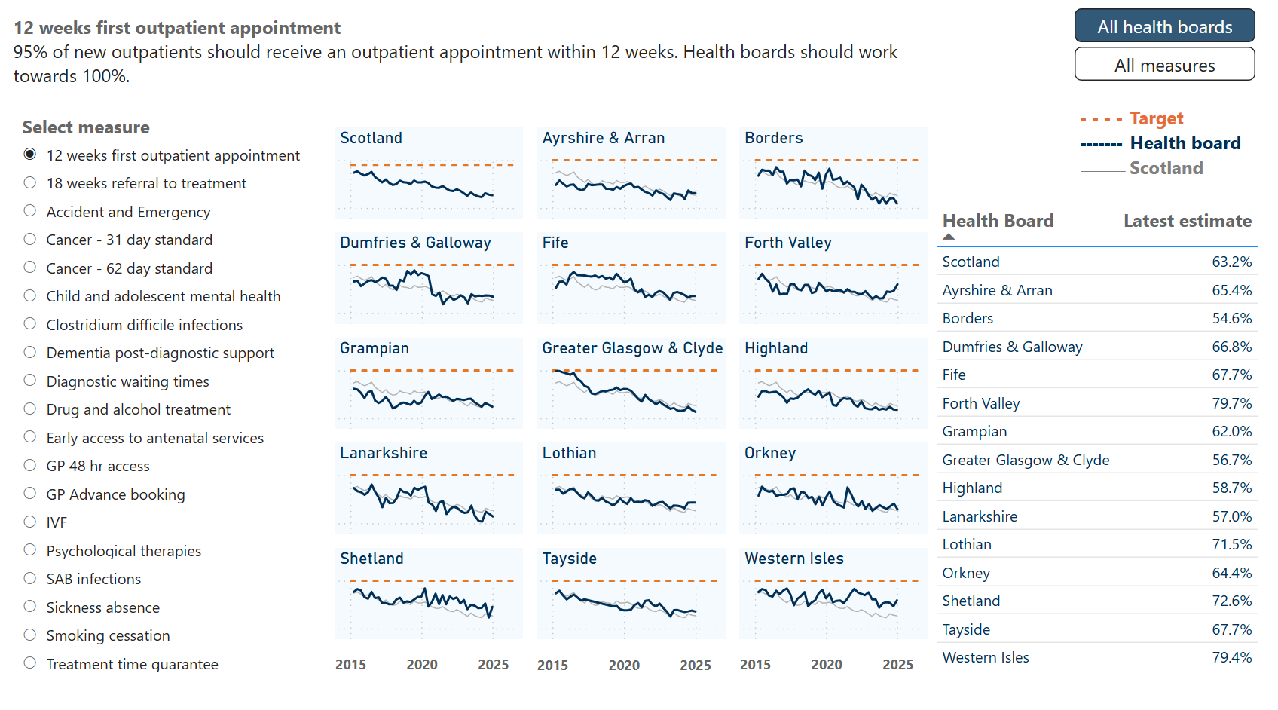
Figure 4 - NHS Scotland Dashboard -1 [53]
A more trend orientated approach has been taken, to visualise to data over a timeline. In contrast to NHS England where it is more of a prevalence approach.

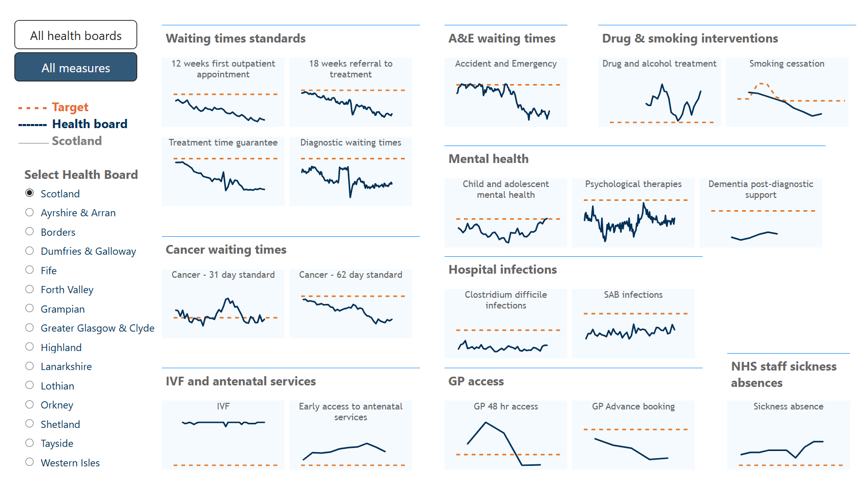
Figure 5 - NHS Scotland Dashboard -2 [53]
NHS Wales’ approach is like NHS Scotland – utilising the same colour themes and visuals. These dashboards also enable translation from English to Welsh, thus reducing the accessibility issues for Welsh language speakers.

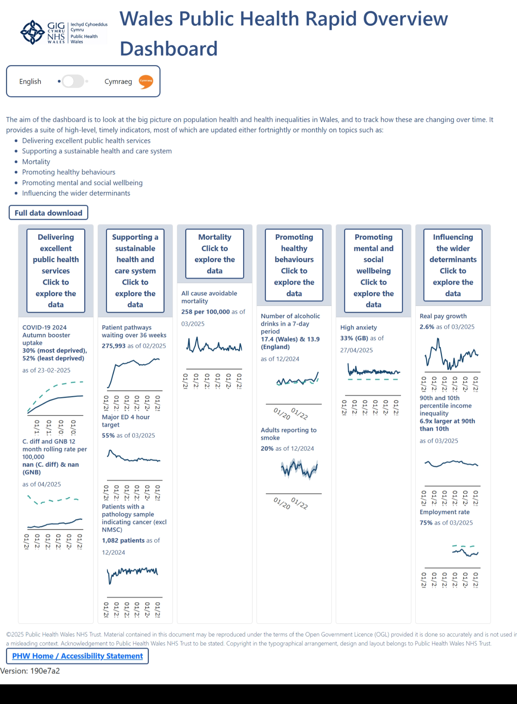
Figure 6 - NHS Wales Dashboard – 1 [54]
The Department of Health Northern Ireland takes a more simplistic approach and shows more high-level data aggregation. A simpler view such as this, may be more beneficial for the public, with an easier understanding of what the data represents.

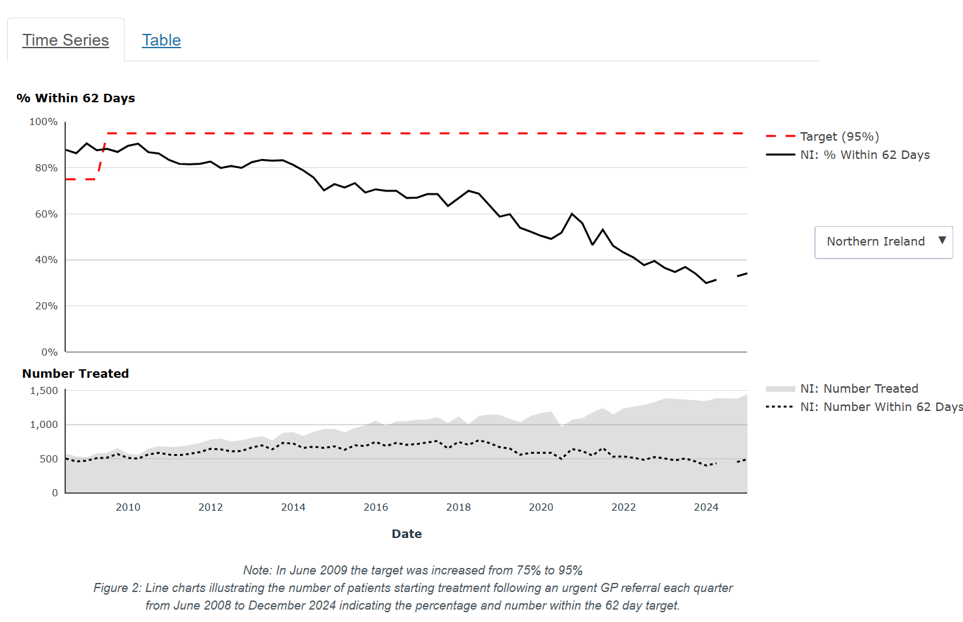
Figure 7 – NHS Northern Ireland Dashboard – 1 [55]

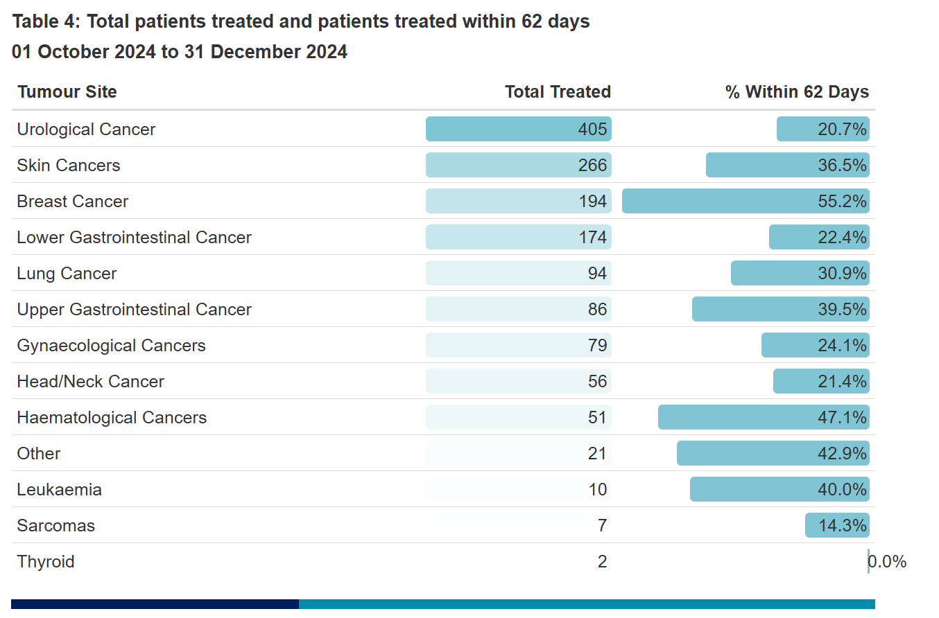
Figure 8 – NHS Northern Ireland Dashboard –2 [55]
Overall, each of the home nations has taken a slightly different approach. Although, the theme is generally similar across the board, each dashboard has advantages and disadvantages from a usability and UX perspective.

All of these dashboard examples will have had to overcome challenges. The following outlines some of the challenges the developers of these dashboards may have faced.

2.2.1. Usability Challenges in Healthcare Dashboards
Dashboards, especially healthcare dashboards, are critical tools that are used for administrative and clinical data, assisting in decision making, resource utilisation, and performance. Healthcare dashboards are not immune to usability challenges that hinder their effectiveness. Such challenges include information overload, poor navigation, lack of accessibility and poor feedback mechanisms, these challenges impact UX and decision making. Addressing these challenges can strengthen both usability and UX [56]. Strategies to address these challenges and improve design and effectiveness can be:

2.2.1.1 Information Overload
Rabiei et. al. [57] describe how information overload occurs when excess data and visuals overwhelm users, obscuring key insights. This sentiment is also backed up by Edmunds et. al. [58] highlighting that but excessive amounts of data can be counterproductive.

In healthcare dashboards, this ‘Information Chaos’ leads to:

- Cognitive overload: fatigue and impaired critical tasks

- Slower decisions: extra time filtering low-priority data

- Increased errors: missed alerts or trends risk clinical mistakes

Zhuang et al. [59] recommend task-aligned, interactive designs with feedback loops and iterative refinement to combat overload A well-designed healthcare dashboard should focus on the critical metrics through clear visual hierarchies and layered views that enable drill-down for detailed data while minimising visual noise.

2.2.1.2 Poor Navigation
Poor navigation refers to difficulties users face when searching or switching between information on dashboards. Unclear menus, non-intuitive layout, or complex workflows all contribute to poor navigation. For a healthcare dashboard this is where frustrations can arise impeding the user’s task.

Juno Health’s article [60] highlights that a complex interface requires heavy interaction - adding more clicks, scrolls, and time to your workflow. This implies that poor navigation increases cognitive load and error risk.

Some strategies include:
- Intuitive layout and menus: group related items and use familiar healthcare terms for quick discovery.

- Consistency: uniform labels and themes reinforce users’ mental models.

- Search functionality: powerful search lets users access any element without navigating complex menus.

2.2.1.3 Lack of Accessibility
Dashboards that lack accessibility become unusable for people with varying abilities or in different contexts of use. When interfaces don’t comply with standards like WCAG, they exclude users, hinder clinical tasks, and risk violating accessibility requirements. In fast-paced clinical environments, poor responsiveness further disrupts workflows and slows decision-making, compounding inefficiencies.

Adhering to international accessibility standards provides a clear strategy for addressing these issues. By following WCAG guidelines for colour contrast and meaningful labels, developers can ensure interfaces meet recognised criteria and offer sufficient clarity. Incorporating comprehensive training that highlights and empowers users to leverage built-in accessibility options further enables clinicians to use dashboards to their full potential.

Bilingual accessibility, especially the integration of Welsh in healthcare dashboards, remains a critical gap. Research shows that permanently visible Welsh labels boost task accuracy by around 20% and reduce completion times by 15% [61], and a reliable English to Welsh toggle can raise System Usability Scale scores by 10 points [62]. Yet inconsistent translations and low visibility undermine adoption, with fewer than one in ten dashboards meeting basic bilingual UI standards [63]. Making Welsh elements clearly visible and standardised is essential to improve equity and usability in healthcare data interfaces.

2.2.1.4 Inadequate Feedback Mechanisms
Feedback is a cornerstone of user interface design, informing users how the system responds to their actions, providing status updates and confirming operations. Kwong [64] shows that poor feedback breeds uncertainty, frustration and reduced efficiency. To remedy this, real-time feedback, clear status indicators and timely alerts for critical thresholds are essential.

Healthcare dashboards also face challenges like information overload, confusing navigation and accessibility gaps. When interfaces are cluttered, decisions can be delayed and error-prone, users become frustrated, productivity reduces, and patient care may suffer.

A deliberate, user-centred design approach that embeds robust feedback mechanisms, adheres to accessibility standards drives faster adoption, smoother workflows and better patient outcomes. By applying best practices early and continuously refining the design based on real user feedback, dashboards can fulfil their promise as powerful, data-driven decision-support tools.

Once the challenges have been addressed, during the design phase, best practices need to be adopted to ensure the reduction of challenges discussed above.

2.3. Design Best Practices for Usability and UX
Easy, efficient, and enjoyable interfaces or digital products makes great user experiences. The definition of ‘Usability’ is the extent to which users can achieve their goals effectively and satisfactory in the given context [65]. This means a usable design allows users to complete tasks quickly without any frustrations.

Steve Krug [5], famously wrote usability is ‘making sure that a person of average ability and experience can use the thing... for its intended purpose without getting hopelessly frustrated.’ [66].

UX tends to further encompass a user’s feelings and perceptions during interactions and interfaces with excellent UX feels intuitive and comfortable to use.

Best practices for high usability and positive UX include principles such as:
- Intuitive Navigation,
- Visual Hierarchy,
- Accessibility, and
- User-Centred Design.

2.3.1 Intuitive Navigation
Intuitive navigation aligns with user expectations, guiding users effortlessly to features and reducing cognitive load. This clarity prevents frustration and encourages full use of the interface.

Grivet [67] references Hicks-Hyman law [68] that demonstrates reaction time increases with the number of choices offered. Therefore, Grivet has assessed certain parameters for intuitive navigation.

- Simplicity - Streamlined menu helps users quickly scan and decide where to go.

- Clear Descriptive Labels – Every item should describe its function, avoiding generic terms that make the user unsure about the selection.

- Logical Hierarchy - Clear hierarchy helps users understand the relationships between sections.

- Search Functionality - Good search complements navigation by handling specific or unexpected queries.

- Consistency - A consistent navigation scheme throughout so users don’t have to re-learn on each page

- Feedback – Cues guide the user’s attention, reducing uncertainty through the interface.

- Test - Continuous improvements based on user behaviour ensuring navigation stays aligned with user needs.

2.3.2 Visual Hierarchy
Visual hierarchy arranges and styles interface elements, so users naturally focus on the most important content in the correct order, reducing cognitive load and boosting clarity. Murash and Silchenko [69] note that if everything looks equally important, nothing stands out, so a clear hierarchy is essential.

Key techniques:
- Size & placement: larger, prominently placed elements draw the eye.

- Colour and contrast: high-contrast hues highlight priorities; WCAG recommends a 4.5:1 contrast ratio for normal text [70].

- Typography: varied font sizes and weights signal information levels.

- Proximity grouping: items close together or sharing style appear related.

- Scanning patterns: align layouts with F- or Z-shaped eye movements.

2.3.3 Accessibility and Inclusive Design
Accessibility ensures that all users, including those with disabilities, can navigate and interact successfully, complementing usability to create inclusive experiences. Theofanos et al. [71] advocate blending empathy with compliance, using a holistic approach to design.

Meeting WCAG’s 4.5:1 contrast ratio [70] maintains readability in any environment, while alternative text for non-text elements [72] clarifies purpose. Touch targets should be at least 44×44 pixels [73], layouts must remain predictable and consistent, and language should be plain and task-focused [74].

The avoidance of colour-only cues, vital for the 300–350 million colour-blind users worldwide [75], and make interactive elements obvious.

Finally, testing with diverse user groups and automated checkers can catch the gaps earlier.
Applying these accessibility practices alongside core UX principles produces interfaces that are effortless to navigate, intuitive to understand, and engaging for every user.

By designing dashboards with usability and UX at the forefront, the positive impact can be realised.

2.4. Impact of Usability and UX Design on Healthcare Outcomes
Usability and UX design are crucial, especially in healthcare dashboards, as it can directly influence patient engagement, treatment adherence, and overall satisfaction. Electronic Health Records (EHRs) can reduce the risk of medical errors and ultimately improve outcomes and patient safety [76].

Omaghomi et al. [77] identify interoperability and data-accuracy gaps as major UX barriers in health data apps, advocating usability frameworks to elevate quality and calling for research on long-term impacts, underserved populations, and AI integration. Both Omaghomi and Abdul et al. [78] stress user engagement, accessibility, technology as a catalyst, and adoption hurdles, but Omaghomi pursues a technology-driven strategy, whereas Abdul adopts a policy-driven approach.

The Journal of Medical Internet Research suggests that good ux can increase engagement by up to 60% and improve medication adherence by up to 40% [79] [80], suggesting a direct impact to patients and boost user satisfaction by 40% [81].

The impact of UX design has been widely documented, these following case studies showcase the real value of usability and UX when designing dashboards.

2.5. Case Studies and Examples
The following case studies from hospitals and health organisations illustrate how well-designed dashboards (with the right data and user-centred design) have improved decision-making and patient outcomes.

2.5.1 Johns Hopkins Hospital – Capacity Command Centre
Taylor [82] describes ‘Command Centres’ as centralised hubs designed to manage patient flow, hospital capacity, and operational efficiency across the organisation. These centres have become increasingly vital due to the rising demand and capacity strain.

John Hopkins Hospital implemented a high-tech capacity command centre in 2016. Functioning as a ‘mission control’ with wall mounted dashboards and analytics that track patient movements through the system.

The key design features bring analytics, artificial intelligence, and decision makers in one location [83]. Predictive algorithms forecast patient volume and highlights bottlenecks via a user-friendly interface that displays colour coded alerts for a range of metrics, such as bed availability, operating room status, and ambulance arrivals – this enables staff to coordinate in real-time.

The impact on decision making, report by John Hopkins, resulted in an increase in bed capacity, and a 38% faster bed allocation time. The ambulance dispatch time was also improved by on average 43 minutes [83].

These changes translated to patients spending less time waiting for beds, and procedures and a timelier delivery of care. This model has become ‘an internationally recognised model of excellence’, demonstrating how a well-designed operations dashboard can improve patient safety, experience, and flow.

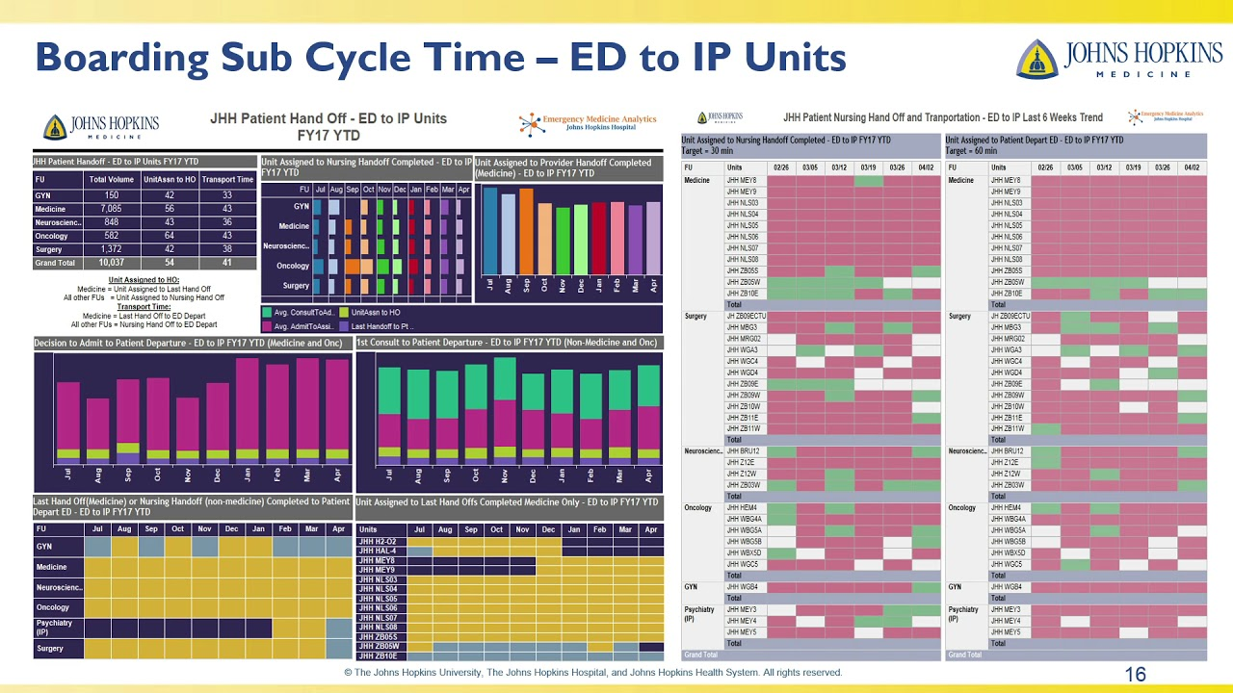
Figure 9 - John Hopkins Demand Dashboard [83]

5.2.2 Ochsner Health – Laboratory Analytics Dashboard for Quality Improvement
In 2021, Ochsner Health, adopted a real-time analytics dashboard to improve clinical quality and standardise laboratory practices across its 46 hospital sites [84]. The dashboard was used to drive improvements, system-wide, in critical care metrics.

The key design features involved integrating data into one central dashboard, updated in real-time. The data can then be sliced by hospital, benchmark, and identify outliers. The emphasis for the system was ‘near real-time’ feedback. Analytical alerts were also introduced, for example, a metric, like test turnaround exceeds a threshold, the dashboard flags it, prompting immediate investigation.

By pulling in data points, like sepsis mortality rates, for example, which are affected by test result speed and accuracy the dashboard linked laboratory performance directly to patient outcomes.

Immediate insight into system-wide data, performance gaps were identified and by pinpointing process bottlenecks they cut the average STAT test turnaround by 60 minutes [84]. Ochsner also saw increased patient satisfaction, likely because faster lab results meant quicker diagnoses and treatment. This case shows how a dashboard focusing on specific care processes can drive significant quality gains and better patient outcomes through data-driven interventions.

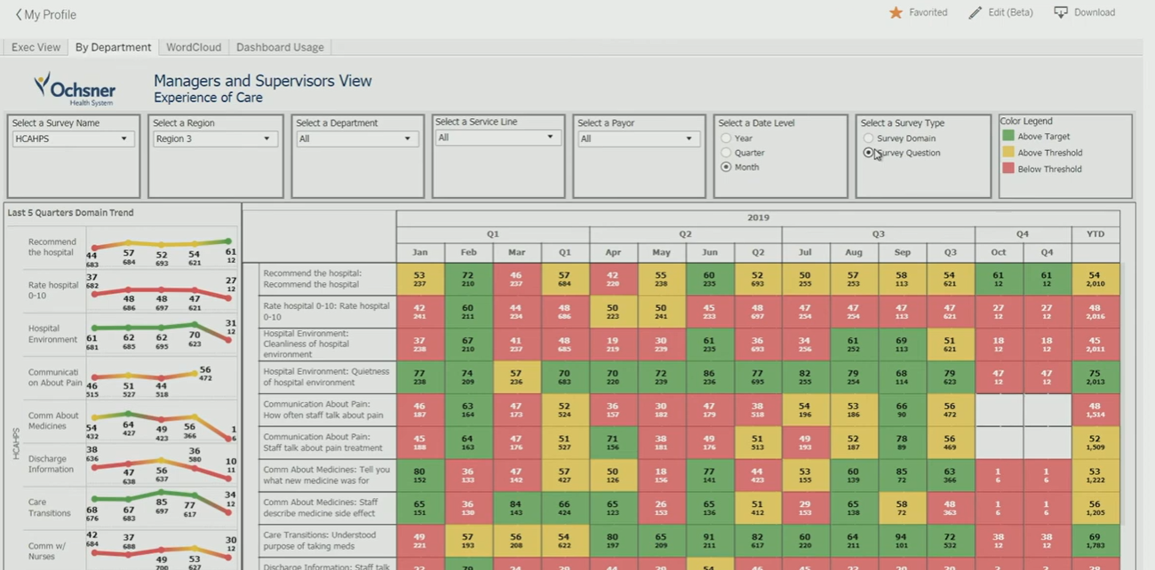
Figure 10 - Ochsner Dashboard [84]

5.2.3 Rush University Medical Centre – Readmissions Reduction Dashboard
Rush University System for Health (Chicago) harnessed a data dashboard and analytics initiative to tackle hospital readmissions [85]. Using an integrated dashboard linked to a national database, Rush University Medical Centre targeted high-risk patients and achieved notable reductions in 30-day readmission rates.

Leverage from the Vizient Clinical Data Base (CDB) [86], allowed Rush to benchmark its performance against comparative hospitals. Readmission metrics were made highly visible throughout the organisation. The design emphasised multi-department collaboration connecting inpatient care, discharge planning, and outpatient follow-up, all informed by the shared data.

Access to timely, comparative data enabled Rush to implement targeted changes to reduce avoidable readmissions. Within the programme’s span, Rush documented 27 fewer readmissions than expected, translating to an estimated $694,000 in savings [85]. Key to this success was making the data transparent and actionable, by cascading the dashboard metrics to all levels, Rush ensured reducing readmissions became “an organisational priority” with shared accountability.

Successfully dashboards pull in data from multiple sources into one unified view. This holistic approach ensures that all relevant information is considered in all decisions. Timeliness is critical when utilising near real-time scenarios. In the case studies, real-time monitoring helped catch issues early directly leading to better outcomes.

Beyond just displaying numbers, effective dashboard help translate data into actions. They often include features like alerts for out-of-range metrics or the ability to drill down into root causes. In the Rush case, for instance, transparency of readmission data across the organization spurred collective action. When users trust the data and see it align with outcomes, they are more likely to take timely action.

Healthcare data dashboards have proven to be transformative in various settings by enhancing decision-making and improving patient outcomes, these case studies show that when dashboards are well-designed and focus on meaningful data, they become powerful instruments for positive change in healthcare as demonstrated by Adekugbe et. al. [87].
These case studies have utilised modern technology to future proof their respective organisations. Many of the technologies that have been employed enhance the future direction of how dashboards can be used.

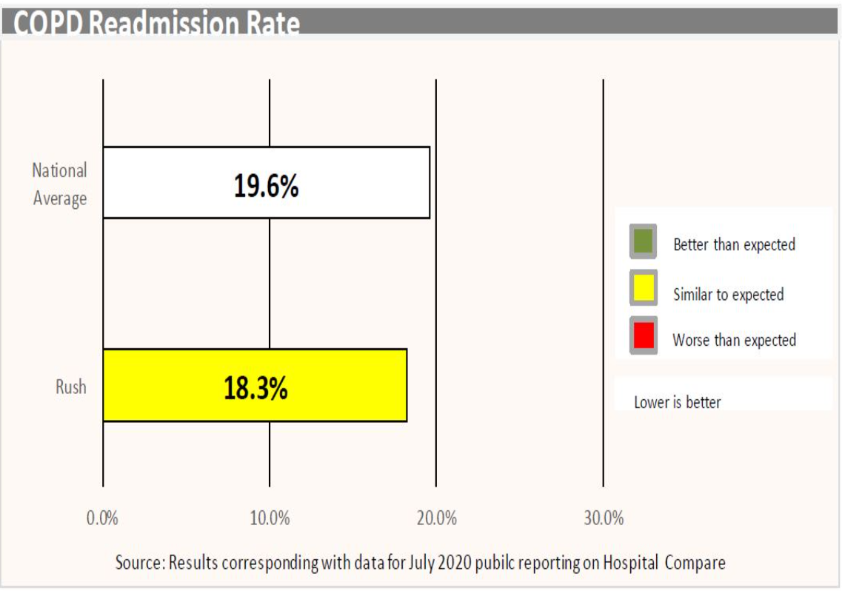
Figure 11 - Rush Readmissions [87]

2.6. Emerging Technologies and Future Directions
Dashboards, especially healthcare dashboards, are rapidly evolving beyond the conventional static and retrospective reports. New technologies and innovations, such as Innovations like artificial intelligence (AI), the Internet of Things (IoT), blockchain, and cloud computing are reshaping how health data used. These innovations are driving more powerful analytics to support clinicians and managers in proactive decision-making [88].

2.6.1 Artificial Intelligence and Advanced Analytics
Artificial intelligence (AI) is becoming the next generation on healthcare dashboards, enabling systems to process datasets and uncover more actionable trends and insights. Machine Learning algorithms can detect patterns and make predictions beyond human capabilities, shifting analytics from descriptive reports to more dynamic decision-making tools. Health organisations are increasingly adopting AI to automate data analysis, reduce manual workload, and gain predictive foresight into patient outcomes.

The impact of AI on dashboards can enhance decision-making more efficiently and the organisations that are utilising these tools report that can improve patient care and outcomes [88].

2.6.2 Internet of Things (IoT) and Real-Time Data
Internet of Things (IoT), such as wearable devices and in-home health monitoring equipment, allow providers to monitor patients from beyond clinical site. An article published by IoT Magazine Newsdesk [89] noted that these devices can track vital signs and behaviours 24/7, streaming the information to cloud-based dashboards. Real-time IoT monitoring empowers interventions at the earliest signs of trouble. Companies like BioTelemetry provide remote patient monitoring platforms that gather data from wearables and use AI to detect anomalies, notifying doctors so they can adjust treatment promptly [90].

By utilising IoT healthcare dashboards can effectively extend beyond where care happens. The joining of IoT with data dashboards creates vital information flow instantly to those who need it. As IoT adoption grows, dashboards will play the crucial role of aggregating and visualising this rich real-time data so that healthcare decisions can be made with the most current information available.

2.6.3 Real-Time Predictive Analysis
Integrating real-time predictive analytics transforms healthcare dashboards into proactive decision-support tools by merging live EHR, wearable, and monitor data with AI-driven, cloud-based models. Forecasting clinical risks, optimises workflows, and guides population health initiatives, enabling clinicians to anticipate deterioration, manage staffing, and deploy preventive interventions for improved outcomes and efficiency.

Predictive dashboards generate real-time risk scores and alerts, such as septic shock predictions up to 24 hours in advance with ~95% accuracy [91] , and prevalence analyses that integrate EHR, social determinants, and search trends to forecast outbreaks and target high-risk groups [92]. Embedding forward-looking and prescriptive insights reduces adverse events and readmissions, enhancing patient flow, and paving the way for AI and IoT-powered, personalised, and ethically designed care.

The emerging technologies can exploit gaps and opportunities. Some of these opportunities are discussed below.

2.7. Research Gaps and Opportunities
Healthcare dashboards still face adoption gaps, long-term usage, behaviour change, and outcomes aren’t well documented resulting in few comparative studies agree on best UX principles.

Predictive-analytics features often remain proofs-of-concept and undermine trust and integration with diverse EHRs, devices, and public-health streams is limited.

Opportunities to strengthen healthcare dashboards include conducting extended trials to monitor usability, adherence, and clinical outcomes over time, developing a standardised UX toolkit tailored for healthcare environments, and embracing interoperability standards such as FHIR to accelerate deployment while ensuring data integrity.

FHIR’s resource-based model creates a shared data vocabulary across systems. By leveraging standard FHIR profiles, teams eliminate most custom mapping and ETL logic. Instead of hand-crafting dozens of bespoke scripts, developers can consume and display FHIR-compliant resources directly, dramatically cutting integration effort and accelerating dashboard rollout.

Identifying the gaps in literature around usability, predictive analytics, and bilingual accessibility, a Double Diamond project methodology will be used as an overarching guide to from discovery to delivery.

Chapter 3 – Methodology
Using ‘Double Diamond’ [93] as an overarching project methodology, nested inside this structure, Feature-Driven Development (FDD) [94] breaks the dashboard interface into user-centric chunks and tested in quick cycles against feedback.

3.1 Project Methodology
The Double Diamond model offers a structured, four-phase roadmap, Discover, Define, Develop, Deliver, that ensures critical research and framing steps aren’t skipped [95], and, as Gustafsson’s [96] thesis shows, it adapts well to fast-paced, resource-constrained environments.

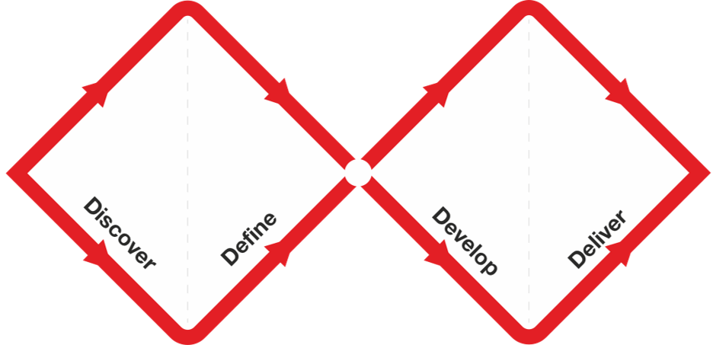
Figure 12- Double Diamond [93]

3.1.1 Discover
The discovery phase uncovers user needs, data gaps, and dashboard barriers via stakeholder interviews, dashboard and data audits, and data-quality reviews. It produces summaries of pain points, cognitive-load and accessibility assessments, and heuristic-based usability recommendations.

The activities for the discovery phase include:
- Stakeholder interviews and surveys.
- Observe current dashboards and data for context to review complexity, accessibility, and cognitive load.
- Review data for quality, completeness, and granularity.

The deliverables for the discovery phase include:
- Interview summaries and survey results to identify key pain points.
- Analyse constraints and accessibility issues for cognitive load hotspots.
- Evaluate heuristic principles and healthcare-specific guidelines for actionable recommendations for improvements.

3.1.2 Define
The goal of the define phase is to aggregate the findings into actionable UX challenges and user personas.

The activities for the define phase include:
- Create evidence-based personas.
- Document usability pain points and bottlenecks.
- Prioritise dashboard use case with operational relevance.

The deliverables for the define phase include:
- Personas and user stories.
- Understand the Key Performance Indicators (KPIs) and data context.
- Reduce cognitive overload to enhance actionable insights.
- UX Requirements and design principles.

3.1.3 Develop
The goal of the develop phase is to create prototype dashboard components that improve usability and support decision-making.

The activities for the develop phase include:
- Layout concepts.
- Wireframe flows for filtering data and navigation.
- Build and refine prototypes using rea-world scenarios.
- Heuristic reviews and peer design critiques.

The deliverables for the develop phase include:
- Annotate wireframes and interaction specifications.
- UX Honeycomb mapping.
- Usability feedback for script testing.

3.1.4 Deliver
The goal for the deliver phase is to validate design through user feedback.

The activities for the deliver phase include:
- Usability testing with diverse participants.
- Analyse results for issues.
- Refine prototypes for clarity, feedback, and learnability.
- Documentation and user guides.

The deliverables for the deliver phase include:
- Report usability findings.
- Final design including layout, style of components.
- Implementation of user adoption and roadmap for any future developments.

By involving the Community Rehab team at every phase, they will be kept informed of progress and give them ownership of the dashboard they’ll use daily. Since team members, from operations to clinical staff, rely on different metrics and workflows, tailoring the interface to their needs rather than force a one-size-fits-all solution. Any design trade-offs will be clearly explained, with full transparency around our decision-making process.

It is important that the most user-centred approach can encounter risks and limitations. By understanding these challenges up front, mitigation can be planned to set realistic expectations to ensure the dashboard’s success in real-world clinical and operational settings.

3.2 Risks & Limitations
Unaddressed data, usability, and integration risks in healthcare dashboards, from schema changes and compliance updates, like GDPR and NHS governance, to shifting priorities, resource turnover, and system outages can mislead insights, erode trust, and harm patient outcomes.

Early testing of data connections, proactive regulatory alignment, and ongoing stakeholder engagement help prevent issues, while contingency plans mitigate disruptions.

Acknowledging time constraints and ethical imperatives like fairness, transparency, privacy, and accountability ensures realistic scope and maintains integrity throughout implementation.

Opaque data integration processes erode transparency and diminish trust. Security gaps that expose sensitive information violate confidentiality, and delayed or inaccurate insights may skew resource allocation, undermining justice in care delivery.

3.3 Ethical Issues
In healthcare data research, fairness, transparency, and privacy are essential. Reducing bias prevents unequal treatment, and clear disclosures build participant trust. While physical harm is minimal in dashboard testing, reviewing sensitive metrics can cause anxiety, and data breaches or misuse threaten reputational integrity.

Compliance with GDPR and the Data Protection Act, using lawful bases, minimal data capture, pseudonymisation, and guidance like the Welsh Information Governance Toolkit [97] paired with robust security, like Active Directory, row-level security, access audits, and accountability measures, DPIAs, asset registers, safeguards confidentiality and underpins the validity, reliability, and generalisability of the findings.

3.4 Validity, Reliability & Generalisability

3.4.1 Validity
Establishing validity means that ensuring interest is measured. Such as the efficiency of decision-making is utilised with the dashboard. By directly measuring usability metrics and heuristics can anchor the investigation in observable behaviours. Adding supplementary measures, like satisfaction or perceived workload, serve as useful context, but are explicitly labelled as proxies. Coalescing quantitative interactions with think-aloud sessions and pre and post interviews and surveys strengthen the validity and confirm that the metrics reflect genuine comprehension and trust.

3.4.2 Reliability
The likelihood that another researcher could replicate the results hinges on how comprehensively the documentation is. Structured methodology and detailed DAX definitions to the exact dataset, transformation logic, and version-controlled data snapshots
and on specifying the tools, environment settings, and any custom scripts will allow a second analyst to follow the same steps and arrive at the same findings, whereas any undocumented filters, unshared parameters or environment nuances will undermine reproducibility.

3.4.3 Generalisability
By consistently reusing validated user-experience surveys and applying a uniform set of usability and UX standards a common measurement framework can be used for any similar organisation or project to adopt. This uniform approach ensures that components remain directly comparable across different contexts and data sets, enabling reliable benchmarking, cross-site learning, and scalable improvements with minimal recalibration.

3.5 Data Evaluation Methods

3.5.1 Data Collection
A pre and post survey questionnaire will be used to evaluate the needs and feedback from the dashboard. Each questionnaire will be implemented through MS Forms and data collected via an MS Excel download.

3.5.1.2 Pre-Development Survey Questions
For the pre-development survey, see Appendices > Appendix 1 – Predevelopment Survey, the SMART Objectives framework will be utilised to manage this aspect of the project.

Specific | Capture usage, pain points, predictive interest, and localised needs.
Measurable | Can the results from the survey produce enough data that it can be quantified.
Achievable | Aim for enough responses that ensure analysis is meaningful.
Relevant | Target potential users.
Time-bound | Ensure there’s enough time to utilise the results to guide the design and build.

SMART objectives provide a clear framework for setting and achieving goals. By crafting objectives that meet all five SMART criteria can evaluate success with confidence.

The scope of this survey will be sent to a large group of general users, with the respondent level of around 20 to gauge insights from the collected data.

3.5.1.3 Post-Development System Usability Scale Survey Questions
For the System Usability Scale survey, see Appendices > Appendix 2 – SUS Survey, again, the SMART Objectives framework will be utilised to manage this aspect of the project.

Specific | Gather metrics from end users to quantify overall satisfaction and actionable issues.
Measurable | Greater than 10 responses and target a SUS score >= 68.
Achievable | Distribute online and prompt users for swift response.
Relevant | Validate whether dashboard meets usability benchmark.
Time-bound | Allow reasonable time to gather enough responses for analysis.

A smaller cohort of potential users will apply for this dashboard. Respondent rate is expected to be higher, due to a more targeted approach, but overall respondents will be lower. Over 10 surveys returned will ensure there is sufficient data to analyse performance.

Additionally, a ‘think-aloud’ session will be used. A ‘think-aloud’ session [98] is when moderated tests in which participants perform predefined tasks on a system while continuously verbalising their thoughts, feelings, and intentions.

This approach gives the researcher direct insight into users’ cognitive processes as they interact with the interface.

To prepare for any suboptimal response rates, the ‘think-aloud’ session can be expanded to include more participants. This multi-pronged approach ensures enough data is secured for meaningful analysis and can adapt when response rates are lower than expected.

Once these data points have been collected, analysing and evaluating will be key to guide the design of the project.

3.5.2 Data Evaluation
To evaluate the pre‐development free‐text survey, an unsupervised text‐analytics pipeline will be used to create themes. Creating themes from the survey will turn scattered free-text responses into clear, actionable insights. By grouping similar comments, like data-quality frustrations, desired visualisation types, or training needs, illuminates the most pressing user pain points and priorities.

The SUS survey will utilise the standard practice to calculate to scores for each user, then aggregate the results into an overall score. With the industry standard set at an average score of 68 – this is what the project aims to achieve. This will be represented through a histogram, box plot and chart to understand the variances in the scores.

During a think-aloud session, the user navigates the dashboard and vocalise every expectation, hesitation, and decision, while GazeRecorder [99] records gaze coordinates and fixation durations. This combined insight pinpoints interface elements that attract attention unnecessarily or undermine the user’s mental model, guiding targeted refinements that improve both visual clarity and overall usability

Once the data evaluation methods have been established, the focus shifts to development methodology that will be utilised in the design and implementation.

3.6 Development Methodology
Feature-Driven Development (FDD) [94] will guide the development of the dashboard through feature-centric approach, that aligns with the goals for releases and stakeholder engagement.

By breaking the development into discrete features ensures each component is scoped, reviewed, and approved.

The five stages of FDD are:
- Develop Overall Model
- Build Feature List
- Plan by Feature
- Design by Feature
- Build by Feature

Justification for using FDD is that it allows users to review and approve features as they’re built. This avoids large releases and ensures each increment aligns with the workflow and needs. This process keeps the risk low while allowing the dashboard to evolve with data insights and user feedback.

Having defined the software methodology, identification of key resources, tools, infrastructure, and expertise that will bring the dashboard to a reality.

3.7 Resources
Various resources are needed to implement the solution.

3.7.1 Hardware Resources
The Welsh Government (WG) announced in 2023 that they will be taking a ‘cloud-first’ approach. They state that cloud platforms are seen as key to rapid, secure exchange of information among stakeholders [100].

3.7.2 Software Resources
Powys Teaching Health Board (PTHB) have taken the ‘cloud-first’ approach and have implemented a cloud-based data warehouse and analytical platform through Azure (warehousing) and Databricks (analytics). For the reporting aspect Power BI is the chosen dashboarding platform of NHS Wales organisations.

For this project Azure will be used as the data storage component, with Databricks as a façade to access the data and for scripting and analytical components.

The dashboard will be built and developed using Power BI Desktop version 2.144.679.0 (June 2025 release) [101].

3.7.3 Information Resources
The patient-level data for this project will be imported from the core Patient Administration System (PAS). This data is initially inputted by clinical and admin staff within the relevant team. This data remains within the NHS Wales domain.

External data sources for this project include GP Practice and geographical lookups. The Organisation Data Service (ODS) Reference Data Catalogue [102] provides unique identification codes and reference data for organisations involved in health and social care. The ODS will be used for the source of GP Practices. For the geographical look up the Open Geography Portal, produced by the Office for National Statistics (ONS), will be utilised [103].

3.7.4 Human Resources
The approach for this project it to have a user-centred design as the priority to ensure success Each aspect of the project will involve a different range of subjects. Many of these subjects will cross-intersect will other aspects.

Initial Pre-Development Survey:
- Sent to large group of users for general feedback on usability and UX aspects of healthcare dashboards.

Data Subject, Metrics, and Dashboard Development:
- Community Rehab Team – including administrative staff and clinical staff.

Usability and UX in other public organisations:
- Interview with a Statistics Regulator at Office for Statistics Regulation (OSR).

System Usability Scale Questionnaire and User Acceptance:
- Community Rehab Team – Evaluate accuracy of measures and dashboard usability
- PTHB Data and BI Team – Evaluate dashboard from a technical point-of-view
- External Subject – Evaluate dashboard from a non-healthcare viewpoint and perform eye-tracking analysis.

As discussed previously, MS Forms will be utilised to gather answers. The other components will be addressed through electronic communications (MS Teams meetings) and in person analysis for the external subject.

Building on the foundational resource considerations, such as data availability, technical infrastructure, and stakeholder input, the focus shifts to the design and implementation phase, where these elements are transformed into functional, user-centred dashboard solutions.

Chapter 4 - Design and Implementation

With collaboration from the Community Rehab Team to define the dashboard measures (see Appendices > Appendix 3 - Metrics and Measures), combining local and national reporting requirements, the metrics, informed by user research, will drive the dashboard’s design and implementation.

Firstly, analysing the responses from the pre-development survey to understand users’ needs.

4.1 Discover - User Needs Analysis
The pre-development survey was used to gather general information and themes around the use of healthcare dashboards. Themes were generated and grouped to drive the design to for a diverse audience and user needs.

4.1.2 Themes
By grouping similar responses, using KMeans, allows a manageable number of themes. Using these themes to inform decisions in design and development of a user-friendly dashboard. The script, see Appendices > Appendix 4 - Pre-Development Text Analysis, analyses the responses from the questionnaire into four distinct clusters.

4.1.2.1 Cluster 1
The first cluster frequently mention challenges such as incomplete data and interoperability issues. This emphasises the need for a unified view of patient data with reliable updates.
What this cluster values are robust integration and clear mechanisms to ensure data accuracy and timeliness.

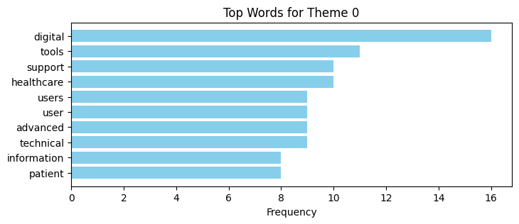
Figure 13- Cluster 1 - Top 10 common words

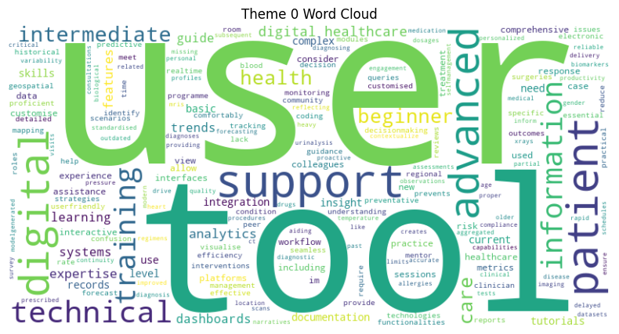
Figure 14 - Cluster 1 word cloud

4.1.2.2 Cluster 2
Cluster 2’s key characteristics focus on having complete data records and seek detailed demographics, clinical history, and up-to-date metrics. The responses indicate that their decisions are based on a broad spectrum of data. This suggests that the users in their cluster are most likely clinicians who need deep contextual information for strategic decisions.
What this cluster values is integration of data from different data sources, in one view, to evaluate both clinical decisions and long-term strategic planning.

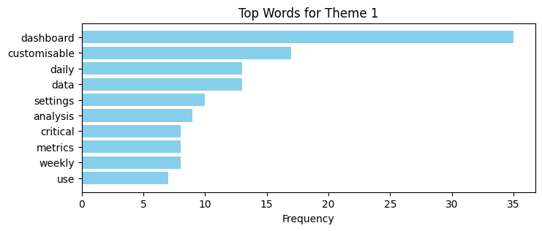
Figure 15 - Cluster 2 Top 10 words
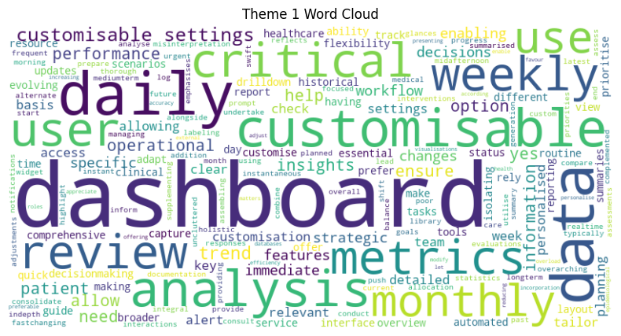
Figure 16 - Cluster 2 Word Cloud

4.1.2.3 Cluster 3
The users in this cluster indicate they rely on dashboards multiple times a day for quick insights. They use the system for routine checks as well as prompt operational decisions. This cluster will likely be frontline managers whose roles demand continuous monitoring and immediate actions. Up-to-date and dynamic visuals is what this cluster values.

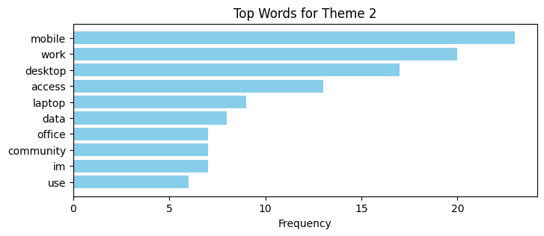
Figure 17 - Cluster 3 Top 10 common words
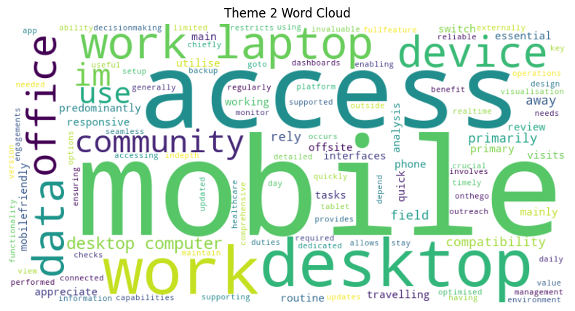
Figure 18 - Cluster 3 Word Cloud

4.1.2.4 Cluster 4
This cluster describes an analyst who is a technically adept user that prioritises comprehensive access to patient and operational data by pulling records from multiple systems and sources into a unified view. They rely on flexible tools and dashboards as their primary interface, enabling on-demand querying, filtering, and visualisation to make data-driven decisions that enhance care delivery.

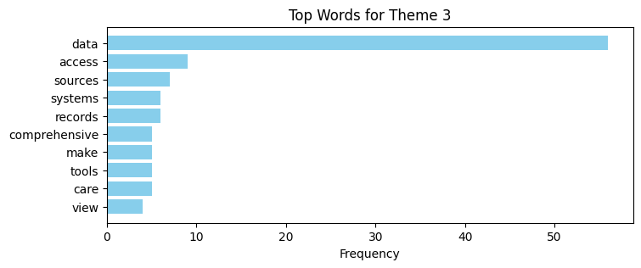
Figure 19 - Cluster 4 word count

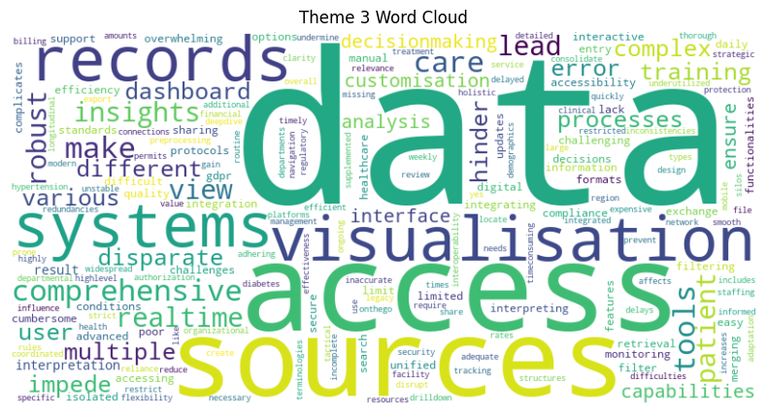
Figure 20 - Cluster 4 word cloud
KMeans clustering of survey responses pinpointed key data access barriers, like fragmented sources, legacy systems, top UX priorities, like real-time updates, intuitive navigation, responsive layouts, and distinct user segments - analysts to novices, who need tailored training and support. These insights steer strategic integration efforts, interface enhancements, and resource allocation to ensure future dashboard iterations meet real user needs.

4.2 Define - Translating Survey Findings into Wireframe Designs
Survey-driven wireframes align navigation flows, content hierarchy, and visuals with real user needs, maintaining consistent layouts for familiarity, and using color-coding to distinguish data subsets.

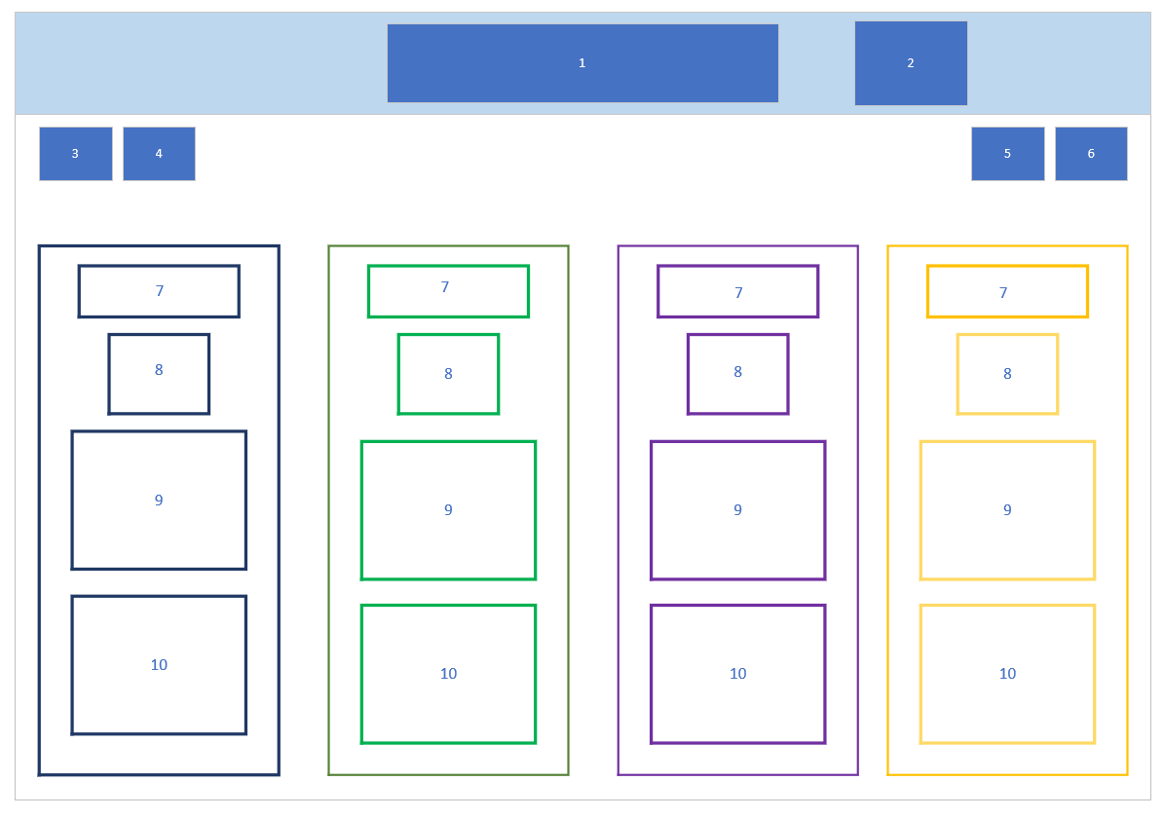
Figure 21 - Wireframe 1

Component | Item | Description
1 | Dashboard Heading | Description of the dashboard
2 | Meta Data | Dashboard last updated date and time.  Data last refreshed date and time.
3 | Back Button | Allows user to return to the previous page
4 | Home Button | Allows the user to return to the home screen
5 | Help Button | Allows user to access the help page for further support
6 | Information Button | Allows user to access the information page for further information on the data and metrics
7 | Subject Heading | Sub-heading for the granularity of the data. Clickable to allow the user to deep dive into the data.
8 | KPI | KPI to allow user a quick glance at latest position.
9 | Lower-Level KPI | Further KPIs that allow user to quickly assess the position of the surface.
10 | Lean Bar Chart | Simple bar chart to show the trend of the data

For each additional page, it will also include the metrics from the summary page preventing the user from returning to the summary page to correlate the high-level measures.

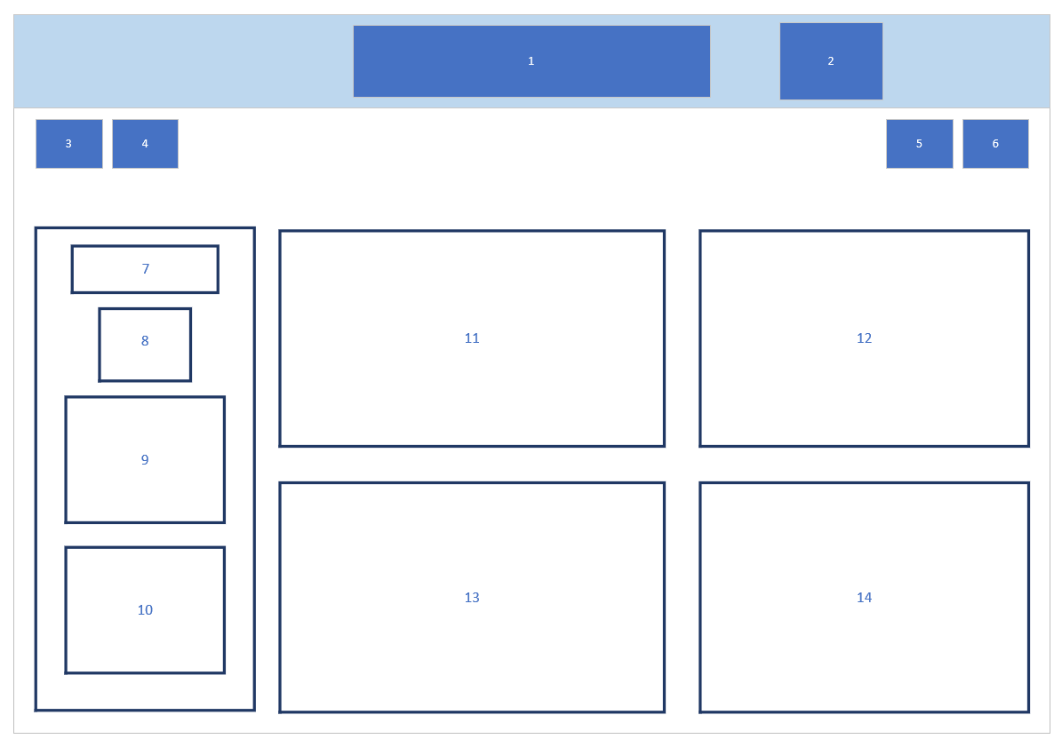
Figure 22 - Wireframe 2
For items 11-14 will display a different metric based on the subset and metrics from the team.

The summary page will allow users to quickly glance at the high-level metrics without deep diving into the data. The supplementary pages support a more in-depth data analysis.

Wireframes provide a good visual representation of what the dashboard may look like. However, the data is the key to the visualisations.

4.3 Develop

4.3.1 Data Scripting and Technical Implementation
Data scripting and technical implementation turn the data sources into a reliable engine for the dashboard, automating extraction, transformation, and loading so the metrics stay accurate and up to date. By layering ETL scripts, and standardised coding practices to ensure the solution is maintainable, scalable, and performance optimised.

The two data sources within the dashboard are:
- Referrals – Source: Patient Administration System (PAS), see Appendices > Appendix 6 – Referrals SQL Script.
- Treatments – Source: PAS to, see Appendices > Appendix 7 – Activity SQL Script.

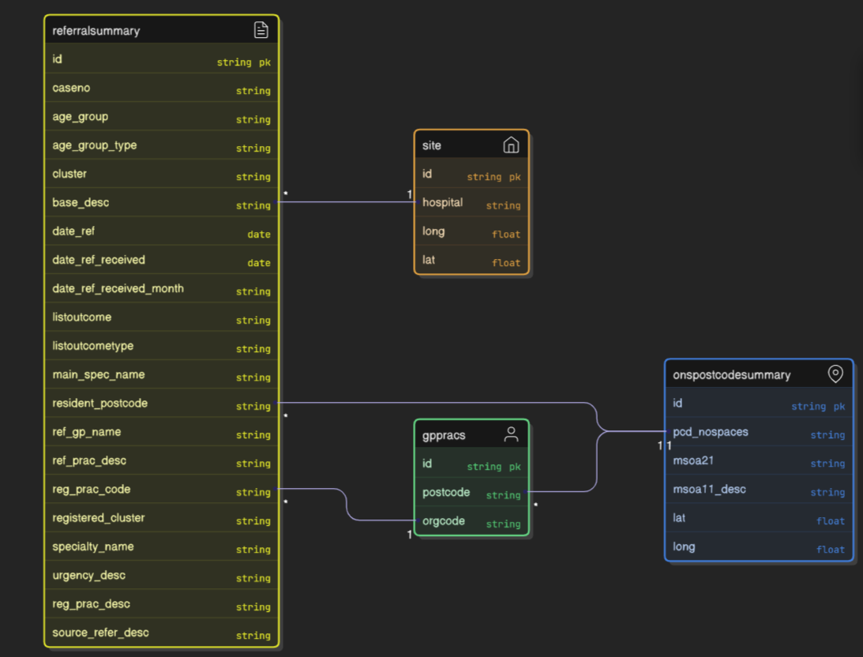
Figure 23 - Referral Table Relationship Entity
The relationship entity for the Referrals contains supplementary tables to gather demographic data for each patient. In the case above GP Practice, Postcode Summary, and Treatment Site. These additional tables will give more descriptive labelling rather than codes, to help users analyse the data in an efficient way.
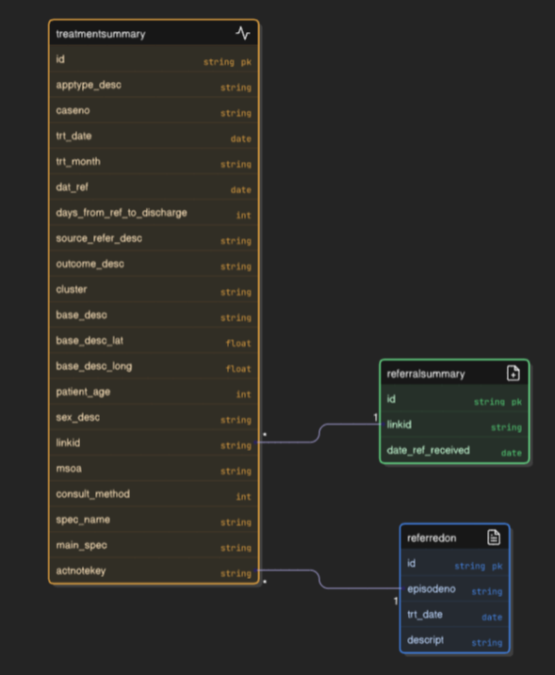
Figure 24 - Activity Relationship Entity
The Treatment table is joined to the Referral table to ensure measures like referral to treatment times are captured. There is also a join to a ‘referredon’ table that holds information on patients that were referred on from the service.

To translate the data into measures, DAX is used to group and calculate different metrics based on the criteria, see Appendices > Appendix 8 - Dax Measures.

Some measures are used purely for UX, like:
- _Assessment TrendColour – this measure assesses and compares two values and switches the colour based on whether there is an increase or increase in activity.
- _Assessment TrendIcon – this measure works the same on ‘TrendColour’ but uses icons to display an increase, decrease, or no change.
- __Map Tooltip Info – is used for showcasing the tooltip within the map visuals.

Once the data architecture and DAX measures have been created, the dashboard visualisations can now be built and turned from wireframe ideas into a working prototype.

4.3.1 Dashboard Prototyping and Functional Refinement
From the wireframes the following functional prototypes have been created.

The summary page, shows each measure in a uniform standard, allowing the user to easily distinguish between each subset.

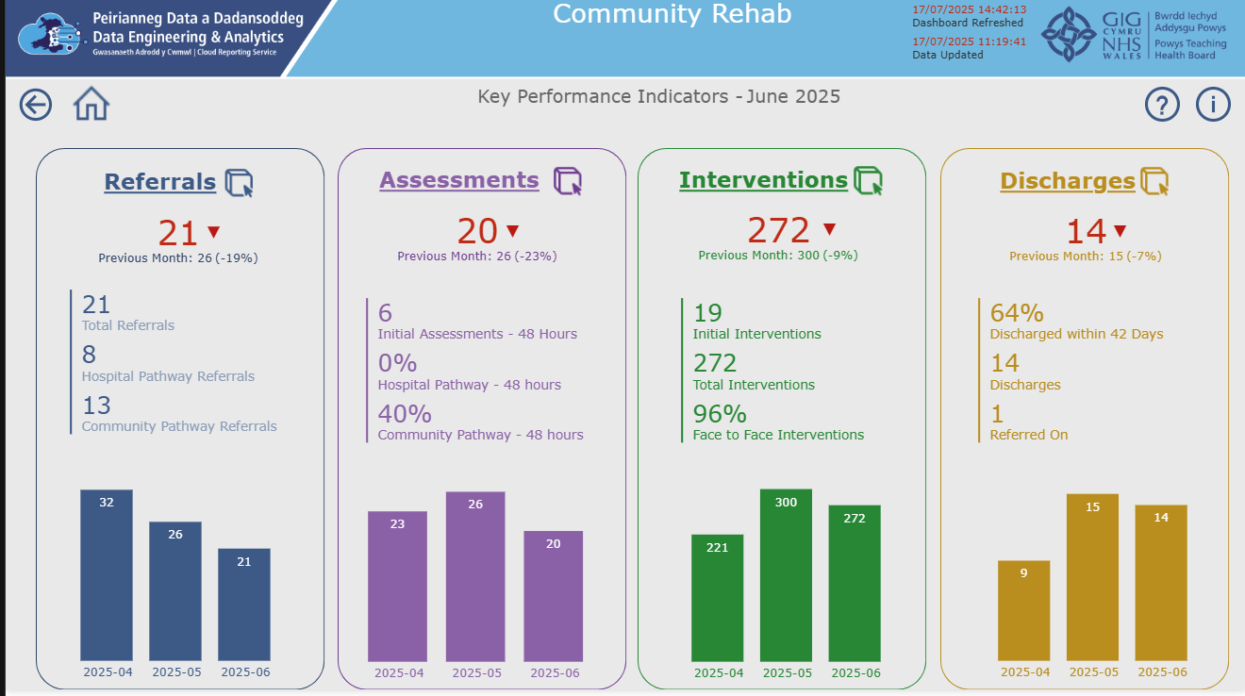
Figure 25- Dashboard – Summary
A conscious effort to following a F,
The user can scan across the high-level measures, using F-Pattern reading style, along with the colour-coding and icons to give a quick overview of the metrics.

Each supplementary page is accessed through clicking on the title of the subject. This is directed through the icon, indicating it is clickable, but also a response when the user hovers over.


Figure 26 - Title Hover

This adds to the usability and UX of the dashboard, allowing the user to navigate intuitively throughout the dashboard.

Each supplementary page has a colour theme and layout; ensuring the user understands where they are without introducing cognitive overload.
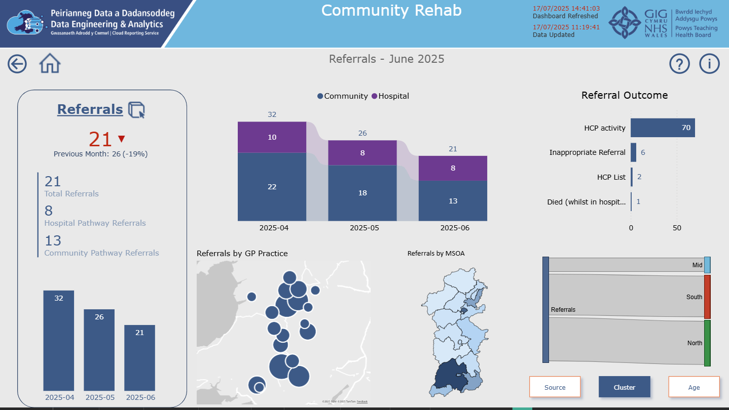
Figure 27 - Dashboard Referrals

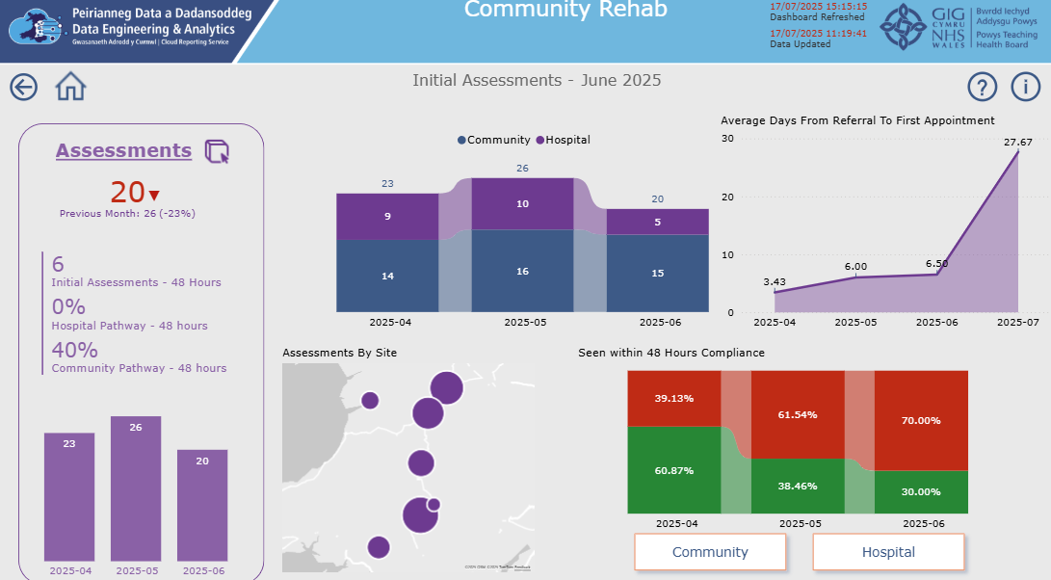
Figure 28 - Dashboard Assessments

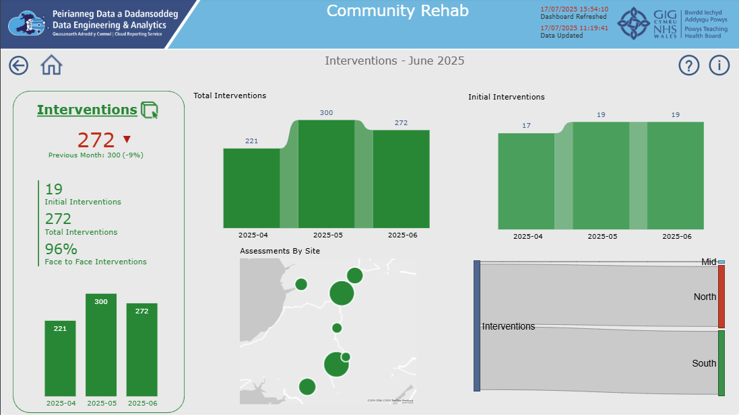
Figure 29 - Dashboard Interventions

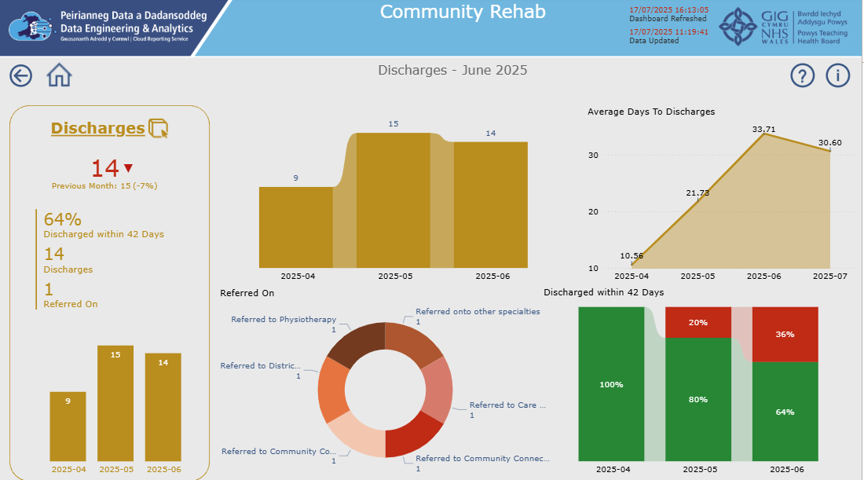
Figure 30 - Dashboard Discharges

The design overall has intentionally been kept minimalist, whilst maintaining a degree of well-presented data analysis. This serves as in keeping with the results from the pre-development survey.

Other usability/UX factors that have been incorporated include:


Figure 31 - Back and Home buttons


Figure 32 - Information and Help Icons
These buttons allow the user to navigate through the dashboard with relative ease. In the same manner as the titles, each button response with a colour change to signify there’s an action attached.

To ensure the user knows if the data is accurate and up to date, there’s meta data included on each page to indicate when the data was last updated and when the dashboard was last refreshed.

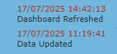
Figure 33- Updated Meta
Tooltips are used to allow the user to hover over a map metric to show more detail from the visual.

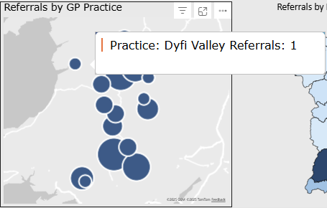
Figure 34 - Tooltip 1
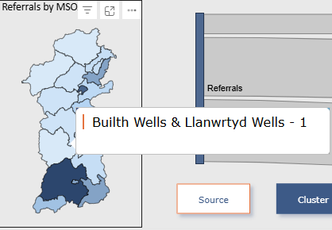
Figure 35 - ToolTip 2

The design and implementation stage has covered the first three principles of the ‘Double Diamond’. To satisfy the deliver phase the following evaluation will analyse the results and discuss the conclusions from the data.

Chapter 5 – Evaluation
This chapter will present the principal conclusions drawn from the data and examine how these findings align, or diverge, from the themes established in the literature review. Reflecting on whether the observed results met the expectations and highlight any areas that could be conducted differently.

5.1 Deliver
The final phase of the ‘Double Diamond’ is to deliver the product and analyse the results.

5.1.1 Post Development Evaluation Using SUS Survey
Firstly, clean and normalize every response, then vectorize the data with TF-IDF [104] to weight terms by their importance across all answers.

Once the data has been cleansed K-Means clustering is used, employing elbow method [105] and silhouette scoring [106] to ensure that the chosen number of themes yields well-separated groupings. A silhouette score of 0.25 and over will be the cutoff for acceptable cluster coherence. If scores fall below this, a change to the cluster count will be investigated.

Flow diagram of the SUS Analysis Script, Appendices > Appendix 11 - Sus Scoring Script:

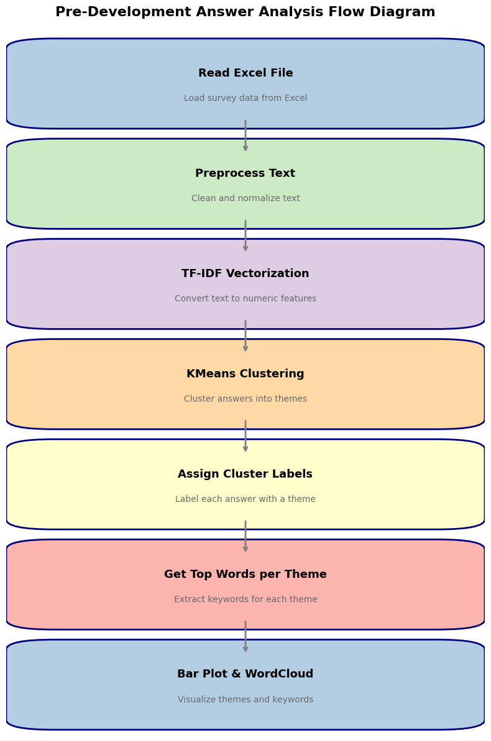
Figure 36 - Pre-Development Flow Diagram

The scoring for the SUS Analysis, see Appendices > Appendix 10 – Sus Scoring Criteria, shows how each question is marked. All scores are added together and multiplied by 2.5 to yield a score of between 0 and 100 [107].

Ensuring reliability Cronbach’s [108] alpha will be used for the full SUS scale, targeting α ≥ 0.70 for acceptable internal consistency.
The results will test the hypothesis of:
- H₀: The mean SUS score for our dashboard equals the industry benchmark of 68.

- H₁: The mean SUS score for our dashboard is greater than 68.

Sauro [109] suggests a SUS score above 68 is widely accepted as ‘above average’.

SUS Scoring Results
- Mean SUS Score: 79.58
- Standard Deviation: 7.45

Responses, see Appendices > Appendix 9 - Sus Response Answers, gave a mean SUS score of 79.58 placing the dashboard above the industry average (68). In practical terms, most users found the interface intuitive, efficient, and satisfying.

A standard deviation of 7.45 shows moderate consistency in responses. About two-thirds of scores fall between 72 and 87, indicating that while most users share a positive view, a handful experienced minor usability issues.

Together, these metrics suggest the dashboard delivers strong overall usability, with only targeted refinements needed. Investigating the lower-scoring outliers should increase the user satisfaction.

Visualising the results pinpoints any outliers or bottlenecks. The visuals show distribution, spread, and count of results. See Appendices > Appendix 12 - Sus Scoring Visual Script.

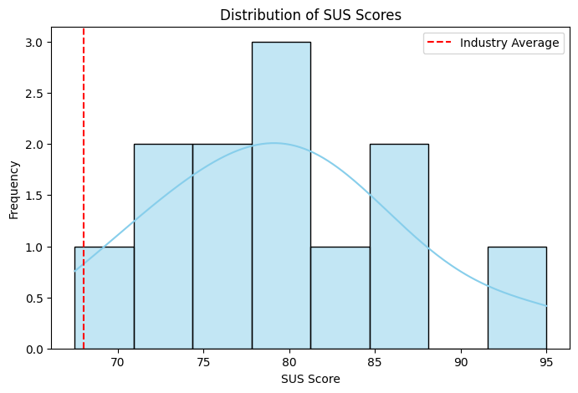
Figure 37 - SUS Scoring Distribution

The histogram of the SUS Score shows how the usability scores are distributed among all respondents. It shows the most common SUS score and where the scores are clustered. It shows that the scores are consistent across each respondent.

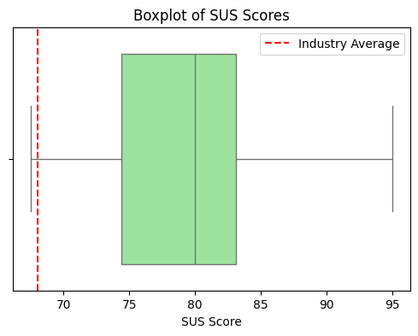
Figure 38 - SUS Scoring Box Plot
The box plot of SUS scores shows the distribution of the scores in the dataset. It visualises the median, interquartile range, and minimum and maximum values. It shows the central tendency and spreads to highlight any unusual scores. In this case the scores are again consistent.

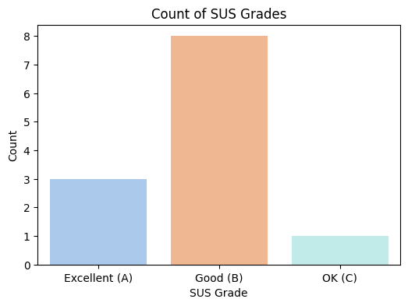
Figure 39 - Sus Score Grades
The count of SUS Scores gives an overall comparison between the respondents. Most were placed in the good category informing that the dashboard has ‘good’ usability and UX tendencies.

To reinforce the scores, a think-aloud session and eye tracking analysis is used, in conjunction, to highlight any key points throughout the dashboard.

5.1.2 Think-Aloud Usability Testing with GazeRecorder
Using GazeRecorder [99] a participant was tasked with viewing the dashboard. The participant wasn’t given any instructions, but asked to commentate on their actions.

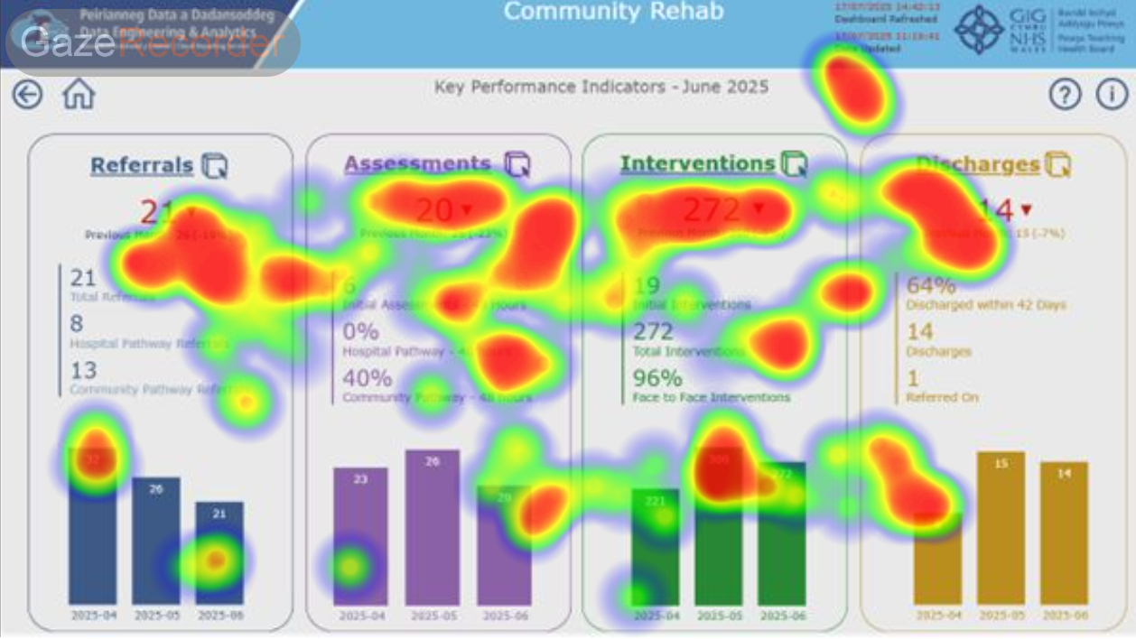
Figure 40 - Eye Tracking 1

In 10-second eye-tracking tests, see Appendices > Appendix 13 - Eye Tracking Visuals for all pages, gaze clustered on high-contrast red text and metadata, and participant scanned the top-row KPIs left-to-right, confirming that linear, high-contrast layouts and top-positioned visuals grab attention.

Think-aloud sessions showed users could hover to reveal interactions and tooltips but struggled when cues disappeared, recommending always-on indicators (underlines, chevrons), non-colour signals (labels, shapes), and clear active-filter highlights. Visible data labels and consistent interaction states would further streamline navigation and boost accessibility. Appendices > Appendix 14 – Think-aloud Session Transcript.

Key aspects from think aloud session:

Aspect | Observation | Impact
Clickable Titles | Four main titles change cursor on hover, so you know they’re interactive. | Good discoverability, but no persistent affordance when not hovered.
Clickable Numbers | Numbers display a down-triangle on hover, hinting at more detail. | Ambiguous icons, users might not know a triangle may not mean “drill through”
Colour Coding | Green/red clearly signal on-target vs. off-target, but no alternative cues. | Colour-only feedback excludes colour-blind users and those viewing in greyscale.
Hover Tooltips | Hovering over data points reveals exact figures. | Great for precision, but unrealistic for mobile or touch type devices.
Icon Semantics | Downward triangles are used inconsistently (sometimes pointing at negative, sometimes just drill). | Leads to misinterpretation, users may think a downward triangle always means “worse.”
Graph Interactivity | Clicking on legend items filters all visuals | Users aren’t certain which filter is active without re-hovering or re-clicking.
KPI Tile Grouping | Tiles are clearly grouped at the top, making the dashboard’s structure obvious. | Lowers cognitive load and helps users orient quickly.

5.2 Accessibility Aspects

5.2.1 Colour Contrast
Four of five dashboard colours meet WCAG 2.1’s 4.5:1 contrast standard. One element registered only 2.5:1, risking readability for low-vision or colour-deficient users; boosting its luminance to 4.5:1 can restore full compliance and inclusivity.

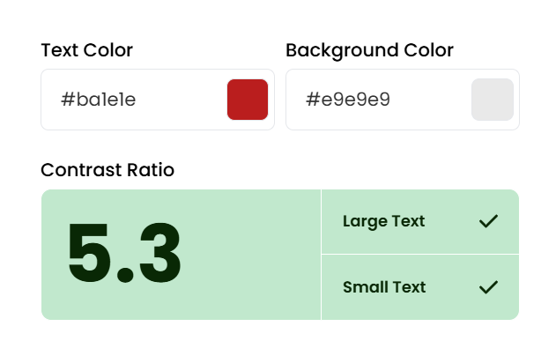
Figure 41- Colour Contrast 1 [109]

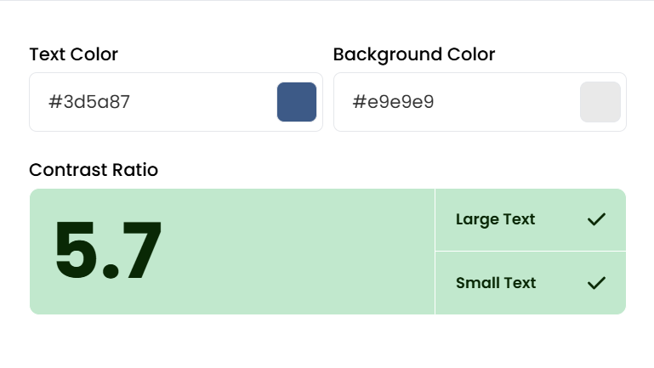
Figure 42 - Colour Contrast 2 [109]
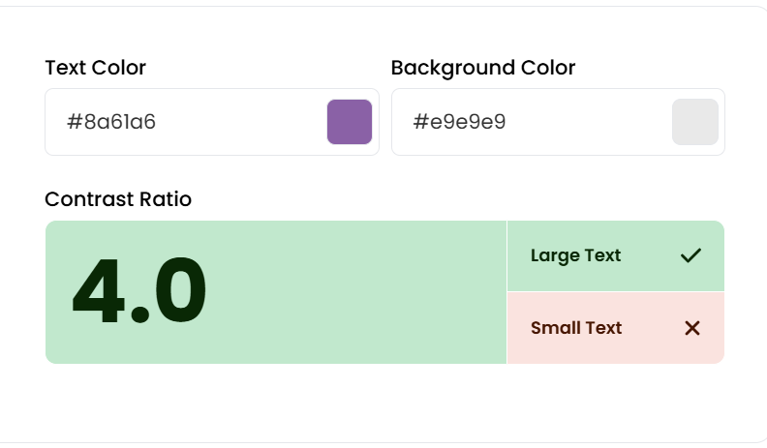
Figure 43 - Colour Contrast 3 [109]
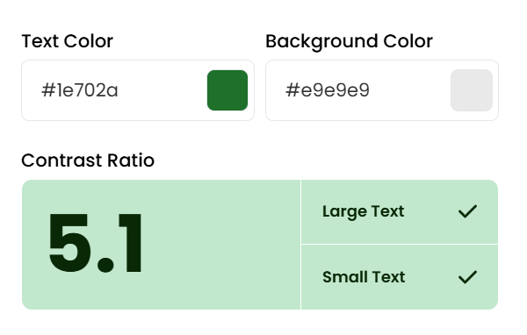
Figure 44 - Colour Contrast 4 [109]
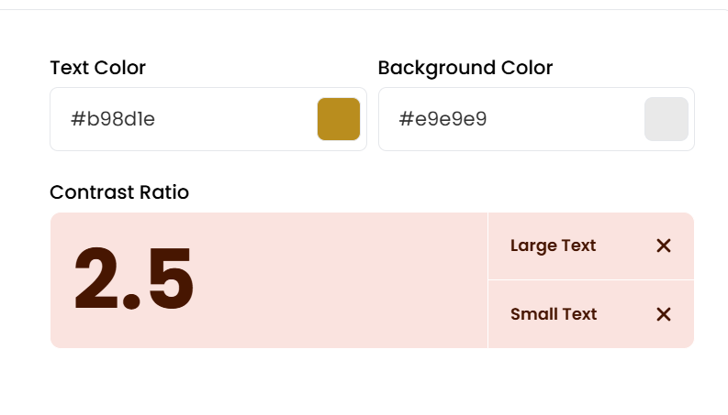
Figure 45 - Colour Contrast 5 [109]
Where colour can be a powerful tool in directing users, as stated previously, colour alone cannot be reliable. To ensure accessibility, an online colour blindness simulator [110] can identify how the colour theme is viewed from users with colour vision deficiencies (CVD).

5.2.2 Colour Blindness
These variations show what the dashboard will look like to a user with certain CVD.
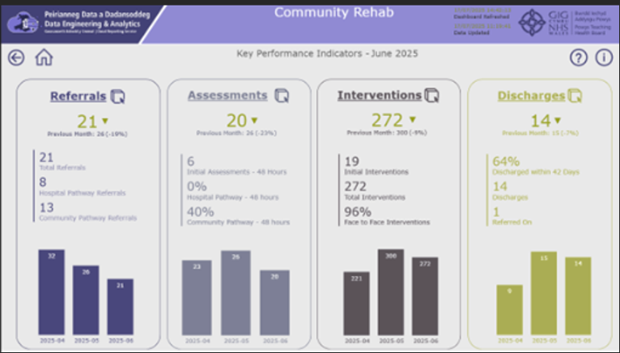
Figure 46 - Deuteranopia Simulation
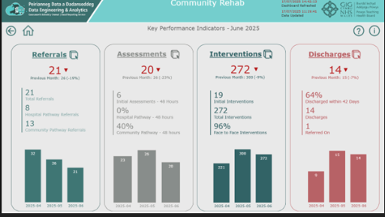
Figure 47 - Tritanopia Simulation
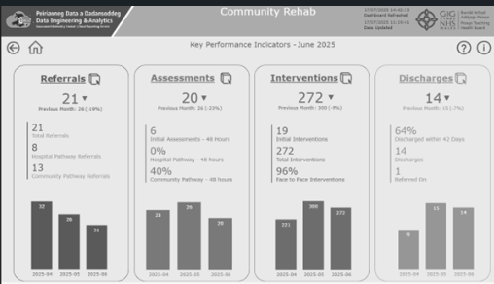
Figure 48 - Achromatopsia Simulation
The use of icons can assist users to differentiate between an increase or decrease in the figures. Further to ensuring the users can differentiate between the aspects of the dashboard, the layout is purposefully designed to segregate each subset, again assisting the users in interpreting the dashboard.

5.2.3 Layout
As discussed in Chapter 2.3.3, the colour and layout theme is consistent throughout the dashboard. By keeping the layout simple, consistent with the principles laid out in the various frameworks, gives the user a sense of familiarity and reduces cognitive load.

Each subset is reproduced on each supplementary pages reducing the need for the user to return to the summary page to know what subset they are viewing.

5.3 Post Delivery Sustainability
To establish a formal Sustainability & Maintenance framework includes version control of the dashboard iterations, bug and issues log via Azure DevOps and deploy real-time data-pipeline monitoring.

User Guides and technical workshops will be run to build a comprehensive training and documentation knowledge base. This will equip end users and support teams with the resources to ensure reliability, issue resolution and continuous improvement post go-live.

Competency surveys or interviews could reveal whether training impacts dashboard uptake and comprehension.

To strengthen our findings, future iterations should target higher survey response rates. A larger dataset would enable richer, more accurate persona development and could reveal new user segments, insights that might lead to a rethink and refine the dashboard’s design.

Having completed the evaluation and addressed any compliance gaps, the overarching conclusions can now be drawn. The next chapter synthesises these insights and outlines targeted directions for future work.

Chapter 6 – Conclusion and Future Work

6.1 Conclusion
This project set out to enhance usability and UX in a community rehabilitation healthcare dashboard by applying a structured, user-centred design process. In Chapter 1, we framed our objectives: to identify key usability challenges, integrate proven UX frameworks, and deliver a prototype that met real-world needs.
Chapter 2 reviewed foundational theories and surveyed best practices and case studies in NHS dashboards. Distilling common pain points, information overload, navigation obstacles, accessibility gaps, inadequate feedback, and laid out design guidelines for clarity, consistency, and inclusivity.
Chapter 3 described the methodology. A nested Double Diamond process and Feature-Driven Development for iterative prototyping. Conducting pre-development surveys and interviews, audited existing tools, and defined SMART objectives for dashboard metrics.
In Chapter 4, survey responses were analysed with TF-IDF and K-Means clustering to uncover four user segments and drive wireframe designs. Building a Power BI prototype, implementing DAX measures, drill-through flows, tooltips, and toggles mapped to NHS pathways.
Chapter 5’s evaluation employed a SUS survey (mean = 79.6, SD = 7.5) that exceeded the industry benchmark, alongside think-aloud sessions with eye-tracking and WCAG-compliance checks. Feedback confirmed intuitive KPI layouts and colour-coded alerts, with minor refinements needed in interactive affordances and tooltip discoverability.
Together, these phases demonstrate that a rigorous, theory-informed, user-centred approach can deliver a healthcare dashboard that aligns with workflows, reduces cognitive load, and supports equitable access. The prototype not only met its stated objectives but also provided a clear blueprint for sustainable adoption within NHS organisations.

6.2 Suggestions for Further Work
- Long-Term Adoption Study - Conduct a longitudinal evaluation over 12–24 months to track dashboard usage patterns, sustained behaviour change, and outcomes.

- Standardised UX Toolkit for Healthcare Dashboards - Develop and validate a bespoke usability-UX assessment toolkit to benchmark dashboards across the health board.

- Expanded Accessibility Trials - Include users with visual, motor, and cognitive impairments in usability tests to uncover additional barriers and refine inclusive design elements.
These avenues build on the core work by deepening evaluation, broadening technical scope, and embedding predictive and interoperability capabilities. Pursuing them will ensure that healthcare dashboards continue evolving as intelligent, equitable, and user-centred instruments in modern care delivery.

Chapter 7 – Reflection
I learned, through this project, how to more effectively bridge theoretical concepts with real-world practice, applying UX frameworks, usability principles and strategies to an actual healthcare dashboard. Studying the Double Diamond model and cognitive load theory laid the groundwork, but it was only by interviewing stakeholders, grouping their feedback, and refining wireframes that these ideas unearthed the joined-up thinking. That hands-on cycle revealed why all these aspects allowed me to turn abstract theory into concrete, user-centred design.

Personally, I have increased my essential soft skills that extend beyond technical abilities, by balancing multiple workstreams, under tight deadlines, resulting in better time management abilities. By conversing with stakeholders, it improved my communication and empathy by listening to their frustrations taught me to value diverse perspectives and to negotiate on pragmatic compromises. This reminded me that effective collaboration often hinges on active listening as much as persuasive design.

I gained valuable insights by discussing usability and UX challenges with other public service organisations. For example, my conversation with Vicky Stone, a Statistics Regulator at the Office for Statistics Regulation, revealed how different teams tackle these issues.

Reflecting on areas for improvement, I recognise that earlier and more frequent usability testing could have accelerated feedback and mitigated late-stage revisions. I would increase the ‘discovery’ phase to allow for deeper exploration and integration challenges.

Finally, I see the value of developing a formal training roadmap alongside the dashboard prototype, allowing users with hands-on exercises to ensure smoother adoption. By consciously integrating these lessons, I’ll be better prepared to lead similarly complex, user-centred projects in the future.

Chapter 8 – References

[1] | Net Health;, “A Comprehensive History of Electronic Health Record Systems,” Net Health, 2025. [Online]. Available: https://www.nethealth.com/blog/history-of-electronic-health-records-ehrs/. [Accessed 07 2025].
[2] | T. R. Haaksma, M. D. T. d. Jong and J. Karreman, “Users’ Personal Conceptions of Usability and User Experience of Electronic and Software Products,” IEEE Transactions on Professional Communication, vol. 61, pp. 116-132, 2018.
[3] | N. N. Group, “Don Norman - Co-Founder and Board Member,” Nielsen Norman Group, 03 2025. [Online]. Available: https://www.nngroup.com/people/don-norman/. [Accessed 29 03 2025].
[4] | N. N. Group, “Jakob Nielsen - Co-Founder & Retired Principal,” Nielsen Norman Group, 03 2025. [Online]. Available: https://www.nngroup.com/people/jakob-nielsen/. [Accessed 29 03 2025].
[5] | S. Krug, “Steve Krug - About me,” Sensible, 03 2025. [Online]. Available: https://sensible.com/about/. [Accessed 29 03 2025].
[6] | Matters, UX, “Alan Cooper,” UX Matters, 03 2025. [Online]. Available: https://www.uxmatters.com/authors/archives/2014/11/alan_cooper.php. [Accessed 29 03 2025].
[7] | U. o. Maryland, “Ben Shneiderman,” University of Maryland, 03 2025. [Online]. Available: https://www.cs.umd.edu/users/ben/. [Accessed 29 03 2029].
[8] | Semantic Studios, “Peter Morville’s Biography,” Semantic Studios, 03 2025. [Online]. Available: https://semanticstudios.com/about/. [Accessed 29 03 2025].
[9] | Interaction Design Foundation - IxDF, “What is User Centered Design (UCD)?,” Interaction Design Foundation - IxDF, [Online]. Available: https://www.interaction-design.org/literature/topics/user-centered-design . [Accessed 04 2025].
[10] | G. Goel, P. Tanwar and S. Sharma, “UI-UX Design Using User Centred Design (UCD) Method,” 2022 International Conference on Computer Communication and Informatics (ICCCI), pp. 1-8, 2022.
[11] | G. Raj, A. K. Chakraverti and S. N. Mehta, “User Interface and User Experience Design Methodologies and Evaluation Techniques: A Systematic Literature Review,” in 2024 1st International Conference on Advances in Computing, Communication and Networking (ICAC2N), 2024, pp. 398-402.
[12] | Collins English Dictionary, “Heuristic Definition and Meaning,” Collins English Dictionary, 2025. [Online]. [Accessed 05 2025].
[13] | J. Nielsen, “Finding Usability Problems Through Heuristic Evaluation,” in CHI '92: Proceedings of the SIGCHI Conference on Human Factors in Computing Systems, New York, NY, USA, ACM, 1992, pp. 373--380.
[14] | J. Nielsen, “10 Usability Heuristics for User Interface Design,” NNg, 1994. [Online]. Available: https://www.nngroup.com/articles/ten-usability-heuristics/. [Accessed 04 2025].
[15] | D. Bittencourt, “Nielsen’s Heuristics: 10 Principles for Intuitive and Usable Interfaces,” Diego Bittencourt Blog, 2025. [Online]. Available: https://diegobittencourt.org/en/2025/02/09/nielsens-heuristics-10-principles-for-intuitive-and-usable-interfaces/. [Accessed 05 2025].
[16] | S. Ivanovs, “Nielsen’s Usability Heuristics: 10 Principles to Enhance the User Experience,” TestDevLab Blog, 01 2025. [Online]. Available: https://www.testdevlab.com/blog/nielsens-usability-heuristics-10-principles. [Accessed 05 2025].
[17] | J. Wilkinson, “The "Tender Technicians" of Nielsen Norman Group Videos,” Weave: Journal of Library User Experience, vol. 5, 2022.
[18] | S. Costanza-Chock, Design Justice: Community-Led Practices to Build the Worlds We Need, The MIT Press, 2020.
[19] | E. Wong, “Shneiderman’s Eight Golden Rules Will Help You Design Better Interfaces,” Interaction Design Foundation, 2025.
[20] | N. Aottiwerch and U. Kokaew, “Design computer-assisted learning in an online Augmented Reality environment based on Shneiderman's eight Golden Rules,” in 2017 14th International Joint Conference on Computer Science and Software Engineering (JCSSE), IEEE, 2017.
[21] | S. Vij, “8 Golden Rules of Interface Design: Shneiderman & Plaisant's Guide for 2025,” Bricx Labs Blog, 02 2025. [Online]. Available: https://bricxlabs.com/blogs/shneiderman-and-plaisant-s-rules-of-interface-design. [Accessed 05 2025].
[22] | A. Siarkiewicz and D. Sobolewski, “Applying the 8 Golden Rules of User-Interface Design,” UXmatters, 10 2022. [Online]. Available: https://www.uxmatters.com/mt/archives/2022/10/applying-the-8-golden-rules-of-user-interface-design.php. [Accessed 05 2025].
[23] | R. Mokhtar, M. A. H. Samed, M. Abd Rahman, A. Suhaimi and N. Isa, “Development of Research Progress Tracking System Based on Shneiderman’s Eight Golden Rules,” International Journal of Business and Technology Management, vol. 5, pp. 553-564, 2023.
[24] | D. A. Norman, The Design of Everyday Things, MIT Press: Cambridge, MA, 2013.
[25] | R. Dam, “Don Norman’s Principles of Design With Examples,” 07 2016. [Online]. Available: https://www.blog.99explore.com/don-normans-principles-of-design-with-examples. [Accessed 05 2025].
[26] | D. Norman, “Norman's Seven Principles of Design: Creating Intuitive and User-Friendly Interfaces,” TutorialsArena, 2025. [Online]. Available: https://www.tutorialsarena.com/fundamentals/software-engineering/normans-seven-principles-of-interaction-design. [Accessed 05 2025].
[27] | C. Sirk, “The Godfather of UX: Don Norman & User-Centered Design,” 01 2024. [Online]. Available: https://crm.org/articles/the-godfather-of-ux-don-norman-user-centered-design. [Accessed 05 2025].
[28] | YourLearningMentor Team, “Norman’s 7 Principles in HCI,” YourLearningMentor Blog, 01 2024. [Online]. Available: https://yourlearningmentor.com/normans-7-principles-hci/. [Accessed 05 2025].
[29] | D. Norman, “Norman's Design Principles,” 2025. [Online]. Available: https://www.eg.bucknell.edu/~cs475/F2011-S2012/NormanDesign.pdf. [Accessed 05 2025].
[30] | N. L. Bayer, “Consistency in Interface Design: An Overview,” Conference Record on Crossing Frontiers, pp. 412-417, 1992.
[31] | J. J. Gibson, The senses considered as perceptual systems, 1966.
[32] | D. A. Norman and J. Nielsen, “Gestural Interfaces: A Step Backward in Usability,” Interactions, vol. 17, pp. 46--49, 2010.
[33] | W. Leahy, G. Cooper and J. Sweller, “Interactivity and the Constraints of Cognitive Load Theory,” in Missing the Meaning, Palgrave Macmillan, 2004, pp. 89--103.
[34] | S. T. M. Sithole, “Application of Cognitive Load Theory in Accounting Education,” {International Journal of Accounting and Financial Reporting, vol. 8, 2018.
[35] | S. Lopez, “The Impact of Cognitive Load Theory on the Effectiveness of Microlearning Modules,” European Journal of Education and Pedagogy, vol. 5, pp. 29--35, 2024.
[36] | C. Mărcuță, “The role of cognitive load in user interface design,” MoldStud, March 2024. [Online]. Available: https://moldstud.com/articles/p-the-role-of-cognitive-load-in-user-interface-design. [Accessed 05 2025].
[37] | Claritee Team, “Understanding the UX Honeycomb: Definition and Practical Applications,” Claritee , 11 2024. [Online]. Available: https://claritee.io/blog/understanding-the-ux-honeycomb-definition-and-practical-applications/. [Accessed 05 2025].
[38] | UXPin Team, “What is UX Honeycomb and How it Impacts User Experience?,” UXPin, 08 2024. [Online]. Available: https://www.uxpin.com/studio/blog/ux-honeycomb-definition-and-use/. [Accessed 05 2025].
[39] | P. Morville, “User Experience Design,” semanticstudios, 06 2004. [Online]. Available: https://semanticstudios.com/user_experience_design/}. [Accessed 05 2025].
[40] | C. Douglas, “The Essence of UX Honeycomb and Its Seven Core Elements,” visily, 02 2025. [Online]. Available: https://www.visily.ai/blog/ux-honeycomb-seven-elements/. [Accessed 05 2025].
[41] | Interaction Design Foundation, “The 7 Factors that Influence User Experience,” Interaction Design Foundation, 03 2025. [Online]. Available: https://www.interaction-design.org/literature/article/the-7-factors-that-influence-user-experience. [Accessed 05 2025].
[42] | E. Chung, “Applying the UX honeycomb for a modern website,” 04 2025. [Online]. Available: https://blog.logrocket.com/ux-design/applying-ux-honeycomb-modern-website/. [Accessed 05 2025].
[43] | Q. LTD, T. U. Group and P. Moville, UX Honeycomb: Seven Facets of User Experience to Consider, Q LTD, 2018.
[44] | B. Fogg, Stanford Guidelines for Web Credibility, 2002.
[45] | Persuasive Technology Lab, The Web Credibility Project, Stanford University, 2007.
[46] | J. Lewis and J. Sauro, “USABILITY AND USER EXPERIENCE: DESIGN AND EVALUATION,” in USABILITY AND USER EXPERIENCE: DESIGN AND EVALUATION, 2022, pp. 972-1015.
[47] | B. Lesselroth, H. Monkman, K. Adams, S. Wood, A. Corbett, J. Homco, E. Borycki, R. Spier and A. Kushniruk, “User Experience Theories, Models, and Frameworks: A Focused Review of the Healthcare Literature,” Studies in health technology and informatics, vol. 270, pp. 1076-1080, 2020.
[48] | W. Brown, P.-Y. Yen, M. Rojas and R. Schnall, “Assessment of the Health IT Usability Evaluation Model (Health-ITUEM) for evaluating mobile health (mHealth) technology,” Journal of Biomedical Informatics, vol. 46, pp. 1080-1087, 2013.
[49] | R. Schnall, H. Cho and J. Liu, “Health Information Technology Usability Evaluation Scale (Health-ITUES) for Usability Assessment of Mobile Health Technology: Validation Study,” JMIR mHealth and uHealth, vol. 6, pp. 2291-5222, 2018.
[50] | J. O’Donoghue, “7 Rules Of UX Design You Should Break Right Now,” Make:Iterate, 2024. [Online]. Available: https://makeiterate.com/7-rules-of-ux-design-you-should-break-right-now/. [Accessed 05 2025].
[51] | B. K. Ooi, “Study of FSKKP Portal Based on Shneiderman's Eight Golden Rules,” Universiti Malaysia Pahang, Malaysia, 2013.
[52] | Department of Health and Social Care;, “Atlas of Health Variation in Head and Neck Cancer in England,” Department of Health and Social Care, 10 2024. [Online]. Available: https://www.gov.uk/government/statistics/atlas-of-health-variation-in-head-and-neck-cancer-in-england/atlas-of-health-variation-in-head-and-neck-cancer-in-england-report-summary. [Accessed 04 2025].
[53] | Scottish Parliament Information Centre (SPICe), “NHS Scotland Performance Standards: Dashboard,” Scottish Parliament Information Centre (SPICe), 04 2025. [Online]. Available: https://spice-spotlight.scot/health-performance/. [Accessed 05 2025].
[54] | Public Health Wales NHS Trust, “Wales Public Health Rapid Overview Dashboard,” Public Health Wales NHS Trust, 2025. [Online]. Available: https://phw-prd-rapiddashboard-app.azurewebsites.net/. [Accessed 05 2025].
[55] | Department of Health (Northern Ireland);, “Northern Ireland Cancer Waiting Times: Quarter Ending December 2024,” Department of Health (Northern Ireland), 04 2024. [Online]. Available: https://datavis.nisra.gov.uk/health/ni-cancer-waiting-times-oct-dec-24.html. [Accessed 05 2025].
[56] | K. Hornbaek, “Current practice in measuring usability: Challenges to usability studies and research,” International Journal of Human-Computer Studies, vol. 64, pp. 79--102, 2006.
[57] | R. Rabiei and S. Almasi, “Requirements and challenges of hospital dashboards: a systematic literature review,” BMC Medical Informatics and Decision Making, vol. 22, 2022.
[58] | A. Edmunds and A. Morris, “The problem of information overload in business organisations: a review of the literature,” International Journal of Information Management, vol. 20, pp. 17--28, 2000.
[59] | M. Zhuang, D. Concannon and E. Manley, “A Framework for Evaluating Dashboards in Healthcare,” arXiv preprint arXiv:2009.04792, 2022.
[60] | Juno Health;, “Navigating EHR Usability Challenges: A Clinician's Guide to Success,” Juno Health, 07 2024. [Online]. Available: https://www.junohealth.com/blog/overcoming-top-ehr-usability-challenges. [Accessed 05 2025].
[61] | J. O'Donoghue and L. Roberts, “Bilingual Design in Welsh Health Information Systems: A Usability Study,” Journal of Health Communication, vol. 3, pp. 145--157, 2019.
[62] | M. Jones and S. Lewis, “Evaluating Bilingual Interfaces in NHS Wales Patient Portals,” International Journal of Medical Informatics, vol. 134, 2020.
[63] | A. Research and O. Research, “Evaluation of More Than Just Words: Promoting Welsh Language Use in Healthcare,” Welsh Government, 2018.
[64] | G. Kwong, “Not every EHR deserves an "F" for usability,” MEDITECH Blog, 2020. [Online]. Available: https://blog.meditech.com/not-every-ehr-deserves-an-f-for-usability. [Accessed 05 2025].
[65] | User Experience Professionals Association, “Definitions of User Experience and Usability,” UXPA International, 2025. [Online]. Available: https://uxpa.org/definitions-of-user-experience-and-usability/. [Accessed 05 2025].
[66] | S. Krug, Don't Make Me Think, Revisited: A Common Sense Approach to Web Usability, San Francisco, CA: New Riders, 2014.
[67] | A. Grivet, “Creating Intuitive Navigation: Best Practices for Better User Flow,” BeanMachine, 2025. [Online]. Available: https://beanmachine.dev/intuitive-navigation-design/. [Accessed 05 2025].
[68] | T. Wu, A. J. Dufford, L. J. Egan, M.-A. Mackie, C. Chen, C. Yuan, C. Chen, X. Li, X. Liu, P. R. Hof and J. Fan, “Hick–Hyman Law is Mediated by the Cognitive Control Network in the Brain,” Cerebral Cortex, vol. 28, pp. 2267--2282, 2018.
[69] | S. Murash and D. Silchenko, “Why Visual Hierarchy in UX Is Key: Expert-Backed Tips and Examples,” Eleken, 2025. [Online]. Available: https://www.eleken.co/blog-posts/visual-hierarchy-in-ux. [Accessed 05 2025].
[70] | Level Access;, “WCAG Checklist | Evaluate & Enhance Web Accessibility,” Level Access, 2025. [Online]. Available: https://www.levelaccess.com/resources/must-have-wcag-2-1-checklist/. [Accessed 05 2025].
[71] | M. F. Theofanos and J. (. Redish, “Bridging the Gap: Between Accessibility and Usability,” Interactions, vol. 10, pp. 36--51, 2023.
[72] | BrowserStack;, “25 Real-World Design Examples that Prioritize Accessibility,” BrowserStack, 05 2025. [Online]. Available: https://www.browserstack.com/guide/accessibility-design-examples. [Accessed 05 2025].
[73] | World Wide Web Consortium (W3C), “Understanding Success Criterion 2.5.5: Target Size,” 04 2025. [Online]. Available: https://www.w3.org/WAI/WCAG21/Understanding/target-size.html. [Accessed 05 2025].
[74] | Government Digital Service and Central Digital and Data Office, “Government Design Principles,” 04 2025. [Online]. Available: https://www.gov.uk/guidance/government-design-principles. [Accessed 05 2025].
[75] | M. Sugue and M. Huang, “Statistics on the Prevalence of Color Blindness,” 05 2025. [Online]. Available: https://www.visioncenter.org/resources/color-blind-statistics/. [Accessed 05 2025].
[76] | Administrator RP UXCollab;, “Designing for Life: The Impact of UX Design in Healthcare,” Administrator RP UXCollab, 29 02 2024. [Online]. Available: https://www.revivalpixel.com/blog/designing-for-life-the-impact-of-ux-design-in-healthcare/. [Accessed 05 2025].
[77] | T. T. Omaghomi, O. A. Elufioye, O. Akomolafe, E. C. Anyanwu and A. I. Daraojimba, “Health Apps and Patient Engagement: A Review of Effectiveness and User Experience,” World Journal of Advanced Research and Reviews, vol. 21, pp. 432-440, 2024.
[78] | S. Abdul, E. P. Adeghe, B. O. Adegoke, A. A. Adegoke and E. H. Udedeh, “Promoting Health and Educational Equity: Cross-Disciplinary Strategies for Enhancing Public Health and Educational Outcomes,” World Journal of Biology Pharmacy and Health Sciences, vol. 18, pp. 416-433, 2024.
[79] | R. Orji, R. L. Mandryk, J. Vassileva and K. M. Gerling, “Design Features for Improving Mobile Health Intervention User Engagement: Systematic Review and Thematic Analysis,” Journal of Medical Internet Research, vol. 22, p. 12, 2020.
[80] | M. Rodriguez, M. Cocosila and N. Archer, “Enhancing User Experience Through User Study: Design of an mHealth Tool for Cardiovascular Patients,” JMIR Cardio, vol. 2, 2018.
[81] | Technology Rivers, “How UX Design in Healthcare Apps Drives Better Outcomes,” echnology Rivers, 2024. [Online]. Available: https://technologyrivers.com/blog/how-ux-design-in-healthcare-apps-drives-better-outcomes/. [Accessed 05 2025].
[82] | M. Taylor, “Command centers, explained: Key challenges, lessons and wins from 5 systems,” Becker's Hospital Review, p. 05, 2025.
[83] | GE HealthCare;, “Johns Hopkins Capacity Command Center Creates a New Center of Gravity,” GE HealthCare Command Center, 2025.
[84] | Labcorp, “Improving Hospital Performance with Real-Time Analytics: A Labcorp and Ochsner Health Case Study,” Labcorp, 2025.
[85] | Vizient Inc.;, “RUSH uses analytics and leading practices to reduce readmissions,” Vizient Inc., 2025. [Online]. Available: https://www.vizientinc.com/case-studies/rush-readmissions-reduction. [Accessed 06 2025].
[86] | Vizient Inc., Clinical Data Base | Healthcare Data Base Records}, 2025.
[87] | A. P. Adekugbe and C. V. Ibeh, “Utilizing comprehensive data dashboards to improve service delivery: Insights from U.S. case studies,” International Journal of Frontiers in Engineering and Technology Research, vol. 6, pp. 008--018, 2024.
[88] | E. Hunt, “The Digital Transformation of Healthcare: AI, IoT, and Blockchain in Action,” PharmiWeb.com, 2025.
[89] | IoT Magazine Newsdesk;, “15 Examples of Digital Healthcare Solutions with AI, IoT, and Blockchain in 2024,” IoT Magazine Newsdesk, 03 2024. [Online]. Available: https://iotworldmagazine.com/2024/03/29/2198/15-examples-of-digital-healthcare-solutions-with-ai-iot-and-blockchain-in-2024. [Accessed 05 2025].
[90] | Philips BioTelemetry;, “Philips Ambulatory Monitoring and Diagnostics,” Philips BioTelemetry, 2025. [Online]. Available: https://www.gobio.com/. [Accessed 05 2025].
[91] | A. Kumar, “Pioneering New Frontiers in Healthcare Data Analytics with AI and Cloud Technologies,” Analytics Insight, 2025. [Online]. Available: https://www.analyticsinsight.net/healthcare/pioneering-new-frontiers-in-healthcare-data-analytics-with-ai-and-cloud-technologies. [Accessed 05 2025].
[92] | T. Mazhar, S. Khan, T. Shahzad, M. A. Khan, M. M. Saeed, J. B. Awotunde and H. Hamam, “Generative AI, IoT, and blockchain in healthcare: application, issues, and solutions,” Discover Internet of Things, vol. 5, 2025.
[93] | Design Council, “The Double Diamond,” Design Council, 2025. [Online]. Available: https://www.designcouncil.org.uk/our-resources/the-double-diamond/. [Accessed 05 2025].
[94] | R. Mahdavi-Hezave and R. Ramsin, “FDMD: Feature-Driven Methodology Development,” 2015 International Conference on Evaluation of Novel Approaches to Software Engineering (ENASE), 2015.
[95] | LaunchNotes, “The Double Diamond Framework: A Comprehensive Guide to Effective Problem Solving,” LaunchNotes, 2023. [Online]. Available: https://www.launchnotes.com/blog/the-double-diamond-framework-a-comprehensive-guide-to-effective-problem-solving. [Accessed 05 2025].
[96] | D. Gustafsson, “Analysing the Double Diamond Design Process Through Research & Implementation,” Aalto University, School of Arts, Design and Architecture, 2019.
[97] | Digital Health and Care Wales, “Information Governance,” Digital Health and Care Wales, 2025. [Online]. Available: https://dhcw.nhs.wales/ig/information-governance/. [Accessed 06 2025].
[98] | Office for Health Improvement and Disparities, “Think aloud study: qualitative studies,” GOV.UK Guidance, 2021.
[99] | GazeRecorder, “GazeRecorder: Webcam Eye Tracking Software,” GazeRecorder, 2025. [Online]. [Accessed 06 2025].
[100] | Welsh Government, “Digital and Data Strategy for Health and Social Care in Wales,” Welsh Government, 2023. [Online]. Available: https://www.gov.wales/digital-and-data-strategy-health-and-social-care-wales-html. [Accessed 06 2025].
[101] | Microsoft, Power BI Desktop Update - June 2025, Microsoft, 2025.
[102] | NHS England, “ODS (Organisation Data Service) Reference Data Catalogue,” NHS England, 2025.
[103] | Office for National Statistics, “Postcode to OA (2021) to LSOA to MSOA to LAD with 2011 Classifications (August 2024) Best Fit Lookup in the UK,” Office for National Statistics, 2024.
[104] | C. Sammut and G. I. Webb, “TF–IDF,” Encyclopedia of Machine Learning, pp. 986--987, 2011.
[105] | I. Herdiana, M. A. Kamal, Triyani, M. N. Estri and Renny, “A More Precise Elbow Method for Optimum K-means Clustering,” arXiv preprint arXiv:2502.00851, 2025.
[106] | A. Dudek, “Silhouette Index as Clustering Evaluation Tool,” in Classification and Data Analysis, Springer, Cham, 2020, pp. 19--33.
[107] | M. Chaudet, “A Guide to Using the SUS Survey in User Research,” Bunnyfoot Blog, 2024. [Online]. Available: https://www.bunnyfoot.com/2024/07/the-sus-survey-in-user-research/. [Accessed 06 2025].
[108] | J. M. Bland and D. G. Altman, “Statistics notes: Cronbach's alpha,” BMJ, vol. 314, p. 572, 1997.
[109] | J. Sauro, “Measuring Usability with the System Usability Scale (SUS),” MeasuringU, 2011.
[110] | ColorblindSimulator.app Team;, “Color Blindness Simulator for Images – Upload or Paste Image URLs,” ColorblindSimulator, 2025. [Online]. Available: https://colorblindsimulator.app/color-blindness-simulator-images. [Accessed 07 2025].
[111] | Tableau;, “The Johns Hopkins Hospital: Uncovering “Hidden In-Patient Bed Capacity”,” Tableau, 2016. [Online]. Available: https://www.youtube.com/watch?v=S2nzgPAkfXU. [Accessed 07 2025].
[112] | Tableau;, “Ochsner Health System: Patients First, Visualizing Experience of Care,” Tableau, 2018. [Online]. Available: https://www.youtube.com/watch?v=4tAnWU3QxXE. [Accessed 07 2025].
[113] | Rush University Medical Center;, “Hospital Readmission Rates,” Rush University Medical Center, 2025. [Online]. Available: https://www.rush.edu/about-us/quality-safety-and-patient-satisfaction/rush-university-medical-center-quality-measures-0. [Accessed 07 2025].
[114] | Poper Accessibility Team;, “Image Color Contrast Checker,” Poper Accessibility Team, 2025. [Online]. Available: https://www.poper.ai/image-color-contrast-checker/. [Accessed 07 2025].

Chapter 9 – Bibliography

Code of Practice for Statistics
https://code.statisticsauthority.gov.uk/
Near time data service: dashboard user engagement – research findings
https://www.gov.scot/publications/near-time-data-service-dashboard-user-engagement-research-findings/
Deaths registered weekly in England and Wales, provisional
https://cy.ons.gov.uk/peoplepopulationandcommunity/birthsdeathsandmarriages/deaths/datasets/weeklyprovisionalfiguresondeathsregisteredinenglandandwales/2025#:~:text=Provisional%20counts%20of%20the%20number%20of%20deaths%20registered,it%20existed%20for%20this%20dataset%20on%20previous%20dates
Programme for Government (PfG) Wellbeing Dashboard
https://www.nisra.gov.uk/news/programme-government-pfg-wellbeing-dashboard
Dashboard: Deaths registered weekly in England and Wales
https://www.ons.gov.uk/peoplepopulationandcommunity/birthsdeathsandmarriages/deaths/articles/deathsregisteredweeklyinenglandandwales/latest

Appendices

Appendix 1 – Predevelopment Survey
- What are the primary challenges you face in accessing healthcare data?
- Which types of healthcare data are most important for your daily work?
- How often do you need to use a dashboard for data visualisation and decision-making?
- What features would make a healthcare dashboard most useful for you? (e.g., real-time updates, predictive analytics, mobile compatibility)
- What device(s) do you primarily use for accessing healthcare data? (Desktop, tablet, mobile)
- Would you prefer a dashboard with customisable settings? Why or why not?
- What challenges have you faced when accessing or interpreting healthcare data?
- What specific features or tools would make accessing and interpreting healthcare data easier for you?
- What level of technical expertise do you have when using digital healthcare tools? (Beginner, Intermediate, Advanced)
- What support or training would you need to use a new healthcare dashboard effectively?

Appendix 2 – SUS Survey
- I think that I would like to use this system frequently.
- I found the system unnecessarily complex.
- I thought the system was easy to use.
- I think that I would need the support of a technical person to be able to use this system.
- I found the various functions in this system were well integrated.
- I thought there was too much inconsistency in this system.
- I would imagine that most people would learn to use this system very quickly.
- I found the system very cumbersome to use.
- I felt very confident using the system.
- I needed to learn a lot of things before I could get going with this system.

Appendix 3 - Metrics and Measures
Category | Metrics | Target | Benchmark / NICE | WPAS
Referral Pathway | Number of referrals | 48 referrals monthly |  | Number of referrals each month
Referral Pathway | Number of referrals from Hospital Pathway / Community Pathway | New measure – baseline from 4 June 2025 | Source of referral: Hospital – DGH/community Hospital; Community
Assessment | % assessed within 48 hours of referral | 95% |  | Receipt referrals from Hospital until initial appointment within 48 hrs
Assessment | % assessed within 24 hours of referral | 95% | NICE Guidelines QS74 (Intermediate Care – assessment within 2 days of referral) | Receipt referrals from Community within 24 hrs
Assessment | Number of new assessments; | New measure | Evaluation criteria for monitoring purposes
Assessment | % assessed for community rehab; | New measure | Evaluation criteria for monitoring purposes
Assessment | % assessed of patients directed to other services | New measure | Evaluation criteria for monitoring purposes
Interventions | Amount of Rehab Activity delivered by the team by location | New measure | To manage demand, capacity and performance | Activity by location
Interventions | % of patient stay in the rehab pathway 42 days or less | 95% | NICE QS74 recommend typical rehab up to 6 weeks | From receipt of referral to discharge
Discharge | Record onward referrals for patients at point of discharge | 100% |  | Secondary activity code
Discharge | Record onward referrals referred to enablement | 100% |  | Secondary activity code “referred to enablement team”

Appendix 4 - Pre-Development Text Analysis
import pandas as pd
import re
import matplotlib.pyplot as plt
from sklearn.feature_extraction.text import TfidfVectorizer, CountVectorizer, ENGLISH_STOP_WORDS
from sklearn.cluster import KMeans
from wordcloud import WordCloud

def preprocess_text(text):
"""Convert text to lowercase and remove punctuation."""
text = str(text).lower()
text = re.sub(r"[^\w\s]", "", text)
return text

def get_common_words(texts, num_words=10, stop_words=None):
"""
Given a list of texts, return the top `num_words` as (word, frequency) pairs using CountVectorizer.
"""
# Ensure stop_words is passed as a list to CountVectorizer
cv = CountVectorizer(stop_words=list(stop_words))
X = cv.fit_transform(texts)
sum_words = X.sum(axis=0)
word_freq = {word: sum_words[0, idx] for word, idx in cv.vocabulary_.items()}
sorted_words = sorted(word_freq.items(), key=lambda x: x[1], reverse=True)
# Filter out any stop words (should already be filtered, but extra-check) and take top num_words
filtered_words = [(word, freq) for word, freq in sorted_words if word not in stop_words][:num_words]
return filtered_words

def main():
# Create an extended stop word list from the default English stop words and add any additional words as needed.
extended_stop_words = set(ENGLISH_STOP_WORDS).union({"etc"})

# Read the Excel file (ensure it resides in your working directory)
df = pd.read_excel("PreDevelopmentSurveyAnswers.xlsx")

# For this example, filter responses to dashboard-related questions (e.g., Questions 3, 4, 5, and 6)
df_dashboard = df.copy()

# Preprocess the 'Answer' text by converting to lower-case and removing punctuation
df_dashboard["processed_text"] = df_dashboard["Answer"].apply(preprocess_text)

# Vectorise the text using TF-IDF with stop words as a list to filter out common words
tfidf_vectorizer = TfidfVectorizer(stop_words=list(extended_stop_words))
X = tfidf_vectorizer.fit_transform(df_dashboard["processed_text"])

# Use K-Means clustering to group similar responses into themes; adjust num_clusters as needed
num_clusters = 4
kmeans = KMeans(n_clusters=num_clusters, init="k-means++", max_iter=100, n_init=10, random_state=42)
kmeans.fit(X)

# Assign the cluster labels to a new column "themes"
df_dashboard["themes"] = kmeans.labels_

# For each theme, calculate top common words (excluding stop words)
theme_keywords = {}
for theme in range(num_clusters):
theme_texts = df_dashboard[df_dashboard["themes"] == theme]["processed_text"].tolist()
top_words = get_common_words(theme_texts, num_words=10, stop_words=extended_stop_words)
theme_keywords[theme] = top_words

# Print common words per theme (stop words removed)
print("Common words per detected theme (stop words removed):")
for theme, words in theme_keywords.items():
print(f"\nTheme {theme}:")
for word, freq in words:
print(f" {word}: {freq}")
# Visualise the words using a horizontal bar plot (outside the inner loop)
if words:
word_labels, freqs = zip(*words)
plt.figure(figsize=(8, 3))
plt.barh(word_labels, freqs, color='skyblue')
plt.xlabel('Frequency')
plt.title(f'Top Words for Theme {theme}')
plt.gca().invert_yaxis()
plt.show()

# Visualise the commonalities using WordCloud for each theme
for theme in range(num_clusters):
theme_text = " ".join(df_dashboard[df_dashboard["themes"] == theme]["processed_text"].tolist())
wordcloud = WordCloud(
width=800,
height=400,
background_color="white",
stopwords=extended_stop_words # WordCloud accepts a set here, so it's fine.
).generate(theme_text)
plt.figure(figsize=(10, 5))
plt.imshow(wordcloud, interpolation="bilinear")
plt.axis("off")
plt.title(f"Theme {theme} Word Cloud")
plt.show()

# Optionally, save the updated DataFrame to a CSV file for further inspection.
df_dashboard.to_csv("dashboard_usability_themes.csv", index=False)

if __name__ == "__main__":
main()

Appendix 5 – Word Counts

Cluster 1
The common terms for cluster 1:
Term | Count
digital | 16
tools | 11
support | 10
healthcare | 10
users | 9
user | 9
advanced | 9
technical | 9
information | 8
patient | 8

Cluster 2
The common terms for cluster 2:
Term | Frequency
dashboard | 35
customisable | 17
daily | 13
data | 13
settings | 10
analysis | 9
critical | 8
metrics | 8
weekly | 8
use | 7

Cluster 3
The common terms for cluster 3:
Term | Count
mobile | 23
work | 20
desktop | 17
access | 13
laptop | 9
data | 8
office | 7
community | 7
im | 7
use | 6

Cluster 4
The common terms for cluster 3:
Term | Count
data | 56
access | 9
sources | 7
systems | 6
records | 6
comprehensive | 5
make | 5
tools | 5
care | 5
view | 4

Appendix 6 - Referrals SQL Script
with site as (select
case when hospitaldesc = 'Llandrindod' then 'Llandrindod Wells Hospital'
when hospitaldesc = 'Brecon' then 'Brecon War Memorial'
when hospitaldesc = 'Machynlleth' then 'Machynlleth Hospital'
when hospitaldesc = 'Newtown' then 'Newtown Hospital'
when hospitaldesc = 'Welshpool' then 'Welshpool Hospital'
when hospitaldesc = 'Ystradgynlais' then 'Ystradgynlais Hospital'
end as Hospital,
LONG,
LAT
from reference_data.geography.powyshospitals
where hospitaldesc in ('Llandrindod','Brecon','Machynlleth','Newtown','Welshpool','Ystradgynlais') )

select 'Referrals' as Referrals,
g.Postcode as GPPostcode,
o.msoa21,
ogp.lat as GPLat,
ogp.long as GPLong,
case when ReferralSource <> 'Ward' then 1 else 0 end as CommunityPathway,
case when ReferralSource <> 'Ward' then 'Community' else 'Hospital' end as CommunityPathwayDesc,
r.RESIDENT_POSTCODE,
r.AGE_GROUP,
o.msoa11_desc,
r.AGE_GROUP_TYPE,
r.BASE_DESC,
r.CASENO,
r.CLUSTER,
r.DATE_REF,
r.DATE_REF_RECEIVED,
r.DATE_REF_RECEIVED_MONTH,
r.LISTOUTCOME,
r.LISTOUTCOMETYPE,
r.MAIN_SPEC_NAME,
r.REF_GP_NAME,
r.REF_PRAC_DESC,
r.REGISTERED_CLUSTER,
ReferralSource as SOURCE_REFER_DESC,
r.SPECIALTY_NAME,
r.URGENCY_DESC,
s.long as SiteLong,
s.lat as SiteLat,
r.reg_prac_desc
from wpas.referralsummary r
left join reference_data.geography.gppracs g on g.OrgCode = r.REG_PRAC_CODE
left join reference_data.geography.onspostcodesummary o on o.PCD_NOSPACES = replace(r.RESIDENT_POSTCODE," ",'')
left join reference_data.geography.onspostcodesummary ogp on ogp.PCD_NOSPACES = replace(g.Postcode," ",'')
left join site s on s.Hospital = r.BASE_DESC
where MAIN_SPEC_NAME = 'Occupational Therapy'
and SPECIALTY_NAME = 'Occupational Therapy D2RA'
and DATE_REF >= '2025-04-01'

Appendix 7 - Activity SQL Script
with referredon as (select EPISODENO, trt_date,
concat_ws(',', collect_list(descript)) as descript
from wpas.codingsummary ro
where ro.DESCRIPT like 'Refer%'
and MAIN_SPEC = 'Occupational Therapy'
and SPEC_NAME = 'Occupational Therapy D2RA'
and TRT_DATE >= '2025-04-01'
group by EPISODENO, trt_date)

select
'Interventions' as Intervention,
descript as ReferredOnDescript,
DAYS_FROM_REF_TO_DISCHARGE,
caseno,
trt_month,
case when rownumber = 1 and apptype_desc = 'New' then 1 else 0 end as InitialAssessment,
case when rownumber = 1 and apptype_desc = 'New' then RefToInitialAssessment else null end as DaysFromRefToInitialAssessment,
case when (case when rownumber = 1 and apptype_desc = 'New' then RefToInitialAssessment else null end) <= 2 then 1 else 0 end as SeenWithin48HoursIA,
case when rownumber = 1 and apptype_desc = 'Follow-up' then 1 else 0 end as InitialIntervention,
case when apptype_desc = 'Follow-up' then 1 else 0 end as Interventions,
CommunityPathway,
CommunityPathwayDesc,
case when cast(DAYS_FROM_REF_TO_DISCHARGE as Int) <= 42 then 1
when cast(DAYS_FROM_REF_TO_DISCHARGE as Int) > 42 then 0
else null end as DisWithin42Days,
Dismonth,
case when Dismonth is not null then 1 else 0 end as Discharged,
referredon,
SOURCE_REFER_DESC,
OUTCOME_DESC,
cluster,
base_desc,
BASE_DESC_LAT,
BASE_DESC_LONG,
PATIENT_AGE,
SEX_DESC,
msoa,

case when CONSULT_METHOD = 1 then 1 else 0 end as FaceToFace
from (
select
ro.descript,
t.apptype_desc,
t.caseno,
t.trt_date,
t.trt_month,
row_number() over(partition by t.caseno,t.apptype_desc order by t.DAT_REF) as rownumber,
date_diff(day,r.date_ref_received,t.trt_date) as RefToInitialAssessment,
case when t.SOURCE_REFER_DESC <> 'Ward' then 1 else 0 end as CommunityPathway,
case when t.SOURCE_REFER_DESC<> 'Ward' then 'Community' else 'Hospital' end as CommunityPathwayDesc,
date_add(t.DAT_REF, cast(t.DAYS_FROM_REF_TO_DISCHARGE as int)) as DisDate,
t.DAYS_FROM_REF_TO_DISCHARGE,
date_format(date_add(r.date_ref_received, cast(t.DAYS_FROM_REF_TO_DISCHARGE as int)),'yyyy-MM') as Dismonth,
case when ro.descript is not null then 1 else 0 end as referredon,
t.SOURCE_REFER_DESC,
t.OUTCOME_DESC,
t.cluster,
t.base_desc,
t.BASE_DESC_LAT,
t.BASE_DESC_LONG,
t.PATIENT_AGE,
t.SEX_DESC,
t.msoa,
t.CONSULT_METHOD
from wpas.treatmentsummary t
left join wpas.referralsummary r on r.linkid = t.linkid
left join referredon ro on ro.EPISODENO = t.ACTNOTEKEY
where t.MAIN_SPEC = 'Occupational Therapy'
and t.SPEC_NAME = 'Occupational Therapy D2RA'
and t.TRT_DATE >= '2025-04-01'
)

Appendix 8 - Dax Measures
Measure Name | Table | Measure
_Assessment Previous Month plus 1 | Data - Activity | _Assessment Previous Month plus 1 =  VAR TwoMonthsAgo = FORMAT(EOMONTH(TODAY(), -2), "yyyy-MM")  RETURN  CALCULATE(  SUM('Data - Activity'[InitialAssessment]),  'Data - Activity'[trt_month] = TwoMonthsAgo  )
_Assessment TrendColor | Data - Activity | _Assessment TrendColor =  SWITCH(  TRUE(),  [_Assessments Previous Month] > [_Assessment Previous Month plus 1], "#00B050",  [_Assessments Previous Month] < [_Assessment Previous Month plus 1], "#C00000",  "#808080"  )
_Assessment TrendIcon | Data - Activity | _Assessment TrendIcon =  SWITCH(  TRUE(),  [_Assessments Previous Month] > [_Assessment Previous Month plus 1], "▲",  [_Assessments Previous Month] < [_Assessment Previous Month plus 1], "▼",  "▬"  )
_Assessments Initial Community | Data - Activity | _Assessments Initial Community =  VAR LastMonth = FORMAT(EOMONTH(TODAY(), -1), "yyyy-MM")  RETURN  CALCULATE(  count('Data - Activity'[caseno]),  'Data - Activity'[InitialAssessment] = 1,  'Data - Activity'[CommunityPathway] = 1  )
_Assessments Initial Count – EOM | Data - Activity | _Assessments Initial Count - EOM =  CALCULATE(  SUM('Data - Activity'[InitialAssessment]),  FILTER(  'Data - Activity',  'Data - Activity'[trt_month] <= FORMAT(EOMONTH(TODAY(), -1), "yyyy-MM")  )  )
_Assessments Initial Hospital | Data - Activity | _Assessments Initial Hospital =  VAR LastMonth = FORMAT(EOMONTH(TODAY(), -1), "yyyy-MM")  RETURN  CALCULATE(  count('Data - Activity'[caseno]),  'Data - Activity'[InitialAssessment] = 1,  'Data - Activity'[CommunityPathway] = 0  )
_Assessments Percentage Seen in 48 Hours Community | Data - Activity | _Assessments Percentage Seen in 48 Hours Community =  VAR Previous_Month = FORMAT(EDATE(TODAY(), -1), "yyyy-mm")  return  CALCULATE([_Assessments SeenWithin48 LastMonth Community]/[_Assessments Initial Community],  'Data - Activity'[trt_month] = Previous_Month  )
_Assessments Percentage Seen in 48 Hours Hospital | Data - Activity | _Assessments Percentage Seen in 48 Hours Hospital =  VAR Previous_Month = FORMAT(EDATE(TODAY(), -1), "yyyy-mm")  return  CALCULATE([_Assessments SeenWithin48 LastMonth Hospital]/[_Assessments Initial Hospital],  'Data - Activity'[trt_month] = Previous_Month  )
_Assessments Previous Month | Data - Activity | _Assessments Previous Month =  VAR CurrentMonth = FORMAT(TODAY(), "yyyy-mm")  VAR Previous_Month = FORMAT(EDATE(TODAY(), -1), "yyyy-mm")  RETURN  CALCULATE(  [_Assessments Initial Count - EOM],  'Data - Activity'[trt_month] = Previous_Month  )
_Assessments Seen Outside 48 LastMonth Community | Data - Activity | _Assessments Seen Outside 48 LastMonth Community =  VAR LastMonth = FORMAT(EOMONTH(TODAY(), -1), "yyyy-MM")  RETURN  CALCULATE(  [_Assessments Previous Month],  'Data - Activity'[InitialAssessment] = 1,  'Data - Activity'[CommunityPathway] = 1,  'Data - Activity'[SeenWithin48HoursIA] = 0,  'Data - Activity'[trt_month] = LastMonth  )
_Assessments Seen Outside 48 LastMonth Hospital | Data - Activity | _Assessments Seen Outside 48 LastMonth Hospital =  VAR LastMonth = FORMAT(EOMONTH(TODAY(), -1), "yyyy-MM")  RETURN  CALCULATE(  count('Data - Activity'[SeenWithin48HoursIA]),  'Data - Activity'[InitialAssessment] = 1,  'Data - Activity'[CommunityPathway] = 0,  'Data - Activity'[SeenWithin48HoursIA] = 0,  'Data - Activity'[trt_month] = LastMonth  )
_Assessments SeenWithin48 LastMonth | Data - Activity | _Assessments SeenWithin48 LastMonth =  VAR LastMonth = FORMAT(EOMONTH(TODAY(), -1), "yyyy-MM")  RETURN  CALCULATE(  SUM('Data - Activity'[SeenWithin48HoursIA]),  'Data - Activity'[InitialAssessment] = 1,  'Data - Activity'[trt_month] = LastMonth  )
_Assessments SeenWithin48 LastMonth Community | Data - Activity | _Assessments SeenWithin48 LastMonth Community =  VAR LastMonth = FORMAT(EOMONTH(TODAY(), -1), "yyyy-MM")  RETURN  CALCULATE(  sum('Data - Activity'[SeenWithin48HoursIA]),  'Data - Activity'[InitialAssessment] = 1,  'Data - Activity'[CommunityPathway] = 1,  'Data - Activity'[trt_month] = LastMonth  )
_Assessments SeenWithin48 LastMonth Hospital | Data - Activity | _Assessments SeenWithin48 LastMonth Hospital =  VAR LastMonth = FORMAT(EOMONTH(TODAY(), -1), "yyyy-MM")  RETURN  CALCULATE(  SUM('Data - Activity'[SeenWithin48HoursIA]),  'Data - Activity'[InitialAssessment] = 1,  'Data - Activity'[CommunityPathway] = 0,  'Data - Activity'[trt_month] = LastMonth  )
_Discharges Count – EOM | Data - Activity | _Discharges Count - EOM =  CALCULATE(  SUM('Data - Activity'[Discharged]),  FILTER(  'Data - Activity',  'Data - Activity'[Dismonth] <= FORMAT(EOMONTH(TODAY(), -1), "yyyy-MM")  )  )
_Discharges Previous Month | Data - Activity | _Discharges Previous Month =  VAR CurrentMonth = FORMAT(TODAY(), "yyyy-mm")  VAR Previous_Month = FORMAT(EDATE(TODAY(), -1), "yyyy-mm")  RETURN  CALCULATE(  [_Discharges Count - EOM],  'Data - Activity'[Dismonth] = Previous_Month  )
_Discharges Previous Month plus 1 | Data - Activity | _Discharges Previous Month plus 1 =  VAR TwoMonthsAgo = FORMAT(EOMONTH(TODAY(), -2), "yyyy-MM")  RETURN  CALCULATE(  SUM('Data - Activity'[Discharged]),  'Data - Activity'[Dismonth] = TwoMonthsAgo  )
_Discharges TrendColor | Data - Activity | _Discharges TrendColor =  SWITCH(  TRUE(),  [_Discharges Previous Month] > [_Discharges Previous Month plus 1], "#00B050",  [_Discharges Previous Month] < [_Discharges Previous Month plus 1], "#C00000",  "#808080"  )
_Discharges TrendIcon | Data - Activity | _Discharges TrendIcon =  SWITCH(  TRUE(),  [_Discharges Previous Month] < [_Discharges Previous Month plus 1], "▲",  [_Discharges Previous Month] > [_Discharges Previous Month plus 1], "▼",  "▬"  )
_Discharges Within 42 Days % | Data - Activity | _Discharges Within 42 Days % =  VAR LastMonth = FORMAT(EOMONTH(TODAY(), -1), "yyyy-MM")  RETURN  CALCULATE(  DIVIDE(  SUM('Data - Activity'[DisWithin42Days]),  COUNT('Data - Activity'[DisWithin42Days])  ),  'Data - Activity'[dismonth] = LastMonth  )
_Interventions Count – EOM | Data - Activity | _Interventions Count - EOM =  CALCULATE(  SUM('Data - Activity'[Interventions]),  FILTER(  'Data - Activity',  'Data - Activity'[trt_month] <= FORMAT(EOMONTH(TODAY(), -1), "yyyy-MM")  )  )
_Interventions FaceToFace | Data - Activity | _Interventions FaceToFace =  VAR CurrentMonth = FORMAT(TODAY(), "yyyy-mm")  VAR Previous_Month = FORMAT(EDATE(TODAY(), -1), "yyyy-mm")  RETURN  CALCULATE(  CALCULATE(sum('Data - Activity'[FaceToFace])/COUNT('Data - Activity'[FaceToFace])),  'Data - Activity'[trt_month] = Previous_Month  )
_Interventions Initial Count – EOM | Data - Activity | _Interventions Initial Count - EOM =  CALCULATE(  SUM('Data - Activity'[InitialIntervention]),  FILTER(  'Data - Activity',  'Data - Activity'[trt_month] <= FORMAT(EOMONTH(TODAY(), -1), "yyyy-MM")  )  )
_Interventions Initial Previous Month | Data - Activity | _Interventions Initial Previous Month =  VAR CurrentMonth = FORMAT(TODAY(), "yyyy-mm")  VAR Previous_Month = FORMAT(EDATE(TODAY(), -1), "yyyy-mm")  RETURN  CALCULATE(  [_Interventions Initial Count - EOM],  'Data - Activity'[trt_month] = Previous_Month  )
_Interventions Previous Month | Data - Activity | _Interventions Previous Month =  VAR CurrentMonth = FORMAT(TODAY(), "yyyy-mm")  VAR Previous_Month = FORMAT(EDATE(TODAY(), -1), "yyyy-mm")  RETURN  CALCULATE(  [_Interventions Count - EOM],  'Data - Activity'[trt_month] = Previous_Month  )
_Interventions Previous Month plus 1 | Data - Activity | _Interventions Previous Month plus 1 =  VAR TwoMonthsAgo = FORMAT(EOMONTH(TODAY(), -2), "yyyy-MM")  RETURN  CALCULATE(  SUM('Data - Activity'[Interventions]),  'Data - Activity'[trt_month] = TwoMonthsAgo  )
_Interventions TrendColor | Data - Activity | _Interventions TrendColor =  SWITCH(  TRUE(),  [_Interventions Previous Month] > [_Interventions Previous Month plus 1], "#00B050",  [_Interventions Previous Month] < [_Interventions Previous Month plus 1], "#C00000",  "#808080"  )
_Interventions TrendIcon | Data - Activity | _Interventions TrendIcon =  SWITCH(  TRUE(),  [_Interventions Previous Month] > [_Interventions Previous Month plus 1], "▲",  [_Interventions Previous Month] < [_Interventions Previous Month plus 1], "▼",  "▬"  )
_Referred On Count – EOM | Data - Activity | _Referred On Count - EOM =  CALCULATE(  SUM('Data - Activity'[referredon]),  FILTER(  'Data - Activity',  'Data - Activity'[trt_month] <= FORMAT(EOMONTH(TODAY(), -1), "yyyy-MM")  )  )
_Referred On Previous Month | Data - Activity | _Referred On Previous Month =  VAR CurrentMonth = FORMAT(TODAY(), "yyyy-mm")  VAR Previous_Month = FORMAT(EDATE(TODAY(), -1), "yyyy-mm")  RETURN  CALCULATE(  [_Referred On Count - EOM],  'Data - Activity'[trt_month] = Previous_Month  )
__Map Tooltip Info | Referrals | __Map Tooltip Info =  VAR SelectedPractice = SELECTEDVALUE('Referrals'[reg_prac_desc])  VAR ReferralCount = CALCULATE(COUNTROWS('Referrals'))  RETURN  "Practice: " & SelectedPractice & UNICHAR(10) &  "Referrals: " & [_Referrals Count - EOM]
__Map Tooltip Info Filled Map | Referrals | __Map Tooltip Info Filled Map =  VAR SelectedPractice = SELECTEDVALUE('Referrals'[msoa11_desc])  RETURN  SelectedPractice & UNICHAR(10) & UNICHAR(10) & " - " & [_Referrals Count - EOM]
_Referrals Community | Referrals | _Referrals Community =  VAR LastMonth = FORMAT(EOMONTH(TODAY(), -1), "yyyy-MM")  RETURN  CALCULATE(  [_Referrals Previous Month],  'Referrals'[CommunityPathway] = 1,  Referrals[DATE_REF_RECEIVED_MONTH] = LastMonth  )
_Referrals Count – EOM | Referrals | _Referrals Count - EOM =  CALCULATE(  count(Referrals[CASENO]),  FILTER(  'Referrals',  Referrals[DATE_REF_RECEIVED_MONTH] <= FORMAT(EOMONTH(TODAY(), -1), "yyyy-MM")  )  )
_Referrals Hospital | Referrals | _Referrals Hospital =  VAR LastMonth = FORMAT(EOMONTH(TODAY(), -1), "yyyy-MM")  RETURN  CALCULATE(  [_Referrals Previous Month],  'Referrals'[CommunityPathway] = 0,  Referrals[DATE_REF_RECEIVED_MONTH] = LastMonth  )
_Referrals Previous Month | Referrals | _Referrals Previous Month =  VAR OneMonthsAgo = FORMAT(EOMONTH(TODAY(), -1), "yyyy-MM")  RETURN  CALCULATE(  [_Referrals Count - EOM],  Referrals[DATE_REF_RECEIVED_MONTH] = OneMonthsAgo  )
_Referrals Previous Month plus 1 | Referrals | _Referrals Previous Month plus 1 =  VAR TwoMonthsAgo = FORMAT(EOMONTH(TODAY(), -2), "yyyy-MM")  RETURN  CALCULATE(  [_Referrals Count - EOM],  Referrals[DATE_REF_RECEIVED_MONTH] = TwoMonthsAgo  )
_Referrals TrendColor | Referrals | _Referrals TrendColor =  SWITCH(  TRUE(),  [_Referrals Previous Month] > [_Referrals Previous Month plus 1] , "#00B050",  [_Referrals Previous Month] < [_Referrals Previous Month plus 1] , "#C00000",  "#808080"  )
_Referrals TrendIcon | Referrals | _Referrals TrendIcon =  SWITCH(  TRUE(),  [_Referrals Previous Month] > [_Referrals Previous Month plus 1], "▲",  [_Referrals Previous Month] < [_Referrals Previous Month plus 1], "▼",  "▬"  )

Appendix 9 - Sus Response Answers
Respondent | Q1 | Q2 | Q3 | Q4 | Q5 | Q6 | Q7 | Q8 | Q9 | Q10
1 | 4 | 2 | 5 | 1 | 4 | 2 | 5 | 1 | 4 | 2
2 | 3 | 3 | 4 | 2 | 3 | 3 | 4 | 2 | 3 | 3
3 | 5 | 1 | 5 | 1 | 5 | 1 | 5 | 1 | 5 | 1
4 | 2 | 4 | 3 | 3 | 2 | 4 | 2 | 3 | 2 | 4
5 | 4 | 2 | 4 | 2 | 4 | 2 | 4 | 2 | 4 | 2
6 | 3 | 4 | 3 | 3 | 3 | 4 | 3 | 3 | 3 | 4
7 | 5 | 2 | 5 | 1 | 5 | 2 | 5 | 1 | 5 | 2
8 | 2 | 5 | 2 | 4 | 2 | 5 | 2 | 4 | 2 | 5
9 | 3 | 3 | 3 | 3 | 3 | 3 | 3 | 3 | 3 | 3
10 | 4 | 1 | 4 | 1 | 4 | 1 | 4 | 1 | 4 | 1
11 | 3 | 2 | 4 | 2 | 3 | 2 | 4 | 2 | 3 | 2
12 | 1 | 5 | 1 | 5 | 1 | 5 | 1 | 5 | 1 | 5

Appendix 10 – Sus Scoring Criteria

Score | Score Description
1 | Strongly Disagree
2 | Disagree
3 | Neutral
4 | Agree
5 | Strongly Agree

Question Number | Scoring
Odd | -1
Even | -5

Appendix 11 - Sus Scoring Script
import pandas as pd
import numpy as np

# Load the SUS answers Excel file (replace with your actual filename and sheet name if needed)
df = pd.read_excel('susanswers.xlsx')

# SUS scoring: Odd questions (positive) are scored as (score - 1), even questions (negative) as (5 - score)
# Assume columns are named Q1, Q2, ..., Q10
sus_columns = [f'Q{i}' for i in range(1, 11)]

def sus_score(row):
total = 0
for i, col in enumerate(sus_columns):
score = row[col]
if (i + 1) % 2 == 1: # Odd (positive)
total += score - 1
else: # Even (negative)
total += 5 - score
return total * 2.5

# Apply SUS scoring
df['SUS_Score'] = df.apply(sus_score, axis=1)

# Summary statistics
mean_score = df['SUS_Score'].mean()
std_score = df['SUS_Score'].std()

print(f"Mean SUS Score: {mean_score:.2f}")
print(f"Standard Deviation: {std_score:.2f}")

# SUS interpretation (Bangor et al. 2009)
def sus_grade(score):
if score >= 85:
return "Excellent (A)"
elif score >= 70:
return "Good (B)"
elif score >= 50:
return "OK (C)"
else:
return "Poor (D/F)"

df['SUS_Grade'] = df['SUS_Score'].apply(sus_grade)

# Show results
df[['SUS_Score', 'SUS_Grade']].head()

Appendix 12 - Sus Scoring visual Script

import seaborn as sns

import matplotlib.pyplot as plt

# Histogram of SUS Scores
plt.figure(figsize=(8, 5))
sns.histplot(df['SUS_Score'], bins=8, kde=True, color='skyblue')
plt.title('Distribution of SUS Scores')
plt.xlabel('SUS Score')
plt.ylabel('Frequency')
plt.show()

# Boxplot of SUS Scores
plt.figure(figsize=(6, 4))
sns.boxplot(x=df['SUS_Score'], color='lightgreen')
plt.title('Boxplot of SUS Scores')
plt.xlabel('SUS Score')
plt.show()

# Bar plot of SUS Grades
plt.figure(figsize=(6, 4))
sns.countplot(x='SUS_Grade', data=df, order=df['SUS_Grade'].value_counts().index, palette='pastel')
plt.title('Count of SUS Grades')
plt.xlabel('SUS Grade')
plt.ylabel('Count')
plt.show()

Appendix 13 – Eye Tracking Visuals
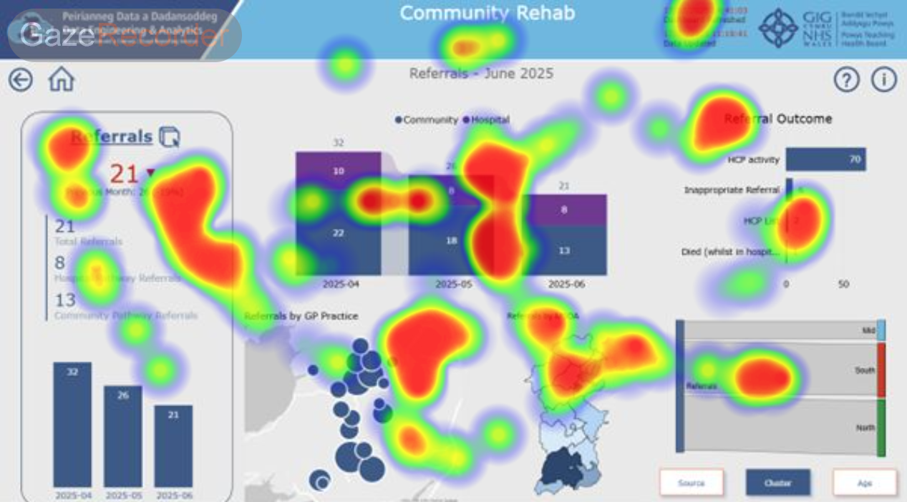
Figure 49 - Eye Tracking 2

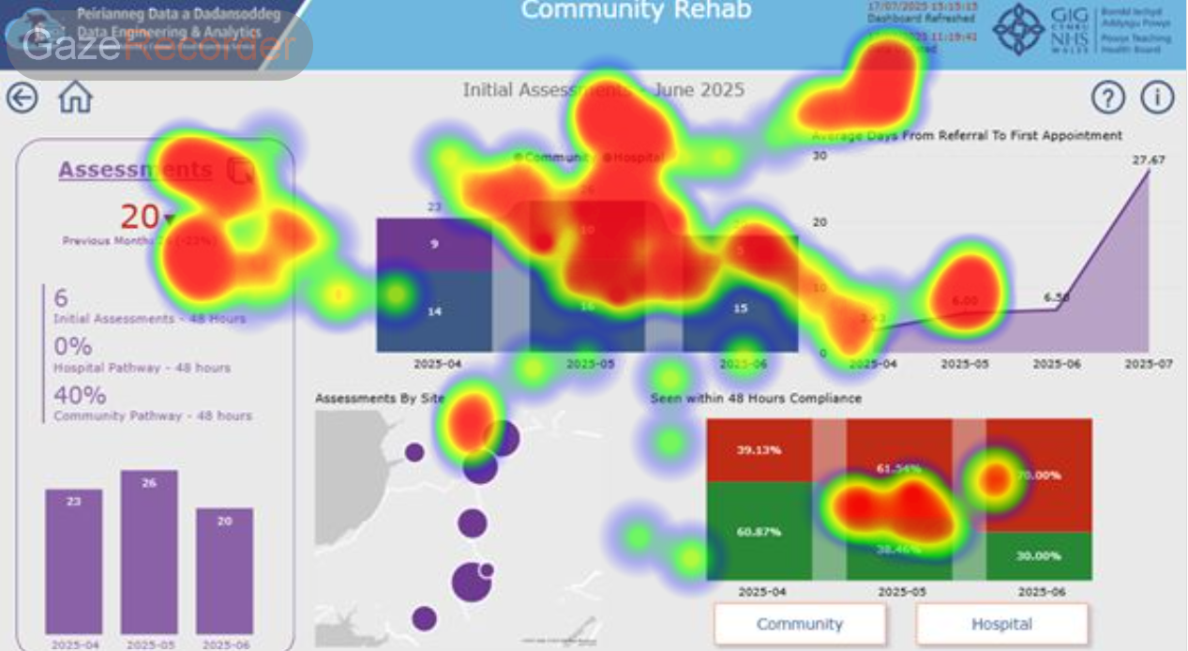
Figure 50 - Eye Tracking 3

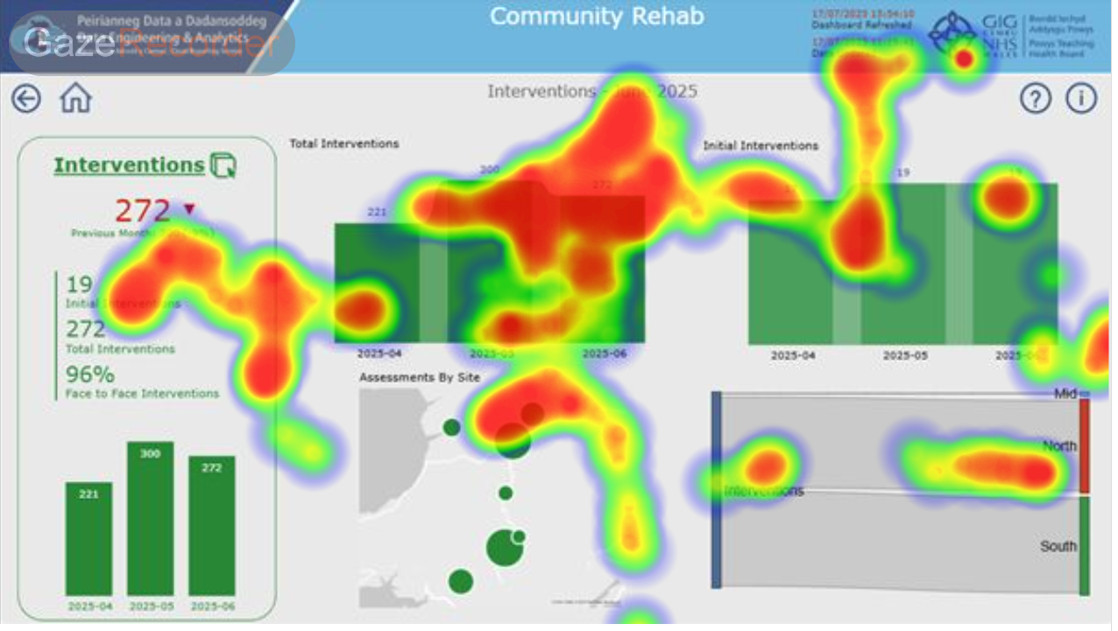
Figure 51 - Eye Tracking 4
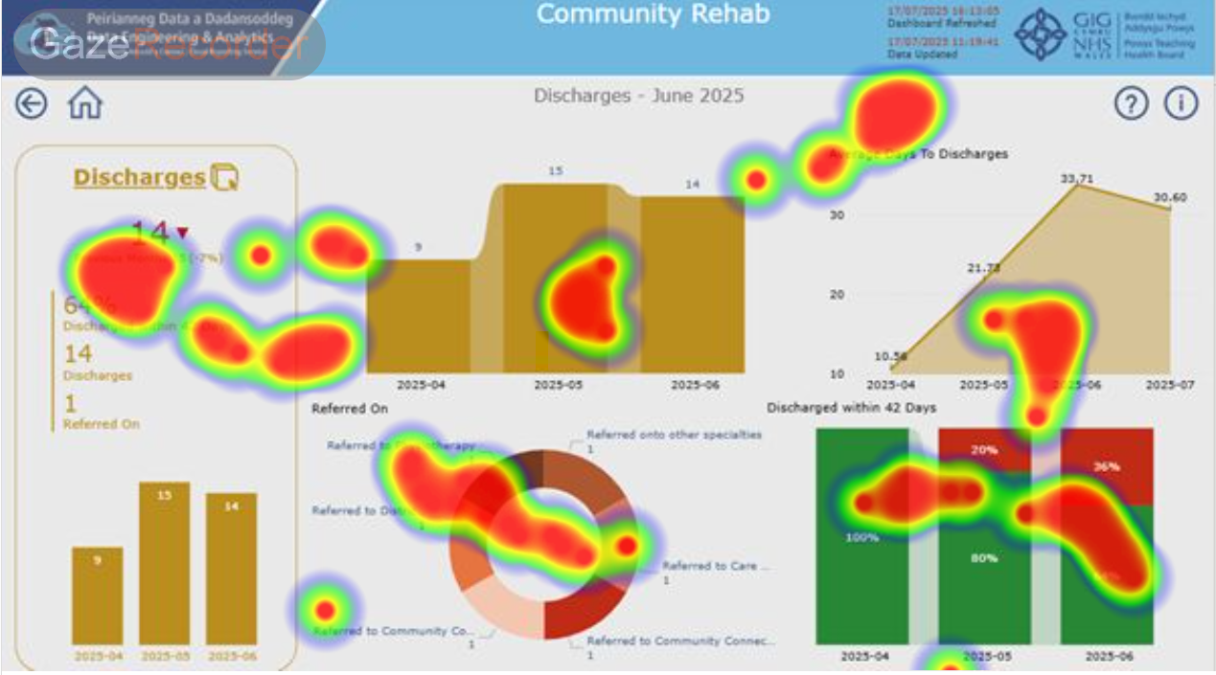
Figure 52 - Eye Tracking 5

Appendix 14 - Think-Aloud Session Transcript
Firstly I can see four different boxes and each of them a different colour The first one is referrals and it's giving me a red number underneath I can see it's the same for all of the different subsets So Referrals Assessments Interventions and Discharges and I can see that title is Community Rehab and Key Performance Indicators June 2025 So these measures look like they associate with June I can also see some dates in the top right that show the date and time it was refreshed and run If I move my mouse I can hover over the referrals and it's changed colours and click through on that it takes me to the referrals page and it's giving me the same metrics I see on the summary but also a further breakdown of the data Depending what I'm hovering over OK so if I use the back button now it takes me back to the summary page and I can click on the other tabs so assessments it takes me to the assessments page and then I can go back The icon arrow showing down on the summary page I'm tempted to click on those but I'm unsure if I'm able to click on them or not and go into intervention Similar functionality I go back to the summary page And I think overall the navigation is easy although there are some aspects where I can click on or not but overall the general theme to be simple to look at and easy to follow.

