

Programme: Master of Business Administration
Module Name & Code: International Business Concepts (LCMB7034)
Assignment Title: Report
Lecturer: Akshay Narayanan
Student Name: Shaikhul Alam Shanto
Student ID: 2504527
Word Count: 5500
Submission Date: 09.08.2026

Contents
Section 1 – International Business Report 1
1. Introduction 1
2. Organisational Classification Using Bartlett & Ghoshal 1
2.1 Overview of IKEA 1
2.2 Bartlett and Ghoshal's International Strategy Framework 2
2.3 Critical Evaluation 3
3. The Global Strategy and International Footprint of IKEA 4
3.1 International Expansion History 4
3.2 Global Presence 4
3.3 Global Sourcing and Logistics 4
3.4 Sustainability and Omni channel Retail Strategy 5
3.5 Market Selection Strategy: Critical evaluation 5
4. Political Environment of Pakistan 6
4.1 Government Stability 6
4.2 Foreign Direct Investment (FDI) Policies 6
4.3 Trade Agreements 6
4.4 Import Regulations 6
4.5 Infrastructure Investment 7
4.6 Political Risks and Critical Evaluation 7
5. Economic Environment 8
5.1 GDP Growth 8
5.2 Inflation and Exchange-Rate Volatility 8
5.3 Purchasing Power and Middle-Class Expansion 9
5.4 Urbanisation and Housing Market 9
5.5 Retail Sector Growth 10
6. Legal Environment 10
6.1 Foreign Investment Regulations 10
6.2 Import Duties and Taxation 11
6.3 Intellectual Property Protection 11
6.4 Critical Evaluation 11
7. Cultural Environment 12
7.1 Consumer Lifestyle 12
7.2 Family Size and Furniture Purchasing Behaviour 12
7.3 Religion and Cultural Values 12
7.4 Home Ownership – Price Sensitivity and Customer Expectations 12
7.5 Critical Evaluation 13
8. Dunning's OLI Paradigm 13
8.1 Ownership Advantages 13
8.2 Location Advantages 14
8.3 Internalisation Advantages 14
8.4 Conclusion 15
9. Entry Mode Strategy and Strategic Synthesis 15
9.1 Exporting 16
9.2 Licensing 16
9.3 Franchising 16
9.4 Joint Venture 17
9.5 Wholly Owned Subsidiary 17
9.6 Recommended Entry Strategy 17
10. Conclusion and Recommendations 18
Section 2 – Reflective Account 20
1. Description 20
2. Feelings 21
3. Evaluation 21
4. Analysis 22
5. Conclusion 22
6. Action Plan 23
6.1 Strengthening Research Planning 23
6.2 Enhancing Information Gathering 23
6.3 Using skills in future learning 23
6.4 Support the Professional Development of others 23
References 24

List of Table
Table 1. Bartlett & Ghoshal Framework 2
Table 2. Comparison of Entry Modes 18

List of Figure
Figure 1 . Global Presence of IKEA Stores and Markets 1
Figure 2. Pakistan GDP Growth (2019–2025) 8
Figure 3. Population and Urbanisation 10
Figure 4.Gibbs' Reflective Cycle 20

Section 1 – International Business Report

1. Introduction
One of the largest multinational home furnishing retailers in the world, IKEA is known for its functional, eco-friendly and low-cost products, which are backed by an efficient global supply chain and a transnational business strategy (Inter IKEA Group, 2025). The opportunities for growth are shrinking significantly in mature markets, and international expansion into emerging markets is crucial to achieve long-term competitiveness (Hill, 2024). This report provides a strategic analysis of IKEA's market potential in Pakistan. As per the analysis, Pakistan has a huge market potential in the long term owing to its population of more than 255 million, rapid urbanisation and growing consumer market. However, inflation, fluctuation in exchange rate, import tariffs and other challenges add to investment risk (World Bank, 2025; IMF, 2025). Using the Bartlett and Ghoshal approach, Dunning's OLI Paradigm and environmental analysis, IKEA has the organisational resources to be a success if it adapts selectively to the local market. The report considers an Omni channel retail strategy combined with progressive local sourcing as the most suitable approach for entering the market, and franchising as the most appropriate approach weighing the opportunities and risks related to market and financial aspects.

2. Organisational Classification Using Bartlett & Ghoshal

2.1 Overview of IKEA
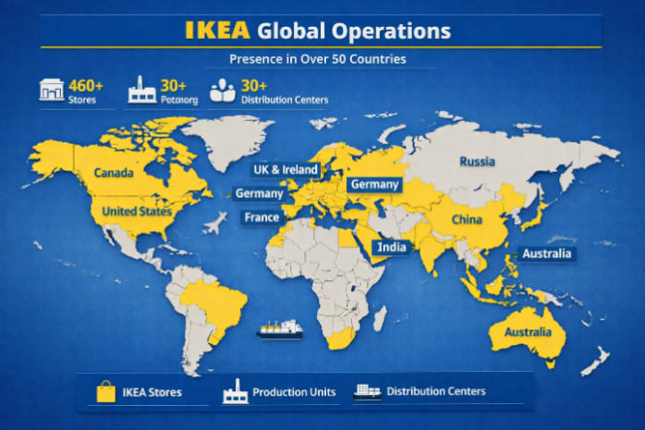
Figure 1 . Global Presence of IKEA Stores and Markets
Source: Inter IKEA Group (2025)
IKEA was established in 1943 by Ingvar Kamprad in Sweden, and has developed into one of the world's largest multinational companies (MNEs) in the home furnishing sector. Acting within the Inter IKEA Group, the company has a franchise structure and supplies a variety of low cost, functional and sustainably manufactured home furnishings and home accessories. With over 60 markets worldwide and hundreds of physical stores, IKEA has the capability to reach millions of customers every year, both online and in-store (Inter IKEA Group, 2025). It has a business model that focuses on cost leadership, standardized product designs, efficient global sourcing, flat-pack packaging, and customer self-service, which enables IKEA to sell high-quality products at affordable prices and remain efficient (Jonsson et al., 2021).

2.2 Bartlett and Ghoshal's International Strategy Framework
Bartlett and Ghoshal (1989) provided four international strategies multinational enterprises use based on the pressures they face for global integration and local responsiveness. An International Strategy is the transfer of valuable knowledge and products created in the home country to other countries that have little local adaptation. The Global Strategy focuses on world-wide standardisation, centralised decision making and economies of scale – it aims to increase efficiency rather than respond to variations at the local level. (Bartlett & Ghoshal, 1989; Hill, 2024).
Table 1. Bartlett & Ghoshal Framework
Strategy | Global Integration | Local Responsiveness | Example
International | Low | Low | Early exporters
Global | High | Low | Apple
Multidomestic | Low | High | Nestlé
Transnational | High | High | IKEA
Source- Bartlett and Ghoshal (1989)

2.3 Critical Evaluation
IKEA has adopted an international strategy that can be described as a Transnational Strategy, given the framework of Bartlett and Ghoshal (1989), which is a combination of global efficiency and local responsiveness. The company is efficient in the global arena due to a central product development process, global store formats and an integrated global sourcing network. The Inter IKEA Group (2025) states that IKEA has roughly 1600 suppliers in over 50 countries, which allows IKEA to be able to buy in bulk and in bulk quantities, which lowers the production and logistics costs. Moreover, it is a flat-pack furniture design that reduces transportation and storage expenses, optimising the shipping space which boosts the cost effectiveness and environmental protection (Inter IKEA Group, 2025)
IKEA's business model is the same around the world, but at the same time, IKEA is flexible when it comes to products and services, making them fit local market conditions. For instance, the company offered affordable furniture, pressure cookers and mostly vegetarian restaurant menus to cater to the preferences of local consumers in India and to their cultural beliefs. Likewise, IKEA extended its home delivery and created the furniture that is appropriate for smaller urban apartments in China (Jonsson et al., 2021; Inter IKEA Group, 2025). These changes illustrate the company's capacity to accommodate customers' different requirements while maintaining its global brand.
Besides, IKEA empowers knowledge sharing by sharing its best practices in sustainability, digital retailing and supply chain management in its global operations, thereby supporting ongoing innovation and organisational learning (Hill, 2024). The evidence shows, therefore, that IKEA has a good control of the local adaptation and global integration, and it is classified as a transnational company, not a purely global or multidomestic one.

3. The Global Strategy and International Footprint of IKEA

3.1 International Expansion History
Since IKEA opened its first store outside Sweden in Norway in 1963, the company has embraced an international expansion plan that is well thought out and strategic. It was the start of the company's journey to become one of the world's largest home furnishers, with business in over 60 markets (Inter IKEA Group, 2025). Over a gradual period, the company has enhanced their entry into developed and emerging markets with a franchise-based approach, which has been more focused on slow but steady growth than fast market penetration. This is a gradual process that has helped IKEA to reduce the risk while establishing a good name for its products in the market globally (Inter IKEA Group, 2025).

3.2 Global Presence
As of FY2024, IKEA has approximately 473 IKEA stores in over 60 countries around the globe (Inter IKEA Group, 2025). The company's expansion efforts in emerging markets like China, India and the United Arab Emirates (UAE) align with its long-term growth approach, with Europe still being the dominant region, accounting for most of the company's retail business and sales. The business of its geographically diversified operations has duly proved the commercial benefits of retail sales, which amounted to EUR 45.1 billion in FY2024, according to Inter IKEA Group (2025). The diverse international presence minimizes reliance on the local market, distributes the company's risk and provides IKEA with the potential to grow in both developed and developing markets (Hill, 2024).

3.3 Global Sourcing and Logistics
IKEA's competitive advantage is based on the global sourcing and logistics system. The Inter IKEA Group (2025) indicates that the company works with around 1,600 suppliers in over 50 countries, which allows them to make large-scale orders and large economies of scale. In addition, IKEA's flat-pack packaging significantly reduces the volume of the product, enabling more to be shipped within a shipping box, which helps cut down on the costs of transporting, warehousing and handling and decreases carbon emissions. This, coupled with the standardisation of product design and centralised distribution systems, facilitates an effective inventory management system and plays a role in IKEA's cost-leadership strategy. The operational efficiencies help it provide affordable products without compromising profitability and global customer experience (Hill, 2024; Inter IKEA Group, 2025)

3.4 Sustainability and Omni channel Retail Strategy
IKEA's corporate strategy is built on sustainability, with programs and commitments in place to practice responsible sourcing, invest in renewable energy, implement circular economy programs and reach net zero emissions. At the same time, IKEA has ramped up its Omni channel retailing efforts to ensure the smooth continuity of shopping across the various platforms, including mobile apps, click-and-collect, and home delivery (Inter IKEA Group, 2025).

3.5 Market Selection Strategy: Critical evaluation
IKEA's approach to entering new international markets is selective and evidence based. The company does not consider fast growth as its main criteria, but rather an attractive market defined by factors like economic growth, purchasing power, urbanisation, demographic trends, political and legal stability, infrastructure quality and long-term consumer demand. This strategy helps to minimize investment risk and promote sustainable growth. But IKEA is cautious with its growth strategy and that could slow down its entry into booming markets where other players make a head-start. So, deciding the market involves a delicate balancing act between conducting a thorough risk assessment and seizing new market opportunities quickly (Bartlett & Ghoshal, 1989; Hill, 2024; Inter IKEA Group, 2025).
IKEA is very cautious in identifying international markets and prioritizes long-term growth potential over political, economic and cultural risks, but this careful selection may prevent the company from entering markets that are growing quickly (Hill, 2024).

4. Political Environment of Pakistan

4.1 Government Stability
Political stability is an important factor for a multinational to take into account when deciding whether it should expand into an international market. Political instability such as changes in governments, policy uncertainty and regional security threats have been a reality in Pakistan. However, the Government still encourages economic reforms and investment programmes that will bring in foreign businesses and encourage growth in the private sector (World Bank, 2025). While political uncertainty can create an added risk to operations, the continued institutional reform process can offer the prospect of long-term foreign investment.

4.2 Foreign Direct Investment (FDI) Policies
In this regard, the Government of Pakistan has enacted various investment policies such as investment incentives, tax concession and treatment of foreign and domestic investors in various sectors on equal footing to attract Foreign Direct Investment (FDI). Foreign control is allowed in the country and repatriation of profits is easy which makes the business environment favourable for the multinational corporations (Board of Investment Pakistan, 2025). Such policies could attract IKEA to invest and at the same time take advantage of the government's preference to international investors.

4.3 Trade Agreements
Pakistan's involvement in regional and international agreements boosts its investment appeal. Favouring trade with Asian countries and getting access to international markets enhances trade connectivity and facilitates the flow of goods and services. These deals can enhance IKEA's regional supply chain and make the market more accessible (World Trade Organization 2024).

4.4 Import Regulations
Import regulations are very important because they are essential to IKEA's business model, which is largely based on the import of furniture and home furnishing products. Pakistan imposes customs duties, product standards and import documentation procedures which can add to operating costs and delivery lead times. Compliances with customs procedures and regulatory standards would therefore be critical in order to allow for efficient market entry and supply chain management (International Trade Administration, 2024).

4.5 Infrastructure Investment
Pakistan has boosted public and international transport infrastructure and logistics investments, as well as port and energy investments. Road access, warehousing and digital infrastructure are increasingly improving the country's business climate and may help IKEA to spread and retail its products. However, infrastructure quality is not uniform in different parts of the country, which may pose logistics problems in expanding the nationwide presence (Asian Development Bank, 2025).

4.6 Political Risks and Critical Evaluation
While investment policies have been improved, political uncertainty, regulatory changes, bureaucratic procedures and regional security concerns are still significant risks for foreign investors. These can raise operating charges and have an impact on investment choices over the long-term. However, with the determination to draw FDI, the ongoing efforts of infrastructure development and economic reforms in Pakistan, there are great opportunities. A gradual market entry policy through local partnerships or a ‘slow and steady' online launch may help IKEA to minimize political risks and also give time to understand market potential before committing significant capital. (Hill, 2024; World Bank, 2025).
The investment climate in Pakistan is improving which is good for IKEA to expand in the market, but political uncertainty and regulatory risks call for a slow and gradual entry to reduce exposure to the market (Hill, 2024).

5. Economic Environment

5.1 GDP Growth
The population of Pakistan in 2025 is projected to be more than 255 million, making it one of the world's fifth largest countries, and the fifth largest emerging economy in South Asia with a significant consumer market (World Bank, 2025). The World Bank (2025) has forecasted that the Pakistani economy will expand by around 2.7% in FY2025 after being stabilised at the macroeconomic level following heavy fiscal and external pressures. The country's GDP has surpassed US$370 billion in 2024 and household consumption is a significant part of the economic activity there, providing long-term opportunities for retailers in the consumer genre. Besides, the retail sector contributes US$150-170 billion to Pakistan's economy and organised retail/ecommerce is still growing (International Trade Administration, 2024).
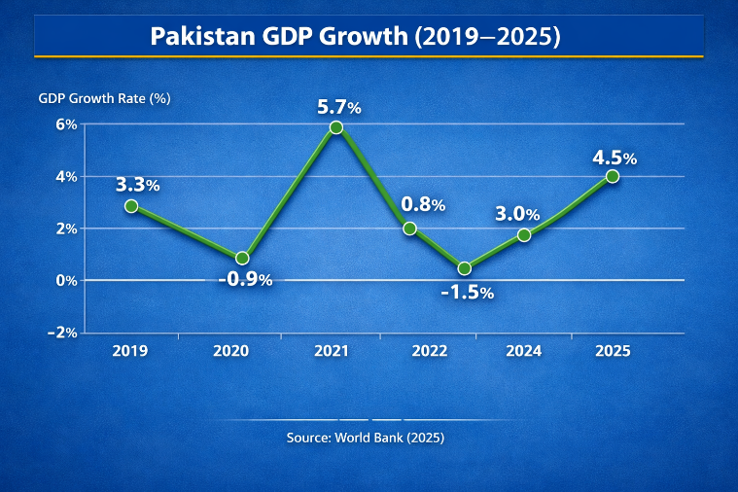
Figure 2. Pakistan GDP Growth (2019–2025)
Source- World Bank (2025)

5.2 Inflation and Exchange-Rate Volatility
Foreign investors face challenges due to high inflation rates and currency fluctuations in Pakistan. Consumer spending could be dampened by higher import prices, as well as exchange-rate volatility, which could drive up IKEA's operating costs, since many of the items would first be imported (International Monetary Fund, 2025).

5.3 Purchasing Power and Middle-Class Expansion
While Pakistan's GDP per capita stood at around US$1,680 in 2024, household consumption is the biggest driver of economic activity accounting for around 80% of GDP per year (World Bank, 2025). The growing urban middle class of around 35-40 million in the country, has been driving the demand for affordable and quality household products, especially in major cities like Karachi, Lahore and Islamabad (International Trade Administration, 2024). In addition, there was a retail industry worth US$150–170 billion in Pakistan, and organised retail has been growing at the same rate as consumer spending. IKEA has implemented a strategy of cost leadership with its products and services, providing a variety of affordable and functional items for the home, which is well suited to this expanding middle income group.(World Bank, 2025; IMF, 2025).

5.4 Urbanisation and Housing Market
Due to rapid urbanization in Pakistan, there is a high demand for residential housing product and home furnishing products. The population of the urban area constitutes around 40% of the total population of the country, over 100 million of whom live in urban areas, and the total population is more than 255 million (United Nations, 2024; World Bank, 2025). This demographic change has spurred the growth of housing projects in major urban centers like Karachi, Lahore and Islamabad, with a growing demand for contemporary, budget-friendly furniture. The Asian Development Bank (2025) forecasts continued investment in urban infrastructure and residential buildings will drive continued expansion in the housing sector.
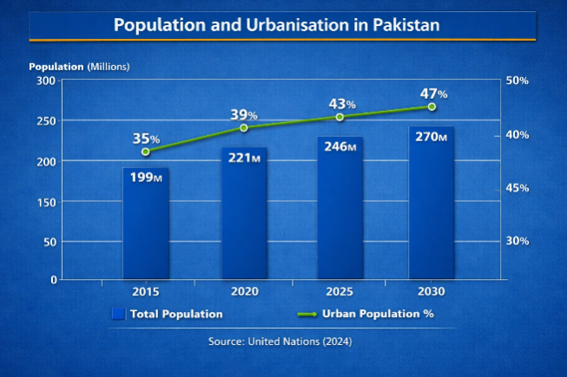
Figure 3. Population and Urbanisation
Source- United Nations (2024)

5.5 Retail Sector Growth
The value of the retail sector in Pakistan is estimated at around US$152 billion, and it is one of the biggest consumer markets in South Asia (International Trade Administration, 2024). Organised retail and e-commerce has also grown exponentially, and the e-commerce market is expected to surpass US$7 billion by 2025 as the internet penetrates the population, smartphone usage rates rise and digital payment adoption grows (Statista, 2025). These trends help to sustain the expansion of modern channels of retailing, as depicted in Figure 5. This makes IKEA's Omni channel marketing approach – combining their stores with online shopping, click and collect and home delivery – very compatible with changing consumer buying habits in Pakistan (Inter IKEA Group, 2025).

6. Legal Environment

6.1 Foreign Investment Regulations
Multinational Companies like IKEA can take advantage of the favourable legal environment created by Pakistan's foreign investment policy. In accordance with the Board of Investment (BOI) policy, foreign investors are permitted to own 100% of foreign business of most sectors and can repatriate profits, dividends and capital without significant constraints (Board of Investment Pakistan, 2025). The provisions lower barriers to investment and give IKEA the flexibility to establish and run investments with strategic control. Moreover, investment incentives and continuous regulatory reforms have enhanced the business environment of Pakistan and boosted investor confidence.

6.2 Import Duties and Taxation
The biggest legal hurdle for IKEA in its plan for expansion is import taxes and taxes. In the first phase of market entry, IKEA would rely heavily on products and furniture that it imports from its global supply chain. Landed costs and price competitiveness are negatively affected in Pakistan due to the application of customs duties, sales tax and other import duties on large number of consumer goods (International Trade Administration, 2024). This is important as IKEA's value proposition is 'stylish product at an affordable price'. The company's import expenses may lead to an escalation in retail prices which may eventually lead to a decline in demand by Pakistan's price-sensitive consumers. (Hill, 2024).

6.3 Intellectual Property Protection
Protection of intellectual property is also an important consideration, since the strength of the IKEA brand, product designs and proprietary retail concepts are relied upon as an integral part of IKEA's competitiveness. Pakistan has enhanced its IP regime and is a member of the World Intellectual Property Organization (WIPO). Yet enforcement is not consistent, and the risk of infringement and imitation of the product exists (World Intellectual Property Organization, 2024). To mitigate these risks, IKEA should have registered its trademarks before entering the market, and actively monitor the market for any infringement and cooperate closely with local legal authorities to assert their IP rights.

6.4 Critical Evaluation
A few legal factors are thought about, and import duty and taxation are likely to be the most strategic factors that will affect IKEA as they directly affect product pricing, profitability and competitiveness. Pakistan's investment policy will provide good opportunities, and though the protection of intellectual property is improving, the ability to control import costs by incremental investment and sourcing from within the country will be important to sustain long term growth in Pakistan market.

7. Cultural Environment

7.1 Consumer Lifestyle
The ongoing changes in consumer lifestyles are attributed to the fast pace of urbanisation, growing digitalization and growing incomes of the households in Pakistan. Modern, functional and affordable home furnishings are sought by urban consumers, especially by younger professionals and middle income families. This is consistent with the world’s most iconic furniture retailer's value proposition, which is to provide fashionable and functional products at an affordable price. (World Bank, 2025)

7.2 Family Size and Furniture Purchasing Behaviour
The average household size in Pakistan is roughly 6.3 persons (Pakistan Bureau of Statistics, 2023) which is larger than many Western countries. With larger families, there is a need for furniture that is more functional, can be used by more people, and is durable, efficient and practical for use in smaller living spaces. In addition, furniture is regarded as an investment product, and consumers are more concerned about the quality, durability and value of the product, rather than change after a few months or years (Hill, 2024). These are all consumer attributes that are strongly related to IKEA's value proposition of providing inexpensive, functional and durable home décor.

7.3 Religion and Cultural Values
Islam has significant influence on the consumer behaviour and lifestyle preferences in Pakistan. The importance of family unity, hospitality, and economy in living are reflected in the design and furnishing of the home. Pakistan exhibits relatively high collectivism as compared to many Western countries which means that the buying decisions are not necessarily based on the individual's preference but on the preferences of the family, too (Hofstede Insights, 2024). Accordingly, IKEA's marketing communications should focus on family home spaces and on home solutions that are culturally suitable

7.4 Home Ownership – Price Sensitivity and Customer Expectations
The demand for home furnishing products has been increased by growing urban Housing Development and rise in the home ownership rate. But the economic condition and inflation makes Pakistani consumers highly price sensitive. This cost-leadership strategy and the affordable product range, therefore, provides a competitive advantage to IKEA. Meanwhile, customers also seek durability, after-sales support and a convenient shopping experience via the sales channels of both physical stores and digital channels, and IKEA's Omni channel business is especially relevant (Inter IKEA Group, 2025).

7.5 Critical Evaluation
While the company's standardisation of its business model across the world would offer a certain level of operational efficiency, it would require some adaptation to become successful in Pakistan. Selected furniture elements, product designs, marketing messages and foodstuffs should be tailored to the local market to meet cultural preferences, larger household sizes and religious values while maintaining the core brand identity. This way of doing things is aligned with IKEA's transnational strategy, as it allows them to operate efficiently on a global scale while being responsive to the local environment. (Bartlett & Ghoshal, 1989; Hill, 2024).

8. Dunning's OLI Paradigm
The motivation behind FDI by multinational enterprises is explained by Dunning's Eclectic Paradigm (OLI) which examines three interrelated benefits: Ownership (O), Location (L) and Internalisation (I) (Dunning, 1988; Hill, 2024). Use of this framework offers a useful framework in evaluating the market potential of IKEA in Pakistan.

8.1 Ownership Advantages
IKEA has impressive ownership specific advantages to facilitate international expansion. First, the company has a well-known brand that is linked to the betterment of affordable, functional and sustainable home furnishings, which leads to high levels of customer trust and competitive differentiation (Inter IKEA Group, 2025). Second, the innovative concept of IKEA flat-pack furniture minimizes the transportation expenses, storage and assembly expenses with boosting the operational efficiency. Third, the company has established an integrated global supply chain with long-term supplier partnerships and advanced logistics, with consistent product supplies at competitive prices (Jonsson et al., 2021).

8.2 Location Advantages
There are a number of advantages that make Pakistan a more appealing investment opportunity compared to other countries. There are several advantages of Pakistan that make it a more appealing investment opportunity compared to other countries. The country has a population of more than 250 million, which makes it one of the biggest consumer markets in South Asia, providing huge long term growth potential (World Bank, 2025). The increasing urbanisation and the rising demand of residential construction have resulted in a higher demand for modern furniture and home furnishing products, especially in the major cities of Pakistan like Karachi, Lahore and Islamabad. Moreover, the growing workforce in Pakistan has access to low cost manpower in retail establishments and in case of local sourcing.

8.3 Internalisation Advantages
Dunning's Internalisation advantage suggests that firms should internalise activities when the benefits of retaining control exceed the costs of using external partners (Dunning, 1988). For IKEA, maintaining direct control over key business activities protects its globally recognised brand, proprietary product designs and operational know-how. This reduces the risk of imitation and ensures consistent product quality, customer service and sustainability standards across international markets (Inter IKEA Group, 2025). Furthermore, IKEA's centralised procurement system, integrated logistics network and standardised product development generate significant economies of scale, reinforcing its cost-leadership strategy (Hill, 2024).
However, internalisation is not without disadvantages. Establishing and managing international operations requires substantial financial investment and increases managerial complexity, particularly in emerging markets characterised by regulatory uncertainty and volatile economic conditions such as Pakistan. Excessive centralisation may also reduce flexibility in responding to local consumer preferences.

8.4 Conclusion
Dunning's OLI Paradigm would suggest that Pakistan is a strategically attractive market for IKEA. The company has a number of distinct ownership advantages: a globally recognised brand, an efficient supply chain, the innovative flat-pack furniture concept and design expertise. Pakistan also has a very strong position in terms of the population of more than 255 million, fast urbanisation and escalating long-term demand for low cost home furnishing products (World Bank, 2025). These factors help to reinforce the business case for market entry. While inflation, exchange-rate fluctuations and uncertainty over regulations persist, IKEA's internalisation benefits allow the company to retain control of the quality of its products, its brand, and its operations. Accordingly, it can be concluded that Pakistan is a good country for the expansion of IKEA, but IKEA will have to adopt a phased market entry strategy to manage the possible risks in investing in the country, while balancing the growth opportunities (Dunning, 1988; Hill, 2024).

9. Entry Mode Strategy and Strategic Synthesis
IKEA has historically expanded internationally primarily through a franchise business model. According to the Inter IKEA Group (2025), more than 90% of IKEA stores worldwide operate under franchise agreements, allowing the company to achieve rapid international expansion while maintaining consistent brand standards and operational procedures. This approach has enabled IKEA to establish approximately 473 stores across more than 60 markets, demonstrating the effectiveness of franchising in supporting global growth while limiting capital investment and operational risk (Inter IKEA Group, 2025).

9.1 Exporting
Exporting is the least risky entry strategy since IKEA can sell IKEA products to Pakistan without having a physical presence in the country itself, by using their manufacturing and distribution centres. This is a less expensive capital investment that allows quick market entry. The high cost of transportation, however, may be offset by import duties and exchange-rate variability. In addition, exporting gives little control over the customer experience, and limits IKEA's ability to tailor products and services to local market tastes (Peng, 2022).

9.2 Licensing
Licensing is a wholesale agreement in which a local firm produces or exports IKEA products for a share of the profits. This is an investment-friendly method with low investment and can provide relatively fast market access. However, licensing provides minimal operational control, and involves risks with regard to product quality, intellectual property rights and brand reputation. However, with IKEA's focus on design, sustainability, and customer experience, licensing is not a strategic option that will assist in the long-term vision. With IKEA's emphasis on design, sustainability, and customer experience, licensing is not an effective option for the long term vision (Hill, 2024).

9.3 Franchising
In some countries, franchising has proven to be one of the IKEA internationalization model's successful elements. Working through this entry mode, the local partner runs their stores, adhering to IKEA's worldwide standards and business systems. Franchising has advantages over licensing in terms of having more control over operations, being consistent with the brand and customer service and having lower investment in wholly owned subsidiaries. IKEA needs to be able to pick and keep an eye on franchise partners in order to make sure they meet the company's criteria and keep the global IKEA brand image (Inter IKEA Group, 2025).

9.4 Joint Venture
Joint venture is a business agreement between two parties, one of them being a local firm. This means that IKEA can share its investment, its operational risks, its market expertise and gain from local expertise, existing distribution arrangements and regulatory knowledge. But the advantages of joint ventures can also generate communications and management issues stemming from common decision making, disagreements and splits between partners, and varying management goals. Hence, good governance and partner selection would be crucial to the sustainable success (Peng 2022).

9.5 Wholly Owned Subsidiary
This puts IKEA in complete control and ownership of the wholly owned subsidiary, enabling IKEA to ensure consistency and quality of the product and its business model throughout the world while safeguarding its brand. But this is the costliest way to achieve the goal, leaves IKEA in high degree of political, economic and operational risk, especially in an emerging market like Pakistan. Thus, it might not necessarily be the best starting point (Hill, 2024).

9.6 Recommended Entry Strategy
After comparing the findings, it is concluded that franchising is the most suitable mode of entry for IKEA in Pakistan. This is in line with IKEA's international expansion strategy, as over 90% of IKEA stores globally are operated as franchises, allowing IKEA to expand into new markets while staying true to its brand and maintaining control over operations (Inter IKEA Group, 2025). Franchising also demands less capital investment than a fully owned subsidiary and decreases financial and operational risks, especially in Pakistan where there is economic insecurity and high fluctuations in exchange rates.
IKEA can also introduce its own ecommerce website and collaborate with local logistics companies to increase accessibility for its customers and improve its Omni channel retailing. But, the dominant mode of entry should be franchising and it is most aligned with the investment needs, operational flexibility, quick time to market and long-term goals. By doing so, IKEA's international experience will be leveraged and the company will carve out a competitive niche in the expanding home furnishing market in Pakistan. (Hill, 2024; Inter IKEA Group, 2025).
Table 2. Comparison of Entry Modes
Entry Mode | Investment | Risk | Control | Speed | Suitability
Exporting | Low | Low | Low | High | Moderate
Licensing | Low | Medium | Low | High | Low
Franchising | Medium | Medium | Medium | Medium | High
Joint Venture | High | Medium | Medium | Medium | High
Wholly Owned Subsidiary | Very High | High | High | Low | Medium
Source- Adapted from Hill (2024) and Peng (2022)

10. Conclusion and Recommendations
The findings of this report suggest that IKEA is at a strategic position in Pakistan market, as their business model (cost-leadership and effective supply chain), transnational approach and brand value are suitable for the long-term market potential in Pakistan. According to the analysis, the opportunities are attractive and there exists a population of more than 255 million, rapid urbanisation, growing number of middle class consumers and demand for affordable home furnishing products in the country (World Bank, 2025). But inflation, exchange-rate volatility and import duties are major problems that must be managed.
According to Bartlett and Goshala’s framework and Dunning's OLI Paradigm, the market entry into Pakistan is justified because of owning advantages, location advantages and internalisation advantages. However, growth should be slow not sudden. IKEA is advised to use a franchising strategy as its key entry mode in the market, complemented by its omni-channel retailing strategy and the growing trend to source locally so that over time IKEA will be less dependent on imports in the future. This strategy aligns with IKEA's international expansion success, mitigates investment risk, ensures operational control, and aligns the firm's focus with the opportunities and challenges of the Pakistani market, thereby allowing the company to achieve sustainable long-term growth.

Section 2 – Reflective Account
Gibbs' Reflective Cycle
Gibbs' Reflective Cycle (1988) is a six-phase reflective structure with phases of description, feelings, evaluation, analysis, conclusion and action plan. The model asks for critical reflection in relation to learning experiences, and allows for an individual to determine strengths and identify areas for improvement and personal and professional growth plans (Gibbs, 1988).
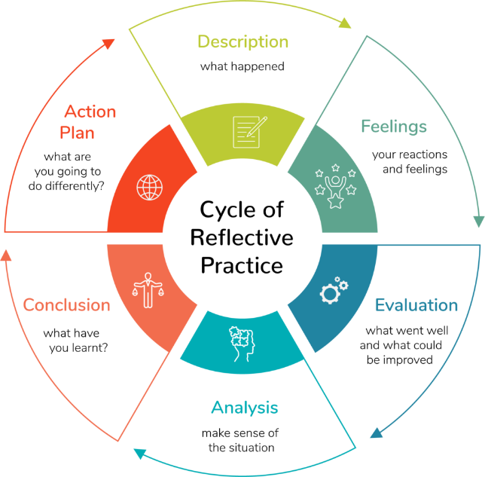
Figure 4.Gibbs' Reflective Cycle

1. Description
This assignment involved an in-depth analysis of the possibility of IKEA entering into the Pakistani market using international business theories and strategic management frameworks. Research was conducted through analysis of IKEA's international strategy by utilizing Bartlett and Goshala’s framework, political, economic, legal and cultural environment analysis of Pakistan, formulation of Dunning's Eclectic (OLI) Paradigm and finally recommending a market entry strategy. For this particular assignment, I did a lot of research based on the use of known international frameworks to assess the possibility of IKEA's extension to Pakistan. Instead of relying on only the textbooks, I have correlated the facts given in the Annual Summary and Sustainability Report of the Inter IKEA Group (2025) with the facts cited in publications of World Bank, International Monetary Fund (IMF), Asian Development Bank (ADB), and peer-reviewed academic publications. The biggest difficulty I had was finding trustworthy economic indicators that could be used in the analysis, such as the GDP growth of Pakistan, inflation, urbanisation rate and retail market size etc and incorporating these data into my analysis rather than describing the business environment. I also critically applied Bartlett and Ghoshal's Transnational Strategy to assess IKEA's strategic match for Pakistan market, Dunning's OLI Paradigm and Hofstede's cultural dimensions to see how the IKEA's strategy matches with the Pakistani market. The frameworks helped me structure the report and form evidence-based arguments and a justification regarding the most suitable entry mode: franchising. This has helped me to develop skills to combine my academic knowledge with current industry evidence to formulate clear strategic recommendations. (Hill, 2024; Gibbs, 1988).

2. Feelings
Initially, I found it challenging to determine which international business frameworks would provide the most appropriate analysis of IKEA's expansion into Pakistan. I first considered using Porter's Diamond Model to assess Pakistan's national competitiveness and Porter's Five Forces to evaluate industry competition. However, I concluded that these frameworks focused primarily on competitive advantage and industry structure rather than explaining international expansion decisions. Instead, I selected Bartlett and Ghoshal's International Strategy Framework to classify IKEA's global strategy, Dunning's OLI Paradigm to evaluate the strategic rationale for foreign direct investment, and Hofstede's Cultural Dimensions to assess the need for local adaptation. These theories complemented one another by examining strategic orientation, location-specific advantages and cultural influences, enabling a more comprehensive evaluation of IKEA's market entry into Pakistan.(Hill, 2024; Dunning, 1988).

3. Evaluation
I feel that the research process was successful because I got an in-depth knowledge of IKEA's business strategy overseas and Pakistan's market scenario. By applying recognised models such as Bartlett and Ghoshal's model, PELC analysis and Dunning's OLI Paradigm it allowed me to not just describe but critically analyse organisational abilities and market conditions in the external environment. The use of academic literature and current international media reports further supported my arguments. A positive one was learning how to find good academic sources in the university databases and to judge them as relevant or not. This helped build my confidence in identifying high quality sources from non-high quality sources. Although there were great accomplishments, there were other challenges that were not as easily overcome. There were differences in economic indicators and investment information between the sources, which needed to be carefully compared to avoid any inaccuracies. (Saunders et al., 2023; Gibbs, 1988)

4. Analysis
The research process has been a subject of reflection that has shown me that good planning has had a positive impact on the quality of the report. Creating a structured outline prior to information gathering helped to keep the report moving logically and to systematically cover all of the assessment criteria. The process of finding information from peer reviewed journals, international organisations and corporate information enabled me to look at different perspectives and critically assess the reliability of information. By using international business theories and practices, particularly the Bartlett and Ghoshal Theory and Dunning's OLI Paradigm, I was able to bring the theory into the real world and relate the theory to business theory and practice. This experience re-emphasized the need for critical thinking, not only descriptive analysis. I also learned that getting the right sources – current, credible and diverse – is critical to ensure the successful production of academically strong business reports (Hill, 2024; Saunders et al., 2023).

5. Conclusion
This assignment has enhanced the academic knowledge and professional skills of analysis in international business. I gained a greater insight into the decision making process for multinational companies to consider expansion into overseas markets taking into account other factors such as organisational resources, political, economic, legal and cultural factors. The project also helped me to enhance my critical thinking, research skills, analytical writing and referencing skills. In addition, I became more confident to use the theory in applied situations in the business world and to make recommendations based on evidence. These experiences have shown that it is essential to make systematic plans, evaluate evidence objectively and make strategic decisions, not assume, in order to successfully make decisions internationally. Overall, I have improved my skills in independent study and academic research to produce professional reports that link academic theory with current business practice (Gibbs, 1988; Hill, 2024).

6. Action Plan

6.1 Strengthening Research Planning
For the next assignments I will start researching earlier and make a clear and detailed project timeline with milestones. This will give enough time for the literature search, critical analysis, drafting and proofreading, lessen time pressure and enhance quality of my work (Saunders et al., 2023).

6.2 Enhancing Information Gathering
To develop skills in using peer-reviewed journals, business databases (Scopus and Business Source Complete), and reports from reputable organizations for literature searching. This will allow me to collect a wider range of evidence that is more up to date and reliable to aid with important academic discussions (Saunders et al., 2023).

6.3 Using skills in future learning
This assignment has helped me to build my research and analytical skills and my strategic evaluation skills, which will help me with other research assignments in my future post graduate studies. The use of acknowledged international business models will also enhance my ability to create evidence-based academic reports and dissertations (Hill, 2024).

6.4 Support the Professional Development of others
These skills acquired in the assignment such as market analysis, strategic decision making, problem solving, and professional report writing will help me in my future career in international business and management. These transferable skills will be useful for me to assess complex business environments, make strategic recommendations and be able to effectively contribute to organisational decision making in an increasingly global business environment (Gibbs, 1988; Hill, 2024)

References
- Asian Development Bank (2025) Asian Development Outlook 2025. Available at: https://www.adb.org/publications/asian-development-outlook-2025 (Accessed: 20 July 2026).
- Bartlett, C.A. and Ghoshal, S. (1989) Managing Across Borders: The Transnational Solution. Boston, MA: Harvard Business School Press.
- Board of Investment Pakistan (2025) Investment Guide Pakistan. Available at: https://invest.gov.pk (Accessed: 20 July 2026).
- Cavusgil, S.T., Knight, G., Riesenberger, J.R., Rammal, H.G. and Rose, E.L. (2024) International Business. 4th edn. Melbourne: Pearson.
- Cottrell, S. (2024) The Study Skills Handbook. 6th edn. London: Red Globe Press.
- Daniels, J.D., Radebaugh, L.H. and Sullivan, D.P. (2022) International Business: Environments and Operations. 17th edn. Harlow: Pearson.
- Dunning, J.H. (1988) 'The eclectic paradigm of international production: A restatement and some possible extensions', Journal of International Business Studies, 19(1), pp. 1–31. https://doi.org/10.1057/palgrave.jibs.8490372
- European Commission (2024) Trade and Investment Report. Available at: https://trade.ec.europa.eu (Accessed: 20 July 2026).
- Ghemawat, P. (2018) The New Global Road Map. Boston, MA: Harvard Business Review Press.
- Gibbs, G. (1988) Learning by Doing: A Guide to Teaching and Learning Methods. Oxford: Oxford Polytechnic.
- Grant, R.M. (2022) Contemporary Strategy Analysis. 11th edn. Hoboken, NJ: Wiley.
- Hill, C.W.L. (2024) International Business: Competing in the Global Marketplace. 15th edn. New York: McGraw-Hill Education.
- Hill, C.W.L. and Hult, G.T.M. (2023) Global Business Today. 13th edn. New York: McGraw-Hill Education.
- Hofstede Insights (2024) Country Comparison Tool. Available at: https://www.hofstede-insights.com/country-comparison/ (Accessed: 20 July 2026).
- Inter IKEA Group (2025) Annual Summary and Sustainability Report 2025. Available at: https://www.inter.ikea.com (Accessed: 20 July 2026).
- Inter IKEA Group (2025) About IKEA. Available at: https://www.inter.ikea.com/en/about-us (Accessed: 20 July 2026).
- Inter IKEA Group (2025) Our Business Model. Available at: https://www.inter.ikea.com (Accessed: 20 July 2026).
- International Labour Organization (2024) ILOLEX and Labour Standards. Available at: https://www.ilo.org (Accessed: 20 July 2026).
- International Monetary Fund (2025) World Economic Outlook. Available at: https://www.imf.org/en/Publications/WEO (Accessed: 20 July 2026).
- International Trade Administration (2024) Pakistan Country Commercial Guide. Available at: https://www.trade.gov/country-commercial-guides/pakistan-country-commercial-guide (Accessed: 20 July 2026).
- Jonsson, A., Foss, N.J. and Johanson, U. (2021) Strategy, Innovation and Growth at IKEA. London: Routledge.
- Kolb, D.A. (1984) Experiential Learning: Experience as the Source of Learning and Development. Englewood Cliffs, NJ: Prentice Hall.
- Kotler, P. and Keller, K.L. (2022) Marketing Management. 16th edn. Harlow: Pearson.
- Meyer, K.E. (2022) International Business. London: Palgrave Macmillan.
- OECD (2024) Economic Outlook 2024. Available at: https://www.oecd.org/economic-outlook (Accessed: 20 July 2026).
- Peng, M.W. (2022) Global Business. 5th edn. Boston, MA: Cengage Learning.
- Porter, M.E. (1985) Competitive Advantage. New York: Free Press.
- Porter, M.E. (1990) The Competitive Advantage of Nations. New York: Free Press.
- Saunders, M., Lewis, P. and Thornhill, A. (2023) Research Methods for Business Students. 9th edn. Harlow: Pearson.
- Schmid, S. and Morschett, D. (2024) Strategic International Management. 4th edn. Wiesbaden: Springer.
- Trading Economics (2025) Pakistan Economic Indicators. Available at: https://tradingeconomics.com/pakistan/indicators (Accessed: 20 July 2026).
- United Nations (2024) World Population Prospects 2024. Available at: https://population.un.org/wpp (Accessed: 20 July 2026).
- United Nations Conference on Trade and Development (UNCTAD) (2024) World Investment Report 2024. Available at: https://unctad.org/publication/world-investment-report-2024 (Accessed: 20 July 2026).
- United Nations Environment Programme (2024) Global Environment Outlook. Available at: https://www.unep.org (Accessed: 20 July 2026).
- World Bank (2025) Pakistan Development Update: Reimagining a Digital Pakistan. Available at: https://www.worldbank.org/en/country/pakistan (Accessed: 20 July 2026).
- World Bank (2025) Pakistan Overview. Available at: https://www.worldbank.org/en/country/pakistan (Accessed: 20 July 2026).
- World Economic Forum (2025) Global Risks Report 2025. Available at: https://www.weforum.org/reports/global-risks-report-2025 (Accessed: 20 July 2026).
- World Intellectual Property Organization (2024) Pakistan Intellectual Property Profile. Available at: https://www.wipo.int (Accessed: 20 July 2026).
- World Trade Organization (2024) Trade Policy Review: Pakistan. Available at: https://www.wto.org (Accessed: 20 July 2026).
- Yin, R.K. (2024) Case Study Research and Applications. 7th edn. Thousand Oaks, CA: Sage.
- Zentes, J., Morschett, D. and Schramm-Klein, H. (2021) Strategic Retail Management. 4th edn. Wiesbaden: Springer.

