UNIVERSITY OF WALES TRINITY SAINT DAVID
CLOUD COMPUTING

Web Development
TechAcademy Website

AUTHOR: CLAUDIU OCTAVIAN ALBUS
STUDENT ID: 1809254

London
2019
Table of Contents

- Introduction________________________________________________________1
- Programming languages used in Web Development_______________________2
- TechAcademy Website_______________________________________________5
- Bibliography_______________________________________________________10

Introduction
The IT domain has seen the largest and fastest progress compared to other domains, considering the relatively short time, since its emergence.
The Internet and the concept of web, have been expanding since its beginning. The Internet in fact represents only the infrastructure of a network interconnected by computers, that allows users to communicate and access the information.
Internet is the name of the largest group of sources of information in the world. The Internet network is extended to the entire planet and includes a huge amount of physical, logical and informational resources (Levine, 2010).
The World Wide Web is the most popular part of the Internet, it is the graphic part, which is easy to introduce to the users and easy to modify. This service allows its users to view, edit or share electronic documents, audio files, images and other file types regardless of the location or distance between users, at any given time (Fensel, 2011).
Web Development contains any activity related to developing a website. This may include business development through e-commerce, web design, web content development, specific programming, web server configuration, etc. Web Development includes both the realization of simple static web pages with text, up to the most complex Internet applications, electronic business (e-business), or social networking services (Deitel, 2007).
HyperText Markup Language, known as HTML, has certain features, which are essential for the distribution of information remotely. It is a descriptive programming language that allows the construction and saving of documents, over the Internet.
The web has become an agglomeration of applications, which come into contact with each other. The users have a collection of applications available and they can choose the one that suits their needs.
The users have a key role in Web Development, through their active and continuous involvement, which has evolved continuously. Users through their feedback, can decide the new trend of the Internet and what it will look like in the near future (Darlington, 2005).

Programming languages used in Web Development

The interface of a web application are web pages made using various technologies such as: HTML, CSS, JavaScript, PHP.

HTML
HTML (HyperText Markup Language), developed by the World Wide Web Consortium (W3C), is used to create documents for the World Wide Web, known as web pages.
HTML is a collection of keywords called ‘tags’, that are used to write documents that can be viewed, using a browser. These tags are written between ‘< >’, and most of them consist of an opening tag ‘<HTML>’, and a closing tag ‘</HTML>’. There are also single tags (which do not have a closing tag) such as ‘<HR>’, ‘<BR>’.
This language is independent of any existing platform such as Windows, Linux, Macintosh and others. In order to view a web document, it is essential that each element in it (paragraphs, tables, images, links, etc.) to be marked with HTML tags. In order to view such a document, it must be opened in a browser. A browser understands and interprets HTML tags, identifies the document structure, and displays it (Castro, 2003).

CSS
For a better presentation of the web pages, it is encouraged to use the CSS language together with the HTML language. Cascading Style Sheets (CSS) offers the ability to precisely control the formatting of the web page elements. HTML is used to control the structure of the web pages, while CSS style sheets are used to control the format of the elements that make up the web page much better than HTML language allows.
Styles are rules that define how elements will appear on the web page, with what kind of font and colour, line spacing, paragraph identification, borders, or content placement. CSS can be defined inside the web page, that is internally, or in an external file with the ‘.css’ extension, attached to the page (Nixon, 2012).
External style files can be attached to multiple web pages, so there is no need to define for each page the element format. CSS has different levels, each level being developed over the previous one, thus adding new features and are known as CSS1, CSS2 and CSS3.
For a better presentation of the pages, the external CSS files have been used, and attached to the pages. Defining CSS styles in external files allows the style changes made to the external file to be applied to all web pages to which it was attached. This way no changes need to be made on each page to change the size of an element, but only in the style file (Nixon, 2012).
This good practice should be used by every programmer, because is reducing the development time, and the future changes can be made easier and faster.

JavaScript
Another very important technology is JavaScript. This is an object-oriented scripting language, which has a similar syntax like C++. JavaScript is an interpretable language, and that means it should not be compiled, unlike C#. Also, JavaScript is based on events that can be triggered when the user clicks on a button or link, or when they hover over an item's surface, or when the user enters text into a text box.
For these events it can be attached functions, that will be called when the event is activated. JavaScript runs on the client side and is part of the HTML document. JavaScript lines of code can be added directly inside the HTML page in the ‘<head>’, or ‘<body>’ part of it, as well as being attached to external web pages with the ‘.js’ extension containing the JavaScript code (Haverbeke, 2015).
When a script is entered directly into the web page, it will be added using the ‘<script>’ tag or the ‘<noscript>’ tag, but also with the help of event management functions (onload, onclick, onmouseover, onmouseout etc.). When external files containing JavaScript code are attached, the ‘<script>’ tag, is no longer used.
Thus, JavaScript has been used to create user-friendly and interactive user interfaces, and to make the application more dynamic.

PHP
Another very important technology used in web application development is PHP (Hypertext Preprocessor). This is a server-side scripting language that means it will be executed by the server.
This indicates that the server executes the script and transcribes the content into HTML before it is sent to the browser. The user, when is analysing the source code of the page created using PHP, will only see the final result returned by the server and not the PHP code (Nixon, 2012).
Using a language such as PHP, allows the creation of web pages with dynamic content, even though these pages look that they have static content, it is dynamically generated using PHP. An advantage of PHP, is the ability to use it together with databases, such as MySQL, allowing data to be added and extracted from the database and then displayed to the user in real time (Ullman, 2012).
The language can be used in conjunction with HTML, but even if a page is written entirely in PHP or contains only a script embedded in HTML, the file must have the ‘.php’ extension. PHP scripts when written, must be between the ‘<?php’ and ‘?>’ delimiters, even if the page is written entirely in PHP or just a script embedded in the page.
Inside the scripts, HTML tags can be used with the help of the echo language builder. PHP is a poorly-typed language, so the variables do not have to be declared explicitly, they are considered declared at the first use in the code, and the assigned data type is determined by the value retained at that time. When using variables, their name must be prefixed by the ‘$‘sign. PHP uses keywords and a language syntax similar to C ++.
PHP is the most important technology that has been used in the development of the client component, because is helping the data processing. The most important advantage offered by PHP is the possibility of being used together with MySQL.
Using all these technologies like: HTML, CSS, JavaScript and PHP, people are able to develop the components for a website used by the clients, so that the content of the web pages is generated dynamically.
This application does not require large resources from the client to be able to run it, because it runs on the provider's server. The client requires a computer connected to the Internet and a browser. Such applications also offer the advantage of portability, the application being accessible from any computer with stable Internet connection. As it can be seen, these technologies offer advantages for the developers, and also for the users.

TechAcademy Website

Description
TechAcademy is a website designed for the students who are interested to build a strong career in the programming field. The students can create a profile on the website, using a username and a password. Once the profile has been registered, they can enrol to one course only and to check the progress of the course.

Website Structure
The structure of the website is the following:
- Study Here
- Courses
- Contact Us
- Register
- Login

Implementation
To create the entire website, the Sublime Text program was used as an editor, to write the code for TechAcademy.
Using the PHP programing language, I have created at the beginning two files with ‘.php’ extension.

The following files contains all the programing codes for the website:
- header.php – contains the top part of the website that includes: meta-tags, libraries, meta-title and meta-description. Also, includes the css style file for the website.
- footer.php – contains the copyright and the year when was updated, which is placed in the bottom side of the website.
- index.php – is the first file read by the browser when the URL of the website is accesed and the homepage will be displayed.
- studyhere.php – contains all the details regarding the improvement of future carrer for students.
- courses.php - contains all the information regarding the courses, modules and duration;
- contactus.php – the student can find here all the contact details.
- register.php – contains a form that will be accessed by the student to create a profile. All the information placed in that form will forwarded to the database in phpMyAdmin.
- login.php – contains a form. After the profile registration, the user can use its username and password to login into the account.

Accessing the database
- locating and accessing phpMyAdmin, this program is installed by XAMPP.
- locating the "create a new database" field on the right side of the phpMyAdmin screen.
- name the created database and add it by clicking on the "add" button.

Creating the entities and establish the relationships between them
- The student can enrol to only one course.
- One course has many modules.
- One module has one lecturer.
- The student receives grades for each module.
- The student has available only two re-sits per module.
- The student passes a course when complete all the modules.
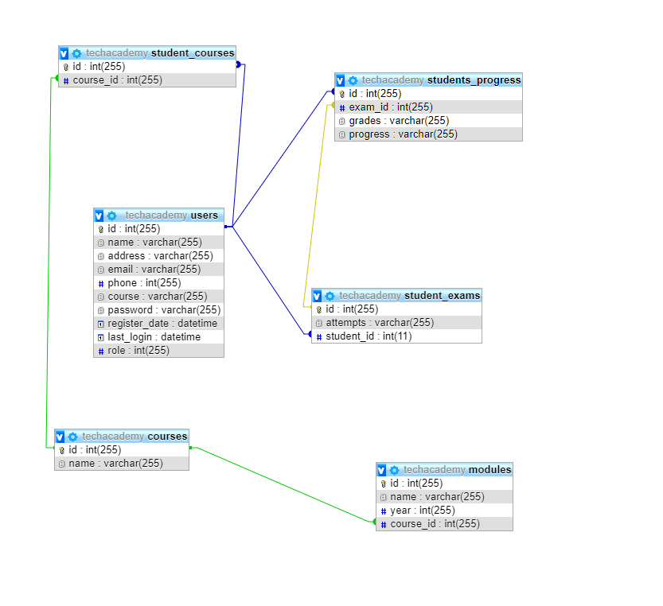
User types
Administrator – role 1
- controls the users, the lecturers and editing the grades over the website
- establishes access to functions by selecting role permissions
- configures the default behaviour of users, including registration requirements, emails and pictures of users
- add, delete and edit registered users
For security reasons, to have access to the admin panel, it could be done by URL. Introduce the URL: https://www.dev.mindlasting.ro/techacademy/admin, and put username: admin and the password: admin12.


User – role 0
- can create his own profile
- can enrol to only one course
- can check the ongoing progress
To log in as a user, enter username: test and password: test12.



Conclusions
The purpose of this paper is to review the multiple possibilities of developing a website, in a world where the Internet is the main modern source of information.
In order to help the visitor to understand the structure of the website and to visit only the sections that interests him/her, it was used as a navigation element the navigation bar. The navigation bar, will send the visitor to the most important places on the site. In order not to confuse the visitor, the navigation bar contains only five different buttons to access the specific pages.
For the web design it was maintained the essential principles: the site should be simple, clear and intuitive. In keeping with the rule of consistency, was kept the same general look and style of the page, throughout the site.
However, once the website development stage was completed, the work was not completed. Because, as strange as it may seem, a website is a living organism that needs to be maintained and optimized at all times to create results.

Bibliography

- John R. Levine, Margaret Levine Young (2010), The Internet for Dummies, 12h Edition, John Wiley & Sons, p. 11-15.
- Dieter Fensel, Federico Michele Facca, Elena Simperl, Ioan Toma (2011), Semantic Web Services, Springer, p. 10-16, p. 18-22.
- P.J. Deitel, H.M. Deitel (2007), Internet & world wide web: how to program, Fourth Edition, Prentice Hall Press, p. 9-11.
- Keith Darlington (2005), Effective Website Development: Tools and Techniques, Pearson Education, p. 2-5.
- Elizabeth Castro (2003), HTML for the World Wide Web, Peachpit Press, p. 14-15.
- Robin Nixon (2012), Learning PHP, MySQL, JavaScript, and CSS: A Step-by-Step Guide to Creating Dynamic Websites, O’Reilly Media, p. 40-43, p. 389-392.
- Marijn Haverbeke (2015), Eloquent JavaScript: A Modern Introduction to Programming, Second Edition, William Pollock, p. 6-8.
- Larry Ullman (2012), PHP and MySQL for Dynamic Web Sites, Fourth Edition, Peachpit Press, p. 3-6.

