ABSTRACT
Personal developing is very important part of our live. Part of this happening with help of reflection and reflective practice. I use my experience during the semester and this module, and some of the theories and practical test for analysis.
REPORT SUMMARY
For this report is used two of the learning cycles – Kolb (1984) and Gibbs (1988). They are very useful tool that show what is my progress in a learning curve. Also, can show my strength and week sides and to help with doing future improvements for my daily life. This also can give us better understanding about what we need to change in our life so we can achieve our goals.
Introduction
Our daily life is full of challenges regarding our future. We need to learn how to face these challenges and to manage daily routine. One of the ways is to use reflections to aim our goals. Meaning is that reflections is a method of training that gives us opportunity for autonomous advanced learning and improving our knowledge and daily routine.
Our experience and practice give us our benefits for reflections. Practice reflection is ‘learning through and from experience towards gaining new insights of self and practice’ (Finlay, Linda, 2008), this is important part of our daily live. For me and for many people is initially difficult to understand what exactly reflective practice is and how this is beneficial for us. I think reason for this is that these theories are still too young, but now more and more students, lecturers, and managers using this approach to better understand and try to improve their lives.

Kolb`s experimental learning
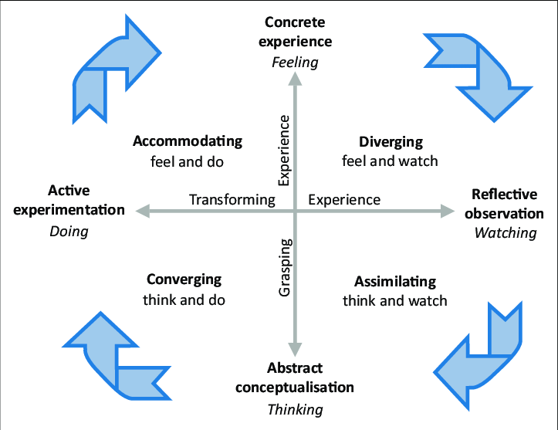

Not long time ago in 1984 David Kolb published his model of learning styles. "Learning is a process in which knowledge is created by transforming experience (Kolb, 2015)." Students’ responsibilities are covered by Kolb ideology. His concept is created based on our unique experience that give motivation for development. With his two concepts – four learning styles and four-phase learning cycle. Kolb’s connect them using logical connections. It includes two modes of understanding in the Experimental Learning Theory (ELT) – Abstract Conceptualization (AC) and Concrete experience (CE). Active Experiment (AE) and Reflective Observation (RO) is a transforming experience two-way base. These four modes of education build an experiential process of education.
Usually, it is showing as learning cycle or spiral. As a process sensitive to current learning situation and what you can learn it “touch all bases” like experience, acting, reflection. Reflection and observations are base for specific or immediate experience. All these reflections are summarized in new directions for action.
Learning styles
For four phases of the learning cycle, Kolb cover with four learning styles. Every two phases of learning cycle cover an individual learning style:
• Concrete experience (feeling) and active experimentation (making) is combination that forming Accommodation style of learning.
• Specific reflection (observation) and experience (feeling) and observation is combination that forming Divergent learning style.
• Abstract thinking (thinking) and observation and reflection is combination that forming Assimilative learning style.
• active experimentation (doing) and abstract thinking (thinking) is combination that forming Convergent learning style.
By checking results regularly, we can make way for new experience.
Gibbs’s reflective cycle.
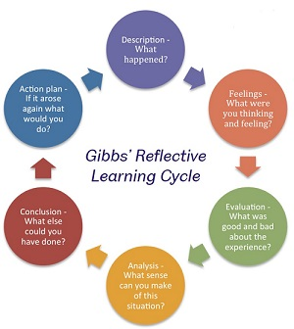
Learning form experience is structure in 1988 by Graham Gibbs and He developed his Gibbs's Reflective Cycle. His theory gives experience a framework for examining. Because of its cyclic nature it is give opportunity to learn and plan from good and bad repeated experience.
Gibb`s defines six stages:
• Experience Description
• Experience related thoughts and feelings
• Evaluation both good and bad experience
• Situation Analysis to make sense
• Conclusion about what you could have done differently and what you learned
• Find appropriate action plan or general changes for future how you would deal with similar situations.
Gibbs reflective cycle may be helpful in many ways. Everyone opens to active change would use the cycle as a helpful tool. Using cycle by coaches and trainers give them opportunity to find different respond for situation. Cycle is excellent tool for individuals to make them aware of their actions and results of them.
Kolb`s and Gibb`s reflective cycle comparison
Kolb's theory is best for improving higher education and for providing training for workers by addressing learning styles to individuals (Kolb, 2015). Gibbs model on the other hand, enhance results reflect on a previous situation for comparable situations in the future; it can be used in professional or personal life in various contexts. Managers can benefit from "Individual use" when organizations recommend improving their performance to workers.

My lifetime management, Maslow’s hierarchy of needs theory, Reflection through Gibb`s cycle.
Reflection can be made by various methods. I start with the Gibb`s reflective cycle.
For me study in university is something new and challenging. Especially with current uncertainty times with Covid-19 and all restrictions and online learning. New people, different system of education, language barrier. But realise that if I want to achieve my dreams this is the only way. In the beginning I was a bit scared if I can cope with lectures and my work and family life. How will do my exams and assessments. But after first few weeks I realise that everything goes smooth and without any disruption. Now trough reflections I am seeing that in the beginning I was not confident enough in my knowledge. Now I feel more confident in my writing, in my answers to the questions from lecturers. Especially this semester was very interesting for me because I learn a lot of theoretical bases of marketing and global business. All this secure me that ill achieve my goals to be successful manager after I finish my studies. What I learned in this module gives me confidence that knowing the intricacies of communication with people. To problem solving and look for mistakes form others and myself. I learn that is no wrong side of experience so you could learn how to avoid same mistakes if the same situation happened again by taking different steps and making an action plan.
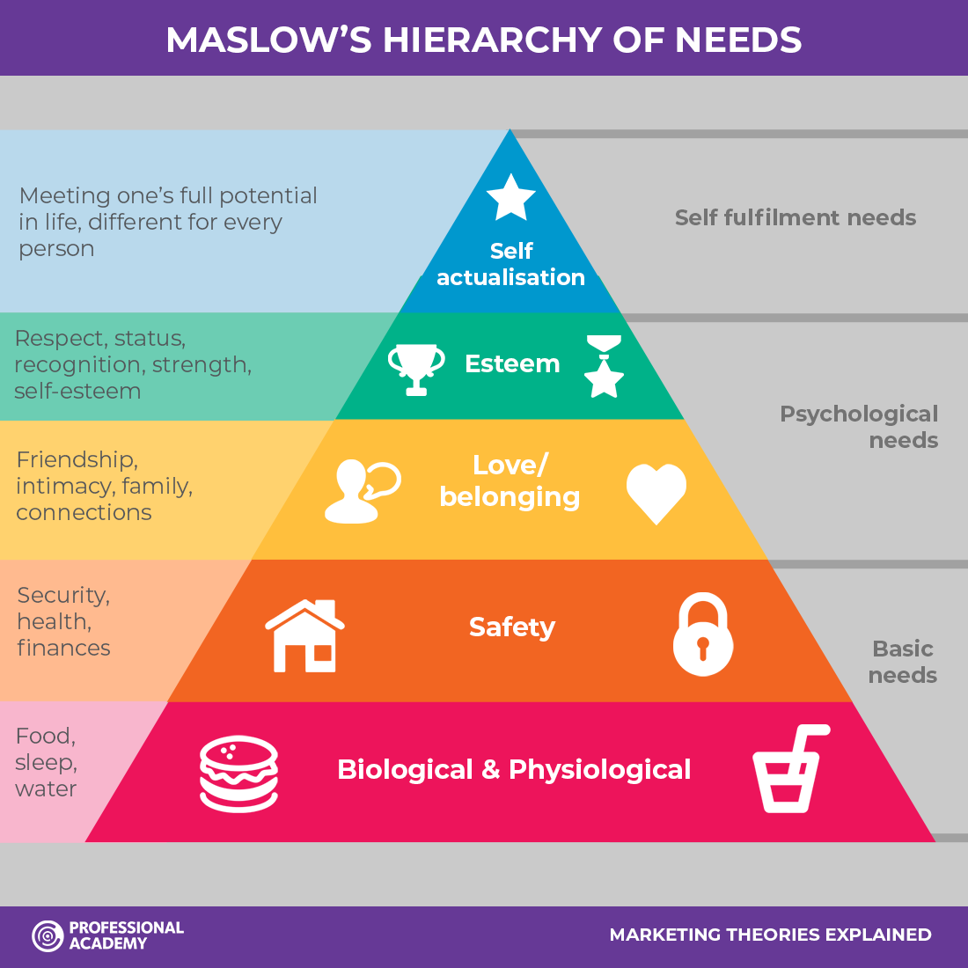
Maslow`s hierarchy saying that we cannot go to higher levels until we are not motivated to the lower levels. If our lover level is not meet, we cannot reach to the next higher self-realization levels (Carley, 2015). Why Maslow? Beginning my reflections with Gibbs I decided to continue with similar theory. With his five levels of needs it is very close to our daily life routine. Starting form a lowest level and step by step going to reach success in my studies.
My goal is to be a manager. And in entry level I have need to start to learn in university. Next level is my university experience with motivation for takin courses and moving forward. Next level is my family life. I am example and role model for my four kids and showing them that if they are with good education can reach better life. Top level is own self-actualization. To achieving that we need time. And this leads us to time management component. This helps to split times between tasks and give you opportunity to work smart than hard. If you good in time management, you can do more for less time. “To complain about a shortage of time is like a fish in the sea complaining that it has a shortage of water” (Foster, 2006). The main thing I learned from Time Management is to using my time optimally. Starting several tasks at the same time did not give me chance to finish them on time. By starting using a to-do list I start to manage tasks for the day. Prioritizing important tasks and postponed task that can be done for next day. Now using my time correctly, I have more time to be with my family, to completing my assignments on time before deadlines, to spend more time with my kinds.
In the future competencies that I learn form this module will help me to plan my job, to try finding mistakes and prevent them to happened again which will lead to achieving my goals.
Conclusion
In conclusion learning of new learning techniques and their application start to change my point of view for learning process from challenge to pleasure.

References

Behavior, D. o. O., WP09-03. weatherhead.case.edu. [Online]
Available at: https://weatherhead.case.edu/departments/organizational-behavior/workingPapers/WP-09-03.pdf
[Accessed 18 07 2021].
Carley, S., 2015. "Educational theories you ust know: Maslow. St.Emlyns", in St. Emlyn`s. [Online]
Available at: https://www.stemlynsblog.org/better-learning/educational-theories-you-must-know-st-emlyns/educational-theories-you-must-know-maslow-st-emlyns/
[Accessed 18 07 2021].
Finlay, Linda, 2008. http://oro.open.ac.uk/68945/1/Finlay-%282008%29-Reflecting-on-reflective-practice-PBPL-paper-52.pdf. [Online]
Available at: http://oro.open.ac.uk/68945/1/Finlay-%282008%29-Reflecting-on-reflective-practice-PBPL-paper-52.pdf
[Accessed 2021 07 2021].
Foster, M., 2006. Do it Tomorrow and Other Secrets of Time Management. none ed. Great Britain: Clays Ltd, Elcograf S.p.A.
Gibbs, G., 2013. Learning by doing. First ed. Oxford: Reproduced Oxford Centre for Staff and Learning Development.
Kolb, D. A., 2015. Experiential learning Experience as the Source of Learning and Development. Second edition ed. Upper Saddle River, New Jersey: Pearson Education, Inc..
Learning, I. o. E., 2020. experientiallearninginstitute.org. [Online]
Available at: https://experientiallearninginstitute.org/resources/what-is-experiential-learning/
[Accessed 18 07 2021].

