[Name: Nia Davies]
[Student Number: 2518521]
[WORKSHEET 2 -- TESTING (Parking Fee Calculator)]
vehicleType=input("Enter your vehicle type. (car, electric car, motorcycle or van)")
if vehicleType == "car":
parkingfee= 2.50
if vehicleType =="electric car":
parkingfee= 1.75
if vehicleType == "motorcycle":
parkingfee= 1.00
if vehicleType == "van":
parkingfee= 4.00
dayparked=input("What day are you parking?")
#weekendfee=0.20
parkedtime=int(input("enter the time parked in hours"))
if parkedtime > 24:
print("The car park has a 24 hour limit. Please restart and enter hours parked.")
if dayparked == "monday" or "tuesday" or "wednesday" or "thursday" or "friday":
totalfee= parkingfee * parkedtime
if vehicleType == "car" and totalfee > 15.00:
print("Your Parking fee total is 15.00")
if vehicleType =="electric car" and totalfee > 10.00:
print("Your Parking fee total is 10.00")
if vehicleType =="motorcycle" and totalfee > 6.00:
print("Your Parking fee total is 6.00")
if vehicleType =="van" and totalfee > 25.00:
print("Your Parking fee total is 25.00")
else:print("Your Parking fee total is", totalfee)
if dayparked == "saturday" or "sunday":
weekendparking= totalfee + 0.20
print("Your weekend parking fee is", weekendparking)

[Code Testing]
For each test below, run your code and enter the values provided. Provide a screenshot of what happened when the programme ran. Did the programme behave correctly or did it do something unexpected? Fill in a box for each test below. You should present 12 separate boxes, 1 for each test. (Note: the first box is provided as a template)
Test the following values for your calculator:

- 2 hours parking with a car on weekday
Output;
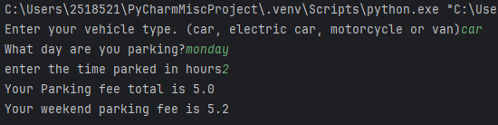
Programme has behaved correctly. It has also shown a weekend fee, due to how the code is written. Should be reviewed to only show output based on user input.

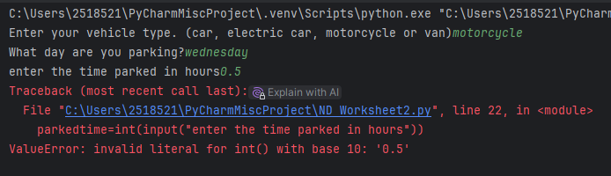
- 0.5 hours parking with a motorcycle on weekday
Programme has not successfully run. This is because the code has not been written to accommodate a value less than 1 in ‘time parked’ section. Code to be reviewed to allow values less than one and calculate fees based on the figures given.

- 8 hours parking with a van on weekend
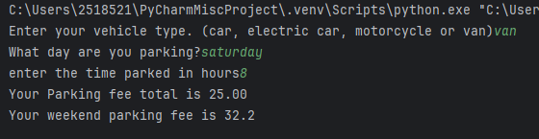
Programme has run successfully and does show the final parking fee but again, shows a weekday parking fee and the weekend fee, presenting a confusing output for someone using this program. Code should be reviewed to only print the information relevant to the user based on input.

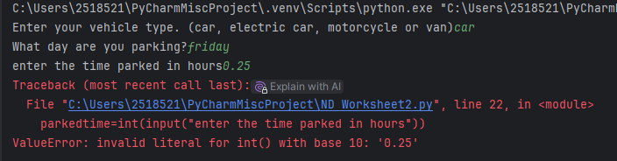
- 0.25 hours parking with a car (short stay outlier)
Programme has not run successfully as code written to only accept base 10 figures and will not accept anything less than 1 hour in ‘time parked’ section. Code to be rewritten, accommodating short-stay times.

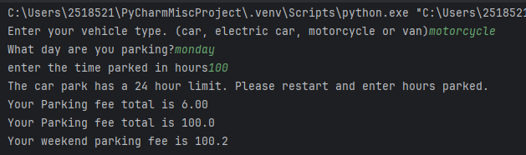
- 100 hours parking with a motorcycle (long stay outlier)
Programme has run, as written. Some unexpected output in line 6. Code could be reviewed to force user to return to start of script when entering an invalid number without showing any fees, as not applicable here as the data should be unacceptable. Further code written to establish long-stay fees.

- 24 hours parking with a van on weekday
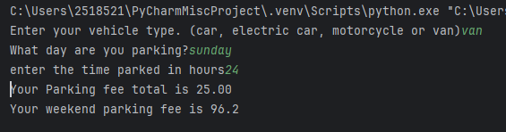
Program has run, similarly to as documented above with both a weekend fee and a weekday fee shown, which could cause confusion. Code should be expanded upon to establish long-stay fees and add limitations in numbers entered. The maths within the weekend rate calculation may also be off and should be reviewed.

- 72 hours parking with a car on weekend
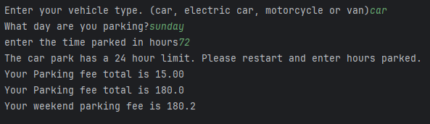
Program has run, shows some unclear output, as shown in the different fee messages. Further code to be written to establish limits and correct some of the mathematical data.

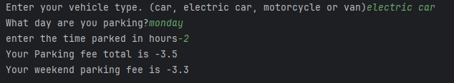
- -2 hours parking with any vehicle
Program has run. Has allowed negative figures and again, shows unclear output in both a weekday and weekend figure. Code to be reviewed and limitations applied to numeric input fields to only allow a certain range of data. Code also needs to be amended to only show the user the output relevant based on their input.

- Enter an outlier value, click "n", then enter another outlier value
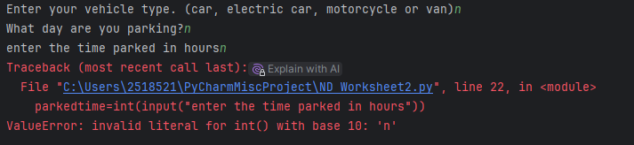
Programme has not run when n selected. As shown, ‘parked time’ field will only accept base 10 figures. Code to be reviewed to determine the acceptable data, dependant on the input being provided and apply acceptable limits to that data.

- Suitable "normal" parking duration for your chosen 4th vehicle
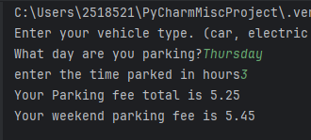
Program has run. Both the weekend and weekday fee is shown. Code should be rewritten to only print the relevant output based on input data.

- Suitable out of range parking duration for your chosen 4th vehicle
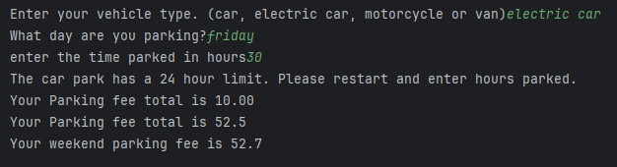
Program has run with both a weekend and weekday fee, as shown throughout. Code should be reworked to only print the relevant output based on user input. The weekend fee, where the 20% additional fee is added, also needs review as it seems that the maths/logic side of the code is incorrect.

- Test your menu -- what happens if you enter "5" for vehicle type?
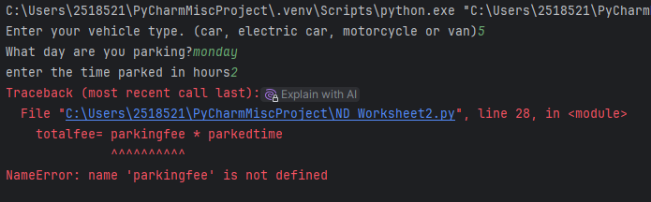
Program has not run. ‘parking fee’ not defined. Code should be reviewed to only allow the pre-determined options and not allow user to proceed without. Same logic should be applied to numeric values and further code should be written to establish limits to the values accepted.

For each test provide screenshots(s) of output: and answer the following questions
- Result: Did the program behave as expected ie syntactically and logically correct? YES/NO
If NO, what problems were encountered and why? Suggest how things could be improved.

Added above.

