DS 1 Template

My Screenshots/Photos
- Please add 4–6 screenshots or photos of your digital life.
- You can use your phone or laptop.
- For each screenshot, write one or two sentences explaining what it shows.

Screenshot/Photo 1
Uber Application

This app really helps in my daily life, and someday I’d like to work for them.

Screenshot/Photo 2

Linkedin Application
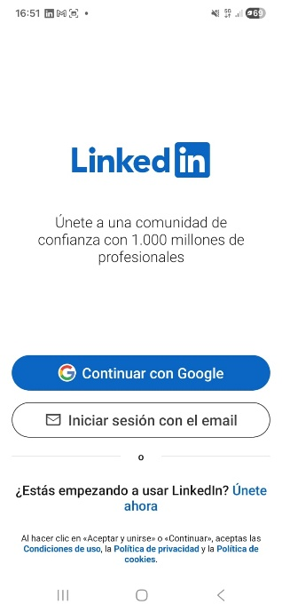
This app helps people find me in my professional life.

Screenshot/Photo 3
Calendar Application
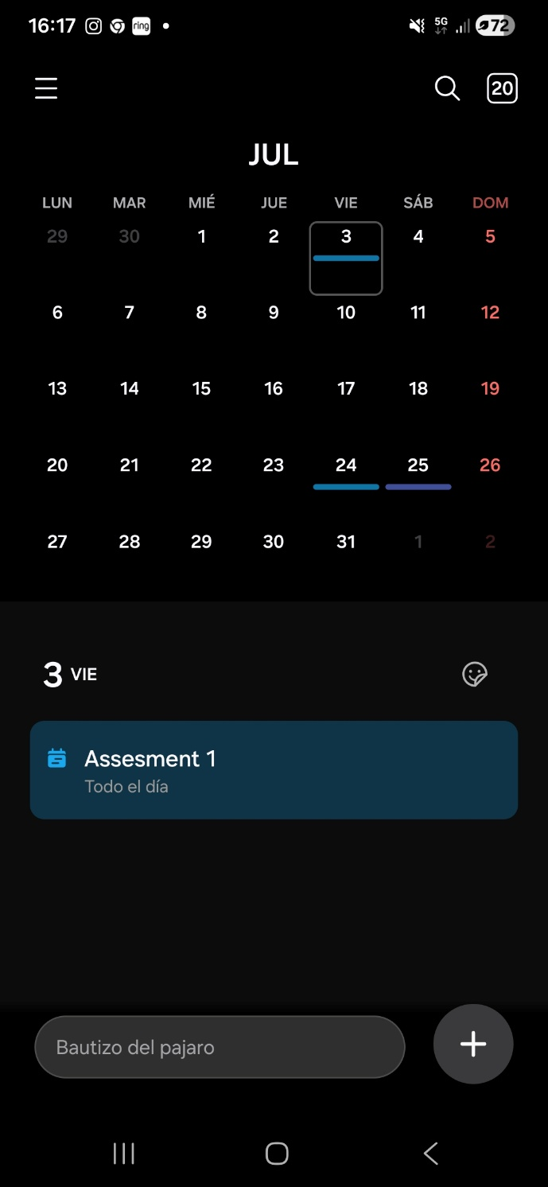
This app has helped me keep my daily life organized.

Screenshot/Photo 4
Instagram

Personally, this application has helped me network with major companies in the wine industry.

Screenshot/Photo 5
Remitly Application
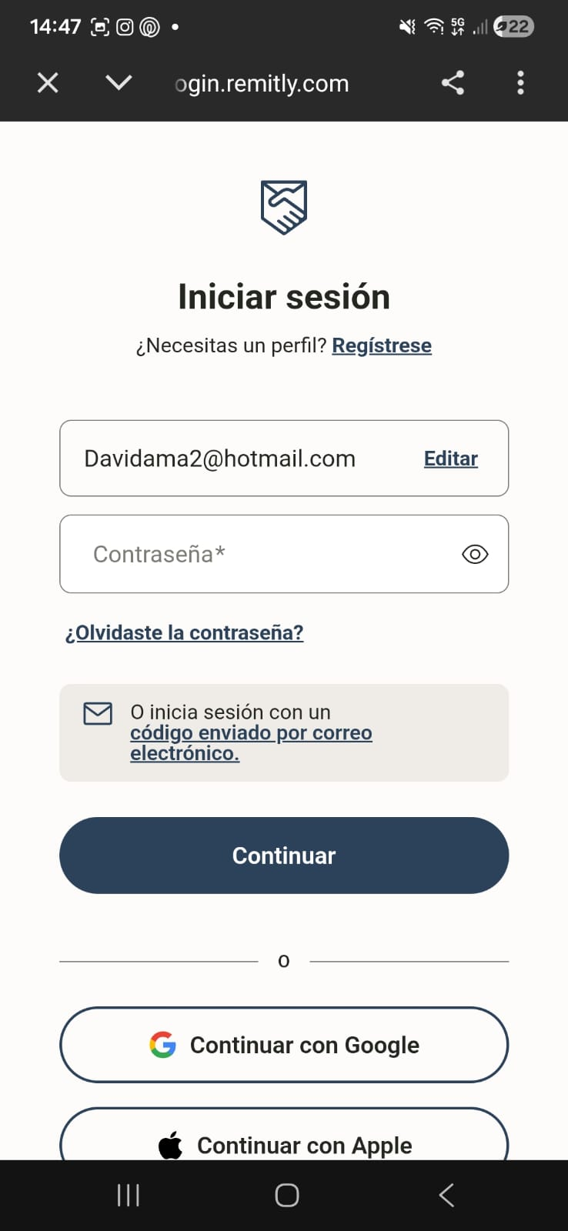
This app has helped me send money to my family quickly and securely.

My Short Reflection
- Write 5–8 simple sentences about your digital life.
- You can use the sentence starters below if helpful.
I use digital tools to try to stay as up-to-date as possible

I feel confident when I search for something in the apps because I find what I need

I want to improve the techniques the professor is teaching us—for example, how to search for something correctly.

I often use these tools when I really need them, depending on daily requirements.

I sometimes I feel nervous when I can't find something online or worry that it might be misinformation.

I hope this module helps me improve at using applications and social media correctly.

Digital skills are important for me because I believe that is what the future is all about; I believe in the robotic era, and these skills will help me in the future.

Sentence starters
- I use digital tools to …
- I feel confident when I …
- I want to improve …
- I often use these tools: …
- I sometimes feel nervous about …
- I hope this module will help me …
- Digital skills are important for me because …
You can write more if you want.

Submission Checklist
Before you submit, please check:
​​​ ☐ I added 4–6 screenshots
☐ I wrote short sentences for each screenshot
☐ I wrote my short reflection
☐ My work is my own
☐ My file opens correctly
​​☐ My file opens correctly

