Driving Change and Building Business Cases

BMHR7014

Helen Golaszewski (2109674)

Title - A critical review of the supportive measures in place for those returning from maternity/adoption leave at South Wales Police (SWP) (Supplementary Notes)

Contents

Introduction……………………………………………………………………………3
Literature Review……………………………………………………………………. 4-7
Methodology……………………………………………………………………………8-10
Findings…………………………………………………………………………………11-14
Conclusions…………………………………………………………………………….15
References Report …………………………………………………………………….16- 23
Appendices
Appendix A – Full Poster References
Appendix B – Email sent to UK Police Forces
Appendix C – Summary of responses from UK Police Forces
Appendix D – Example survey sent to SWP Employees
Appendix E – Summary of Online Survey Results
Appendix F – Focus Group Notes

Poster Total Word Count - 917
Report Total Word Count – 2926
Total - 3843

Introduction
In 2021, the Chief Constable set out his Delivery Plan (SWP, 2021) which included “People” as one of the four main areas of focus. The plan has been a catalyst for several projects within the HR, including a review of the current Maternity/Adoption policies and processes.
In 2021, 81 South Wales Police (SWP,2021) employees took maternity or adoption leave, in the same year the Office for National Statistics recorded that working mothers with dependent children are at their highest levels for 20 years at 75.6% (ONS,2022).
It is important to acknowledge that whilst fathers can also be primary carers for children, research suggests that childcare responsibilities are still predominately taken on by mothers (Howlett, 2020; Reynard,2018), therefore the primary focus of this review will be on the impact that returning from maternity/adoption leave has on working mothers.

Sharma (2020) found that “over third of employees found it harder than expected” to return to work after a period of maternity leave and SWP has recently seen a 75% increase in employees who have sickness absence following leave (SWP,2022) which suggests that some employees may be finding the return to work challenging. This not only means that employees are not in the workplace but also incurs additional costs to the organisation in sick pay.
Organisations who have “Family friendly” policies within the workplace can improve the recruitment and retention of employees, reduce absenteeism and improve employee wellbeing. Lyonette and Bauldalf (2019); CIPD (2018).
These outcomes, in addition to the direction from the Delivery Plan provides incentive for SWP to ensure their policies are fit for purpose.
To conduct an effective review, it is important to establish the challenges that mothers experience when returning to work, review the effectiveness of current supportive measures within SWP, conduct external research, including a comparison of what SWP offers to other employers to identify any potential gaps and finally, look at what improvements and recommendations can be made.
Literature Review
Work/life Balance
Adapting to life with a new child and returning back to work can be a challenge for employees and in many cases, there will be a need to request flexible working. Hochchild’s “second shift theory” describes the need for many working mothers to balance their paid work with the responsibilities of raising a child which can be likened to having a second job (Brailey, Slatton 2019). In a survey conducted by NCT (2008), 57% of respondents highlighted that achieving a work/life balance was a concern for working mothers. Research also suggested that 50% of working mothers cannot get the flexibility they require from their employers and that 42% believe that flexible working is “not perceived positively” (TUC,2021; Williams 2018).
The Covid-19 pandemic has had a large impact on working practices in recent years, CIPD (2022) report that 78% of employers are offering some form of hybrid working and UK employers have an “increased openness to part time working and other flexible working practices” (Finch,2022).
Attitudes of employees have also changed drastically in recent years with many expecting more flexible working practices as standard (Fleming, 2020), there has also been a shift of focus for many employers away from the number of hours employees are working and more towards work output (Zucker 2021). The trail of the 4-day week in the UK by many organisations highlights the move away from traditional working patterns (Ellerbeck, 2022).
SWP have recognised the need to change regarding flexible working culture and have a “Smarter Working” Policy to encourage more flexible working practices and has changed attitudes towards homeworking with many roles becoming more agile (SWP,2022), however as the organisation is a 24/7 service, this can limit the amount of flexibility that can be offered for some roles such as front-line officers, nevertheless there were 398 flexible working requests granted in 2021 (SWP, 2021).

Post Natal/Adoption Mental Health
It is thought that 1 in 10 women experience post-natal depression (PND) symptoms (NHS,2022) and that those who adopt can also suffer with similar symptoms (Adoption UK, 2013). Tena (2022) found that one in four women had feelings of guilt returning to the workplace. Hays “Intensive mothering” theory (Bull,2021) describes the societal pressures that mothers face to be the “perfect” parent to their child which is also reflected in research by Prikhidko and Swank (2018) and Forbes (2021) who discovered mothers often struggle with balancing work and raising their child which can lead to some putting their own wellbeing aside. Whilst PND has been a recognised illness for some time, it appears changes to societal attitudes towards mental health may mean more mothers coming forward (BACP 2021, Venters 2018) however, there is also research to suggest that many still do not disclose symptoms (Feeney,2018).
As already identified, incidents of employees having time off sick for PND has risen in recent years, therefore SWP need to look at how this can be addressed.
To support employees back in to the workplace, SWP allows for a “phased return” and also have Maternity/Adoption Champions who volunteer to support employees when they require any assistance. Line managers are also required to check in also complete a supportive return to work plan. If employees are struggling with their mental health, SWP also has a 24/7 employee assistance programme and an internal counselling service.

Attitudes of line managers
A significant factor for a mother successfully returning is whether or not they feel and are supported by the organisation, in particular by line management. A lack of support by can result in employees feeling isolated, feeling as if they have to work harder to prove themselves or in some cases, it can lead to some resigning from their jobs. A reason for this could be due unconscious bias or a lack of line management knowledge and skills which can create barriers for creating a family friendly culture within an organisation. (Burt, 2018; Williams 2018; Working Families 2021). Line managers who are proactive in planning a return to work, who address concerns and implement supportive measures greatly increase the chances of an employee integrating back in to the workplace successfully (Ericksen, K.S. et al. (2008); McRae, S. (1993); Houston, D.M.& Marks, G. (2003)).
As discussed, SWP require line managers to keep in contact with employees during their leave and also complete a return-to-work supportive plan. Line managers have access to maternity and adoption information via the staff intranet and Maternity/Adoption Champions can also be utilised to assist.
Competitor Analysis
Competitor analysis allows an organisation to benchmark themselves and determine whether the benefits they are offering is “keeping up” with other similar organisations (Tompkins, 2021). As a public organisation, SWP are limited in what rewards they provide their employees and have to look to more intrinsic options.
Working Families is a “UK’s national charity for working parents and carers” which recognises the top flexible family-friendly employers each year (Working Families,2022). Welsh Senedd and North London NHS Trust featured in the “Top 10 most flexible family- friendly workplaces” list out of 500,000 UK employers in 2021 and organisations were commended on the platforms that they had created for parents to be able to network (Senedd Cymru, 2021; NELFT,2021)
Whilst SWP have supportive measures such as offering a buddy/mentor when returning, there are not specific opportunities for employees to network with each other which may be something that can be explored.
Limitations
During the review of literature around this subject, it has been noted that there is significantly less research regarding the impact of adoption leave which can be seen as a limitation, however, whilst the experience for someone who has adopted a child will be different to those who have been on maternity leave, it could be reasonable to suggest that there will be similarities in experiences when returning to work.
Benchmarking Exercise
A benchmarking exercise was undertaken with other UK Police forces.
Out of 43 Police Forces there were 12 responses. 6 forces had the same or less supportive measures in place than SWP, however there were some forces that offered additional measures including:
- Breastfeeding policy and protocol – whilst SWP do offer facilities to support the needs of breastfeeding mothers in work, there is not a specific detailed policy and procedure in place.
- Weekly newsletter sent to those on leave upon request.
- Maternity/Adoption KIT (Keeping in Touch) Day events – Some Forces organise specific events to enable networking with others, meet with key personnel to ask any queries they may have before returning to work.
- Maternity/Adoption support networks – SWP do not currently have anything in place to facilitate employee networking.
Whilst there wasn’t any information to suggest how effective these measures were, it highlights some incentives that are not currently available or could be developed should the research highlight a gap in these areas.

Methodology
Research Type
Research type | Examples | Advantages | Limitations
Quantitative data | Surveys, statistics, data (Stevens,2022) | Tends to be larger amounts of data that can be analysed for trends. Can include a more diverse pool of respondents which reduces risk of bias. (Miller,2020) | Requires a satisfactory amount of data to be able to identify trends.  Information gathered will need to be carefully designed to gain specific information needed. (e.g., survey questions). (Miller,2020)
Qualitative data | Interviews, focus groups, observation | Can gain an understanding of personal opinion, experiences, gain in depth information. | Tends to be smaller samples and therefore open to bias (Stevens,2022)  More ethical risks to be considered.
Triangulation | Mixture of both quantitative and qualitative methods | Information from both sources can be compared and can provide more well-rounded evidence. | Time taken to conduct two separate forms of research. Potential for two sets of data that contradicts the other. Noble, H. & Heale, R. (2019)

The decision has been made to conduct both quantitative and qualitative research known as methodological triangulation Noble, H. & Heale, R. (2019). The quantitative data should help establish how supportive measures are being used across the force, however as individuals return to the workplace will be personal to them, the qualitative data will provide the opportunity to understand employees’ experiences on a more detailed level and an insight in to some of the trends that may come from the quantitative data (QuestionPro, 2022).
It is important to note that there are limitations to doing a triangulation method, including time taken to conduct both forms of research and also being able to analyse both sets of data effectively (Naeem, 2019).

Research Methods
The method of collection for the quantitative data will be on online survey, the reason for this is that it can be sent to the target audience and results can be returned in a shorter timeline than for example, a postal survey. The survey will contain both open and closed questions, the closed questions will allow for data to be easily quantified and analysed and the open questions will allow employees who wish feedback their experiences the ability to do, additionally this information may also help explain some of the trends that come from the closed questions (SurveyMonkey,2022).
The survey questions will be focussed on the supportive measures that the employees were offered, which ones they found most useful and whether there are suggestions for improvement.
The qualitative data will be collected from a focus group as this will be the most time efficient method as it is quicker than conducting separate interviews. Advantages of this is that participants can speak in a forum with others who have also been through the experience of returning to work and share feedback, however there is also the risk that some participants may not feel comfortable talking within the group (Kitzinger, 1995). To manage this risk, all participants in the focus group will be employees who volunteer to attend.
Audience
Participants in the both sets of research will be employees who have had experience of returning to work after maternity/adoption leave. To narrow down the pool of employees, a “cluster” sample (Simkus, 2022) will be used which will include all employees that have returned within the last 3 years, therefore participants will have had a more recent experience and information will reflect current needs of employees.

Analysis
The data from the survey will be analysed for trends by using descriptive analytics (CIPD,2022) which will look at what the survey has highlighted and compare it with the outcomes from the focus group.
The “MaxDiff” analysis technique will provide clear results regarding which measures are most and least important to SWP employees. (QuestionPro,2022)
The focus group will be analysed based on “Grounded theory” (Dawson, 2009) as the questions will be tailored based on the data gathered from the online survey, with the aim of providing perspective to some of the trends identified.
Ethics
Participation is voluntary and a brief will be provided on why information is being collected and what it will be used for with the opportunity for participants to withdraw if requested. All information will be anonymised, this may encourage more participants to complete the survey and also allow them to be more honest in their answers knowing that they will not be identified (Cleave,2021).

Findings – Survey
Survey Responses – 60
Maternity Leave – 95%
Adoption Leave – 27.27%
Overall response rate 26.5%.
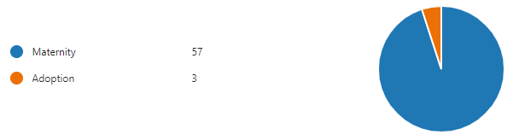

Findings show an almost even split of Police Officer/Staff respondents which provides a balanced view.
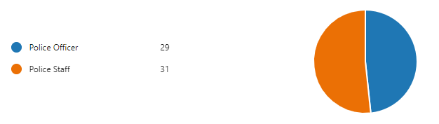
Existing Measures
The survey provided us with an insight in to what supportive measures were offered and what measures employees used. The graph below shows the most to least frequently offered measures. A key finding from this chart is, only 15% of respondents were offered a return-to-work plan which is something that all line managers should offer as part of SWP procedure. Maternity/Adoption Champions were established in SWP 2018 to act as a point of contact throughout an employee’s maternity/adoption journey and involved financial investment and time to launch the initiative, therefore it is surprising that only 30% of employees being offered a champion.
Table 1- Supportive Measures offered to employees

Table 2 - Supportive measures used by employees

Table 2 shows what measures employees used the most and least which reflects the trends of Table 1 – the most popular measures are Phased Return, KIT Days and Flexible working which highlights the need for more flexibility and time to adjust back to work.
When looking at some of the feedback from the open questions on the survey, it appears that many employees were not aware of the options available to them which could provide an explanation for low uptake in some areas, this was applicable when looking at comments regarding champions.
“I was not aware of the champions and how they could assist” and “I had no idea there were champions” are examples of some comments from 85% of employees who did not have a champion.

General Feedback
When asked about their experience, many employees chose to comment on the impact that their line manager had on their experience whether this was positive or negative.


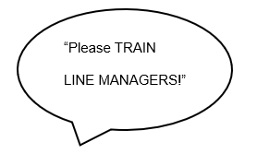

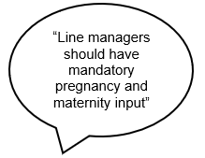

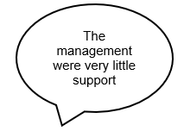
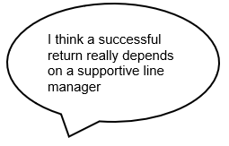

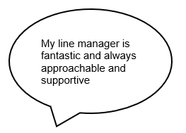

A further theme within the comments was the isolation that many employees felt when they were away from the workplace, which made their return to work much difficult, it is important to note that many employees would have been working from home for some time before their leave as a result of the Covid pandemic, CIPD (2020) found that social isolation was a negative impact on homeworking during this time period.

Focus Group
The aim of the focus group was to explore further in to some of the key findings from the survey.
Participants consisted of 3 Officers and 2 Staff. There were no volunteers from those who had been on adoption leave.
- All participants raised line manager support and understanding as a large part of their experience. None of the participants had a return-to-work plan and all stated that they had to research what support was available themselves which they felt highlighted a knowledge gap with many line managers. Many Police Officers who become line managers have often only had operational experience, something that is also stated by CIPD (2022) who recommend development of line managers in order for them to support their teams.
- There were mixed experiences with those who had a champion, common problems were lack of communication, availability and some champions didn’t appear to have the knowledge to provide answers to queries.
- The participants felt strongly about having the opportunity to network with other colleagues going through a similar experience so that they could share concerns and be a source of support for each other.

Conclusion
This report has shown that supporting employees effectively back in to the workplace can benefit both the organisation and its employees. CIPD (2022) recommends that organisations should treat those returning like a new starter and that time invested by line managers is key to a successful transition.
Findings have shown that whilst SWP have a wide range of measures, many are not utilised. A lack of knowledge around some measures appears to be an issue and this is particularly relevant to the Maternity/Adoption Champions whose aim was to act as a key source of support for employees but also line managers who may have queries regarding how to support their colleagues.
The research has also highlighted some potential gaps in the support that SWP offer for example, creating an avenue for employees to network with others.
Whilst the research has shown the current experience appears to be satisfactory,
the majority of the findings were specific to maternity leave; therefore, it is important to acknowledge whilst the experiences have similarities, they also have their differences, therefore this will need to be in mind when proposing recommendations.

References
AdoptionUK (June 2013) Post Natal Depression Factsheet 14 [online] available at https://www.google.com/url?sa=t&rct=j&q=&esrc=s&source=web&cd=&ved=2ahUKEwi6lebR-6L5AhV1QEEAHfNCC80QFnoECB4QAQ&url=https%3A%2F%2Fwww.nhs.uk%2FLivewell%2Fadoption-and-fostering%2FDocuments%2FAdoption%2520UK%2520Factsheet%252014%2520-%2520Post-adoption%2520depression%2520June%25202013.pdf&usg=AOvVaw2gUio-0CbvO6JcpTtF3u9f [accessed 31.07.2022]

BACP (2021) Attitudes to mental health are changing, our research finds [online] Available at: https://www.bacp.co.uk/news/news-from-bacp/2021/8-october-attitudes-towards-mental-health-are-changing-our-research-finds/ [Accessed: 30 September 2022]

Bets, A. (14th Augus 2021) How to Write a Research Design - Guide With Examples, Research Prospect [online] Available at: https://www.researchprospect.com/how-to-write-a-research-design/ [Accessed: 31 July 2022]

Brailey, C and Slatton, B. (2019). Women, Work, and Inequality in the U.S.: Revising the Second Shift. Journal of Sociology and Work. 7. 10.15640/jssw.v7n1a4 [online] https://www.researchgate.net/publication/333423974_Women_Work_and_Inequality_in_the_US_Revising_the_Second_Shift#:~:text=Abstract%20The%20second%20shift%2C%20coined%20in%201989%20by,second%20shift%20of%20unpaid%20labor%20in%20their%20households [accessed 22nd August 2022)

Brogden, K. (24th March 2020) Working [New] Mothers: The struggle and a message to CEOs, Linkedin.com [online] Available at: https://www.linkedin.com/pulse/working-new-mothers-struggle-message-ceos-kate-brogden-cpa?articleId=6648266118026838016 [Accessed: 22 May 2022]

Bryanna Hahn Fox & Wesley G. Jennings (2014) How to Write a Methodology and Results Section for Empirical Research, Journal of Criminal Justice Education, 25:2, 137-156 [online] available at https://www-tandfonline-com.ezproxy.uwtsd.ac.uk/doi/citedby/10.1080/10511253.2014.888089?scroll=top&needAccess=true [accessed 30.07.2022]

Bull, G. (2021) The day I learned about 'intensive mothering' I stopped feeling guilty., Mamamia [online] Available at: https://www.mamamia.com.au/intensive-mothering/ [Accessed: 22 August 2022]

Burt, E. (26th October 2018) Fewer than one in five women feel confident returning to work after maternity leave, Peoplemanagement.co.uk [online] Available at: https://www.peoplemanagement.co.uk/article/1744915/fewer-than-one-in-five-women-confident-return-maternity-leave [Accessed 23 August 2022]

Bush, T. (10th May 2020) 7 Data Analysis Methods and How to Choose the Best, PESTLE Analysis [online] Available at: https://pestleanalysis.com/data-analysis-methods/#Quantitative_Data_Analysis_Methods [Accessed: 30 August 2022]

Chatterji, P. & Markowitz, S. (2005) Does the Length of Maternity Leave Affect Maternal Health? Southern economic journal. [Online] 72 (1), 16–41 available at https://web-s-ebscohost-com.ezproxy.uwtsd.ac.uk/ehost/pdfviewer/pdfviewer?vid=0&sid=994c4eff-1d8a-436e-bc96-9d22b1cfde99%40redis [accessed 23rd May 2022]

CIPD (12th April 2022) Trends in flexible working arrangements, Reports, [online] Available at: https://www.cipd.co.uk/knowledge/fundamentals/relations/flexible-working/trends#gref [Accessed: 25 August 2022]

CIPD (17th February 2022) Line managers’ role in supporting the people profession [online] Available at: https://www.cipd.co.uk/Images/8051-working-from-home-report_tcm18-84208.pdf [Accessed: 6 October 2022]

CIPD (18th April 2019) A woman’s work: lessons in gender equality from Norway | CIPD (2019) [online] Available at: https://www.cipd.co.uk/news-views/nutshell/issue-86/gender-equality [Accessed: 10 July 2022]

CIPD (18th February 2022) Making maternity policies fit for purpose CIPD (2022). Available at: https://www.cipd.co.uk/news-views/nutshell/issue-114/maternity-policies [Accessed: 10 July 2022]

CIPD (2022) Case study: returning to work after maternity CIPD [online] Available at: https://www.cipd.co.uk/careers/career-guidance/back-to-work-support/maternity [Accessed: 6 October 2022]

CIPD (2022) Case study: returning to work after maternity, CIPD [online]. Available at: https://www.cipd.co.uk/careers/career-guidance/back-to-work-support/maternity#gref [Accessed: 10 July 2022]

CIPD (27 June 2022) Three-quarters of employers now offer hybrid working but employers are split over whether it will last [online] Available at: https://www.cipd.co.uk/about/media/press/270622-cipd-hybrid-working-splits-employers#gref [Accessed: 23 August 2022]

CIPD (30th September 2022) People Analytics, Factsheets ,CIPD [online] Available at: https://www.cipd.co.uk/knowledge/strategy/analytics/factsheet#gref [Accessed: 1 October 2022]

CIPD (5th May 2021) Flexible working arrangements and the impact of theCOVID-19 pandemic [online] Available at: https://www.cipd.co.uk/knowledge/fundamentals/relations/flexible-working/flexible-working-impact-covid [Accessed 23 August 2022]

CIPD (November 2018) Flexible Working: the business case, CIPD [online] available at https://www.cipd.co.uk/Images/flexible-working-business-case_tcm18-52768.pdf [Accessed 25th September 2022]

CIPD (September 2020) Working from Home, Assessing the research evidence [online] available at https://www.cipd.co.uk/Images/8051-working-from-home-report_tcm18-84208.pdf [Accessed 06.10.2022]

Cleave, P. (7th June 2021) The Benefits of Anonymous Surveys - SmartSurvey, [online] Available at: https://www.smartsurvey.co.uk/blog/the-benefits-of-anonymous-surveys [Accessed: 7 October 2022]

Dawson. C (2009) Introduction to research methods: a practical guide for anyone undertaking a research project VLEBOOKS-9781848033429 4th Edition, How to Books Ltd Oxford p1-38 [online] available at https://r2.vlereader.com/Reader?ean=9781848033429 [accessed 30.07.2022]

DCU Business School (2022) New DCU Business School research identifies post-maternity leave best practice for Irish businesses [online] available at https://business.dcu.ie/new-dcu-business-school-research-identifies-post-maternity-leave-best-practice-irish-businesses/ [Accessed 10.07.2022]
Ellerbeck, S. (21st June 2021) The UK has begun the world’s biggest trial of the four-day work week. What are the pros and cons? World Economic Forum [online] Available at: https://www.weforum.org/agenda/2022/06/four-day-work-week-uk-trial/ [Accessed: 25 September 2022]

Ericksen, K. S. et al. (2008) Should I stay at home or should I go back to work? workforce re-entry influences on a mother’s decision-making process. Journal of employment counselling. [Online] 45 (4), 156–167 available at https://web-s-ebscohost-com.ezproxy.uwtsd.ac.uk/ehost/pdfviewer/pdfviewer?vid=0&sid=88e9431b-0f12-4a4d-bae8-c64478add332%40redis [accessed 23rd May 2022]

Feeney,L. (25th October 2018) HR Magazine - An employer's guide to postnatal depression, HR Magazine [online] Available at: https://www.hrmagazine.co.uk/content/features/an-employer-s-guide-to-postnatal-depression [Accessed: 10 July 2022]

Finch, H. (25th May 2022) Employers more open to part-time working post pandemic, study shows, Business Live [online] Available at: https://www.business-live.co.uk/enterprise/employers-more-open-part-time-24045220 [Accessed: 23 August 2022]

Fleming, S. (2020) Workers want flexibility - after COVID, they just might get it, World Economic Forum. Available at: https://www.weforum.org/agenda/2020/07/working-flexibly-new-normal-poll/ [Accessed: 25 September 2022]

Flores, P. (8th August 2018) Working mothers feel discriminated against at work – HRreview [online] Available at: https://www.hrreview.co.uk/hr-news/diversity-news/working-mothers-feel-discriminated-against-at-work/46869 [Accessed: 22 May 2022]

Forbes (23rd August 2021) Council Post: 15 Ways Companies Can Better Support Working Parents, Forbes. Available at: https://www.forbes.com/sites/forbeshumanresourcescouncil/2021/08/23/15-ways-companies-can-better-support-working-parents/?sh=6ba8b6fa759e [Accessed: 10 July 2022]

Forbes L.K et al (2021) Working Mothers’ Experiences in an Intensive Mothering Culture: A Phenomenological Qualitative Study July 2020 Journal of Feminist Family Therapy [Online] 33 (3), 270–294 available at https://www-tandfonline-com.ezproxy.uwtsd.ac.uk/doi/full/10.1080/08952833.2020.1798200 [accessed 23rd May 2022]

Fordham, L. (13th December 2016) American Express to enhance parental leave and family-friendly benefits for US staff, Employee Benefitt [online] Available at: https://employeebenefits.co.uk/issues/december-online-2016/american-express-enhances-parental-leave-family-friendly-benefits/ [Accessed: 30 July 2022]

Frith, B. (9th October 2015) HR Magazine - Half of mothers find it 'impossible' to return to their field of work, HR Magazine [online] Available at: https://www.hrmagazine.co.uk/content/features/half-of-mothers-find-it-impossible-to-return-to-their-field-of-work [Accessed: 10 July 2022]
Greedy, E. (21st May 2021) HR Magazine - How support groups can help new mums return to work, HR Magazine [online] Available at: https://www.hrmagazine.co.uk/content/news/how-support-groups-can-help-new-mums-return-to-work [Accessed: 22 May 2022]

Hamilton, P. (2020) ‘“Staying at Home” or “Choosing to Work”’, in Black Mothers and Attachment Parenting. [Online]. Bristol University Press pp. 133–144.Available at https://www.cambridge.org/core/books/abs/black-mothers-and-attachment-parenting/staying-at-home-or-choosing-to-work/44BCCED75F45593197481D2CEF0BAE9A [accessed 23rd May 2022]

Harvard Business Review (7th February 2019) Are You Struggling to Balance Career and Family? [online] Available at: https://hbr.org/podcast/2019/02/working-mothers [Accessed: 22 May 2022]

Houghton. B (23rd August 2021) Uptake of paternity leave drops to 10-year low, report finds [online] Available at: https://www.peoplemanagement.co.uk/article/1747262/uptake-of-paternity-leave-drops-to-ten-year-low [Accessed: 10 July 2022]

Houston, D. M. & Marks, G. (2003) The Role of Planning and Workplace Support in Returning to Work after Maternity Leave. British journal of industrial relations. [Online] 41 (2), 197–214. available at https://web-s-ebscohost-com.ezproxy.uwtsd.ac.uk/ehost/pdfviewer/pdfviewer?vid=0&sid=fe2c1ded-653f-416d-b951-c21b2aef51a3%40redis [accessed 23rd May 2022]

Howlett, E. (2020) Women providing two-thirds more childcare than men during lockdown, ONS finds, Peoplemanagement.co.uk [online] Available at: https://www.peoplemanagement.co.uk/article/1742891/women-providing-two-thirds-more-childcare-than-men-during-lockdown [Accessed: 6 August 2022]

Jay, S. (2022) A Complete Guide to Employee Engagement Survey Analysis - AIHR, AIHR [online] Available at: https://www.aihr.com/blog/employee-engagement-survey-analysis/ [Accessed: 30 August 2022]

Jennifer, B. (2022) This Is The Reality Of Returning To Work After Maternity Leave — And How Mums Made It Work, HuffPost UK [online] available at: https://www.huffingtonpost.co.uk/entry/returning-to-work-after-maternity-leave_uk_62860cbde4b02667554e8b3c [Accessed: 10 July 2022]

Johnson, L. (2022) Qualitative and Quantitative Research Methods, The Classroom [online] Available at: https://www.theclassroom.com/qualitative-quantitative-research-methods-8144495.html [Accessed: 6 October 2022]

Knight, R. (2019) 8 Tips for Returning to Work After Parental Leave, Harvard Business Review. Available at: https://hbr.org/2019/08/how-to-return-to-work-after-taking-parental-leave%20-%20 [Accessed: 10 July 2019]

Kritzinger, J. (1995) Qualitative Research, Introducing Focus Groups, Ncbi.nlm.nih.gov. [online] Available at: https://www.ncbi.nlm.nih.gov/pmc/articles/PMC2550365/pdf/bmj00603-0031.pdf [Accessed: 1 October 2022]

Lois, A. (7th July 2022) How to Write Methodology for Dissertation, Research Prospect [online] Available at: https://www.researchprospect.com/how-to-write-methodology-for-dissertation/ [Accessed: 31 July 2022]
Luo, H. (2nd October 2012) Introducing Research Methodology: A Beginner’s Guide to Doing a Research Project by FLICK, UWE. The Modern Language Journal. [Online] 96 (3), 481–483 available at https://librarysearch.uwtsd.ac.uk/view/action/uresolver.do?operation=resolveService&package_service_id=8528414250002421&institutionId=2421&customerId=2415&VE=true [accessed 23rd May 2022]

Lynonette.C and Baldauf.B (October 2019) Family Friendly working policies and practices: motivations, influences and impacts for employers, Insititue for Employment Research, University of Warwick [online] available at
https://www.google.com/url?sa=t&rct=j&q=&esrc=s&source=web&cd=&ved=2ahUKEwiax5nD_7H5AhVHQEEAHfXYA04QFnoECDkQAQ&url=https%3A%2F%2Fassets.publishing.service.gov.uk%2Fgovernment%2Fuploads%2Fsystem%2Fuploads%2Fattachment_data%2Ffile%2F840061%2FWarwick_Final_Report_1610.pdf&usg=AOvVaw14R0gyaW6B0pLwgGTJd_VB [accessed 06th August 2022

Macdonald, C. L. (2019) ‘Mother-Employers: Blanket Accountability at Home and at Work’, in Shadow Mothers. [Online]. Berkeley: University of California Press. pp. 17–41 available at https://www-jstor-org.ezproxy.uwtsd.ac.uk/stable/10.1525/j.ctt1pnntt [accessed 23rd May 2022]

Maltesers (2022 ) The Maternity Return; Help Mums thrive [online]. Available at: https://www.maltesers.co.uk/maternity-return [Accessed: 10 July 2022]

McKie. L and Cunningham-Burley, S. (2005) ‘Balancing work and family life: mothers’ views’, in FAMILY IN SOCIETY. [Online] Policy Press. pp. 23–38 Available at https://www-jstor-org.ezproxy.uwtsd.ac.uk/stable/j.ctt9qgm6r [accessed 23rd May 2022]

McKinsey and Company (8th May 2022) Working mothers are still struggling - here's how companies can support them [online] Available at: https://www.mckinsey.com/featured-insights/themes/working-mothers-are-still-struggling-heres-how-companies-can-support-them [Accessed: 22 May 2022]

McCrae, S. (1993) Returning to work after childbirth: opportunities and inequalities. European sociological review. Volume 9, Issue 2, September 1993 [Online] 9 (2), 125–138 available at https://librarysearch.uwtsd.ac.uk/view/action/uresolver.do?operation=resolveService&package_service_id=8530057440002421&institutionId=2421&customerId=2415&VE=true [accessed 23rd May 2022]

Miller.B (27th January 2020) 15 Advantages and Disadvantages of Quantitative Research [online] available at https://greengarageblog.org/15-advantages-and-disadvantages-of-quantitative-research#:~:text=List%20of%20the%20Advantages%20of%20Quantitative%20Research%201,the%20quantitative%20approach%20is%20anonymous.%20...%20More%20items [Accessed 06th October 2022]

Moss, P, Kosolowski. A, Duvander AZ (2019) ‘United Kingdom: leave policy and an attempt to take a new path’, in Parental Leave and Beyond. [Online]. Policy Press. p.57-74 available at https://www-jstor-org.ezproxy.uwtsd.ac.uk/stable/j.ctvfrxngh [accessed 23rd May 2022]

Mullen, C. (27th August 2020) Bizjournals.com. Working moms are struggling to balance it all. Employers are responding with new or improved benefits [online] Available at: https://www.bizjournals.com/bizwomen/news/latest-news/2020/08/working-moms-are-struggling-to-balance-it-all-emp.html?page=all [Accessed: 22 May 2022]
Muller-Heyndyk, R. (2018) HR Magazine - Maternity attitudes affect return to work success, HR Magazine. [online] Available at: https://www.hrmagazine.co.uk/content/news/maternity-attitudes-affect-return-to-work-success [Accessed: 10 July 2022]

Naeem, S. (2019) Data Triangulation in Qualitative Research - Helping Research writing for student & professional researchers, Helping Research writing for student & professional researchers [online] Available at: http://researcharticles.com/index.php/data-triangulation-in-qualitative-research [Accessed: 27 August 2022]

NCT (2008) Returning to Work Survey 2008 NCT [online] available at https://www.nct.org.uk/sites/default/files/related_documents/ReturningToWork-Survey.pdf [accessed 23rd August 2022]

NELFT NHS (8th September 2021) NELFT proud to be named as a Working Families Top Ten Employer 2021 [online] available at https://www.nelft.nhs.uk/camhs-news/nelft-proud-to-be-named-as-a-working-families-top-ten-employer-2021-4409 [accessed 27th August 2022]

NHS (2022) Postnatal depression [online] Available at: https://www.nhs.uk/mental-health/conditions/post-natal-depression/overview / [Accessed: 25 August 2022]

Nowak, M. J. et al. (2013) Returning to Work After Maternity Leave: Childcare and Workplace Flexibility. Journal of industrial relations. [Online] 55 (1), 118–135 available at https://journals-sagepub-com.ezproxy.uwtsd.ac.uk/doi/full/10.1177/0022185612465530 [accessed 23rd May 2022]

ONS (22nd July 2022) Families and the labour market, UK (2021) Office for National Statistics [online] available at https://www.ons.gov.uk/employmentandlabourmarket/peopleinwork/employmentandemployeetypes/articles/familiesandthelabourmarketengland/2021 [Accessed 31st July 2022]

ONS (24th October 2019) Families and the labour market, UK - Office for National Statistics (2019) [online] Available at: https://www.ons.gov.uk/employmentandlabourmarket/peopleinwork/employmentandemployeetypes/articles/familiesandthelabourmarketengland/2019 [Accessed: 10 July 2022]

Prikhidko, A. & Swank, J. M. (2018) Motherhood Experiences and Expectations: A Qualitative Exploration of Mothers of Toddlers. The Family journal (Alexandria, Va.). [Online] 26 (3), 278–284. https://journals-sagepub-com.ezproxy.uwtsd.ac.uk/doi/pdf/10.1177/1066480718795116 [accessed 22nd August 2022]

Question Pro (2022) Qualitative Data: Definition, Types, Analysis and Examples [online] Available at: https://www.questionpro.com/blog/qualitative-data/ [Accessed: 6 October 2022]

Question Pro (2022) MaxDiff Analysis in market research, Max-Diff survey, QuestionPro [online] . Available at: https://www.questionpro.com/max-diff/ [Accessed: 30 August 2022]

Reynard, C. (2018) Women still primary carer in most households, Your Money [online] Available at: https://www.yourmoney.com/insurance/women-still-primary-carer-households/ [Accessed: 6 August 2022]

Royal Literacy Fund (2022) The structure of a literature review [online]. Available at: https://www.rlf.org.uk/resources/the-structure-of-a-literature-review/ [Accessed: 9 July 2022]
Scott, K. (25th July 2016) How does the UK's support for working parents compare with other countries?, Employee Benefits [online] Available at: https://employeebenefits.co.uk/issues/july-aug-2016-2/how-the-uks-support-for-working-parents-compares-with-other-countries/ [Accessed: 22 May 2022]

Senedd Cymru Welsh Parliament (9th September 2021) Senedd Rewarded as a Family-Friendly Employer [online] Available at: https://senedd.wales/senedd-now/news/senedd-rewarded-as-a-family-friendly-employer/ [Accessed: 31 July 2022]

Sharma, M (2nd December 2020) Over a third of working mothers find it "harder than expected" after maternity leave – HR Magazine [online] Available at: https://www.hrreview.co.uk/hr-news/over-a-third-of-working-mothers-struggle-to-adjust-when-returning-from-maternity-leave/129604 [Accessed: 22 May 2022]

Sharma, M. (11th October 2021) Working mothers and carers feel held back from promotions - HRreview, [online] Available at: https://www.hrreview.co.uk/hr-news/working-mothers-and-carers-feel-held-back-from-promotions/138299 [Accessed: 22 May 2022]

Simkus, J. (3rd January 2022) Cluster Sampling: Definition, Method and Examples, Simplypsychology.org [online] Available at: https://www.simplypsychology.org/cluster-sampling.html [Accessed: 30 August 2022]

South Wales Police (2021) Chief Constables Delivery Plan 2021-2015, accessed via SWP Staff Intranet [Accessed 25th August 2022]

South Wales Police (2022) Flexible Working Report, HR Department [Accessed 30th August 2022]

South Wales Police (2022) Maternity and Adoption Leave Data Internal Report, HR Department [Accessed 25th August 2022]

South Wales Police (2022) Post Natal Depression Sickness Internal Report, HR Department [Accessed 25th August 2022]

South Wales Police (2022) Smarter Working Policy, accessed via Staff Intranet [Accessed 30 August 2022]

Smith, T. A. (2019) ‘Public Works: Female Citizens as Mothers and Workers’, in The Emerging Female Citizen. [Online]. Berkeley: University of California Press. pp. 148–177 available at https://www-jstor-org.ezproxy.uwtsd.ac.uk/stable/10.1525/j.ctt1ppm1p [accessed 23rd May 2022]

Stevens, E. (16th August 2022) What is Quantitative Data?, Definition, Examples & FAQ CareerFoundry [online] Available at: https://careerfoundry.com/en/blog/data-analytics/what-is-quantitative-data/ [Accessed: 6 October 2022]

Stevens, E. (2022) What is Quantitative Data? [Definition, Examples & FAQ], CareerFoundry [online] Available at: https://careerfoundry.com/en/blog/data-analytics/what-is-quantitative-data/#what-are-the-different-types-of-quantitative-data [Accessed: 27 August 2022]

Survey Monkey (2022) Open-Ended vs Closed-Ended Questions SurveyMonkey [online] Available at: https://www.surveymonkey.co.uk/mp/comparing-closed-ended-and-open-ended-questions/ [Accessed: 1 October 2022]

TENA (2022) Back To Work: How Mums Really Feel, TENA Women [online] Available at: https://www.tena.co.uk/women/living-with-bladder-weakness/everyday-life/back-to-work-how-mums-really-feel [Accessed: 10 July 2022]

Tompkins, C. (3rd September 2021) Council Post: 3 Reasons Why A Competitive Analysis Is Essential, Forbes [online] Available at: https://www.forbes.com/sites/forbesagencycouncil/2021/09/03/3-reasons-why-a-competitive-analysis-is-essential/?sh=1f6419f557be [Accessed: 1 October 2022]

TUC (2022) Denied and discriminated against: The reality of flexible working for working mums [online] available at https://www.tuc.org.uk/sites/default/files/2021-10/Report.pdf [accessed 23rd August 2022]

Venters. N (10th July 2018) Attitudes to mental health are changing, our research finds [online] Available at: https://www.bacp.co.uk/news/news-from-bacp/2021/8-october-attitudes-towards-mental-health-are-changing-our-research-finds/ [Accessed: 30 September 2022]

Wilkinson, K. (19th January 2022) Maternal (perinatal) mental health and employment: An agenda for research and practice. Human resource management journal. [Online] available at https://onlinelibrary-wiley-com.ezproxy.uwtsd.ac.uk/doi/full/10.1111/1748-8583.12434 [accessed 10.07.2022]

Williams, A. (2018) Workingmums Annual Survey 2018 | workingmums.co.uk, [online] Available at: https://www.workingmums.co.uk/workingmums-annual-survey-2018/ [Accessed 23rd August 2022]

Wisdom for Working Mums (2022) 4 key strategies to support your work return after maternity leave [Online] Available at: https://wisdomforworkingmums.co.uk/four-key-strategies-to-support-your-return-to-work-after-maternity-leave/ [Accessed: 10 July 2022]

Working Families (16th May 2017) Baby steps – 10 tips for returning to work after post-natal depression - Working Families (2017) [online] Available at: https://workingfamilies.org.uk/workflex-blog/10-things-you-need-to-know-about-post-natal-depression/ [Accessed: 10 July 2022]

Working Families (2022) About us - Working Families (2022) [online] Available at: https://workingfamilies.org.uk/about-us/ [Accessed: 1 October 2022]

Working Families (2022) The Top 30 Employers in 2022 - Working Families [online] Available at: https://workingfamilies.org.uk/employers/benchmark/the-top-30-employers-in-2022 [Accessed: 22 May 2022]

Working Families (8th September 2021) Working Families Announces the UK’s Most Flexible, Family-friendly Workplaces 2021-Working Families [online]. Available at: https://workingfamilies.org.uk/news/top-employers_2021/ [Accessed: 10 July 2022]

Zucker, R. (2021) Breaking Free from a “9 to 5” Culture, Harvard Business Review [online] Available at: https://hbr.org/2021/07/breaking-free-from-a-9-to-5-culture [Accessed: 25 September 2022]

Full Poster References
Burt.E (26th October 2016) Fewer than one in five women feel confident returning to work after maternity leave [online] available at https://www.peoplemanagement.co.uk/article/1744915/fewer-than-one-in-five-women-confident-return-maternity-leave [accessed 23 August 2022]

Dawson. (2009). Introduction to Research Methods A Practical Guide for Anyone Undertaking a Research Project (4th ed.). Constable & Robinson p.20 [online] available at https://www-vlebooks-com.ezproxy.uwtsd.ac.uk/Product/Index/2036027?page=0 [accessed 30th July 2022]

Dreamstime.com (2022) Focus Group Image [online] available at https://www.dreamstime.com/focus-group-business-modern-abstract-circle-background-flat-color-icon-image148904919 [Accessed 25 August 2022]

Dreamstime.com (2022) Online Survey Image [online] available at https://www.dreamstime.com/online-survey-internet-surveying-hands-holding-tablet-test-form-mobile-questionnaire-customers-voting-vector-concept-image134503931 [Accessed 25 August 2022]

Istockphoto.com (2022) Employees image [online] available at https://www.istockphoto.com/vector/happy-young-employees-giving-support-and-help-each-other-gm1221448721-358049391?phrase=workplace%20happiness [accessed 29th August 2022]

Istockphoto.com (2022) Woman and child image [online] available at https://www.istockphoto.com/vector/a-woman-with-a-child-in-her-arms-asks-herself-many-questions-conceptual-gm1214316850-353249950?phrase=postpartum%20depression [accessed 29th August 2022]

Istockphoto.com (2022) Work life balance image[online] available at https://www.istockphoto.com/vector/tiny-woman-sitting-in-lotus-position-and-keep-harmony-work-and-life-balance-choose-gm1305814462-396583840?phrase=work%20life%20balance [accessed 29th August 2022]

Noble, H. & Heale, R. (2019) Triangulation in research, with examples. Evidence-based nursing. [Online] 22 (3), 67–68 available at https://www.proquest.com/docview/2244010739?accountid=130472&parentSessionId=5Zx8MCLPaxvz43AEqOHmV3NzzmkfKlg7Rrd9QD9vUtk%3D&pq-origsite=primo [accessed 17th September 2022]

PosterPresentations.com (2022) Powerpoint poster templates for research poster presentations A1-Template-Kensington.pptx [online] available at https://view.officeapps.live.com/op/view.aspx?src=https%3A%2F%2Fwww.posterpresentations.com%2Fposter-templates-2019%2FDesign-Kensington%2FPosterPresentations.com-A1-Template-Kensington.pptx&wdOrigin=BROWSELINK [Accessed 30th July 2022]
Senedd Cymru Welsh Parliament (2021) Senedd rewarded as a Family – Friendly employer [online] available at https://senedd.wales/senedd-now/news/senedd-rewarded-as-a-family-friendly-employer/ [accessed 31st July 2022]

Simkus. J (3rd January 2022) Simply Psychology Cluster Sampling: Definition, Method and Examples [online] available at https://www.simplypsychology.org/cluster-sampling.html [Accessed 30 August 2022]

South Wales Police (2021) Chief Constables Delivery Plan 2021-2015, accessed via SWP Staff Intranet [25th August 2022]

South Wales Police (2022) Maternity and Adoption Leave Data Internal Report [25th August 2022]

South Wales Police (2022) SWP Logo Image [online] available at https://www.south-wales.police.uk/ [accessed 25 August 2022]

Tena (2022) Back to work: how mums really feel [online] available at https://www.tena.co.uk/women/living-with-bladder-weakness/how-to-deal-with-incontinence/back-to-work-how-mums-really-feel 22 [accessed 10th July 2022]

Vecterstock.com (2022) Cluster Sample [online] available at https://www.vectorstock.com/royalty-free-vector/crowd-behaviors-measuring-social-sampling-vector-16312866 [accessed 29th August 2022]

Williams, A (2018) Working mums annual survey 2018 [online] available at https://www.workingmums.co.uk/workingmums-annual-survey-2018/ [accessed 23rd August 2022]

Appendix B - Benchmarking email sent to UK Police Forces
Good Afternoon,
I would be grateful if the following email could be forwarded on to the relevant person in your HR Department.
I am a HR Advisor within South Wales Police and I am currently undertaking a piece of research in relation to how we support our colleagues back to work after a period of maternity/adoption leave. We understand that this is often an important time within our colleagues career as they come back in to the working environment and try to balance the changes to work and family priorities. This has therefore been identified as an area of focus for us to ensure that we are doing all that we can to support working parents within our organisation. This piece of work is also going to be utilised as part of my Post Graduate Diploma in Strategic People Management that I am currently studying at University of Wales Trinity St David.
The purpose of my email is to gain an understanding of how other Police Forces and public sector organisations support colleagues back in to the workplace to see if there are any potential gaps in our practices and to share any best practice.
Below is a list of some the supportive measures that we currently have in place within South Wales Police
Supportive Return Plan
Keeping in Touch Days
Phased Return
Flexible Working
Pregnancy and Adoption Champions
I would be really grateful if you share with me some details around what supportive measures are currently in place within your organisation and or any best practice that you are happy to share. Once my research has been completed, if you wish, I would be happy to inform you of any outcomes or recommendations which you may find useful.
As I will also be using the information for my own research, I can confirm that any information I receive will be anonymised and I will not be identifying specific organisations in my report.
Due to the tight timescales, please could I have a response as soon as possible. If you have any queries, please do not hesitate to contact me.
Kind Regards
Helen
 |  |  | Helen Golaszewski
 |  |  | Cynghorydd Adnoddau Dynol| HR Advisor
 |  |  | Adran Adnoddau Dynol | Human Resources Department
 |  |  | Pencadlys Heddlu De Cymru | South Wales Police Headquarters
Appendix C – Summary of responses from UK Police Forces
Force Name | Response
Force A | Offered the same supportive measures as SWP
Force B | Offered the same supportive measures as SWP  Additional Measure:  The parenting champions hold regular drop-in sessions (which are KIT days) where those who are off on maternity have the opportunity to speak to other parents and break out rooms are set up during the session to provide them the opportunity to specialists – for example HR, payroll, pensions, Occupational Health etc.
Force C | Offered the same supportive measures as SWP  Additional Measure:  Separate Breastfeeding protocol and process
Force D | Offered same supportive measures as SWP  Additional Measure:  Sessions which would allow any expecting parent including those who preparing for adoption leave to meet on a regular basis, to have a platform to discuss their journey including adapting to life as a parent, retuning to policing with the demands of the role and shift work. Sessions would provide the opportunity for informal peer support, allowing staff to remain engaged with their professional lives and working environments whilst allowing them to feel connected.  Group meetings would be held monthly allowing individuals and their babies to come together at a central location within local communities  Providing the opportunity for a holistic support network helping new parents feel ready to engage once again with their Police family.
Force E | Less supportive measures than SWP – nothing different to what SWP already has in place.
Force F | Offered same supportive measures as SWP
Force G | Offered same supportive measures as SWP  Additional Measures:  Send out weekly newsletter and jobs via email to those who request it.  Have maternity/adoption leave events with guest speakers etc. so that staff on leave can collect information on flexible working, career breaks, returning to work whilst breast feeding or ask any questions whilst they are on maternity/adoption leave. They are then paid for the hours they attend as a KIT day and can bring their babies/children along with them.
Force H | Same supportive measures as SWP
Force I | Same supportive measures as SWP
Force J | Same supportive measures as SWP
Force K | Same supportive measures as SWP  Additional Measure:  We have also previously held a Maternity/Adoption KIT Day event whereby employees who are considering adopting/ pregnant employees, as well as their partners and children are also invited to an event with stalls to discuss the various subjects:  * Payroll queries  * Wellbeing & Flexible Working  * Maternity SPOCS attend to answer operational queries as well as offering ongoing support  * UNISON/Fed Reps to promote the support they can offer  * Stores - to offer any Uniform queries  * Training - to discuss fitness and pelvic floor exercises, and Baby 1st Aid  * Breastfeeding Lead  * Health & Safety to answer any queries  * Blue light Champions to discuss mental health/ post- natal depression
Force L | Same supportive measures as SWP  Additional Measures:  - Maternity Mental Health Group  - Bumps and Beyond Maternity Support Team Chat

Appendix D – Sample Survey sent to SWP employees
SWP People - supporting colleagues returning from maternity leave
We recognise that returning to work after a period of Adoption/Maternity leave can be a challenging time for colleagues as they adjust to the changing priorities in their lives and creating a work/life balance. Whilst there are supportive measures currently in place, we would like to hear from you to see if there are any additional things you would feel could enhance our current measures and/or whether there are any improvements we can make to existing measures.
We would be grateful if you could fill in this short survey which will assist us in this process. This piece of research is voluntary and all participants feedback will be anonymous as there is not a requirement to collect personal data.
Data from this survey will also be used to support Helen Golaszewski, HR Advisor who is currently undertaking a Post Graduate Diploma in Strategic People Management at University South Wales, Trinity St David and is conducting this research as part of a work project.
Participation in this survey will mean that you have given consent for the information to be used for the purposes of this project. If you have any queries or concerns, please contact Helen Golaszewski by email helen.golaszewski@south-wales.police.uk
Thank you in advance for your participation, any recommendations/improvements will be communicated upon completion of this project.

Required

1.Are you:
Police Officer
Police Staff

2.What type of leave did you take?
Maternity
Adoption

3.How long was your leave?
less than 3 months
3-6 months
6-9 months
9-12 months

4.Were you offered any of the following supportive measures prior to returning to work?
Phased Return
Return to work plan
Pregnancy and Adoption Champion
KIT Days
Mandatory Training/OST Support
Mentor
Flexible Working

5.Which of the supportive options did you utilise?
Phased Return
Return to work plan
Pregnancy and Adoption Champion
KIT Days
Mandatory Training/OST Support
Mentor
Flexible Working

6.Which, if any of the supportive measures did you find the most useful?

7.Did you return to the same role you were in prior to maternity leave?
Yes
No

8.Were you allocated with a Pregnancy and Adoption Champion prior to going on leave?
Yes
No

9.If answer to Q8 was no - was this through personal choice or were you not aware of the champions and how they could assist? Please write comments below.

10.If answer to Q8 was yes - what was your experience with your Pregnancy and Adoption Champion? Do you have any thoughts on how the role could be improved? Please write your comments below.
11.Did your line manager keep in contact with you throughout your leave as per your maternity plan?
Yes
No

12.Do you feel that there could be any other supportive measures offered to colleagues returning to work after maternity/adoption leave?

13.How do you feel your transition back in to the workplace went overall?

14.Do you have any further feedback or comments which would help us to improve our support for colleagues in the future?

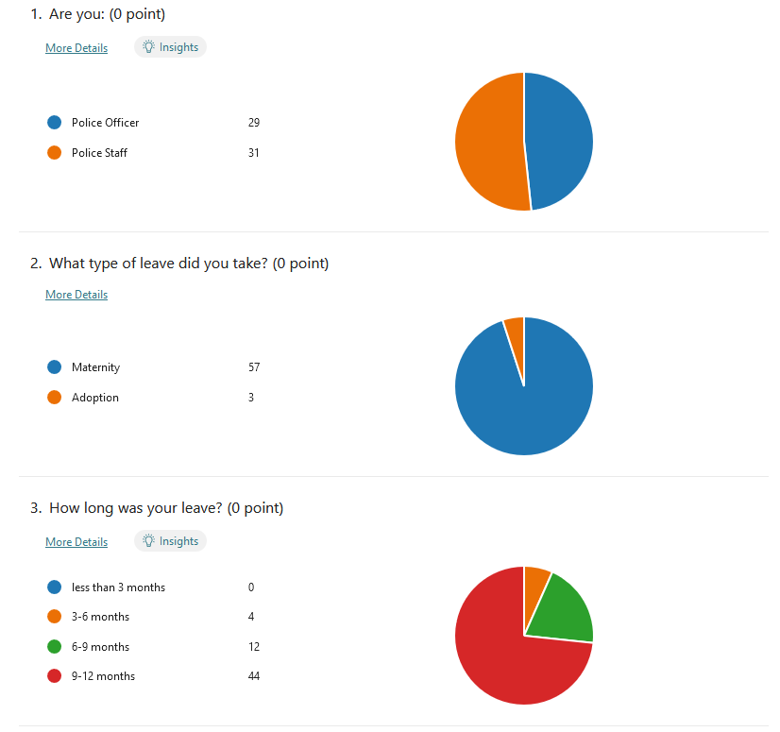
Appendix E – Summary of Survey Results

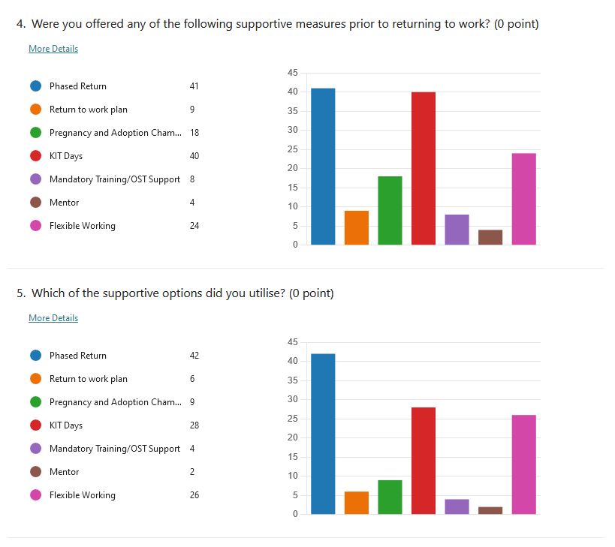

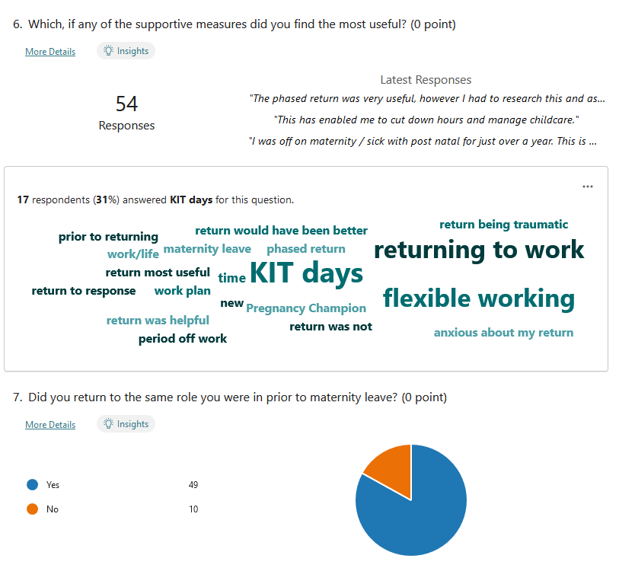

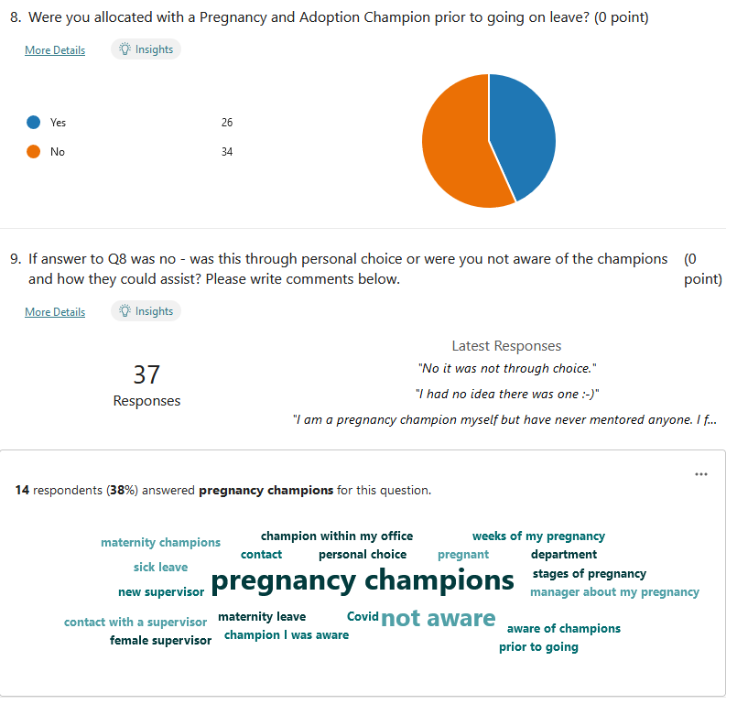

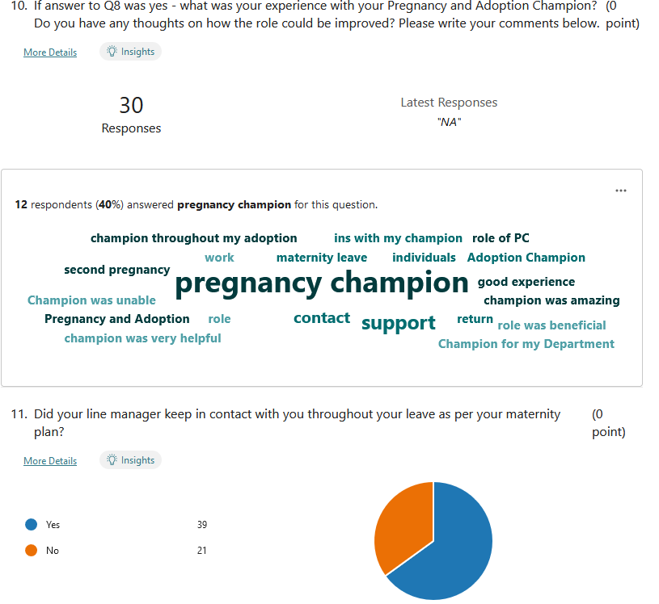
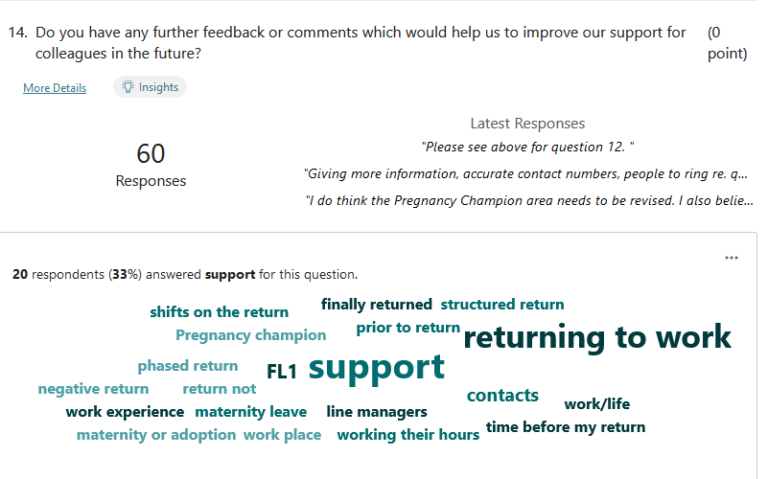
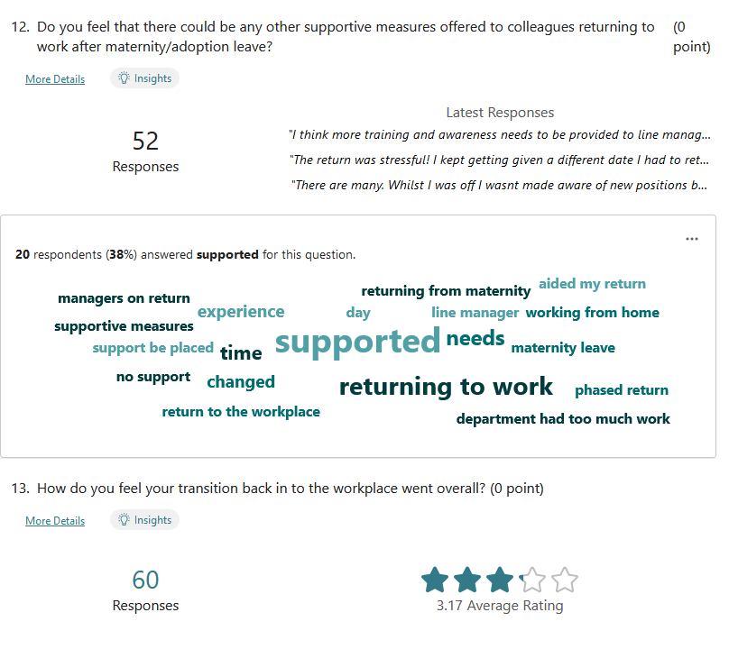
Appendix F - Supporting returning from Maternity and Adoption Leave Focus Group

Date and Time - Tuesday 9th August 2022, 10.00 – 11.00
Location – via Microsoft Teams
Attendance
Helen Golaszewski (HG) – HR Advisor
Linda Williams – (LW) – HR Business Partner
Officer 1
Officer 2
Officer 3
Staff 1
Staff 2

Introduction
HG opened the meeting by thanking those who have attended the focus group today. HG introduced herself as the HR Advisor and that as part of her role, HG supports the Maternity, Adoption and Parental Leave HR Lead (LW). HG explained that there has been a recent need to review the supportive measures offered by South Wales Police (SWP) to those returning from Maternity or Adoption leave and that the purposes of the focus group today was to discuss the personal experiences of those who had attended today, identify areas that may require further improvement and to gain any ideas or feedback from the participants on how they think this can be achieved.
HG also explained that the areas of focus for the meeting would be around areas that have been highlighted in a recent survey in which the participants have recently completed along with other colleagues within SWP.
Prior to commencing discussions, HG explained that the information from this focus group would be used for the purposes of the review and also for the purposes of the project that she is conducting as part of her Post Graduate Diploma in Strategic People Management. HG confirmed that all participants would be anonymous and that no personal data will need to be collected. HG also stated that participants were able to withdraw at any point as attendance was voluntary.
All participants confirmed that they understood and were happy to continue.

Note – All participants stated that they had been on maternity leave, therefore there was no any representation from anyone who had returned from adoption leave.

Discussion
Question: When returning from maternity leave, what were the main concerns/queries that you had?
Officer 1 – Main concern was what role that they would return back to, when they had their child, they realised that they could not come back to full time shift working due to the availability of childcare. Line management did not communicate very well with them, therefore when they returned, they had to learn a new role and had not been provided with much information prior which was daunting. Officer also suffered from Post Natal Depression and feels that line managers should have awareness of signs and symptoms so that support can be offered.
Officer 2 – Main concerns were getting back in to shift working on the front line and balancing this will caring for a new child, felt that there was very little support from supervisor when they were transitioning back in to the workplace. Officer also did not have a very good experience in relation to Maternity/Adoption Champion that was allocated to support her.
Officer 3 – Was pregnant and on maternity leave during covid which meant that she was away from the workplace for a long time. In addition to this, the department that she had worked in previously was disbanded whilst on leave and therefore was worried what role she was coming back to. Officer also needed a weekday working pattern due to childcare and was not aware of how to apply for flexible working at the time. Officer was also concerned about how much had changed whilst she was on leave and found it difficult to get up to speed with the changes in policing upon return to work, therefore felt they could have had further input from line management to assist.
Staff 1 – Main concern was that they did not feel supported by their line manager whilst on leave. They were not aware of the supportive measures available and had to do their own research on the staff intranet to get any information. When they returned, due to the job role that they are in, they were required to look at upsetting images as part of a case that they were allocated to which greatly affected her after recently having a child. Staff member felt line managers should be more aware of the impacts that maternity leave can have and provide more support.
Staff 2 – Had IVF treatment in order to get pregnant and had a good experience with line manager during this time, however whilst on maternity leave the line manager changed and they did not make contact until they were due to return to work. Staff member requested a flexible working pattern however, line manager did not know the process or what to do with it. Was not aware that they could have a phased return and utilised their annual leave instead to create a phased return to work.

Question: How did you find out what supportive measures you could utilise when you were returning from maternity leave?
Staff 1 - Found out all information via the staff intranet – All other participants agreed that this was their main source of information.
Officer 3 – Knew about KIT Days but found that they couldn’t utilise them because of issues with getting childcare. Had Maternity/Adoption Champion prior to going on leave but did not know they could also help with returning to work.
Officer 2 – Suffered with Post Natal Depression and only felt able to come back when new line manager contacted them and informed them of what support they could offer, felt that if they had this information earlier then this may have helped them return to work quicker.
HG highlighted that as part of SWP process that is currently in place, a supportive return to work plan should be conducted, all participants stated that they were not aware of this and did not have one completed by their line manager.
Question: What is your feedback regarding Maternity/Adoption Champions?
Officer 2 – Original champion was moved to new role and did not get a replacement so was left without a champion.
Officer 3 – They knew their champion and already had a working relationship which made things easier, however wouldn’t have felt comfortable talking to a complete stranger. Also felt that Champions should be matched to people in similar roles so that they can understand experiences.
Staff 1 – Champion would forward all their queries on to HR as they couldn’t answer them, therefore didn’t find them useful.
Question: What do you feel is a gap in what SWP offer?
Staff 2 – The ability to connect with others, would appreciate being linked in with others on maternity leave.
All participants agreed that this would have been a useful measure during their time on leave and would have helped them feel less isolated.

