Build, deploy, configure, and manage a Type 2 Hypervisor platform based Virtualised network
  - Student name: Cristian Stefan Stancu
  - Student ID: 2008911
  - Module: ACCA5023

Name of the Team: NOS

Team Members

Student Name | Student ID
Iwan Dyke | 1800933
Joshua James Harries | 2021807
Karen Anne Windsor | 1918576
Cristian-Stefan Stancu | 2008911

Team Evaluation (Self Evaluate your Team)
 | Iwan Dyke | Joshua Harries |  | Karen Windsor |  | Cristian Stancu |  | Student 5
Iwan Dyke | 5 |  | 5 |  | 5 |  | 5
Joshua Harries | 5 |  | 5 |  | 5 |  | 5
Karen Windsor | 5 |  | 5 |  | 5 |  | 5
Cristian Stancu | 5 |  | 5 |  | 5 |  | 5
Student 5

For this part of the assignment we worked closely as a team and we all played an important role in its completion. Therefore, the consensus of the team was that we should all have the same score.
Student 1: Iwan worked with Cristian to write the annotation for the screen shots that the team included for part 1 – which included the research for the explanations.
Student 2: Joshua is a cyber/network student and it only due to him that the team was able to complete task 1 and 2 that made up part 1 of this assignment.
Student 3: Karen completed tasks 1and 2 and took the necessary screen shots and worked on the annotations.

Student 4: Cristian worked alongside Iwan to complete the annotations of the screen shots.

Table of Contents
Name of the Team: NOS 1
Team Members 1
Abstract 4
VM creation and Operating System Installations 4
Server Installation 4
Client installation 4
Installation of server operating System 5
Serial Advanced Technology Attachment (SATA) port1 5
Installation of Client Operating System 6
Virtual Network Configuration 6
Adaptor configuration for Server and Client 6
LAN configuration for Servers 7
LAN Configuration for Clients 7
Firewall deactivation of Server1 and Client 1 7
Ping from Server1 to Client1 and Server 2 to Client 2 8
Sever IP is Statically Defined 9
Server1 nslookup 9
Server1 firewalls down 10
Changing machine name on Server1 to DMC1-NT 10
Installing Active Directory Domain Services Server1 10
Paths window Server1 11
Domain Controllers Window Server1 11
Add new logon account to Server1. 12
New Active Directory User Server1 13
Logging on active directory Client1 13
Logging in as alternative NT-ID 14
Time restrictions set for user NT-ID 15
Observations 17
Hypervisor 17
DHCP (Dynamic Host Configuration Protocol) 17
Windows Firewall 18
Reflection 20
Bibliography 22

Abstract
Systems and network security have never been more essential than they are today. Perpetrators continue to reveal new exposures and exploit them as fast as new applications, technologies, and security approaches are established. Windows Active Directory and Linux Directory Service are used by the government, organizations, and company depending on their needs. Some prefer Windows Active Directory, and other use Linux Directory Service [1].

VM creation and Operating System Installations

Server Installation
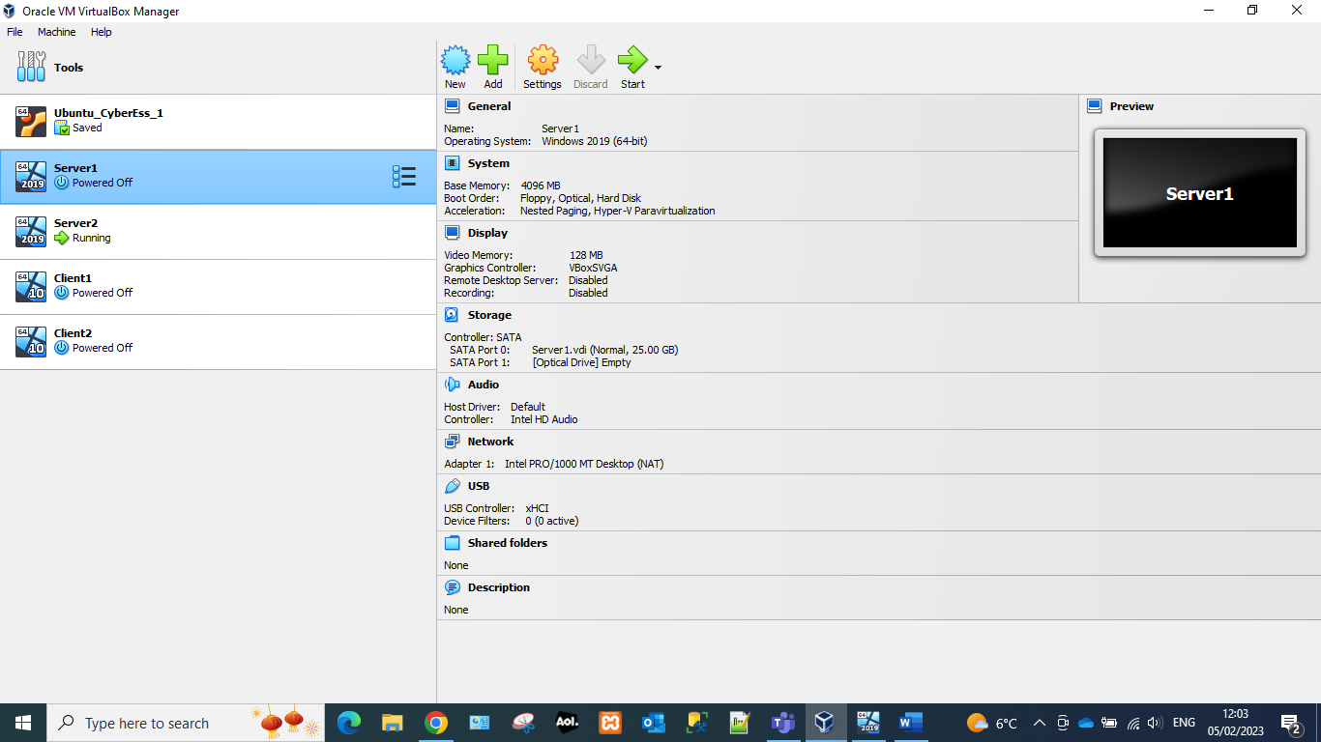 | 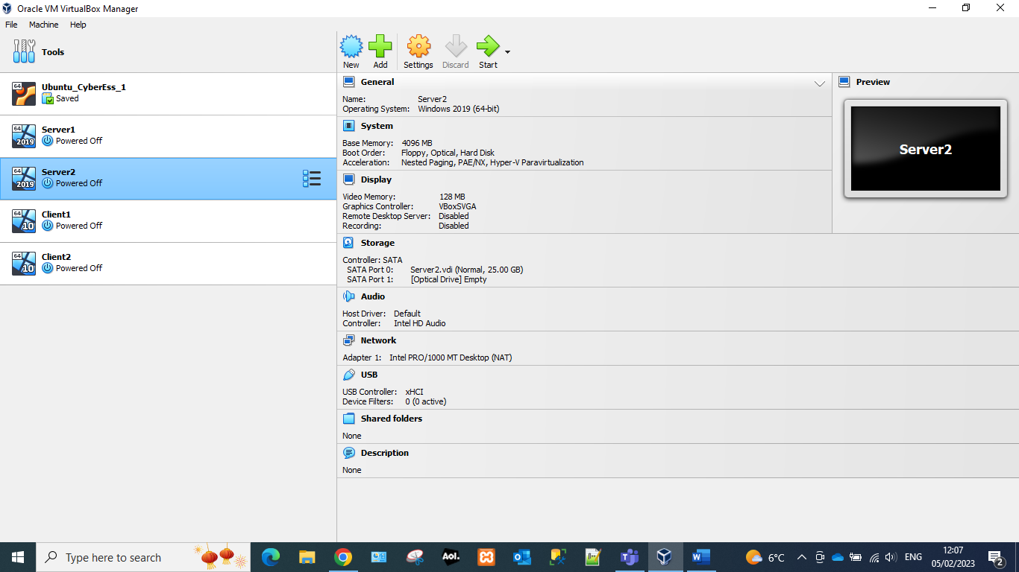

All servers have been created with a standard setup. These will be enough for standard usage on a LAN (local area network). This configuration has enough memory, and processing for most operations on a smaller LAN. The Sata port has been configured to allow for enough memory to host windows server and basic storage.

Client installation
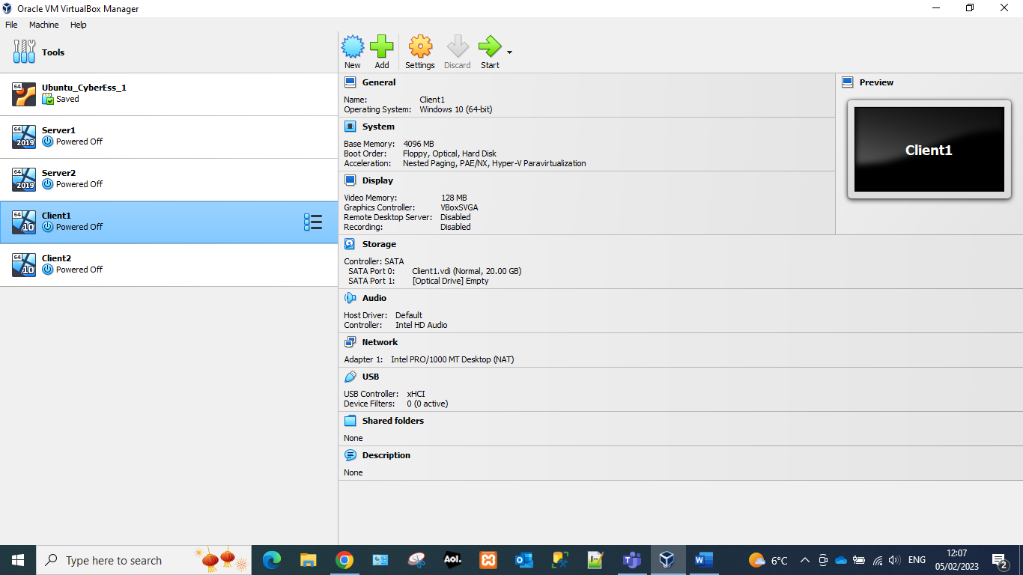 | 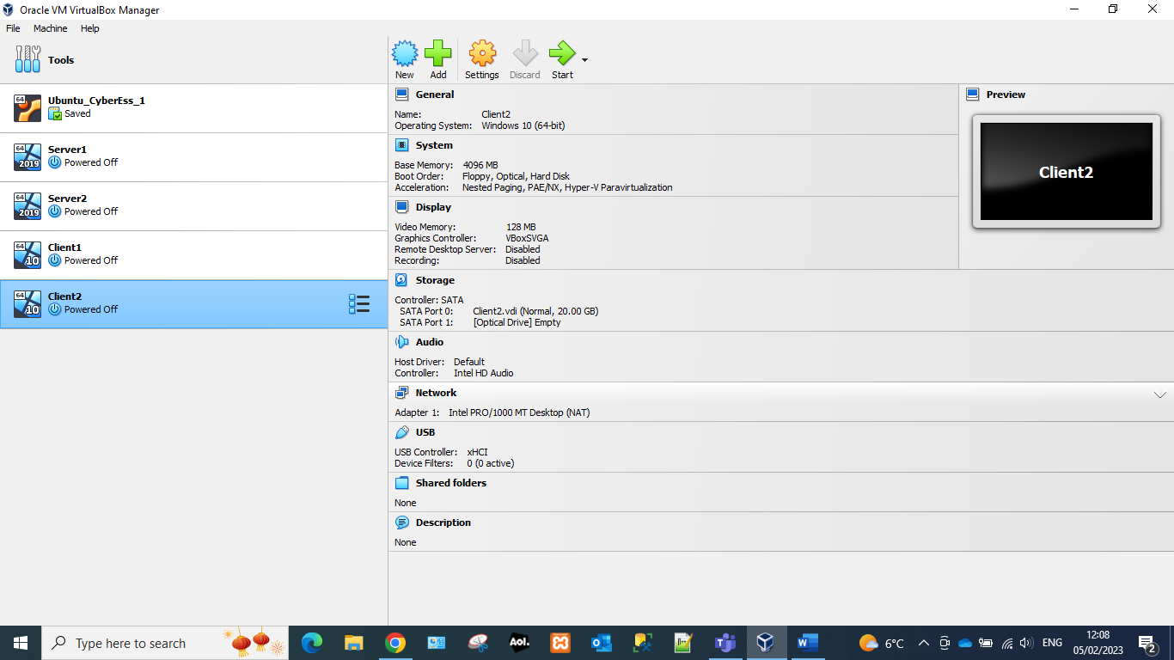

The client has been created with a lower specification to the server as it would not be hosting users. The Sata port has been created with a smaller storage amount as it is not hosting any clients. It has enough storage space for windows 10.

Installation of server operating System
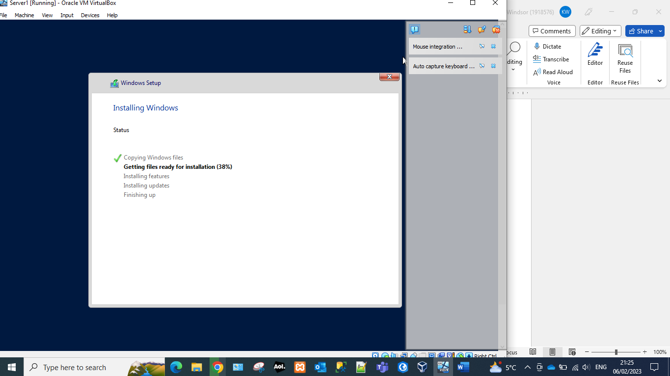 | 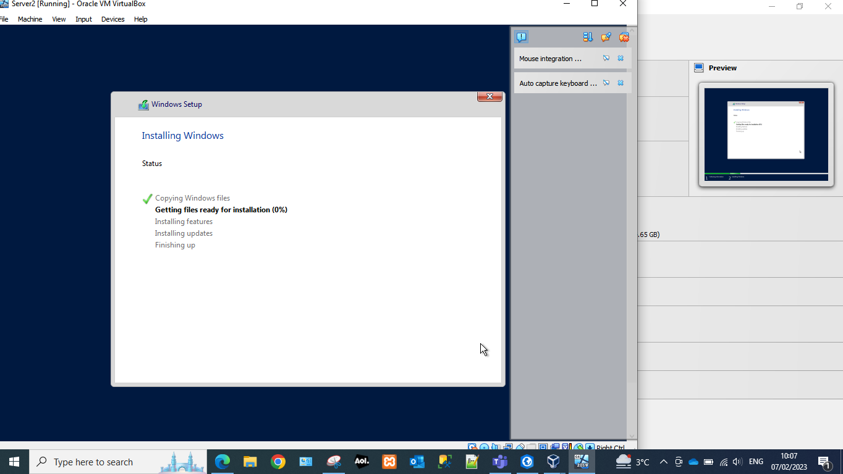

Windows 10 is the most recent operating system available on the market. This would ensure that the most recent security patches would be applied. Windows 11 would also support the most recent version of all software needed for most operations.

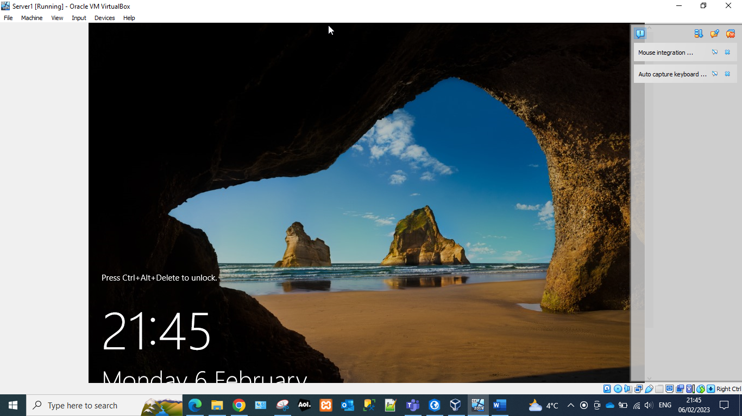 | 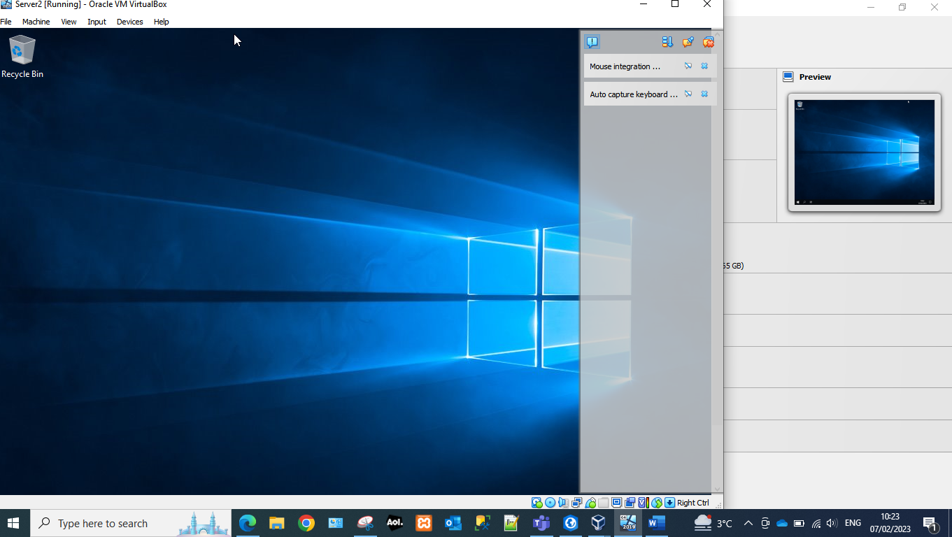

Checks were performed to ensure that the user would be able to logon to the operation system with the specified passwords.

Serial Advanced Technology Attachment (SATA) port1
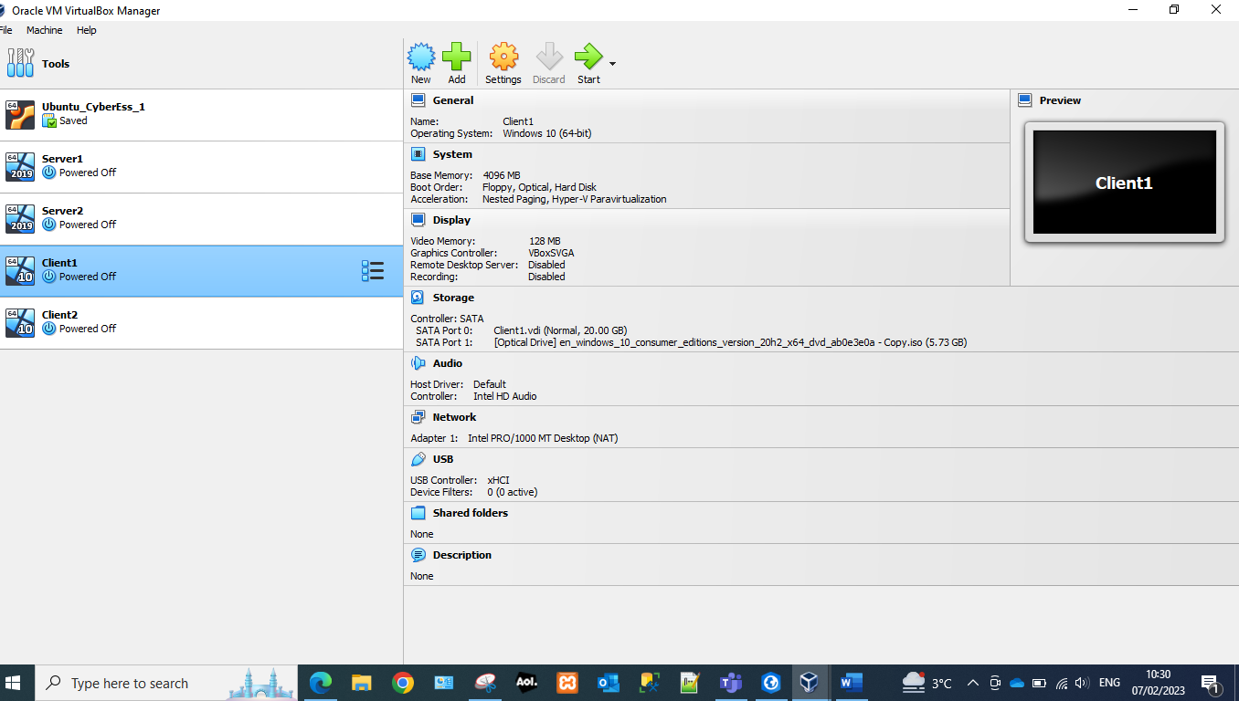 | The SATA enables communication between storage devices and the motherboard using high-speed serial cable over 2 pairs of conductors.  For the best compatibility settings windows 10 has been used on the client devices as well as the servers. The SATA port has a lower storage capacity due to the fact it is a client machine and will not be hosting multiple users. The storage space will be able to host windows and also be able to store basic data.

Installation of Client Operating System
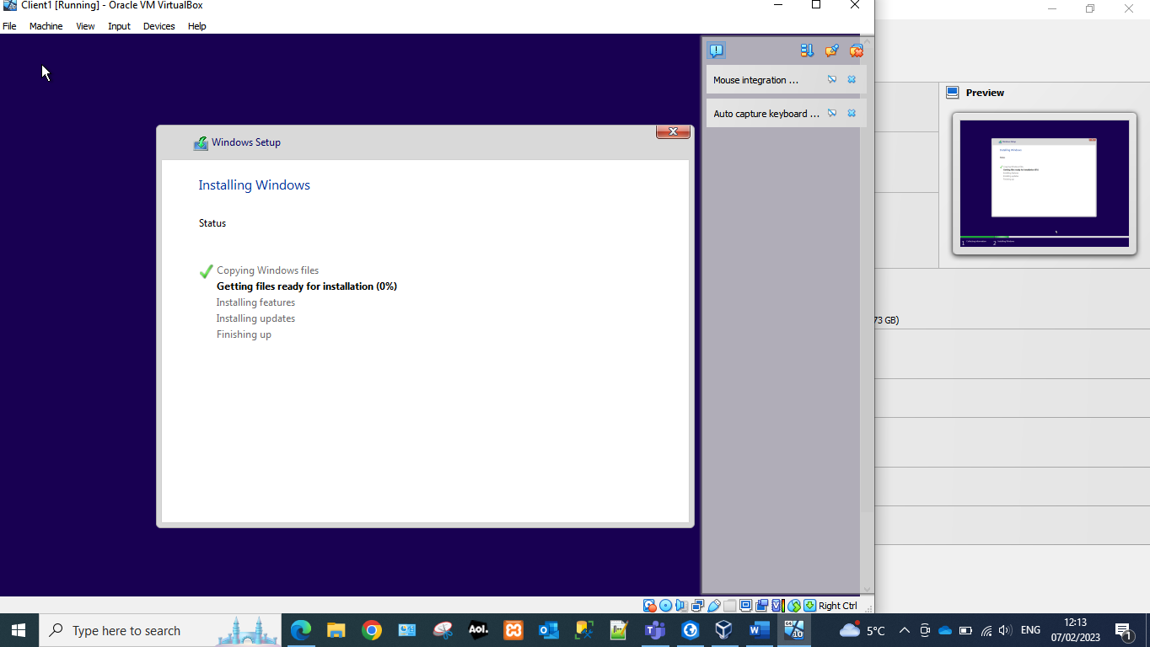 | 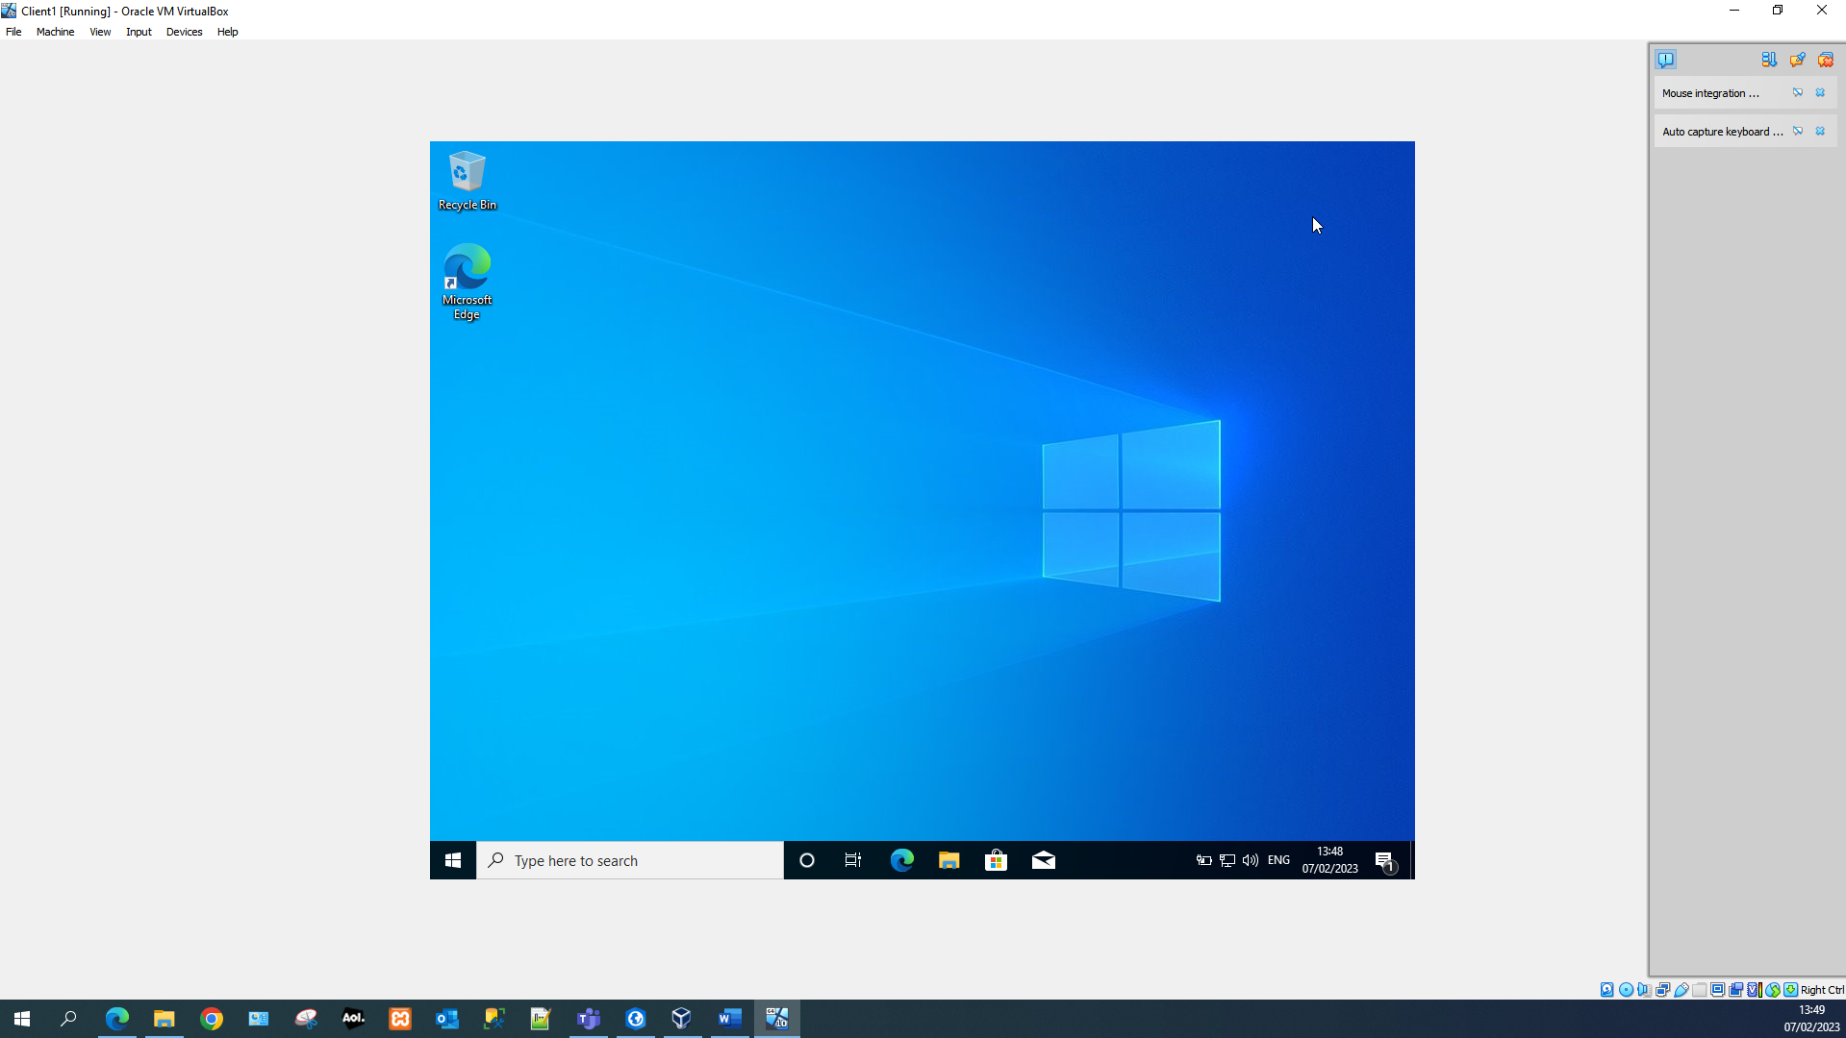
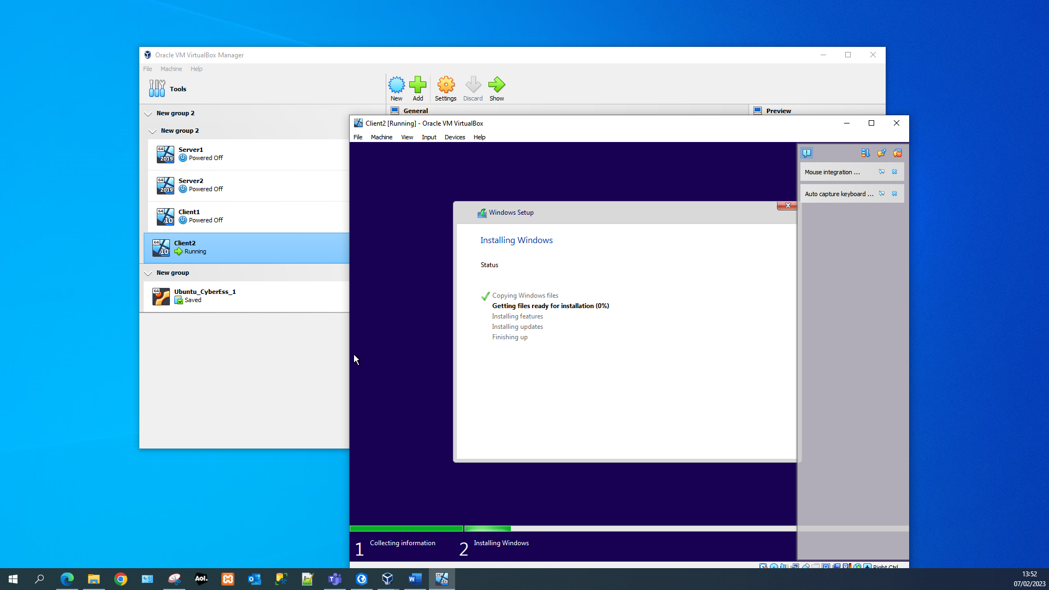 | 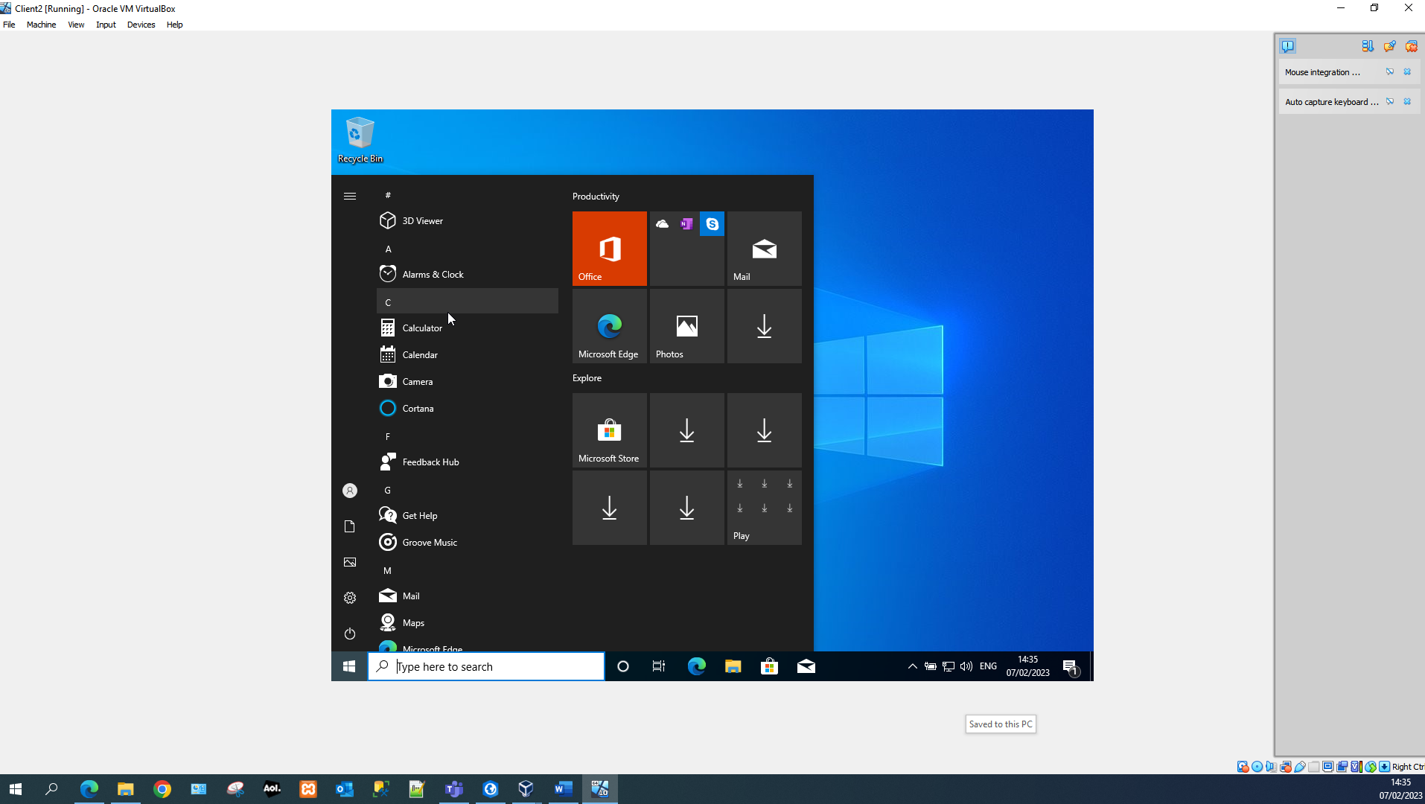
Window 10 pro was installed on the client machines and checks were performed post installation to ensure that the OS had been installed correctly and that the user was able to logon on the account.

Virtual Network Configuration

Adaptor configuration for Server and Client
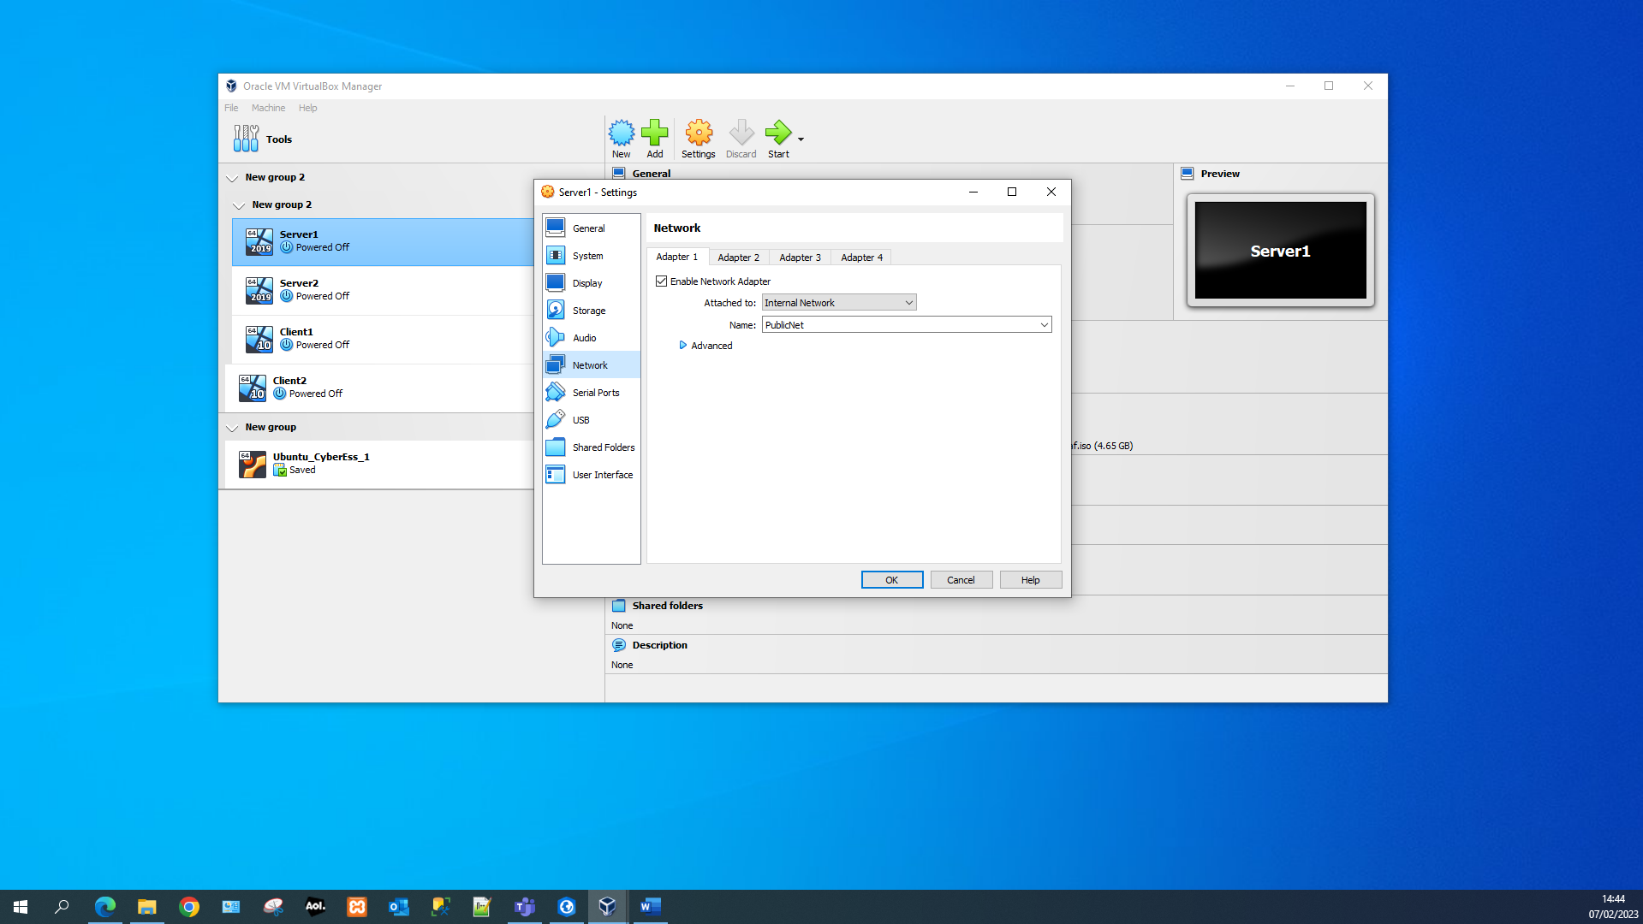 | 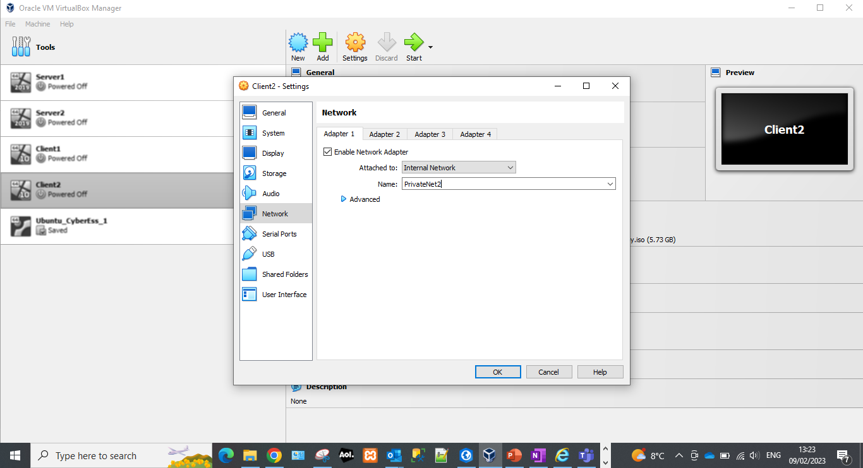

The network configuration for the LAN which is being set up is called “PublicNet.” As a local area network the server should be attached to an internal network and network access should be enabled otherwise it would be impossible for a connection to be made.

LAN configuration for Servers
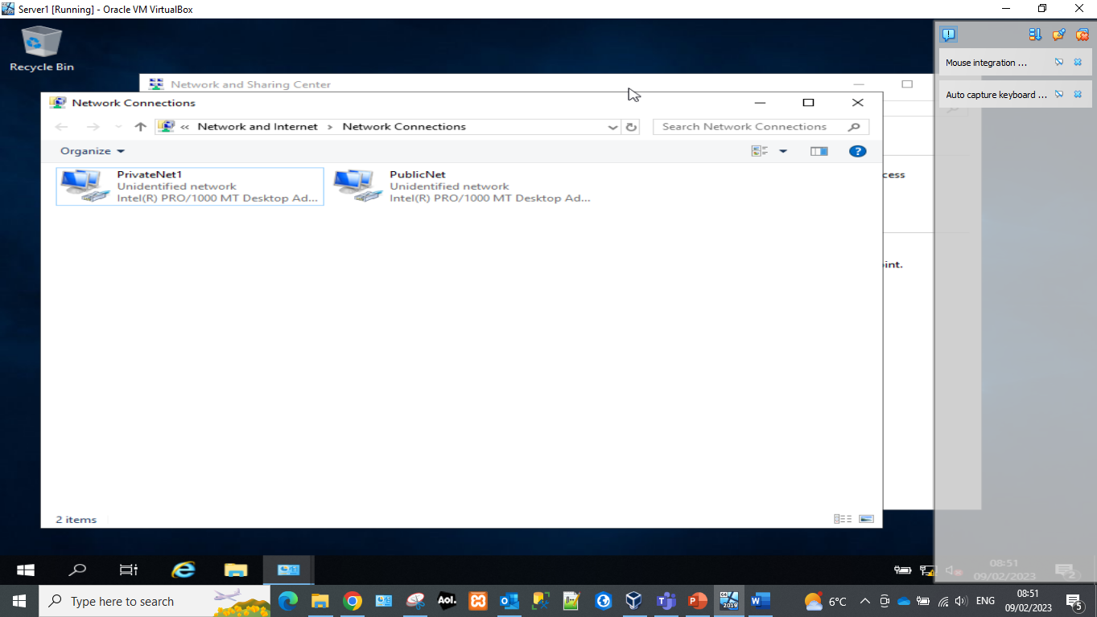 | 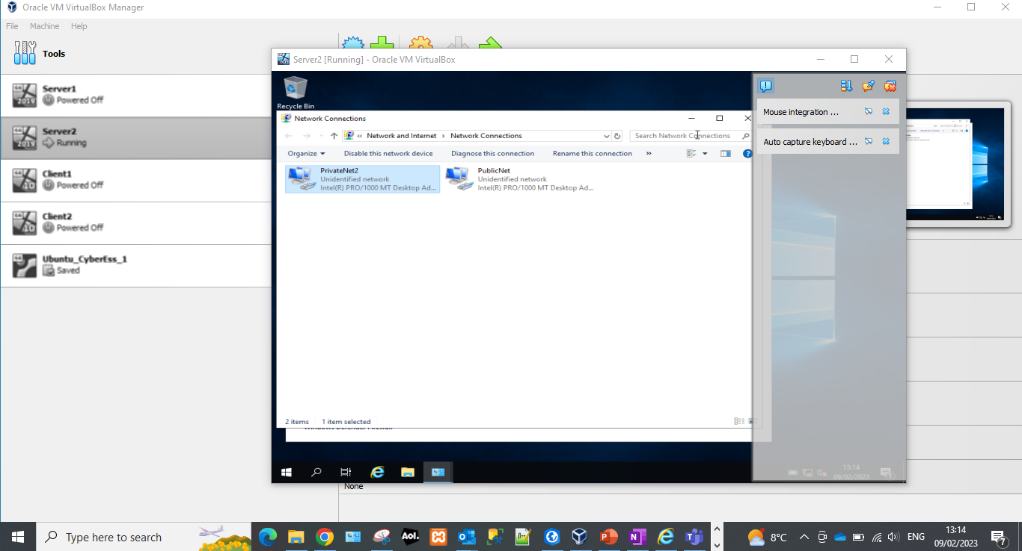

Two networks have been created within Server1: PrivateNet1 and PublicNet. One of these networks is a publicly discoverable and another one is private. The private network is a secure network which will need to be set up in a specific manner to allow devices and users to be able to connect to it.

LAN Configuration for Clients
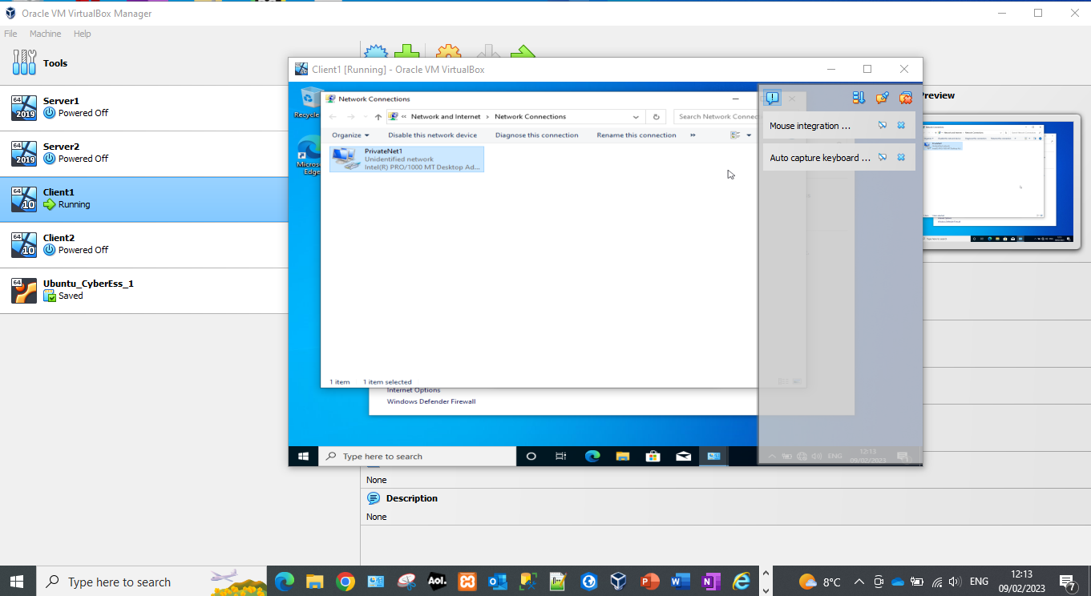 | 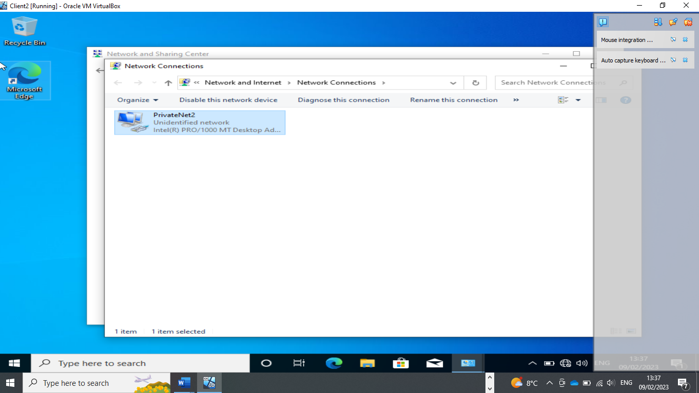

The client has been setup to allow access to the PrivateNet1.

Firewall deactivation of Server1 and Client 1

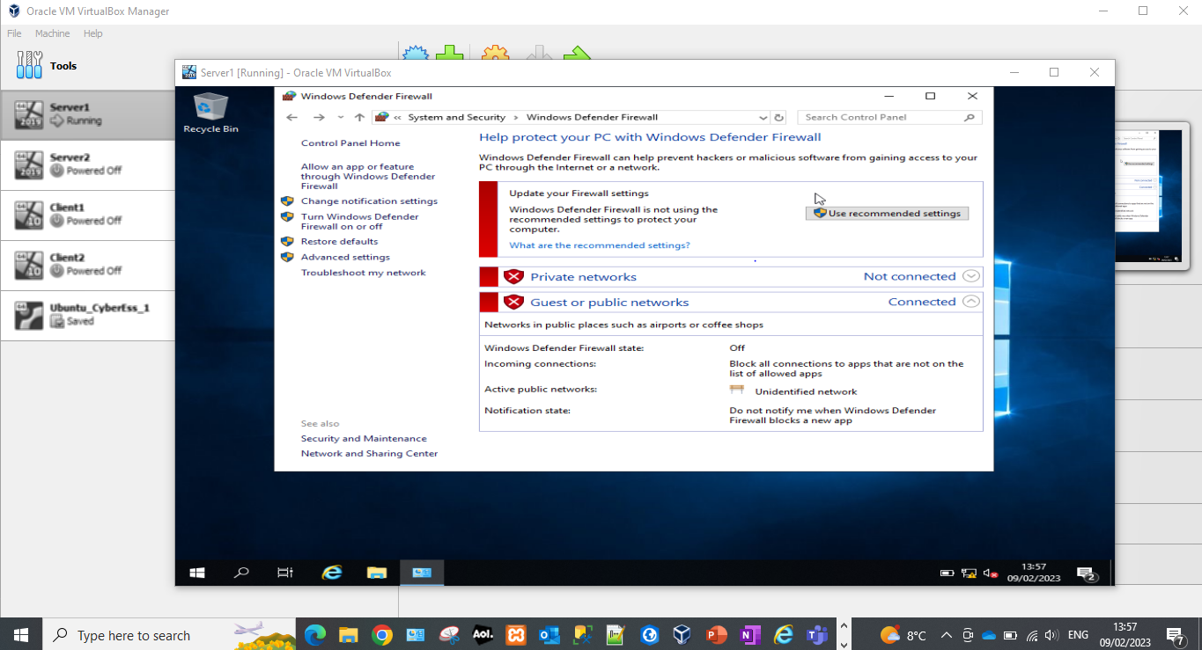 | 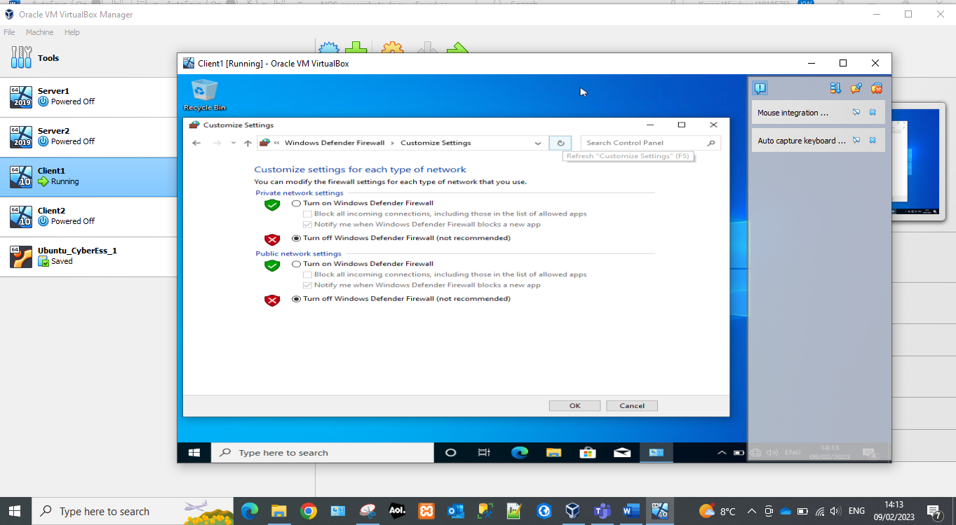

For the connection to be successful the firewalls need to be deactivated on both sides to allow data transfer between the two devices. Private networks are not automatically joined and therefore need extra configuration to be able to set up a successful connection.
The easiest way to ensure a connection can be successful is by turning off the windows firewall. This can be problematic for security reasons with clients connected to an external network. However as this is a local area network it should not be an issue.

Ping from Server1 to Client1 and Server 2 to Client 2
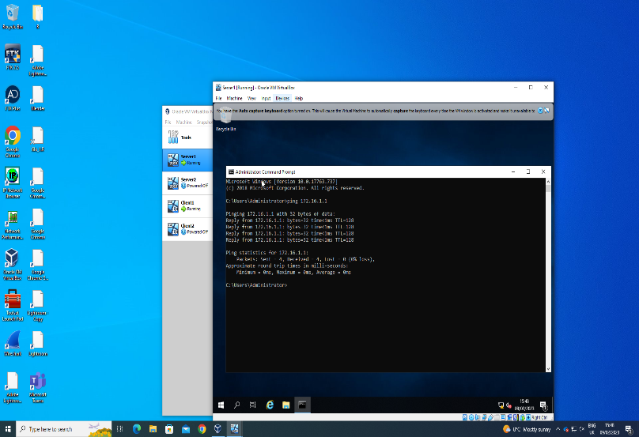 | 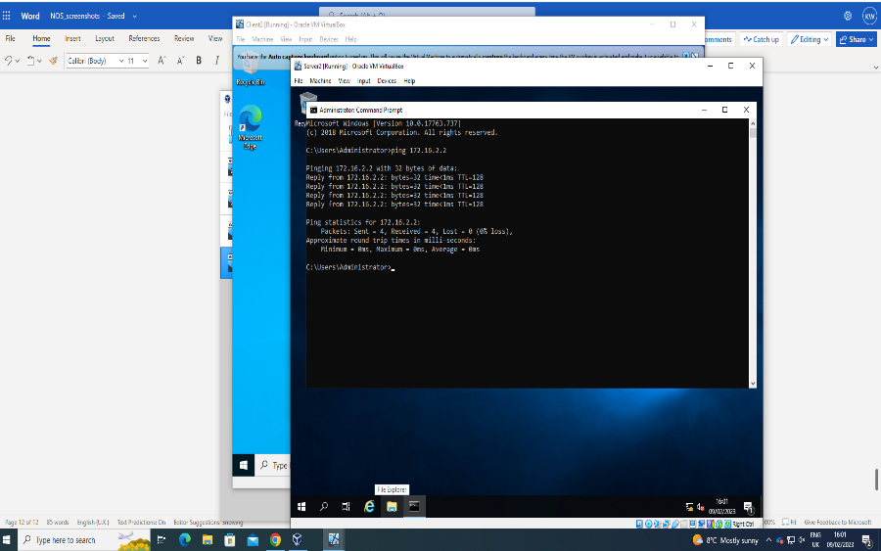

A successful ping between two devices shows a connection has been made over a network. This can be done using the following command within command prompt: ping <device IP address>. The ping command will send four packets to the specified IP address. If they are returned then it can be considered a successful ping.

Sever IP is Statically Defined
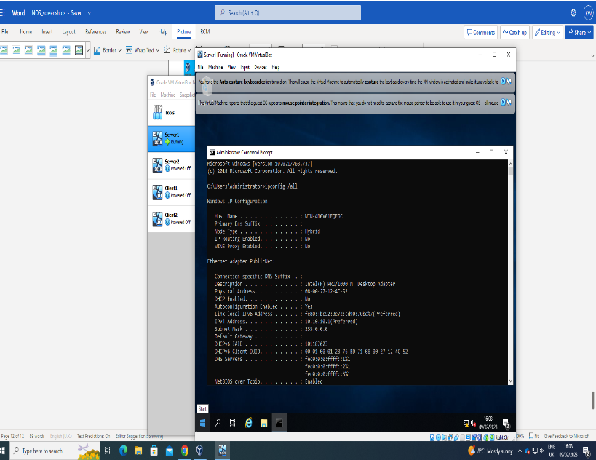 | 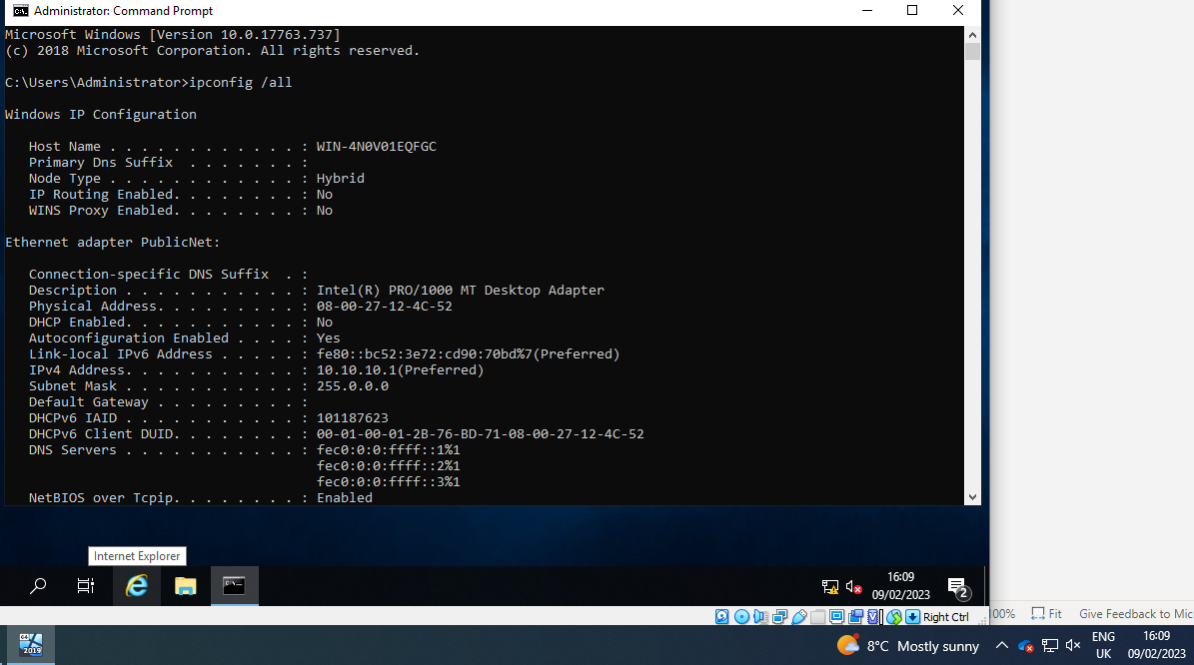
The ipconfig /all command was used to verify that the static IP that was assigned was pulling through to the network adaptor.

Server1 nslookup
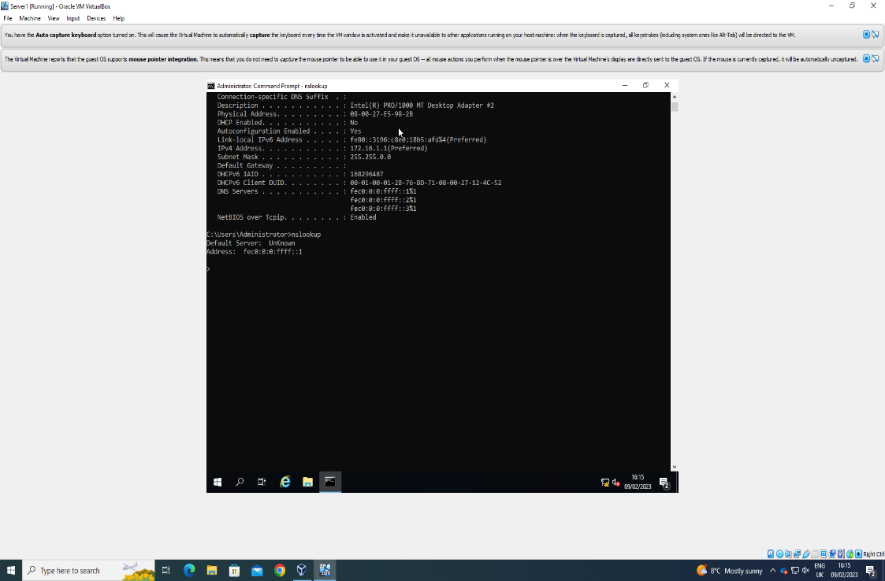
Nslookup was used to verify that the DNS was configured correctly.

Server1 firewalls down
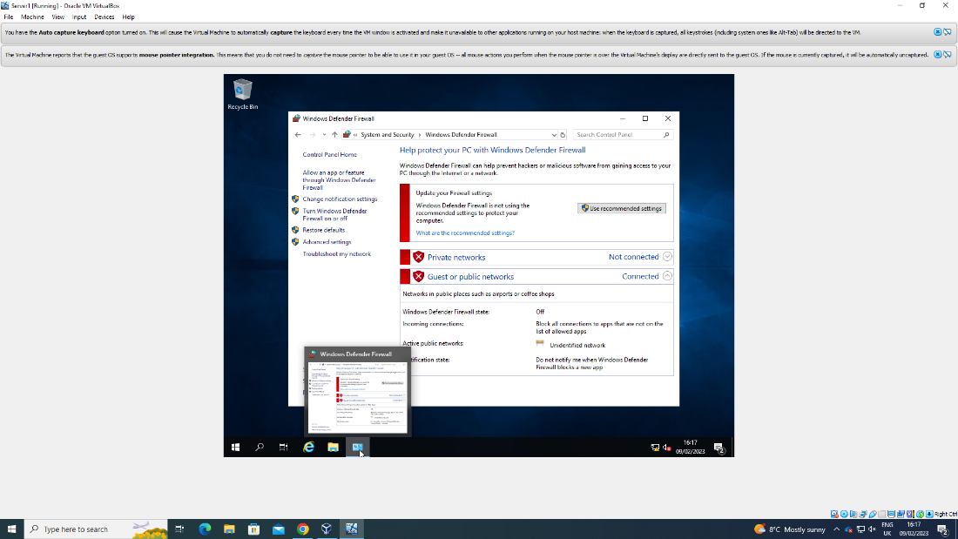

Changing machine name on Server1 to DMC1-NT
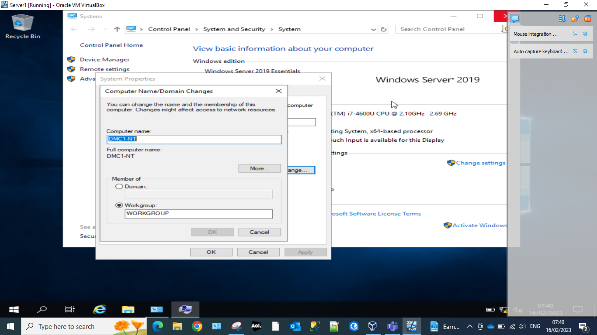

Installing Active Directory Domain Services Server1
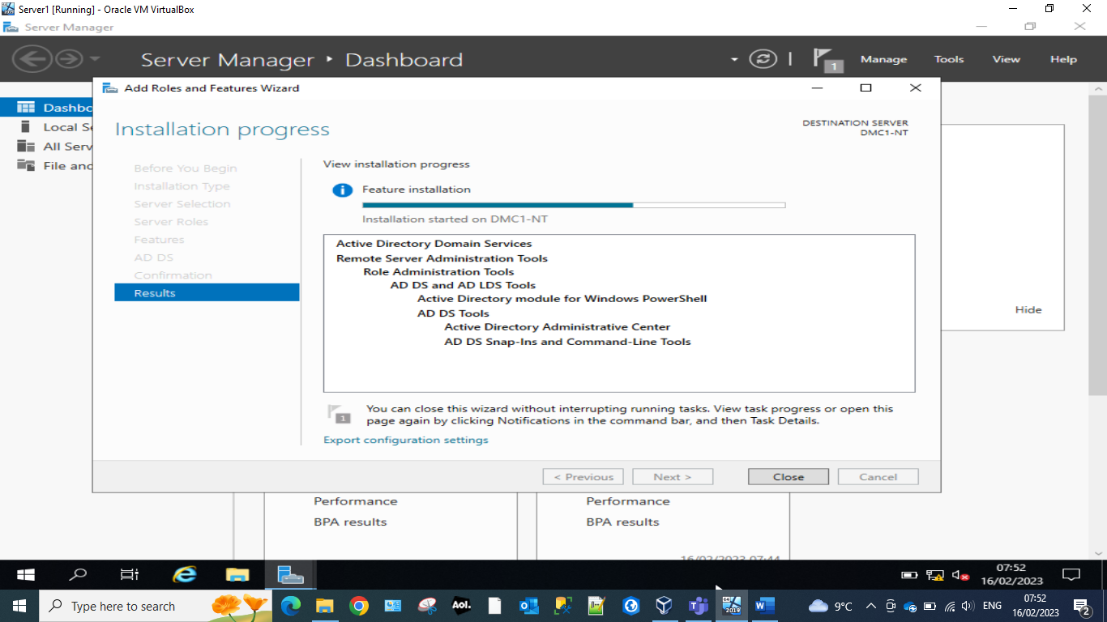

Active directory is an essential software which handles security and group policy management across entire network estates. It ensures users and devices are managed by groups, this is essential for larger network estates with multiple users as managing these devices or users individually can get unmanageable quickly.

Paths window Server1
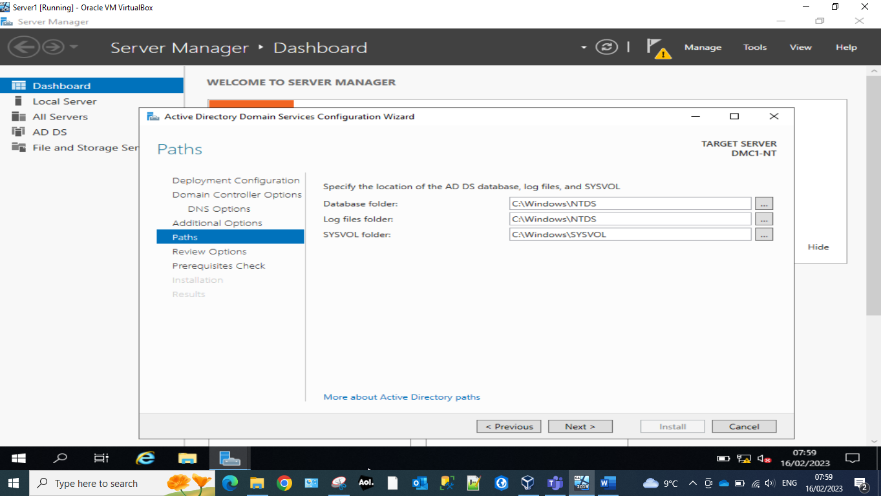
The active directory installation wizard will specify the paths of the database and the log files. These will hold the policies, users, devices and groups in a secured database at the specified path.

Domain Controllers Window Server1
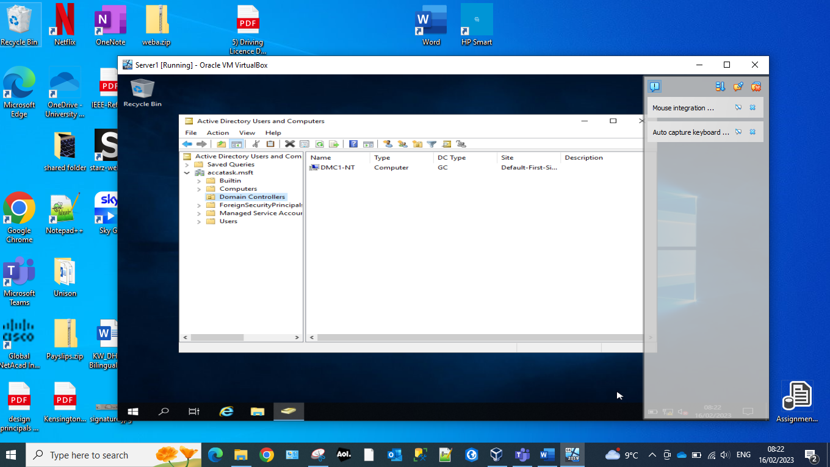
The domain controllers handle authentication requests from other devices trying to access a network. This is mostly common to active directory but can be used with other software. The domain controllers need to be specified in order for their permissions to be elevated to handle these requests.

Add new logon account to Server1.
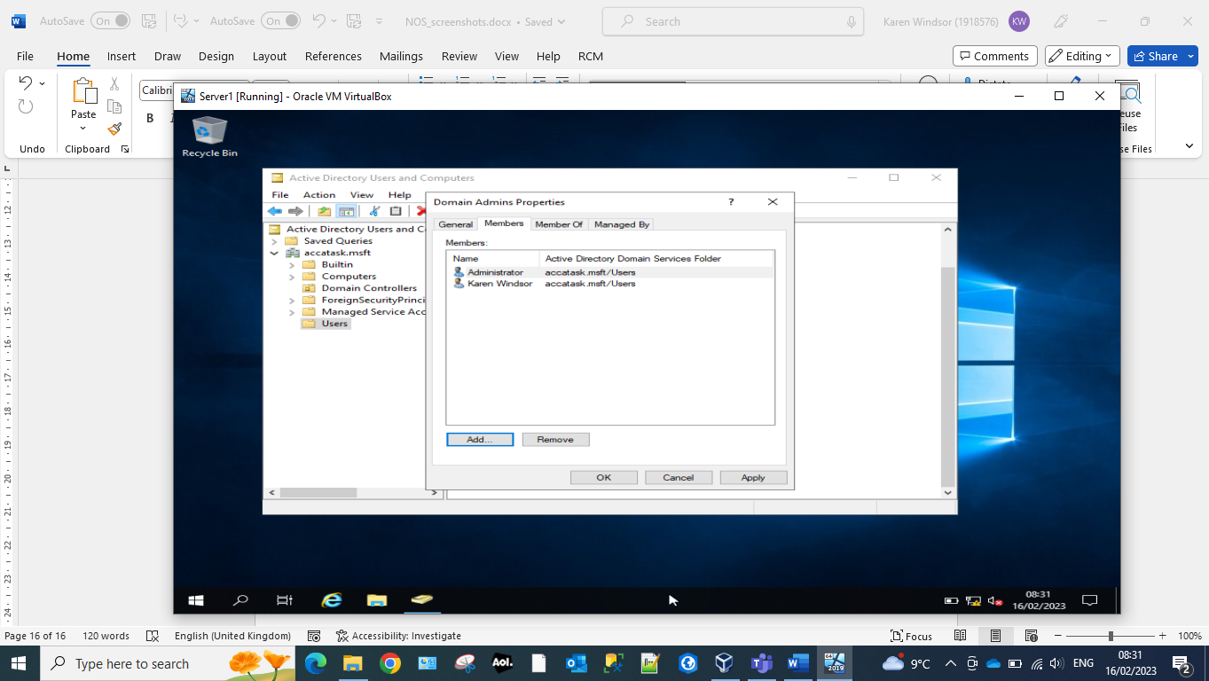

New Active Directory User Server1
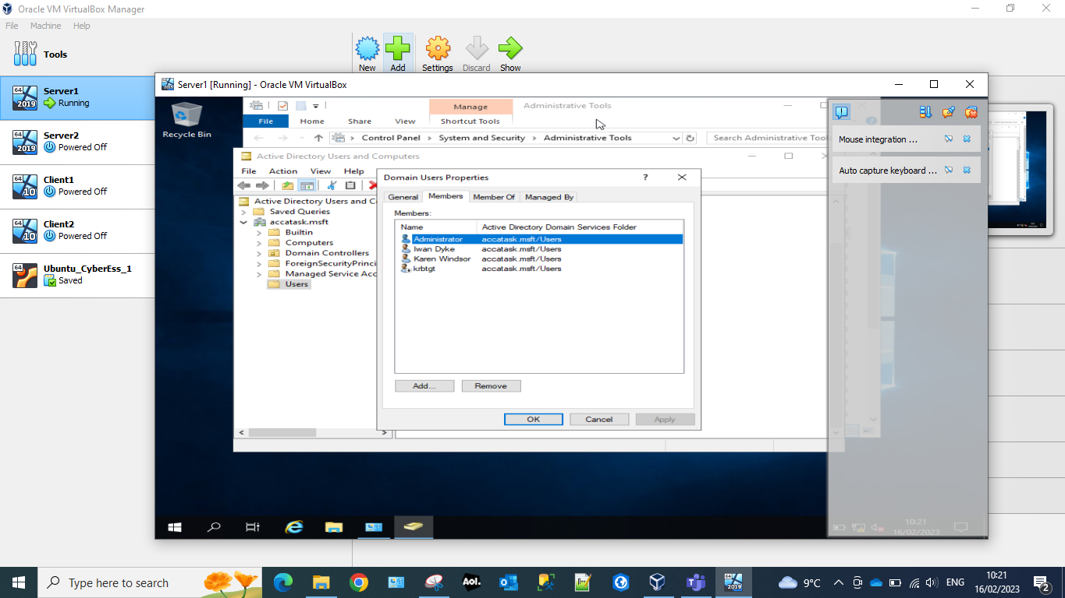
Users can be added to domains which will allow them to be managed within active directory. Users within a domain can be assigned to security groups. These users will then inherit the permissions and access granted to that group. This could be access to file shares, servers, data, software or networks among many other things.

Logging on active directory Client1
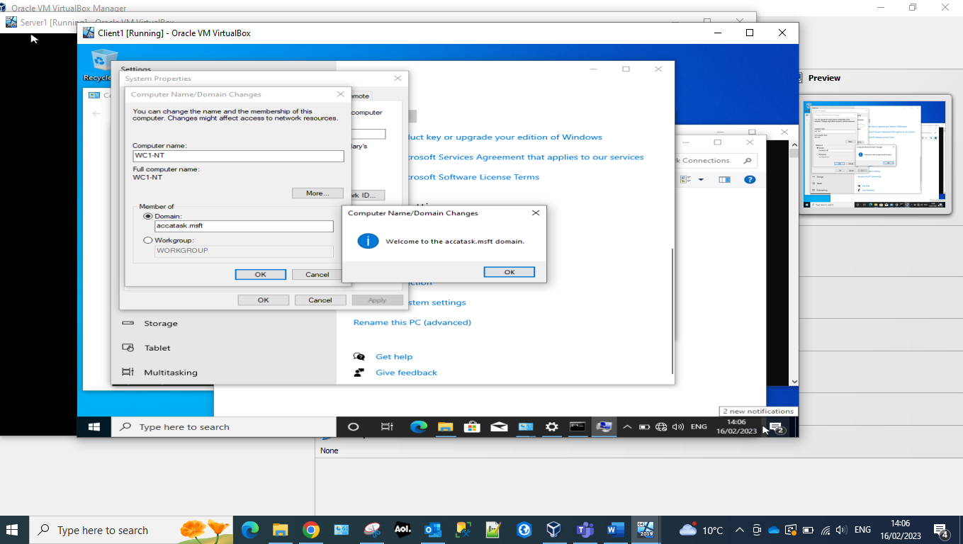
To connect to a created domain. Once the users have been given the required access, the domain will need to be set on the client device within system properties. This indicates to the client device which domain it should attempt to make a connection with. Any policies which have been applied to that domain will then be carried across to the device after a successful connection.

Logging in as alternative NT-ID
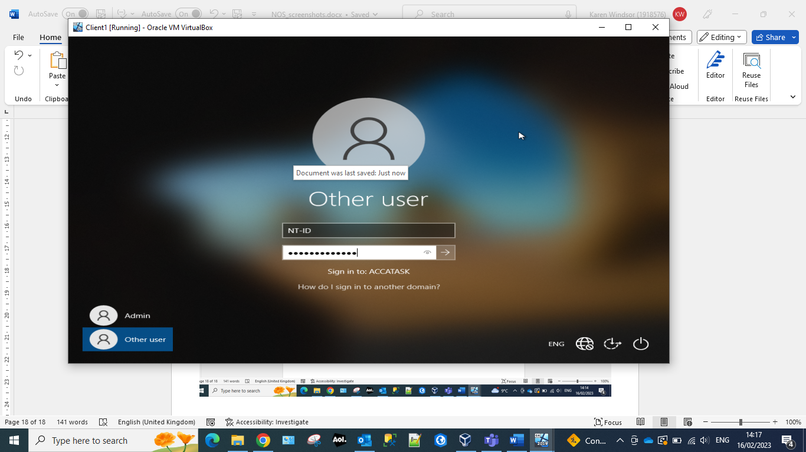

Time restrictions set for user NT-ID
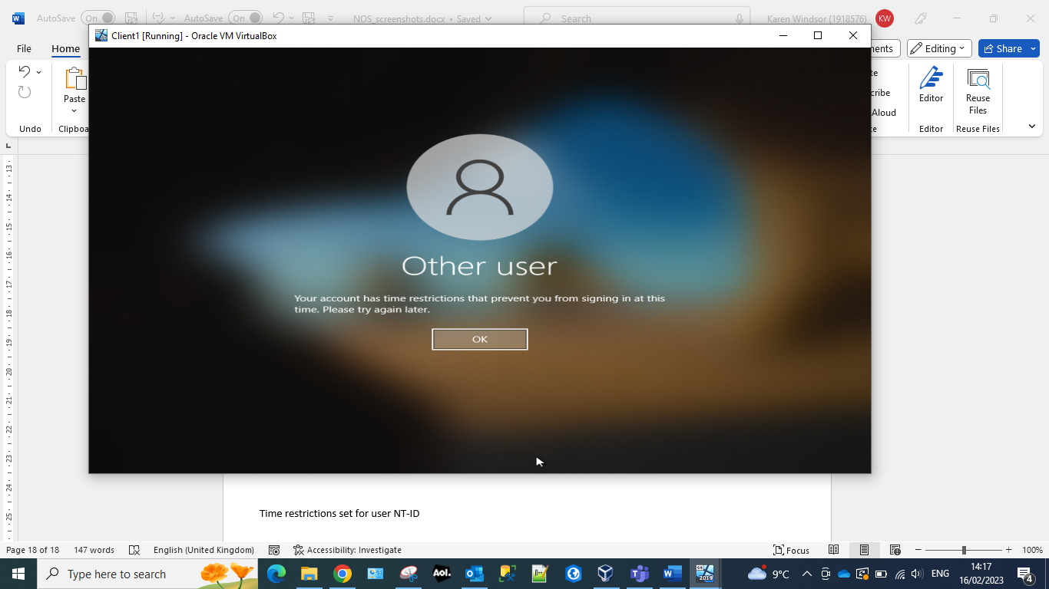
Active directory allows for users to be given limited timeframes to log into devices. This can be to limit the number of users which are connecting to a network at any one time. This could be for bandwidth issues or due to lack of resources available on a network or server.
Logging on as Karen Windsor
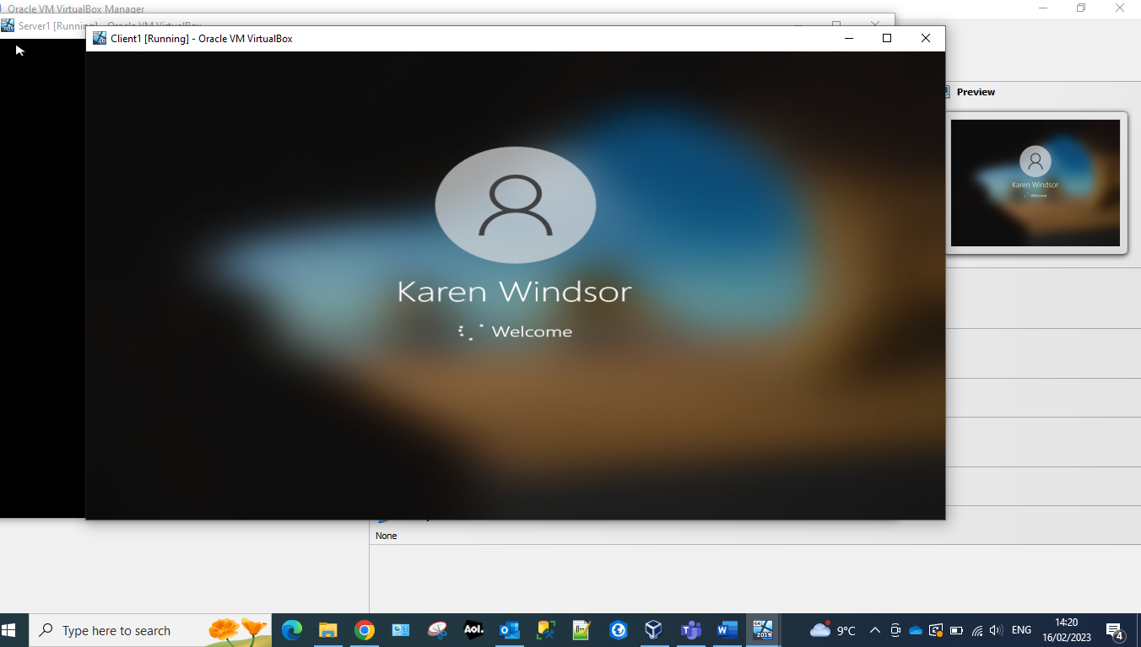
Accounts without limitations specified by active directory will be able to log into the network at any time. These rights on a limited network could be limited to administrators of the network or users which would require elevated permissions.

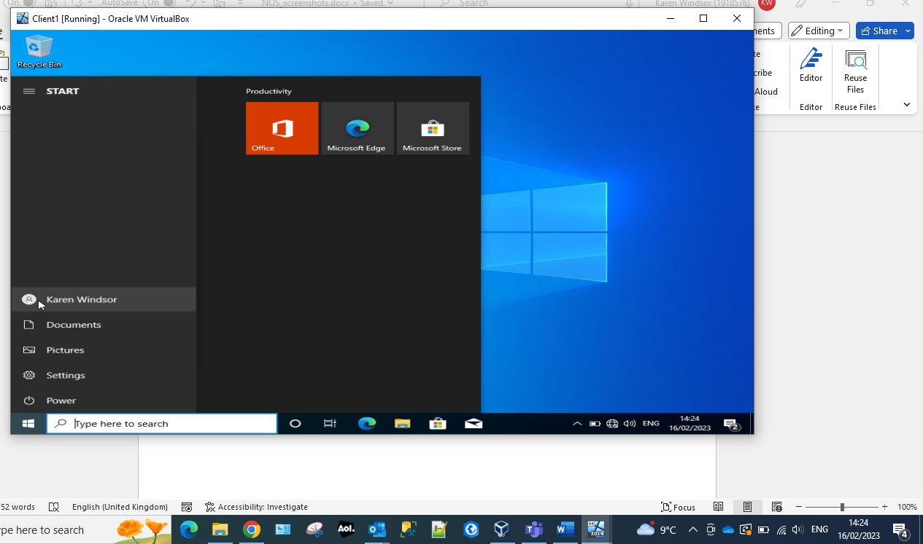
Final check to verify the user’s name.

Observations

Hypervisor
Oracle Virtual Box is a type 2 Hypervisor meaning that it runs as a software layer on top of the machine operating system being, for instance my colleagues used a Windows Machine while myself I’m using a MacOS system. Type 1 Hypervisors relies on the machine physical hardware, most of the time requiring a separate management machine and/or hardware acceleration software in order to manage multiple Virtual Machines and the host computer hardware. Also, one other important factor is that a Type 1 Hypervisor is a big resources consumer and managing multiple VMs simultaneously is extremely intensive for the host machine. On the other hand, the Type 2 provide an easy setup process, quick switch between the guest and host machine. Type 2 because it doesn’t have access directly to the host hardware but have to do that using the OS layer can lead to a high latency, hence you’ll observe a slow speed in running a VM.
Some of the drawbacks of using Hypervisor are:
- Resource Overhead: Because hypervisors are the managers of their virtual servers, some of the resources of the physical server will be used by the hypervisor, so the virtual servers will not be able to use 100 percent of the resources of the physical servers.
- Learning Curve: Managing servers in a virtual environment is different from a traditional environment, as you need to learn how to use the hypervisor itself to manage the virtual servers. This can mean additional training for some technicians.
- Additional Security Concerns: Every piece of hardware and software on your server represents a possible attack vector for hackers. Adding virtualization can therefore add security risk through additional attack surface(s).
[2]

DHCP (Dynamic Host Configuration Protocol)
DHCP server is a network server that automatically provides and assigns IP addresses, default gateways and other parameters to the clients. The advantages of using DCHP Server to manage the IP addresses in a network or multiple networks is that the user management is very reduced. Let’s take as a sample a private network of Class C 192.168.5.x. which can have up to 254 hosts. This can be a simple small office network with a few tens of stations all across the premises. It would be hard to manage even let’s say only 50 hosts because assigning same IP address to 2 or more devices would create a conflict in the network and neither one of the devices will be able to use the network. Most of the routers have these days the ability to provide the DHCP server support as following:
- A client can request and obtain/lease a valid IP address
- Have a reserved IP list associated with DHCP clients
- Manage the lease duration
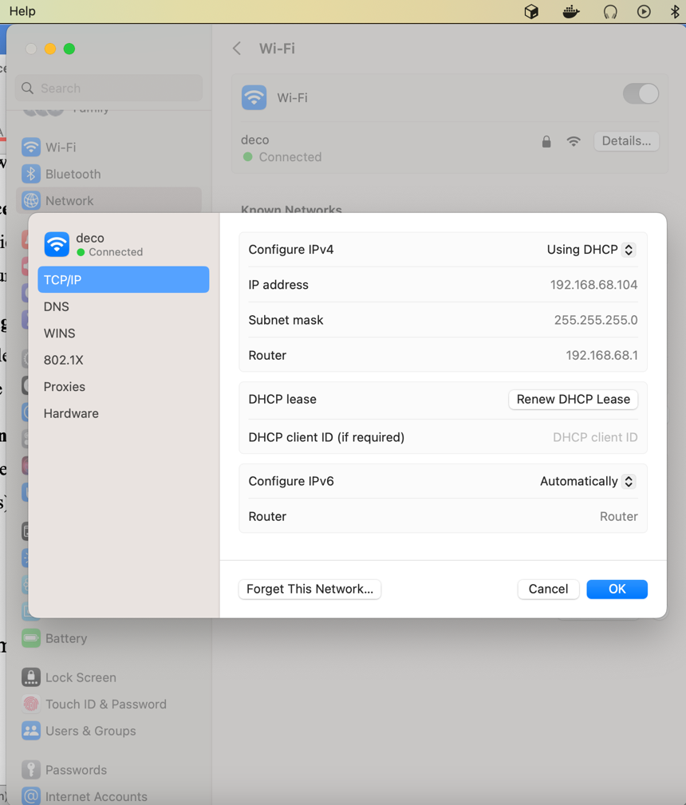
Using a DHCP server, the network infrastructure will benefit of:
- Reliable IP address configuration
- Reduce network administration
- Centralized and automated TCP/IP configuration.
- The ability to define TCP/IP configurations from a central location.
- The ability to assign a full range of additional TCP/IP configuration values by means of DHCP options.
- The efficient handling of IP address changes for clients that must be updated frequently, such as those for portable devices that move to different locations on a wireless network.
- The forwarding of initial DHCP messages by using a DHCP relay agent, which eliminates the need for a DHCP server on every subnet. [3]

Active Directory
Active Directory (AD) is a database and set of services developed by Microsoft for Windows Domain Networks and helps administrators to manage the permissions, users and control access to different network resources.
In Active Directory, data is stored as objects, which include users, groups, applications, and devices, and these objects are categorized according to their name and attributes. [4]
Active Directory Services:
- Active Directory Domain Services (AD DS) are the core functions of AD and manages users, computers, permissions, provides security certificates, LDAP, provides Single Sign-On and access right management.
- Lightweight Directory Services (AD LDS) is a Lightweight Directory Access Protocol (LDAP)
- Certificate Services
- Active Directory Federation Services
- Rights Management Services

Windows Firewall
Windows Server 2019 is a very complex and customizable Firewall Application compared to firewall apps you can find on devices. For instance in Windows Firewall app you can set rules to allow only certain ports and protocol (TCP/UDP) to be open for incoming connections.
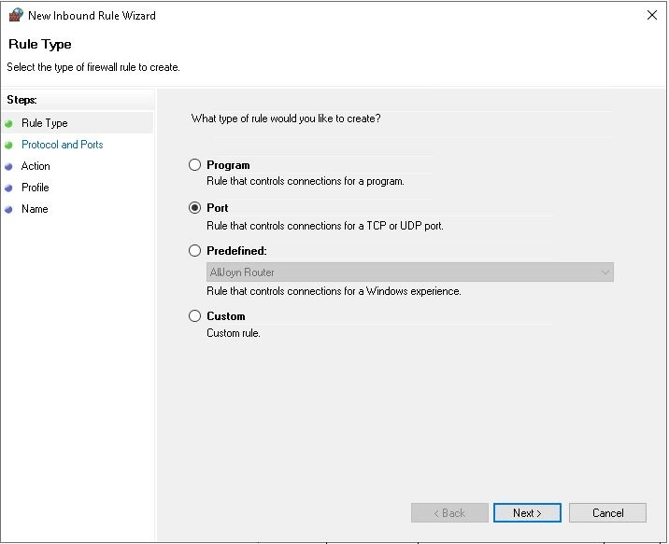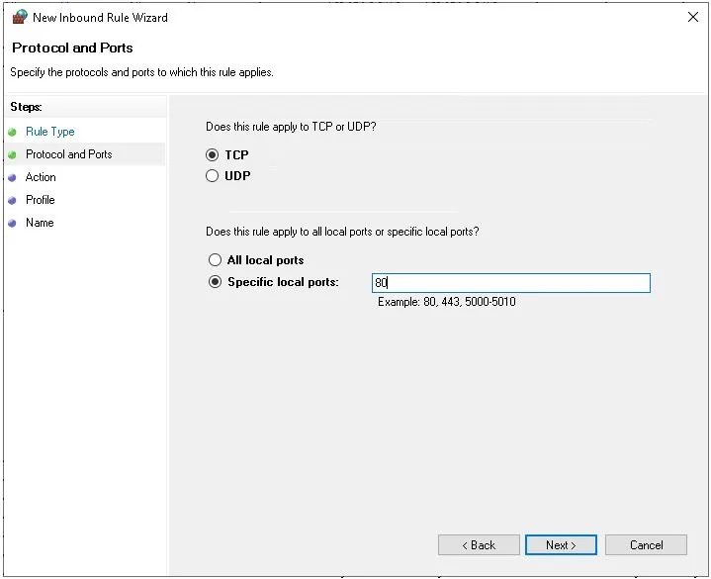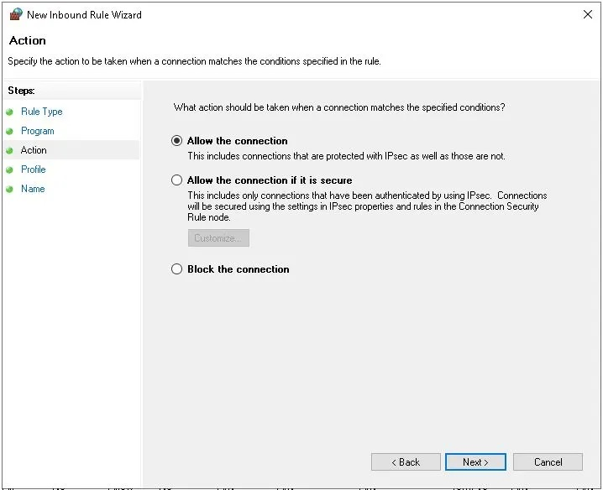
Or opening the incoming ICMP requests, so we can run ping and get a response from the device:
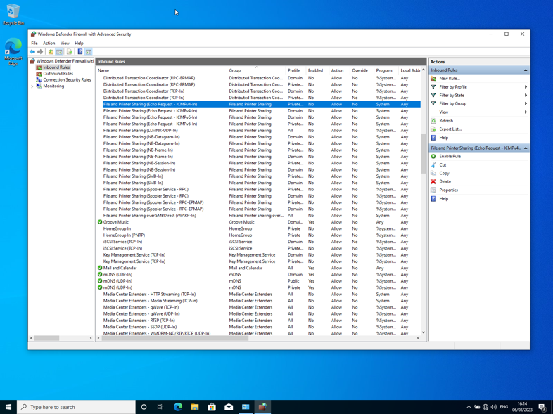
On the regular devices most of the time we will find Firewall apps with very few options to be customisable, most of them coming with rules in place already based on vulnerabilities lists available. MacOSX is coming out of box with a Firewall app with just a few options to activate/deactivate and the possibility to limit/allow certain apps to accept/make requests:

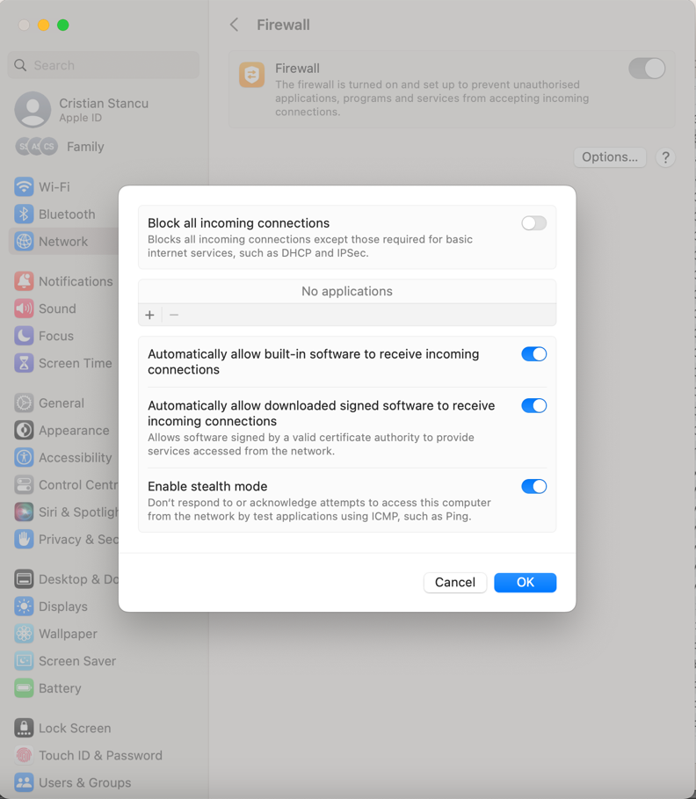
When an application want to accept incoming connections, a window pop-up to ask the user whether allows it.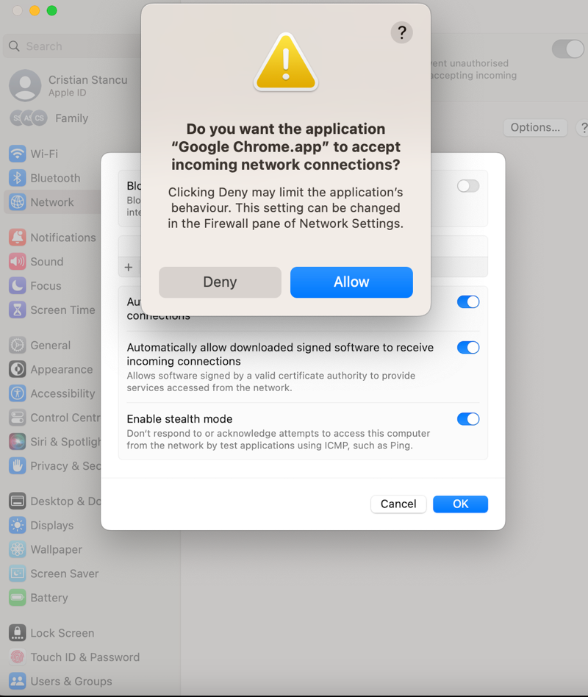

Reflection

All servers have been created with a standard setup. These will be enough for standard usage on a LAN (local area network). This configuration has enough memory, and processing for most operations on a smaller LAN. The Virtual Hard Drive has been set to 25GB to satisfy the minimum requirements for Windows Server 2019 of 14515MB
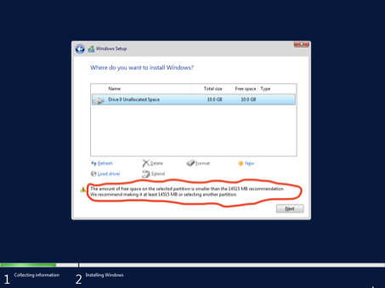
For both Server and Client VMs, the OS installation images have been mounted to the virtual DVD unit so we can boot the setup by there.
Windows Server 2019 is the 19th version of the Windows Server operating system. The Essentials version used for installation on our Virtual Machines is having certain limitation such as: a max of 25 employees/users. Window 10 Consumer Edition was installed on the client machines, the Pro version being chosen at the time when that has been requested.
It is very important to double check that the right netmask has been set for both Private and Public Networks so:
- The public network IPs provided 10.10.10.1 and 10.10.10.2 belongs to the Class A network 10.x.x.x and the netmask is 255.0.0.0
- The private network IPs provided belongs to the Class B network 176.16.x.x so the correct netmask is 255.255.0.0

By default, the windows machines both server and client are coming with the Windows Defender Firewall which is preventing the incoming ICMP requests. Since we are using ping networking utility which relies on ICMP protocol, in order to Allow the inbound requests, we have either to disable the Firewall which in a real case scenario is not advisable to be done. The best way to control what we allow/deny is to add an Inbound rule in Windows Defender Firewall for the ICMP protocol:
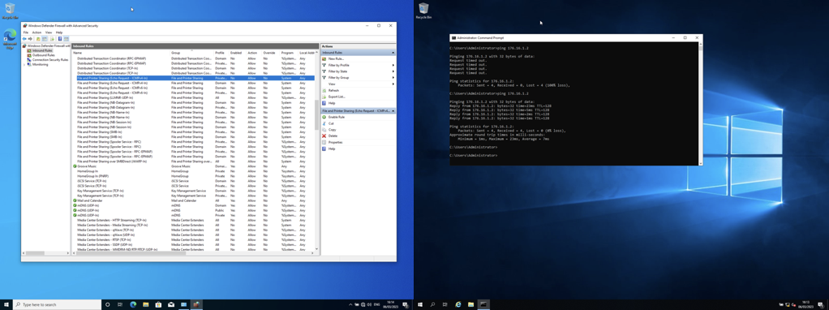
However, on a public accessible network, is strongly advisable to DISABLE the ICMP requests as that’s the easiest way for an attacker to mitigate a DDoS (Distributed Denial-of-Service) attack and this kind of vulnerability is still sitting on OWASP Top 10 vulnerabilities.

Bibliography

[1] | O. Bamidele and K. Aboubakar, “https://www.researchgate.net/publication/367077101_Windows_Active_Directory_vs_Linux_Directory_Services,” January 2023. [Online]. Available: https://www.researchgate.net/publication/367077101_Windows_Active_Directory_vs_Linux_Directory_Services.
[2] | D. Richards, “What is a Hypervisor?,” August 2022. [Online]. Available: https://www.liquidweb.com/blog/what-is-a-hypervisor/#:~:text=While%20a%20Type%201%20hypervisor,not%20require%20separate%20management%20machines..
[3] | “Dynamic Host Configuration Protocol,” Microsoft, 07 2021. [Online]. Available: https://learn.microsoft.com/en-us/windows-server/networking/technologies/dhcp/dhcp-top.
[4] | J. Coggins, “What Is Active Directory and How Does It Work?,” August 2022. [Online]. Available: https://www.lepide.com/blog/what-is-active-directory-and-how-does-it-work/.

