Community Engagement Assignment 2 2018 – Identify, Analyse and Implement a Solution to a Problem



APRIL 2018

MODULE NAME: community engagement - M4X00799
Name: Ryan D. Price
Student Number: p152137

Table of Contents

1. eXECUTIVE sUMMARY 1
2. Introduction 2
2.1 Report Remit 2
2.2 Brief background the organisation 2
2.3 The problem – MISLABELLED PARTS TO JAGUAR LAND ROVER 3
3. Problem solving techniques 3
3.1 Solving the problem 4
3.2 Problem solving implementation 4
4. Conclusion 4
5. References 5

APPENDICES

Appendix A -5 Why
Appendix B – 8D
Appendix C – Company Handbook
Appendix D – Project Authorisation

eXECUTIVE sUMMARY

The purpose of this report is to outline a problem found at GTEM (for this example it is mislabelling JLR parts), analyse why this problem has occurred using relevent problem solving techniques and provide a solution to stop this problem reoccurring.
GTEM is a manufacturing company that specialises in the manfucatering of automotive parts here in the UK supplying many high end automotive companies such as Jaguar Land Rover, Toyota, Honda and BMW.
The problem-solving techniques used in this report are 5 Why, 8D and an unconventional method of Shreyan Jain. All of which can be found in section three.
The solutions put forward to solve the problem consists of; retraining the associate to ensure the standard, disciplinary action to emphasis significance of the role, implementing extra quality checks to create a safety net if one associate fails to conduct his/her quality checks and lastly, the introduction of it systems to minimise the level of human involvement allowing the process to me automated leaving no room for human error.

Introduction

Report Remit

This report will include an analysis of a problem identified within a business, utilise formal problem solving techniques and make recommendations in line with the findings from these models and approaches to problem solving.

Brief background the organisation

GTEM is a subsidiary company of GTEKT Corporation and an affiliate of Honda Motor Company Japan. GTEM is a global company in the field of design, development and manufacturing of automotive body structures. Some of the key models manufactured at GTEM are; Honda, Toyota, BMW Mini and, Jaguar Land Rover. The vision of the company is ‘To become a company that contributes to a low-carbon society by integrating cutting-edge technology with high quality products at an affordable price, while serving customers around the globe to their fullest satisfaction’.

This image shows where the corporation operates and how the company categorises itself regionally.

MISLABELLED PARTS TO JAGUAR LAND ROVER

The problem GTEM is facing is the mislabel of supplier parts to Jaguar Land Rover, this means that when parts were manufactured and supplied to Jaguar Land Rover the parts that the customer received were incorrect. In this case the parts supplied were going to Jaguar Land Rover plant in ESC HAMS HALL. JLR part number HK72112D34AA arrived at plant but when moved onto the JLR production line, part number HK72112D36AA was found inside; understandably this can have significant consequences. This caused the production line to go on stop while the issue was identified and actioned within the Jaguar Land Rover plant. Once Jaguar Land Rover has confirmed a quality error a company called ‘G&P’ (GPQM, 2018) are called instantly by an Acting Manager. G&P are a standalone quality company that ‘offer total quality management solutions to the Manufacturing industry’ (GPQM, 2018) The production line stays on stop until the company arrive to contain all parts that are involved in the specific process to quality check them and confirm if the parts are accurate or not. Once G&P have identified the wrong parts and recognised what parts are correct they will remove the parts and allow Jaguar Land Rover to continue the production process with the correct parts. Unmistakably, this process is unfavourable for GTEM as this could put GTEM into a negative light when it comes to the quality of parts manufactured; there is a risk that this will deter any future contracts with new suppliers.

Problem solving techniques

A problem can be defined as ‘a matter or situation regarded as unwelcome or harmful and needing to be dealt with and overcome’ (Dictionary, 2018). In the TED talk ‘figure it out’ by Shreyans Jain it is suggested that there are two parts of problem. The declaration and the consequences, to put this into real life context, the declaration could be a tough report due in and the consequences could be stress and anxiety, highlighting the two parts of problem suggested by Jain. (Figure It Out - The Art of Problem Solving, 2017). So now that we know what a problem is and how they can be broken down, how can they be solved? Jain has his own method to problem solving which consists of Identification, this is where you state the source of trouble, after that comes the analysing stage this is the second part of a problem ‘declaration’ where you think how this has affected you and those involved. After this comes the solutions stage this is where you try to find out how to solve the problem and hopefully decide on a solution to home in on. Then there’s the plan stage where you have your solutions and form them into descriptive plans and lastly is the implementation stage, this is the stage that all the thought processes become fruition. Jain suggest however that a problem can be big or small, simple or complex and the person can employ any method of problem solving but if the person’s mind-set and perception are negative and defeatist then they will struggle to solve any problem, this is why the title of his talk is ‘figure it out’ he has faith in that this is the mind-set that should be taken into every problem that is faced. (Figure It Out - The Art of Problem Solving, 2017).
Jain’s problem-solving method isn’t as globally renowned as other methods of problem solving such as the Ishikawa diagram, 5Why and the root cause analysis.
The Ishikawa diagram is ‘A diagram that shows the causes of an event and is often used in manufacturing and product development to outline the different steps in a process, demonstrate where quality control issues might arise and determine which resources are required at specific times. The Ishikawa diagram was developed by Kaoru Ishikawa during the 1960s as a way of measuring quality control processes in the shipbuilding industry.’ (Investopedia, 2018).
Below is a template of the Ishikawa diagram.
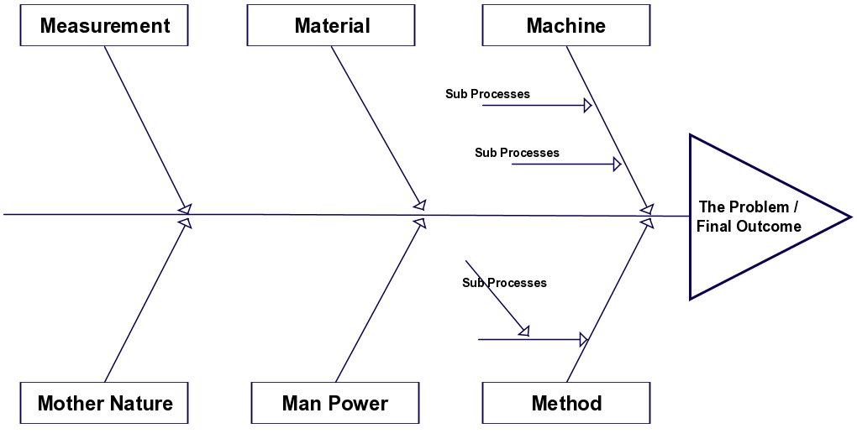
Figure 1 - Ishikawa Diagram
(Ltd, 2014)

Another problem-solving technique extensively used in the manufacturing industry is the 5Whys analysis. This is an amazingly effective and simple technique which is undoubtedly why it is so popular.

An example of using the 5Why problem solving method is;
The vehicle will not start. (the problem)
- Why? - The battery is dead. (First why)
- Why? - The alternator is not functioning. (Second why)
- Why? - The alternator belt has broken. (Third why)
- Why? - The alternator belt was well beyond its useful service life and not replaced. (Fourth why)
- Why? - The vehicle was not maintained according to the recommended service schedule. (Fifth why, a root cause)

As the example shows, the method consists of asking the question ‘why?’ five times to delve into the problem deeper five times coming to the root cause of the problem with the fifth ‘why?’.

This method is one of the most commonly used in the manufacturing industry however there are some doubters of the method. Toyota executive Teruyuki Minouara articulates that;
‘When an error occurs, the first thing that needs to be done is fix the error. Minoura recalls that Ohno used to order them to ask the question “Why?” five times over because “that way you’ll find the root cause, and if you get rid of that it’ll never happen again.” However, Minoura emphasizes that on-the-spot observation rather than deduction is the only correct way to answer a “Why?” question. “I’m always struck that the five-why method doesn’t seem to be working as well as it should be because there’s been a lack of practical training. The reason is that they end up falling back on deduction. Yes, deduction. So, when I ask them ‘Why?’ they reel off five causes as quick as a flash by deduction. Then I ask them five whys again for each of the causes they produced. The result is that they start falling back on deduction again, and so many causes come back that you end up totally confused as to which of them is important.”

“Through real training,” Minoura says, “you’ll be able to discover dozens of problems and get to their root causes. You’ll be able to make dozens of improvements. If you incorporate all the accumulated knowledge of root causes that you’ve got from always asking ‘Why? Why? Why? …’ into your equipment, you’re going to have something that no one else can come close to. I don’t think it’s got anything to do with nationality; it all has to do with whether you’ve received the proper training. I feel though that the tendency to give that kind of training and education forms the basis of Toyota’s approach to monozukuri.” (TapRoot, 2007) (Monozukuri translates to production).

The last problem-solving technique that will be used in this report is the 8D method. This method was developed at Ford Motor Company it consists of 8 disciplines which are;
‘D0: Preparation and Emergency Response Actions: Plan for solving the problem and determine the prerequisites. Provide Emergency response Actions
D1: Use a Team: Establish a team of people with product/process knowledge.
D2: Describe the Problem: Specify the problem by identifying in quantifiable terms the who, what, where, when, why, how, and how many (5W2H) for the problem.
D3: Develop Interim Containment Plan: Define and implement containment actions to isolate the problem from any customer.
D4: Determine and Verify Root Causes and Escape Points: Identify all applicable causes that could explain why the problem has occurred. Also identify why the problem was not noticed at the time it occurred. All causes shall be verified or proved. One can use five whys or Ishikawa diagrams to map causes against the effect or problem identified.
D5: Verify Permanent Corrections (PCs) for Problem will resolve problem for the customer: Using pre-production programs, quantitatively confirm that the selected correction will resolve the problem. (Verify that the correction will solve the problem.)
D6: Define and Implement Corrective Actions: Define and Implement the best corrective actions.
D7: Prevent Recurrence / System Problems: Modify the management systems, operation systems, practices, and procedures to prevent recurrence of this and similar problems.
D8: Congratulate main contributors to your CAR team: Recognize the collective efforts of the team. The team needs to be formally thanked by the organization.’ (Wikipedia, 2018)

The case study ‘The 8D Methodology: An effective way to reduce recurrence of customer complaints?’ makes an investigation to identify the variables influencing the customer complaints process in the automotive industry. The investigation results showed that ‘The improvement and reduced variability in the 8D process was achieved by integrating and managing the quality data in an integrated management system and by the reorganization of tasks and methods. A faster and more qualified reaction to complaints and therefore problems was achieved, reducing and preventing problem recurrence, representing cost savings whenever a complaint appears or is avoided’ (Rambaud, 2006) this report shows how using a defined problem-solving technique is imperative to a companies continued progression.

Solving the problem

Now that the problem has been identified and problem solving methods have been discussed in the previous sections the report will now go into how to solve the problem using the methods previously identified. Using the 5 Why analysis (Appendix A) I have come to the conclusion that the root cause of this problem is the associate not following his/hers correct training. To stop this problem reoccurring I believe the correct countermeasure would be to retrain the associates, re-emphasising the importance of the quality checks that they are expected to undergo. Retraining of associate is the first line of protocol when it comes to quality concerns however the question still lies on if its effective because once the associate has been retrained there will still be an element of human error involved in the process and after a duration of time the associate could become accustomed to their job and start to cut corners. This will then result in the same mistake occurring.
Another solution to this error could be to discipline the associate for not following GTEM procedures; this would involve verbal warning, written warning or counselling. Which could potentially uncover why the associate did not follow protocol to stop the problem reoccurring. In the book ‘How to win friends and influence people’ (Carnegie, 2016) discusses how to influence individuals into your way of thinking. The idea of retraining an associate to influence them to the correct way of thinking can be effective. However, Carnegie discusses how to do this correctly throughout his book and in chapter one he tells the story how criticising, condemning and complaining will not effectively influence any individual into your way of thinking. If GTEM was to use this solution to overcome their problem they should analyse their retraining process and manipulate their training so that it fits in with (Carnegie, 2016) principles. Another argument of this solution is the national archive by (Green, 1997) who ‘reviews the formal evidence in existence on the benefits to training for employers, in order to contribute to the overall evaluation of the functioning of the skill formation system in Britain…Evidence about the link between training and labour productivity is lacking in Britain. Studies from abroad in most but not all cases show that training does have a positive impact on productivity. There is little agreement, however, about the magnitude of this effect. Estimates range from very large (about an 80% increase attributed to training) to a negligible effect. One of the best studies, especially in terms of its representativeness and its standards of data collection, found no significant overall impact from training on company turnover or on productivity, using a survey that sampled American establishments with at least 20 employees. Nevertheless, it did find that certain kinds of training were effective in raising productivity, notably computer training in the nonmanufacturing sector.’ This report shows evidence that retraining in the manufacturing sector may not be worth the time and money it would cost GTEM.
When conducting the 5 Why analysis it was identified that another root cause was the lack of secondary measures to stop the problem from escalating. This option wouldn’t essentially stop the mislabel from reoccurring but it would however stop the mislabelled parts reaching the supplier (Jaguar Land Rover) saving GTEM the third parts costs and stress of supplying the correct parts immediately whilst conducting an investigation on how it has happened. Again, the criticism of this is that the human error concept is not only minimised but essentially doubled by creating two layers of human quality checks.
Using the Ishikawa Diagram, it has been acknowledged that one of the causes of the problem is the capability of the associates. Having looking deeper at this problem one of the solutions could be to investigate the recruitment process when recruiting associates for this job. By increasing the demand on this job role (adding extra systems for quality authorisations) it could mean that the recruitment process criteria must be increased. Therefore, having a more skilled workforce should result in less manufacturing concerns.
The last solution for this problem is to eliminate all human processes and introduce an electronic system to minimise the human error. This solution in the long run will inevitably be the most effective solution. As stated by in the BBC Report ‘robot automation will take 800million jobs by 2030’ (James Manyika, 2017) This sparks the debate on how AI technology will affect the workplace, many people see systemising human processes as undesirable but ‘history shows that technology has created large employment and sector shifts, but also creates new jobs. Below shows the percentage of workforce per sector;
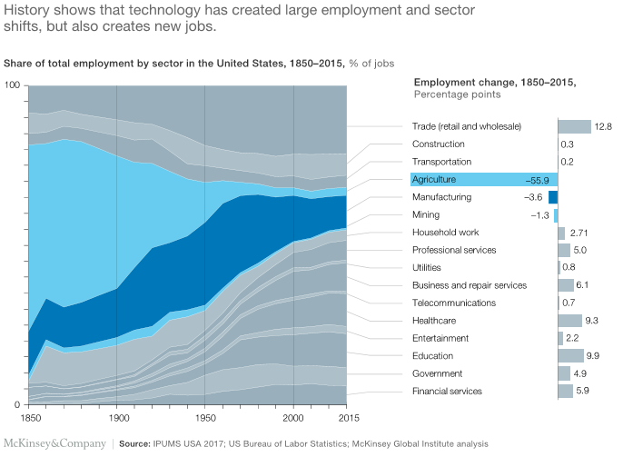
Figure 2 - Share of total employment by sector in the United States, 1850 - 2015
(James Manyika, 2017)

As you can see, from the 1850 to 1900 there was a large percentage of the workforce in agricultural trades and then came industrialisation and the workforce shifted into sectors such as Trade, Professional services, healthcare and education. Although the majority feared industrialisation obviously it has been the greatest movement for generations. Maybe creating AI systems to minimise human error in manufacturing is the natural progression that just like industrialisation, should not be feared.
The counterparts to this argument is the report written by (GULLAND, 2006) which quotes; ‘human error may occur when specifying, designing, implementing, installing, commissioning, operating and maintaining systems. Even if technological systems can operate without human intervention, there is still the possibility of human error at other phases of the lifecycle. Design may reduce the possibilities for human error during operation, but only if human error can also be eliminated during all the other phases of the lifecycle. Thus, it will be necessary to focus on human behaviour and methods of working during the whole lifecycle, not just operation. Focusing on ‘the design for operation’ alone will not be enough.’ (GULLAND, 2006)
Now that you have two sides of the argument its up to you decide if you agree that introducing IT systems to replace the risk of human error is worth the investment or not.

Problem solving implementation

When conducting a 5why and 8D problem solving method it was evident that there were several areas that needed to be solved. Firstly, the level of training and secondly the high amount of scope for human error. To correct these problems the following will take place.
Firstly, as evident by the 5why (Appendix one) you can see that the root cause was the ‘decant associate has disregarded his training to complete the required decant operation’. Decant meaning ‘to pour (a liquid) from one container to another.’ (Dictionary, 2018) However in this operation is was moving parts from a large container into smaller containers. Subsequently to stop this problem from reoccurring initial action is to retrain the associate. The retraining will be done via an assessment of work complete this training will be done over the course of the week too confirm the associate is capable of his/her job. However, due to the associate completely ignoring his training previously the disciplinary route must be taken to show the significance of the quality checks he should have done. The resources needed for this to commence will be the associate that created the problem, a week work to assess and a co-ordinator to lead this re-training process. Once this process has been completed the co-ordinator will report to senior management discussing if he felt the retraining will help the associate, if the associate is capable to do the quality checks and any of miscellaneous feedback. To measure the success of this approach there will be ad-hoc audits taken out by co-ordinators to see if the associate is conducting his/hers assigned quality checks.
In an idealistic world these checks will be confirmed systematically and not by an entry level job recruit. However, putting in this system will take a large investment of finance and time. But I believe use of IT systems will improve overall performance of the operation and decrease the level of human error that is currently there.
The second approach to curing this problem is a long term, high investment approach. It would involve systemising the operation right from the beginning. This way when the parts are created the system identifies them as the parts and there is no way the system will mix up any parts, then using the system to ‘decant’ the parts. This way there is no level of human interaction with the parts resulting in minimal scope for human error. Thus, coming from a problem riddled operation and transforming the area into a more efficient, accurate and effective operation. Nonetheless this approach will take several years, time and finance but however I believe it will in the long run create a substantial return on investment. This article provides evidence of the benefit of robotics replacing human labour ‘By 2025, labor cost savings in the United States from the adoption of advanced industrial robots should surpass 22%.’ (Technavio, 2016) understandably these figures are from USA however the concept is still the same in the UK. This approach would have to be presented to senior management who (if approved) would approach shareholders and board of directors with this solution.
Intertwining the two approaches is the best solution to the problem, by doing this there will be an immediate response to the problem and a solution to stop the reoccurrence of mislabelling of parts.

Conclusion
To summarise the above points, the use of problem solving techniques in industry is an effective tool when attempting to create solutions. Models such as 5 Why, 8D are useful for the manufacturing sector and although problems will always arise when work is being conducted I strongly believe that the introduction of AI and IT systems will minimise these problems. As TED talk representative Shreyans Jain said ‘problems are solutions waiting to be found’. (Figure It Out - The Art of Problem Solving, 2017)

References

Carnegie, D., 2016. How To Win Friends and Influence People. s.l.:e-artnow.
Dictionary, 2018. Dictionary. [Online]
Available at: http://www.dictionary.com/browse/decant
[Accessed 30 04 2018].
Dictionary, O., 2018. Oxford Dictionary. [Online]
Available at: https://www.oxforddictionaries.com/
[Accessed 16 04 2018].
Figure It Out - The Art of Problem Solving. 2017. [Film] Directed by Shreyans Jain. India: TED Talks.
GPQM, 2018. GPQM. [Online]
Available at: http://www.gpqm.com/
[Accessed 0417 2018].
Green, F., 1997. National Archives. [Online]
Available at: http://webarchive.nationalarchives.gov.uk/20130402143334/https://www.education.gov.uk/publications/eOrderingDownload/RB07.pdf
[Accessed 19 04 18].
GULLAND, A. G. F. a. W. G., 2006. Can technology eliminate human error?, s.l.: Trans IChemE.
Investopedia, 2018. Investopedia. [Online]
Available at: https://www.investopedia.com/terms/i/ishikawa-diagram.asp
[Accessed 16 04 2018].
James Manyika, S. L. M. C. J. B. J. W. P. B. R. K. a. S. S., 2017. McKinsey & Company. [Online]
Available at: https://www.mckinsey.com/global-themes/future-of-organizations-and-work/what-the-future-of-work-will-mean-for-jobs-skills-and-wages
[Accessed 18 04 2018].
Ltd, C. P., 2014. Cinergix Pty Ltd. [Online]
Available at: https://creately.com/blog/wp-content/uploads/2014/04/Manufacturing.png
[Accessed 17 04 2018].
Rambaud, L., 2006. 8D structured problem solving; a guide to creating high quality 8D reports, s.l.: Phred Solutions.
TapRoot, 2007. TapRoot. [Online]
Available at: http://www.taproot.com/archives/710
[Accessed 16 04 2018].
Technavio, 2016. Technavio. [Online]
Available at: https://www.technavio.com/blog/industrial-robots-united-states-cut-labor-costs-21-2020
[Accessed 30 04 2018].
Wikipedia, 2018. Wikipedia. [Online]
Available at: https://en.wikipedia.org/wiki/Eight_Disciplines_Problem_Solving
[Accessed 16 04 2018].

Appendix a – 5y
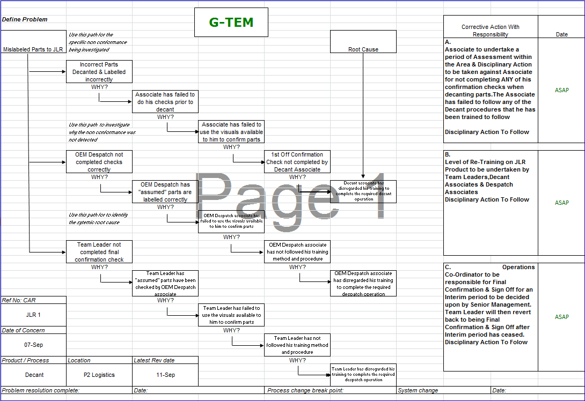

APPENDIX B – 8D
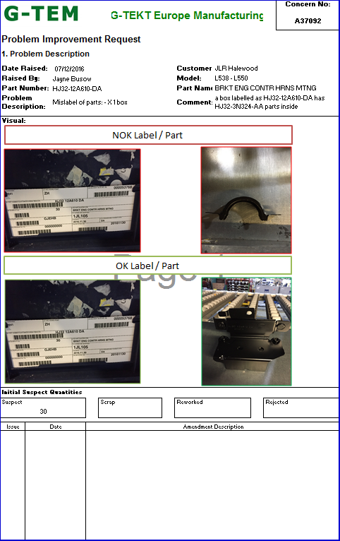



APPENDIX C – Company Overview
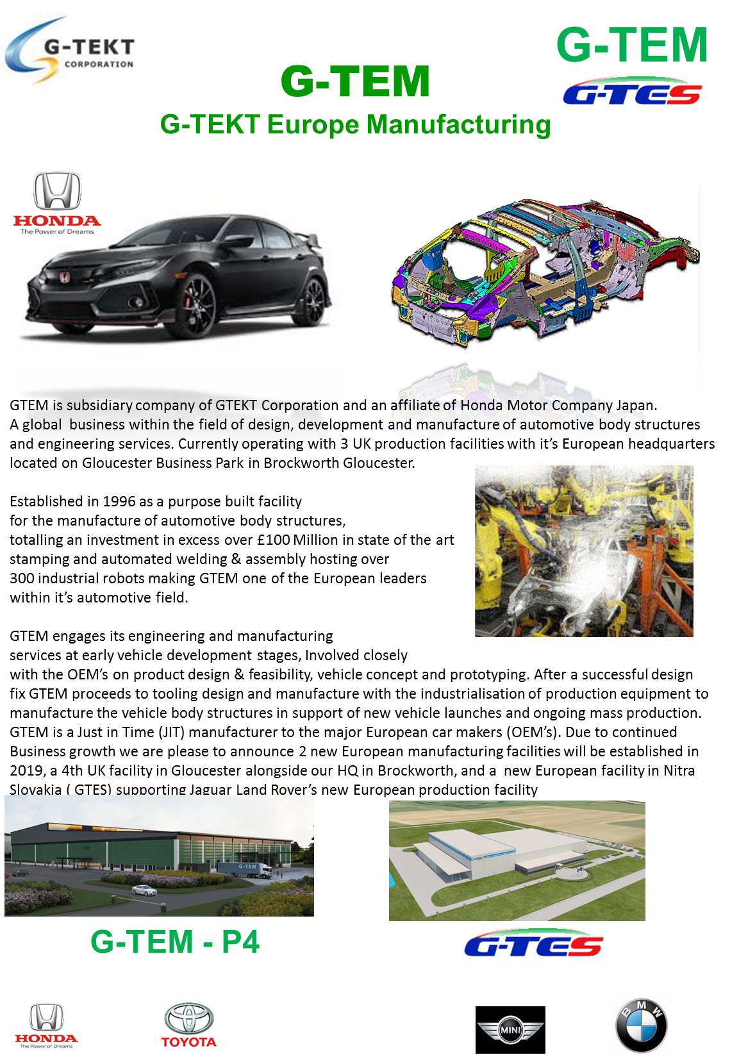

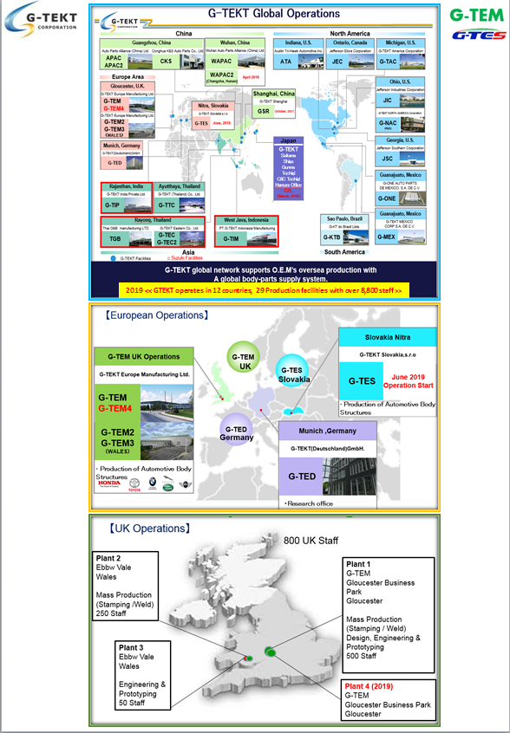

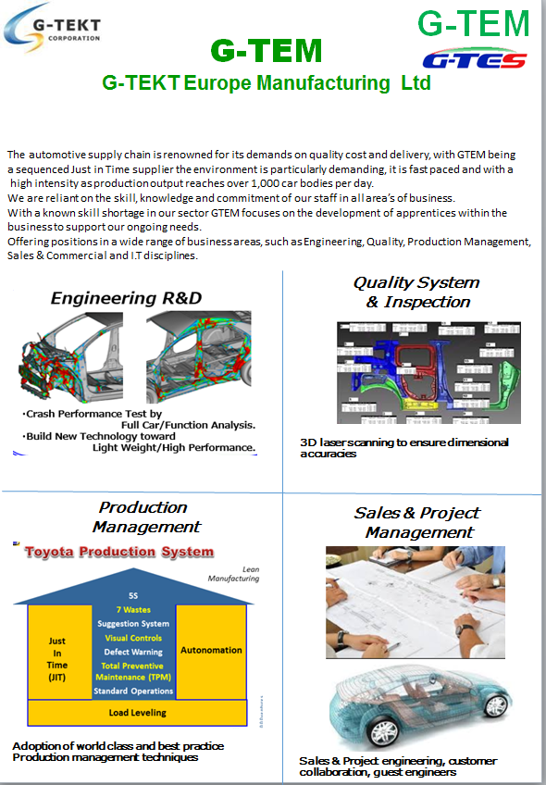

Appendix D – Project Authorisation




