

NAME ; ZEBIBA HUSSEN
STUDENT ID ; 1913291
MOODLE CODE; BMSW5101
NAME OF THE MODULE; DEVELOPING WORKPLACE
CRITICAL THINKING
LECTURE NAME; FAIZU EDU

CONTENTS
PART A 2
EXECUTIVE SUMMERY 2
1 – INTRODUCTION 3
2 KEY MANAGEMENT THEORIES 5
2.1 VALUES-BASED MANAGEMENT THEORY 5
2.2 PRINCIPLES OF ADMINISTRATIVE MANAGEMENT 6
2.3 CLASSIC MANAGEMENT THEORY 7
2.4 MODERN MANAGEMENT THEORY 8
3 APPLYING THEORIES TO TESLA 8
4 HOW SOMEONE WITH DIFFERENT BELIEFS, ATTITUDE AND VALUES MAY INTERPRET THEORY DIFFERENTLY 11
5 RECOMMENDATIONS 12
PART B 13
6 DIFFERENT BETWEEN BELIEVES, ATTITUDES AND VALUES WITHIN THE ORGANIZATION 13
6.1 BELIEVES 14
6.2 VALUES AT WORKPLACE 15
6.3 ATTITUDE AT WORKPLACE 16
7 ORGANIZATIONS BELIEFS, ATTITUDE AND VALUES SYSTEM AND THEIR IMPACT ON WORKPLACE BEHAVIOUR 16
8 HOW THEORIES MAY INTERPRET WRONGLY WITH DIFFERENT PROSPECTIVE AND PEOPLE 18
9 CONCLUSION 19
10 REFERENCES 20

FIGURE 1: TESLA COMPANY REVENUES (CARLIER, M, 2022) 5
FIGURE 2: FIGURE 5: TESLA MODEL 3, ECO FRIENDLY AS IT OPERATES ON ELECTRICAL ENERGY (ZIZMALL, 2022) 6
FIGURE 3: VALUE BASED MANAGEMENT THEORY (KOLLER, T, 1994) 7
FIGURE 4: HENRY FAYOL MANAGEMENT THEORY MODEL (CLAUDIA F, 2021) 8
FIGURE 5: TURNOVER RATIO AT THE TESLA COMPANY (RASOULIAN, A, 2022). 10
FIGURE 6: THE NUMBER OF EMPLOYEES SATISFIED AT TESLA WITH AVERAGE INCOME (PAY SCALE, 2022). 11
FIGURE 7: TESLA ORGANIZATIONAL STRUCTURE (ORGANIMI, 2022) 12
FIGURE 8: THE ATTITUDE, BELIEVES AND VALUES (KUMAR, M, 2022) 14
Figure 9: The difference between values and believes (Hasa, 2016) 16
FIGURE 10: CORE VALUES FOR A WORKPLACE (SCHUNEMAN F, 2019). 17

PART A

EXECUTIVE SUMMERY
Tesla is one of the top notch companies in the automobile industry. The company is known for its innovative products that are operating on electrical energy rather than conventional petroleum energy. The organization has more than 100,000 employees and 53 dollars revenues. Value based management theory is the fundamental approach to ensure that human values are always there within the management decisions because it is the core of managing organizations. The principles of administrative management focused on the real life situations where the management needs a proper approach to control and operates their teams effectively. Classical management theory based on a classical approach of work and reward phenomena, for the workplace where employees are performing tasks successfully in order to achieve rewards as a result. Furthermore modern management theory deals with the technological support to bring solutions and also find ways to establish relationship between employees and management. Tesla applies all these theories effectively to bring sustainability in their working environment. This is the reason they have more than 50% of satisfied employees and average income of more than 40 thousand dollars annually. Different people have different mindsets and with each of them interpret things and task differently at the workplace. Due to this change they interpret theories differently. Some of the recommendation are organization must consider the safety of their employees as their first priority. The organizations will need to consult their employees and monitor their mental regularly. The organizations must need to consider their employees needs and choices.

1 – INTRODUCTION
The assignment is based on the organizational believes, attitudes and value system that affect the workplace behavior and how will post pandemic challenges in business arena be addresses to create a resilient business organizations in the future. To critically assess these questions, it is fundamental to take Tesla Company as model for applying theories.
Tesla is brand in automobile industry which is known for its ultimate designs and innovation. Owned by one of the richest person on the planet earth Elon Musk, the company started its initial operations by manufacturing space rockets for their clients (Tesla, 2022). As mentioned the organization is known for its scientific research and development, named after renowned scientist Nikola Tesla, now operates and manufactures multiple industry products (Reed, E, 2020). The most famous product in the market are their electric vehicles. Their products are the most top listed sale items in the market especially their vehicles in American and Chinese markets. The reason behind their success is the environment friendly products that helps the planet for sustainability and contributes to greenhouse effect (US energy department, 2022). Furthermore the organization now steps into the modern form of transections by trading through crypto currency which is now considered a game changer in the markets. Their success can be assessed through the fact that they spend zero budget on their advertisements. The size of the organization as per company reports consists of approximately 100 thousand employees increasing with constant pace annually because of its diversified business and industry it operates directly. The company revenues are estimated to be more than 53 billion dollars as is expected to reach the milestone of 1.5 trillion dollars by the year 2030 (Norton, L, 2020). Some of their famous products in the market are their electric vehicle name as Model S, Model X and Model Y which are famous among the consumers because of their advance technology and electrical battery operations which make these product unique compared to traditional petroleum vehicles.
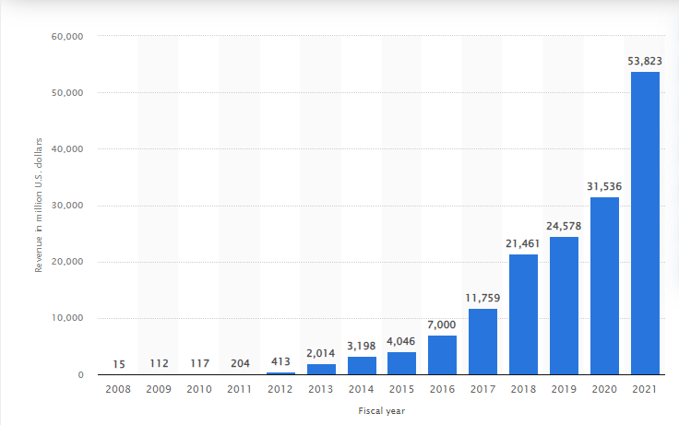
FIGURE 1: TESLA COMPANY REVENUES (CARLIER, M, 2022)
The figure above shows details of revenues generated by the Tesla Company over the years. The graph illustrate that it grows with a constant phase annually.

FIGURE 2: FIGURE 5: TESLA MODEL 3, ECO FRIENDLY AS IT OPERATES ON ELECTRICAL ENERGY (ZIZMALL, 2022)
The figure above shows the company Model 3 product which is known for its ecofriendly system because these products contributes to minimize 52,000 metric tons of carbon dioxide emission to the air (US energy department, 2022).

2 KEY MANAGEMENT THEORIES
There are number of management theories that are applicable at the workplace. All these theories are unique in their style of operation however their main purpose are almost the same (Getsling, 2022). These theories are system theory, X and Y theory, principle of administrative management, scientific management, human relation theory and value based management theory. As per the above scenario, the following theories are considered as most relevant in delivering the possible solution to the above problem.

2.1 VALUES-BASED MANAGEMENT THEORY
Value based management theory based on the interconnection between series of managerial activities that are applied at the workplace to ensure that the organizational values are accepted at both outside and inside the organization (Beutell, N, 2018). The theory fundamental approach is to ensure that human values are always there within the management decisions because it is the core of managing organizations. In this style of managing organizations, the management stark contrast to more mechanic, scientific and bureaucratic views as a main objective but within the context of human needs , values and desires. These values are important because they drive the organizational mission, goals, and objectives along with effective leadership, strategies & decision making for the management (Beutell, N, 2018).

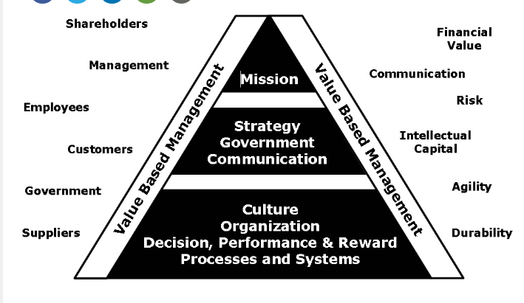
FIGURE 3: VALUE BASED MANAGEMENT THEORY (KOLLER, T, 1994)
The figure above shows value based management theory which are essential for the organization mission, strategy and defining culture (Koller, T, 1994).

2.2 PRINCIPLES OF ADMINISTRATIVE MANAGEMENT
Henry Fayol famous theory of administrative management was developed on the phenomena of management approach from top to down for examining any business (Claudia F, 2021). The theory focused on the real life situations where the management needs a proper approach to control and operates their teams effectively. This theory is concluded into six responsibilities and step wise approach to manage employees. These are as follows
- Organize
- Command
- Control
- Coordinate
- Plane
- Forecast
Based upon these six responsibilities, Henry Fayol developed 14 principles of administrative approach to counter and lead teams effectively. Similarly for a successful business it is important to apply these principles for maintaining, and initiating teamwork’s within the workplace.
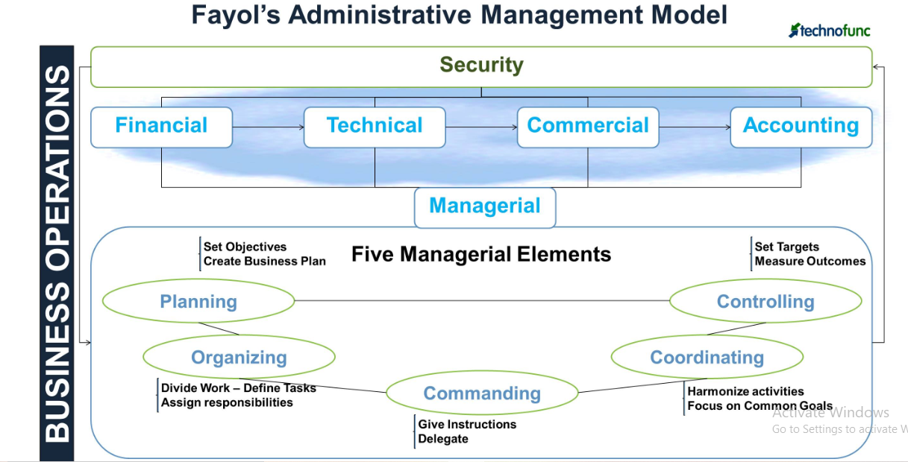
FIGURE 4: HENRY FAYOL MANAGEMENT THEORY MODEL (CLAUDIA F, 2021)
The figure above illustrate the administrative management theory model which is based on six stages of organize, command, coordinate, plane, forecast.

2.3 CLASSIC MANAGEMENT THEORY
The classical management theory is based on the phenomena of employees’ needs that are directly in relation with their rewards. According to this theory, employees always possess physical needs and their needs can only be satisfied with financial income. Classical management theories do not involve employee’s personal and social needs that influence their job satisfaction and this is the prime reason that this theory has seven key principles (Getsling, 2022). These principles are as follows
- Profit maximization
- Centralize leadership with effective outcomes
- Labor specialization
- Streamlined operations
- Emphasis on productivity
- Single person decision making
- Bottom line priority
Whenever these seven principles are applied at the business and organizations, then they create ideal workplace experiences that are completely based on hierarchical structure, financial rewards and specialization (Getsling, 2022). The theme of the theory focused the control management that took decisions and then the middle management that are part of daily operations with interaction with lowest staff and bottom line employees. As the theory revolves around the employees work against rewards and increments, this is not considered as an ideal theory in today’s modern management concepts but on practical level this is very much effective at the workplace.

2.4 MODERN MANAGEMENT THEORY
Developed as direct response to classical management theory, modern day business is influence by rapidly changing environment and new complexities that seem to grow exponentially overnight (Getsling, 2022). For these challenges technology is the only possible solution as modern management requires these supportive advance tools to handle challenges easily. This theory emphasizes mathematical techniques to understand and develop a relationship between managers and employees. Another supportive argument for this theory shows that employees not only work for money alone but they work for their own satisfaction and happiness unlike to classical theory where employee is only focused on rewards (Getsling, 2022).

3 APPLYING THEORIES TO TESLA
Tesla is one of the modern technological operators in the market providing premium quality products to its consumers and is one of the top contenders in the automobile industry. Within this competitive market the company always needs innovative and effective strategies to counter their rivals and position within the industry. This requires commitment from the top level management and employees to ensure every operation within the company operates perfectly. Due to these challenges organization spent handsome budget to engage every employee and worker at the workplace for excellent outcomes. The theories above mentioned, can be understand through Tesla Company as an example.
As mentioned above Tesla is one of the top brands in the global automobile market. The company has approximately 100 thousand employees and managing such number requires proper management techniques and processes (Carlier, M, 2022). Every employee within the company always attached through it by its core values, mission, goals and objectives (Pollack, S, 2022). These not only unit the employees but they bring effective teams to the organization. At this point, value based management theory steps in which totally focused on the employee’s core values that must be part of decision from the top management. Through this management Tesla has successfully achieved employee’s engagement by providing environment with clear goals and objectives through effective leadership. As Tesla company has the core values states as always do your best, no forecast is perfect, respect and encourage people, always be learning and respect to environment (Tesla forecast, 2022). Supportive evidence can also be illustrated by the fact that whenever organizations consider core values within their decision making employees trust can grow higher and trustful. A report suggests employees spend most number of years with the Tesla Company compared to others.
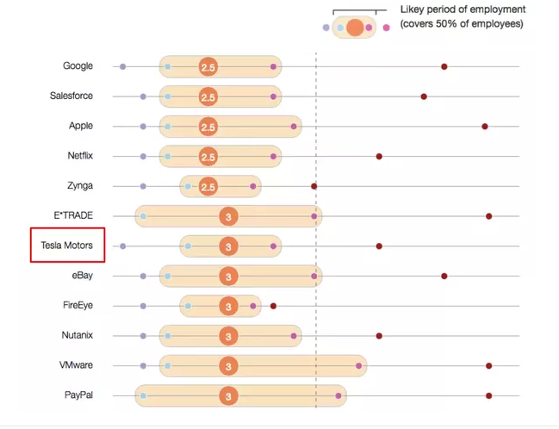
FIGURE 5: TURNOVER RATIO AT THE TESLA COMPANY (RASOULIAN, A, 2022).
The figure above shows the average number of years spent in companies by their employees. It shows the maximum 3 years for top companies in the market (Rasoulian, A, 2022).
Similarly the classic management theory which is considers one of the effective theory at the workplace despite their old version of approach. Tesla Company’s employees are satisfied as they earn high income form the company as reports suggests that on average Tesla company employees earn approximately 104 hundred thousand dollars per annum with the 9 thousand dollars increment per year (Pay scale, 2022). As the theory suggests, the organization has more than 50% of employee’s satisfaction.
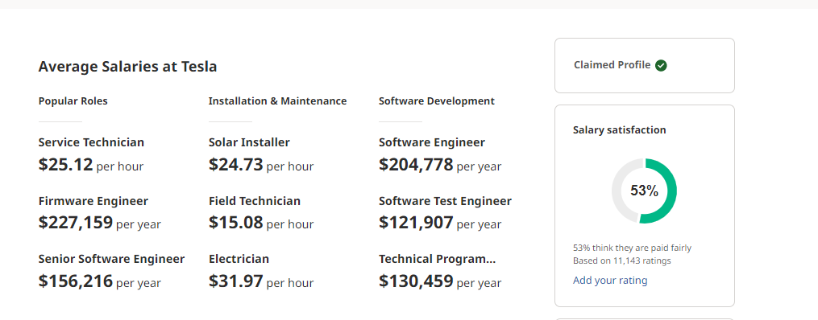
FIGURE 6: THE NUMBER OF EMPLOYEES SATISFIED AT TESLA WITH AVERAGE INCOME (PAY SCALE, 2022).
The figure above illustrate that the number of employees satisfied at the Tesla Company and their average earning salaries at the organization.
As per modern management theory, the business must possess technological advancements to make organization effective and challenges. As Tesla is known for its modern scientific research and technological advancement which results into modern solutions. Annual seminars, employee engagement meetups and induction training are the part of modern management theory which ends up on resulting a perfect hierarchal culture within the organization. Alongside that these management practices that involves a few top level management to make decision but involve every aspect of employees interest and needs to secure best results and outcomes. This also brings a proper hierarchical structure for the company (Organimi, 2022)

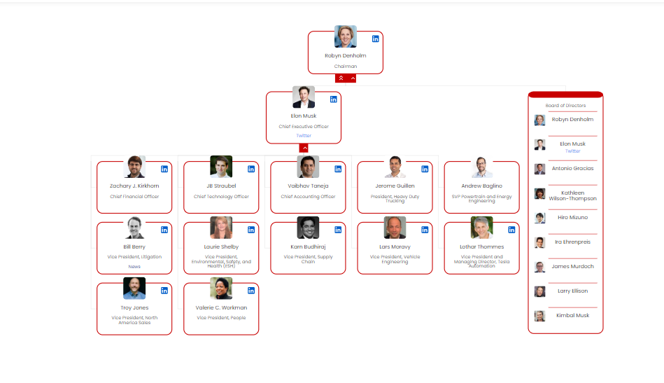
FIGURE 7: TESLA ORGANIZATIONAL STRUCTURE (ORGANIMI, 2022)
The figure above shows the Tesla organizational culture which is based on proper hierarchy with Ellon Musk at the top followed by the rest of the team (Organimi, 2022).

4 HOW SOMEONE WITH DIFFERENT BELIEFS, ATTITUDE AND VALUES MAY INTERPRET THEORY DIFFERENTLY
Different people have different mindsets and with each of them interpret things and task differently at the workplace. When these people on management level with specific role and responsibility must acquire a linear approach to the tasks and challenges. If they do not have a linear approach then it will be conflict of decisions among them. Similarly people with different attitudes, believes and values may interpret the management theories differently. According to Block, D, 2018, within the organization different managers have different approaches which are due to difference in nature, attitude, believes etc. A manager with risk taking approach will perform duties and task rather differently than a person with hesitant nature to take risk. Similarly a person with positive attitude will bring effective teams and coordination while on the other hand a person with negative attitude will bring further fear and no trust upon the team leader by their team members. If the classical management theory is taken as standard, then a person with believe that rewards will only work at workplace may succeed on shorter period but will not be beneficial on longer version of his carrier. This is the reason that organizations handle employees with proper idealistic approaches by taking different management theories at different times. The best example is when organization offer rewards for employees who perform safety procedures at the workplace generally end up on employees not reporting accidents to avail maximum rewards (Benton J, 2014).

5 RECOMMENDATIONS
Covid -19 pandemic has adverse effects and long term repercussions on the global business markets. Since its outbreak different waves forced the industries to move to precautionary steps to avoid any losses. For this purposes the following are the recommendations for the organizational mindset to tackle challenges through believes, attitude and values.
- Organization must consider the safety of their employees as their first priority. As per the report that now 3 out of 10 people now avoid touching surfaces & human contacts (Cerutti K, & Grodoski L, 2021). This will bring organization to design their workplace safe and healthy as per ILO convection 164, that it’s the employer obligation to provide safe system of work.
- The organizations will need to consult their employees and monitor their mental regularly. As the pandemic cause enough psychological stresses to employees because of its health and economic impacts to developed effective organizational culture.
- Organizations must develop their workplace with up to date and modern technologies to develop a sustainable environment. As per the reports that work from home results into 47% extra effective production compared to pre pandemic era of physical work (Apollo technical).
- The organizations must need to consider their employees needs and choices. When employee’s needs and choices are considered as priority then it results in building trust on the organization. Also engaging employees in the decision making helps them to deliver projects and task more efficiently with fragile approaches.

PART B

6 DIFFERENT BETWEEN BELIEVES, ATTITUDES AND VALUES WITHIN THE ORGANIZATION
Followings are the difference between believes, attitudes and values that lies within the organization.
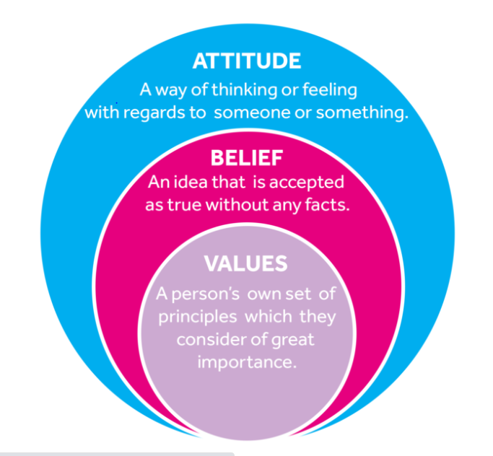
FIGURE 8: THE ATTITUDE, BELIEVES AND VALUES (KUMAR, M, 2022)
The figure above constrain the basic differences among the believes, attitudes and values (Kumar, M, 2022).

6.1 BELIEVES
Believes are the things that are believed to be true regardless of the evidence (Kumar, M, 2022). These are the perceptions about a task or thing that exists or true. An average person has hundreds of thousands of believes and this is the reason believes influence thoughts, behavior and attitude of a person. Believes are classified into two categories. These are as follows.
- CENTRAL BELIEVES - Which are harder to change as they are central to the individual existence.
- PERIPHERAL BELIEFS – These believes can be easily change because they are less important to the individual.
There are many types of believes which are classified according to the perception they orient. These include political beliefs, social beliefs, religious etc. (Kumar, M, 2022). It relates to daily life of an individual and the main difference of believe from values are that it affect the values & morale while in the second case it affect behavior and characters of the individuals (Hasa, 2016). Within the workplace believes are the perception through which an individual sense that they can perform tasks at the workplace and it also includes all the other perception about their working environment such as senior expectations, performing tasks at individual and group level.
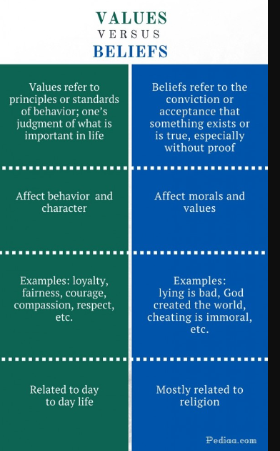
Figure 9: The difference between values and believes (Hasa, 2016)
The figure above illustrates the difference between values and believes in a daily life prospective.

6.2 VALUES AT WORKPLACE
Values in a workplace are the standards, qualities that employees hold in a high regard. These values are responsible for the style of life they live and the decision they make at the workplace. In a broader definition of values anything or quality that is considered worth because it is important for the decision making at the company (Sean Hale, 2014). Generally a value is formed as a result of belief that can be related to an idea or behaviour. At the workplace values are the defining characters as it possess each and every aspect of the organization. It includes customer and quality of product or service they provide, the level of commitment they make for their business and the organizational internal structure. As mentioned above Tesla has the core values of environmental sustainability, so their products contributes to minimize the carbon content in air through their electrical equipment’s of latest technology. Values help the organizations to accept diversified range of behaviours that bring defining leadership and employees relates to the organization better (Sean Hale, 2014). It also helps the organizational employees to identify good and bad things.
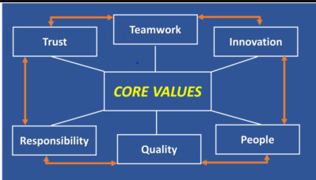
FIGURE 10: CORE VALUES FOR A WORKPLACE (SCHUNEMAN F, 2019).
The figure above shows the core values that bring teamwork, trust, responsibilities, innovation etc. to the workplace. This workplace results into the success of the organization.

6.3 ATTITUDE AT WORKPLACE
Work place attitudes refer to the feelings that relates to the different aspects of organizational environment (Belcher M, 2019). Attitude creates an intention that leads to perform and behave in a particular way along with the prediction of actual behavior under specific conditions. Attitude also relates to the individuals personality that bring positive work, fit with their environment, stress level and relationship they develop and helps the individuals to reduced conflicts. Positive workplace attitude results to perform better & improves employee’s turnover. This attitude at the workplace can be improved easily through respect for others, having infectious enthusiasm about life, bring situation that encourage individuals for commitment to the job, innovative ideas and finding new ways and last but not the least making the individual a team player that possess the ability to help others.

7 ORGANIZATIONS BELIEFS, ATTITUDE AND VALUES SYSTEM AND THEIR IMPACT ON WORKPLACE BEHAVIOUR
The organizational believes, attitudes and values possess significant impact on workplace behavior. As values are the organizational commitment towards their fundamental laws and basic guidance towards their goals and mission (Pearson, 2014). Believe are the things, individuals naturally possess about something. These believes are the core to understand and perform tasks and operations in a certain way depending upon the believe a person developed for it. If positive believes are there then the tasks and operations are performed and vice versa. Similarly the attitude is the set of believes and norms that drive individuals behaviors, emotions and prospective towards that a particular objectives or goals. Attitude is the core of individuals discipline, behavior and actions that they will take for that particular task (Pearson, 2014).
All these believes, attitude, and values are not 100 percent natural as they can be developed with experience and time during the working span. Working environment can effect these factors as negative organizational culture can influence the employees behavior with negative prospective and these negative values, believes and attitude may developed in them too (Pearson, 2014). Similarly when organization developed team work among their employees, the employees developed the skills of how to carryout operations within the team accordingly and learn the art of collaboration with other counterparts within the working space. The same is the case for an organization with negative influential culture that drive their followers and employees to develop characters with negativity. According to a report organizations with negative culture results into 20.2 billion pounds per annum (Benstead S, 2021). This organizational culture drive the workplace. One of the characters that is associated with it that these believes, values and attitudes can be shaped and developed accordingly, through proper trainings and orientation sessions periodically. When these three are successfully developed then the workplace experience idealistic approach towards tasks and targets with minimum staff turnovers, effective communication between teams and management performance at the highest best.
Furthermore according to American psychological association, individuals with stronger beliefs possess more self-confidence, and develop effective communication between senior and lower management. This is due to the behavior and emotions that makes the individuals capable of performing challenges and perform under pressure situations. Similarly these believes drive values which results into positive attitudes. However within the same workplace different employees possess different attitudes which may results into different prospective for the same task that has to be performed. Organizations change these factors in their employees by realizing them the reason for the change, engaging them in their decision making process and create homogenous environment that force every single employee to adopt these changes weather they are positive or negative. Once an employee’s inject themselves into the organization, they observe the culture surrounding and try to adopt it at every cost to survive in that arena (Pearson, 2014). Tesla has developed a culture where they operates and deals with scientific innovations, which can only be possible when the environment is challenging, the workers had believe in them and they are ready to take risks if the results does not ended up as per their desired structure. This is the reason that employees in Tesla ideally performs better because of their values, attitudes and believes which results into the lowest number of staff turnover among its competitors within the market (Pay Scale, 2022).

8 HOW THEORIES MAY INTERPRET WRONGLY WITH DIFFERENT PROSPECTIVE AND PEOPLE
Tesla is known for its premium quality products within the industry. With such a huge operations and research and development, it requires proper management to deal teams, employees and customers. As discussed above, different people possess different mind sets that results into different prospective and approaches towards a specific task. This difference in approach results into different interpretation of theories that are applied in organizations. To understand this phenomena, it is obvious to take administrative management theory as standard.
The theory focuses on the five function that revolves around the control and command must be with single administration and they are responsible for the decision making (Ward, P, 2021). Generally the five components includes planning, organizing, command, coordination and control, that can be decided and implemented by single centralize administration. This theory has advantages of central control where single individual or team with high competent skills take better decisions for the organization.
However there is still an element of risk involve with the style management, because if the theory is interpreted with negative approach or positive but with different prospective that does not suit the company culture will ended up on different result from expectation. For example a person who interpret the theory, with individual control and none of employees be involved in the decision making along with no right to question the authority of that individual. This type of approach can results into deterioration of organizational culture where employees lose trust on the organization and senior management. Similarly if the approach and understanding of theory is that a person with senior management consider his/her authority as final in decision making but consider advices from other teammates and employees then, this approach leads to success within the organization as every single employee become part of the organization through decision making process and trust build among themselves.
It is concluded from the above example that different attitudes, values & beliefs results into the different interpretation of management theories.

9 CONCLUSION
Tesla is one of the top notch companies in the automobile industry. The company is known for its innovative products that are operating on electrical energy rather than conventional petroleum energy. The organization has more than 100,000 employees and 53 dollars revenues. Value based management theory is the fundamental approach to ensure that human values are always there within the management decisions because it is the core of managing organizations. The principles of administrative management focused on the real life situations where the management needs a proper approach to control and operates their teams effectively. Classical management theory focused on classical approach of reward and work while modern management theory results into relationship between employees and management. When theories are interpreted differently, then different results can be experienced at the workplace due to the fact that every single individual possess different prospective to understand the theories depending upon their believes, attitudes and values. Believes are emotions and senses that drive a person towards a prospective about something. The perception developed for a certain task that weather it can be performed or not, its difficulty level, approach and commitment level towards it. Beliefs are classified into two categories central and peripheral where the first one are those that are harder to be change while the second can be changed easily. Values in a workplace are the standards, qualities that employees hold in a high regard. These values are responsible for the style of life they live and the decision they make at the workplace. In a broader definition of values anything or quality that is considered worth because it is important for the decision making at the company. Similarly Attitude creates an intention that leads to perform and behave in a particular way along with the prediction of actual behavior under specific conditions. Attitude also relates to the individuals personality that bring positive work, fit with their environment.

10 REFERENCES
Apollo technical, 2022. “Surprising working from home productivity statistics (2022)”. Apollo technical. [Online]. Retrieved from https://www.apollotechnical.com/working-from-home-productivity-statistics/#:~:text=Several%20studies%20over%20the%20past,and%20are%2047%25%20more%20productive. [Accessed on 22nd Dec, 2022].
Belcher M, 2019. “Five Attitudes That Are Important in Workplaces”. Small business. [Online]. Retrieved from https://smallbusiness.chron.com/five-attitudes-important-workplaces-19114.html. [Accessed on 22nd Dec, 2022].
Benstead S, 2021. “What impact does negative workplace culture have on wider society?”. Breathe her. [Online]. Retrieved from https://www.breathehr.com/en-gb/blog/topic/company-culture/what-impact-does-negative-workplace-culture-have-on-wider-society#:~:text=Other%20consequences%20of%20negative%20culture,flexibility%20and%20high%20employee%20turnover. [Accessed on 28th Dec, 2022].
Benton J, 2014. “Do Employee Safety Incentives Discourage Workers from Reporting Injuries?". Linked In. [Online]. Retrieved form https://www.linkedin.com/pulse/20140419235447-5310498--do-employee-safety-incentives-discourage-workers-from-reporting-injuries/?trk=seokp_posts_primary_cluster_res_title. [Accessed on 22nd Dec, 2022].
Beutell, N, 2018. “Values-Based Management Theory”. Proceedings of the Encyclopedia of Business and Professional Ethics. Vol 2(1). PP 1- 5.
Block, D, 2018. “Developing Critical Thinking (M5.04)”. Academia. {Online]. Retrieved from https://www.academia.edu/23511526/Developing_Critical_Thinking_M5_04. [Accessed on 22nd Dec, 2022].
Carlier, M, 2022. “Tesla - Statistics & Facts”. Statista. [Online]. Retrieved from https://www.statista.com/topics/2086/tesla/#topicHeader__wrapper. [Accessed on 20 Dec, 2022].
Cerutti K, & Grodoski L, 2021. “Five Post-COVID Behaviors And Attitudes That Will Reshape The Workplace”. Work design. [Online]. Retrieved from https://www.workdesign.com/2020/06/five-post-covid-behaviors-and-attitudes-that-will-reshape-the-workplace/. [Accessed on 22nd Dec, 2022].
Claudia F, 2021. “What Is Administrative Management Theory? - Definition & Functions”. Study. [Online]. Retrieved from https://study.com/academy/lesson/what-is-administrative-management-theory-definition-functions-quiz.html. [Accessed on 20th Dec, 2022].
Getsling, 2022. “The 11 Most Important Management Theories For Small Business”. Getsling. [Online]. Retrieved from https://getsling.com/blog/management-theories/. [Accessed on 20 Dec, 2022].
Hasa, 2016. “Difference Between Values and Beliefs”. Pediaa. [Online]. Retrieved from https://pediaa.com/difference-between-values-and-beliefs/. [Accessed on 22nd Dec, 2022].
Koller, T, 1994. “What is value-based management?”. Mckinsey. [Online]. Retrieved from https://www.mckinsey.com/capabilities/strategy-and-corporate-finance/our-insights/what-is-value-based-management. [Accessed on 20th Dec, 2022].
Kumar, M, 2022. “The Relationship between Beliefs, Values, Attitudes and Behaviours” Owl cation. [Online]. Retrieved from https://owlcation.com/social-sciences/Teaching-and-Assessing-Attitudes#:~:text=Attitudes%20arise%20out%20of%20core,on%20things%2C%20concepts%20and%20people. [Accessed on 22nd Dec, 2022].
Norton, L, 2020. “Why Tesla Could Be Worth $1.5 Trillion by 2030, According to Ron Baron”. Barrons. [Online]. Retrieved from https://www.barrons.com/articles/tesla-could-be-worth-1-5-billion-by-2030-says-ron-baron-51582894817. [Accessed on 20th Dec, 2022].
Organimi, 2022. “Tesla’s Organizational Structure”. Organimi. [Online]. Retrieved from https://www.organimi.com/organizational-structures/tesla/. [Accessed on 22nd Dec, 2022].
Pay scale, 2022. “Average Salary for Tesla Motors Employees”. Pay scale. [Online]. Retrieved from https://www.payscale.com/research/US/Employer=Tesla_Motors/Salary. [Accessed on 22nd Dec, 2022].
Pearson Canada, 2012. “Values, Attitudes, and Their 3 Effects in the Workplace”. Pearson Canada. [Online]. Retrieved from https://www.pearsoncanada.ca/media/highered-showcase/multi-product-showcase/showcase-websites-4q-2012/M03_LANG1160_05_SE_C03.pdf. [Accessed on 22nd Dec, 2022].
Pollack, S, 2022. “How and why to create your team’s core values”. Office vibe. [Online]. Retrieved from https://officevibe.com/blog/define-core-values. [Accessed on 22nd Dec, 2022].
Rasoulian, A, 2022. “Tesla Motors (company): How high is employee turnover at Tesla?”. Quora. [Online]. Retrieved from https://www.quora.com/Tesla-Motors-company-How-high-is-employee-turnover-at-Tesla. [Accessed on 22nd Dec, 2022].
Reed, E, 2020. “History of Tesla: Timeline and Facts”. The street. [Online]. Retrieved from https://www.thestreet.com/technology/history-of-tesla-15088992. [Accessed on 20th Dec, 2022].
Schuneman F, 2019. “The Importance of Workplace Culture”. Invist a performs. [Online]. Retrieved from https://www.invistaperforms.org/the-importance-of-workplace-culture/. [Accessed on 22nd Dec, 2022].
Sean Hale, 2014. “The difference between beliefs, attitudes and values”. Sean Hale. [Online]. Retrieved from https://seanhale.wordpress.com/2014/02/16/the-difference-between-beliefs-attitudes-and-values/. [Accessed on 22nd Dec, 2022].
Tesla forecast, 2022. “About TESLA”. Tesla forecast. [Online]. Retrieved from https://www.teslaforecast.com/about-tesla/. [Accessed on 22nd Dec, 2022].
Tesla, 2022. “About Us”. Tesla. [Online]. Retrieved from https://www.tesla.com/about. [Accessed on 20th Dec, 2022].
US energy department, 2022. “TESLA”. Energy.gov. [Online]. Retrieved from https://www.energy.gov/lpo/tesla#:~:text=Tesla%20has%20manufactured%20vehicles%20at,of%20carbon%20dioxide%20emissions%20annually. [Accessed on 20th Dec, 2022].
Ward, P, 2021. “Management Theory of Henri Fayol: Summary, Examples”. Nano Globals. [Online]. Retrieved from https://nanoglobals.com/glossary/henri-fayol-management-theory/. [Accessed on 30th Dec, 2022].

