

Component 1 - Individual Report
Module code and name: LCBB4006_BIRM: Academic Skills

Student Name: Andreea Alina Tudorache
Student Number: 2130698
Lecturer Name: Dr Yousuf Kamal, Valentina Bartali

Table of Contents
1. Introduction 3
2. Academic Writing and Referencing 4
2.1. Understanding Academic Writing Skills 4
2.2. Understanding Referencing 5
3. Conclusion 7
4. Reference List 8
5. Appendix 9

1. Introduction
The foundations of effective communication within the academic community and necessary for producing credible and morally sound academic work are academic writing and reference abilities. They require accuracy in thought expression and source citation to allow the sharing of ideas and research findings. The lack of these abilities creates problems in education such as plagiarism and ethical violations. This article emphasises the significance of academic writing and referencing abilities and their applicability to scholarly pursuits. It discusses the difficulties kids have learning these skills and provides techniques and abilities to help them. The article offers a thorough grasp of academic writing and referencing, highlighting its importance, difficulties, and suggested approaches to success.

2. Academic Writing and Referencing

2.1. Understanding Academic Writing Skills
The ability to communicate successfully in an academic setting is made possible by having academic writing abilities. These abilities go beyond merely organising words on a page and include conducting rigorous analysis, adhering to scholarly discourse rules, and developing clear, well-structured arguments.
Meaning of Academic Writing Skills
Academic writing is formal and organised by its very nature. It entails the organisation, clarity, and succinct expression of ideas to correctly transmit the intended meaning to the reader. Academic writing includes abilities including critical thinking, analysis, synthesis, and the capacity to interact with previous work, according to the UWTSD Referencing Guide. It adheres to certain reference standards, such as the UWTSD Harvard Referencing Style, and emphasizes the necessity of citing sources to maintain academic integrity (Schillings et al., 2023).
Process of Developing Academic Writing
Writing well in academic settings evolves with time. Building a solid foundation in language, grammar, and style is the first step. Students proceed to more sophisticated abilities like critical thinking and analysis once this foundation has been created. The procedure entails carrying out extensive study, developing precise research questions, and organising convincing arguments. To improve one's writing, it is crucial to participate in peer review and request comments. The development of these abilities requires constant repetition and review (Numan Khazaal, 2019).
Importance of Academic Writing Skills
The importance of academic writing abilities cannot be overstated. They enable clear and organised presentations of research and conclusions by researchers because they first support the effective transmission of ideas. This helps both the writer and the reader, who can more easily understand complicated ideas.
Second, academic writing abilities allow one to add to the corpus of information already in existence. Students can develop their fields of study and participate in intellectual dialogue via their work. They join the scholarly debate by following accepted practices and correctly citing their sources (Wischgoll, 2016).
Examples of the Importance of Academic Writing Skills
Consider a situation where a student is performing a literature study on climate change to illustrate the significance of academic writing abilities. Students with strong academic writing abilities may not only summarise previous research but also analyse it critically to find gaps in the literature. By properly citing sources, the student recognises the work of others and defends themselves against charges of plagiarism. This thorough information synthesis increases the understanding of the topic among academics and advances the conversation on climate change.

2.2. Understanding Referencing
A key component of academic writing is referencing, which makes sure that the ideas, theories, facts, and conclusions utilised in scholarly work are properly cited. It accomplishes a variety of tasks, including confirming the veracity of claims, preventing plagiarism, and promoting intellectual honesty among academics.
Meaning of Referencing
Referencing involves acknowledging the sources of information used in academic writing, which can range from scholarly articles and books to online resources. It encompasses two primary elements: in-text citations, where sources are acknowledged within the text, and a reference list, which provides comprehensive details of each source cited. The UWTSD Referencing Guide emphasizes that referencing styles, such as the UWTSD Harvard Referencing Style, offer specific guidelines for citing various types of sources (Marshall et al., 2021).
How Referencing is Done
Referencing is a complex procedure that includes numerous important components. In-text citations, which normally include the author's name and the year of publication, are used to show where material has been taken from inside the text. To guarantee consistency and correctness, proper citation practises must be followed, such as those stated in the UWTSD Harvard Referencing Style. Additionally, reference is a vital tool in the fight against plagiarism, which is the uncredited use of someone else's work. The significant academic and moral repercussions of plagiarism must be made clear to students (Igwenagu, 2016).

Importance of Referencing to Students in Higher Education
Referencing has an essential part to play in higher education for students. First off, it demonstrates respect for other people's intellectual property, upholding the ideals of academic honesty. The misuse of ideas is avoided when students correctly cite their sources, recognising the authors' intellectual contributions.
Second, reference gives scholarly discourse a structure. Students participate in an ongoing intellectual discussion when they read current material and cite references. This not only improves their research but also advances knowledge in their area of study (Neville, 2016).
Examples of the Importance of Referencing
Consider a student who is conducting a research paper on how social media affects mental health. They might attribute the theories and results of well-known psychologists by citation to bolster their claims. This not only increases the validity of their argument but also shows how their assertions are supported. In contrast, neglecting to cite sources would obfuscate the sources of their knowledge and may result in plagiarism charges.
Furthermore, accurate reference is necessary in a collaborative effort to identify each contributor's contributions, guarantee fair credit distribution, and maintain the project's integrity. This is especially important when working on group projects or conducting research together.

3. Conclusion
The essential significance of academic writing and referencing abilities in the field of higher education has been highlighted in this article. The ability to communicate, systematically, and effectively requires academic writing abilities and correct referencing guarantees that intellectual contributions are appropriately acknowledged and protect academic integrity. However, the ongoing problem of incorrect referencing and subpar academic writing techniques poses a serious concern, leading to problems like plagiarism and ethical violations. It has examined the definition and growth of academic writing abilities throughout this article, emphasising its importance for successful information transfer and communication. We have also looked at the nuances of reference, highlighting its importance in discouraging plagiarism and promoting academic integrity. It has been shown that these abilities apply to students in higher education and that they have an influence on both academic development and the scholarly community. Students are urged to acquire crucial skills in research, note-taking, and appropriate citation as they handle these problems. They need to be proficient in reference guidelines such as the UWTSD Harvard reference Style. By doing this, students may make sure that their academic work is both academically and morally sound, strengthening the thriving and reliable academic community.

4. Reference List
Igwenagu, C., (2016). Fundamentals of research methodology and data collection. LAP Lambert Academic Publishing.
Marshall, H., Reilly, A.M., McCormick, K., Smith, J., Brennan, A. and Gardiner, L., GCU, (2021). Library Harvard Referencing Guide.
Neville, C., (2016). EBOOK: The Complete Guide to Referencing and Avoiding Plagiarism. McGraw-Hill Education (UK).
Numan Khazaal, E., (2019). Improving postgraduates’ academic writing skills with summarizing strategy. Arab World English Journal (AWEJ) Volume, 10.
Schillings, M., Roebertsen, H., Savelberg, H. and Dolmans, D., (2023). A review of educational dialogue strategies to improve academic writing skills. Active Learning in Higher Education, 24(2), pp.95-108.
Wischgoll, A., (2016). Combined training of one cognitive and one metacognitive strategy improves academic writing skills. Frontiers in Psychology, 7, p.187.

5. Appendix
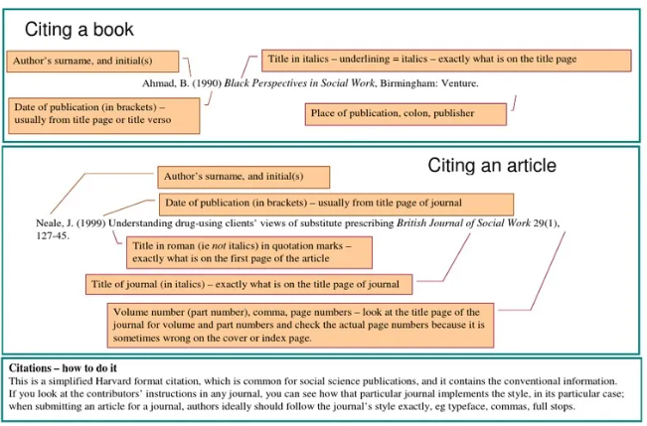
Figure 1: Citing books and articles
Source: (www.scribd.com, 2017)
In-text citations must be used in the body of the text in Harvard style, usually between brackets. The last name of the author and the year of publication should be included in these citations. Only the publishing year has to be put in brackets if the author's name is stated in the sentence. The page number should be included when directly quoting from a source. A thorough reference list with a list of all the sources used in the text should also be included at the conclusion of the document. The author's name, the publication year in brackets, the work's title in italics or quotation marks, the source's type, and any pertinent publishing information should be included with each entry in the reference list. To achieve correct and consistent citations in the Harvard style, care should be taken to adhere to the specific structure for different source categories (such as books, journal articles, and websites).

