Component 2: Online portfolio of set exercises
Student name: Albert Buxton
Student number: 2427263
Lecturer’s name: Caroline Salami

Module Number: BMHP5014

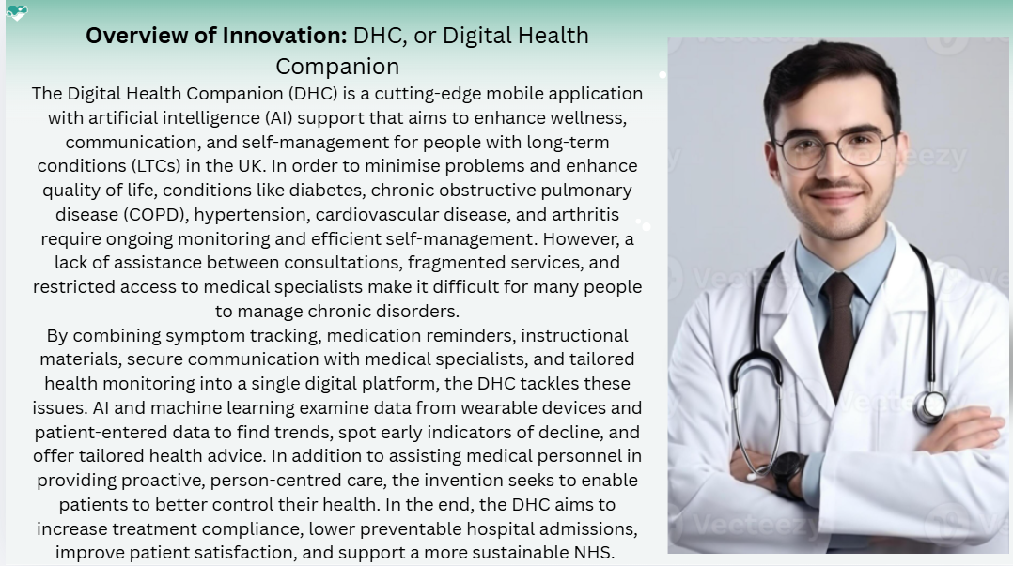

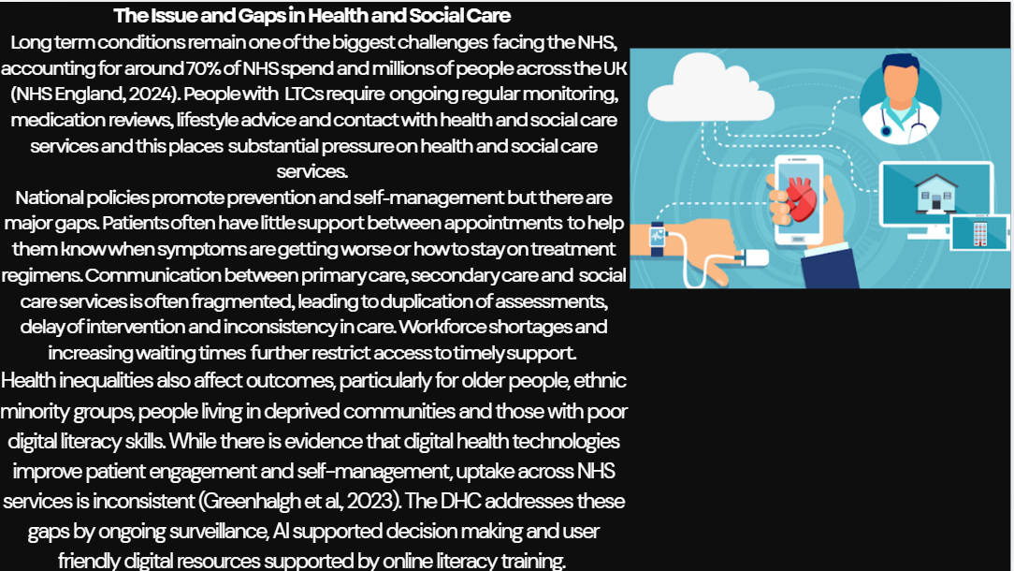

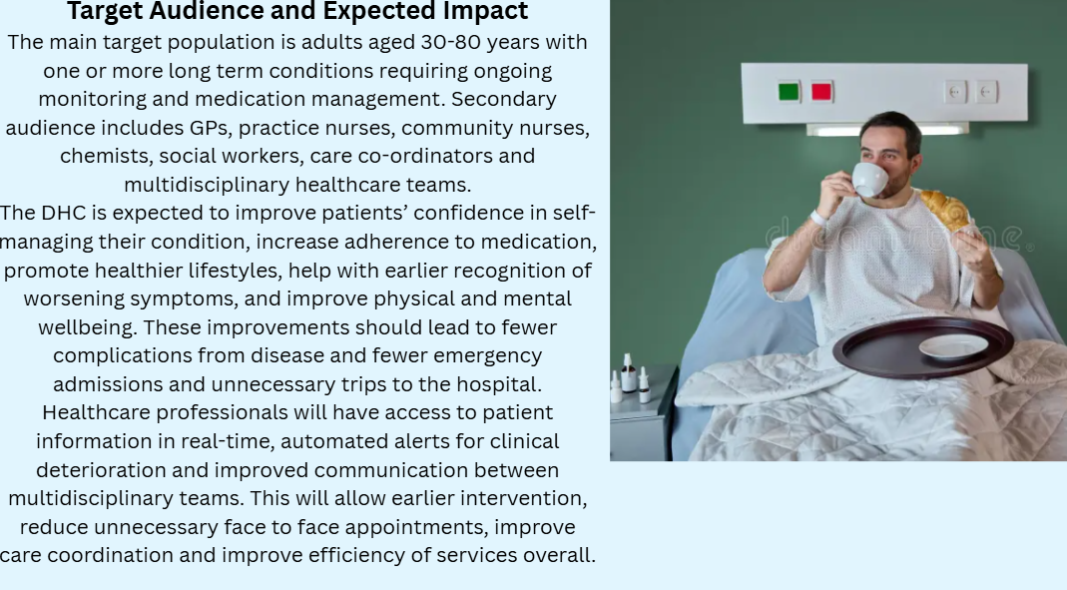

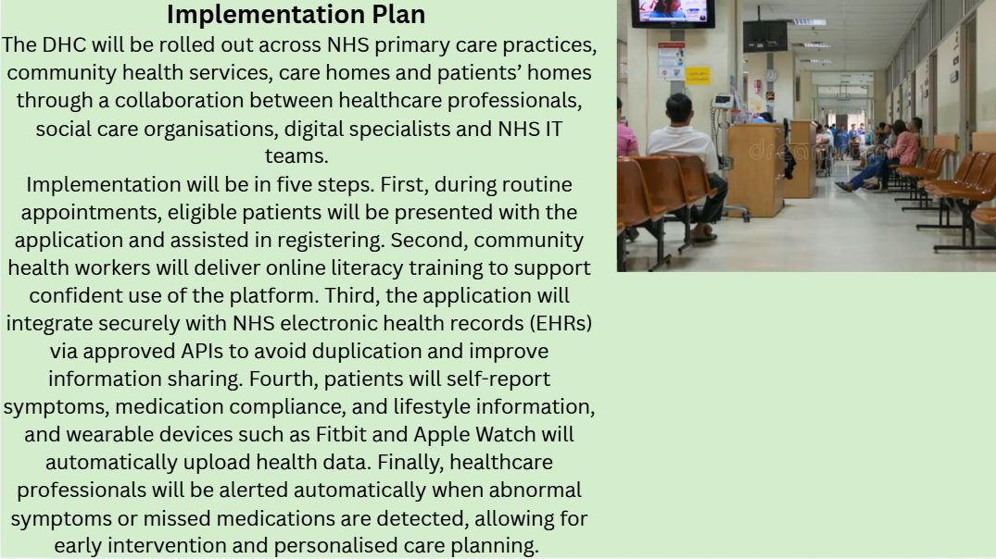

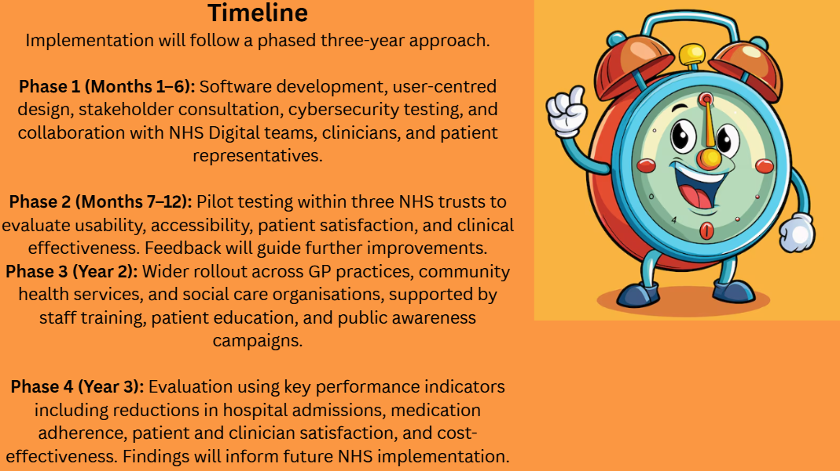



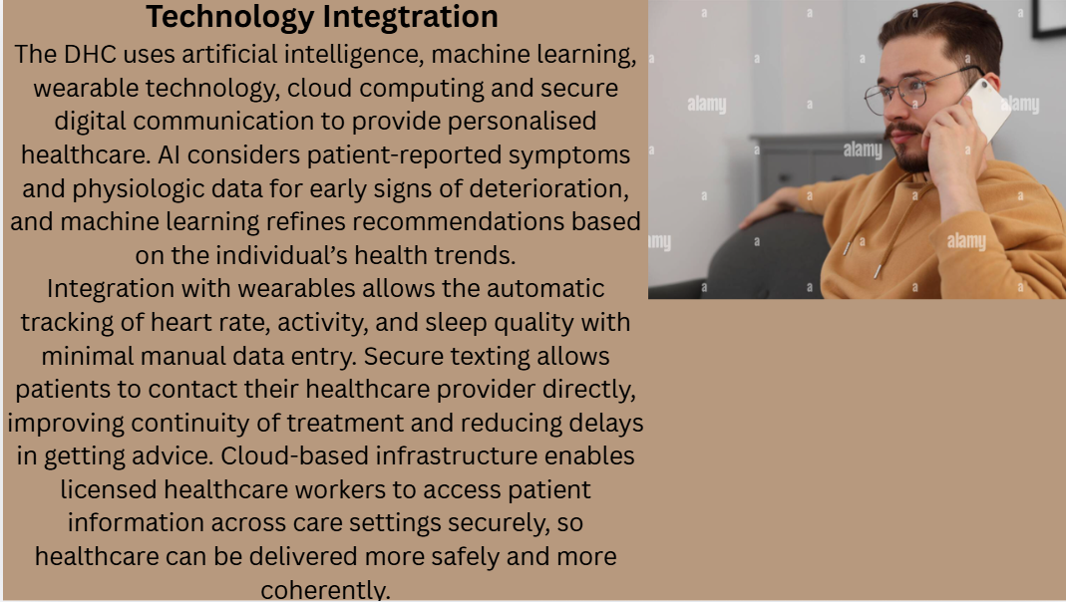



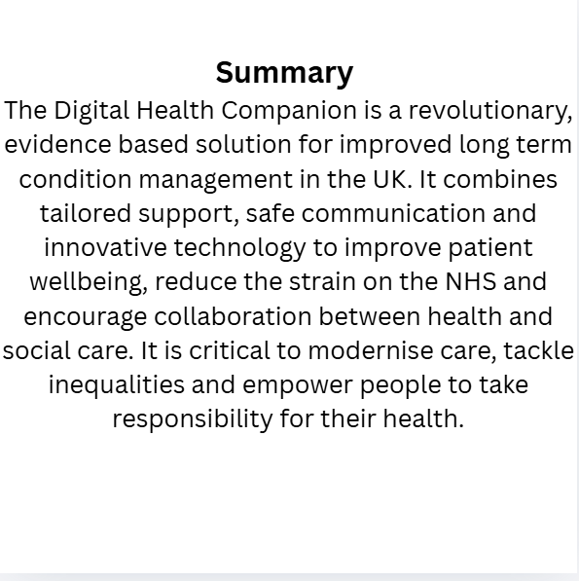

Pitch: Digital Health Companion (DHC)

Digital Health Companion (DHC) is an AI-powered mobile app designed to improve long term condition (LTC) management in the UK. Long-term conditions such as diabetes, chronic obstructive pulmonary disease (COPD), hypertension, cardiovascular disease and arthritis affect millions of people and are a major cause of NHS appointments, hospital admissions and healthcare costs.
As demand for health and social care continues to grow, there is a desperate need for innovative, person-centred solutions that help people to manage their own health, while helping medical professionals to deliver more efficient treatment. To address these issues the Digital Health Companion was developed. It provides personalised health monitoring, medication assistance, symptom monitoring, educational resources, and increased interaction between patients and providers. The innovation is in keeping with the NHS Long Term Plan, which is focused on integrated health and social care, preventative, personalised care and digitally connected services.
One of the hardest things for people with chronic illness is knowing when a person’s health is getting worse. Symptoms worsen before people seek medical attention, leading to many preventable hospitalisations. Others struggle to remember important information when they go to the doctor, or make lifestyle changes, or take their medication as prescribed. Digital self-management strategies have been associated with benefits including improved health outcomes, patient confidence and drug adherence and reduction in emergency hospital admissions (Murray et al, 2022).
However, many of today’s digital health apps offer general advice, not tailored to the needs of the individual customer. The Digital Health Companion overcomes these limitations by taking advantage of artificial intelligence and machine learning to deliver personalised care based on the individual’s health status and long-term symptoms. That's not something an app usually says. It takes your health information and looks for patterns that might indicate a decline. For example, if a Chronic Obstructive Pulmonary Disease patient is detected to be experiencing breathing symptoms, an alert may be sent to prompt them to call their healthcare provider before their condition deteriorates. Also, a patient with diabetes can get individualised teaching materials, medication reminders, food guidelines and blood glucose monitoring reminders. This personalised approach enables patients to play an active part in managing their own health. More confidence in themselves and more knowledge about health will help people lead more independent and healthy lives and avoid more negative outcomes.
Another important benefit of the Digital Health Companion is that it improves communication between patients, medical professionals and social care providers. During the time between appointments, patients often forget symptoms, prescription changes, or lifestyle issues, making it hard for health care providers to get a complete picture of their health. The program safely stores health measurements, medication adherence and symptom diaries to share with medical specialists during consultations. With accurate and up-to-date information, clinicians can make better informed decisions, tailor treatment strategies, and identify deterioration much earlier. Social workers can also monitor statistics about everyday functioning, mobility, nutrition and emotional health, meaning they can offer more timely assistance. This supports interdisciplinary cooperation and makes it possible to offer integrated, person-centred care across social and health care sectors.
The Digital Health Companion also supports one of the key aims of the NHS to shift healthcare from treatment to prevention. Prevention leads to better patient outcomes and reduces the burden on NHS resources. The app aids in better behaviours and early intervention by ongoing tracking, medication reminders, customised goals and health education to prevent medical emergencies. Timely intervention can cut hospital admissions, improve quality of life and save on medical costs. “The NHS is still struggling with staff shortages and rising demand, so the DHC and other digital technologies provide a sustainable route to treating more patients without sacrificing quality of care.
The legislation and policy are the key to the successful implementation of this innovation. The Digital Health Companion supports the NHS Long Term Plan to deliver personalised, preventative and technology enabled care. It also conforms to the UK General Data Protection Regulation (UK GDPR) which ensures the secure and transparent collection, storage and processing of patient data. The application has also been designed in accordance with NHS England’s Digital Technology Assessment Criteria (DTAC) which detail requirements for clinical safety, cybersecurity, accessibility, usability and interoperability. These national standards support safe delivery in the NHS and social care settings and build confidence in healthcare professionals. The innovation is also intended to help reduce health disparities. Digital technology offers a plethora of opportunities, but many people are still excluded from it because of their age, handicap, language barriers, lack of digital skills or financial situation.
Digital healthcare, if not carefully planned, can worsen existing disparities. To address this problem, the Digital Health Companion has a range of accessibility features including voice navigation, screen reader compatibility, multilingual language options, font size adjustments and simple, intuitive interfaces. Workshops in community online literacy offered by general practitioners’ offices, libraries, community centres and not-for-profit organisations can help people become more comfortable with technology. Training healthcare providers and caretakers is essential so that the right support is provided to patients. These policies are inclusive and help to make sure that everyone has the chance to benefit from digital healthcare, regardless of where they’re from or their abilities. Public involvement is also key to successful implementation. People are more likely to embrace digital health technologies if they are aware of the benefits and have confidence that their personal data is secure. The Digital Health Companion will therefore be promoted through NHS organisations, social media campaigns, patient charities, community health events and local healthcare providers. Real world benefits will be demonstrated by testimonials from patients, carers, nurses, doctors and social workers.
Online resources and instructional videos will help users learn how to use the programme effectively. Involving patients in all stages of development and evaluation promotes co-production and will ensure the program will meet the changing needs of users. The implementation plan will be evidence-based and phased. Clinical efficacy, user satisfaction and technical performance will be evaluated in pilot programmes within individual NHS Trusts and Integrated Care Systems before wider national deployment. Results will be measured through continuous assessment of less emergency admissions, better self-management, higher quality of life, higher patient satisfaction and cost-effectiveness. Input from patients, medical professionals, researchers and policy makers will be important to secure the sustainability of the innovation.

Conclusion
To summarise, the Digital Health Companion offers a creative and workable solution to one of the biggest challenges for healthcare in the UK. It combines artificial intelligence, bespoke self-management, preventative healthcare and integrated communication to empower patients and enable healthcare providers to deliver better, person-centred care. It is a pragmatic and sustainable innovation that is committed to NHS policy, data security and accessibility, and reducing health inequalities for the future of health and social care in the UK. At the end of the day, the Digital Health Companion can improve integrated care, reduce unnecessary hospital admissions, improve health outcomes and make people healthier and more resilient.

REFERENCES
Bianchi, C., et al. (2023) AI-supported health monitoring: implications for patient safety.
Cybersecurity in digital health applications. International Journal of Medical Informatics, 180(1), pp. 1–10.
Digital transformation in UK social care. Social Care Review, 41(3), pp. 210–225. Foster, J. and Ahmed, K. (2022).
Greenhalgh, T., Wherton, J., Papoutsi, C. and Shaw, S. (2023) Digital health adoption in primary care: challenges and opportunities. BMJ, 380(1), pp. 45–52. Murray, E., Hargreaves, J., and Bate, P. (2022) Digital interventions for long-term condition management. Journal of Medical Internet Research, 24(6), pp. 1–12.
Health literacy and digital self-management tools. Health Education Journal, 81(7), pp. 890–905. Thomas, G. and Patel, S. (2023).
Integrated care pathways for long-term conditions. Journal of Integrated Care, 32(1), pp. 15–27. O’Connor, M. and Lewis, H. (2023).
NHS England (2024) Long Term Conditions: Policy and Strategy. Available at: https://www.england.nhs.uk (Accessed: 20 July 2026).
Reducing health inequalities through digital innovation. Public Health, 218(2), pp. 120–128. Williams, D. and Clarke, A. (2024).
The Lancet Digital Health, 5(4), pp. 300–312. Smith, L. and Jones, R. (2022)
Wearable technology and chronic disease management. Journal of Telemedicine and Telecare, 28(5), pp. 350–360. Reed, S. and Martin, P. (2024).

