  THE GLOBAL BUSINESS ENVIRONMENT  BA Business Management; Module Code: LCBB4005 | Module Leader: Alfred Mensah and Nadeem Mirza Student ID: 2123042 – Natalia Dimitrova

Table of Contents
Introduction 2
Evaluation and literature review 2
1. Porter’s diamond model 5
2. Porter’s five forces 6
References 7

Introduction
The Global Business environment is tightly connected with the automobile industry, as mainly the companies focused on automobile production are rarely operating on a national basis. Often factories are looking to expand their production and try to reach as many destinations as possible, however, there are many factors influencing the global operating businesses. In addition, to expand and reach higher targets, corporations are looking to research and develop following the standards of demand, lifestyle, and economic state of the countries they are looking to reach. Nowadays, in addition to blending with the Global market, companies must know well the interrelations communication style and research the targeted market, as there are many fractures that might vary, for example, affordability of the population to buy the offered the product/ service. The company under consideration is Tesla – one of the quickest developing and innovative companies on the market today. Tesla entered the market in 2003 and since then has been a leader in the automobile production market for electric vehicles, bringing a complete change in the auto world. The demand from customers started slowly at first, and however reached peaks, especially in the past couple of years. In 2017-2018 Tesla had production issues that obstructed the production of the cars, and this led to slightly negative feedback from customers, as the waiting time to get their desired vehicle was longer than usual. The cash flow of the company at this time was negative, therefore the corporation faced losses. Looking the SWOT and PESTLE analysis of Tesla are showing the success of the company; however, it does expose the potential future struggles it might face. The presented evaluation of the internal and external factors and the presence of the company in the Global Business Environment show a pattern of successful work and quality examples of the potential success of companies in general. As one of the major influencers on the automobile market, Tesla’s experience with export and international relations allows business researchers to understand better the interrelations and way of work of the international businesses.

Evaluation and literature review
Any business entering the market is influenced by internal and external environments. The internal environment is representing the components that are working together, in addition, to making the company work, taking the input (materials, labor, initial investments) and turning it into a ready-to-sell product/ service for the market. Depending on the internal environment of any business is its success (Brinkman, Navarro, and Harper, 2014). The input in a business, like finances, personnel, and equipment is building the internal environment, and its success depends on the proper management and responsibilities establishment. Tesla is a well-known multi-billion-dollar company that has been a leader in the electric car market since it was established in 2003. It is mainly relying on technological workforces rather than human force, which allowed the company to avoid many human relations obstructions they could have faced during the time of launching the company and from then on (Schreiber, 2019). Becoming one of the leading companies in the automobile market requires major flexibility in regard to public relations, communication with the external environment, quality research, and on-time developments of the vehicles they produce. Their success on a market basis has proven that the structure the company is following is intact with the demand and production, as well as the requirements an internal environment might have. However, as important as the internal environment is, the external one has the same major impact on any company’s success. The external environment represents all factors influencing a business as well as the market it takes part in, that the business itself doesn’t have an influence on (Otter and Whetherly, 2011). The external environment is built by the economic, technological, political, legal social, and cultural states of a country where the business is selling its product/ service. Depending on the external environment are the supply to a business’s needs, labor, laws influencing the trading, and the economical state of the country (percentage of poverty, minimum wage, personal and professional development rates {which allows a business to decide whether their product is suitable for the targeted market, more said if there are going to be any consumers at all}).
Tesla is a company that produces cars of high quality, therefore, the prices they are offering to the market are not affordable just by anyone. At the same time, the products that are produced are in extremely high demand from the entire world. The Tesla market was originally based in the United States, where the cars are produced and sold mainly to people in America, however, once they have gained popularity in the automobile market by offering innovation and a greener lifestyle, the demand increased, and Tesla had to expand their sales on a global level. Trading across the globe has its positive and negative influences on businesses. There are certain main perks in addition to globalizing a business. Why, where, and how to expand the business? Any business manager should evaluate those questions and comparing to the business’ goals to research the market for potential expansion, recognizing the major forces shaping the Global Business Environment. One of the targets that most international-based companies chase is the increase in sales, though often global expansion applies to transportation and communication costs increase (Guy, 2009). The set target of sale increase itself demands an expansion of the business on an international base. Therefore, the decision of which country is the best choice to expand to and “why?” is the best choice comes to the manager’s mind. Choosing a country is not an easy task if it’s not supported by the proper measurement of the distance between countries, not only geographically, but as well culturally, administrative, and economically. If the targeted country is too different in processing trading businesses, it might affect the business negatively. In cases like this, the best decision is to evaluate whether the changes a company has to make are worth the expansion and how the potential move to a different country will contribute to the company’s goals – positively or negatively. Often the targeted countries are the ones with the largest number of potential customers (financially fit citizens). Tesla expanded its market to the UK, following the demand of people, not only because of the financial fitness of the country but as well because of the positive impact on the environment they are providing. Electric cars are highly valued in the UK as the country is focused on reducing CO2 levels and prioritizes the “keep the environment clean” products. The vehicles have to be modified following the United Kingdom’s Road standards (the right direction), and still, this is not quite the large impact on the company’s working process and timeframe of development. People, all over the UK at the moment are looking for electric vehicles, mainly because of the gas’s increased prices, but as well because of the expansion of the low emission zone, which is adding more expenses to people using fuel vehicles.
Tesla is an important company for the Global Business environment because it provided the market with new technology, which is useful for the consumers, creating greener energy, keeping the planet healthier, and at the same time bringing investment capital from other countries. Prices of the Tesla products are slightly affected by the currency exchange and inflation rates around the World; however, it represents a good investment for the customers, because of the long-lasting battery, quick charging, and times cheaper than the fuel-loaded vehicles. Depending on the miles driven per day, often one full charge could last between 7 and 10 days and charging in full is approximately 10 GBP. In most capital cities in the world, there are additional charges for regular vehicles, which do not apply to the electric ones (Malmgren, 2016), which makes the Tesla products even more desirable.
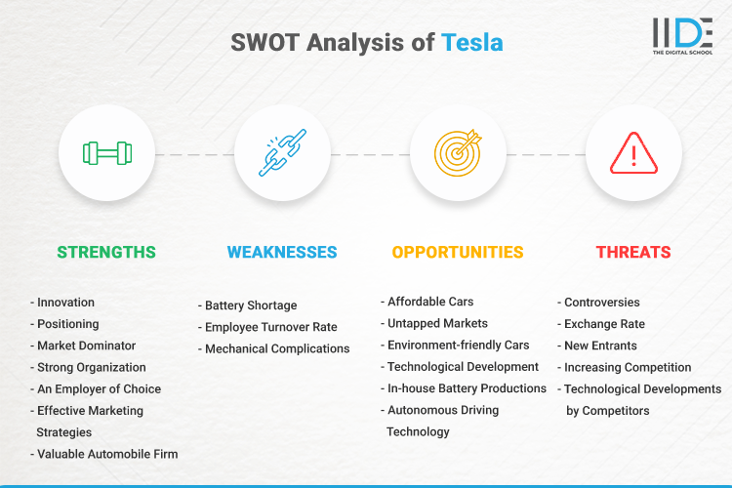
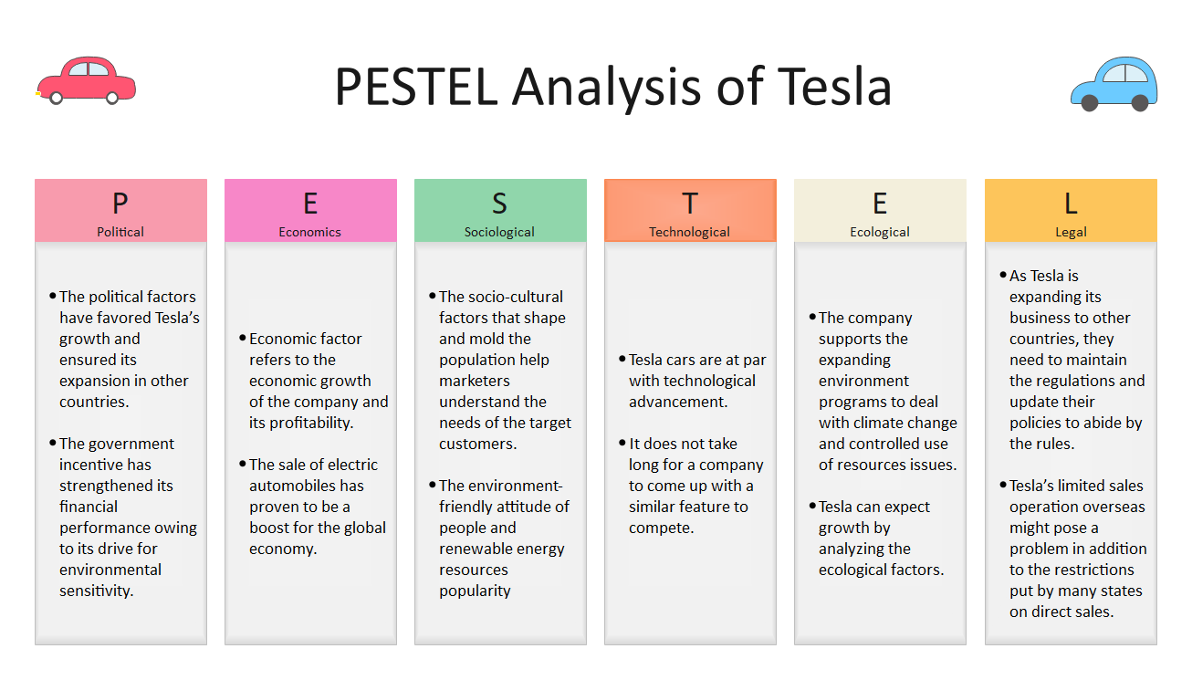
Compatible with every business are the Porter’s theories addressing whether certain industry is competitive internationally or not. The theories are showing the research developed by M. Porter explaining the reasons why some nations can be more consistently innovative than others, building a strategic economic model.

Porter’s diamond model
This strategic economic model is based on 4 main factors and 2 additional factors that have an impact on businesses. The unchanging factors are:
- Factor conditions that may vary between basic and advanced ones. The basic factors are natural resources that the businesses use like oil, metal, natural gas, stone, sand, etc., more said, the materials necessary to produce any type of product in the world. The advanced factors are human resources and research capabilities. Both forces rely on human power and the rehash of the products entirely depends on it.
- Demand conditions are focused on predicting the demands of consumers, making focused research on variables that might influence the market and the desires of the customers. The demand conditions are often explored by using media, following political influence, etc. (In the case of Tesla, the demand conditions were explored by regulations and demand for greener energy, different movements, and political changes supporting the protection of the planet).
- Related and supporting industries are the suppliers, component manufacturers, and distributors of a business. The majority of businesses rely on subcontractors, to support their working process and product development. Many businesses don’t have the sources to manufacture, supply, and distribute their products by themselves, which leads them to take part in partnerships, in addition, to expanding the business to a global level.
- The fourth influential factor of Porter’s diamond model is the company strategy, structure, and rivalry. The strategy of companies is based on market changes and prediction of potential decision making, in addition, to building a path towards achieving the company’s goal. The structure of a company is mainly focused on the internal process development of the company, maintaining the working process, and keeping the balance between the working departments in the company’s hierarchy. The rivalry of a company often depends on the ratio of quality: price: availability and accessibility on the market.
- The first additional factor is the government of the country in which the business is operating at. The government can influence the demand market by stimulating early demand for certain types of products (like applying additional taxes for non-electric automobiles), including in the education system studies related to the certain business sector, motivating young people to be more interested and look forward to further development within the industry, creating range of qualified personnel, etc.
- The second additional factor that might influence a business is the uncontrollable natural disasters and international wars which might affect the production of the product, or the customers demanding it.

Porter’s five forces
The five forces method is used to determine and evaluate the root causes of profitability of an industry a company is operating at. The five forces are expressing five potential threats that measure the competitive forces of a company and assist the predictions of whether the company has profit potential or not. The threats are measured on a three-level basis – high; medium and low, where potentially if all threats are detected as low could be a sign that the company is well-positioned for long-term profitability in the market. The five forces model was developed in addition to making the process of measuring the intensity of competition on the market for a certain product, based on the following research: Threats of new entrants on the market (instantly evaluated as a higher percentage f competition and lower chances of market dominance if marked as high), industry rivalry, threats of substitutes (alternative, cheaper products), bargaining power of suppliers and buyers.
When planning a business activity or before the actual development of a product, the market must be researched. Porter’s models of evaluation and strategic economical planning allow the business developers, to correctly understand the levels of rivalry they are about to face when stepping forward with the development process and decide whether the product is good enough to beat the rivals and dominate the market. The fact that Tesla invented a product that was not been ever presented on the market, gave the company the advantage of low rivalry and high dominance on the demand of people for electric vehicles.

References
Brinkman, J., Navarro, I. and Harper, D., 2014. Unlocking the Business Environment. 1st ed. Taylor and Francis.
Corpbiz. 2022. International Business Environment (IBE) - Corpbiz Advisors. [online] Available at: <https://corpbiz.io/learning/international-business-environment-ibe/amp/> [Accessed 3 May 2022].
Edrawsoft. 2022. Detailed PESTEL Analysis of Tesla | EdrawMax Online. [online] Available at: <https://www.edrawmax.com/article/tesla-pestel-analysis.html> [Accessed 4 May 2022].
Grundy, T., 2006. Understanding Michael Porter The Essential Guide to Competition and Strategy. John Wiley & Sons, Ltd.
Guy, F., 2009. The Global Environment of Business. Oxford University Press, pp.8-34.
Investopedia. 2022. Trade Liberalization Explained. [online] Available at: <https://www.investopedia.com/terms/t/trade-liberalization.asp> [Accessed 2 May 2022].
Magretta, J., 2012. Understanding Michael Porter. Boston, Mass.: Harvard Business Review Press, pp.85-93.
Malmgren, I., 2016. Quantifying the Societal Benefits of Electric Vehicles. 1st ed. [ebook] Available at: <https://www.mdpi.com/2032-6653/8/4/996/pdf> [Accessed 1 May 2022].
Otter, D. and Whetherly, P., 2011. The Business Environment : Themes and Issues. 2nd ed. Oxford University Press, pp.3; 204-228; 32-62.
Pettus, M. and Helms, M., 2008. Government Inclusion in Porter’s Diamond: The Case of Argentina. [online] Hbs.edu. Available at: <https://www.hbs.edu/ris/Publication%20Files/20170524%20Strategy%20Keynote_%20v4_full_final_2814963a-c8ca-457d-8ee6-69e8b57921ea.pdf> [Accessed 2 May 2022].
Sathre, R. and Gustavsson, L., 2021. A lifecycle comparison of natural resource use and climate impact of biofuel and electric cars. Energy, 237, p.121546.
Satryo, C., 2022. Free Trade Intervention: Political-Economic Intervention on Global Business Environment. [online] Available at: <https://apmba.ub.ac.id/index.php/apmba/article/view/295> [Accessed 2 May 2022].
Schreiber, B., 2019. Tesla, Inc. | History, Cars, Elon Musk, & Facts. [online] Encyclopedia Britannica. Available at: <https://www.britannica.com/topic/Tesla-Motors> [Accessed 3 May 2022].
Srinivasan, S., 2012. Understanding Michael Porter: The Essential Guide to Competition and Strategy. Journal of Education and Vocational Research, 3(3), pp.80-81.

