
Skills for the Workplace
Module Assignment Submission
Student Name: | Emma Jayne Evans
Student Number: | 1910917
Module No: | BMSK4007
Module Title: | Digital Skills and Personal Branding

Statement of Confirmation of Authenticity
By the act of making this submission, the student declares that this is the work of the student named above. The work has not, in whole or in part, been knowingly presented elsewhere for assessment, or where assessment has been built on a previous assessment, this has been identified. Where materials have been used from other sources it has been properly acknowledged. If this statement is untrue, the student acknowledges that an assessment offence has been committed.
Attention is drawn to the plagiarism and unfair practice policies of both the University and of ILM.
Permission for ILM to use this script
ILM uses learners’ submissions – on an anonymous basis – for assessment standardisation. By submitting, both the centre and the learner agree that ILM may use this script on condition that identifying information is removed. However, if you are unwilling to allow ILM use this script, please refuse by ticking the box: □

Table of contents

- Technology
  - Overall look at Technology in the workplace
  - Technology used in Retail
  - GDPR
  - Conclusion - Gap Analysis
- Social Media
  - what is social media?
  - Social media recruitment and employability
  - Social media safety and security
  - Conclusion
- Linkedin profile
  - Analysis of profile picture
  - Conclusion
- Personal Branding
4,1 Overview of personal branding
4.2 SWOT analysis and conclusion
4.3 Questionnaire and conclusion
4.4 Creating my own Personal Brand
4.5 Conclusion

Introduction

Throughout this report I will talk about different technology used in my workplace .I will explain explain how safety and security online is both important for my customers and employees. I will look at how social media can be used in the workplace, through recruitment and how I can use it to create my own personal brand.
I will analyze myself and create my own Personal Brand by comparing how I view myself to how others view me.I will report any barriers that I need to overcome so that I am able to achieve my future goals through my Personal Brand.
I will then reflect on what I have learned and I will give an overview on the Personal Brand I have created.

Overall look at technology in the workplace.

Technology is evolving and completely changing the workplace today.Many industries are evolving with this trend of technological innovation by introducing modern technology tools in the workplace. This allows everyone to be digitally connected in the workplace, with the use of smartphones, cloud and WIFI which all depend on one-another. With the use of a range of hardware and software, people can now complete jobs quickly, efficiently and productively.
Technology is used in different ways in the workplace, including communication within the company, data sharing, data protection, knowledge management and quick decision making. Information Technology, Networks, sensors, Internet, Robotics, AI and Super Intelligence, all take part in this, making work much easier for employees and and employers, which increases productivity in the workplace, allowing people to get more done in the same amount of time, increasing work flow. Therefore employers may need less workers, less resources which will then cut out costs and reduce payroll. With the use of all this technology to hand, managers are able to supervise workplace activities and keep everything on track.

Technology used in Retail Industry

Retail like many other industries, has been revolutionized by digital technology and most Retailers are needing to invest in beneficial technologies to keep up with the latest concepts and innovations. In particular, fast moving spaces like E-Commerce, this has changed the way in which people buy and sell online. This is allowing a fast and easy way for people to purchase items without actually visiting a store. In fact online shopping has become so populare that many companies only sell online and have no physical store location. This ahs proved to be very helpful in businesses being able to survive through the current COVID-19 pandemic. While other businesses have concentrated more on physical stores such as Debenhams and Topshop, who are now being forced to shut all stores and only have an online presence in the future. This may have a negative impact on High Street shopping.
When conducting primary research, it seems evident that online shopping is becoming more popular. Especially through the pandemic, not only are all non-essential shops closed at the moment but also people are weary and uncomfortable shopping in essential store that are still open. This is turn will also have a negative impact on high

street shopping as customers in the future may only shop online as not only do they prefer it, but also simply out of habit.
When I asked 100 customers whether they prefered shopping online, in store, or both, here are the results:
50% preferred to shop online
25% preferred to shop in store
25% preferred to to shop both

Pie chart on primary research:

Prefer to shop in store
Prefer to Shop online

Prefer to shop in both

I have understood that the use of technology is very helpful and extremely important. In my company we use a wide rage of hardware and software, including I pads, E- Commerce programs, smartphones, POS Systems, mobile POS Systems, CCTV cameras, emails, Apps, (Timendo and Sage Pay), Internet and Social Media, all of which increase efficiency and productivity within my workplace. With all the information gathered from my primary research, I have learned that it is important to overcome the barriers of online shopping and we will do this by keeping uo with new technologies.

Natalie Berg (Retail Analyst, NBK Founder) states:
“ We are not seeing the death of retail, we are seeing the death of mediocre retail….we are seeing retailers who haven’t prioritized online retail, struggled to be relevant to their shoppers and can’t differentiate from their rivals.”

Therefore it is important for my company to come up with solutions that work in favor of our business. I have learned that today’s customers expect a joined up experience with online and shopping. They want to walk into our store, after browsing our website, log into their ‘wishlist’ and then try on their products that they had saved, find out whether we have their size etc and then order for store collection or home delivery the next day.For my company it is all about using technology to ensure great customer service is always achieved.

Berg states “its all about using the stores as fulfillment hubs to cater for same day delivery in- store collections and returns…. In the future, selling space will be reduced as more square footage is dedicated to online stores.”

Being the in-store Personal Stylist, I have use of an I Pad and I use the App Timendo to book appointments for customers who require help with styling. By doing this and using this technology, in store profits have increased daily by 20%.
In my store, we understand that technolology is fast moving and we need to keep up with the fast pace , so we have set to introduce a new cloud based POS system from Aptos. Investment in new technology will show how important it is for us to support modern day customer journeys. We have learned over the past few year that the ‘

‘shopping experience’ is changing fast in many companies. In October 2018, Waitrose actually trialed its ‘while you’re away’ service which sees delivery drivers given access to your house with a special Smart lock. Is this safe for consumers?
Berg states : “it might seem strange now to let a Tesco driver into our homes, but this will become the norm, just like Air BNB and Uber.”
Although, in my workplace, we aim to use technology for positive, productive, profitable outcomes, some of the technology can also have a negative affect. We have realized that the use of smartphones in the workplace, when misused, could lead to hours of lost productivity and loss of money. Smartphones have also cause a distraction as team members have been too tempted to use social media instead of doing their job. After collecting primary data, I found out that 4 in 10 employees admitted they used Instagram, Facebook, Snap chat and Whats app for more than two hours a day during work hour, causing the erosion of work/ life balance By doing this, the risks of them using undocumented, unsecured Apps, especially in light of GDPR is a danger my my company. Because of this we only have two selected members of the team who have access to the company smart phones and all employees phones must be kept in the staff room locker until the end of their shifts.

GDPR (general data protection regulation) in Retail.

It is critical for my retail store to understand GDPR, which aims to safeguard personal data of individuals in the EU. There are many data protection policies, and non- compliance with these policies will result in hefty legal reputational and financial consequence. As the use of technology grows, people agree growing more concerned about how their data is being used.
There are seven key principles that GDPR set out, which are;
- Lawfulness, fairness and transparency
- Purpose limitation
- Data minimization
- Accuracy
- Storage limitation
- Integrity and confidentiality (security)
- Accountability

GDPR exists because of public concern over privacy. It is important the our customers feel and and that they trust us with their personal information. Lack of trust will have a massive impact on our company. Our job is to protect our customers by making our website secure to use/ pay on. In my workplace we commit to doing things properly to protect our customers, colleague and our suppliers. Handling personal data properly will allow us to achieve our business strategy goal, which are;

- Creating a culture which embeds processes, compliance and governance.
- Improving our online customer experience.
- Building consumer insight capability.
- Ensuring customers continue to trust us and shop with us.

In my workplace, we must be transparent and fair about the lawful basis for collecting personal data, by doing things like;
- Privacy notices and privacy policies
- Only collecting the data we need
- Collect all personal data accurately
- Only keep personal data for as long as wee need it.
- Keep personal data, safely, lock it away or ensure the systems that store it are secure
- Treat all personal data as confidential, do not share personal data except with those authorized to have it.
- Remember the personal data belongs to the customer, not us
- Only do what we have permission for with the data.

GDPR requires that social media companies also have a designated EU representative that can be held accountable for the GDPR compliance of the organization within Europe.

Social media

What is social media.

Social media refers to websites and applications that are designed to allow people to share content quickly, efficiently and in real time. Some, like Twitter, specialize in sharing links and short messages, while others like Instagram and Tik Tok are built to optimize the sharing of photos and videos and Linked In comes with networking opportunities. The ability to share photographs, opinions and events in real time has transformed the way we live and the way we do business.
There are many different types of social media such as;
- Social networks
- Media networks
- Discussion networks
In my workplace, as the Personal Stylist, I run the Instagram and Twitter accounts and I use these accounts for research and customer feedback. They are also used for advertising, marketing, recruitment, brand identity, promotional offers and sales. I upload a minimum of five photographs a day and a minimum of five tweets a day about promotional offers, or anything relevant to our brand, even inspirational quotes. These quotes tend to see higher engagement on Twitter because people enjoy reading and sharing with others. The use of social media in my workplace has increased store profit and advertising through gaining followers.I believe we still have room for improvement, and as a Personal Stylist, it would be beneficial to use You tube app.

Social media recruitment and employ-ability.

Social media is increasingly being used to attract candidates and potential new people to hire. In my workplace, we use Facebook, Twitter and Instagram and Linked In to recruit and hire candidates. The reasons why we use social media to recruit are;
- To target passive and active candidates at the same time, making it quicker and easier to find the perfect employee.
- Social media allows the candidate pool to be narrowed and become much easier and to find the perfect candidate.
- Attract high quality candidates.
- Maximize job AD exposure, shares and comments.
- Save time and money
- See candidates true identity.
In my store, we have found that the best way to do this is to run a ‘paid for’ campaign, to target the people who fill the job requirements. By doing this we can get our message across lots of social platforms. This then allows us to strengthen our reputation and increase awareness of our company and brand.

Social Media safety and security.

While most people who use social networking sites are well intentioned, care must be taken when sharing your own (your companies) information. People can use your information against you to damage your reputation, steal your identity or even find out where you live.
Here are some safety measure we put I place in my workplace;
- Keep privacy settings on for customer information.
- Provide privacy guidelines for employees and full training on safety and security
- Choose strong password
- Make our site secure for customers
- Keep security software up to date

- Being aware of ‘phishing’ scams and fake accounts.

Conclusion
We have created a media policy in store which includes brand guidelines explaining how to talk about our brand on social media and also rules about confidentiality. We have guidelines related to copyright and how to create/ change an effective secure password. Also who to notify and how to respond to any security concerns (Manager).

Linked In Profile.
I have created a Linked In profile which comes with networking opportunities and I can promote my personal brand to professionals that might require my services.

Profile picture:

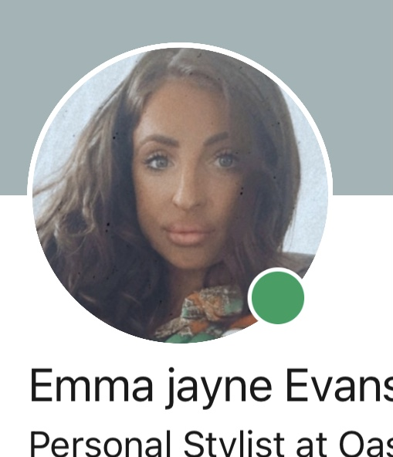

My profile picture is the key element to my profile and it is my fist chance to make a good impression. I used good lighting to make it look professional and I used an up to date photograph with no filters so I can be quickly identified in a room full of other candidates. Having a slight smile in my picture keeps it professional but also shoes I am friendly and approachable which is very important for my job title.

L

Linked In Summary:

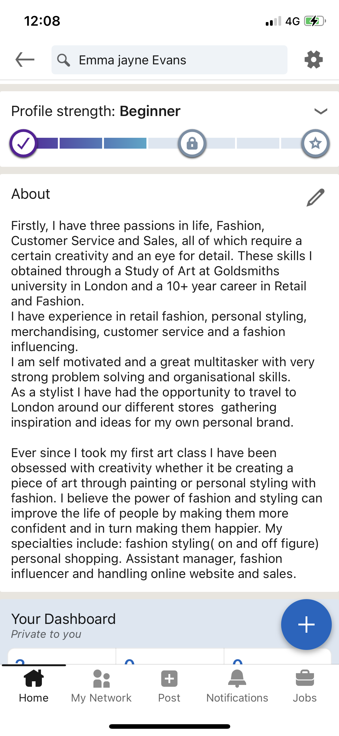
I have made my summary in to a story, making it stand out from the crowd, I highlighted and promotes my skills, experience and passions . This will draw recruiters to my profile and help me stand out from the crowd.

Personal branding

My goal is to have a sense of identity, something that defines my personality, career skills and values. I believe that creating my own personal brand is a solution to this. A personal brand is a unique image and name that creates a lasting impression in the mind of the customer, whether it be an impressive reputation or a long lasting emotion.
My personal brand is a way of selling myself and it reflects what I want people to see who I am and what I stand for. Before I start to create my personal brand, I am aware that I already have whether I like it or not, people already have an impression on me, from what I wear to how I talk and how I behave. People will create a brand for me if I don’t create one myself, so I believe now is the time to put effort and creativity into doing this.
With the constant use of social media everyday in this society, it is important to have a brand vision as a Personal Stylist, to stand out from the crowd and be unique. This uniqueness will draw people to my services, products and lifestyle.
For a personal brand to be successful it needs to be Quality, reliable, consist ant and competitive. I also need to be aware of my USP (unique selling point) which are
- BA hon ours in Art Goldsmiths University
- A ten year career in retail and customer service
- Being able to relate to my target audience.
Now I am ready to create my personal brand. To do this I need to ask myself, who am I? what are my values, beliefs? What do people think of me, and are their answers different to the opinion I have on myself? This will help me adjust and make changes, to make my dreams possible.
I gathered some primary data, three questions to five close friends about me.
- How do you perceive me? :
- What do you think I’m good at?
- How can I improve?
I think created a SWOT from the answers I received.

SWOT analysis

Strengths Weakness

Friendly To be more open about myself
Loving To be more confident
Family orientated Socially awkward in large groups
Happy, always smiling /laughing
Great at organizing social events
Always look presentable (hair/makeup/clothes)

Opportunities Threats

Be a successful well known personal stylist Not having work/ family balance
Have my own website Not having confidence
Have my own PS app Not being open and allowing
Balance work life/family life people to see the real me.

Conclusion

I have learned this research that I am on the right track to creating my personal brand in the way that I am perceived with image, values and passions. However, I do need to change by being more confident and open. I will overcome this by telling people more about me, and about my life. For example, most of my customers are new mums , they are in need of a new wardrobe, their old clothes no longer fit, their style has changed since having a baby. I need to be more open about my experience of being a mum and what I went through and how it inspired me to do the job I am doing as I have experienced the same as them. Being more open will allow my customers to understand me and will in turn strengthen my personal brand.
I also learned that I need to prioritize my values. I might find that creating a personal brand might conflict with my personal values. For example, I will need to take time away from my family to concentrate on being a PS, therefore my beliefs and values could be conflicted, so I need to find a balance for this.
I will therefore do some research on creating a personal stylist app, where I could work from home as much as possible but still be there for my customers needs, but not having to meet face to face as much. Having a balance will bring even more happiness and fulfillment to my professional life.
I can now concentrate on promoting ‘me’, this involves having a Linked In account for networking in the corporate world, having a you tube channel for posting styling videos, a Twitter account for effective communication /research/ customer feedback and an Instagram account for advertising and images.I can optimize my LinkeLn account by adding my blog feed and twitter to my homepage.

