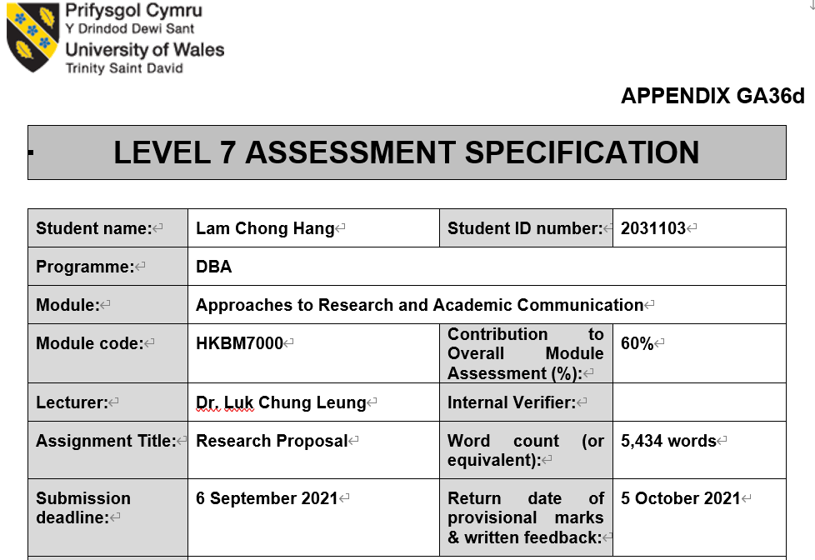
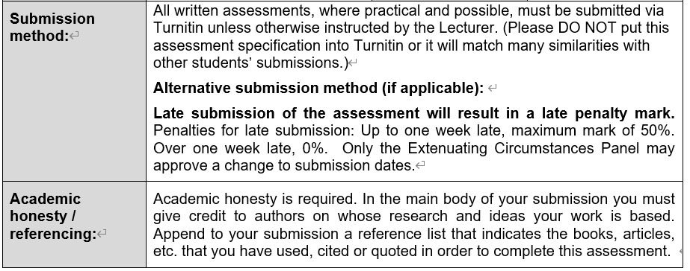

Research Paper Individual Assessment

Module name and code:
Approaches to Research and Academic Communication (Code: HKBM7000)

Student Name:
Lam Chong Hang Alvin (Student No.: 2031103)

Title of the paper:
Effects of workplace retirement planning program on psychological wellbeing of middle-aged employees in Hong Kong

Introduction
This study will focus on understanding the effects of a new workplace retirement planning education course to Hong Kong employees. Middle-aged employees will be the focused group of employees in this study since they concern more on retirement when compared with younger working adults. The study will explore the changes in the levels of anxiety, stress, as well as attitudes in future retirement of this group of employees after completing the retirement planning education course. The study will also investigate the effects of integrating psychological elements in the retirement planning education course.

Current situations of retirement planning of middle-aged working people in Hong Kong
Chung and Marmot (2020) reveals that Hong Kong population has the longest life expectancy globally. Investor and Financial Education Council (IFEC, 2015) finds that 65% of working people felt stressful about their finance with major worries on increasing living cost, unexpected expenses, job insecurity and poor economy. In addition, their financial stress had impacted their work performance negatively.
Mandatory Provident Fund Schemes (MPF) were started 21 years ago in 2000. Mandatory Provident Fund Schemes Authority (MPFA, 2020) discloses that at the end of 2019, average accrued benefits held in each employee’s MPF account is HK$159,000 only, this amount is just enough for a short term of retirement living. Besides, aging population is a continuing trend in Hong Kong. In 2020, the median ages of the population reached 44.9 for male and 45.2 for female. The life expectancy at birth for male and female are 82.7 years and 88.1 years respectively in 2020 (Census and Statistics Department, [CSD], 2021), the figures are higher than many countries or regions in the world. As employees’ retirement protection from government and employers are insufficient, they are required to prepare more by themselves if they want to achieve their expected retirement living standard.
If employers can provide suitable retirement planning education program to employees so that they can understand more the reality, then they may decide to start their retirement planning earlier and have more actions to tackle the coming challenges on retirement.

Research questions
The following research questions will guide the study.
- What is the current status of retirement preparation of middle-aged employees in Hong Kong?
- What are the employers doing to help middle-aged employees plan for retirement?
- What is the progress of workplace financial wellness programs in Hong Kong?
- What are the challenges to employees in current market situations in achieving their retirement goals?
- In addition to financial need, what are the other needs that would impact middle-aged employees in their retirement planning?
- What will be the challenges in developing workplace retirement planning programs for employees at different levels or age groups?
- How to measure quantifiable objectives or goals of the programs to the course developer, employers and the participating employees?
- How to encourage employers and employees to participate in the workplace retirement planning programs?
- How to design an effective marketing and communication plan to encourage targeted employers and employees to participate in the program?

Research Objectives
There are different key research objectives of this study.
- To understand the current status of retirement preparation of middle-aged employees in Hong Kong.
- To examine employers’ policies relating to employees’ retirement planning.
- To evaluate the progress of workplace financial wellness programs in Hong Kong.
- To explore the challenges of current financial and social situations for employees planning for retirement.
- To identify needs, in additional to financial need, that would impact middle-aged employees’ retirement satisfaction.
- To explore the challenges in the process of developing retirement planning programs for employees at different levels or age groups.
- To describe the quantifiable objectives or goals of the programs to the providers, employers and the participating employees.
- To understand the marketing and communication strategies that can encourage employers and employees to participate in the workplace retirement planning programs.

Literature Review
History and developments Workplace financial wellness programs. Workplace financial wellness programs started to become popular in the past few years, however in the past two decades, the programs have been developed in a less structural format (Davidson, 2018). Figure 1 shows the development of financial wellness programs in organizations.
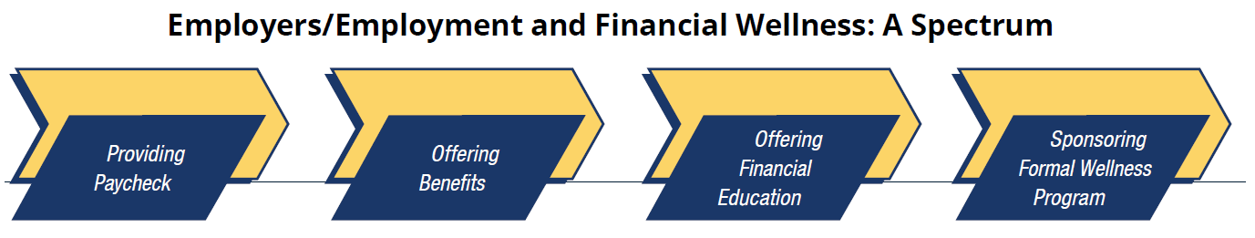
Figure 1: Development of formal financial wellness programs (Dupont, 2020, p.32)
The fundamental objective of employees to provide their skills, knowledge and efforts to organizations is to earn income as return. In addition to monetary compensations, employees are expected to get more from employers. Offering financial education is one of the employees’ benefits and a structured approach to enhance employees’ financial situations is formal financial wellness programs in organizations.
Formal workplace financial wellness programs can have different types and content. Wernette (2019) suggests that there are five most common types of workplace financial wellness programs, namely Tool-based programs, Product-based services, Education and literacy programs, Coaching and behavioral programs, and Customized employee education programs. Tool-based programs are often related to technical supports to help employees manage their own finance, online calculators are commonly included in the programs. Product-based services are similar to Tool-based programs, but more specific financial solutions will be provided, like life insurance needs and retirement income plans. Education and literacy programs are mainly in online format. The purposes are to educate employees to manage their savings and spending practices properly. Employers often provide online resources related to different personal financial topics for employees to learn, assessment tools are also included so that employees can assess their financial situations by themselves. Coaching and behavioural programs emphasize participations. Through the discussions with professionals, employees will be encouraged to focus on behaviours which can help improve their short-term to long-term financial status. Customized employee education programs are tailor-made financial wellness programs for selected employees.
Indeed, workplace financial wellness programs can offer many advantages to employers. Davidson (2018) suggests that there are several improvements in the organization performance through the implementation of the financial wellness programs. Areas with improvement include reduction in employees’ absence rates, reduction of withholding employees’ salaries for specific purposes like debt repayment and child support, reduction of staff turnover and reduction of employees’ financial stress. In addition, the programs can help increase employees’ productivity, increase their monetary savings for future spending in health and retirement. Dupont (2020) has similar findings and suggests that there are additional benefits of offering financial wellness programs by employers. The additional benefits for employees are having greater work satisfactions; better preparation for retirement, lower stresses in different areas. Employers’ additional benefits are higher employee engagement in the companies, reduction in expenses for company medical plans and meeting or exceeding employees’ expectations on company benefits. These research findings encourage employers to provide workplace financial wellness programs to their employees.
Although there are many benefits to the employers, Dupont (2020) finds that there are currently only 29% of employers are offering these programs and 43% interviewed employers do not offer or have no plan to do so. Siciliano, Rizek and Veld (2019) suggests the biggest challenge for successful implementation of financial wellness programs in organization is to engage employees in the programs. Davidson (2018) summarizes the reasons of failure of workplace financial wellness programs into nine areas which are 1) changes of financial behaviours of employees; 2) scale of the programs; 3) availability to employees; 4) utilization with other employee benefits; 5) use of technology; 6) suitability of programs to employees; 7) communications with employees; 8) programs with focus on retirement planning; and 9) program fees by employers or other sources.
The discussions indicate that workplace financial wellness programs are beneficial to both the employees and the employers. Employees can learn appropriate knowledge and skills to improve their financial behaviours and also financial health, employers can enhance their organization performance through different improvement in workplace, such as better productivity and employees’ satisfaction. However, the effectiveness of the programs is affected during the implementation process which includes the stages of development of programs, acceptance by employers and employees and the delivery etc.

Development of financial wellness programs in Hong Kong. What is the status of development of workplace financial wellness programs in Hong Kong? Randstad Hong Kong Limited (RHKL, 2021) suggests that employees are more likely to stay loyal to their employers if they can participate in financial support programs which help improve the level of financial literacy of the employees.
Hong Kong is a busy and stressful city, A survey discovers that 29.6% of respondents experienced high pressure from work, where education, construction and transportation sectors have 30% of their workers are very stressful (Siu, 2020). Occupational stress will lead to absenteeism, family problems or sickness (Siu, 2020), therefore easing workplace stress will likely reduce the costs of employers and improve the organization performance.
There are different sources of stress, Siu, Cooper, Roll & Lo (2020) identifies 5 major types of stress that Hong Kong employees are facing, which are Insecurity in job, Workloads, Constraints in organization, Interpersonal conflicts and Problems in work-family balance.
As the workplace stress is high and Hong Kong employees are not required to work to a particular age so as to get the most benefits from social security, Hong Kong employees often choose to retire early if conditions allow. Lee & Choi (2019) reveals that Hong Kong people at age 30 to 40 on average estimated to retire at 61 with HK$3.6 million of savings and assets, but their estimations for retirement needs may be inadequate with existing wealth management approach. Yiu (2021) opines that majority of working people in Hong Kong would not have enough pension savings to retire at their expected living standard and increase in health care costs may further worsen the situations.
Under current legislation, employers and employees joining MPF schemes are required to contribute 5% of monthly relevant income as mandatory contributions to the schemes. The employees may only withdraw their accumulated benefits, called accrued benefits, from their mandatory contributions upon reaching age 65, except for certain specific circumstances (Mandatory Provident Fund Schemes Authority [MPFA], 2021a). In addition to mandatory contributions, employers and employees can also make voluntary contributions to the MPF schemes.
Mandatory Provident Fund Schemes Authority [MPFA], 2021b) reported 2.61 million employees are making contributions to Mandatory Provident Fund schemes (MPF Schemes), which is more than 76% of the total number of employees in Hong Kong. Therefore, the amount of retirement savings under MPF schemes is very critical to most of the employees in Hong Kong. If their accrued benefits under MPF schemes are sufficient, their retirement protection will be better. Then how much is accumulated in the MPF system?
As at the end of December 2019, average accrued benefits held in each employee’s MPF account is HK$159,000 (Mandatory Provident Fund Schemes Authority [MPFA], 2020). Each employee may have more than one MPF account, so the total accrued benefits per each employee may be more than this amount. Institute of Financial Planners of Hong Kong (IFPHK, 2021) reported their findings that retirees interviewed on average spent HK$11,500 per month. The amount has reflected the situation that travelling and dining-out expenses of retirees were significantly dropped due to COVID-19. It implies retirees in general will spend more than this amount. Even with the amount, HK$159,000 can last for 13.8 months only, less than 2 years. This gives a warning signal that retirement savings in general is seriously inadequate for retirement living.
Figure 2 shows the distribution of MPF accounts by range of accrued benefits (MPFA, 2020), it can be noted that only 14% of total number of accounts have more than HK$200,000 accrued benefits. Therefore, if employees cannot save more for retirement during their working periods, they may not be able to accumulate sufficient amount for retirement spending.
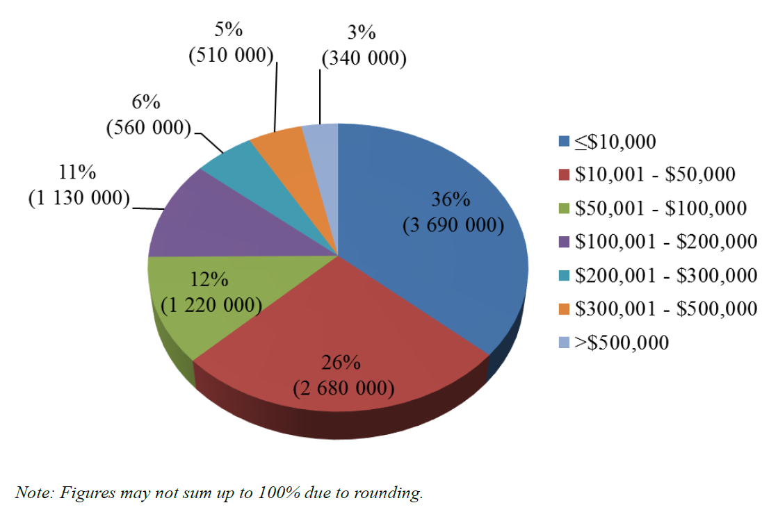
Figure 2: Distribution of Accounts by Range of Accrued Benefits (MPFA, 2020)
In addition to the challenge of insufficient savings for retirement spending, Hong Kong employees also face the longevity risk. Yiu (2021) explains that Hong Kong people has the highest life expectancy in the world with average more than 85 years. Census and Statistics Department, Hong Kong Special Administrative Region (CSD, 2021a) reports that the life expectancies at birth are 82.7 for male and 88.1 for female. For employees at adult ages, the life expectancies will be higher. Figure 3 shows the projected life expectancies of males and females in Hong Kong at selected ages. For example, the life expectancies for male and female at age 40 are 83.6 and 88.8 respectively.
In 1991, the life expectancies at birth for females and males were 80.7 years and 75.2 years respectively. Comparing 1991 and 2020, it can be observed the life expectancy of Hong Kong people is in increasing trend. “Living too long” is one of the most common worries of employees in Hong Kong，if employers can offer more assistance to help employees to prepare better for their retirement, it must be able to reduce the stress levels of employees.
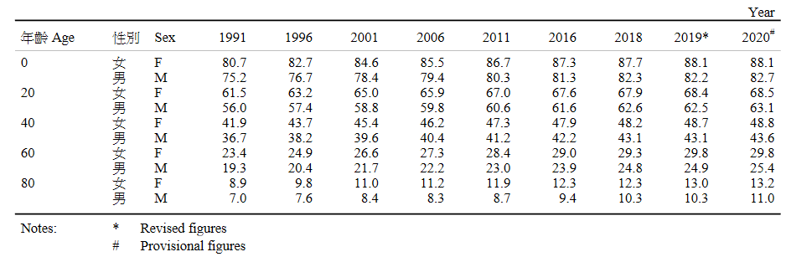
Figure 3: Expectation of life by selected age and sex (CSD, 2021a, p43)
Investor and Financial Education Council (IFEC, 2015) finds that 65% of interviewed working adults felt that they are stressful about their personal financial situations where 26% of them claimed that their work performance were negatively affected. They reported that the financial stress made them difficult to focus at work and some even could not go to work. The same research also reveals that employees are interested to learn financial knowledge at workplace. They have diversified interests in different financial topics, younger working adults wanted to know more on investment products, retirement planning is more welcomed by employees with age over 40 (IFEC, 2015).
Status of development of retirement planning and education programs. Research evidence reveals that retirement planning during career period is beneficial to retirees as more preparatory activities help them to accumulate more initial amount of total resources. (Muratore & Earl 2015; Yeung, 2018; Yeung & Zhou, 2017). Working adults can maintain their post-retirement psychological well-being if they can plan ahead during their working life. To encourage working adults to prepare for their retirement, pre-retirement education programs focusing on social, physical, personal and relationship changes can help lower psychological distress following retirement (Sharpley & Layton, 1998).
Retirement planning education programs for working adults are generally categorized into three main types by their duration and number of meetings (Leandro-França, Giardini Murta, Hershey, & Barbosa Martins, 2016), including long-duration, intensive, and single-session programs. For long-duration programs, they can span over a few months with weekly meetings. For instance, some programs lasted for eight weeks and each lesson lasted for about 3 hours, whereas some programs had even longer duration, like 13 consecutive weeks (Leandro-França, Van Solinge, Henkens & Murta 2016). Intensive programs in general are held in a few consecutive training days within a week. Testimony or single events are just one meeting with unstructured content. They may be a session conducted by retired people to share their personal experiences in the transition period. Brief or short programs have one to a few meetings, but the classes are usually conducted by professional experts. Leandro-França et al. (2016) found that both long-duration and brief programs have positive impacts on cognitive, motivational and behavioural aspects of the participants. Besides, pre-retirement planning education programs with just a few modules with different planning topics can be useful. Planning related goal setting skills were improved when the training program was conducted in weekly basis for three weeks (Earl & Burbury, 2019).
The pre-retirement planning phase generally occurs in midlife, but there is no exact time when it actually happens (Ekerdt, Kosloski, & Deviney 2000). Therefore people’s intention to plan for their retirement varies with age. Killins (2017) found that people younger than 36 years generally lack retirement planning knowledge. People aged over 40 years save more for retirement than their younger counterparts (Helman et al., 2014). Most of the retirement planning programs were designed for employees aged 50 or above (Leandro-França et al., 2016). Local researchers further found that age 44 is a turning point for Hong Kong people to save more for their retirement (Zhu & Chou, 2018). It is common that working adults aged above 40 are more concerned about their retirement plans and will take more actions to secure their future retirement living (Hira, Rock, & Loibl, 2009). Based on these studies, the proposed study will focus on working adults at 40 or above.
Theoretical framework for the program development. There are evidences that workplace financial wellness programs are useful to enhance organization performance in different various aspects (Davidson, 2018, Dupont, 2020). On the other hand, there are also many challenges that workplace financial wellness programs are difficult to implement in organizations (Davidson, 2018, Siciliano, Rizek and Veld, 2019). According to these findings, the strategies to implement workplace financial wellness programs will be impacts on the performance of the programs.
Maslow’s Hierarchical Theory of Human Needs. Maslow Abraham proposed the human motivational concept “Hierarchy of needs” in 1943 in his article “A Theory of Human Motivation” and now is one of the most influential motivational theories. Conley (2013) describes that there are five levels in the pyramid of hierarchy of needs. The bottom level is physiological needs, then need for safety, in the middle is the social or belonging needs, then self-esteem needs, and at the apex is the self-actualization needs. Lussier, K. (2019) suggests the pyramid of hierarchy of needs is a practical toolkit for explaining human motivations in business and management training, the simple and easy-to-remember pyramid allows managers to follow and identify the different levels of needs that the employees are looking for. Hicks (2018) explains that when employees reach their goals, their needs for esteem are satisfied as they experienced the sense of accomplishment, this will make them more confident in their abilities. If social needs are fulfilled, such as good relationships with working partners, friends and families, employees will have better bonding and trusts with people, it can also enhance the positive outcomes in workplace. Good managers should be good at motivating staff. In addition to money, Stein (2013) opines that employees are also motivated by many different factors, such as recognition, security of employment and personal growth. Stein (2013) suggests some principles for managers to follow so as to boost the motivations of the team, namely offering appropriate incentives and rewards; consistent and clear communications; and be a role model leading by example.
This pyramid of hierarchy of needs can be used to explain human motivations, organizational behaviours and also personal financial needs. Spafford (2015) argues that earning income for spending is the physiological needs of people, getting financial security is about the need for safety, interdependence of people is equivalent to the needs for love and belonging, people at affluent level can achieve the need of esteem, legacy succession is about the need of self-actualization.
Lee and Hanna (2015) associates saving goals and behaviours with the levels in Maslow’s Hierarchy. The lowest level of physiological needs consists of the budgets for basic quality of living and savings are for daily spending, like paying bills, taxes and food. When people are still struggling for the money to pay for the basic daily expenses, they are hard to plan for the future. Working people in this level may concern more on job security and salary increments. In the level of needs for safety, the saving objectives are mainly for financial and physical safety, such as savings for expenses due to unexpected events like accident, illness or unemployment. Buying shelter for family is also in this level. Saving goals in this level include saving for emergency and instalment for buying flat for living. People in this level may want to know more on knowledge and skills in budgeting and cashflow management. Saving for retirement and security is in the third level of needs. In this level, people save for their future goals, like retirement living and additional income for future use. The next level of financial needs is saving for loved ones and the society. Saving goals are for family members, like saving for university education fund for children. Saving for esteem or luxuries is related to the needs for self-esteem. Some individuals believe that certain kind of behaviours may help get recognitions from others. Financially, they may buy some luxury items like expensive cars, jewellery and watches, or live with luxury lifestyles. These behaviours may convey the messages to others that they are more superior in status and others may then respect them. The highest level is saving for self-actualization. This goal level consists of strong desire to achieve one’s personalized values in life. Money may be saved for others, such as making charitable or religious contributions. If for own use, money may be saved for buying businesses or living at a totally different lifestyle.
If Maslow’s “Hierarchy of needs” is used in developing workplace financial wellness programs, it can firstly help categorise employees in accordance with their level of needs, and then appropriate financial concepts and skills can be taught to employees in different level of needs.
Company strategies should react to the environmental changes. After more than a year of pandemic, what should the employers do to help their employees reduce their stresses? PwC (2021) suggests four strategies in workplace financial wellness programs. Firstly, as the financial situations of employees in general are worsened, employers should commit to employees that workplace financial wellness programs will be a core element in company wellness programs so that they can get suitable financial advice. Secondly, as the backgrounds of employees vary, they are looking for different financial solutions to meet their personalized needs. Employers can consider offering range of benefits and different compensation packages to meet employees’ needs. At the same time, workplace financial wellness programs should be provided to assist employees to make appropriate financial solutions. Thirdly, personal financial situation is a sensitive issue that employees may not want to disclose to their employers, proper HR process, rules and procedures are required to protect employees’ privacy and dignity. Content and classes of workplace financial wellness programs should also be carefully developed to avoid touching on sensitive issues of employees and more resources may be allocated to support the vulnerable groups. Lastly, more uncertainties have been evolved in current environment, financial wellness programs should have more flexibilities so as to continuously engage the employees. Employers can utilize online tools to educate employees general financial concepts and help them track their spending and savings habits. In the meantime, one-on-one financial coaching benefits may be offered to selected group of employees.
Retirement planning involves resources allocation. Nielsen et al. (2017) indicates that there are four levels of workplace resources which can have impacts on employee well-being and organizational performance, namely individual, group, leader and organizational levels. Individual level resources help employees perform in workplace, which are related to personal characteristics or behaviours, resilience and self-efficacy and problem-solving skills are examples of individual level resources. It can be expected that a team with good interactions and mutual supports will have better performance, these qualities are examples of Group level resources. Employers welcome good teamwork because employees can interact positively and contribute their knowledge and talents to make the organization success. Leader level workplace resources are related to leadership style and leaders’ quality, good leaders know the importance of workplace motivation and strategies to support the team to perform. Ability to build trust with people is also important for leaders. Finally, organizational level resources are about how the tasks are decided, implemented and managed. Performance review system, compensation packages and autonomy are examples of organizational level resources.
Nielsen et al. (2017) suggests that all four levels of resources have positive impacts on organization performance and employees’ well-being and multiple levels are recommended.
For the implementation of workplace financial wellness programs, duties of HR managers may be different, they are required to appoint qualified and suitable professionals to conduct the programs.
Verheyen, Kohn, and Diersch (2018) explains that workplace financial wellness programs can be conducted by internal or external business partners. Internal business partners can be colleagues from different departments, but they need to be the experts in the relevant topics. If colleagues from different departments are involved as instructors or program providers, participation rates of the programs may be higher because they are organized by their peers. However, the program content must be carefully designed to avoid any sensitive topics. On the other hand, external business partners should be used to fill the gaps that internal business partners cannot cover and also bring inspiring ideas to employees. No matter by internal staff or external consultants, clear schedule for the programs must be provided.
Impacts of behavioural economics in developing retirement planning programs. Vernon (2019) suggests that education programs help raise awareness but don’t necessarily lead to changes in habits and behaviours due to the reason that employees not always make rational decisions for their best interests. They are easily interfered by advertisement, social media and other people.
Besides, Vernon (2019) explains further that psychological bias affect their decisions especially on complicated issues, for example, planning for future retirement.
On the other hand, if people’s psychological bias can be applied appropriately, better decisions result. Thaler and Wang (2015) finds that concepts of behavioural economics can help working people save more for their retirement without forcing them and subsequently they will have better future retirement living.
Antony (2020) explains that “behavioral finance (also known as behavioural economics) examines the impact of psychology on market participants' behavior and the resulting outcomes in markets, focusing on how individual investors make decisions”.
Kroncke (2018) suggests to employers to use apply the concepts of behavioural economics to encourage employees in retirement planning education programs, which might lead to happier future retirees.
These researches support psychological elements can be effective in changing employees’ financial behaviours and habits through retirement planning education programs. However, it is not common a practice in the workplace retirement planning education programs in Hong Kong.

Hypotheses
Building on the theories of behavioural economics and Maslow’s Hierarchy of Needs, this study aims to examine the effects of workplace retirement planning program with psychological content on retirement preparation of middle-aged employees. Accordingly, 3 hypothese are formulated.
Hypothesis 1: Positive attitudes toward retirement and lower retirement anxiety and stress are associated with more planning behaviours for retirement.

Hypothesis 2: Psychological preparations for retirement can reduce the stress level of middle-aged employees in Hong Kong.

Hypothesis 3: Workplace retirement planning programs developed with psychological elements can encourage the planning behaviours for retirement of middle-aged employees in Hong Kong.
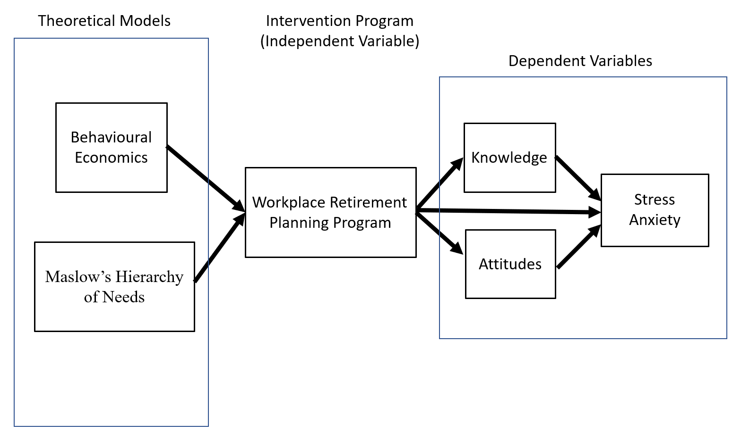
Hypothesized model of the relationships between the variables
Methodology
Sampling and Participants
The study will utilize convenience sampling. Employees aged 40 or above will be invited to participate in the study through different means of recruitment. Some possible ways of recruitment may include but not restricted to posting invitation through social platforms, such as facebook and Moment in Wechat, advertising in online media, and sending invitation letters to different organizations to invite their staff to join.
Workplace retirement planning program with psychological content will be developed for middle-aged employees in this study. The objective of the program is to increase the participants’ retirement preparation and investigate their effects on psychological wellbeing. Through the program, participants will learn both financial and psychological knowledge and skills aiming to develop their positive attitudes and reduce their anxiety level for retirement. Classroom learning, homework assignments and diversified group activities are included in the program to enhance its effectiveness.
Before doing the actual program, a pilot program will first be conducted to ensure the teaching materials would successfully influence the participants’ planning behaviors for retirement. In the program, participants will be randomly assigned to two groups, Intervention Group and Control Group. Participants of Intervention Group will participate in the workplace retirement planning program and the Control Group will participate in financial planning for retirement program which has the same class time as the workplace retirement planning program but concentration on financial planning knowledge only.

Measurements
Pre- and post-tests will be performed to examine whether the program can successfully improve middle-aged employees’ retirement attitudes and planning behaviours, and reduce their anxiety. This study adopts the longitudinal design to measure individual changes in resources, attitudes and anxiety level after the program.
Three waves of assessments will be used in order to capture the changes. Time 1 assessment will be conducted at the beginning of the first module, Time 2 assessment will be conducted immediate after the last module. Time 3 assessment will be conducted three months after Time 2 assessment.
The questionnaire to be used for the pre- and post-test measurements consist of 4 parts which are changes in retirement planning knowledge, behaviours, stress and anxiety, and attitude toward retirement. Basic demographics will be collected, including gender, marital status, education level, age range and monthly average income range.
The questionnaire will be a combination of four scales. Table 2 below indicates the scales proposed to be used.
Variables to be measured | Measures / Instruments
Changes in financial knowledge for retirement | Scale for retirement planning knowledge
Changes in retirement planning behaviours | Retirement Planning Activity Scale
Changes in stress and anxiety levels | Scales for anxiety and stress of Depression, Anxiety and Stress Scale - 21 Items (DASS-21)
Changes in attitude toward Retirement | Attitudes toward retirement Scale
Table 2: Proposed scales for different variables measurement
Scale for retirement planning knowledge
Jacobs-Lawson and Hershey (2005) uses the scale to measures 3 areas on retirement planning knowledge, namely financial planning for retirement, financial risk tolerance and investing for retirement, and retirement savings. All items use a seven-point response format (1 _ strongly disagree, 7_ strongly agree).
Retirement Planning Activity Scale
This 10-item scale is designed to tap the frequency of both information seeking and instrumental planning activities that have occurred during the preceding 12 months.
​Hershey et al. (2007) designs this 10-item scale to measure the retirement planning activities during the preceding 12 months. It uses the seven Likert-type response format (1 = strongly disagree; 7 = strongly agree), participants are asked to indicate the extent to which they agree or disagree with each of the following statements.​
Scale for Anxiety and Stress
Part of the questions in the Depression, Anxiety and Stress Scale - 21 Items (DASS-21) are used as the scale to measure the levels of anxiety and stress of participants. DASS-21 has three self-report scales to measure the emotional states of depression, anxiety and stress, each scale contains 7 items, only scales measuring anxiety and stress are used in the study. Chan et al. (2021) uses the scale to assess any symptoms of anxiety.
Attitudes toward retirement Scale
Attitudes toward retirement will be measured by the scale developed by Glamser (1976). It is a five-item Likert with five possible responses each (1=strongly disagree to 5=strongly agree). The final score of participants will be calculated, which is ranged from 5 to 25, with higher scores indicating more positive attitudes toward retirement.
Projected results for each of the proposed hypotheses

Hypothesis 1: Positive attitudes toward retirement and lower retirement anxiety and stress are associated with more planning behaviours for retirement.

It is projected the participants’ with lower levels of stress and anxiety buy more positive attitudes toward retirement are more likely to involve in retirement planning activities.

Hypothesis 2: Psychological preparations for retirement can reduce the stress level of middle-aged employees in Hong Kong.

It is projected more psychological knowledge and skills learned from the education program can help the participants reduce their stress level in retirement preparation.

Hypothesis 3: Workplace retirement planning programs developed with psychological elements can encourage the planning behaviours for retirement of middle-aged employees in Hong Kong.

It is projected participants in the programs will have more planning activities when compared with employees without participating in the program.

Conclusion
The research aim of this study is to reduce levels of anxiety and stress of middle-aged employees and improve their planning behaviours and attitude toward retirement through comprehensive retirement planning education course, consequently organizational performance is also improved.
Contributions of the study
The possible contributions of this study are to improve the retirement planning behaviours and attitudes of employees especially those in middle-aged group. It will assist employees of different levels to plan well for their financial health.
The employers include the workplace retirement planning programs as one of the employees’ wellness benefits will also be benefited. It is because employees with positive attitudes and lower levels of stress and anxiety will have better contributions to their works, it ends up will improve organization performance.
Finally, the findings will assist HR to decide the criteria to assess the workplace financial wellness programs for their employees.

References
Antony, A. (2020) ‘Behavioral finance and portfolio management: Review of theory and literature’, Journal of Public Affairs (14723891), 20(2), pp. 1–7. doi: 10.1002/pa.1996.
Bergstrom, K. (2019) ‘what’s working: putting participants in the pole position for retirement’, Benefits Magazine, 56(7), pp. 12–14. Available at: https://search.ebscohost.com/login.aspx?direct=true&db=bth&AN=137172418&site=ehost-live (Accessed: 5 September 2021).
Blake, D. and Boardman, T. (2014) ‘Spend More Today Safely: Using Behavioral Economics to Improve Retirement Expenditure Decisions with Speedometer Plans’, Risk Management & Insurance Review, 17(1), pp. 83–112. doi: 10.1111/rmir.12007.
Census and Statistics Department, Hong Kong Special Administrative Region, 2021a. Women and Men in Hong Kong – Key Statistics, 2021 Edition [pdf] Available at: <https://www.censtatd.gov.hk/en/data/stat_report/product/B1130303/att/B11303032021AN21B0100.pdf> [Accessed 11 August 2021].
Census and Statistics Department, Hong Kong Special Administrative Region, 2019. 2018 Report on Annual Earnings and Hours Survey [pdf] Available at: <https://www.censtatd.gov.hk/en/data/stat_report/product/B1050014/att/B10500142018AN18B0100.pdf> [Accessed 16 August 2021].
Census and Statistics Department, Hong Kong Special Administrative Region, 2017. 2016 Report on Annual Earnings and Hours Survey [pdf] Available at: <https://www.censtatd.gov.hk/en/data/stat_report/product/B1050014/att/B10500142016AN16B0100.pdf> [Accessed 16 August 2021].
Chan, S., Au-Yeung, T., Wong, H. et al. (2021). Long Working Hours, Precarious Employment and Anxiety Symptoms Among Working Chinese Population in Hong Kong. Psychiatr Q (2021). doi: 10.1007/s11126-021-09938-3
Chung, R. Y., and Sir M. Marmot. (2020). People in Hong Kong have the longest life expectancy in the world: Some possible explanations. NAM Perspectives. Commentary, National Academy of Medicine, Washington, DC. https://doi.org/10.31478/202001.
Conley, C. (2013) ‘LEADERSHIP’, Leader to Leader, 2013(67), pp. 30–35. doi: 10.1002/ltl.20059.
Davidson, L. (2018) ‘What’s Working (and What’s Not Working) in Financial Wellness Programs’, Benefits Magazine, 55(9), pp. 22–28.
Dupont, D. (2020) ‘FINANCIAL wellness IN THE WORKPLACE’, LIMRA’s MarketFacts Quarterly, (3), pp. 31–35.
Earl Jk, & Burbury B. (2019). Trialing an online intervention to improve retirement planning goal setting and goal specificity. Clinical Interventions in Aging, 14, 419-425.
Ekerdt, D. J., Kosloski, K. and Deviney, S. 2000. The normative anticipation of retirement by older workers. Research on Aging, 22, 1, 3-22.
Glamser, F. D. (1976). Determinants of a positive attitude toward retirement. Journal of Gerontology, 31, 104-107.
Helman, R., Adams, N., Copeland, C., & VanDerhei, J. (2014). The 2014 Retirement Confidence Survey: Confidence Rebounds-for Those With Retirement Plans. EBRI Issue Brief, (397), 1-2, 5-34.
Hershey, D. A., Jacobs-Lawson, J. M., McArdle, J. J., & Hamagami, A. (2007). Psychological foundations of financial planning for retirement. Journal of Adult Development, 14, 26-36. doi: 10.1007/s10804-007-9028-1
Hicks, R. (2018) ‘Coach’s Corner: Modern Thinking, in Tune with the Basics’, Physician Leadership Journal, 5(3), pp. 62–64. Available at: http://search.ebscohost.com/login.aspx?direct=true&db=bth&AN=129151397&site=ehost-live (Accessed: 12 August 2021).
Hira, T., Rock, W., & Loibl, C. (2009). Determinants of retirement planning behaviour and
differences by age. International Journal of Consumer Studies, 33(3), 293-301.
Investor and Financial Education Council, 2015. IFEC Segment Research – Working Adults[pdf] Available at: <https://www.ifec.org.hk/common/pdf/about_iec/iec-segment-research-working-adults-2015.pdf> [Accessed 11 August 2021].
Institute of Financial Planners of Hong Kong, 2021. Press release of “Hong Kong Retirees’ Actual Expenses Survey” [pdf] Available at: <http://www.ifphk.org/pdf/press_release/PR20210413_en.pdf> [Accessed 11 August 2021].
Jacobs-Lawson, J. M. and Hershey, D. A. (2005) ‘Influence of future time perspective, financial knowledge, and financial risk tolerance no retirement saving behaviors’, Financial Services Review, 14(4), pp. 331–344. Available at: http://search.ebscohost.com/login.aspx?direct=true&db=bth&AN=19521128&site=ehost-live (Accessed: 16 August 2021).
Killins, R. (2017). The financial literacy of Generation Y and the influence that personality traits have on financial knowledge evidence from Canada. Financial Services Review : The Journal of Individual Financial Management, 26(2), 143-165.
Kroncke, C. (2018) ‘Nudging toward a stable retirement’, Politics & the Life Sciences, 37(1), pp. 126–129. doi: 10.1017/pls.2018.5.
Leandro-França, C., Giardini Murta, S., Hershey, D. A., & Barbosa Martins, L. (2016). Evaluation of retirement planning programs: A qualitative analysis of methodologies and efficacy. Educational Gerontology, 42(7), 497-512. doi:10.1080/03601277.2016.1156380
Leandro-França, C., Van Solinge, H., Henkens, K., & Murta, S. G. (2016). Effects of three types of retirement preparation program: A qualitative study of civil servants in Brazil. Educational Gerontology, 42(6), 1-13. doi:10.1080/03601277.2016.1139969
Lee, G., & Choi, M., (2019). Hong Kong millennials want to retire earlier on lower savings, but their maths may fail, JPMorgan survey shows. South China Morning Post, [online] 17 December. Available at: https://www.scmp.com/business/money/wealth/article/3042336/hong-kong-millennials-want-retire-earlier-lower-savings-their [Accessed 11 August 2021].
Lee, J. M. & Hanna, S. D. (2015). Savings Goals and Saving Behavior From a Perspective of Maslow’s Hierarchy of Needs. Journal of Financial Counseling and Planning, 26(2), 129–147.
Lussier, K. (2019) ‘Of Maslow, motives, and managers: The hierarchy of needs in American business, 1960–1985’, Journal of the History of the Behavioral Sciences, 55(4), pp. 319–341. doi: 10.1002/jhbs.21992.
Mandatory Provident Fund Schemes Authority, 2020. Statistical Analysis of Accrued Benefits Held by Scheme Members of Mandatory Provident Fund Schemes. [pdf] Available at: <https://www.mpfa.org.hk/en/-/media/mpfa/files/research-report-eng/statistical_analysis_of_accrued_benefits_held_by_scheme_members_2020.pdf> [Accessed 11 August 2021].
Mandatory Provident Fund Schemes Authority, 2021a. MPF System Withdrawal of MPF. Available at: < https://www.mpfa.org.hk/en/mpf-system/withdrawal-of-mpf/withdrawal-of-mpf-upon-retirement > [Accessed 11 August 2021].
Mandatory Provident Fund Schemes Authority, 2021b. Mandatory Provident Fund Schemes Statistical Digest, March 2021. [pdf] Available at: < https://www.mpfa.org.hk/en/-/media/mpfa/files/pdf/tab-8/march_2021_issue.pdf> [Accessed 11 August 2021].
Muratore, A. M., & Earl, J. K. (2015). Improving retirement outcomes: The role of resources, pre-retirement planning and transition characteristics. Ageing & Society, 35(10), 2100-2140. doi:http://dx.doi.org.ezproxy.cityu.edu.hk/10.1017/S0144686X14000841
Nielsen, K., Nielsen, M.B., Ogbonnaya, C., Känsälä, M., Saari, E., and Isaksson, K., (2017). Workplace resources to improve both employee well-being and performance: A systematic review and meta-analysis, Work & Stress, 31:2, 101-120, DOI:10.1080/02678373.2017.1304463.

PwC, 2021. 2021 PwC Employee Financial Wellness Survey, [online]. Available at: <https://www.pwc.com/us/en/services/consulting/workforce-of-the-future/library/employee-financial-wellness-survey.html> [Accessed 12 August 2021].

Randstad Hong Kong Limited, 2021. why employee financial wellness is important to your talent strategy. Available at:＜https://www.randstad.com.hk/hr-trends/employer-brand/why-employee-financial-wellness-is-important/＞[Accessed 11 August 2021].
Sharpley, C. F., & Layton, R. (1998). Effects of age of retirement, reason for retirement and pre-retirement training on psychological and physical health during retirement. Australian Psychologist, 33(2), 119-124. doi:http://dx.doi.org.ezproxy.cityu.edu.hk/10.1080/00050069808257392
Siciliano, V., Rizek, B. and Veld, D. (2019) ‘Financial Wellness in the Workplace: Getting Back to the Basics’, Plans & Trusts, 37(6), pp. 16–21.

Siu, O., 2020. LU study finds work stress costs Hong Kong HK$14.9 billion a year. Lingnan Touch, [online] January. Available at:＜https://www.ln.edu.hk/lingnan-touch/99/lu-study-finds-work-stress-costs-hong-kong-hkusd14-9-billion-a-year＞[Accessed 11 August 2021].
Siu, O. L., Cooper, C. L., Roll, L. C., & Lo, C. (2020). Occupational Stress and Its Economic Cost in Hong Kong: The Role of Positive Emotions. International journal of environmental research and public health, 17(22), 8601. https://doi.org/10.3390/ijerph17228601.
Spafford, K. (2015) ‘Succession starts with your personal financial security’, Southeast Farm Press, 42(24), p. 12. Available at:<http://search.ebscohost.com/login.aspx?direct=true&db=bth&AN=110563108&site=ehost-live> (Accessed: 12 August 2021).
Stein, N. (2013) ‘Motivation matters’, Horticulture Week, p. 23. Available at: <http://search.ebscohost.com/login.aspx?direct=true&db=bth&AN=90308366&site=ehost-live> (Accessed: 12 August 2021).
Thaler, R. and Wang, P. (2015) ‘Q+A: How Can I Make Smarter Money Choices?’, Money, 44(5), pp. 66–70. Available at: https://search.ebscohost.com/login.aspx?direct=true&db=bth&AN=102681739&site=ehost-live (Accessed: 5 September 2021).
Verheyen, T., Kohn, T. and Diersch, B. (2018) ‘A Practical Guide to Workplace Financial Wellness Considerations, Assessment, and Implementation’, Journal of Pension Planning & Compliance, 44(1), pp. 78–90. Available at: <http://search.ebscohost.com/login.aspx?direct=true&db=bth&AN=127768364&site=ehost-live> (Accessed: 12 August 2021).
Vernon, S. (2019) ‘Beyond Defaults: Using Behavioural Economics to Improve Retirement Outcomes’, Plans & Trusts, 37(2), pp. 20–26. Available at: https://search.ebscohost.com/login.aspx?direct=true&db=bth&AN=135029194&site=ehost-live (Accessed: 5 September 2021).
Wernette, G. J. (2019) ‘Developing Workplace Financial Wellness Programs’, Benefits Magazine, 56(2), pp. 42–46.
Yeung D.Y. & Zhou X. (2017). Planning for Retirement: Longitudinal Effect on Retirement Resources and Post-retirement Well-being. Frontiers in Psychology, 8. doi:10.3389/fpsyg.2017.01300
Yeung, D.Y. (2018). Adjustment to retirement: effects of resource change on physical and psychological well-being. Eur J Ageing, 15(3), 301-309. doi:10.1007/s10433-017-0440-5
Yiu, E (2021). Pension Shortfalls Keep 9 Out Of 10 Middle-income Hong Kong Residents Toiling. South China Morning Post, [online] 05 July. Available at:＜ https://www.scmp.com/business/banking-finance/article/3139893/nine-out-10-middle-income-hongkongers-aged-over-50-have-no?＞[Accessed 11 August 2021].
Zhu, A., & Chou, K. (2018). Retirement Goal Clarity, Needs Estimation, and Saving Amount: Evidence from Hong Kong, China. Journal of Financial Counseling and Planning, 29(2), 328-342.

