Kristina Spasova ID:2014059 LCBB5004

University of Wales
Level 5 assessment 2

MANAGING PEOPLE
Lecturer: Charles Oham

LONDON
8/05/2022

Table of Contents
Introduction: 1
Body of report: 2
Related concepts and drivers of employee engagement: 2
Concepts behind Employee Engagement 2
Drivers of employee engagement 2
Diagnostic tools to measure engagement: 5
Employee value preposition: 6
Conclusion: 6
References 7

Name of the organization on whom we must pursue analysis:
“NORTON DIGITAL AGENCY”

Introduction:
We have to present a report about employee engagement for the chief executive of our company as it has already been determined that employee engagement is one of the biggest concerns. If employee engagement is weak, an Organisation could not progress in any possible way. This report would be devised to retain the Organisation at its best and conduct an in-depth investigation concerning the importance of employee engagement. We have to follow up on three primary contexts to be taken forth across this report in a holistic approach. This report has to discuss the concept and related drivers of employee engagement. Furthermore, the system we have to determine is how we can measure employee management. We have to follow up on one more aspect we have to generate an employee value proposition in which we will promulgate strategies to improvise employee engagement.
Over this aspect, the primary approach on which we must conduct analysis is known to be as that how engagement would be improved in an Organisation. Our initial focus is to present an evaluation concerning how engagement could be improvised at its best. Moreover, the organization’s measures are concerning making the business environment free from the Covid'19 pandemic. The employees follow up work from home, flexible working time, and job design/ restructuring roles. In the concept of employee engagement, the Organisation could not gain operational and functional excellence – until and unless an Organisation becomes capable enough to improve engagement of tasks among its employees. Therefore, employees are the backbone of any organization. For this reason, it is necessary and fundamental to gain the best of their engagement to gain ample completion of all tasks as a whole.

Body of report:

Related concepts and drivers of employee engagement:

Concepts behind Employee Engagement

What is employee engagement?
Employee engagement could be defined as how the employees and professionals of the organization are committed to achieving the goals of an organization. It could be described as how much employees are focused on attaining the best for the organization in any possible way. Along with that, employee engagement is simply a determinant of how employees give their best for the organization’s benefit.

Importance of employee engagement
It seems to be quite evident that in case employees’ engagement towards their duties and responsibilities is higher, they would give their best for the benefit of the organization. However, employees would remain focused on achieving the goals of the organization. With higher employer engagement, the organization would progress drastically.

Explanation of Employee Engagement:
We can mound the concept of employee engagement as the engagement of employees and professionals with the organization. The employees' enthusiasm towards their duties and responsibilities and how much indulged or focused they are to complete their tasks is the consideration that could be encompassed in employee engagement. Employees who are highly engaged with their organizations stay extremely devoted and focused on their duties and responsibilities. They give their best towards what has been allocated to them. They remain connected with their teams. They put extra effort into contributing to the benefit of the organization. As they put all their additional steps for the use of the organization, it is how they similarly result in encouraging their colleagues so that the growth of the organization could be gained at its best.

Drivers of employee engagement

Importance of clear vision in employee engagement:
The organization has a clear vision that they must provide an environment in which employees could operate from the ease of their homes as they have to keep their workplace free from the Covid'19 pandemic. Suppose an organization has a clear vision or goals to achieve. In that case, it is a primary driver that employees would know about its plans, resulting in being engaged in their duties and responsibilities. In case an organization has a distorted vision or goals, employee engagement in their tasks could not be achieved in any possible way. It is essential for the organization to openly discuss their goals and vision to whom the employees would remain engaged or stick towards achieving. We can render that a clear picture is exceptionally viable for employee engagement and benefit an organization.

Importance of work-life balance and employee engagement:
What is work-life balance? It is determined as leverage provided to the employees to be indulged in retaining their personal lives. If employees do not get proper time to complete chores in their personal life – they do not be satisfied. Therefore, an organization should promise its employees’ health, paid leaves, yearly vacations, gratuity pay, rewards, business trips, flexible working hours, etc. If a work-life balance is created with employees, complete leverage would be provided to them to follow up on their personal lives. It would also contribute the most and result in the second most important driver towards employee engagement follow-up.

Motivation as a driver of employee engagement:
Employee motivation also contributes the most towards their engagement with operational and functional tasks. The cause could be served to employees in multiple possible ways. Initially, it is possible if they should get a motivational or training session in which the importance of their indulgence towards tasks could be taken forth. It is human nature that motivation arrives in a person wants to achieve a target. A target in the workplace could either be appraisal, bonuses, rewards or promotions. For inspiration, an organization should keep a reward system where employees who work better gain rewards. Rewards could either be monetary or advancements in their workforce if the employees would have the motivation to earn a bonus for their efforts. In this way, it would also contribute to employee engagement. If an employee lacks motivation in any possible way – they could not, simply contribute to the betterment of the organization. For employee engagement,

Employee Satisfaction as a driver of employee engagement:
Employee satisfaction is so crucial to employee engagement in the organization. If employees are not satisfied with their job or workforce, they cannot even operate and function in top-performing businesses. How employee satisfaction arrives? It arrives from work-life balance, being motivated to work and the best of a workplace environment. If an employee is not satisfied in any possible way, they would fwillo be engaged in their functional and operational tasks. To increase employee engagement in their functions, it is fundamental for an organisation to ensure that all of its employees are satisfied with their jobs. The employees' contribution towards their responsibilities increases; if they are happy with their workforce.

Impact of HR on employee engagement:
The participation of tan organization’s human resources (HR) department s probably considered most helpful in this manifestation of employee engagement. Therefore, the human resource department has to conduct recruitment and DE recruitment of employees. Along with that, the selection of viable employees is so helpful for employee engagement. If the choice for a particular designation is not valid for an organization, e.g., the employee is not eligible. In that situation, it could be initiated that for engagement of employees – they should be qualified or have enough expertise for the particular designation. Suppose the HR department of the organization fails to select any eligible employee. In that case, it seems to be quite evident that the organization could not achieve employee engagement in any possible way. The HR department also has to take proper measures so that employees can remain motivated and satisfied with their jobs. The HR department plays the most vital role in employee engagement; if it performs all of its duties accordingly, the organization could achieve the best employee engagement.

Role of managers in employee engagement:
Managers also contribute the most to employee engagement as they help develop and grow employees. They result in a celebration of employee engagement and assist them in how all of their operational and functional tasks could be performed at their best. If managers build better relationships with all employees, it makes employees duly follow all the instructions based on a manager's experience. It is only possible if a manager has a better relationship with employees – it also results in driving employee engagement to a greater extent.

Diagnostic tools to measure engagement:
It seems evident that various diagnostic tools can only measure employee engagement. These diagnostic tools could be followed up as follows;

To conduct employee surveys:
As far as this approach is concerned, employee engagement could be measured by conducting employee surveys. A monthly evaluation form should be provided to all of the employees in which employees should teach a critical observation about satisfaction with their job. In these surveys, employees can give complete feedback about what they are undergoing within the organization. By the follow up of employee surveys, it could be crystal clear if there would be any concerns or issues the employees have faced in any possible way. It is the most helpful tool in consideration of employee engagement. Along with that, the results which could be gained from surveys cannot be achieved from any other tool for the satisfaction of employees. Online questionnaires would be granted to employees to provide holistic feedback about the organization as a whole.

Social media:
The company would conduct Glassdoor ratings and reviews using social media, e.g. Facebook. Thus, by the intranet (internal network) of the organization. It would contribute the most for the employees to post their feedback about the organization. The reviews or feedback could either be taken forth anonymously or not, e.g. it depends on the user. Through Glassdoor reviews and ratings, the employees could also post their ideas through which managers could also gain an insight into their cognitive ability and follow it up for the betterment of the organization.

HR tools:
Human resource tools could also be followed up to measure employee engagement. In these HR tools, some applications or interfaces would be created through which employee engagement could be calculated by the determination of various factors.

Employee value preposition:
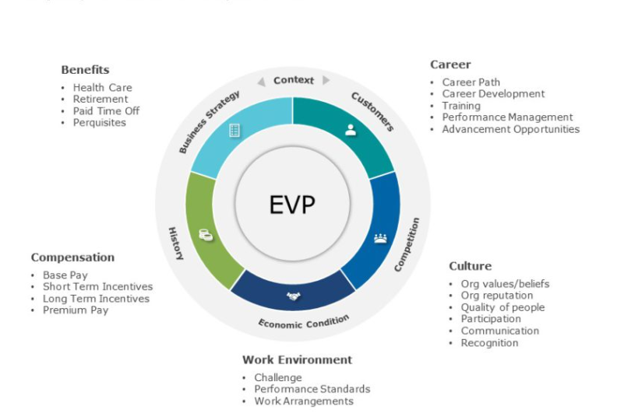
These are some of the significant Employee Value Prepositions; it includes aspects related to Career, culture, work environment, compensation and benefits that could be provided to employees. It is also based on the strategies of employee engagement that we have suggested. By all of these, employees get a lot of work life balance, they remain motivated and aimed to achieve their goals.

Conclusion:
As we have already promulgated this approach, we have resulted in a holistic determination of all the concepts behind employee engagement. In that concept, we have followed up definition employee engagement. In the concepts, we have promulgated a complete understanding of what is employee engagement. Contrary to this, we have taken forth all aspects which drive employee engagement. Along with that, all the possible diagnostic tools have also been discussed across this consideration by which all approaches have been made crystal clear.

References
Dziuba, S. T. (March 2020). Employees’ Job Satisfaction and their Work Performance as Elements Influencing Work Safety. CzOTO, 2(2), 18-25.
El-Said, O. (October 2014). Impacts of Workplace Relationships on Employees' Perceptions of Productive Work Environment. EuroCHRIE Dubai Conference Proceedings, 4-19.
Inayat, W. (05 Aug 2021). A Study of Job Satisfaction and Its Effect on the Performance of Employees Working in Private Sector Organizations, Peshawar. Education Research International, 1(1), 2-9.
Kenny, V. (2019). Employee productivity and organizational performance: A theoretical perspective. 2-8.
M, S. (February 2017). A study on the impact of Job Satisfaction on Job Performance of Employees working in Automobile Industry, Punjab, India. Journal of Management Research, 1(1), 2-9.
Macgillavry, K. (2016). Focusing on the Critical Link Between Employee Engagement and Customer Centricity at any organisation. Global Business and Organizational Excellence, 6-16.
Markgraf, B. (March 05, 2019). Importance of Information Systems and social media in an Organisation WITH REFERENCE TO US COMPANIES. CHRON Human Resource Information Systems, 7-19.
Preema, M. T. (2019). “Effectiveness of Employee Engagement for DHL". REPORT BY BRAC UNIVERSITY BANGLADESH, 8-22.
Zafar, N. (2014). Determinants of Employee Motivation and its impact. zzzzInternational Journal of Human Resource Studies, 1-20.

