LCBB4005
The Global Business Environment
Environmental Analysis of Automobile Industry
Assessment 1

Contents
Introduction 2
Mercedes Benz – Internal and external challenges in trading across the globe ………………3
SWOT analysis 3
PEST analysis 5
Business models used in Mercedes Benz environmental analysis
Porter’s diamond strategy 6
Five forces strategy 8
Value chain analysis 10
Conclusion 12
References 13

Introduction

Mercedes-Benz (Daimler Group), is a German automobile manufacturer founded by Karl Benz and Gottlieb Daimler in 1886 and located in Germany. The Daimler Group has grown into a multinational automaker that produces a large range of premium vehicles from small cars to vans, trucks, buses. Daimler's ambition is to remain at the forefront of the evolution of goods and services for a great future in this field. Mercedes-Benz is a leading luxury traveller car manufacturer in the globe.
Mercedes-Benz is constantly growing its global manufacturing organisation, which now includes plenty of production facilities across four continents, at the same time as preparing for the challenges of an electric vehicles. Mercedes-Benz (Daimler Group) includes everything from brilliant minicars to Mercedes-Benz- Maybach product lines to powerful Mercedes-with the best performance AMG and sports automobiles. Mercedes-Benz Cars is utilising Mercedes-EQ to accelerate the systematic development of different propulsion with the goal to have a complete portfolio by 2022 with electric cars.

Mercedes Benz (Internal and external challenges in trading across the globe)

In this evaluation, we are using SWOT, PESTLE utilising Porter’s Five Forces, Value Chain, Porter’s Diamond, analysis to reflect the challenges that Mercedes Benz meet across the globe.

SWOT ANALYSIS ON MERCEDES-BENZ
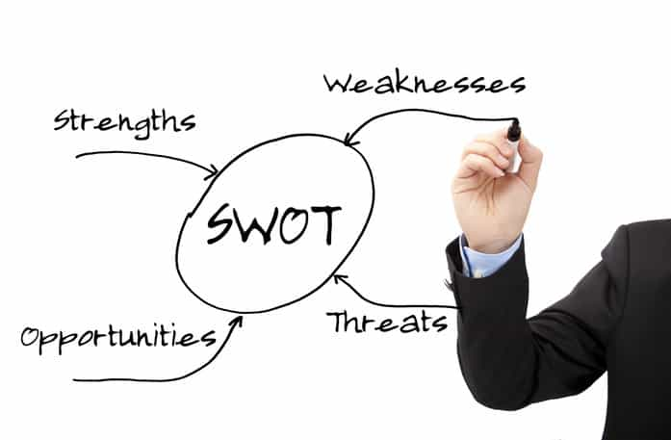

In this "SWOT" analysis we try to find out how Mercedes Benz may increase its power and improve external opportunities and responding quickly to external dangers. This method can be used to minimise a company's flaws, such as a drop in revenue and profitability.
Strengths is one part of SWOT analysis that contain Mercedes Benz advantageous internal activities, procedures, and behaviours. We can describe the Mercedes Benz strengths with some examples like earnings growth estimated (the revenue expectation is around 10 percent annual rate);performance in the Chinese Market( Mercedes-Benz sales grow by 60% automobiles in the third quarter, (‘Burger & Carey’ 2021).Also Mercedes-Benz is a champion in modernization, having invented diesel engines, “fuel injection”, and “anti-lock brakes” first. Mercedes Benz is a company that promote technology and innovation and develop many concepts like the electric cars (EQS),that have a special design with an advanced mechanization. Mercedes-Benz have strong fleet in the new markets that expects to grow quickly, thanks to a slew of new product introductions, including some high-value offering and his name is active in every country on the planet, thanks to its strong brands. Another strengths for Mercedes-Benz is the green market spreading this concept on new markets in collaboration with energy producer like ‘Enovos’ and ‘Statkraft’.
We can find weaknesses in this analysis like Mercedes- Benz's maintenance and service costs are excessive when compared to competitors such as BMW. (2020, Motor1.com)
The new technology like the EQC's introduction was plagued by numerous production issues, and the penalty for cheating on emissions when Mercedes-Benz (Daimler AG Group) receive a penalty for $1.5 billion by the “Environmental Protection Agency”, because a contravention in climate rules to avoid emissions testing.
Opportunities is one part of this analysis that refers to favourable environmental factors that may provide a comparative benefit to Mercedes Benz .One of the biggest opportunities for electric vehicles (EVs) is in China because this country has an objective to be ‘carbon neutral’ by 2060. Furthermore, by 2030, the country plans to minimise CO2 emissions. The company might seize this event by concentrating and developing an electric cars for a huge market in Asia (“McGrath, 2020”).
Another big opportunities for Mercedes Benz is the collaborations and partnerships with BMW because they put their relationship on hold in 2019 to work on autonomous driving technologies. By renewing the agreement, both companies may reinforce their cooperation in the sphere of automated vehicles in regarding safety and service offering. A great partnership Mercedes-Maybach is focusing on worldwide expansion potential, plans to treble transaction volume, and will produce electric expensive limousine.
The last part of Swot analysis is threats who means the challenges and changes that could appear in a company like Mercedes Benz. Competitors between comparable companies in the same sector, including Audi, BMW, and others, that are constantly striving to become the worldwide market leader, is greatest challenges for the Mercedes Benz as a corporation.
Because fuel Prices Have Risen Government rules restricting alternative fuels, such as compressed natural gas (CNG), Shell gas, and others, have a detrimental impact on stocks ("EPAct, 2001"). Because the prices for basic material are growing fast, this is the greatest threats to the automobile industry. Also the Costs of materials, Diversity, Fuel Efficiency is a threats for Mercedes Benz because BMW is less expensive in terms of model variety and fuel efficiency while still giving top performance and a wonderful driving experience (Carcody, 2021).

PEST ANALYSIS– MERCEDES BENZ

The PESTLE Analysis looks into the Mercedes-Benz strategies. The Mercedes-Benz operations are examined in terms of political, economic, social, and technological (PEST) aspects, in addition to legal and environmental considerations. Alternative fuels, such as compressed natural gas (CNG), Shell gas, and others, have a detrimental impact on stocks ("EPAct, 2001").
Political Factors
The Mercedes-Benz corporation is selling cars imported from other countries, and every automobile imported from another country will be taxed by our country's government. The price of an automobile will rise as a result of the tax, making it more expensive. This will have an indirect impact on Mercedes-Benz Company's sale.
Economic Factors
Economic factors will have an impact on our auto-mobile company since as the economy grows, so will customer income. This will enable them to bear the weight, and they will have enough money to purchase a better vehicle.
Many people will be unable to get a new car in this situation since they do not have enough spare cash to do so.
Social Factors
Social factors affect population growth, consumer behaviour, and lifestyle, as well as people's attitudes about work, quality of life, and so on. The growth of the population will have an impact on the Mercedes-Benz Company because as the population grows, so will the demand for Mercedes-Benz vehicles.
Technological Factors
As technology advances, the corporation has been able to cut its labour force, which has helped the company save money. They can also create more cars in a shorter period of time. Furthermore, technology aids in the promotion of the company's goods.

Business models like Porter’s Diamond, Five Forces and Value Chain are used in the context of Mercedes Benz environmental analysis (SWOT and PESTEL)

Porter’s Diamond model of Mercedes Benz is a strategy for identifying and developing the comparative benefit needed for global success and development.

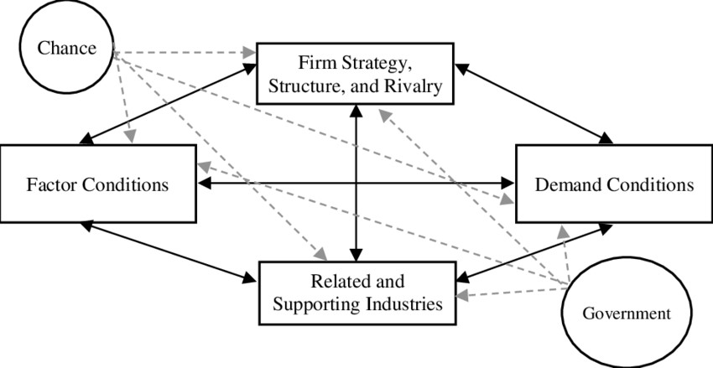
Porter's Diamond Model - Mercedes Benz

Factor conditions
Natural resources (the location include water channels ,easy to access);capital resources (Mercedes Benz uses internal resources); people resources(training programs, performance and achievements for the human resources at Mercedes Benz); scientific knowledge(technical and scientific knowledge can be found through national and international resources);technical innovation( help Mercedes Benz to reduce costs and enlarge the market);infrastructure (helps Mercedes Benz to grow and spread his network in the world).
Related and supporting industries
The presence of both helpful and competitive industry players provides good pressure on players to perform and expand through innovation and internationalisation. Mercedes-Benz has received a boost first from cooperation and manufacturing businesses, which also have allowed the firm achieve greater levels with every consecutive season.
The presence of the similar industry help Mercedes Benz to obtain materials for a good price. The support from domestic market and international market make Mercedes Benz to grow in this industry.
Another reason for the progress of Mercedes Bens is the rival industries. This presence is very important because helps the company to find new ways to perform and to discover international markets. The competition make Mercedes Benz to improve the technology.
One of the most important reason to have a strong international network for Mercedes Benz, who can distribute the products to the clients is to have strong global suppliers.
Strategy, structure, and rivalry
Mercedes Benz is a luxury company that promise to the clients a high quality of the products and a great satisfaction for the money that they spend. The structure of the Mercedes Benz organisation is open to free communication between the management and employees.
The competition with the local and global rivals had an important influence in the Mercedes Benz strategy. With the local rivals Mercedes Benz is force to create new technologies in the automobile construction and global competition allowed to predict global trends.
Government
The government policies help Mercedes Bens to grow and to expand his production and market around the world. Also the industry regulation helps Mercedes Benz to improve the production technology and efficiency.
Chance events
Chance events have included for Mercedes-Benz all type of events that affect in a good way (scientific discovery) or in a bad way (natural disasters).

Five Forces model of Mercedes Benz will assist us in determining how Mercedes-Benz compares to its candidates and how suppliers and customers are acting like collaborators .The Mercedes-Benz structure is determined by five forces.
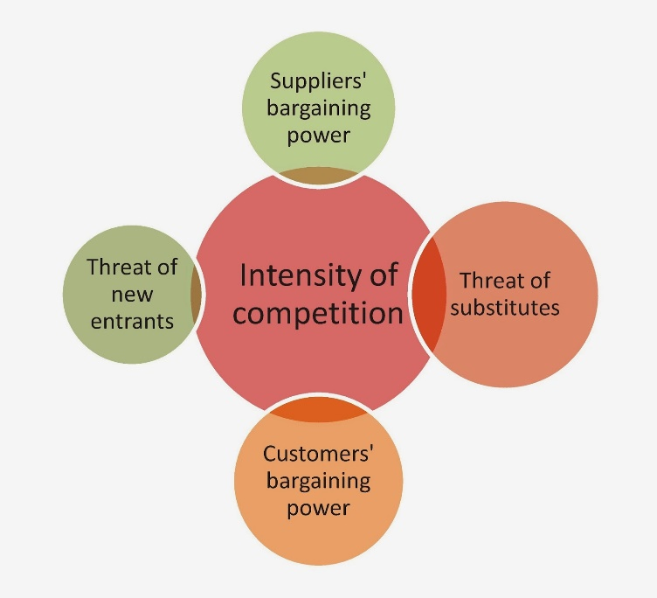
Threat of new entrants
New entrants into the auto sector are improbable, and the bulk of present high price and luxury vehicle firms, which including Mercedes Benz, are very strong brands on the market. For a newcomer lacking a global base and other advantages comparable to existing firms, competing against such tough opponents would be extremely difficult. Corporate reputation, wide selection, existing network infrastructure, scale of recognition, and other gain competitive advantage such as client satisfaction help to offset the threat of new competitors in the automotive business. Mercedes-Benz faces an extremely low overall threat from new entrants.
Bargaining strength of Mercedes-Benz customers
Clients with negotiating power usually cut prices, which limits Mercedes Benz capacity to create long-period profits.
Customers frequently haggle with us on price in order to get a better deal on a vehicle. Mercedes-profit Benz's will suffer as a result of this. Why will the buyer haggle over the price, and what are the chances? The first is that the buyer recognises that the number of individuals interested in purchasing a Mercedes car is limited, and that the buyer's purchasing power is greater, therefore they will bargain the price with the seller. The buyer then realises that there are still a lot of sellers selling Mercedes-Benz cars on the market, so they will haggle over the price with the seller. The final alternative is that the customer purchases multiple cars at the same time and bargains with the seller as a result. This is why the buyer and seller will haggle over the price.
The bargaining strength of Mercedes-Benz suppliers
Suppliers with a lot of negotiation power can get Mercedes-Benz to give them a better deal. Because of many of factors, like provider volume, segmentation; Mercedes Benz suppliers have limited negotiation strength. Daimler AG, for example, works with vendors from all over the world, including China and Brazil. Several probably remain on huge organisations such Mercedes-Benz for a significant percentage of their business, and if these massive corporations quit consuming materials from them during a constant schedule, their earnings would drop. As a result, Mercedes-Benz seems to have a lot of negotiating power with its providers and sets the regulations for either of them to follow.
The current players' rivalry
When the competition is severe, incumbent players like Mercedes-Benz have a hard time being profitable in the long run. Premium and luxury automobile manufacturers include GM, Volkswagen, BMW, and Tesla, to name a few. Even though the automobile sector is very large, most of the companies have a combative marketing and strategies. In this field of the Mercedes-Benz company, competition is limited by aspects of brand reputation, technology development, advertising, customer commitment, and an understanding of consumer satisfaction.
Threatening “substitute products and services”
If reserves are a serious threat, Mercedes-Benz must continue to invest in research and development or have a big risk to lose clients because of the competitors. The buyer will be more likely to substitute products such as BMW or Jaguar, because they are of similar quality and BMW or Jaguar may provide more options than Mercedes-Benz. Aside from that, comparable substitute products will be less expensive than Mercedes-Benz. They can find a better deal on a product of the same quality for a lower price. People will desire a product of higher quality at a lower cost. As a result, several companies will be compared in order to obtain a superior product and service.

Value Chain Analysis for Mercedes-Benz

Value Chain, often known as "Porter's Value Chain Framework," is a popular tool for analysing a company's important activities and identifying sources of competitive advantage.
In the Value Chain diagram for Mercedes-Benz we can find five types of primary activities.

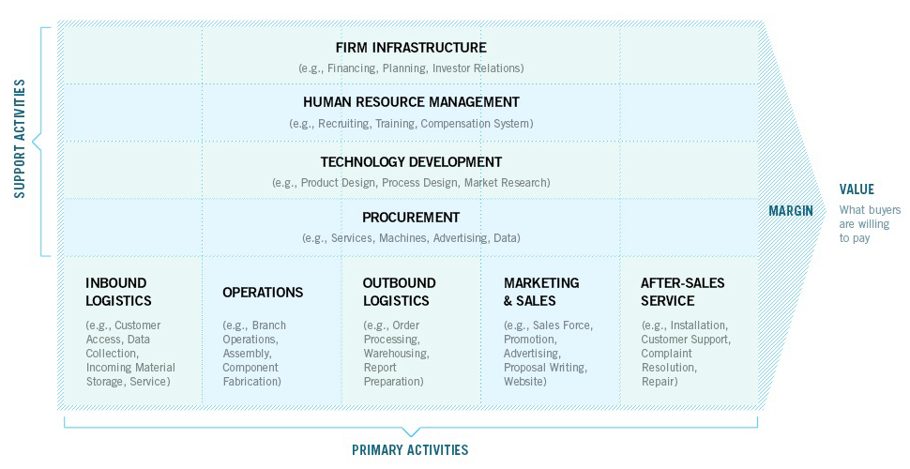

Support Activities in Mercedes Benz Value Chain

Inbound Logistics is the process at Mercedes-Benz that consists in obtaining, holding, disseminating material resources are all part Equipment and technology, specific item warehousing, architectural design for something like a multimedia business's customer data collection and storage are all possibilities. The preponderance of Mercedes-inbound Benz's logistics activities are currently outsourced.

Operations include actions which help throughout the production process into final products The phrase "plastic moulding" encompasses both the technique of forming polycarbonate for create products including the use of client information to target advertisements to clients depending on their browsing patterns.

For the Outbound Logistics Mercedes-Benz takes these procedures to ensure that channel partners and end consumers receive completed products. Order fulfilment, warehousing, distribution networks, processing, and scheduling are some of the responsibilities of outbound logistics workers
Marketing and sales-these are activities that are carried out by Mercedes-Benz in attempt to provide customers with a wide range of product possibilities. Some of the operations that fall under this area are company sales management, pricing, marketing, channel selection, advertising, and promotion.
Because they want the product to have success, Mercedes-Benz arrange after-sales services and maintenance. Mercedes-Benz service activities include components delivery, technical services, training, update for new software, and maintenance after they sale the vehicles.

Conclusion

Mercedes-Benz is one of the most popular luxury brands in the automotive industry, setting new benchmarks for comfort, luxury, and comfort. I believe that Mercedes-new Benz's strategy will assist them in increasing profits. Mercedes-Benz caters to a diverse spectrum of market clients while simultaneously addressing the needs of the general public. The profit of Mercedes-Benz could reach new heights as a result of this strategy. This new strategy should boost the commercial performance and to increase the production. Because of these changes like reducing the cost and industrial footprint, Mercedes Benz have a strong position on the market. With this plan, the corporation declares its commitment to fully electrifying its fleet and its desire to be sure that the company is ‘carbon-neutral’ by 2039, as set out in the ambitious projects.

References

Autovista Group, (2020) BMW and Mercedes Autonomous partnership on hold (online). Available at: https://autovistagroup.com/news-and-insights/bmw-and-mercedes-benz-autonomous-driving-partnership-hold [May, 2021]

Burger, L., Carey, N. (2021), Mercedes sales in China help accelerate Daimler profit, Reuters, (online). Available at: https://www.reuters.com/business/autos-transportation/daimlers-q1-earnings-beat-market-expectations-prices-china-2021-04-16/ [May, 2021]

CBC NEWS, (2020) Mercedes-Benz fined $1.5 billion for emission cheating (online). Available at: https://www.cbsnews.com/news/mercedes-benz-emissions-cheating-1-5-billion-fine-daimler/ [May, 2021]

Carcody, (2021) BMW Vs Benz: This is the clear winner for 2021 (online). Available at: https://carcody.com/bmw-vs-mercedes/#:

Bakan, I. and Doğan, İ.F., 2012. Competitiveness of the industries based on the Porter’s diamond model: An empirical study. International Journal of Research and Reviews in Applied Sciences, 11(3), pp.441-455.

Demirbas, D., Wilkinson, L. and Bennett, D., 2018. Supplier relations impact within the UK automotive industry. Benchmarking: An International Journal, 25(8), pp.3143-3161.

UK Automotive Industry. 2022. UK Automotive Industry.Available at: <https://www.smmt.co.uk/industry-topics/uk-automotive/> [January 2021].

Fainshmidt, S., Smith, A. and Judge, W.Q., 2016. National competitiveness and Porter's diamond model: The role of MNE penetration and governance quality. Global Strategy Journal, 6(2), pp.81-104.
Harding, S., 2017. MBA management models. Routledge.
Johnson, G., 2016. Exploring strategy: text and cases. Pearson Education.

Ozgen, E., 2011. Porter's diamond model and opportunity recognition: a cognitive perspective. Academy of Entrepreneurship Journal, 17(2), p.61.

Rothaermel, F.T., 2016. Strategic management: concepts (Vol. 2). McGraw-Hill Education.
Rugman, A.M. and Verbeke, A., 2017. Global corporate strategy and trade policy. Routledge.

Smit, A.J., 2010. The competitive advantage of nations: is Porter’s Diamond Framework a new theory that explains the international competitiveness of countries. Southern African Business Review, 14(1).

Thompson, A., Strickland, A.J. and Gamble, J., 2015. Crafting and executing strategy: Concepts and readings. McGraw-Hill Education.

Vlados, C., 2019. Porter’s diamond approaches and the competitiveness web. International Journal of Business Administration, 10(5), pp.33-52.

Epstein, M.J., 2018. Making sustainability work: Best practices in managing and measuring corporate social, environmental and economic impacts. Routledge.

Sinfield, J.V., Calder, E., McConnell, B. and Colson, S., 2012. How to identify new business models. MIT Sloan management review, 53(2), pp.85-90.

Morden, T., 2016. Principles of strategic management. Routledge.

Alkhafaji, A. and Nelson, R.A., 2013. Strategic management: formulation, implementation, and control in a dynamic environment. Routledge.

