UNIVERSITY OF WALES TRINITY SAINT DAVID
MSc Cybersecurity and Digital Forensics
FinSure Bank (FSB)
Integrated Security Governance Report
ACCA7028 — Data Security, Governance and Compliance
Student Name: | Rajul Gupta
Student ID: | 2523934
Module Code: | ACCA7028
Lecturer: | Dr Ayman Al Hajjar
Submission Date: | 29 April 2026

Abstract
FinSure Bank’s unchecked technological expansion, with over 90% of its infrastructure hosted offsite and no formal BYOD regulation, has eliminated its traditional security perimeter. This paper critically evaluates ISO/IEC 27001:2022 and ITIL 4, determines that they are individually inadequate, and proposes an FSB Integrated Security Governance Model incorporating Zero Trust Architecture (NIST SP 800-207) driven by AI-based risk assessment. It further argues that GDPR, DORA, and the UK Cyber Security and Resilience Bill must be treated as essential defensive infrastructure rather than an administrative burden.
Keywords — ISO/IEC 27001:2022; ITIL 4; Zero Trust Architecture; GDPR; DORA; BYOD; Financial Security Governance

1. Introduction
Data security, governance, and compliance are the three pillars of institutional viability. Data security maintains the confidentiality, integrity, and availability of information assets; governance operationalises security intent into coordinated institutional activity; and compliance ensures that multi-jurisdictional regulatory requirements are met. Together, they provide the infrastructure for institutional resilience against limitless, adaptive, and increasingly automated adversaries. FinSure Bank’s technology-led growth has outpaced its risk management capabilities. An informal BYOD policy has eliminated the perimeter on which traditional security architecture depends. The absence of a formal risk strategy and compliance audits creates significant insider risk, unchecked data leakage, and potential regulatory insolvency.
This report develops an integrated security governance model for FSB. The objectives are to: (1) critically analyse ISO/IEC 27001:2022 and ITIL 4 within FSB’s operational scope; (2) compose an integrated framework addressing BYOD, risk governance, and third-party accountability; and (3) argue why regulatory evolution is a necessity rather than an imposition.

Assumptions
A.1 FSB operates a multi-cloud environment with significant technical debt.
A.2 Executive willingness and funding exist for remediation.
A.3 FSB serves EU and UK customers; GDPR, DORA, and the UK Cyber Security and Resilience Bill therefore apply simultaneously.
A.4 No unified governance currently exists, making this an additive intervention.
A.5 FSB employs a mixed workforce of employees, contractors, and third-party partners with varying levels of technical capability.
A.6 The proposed model is to be implemented within a 12-month remediation timeline.
2. Critical Evaluation of Security Frameworks
2.1 ISO/IEC 27001:2022
ISO/IEC 27001:2022 mandates a structured approach to implementing and managing an Information Security Management System (ISMS) [1]. Its auditable, risk-based approach requires organisations to categorise information assets, conduct risk assessments, and maintain evidence of control effectiveness. Controls 5.23 (Cloud Services) and 5.7 (Threat Intelligence) are the two most pertinent 2022 additions for FSB, providing a baseline against cloud-specific threats.
ISO 27001’s core weakness is its technology-neutral nature — prescribing what must be protected, not how controls should be engineered. Disterer (2013) identifies this as ‘symbolic adoption’: certification used as proof of compliance rather than genuine security improvement [7]. FSB risks creating a ‘paper shield’ that satisfies auditors whilst failing against real attackers.
2.2 ITIL 4
ITIL 4 reframes IT service management within the Service Value System, standardising the operational workflows through which security policies are enacted: incident response, change enablement, and supplier coordination [2]. Embedding Information Security Management as a formal ITIL practice — measured through Practice Success Factors — converts ISO 27001’s abstract controls into repeatable, measurable daily operations.
However, ITIL 4 is not a security architecture. It treats information security as one practice among thirty-four, with insufficient depth in cryptographic design, identity federation, and advanced threat detection — the precise disciplines FSB requires. Operational efficiency without security architecture produces well-managed but fundamentally insecure configurations [8].
2.3 Integration and NIST CSF 2.0
ISO 27001’s structural lack of operational detail is addressed by the operational granularity of ITIL 4. According to Kekgathetse et al. (2024), the adoption of multiple frameworks eliminates the blind spots created by the weaknesses of any single framework [8]. A gap nevertheless remains: linking strategy directly to enterprise risk governance at the board level. NIST CSF 2.0 (2024) adds a Govern function that directly connects enterprise risk to board-level governance, providing the strategic linkage that both ISO and ITIL lack [16]. Integrated rationale is presented in Table I; a critical comparison is provided in Table II.
TABLE I — FSB Integrated Security Framework Model
Layer | Framework Component | Function for FSB
Strategic Governance | ISO/IEC 27001:2022 ISMS | Risk appetite, control catalogue, audit evidence, regulatory alignment
Operational Execution | ITIL 4 Service Value System | Incident management, change enablement, supplier operations, PSFs
Technical Enforcement | NIST SP 800-207 Zero Trust + AI Monitoring | Identity verification, least-privilege access, continuous behavioural analytics
Table I: FSB integrated security framework derived from ISO/IEC 27001:2022 [1], ITIL 4 [2], and NIST SP 800-207 [3].
TABLE II — Critical Framework Comparison for FSB
Framework | Primary Role | Key Strength for FSB | Core Limitation
ISO/IEC 27001:2022 | Governance & ISMS | Auditable risk-based controls; cloud-specific 2022 additions | Technology-neutral; prescribes what, not how
ITIL 4 | Operational Service Mgmt | Embeds security into repeatable daily IT operations | Not a security architecture; lacks cryptographic depth
NIST SP 800-207 (ZTA) | Technical Enforcement | Continuous verification; ideal for BYOD and cloud-native FSB | Implementation complexity across legacy APIs
NIST SP 800-30 | Risk Assessment | Structured continuous risk lifecycle for real-time posture | Guidance only; no certifiable compliance outcome
Table II: Comparative evaluation of frameworks adopted for FSB. Source: synthesised from [1][2][3][16].
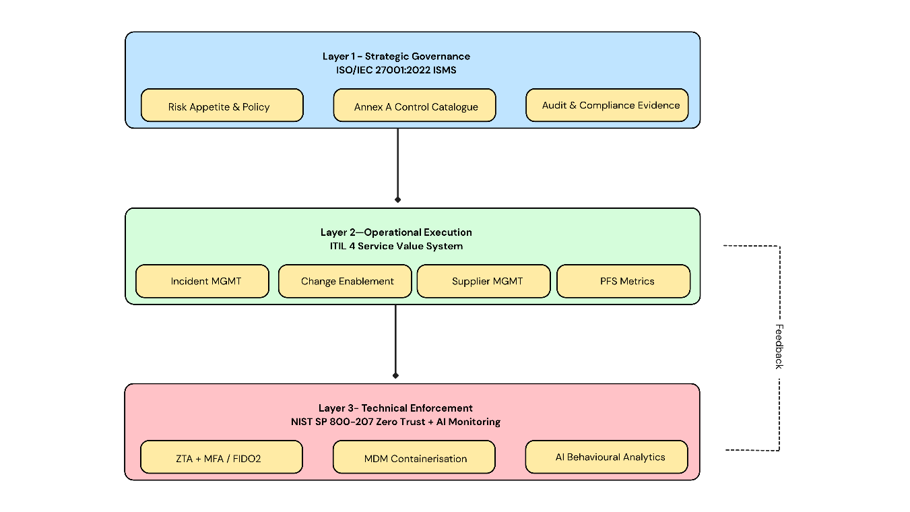
Fig. 1: Three-layer integrated security governance architecture derived from ISO/IEC 27001:2022 [1], ITIL 4 [2], and NIST SP 800-207 [3].

3. Custom Security Governance Model for FSB
The FSB Integrated Security Governance Model comprises eight interlinked pillars grounded in regulatory compliance and academic research, collectively progressing FSB towards measurable cyber resilience.
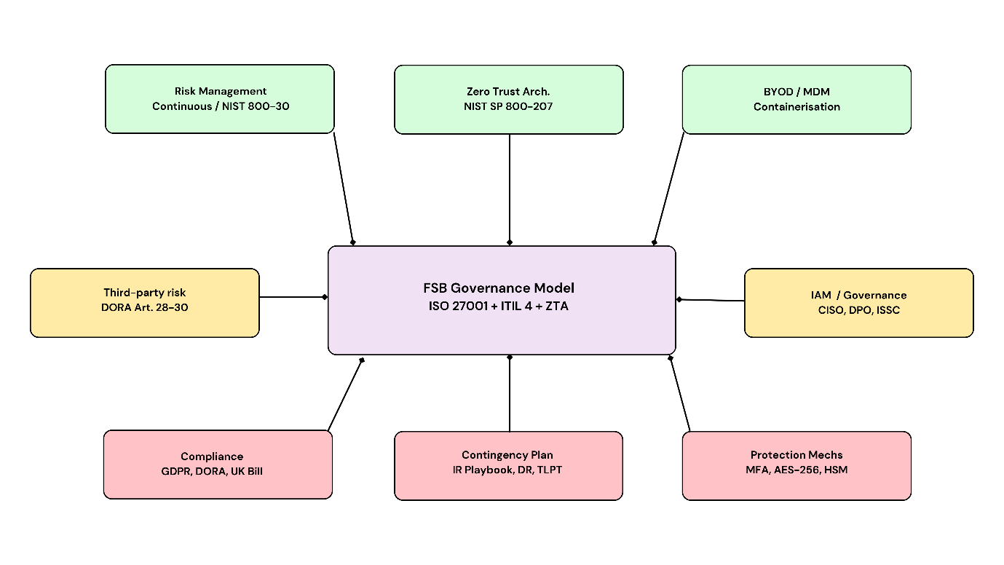

Fig. 2: The eight-pillar FSB Integrated Security Governance Model.

3.1 Continuous Risk Management
Annual risk assessments are actively harmful to FSB — they create a register that is out of date from the moment of generation. FSB needs to shift to the continuous risk lifecycle described in NIST SP 800-30 Rev. 1 [10], supplemented by machine learning behaviour analysis for real-time risk posture monitoring. Asmar and Tuqan (2024) demonstrate how Recurrent Neural Networks can detect insider attacks and DDoS attacks before compromise occurs [11]. Figure 3 presents the risk matrix for FSB, ranking the six highest identified risks by impact and likelihood to underpin the control selection illustrated in Table V.

FIGURE 3 — FSB Risk Matrix: Likelihood vs. Impact (R1–R6)
Likelihood / Impact | Low | Medium | High | Critical
Certain |  |  |  | GDPR non-compliance (R6)
High |  |  | BYOD compromise (R1) | Cloud breach (R2)
Medium |  |  | API abuse (R5) | Insider threat (R3)
Low |  |  |  | Ransomware (R4)
Figure 3: FSB risk matrix. Red = critical; Amber = high. Risks R1–R6 correspond to Table V. Source: adapted from NIST SP 800-30 [10] and ISO 27001 [1].
3.2 Zero Trust Security Architecture
The traditional perimeter model fails for an organisation where 90% of infrastructure is cloud-hosted, and access originates from unmanaged devices. FSB must implement Zero Trust Architecture in accordance with NIST SP 800-207: ‘never trust, always verify’ across the entire access lifecycle [3]. All requests are evaluated by a Policy Decision Point (PDP) and enforced by Policy Enforcement Points (PEPs). Joshi (2025) confirms that ZTA maturity directly reduces breach severity for cloud-native organisations [12]. Daah et al. (2023) propose a ZTA framework specifically adapted to financial institutions, with micro-segmentation as a core control [14].
TABLE III — FSB Zero Trust Architecture: Access Verification Flow
Stage | Component | Action | Outcome
1 | Identity Provider | MFA / FIDO2 credential validation; SSO session scoping | Identity verified
2 | Device Health Check | MDM compliance posture, OS patch level, jailbreak detection | Device trusted or quarantined
3 | Policy Decision Point | Contextual risk score; role-based access matrix; sensitivity classification | Access policy selected
4 | Policy Enforcement Point | Least-privilege, time-limited, micro-segmented access grant or denial | Resource access controlled
5 | Continuous Monitoring | AI behavioural analytics; session anomaly detection; auto revocation trigger | Ongoing trust recalculation
Table III: Zero Trust access verification flow. Adapted from NIST SP 800-207 [3] and Hussain et al. (2024) [13].
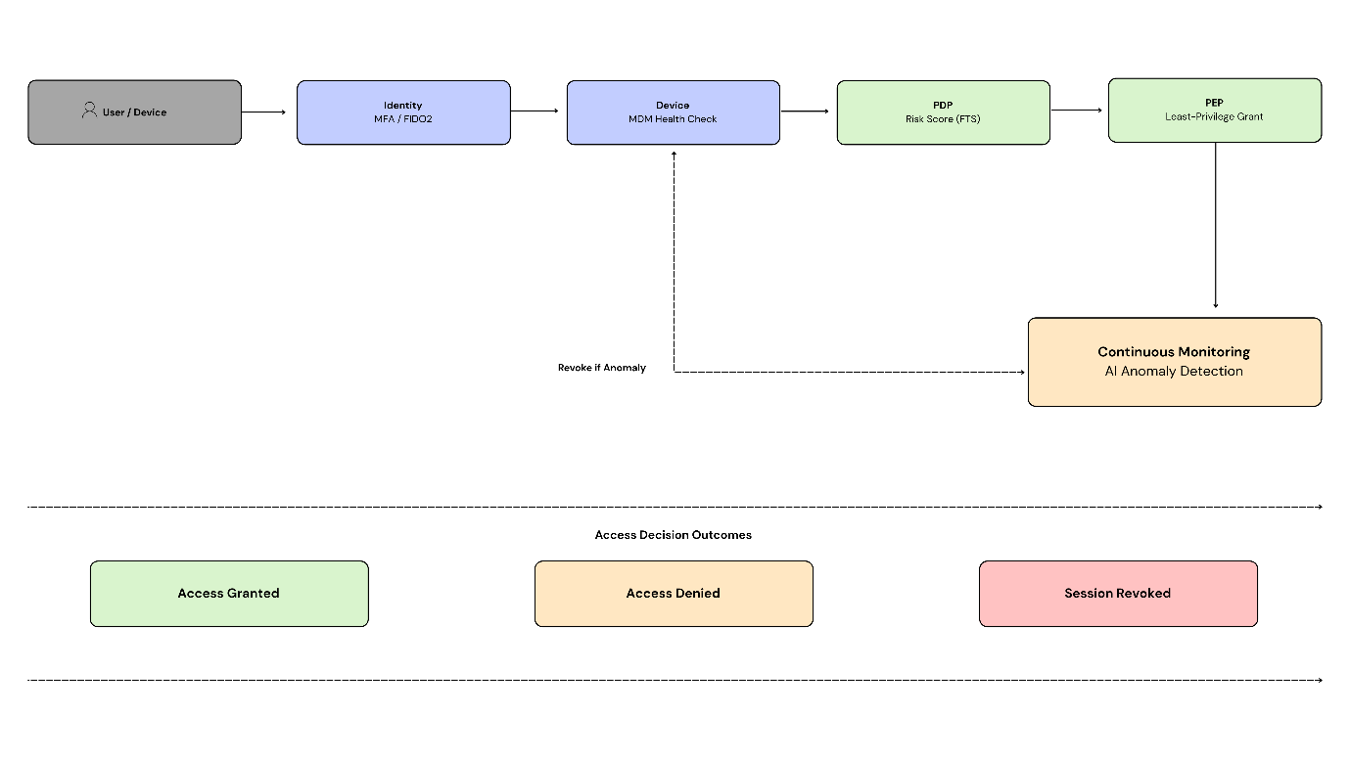
Fig. 4 — Zero Trust Access Verification Flow. Adapted from NIST SP 800-207 [3] and Hussain et al. (2024) [13]
3.3 Cryptographic Controls and API Security
Multi-factor authentication must be phishing-resistant and universally mandated across FSB. All data at rest and in transit must utilise AES-256 encryption. Service-to-service communications must use capability-based API gateways to control and secure all internal communications. FIDO2/WebAuthn, combined with Cloud Hardware Security Modules (HSMs) to which only FSB holds access keys, represents the mandatory minimum complement to AES-256; without these controls, Zero Trust enforcement would be impractical [15].
All FSB APIs and microservices must enforce TLS 1.3, with immediate deprecation of TLS 1.2. Automatic certificate lifecycle management is required to eliminate vulnerabilities arising from expired certificates. All API keys and secrets must be stored within Cloud HSMs and must never be placed within code repositories or environment variables. Keys must be rotated at intervals not exceeding 90 days, with immediate rotation on any personnel change or any indication of key compromise, in accordance with NIST SP 800-57 [17]. For FSB, a single exposed key or certificate is not a minor operational issue — it constitutes notification of a GDPR Article 33 violation and a potential DORA financial penalty. The controls listed above therefore, represent the minimum viable security baseline, not merely best-practice recommendations.
3.4 Security Governance Structure
An Information Security Steering Committee (ISSC) should be formalised, chaired by the Chief Executive Officer with the Chief Information Security Officer (CISO) and the Data Protection Officer (DPO — mandated by GDPR Article 37 [4]) as standing members. The CISO should report directly to the Board, not to the Chief Technology Officer, thereby framing security as a financial risk discipline rather than an IT operational matter. The ISSC should convene quarterly, with agenda items including: review of the risk register; control performance metrics; and post-incident reviews. Key Performance Indicators (KPIs) should be embedded within executive performance evaluations to ensure that Board-level accountability flows through all levels of the organisation.
3.5 Third-Party Risk Management and Service Level Agreements
Given that over 90% of FSB’s infrastructure is outsourced, third-party risk management represents the organisation’s highest operational priority. FSB cannot delegate ICT third-party risk management in accordance with Articles 28–30 of DORA [5]. Service Level Agreement (SLA) obligations for third parties must include confirmation of data ownership, the right to audit, the provision of SOC 2 Type II reports, and disclosure of any subcontracted parties, as specified in Table IV. The operational failure of a cloud provider constitutes a regulatory failure for FSB. Any vendor unwilling to sign an SLA that meets Table IV parameters is incompatible with FSB’s compliance requirements and must not be engaged.
TABLE IV — FSB Mandatory SLA Requirements
SLA Parameter | Target | Regulatory Basis
Core banking system uptime | 99.95% minimum | DORA operational resilience mandate
Recovery Time Objective (RTO) | ≤ 4 hours | DORA Art. 12; business continuity requirement
Recovery Point Objective (RPO) | ≤ 1 hour | GDPR data integrity; DORA Art. 12
ICT incident notification to FSB | ≤ 24 hours | DORA Article 19
GDPR supervisory authority notification | ≤ 72 hours | GDPR Article 33
Third-party security audit cycle | Annual minimum | DORA Art. 28–30; right-to-audit clause
Data portability on contract termination | ≤ 72 hours | GDPR data portability; contractual obligation
Table IV: Minimum SLA obligations for all FSB cloud and ICT third-party providers. Source: [4][5].
3.6 BYOD and Mobile Device Management
Unmanaged BYOD devices represent the largest attack surface on FSB’s systems. All personal devices used to access FSB resources must be enrolled in a Mobile Device Management (MDM) solution with cryptographic containerisation, whereby sensitive corporate data is held within an encrypted vault and network access is denied to non-compliant or jailbroken devices. Conditional access, identified by Ratchford et al. (2022) as the dominant BYOD mitigation strategy, must be implemented [9]. Employees should be clearly informed that only corporate data is subject to monitoring, supported by a robust Acceptable Use Policy.
3.7 Regulatory Compliance and Ethics
3.7.1 General Data Protection Regulation (GDPR)
GDPR mandates data minimisation, privacy by design, Data Protection Impact Assessments (DPIAs), and the appointment of a DPO for organisations processing personal data at scale [4]. Non-compliance carries penalties of up to 4% of global annual turnover. FSB must implement privacy by design across all product development and ensure all data processing activities are documented, lawful, and proportionate.
3.7.2 Digital Operational Resilience Act (DORA)
DORA, effective January 2025, imposes direct, non-delegable ICT risk management obligations on financial institutions and their critical third-party providers [5]. It mandates Threat-Led Penetration Testing (TLPT), ICT incident notification within 24 hours, and maintenance of ICT third-party risk registers. DORA explicitly prevents FSB from treating cloud provider failures as solely a vendor responsibility; such failures are treated as the institution’s own regulatory risk.
3.7.3 UK Cyber Security and Resilience Bill
The UK Cyber Security and Resilience Bill (2024–26) extends compliance obligations to critical suppliers and mandates the reporting of significant cyber incidents to the relevant supervisory authority [6]. FSB must ensure that its supply chain is assessed against these obligations and that its incident notification procedures are aligned with the Bill’s requirements.
3.7.4 Ethical Considerations
MDM deployment and AI-based monitoring must operate on the principle of minimum data footprint, collecting only data that directly relates to enterprise activity. Ethically, effective security awareness training reduces the insider threat by cultivating a culture of responsibility; conversely, coercive, surveillance-heavy enforcement increases the insider threat by undermining employee trust and organisational morale. FSB must balance robust monitoring with proportionate, transparent governance to fulfil both its legal obligations and its duty of care to employees.
3.8 Contingency Planning and Implementation Roadmap
FSB must maintain air-gapped, immutable backups of all critical data, together with a tested Business Continuity Plan (BCP) and Disaster Recovery Plan (DRP), achieving a Recovery Time Objective (RTO) of no more than four hours and a Recovery Point Objective (RPO) of no more than one hour for critical banking systems [5]. Compliance testing must move beyond paper-based audit: DORA Threat-Led Penetration Testing must be conducted annually, and incident notification procedures must be validated through live quarterly testing to ensure that GDPR Article 33’s 72-hour supervisory notification [4] and DORA Article 19’s 24-hour ICT incident notification [5] obligations can be reliably met. For FSB, an undocumented or untested plan is equivalent to no plan at all — only live quarterly testing can verify that recovery objectives and notification deadlines are genuinely achievable.

TABLE V — FSB Risk Register: Impact, Control and Framework Mapping
ID | Risk | Impact | Control / Mitigation | Framework Mapping
R1 | Unmanaged BYOD device compromise | High: data exfiltration, ransomware lateral movement | MDM + containerisation; conditional access; ZTA device health checks | ISO 27001 (A.8.1); NIST SP 800-207; ITIL 4
R2 | Cloud provider outage or breach | Critical: systemic service loss, regulatory penalties | Right-to-audit SLAs; multi-cloud failover; immutable DR backups | DORA Art. 28–30; ISO 5.23; ITIL 4 Continuity
R3 | Insider threat and credential abuse | High: unauthorised access to financial ledgers and PII | AI behavioural analytics; ZTA least-privilege; FIDO2 MFA | NIST SP 800-30; GDPR Art. 32; ISO 27001 (A.5.16)
R4 | Ransomware encryption of critical data | Critical: permanent data loss, operational failure | Immutable backups; ZTA microsegmentation; TLPT; IR playbook | ISO 27001 (A.8.13); UK Cyber Bill; DORA TLPT
R5 | API abuse or broken authentication | High: data leakage, financial fraud | Capability-based API gateways; AES-256; HSM key management | ISO 27001 (A.8.10); GDPR Art. 32; ITIL Change Mgmt
R6 | Regulatory non-compliance | Critical: fines up to 4% global annual turnover | Privacy-by-design; DPIAs; GRC platform; unified compliance strategy | GDPR; DORA; UK Cyber Security and Resilience Bill
Table V: FSB risk register. Source: adapted from NIST SP 800-30 [10], ISO/IEC 27001:2022 [1], GDPR [4], and DORA [5].

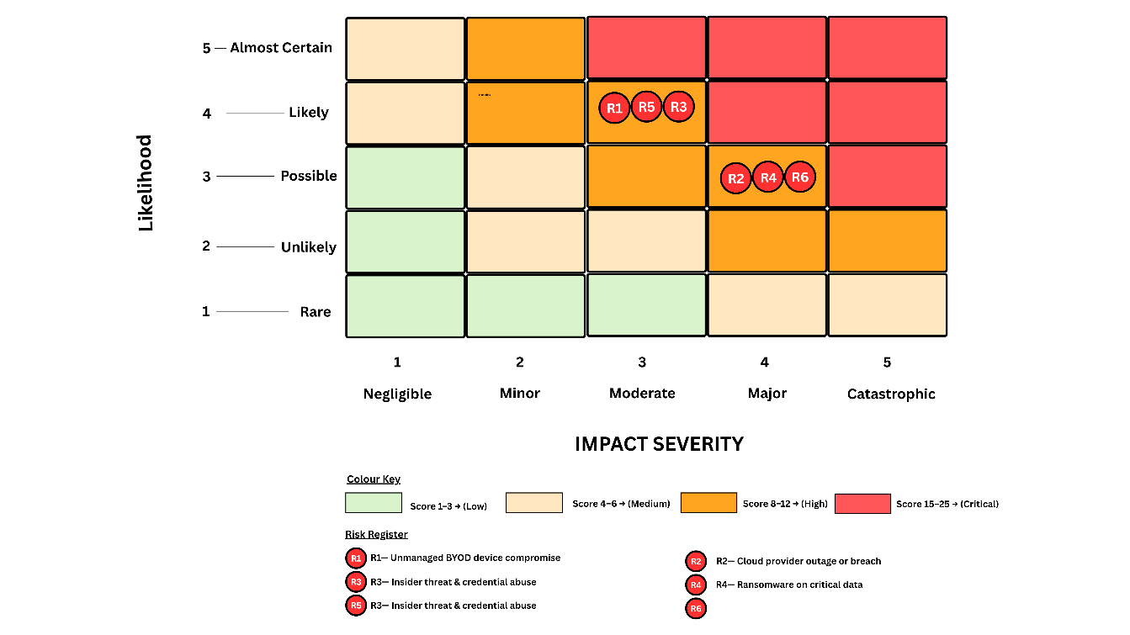
Fig. 5: FSB risk heatmap showing severity classification for risks R1–R6.
4. Critical Discussion: The Necessity of Evolving Regulation
Static regulatory frameworks cannot protect institutions against a threat environment evolving at machine speed. Generative AI-enabled malware and automated zero-day exploitation can be weaponised within days of a new technology’s release — a pace that no fixed standard can match.
4.1 Why Static Standards Fail
The 2013 iteration of ISO/IEC 27001 contained no controls for cloud security, threat intelligence, or data leakage prevention. Organisations certified under it operated for nearly a decade without controls addressing their most critical threats [1]. Disterer (2013) terms this ‘symbolic adoption’ — an institutional self-deception that satisfies auditors whilst exposing organisations to real attackers [7]. Static standards do not merely fail to protect; they actively certify complacency.
4.2 DORA, AI Threats, and Supply Chain Risk
DORA’s implementation in January 2025 reflects an observed systemic reality: cloud concentration means that a single successful attack could simultaneously disable dozens of financial institutions [5]. DORA’s non-delegable ICT risk accountability, TLPT mandate, and third-party risk registers fill the governance vacuum that neither GDPR nor ISO 27001 was conceived to address. Beyond cloud risk, AI-enabled deepfake authentication attacks now necessitate hardware-based MFA as a regulatory minimum, and AI-generated phishing via large language models demands continuous, human-centric security awareness training embedded within institutional culture [16]. Supply chain liability is shifting equally: regulators increasingly treat third-party ICT failures as the institution’s direct regulatory risk rather than a delegable vendor obligation.
4.3 Limitations: Compliance Fatigue and Regulatory Lag
Concurrent obligations under GDPR, DORA, NIS2, PSD2, and the UK Cyber Security and Resilience Bill impose a disproportionate burden on smaller digital banks without dedicated compliance functions [9]. Furthermore, even current standards lag behind emerging threats: neither GDPR nor DORA mandates post-quantum cryptographic standards, despite quantum computing presenting a credible near-term threat to RSA and ECC encryption across the entire financial sector [15]. These limitations reinforce rather than undermine the case for regulatory evolution — FSB must treat existing regulations as a floor, not a ceiling, adopting NIST post-quantum cryptography standards proactively ahead of any formal regulatory requirement.

5. Conclusion
FSB’s digital transformation has produced a governance gap that represents an existential institutional risk. Neither ISO/IEC 27001:2022 nor ITIL 4 — individually or integrated — can secure a decentralised, BYOD-dependent financial institution against the combined pressure of GDPR, DORA, and the UK Cyber Security and Resilience Bill [1][2][4][5][6]. The proposed FSB Integrated Security Governance Model addresses this through three layers: ISO 27001 controls providing the governance framework; ITIL 4 value streams operationalising those controls in daily practice; and Zero Trust Architecture — via AI-driven monitoring, FIDO2 MFA, AES-256 encryption, MDM containerisation, and immutable backups — transforming policy into adaptive defence [1][2][3][11][13].
Regulatory compliance is an outcome of sound governance, not a standalone objective. GDPR, DORA, and the UK Cyber Security and Resilience Bill are mandatory enablers essential to closing FSB’s governance gap [4][5][6]. Limitations exist: ZTA implementation carries high cost and architectural complexity, and AI monitoring systems require ongoing human oversight to manage false positives and model drift. FSB must choose between building resilience now and awaiting an inevitable breach.

References
[1] International Organisation for Standardisation (ISO), ISO/IEC 27001:2022 Information Security, Cybersecurity and Privacy Protection. Geneva: ISO, 2022.
[2] Axelos, ITIL Foundation: ITIL 4 Edition. London: TSO, 2019.
[3] National Institute of Standards and Technology (NIST), Zero Trust Architecture, Special Publication 800-207. Gaithersburg, MD: NIST, 2020.
[4] European Union, General Data Protection Regulation, Regulation (EU) 2016/679. Official Journal of the European Union, 2016.
[5] European Parliament and Council, Regulation (EU) 2022/2554 on Digital Operational Resilience for the Financial Sector (DORA). Official Journal of the European Union, 2022.
[6] UK Parliament, Cyber Security and Resilience (Network and Information Systems) Bill 2024–26. London: House of Commons Library, 2025.
[7] G. Disterer, “ISO/IEC 27000, 27001 and 27002 for Information Security Management,” Journal of Information Security, vol. 4, no. 2, pp. 92–100, 2013.
[8 M. B. Kekgathetse, B. Lucas, and M. Sebapalo, ‘A Systematic Review on Cyber Security Integration in Information Technology Governance,’ IEEE Conference Proceedings, 2024.
[9] M. Ratchford, O. El-Gayar, C. Noteboom, and Y. Wang, ‘BYOD security issues: A systematic literature review,’ Information Security Journal: A Global Perspective, vol. 31, no. 3, pp. 253–273, 2022.
[10] National Institute of Standards and Technology (NIST), Guide for Conducting Risk Assessments, Special Publication 800-30 Rev. 1. Gaithersburg, MD: NIST, 2012.
[11] M. Asmar and A. Tuqan, ‘Integrating machine learning for sustaining cybersecurity in digital banks,’ Heliyon, vol. 10, no. 17, p. e37571, 2024.
[12] H. Joshi, ‘Emerging technologies driving zero trust maturity across industries,’ IEEE Open Journal of the Computer Society, vol. 6, pp. 25–36, 2025.
[13] M. Hussain, S. Pal, Z. Jadidi, E. Foo, and S. Kanhere, ‘Federated Zero Trust Architecture using Artificial Intelligence,’ IEEE Wireless Communications, vol. 31, no. 2, pp. 30–35, 2024.
[14] T. Daah, A. Qureshi, and A. Awan, ‘Zero Trust Model Implementation Considerations in Financial Institutions: A Proposed Framework,’ in Proc. IEEE International Conference on Future Internet of Things and Cloud (FiCloud), Marrakesh, Morocco, 2023, pp. 71–77, doi: 10.1109/FiCloud58648.2023.00019.
[15] N. Bindel, C. Cremers, and M. Zhao, ‘FIDO2, CTAP 2.1, and WebAuthn 2: Provable security and post-quantum instantiation,’ in Proc. IEEE Symposium on Security and Privacy (S&P), San Francisco, CA, May 2023, pp. 1471–1490.
[16] National Institute of Standards and Technology (NIST), The NIST Cybersecurity Framework (CSF) 2.0, NIST CSWP 29. Gaithersburg, MD: NIST, 2024.
[17] National Institute of Standards and Technology (NIST), Recommendation for Key Management, Special Publication 800-57 Part 1 Rev. 5. Gaithersburg, MD: NIST, 2020.

