Group Project ACDA5017 BEng Embedded Electronics
Dead Reckoning Tracking Device Portfolio
Zakir Basit (2321771), Rowan Patey(2317629), EDWARD BULPITT (2317250), LEWY HARRISON (2321772)
2025

Table of contents

Table of contents 1
Table of Figures 3
Introduction 4
Aim/Research Question 4
Objectives 4
Target market 4
Literature and technical review 5
IMU 5
GNSS 5
Dead-Reckoning 5
LoRa 6
Legal, Ethical and Safety Considerations 6
Methodology and Project Management 7
Development Model 7
Customer Requirements 7
Success Evaluation 8
Initial Gantt Chart 8
Final Gantt Chart 9
Design 10
Hardware Architecture 10
Microcontroller – Adafruit Feather RP2040 RFM95 10
LoRa Transceiver – RFM95 10
GNSS Receiver – Adafruit Ultimate GPS module 11
9-DOF – Adafruit Absolute Orientation BNO085 11
Barometric sensor – BMP280 (AZdelivery) 11
10-DOF – DFRobot 10-DOF MEMs IMU 11
Button, Battery, Power Switch 12
Software Architecture 12
Risk Analysis 13
Bill of Materials 13
Implementation 13
Lab access 13
Breadboarding 14
Firmware Development 14
GNSS 15
LoRa 16
9-DOF 18
Stride length calculation 19
Geomagnetic rotational vector for heading 20
10-DOF 21
Barometric Sensor 24
Base Station Application 25
Pseudocode for Finalized Firmware/Software 29
Wearable schematic 31
Final Wearable PCB 32
Difficulties 34
PCB design and order 34
Batteries 35
Testing and Validation 35
SOS Button / Emergency Call 35
Altitude / Floor Detection 37
Encryption Validation 38
GPS Accuracy 39
Sensor-Fusion Tracking / Dead-Reckoning Tracking 41
LoRa Range Test 44
Results 46
Evaluation 47
Final BOM for a single product 47
Conclusion 48
Future Work 48
Reflections 48
References 51
Appendix A – Group Meeting Minutes 54

Table of Figures
Figure 1. The Gantt chart initially designed for the project at the beginning. Due to the tight scope of the project, building in contingency was largely ignored. 9
Figure 2. The final Gantt chart by the first deadline of the project, the product of the weekly changes across the project duration. 10
Figure 3. Feather RP2040 pin out configuration [17] 11
Figure 4. Complete breadboard prototype setup, here the DFRobot 10-DOF is supplemented for the BMP280 module 15
Figure 5. The repository for all the singular components 16
Figure 6. GPS.py prints RMC and GGA only data every 10 seconds. 16
Figure 8. TRANSMITTER.py sets up and transmits a message in a loop at 868MHz with a tx power of +5dBm (max +14dBm) 17
Figure 9. RECEIVER.py opens and listens on the frequency 868MHz for packets, printing each received string 17
Figure 7: Showcasing code for encrypting packets through LoRa 17
Figure 10: Code to decrypt packets sent from LoRa 18
Figure 11. Compass.py returns heading from BNO085 9dof sensor 19
Figure 12. STEPS.py, loops through and polls the internal BNO085’s step counter returning a value if a increase in steps is found. 19
Figure 13. Calibration sequence at the beginning of 'wearable' runtime 20
Figure 14. Stride length calculations via double integration of linear acceleration values test attempt 20
Figure 15. Heading style roll function generator. 21
Figure 16. Image capture of breadboard with 10DOF and RP2040 Feather. In between is a person OLED screen to display data from sensors 23
Figure 17. Quaternion class used maintain 3d rotational data 23
Figure 18. Mahony AHRS class that applies algorithms to reduce gyro drift 24
Figure 19: Pseudocode of the main loop for the 10DOF 25
Figure 20: Screengrab of Adafruit's 3D Model Viewer web app, showcasing quaternion values and its effect to the 3D model based on the movement of the 10DOF 25
Figure 21: Code snippet for reading barometric sensor data and outputting delta values for altitude 26
Figure 22. Early 3D mapping application 27
Figure 23. 3D building implementation into tkinter web view with marker at simulated testing locatio 27
Figure 24. USB COM port logic pass through to user for reconnection on data loss 28
Figure 25. Real Live Seriel data view of map with simulated data from 3 users. 28
Figure 26. Multiple map looks for useability at night/day or for more location information in original mode. 29
Figure 27. Finalized and corrected circuit schematic for the wearable device, generated in KiCad7.0 33
Figure 28. Finalized and corrected PCB design for DR wearable in KiCAD7.0 34
Figure 29. KiCad 7.0 calculator tool showing the expected voltage dropout with 0.4mm internal trace width 35
Figure 30. KiCad 7.0 calculator tool showing the expected voltage dropout with 0.25mm internal trace width 35
Figure 31. OSHPark 2 layer PCB drill specifications used within KiCad for the DRC check 35
Figure 32. Finalized and corrected wearable PCB 3-D model generated in KiCad7.0 36
Figure 33. two frames captured while flashing red of unit1 person 1's identifier block during an SOS request. 37
Figure 34. UI showing user at Ground level Figure 35. UI showing user at floor 1 38
Figure 36. independent receiver code output showing data and signal strength of packets. 39
Figure 37. Testing route on base station map. 41
Figure 38. Testing route and GPS location start around and through a house 41
Figure 39. Testing Location 43
Figure 40. Distance from user wearing the tracking device and the base station. 43
Figure 41. Showing square tracking of user wearing device. 44
Figure 42. Satellite view of testing perimeter walked by user wearing tracking device. 44
Figure 43. Maximum range in test transmitter shown above, receiver below 45
Figure 44. Range test 2 in separate direction. 46
Figure 45. 3D view of geographic area, with obstructions shown in red of landscape and buildings. 46

Introduction
The following report details team-based development of a “dead-reckoning” tracking device. Having identified a use case for basic mapping of building internals for emergency personnel, it aimed to provide accurate tracking of personnel - including their geographic location, motion, and orientation - in real-time even in areas lacking cellular coverage. This was a desired product by an internal funding source.

Aim/Research Question
To investigate whether a pedestrian dead-reckoning system can be developed on consumer grade commercial-off-the-shelf (COTS) hardware.

Objectives
To therefore achieve the aim, objectives were set:
- Research:
  - Assess LoRa capabilities
  - Study IMU sensor fusion
  - Investigate existing pedestrian dead-reckoning tracking systems
- Design:
  - Selection of suitable hardware for a ‘wearable’ and a ‘base station’
  - Designing a portable yet rugged to case the modules
- Implementation:
  - Develop software to handle data processing and transmission
  - Implement visualisation of said data at the base station
- Testing:
  - In-depth analysis on the accuracy of sensors and GPS
  - Stress testing the LoRa module via range tests and adjusting packet size

Target market
Emergency responders are the primary market. In unfamiliar environments—most often buildings—this device tracks personnel movement in real time. Firefighters can broadcast their path and last known position for rescue teams; police gain vital location awareness when entering hazardous structures; and military units can map unknown areas and relay their movements back to a tactical operations center.

Literature and technical review

IMU
Inertial measurement units (IMUs) combine 2 to 3 sensors, accelerometers for linear/raw acceleration, gyroscopes for angular velocity and sometimes magnetometers to sense magnetic field for heading [1]. 9 degrees of freedom (9-DOF) IMU modules will carry all three while 10-DOF versions carry a barometric sensor for pressure/altitude sensing. To then integrate the kinematic sensor data, fusion algorithms are necessary. Kalman filtering and complementary filters are among the most common for this [2]. Extended Kalman filtering (EKF) and Adaptive Kalman filtering (AKF) for example integrate global navigation satellite system (GNSS) fixes to provide external reference points for correcting the other three measurement kinematic datastreams [3]. The overwhelming theme of IMU devices is their liability to accumulating errors over time, drift, countering such being the goal of any IMU algorithm. Many sensor fusion algorithms integrate step count to add an external reference for displacement, where inertial acceleration/the derived displacement from acceleration provided by the accelerometer typically becomes unstable rapidly without external references to fix against [4].

GNSS
Previously mentioned, GNSS receivers, often known as GPS modules, can provide ‘true’ external positional fixes to anchor an IMU via a coordinate system of latitude and longitude [2]. If the environment permits, a stream of received fixes can provide ‘true’ positional data, point by point with known distance and time between each, allowing for a complementary velocity calculation against the drift-liable inertial device: The IMU outputs a high throughput prediction of position and velocity while the less regular GNSS coordinates correct against the predictions [2]. The major weakness of GNSS receivers is inaccuracy, particularly consumer grade GNSS [5]. Even within consumer smartphones, GNSS readings are only accurate to within a ~5m radius [6]. Filtering algorithms for employing GNSS against an IMU must account for this inaccuracy. GNSS receivers often carry update rates of 1–10 Hz (possibly up to 18 Hz in high-end modules) and cold-start times of 30+ s, both require consideration for this project and how the resultant device will function [7].

Dead-Reckoning
Pedestrian dead-reckoning (PDR) combines IMU and GNSS data to determine a true coordinate position through stride approximation, steps observed and heading [1] [4]. IMUs can usually detect step events (via vertical acceleration peaks) and integrate acceleration and gyro data to infer stride distance and direction but as previously mentioned, these components are liable to drift: PDR devices are often designed to be waist or foot worn and take advantage of zero-velocity updates (ZUPT) events such as the foot meeting the ground to constantly reset accumulating integration errors. Even on the waist, it has been shown that a ~2% relative error for displacement and heading can be achieved [8]. PDR effectively maps out the path of the held device using heading as the direction and integrating displacement travelled moment to moment.

LoRa
Given the small, portable expected form factor of the device and low power requirements of onboard electronics, transmitting collected kinematic data to the base station will need a wireless data transmission solution that can work under low power. To meet both the range and power requirements of the device, LoRa has been identified: A Long Range (LoRa), low power radio protocol like this suits the intended device. LoRa constitutes both the LoRa physical layer and LoRaWAN network layer [9], for the purposes of this project only the physical layer and communication protocol is required, carried by consumer available solutions such as the Semtech RFM95 LoRa transceiver with suitable control libraries for packet transmission/decoding. As a communication protocol, LoRa functions within the sub-GHz range, specifically in the UK bound to the 863-870MHz ISM band [10]. At the 14dBm regulatory capped output power (with +2dBm antenna gain) [11], a LoRa transceiver can handily transmit over 2-5km in urban locations [11] implying a degree of penetration. The shortfall of the LoRa protocol is data rate, rated at between 0.3kbps and 5.5kbps [11]. As such any use case for LoRa must conform to a low transmission throughput. Packets can easily be sent and received between transceivers.

Legal, Ethical and Safety Considerations
In the UK, 868 MHz LoRa is a Short-Range Device (SRD) operating license-exempt under Ofcom’s Interface Requirement 2030 [12]. Therefore, no license will be required to operate a LoRa protocol as long as the previously mentioned power output cap and a duty cycle limit of ~1% per channel is upheld.
Location data is personal data under UK GDPR, particularly for emergency staff who may be at unique risk of public interest [13]. Tracking staff for safety purposes must have: clear lawful basis, explicitly inform users of why it is tracked and who can see it. Therefore, all collected payloads must be sufficiently secure via encryption, ideally not be saved at all on the eventual device and not contain any other identifying information about the user [13].
Given the likely use case by emergency staff, the safety of the device itself is necessary to consider. The battery for example needs to be protected from physical risks such as penetration or crushing but also electronically from overcharging/overloading. The typical chemistry of portable hardware rechargeable batteries can cause explosive results if exposed to air or even simply through overcharging [14].
Ethically, the device may ultimately save the lives of those who risk their own; if data is protected while in use, it may bring job and health security to emergency staff.
As a device of various modules, end-of-life and recyclability is a crucial ethical consideration. It is likely that modules will not expire at the same rate as one another. Perhaps keeping modules as through-hole header soldered to the eventual PCB could allow for easy removal and may yet increase the lifespan of the modules. Components such as the battery need to be sufficiently labelled as unsafe to dispose of through normal means. Disposed lithium batteries may even be recyclable, emphasizing the ethical/environmental importance of proper disposal [15]. Battery chemistries such as lithium polymer (LiPo) are less hazardous to the environment so may be worth consideration [14]. PCBs by their typical manufacturing are potentially hazardous to humans and the environment and are also unsuitable for normal disposal. They cannot be incinerated or contaminate ground soil [16].

Methodology and Project Management

Development Model
- Agile development with weekly meetings to keep everyone on track
- Deliverables timeline via a regularly updated Gantt chart
- Delineation of tasking between team members – modularity that can be brought together
- Version control with on-the-go testing
- Using robust, well-resourced components to aid development speed

Customer Requirements
Having met with the primary funding source and discussed the desired product, the following requirements were set:
System Requirements:
- Have at least one hour of battery life.
- Small, portable form factor
- Cost per unit of <£100 using COTS components.
Functional Requirements:
- Data from the device should be able to relay to a ‘base station’ over a distance of at least 1km.
- Data can be sent through a building’s walls to the ‘base station’
- Orientation data must be accurate up to 10 degrees per minute.
- Encryption of transmitted data wirelessly to stop interception of personal data
“Nice to haves”:
- Minimal training needed to operate both the device and the base station application
- Easy to wear, can attach to any body part without disrupting the orientation data.
- Ruggedized to resist high thermal energy and be dustproof.
- Able to withstand the effects of being dropped a minimum of a 2m.
- Open code base on GitHub for transparency/end-of-life.

Success Evaluation
A test routine would be implemented in the penultimate week of the project timeline to meet the first deadline (11/07/2025). Success criteria for each test will be outlined and the results of each test compared against said criteria to derive how effectively the objectives/requirements were met. If the final product is reached in the timeframe, customer testing may be possible to further confirm project success/failure.

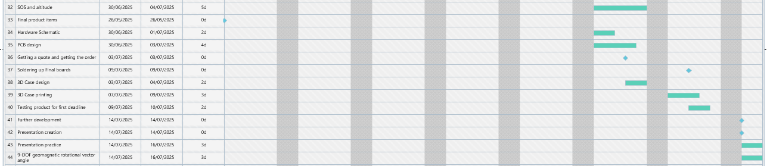
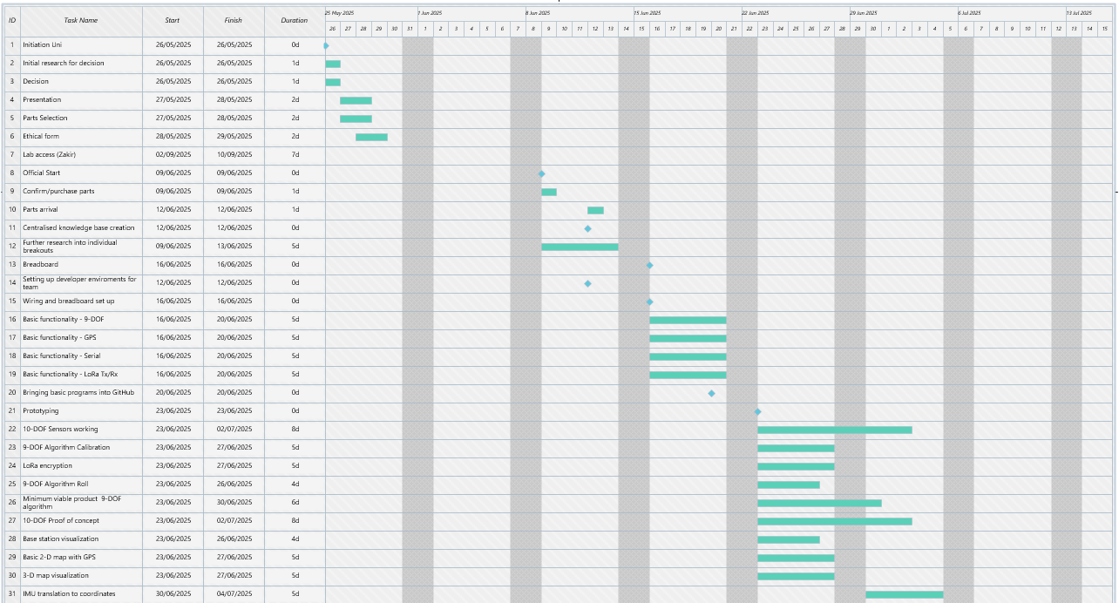
Initial Gantt Chart
Figure 1. The Gantt chart initially designed for the project at the beginning. Due to the tight scope of the project, building in contingency was largely ignored.

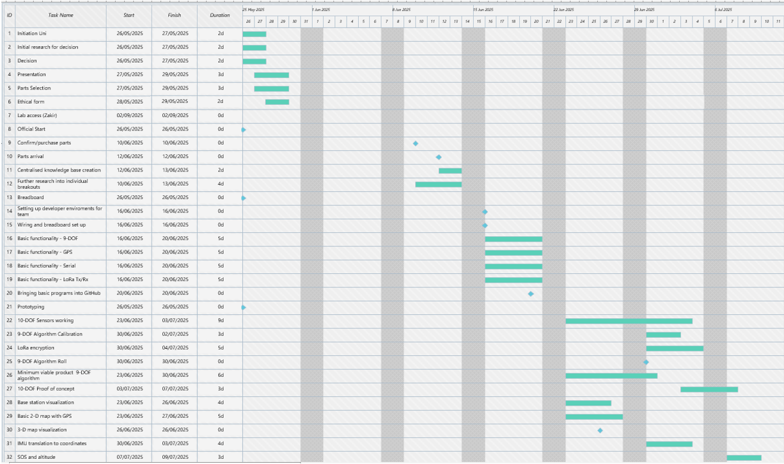
Final Gantt Chart
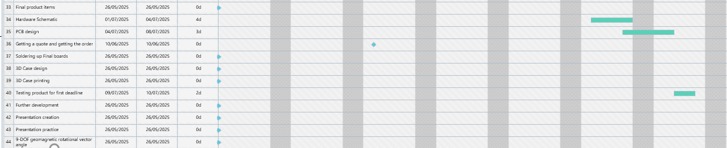
Figure 2. The final Gantt chart by the first deadline of the project, the product of the weekly changes across the project duration.

Design

Hardware Architecture

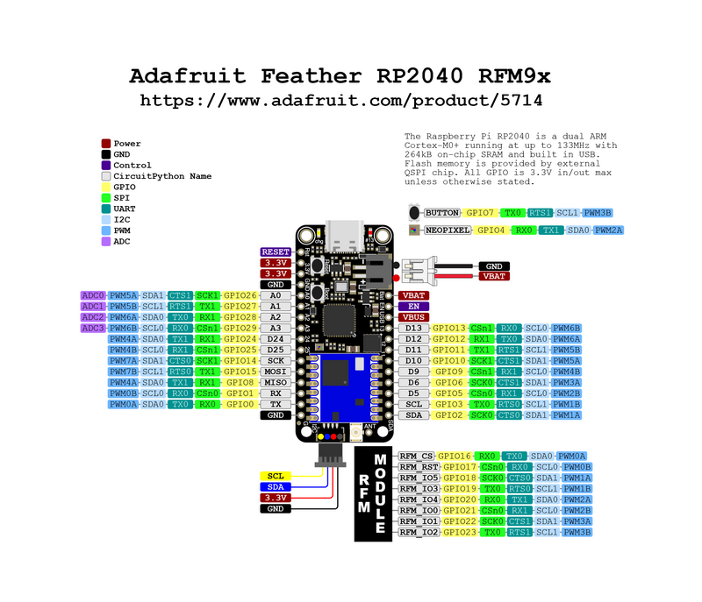
Microcontroller – Adafruit Feather RP2040 RFM95
Figure 3. Feather RP2040 pin out configuration [17]
The Adafruit Feather RP2040 (RFM95) microcontroller was selected, with a 32-bit Cortex M0+ dual core running at ~133 MHz offering sufficient processing power for the project. Its compatibility with Adafruit’s extensive library ecosystem (through CircuitPython) alongside this specialized LoRa model were strong deciding factors [17]. The feather carries more than sufficient GPIO for every component needed/their necessary protocols, see figure 1. 8MB of SPI flash memory will be able to carry the firmware written for both the ‘wearable’ and serially connected ‘base station’.
The Feather carries tight 3.3V regulation onboard and can be simultaneously serially communicating/powered through the USB-C connector with a computer, making it suitable for the ‘base station’. Also onboard is a JST connector for a 3.7V LiPo battery, meaning the ‘wearable’ carried device can be battery powered. By connecting a power switch to the ENable pin and ground, the 3.3V regulator internally can be shut off while leaving the battery and USB port connected, allowing for 200mA+ recharging of the battery without removal [17]. Two 3.3V power outputs can carry up to 500mA of charge to peripherals, sufficient for the selected modules [17].

LoRa Transceiver – RFM95
As mentioned, this is carried on the selected Feather and only needs to be turned on through software. It is based upon the SX127x LoRa module and is a packet-based radio transceiver easily accessible with a CircuitPython library [17]. At peak transmit power it may use up to ~120mA of current draw, however as discussed prior regulatory control means only +14dBm of transmit power is allowed instead of the +20dBm max power of this transceiver [17].

GNSS Receiver – Adafruit Ultimate GPS module
The Adafruit Ultimate GPS module was selected for its apparent high sensitivity receiver, -165dB while tracking, along with its built-in antenna and low power draw of 20mA [18]. It has a claimed accuracy of 1.8m and an acquisition sensitivity of -145dBm with the ability to get multiple satellite fixes at once for greater positional accuracy [18]. It supposedly has a warm/cold start of 34 seconds so this must be factored into the design [18]. It can function with the 3.3V logic of the intended final circuit design. Again, the Adafruit modules were highly preferred for their ease of integration and wealth of resources, with this module being no different. This module connects to the Feather via the UART ports and will use UART for communication, refer to figure 1.

9-DOF – Adafruit Absolute Orientation BNO085
The Adafruit Absolute Orientation BNO085 is a greatly simplified 9-DOF module that carries an onboard microcontroller IC to handle the complexities of the sensor fusion/filtering/calibration [19]. The intention is for this to allow development to focus less on getting the IMU to work whatsoever (given current skill/knowledge level) and instead to focus on the implementation of the intended product function of dead-reckoning tracking. This module can report rotation vectors based on values from all three sensors for maximum confidence/stability over time of running. Other relevant features include a step counter and activity classification. The rotational vectors can be processed into Euler angles for airplane style angular heading values; the magnetometer alone can produce magnetic heading (based on magnetic North) [19]. Similarly, the Adafruit resources and integration for this module are highly valued for the project. The BNO085 will communicate via the I2C bus, using the SDA and SCL ports of the Feather, see figure 1.

Barometric sensor – BMP280 (AZdelivery)
The BMP280 is a common barometric sensor produced by Bosch, found in various form factors [20]. The one purchased for the project was chosen due to accessibility and price, given it was available through one of the two sources we selected. Crucially this AZdelivery model being purchased will not have built in pull-up resistors for the SDA and SCL line, however given the intended function of this sensor in the eventual wearable, the pull-up resistors of the 9-DOF should suffice alone. Bosch claim a relative pressure accuracy of ±0.12 hPa, equivalent to ±1 m [20]; for the purposes of this device, a change of +2m can be considered an increase in building floor, hence this accuracy should not affect the functioning of the 3-D tracking.

10-DOF – DFRobot 10-DOF MEMs IMU
The DFRobot 10-DOF is a traditional IMU wherein it offers only the 4 sensors for achieving an IMU algorithm manually: The Adxl345 accelerometer, ITG3200 gyroscope, VCM5883L Compass and BMP280 barometric sensor [21]. Given the significantly cheaper price and potential delineation of tasks, this was also purchased. Trying to use it would allow someone on the team to more intimately understand the underlying functions of the Adafruit 9-DOF/sensor fusion. If the 10-DOF was found to be easier to work with than expected, it would make per unit cost cheaper and far smaller where both the 9-DOF and BMP280 could be swapped out. It would connect via I2C to the Feather as the 9-DOF would, see figure 1.

Button, Battery, Power Switch
A momentary SPST button was selected from one of the suppliers, intended to be an ‘S.O.S’ button. It will connect to the Feather through one of the GPIO pins and pull the system to ground. A panel mounting style button with a length of wire was selected to be able to secure to the eventual enclosure. A 3.7V LiPo battery with a JST connector was selected for use with the ‘wearable’, as is supposedly suitable [17]. A basic rocker style power switch was selected and will be used on the ENable pin [17]. It is a panel mounting switch that like the button is intended to be wired to the board and mounted onto the enclosure. A rocker style switch was chosen for ergonomic reasons, where the intended use of the device is on the hip and the user may not be able to see the switch directly; a user may be moving/twisting in unexpected manners so a rocker switch will remain lower profile to avoid accidental switching.

Software Architecture
The software tools used for this project were chosen based on ease of use, reliability, and compatibility with existing libraries. For the device firmware, the team selected CircuitPython. This choice was largely influenced by the availability of well-supported Adafruit libraries, which are written specifically for CircuitPython [22]. These libraries offered clear documentation, strong community support, and full compatibility with the Adafruit Feather hardware. By using CircuitPython, the team was able to follow existing example code, making the development process faster and reducing the chances of errors. Its simple and readable syntax also allowed the team to quickly make changes and test new features without the complications often found in lower-level programming environments.
For writing and uploading the CircuitPython code, Thonny was chosen as the main integrated development environment (IDE). A team member was already familiar with Thonny from a previous project, which helped save time during setup. In addition to this familiarity, Thonny provided practical benefits over other options such as Mu, VS Code with extensions, and the Arduino IDE. One of the key reasons for choosing Thonny was its control over when the code runs. Unlike some other IDEs that automatically execute code when the device is connected, Thonny allowed the team to manually start the program, which made testing and debugging safer and more predictable. This also helped with not transmitting data when not appropriate. Thonny’s quick and straightforward setup process also played a major role in the decision.

Risk Analysis
Soldering will be required for the project, as such the team members who were not suitably SQEP checked went through the procedure in the workplace to become assured to work. Any soldering that would take place would be done with ventilation and eye protection. A risk assessment is used in the laboratory to ensure any soldering work is suitably informed.

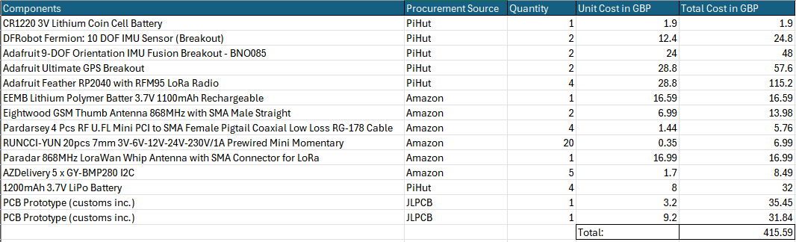
Bill of Materials
Table 1. Total BOM across the project runtime.

Implementation

Lab access
To work in the lab, an induction is required. This works to demonstrate various aspects of the lab space such as the power shut off emergency button and waste disposal bins for different waste types included assessing an individual’s knowledge on the understanding of lab safety protocols, including the correct usage of personal protective equipment (PPE) and emergency procedures.
Two safety risk assessments aligned with the project: soldering and low power transmissions. Risk assessment documentation for both aspects had to be read through and signed off by team members before any work began. A SQEP (Suitably Qualified and Experienced Person) check for soldering was needed for 2 out of the 4 team members. This is an assessment to ensure an individual is safe and knowledgeable enough to do soldering jobs alone. This could include knowledge on how to hold components together safely, what to do in case of an accident and assurances that the person has sufficient knowledge on how to handle the soldering iron safely.

Breadboarding
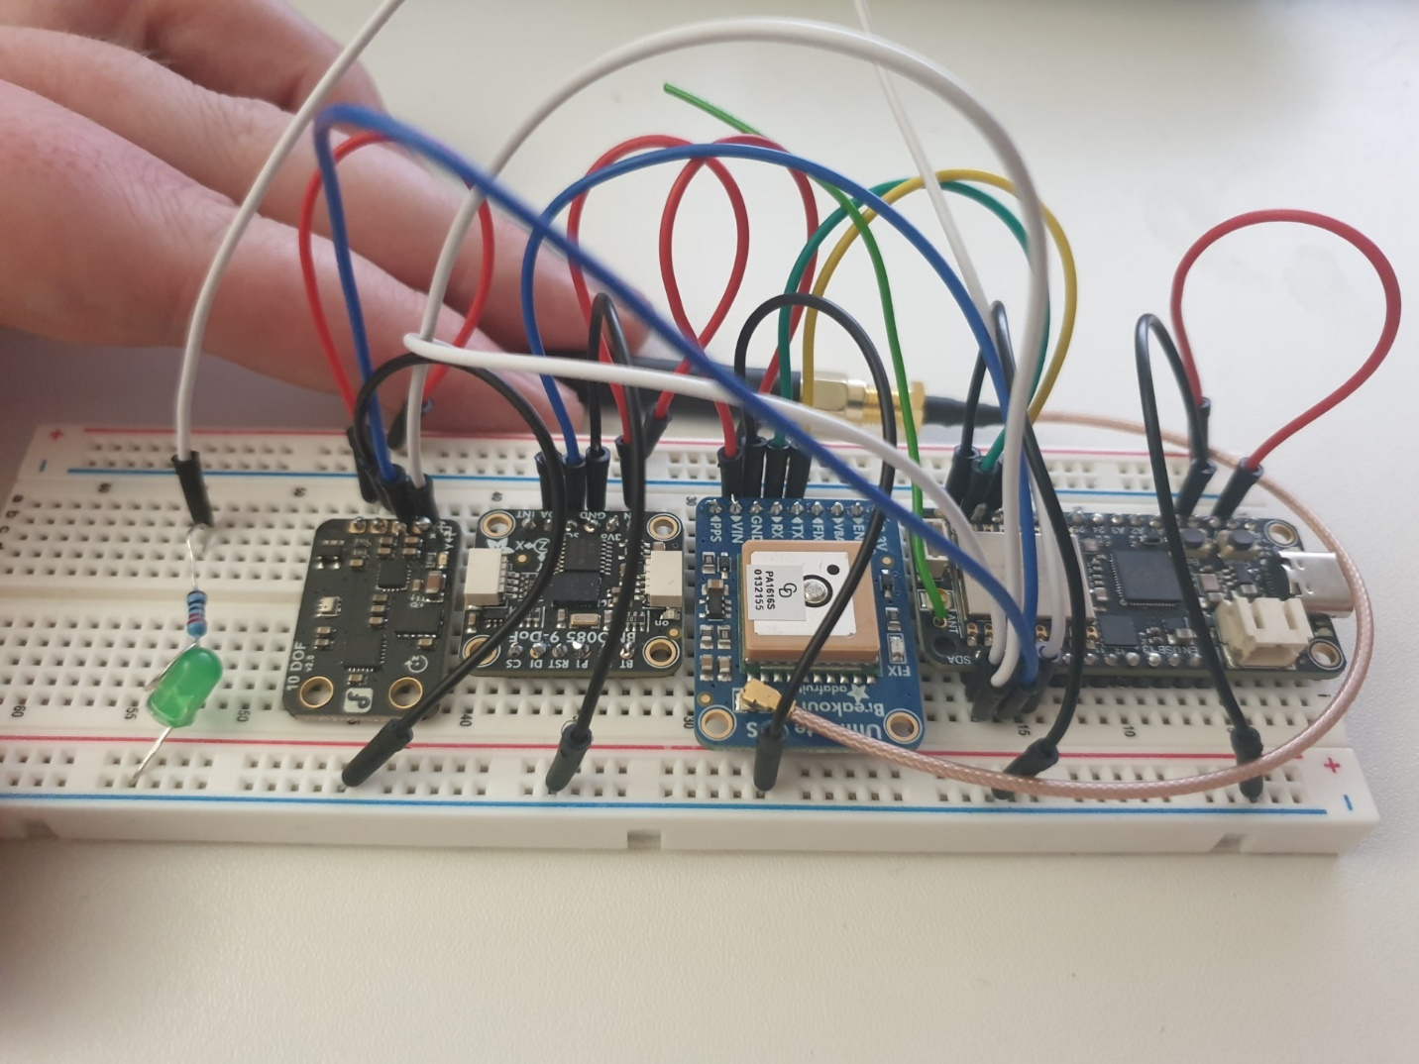
Once in the lab setting and suitably SQEP checked/risk assessments read through, prototyping with breadboards could begin. Figure 4 shows a complete set up that will meet the requirements of the dead reckoning wearable device. Placement follows conventions for breadboard routing to ensure pins are correctly connected and power is safely routed to each device. The breadboard prototype was USB-C powered through the 3.3V regulator of the Feather. Each module had to be soldered to a header for this, requiring safe soldering practice using ventilation and eye protection.
Figure 4. Complete breadboard prototype setup, here the DFRobot 10-DOF is supplemented for the BMP280 module

Firmware Development
Firmware development started by firstly looking at open-source projects mainly from GitHub alongside the Adafruit CircuitPython libraries. Members of the team looked at separate modules of the intended final device before bringing it together in a GitHub repository. See figure 5 for an example section of the repository.
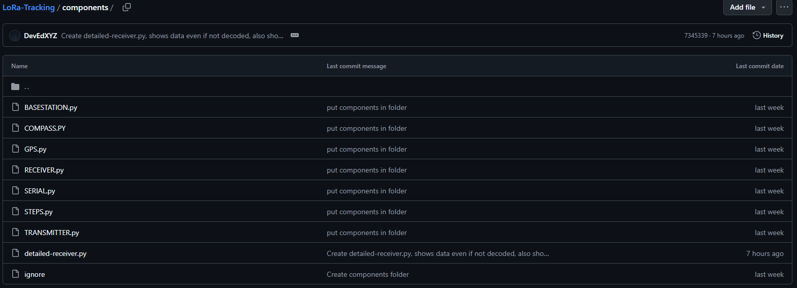
Figure 5. The repository for all the singular components

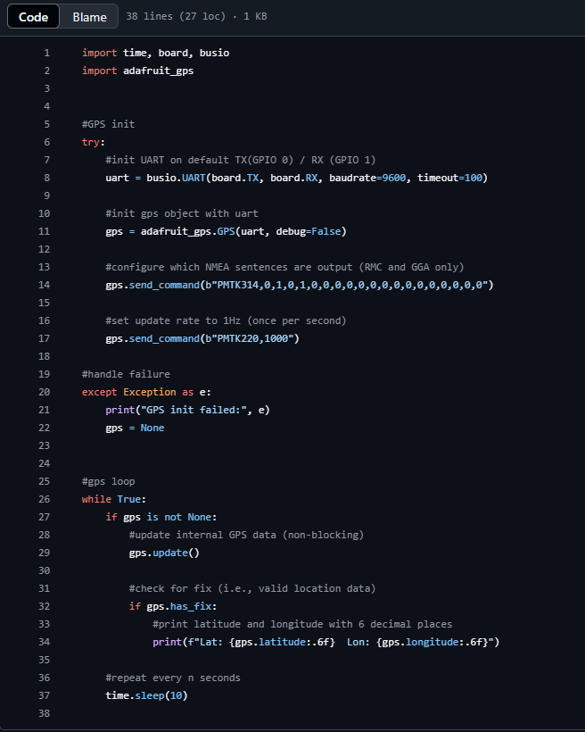
GNSS
Figure 6. GPS.py prints RMC and GGA only data every 10 seconds.
The initial interaction with the Adafruit Ultimate GPS module was conducted using the "more_reports.py" example script, which proved particularly valuable due to its integrated debugging functionality. This allowed real time monitoring of satellite connections and data reception patterns. It became quickly obvious that NMEA sentence format was the important first step to research [23], being how GNSS is reported and the sort of data that will be captured/transmitted by the ‘wearable’.
The optimal data stream for the eventual dead reckoning algorithm was quickly selected using the following:
RMC (Recommended Minimum Course)
GGA (Global Positioning System Fix Data)
These formats were selected based on RMC's widespread compatibility and examples, with GGA being used for its signal quality indicators.
This was done using the following command structure:
gps.send_command(b"PMTK314,0,1,0,1,0,0,0,0,0,0,0,0,0,0,0,0,0,0,0")
GPS data could be extracted by simply calling gps.latitude etc.
lat, lon = gps.latitude, gps.longitude
last_lat, last_lon = lat, lon
gps_fix_count += 1

LoRa
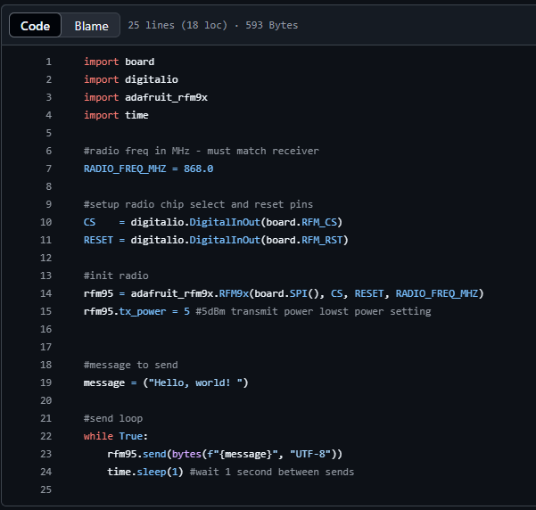
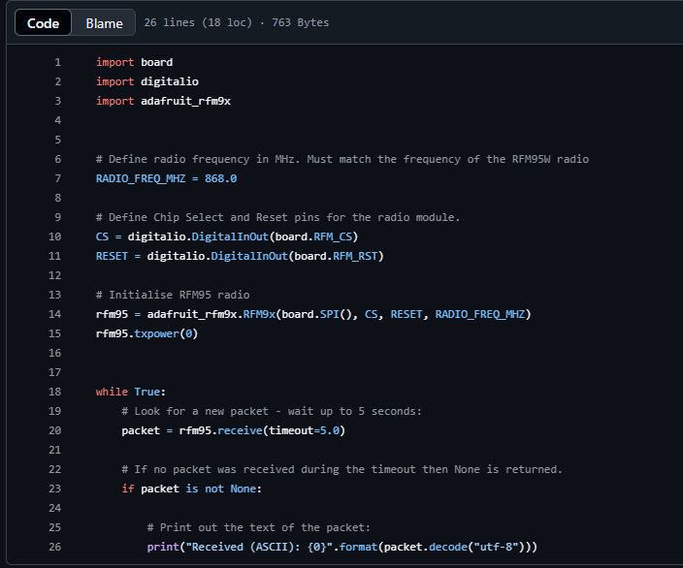
With these values stored as variables for transmission via the LoRa communication system. By modifying a "hello world" style example found on the library example, transmission could be triggered by a button press. Since the specified device model lacked the required button interface, it was then restructured into two discrete components: a continuous receive loop and a transmitter accepting user text input
Figure 7. TRANSMITTER.py sets up and transmits a message in a loop at 868MHz with a tx power of +5dBm (max +14dBm)
Figure 8. RECEIVER.py opens and listens on the frequency 868MHz for packets, printing each received string

Encryption
To encrypt data being sent over LoRa, CircuitPython offers a library that provides access to AES encryption methodology [24]. The library implements standard AES cipher modes, including CTR (Counter) mode which will be used for this implementation.
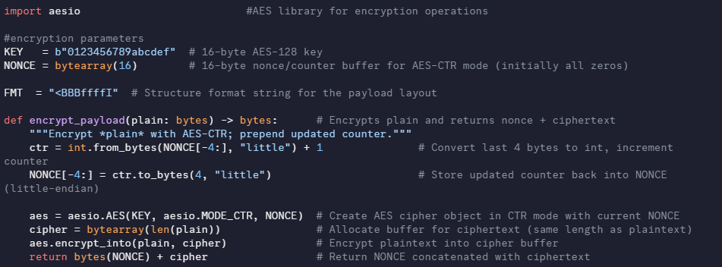
Figure 9. Showcasing code for encrypting packets through LoRa
The encryption code in Figure 7 begins with assigning a 16-byte key paired with a 16-byte nonce. The ‘nonce’ parameter acts as a counter which ensures each encryption operation produces unique ciphertext. The function handles the encryption of the plaintext and returns both the nonce and the cipher for transmission over LoRa. The function will convert the last four bytes of the nonce to an integer, increments this counter, and then stores the updated counter back into the nonce buffer. Using the current nonce value, the function will create an AES cipher object, allocating a buffer for the ciphertext with the same length as plaintext. Finally, the plaintext is encrypted into the cipher buffer via an in-place operation, with the function returning concatenated nonce and ciphertext for LoRa transmission.
At the receiver ‘base station’, the first 16 bytes of the received, valid packet are spliced out. Anything remaining should be the ciphertext. Using the same secret key and extracted nonce, the AES cypher object is recreated in CTR mode, which allows the receiver to decrypt the ciphertext back into the original plaintext. The plaintext retrieved will contain the transmitted data, the predefined struct format of the message can then be used to unpack it. The result if successful should be the data bytes that were encrypted upon initial transmission by the ‘wearable’.
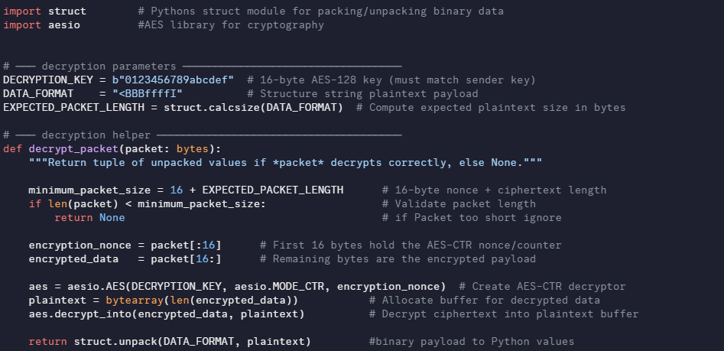
Figure 10. Code to decrypt packets sent from LoRa

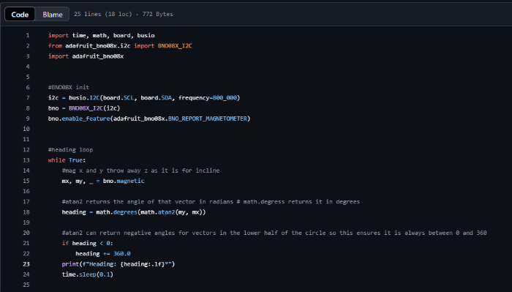
9-DOF
Figure 11. Compass.py returns heading from BNO085 9dof sensor
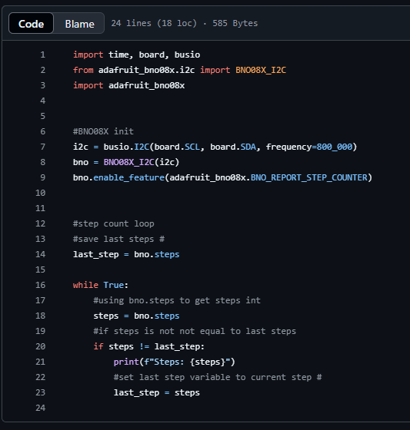
This 9-DOF module was easy to initialize and start running library examples with, given the heavy lifting the onboard microcontroller was doing in sensor fusion etc. The Adafruit BNO085 can report each of the sensors individually or even combined in processed rotational vectors. The rotational vectors can then be used to calculate Euler angles. It was quickly found however that both a step counter and a heading using just the magnetometer could be generated. Figure 11 Shows how the heading could be calculated using an arctan calculation of the x and y axes outputs of the magnetometer, converting to degrees for an easy to use and understand heading that will attempt to stay North. Using North as the center value of the heading will allow for much easier translation into GPS style coordinates later. Figure 8 shows how the to ascertain step count.
Time was spent researching how the BNO085 handles calibration: Calibration is typically a crucial element of IMUs wherein both ‘static’ and ‘dynamic’ calibration is necessary . However the BNO085 datasheet was unfortunately sparse on calibration details beyond the existence of a calibration status reporter variable [25]; a sensor calibration procedure exists but only outlines physical calibration movements [26]. Given the intended use case for the ‘wearable’ i.e. on the hip vertically, a calibration sequence of some kind was determined to be necessary. As such, figure 11 was integrated into the final wearable code, where upon system start, bno.begin_calibration() is called, a function built into the CircuitPython library [27]: The purpose of this sequence is to use the reporter variable, a value from 0-3, to determine when the IMU is sufficiently calibrated. Successful calibration is deemed to occur when the reporter variable remains at 3 for 5 seconds, allowing the system to continue once the condition is met and using bno.save_calibration_data() to store the captured offset values. The LED attached to GPIO6 of the Feather is used to indicatively flash while calibration occurs.
Figure 12. STEPS.py, loops through and polls the internal BNO085’s step counter returning a value if a increase in steps is found.

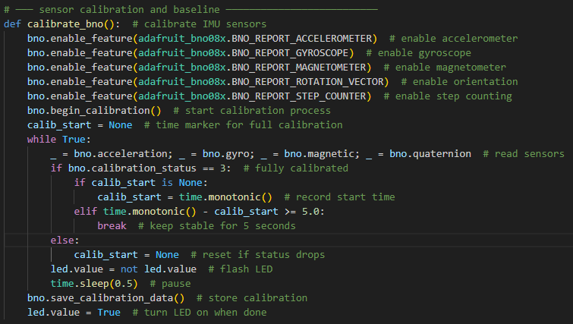
Figure 13. Calibration sequence at the beginning of 'wearable' runtime

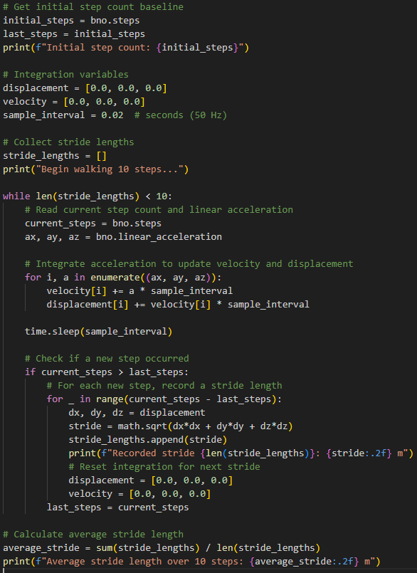
Stride length calculation
With linear acceleration being a reportable value, the assumption was made that these values could be used to derive displacement, which would serve as a consistent method of adaptively tuning stride length. Being a double derivative of displacement, it logically follows that a double integration of acceleration will yield positional information. An attempt to integrate this theory was made, running after calibration was complete and requiring the user to take 10 steps. Figure 14 shows the attempted calculations that printed to the terminal as a test. Displacement would be calculated between each step and the average taken to assume a user’s true stride length. On-the-go testing revealed the drift that is expected with accelerometers in inertial navigation systems: Values appeared incoherently inconsistent despite the same individual testing each time, implying that even within a short timeframe of seconds that the integration drift experienced made this unviable. As such the minimum viable product assumes average stride length at 0.76m [28].
Figure 14. Stride length calculations via double integration of linear acceleration values test attempt

Geomagnetic rotational vector for heading
Despite the minimum viable heading option being found, only the magnetometer was used in a compass style. To fully utilize the 9-DOF, ideally for greater stability over a longer period of runtime, an attempt to use the geomagnetic rotational vector handling of the module was made. This vector report supposedly uses all three IMU sensors to generate the values, each sensor used conjunctively to correct drift in others. Of particular note, the device will be vertical on the user, so on-the-go testing of the module revealed the roll component to be the component that would actually determine this heading. This is in place of yaw, the typical Euler angle for heading. To do so, the bno.geomagnetic_quarternion reporter of the BNO085 [27] was fed into a function designed to calculate the roll of the device, followed by a degrees conversion and finally a wrapping line to output this roll as a heading. This was compared directly against the magnetometer heading as a print out. The result was that the magnetometer remained as the more accurate heading reporter: Comparing against a physical compass, magnetometer heading more consistently produced a value that matched magnetic North and updated correctly while turning (even when vertically held), compared to this roll heading attempt that did not update as cleanly and sometimes appeared to lose magnetic North as the heading center. For this reason it has not been implemented over the minimum viable heading option.
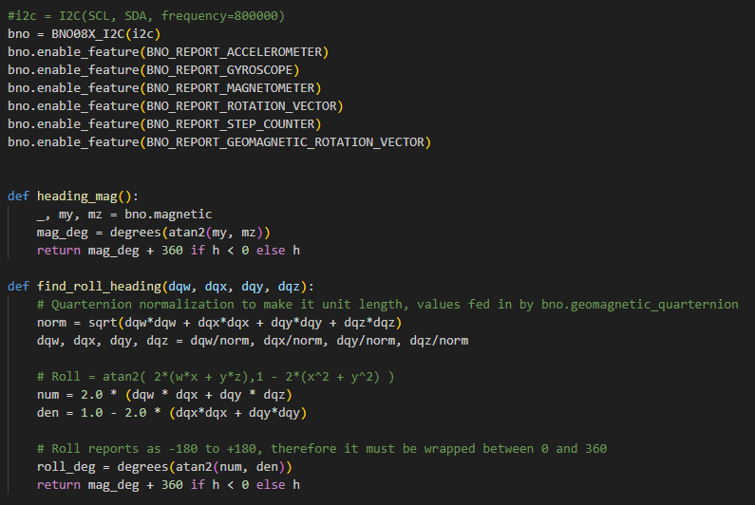
Figure 15. Heading style roll function generator.

10-DOF
The DFRobot 10-DOF IMU sensor required more hands-on work to get operational, given that no pre-built sensor fusion was available like with other modules. CircuitPython libraries were found for the barometric pressure sensor and accelerometer components, making these straightforward to implement. The magnetometer and gyroscope, however, needed custom drivers to be written from scratch. For the gyroscope, existing Arduino libraries provided a good starting point to create a compatible CircuitPython driver with similar register handling [29].
The magnetometer proved more challenging than expected. Initial attempts followed the HMC5883L datasheet [30], expecting the device to respond to I2C address 0x1E with standard register mappings for identification at 0x0A-0x0C [31]. However, the magnetometer wasn't responding at this address, so systematic testing with an I2C scanner script revealed it was at address 0x0C instead. This suggested either a different chip variant or undocumented hardware revision in the module. With further probing, it revealed a completely different register layout than documented, with magnetic data starting at 0x00, status at 0x09, and control registers at 0x0A-0x0C.
// Initialize
INITIALIZE I2C_bus(SCL=A3, SDA=A2)
DEFINE magnetometer_addresses = {0x0C, 0x0D, 0x1E, 0x30, 0x10, 0x1C, 0x0E, 0x48}

// Scan for devices
devices = SCAN_I2C_bus()
PRINT "Found " + count(devices) + " devices"

// Check each device
FOR each device IN devices DO
IF device IN magnetometer_addresses THEN
PRINT "Magnetometer found at 0x" + HEX(device)

// Identify specific chip
SWITCH device
CASE 0x0D:
IF READ_REGISTER(device, 0x0D) == 0xFF THEN
PRINT "QMC5883L confirmed"
END IF
CASE 0x1E:
IF READ_REGISTERS(device, 0x0A, 3) == [0x48, 0x34, 0x33] THEN
PRINT "HMC5883L confirmed"
END IF
CASE 0x0C:
IF READ_REGISTER(device, 0x00) == 0x48 THEN
PRINT "AK8963 detected"
ELSE
PRINT "Possible VCM5883L"
END IF
END SWITCH
ELSE
PRINT "Unknown device at 0x" + HEX(device)
END IF
END FOR

END PROGRAM

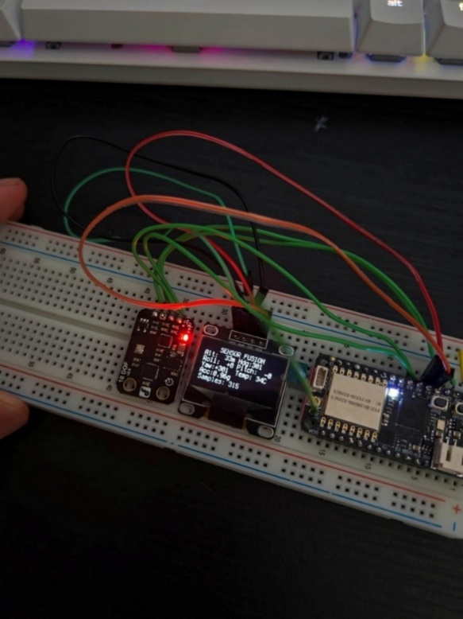
This reverse-engineering work eventually resulted in a working custom driver that could interface with whatever magnetometer chip was on the board. The driver provided calibrated magnetic field readings and compass heading calculations despite the lack of proper documentation for the actual hardware present.
With all sensors working, sensor fusion algorithms were implemented to combine accelerometer, gyroscope, and magnetometer data into quaternions, which could then be converted to Euler angles for pitch, roll, and yaw measurements. In addition, the barometric sensor provided altitude readings with the delta to determine floor level changes see Barometric Sensor.
Figure 16. Image capture of breadboard with 10DOF and RP2040 Feather. In between is a person OLED screen to display data from sensors

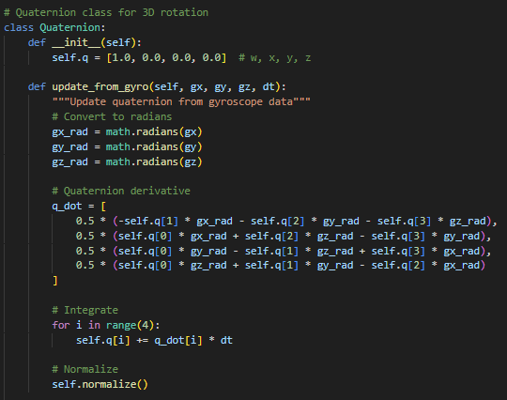
Figure 1 is a quaternion class that maintains the orientation as a four-component vector (w, x, y, z), where w represents the scalar part and x, y and z form the vector part.
Figure 17. Quaternion class used maintain 3d rotational data
The quaternion is updated through gyroscope integration, where angular velocities (deg/s) are first converted to radians. Following quaternion kinematics, the quaternion derivative is calculated using the formula:
$$q_{derivative}=\frac{1}{2}*q*ω$$
Where ω is the angular velocity matrix, represented as a quaternion with a zero-scalar part (i.e. ω = [0, ωx, ωy, ωz]).
This derivate is then integrated over the time step (dt) and the resulting quaternion undergoes normalization to maintain the unit length and is required for valid rotation representation. Normalization is essential because it prevents accumulation of numerical errors that would otherwise reduce the accuracy of the orientation over extended periods of runtime.

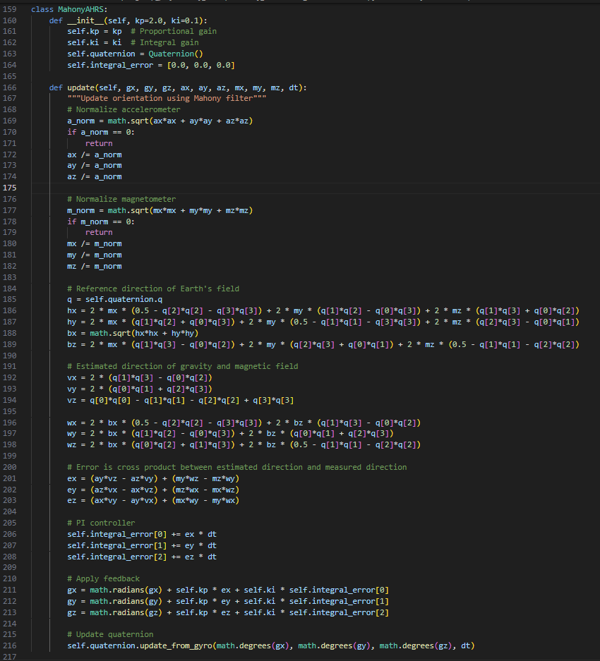
To address the drift that is expected with gyroscopes, the Mahony’s Attitude and Heading Reference System algorithm was implemented [32]. It aims to calculate error vectors between the gravity direction estimated from the current quaternion orientation and the measured acceleration vector, alongside errors between estimated and measured magnetic field directions. These error vectors are then processed through a ‘Proportional Integral’ controller, with gains tuned to ‘kp=2.0’ and ‘ki=0.1’, generating correction terms for the raw gyro measurements before quaternion integration.

Figure 18. Mahony AHRS class that applies algorithms to reduce gyro drift

Eventually, the quaternion calculations were validated using Adafruit's web-based 3D model viewer [33], which showed real-time sensor orientation and confirmed the fusion algorithms were working correctly through interactive 3D visualization of the IMU's positioning.
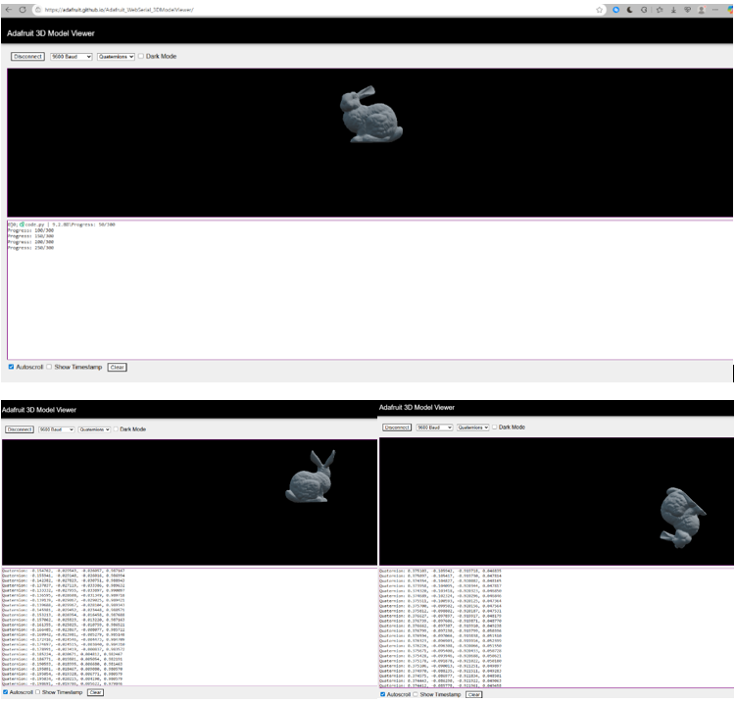
Unfortunately, due to the reliability of the 9DOF the 10DOF will not be implemented to the PCB chip. It was evident when the investigations from 9DOF concluded that it was much easier to work with as there’s libraries from Adafruit that directly develop IMU data.
Figure 19: Pseudocode of the main loop for the 10DOF
Figure 20: Screengrab of Adafruit's 3D Model Viewer web app, showcasing quaternion values and its effect to the 3D model based on the movement of the 10DOF
FUNCTION main():
INITIALIZE calibration = new SensorCalibration()
INITIALIZE ahrs = new MahonyAHRS(kp=2.0, ki=0.1)

// Calibration phase
calibration.calibrate_gyroscope()
calibration.calibrate_accelerometer()
calibration.calibrate_magnetometer()

SET last_time = current_time()
SET use_quaternion = true

LOOP forever:
// Calculate time delta
current_time = get_time()
dt = current_time - last_time
last_time = current_time

// Read and calibrate sensors
READ accel_raw, gyro_raw, mag_raw
APPLY calibration_offsets

// Update orientation filter
ahrs.update(gyro_cal, accel_cal, mag_cal, dt)

// Output for 3D visualization
IF use_quaternion:
OUTPUT quaternion_data(ahrs.quaternion.q)
ELSE:
CALCULATE roll, pitch, yaw = ahrs.quaternion.to_euler()
OUTPUT euler_angles(roll, pitch, yaw)

// Status indication
EVERY 100 samples:
TOGGLE LED

WAIT 0.02 seconds // ~50Hz output rate

CATCH keyboard_interrupt:
PRINT "Stopping..."
TURN_OFF LED

Barometric Sensor
The barometric pressure sensor on the DFRobot 10DOF module was much less problematic than the magnetometer situation. The BMP280 chip had proper CircuitPython library support through Adafruit's standard libraries [34], so getting basic temperature, pressure, and altitude readings was routine. The sensor communicated reliably at I2C address 0x77 without any of the address hunting that was needed for the magnetometer.
What became apparent early on was that absolute altitude readings weren't particularly useful for the intended application. The sensor calculates altitude based on atmospheric pressure, which varies with weather conditions and location. So instead of fighting sea level pressure calibrations, a simpler approach was taken where the system establishes baseline reading at startup and then tracks changes from that reference point.
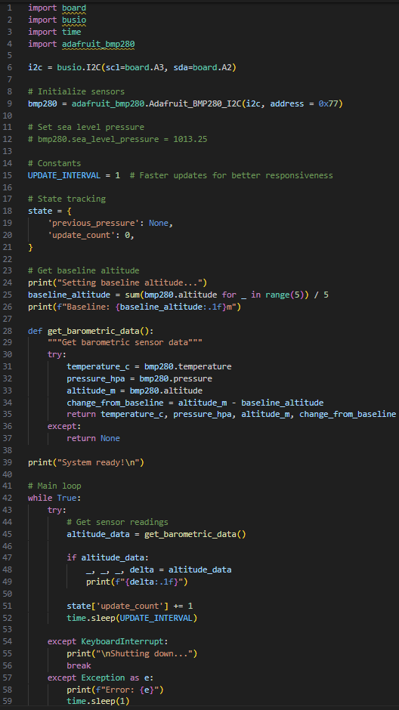
Figure 21: Code snippet for reading barometric sensor data and outputting delta values for altitude
The baseline calibration process averages five readings at initialization to smooth out any noise, then all subsequent altitude measurements are reported as delta values from this starting point. This approach proved quite effective for detecting floor changes in buildings, since the sensor is sensitive enough to pick up the 3-4 meter altitude differences between floors. The delta calculation also filters out atmospheric pressure drift that would otherwise throw off absolute readings over time. This was confirmed to work on the separate barometric sensor part, which will ultimately take part in the final PCB.

Base Station Application
The mapping and data visualization capability began with basic positional display using tkinter, OpenStreetMaps and a png overlay for the user’s position tied to GPS coordinates. As the data protocol developed, the map GUI was extended to include a separate section of the window for displaying information about each user, COM port logic for connection, and multiple subject tracking capability. Each newly added user was also assigned their own colour and timer display, indicating time since last received packet with various other info about each user.
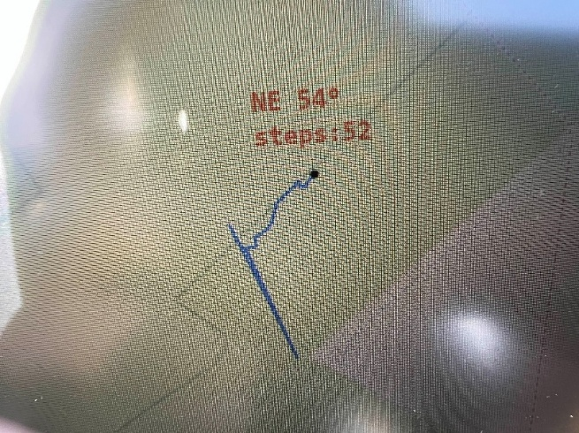
Figure 22. Early 3D mapping application
There was a strong push and attempt to include OSMBuildings for 3D map visualization. However, a technical limitation on the server side caused problems, the server gave responses in RGB values only with no alpha channel meaning, transparent rendering of the building interior was not possible. After a few hours of research and a basic example reached, this feature was partly abandoned to concentrate on enhancing the 2D interface as it stood a base for not only development but as a minimal viable product to deliver to an end user.
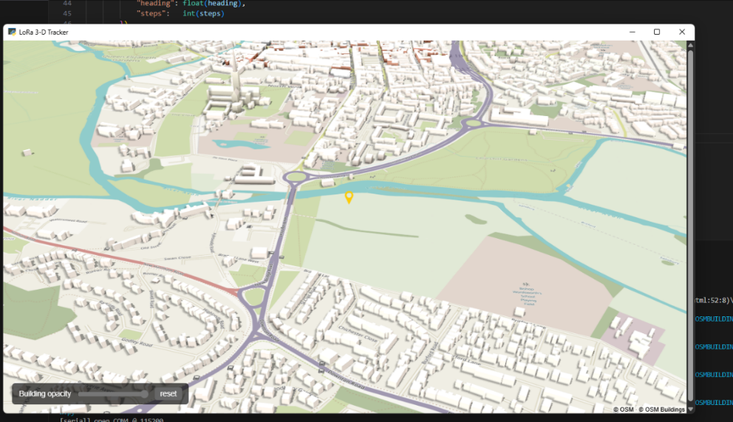
Figure 23. 3D building implementation into tkinter web view with marker at simulated testing locatio
There was a requirement to keep the code easily reformattable due to the constantly adjusting data flow from new research or improvements made across the team which would then need implementing to prove functionality of the new work. For example, when starting the only data required was the latitude longitude and SOS bit, however this changed with development
The following final data format and Transmission Protocol Standard data was employed at the go ahead from the team ensuring we were all on the same page for what was expected in the final visualisation:
Unit number identifier number(1-9), person/user number identifier (0-99), sos bit 0/1, lat(6 d.p.), lon(6 d.p.), altitude change(m), heading(degrees 0-360), steps(integar)
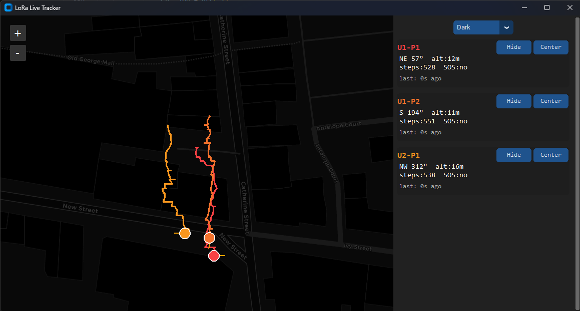
Figure 24. USB COM port logic pass through to user for reconnection on data loss
The above figure shows the final design interface of the base station, the user/s of the base station will be able to see the current location off all units and personal on the map colour coded to their specific information section on the right hand side of the window. The current orientation that the tracked user is facing is also displayed with a thin orange line extruding from the point of location circle of the user. Altitude, SOS request and also current building floor level is also shown in the UI and will be further explained later in this report.
A trail is also displayed following the users last known movement by tracing a line from each individual packet received and updated into the software.
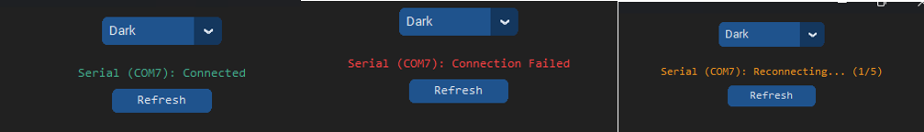Figure 25. Real Live Seriel data view of map with simulated data from 3 users.
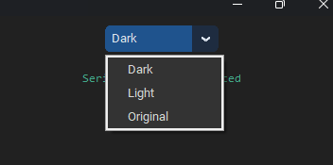
Figure 26. Multiple map looks for useability at night/day or for more location information in original mode.
There are 3 maps loaded from different online sources on selection of a map
“Dark” & “Light” modes are for a more minimal overview of the area for different displays/operating environments for the user of the base station while “Original” uses open street maps data rich view to show more information that could be useful for rescue, for example relaying building or business names to a third party.
Combining all of the work of the group, the finalized wearable firmware, base station firmware and base station computer application were written and ported to the GitHub repository, see the following section for pseudocode breakdowns of each key file.

Pseudocode for Finalized Firmware/Software
The software for the devices was kept to 3 main files: ‘Wearable’ firmware, the ‘base station’ firmware (receiver and decryption) and the ‘Map and UI’ software
Base Station Map:
1. 1. Define GLOBAL SETTINGS
2. 1.1 Serial port parameters
3. 1.2 UI and map constants
4. 1.3 Regex pattern for LoRa payload
5. 1.4 Colour cycles and compass lookup
6.
7. 2. Define HELPER FUNCTIONS
8. 2.1 convert_heading_to_compass degrees ⇒ N‒NW etc cardinal text
9. 2.2 elevation_to_floor metres ⇒ floor label
10. 2.3 calculate_new_position lat/lon ⇒ offset point
11. 2.4 create_circular_icon colour ⇒ Tk icon
12.
13. 3. Class SimpleTrackerApp
14. 3.1 __init__(window)
15. • style window, fonts, layout
16. • call setup_user_interface
17. • call setup_serial_connection
18. • start two repeating timers:
19. – check_for_new_data every UPDATE_SPEED
20. – update_age_labels every 1 s
21. 3.2 setup_user_interface
22. • build left map frame
23. • build right control panel
24. • theme selector dropdown
25. • map widget with default tiles & zoom
26. • call setup_serial_status_display
27. 3.3 setup_serial_connection
28. • initialise connection state
29. • call connect_to_serial_port
30. 3.4 connect_to_serial_port
31. • open serial
32. • on failure ⇒ update status, schedule retry
33. 3.5 check_for_new_data
34. • verify port is getting data
35. • read line if available
36. • if line matches DATA_PATTERN:
37. call process_new_location_data
38. • reschedule self
39. 3.6 process_new_location_data(payload)
40. • derive tracker_id = “U…-P…” # unit and person
41. • if new tracker ⇒ call create_new_tracker
42. • call update_tracker_data
43. 3.7 create_new_tracker(id)
44. • pick colour, build icons
45. • create tracker card with buttons + labels
46. • store elements in tracker_data[id]
47. 3.8 update_tracker_data(tracker, new_info)
48. • refresh card text & colour (SOS aware)
49. • add point to history (cap at MAX_PATH_POINTS)
50. • create/update marker, path, arrow
51. • call handle_sos_flashing
52. 3.9 redraw_tracker_path(tracker)
53. • draw poly-line and heading arrow
54. 3.10 handle_sos_flashing(tracker, sos_flag)
55. • toggle card FG colour every 400 ms when SOS
56. 3.11 update_age_labels
57. • iterate trackers → “last: Ns ago”
58. 3.12 centre_map_on_tracker(id) → pan map
59. 3.13 toggle_tracker_visibility(id) → hide/show markers & card style
60. 3.14 cleanup_before_closing → close serial safely
61.
62. 4. Program ENTRY
63. 4.1 main_window ← CTk()
64. 4.2 app ← SimpleTrackerApp(main_window)
65. 4.3 bind WM_DELETE_WINDOW → app.cleanup_before_closing + destroy
66. 4.4 main_window.mainloop()
67.

Receiver and Decryption:
1. 1. SETUP
2. 1.1 DATA_FORMAT "<BBBffffI" little endian
3. 1.2 EXPECTED_LEN calcsize(DATA_FORMAT)
4. 1.3 DECRYPTION_KEY (16 bytes)
5. 1.4 Init LoRa radio (RFM9x) on RADIO_FREQUENCY
6. • radio.sleep(); radio.receive()
7. 1.5 print “ready”
8.
9. 2. MAIN LOOP (forever)
10. 2.1 pkt radio.receive(timeout = 0.5 s) (pkt = packet)
11. 2.2 if pkt is None: continue
12.
13. 2.3 if len(pkt) < 16 + EXPECTED_LEN: continue // too short
14.
15. 2.4 nonce pkt[0:16]
16. cipher pkt[16:]
17.
18. 2.5 try
19. 2.5.1 aes AES(DECRYPTION_KEY, CTR, nonce)
20. 2.5.2 plain aes.decrypt(cipher)
21. 2.5.3 (unit, person, sos, lat, lon, d_alt, heading, steps) unpack(DATA_FORMAT, plain)
23. 2.5.4 print f"Data: {unit} {person} {sos} {lat:.6f} {lon:.6f} " +
24. f"{d_alt:.1f} {heading:.1f} {steps}"
25. except: // decryption/unpack error
26. continue
27.

Wearable:
1. WearableTracker // runs on the person’s device
2.
3. 1. USER CONFIG
4. 1.1 UNIT_ID, PERSON_ID, SOS flag
5. 1.2 STEP_LENGTH_M, GPS usage, encryption key
6.
7. 2. HARDWARE INIT
8. 2.1 LoRa radio (RFM9x) at RADIO_FREQ_MHZ
9. 2.2 GPS module over UART RMC+GGA
10. 2.3 IMU (BNO08X) over I2C accel, gyro, mag, rot-vector, step counter
11. 2.4 Barometer (BMP280) over I2C
12. 2.5 Status LED pin
13.
14. 3. HELPER FUNCTIONS
15. 3.1 encrypt_payload(plain) → AES-CTR KEY
16. 3.2 calibrate_bno() → full 3-axis + step, LED blink
17. 3.3 baro_alt() → absolute & Δalt
18. 3.4 heading_mag() → magnetometer θ ∈ 0…360°
19.
20. 4. INITIALISATION
21. 4.1 calibrate_bno()
22. 4.2 BASELINE_ALT← 5-sample mean from barometer
23. 4.3 Enable BNO mag
24.
25. 5. STATE
26. 5.1 last_lat, last_lon = None
27. 5.2 last_steps = 0
28. 5.3 gps_fix_count = 0
29. 5.4 dr_only (dead-reckoning mode) = False
30.
31. 6. MAIN LOOP (forever, ~1 Hz)
32. 6.1 gps.update()
33. 6.2 steps bno.steps
34. 6.3 heading heading_mag()
35. 6.4 alt, d_alt baro_alt() (d_alt = 0 if alt None)
36.
37. 6.5 POSITION ESTIMATE
38. 6.5.1 if (GPS fix & not dr_only):
39. lat, lon ← gps.lat/lon
40. gps_fix_count++
41. if (!CONTINUOUS_GPS & gps_fix_count ≥ GPS_FIXES_BEFORE_LOCK):
42. dr_only ← True, send “PMTK161,0” to stop GPS
43. else if last_lat not None: // dead-reckon
44. step_delta max(steps − last_steps, 0)
45. dist step_delta × STEP_LENGTH_M
46. d_lat dist·cosθ / METRES_PER_DEG_LAT
47. d_lon dist·sinθ / (METRES_PER_DEG_LAT·cos(lat))
48. lat, lon last_lat+d_lat, last_lon+d_lon
49. else:
50. last_steps steps; sleep 1 s; continue // no position yet
51. 6.5.2 last_lat, last_lon lat, lon
52. 6.5.3 last_steps steps
53.
54. 6.6 PAYLOAD
55. plain pack(UNIT_ID, PERSON_ID, SOS,
56. lat, lon, d_alt, heading, steps)
57.
58. 6.7 TRANSMIT
59. rfm.send(encrypt_payload(plain))
60.
61. 6.8 sleep(1 s)
62.

Wearable schematic
Figure 9.0 shows the final layout schematic of the eventual ‘wearable’ PCB, designed using KiCad7.0. The Feather will power every module through the regulated 3.3V output pins. As planned it has a power switch on the ENable pin, a momentary button on GPIO5 and a newly added LED on GPIO6 [17]. The LED will aid in interfacing with the user, say for calibration protocols. The GPS communicates through UART and the other two modules will share an I2C bus. Custom schematic items had to be designed to suitably match the pins of the components.

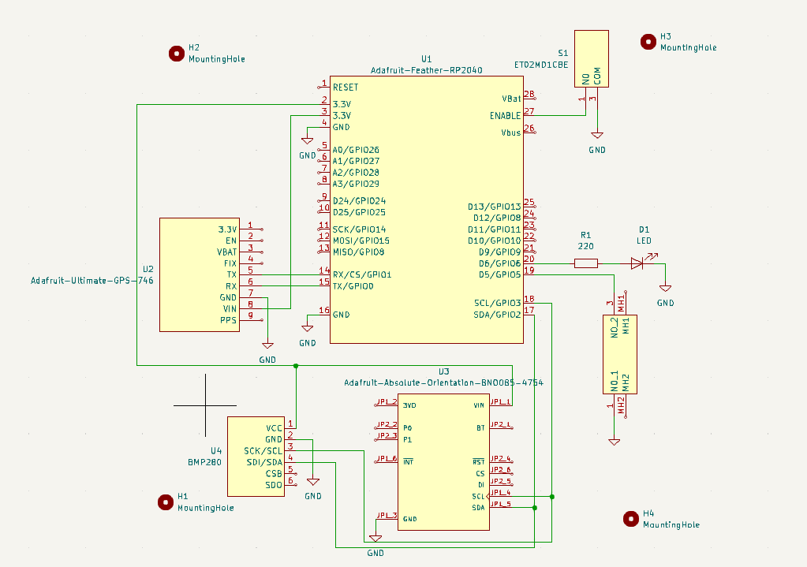

Figure 27. Finalized and corrected circuit schematic for the wearable device, generated in KiCad7.0

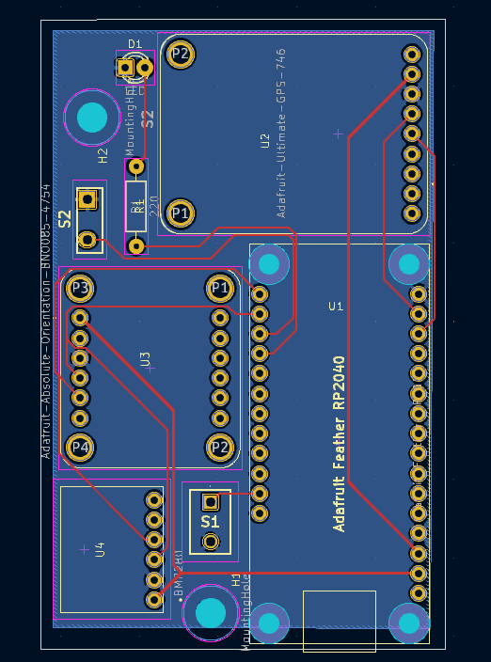

Final Wearable PCB
Figure 27 seen above shows the final PCB design based upon the schematic in figure 26. A ground plate of copper has been used, this will minimize noise and interference [35]. Trace widths of 0.4mm width have been used for the power lines to ensure voltage dropout across the length is minimal, figure 28 below is a calculation using the calculator tool of KiCad 7.0 to determine voltage dropout observed over 50mm of 0.4mm internal trace width copper with a tight accepted temperature delta of 1ºC. Minimal dropout is of significant importance for power traces where modules require a certain threshold voltage on the current draw: A dropout of ~36mV is expected over 50mm, assuming a perfect 3.3V output will mean that the modules are being supplied a perfectly sufficient voltage, where the modules selected here all have wide operational voltage ranges [18] [19] [20]. A similar calculation was made for the 0.25mm traces used for I/O pins, though the voltage threshold/power requirements of these traces are notably less important, see below for the calculation. The PCB was designed with the fund source’s needs in mind: A slim and small form factor device where space is used conservatively to ensure it is small against the body while in operation. The pushbutton and power switches are carried as the pads for wire to solder to, with the intention of having panel mounted components. Panel mounting will allow for greater flexibility in deciding final placement against the case, meaning testing can be done to work out the most ergonomically sensible fitting for hip-attached use. The PCB is designed to place the charging port at the bottom, using the overhang of the port on the Feather to position it against the enclosure in a manner that will mitigate any gaps for dust while allowing for easy access. It is designed to be used ‘vertically’ as seen in figure 27. For the minimal viable product, ruggedization is unnecessary and heavily time consuming meaning the eventual enclosure can be designed around the PCB as a 3-D print, using features like the USB-C port placement here to save time in design. The LED is placed liberally on the ‘top’ where the pins will likely be bent to have the light point upwards for user visibility. The option is also there for it to remain as is seen figure 27, another flexible choice designed to make enclosure design later faster. DRC checks were verified using OSHPark’s drill specifications [36].
Figure 28. Finalized and corrected PCB design for DR wearable in KiCAD7.0

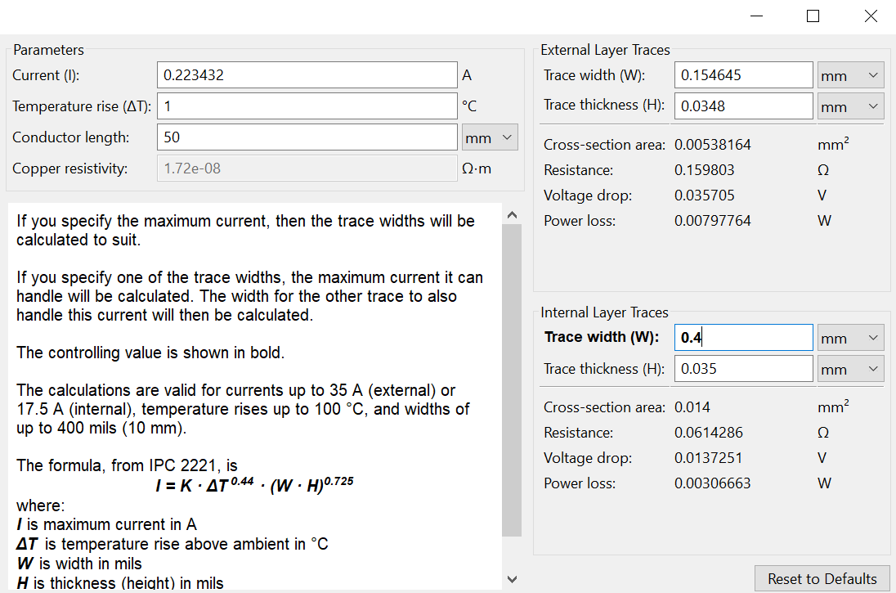

Figure 29. KiCad 7.0 calculator tool showing the expected voltage dropout with 0.4mm internal trace width

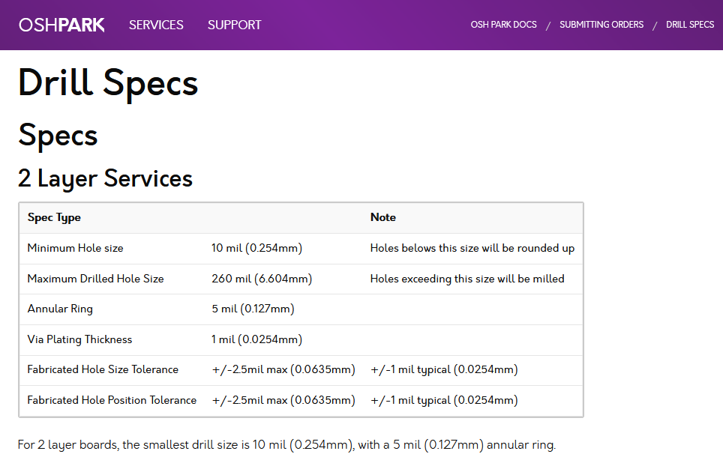
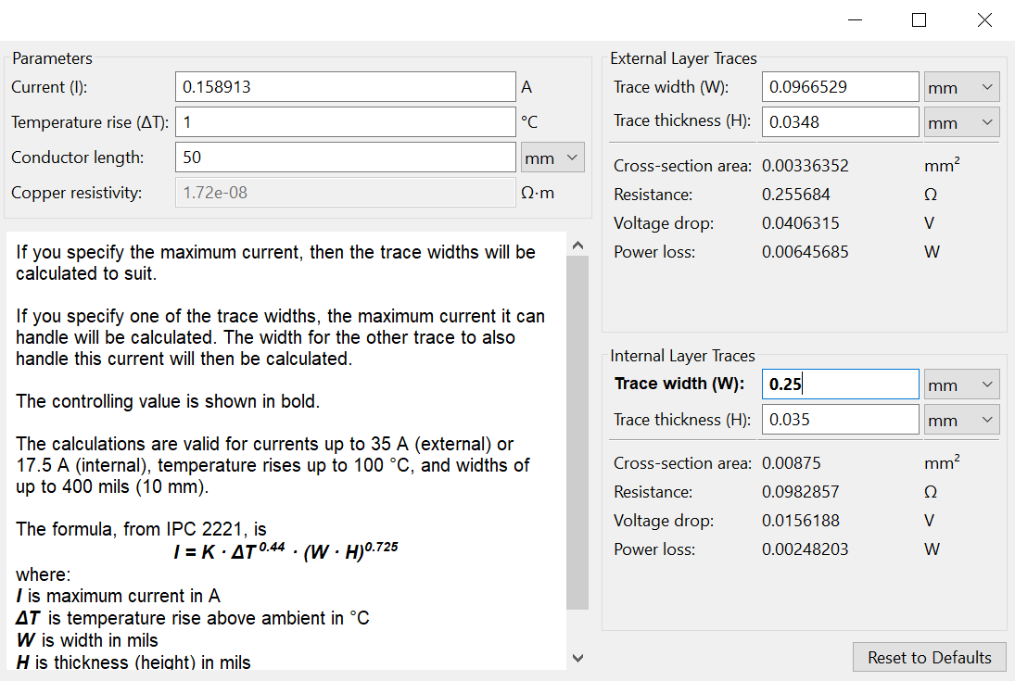
Figure 30. KiCad 7.0 calculator tool showing the expected voltage dropout with 0.25mm internal trace width
Figure 31. OSHPark 2 layer PCB drill specifications used within KiCad for the DRC check

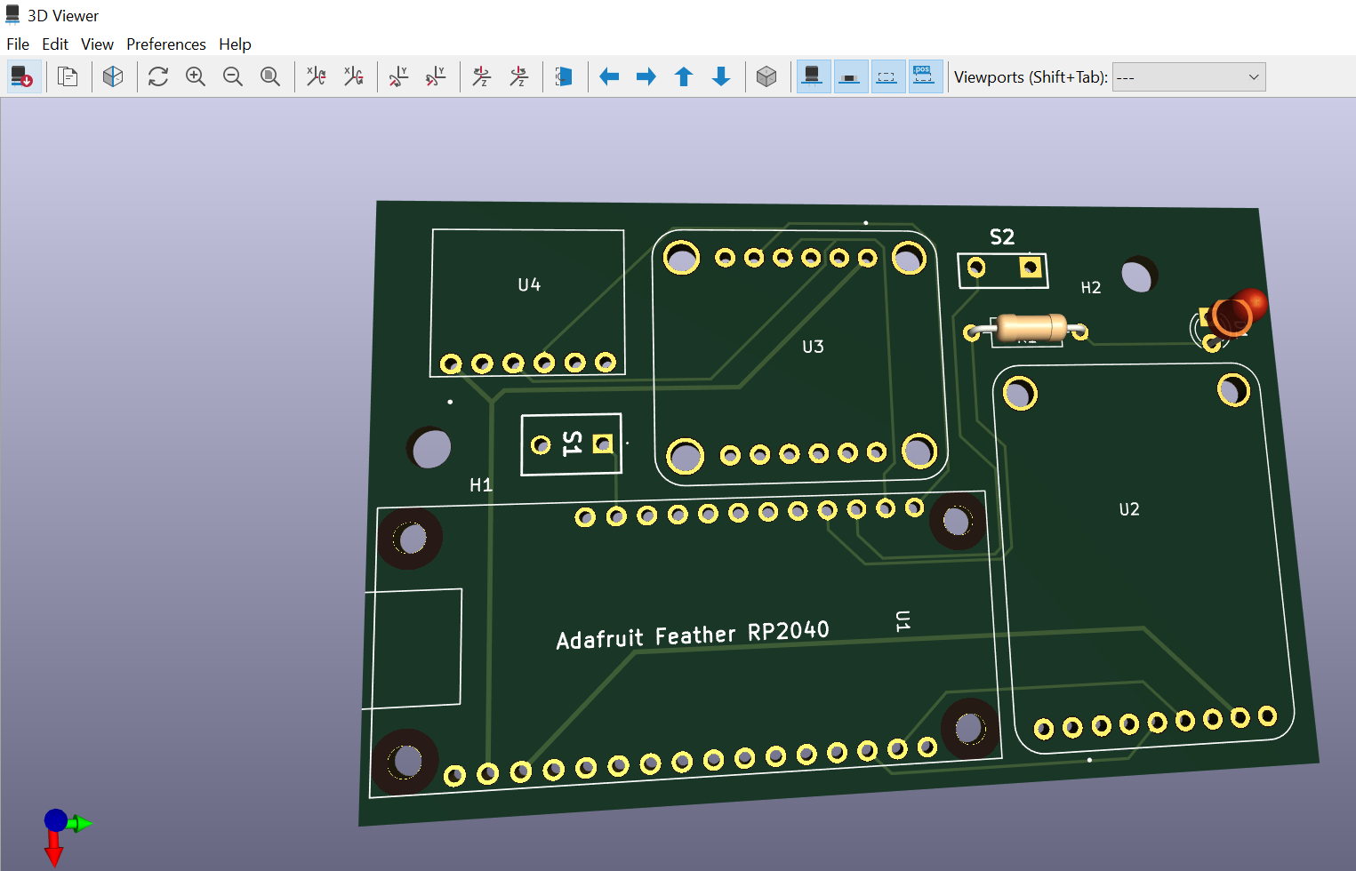
Difficulties
Figure 32. Finalized and corrected wearable PCB 3-D model generated in KiCad7.0

PCB design and order
The design for the PCB took notably longer than anticipated for two reasons. Adafruit components/modules are typically well resourced and though in every other area aspect of the project the resources found use, unfortunately no easily integrated schematic and footprint models were available for all of the modules. As such, both custom schematic diagrams and custom PCB footprints had to be designed. This increased the time spent on the PCB design further than was previously anticipated. Following this, a PCB was finally submitted, however it was noted shortly after that a major issue had occurred when routing the GPS; the Tx port of the GPS module and the Feather were directly connected, as were the Rx ports, from the beginning of the schematic into the final submitted PCB design. As such the GPS module would require an exceptional work around if this PCB were to be used. The decision was made to reroute the pins/PCB traces to match Tx to Rx respectively, then resubmit the PCB order, a costly mistake that would see the viable PCB arrival push past the week where testing had been planned. The PCB is set to arrive in time for soldering and testing to be carried out prior to the second deadline for final product completion (17/07/25). The first order could not be cancelled and so the cost was incurred.

Batteries
3.7V 1100mAh batteries from Amazon which we had identified to be perfect for our use case, they had a JST connector which matched the pin configuration shown in figure 1. Despite appearing to match, result of plugging the battery into a Feather was immediately concerning and dangerous. A safety incident form was submitted to the workplace manager of the lab to inform them of the incident and the rest of the team was notified. The battery used was placed into the dedicated battery bin after being seemed safe enough. New batteries were then selected from an official distributor of the Feather (PiHut); Adafruit provide a warning that “cheaper batteries from Amazon” may destroy the Feather, it was assumed based on the reaction of the battery with the USB-C/JST connection circuitry that despite the colouration of the wiring, it is likely that the poles were in fact reversed. This unfortunately pushed testing back where the batteries were needed for the ‘wearable’ component, in a position where little contingency had been set.

Testing and Results

SOS Button / Emergency Call
Description
Verify correct functioning of the SOS button and its visual representation on the base-station UI.
Methodology
Power on both the wearable and the base station and wait until the base station confirms the wearable is connected.
Press the wearable's momentary SOS button and then observe the base-station UI.
Press the button again once SOS is activated to make sure multiple presses in a panic situation are not ignored/switched off.
Success criteria
The UI flashes the wearer's icon in red, indicating an active SOS call. SOS request is also switched to red and remains there.
Result
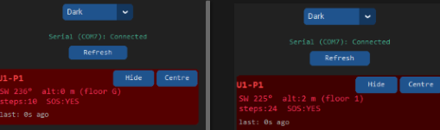
The wearer's icon flashed red exactly as required. Pressing the button a second time did not cancel the flashing of the SOS request, this all behaved as expected.
Figure 33. two frames captured while flashing red of unit1 person 1's identifier block during an SOS request.

Altitude / Floor Detection
Description
Confirm that a 3-4 m change in altitude correctly increments or decrements the floor number shown on the base-station UI.
Methodology
Ensure the wearable powers-on at ground level (altitude zero-reference).
Move the wearer up one floor (~3-4 m).
Observe the base-station UI for floor change and that it matches the actual floor level, verify that raw altitude (m) remains visible.
Success criteria
UI floor indicator increments (or decrements) exactly one level for a 3-4 m altitude change.
Result
Moving from ground (Floor 0) to Floor 1 was reflected immediately and accurately in the UI. This continued working with further floors, as no underground test could be performed we were able to zero the altitude at a higher floor then descend to ground floor to see B levels this also worked as expected after a few tweaks to average floor height.
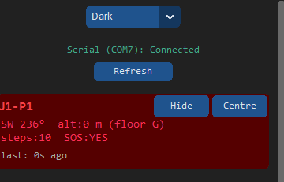
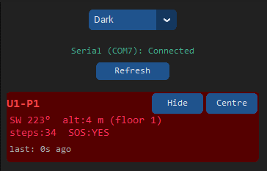
Figure 34. UI showing user at Ground level Figure 35. UI showing user at floor 1

Encryption Validation
Description
Demonstrate for safety reasons that transmitted location packets cannot be interpreted by other listeners without the correct decryption key.
Methodology
Capture a packet stream with an independent receiver.
Log raw bytes before decryption.
Success criteria
Captured bytes are unintelligible data, no location information can be extracted.
Result
A Sample packet (…25 F9 31 FE DD F9 CF C8) produced no coherent output until decrypted with the valid key. This was the same with all other packets sent with encryption enabled.
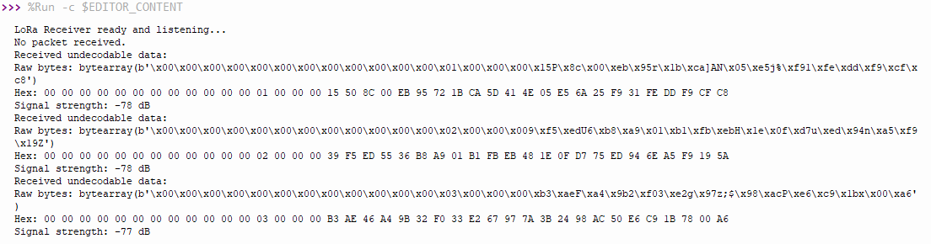
Figure 36. independent receiver code output showing data and signal strength of packets.

GPS Accuracy
Description
test initial GPS lock quality and overall tracking accuracy after also checking GPS lock with introducing a "settle" period and over quality enhancements.
Methodology
Baseline test: log first-fix positions with no quality filtering.
Firmware changes:
Require GPS_FIXES_BEFORE_LOCK = 60.
Filter by GGA quality flag.
Retest:
Record settled start position.
Walk a defined route: around a building, then a 4 × 5-step square (using a compass for exact cardinal turns).
Compare logged path against satellite imagery and measured step length (0.77 m).
Success criteria
Start position ≤ 2 m from ground-truth
Tracked path overlays walking route with deviations ≤ 1 m.
Square walk returns to start within one step length.
Result
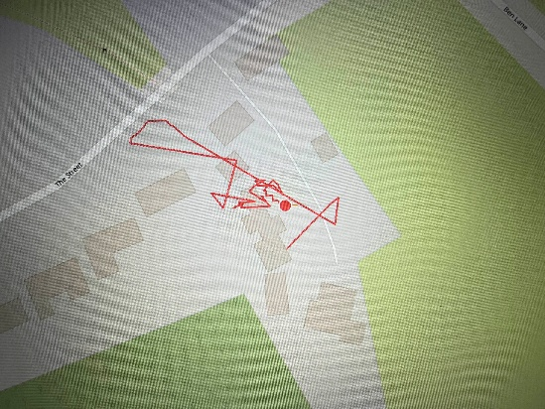
Real device position:
51.062287968324945, -1.6788835325379934
Resultant device position after multiple GPS calls:
51.062299346810086, -1.6789049902099216
Testing concluded that first calls from the gps module should not be taken as an accurate reading due to low satellite count acquisition. This is shown in the figure by a random jump of locations, finally settling close to the real position of the device.

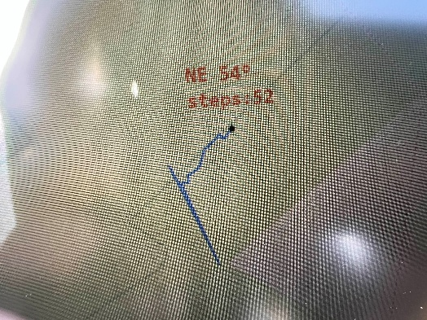
After changing this, two more tests and updates to the firmware were conducted to test the accuracy of the tracking:
The figure shows a jump of nearly 50 meters while GPS settled, then a stable walking path.
GPS_FIXES_BEFORE_LOCK = 30 was used in the code to only take the GPS data after 30 seconds receives spaced 1 second apart.
This was a test to see if the data displayed would be alleviated of the jagged position jumps, while the position did eventually “settle” it was still visible and affecting functionality
Figure 37. Testing route on base station map.

As displayed in the figure the starting point no longer had the large deviation as before, due to the new method of capturing only high accuracy GPS data.

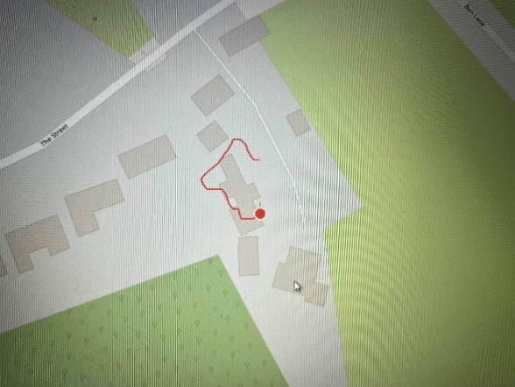
Figure 38. Testing route and GPS location start around and through a house
A new method was developed by verifying GPS quality through different NEMA sentences using GGA (Global Positioning System Fix Data).
only data of quality index of 2 was taken meaning a DGPS fix Differential GPS lock
A route was taken first around a house then through the house, the map showed a near perfect representation of walked route. This was with one GPS call at the starting position with the rest of the tracking done entirely through the 9dof sensor. This was a great result. Especially with the singular accurate starting position. Showing that the new NEMA sentence GGA implementation worked.

Sensor-Fusion Tracking / Dead-Reckoning Tracking
Description
Validate the tracking once an initial GPS fix has been taken, ensuring that the wearer's path is reproduced accurately on the base-station map.
Methodology
Initial reference:
Take a single high-accuracy GPS fix at a reproduceable position/landmark
The base station is placed away from the user to avoid interference if any.
Dead-reckoning run:
Using a compass, face exactly south and walk 5 steps (0.77 m per step).
Turn 90 ° clockwise (now facing east) and repeat another 5 steps.
Continue the turn-and-walk sequence twice more to form a closed square (total 20 steps).
No further GPS data are accepted during the walk. Position updates rely solely on IMU data.
Record the path plotted on the base-station UI and compare with the expected geometric square.
Success criteria
Shape on the UI must be a square aligned to the cardinal axes.
The perimeter calculated by the base station should match the expected 15.4 m within one step length (≤ 0.8 m).
Start and finish points should coincide within one step length.
Result
The base-station map displayed a perfect south-east-north-west square with a measured perimeter of 15.39 m. The start and end points overlapped inside the one-step tolerance, confirming that sensor-fusion dead-reckoning maintained step by step accuracy over the 20 step route. Figures the figures below show the base-station view and satellite overlay of the walked perimeter. As well as more information regarding the testing procedure.
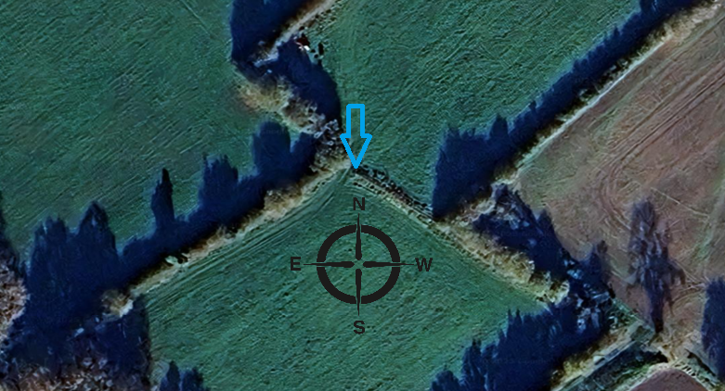
Figure 39. Testing Location
To test the accuracy of the tracking we used the point with coordinates at one of the team members private land:
longitude: 51.075135278333455 Lattitude: -1.693804114889145
These Coordinates were chosen to be the single reproducible starting coordinates. This being at the end of a fence was a good starting point for repeated testing as we can return to this same position with ease.
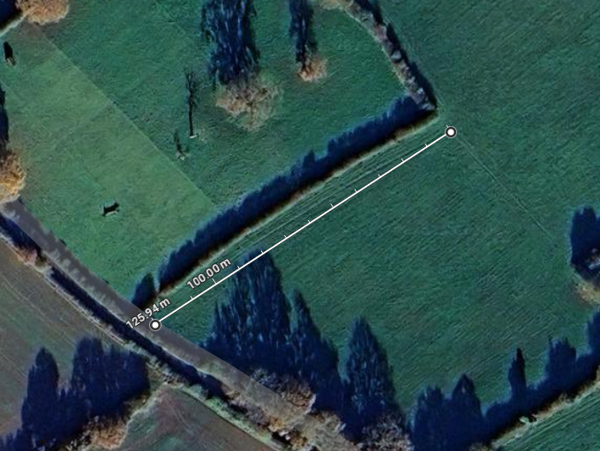
Figure 40. Distance from user wearing the tracking device and the base station.
The base station was located at the entrance of this field with a 125m distance to the user testing the steps.
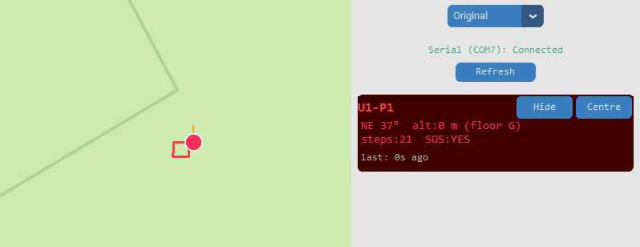
Figure 41. Showing square tracking of user wearing device.
Using a compass the wearer oriented themselves facing exactly south and took 5 steps, turned 90 degrees clockwise to now face east then walked another 5 steps and repeated this 4 times to arrive back at the starting position.
The base station map reflected exactly what was expected showing a perfect square aligned to each direction.
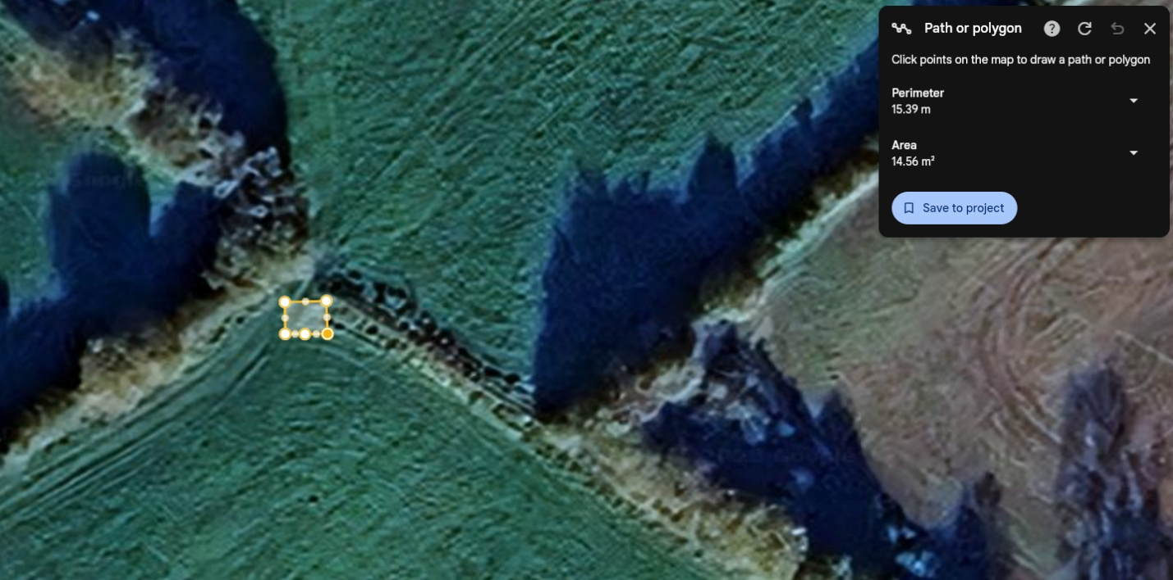
Figure 42. Satellite view of testing perimeter walked by user wearing tracking device.
The perimeter shows 15.39 meters which matches very closely to the walked distance of 15.4 meters. Each step being 0.77 meters [28]. Overall, this test was a great success in terms of accuracy of the heading, the step counter and the conversion to coordinates from a distance.
While steps being set to the average stride length was accurate in the tested scenarios, for longer operation an approach similar to how Apple watches calculate stride length based on the user’s height may have been a better alternative. This can be hard coded to each user’s device however there is no direct input for this.

LoRa Range Test
Description
Measure maximum reliable communication distance between wearable and base station over 868 MHz LoRa at 14 dBm with quarter-wave antennas.
Methodology
Position devices along an open, as close to open line-of-sight track as possible, increase separation until packets drop.
Repeat in a second direction where terrain or other factors may cause obstruction / interference.
Success criteria
Sustain a usable stable link at or near the manufacturer’s 2 km specification, observe predictable reduction with terrain changes.
Result
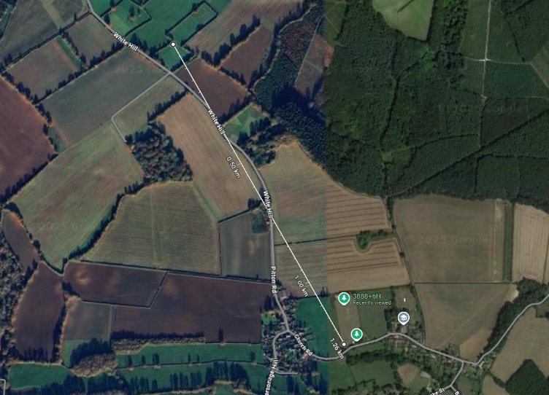
Figure 43. Maximum range in test transmitter shown above, receiver below
The range of the LoRa transmission and reception was also tested in the same location as the dead reckoning. This range of 1.26km while lower was expected due to the stated 2 km range from Adafruit documentation. [17]
The setup for this test included both devices being set to 14 dBm, the maximum allowed power for transmission at this frequency. While further range can be achieved with more power, we had made sure to stay within Ofcom's guidance.
Both devices were also connected to a quarter-wave antenna with a UFL-to-SMA cable directly mounted to the Feather RP2040's antenna pin.
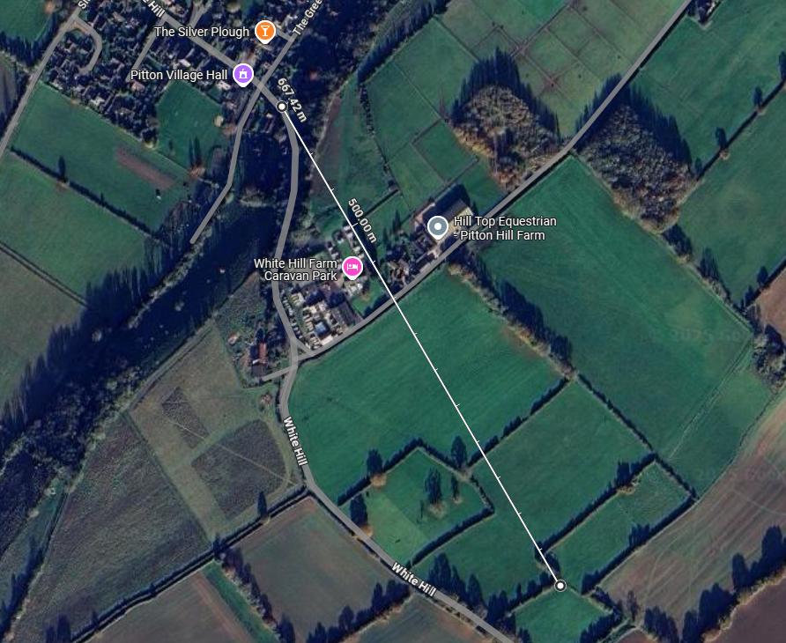
Figure 44. Range test 2 in separate direction.
Range was also tested in another direction to gather more results. However, the range here of 667m was significantly impeded by the decline in gradient as the line of sight was occluded by terrain. Further testing in a better environment could provide better results and highlight more limitations, however for the time scale this was a significantly important test to give guidance to users and to understand the operational ranges of the device.
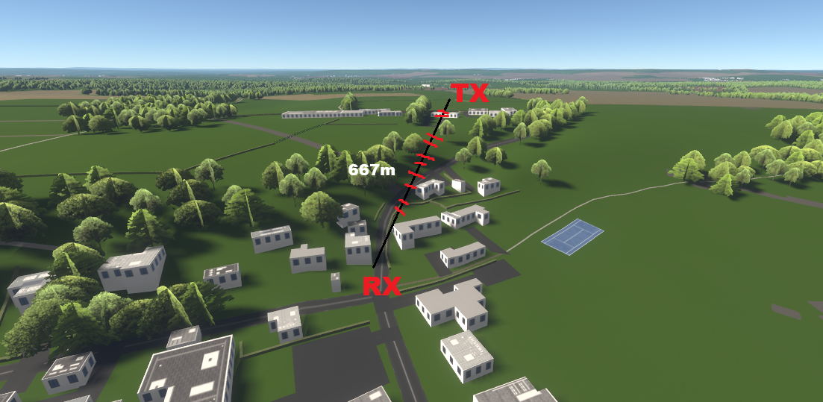
Figure 45. 3D view of geographic area, with obstructions shown in red of landscape and buildings.

Evaluation
The device designed meets two of the funding source’s system requirements:
- Battery life, while not tested due to the timing of the battery difficulties, can to far exceed one hour of continuous use, where typical operation is estimated to be significantly below a continuous current draw no more than 150mA with continuous +14dBm transmissions.
- The product will be close to ~40cm² large. A small, comfortably worn form factor.
- Table 2 shows that the cost per unit exceeded the goal, however this may be mitigated were the device to be brought to a larger scale of manufacture where the economy of scale brings IC prices down – in particular, PiHut is a consumer electronics distributor often more expensive than other options where component quality is more tightly controlled. The development model lead us to using components with higher premiums and unnecessary hardware, for example the Feather I/O pins. Although attempts were made to integrate more cost effective, restricted hardware (10-DOF), attempts were ultimately unsuccessful in the limited time frame.
Of the funding source’s functional requirements:
- Data from the wearable was shown to be received from a distance exceeding 1km.
- Packets sent from the wearable were shown to penetrate through a building’s walls to the ‘base station’, such as in the floor detection test.
- Orientation data appeared to remain accurate across tests over a period of time.
- Encryption of transmitted data was implemented and proven in testing.
Of the funding source’s “nice to haves”:
- Both the wearable and base station are designed with simple operation in mind, requiring singular inputs for whole functions for the wearable and just the execution of an application for the base station respectively.
- With no enclosure, currently the device cannot be worn, this may improve by the second deadline.
- Minimum viable product design meant forgoing proper ruggedization design and testing.

Final BOM for a single product
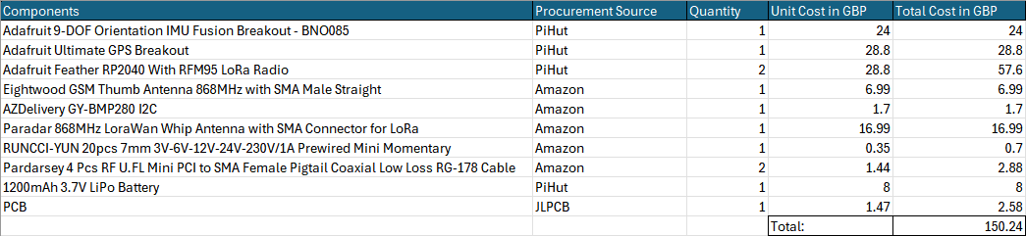
Table 2. Final BOM for a single wearable and base station device pairing using the same distributors/components

Conclusion
The majority of the funding source’s basic requirements have been met, however more time is necessary to bring the product together into a usable state by an end user with an enclosure and PCB. The tight timeframe and lacklustre initial planning with no built-in contingency lead to unnecessary issues that blocked final product development steps.
The project met the aim of implementing a true dead-reckoning positional tracker with accessible COTS hardware alongside open-source software solutions. Despite not fully utilizing the sensor fusion potential of the BNO085, dead-reckoning and basic 3D movement tracking within building structures was achieved. This capability provides significant operational value for police, firefighting, and military personnel operating in unknown or hazardous environments.
The technical implementation demonstrates the effectiveness of accessible development approaches, utilizing CircuitPython and Adafruit libraries to achieve efficient development cycles. While the development philosophy was beneficial for some areas like programming time, other areas like cost per unit were harmed.

Future Work
While the current system meets the basic objectives, immediate future work, potentially for the second deadline, will focus on bringing the prototype into a final product with the PCBs and an enclosure design.
The dead reckoning algorithm currently deployed would have significant headroom for improvement, gains in prolonged orientation/positional accuracy will likely be found through following research outlined in the literature review including proper integration of GNSS fixes for runtime corrections. In particular, stride length handling is nonadaptive and assumes a universal value for every user and every step taken, an abstraction that will damage positional accuracy over a prolonged runtime.
With more time and team experience, cheaper, more restricted hardware like the 10-DOF of less complex microcontrollers, say one of the PICC family of controllers, could instead be incorporated for a greatly reduced cost per unit.

Reflections
Ed Bulpitt:
Throughout this project I’ve grown significantly on both the technical and project-management fronts. Technically, I’ve deepened my proficiency in Python, particularly with CircuitPython. I also got hands on experience with more RF technologies (LoRa) a comms protocol I was not previously familiar with, Working with the Adafruit GPS module and what seemed like reverse engineering NMEA sentence formats improved my ability to parse and normalize data streams, which seemingly will be very helpful in my current career path, development on the BNO085 9DOF sensor required me to understand the real world limitations of MEMS devices.
I also thought taking charge of the repository and developing alongside it helped not only myself but also the team in this project (from GPS.py and Compass.py to TRANSMITTER.py and RECEIVER.py) each was easily accessible to everyone and easy to understand, this helped my software-engineering and version-control practices which were already deemed as needing some work by senior engineers. Developing the map interface also has given me knowledge and now skills to visualize data as well as some UI-design skills.
On the soft-skills side, I've learned to integrate into multi-disciplinary project from start to finish. One of the biggest take aways from this was the value in taking lead on ideas you believe will be helpful or even vital to the project’s success one example I made of this was standardizing our teams development environment at the start with the same versions of Thonny with the same CircuitPython libraries and firmware, by using the version control I felt as If I was able to be a point of contact for questions and progress updates throughout the project.
If I were to remake this project, I would have spent more time on initial research of the projects feasibility so that failure or deadline pushbacks would not be within scope, that being said the hurdles faced made for a far more challenging and rewarding project, with a lot of project management, software and hardware issues to raise, learn from, and talk about in this report. Finally, I believe that giving myself more time to thoroughly test and gather real world end user opinions would have improved the project greatly due to the more iterative nature of designing in that way. These are all the things I am now aware of from this project.

Zakir Basit:
In reflection, this project was an exciting challenge to me. It was a great opportunity to dive into working with both hardware and software sides of electronics. From devising a breadboard for the proposed device, to reverse-engineering sensor drivers, and finally going outside to test our devices to their limits – this project was an adventure to say the least. Even though we couldn’t reach our final goal of producing a fully-fledged dead reckoning device with a cool and interactive application for the base station, there were so many skills and lessons learned. I feel confident that I can work with microcontrollers hands on, integrating sensors by following their respective datasheet, to then extracting and manipulating data from them. I now understand the hassle with sourcing electronic parts. Being able to judge whether the part we’ve found online is truly quality or just a cheap-knock off has massively improved, as now I’ll ask myself if it’s worth taking the gamble on a cheaper part and envision the long-term faults that may arise. If there’s one thing I’d do if we were to start again, it would be first generating more customers to work with and then establishing a strong network with them. I feel if we had the chance, incorporating more frequent meetings, discussing what we’ve done so far and argue what should be implemented, it would help carry lots of momentum as we can focus on getting tasks completed instead of deciding between tasks. In addition, I would take more time to learn the math and algorithms that I implemented in the 10DOF development as this knowledge would hold so much value in my future endeavours as an electronics engineer.

Lewy Harrison:
This project has given me very valuable experience. Using Thonny to write code for a microcontroller was new to me, and a skill I feel has developed to a high level. I have never previously worked with LoRa or any low voltage transmissions and after working on this project and learning a lot about this subject, I now feel confident that if asked to complete any similar work I could do it to a high standard.
On more personal skills, I have learned the process to complete a larger project from start to finish and to work effectively with a team. Coordinating effectively with the team was key to the success of this project and I feel that it was done well. I have also learnt how to use pre-existing libraries to create new code and shape them to the needs of the project.
If I were to redo this project, I would have liked to participate more in the hardware side. Even though I did some soldering, I would have liked to be a part of the design process of the casing or the PCB for the final device.
Overall, I feel like I have learnt a lot of valuable skills and information on this project that I will use many times in the future. The CircuitPython and LoRa knowledge has built a solid foundation for the future.

Rowan Patey:
This project initially seemed daunting, particularly in the timeframe, but has shown me how valuable it can be to make good selections in hardware with respect to their resources. I’m a little disappointed that we didn’t quite reach the stage of final product output, in part due to some of my missteps, but for that I have taken on a strong lesson in really checking any hardware I may design in the future. Researching the IMUs/GPS/LoRa modules gave me a lot of insight I previously didn’t have and it was a really enjoyable experience to then try to convert the mathematical theory into real working functions. I find those sort of theoretically challenges engaging and this project pushed me to confront a lot or problems like this, such as my stride length estimation and rotation vector work. It was definitely quite a brave project to take on but I am surprised at some of our results. I feel like I have barely scratched the surface of proper IMU fusion/dead reckoning navigation implementation and have a new found appreciation for the area having seen the brilliant work of many others during research.
For soft skills, I haven’t had many opportunities to work in a larger group than 2, particularly where I may be more senior in some ways to other team members, so this was a great opportunity to develop some lighter leadership/management skills in managing the less experienced members/guiding them. I haven’t typically had to consider the implications (ethical, environmental, social etc.) of my study and work so having that as a good component of the project made me pay mind to them. This report has been a good test of my ability to guide the others on how to properly reference and research as well as writing out a proper report. This project has presented quite a good mixture of skills.
With just a little more time we would have been able to reach that ‘final product’ sort of stage and I see myself perhaps doing so in my own time simply because of how interesting I’ve found some of the dead reckoning algorithm research to be; I’d like to see this through to a more complete product whether its in my own time or not.

References

[1] | Advanced Navigation, “Pedestrian Dead-Reckoning - An Introduction,” Advanced Navigation, 8 May 2023. [Online]. Available: https://www.advancednavigation.com/tech-articles/pedestrian-dead-reckoning-pdr-an-introduction/#:~:text=A%20modern%20INS%20will%20typically,from%20the%20last%20known%20fix. [Accessed 7 July 2025].
[2] | A. X. X. S. a. Y. W. Yushi Hao, “A Modified Extended Kalman Filter for a Two-Antenna GPS/INS Vehicular Navigation System,” MDPI, 6 Nov 2018. [Online]. Available: https://www.mdpi.com/1424-8220/18/11/3809#:~:text=Usually%2C%20the%20extended%20Kalman%20filter,of%20the%20statistics%20of%20state. [Accessed 7 July 2025].
[3] | C. A. L. K. Y. P. Kai Wei Chiang, “Applied Mechanics and Materials (Volumes 284-287),” Scientific.Net, January 2013. [Online]. Available: https://www.scientific.net/AMM.284-287.1956. [Accessed 7 July 2025].
[4] | W. F. P. L. Z. L. X. X. Y. Y. Zhengjing Zhou, “A fusion method of pedestrian dead reckoning and pseudo indoor plan based on conditional random field,” Measurement, vol. 207, 15 Febuary 2023.
[5] | Y. K. &. T. Tanaka, “Improvements in Accurate GPS Positioning Using Time Series Analysis,” Taylor & Francis, 18 January 2021. [Online]. Available: https://www.tandfonline.com/doi/abs/10.9746/jcmsi.4.283. [Accessed 7 July 2025].
[6] | GPS.gov, “GPS Accuracy,” GPS.gov / US Space Force, 3 March 2022. [Online]. Available: https://www.gps.gov/systems/gps/performance/accuracy/. [Accessed 7 July 2025].
[7] | antenova, “GNSS module performance: 4 key metrics,” antenova, [Online]. Available: https://blog.antenova.com/gnss-module-performance-4-key-metrics. [Accessed 7 July 2025].
[8] | D. A. A. M. L. R. C. G. Juan Carlos Alvarez, “Pedestrian Navigation Based on Waist-Worn Inertial Sensor,” August 2012.
[9] | D. G. R. R. G. Joao Pedro do Omena Simas, “Software-Defined Radio Implementation of a LoRa Transceiver,” National Library of Medicine, 25 July 2024. [Online]. Available: https://pmc.ncbi.nlm.nih.gov/articles/PMC11315052/. [Accessed 7 July 2025].
[10] | The Things Network, “EU863-870 MHz Band,” The Things Network, [Online]. Available: https://www.thethingsnetwork.org/docs/lorawan/regional-parameters/eu868/. [Accessed 7 July 2025].
[11] | E. B., “LoRa Documentation,” LoRa, 2018. [Online]. Available: https://lora.readthedocs.io/en/latest/#data-rates. [Accessed 7 July 2025].
[12] | Ofcom, “Short-range devices,” Ofcom, 16 March 2023. [Online]. Available: https://www.ofcom.org.uk/spectrum/radio-equipment/short-range-devices#:~:text=A%20short,interference%20basis. [Accessed 7 July 2025].
[13] | B. White, “Data protection compliance and monitoring staff,” Harper James, 16 June 2025. [Online]. Available: https://harperjames.co.uk/article/data-protection-and-monitoring-staff/#:~:text=,the%20type%20of%20staff%20you. [Accessed 7 July 2025].
[14] | Ufine, “How to Prevent LiPo Battery Explosion?,” Ufine Blog, 2 Febuary 2024. [Online]. Available: https://www.ufinebattery.com/blog/how-to-prevent-lipo-battery-explosion/. [Accessed 7 July 2025].
[15] | “Lithium-ion battery recycling,” Li-Cycle, [Online]. Available: https://li-cycle.com/ . [Accessed 7 July 2025].
[16] | M. Hosseini, “How PCB Hazardous Material Impacts PCB Manufactoring and Environmental Complience,” Arshon Technology, 18 March 2025. [Online]. Available: https://arshon.com/blog/how-pcb-hazardous-material-impacts-pcb-manufacturing-and-environmental-compliance/. [Accessed 7 July 2025].
[17] | K. Rembor, “Adafruit Feather RP2040 RFM95,” Adafruit, 5 Febuary 2025. [Online]. Available: https://learn.adafruit.com/feather-rp2040-rfm95/pinouts. [Accessed 7 July 2025].
[18] | l. ada, “Adafruit Ultimate GPS,” Adafruit, 22 January 2025. [Online]. Available: https://learn.adafruit.com/adafruit-ultimate-gps/overview. [Accessed 7 July 2025].
[19] | B. Siepert, “Adafruit 9-DOF Orientation IMU Fusion Breakout - BNO085,” Adafruit, 21 April 2025. [Online]. Available: https://learn.adafruit.com/adafruit-9-dof-orientation-imu-fusion-breakout-bno085/overview. [Accessed 7 July 2025].
[20] | Bosch, “BMP280 Digital Pressure Sensor Datasheet,” 2015.
[21] | DFRobot, “10 DOF Mems IMU Sensor (Arduino Compatible) v2.0 wiki - DFRobot,” DFRobot, [Online]. Available: https://wiki.dfrobot.com/10_DOF_Mems_IMU_Sensor_V2.0_SKU__SEN0140. [Accessed 7 July 2025].
[22] | Circuitpython, “Circuitpython Libraries,” Circuitpython, 2025. [Online]. Available: https://circuitpython.org/libraries. [Accessed 7 July 2025].
[23] | E. Gakstatter, “What exactly is GPS NMEA data?,” GPSWORLD, 04 02 2015. [Online]. Available: What exactly is GPS NMEA data?. [Accessed 12 07 2025].
[24] | MicroPython & CircuitPython contributors, “AES encryption routinesℑ,” 10 07 2025. [Online]. Available: https://docs.circuitpython.org/en/latest/shared-bindings/aesio/. [Accessed 11 07 2025].
[25] | CEVA, Hillcrestlabs, “BNO08X Data Sheet,” 2023.
[26] | CEVA, HillCrest, “BNO080/BNO085 Sensor Calibration Procedure,” 2019.
[27] | Adafruit Industries, “adafruit / Adafruit_CircuitPythong_BNO08x,” [Online]. Available: https://github.com/adafruit/Adafruit_CircuitPython_BNO08x/blob/main/examples/bno08x_more_reports.py. [Accessed 23 06 2025].
[28] | “Real-Time Step Length Estimation in Indoor and Outdoor Scenarios,” sensors, vol. 22, no. 21, p. 8742, 2022.
[29] | “Github - rowoflo/ArduinoLibrary_ITG3200,” [Online]. Available: https://cdn-shop.adafruit.com/datasheets/HMC5883L_3-Axis_Digital_Compass_IC.pdf.
[30] | HoneyWell, “Datasheet - HMC5883L 3-Axis Digital Compass IC,” [Online]. Available: https://cdn-shop.adafruit.com/datasheets/HMC5883L_3-Axis_Digital_Compass_IC.pdf.
[31] | PARALLAX INC, “Compass Module 3-Axis HMC5883L (#29133) Datasheet,” [Online]. Available: https://www.generationrobots.com/media/module%20boussole%203%20axes%20HMC5883L/29133-HMC5883L-Compass-Module-IC-Documentation-v1.0.pdf. [Accessed 07 07 2025].
[32] | “Mahony Orientation Filter,” [Online]. Available: https://ahrs.readthedocs.io/en/latest/filters/mahony.html.
[33] | Adafruit, “Adafruit 3D Model Viewer,” [Online]. Available: https://adafruit.github.io/Adafruit_WebSerial_3DModelViewer/.
[34] | Adafruit, “Introduction — Adafruit BMP280 Library 1.0 documentation,” [Online]. Available: https://docs.circuitpython.org/projects/bmp280/en/latest/.
[35] | AdvancedPCB, “The Importance of Power and Ground Planes in PCB Design,” 15 08 2024. [Online]. Available: https://www.advancedpcb.com/en-us/resources/blog/the-importance-of-power-and-ground-planes-in-pcb-design/. [Accessed 8 07 2025].
[36] | OSHPark, “Drill Specs,” [Online]. Available: https://docs.oshpark.com/submitting-orders/drill-specs/. [Accessed 08 07 2025].

Appendix A – Group Meeting Minutes
Meeting date 9th June 2025:
Blockers:
- Rowan and Ed fully focusing on report writing for a work project.
- Zakir and Lewy engaged with personal work projects primarily.
- Zakir did not have lab access/SQEP checked for soldering.
- Lewy was not SQEP checked for soldering.
Tasking:
- RESEARCH – Researching the parts/methods of dead-reckoning that exist will be the primary focus this week, having some idea of how the modules will work/how we want to use them for the aim will decrease friction once in the lab.
- Parts acquisition – Having spent time at university deciding on potential parts to use, this week they will need to be purchased to be ready for the next week in lab. Someone needs to spend some time to make the order, ensuring multiple sources have been checked before selecting a distributor.
- Potentially setting up the centralised information hub in the form of a GitHub repository that will act as an open source for viewing onboard firmware.
Division of tasks:
- Rowan – Parts ordering, looking at the selected 9-DOF
- Ed – GitHub, looking at the GPS module
- Zakir – Focus on getting lab access, looking at the selected 10-DOF
- Lewy – SQEP check for soldering, LoRa transceiver module

Meeting date 16th June 2025:
Blockers:
- Rowan and Ed still needed to spend time on the report, Rowan may take over to allow Ed focus on this project.
- Zakir and Lewy giving some focus to personal projects.
- Zakir now has lab access and will be SQEP checked for soldering this week.
- Lewy getting SQEP checked this week.
Tasking:
- Research – Researching the parts/methods of dead-reckoning continues alongside having the
- Soldering – Parts have now arrived but need to be soldered to headers for use with the breadboards, this can be equally divided for experience.
- Breadboards – setting up breadboards for prototyping with different modules, particularly looking at the pinouts
- Developer environments – Everyone on the team needs to be set up with a suitable developer environment and taught how to use it, this will be Thonny for the RP2040.
- Repository – GitHub is now ready; we can upload our individual files to here for a basic component library
Division of tasks:
- Rowan – Header soldering, looking at the selected 9-DOF, helping others with Thonny.
- Ed – Header soldering, GitHub, looking at the GPS module, helping others with Thonny.
- Zakir – Header soldering, setting up Thonny, looking at the selected 9-DOF
- Lewy – Header soldering, setting up Thonny, LoRa transceiver module of Feather

Meeting date 23rd June 2025:
Blockers:
- Rowan and Ed now clear of previous project needs, they have new projects individually, but they are less demanding time wise.
- Zakir fairly free this week.
- Lewy busy with personal project work.
Tasking:
- Proper development begins – having gained some confidence with the developer environment and parts.
- Extract and start to manipulate data from the sensors.
- Research into more LoRa capabilities, specifically encryption
Division of tasks:
- Rowan – Working on the 9-DOF looking at the options for applying a basic dead reckoning
- Ed – Integrating GPS, data stream implementation, serial communication, with the expected basic dead reckoning algorithm/coordinates system, beginning to develop the visualization element/application for the base station.
- Zakir – Fully taking over 10-DOF research/implementation as another avenue for the project, looking at how to get all the sensors working to begin with.
- Lewy – Looking at encryption options for the LoRa transmission.

Meeting date 30th June 2025:
Blockers:
- Lewy engaged with personal work project.
Tasking:
- PCB design and order
- Finalise proper heading calculation and integrations.
- Finalise work on sensors and begin testing
- Create base station application.
Division of tasks:
- Rowan – Trying to refine the 9-DOF algorithm with calibration and proper geomagnetic rotational vector-based heading instead of soley magnetometer, PCB design and order by Friday for arrival next week.(schematic and PCB through KiCad)
- Ed – Continuing the application for the base station.
- Zakir – finalise work on 10DOF and produce code for the barometric sensor. Look into implementing 3d buildings into the base station application
- Lewy – Personal Project work

Meeting date 7th July 2025:
MINIMUM VIABLE PRODUCT DECLARATION
Blockers:
- Everyone available for solely group project work.
- Planned testing may need to wait until a correct battery + PCB order arrives
- As such it has been agreed that we will look to produce the minimum viable product option by the 10th, allowing for test routine time.
Tasking:
- PCB order – Rowan misjudged the time required for him to generate the PCB and have it ordered in time where he otherwise chose to try and help firmware development last week. The order needs to be made this week to try to have it in time for the end of the week for some testing.
- Testing – Testing could ultimately be carried out without the PCB, where the board is simply a way to integrate the parts in a secure manner. Breadboard prototypes + batteries provide a suitable test platform.
- Difficulties implementing 3d mapping – resort to 2d map interface and ensure data is correct
- Report writing, ideally starting on 09/07/25.
Division of tasks:
- Rowan – Priority on PCB order placement within the day, designing and refining the test routine, further attempts to integrate proper heading calculations if there was time, report writing.
- Ed – Refactoring teams code base into singular MVP, Testing said MVP, report writing
- Zakir – ready to pipeline barometric code into code base, take part in testing MVP
- Lewy – LoRa transmission encryption method, report writing with the group

