Embedded C – ACDA4013
Generating a Program for a Specified Embedded Requirement in C

Tamsin McKerrow (2415958)
December 2025

Table of Contents
Introduction 2
Background Research 3
Engine Cooling Systems 3
Microcontroller Application in Embedded Systems 3
System Logic and Operation 4
Circuit Design 5
Simulation and Testing 6
Each Stage of Simulation 6
Expected vs Actual Output 8
Adjustments Made 8
Conclusion 9
References 10
Appendix 11
Appendix 1 – Initial Code 11
Appendix 2 – Final Code 13

Table of Figures
Figure 1: Flowchart of Program Operation 4
Figure 2: Engine Cooling System Simulation Schematic 5
Figure 3: Working Simulation 5
Figure 4: Circuit Stage 1 6
Figure 5: Circuit Stage 2 6
Figure 6: Circuit Stage 5 7
Figure 7: Circuit Stage 4 7
Figure 8: Circuit Stage 3 7
Figure 9: Circuit Stage 6 8
Figure 10: Simulation with Initial Code 8
Figure 11: Initial Code Line 1-45 11
Figure 12: Initial Code Line 45-89 12
Figure 13: Initial Code Line 90-101 12
Figure 14: Final Code Line 1-44 13
Figure 15: Final Code Line 90-122 14
Figure 16: Final Code Line 45-89 14

Introduction
This project aims to replicate the logical sequence of an engine cooling process by designing a simulator to monitor the status of a simplified automotive engine cooling system. This is done using a PIC16F877A microcontroller and switches to simulate real-world sensors and components such as the radiator fan, coolant monitoring and engine start inputs. Each button provides feedback via LEDs, a display and UART messages.
This report contains research on the engine cooling system domain, including the system logic and operation. A circuit has been designed for simulation, and the results are included in this report.

Background Research

Engine Cooling Systems
Engine cooling is one of the most critical applications of heat transfer in modern engines, as they generate substantial heat. This must be managed effectively to prevent overheating and ensure optimised performance. These systems usually consist of a radiator, water pump, thermostat, and coolant – the coolant absorbs the heat from the engine and dissipates it through the radiator. [1] The coolant circulates through the engine block via passages, picking up heat on its way to the radiator, which is then cooled by the air stream entering the engine compartment through the grill at the front of the car. A thermostat is placed between the engine and the radiator to ensure that the coolant stays above a preset temperature; if it does not, the thermostat blocks coolant flow to the radiator, forcing it to flow back through the engine passages. [2]
An engine cooling system is an example of an automotive embedded system, a microprocessor-based system built into control units (ECUs) that operate under real-time constraints. They receive signals from sensors and actuators, then process the data using embedded software. [3] These systems are optimised for reliability, low power consumption, and real-time performance. [4]

Microcontroller Application in Embedded Systems
The PIC16F877A is based on the enhanced Harvard RISC architecture. It is known for its high performance, low power consumption, and extensive peripheral set, making it ideal for embedded systems and simulation. [5] It has a high operating frequency of 20 MHz, enabling fast instruction execution. [6] The 8K program and 368 bytes of data memory provide sufficient space for complex applications. The PIC16F877A also has a simple instruction set and has many available development tools, making it easy to program and debug. [5]

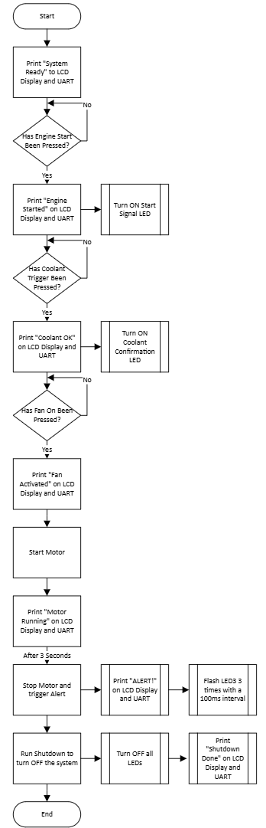
System Logic and Operation

The system has three push-button inputs that must be pressed in the correct order to trigger the next stage of operation: engine start, coolant check, and fan activation. For each of these stages, an LED should turn ON to simulate that the stage has been completed, along with confirmation on the LCD display and via a UART message on the virtual terminal.
Once all the buttons have been pressed, the system should trigger Alert (by flashing LED3 three times) to indicate that it is moving to shut down.

Figure 1: Flowchart of Program Operation

Circuit Design
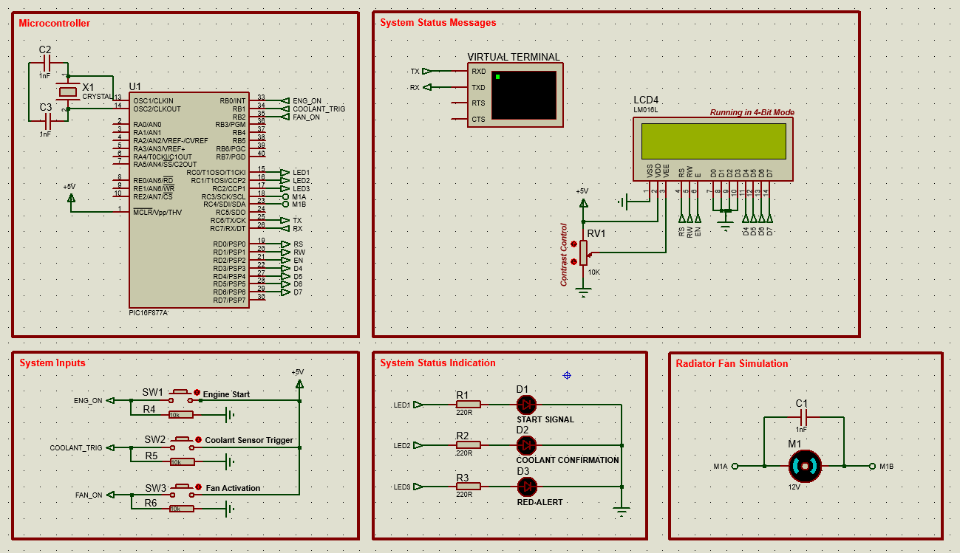
Figure 2: Engine Cooling System Simulation Schematic
Figure 3: Working Simulation
The circuit design is shown in Figure 2. Each part of the circuit is separated into boxes to present the system clearly: button inputs, status indication LEDs, the microcontroller, fan simulation, and status messages. The LCD is operating in 4-bit mode, which uses fewer pins on the microcontroller. Input and output labels were used to create a cleaner-looking schematic, making it easier to see what goes where.
Pull-down resistors were used on the buttons to ensure that the microcontroller reads 0V when the button is not pressed, and standard 220R current-limiting resistors were used before the LEDs to prevent them from being too bright. The motor simulating the fan has a capacitor in parallel to prevent noise.

Simulation and Testing

Each Stage of Simulation
Each stage of the simulation is shown in Figures 4-9, and the screen recording is shown in Figure 3.
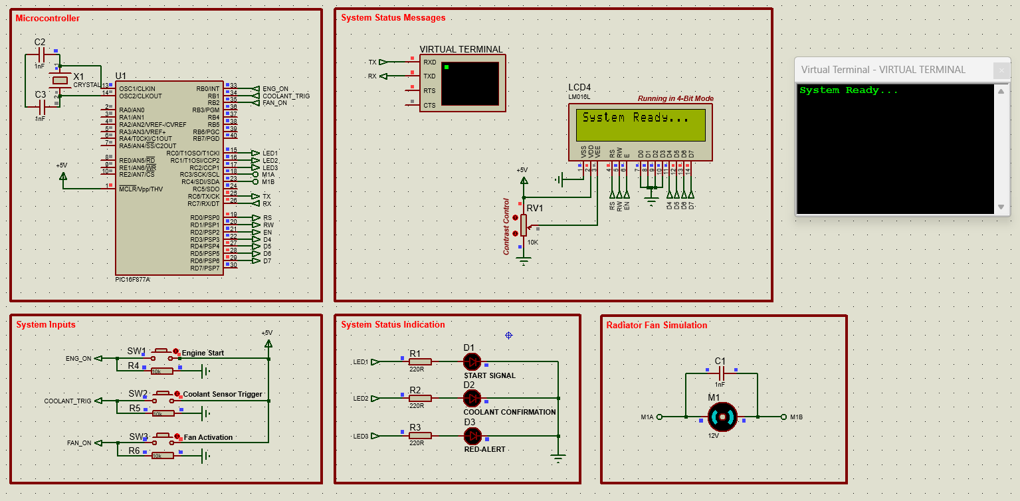
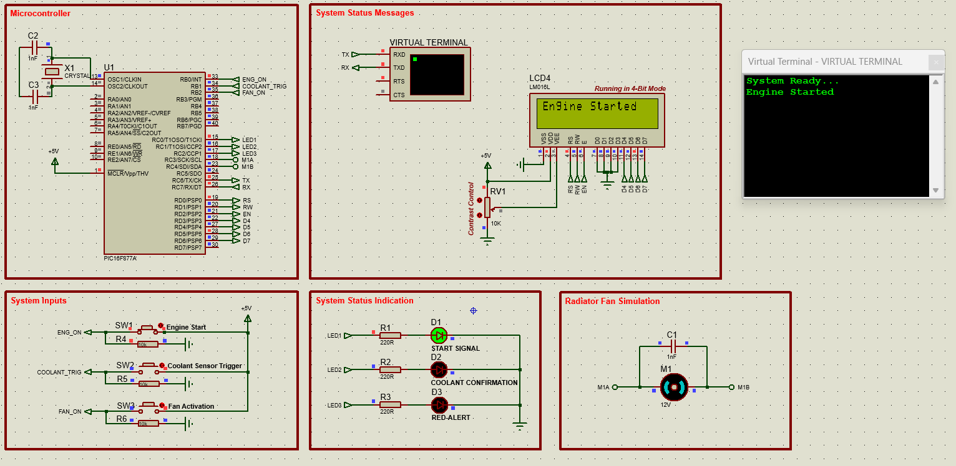
Figure 4: Circuit Stage 1
Figure 5: Circuit Stage 2

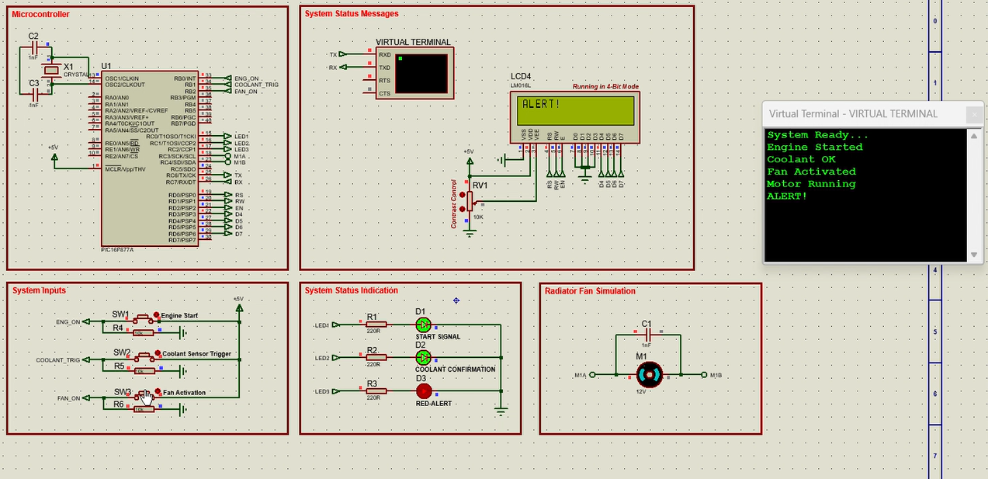
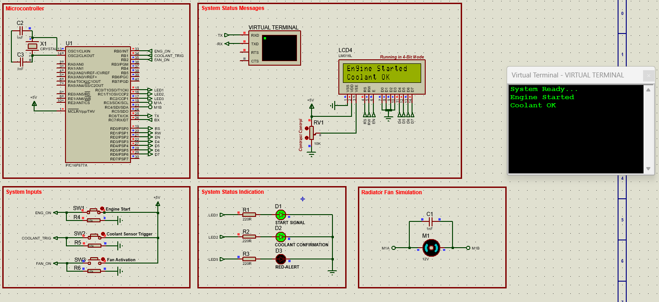
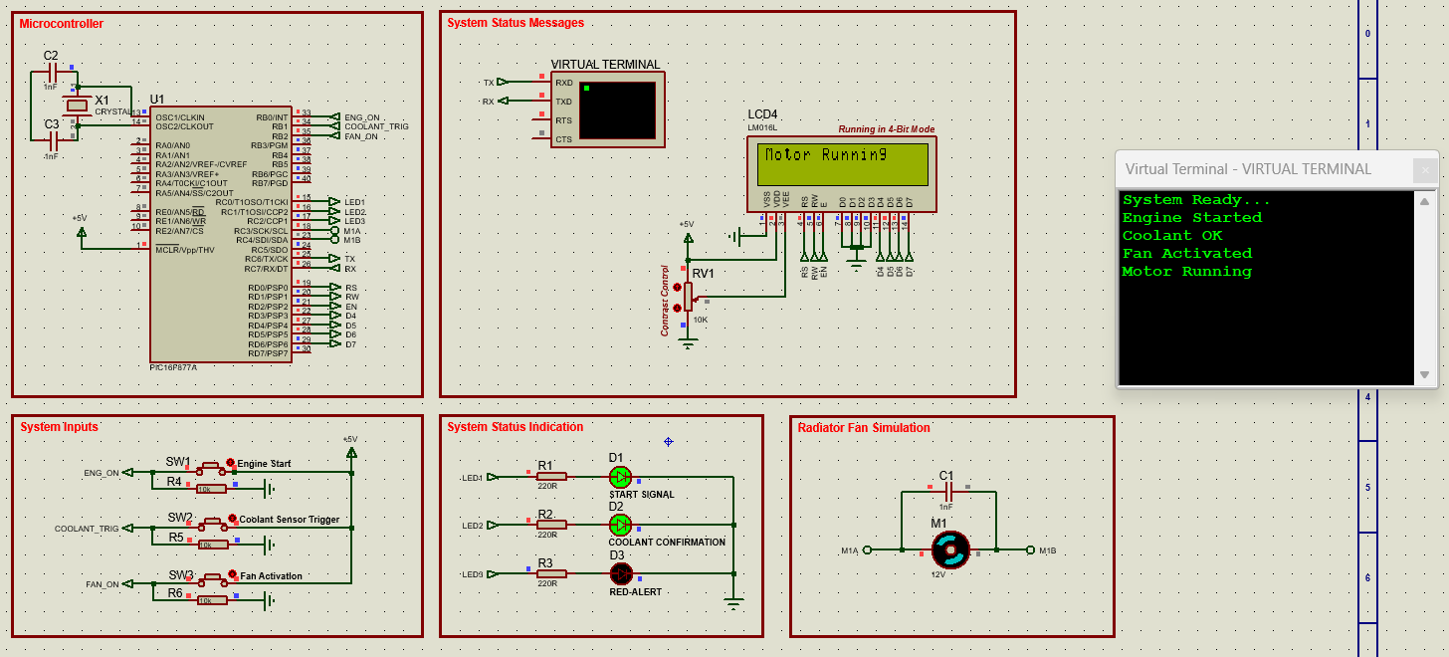
Figure 6: Circuit Stage 5
Figure 7: Circuit Stage 4
Figure 8: Circuit Stage 3
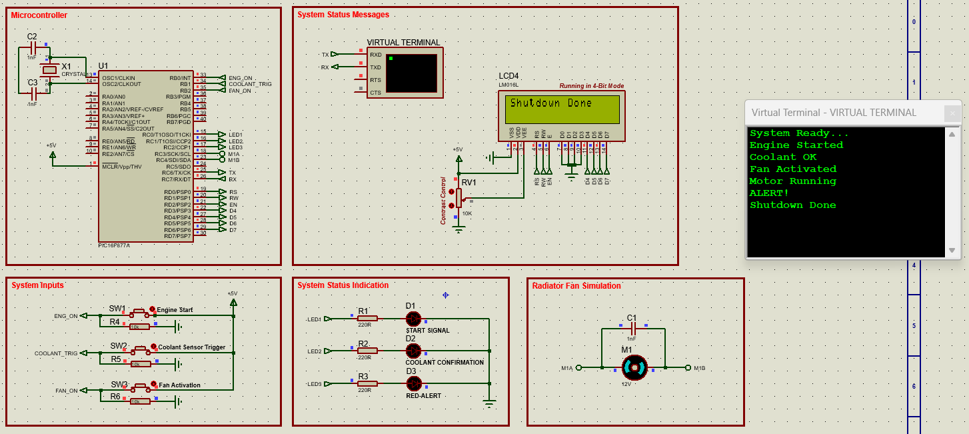
The code running in this simulation is shown in Appendix 2, where each line is commented to explain its operation.
Figure 9: Circuit Stage 6

Expected vs Actual Output
At each stage of the simulation, the expected outputs are the LCD screen, LEDs turning ON, the motor turning clockwise, and the UART messages on the virtual terminal.
During testing, the procedure was to press each button in order and verify that each executed the correct action by checking the UART messages, the LCD screen, and the LEDs. Then, once this had been verified, the buttons were pressed in the incorrect order to see what would happen. In the initial code (Appendix 1), pressing the coolant and fan buttons did nothing, but once the engine button was pressed, the code ran through the whole sequence as if the buttons had been pushed in the correct order – this was not the ideal output.

Adjustments Made
The initial code used logical operators to determine which buttons were pressed and what code to execute. This code also printed the LCD and UART messages multiple times, which led to them clogging up the virtual terminal and the LCD screen flashing. This is shown in Figure 10.
Figure 10: Simulation with Initial Code
The adjustments made to the code after this included removing the logical operators and using state machines and nested ifs to ensure that the next stage would not start unless the button sequence was correct. A subroutine was also added to tell the user to restart the system if the buttons had been pushed in the incorrect order.

Conclusion
The resulting simulation of this project sufficiently replicates the logical sequence of an engine cooling system. The code produced allows for status messages and indications at each stage of the system to clearly show what is happening.
Based on background research into the workings of an automotive engine cooling system, this simulation could be improved by adding another button to simulate the thermostat and what would happen if the coolant drops below a specific temperature. For example, the ‘radiator fan’ could switch OFF, meaning the coolant is bypassed back through the engine passages, and then switch back ON when the coolant reaches a sufficient temperature to be cooled again.

References

[1] | R. Santiago, “Heat transfer in automotive systems,” Discover Engineering, 26 November 2024. [Online]. Available: https://www.discoverengineering.org/heat-transfer-in-automotive-systems/. [Accessed 16 December 2025].
[2] | G. G. B. Gogineni. Prudhvi, “Cooling Systems in Automobiles & Cars,” International Journal of Engineering and Advanced Technology (IJEAT), vol. 2, no. 4, pp. 668-696, 30 April 2013.
[3] | Uplatz Blog, “Automotive Embedded Systems & Applications,” Uplatz Blog, 13 December 2025. [Online]. Available: https://uplatz.com/blog/automotive-embedded-systems-applications/. [Accessed 16 December 2025].
[4] | M. Jukaku, “Automotive Embedded Systems – Applications, Examples, and Future Trends,” EMERTXE, 02 December 2025. [Online]. Available: https://www.emertxe.com/blog/2025/12/02/automotive-embedded-systems/. [Accessed 16 December 2025].
[5] | FLEXPCB, “PIC16F877A: A Breakdown of the Basics and How to Select One for Your Project,” Flex PCB, 16 August 2024. [Online]. Available: https://flexpcb.org/pic16f877a-a-breakdown-of-the-basics-and-how-to-select-one-for-your-project/. [Accessed 18 December 2025].
[6] | Microchip Technology, “PIC16F877A,” [Online]. Available: https://ww1.microchip.com/downloads/aemDocuments/documents/MCU08/ProductDocuments/DataSheets/39582C.pdf. [Accessed 18 December 2025].

Appendix

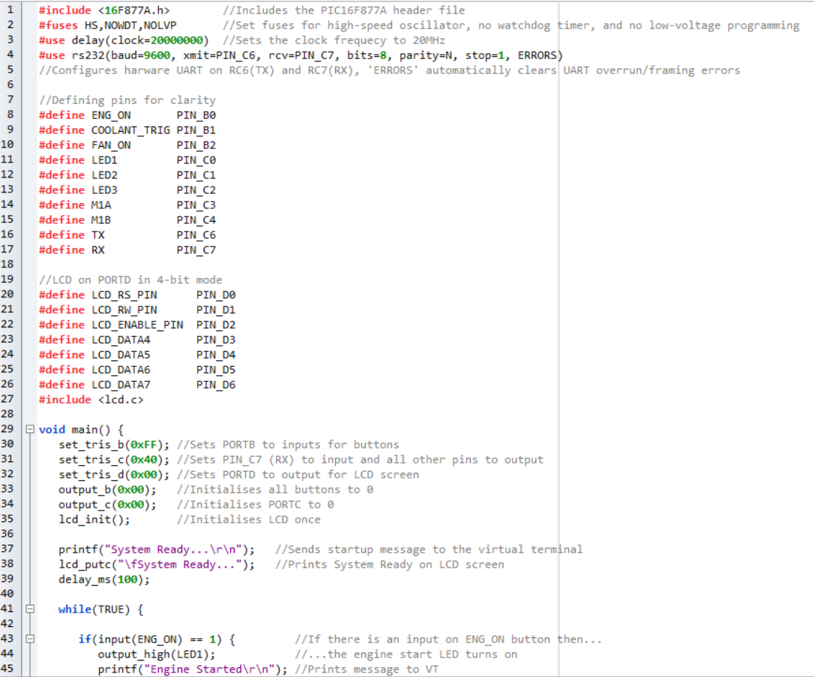
Appendix 1 – Initial Code
Figure 11: Initial Code Line 1-45

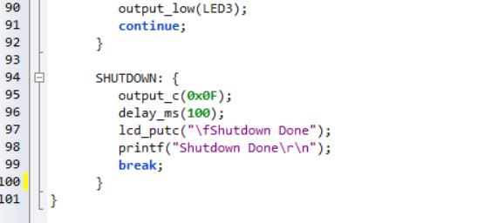
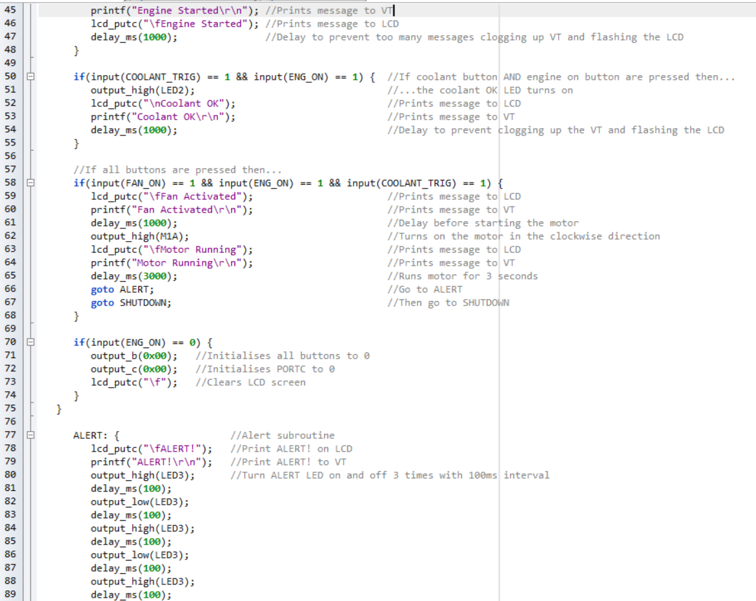
Figure 12: Initial Code Line 45-89

Figure 13: Initial Code Line 90-101

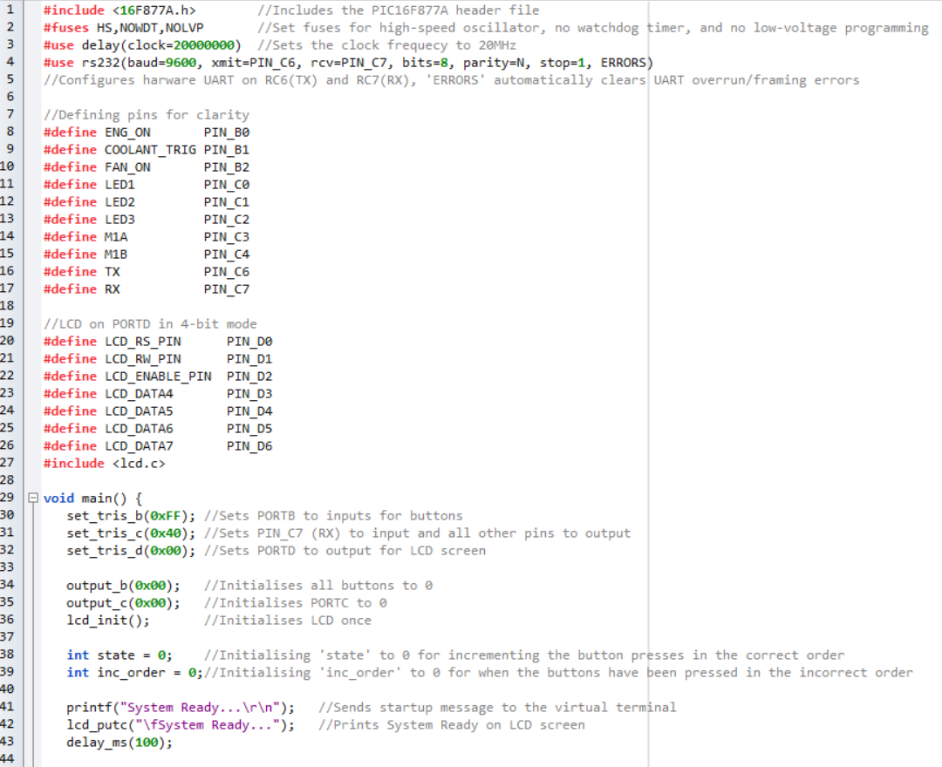
Appendix 2 – Final Code
Figure 14: Final Code Line 1-44

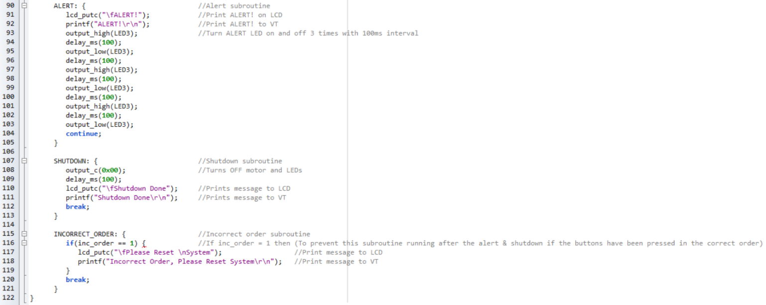
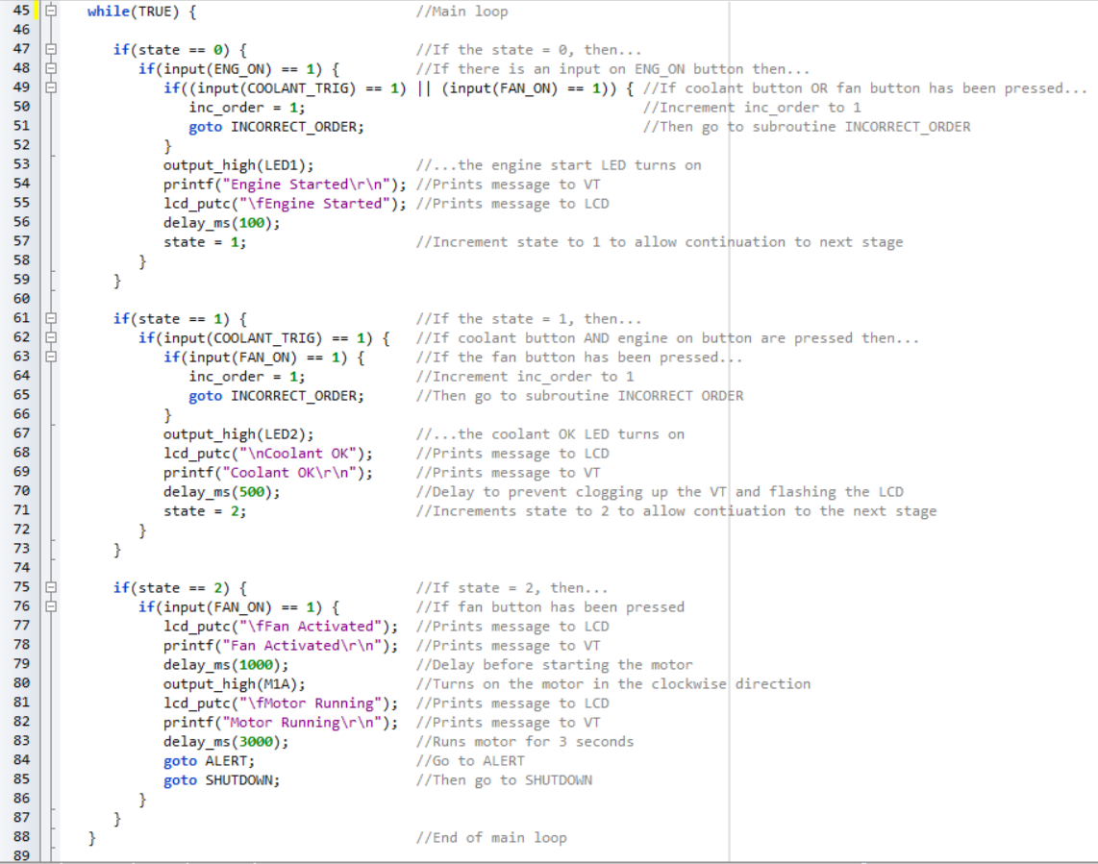
Figure 15: Final Code Line 90-122
Figure 16: Final Code Line 45-89

