

LEVEL 6 ASSESSMENT SPECIFICATION

Student name: | Alexandra Adriana Popa | Student ID number: | 2133013
Programme: | BA International Hotel Management
Module: | Managing Guest Service Operations
Module code: | BMIH6003 | Contribution to  Overall Module Assessment (%): | 50%
Lecturer: | Jessica Newport, Lisa Bassler, Giulia Chifari, Ka Po Chong | Internal Verifier: | Antoinette Milne
Assignment Title: | Student Learning Log | Word count (or equivalent): | 1,250 words (+/-  10%)
Submission deadline: | Friday, 15th November 2024 by 23:59pm | Return date of provisional marks & written feedback: | Friday, 13th December 2024 by 23:59pm

Table of Contents
Introduction 3
Learning Objectives for the Placement Within the Front Office 3
Section 1: Reflection on Experience and Personal Development 4
Section 2: Critical Analysis of Work-Based Skills and Technical Knowledge 6
Section 3: Reflection on Organisational Issues 8
Conclusion and Action Plan 10
Reference 11

List of Figures
Figure 1: Personal Development 4
Figure 2: Work-Based Learning 6
Figure 3: Organisational Issues 8

Introduction
The guest service operations of the Best Western Abbots Burton Hotel's housekeeping department are primarily based on ensuring guest comfort and satisfaction (Lee & Lee, 2019). This includes preparing the bed, cleaning the bathroom, and confirming other required supplies such as dries, toiletries, and toilet paper. For those staying longer, daily services such as bed making, and garbage collection.

Learning Objectives for the Placement Within the Front Office
- Learn techniques for meeting guests' needs and building professional relationships with them.
- Proficiency in handling room bookings, customisations, and guest special requests using the hotel's booking system.
- Learning how to quickly and efficiently complete the check-in and check-out processes upon guest arrival and departure.

Section 1: Reflection on Experience and Personal Development
I will use Driscoll's Model of Reflection, which is a simple but effective method that allows individuals or professionals to learn from experience and evaluate their own work (Mulryan-Kyne, 2020). It is primarily based on three questions, which facilitate analysis and learning from experience. This model is based on Terry Borton's 1970 "What? So What? Now What?" Based on the framework.
What?
While job shadowing as a supervisor in the housekeeping department, my main responsibility was to monitor the cleanliness and service quality of the guest rooms. This involved monitoring room cleaning processes, coordinating housekeeping staff, and responding quickly to guest requests (Ryan et al., 2018). In addition, room inventory management, reporting repair issues, and analysing the impact of activities were important.
So what?
This experience helped in understand the work-based skills and technical knowledge required to manage guest services. Ensured smooth communication between guests and staff. Clear and effective communication was essential to direct staff and quickly resolve guest needs. Learned how coordination and cooperation between different levels of housekeeping staff makes work easier. The ability to properly prioritise daily tasks was essential.
Now what?
This experience provided some useful lessons for future improvement. Must maintain quick and effective communication with guests and staff and learn how to problem solve when critical situations arise.
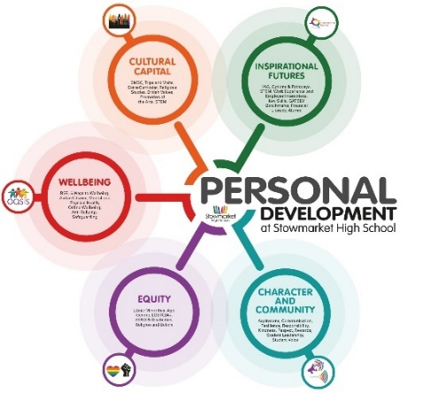
Figure 1: Personal Development
Source: (Jones et al., 2017)
Providing effective leadership and equally distributing the workload of employees will help them to work more efficiently in the future (Anjum, 2020). The efficiency must be increased in the more effective use of housekeeping software, so that the work can be done quickly and without any mistakes.
Implications for personal and professional development
Previous work experience has been helpful in this shadowing experience, as the skills and confidence to deal with different situations have been developed. Experience in coordinating with different departments while working with other departments in the hotel has increased.

Section 2: Critical Analysis of Work-Based Skills and Technical Knowledge
What?
Work-based skills were important for managing the basic tasks of the housekeeping department, such as room cleaning and maintenance monitoring, managing staff, and meeting guest needs. These skills included time management, team leadership, and problem-solving skills (Dogara et al., 2020). Technology has to be used for room booking systems, inventory management systems, and monitoring of cleanliness standards.
So what?
Work-based skills were crucial for managing guest services. Skills are needed to resolve guest complaints quickly and effectively or to divide the workload equally among staff. Moreover, decision-making and multi-tasking skills under pressure have helped speed up the work.
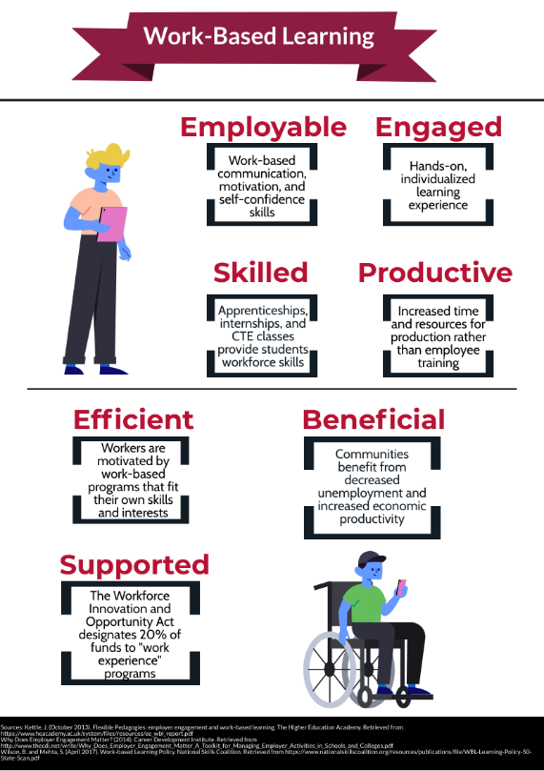
Figure 2: Work-Based Learning
Source: (ASET, 2017)
The need for technical knowledge has made housekeeping operations easier. Tasks like room booking and inventory management can be done easily and quickly through the software.
Now what?
More training will be needed to enhance effective teamwork and leadership skills in the future. Leadership skills are an important area for improving morale among employees and getting work done smoothly (Haruna & Kamin, 2019). Further training and education should be undertaken to improve technical skills. It is important to keep employees updated, especially when it comes to new software and technology. It is important to coordinate with the technical team to resolve future software issues quickly.

Section 3: Reflection on Organisational Issues
What?
The main issue here was how the organisation is structured and how work is divided between different departments and employees. In the housekeeping department of a hotel, the distribution, coordination, and supervision of work among employees was an important part of the organisational structure (Jones et al., 2017). How leadership roles at each level manage work and how employees perform their responsibilities determine the organisation's performance. Certain policies and cultures had to be adhered to in order to maintain the standard of guest service.
So what?
Organisational structure and workflow have a direct impact on employee performance and workflow. Having a well-organised and organised structure increases work efficiency and productivity. If clear roles and responsibilities are defined among employees, day-to-day tasks are completed quickly and smoothly.
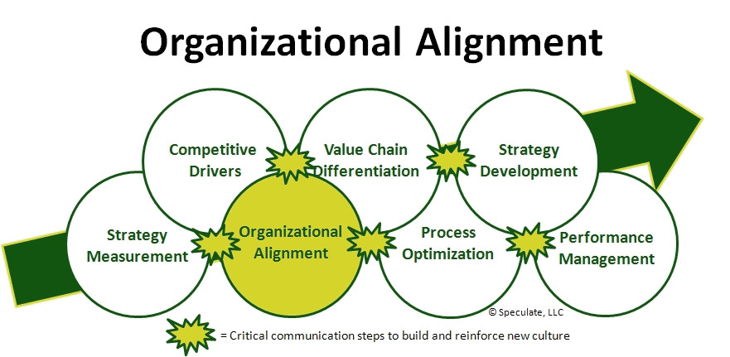
Figure 3: Organisational Issues
Source: (Hagg. 2013)
Organisational culture influences employee behavior and attitudes. A professional and collaborative environment enhances morale and enthusiasm among employees. It is possible to maintain the reputation and quality of the organisation by following the policy.
Now what?
Future organisational structures require more effective coordination and oversight. Work speed and efficiency can be increased by dividing work and assigning clear responsibilities among employees. Moreover, better training systems need to be developed for supervisors, so that they can effectively lead and maintain coordination among workers (Southgate et al., 2019). A collaborative and professional organisational culture needs to be developed, where employees feel safe and supported. Regular training and feedback systems should be put in place for the staff to improve the quality of guest service.

Conclusion and Action Plan
The overall conclusion of this study is that working as a supervisor in the housekeeping department of a hotel was a valuable experience, which played an important role in developing professional skills, work-oriented skills, and leadership qualities. Driscoll's model of reflection enabled in-depth evaluation of this experience, which helped in determining different aspects of learning and action planning. The first step is to think about what exactly I am experiencing and what needs to be changed or improved. What kind of problems I have faced while working in hotel housekeeping or guest service, what has been successful in my work, and in which areas need improvement.
The second step is to ask why this experience was important, and what was learned. Analyse how the challenges I have faced have affected my work skills or the organisation's performance (QAA, (2018). If I think there was a removal of communication involving staff, I need to think about why it occurred and how to resolve it. Here I can be concerned about my strengths and weaknesses, and how I can conquer these weaknesses. In the third step, I need to create effective action plans, which will use the lessons learned from the experience to lead to future improvements. I have to think about how to solve these problems in the future and what new initiatives to take. Regular meetings and feedback sessions can be held for effective communication among employees.

Reference
Anjum, S. (2020) ‘Impact of internship programs on professional and personal development of Business Students: A case study from Pakistan’, Future Business Journal, 6(1). doi:10.1186/s43093-019-0007-3.
ASET (2017) Good Practice Guide for Workbased and Placement Learning in Higher Education. Sheffield: ASET.
Dogara, G., Saud, M.S. and Kamin, Y.B. (2020) ‘Work-based learning conceptual framework for effective incorporation of soft skills among students of vocational and technical institutions’, IEEE Access, 8, pp. 211642–211652. doi:10.1109/access.2020.3040043.
Hagg, E. (2013) Internship Guide: Work Placements Step by Step. 5th Ed. The Hague: Eleven International Publishing.
Haruna, R. and Kamin, Y. bin (2019) ‘Application of work-based learning model in technical and Vocational Education: A systematic review’, Education, Sustainability And Society, 2(4), pp. 01–04. doi:10.26480/ess.04.2019.01.04.
Jones, S. et al. (2017) ‘Risks and rewards of cloud computing in the UK public sector: A reflection on three organisational case studies’, Information Systems Frontiers, 21(2), pp. 359–382. doi:10.1007/s10796-017-9756-0.
Lee, S.M. and Lee, D. (2019) ‘“UNTACT”: A new customer service strategy in the Digital age’, Service Business, 14(1), pp. 1–22. doi:10.1007/s11628-019-00408-2.
Mulryan-Kyne, C. (2020) ‘Supporting reflection and reflective practice in an initial teacher education programme: An exploratory study’, European Journal of Teacher Education, 44(4), pp. 502–519. doi:10.1080/02619768.2020.1793946.
QAA (2018) UK Quality Code, Advice and Guidance: Work-based Learning. London: QAA.
Ryan, R.M., Soenens, B. and Vansteenkiste, M. (2018) ‘Reflections on self‐determination theory as an organizing framework for personality psychology: Interfaces, integrations, issues, and unfinished business’, Journal of Personality, 87(1), pp. 115–145. doi:10.1111/jopy.12440.
Southgate, E. et al. (2019) ‘Embedding immersive virtual reality in classrooms: Ethical, organisational and Educational Lessons in bridging research and practice’, International Journal of Child-Computer Interaction, 19, pp. 19–29. doi:10.1016/j.ijcci.2018.10.002.

