How the John Lewis Partnership Culture Enables and Constrains Organisational Performance

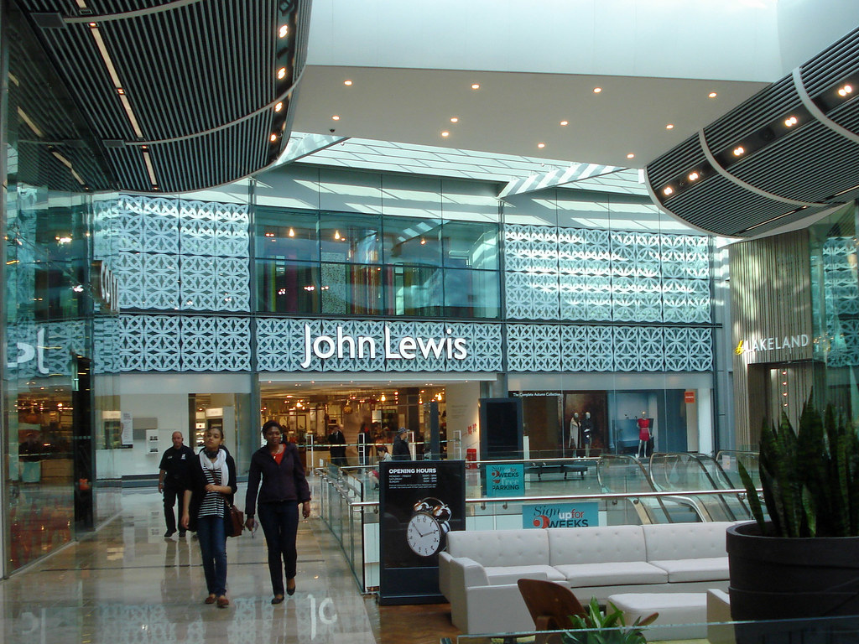

Programme: BA (Hons) Leadership and Management Skills For The Workplace
Module Name: Organisational Culture
Module Code: LCLM5005
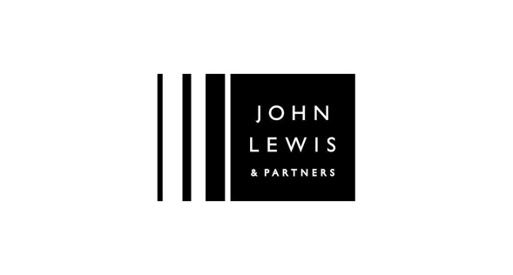
dUE 12TH OF August 2026

Student Name: Lamia Ramdani
Student ID: 2411548
Lecturer Name: Christopher Osborne

Table Of Content:

- Introduction:

What if a business could be built on trust rather than control, on shared purpose rather than hierarchy? The John Lewis Partnership proves that it is not only possible but profitable. For over 90 years, it has operated on a simple premise: employees who own the business care more, stay longer, and serve better. That premise was deceptively simple, but nothing short of brilliant. That move turned employees into owners and a small business into a successful organisation. It was not luck, magic, or accident; it was a deliberate, clever, and well-executed decision.
Founded in 1929 by John Spedan Lewis, it now operates 34 department stores and over 300 Waitrose supermarkets, employing 74,000 Partners (John Lewis Partnership, 2023). Based on its dual retail divisions, JLP operates as a hybrid divisional organisation, supported by functional departments, currently led by Chairman Jason Tarry (John Lewis Partnership, 2025).
To understand this unique model, Mintzberg (2023) argues that competitive advantage relies on people, while structure determines formal work roles and authority. Organisational behaviour also examines how group interactions affect performance. JLP’s co-ownership culture, where Partners share power and profit (John Lewis Partnership, 2023), is exceptional. As Schein (2010) explains, culture shapes “how things are done around here”, influencing structure and control.
This report evaluates how JLP’s culture shapes decision-making. Applying Schein’s (2010) Three-Level Model, which explores culture through Artifacts, Espoused Values and Basic Underlying Assumptions (Psych Safety,2023), alongside Handy’s (1993) cultural types, it will assess JLP’s culture. Handy’s types help identify whether JLP is driven by democratic structure (Role) or shared values (Person).

Furthermore, a PESTEL analysis will investigate the external pressures shaping JLP’s retail environment, assessing how its ethos adapts to modern challenges and offering practical recommendations for sustained performance.

Figure 1, JLP organization structure (John Lewis Partnership, 2025)
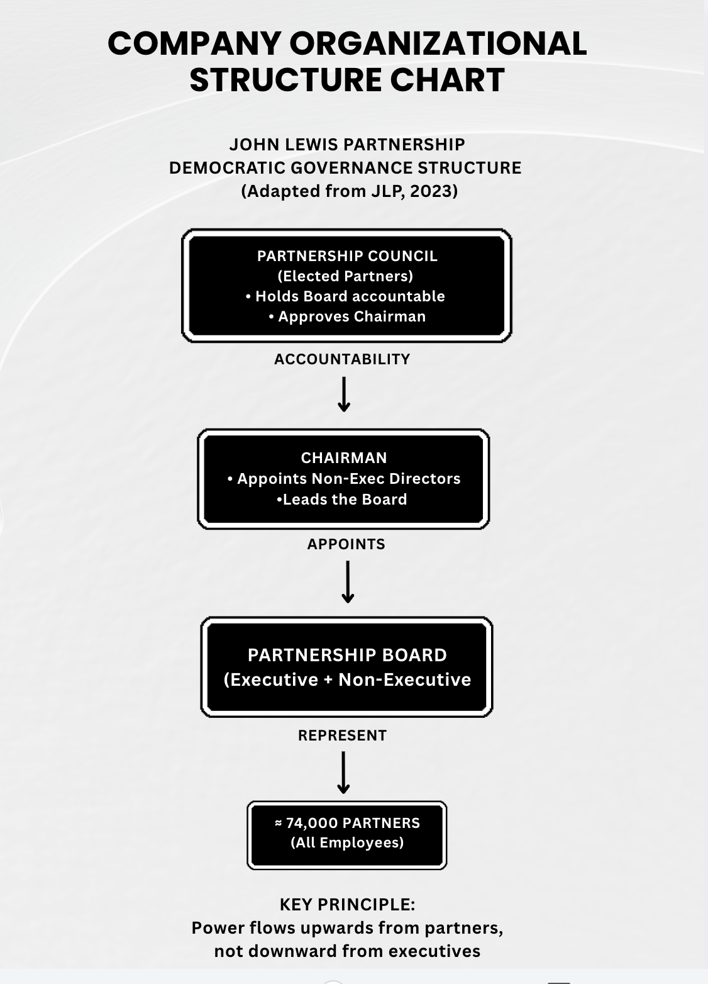

- The Influence of Organisational Culture on Structure and Decision-Making:

Unlike other conventional hierarchical retailers, John Lewis Partnership distributes power horizontally across three governing authorities- the Partnership Council, the Partnership Board, and the Chairman – creating a structure constitutionally embedded with its co-ownership values (John Lewis Partnership, 2023). The Partnership Council, comprising elected Partnership representatives, holds the authority to dismiss the chairman, ensuring that decision-making is not concentrated at the top but diffused across the workforce.
The Brighton School of Business and Management (2023) highlighted that organisational culture and structure are deeply interconnected, as culture influences how decisions are made and how work is carried out within a firm.

At JLP, this means strategic choices from store closures to diversification requires extensive Partner consultation before execution as all Partners have a voice in how business is run (Employee Ownership Association, 2023). This democratic process gives Partners genuine voice, yet simultaneously slows responsiveness, introducing what Johnson (1992) terms “strategic drift”. Handy’s (1993) Person culture concept explains this structural choice, JLP exists to serve its members, rather than operating purely as a role culture within store management. The governance diagram below illustrates this distinctive democratic architecture (Adapted from JLP, 2023)

- Identifying the Prevailing Culture: Applying Schein and Handy
To identify the john Lewis Partnership’s prevailing culture, Schein’s (2010) Three-Level Model and Handy’s (1999) Cultural Types are applied. Schein’s Framework is ideal because its three layers allow a structured examination of JLP’s visible artifacts, such as, Partner badges and open – plan offices alongside its stated democratic values and deeper, unconscious assumption that shared ownership drives commitment and ethical conduct (John Lewis Partnership, 2023; Employee Ownership Association, 2023).

Handy’s typology complement this categorising JLP’s dominant culture as a Person culture yet revealing the necessary presence of secondary Role culture to enforce standardisation across its vast retail network. Together these two models are uniquely suited to JLP because they directly expose the central tension of identity: democratic ownership empowers Partners and fosters loyalty, yet the embedded bureaucratic discipline slows decision- making creating strategic friction during periods of rapid change. This dual configuration, visually consolidated in Figures 2 and 3, demonstrates that JLP operates as balanced hybrid, where the Person culture enables high commitment, while the Role culture imposes essential structure to maintain order and consistency across the business.

Figure 2, Three-Level Pyramid Model (Schein’s Model ,1999)
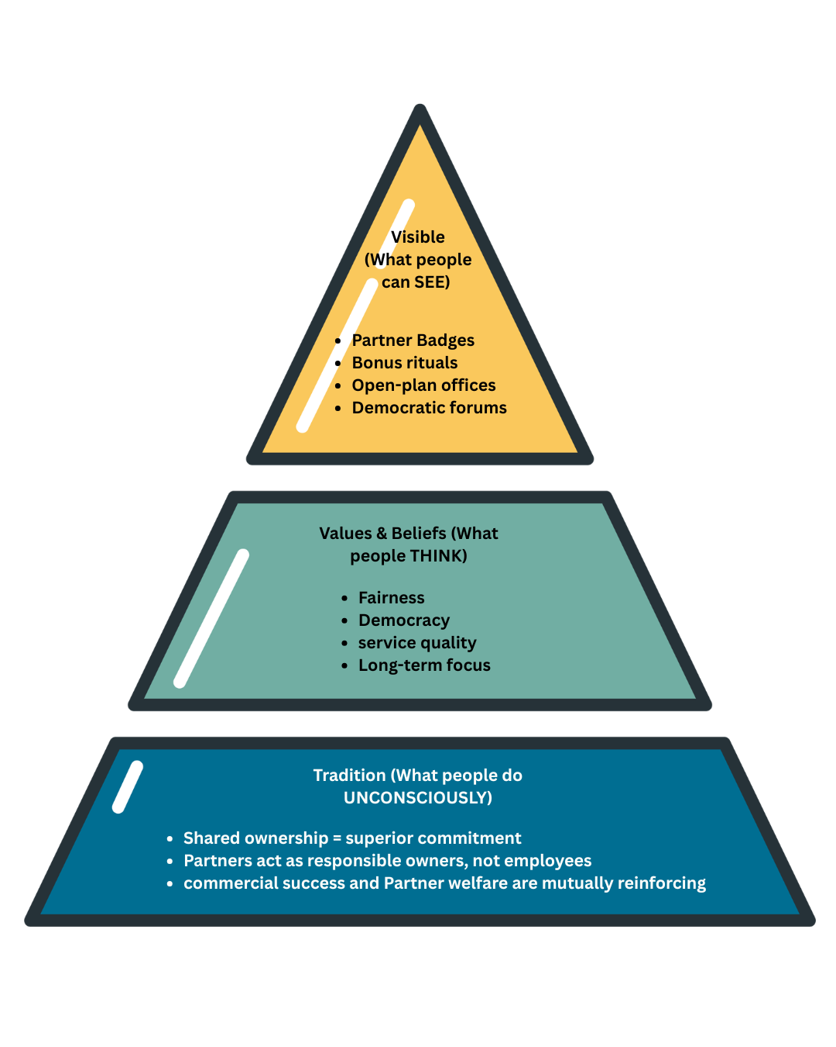

Figure 3, Handy’s Cultural Type – JLP Position (adapted from Handy,1999)

High Formalisation

High Power
Low
Power

Task Culture
Person culture
JLP dominant
Low Formalisation

Key:
JLP’s dominant cultural position (Person Culture).
Secondary cultural layer present in operational function.
JLP exists primarily to serve its partners, not external shareholders.
However, retail operations require role culture elements for consistency.
Across 34 department stores and over 300 Waitrose supermarkets.

- Leveraging Culture for External Adaptation

To understand how JLP can survive external threats, it is first important to identify the pressures acting upon it. PESTEL analysis is one of the best tools that provides a clear framework for this assessment.
Currently JLP faces significant economic pressures, such as raising cost of living which leads to reduced consumer spending, and intense social shifts, including the continued dominance of online retail, where the proportion of sales made online increased to 27.7% in September 2024 (Office for National Statistics,2024).

Additionally, technological disruption demands continuous digital investment, while environmental regulations push the retail sector toward net-zero carbon goals. The Climate Change Committee (2024) warn that the UK is falling behind on its Net Zero targets, with low-carbon technology roll-out significantly off-track and urgent action required across all sectors.

Politically and Legally, JLP faces rising employment costs; the British Retail Consortium (2025) warns that the October Budget will add £5 billion to the retail industry’s employment costs, and with slim profit margins of just 2-4 %, this will inevitably lead to higher prices and reduces store operations.

However, external threats do not exist in a vacuum; how a company responds depends heavily on its internal culture. Academy research from Brunel University London (Burak, 2018) argued that the relationship between an organisation’s culture and its external environment is critical for long-term survival.

Organisations with a strong, cohesive culture can leverage their values to adapt to disruptive changes more effectively than those with weak cultures.

For JLP, its deep-rooted Person culture acts as a powerful enabler because Partners genuinely care about the business’s long-term survival, they are often more willing to embrace necessary changes, such as digital upskilling to meet economic and technological demands.
On the other hand, this same culture can also act as a barrier, because consulting all partners on every major decision can sometimes take too long when the market demands immediate action.

Figure 4 below provides a visual summary of these key external pressures.

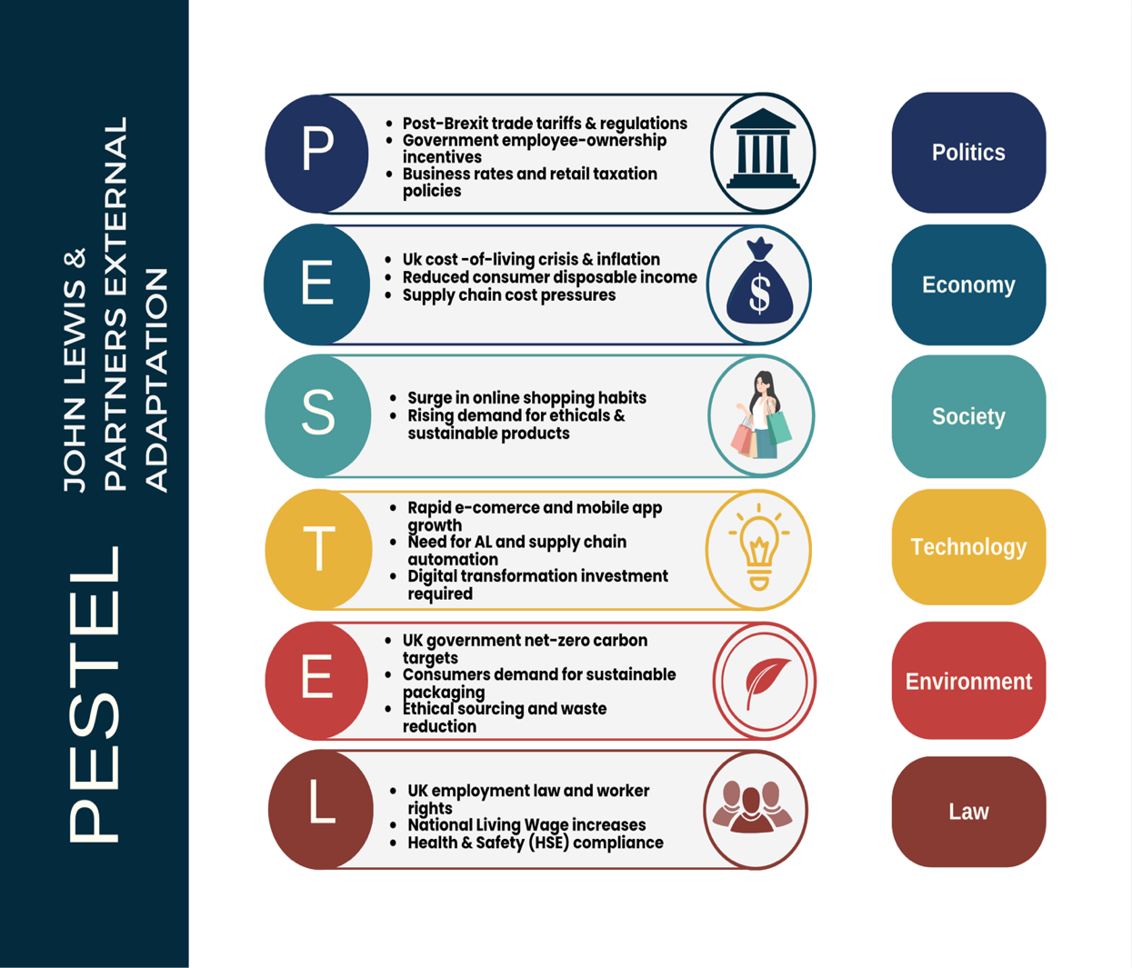

Figure 4: PESTEL Analysis of John Lewis Partnership

PESTEL Analysis of the John Lewis Partnership (Based on current UK Retail market data and government climate target).

- Culture as Enabler or Barrier

To assess whether JLP’s culture function as an enabler or barrier, it is useful to examine how its core values translate into actual management decisions. On one hand, the culture acts as an enabler by fostering loyalty and collective commitment. As seen in recent management actions, JLP has ordered its commercial team back to the office to preserve its collaborative, face -to-face Partnership culture, believing that in-person interaction is vital for long-term success (the Industry Beauty, 2025). This decision demonstrates how JLP’s cultural values directly shape workplace strategy to maintain its unique identity.

However, this same culture can act as a barrier when it clashes with modern workforce expectations, this same mandate to return to the office may be viewed by same partners as restrictive, especially in an era where flexible and remote working has become the industry norm.
This tension highlights that while JLP’s culture enables internal cohesion, it can constrain its ability to adapt to changing employee preferences and the broader competitive landscape.

To further analysis this dual nature, the table below summarises how specific cultural features of JLP act as both enablers and barriers:

Figure 5: Table showing how JLP’s Culture Enables and constrains Performance

Cultural feature | How to Enables Success | How it could be a barrier
Shared Wealth  (Profit Bonus) | Motivates Partners to work harder and stay loyal (JLP, 2025a) | High performers may feel under-rewarded compared to external markets.
Employment Security | Reduces staff turnover and experienced talent (John Lewis ,2025) | Hard to remove underperformers which can reduce efficiency (JLP,2025a)
Democratic Governance (Partner Councils) | Gives Partners a voice, leading to better ideas and innovation (JLP ,2025b) | Slow down decision-making because management must consult widely (JLP,2025b)
Long-term  Sustainability Focus | Protect the business from short-term risky decisions (John Lewis Partnership, 2026) | May miss quick opportunities in a fast-changing market

Analysis of the Table
The table exposes a fundamental tension: JLP’s culture is simultaneously its greatest strength and its most significant constraint.
As an enabler, democratic governance gives Partners a genuine voice, employment security builds loyalty and reduces turnover, and the long-term focus protects against short-risky decisions (John Lewis Partnership, 2025).
As a barrier, the same democratic processes slow decision-making, employment security can shield underperformers, and the long-term orientation may cause JLP to miss quick market opportunities (John Lewis Partnership ,2025; The Industry Beauty, 2025).
Key Insight: JLP’s culture is not weakness to be fixed, but a tension to be managed. Its greatest strengths are also its greatest vulnerabilities. The Partnership must leverage its enabling features while mitigating the barriers through proactive ethical practices.

This analysis aligns with Schein’s (2004) model of organisational culture, where JLP’s Constitution represents espoused values that shape Partner behavior, while the tensions identified reflect Handy’s (1993) observation that a “person” culture, though empowering, can impede decisive action. Critically, the evidence suggests that JLP’s culture remains predominantly an enabler: the long-term stability, Partner loyalty, and brand trust it generates outweigh the inefficiencies of democratic processes. However, this conclusion is conditional without actively managing the barriers identified, JLP risks losing agility in a competitive market, which could ultimately undermine its performance.
This is reflected in Chairman Jason Tarry’s words: “Our customers expect us to lead, not only on ethics and sustainability, but also on a value for money “(John Lewis Partnership, 2025a, p.3). This demonstrate that JLP’s leadership recognizes the need to balance its distinctive culture with competitive performance, a tension that requires constant attention.

Another example of JLP actively managing this cultural tension is its “Better Jobs Programme”, which replaced restrictive ethical audits with a framework for continues employee improvement (John Lewis Partnership, 2025; Insight DIY 2020)

6.0The impact of organisational culture on organisational performance

6.1 Business Ethics & Social and Environmental Responsibilities

JLP’s does not stop treating its own Partners fairly; it applies the same ethical standers across its entire supply chain. A key initiative is the Better Jobs Programme, launched in 2020 and now rolled out to all 120 UK manufacturing suppliers (John Lewis Partnership, 2025a).
The Better Jobs Programme does not stop at simple audit. It seven themes are built around one core idea: giving workers a genuine voice. As Figure 6 shows, the framework values psychological security alongside physical safety, acknowledging that heard and respected employees offer greater discretionary effort and innovation. This reflects Schein’s (2010) Basic Underlying Assumptions: JLP does not merely police suppliers but embeds its cultural values into their operations. The anonymous annual survey is particularly powerful, as it reduces power imbalances and encourages honest feedback without fear. The Programme therefore transcends corporate social responsibility; it embodies the Partnership’s conviction that meaningful work is a fundamental right. At a time when supply chains face intense scrutiny, this ethical approach protects JLP’s reputation and sets it apart from competitors (Salaman& Storey, 2016).
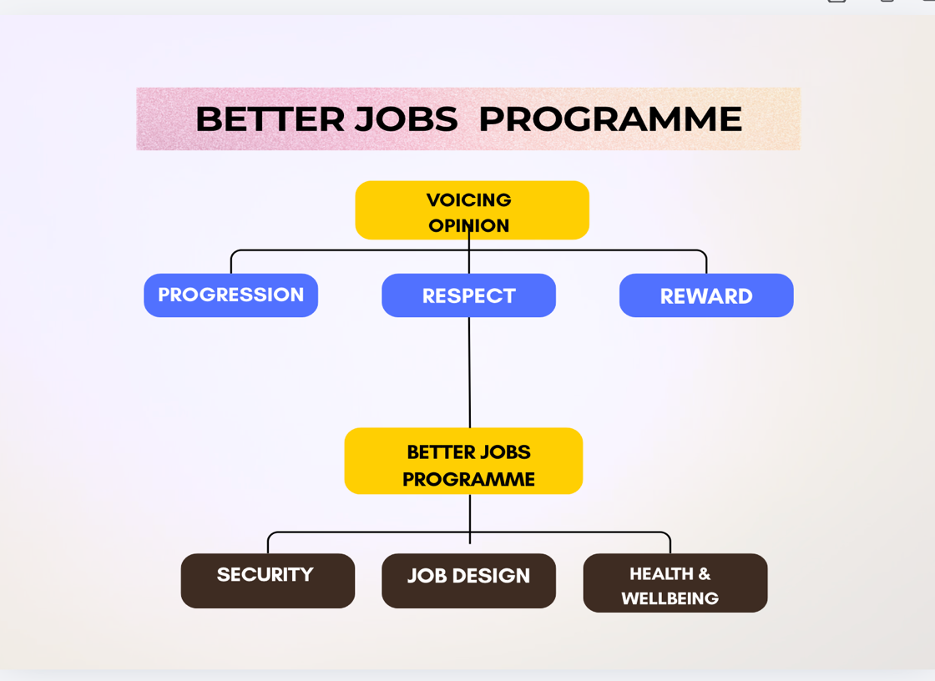

Figure 6, Better Job Programme, diagram adapted from, JLP Annual Report (2025)
The programme was developed in response to supplier feedback that traditional ethical audits were restrictive. It replaces these “tick-box” audits with continuous employee improvement farmwork based on seven themes: voicing opinion, progression, reward, security, job design, respect, and health and wellbeing. Suppliers receive an annual employee survey, and JLP experts help create action plans to address identified issues. This approach directly operationalises the founding principle that “the purpose of the business is the happiness of all partners through their worthwhile and satisfying employment “, extended this ethos to workers making JLP owned-brand products (John Lewis Partnership, 2025a).

Environmentally, JLP has made significant progress towards its net Zero commitments.
As of 2025/26, the Partnership achieved a 40% absolute reduction in Scope 1 and 2 greenhouse gas emissions against its 2020/21 baseline (John Lewis Partnership, 2025). It has also distributed £470,000 through its Zero Farms Fund to support innovative projects tackling climate impact in agriculture. Waitrose became the first UK supermarket to fully meet Better Chicken commitment, demonstrating leadership in animal welfare (John Lewis Partnership,2025). These actions illustrate how JLP translates its culture of Partnership and long-term thinking into concrete social and environmental responsibilities, reinforcing its brand promise and stakeholder trust (Salaman & Storey, 2016).

6.2. Impact on Organisational Performance

The combination of democratic ownership and bureaucratic processes at JLP clearly affects how the business performs. The Partnership’s 2025/26 full -year results show a mixed but improved financially position. Sales grew 5% to £13.4 bn, and profit before tax, bonus and exceptional items rose 6% to £134m. Cash also increased to £595m and liquidity to £1.6bn, enabling continued self-funded investment. However, overall loss was about £21m, while the non-cash write-downs of legacy technology system. JLP position this investment in innovation as necessary for long-term competitiveness.

JLP’s culture also contributes to measurable non-financial performance, in 2025/26 the company achieved record customer satisfaction scores and grew loyalty scheme membership (My Waitrose +6%, My John Lewis +10%). The decision to award a 2% Partnership Bonuses, the first since 2022 as a return to profit-sharing norms , reinforcing partners motivation and trust , also the Better Jobs Programme data shows that over 70% of suppliers employees felt they could voice their opinion and the majority felt their employer supported their wellbeing .This is largely due to the anonymous nature of the survey, which allows employees to freely share their concerns and ideas with their employer ( John Lewis Partnership ,2025a).

However, the culture’s democratic processes create tensions. Nearly 4000 Partnership signed a petition demanding the reinstatement of bonuses, showing tension between commercial decision and Partner expectations. Profit growth was also hit by £53m in new taxes (EPR packaging levy and higher National Insurance). This shows JLP’s culture enables long-term stability and trust but can slow agility and financial performance (Salaman & Storey, 2016, Chapter 8).

6.3. Recommendation for Organisational Performance Improvement

Salaman and Storey (2016) describe JLP as “a delicate and complex organization, where management have to balance commercial pressures against the happiness of the staff who own it “. This perfectly captures the central challenge my recommendations aim to address: how can JLP preserve its unique culture while becoming more agile in a fast-changing retail market?

As recently as 2023, Government Minister Clair Coutinho praised the Partnership’s commitment to its employees, highlighting its unique approach to social responsibility (Banham,2023). However, as Salaman and Storey (2026) pointed out, while JLP’s is highly participatory, it is “not very accountable management can be questioned but not rigorously held to account. This insight has shaped my recommendations, which aim to strengthen accountability while preserving democratic voice. Yet Salaman and Storey (2026) argue, JLP’s tension must be actively managed, rather than suggesting drastic changes that could damage the Partnership’s identity.

I have focused on practical steps that build on what JLP already does well, empowering local managers, improving transparency, investing in digital systems, adopting a wellbeing dashboard (similarly to the retail Trust’s model already used by Next and Fat Face), and reviewing governance regularly. These recommendations are designed to protect what makes JLP special while addressing the barriers that could hold it back.

- Conclusion

My curiosity about the John Lewis Partnership began in their stores. I experienced something different there: an atmosphere that felt less transactional and more human. Partners who seemed genuinely invested. That feeling caught my attention and stayed with me. So, when my assessment brief invited me to investigate organisational culture, I knew exactly where to look. I immediately chose JLP, because I believed what makes business feel human lay hidden inside its structure.

The ownership model that JLP offers is not a historical artefact, it is a live experiment in making ethics and commerce work together. Chairman Jason Tarry recently stated:” Our customers expect us to lead, not only on ethics and sustainability, but also on value for money” (JLP,2025). This is the central question: can an organisation remain both principled and commercially sharp in an industry that devours the slow?

This tension is real. Short-term costs build long-term resilience, but the same culture that fosters loyalty and trust can also slow decision-making in a market that forgives no one for a delay. Salaman and Storey (2016) capture this dilemma: managers craft compelling narratives that do not always align with leadership realities.

As Peter Drucker said, “Culture eats strategy for breakfast.” For JLP, the challenge is to ensure its strategy is strong enough to survive the meal. And as Sumantra Ghoshal observed, “The only real source of competitive advantage is the ability to adapt faster than your competitors.” For JLP, this means preserving its distinctive culture while building the agility to survive.

The path forward is not a choice between culture and competitiveness. JLP’s distinctiveness is both its greatest strength and its greatest vulnerability. JLP continues to fight, keeping its culture as its greatest strength in an age of relentless competition.

8.References

Banham, M. (2023) John Lewis rolls out foster care paid leave. Available at: https://www.drapersonline.com/news/john-lewis-rolls-out-foster-carer-paid-leave (Accessed: 1 August 2026).
Brighton School of Business and Management (2018) Is There a Relationship Between Organisational Structure and Culture? Available at: https://www.brightonsbm.com/news/relationship-organizational-structure-culture/ (Accessed on 23rd July 2026).
British Retail Consortium (2025) 'Retailers face £5Bn cost hike as NIC and Living Wages rises hit sector', BRC News, 7 April. Available at: https://brc.org.uk/news-and-events/news/corporate-affairs/2025/ungated/labour-costs-will-harm-employment/ (Accessed: 14 July 2026).
Burak, E. (2018) The relationship between organisational culture and organisational performance: A study of the retail sector. PhD thesis. Brunel University London. Available at: https://bura.brunel.ac.uk/bitstream/2438/16324/1/FulltextThesis.pdf (Accessed: 9 July 2026).
Climate Change Committee (2026) Progress in reducing emission:2026 report to Parliament. Available at: https://www.theccc.org.uk/publication/progress-in-reducing-emissions-2026-report-to-parliament/ (Accessed: 3 August 2026).
Employee Ownership Association (2023) John Lewis Partnership: Case Study. Available at: https://employeeownership.co.uk/Site/Site/content/All-About-EO/Case-Studies/john-lewis-partnership.aspx (Accessed: 9 July 2026).
Handy, C. (1993) Understanding Organisations. 4th end. London: Penguin. Available at: https://www.business.com/articles/management-theory-of-charles-handy/ (Accessed: 28 June 2026).
John Lewis Partnership (2023) Annual Report and Accounts 2023. Available at: https://www.johnlewispartnership.co.uk (Accessed: 26 June 2026).
John Lewis Partnership (2025) Annual Report and Accounts 2025. Available at: https://www.johnlewispartnership.co.uk (Accessed: 3 August 2026).
John Lewis Partnership (2025a) Better Jobs Programme: Supplier Ethical Framework. Available at: https://www.johnlewispartnership.co.uk (Accessed: 3 August 2026).
John Lewis Partnership Constitution (2025) Part 2, Purpose; Part 4, Rules. Available at: https://www.johnlewispartnership.co.uk/~/media/Files/J/john-lewis/corp/documents/constitution-of-the-john-lewis-partnership.pdf (Accessed: 17 July 2026).
Johnson, G. (1992) 'Managing strategic change: strategy, culture and action', Long Range Planning, 25(1), pp.28-36. Available at : https://oeclass.aua.gr/eclass/modules/document/file.php/5565/managing%20change%20-%20culture%20and%20action%20-%20Johnson.pdf (Accessed: 1 August 2026).
Mintzberg, H. (2023) Understanding Organizations… Finally: Structuring in Sevens. Oakland: Berrett-Koehler Publishers. Available at : https://thekeypoint.org/2024/03/24/understanding-organizations-finally/ ( Accessed on 3rd August 2026).
Office for National Statistics (2024) Retail Sales, Great Britain: September 2024. Available at: https://www.ons.gov.uk/businessindustryandtrade/retailindustry/bulletins/retailsales/september2024 (Accessed: 14 July 2026).
Psych Safety (2023) Psychological Safety & Edgar Schein's Three Layers of Organisational Culture. Available at: https://psychsafety.com/psychological-safety-edgar-scheins-three-layers-of-organisational-culture/ (Accessed: 9 July 2026).
Retail Trust (2024) Happiness Dashboard. Available at: https://www.retailtrust.org.uk/helping-your-business/workplace-wellbeing/happiness-dashboard (Accessed: 1 August 2026).
Robbins, S.P. and Judge, T.A. (2019) Organizational Behaviour. 18th end. Harlow: Pearson.
Salaman, G. and Storey, J. (2016) A Better Way of Doing Business? Lessons from the John Lewis Partnership. Oxford: Oxford University Press. Available at : https://academic-oup-com.uwtsd.idm.oclc.org/book/5962?login=true&token=eyJhbGciOiJub25lIn0.eyJleHAiOjE3ODgzNTU1MjcsImp0aSI6IjRkMDEzM2NhLTNlZmEtNDJkMy04YTQ4LTRmNTI5MDJjNWZkYyJ9. (Accessed on 24th July 2026).
Schein, E.H. (2010) Organizational Culture and Leadership. 4th end. San Francisco: Jossey-Bass. Available at : https://readingraphics.com/book-summary-organizational-culture-and-leadership-edgar-schein/ ( Accessed on 3rd August 2026) .
secNewgate (2023) Embracing internal activism: John Lewis and its unique employee-owned journey. Available at: https://www.secnewgate.co.uk/our-insights/embracing-internal-activism-john-lewis-and-its-unique-employee-owned-journey (Accessed: 17 July 2026).
The Industry Beauty (2025) John Lewis orders commercial teams back to office to improve collaborative culture, 23 July. Available at: https://theindustry.beauty/john-lewis-orders-commercial-teams-office-return-to-improve-collaborative-culture/ (Accessed: 9 July 2026).

