Component 2: Written Assignment (Report)

A Critical Evaluation of SDG 3 and SDG 13
Global, National and Local Policies for Health, Wellbeing and Climate-Resilient Sustainability

Student Name: Shazia Parveen
Student ID: 2231216
Module Name: Health, Wellbeing and Sustainable Development
Module Code: BMHP6030
Lecturer: Parese Ahmed
Word Count: 2,000 Words

Table of Contents
1. Introduction 3
2. Section 1 – SDG 3: Good Health and Wellbeing 4
2.1. Overview of SDG 3 4
2.2. Global Policies 5
2.3. UK National Policies 5
2.4. Local Policies 6
2.5. Critical Evaluation 7
2.6. Recommendations 7
3. Section 2 – SDG 13: Climate Action 8
3.1. Overview of SDG 13 8
3.2. Global Policies 9
3.3. UK National Policies 9
3.4. Local Policies 10
3.5. Critical Evaluation 10
3.6. Recommendations 11
4. Conclusion 11
5. References 12

Introduction
Complex global issues that shape sustainable health and development make the implementation of the 17 Sustainable Development Goals (SDGs) in 2015 by the United Nations a universal standard of universality, prosperity, and well-being of the planet (United Nations, 2025). This report critically analyses SDG 3: Good Health and Wellbeing, which UN defines as gathering healthy lifestyles and encouraging wellbeing to all people at all ages and SDG 13: Climate Action, which lists active things which should be done urgently in fighting the climate change and its effects. Section 1 attempts to critically examine SDG 3 and its policies through health frameworks whereas Section 2 analyses SDG 13 and the influence it has on the health of the general people. The report will be concluded with findings synthesis and recommendations as to how it can be improved to enhance health and climate resilience.

Section 1 – SDG 3: Good Health and Wellbeing

Overview of SDG 3
SDG 3 focuses on the need to secure healthy lives and well-being of the entire population at all ages (United Nations, 2023). It has the subsequent targets reducing maternal mortality to less than 70 deaths per 100,000 live births, ending preventable infant and child mortality, attaining universal health coverage (UHC), and cutting the untimely mortality rate attributable to non-communicable diseases (NCDs) by a third by 2030 (Raina et al., 2023). The Dahlgren and Whitehead Model (1991) explains that health is influenced by layered determinants, from individual lifestyle to social networks, living conditions, and wider socioeconomic and environmental factors (Dahlgren and Whitehead, 2021). Applying this to SDG 3 shows that access to healthcare alone is insufficient; policies must also address inequality, housing, education, and environmental quality.
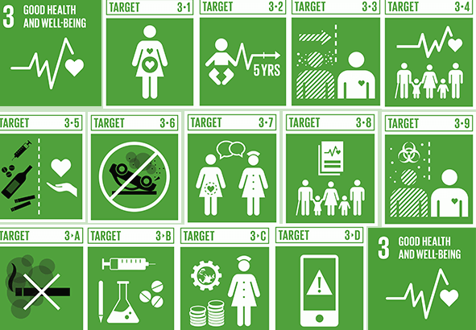
Figure 1 Sustainable Development Goal 3
Source: (Epomedicine, 2019)

Global Policies
At the international affiliation, efforts in place, like the WHO Universal Health Coverage (UHC) structure or Global Vaccine Action Plan (GVAP), assist SDG 3 directly. By 2023, half of the global population uses essential health services without distress among all income groups, and more than 930 million individuals pay greater than 10 percent of household income on healthcare (WHO, 2017). The GVAP has worked effectively to raise the rates of childhood immunisation averting some 2-3 million deaths a year on vaccines such as measles and diphtheria. The WHO Mental Health Action Plan deals with the increasing prevalence of mental disease, and now depression has become the major cause of disability in the world (World Health Organization, 2021). However, using the Dahlgren and Whitehead model, these policies mainly address the individual and healthcare service layers, neglecting wider social and economic determinants (Dyar et al., 2022).

UK National Policies
In the UK, SDG 3 is largely met by the NHS Long Term Plan (2019) which is an effort to change cancer survival rates, cardiovascular mortality, and investing 2.3 billion pounds annually in mental health services by 2023-24 (NHS England, 2019). The plan increases social prescribing, where GPs would refer patients to non-clinical services like community groups, exercise programmes, and financial advice to the community directly addressing the community and lifestyle strata of the Dahlgren and Whitehead model (Graham, 2004). The policies that are backed by the Public Health England include national screening, epidemic of smoking cessation as well as obesity (GOV.UK, 2022). Nevertheless, inequalities remain deeply rooted, with life expectancy in the most disadvantaged communities in England has stopped or decreased. In Blackpool male life expectancy is 73.4 years compared to 85.4 in Kensington and Chelsea (IFA Magazine, 2024). The mental health issues keep increasing, as 1 out of 4 adults develop a mental disorder every year, and 1.6 million individuals are on the treatment queue in 2023 (BMA, 2025). Such inequalities are structural determinants that are at the outer spheres of the Dahlgren and Whitehead model and cannot be taken care of by the healthcare-based policies alone (Wilderink et al., 2022).
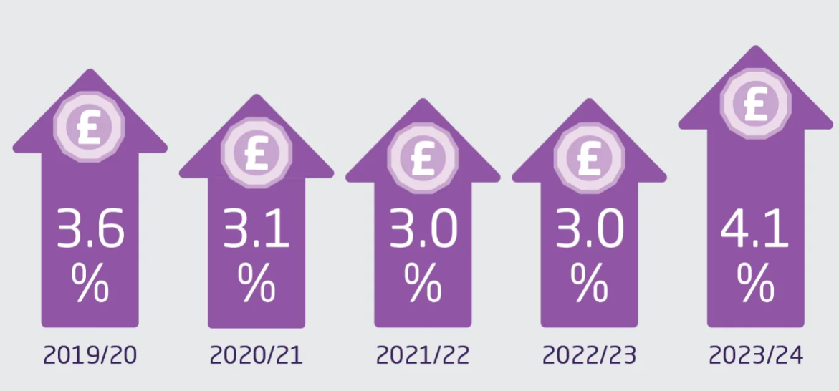
Figure 2 The NHS long-term plan
Source: (Charles et al., 2019)

Local Policies
Local authorities and the NHS Birmingham and Solihull Integrated Care System in Birmingham coincide with SDG 3, as obesity, air quality, mental health and homelessness are tackled in their efforts. The city of Birmingham has amongst the highest prevalence of obesity in England and 25.5% of adult residents are obese resulting in local interventions campaign and social prescribing of physical activity (Birmingham Food Council, 2025). The Birmingham Clean Air Zone (CAZ) was implemented in 2021 and lessened the level of nitrogen dioxide by 7.3% in its initial year of implementation, which has allowed to contribute to respiratory well-being (University of Birmingham, 2025). However, there is a high level of health inequality with people living in the deprived neighbourhoods such as Ladywood having a shorter lifespan of between 7-10 years compared to Sutton Coldfield (The King's Fund, 2024). The health support of the complex population with the complex needs is offered by homeless service, showing the implementation of the Dahlgren and Whitehead model with references to the living conditions and community networks, and not just the medical treatment (PSLHub, 2021).
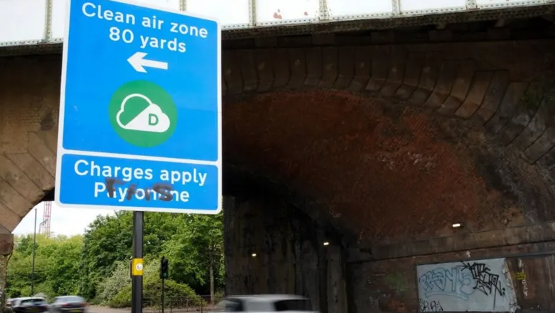
Figure 3 Birmingham CAZ: Pollution levels drop as cars increase
Source: (Gregory-Kumar, 2023)

Critical Evaluation
Although the SDG 3 policies have enhanced the vaccination coverage, low smoking rates, and increment in the life expectancy, there are still significant disparities between and within the countries. At the local level, Birmingham reduced air pollution but thus unfairly disenfranchised low-income car drivers unable to afford alternatives to less-polluted vehicles (Brock, 2025). UHC still lacks accessibility to approximately half of the global population and the maternal mortality in the low-income countries is still greater compared to high income countries (World Health Organization, 2025). One of the weaknesses is that a large number of interventions concentrate on the downstream level where the disease is treated, instead of the upstream factors of poverty, lack of housing, education and weather conditions, restricting the sustainability and long-term impact.

Recommendations
Policies to enhance SDG 3 results should be refocused on upstream prevention that takes social modifications on health instead of mainly clinical reactions. At the national level, the government of the UK ought to provide more investments in deprived areas through Health Equity Zones, allocate funding on affordable housing, and maximize mental health services with the aim of cutting warning lists within two years. In the local area, more infrastructure supporting active travel, subsidies to low-income households impacted by the Clean Air Zone, and more health hubs in the community should be increased (Makahleh, Taamneh and Dissanayake, 2025). UHC strategies need to be based on poverty reduction, climate resilience, and gender equity strategies to provide health justice globally.

Section 2 – SDG 13: Climate Action

Overview of SDG 13
Goal number 13 urges an immediate response to climate change and its effects because climate change is no longer an environmental problem but a direct health crisis (The Global Goals, 2024). Extreme heatwaves, breathing diseases, lack of water and malaria and dengue are among the consequences of rising world temperatures. Total number of deaths expected annually between 2030 and 2050 due to malnutrition, heat stress, and infectious diseases will reach 250,000 annually due to climate change (WHO, 2023). Using the Triple Bottom Line (TBL) model, SDG 13 requires that there should be a form of balance between economic sustainability (profit), environmental protection (planet), and population health (people).
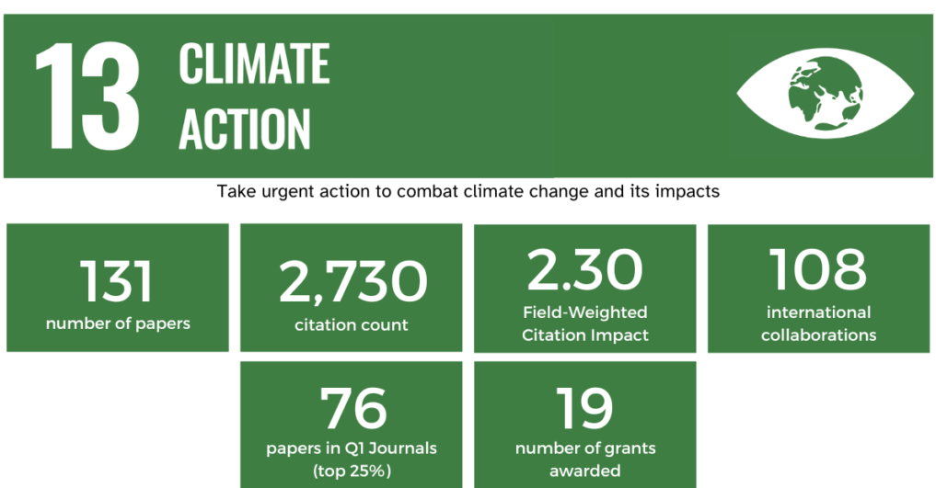
Figure 4 SDG 13: Climate Action
Source: (Abdalla et al., 2023)

Global Policies
The foundation of Paris Agreement (2015) committed 196 countries to limit warming to “well below 2 °C” and pursue efforts towards 1.5 °C, yet current national policies are projected to lead the world toward approximately 2.7 °C of warming by 2100 (UNFCCC, 2025). Disasters triggered by climate have gone five times higher over the last 50 years that resulted in more than 2 million fatalities and a cost of 4.3 trillion in the economy (IPCC, 2023). The WHO Climate and Health Programme assist countries to become climate-resilient in their health, but few countries have comprehensive implementation of national health and climate plans, 27 out of the 194 WHO member states have this strategy in place (ClimaHealth, 2025). The very fact that schemes such as early warning systems in Bangladesh have made losses due to the effect of the cyclones by more than 90 percent since 1970s yet the nations with low income share the least percentage of total emission in the environment, but face the highest number of deaths due to climate, is suggesting an issue of ethics under the TBL model (Our World in Data, 2020).

UK National Policies
The UK has committed to reaching net-zero emissions by 2050, and NHS England’s Net Zero Strategy (2020) aims for an 80% reduction in its “Carbon Footprint Plus” by 2036-39, with the NHS accounting for roughly £25 million tonnes of CO₂e annually, thus highlighting the scale of the challenge (LSE, 2025). The UK Clean Air Strategy (2019) covers air pollution as a major cause of premature mortality (40,000 every year) costing the economy up to 20 billion annually (Royal College of Physicians, 2020). In the year 2020, the National Flood and Coastal Erosion Risk Management Strategy was revised following severe flooding in Yorkshire and Wales which impacted more than 4,600 homes (Gov.Wales, 2020). In the UK, the climate-health policies under TBL excel in the environmental and economic rhetoric definitions, but there are still deficiencies in social equity, particularly to the deprived and ethnic minorities residing in urban high-density centres with high pollution.
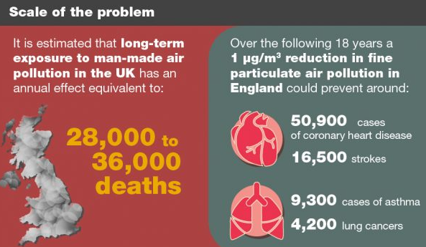
Figure 5 The Clean Air Strategy
Source: (UKHSA, 2025)

Local Policies
Birmingham introduced Clean Air Zone (CAZ) in June 2021, charging high-emission vehicles a small fee of £8 in a day that lowered the concentration of NO2 in the air in 12 months and improved respiratory health among kids (Birmingham City Council, 2021). However, it has a disproportionate impact on the low-income citizens who cannot afford newer vehicles. Birmingham has also spent 2 billion pounds on active travel and green space development and launched the Route to Zero (R20) program, aiming to reduce available emissions on 60 percent by 2030 (Distinctly Birmingham, 2024). Planting of trees, cycling roads and buses with low emission are part of green amenities, but with all this improvement, Birmingham still manages to record 1,400 air-pollution-related deaths each year (University of Birmingham, 2024). In TBL, the environment gains whereas social fairness will be missed as financial implications are imposed on low-income earners, taxi drivers and small businesses.

Critical Evaluation
The climate policies in UK and Birmingham have shown some tangible results in the environmental enhancement but the health benefits are asymmetrical. While NO₂ levels have fallen since the introduction of Clean Air Zones, children in England’s most deprived areas remain over twice as likely to be hospitalised for asthma as those in the least deprived, highlighting persistent structural inequalities (RCPCH, 2020). Although the NHS Net Zero strategy shows strong ambition, progress is limited by funding constraints, with a £15.9 billion maintenance backlog restricting trusts’ ability to upgrade estates for greener operations (NHS, 2023). The flaw of TBL model is reflected in the fact that environmental gains are always the first option, followed by economic gains, and the last pillar is social equity. Integration of climates and health is more of a response than a proactive process minus the failure of the policy to adequately safeguard vulnerable elderly individuals despite the existence of policies on climate-responding deaths.

Recommendations
The policies should consider the people with equal priority to the planet and profit in order to match the climate action with health and the Triple Bottom Line. To enhance healthy living and environmental standards the UK government must consider introducing a cleaner vehicle scheme, Home Insulation and Air Filtration to low-income families, especially those in Birmingham and other polluted urban areas. The NHS ought to collaborate with industries in order to decarbonise medical supply chains, develop more hospitals that operate on renewable energy, and have a heatwave early-warning system attached to GP practices. The local councils need to co-design policies with the affected communities so that the climate action does not exacerbate poverty (King, 2023). The health, transport, housing, and industry sectors must work across to attain sustainable, equitable and health-based climate resilience.

Conclusion
SDG 3 and SDG 13 are highly interrelated as climate change directly influences the health, disease, and inequality patterns in the world to a large extent. Although such international policy advocated by the WHO has a strategic orientation, it can produce minimal effect due to uneven implementation, the lack of initiative, and the growing gap between high- and low-income groups. In the UK however, the increasing waiting lists, unequal access to healthcare, and climate-related deaths during the 2022 heatwave have shown that the system has flaws that require improvement. In Birmingham, the Clean Air Zone and public health power has been used to enhance health and quality of the air locally, yet the financial strain of these measures on low-income households exhibits a notable lack of success in entrenching social justice into climate and health governance. To fulfil SDG 3 and SDG 13, an upstream, equity-based strategy must be implemented one that touches on structural determinants of health, participative by the community, with human wellbeing as the core of sustainability as opposed to a secondary effect of environment policy.

References
Abdalla, A.M., Osama Abdelrehim, Wei, B., Wang, X., Azad, A.K. and Dawood, M.K. (2023). Hydrogen production technologies: Conventional processes. Elsevier eBooks, pp.381–396. doi:https://doi.org/10.1016/b978-0-323-99514-6.00004-2.
Birmingham City Council (2021). Introduction | A clean air zone for Birmingham | Birmingham City Council. [online] Birmingham.gov.uk. Available at: https://www.birmingham.gov.uk/info/20076/pollution/1763/a_clean_air_zone_for_birmingham.
Birmingham Food Council (2025). Fit for the Future Birmingham’s Childhood Obesity Strategy. [online] Available at: https://www.birminghamfoodcouncil.org/wp-content/uploads/2019/07/Fit_for_the_Future_Childhood_Obesity_Strategy.pdf.
BMA (2025). Mental health pressures data analysis. [online] The British Medical Association. Available at: https://www.bma.org.uk/advice-and-support/nhs-delivery-and-workforce/pressures/mental-health-pressures-data-analysis.
Brock, A. (2025). Birmingham: Two city areas exceed legal limits of nitrogen dioxide. [online] 30 Jan. Available at: https://www.bbc.com/news/articles/cy7gee0ke42o.
Charles, A., Ewbank, L., McKenna, H. and Wenzel, L. (2019). The NHS Long-term Plan Explained. [online] The King’s Fund. Available at: https://www.kingsfund.org.uk/insight-and-analysis/long-reads/nhs-long-term-plan-explained.
ClimaHealth (2025). WHO-WMO Climate and Health Joint Programme - ClimaHealth. [online] ClimaHealth. Available at: https://climahealth.info/who-wmo-joint-programme/.
Dahlgren, G. and Whitehead, M. (2021). The Dahlgren-Whitehead Model of Health Determinants: 30 Years on and Still Chasing Rainbows. Public Health, [online] 199(1), pp.20–24. doi:https://doi.org/10.1016/j.puhe.2021.08.009.
Distinctly Birmingham (2024). Birmingham City Council’s Route to Net Zero - Distinctly Birmingham. [online] Distinctly Birmingham. Available at: https://distinctlybirmingham.com/birmingham-city-councils-route-to-net-zero/.
Dyar, O.J., Haglund, B.J.A., Melder, C., Skillington, T., Kristenson, M. and Sarkadi, A. (2022). Rainbows over the world’s public health: determinants of health models in the past, present, and future. Scandinavian Journal of Public Health, [online] 50(7), pp.1047–1058. doi:https://doi.org/10.1177/14034948221113147.
Epomedicine (2019). Sustainable Development Goal 3 - Points to Remember. [online] Epomedicine. Available at: https://epomedicine.com/medical-students/sustainable-development-goal-3-points-to-remember/.
GOV.UK (2022). Smoking and tobacco: Applying All Our Health. [online] GOV.UK. Available at: https://www.gov.uk/government/publications/smoking-and-tobacco-applying-all-our-health/smoking-and-tobacco-applying-all-our-health.
Gov.Wales (2020). The National Strategy for Flood and Coastal Erosion Risk Management in Wales THE NATIONAL STRATEGY FOR FLOOD AND COASTAL EROSION RISK MANAGEMENT IN WALES 2. [online] Available at: https://www.gov.wales/sites/default/files/publications/2021-03/the-national-strategy-for-flood-and-coastal-erosion-risk-management-in-wales.pdf.
Graham, H. (2004). Social Determinants and Their Unequal Distribution: Clarifying Policy Understandings. The Milbank Quarterly, 82(1), pp.101–124. doi:https://doi.org/10.1111/j.0887-378x.2004.00303.x.
Gregory-Kumar, D. (2023). Birmingham CAZ: Pollution levels drop as cars increase. [online] 6 Oct. Available at: https://www.bbc.com/news/uk-england-birmingham-67022692.
IFA Magazine (2024). Male life expectancy lowest in Blackpool; highest for women in Kensington & Chelsea - IFA Magazine. [online] IFA Magazine. Available at: https://ifamagazine.com/male-life-expectancy-lowest-in-blackpool-highest-for-women-in-kensington-chelsea/.
IPCC (2023). FIFTY-EIGHTH SESSION OF THE IPCC IPCC SIXTH ASSESSMENT REPORT (AR6) ‘CLIMATE CHANGE 2023’ SYNTHESIS REPORT Adopted Longer Report. [online] Available at: https://www.ipcc.ch/site/assets/uploads/2023/03/Doc5_Adopted_AR6_SYR_Longer_Report.pdf.
King, M. (2023). What Makes A Strong Climate Action Plan? 6 Local Government Climate Action Plan Examples. [online] Envisio. Available at: https://envisio.com/blog/what-makes-a-strong-climate-action-plan-6-local-government-climate-action-plan-examples/.
LSE (2025). Reviewing the NHS’s net-zero strategy. [online] Grantham Research Institute on climate change and the environment. Available at: https://www.lse.ac.uk/granthaminstitute/news/reviewing-the-nhss-net-zero-strategy/.
Makahleh, H.Y., Taamneh, M.M. and Dissanayake, D. (2025). Promoting Sustainable Transport: A Systematic Review of Walking and Cycling Adoption Using the COM-B Model. Future Transportation, [online] 5(3), p.79. doi:https://doi.org/10.3390/futuretransp5030079.
NHS (2023). NHS estate maintenance bill rising to nearly £16bn is deeply worrying, health leaders warn. [online] NHS Confederation. Available at: https://www.nhsconfed.org/news/nhs-estate-maintenance-bill-rising-nearly-ps16bn-deeply-worrying-health-leaders-warn [Accessed 9 Nov. 2025].
NHS England (2019). NHS England» NHS Long Term Plan to tackle major killer conditions and save up to half a million lives. [online] England.nhs.uk. Available at: https://www.england.nhs.uk/2019/01/long-term-plan/.
Our World in Data (2020). Bangladesh has become much more resilient to cyclones, saving many lives. [online] Our World in Data. Available at: https://ourworldindata.org/data-insights/bangladesh-has-become-much-more-resilient-to-cyclones-saving-many-lives.
PSLHub (2021). The Dahlgren-Whitehead Rainbow (1991). [online] Patient Safety Learning. Available at: https://www.pslhub.org/learn/improving-patient-safety/health-inequalities/the-dahlgren-whitehead-rainbow-1991-r5870/.
Raina, N., Khanna, R.K., Gupta, S., Jayathilaka, C.A., Mehta, R. and Behera, S. (2023). Progress in achieving SDG targets for mortality reduction among mothers, newborns, and children in the WHO South-East Asia Region. The Lancet Regional Health - Europe, 18, pp.100307–100307. doi:https://doi.org/10.1016/j.lansea.2023.100307.
RCPCH (2020). Asthma – RCPCH – State of Child Health. [online] stateofchildhealth.rcpch.ac.uk. Available at: https://stateofchildhealth.rcpch.ac.uk/evidence/long-term-conditions/asthma/.
The Global Goals (2024). Goal 13: Climate action. [online] The Global Goals. Available at: https://globalgoals.org/goals/13-climate-action/.
The King's Fund (2024). Health Inequalities in a Nutshell. [online] The King’s Fund. Available at: https://www.kingsfund.org.uk/insight-and-analysis/data-and-charts/health-inequalities-nutshell.
UKHSA (2025). The Clean Air Strategy: We all have a role to play in tackling air pollution - UK Health Security Agency. [online] ukhsa.blog.gov.uk. Available at: https://ukhsa.blog.gov.uk/2019/01/15/the-clean-air-strategy-we-all-have-a-role-to-play-in-tackling-air-pollution/.
UNFCCC (2025). The Paris agreement. [online] United Nations Climate Change. Available at: https://unfccc.int/process-and-meetings/the-paris-agreement.
United Nations (2023). Goal 3: Ensure healthy lives and promote well-being for all at all ages. [online] United Nations Sustainable Development Goals. Available at: https://www.un.org/sustainabledevelopment/health/.
United Nations (2025). THE 17 GOALS | Department of Economic and Social Affairs. [online] sdgs.un.org. Available at: http://sdgs.un.org/goals.
University of Birmingham (2024). West Midlands air pollution causing up to 2300 early deaths each year. [online] University of Birmingham. Available at: https://www.birmingham.ac.uk/news/2024/west-midlands-air-pollution-causing-up-to-2300-early-deaths-each-year.
University of Birmingham (2025). Clean Air Zone reduces air pollution levels in Birmingham - study. [online] University of Birmingham. Available at: https://www.birmingham.ac.uk/news/2023/clean-air-zone-reduces-air-pollution-levels-in-birmingham-study.
WHO (2017). World bank and WHO: Half the world lacks access to essential health services, 100 million still pushed into extreme poverty because of health expenses. [online] World Health Organization. Available at: https://www.who.int/news/item/13-12-2017-world-bank-and-who-half-the-world-lacks-access-to-essential-health-services-100-million-still-pushed-into-extreme-poverty-because-of-health-expenses.
WHO (2023). Climate Change. [online] World Health Organization. Available at: https://www.who.int/news-room/fact-sheets/detail/climate-change-and-health.
Wilderink, L., Bakker, I., Schuit, A.J., Seidell, J.C., Pop, I.A. and Renders, C.M. (2022). A Theoretical Perspective on Why Socioeconomic Health Inequalities Are Persistent: Building the Case for an Effective Approach. International Journal of Environmental Research and Public Health, [online] 19(14), p.8384. doi:https://doi.org/10.3390/ijerph19148384.
World Health Organization (2021). Comprehensive Mental Health Action Plan 2013 - 2030. [online] www.who.int. Available at: https://www.who.int/publications/i/item/9789240031029
World Health Organization (2025). Universal Health Coverage (UHC). [online] World Health Organization. Available at: https://www.who.int/news-room/fact-sheets/detail/universal-health-coverage-(uhc).

