Certificate of Higher Education in Employability
Skills
Level 4
Module name: Digital Skills for Personal Development and Business Growth
Module code: BMSW4008
Assignment name: Portfolio
Task1, and 2
Lecturer: Muhammad Cassamo
Student name: Magdalena Mysluk
Student number: 2412312
Al Acknowledgement I confirm that I have not presented any Al generated materials as my own work.
I confirm that I have copies of my drafts, notes, and other resources I used, which I may be asked to provide in evidence.

Market Research Analysis for Duck’s Bakery
I used both direct research from a customer survey and secondary data from the current 2025 bakery industry statistics to see if Duck's Bakery in Clydach was a good idea. The survey has 52 people from the area who answered it. I chose four questions from the whole data set that show the strongest trends in behaviour and buying. These questions give us important information about demand, why customers buy things, and how they like to shop. They also had a big impact on my business idea, the design of my website, and my marketing materials. My investigation adheres to established methodologies for consumer insight creation within the bakery industry (British Baker, 2025).
1. How often people buy things—people want fresh, daily products
The first important question asked how often people buy baked goods. The results show that 20 of the people who answered the survey buy baked products every day, and 17 buy them a few times a week. 77% of people eat baked goods on a regular basis. This shows that demand is stable, predictable, and happens often. This is backed up by national data, which shows that bakery consumption is still rising in the UK, especially for artisan items (The Grocer, 2025).
The trend has big effects. It shows that Clydach has a lot of regular customers, which means that Duck's Bakery needs to focus on freshness, quality, and consistency. This information helped us make a big decision about how to run our business: we now bake twice a day. Reports from the industry say that baking things again and over makes them seem fresher and makes people want to buy things on impulse (Food Manufacture, 2025). It also helped me come up with my Unique Selling Proposition, which is based on real Polish recipes that are made fresh every morning and afternoon.
This research helped us come up with the hero title for the website: "Fresh Polish baking every day." I put a lot of focus on the early-morning bake cycle in the "Visit Us" section, since customers like to know when things are fresh. I used terms like "Warm donuts every morning" in flyers and other marketing materials to emphasize freshness and appeal to customers who buy often.
2. Where to Buy: Strong Support for Local Bakeries
The second most essential question was where individuals buy baked goods. Data reveals that 34 people prefer local bakeries to supermarkets (14) or cafés (3). Based on UK research, more customers are choosing independent artisan bakeries for their authenticity, quality, and personal service (DeliFrance, 2025; IBISWorld, 2025). Shopping in supermarkets is shifting from mass-produced to artisanal goods.
This idea changed my business thinking. Duck's Bakery is a family-run Polish bakery using recipes from my father's bakery. Storytelling makes food businesses more trustworthy and loyal (Jellybean Creative, 2025). People adore tales. The website contains a beautiful "Our Story" page about my father's baking heritage. This creates an emotional connection and promotes the community-focused company identity clients adore.
This trend is also shown in marketing materials. The flyer talks about "family recipes" and "traditional Polish baking," which are things that people who like to shop at local artisan stores will be interested in. This backs up the trend in the market towards independent bakeries that make one-of-a-kind, hand-made goods.
3.Buying Time—Morning Peak Helps Open Early
The third most important question is when clients usually buy baked goods. According to the results, 32 people buy in the morning, 8 in the afternoon, and 12 in the evening. This tendency fits with what bakeries do across the country: mornings are the busiest time for business, notably for bread, pastries and takeaway (Food Manufacture, 2025).
This information had a big impact on planned operations. I opened the bakery at 5:00 AM so that people who were going to work, school, or walking in the morning could come. It also confirmed that the first bake cycle had to happen before the store opened. The second bake cycle later in the day helps the customers who come in the evening, as shown by the poll.
This discovery also influenced how the website was designed. I put the opening hours right below the main introduction on the webpage so that people who want to buy in the morning may access the information immediately.
4. Buying Priorities: Freshness and Taste as Main Factors
The fourth important question was what is most important when buying baked goods. Freshness (25 votes) and Taste (22 votes) were the most popular answers. Price only got one vote. This shows that quality is more important than pricing. These reasons are in line with national trends that suggest that flavour and freshness are the main reasons people stay loyal to UK bakeries (British Baker, 2025; Westbury Packaging, 2025).
This information strengthens the choice to focus on traditional Polish recipes, making things by hand, and using only natural ingredients. It also backs the plan to bake twice a day. Taste and tradition are very important to the content and marketing materials on my website. The website says things like "made fresh with family recipes," while the ads stress authenticity and workmanship instead of inexpensive prices.
Segmentation
The analysis confirmed the choice to compete based on experience, freshness, and quality rather than price. This is what people expect from artisan bakers (6WResearch, 2025).
Using surveys and other data, I was able to clearly see which client groups were most important:
Families in the area that buy bread every day and want it to be fresh (Swansea Council, 2025).
People who work and commute—people who need things to be easy in the morning.
44 people who like traditional food said they favour traditional dishes.
Event customers—36 people desire things for their birthday, wedding, or holiday.
Segmentation helped form the website by making it easy to find your way around, showing off conventional products with good pictures, and making event cakes easy to find.
SEO Strategy
My SEO strategy is based on both consumer behaviour and digital marketing research, which emphasizes the importance of local SEO for independent food businesses (Ethical Consumer, 2025).
Key SEO actions include:
- Using keywords such as “Clydach bakery,” “Polish bakery Swansea,” and “fresh bread near me.”
- Adding alt text like “fresh Polish donuts baked daily.”
- Creating location-based content.
- Registering for the business on Google Maps.
- Encouraging online reviews to increase rankings.
The way the website is set up follows these rules, which makes it easier for Google and customers to comprehend the firm.
Conclusion
The four main poll questions demonstrate that people prefer fresh, traditional, local baked goods to be available early in the morning. Duck's Bakery used this data to come up with its idea, name, website, and marketing plan. The evidence, when combined with secondary research, clearly supports the bakery's capacity to stay open in Clydach.

References:
Cheez-It (2025). Bakery Market Report 2025. [online] British Baker. Available at: https://bakeryinfo.co.uk/bakery-market-report/bakery-market-report-2025/703671.article? [Accessed 30 Nov. 2025].
Ethical Consumer. (2019). Alternative supermarkets: a more sustainable food network | Ethical Consumer. [online] Available at: https://www.ethicalconsumer.org/retailers/alternative-supermarkets-more-sustainable-food-network?.
FoodManufacture.co.uk. (2025). Top bakery trends of 2025. [online] Available at: https://www.foodmanufacture.co.uk/Article/2025/02/21/top-bakery-trends-of-2025/?.
Hynd, C. (2025). Bakery Trends, as found by British Baker - Jellybean Creative Solutions. [online] Jellybean Creative Solutions. Available at: https://www.jellybeancreative.co.uk/2025/05/30/bakery-trends-as-found-by-british-baker/? [Accessed 30 Nov. 2025].
IBISWorld (2024). Bread & Bakery Goods Production in the UK. [online] Ibisworld.com. Available at: https://www.ibisworld.com/united-kingdom/market-size/bread-bakery-goods-production/580/? [Accessed 30 Nov. 2025].
Swansea. (2022). Ward profiles - Swansea. [online] Available at: https://www.swansea.gov.uk/wardprofiles? [Accessed 9 Dec. 2025].
Szczepaniak, L. (2025). Top 10 bakery trends to follow in 2025 l Délifrance. [online] Delifrance.com. Available at: https://delifrance.com/Blog/post/top-10-bakery-trends-to-follow-in-2025? [Accessed 30 Nov. 2025].
Westbury Packaging (2025). Bread, Brand and the Box: What Bakeries Need to Know in 2025. [online] Westbury Packaging. Available at: https://www.westbury-pkg.co.uk/bakery-in-2025-trends-challenges-and-the-power-of-smarter-packaging? [Accessed 30 Nov. 2025].
6Wresearch (2025). United Kingdom (UK) Bakery Market (2025-2031) | Outlook Growth & Size. [online] 6wresearch.com. Available at: https://www.6wresearch.com/industry-report/united-kingdom-uk-bakery-market? [Accessed 30 Nov. 2025].

Duck’s Bakery Website screenshots:

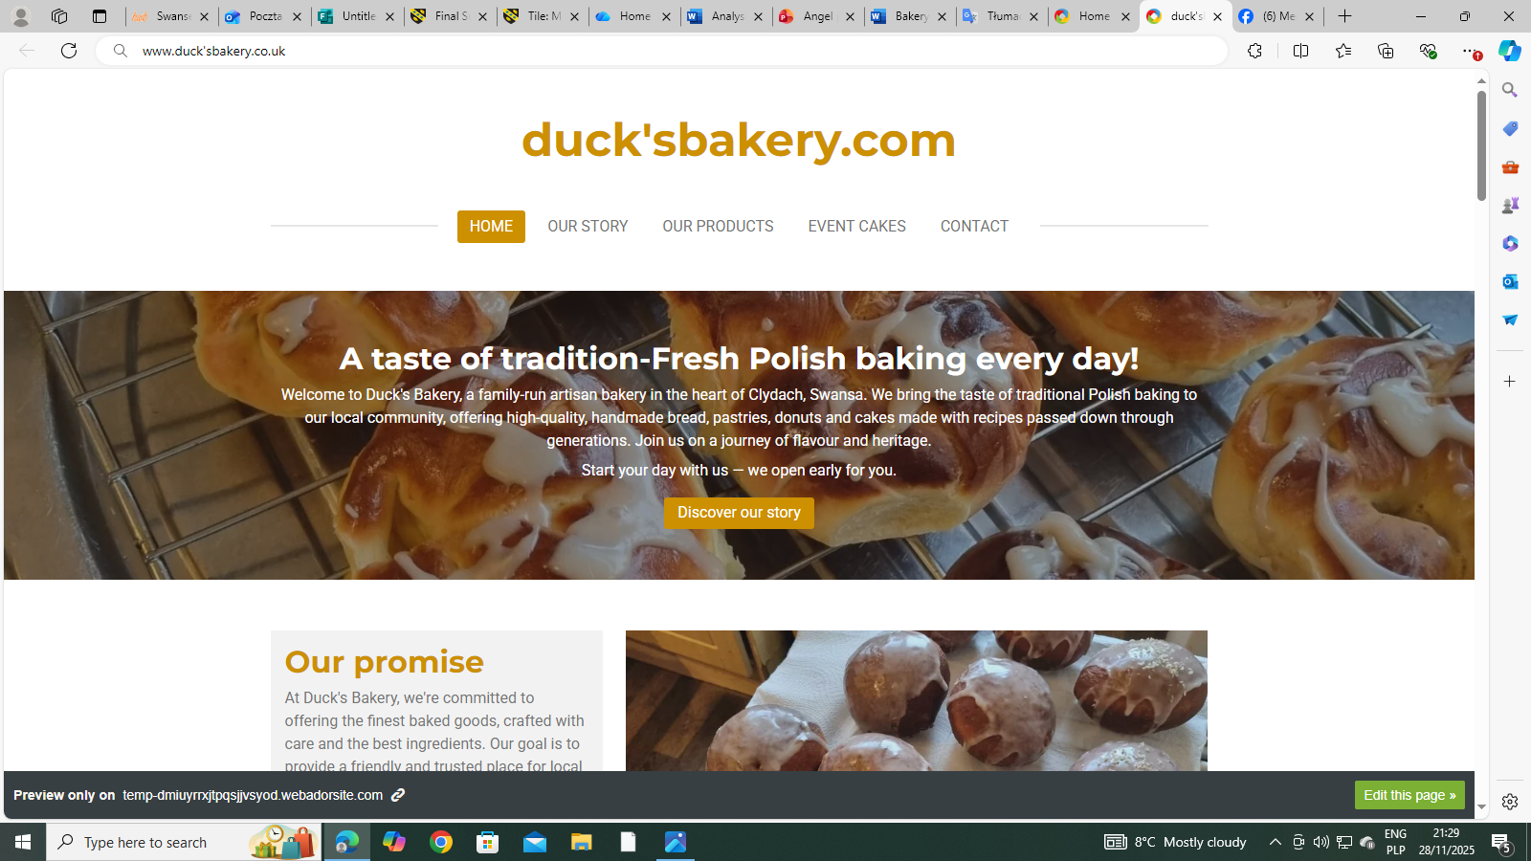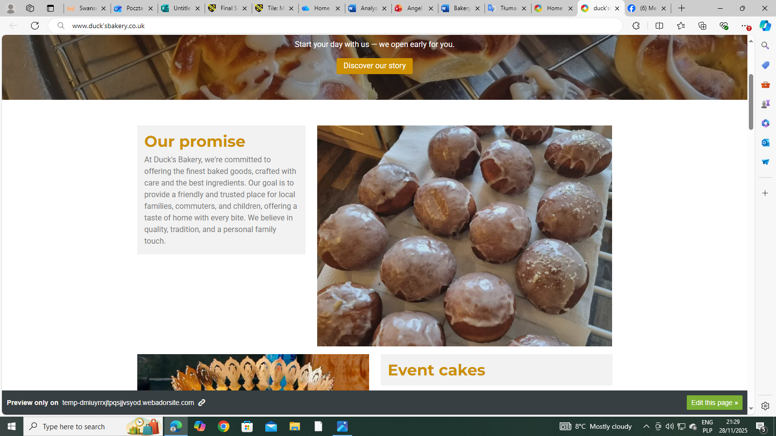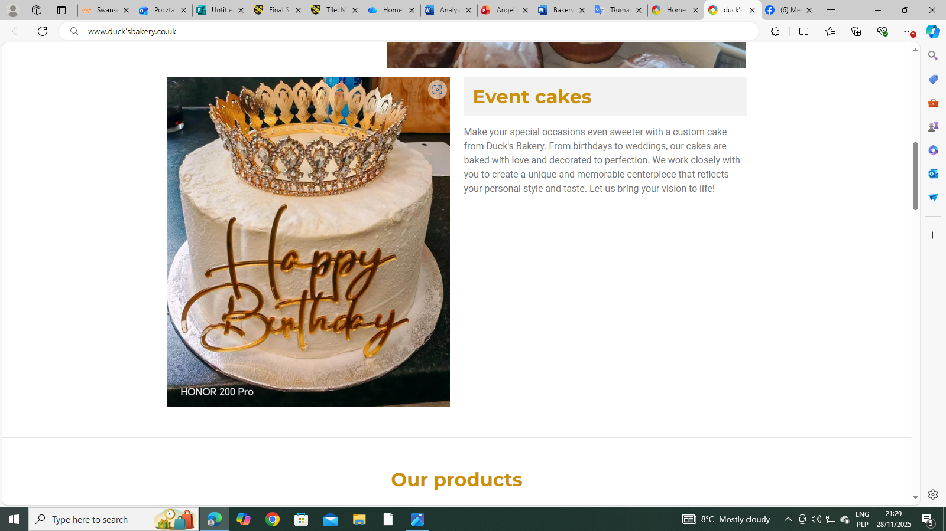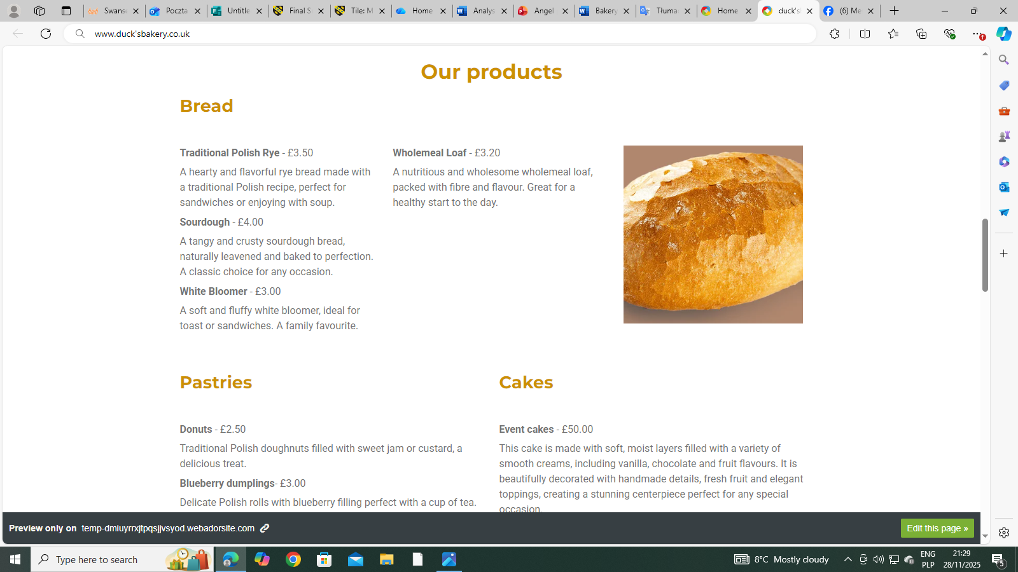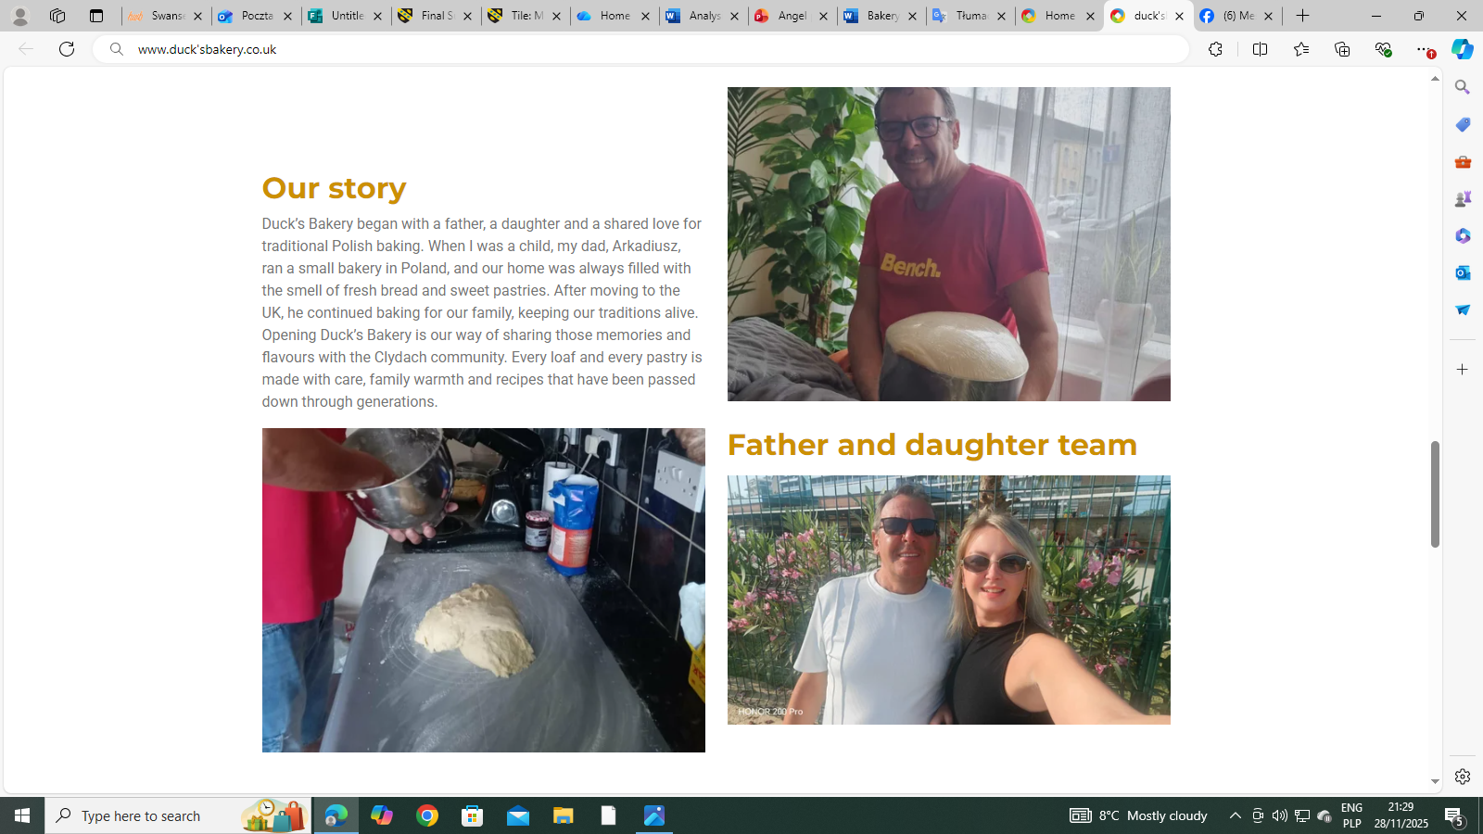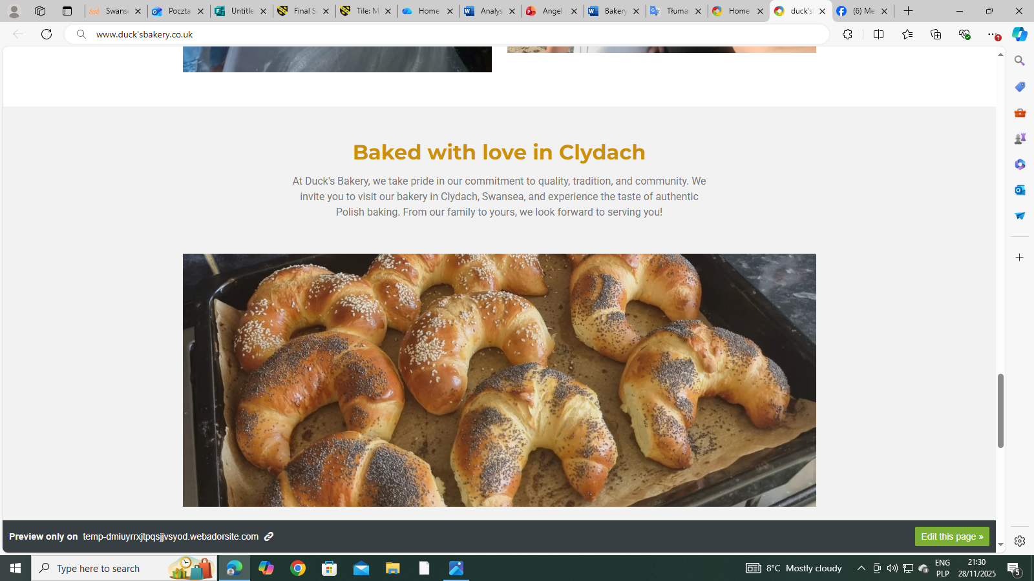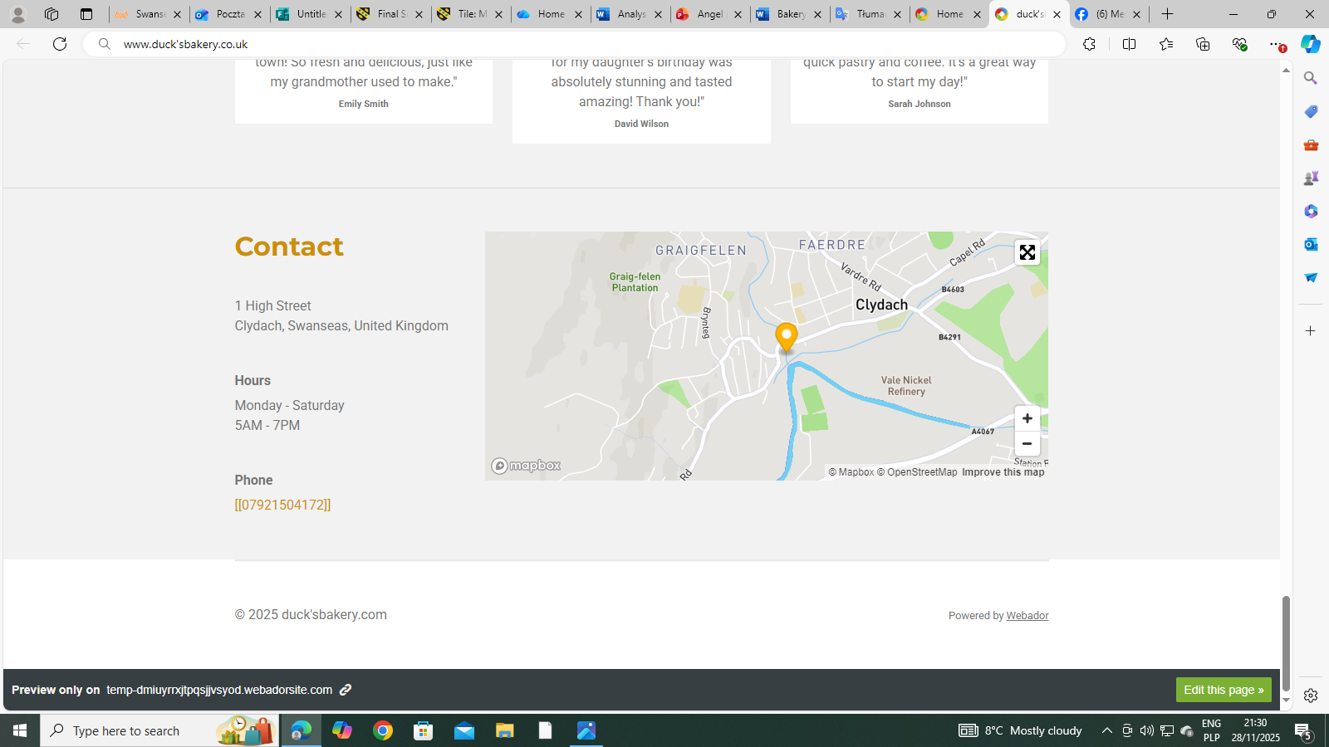

Importance of Excel in the Digital Era – The Case of Duck’s Bakery
In the digital age we live in now, small businesses are under more and more pressure to keep track of their data and cash flow and make rapid, smart decisions. Microsoft Excel has been quite beneficial for Duck's Bakery, a small bakery. Excel is useful for more than just keeping track of sales, expenses, and profits. It may also help with planning, forecasting, and making strategic decisions. My experience demonstrates that Excel is still a basic tool for small business owners in the digital age. It's cheap, adaptable, and powerful (Payne, 2024).
Excel is the basis for managing money.
I wanted a way to track Duck's Bakery's monthly sales and costs without a bookkeeper or expensive accounting software. Best answer: Excel. I created a simple spreadsheet with rows for "Bread and Pastries", "Custom Cakes", "Coffee and Drinks", and "Catering Orders", and columns for January to December. I divided expenses into rent, ingredients, staff salary, utilities, marketing, and equipment and maintenance. I could immediately see how my business was going each month and year using built-in formulas like SUM() to calculate total income and total expenses and then subtracting the expenses from the income to calculate profit or loss. Many small business owners recommend this (Payne, K. 2024).
It was cheap because Excel is easy to obtain as part of Microsoft 365. I did not have to buy expensive accounting software, which is beneficial for small enterprises with tight finances (Small Business Expo, 2024). In Duck's Bakery, these benefits meant that I could spend my money on ingredients and tools instead of paying for software subscriptions that I didn't need.
Helping with Planning and Making Decisions
I had all the bakery's financial data in one spreadsheet, so I could track its success. The Excel file I prepared previously showed that my income was highest in June and December, but my expenses were stable all year. This study helped me decide on supplies, hiring, and seasonal sales. Excel made it easier to observe profit patterns and detect months with higher expenses, such as June, when more clients wanted ingredients (Zach Lezberg 2025) recommends Excel for budgeting in small businesses, and this practical forecasting and planning is an example.
Excel was also flexible enough that I could add new categories when my bakery started offering holiday catering and unique cake creations. This ability to adapt is especially useful for small businesses where things might change quickly. I could tell right away if these new services made more money because Excel formulas update on their own.
Helping Small Business Owners with Accessibility and Digital Skills
Excel is important in the digital age since it is also a digital ability. According to (FutureDotNow 2025), basic digital literacy, such as knowing how to use spreadsheets, is becoming a prerequisite not just in offices but in many other places of employment. Using Excel helped me comprehend financial information better and explain it effectively to suppliers, partners, and even possible investors as a small business owner.
Learning Excel also helps people get better at things like problem-solving, data analysis, and making decisions at work. I learnt these abilities by managing Duck's Bakery with Excel instead of just reading about them. It made me surer of myself while working with numbers and data, which is crucial in today's digital economy. (QuickBooks, 2025)
Why Excel Is Still Important in the Digital Age
Excel is still widely used and trusted, even if cloud-based accounting applications are becoming more popular. Many businesses still use spreadsheets because they are easy to understand, let users control their data, and allow for speedy analysis (Kelly, O., Hall, T. and Connolly, C. 2023). For Duck's Bakery, Excel gave them:
Duck's Bakery no longer needed to purchase expensive accounting software (Zach Lezberg 2025)
Flexibility—new goods or expense categories can be added right away (Zach Lezberg 2025).
Digital skill development: practical digital literacy is necessary for business today (FutureDotNow 2025).
Easy to see - charts and tables make it simple to see how performance is changing.
Accessibility: Most people know how to use Excel, so it's simple to share files.
Conclusion
My time at Duck's Bakery illustrates that Microsoft Excel is still powerful for small businesses in the digital age (Duly, T. 2024). Using Excel to track my income, expenses, and earnings helped me make smart decisions, plan, and understand my finances. The programme is simple, affordable, and adaptable, making it ideal for young entrepreneurs. Excel is a useful beginning point for online money management, but it may not be enough as a company grows (Unit4, 2024). Excel keeps small business owners, like me, organised, up-to-date, and ready for development in a data-driven world.

Reference:
Duly, T. (2024). Accountants: is it time to break up with Excel? [online] Wolterskluwer.com. Available at: https://www.wolterskluwer.com/en/expert-insights/is-it-time-to-break-up-with-excel? [Accessed 9 Dec. 2025].
FutureDotNow. (2025). Economic impact of closing the work digital skills gap - FutureDotNow. [online] Available at: https://futuredotnow.uk/economic-impact-of-closing-the-work-digital-skills-gap/ [Accessed 9 Dec. 2025].
Kelly, O., Hall, T. and Connolly, C. (2023). Digital Workplace Skills: Designing the Integrated Learning of Accounting and Microsoft Excel. Accounting, Finance & Governance Review, 30. doi:https://doi.org/10.52399/001c.77593.
Payne, K. (2024). How to Do Small Business Bookkeeping in Excel Like a Boss. [online] Novo.co. Available at: https://www.novo.co/blog/how-to-do-small-business-bookkeeping-in-excel-like-a-boss? [Accessed 9 Dec. 2025].
QuickBooks (2025). How to use Excel for accounting in 2026 (free template) | QuickBooks. [online] Intuit.com. Available at: https://quickbooks.intuit.com/r/bookkeeping/excel-accounting-bookkeeping/? [Accessed 9 Dec. 2025].
Unit4 Communications (2024). Unit4 FP&A vs. Excel – Insights from the BARC Planning Survey 2024. [online] Unit4.com. Available at: https://www.unit4.com/blog/unit4-fpa-vs-excel-insights-barc-planning-survey-2024?.
Zach Lezberg (2025). What Spreadsheets to Keep for a Small Business. Master Your Finances! [online] Small Business Expo. Available at: https://www.thesmallbusinessexpo.com/blog/what-spreadsheets-to-keep-for-a-small-business/? [Accessed 9 Dec. 2025].
QuickBooks (2025). How to use Excel for accounting in 2026 (free template) | QuickBooks. [online] Intuit.com. Available at: https://quickbooks.intuit.com/r/bookkeeping/excel-accounting-bookkeeping/? [Accessed 9 Dec. 2025].

