
MODULE NAME: Practice-Based Research
MODULE CODE: LCHS7008

TOPIC: INTEGRATED CARE COORDINATION FOR OLDER ADULTS WITH MULTIMORBIDITY IN THE UK: A SYSTEMATIC REVIEW OF HEALTH OUTCOMES AND SERVICE UTILISATION
Student Name:Salomi Rasikbhai Khristi
Student ID:2433236
Lecturer:Diola Bijihout
s
TABLE OF CONTENTS
1. Prevalence of the Problem 3
2. Introduction and Literature-Based Background 4
3. Rationale, Research Question, Aim and Objectives 6
Research Rationale 6
Research Question 6
Research Aim 6
Research Objectives 6
4. Research Methodology 7
4.1 Research Design 7
4.2 Data Sources and Search Strategy 7
4.3 Inclusion and Exclusion Criteria 8
Inclusion Criteria 8
Exclusion Criteria 8
4.4 Screening and Selection Process 9
4.5 Data Extraction 10
5. Data Analysis 10
6. Ethical Considerations 10
7. Implications of the Research 11
8. Plan of Work and Time Schedule (Gantt Chart) 11
8. Conclusion 12
9. References 13

1. Prevalence of the Problem
Multimorbidity, or the presence of two or more chronic disorders, is one of the largest challenges in the public health of the United Kingdom. According to the recent evidence, more than 40% of 65-and-above adults reside with multimorbidity and over 65% of the older than 80-year-old population do (Skou et al., 2022). In adults, especially those aged 70 and older, the number of affected people is more or less 2.5 million, which imposes much strain on the health care systems.
The accommodation of multimorbidity is correlated with augmented healthcare utilisation, such as augmented hospital productive experiences, augmented ED visits and augmented primary care consultations. People having multiple chronic health problems are also vulnerable to worse health outcomes, such as worse quality of life, functional impairment, and risk of death (Khan et al., 2023).
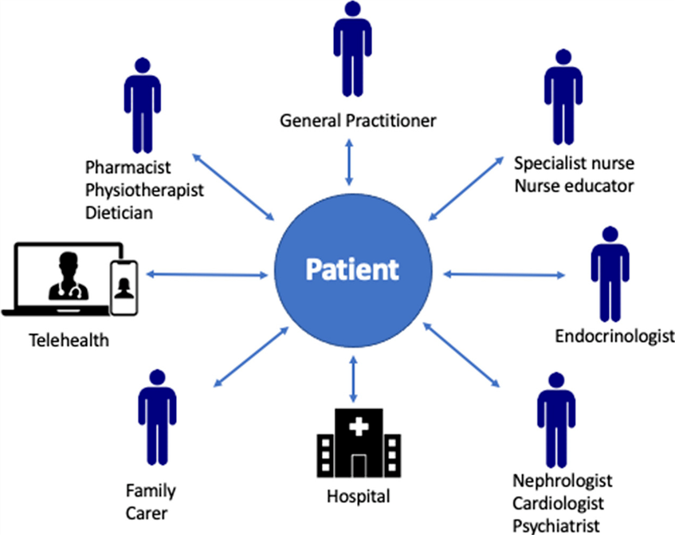
Figure 1: An integrated care model in the context of a chronic disease
(Source: Carrigan et al., 2023)
The fact that in the UK context, the population is ageing exacerbates this problem. By the year 2035, it is estimated that the elderly (those of 65 years and above) will have reached around 14 million people, thereby putting a huge strain on the integrated and coordinated care services (Khan, Addo and Findlay, 2024). The complexity and interrelationship of needs of such a population are problematic to traditional healthcare systems that have mainly been disease-specific and, in most cases, progressively fragmented.
These difficulties have led to an integrated care coordination as a means of response. It entails the organisation and management of healthcare between various providers to provide continuity, efficiency, and patient-centred care. Nevertheless, with policy focus as evidenced by policy initiatives like Integrated Care Systems (ICSs) in England, there is still scant evidence on the feasibility of integrated care coordination in enhancing older adult outcomes with multimorbidity.

2. Introduction and Literature-Based Background
The rising trend in multimorbidity has changed healthcare delivery aspects, whereby people are no longer treated individually but provided holistic care with the person as the centre. Multimorbidity is also linked to complex care needs, which need coordination of primary, secondary and social care systems. The issue of service fragmentation tends to create the problem of care duplication, medication mistakes, and negative patient experience.
Integrated care refers to a type of coordinated healthcare which tries to enhance patient outcomes by connecting services when organisational boundaries are crossed (WHO, 2024). There have been policy actions in the UK to operationalise integrated care, including the NHS Long Term Plan and the design of Integrated Care Systems, which will enhance the co-operation of healthcare providers and social care.
Available evidence indicates that, through integrated care models, it is possible to enhance some of the health outcomes, such as fewer hospital stays and patient satisfaction. As an example, Izabella Uchmanowicz et al. (2025) found that the mixture of care approaches that targeted frailty and multimorbidity resulted in better functional outcomes and less healthcare usage. In a similar fashion, Yu et al. (2020) discovered that case management interventions of integrated care models have the ability to lessen the emergency admissions of older adults.
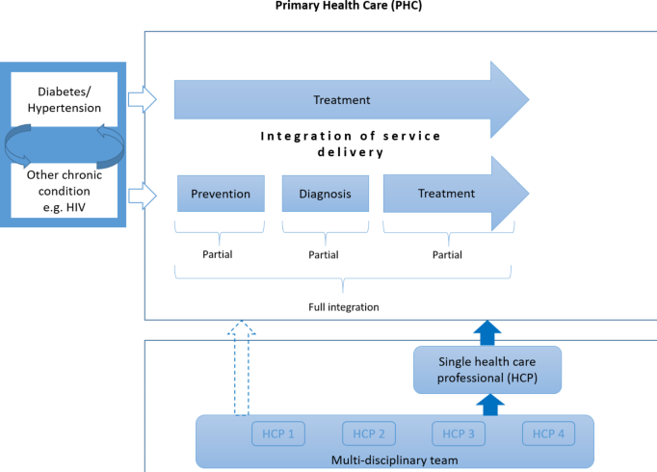
Figure 2: Models of integrated care for multi-morbidity
(Source: Rohwer et al., 2023)
The evidence is not all agreeable, however. According to some research, although integrated care can enhance the level of patient experience and coordination, its effect on the clinical outcomes and cost-effectiveness is mixed (Baxter et al., 2018). Moreover, the effectiveness of integrated care initiatives is undermined by the challenges of implementation on a national level (like shortages of workforce, financing, and the lack of interoperability between digital systems, etc.) (Khan, Hewson and Randhawa, 2024).
The gap in literature is the absence of a systematic review based on the UK population, specific to adults (70 years and older) with multimorbidity categories. Most of the existing research either considers wider groups of individuals or considers several conditions, like frailty and dementia, which creates an issue of heterogeneity in the results (Rahman et al., 2022). Moreover, the evidence on health outcomes as well as service utilisation is scarcely generated in this particular population.
This research aims to fill these gaps by conducting a systematic review and synthesising the available evidence on the concept of integrated care coordination in the UK, focusing on older adults aged 70 years and above with multimorbidity.

3. Rationale, Research Question, Aim and Objectives

Research Rationale
Multimorbidity has increasingly become a challenge to the healthcare systems, especially in relation to handling complex healthcare needs and minimising healthcare utilisation among older adults. Although the concept of integrated care coordination has been popularised, no in-depth synthesis of evidence on integrated care coordination that is UK context- and cohort-specific (older populations) has been published (Thomson, 2024).
Current literature tends not to differentiate between age groups or covers larger groups in general, restricting the scope of its application to populations at risk, rather than applying it to the most vulnerable (Beller et al., 2022). Also, the relationship between integrated care models and their effect on the health outcomes and the service utilisation at the same time is not well understood.
This research is thus timely and topical in the sense that it seeks to offer a holistic systematisation of the evidence available in the UK, on which policy, practice and future studies can be informed. It complies with the national priorities in pursuit of integrated care delivery and better resource allocation in the NHS.

Research Question
How does integrated care coordination influence health outcomes and service utilisation among adults aged 70 years and over with multimorbidity in the UK?

Research Aim
To systematically review and synthesise evidence on the effectiveness of integrated care coordination in improving health outcomes and service utilisation among adults aged 70 years and over with multimorbidity in the UK.

Research Objectives
- To identify different integrated care models used for older adults with multimorbidity in the UK.
- To examine evidence on the impact of integrated care coordination on health outcomes among older adults.
- To review the effects of integrated care models on healthcare utilisation (e.g., hospital admissions, primary care visits).
- To identify barriers and facilitators to the implementation of integrated care coordination reported in the literature.

4. Research Methodology

4.1 Research Design
The research will include a systematic literature review design as it is suitable for the synthesis of existing evidence in a systematic and transparent way (Kabir et al., 2023). A systematic review allows identification, appraisal, and synthesis of the relevant studies, which contributes to high-quality evidence in making policies and practices.

4.2 Data Sources and Search Strategy
The IRB library will be searched comprehensively to make sure that high-quality and relevant academic sources will be included (Gusenbauer and Gauster, 2024). Significant databases like PubMed, Scopus and Google Scholar will be used to find peer-reviewed articles, reports and studies. Specific keywords will be used, and this will include: integrated care, care coordination, multimorbidity, older adults, elderly, UK, health outcomes, and service utilisation. These terms will be combined and narrowed down using the Boolean operators like AND and OR to help narrow down the search to a narrow and orderly range of literature addressing the subject of our research (Dambha-Miller et al., 2021).

4.3 Inclusion and Exclusion Criteria

Inclusion Criteria
To be relevant, fully consistent, and of high quality, the review will entail the use of studies that meet well-developed criteria. Peer-reviewed journal articles will be included only in the prospective, which are not older than ten years old; this way, they will represent the latest healthcare practices and policies (Shaheen et al., 2023). Only the studies carried out in the United Kingdom will be reviewed, so that the study objective is always within a context. Moreover, only journals which are in English will be incorporated to ascertain a precise interpretation of results. The target group is adults aged 70 years and older with multimorbidity, since they are the most impacted by the complex care requirements. Moreover, the research should be focused on interventions of integrated care or care coordination strategies, which should be assessed specifically to make sure that they are central to the study.

Exclusion Criteria
The review will exclude studies that fail to meet the inclusion criteria as a way of preserving rigour and focus of the review. Such studies that were conducted outside of the UK will be excluded because of the variance in healthcare systems and policy markets (Patino and Ferreira, 2018). Reports that are not peer-reviewed and not academic sources will not be taken into consideration to maintain academic credibility. Also, the opinion pieces, commentaries and editorials will be avoided since they are not empirical. Research that either does not mention multimorbidity specifically or other research that does not investigate the intervention of integrated care will also be omitted, and only potentially pertinent and evidence-based research studies will be discussed.

4.4 Screening and Selection Process

Identification of studies via databases and registers

Records removed before screening:
Duplicate records removed (n = 30)
Records marked as ineligible by automation tools (n = 2)
Records removed for other reasons (n = 5)
Records identified from*:
Databases (n =100)
Registers (n = 50)

Identification

Records screened
(n = 113)
Records excluded**
(n =55 )

Reports sought for retrieval
(n = 58)
Reports not retrieved
(n = 27)

Screening

Reports assessed for eligibility
(n = 31)
Reports excluded: 15
.

Studies included in review
(n = 16)
Reports of included studies
(n = 16)
Included

Figure 3: PRISMA
(Source: Self-created)
The PRISMA flow chart provides a way the systematic review will operate the selection of studies. It was identified that there were 150 records, and 30 duplicate records and 7 inappropriate were removed. After the screening and evaluation of their eligibility, 16 studies were included. The process guarantees transparency, systematic filtering and methodological rigour of selection of appropriate evidence to analyse.

4.5 Data Extraction
A structured data extraction form will be used to extract relevant data in an organizationally orderly manner to reach consistency, accuracy and transparency of the review process. It is a type that will ensure capturing of the main study features, such as the author, year of publication and type of research design, which can be compared to various studies (Afifi, Stryhn and Sánchez, 2023). A thorough description of the study population, especially adults at the age of 70 years and above with multimorbidity, will also be recorded to ensure it is relevant towards the objective of the research. Moreover, the nature of the implemented integrated care intervention in each of the studies will also be reported to determine various models of care coordination (Duan-Porter et al., 2020). Outcome measures will comprise health outcomes, e.g. quality of life and mortality, and service utilisation outcomes, e.g. hospital admissions, primary care visits. Lastly, findings of the two studies will be summarised to help in the synthesis and thematic analysis.

5. Data Analysis
An approach based on a narrative synthesis will be followed to analyse the gathered data, because the studies that will be included are likely to differ with regard to design, interventions and measurement outcomes. This approach facilitates the assimilation of results of multiple sources in a purposeful and well-constructed manner (Riddell et al., 2025). It will be analysed following the structure of the main themes, such as health outcomes, service utilisation, barriers and facilitators to implementation. The health outcomes will be considered in terms of quality of life, functional status and mortality, whereas service utilisation will discuss aspects like hospitalisation and visits to general practitioners (Rogers et al., 2021). Also, the barriers and facilitators, including the workforce capacity, funding, and digital infrastructure, will be discussed. The identification of patterns, comparisons across studies and a critical assessment of the evidence on the whole will be aided by the presence of thematic analysis.

6. Ethical Considerations
The research will be carried out using only secondary data resources, including the published scholarly articles and reports and will not include direct contact with human participants. This leads to the impaction of the low-risk level of ethical risk (Jol and Stommel, 2016). Nevertheless, some key ethical issues will nonetheless be addressed in order to guarantee the integrity and credibility of the research. To prevent misrepresentation and bias, the study will make sure that all findings will be represented without creating misinformation about the findings (Sony et al., 2025). Appropriate referencing and citation will be used to prevent plagiarism and to refer to the sources used by their original authors. Academic integrity will be among the priorities in the research process. In addition, ethical consent will be received as per the university laws to ensure that the research conforms to the institutional requirements in research.

7. Implications of the Research
This study could be very important to healthcare policy and practice in the United Kingdom. Assessing evidence on the coordination of care across organisations, the study will create useful information on how multimorbidity can be managed successfully in older adults, which is becoming an increasingly critical issue among ageing populations (Wu et al., 2023). The results will be used to make policy changes in the National Health Service, especially in enhancing Integrated Care Systems that would enhance coordination between the services. Moreover, the study will help to allocate the resources and plan the services more efficiently as the effective models of care will be identified. It will also serve to improve the patient-centred care approach as it will advance approaches that can cater to more complicated health demands (Yu et al., 2023). Moreover, the research will determine gaps in the literature, allowing upcoming research and enhancing the overall progress of knowledge on the subject in the domain of public health and social care.

8. Plan of Work and Time Schedule (Gantt Chart)
Key activities | W1 | W2 | W3 | W4 | W5 | W6 | W7 | W8 | W9 | W10 | W11 | W12 | W13 | W14 | W15 | W16
Database searches (PubMed, Scopus, google scholar) | ■ | ■
Introduction chapter |  | ■ | ■
Literature review (chapter 2) |  |  | ■ | ■ | ■
Title/abstract screening |  |  |  | ■ | ■
Full-text screening |  |  |  |  | ■ | ■
Quality appraisal |  |  |  |  |  | ■ | ■
Methodology chapter (chapter 3) |  |  |  |  |  | ■ | ■
Data extraction |  |  |  |  |  |  | ■ | ■
Data analysis (narrative synthesis) |  |  |  |  |  |  |  | ■ | ■ | ■
Results/findings (chapter 4) |  |  |  |  |  |  |  |  | ■ | ■
Discussion (chapter 5) |  |  |  |  |  |  |  |  |  | ■ | ■
Conclusion & recommendations |  |  |  |  |  |  |  |  |  |  | ■ | ■
Editing & revision |  |  |  |  |  |  |  |  |  |  |  | ■ | ■ | ■
Final submission |  |  |  |  |  |  |  |  |  |  |  |  |  | ■ | ■ | ■

Figure: Gantt chart
(Source: Self-created)

8. Conclusion
Conclusively, the increased prevalence of multimorbidity in older adults in the UK, specifically aged 70 years and above, poses a considerable challenge to the healthcare systems, especially as far as fragmentation of care delivery and rising service demand is concerned. This research proposal has described a systematic method of studying the effectiveness of integrated care coordination to enhance the health outcomes as well as the utilisation of health care services among this population. The suggested review will help to identify a detailed picture of the functioning mechanisms of integrated care models in the real world, barriers, and facilitators of their implementation, as the findings will be synthesised based on the research conducted in the UK. It is anticipated that the findings will make a contribution to evidence-based policy and practice, specifically, in enhancing Integrated Care Systems and improving person-centred care. Finally, the study is going to be helpful in creating better coordinated, efficient, and sustainable healthcare services that meet the multifaceted needs of older adults with multimorbidity.

9. References
Afifi, M., Stryhn, H. and Sánchez, J. (2023). Data extraction and comparison for complex systematic reviews: a step-by-step guideline and an implementation example using open-source software. Systematic Reviews, [online] 12(1). doi:https://doi.org/10.1186/s13643-023-02322-1.
Baxter, S., Johnson, M., Chambers, D., Sutton, A., Goyder, E. and Booth, A. (2018). The Effects of Integrated care: a Systematic Review of UK and International Evidence. BMC Health Services Research, [online] 18(1). doi:https://doi.org/10.1186/s12913-018-3161-3.
Beller, J., Luy, M., Giarelli, G., Regidor, E., Lostao, L., Tetzlaff, J. and Geyer, S. (2022). Trends in Activity Limitations From an International Perspective: Differential Changes Between Age Groups Across 30 Countries. Journal of Aging and Health, p.089826432211411. doi:https://doi.org/10.1177/08982643221141123.
Carrigan, A., Roberts, N., Clay-Williams, R., Hibbert, P., Austin, E., Pulido, D.F., Meulenbroeks, I., Nguyen, H.M., Sarkies, M., Hatem, S., Maka, K., Loy, G. and Braithwaite, J. (2023). What do consumer and providers view as important for integrated care? A qualitative study. BMC Health Services Research, 23(1). doi:https://doi.org/10.1186/s12913-022-08997-x.
Dambha-Miller, H., Simpson, G., Hobson, L., Roderick, P., Little, P., Everitt, H. and Santer, M. (2021). Integrated primary care and social services for older adults with multimorbidity in England: a scoping review. BMC Geriatrics, [online] 21(1). doi:https://doi.org/10.1186/s12877-021-02618-8.
Duan-Porter, W., Ullman, K., Majeski, B., Miake-Lye, I., Diem, S. and Wilt, T.J. (2020). Care Coordination Models and Tools: A Systematic Review and Key Informant Interviews. [online] PubMed. Washington (DC): Department of Veterans Affairs (US). Available at: https://www.ncbi.nlm.nih.gov/books/NBK566155/.
Gusenbauer, M. and Gauster, S.P. (2024). How to Search for Literature in Systematic Reviews and meta-analyses: a Comprehensive step-by-step Guide. Technological Forecasting and Social Change, [online] 212, p.123833. doi:https://doi.org/10.1016/j.techfore.2024.123833.
Izabella Uchmanowicz, Faulkner, K.M., Iovino, P., Kwaśny, A., Surma, S., Magi, C.E., Jakubiak, G.K., Yari Longobucco, Janczak, D., Rak-Pasikowska, A., Czapla, M. and Bartosz Uchmanowicz (2025). Integrating frailty interventions into existing care models: a comprehensive approach to enhancing patient outcomes in chronic disease management. Frontiers in Public Health, 12. doi:https://doi.org/10.3389/fpubh.2024.1518774.
Jol, G. and Stommel, W. (2016). (PDF) Ethical considerations of secondary data use: What about informed consent? [online] ResearchGate. Available at: https://www.researchgate.net/publication/313684590_Ethical_considerations_of_secondary_data_use_What_about_informed_consent.
Kabir, R., Hayhoe, R., Bai, A.C.M., Vinnakota, D., Sivasubramanian, M., Afework, S., Chilaka, M., Mohammadnezhad, M., Aremu, O., Sah, R.K., Khan, H.T.A., Messner, S., Syed, H.Z. and Parsa, A.D. (2023). The systematic literature review process: a simple guide for public health and allied health students. International Journal of Research in Medical Sciences, [online] 11(9). doi:https://doi.org/10.18203/2320-6012.ijrms20232496.
Khan, H.T.A., Addo, K.M. and Findlay, H. (2024). Public Health Challenges and Responses to the Growing Ageing Populations. Public Health Challenges, 3(3), pp.1–9. doi:https://doi.org/10.1002/puh2.213.
Khan, N., Chalitsios, C.V., Nartey, Y., Simpson, G., Zaccardi, F., Santer, M., Roderick, P., Stuart, B., Farmer, A. and Hajira Dambha‐Miller (2023). Clustering by multiple long-term conditions and social care needs: a cross-sectional study among 10 026 older adults in England. Journal of Epidemiology and Community Health, 77(12), pp.770–776. doi:https://doi.org/10.1136/jech-2023-220696.
Patino, C. and Ferreira, J. (2018). Inclusion and Exclusion Criteria in Research studies: Definitions and Why They Matter. Jornal Brasileiro De Pneumologia, [online] 44(2), p.84. doi:https://doi.org/10.1590/s1806-37562018000000088.
Rahman, Md.M., Kamal, M.A., Mim, S.A., Islam, Md.R., Parvez, A., Islam, F., Uddin, M.B., Rahaman, Md.S., Shuvo, P.A., Ahmed, M. and Greig, N.H. (2022). Exploring the Recent Trends in Management of Dementia and Frailty: Focus on Diagnosis and Treatment. Current Medicinal Chemistry, 29(32), pp.5289–5314. doi:https://doi.org/10.2174/0929867329666220408102051.
Riddell, J., Srebrenka Letina, Skivington, K., Archambault, D., Wells, V., Long, E., Hunter, R. and McCann, M. (2025). Methods for interventions using networks to improve health: A narrative synthesis of methodological research on network data collection, visualisation and intervention. Social Networks, 84, pp.202–219. doi:https://doi.org/10.1016/j.socnet.2025.10.003.
Rogers, H.L., Pablo Hernando, S., Núñez - Fernández, S., Sanchez, A., Martos, C., Moreno, M. and Grandes, G. (2021). Barriers and facilitators in the implementation of an evidence-based health promotion intervention in a primary care setting: A qualitative study. Journal of Health Organization and Management, [online] ahead-of-print(ahead-of-print). doi:https://doi.org/10.1108/jhom-12-2020-0512.
Rohwer, A., Toews, I., Uwimana-Nicol, J., Nyirenda, J.L.Z., Jean Berchmans Niyibizi, Akiteng, A.R., Meerpohl, J.J., Bavuma, C., Kredo, T. and Young, T. (2023). Models of integrated care for multi-morbidity assessed in systematic reviews: a scoping review. BMC Health Services Research, 23(1). doi:https://doi.org/10.1186/s12913-023-09894-7.
Shaheen, N., Shaheen, A., Ramadan, A., Hefnawy, M.T., Ramadan, A., Ibrahim, I., Hassanein, M., Ashour, M.E. and Flouty, O. (2023). Appraising Systematic reviews: a Comprehensive Guide to Ensuring Validity and Reliability. Frontiers in Research Metrics and Analytics, 8(8). doi:https://doi.org/10.3389/frma.2023.1268045.
Skou, S.T., Mair, F.S., Fortin, M., Guthrie, B., Nunes, B.P., Miranda, J.J., Boyd, C.M., Pati, S., Mtenga, S. and Smith, S.M. (2022). Multimorbidity. Nature Reviews Disease Primers, [online] 8(1), pp.1–22. doi:https://doi.org/10.1038/s41572-022-00376-4.
Sony, E., Ali, E., Cletus, E., Agbakhamen, O., Ogheneteme, E. and Okoro, P. (2025). Ethical Standards in Research: A Professional Imperative. International Journal of Innovative Scientific & Engineering Technologies Research, [online] 13(1), pp.94–104. doi:https://doi.org/10.5281/zenodo.14875237.
Thomson, L. (2024). Barriers and Enablers of Integrated Care in the UK: a Rapid Evidence Review of Review Articles and Grey Literature 2018–2022. Frontiers in Public Health, [online] 11(1). doi:https://doi.org/10.3389/fpubh.2023.1286479.
WHO (2024). Integrated people-centred care - GLOBAL. [online] www.who.int. Available at: https://www.who.int/health-topics/integrated-people-centered-care.
Wu, J., Zhang, H., Shao, J., Chen, D., Xue, E., Huang, S., Fu, Y., Tang, L. and Ye, Z. (2023). Healthcare for Older Adults with Multimorbidity: A Scoping Review of Reviews. Clinical Interventions in Aging, Volume 18, pp.1723–1735. doi:https://doi.org/10.2147/cia.s425576.
Yu, C., Xian, Y., Jing, T., Bai, M., Li, X., Li, J., Liang, H., Yu, G. and Zhang, Z. (2023). More patient-centered care, better healthcare: the association between patient-centered care and healthcare outcomes in inpatients. Frontiers in Public Health, 11(1148277), pp.1–9. doi:https://doi.org/10.3389/fpubh.2023.1148277.
Yu, Z., Gallant, A.J., Cassidy, C.E., Boulos, L., Macdonald, M. and Stevens, S. (2020). Case Management Models and Continuing Care: A Literature Review across nations, settings, approaches, and assessments. Home Health Care Management & Practice, 33(2), p.108482232095439. doi:https://doi.org/10.1177/1084822320954394.

