

Control & Automation
Application of automation in wastewater treatment

(ACMA5001)

Word count (2609)

Parry Phillips
2011664
April 2026

Table of Contents
Table of Figures 2
1.0 Introduction 3
2.0 Historical Background of Wastewater Treatment and Automation 4
2.1 Historical Fundamentals of Control and Automation 6
3.0 Modern Day Wastewater Treatment Plants 8
3.1 Sensors and Instrumentation 8
3.2 Process Controllers 10
3.3 Final Control Elements 11
3.4 Supervisory Control (SCADA & HMI) 12
4.0 Regulations and Standards in UK Wastewater Treatment and ICA 14
5.0 Future Advancements 15
Conclusion 16
References 17
Bibliography 20

Table of Figures
Figure 1. Imhoff tank (https://sswm.info/es/taxonomy/term/3799/imhoff-tank) 4
Figure 2. Blower integrated to sludge system. (https://www.mdpi.com/2076-3417/8/2/261) 5
Figure 3. PID functions explained (https://chatgpt.com/c/69e8dbf0-c6a8-83eb-8b1f-87e40381637f) 6
Figure 4. Differing signal types depending on sensor. (https://chatgpt.com/c/69e8dbf0-c6a8-83eb-8b1f-87e40381637f) 8
Figure 5. PLC overview. (https://www.coalhandlingplants.com/what-is-plc-programmable-logic-controller/) 10
Figure 6. Wastewater plant process flow diagram. (https://www.britannica.com/technology/wastewater-treatment/Primary-treatment) 11
Figure 7. SCADA Overview (https://www.reverecontrol.com/scada-basics-what-are-scada-and-telemetry/) 13
Figure 8. HMI for a wastewater plant. (https://atscada.com/waste-water-treatment-management-system/) 14

Introduction
Wastewater treatment is a critical service, responsible for processing effluent from domestic, commercial, and industrial sources before it is safely returned to the natural water environment (DEFRA, 2002). Without adequate treatment, wastewater contains excess nutrients, harmful chemicals, and bacteria that present significant risks to human health and the wider ecology of water bodies (DEFRA, 2002). In the United Kingdom there are over nine thousand wastewater treatment plants are in operation (National Engineering Policy Centre, 2024). Given the scale, complexity, and continuous nature of these operations, the effective monitoring and control of the process is essential.
Instrumentation, Control and Automation (ICA) refer to the integrated use of sensors, process controllers, actuators, and supervisory systems to monitor and regulate industrial processes with minimal human intervention. (Dorf and Bishop, 2017). Wastewater treatment plants are load driven, subject to significant variability in flow rate and composition throughout the day, seasonally, and in response to storm events (National Engineering Policy Centre, 2024). Maintaining consistent and compliant effluent quality under these conditions demands a level of responsiveness that manual operation alone cannot reliably provide.
This report investigates the specific application of ICA to wastewater treatment, examining the historical context of its adoption, the sensors, controllers and actuators that underpin plant operation, the role of supervisory control in enabling autonomous function, the regulatory framework governing these systems, and the technologies that are driving further improvements in the sector.

Historical Background of Wastewater Treatment and Automation
The application of ICA to wastewater treatment has evolved considerably over the past century, driven by advances in control and automation, process understanding, and environmental regulation. In the early twentieth century, wastewater treatment facilities operated almost entirely through manual intervention, with operators conducting periodic inspections, manually adjusting valves, and recording readings such as flow, level and water quality.
An example of early control monitoring can be highlighted by a Imhoff settling tank, developed by Karl Imhoff in the early twentieth century, it is a two-stage wastewater treatment unit that combines primary sedimentation with anaerobic sludge digestion (S. Friel, 1930).
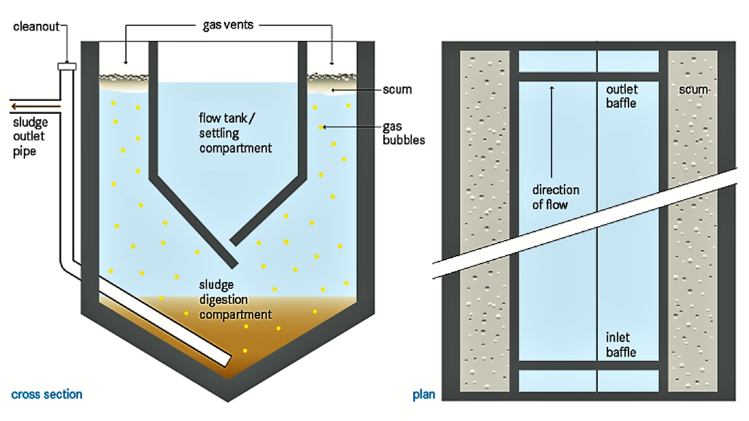
Figure 1. Imhoff tank (https://sswm.info/es/taxonomy/term/3799/imhoff-tank)
Figure 1. shows the upper chamber which facilitates gravitational settling of suspended solids, while the lower chamber collects the sludge and breaks down the material through anaerobic biological processes. A defining feature of the design is the separation between chambers, which prevents gases produced during digestion from disrupting sedimentation (S. Friel, 1930). The Imhoff tank operates entirely through passive hydraulic and biological mechanisms, requiring manual monitoring and sludge removal by an operator, and represents a key transitional development in early wastewater treatment engineering. This approach was labour-intensive, prone to human error, and wholly incapable of responding dynamically to rapid changes in conditions.
The next step in the field of wastewater treatment was an important development, the introduction of dissolved oxygen (DO) sensors to control aeration in activated sludge systems. Figure two Represents a similar system to what was first introduced.
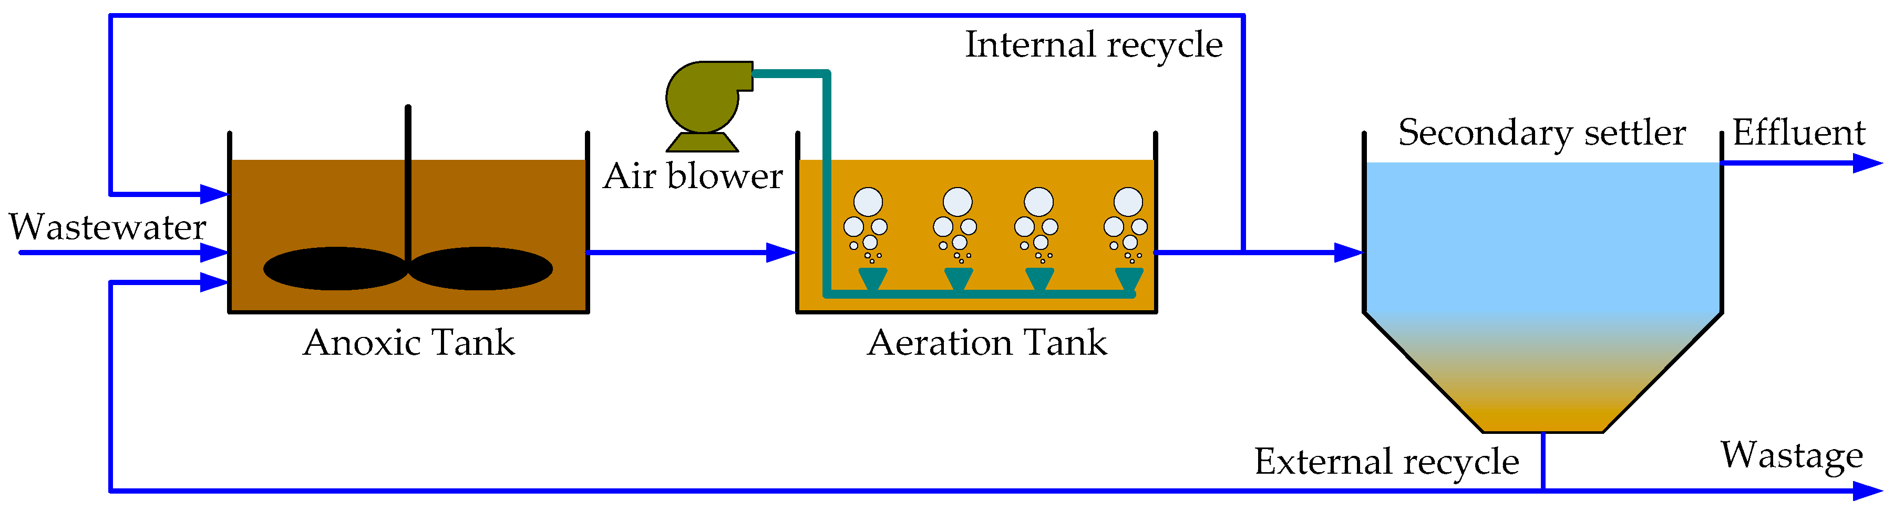
Figure 2. Blower integrated to sludge system. (https://www.mdpi.com/2076-3417/8/2/261)
Facilities in countries such as Germany, and the Netherlands began implementing feedback control loops in the late 1960s. These systems used signals from dissolved oxygen sensors to automatically regulate aeration. Control was typically achieved through on/off operation of blowers in response to oxygen levels depending on the input oxygen sensor reading, representing one of the first practical applications of closed-loop control in wastewater treatment (Du et al., 2018).

2.1 Historical Fundamentals of Control and Automation
The evolution of modern control and automation systems is fundamentally rooted in the development of mathematical control theory and its implementation within programmable logic controllers (PLCs). Early theoretical foundations were established by engineers and mathematicians such as James Clerk Maxwell, who analysed feedback mechanisms (Bittanti, 2015), and Nicolas Minorsky, who formalised proportional–integral–derivative (PID) control in the early 20th century (Cahill, 2013). Later contributions from Rudolf Kalman advanced modern control theory through state-space modelling and optimal control (Fan, Hwang and Hwang, 1970).
These mathematical principles underpin the operation of PLC-based systems, where real-time data from instrumentation (sensors measuring variables such as pressure, temperature, or flow) are continuously transmitted to a controller (Zhang, 2024). The PLC executes control algorithms, comparing measured values to setpoints and calculating corrective actions. Figure three demonstrates how proportional, integral, and derivative actions work together in a closed-loop system to minimise error between a setpoint and the measured value. Together, these mathematically derived functions balance speed, accuracy, and stability (Crowe et al., 2014).
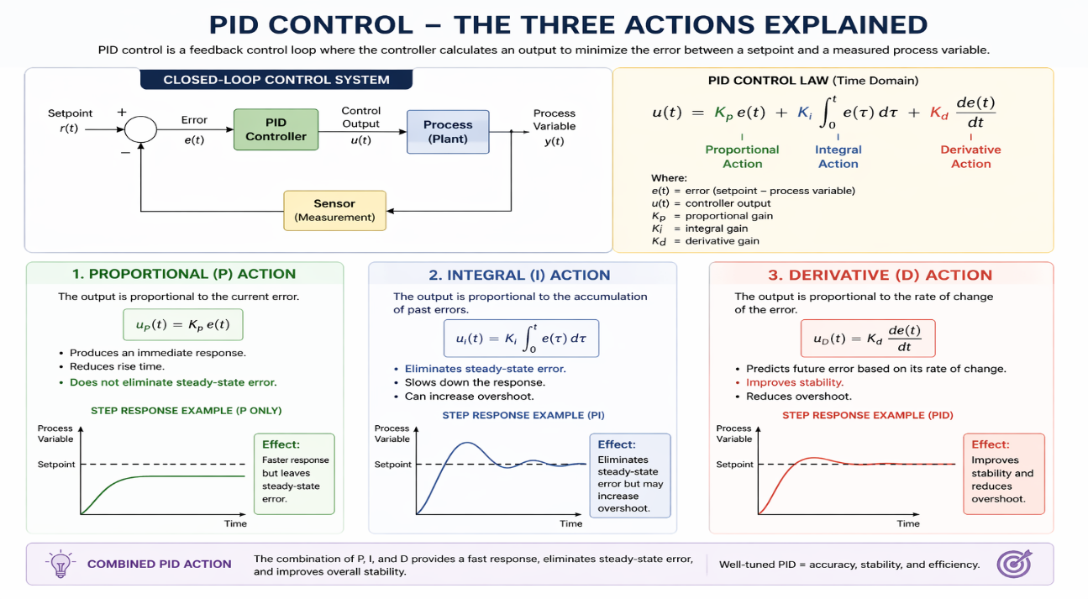
Figure 3. PID functions explained (https://chatgpt.com/c/69e8dbf0-c6a8-83eb-8b1f-87e40381637f)
From the controller, output signals are then sent to actuators, pumps or relays forming a closed-loop feedback system (Zhang, 2024). This integration of measurement, computation, and actuation represents a significant advancement from earlier manual control, enabling high precision, repeatability, and adaptability in complex industrial processes.

3.0 Modern Day Wastewater Treatment Plants

3.1 Sensors and Instrumentation

Accurate and reliable instrumentation forms the foundation of any automated wastewater treatment plant. Without continuous, real-time measurement of process variables, effective automatic control is not possible. Sensors enable the real-time reading of physical parameters such as flow rates, water quality throughout the treatment stages (electrical conductivity, pH, turbidity, redox potential, and dissolved oxygen) (Niazi, 2021). Most sensor signals within a modern plants utilise standardised 4–20 mA analogue signals (zero to one hundred percent) and 0-24 volts for digital signals (on/off) to the plant's control system highlighted in figure four (Santi Nuratch, 2017). Field instruments utilise this standard to connect with PLCs and SCADA systems using a common signal range (Olsson et al., 2014).
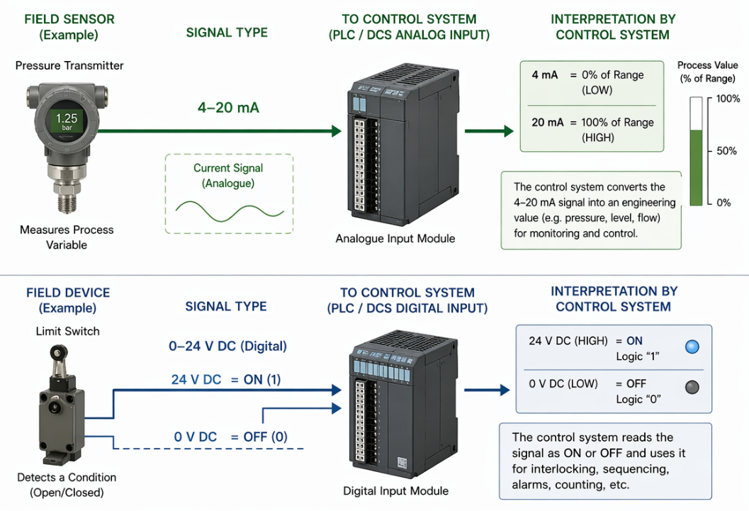
Figure 4. Differing signal types depending on sensor. (https://chatgpt.com/c/69e8dbf0-c6a8-83eb-8b1f-87e40381637f)

The two dominant flow measurement technologies in wastewater applications are electromagnetic flowmeters and ultrasonic flowmeters. Electromagnetic flowmeters utilise electromagnetic induction whereby the conductive liquid passes through a magnetic field produces a voltage which is proportional to velocity of the flow (Toshiba, 2010). Their unobstructed bore eliminates blockage risks, making them well suited to the solid nature of sewage at the primary treatment stage. Ultrasonic flowmeters offer a non-invasive measurement approach, with Doppler-based technology particularly effective in wastewater and slurry applications where suspended solids or gas bubbles are present (Sun et al., 2021).

Large scale wastewater treatment plants typically deploy water quality sensors with multiple probes commonly measuring variables such as temperature, pH, dissolved oxygen (DO), oxidation–reduction potential (ORP), electrical conductivity, and turbidity. (Leadmed Technology, 2022). Each probe measures a different variable, pH sensors are used to maintain suitable acidity levels for biological treatment processes, although they require regular calibration and can be affected by fouling and gradual measurement drift. Dissolved oxygen (DO) sensors play a key role in supporting aerobic biological activity by ensuring sufficient oxygen is available. Turbidity sensors are used to monitor how effectively solids are settling or being removed during treatment, while ammonia and nitrate analysers provide continuous information on nutrient levels. This data is essential for process control and for ensuring that treated water meets regulatory discharge standards (Kruse, 2018).

A persistent challenge across all wastewater instrumentation is maintaining accuracy within an aggressive environment. Factors such as biological fouling, solid deposition, and biofilm accumulation can interfere with sensor measurements, leading to deteriorating precision and accuracy over time and eventually failure. Routine maintenance programmes including cleaning and verification against laboratory samples are therefore essential to preserving data integrity and ensuring the control system can make accurate corrective decisions (Kruse, 2018).

3.2 Process Controllers

Within modern wastewater treatment plants, the Programmable Logic Controller (PLC) plays a central role in coordinating and optimising process performance. Rather than simply acting as a control device, the PLC integrates data from multiple field instruments and enables continuous, automated regulation of key treatment stages, highlighted in figure five (Dorf and Bishop, 2017). This allows the plant to respond dynamically to variations in flow rates and composition, ensuring stable operation.
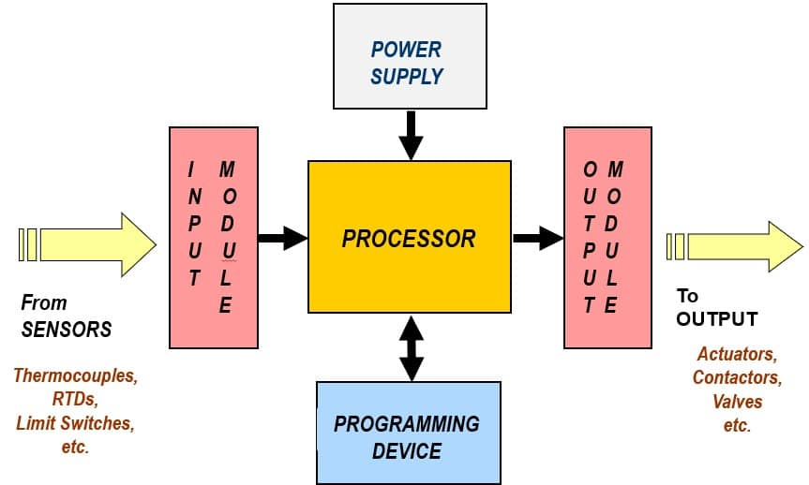
Figure 5. PLC overview. (https://www.coalhandlingplants.com/what-is-plc-programmable-logic-controller/)
In biological treatment processes, the PLC maintains optimal conditions for microbial activity by regulating parameters such as aeration, mixing, and sludge handling. Dissolved oxygen control within aeration tanks illustrates this role, where the PLC continuously adjusts blower operation to maintain a target oxygen concentration, supporting efficient biological treatment while minimising energy use (Kabir and Anick, 2024).

More broadly, PLCs facilitate the coordination of interconnected processes across the plant, reduce reliance on manual intervention, and enhance operational reliability. Their ability to manage disturbances and maintain compliance with discharge standards makes them essential to the effective operation of modern wastewater treatment facilities.

3.3 Final Control Elements

Final control elements are the devices that receive output signals from the PLC and act directly on the system to physically alter the process.

Firstly, pumps transfer wastewater between treatment stages, return activated sludge, and discharge final effluent. Blowers supply air to the aeration tanks to sustain the activated sludge process. Variable Frequency Drives (VFDs), are applied to pump and blower motors, allowing the PLC to regulate motor speed proportionally rather than simply switching equipment on or off. Changing blower control from fixed-speed operation with flow control valves to variable frequency drive (VFD) speed control has been shown to significantly reduce energy consumption in wastewater aeration systems, with reported savings of up to 50% in some cases (Yehia, 2015). This is particularly important given that aeration can account for up to 70% of total energy use at a wastewater treatment plant (Water Environment Federation, 2009).

An actuator is a device that converts a control signal into physical motion or force, allowing a control system to directly influence a process. It serves as the link between the controller output and the physical action in the field, typically producing linear or rotational movement (Janocha, 2004). Actuators include pneumatic, motor and solenoid-operated control valves, which regulate flow between process units in direct response to PLC output signals. Valve position is fed back to the controller to confirm the actuator has responded correctly by adjusting the valve position (open or closed), completing the closed-loop control (Bentley, 2005). Figure six highlights the final elements controlled in a wastewater plant. 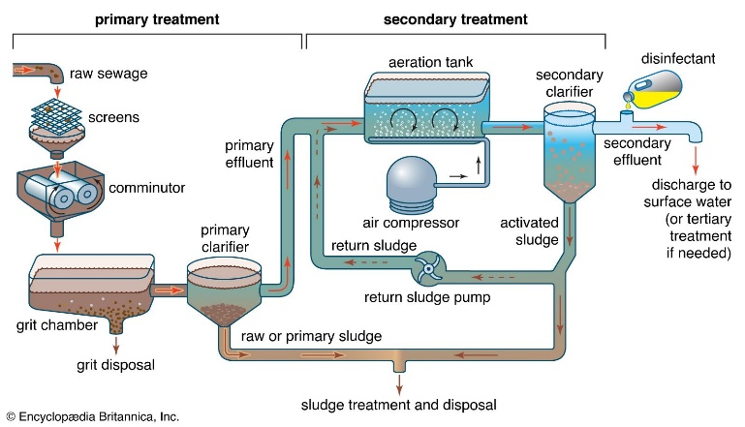

Figure 6. Wastewater plant process flow diagram. (https://www.britannica.com/technology/wastewater-treatment/Primary-treatment)

3.4 Supervisory Control (SCADA & HMI)

Whilst PLCs perform localised control of individual processes, the overall running of a wastewater treatment plant is achieved through a Supervisory Control and Data Acquisition (SCADA) system. SCADA acts as the supervisory layer, integrating data from across the facility to provide a real time overview of plant performance. SCADA supports monitoring, alarm handling, and data recording, enabling largely autonomous operation while maintaining operator oversight (Daneel and Salter, 1999).

A typical wastewater plant SCADA system is structured hierarchically. Field instrumentation and equipment are connected to PLCs, which carry out the control aspect. These PLCs communicate with a central SCADA server, where plant-wide data is aggregated and presented. This allows different treatment stages, including inlet works, biological processes, and pumping systems, to be coordinated within a single platform. Remote Terminal Units (RTUs) are often used at unmanned sites such as lift stations, transmitting key operational data and alarms to the control room, illustrated in figure seven (MD Jaleel, 2018).
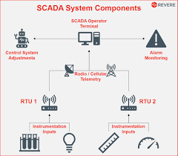
Figure 7. SCADA Overview (https://www.reverecontrol.com/scada-basics-what-are-scada-and-telemetry/)

The Human Machine Interface (HMI) provides the operator with a visual representation of the plant. HMI displays mimic live data, enabling operators to quickly assess system conditions and identify faults, an example can be seen in figure eight.
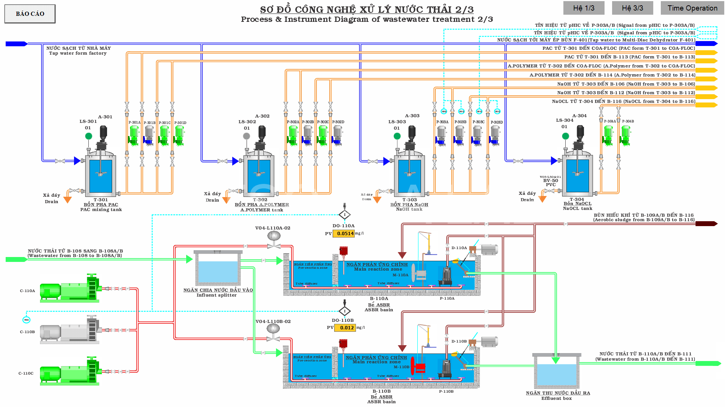
Figure 8. HMI for a wastewater plant. (https://atscada.com/waste-water-treatment-management-system/)

Operators can also adjust setpoints, start or stop equipment, and intervene in automated processes where necessary. Effective HMI design is essential to ensure clear interpretation of data and safe operation.

Alarm management is a critical SCADA function, ensuring that abnormal conditions such as equipment failure or process deviations are quickly identified. When triggered, alarms are prioritised, logged, and displayed to the operator, and may also initiate automatic corrective actions via the PLC. In addition, the data historian continuously records time-stamped process data, providing a valuable record for performance analysis and regulatory compliance (Daneel and Salter, 1999). This is particularly important for demonstrating adherence to standards set by the Environment Agency.

4.0 Regulations and Standards in UK Wastewater Treatment and ICA

Wastewater treatment in the UK is governed by a comprehensive regulatory framework that ensures the protection of public health and the environment. A central component of this framework is the Urban Wastewater Treatment Directive, which establishes minimum requirements for the collection, treatment, and discharge of wastewater (Legislation.gov.uk, 2011). In the UK, compliance with these requirements is enforced by the Environment Agency through environmental permits, which specify discharge limits for key parameters such as biochemical oxygen demand (BOD), ammonia, and suspended solids. These permits necessitate reliable monitoring systems and accurate data reporting, making ICA systems essential for continuous compliance (Environmental Agency, 2018).

The Water Industry Act 1991 provides the legal foundation for wastewater service provision (legislation.gov.uk, 2011), while economic regulation by Ofwat encourages efficiency, performance improvement, and investment in advanced technologies (Ofwat, 2015). Together, these frameworks promote the integration of automated monitoring and control systems to ensure consistent operational performance.

From a technical perspective, ICA systems must adhere to recognised international standards. The IEC 61511 standard governs the design and operation of safety instrumented systems, ensuring that automated processes respond appropriately to hazardous conditions (G Foord, 2004).

Overall, these regulations and standards collectively ensure that wastewater treatment plants operate safely, efficiently, and in compliance with environmental obligations, with ICA systems playing a central role in achieving these outcomes.

5.0 Future Advancements

The trajectory of control and automation in wastewater treatment points towards greater autonomy, energy efficiency, and data-driven decision-making. With innovative AI solutions expected to bridge the gap to future plants (Kwon et al., 2025).

Veolia’s Hub grade Performance Plant platform represents a shift towards digital twin-based operation, where a virtual model of the treatment plant continuously receives real-time data from instrumentation and applies advanced analytics to optimise performance. These systems generate predictive insights and automatically adjust control setpoints at the PLC level, enabling proactive rather than reactive process management. With a digital twin control strategy can be tested, adjusted, and implemented without risk to the physical system (Veolia Water Technologies, 2023).

By integrating artificial intelligence and model-based control, such platforms can significantly improve operational efficiency, reduce energy consumption, and enhance treatment performance. Reported outcomes include reductions in energy use of up to thirty percent, decreases in greenhouse gas emissions of up to sixty percent, and improved nutrient removal efficiency (Veolia Water Technologies, 2023).

Furthermore, these systems support regulatory compliance by continuously monitoring effluent quality, generating automated reports, and providing early warning of process deviations. The ability to predict influent variations, such as storm events, allows treatment processes to be dynamically adjusted in advance, improving resilience and reducing the risk of permit breaches (Veolia Water Technologies, 2023).

Conclusion

This report has examined the development and application of instrumentation, control and automation (ICA) within wastewater treatment, from early manually operated systems to the highly integrated and automated facilities used today. The evolution of ICA has enabled treatment plants to operate with significantly greater precision, reliability, and efficiency, ensuring consistent compliance with environmental standards despite variable influent conditions.

Modern wastewater treatment plants rely on the integration of sensors, controllers, and final control elements to form closed-loop systems capable of real-time process adjustment. Supervisory systems such as SCADA further enhance this capability by providing plant-wide monitoring, alarm management, and data recording, supporting both operational performance and regulatory reporting requirements.

Looking forward, emerging technologies including artificial intelligence, machine learning, and digital twin systems are expected to further advance automation, enabling predictive and self-optimising operation. However, the successful implementation of these technologies will depend on continued investment in infrastructure, data quality, and technical expertise.

Overall, ICA remains central to the effective operation of wastewater treatment systems, with ongoing innovation set to play a key role in improving sustainability, efficiency, and resilience within the sector.

References
Bittanti, S. (2015). James Clerk Maxwell, a precursor of system identification and control science. International Journal of Control, 88(12), pp.2427–2432. doi:https://doi.org/10.1080/00207179.2015.1098783.
Cahill, J. (2013). PID Control History and Advancements. [online] Emerson Automation Experts. Available at: https://www.emersonautomationexperts.com/2013/control-safety-systems/pid-control-history-and-advancements/ [Accessed 23 Mar. 2026].
Daneel, A. and Salter, W. (1999). What Is SCADA. [online] Repository.cern. Available at: https://repository.cern/records/b0mft-5b722/preview/mc1i01.pdf [Accessed 28 Mar. 2026].
DEFRA (2002). Sewage Treatment in the UK UK Implementation of the EC Urban Waste Water Treatment Directive. [online] Available at: https://assets.publishing.service.gov.uk/media/5a799210ed915d0422069741/pb6655-uk-sewage-treatment-020424.pdf [Accessed 22 Mar. 2026].
Dorf, R.C. and Bishop, R.H. (2017). Modern Control Systems. 13th ed. Hoboken: Pearson.
Du, X., Wang, J., Jegatheesan, V. and Shi, G. (2018). Dissolved Oxygen Control in Activated Sludge Process Using a Neural Network-Based Adaptive PID Algorithm. Applied Sciences, 8(2), p.261. doi:https://doi.org/10.3390/app8020261.
Environmental Agency (2018). Water Regulation. [online] Engage Environment Agency. Available at: https://engageenvironmentagency.uk.engagementhq.com/water-regulation [Accessed 2 Apr. 2026].
Fan, L.T., Hwang, Y.S. and Hwang, C.L. (1970). Applications of modern optimal control theory to environmental control of confined spaces and life support systems. Building Science, 5(1), pp.57–71. doi:https://doi.org/10.1016/0007-3628(70)90017-4.
G Foord, A. (2004). APPLYING THE LATEST STANDARD FOR FUNCTIONAL SAFETY -IEC 61511. [online] Available at: https://www.icheme.org/media/9906/xviii-paper-23.pdf.
Janocha, H. (2004). Actuators. Actuators, pp.1–17. doi:https://doi.org/10.1007/978-3-662-05587-8_1.
Kabir, T. and Anick, K.M.T.A. (2024). PLC–SCADA–Integrated Electrical Automation Frameworks for Process Optimization in Water and Wastewater Treatment Facilities. Review of Applied Science and Technology, 03(01), pp.221–262. doi:https://doi.org/10.63125/y1145g11.
Kruse, P. (2018). Review on water quality sensors. Journal of Physics D: Applied Physics, 51(20), p.203002. doi:https://doi.org/10.1088/1361-6463/aabb93.
Kwon, S., Kang, Y., Nam, S.H. and Kim, Y.D. (2025). Water quality monitoring using hybrid physical–soft sensors for river digital twins: a comprehensive review. Water Science & Technology, [online] 92(9), pp.1286–1307. doi:https://doi.org/10.2166/wst.2025.145.
Leadmed Technology (2022). Online Multiparameter Water Quality Sensor. [online] Lmwatersensors.com. Available at: https://www.lmwatersensors.com/Online-Multiparameter-Water-Quality-Sensor-pd580192358.html [Accessed 23 Mar. 2026].
Legislation.gov.uk (2011). The Urban Waste Water Treatment (England and Wales) Regulations 1994. [online] Legislation.gov.uk. Available at: https://www.legislation.gov.uk/uksi/1994/2841/contents.
legislation.gov.uk (2011). Water Industry Act 1991. [online] Legislation.gov.uk. Available at: https://www.legislation.gov.uk/ukpga/1991/56/contents.
MD Jaleel (2018). Waste Water Treatment Using PLC and SCADA. IRE Journals |, [online] 1. Available at: https://www.irejournals.com/formatedpaper/1700683.pdf.
Ofwat (2015). Legislation - Ofwat. [online] Ofwat. Available at: https://www.ofwat.gov.uk/regulated-companies/ofwat-industry-overview/legislation/.
S. Friel, F. (1930). Operation and Control of Sewage Treatment Plants. Sewage Works Journal, [online] 2(4), pp.597–612. doi:https://doi.org/10.2307/25027993.
Santi Nuratch (2017). The IIoT devices to cloud gateway design and implementation based on microcontroller for real-time monitoring and control in automation systems. The IIoT Devices to Cloud Gateway Design and Implementation Based on Microcontroller for real-time Monitoring and Control in Automation Systems. doi:https://doi.org/10.1109/iciea.2017.8282970.
Soares, A. (2020). Wastewater treatment in 2050: Challenges ahead and future vision in a European context. Environmental Science and Ecotechnology, 2, p.100030. doi:https://doi.org/10.1016/j.ese.2020.100030.
Sun, B., Chen, S., Liu, Q., Lu, Y., Zhang, C. and Fang, H. (2021). Review of sewage flow measuring instruments. Ain Shams Engineering Journal, 12(2), pp.2089–2098. doi:https://doi.org/10.1016/j.asej.2020.08.031.
Toshiba (2010). Field Intelligent Device – Premium Value Series Electromagnetic Flowmeter . [online] Available at: https://koreaflowcell.com/wp-content/blog119kr/data/catalog/Toshiba/GF630_LF620_NEW_MODEL.pdf.
Turner Integrated Systems (2021). PLCs and SCADA Systems in the Wastewater Treatment Industry. [online] Turner Integrated Systems. Available at: https://www.turnerintegratedsystems.com/blog/plcs-scada-systems-wastewater-treatment/.
Veolia Water Technologies (2023). Transforming the Future of Wastewater Treatment Plants with Digital Solutions. [online] Available at: https://www.veoliawatertechnologies.com/sites/g/files/dvc2471/files/document/2024/08/WP%20All%20HUBGRADE%20Performance%20Plant%20White%20Paper%20EN.pdf [Accessed 26 Mar. 2026].
Yehia, S. (2015). VFD application in wastewater treatment aeration control - Control Engineering. [online] Control Engineering. Available at: https://www.controleng.com/vfd-application-in-wastewater-treatment-aeration-control/.
Zhang, H. (2024). Optimization and Innovation of Industrial Control Systems Based on PLC. Advances in Computer, Signals and Systems, 8(4). doi:https://doi.org/10.23977/acss.2024.080403.

Bibliography

Nise, N.S. (2019). Control systems engineering. 7th ed. Hoboken, Nj: Wiley.
Rumana Riffat and Taqsim Husnain (2022). Fundamentals of Wastewater Treatment and Engineering. CRC Press.

