
Structural Design
Design of Structural Elements



Jonathan Triggs
1807834

Contents
Structural Scheming 3
Loading Schedule 4
Dead Load - Slab 4
Self-Weight 4
Finishes 4
Live Load 5
Summary – Ultimate Load 5
One Way – Two Way Slab 6
Durability Design 7
Slab Durability 7
Slab Analysis and Design – P4 8
Step 1 9
Step 2 9
Step 3 10
Step 4 10
Beam Analysis and Design 11
Steel Beam Design 14
Pad Footing 15
References 17

Structural Scheming
To ensure an efficient and practical structural frame for a house the frame should be hidden as much as possible as well as allowing the most open spaces as possible. This can be done by hiding the beams and columns within the walls of the house and obvious separation of different rooms that gives the impression that the visible beam is meant to be there. Below are the architectural floor plans that show the ground floor and upper floor of a domestic house that required a structural frame.
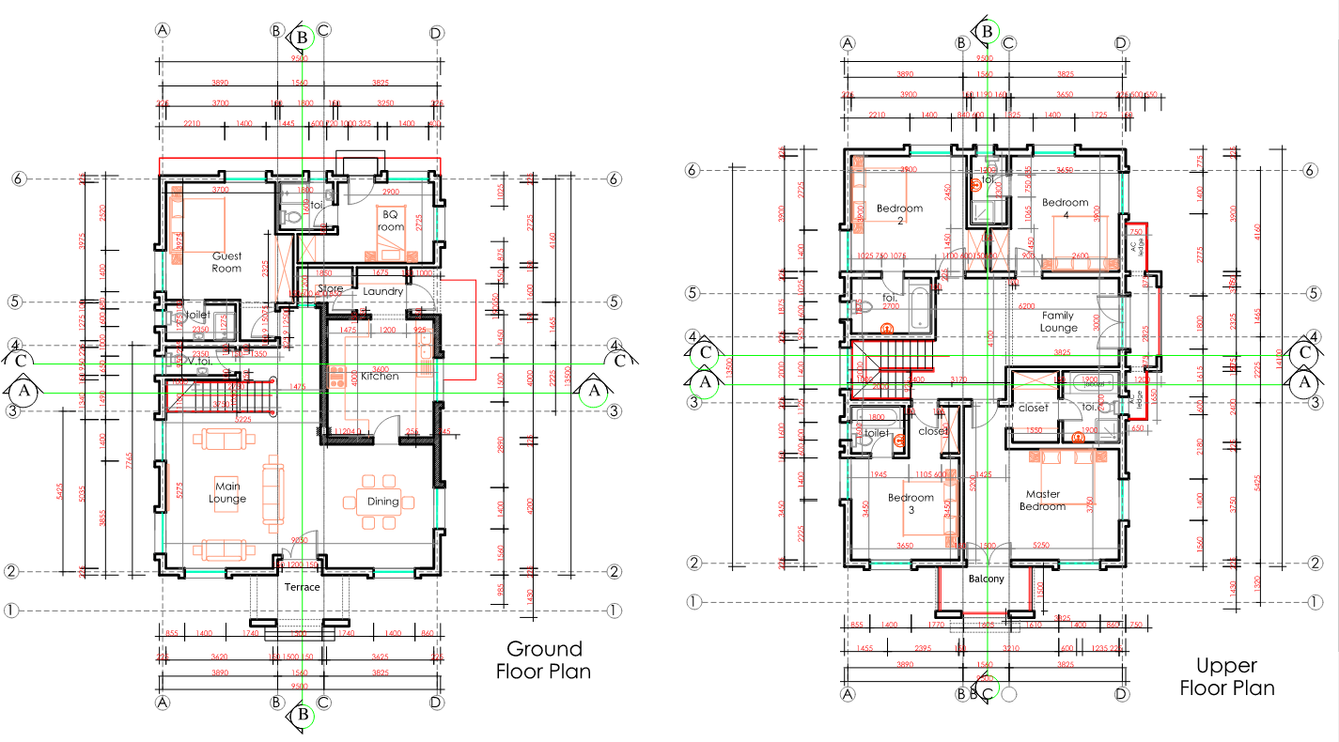
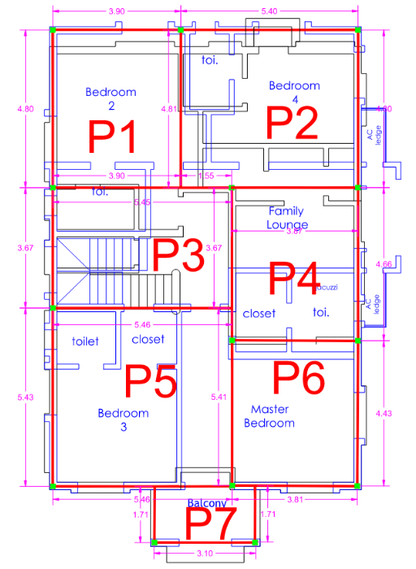
Figure 2 Architectural Drawings
Figure 1 Structural Scheming
To do this we overlay the ground and upper floor so that we can see where the upper floors are required to be supported. Overlapping the floors also allows us to hide any beams and columns that the upper floors require in the ground floors walls. The beams and columns support the upper floor however they are visible on the ground floor. This can be seen the image below:

Loading Schedule
To enable us to design the structural frame a schedule of load needs to be produce to allow us to analyze the different loads that will be put on the structure. There two types of loads that will make up the total load on a member, Live load and Dead load. A dead load is a permeant load on the structure this can include finishes services and self-wight. The live load all depends on the usage of that area of the frame.

Dead Load - Slab

Self-Weight
To establish the slabs self-weight, we must assume a thickness in this case we assumed 150mm and times that by the density. To identify a density, we choose from a material density from the table below. In this case 24Kn/m³. (24 x 0.150 = 3.6KNm-₂) This figure will be shown the in the schedule of loading.
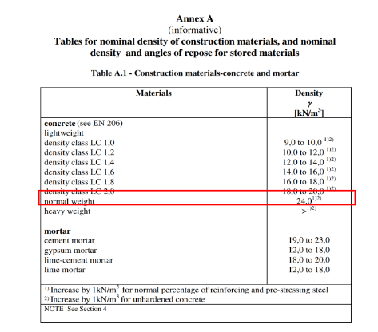
Figure 3 Concrete Density

Finishes
The table below shows the different finishes classifications
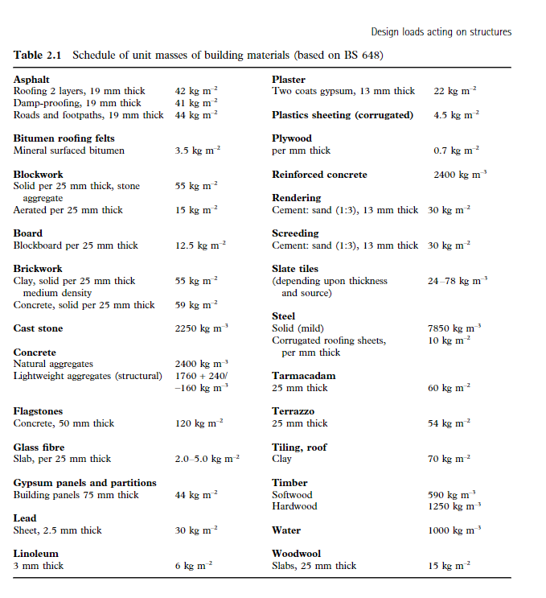
Figure 4 Finishes Table 2.1 REF1 – Design of structural elements

Live Load
To identify the live load, we can take the values from euro code 2 and categorize the different panels within the upper floor. As it is a residential building it is category A and the different sections under category A can be seen in the table.
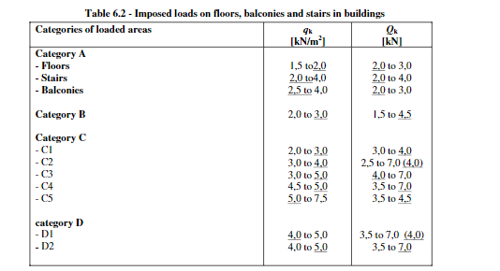
Figure 5 Eurocode 1 table 6.2

Summary – Ultimate Load
This table summarizes these calculations. This then allows us to calculate the ultimate load. Which is 1.4gk Dead load + 1.6qk Live load according to Eurocode 2. These values represent a factor of safety, and the live load factor of safety is higher because live loads are unpredictable, so this allows for more flexibility for mixed uses in the future.
SCHEDULE OF LOADING
Level | Functional Spaces | Superimposed Dead Load (KN/sqm) |  |  | Total Imposed Dead Load (KN/m2) | Live Load (KN/m2) | Ultimate Load (1.4gk + 1.6qk) KN/m2
Level | Functional Spaces | Finishes | Services | Self-Weight | Total Imposed Dead Load (KN/m2) | Live Load (KN/m2) | Ultimate Load (1.4gk + 1.6qk) KN/m2
1ST Floor | P1 Toilet/Bedroom | 1.1 | 0.1 | 3.60 | 4.80 | 1.50 | 9.12
1ST Floor | P2 Toilet/Bedroom | 1.1 | 0.1 | 3.60 | 4.80 | 1.50 | 9.12
1ST Floor | P3 Stairway/Landing | 1.1 | 0.1 | 3.60 | 4.80 | 2.00 | 9.92
1ST Floor | P4 Lounge/Toilet | 1.2 | 0.1 | 3.60 | 4.90 | 2.00 | 10.06
1ST Floor | P5 Toilet/Bedroom/Closet | 1.1 | 0.1 | 3.60 | 4.80 | 1.50 | 9.12
1ST Floor | P6 Bedroom/toilet | 1.1 | 0.1 | 3.60 | 4.80 | 1.50 | 9.12
1ST Floor | P7 Balcony | 1.1 | 0 | 3.60 | 4.70 | 3.00 | 11.38

One Way – Two Way Slab
To then identify how the ultimate load of the slab is distributed throughout the structure we must identify whether each slab is a one- or two-way slab. This can be done by divided the longest length by the shortest length and if the answer is greater than two then it is one way. (Ly/Lx >2=1 Way). The figure below shows that every slab within this structure is two-way, so the ultimate load needs to be spread across the four beams.
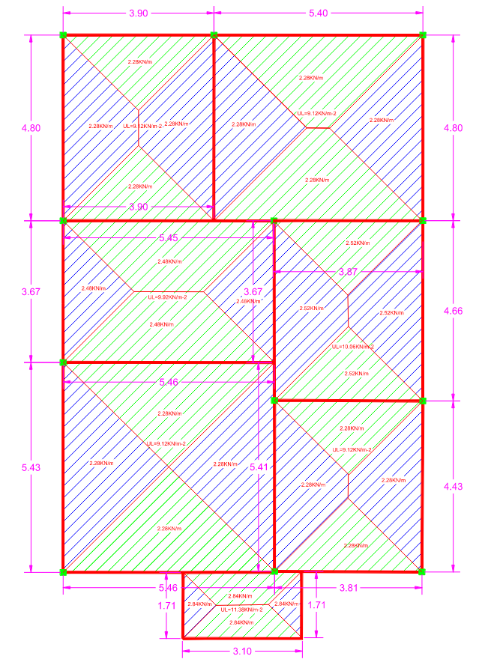
Figure 6 Slab Load Scheming

Durability Design

Slab Durability
Ref | Description | Output
 | FLOOR SLAB
Eurocode 2  4.4.1.1  4.4.1.2 | Bar Size  Assumed Bar Size = 12mm  Nominal Cover C ≥ 12mm
Eurocode 2  Section 11 | Aggregate Size  Assume Largest nominal aggregate size D_{g} = 20mm  D_{g}≤ 0.25 x Slab Thickness = 0.25 x 150 = 37.5mm  Nominal cover ≥ 20mm | D_{g} is Ok
Eurocode 2  Table 4.1 | Exposure Condition  Environment – XC3 Internal Humid Environment & Outside Concrete Sheltered  Concrete Grade C40 is intended to be used.  Nominal cover ≥ 20mm
EN 1990 Section 5 and EN 1992-1-2 | Fire Resistance  1hr fire resistance is intended  Nominal cover ≥ 20mm  Minimum depth of slab panel = 95mm  Depth of slab panel =150mm. | Slab depth ok
 | Nominal cover to all floor slab = 20mm | C = 20mm

Slab Analysis and Design – P4
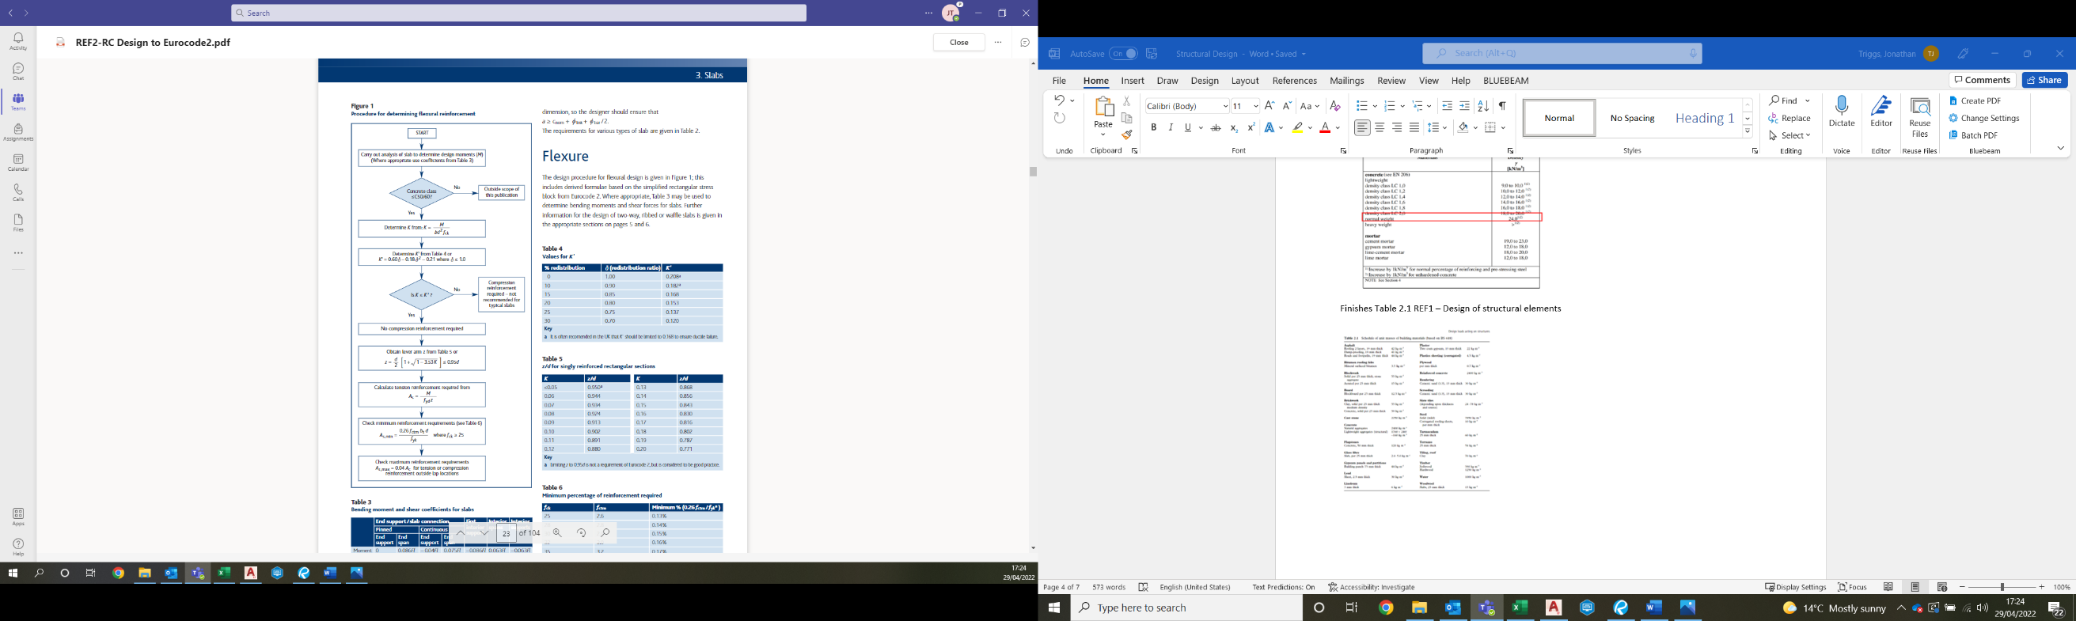
Once the durability design and loading schedule is complete this gives the parameters to enable us to design a slab. To do this we can follow the flow chart as shown below:
Figure 7 How to design concrete structures using Eurocode 2

Step 1
Firstly, we must identify maximum bending moment acting on the slab. To do this we use the beam bending table to identify the formula to calculate the maximum bending moment. The force acting on the slab is a UDL so we use wl²/8. Giving us 27.31KNm
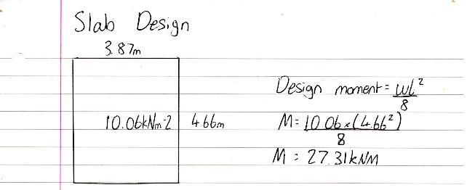

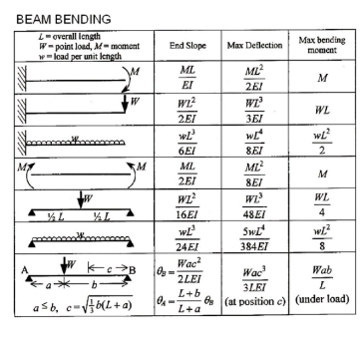

Step 2
The next step then involves determining K. To do this we use table 3.6 to gain our Fck value and our cover value. The design life and exposure condition can be taken from the durability design. Once K is identified we must compare it to k¹ and in this case our value is lower so we can use the value from our calculation. Once this is complete, we can plug all the required values into the formula from table to 5 to obtain the lever arm (z). We then compare this to 0.95d of the slab and because our value is less than this, we can use the value we calculated in the next step of the flow chart.

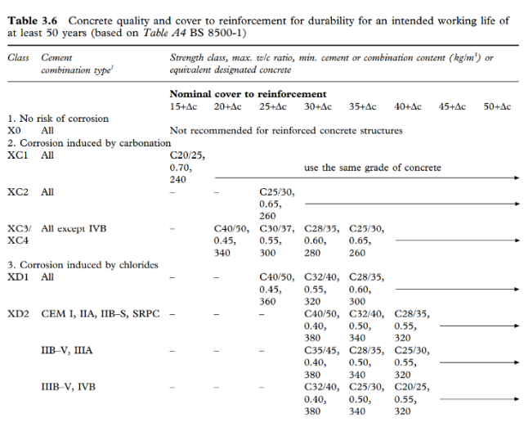
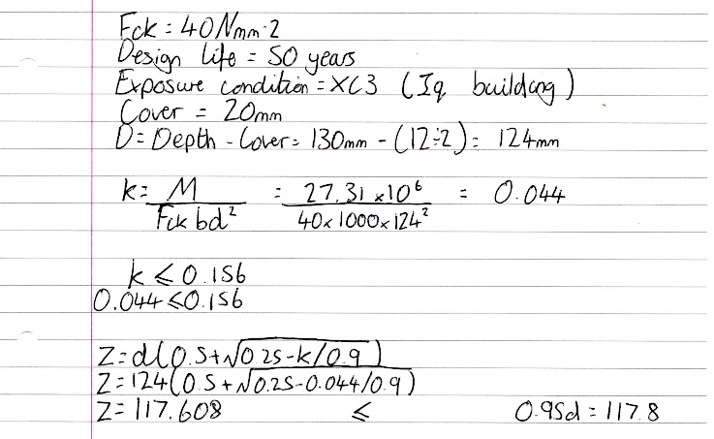
Figure 8 Eurocode 2 Table 3.6

Step 3
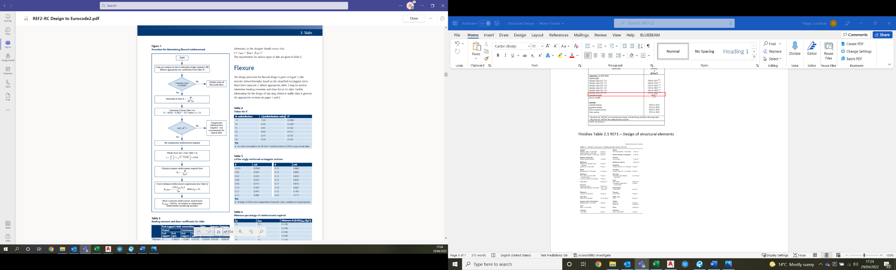
Then we calculate tension reinforcement required A_{s} to do this we use our moment value along with the lever arm value previously calculated, and assume a strength for steel and plug into the formular as shown below. Now that we have our A_{s} value, we can identify the spacing of the bars and size using the table below. As our answer was 464mm we pick a value slightly higher to ensure a factor of safety. So, in the case we chose H12 200 center/center which gives us 566mm².
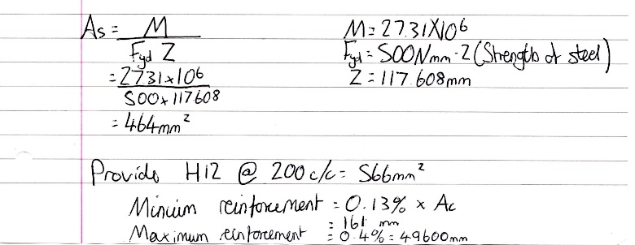
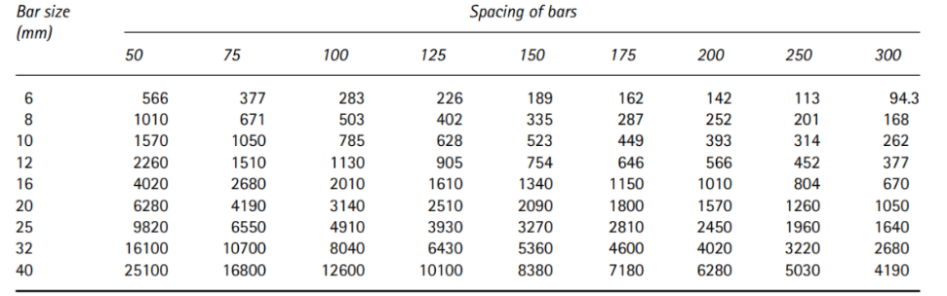

Step 4
The final step is to check minimum and maximum reinforcement of slab to see if our As fits between these values. To do this we find 13% and 40% of the area of concrete giving us our minimum reinforcement. In this case our result does fit between these values so the design will work.

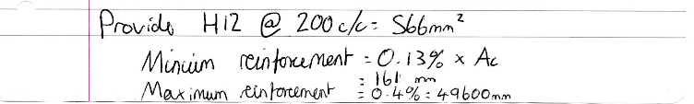

Beam Analysis and Design
To allow us to design a beam for this structure we must first analyses the forces acting upon the beam to enable us to work out the largest moment acting upon the beam using Clapeyron’s 3 moment equation. Once this has been acquired, we have all the required information to design a beam. Moment calculation is as follows:
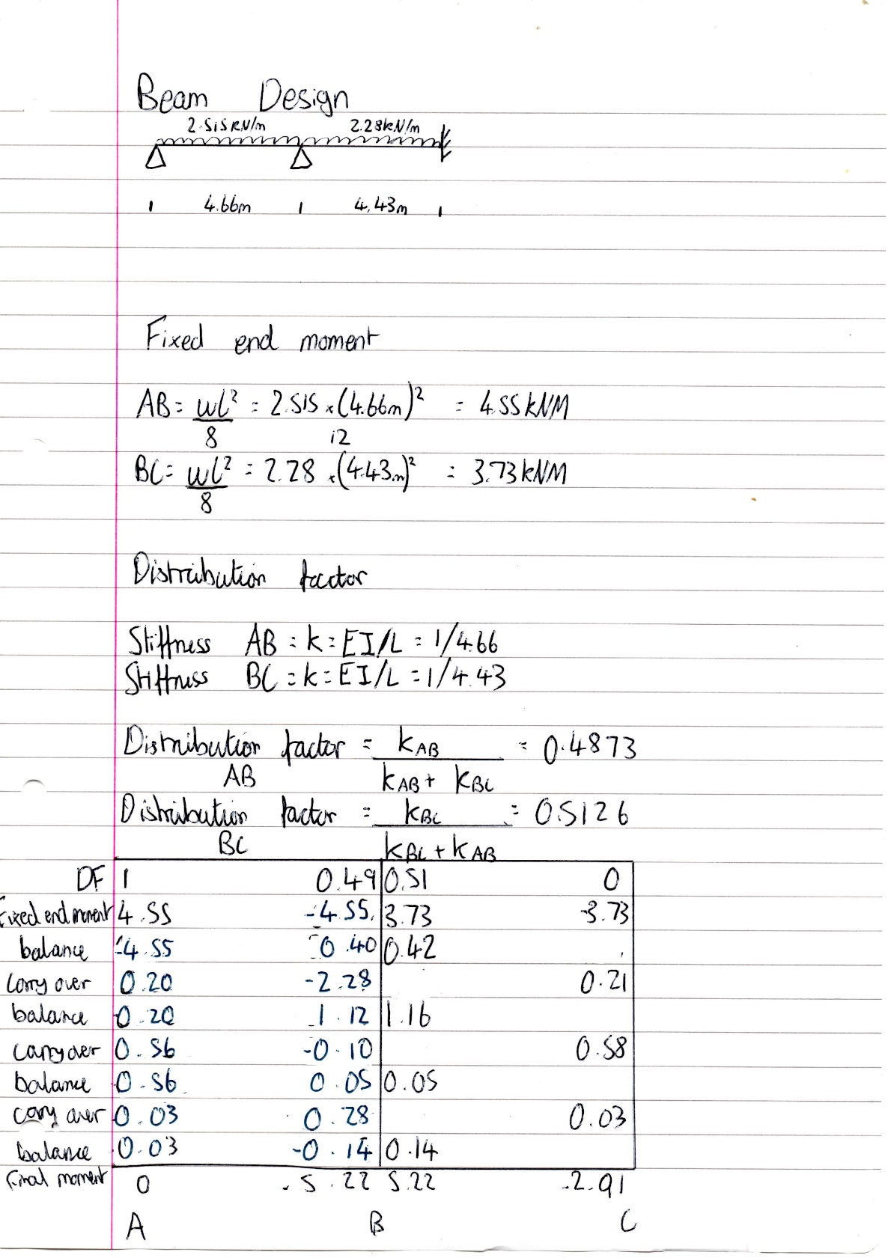
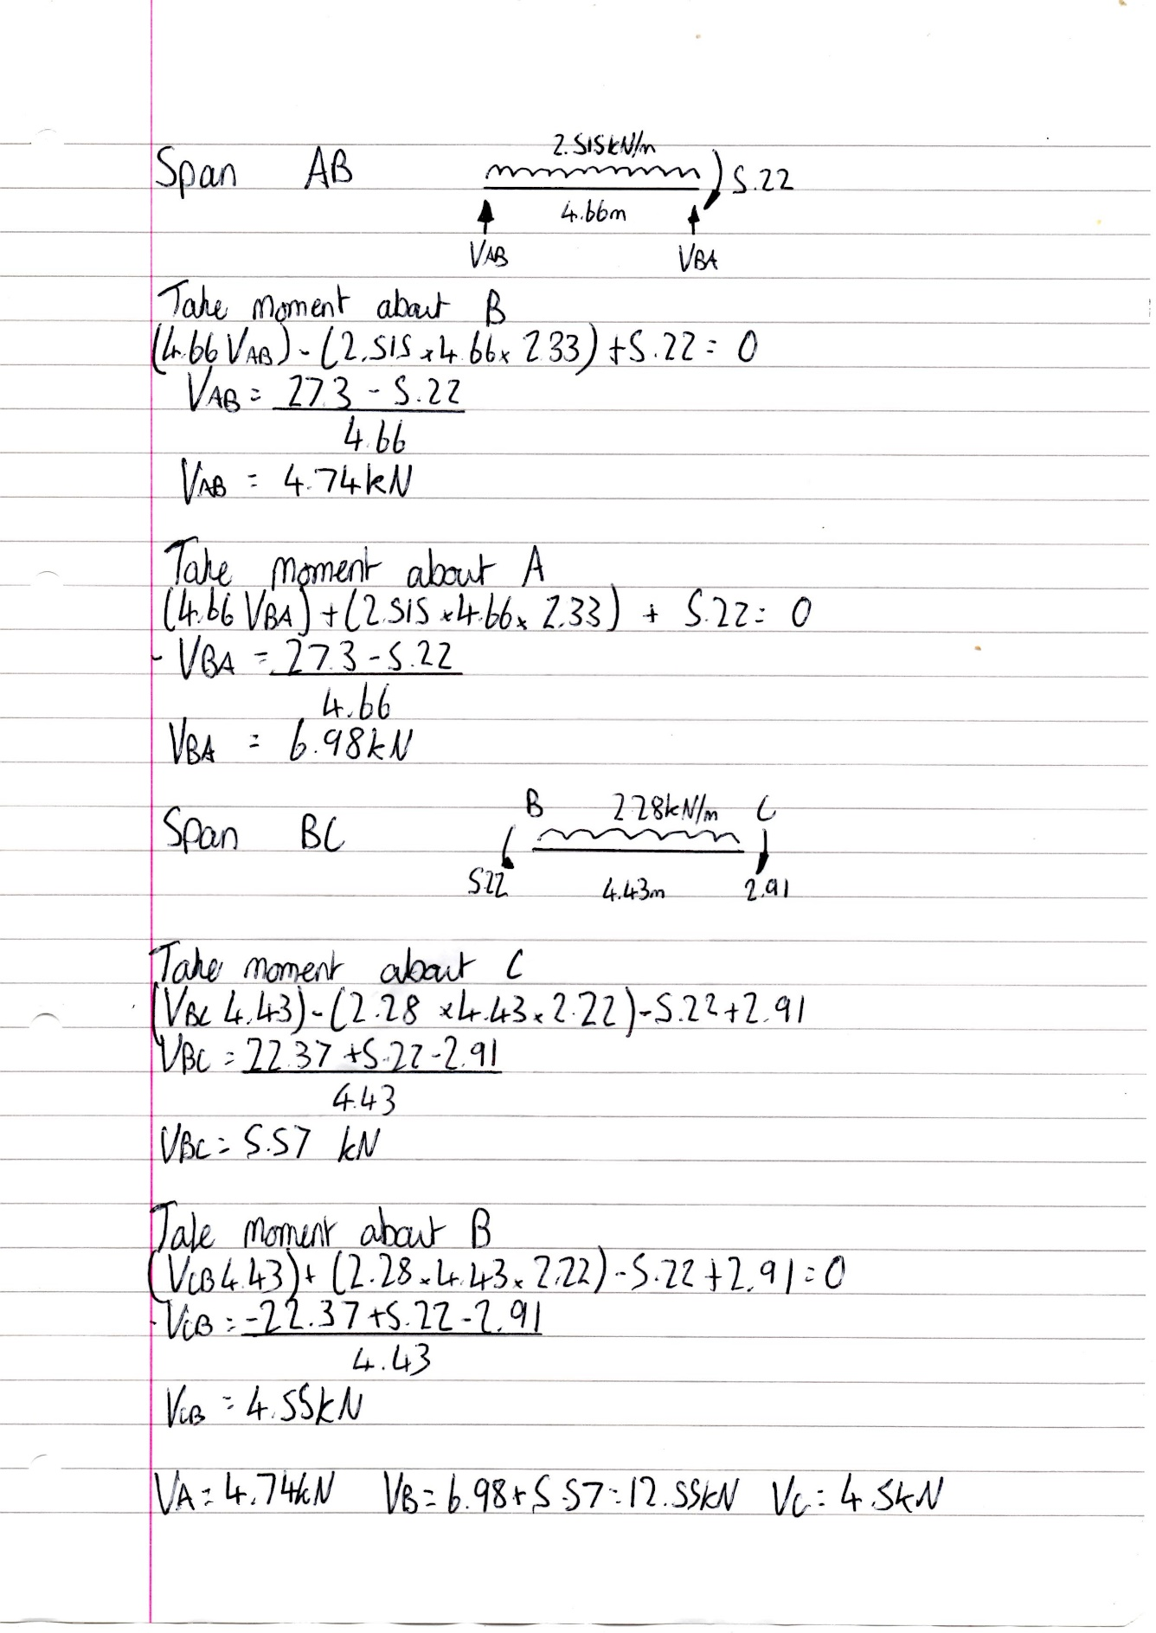
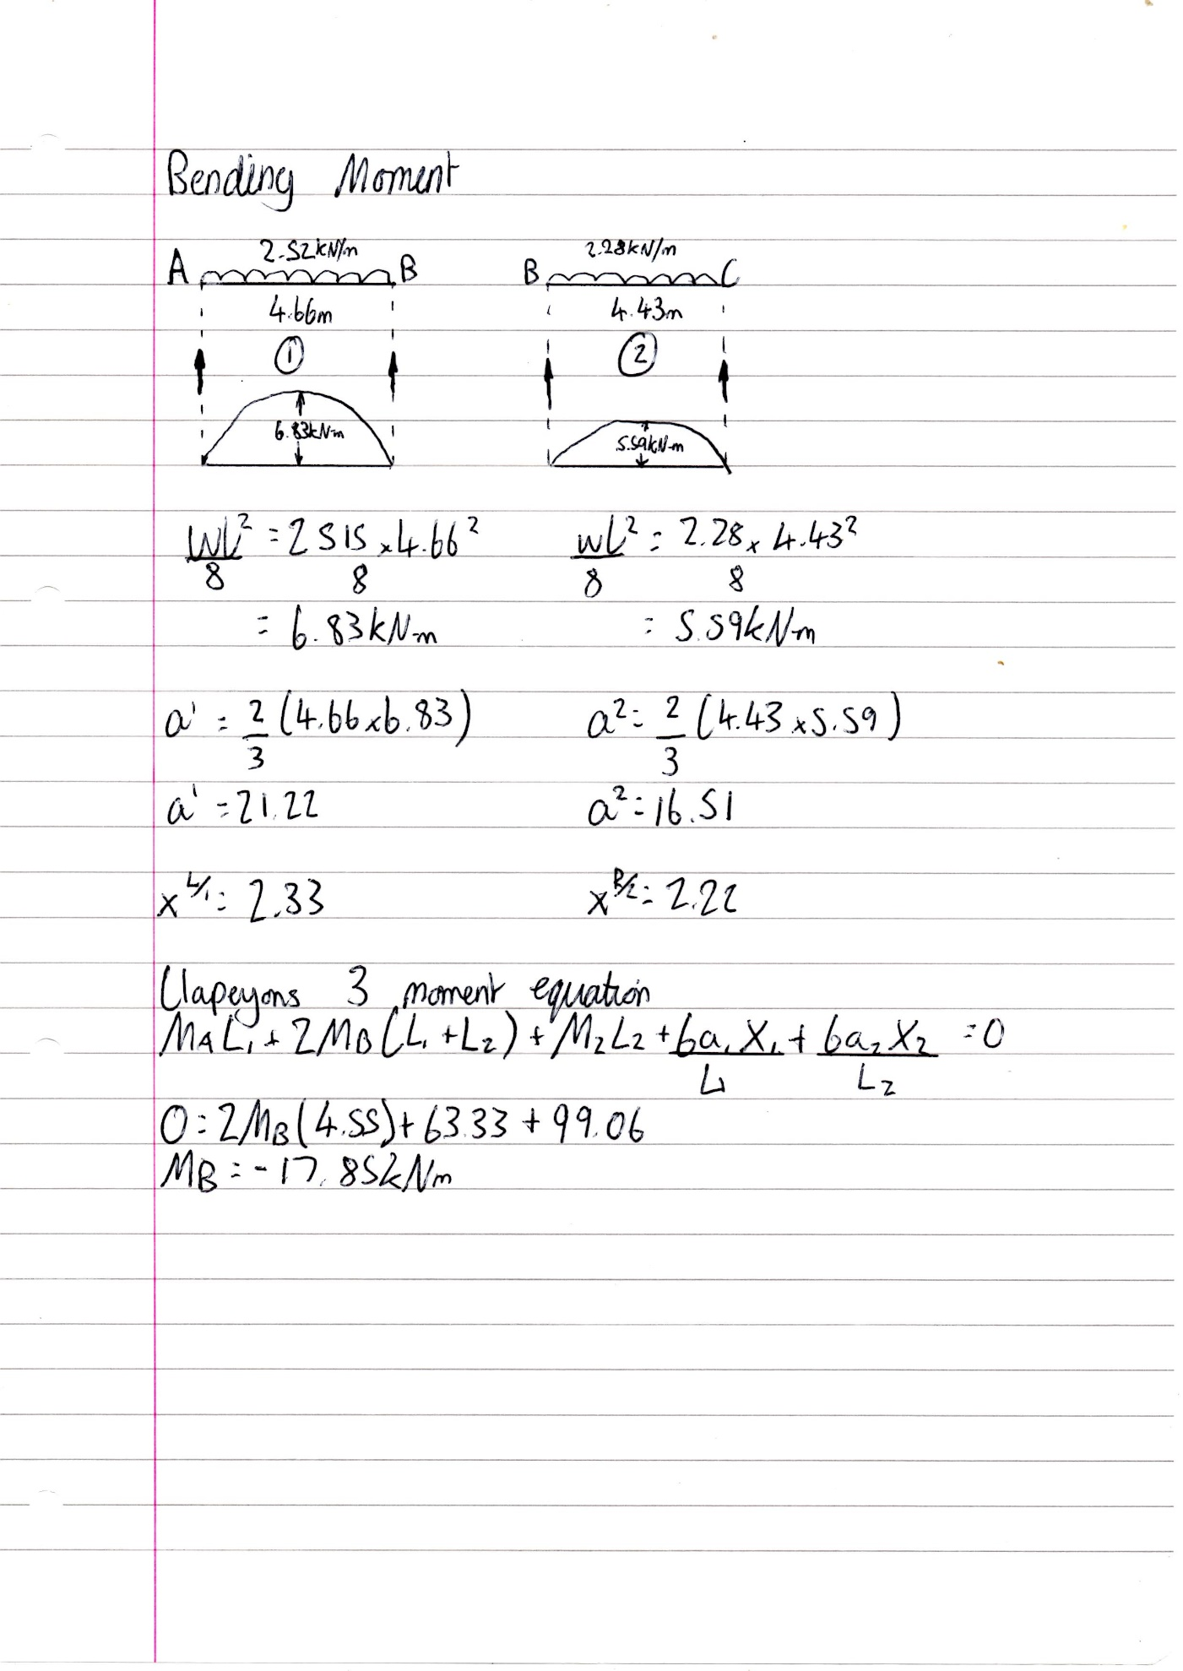

Steel Beam Design
Now that we have our maximum moment value, we can now use this to work out the section modulus required. Once we have our section modulus that we require, we then go to the table on the section modulus for universal beams to pick an appropriate size steel beam that isn’t too high so that it isn’t cost effective but high enough to allow some safety. In this case we picked UB254 146 x 31 as it gives us 61.3 higher than the required section modulus of 38.9.

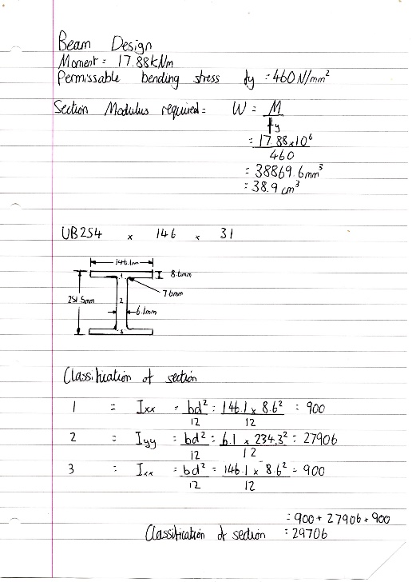

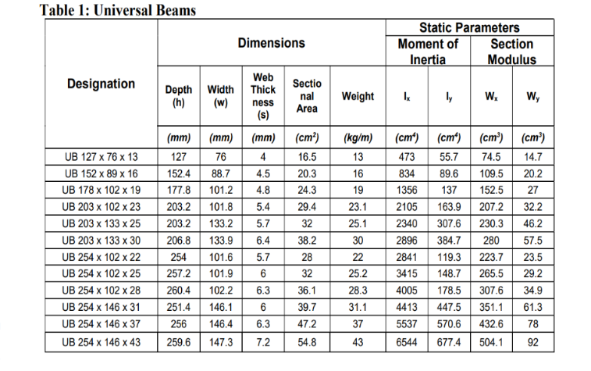

Pad Footing
To design a pad footing we need to refer to Eurocode 7 – Geotechnical design part 1 and 2. Part 1 being general rules and part 2 being ground investigation. This applies to the footing as it is the member touching the ground so the make up of the ground comes into play. There are two methods to designing a footing within Eurocode 7 this being the direct method or in-direct. The direct method would be to do everything from scratch yourself include the ground investigation to gain its bearing capacity then you can design a footing to these values. Or indirect where we assume from a graph. We are using the in direct method and we work through the following flow chart step by step:
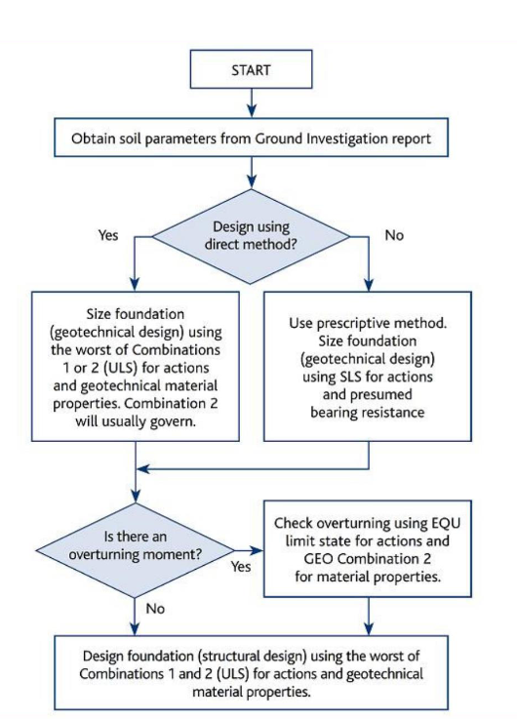

To work the footing out an assumption of 500KN acting down from the column was assumed and a column area of 200mm was assumed. The workings out for the footing are as followed:
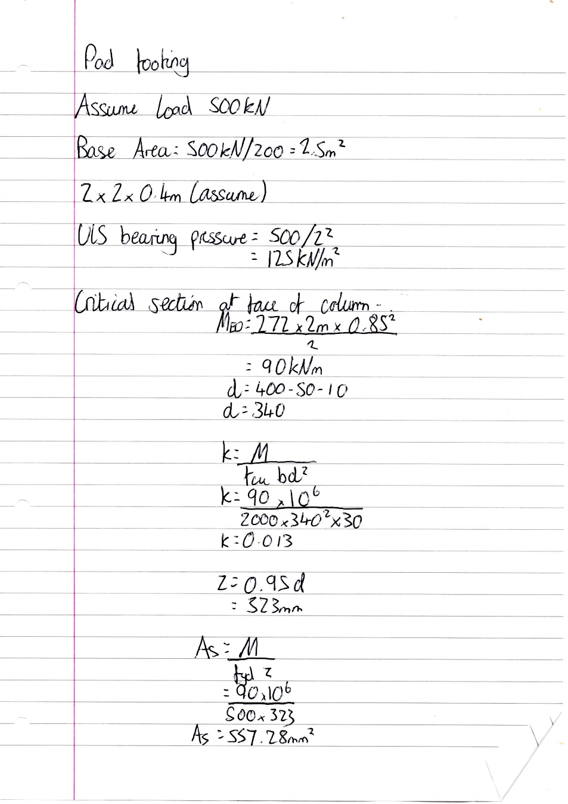
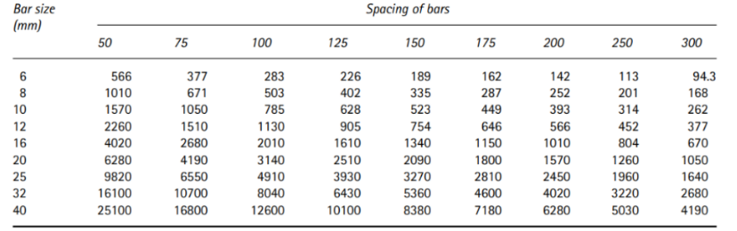
As the area of concrete required is 557mm² we can use H12 with spacing 200mm C/C to give us 566mm².

References
Anon., 2009. UK National Annex for Eurocode Basis of structural design. s.l.:The authority of the Standards Policy and Strategy Committee .
BSI, 2009. Eurocode — Basis of structural design. s.l.:EUROPEAN COMMITTEE FOR STANDARDIZATION.
BSI, 2009. UK National Annex for Eurocode Basis of structural design. s.l.:BSI.
BSI, 2014. Eurocode 2: Design of concrete structures — Part 1-1: General rules and rules for buildings. s.l.:The authority of the Standards Policy and Strategy Committee.

