LCLM4002_BIRM Digital Skills Task 3 Website Evaluation
Student Number | 2432935 | Student Name | Cristina Dalila Nica
Website Chosen | Suited Cars
Insert hyperlink to website | https://www.suitedcars.com/


Answer: The site loads quickly in desktop and mobile browsers, with a loading time of around 2–3 seconds on average. The main pages like "Book Now" and "Services" are very easily clickable in seconds. A few high-definition images on the front page may be a bit slow to load on slower speeds of internet.
Answer: Yes, the site has various sub-pages such as "Book Now," "Services," "Fleet," "Airport Transfers," and "Contact." The site can be easily navigated using the top menu bar and bottom footer links. All the pages are labeled properly so that clients can quickly locate useful information with minimal page scrolling.
Answer: Reservations can be booked directly on the website using the "Book Now" option. The process is simple, with insertion of pick-up and drop-off locations, date and time, and vehicle. The interface, however, could use more user directives or check prompts.
Answer: The reservation process would be easier through real-time availability checks and an up-to-date confirmation page. Breadcrumbs for easy navigation and enhancing mobile responsiveness on drop-down menus would also enhance usability.
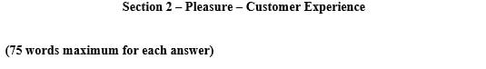
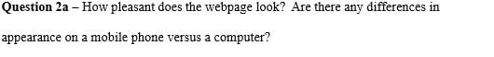
Answer: The website appears quite streamlined, elegant in looks fitting for the high-end nature of the service. A few of the elements such as picture dimensions and menu alignment require correction on mobile, but generally the look is still pretty to behold and usable on both platforms.
Answer: Suited Cars employs top-of-the-line vehicle photos and crisp black and gold color scheme to project luxury. The website is devoid of powerful videos or interactive features, which can be utilized to assist with storytelling and consumer engagement.
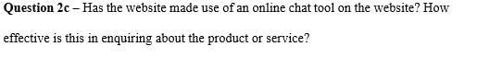
Answer: There is no live chat feature on the website today. This restricts customer communication in real time. Adding a live chat or chatbot would really help improve customer service and facilitate interaction.
Answer: Social media icons (Facebook, Instagram) are in the footer but not visible and up to date. Links are live but outdated or scant content prevents them from engaging or retaining customers.



Answer: Services are accurately covered under individual tabs like "Airport Transfers" and "Chauffeur Service." Every page captures the offering with its own pictures. Descriptions, though, could be expanded with further service information and benefits to customers.
Answer: Customer feedback is included on the home page and sourced from Google. They are recent and emphasize positive comments, thereby increasing credibility. Having a separate "Testimonials" page would improve it even more.

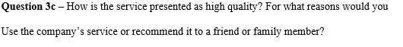
Answer: The luxury car photos, luxury brand, and business-like tone make it look like a premium service. The focus on executive transport, airport transfer, and punctuality makes it appropriate for business travelers or any special occasion. Personal suggestion would be based on perceived comfort and trust.

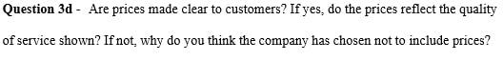
Answer: Prices are not actually stated on the website. Maybe variable prices depending on location, car type, and booking duration. That lack of transparency might put off price-conscious customers, but this is a plausible rationale. An estimated fare calculator would enhance trust and choice.

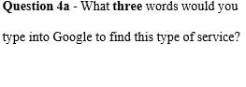 | - Executive car hire
 | - Chauffeur London
 | - Airport transfer service
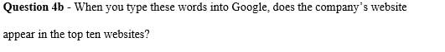
Answer: It is not consistently in the top ten for these keywords. This means that there is a requirement for stronger SEO techniques like keyword optimization, link building, and meta tag updates to increase visibility.
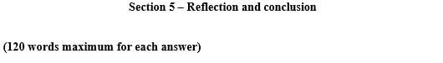
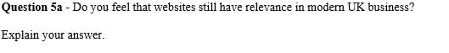
Answer: Yes, websites are indeed very much at the head of the pack for UK businesses, particularly smaller businesses providing quality services such as (Suited Cars, 2025). A well-designed, professional website provides reassurance, sells services, and allows online bookings. Social media and apps are significant, but websites allow control over branding and SEO. Users anticipate big information to be accessible at once and will make a judgment of credibility from web design and ease of use. For targeted high net worth or professional companies, a nicely crafted web site is critical.

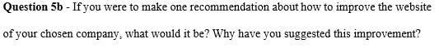
Answer: I suggest incorporating a live chat or chatbots facility in real-time. It would provide instant support to prospects, dispel confusion on the spot, and boost conversion rates. In a field where speedy response has an impact on client decisions, having an online personal assistant available 24/7 would improve user experience and reflect professionalism, leading to customer trust and satisfaction.

Reference List
- Ghosh, S. and Dubey, S., 2025. The Field of Usability and User Experience (UX) Design. In Navigating Usability and User Experience in a Multi-Platform World (pp. 117-154). IGI Global.
- Laudon, K.C. and Traver, C.G., 2021. E-commerce 2020-2021: business, technology, society. Pearson.
- Papadimitriou, D. and Duysinx, P., 2022. FUTURE MOVE: A review of the main trends in the automotive sector at horizon 2030 in the Great Region.

- Suited Cars. (2024). Homepage. [online] Available at: https://www.suitedcars.com

